*Chapter 19: The Speaker in Dreams*

Round 90

“No imps: that’s for sure,” Elsabet first murmured, still looking for auras. The Baron was certainly under some form of compulsion effect, and an Enchantment aura did not so much confirm this, but failed to refute it. Having determined the Baron was under an Enchantment of some kind, she stopped concentrating to inform the others. “Sgt. Pepper, Bishop Jericho, the Baron is definitely under an Enchantment of some kind. Assuming I have any first-level magic left, I will call upon Mayaheine to give him a chance to shake it off with his own will power with a resurgence spell, after first giving him a guidance spell to boost his chance.”

She looked within to see what spell energy she had remaining, then nodded, saying, “I still have some mojo, so here goes.”

Elsabet cast *guidance [expired on Round 130]* on the Baron, briefly touching him in a reassuring manner.

*Baron Baron Euphemes II of the Houses of Ulfren and Rajapur gained +1 to any roll.*

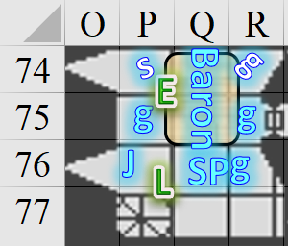

~*~

Saradette stepped to her left as she entered the room, her launcher leveled. This was the Treasurer’s bureau, with three bronze and iron chests resting along the western wall, and a single, L-shaped desk along the eastern wall, with a dead body dressed in civilian clothing lying behind the desk amidst its own blood. Saradette could not see the majority of the corpse, and thus could not ascertain its race or gender.

Barkley followed Saradette into the next room. He then headed to the desk and the body, still sniffing the air to see if he could pick up any familiar scent. “Be careful if you plan on checking out those chests. I’m going to take a look at the body and check the desk.” Confirming that the person was dead, he did his best to pick up the scent of the killer, recognizing the odor of no specific wereserpent. The body had not been dead for long, and the pool of blood was just beginning to dry at the edges. He could not recognize anyone by odor, and rummaged through the desk’s effects for anything of interest, thinking about checking the two closed drawers to see if anything interesting might have been left therein, but not doing so.

Solstice aided Barkley in the searching of the room for any clues, and made his way over to the chests, inspecting the northernmost one.

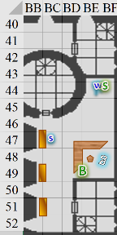

Round 91

*Haste* expired.

Barkley noted a quill, two vials of ink, and about a half-dozen ledgers that constituted the majority of the desktop’s contents, but there was also a parchment detailing the acquisition of a variety of weapons, armor, and raw materials.

“Any keys on the desk?” Solstice noted the locked chest.

“No,” Barkley simply murmured as he took the list of weapons, armor, and raw materials, and placed it in his vest pocket.

The musteval produced his lockpick set.

Saradette was about to check the chests one at a time, then noticed that Solstice was already at the first one, so she went to the second one. She’d busted out her launcher, and in order to do that, had had to put away her lockpick set, so she set down the launcher and produced the necessary tools to undo the lock on the center chest.

Widget sniffed the air.

~*~

“Yes, plenty of charges! If Elsabet still ails, cured she should be.” Luran tapped that act of healing upon his friend.

*Elsabet gained 6 + 1 = 7 hps [47/48].*

Elsabet followed up with a short prayer to Mayaheine to give the Baron the will to recover his own wits, casting *resurgence* on him and whispering “come back to yourself, lord of Mintar. Your people need you.”

|  |  |  |  |  |
| --- | --- | --- | --- | --- |
| **Character** | **Save vs.**  *?* | **Ranks** | **Roll** | **Save** |
| Baron | Will | 7 + 2 Courage + 1 Guidance | 4 | 14 |

*Fail.*

The Baron remained with a dreamy, moribund expression as Sgt. Pepper shook her head in frustration. “Perhaps Bratislava can help.”

A few short seconds later, they heard the footsteps of at least one person coming from the tower to their east, but not with enough anticipation to react. Dressed in the black-and-red robes indicative of the new administration, the reptilian lycanthropes hissed a few unintelligible syllables, as two other wereserpents entered from the spiral staircase that the heroes had just taken.

Prefect Groshke smirked and flicked his forked tongue as he cast *bestow curse* upon one of the Baron’s Guards.

Sgt. Pepper and her aide-de-camp were next to the Prefect when he cast the spell, and swung at him.

|  |  |  |  |  |  |  |  |  |  |  |  |
| --- | --- | --- | --- | --- | --- | --- | --- | --- | --- | --- | --- |
| **Character** | **Attack Type** | **Damage** | **BAB** | **Str Mod+** | **W+** | **Other+** | **Total Score** | **Roll** | **Total** | **Crit** | **Threat** |
| Sgt. Pepper | MW Short Sword | 1d6+3 | 4 | 3 | 1 | 2 | 10 | 20 | 30 | 20 | þ |
| Baronial Guard | MW Short Sword | 1d6+3 | 3 | 3 | 1 | 2 | 9 | 13 | 22 | 20 | ý |

*Threat. 1d20 = 16 + 10 = 26, critical hit.*

*Dmg: (2 x 3) + 3 = 9. Damage negated.*

*Dmg: 4 + 3 = 7. Damage negated.*

|  |  |  |  |  |
| --- | --- | --- | --- | --- |
| **Character** | **Check** | **Ranks** | **Roll** | **Check** |
| Prefect | Concentration | 7 | 5 | 12 |
| Prefect | Concentration | 7 | 7 | 14 |

*Fail, fail. Moot.*

|  |  |  |  |  |
| --- | --- | --- | --- | --- |
| **Character** | **Save vs.**  *bestow curse* | **Ranks** | **Roll** | **Save** |
| Baronial Guard | Will | 4 | 11 | 15 |

*Fail. Guard’s Dexterity dropped by 6.*

Father d’Ethic had less powerful spells left in his repertoire, and thus cast *bane* upon the heroes, inciting an attack of opportunity from the fellow next to him.

|  |  |  |  |  |  |  |  |  |  |
| --- | --- | --- | --- | --- | --- | --- | --- | --- | --- |
| **Character** | **Attack Type** | **Damage** | **BAB** | **Str Mod+** | **W+** | **Other+** | **Total Score** | **Roll** | **Total** |
| Baronial Guard | MW Short Sword | 1d6+3 | 3 | 3 | 1 | 2 | 9 | 14 | 23 |

*Hit. Dmg: 1 + 3 = 4. Damage negated.*

|  |  |  |  |  |  |  |  |
| --- | --- | --- | --- | --- | --- | --- | --- |
| **Save vs.**  *bane* | **Rank** | **Ability**  **& Mod.** | **Misc.**  **Mods.** | **Total** | **Roll** | **Check** | **Notes** |
| **Elsabet, Will** | **7** | **Wis (-1)** | 4 | 10 | 9 | 19 | +3 vs. Enchantments |
| **Luran, Will** | **7** | **Wis (-1)** | 2 | 8 | 19 | 27 |  |

*Success, success. Effect negated.*

|  |  |  |  |  |
| --- | --- | --- | --- | --- |
| **Character** | **Save vs.**  *bane* | **Ranks** | **Roll** | **Save** |
| Sgt. Pepper | Will | 5 | 19 | 24 |
| Jericho | Will | 2 | 6 | 8 |
| Baronial Guard 3 | Will | 4 | 10 | 14 |
| Baronial Guard 5 | Will | 4 | 14 | 18 |

*Success, fail, fail, success. Jericho and Baronial Guard 3 incurred -1 to attacks and saves vs. Fear.*

Jericho shook his head as he prepared to cast a spell.

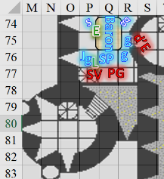

Round 92

|  |  |  |  |  |  |
| --- | --- | --- | --- | --- | --- |
| **Character** | **Group** | **Initiative** | **Roll** | **Modified Roll** | **Move** |
| Saradette (n.a.) | 1 | 3 | 17 | 20 | 20’ |
| Baronial Faction | 2 | 2 | 17 | 19 | 30’ |
| Prefect Groshke | 3 | 4 | 9 | 13 | 30’ |
| Elsabet | 1 | 4 | 8 | 12 | 30’ |
| Stepmother Virami’in | 3 | 2 | 3 | 5 | 30’ |
| Barkley (n.a.) | 1 | 2 | 3 | 5 | 40’ |
| Father d’Ethic | 3 | 1 | 2 | 3 | 30’ |
| Luran | 1 | 1 | 2 | 3 | 30’ |
| Solstice (n.a.) | 1 | 1 | 1 | 2 | 30’/10’ |

Sgt. Pepper and her guards attacked without hesitation. The Sergeant simply said, “Groshke, you as well? I expected more from you!”

|  |  |  |  |  |  |  |  |  |  |  |  |
| --- | --- | --- | --- | --- | --- | --- | --- | --- | --- | --- | --- |
| **Character** | **Attack Type** | **Damage** | **BAB** | **Str Mod+** | **W+** | **Other+** | **Total Score** | **Roll** | **Total** | **Crit** | **Threat** |
| Sgt. Pepper | MW Short Sword | 1d6+3 | 4 | 3 | 1 | 2 | 10 | 16 | 26 | 20 | ý |
| Baronial Guard 3 | MW Club | 1d6+3 | 3 | 3 | 1 | 2 | 9 | 8 | 17 | 20 | ý |
| Baronial Guard 5 | MW Short Sword | 1d6+3 | 3 | 3 | 1 | 2 | 9 | 20 | 29 | 20 | þ |

*Hit, miss, threat. 1d20 = 13 + 9 = 22, critical hit. See below.*

Prefect Groshke cast *alter fortune* immediately upon seeing the Sergeant swing at him.

|  |  |  |  |  |  |  |  |  |  |
| --- | --- | --- | --- | --- | --- | --- | --- | --- | --- |
| **Character** | **Attack Type** | **Damage** | **BAB** | **Str Mod+** | **W+** | **Other+** | **Total Score** | **Roll** | **Total** |
| Sgt. Pepper | MW Short Sword | 1d6+3 | 4 | 3 | 1 | 2 | 10 | 7 | 17 |

*Hit. Dmg to Stepmother Virami’in: (2 x 6) + 3 = 15. Partial damage negated.*

Prefect Groshke cast *curse of ill fortune [expired on Round 132]* upon Sgt. Pepper.

|  |  |  |  |  |
| --- | --- | --- | --- | --- |
| **Character** | **Check** | **Ranks** | **Roll** | **Result** |
| Prefect | Concentration | 7 | 11 | 18 |

*Success. Spell not thwarted.*

|  |  |  |  |  |
| --- | --- | --- | --- | --- |
| **Character** | **Save vs.**  *curse of ill fortune* | **Ranks** | **Roll** | **Save** |
| Baronial Guard | Will | 4 + 2 | 17 | 23 |

*Success. Effect negated.*

Sneering at the new foes, but still at the Baron’s side, Elsabet expected Luran to be able to fend off his foes for a moment, after all, she’d share in the damage he might take. And she decided to take one more shot at snapping the Baron out of it—if he came to his senses, he’d want some personal vengeance, surely.

Laying her hand on the rightful ruler of Mintar, calling upon Mayaheine to help him recover, she cast *resurgence* a second time. “I’ll try again, maybe this time,” Elsabet said. She cast *resurgence* again on the Baron, hoping that this time he would shake off the effect and come to his senses, while the musical boost still lingered.

|  |  |  |  |  |
| --- | --- | --- | --- | --- |
| **Character** | **Save vs.**  *?* | **Ranks** | **Roll** | **Save** |
| Baron | Will | 7 + 2 Courage + 1 Guidance | 16 | 26 |

*Success.*

The Baron began to come out of his stupor, looking at Elsabet and gasping as if with the realization of what had happened, though he did not yet look like he was fully aware of the conflict ensuing around his bed.

Elsabet then got a firm grip on her sword and assessed the situation in the crowded room.

Stepmother Virami’in—armed with an extra-spikey morningstar, attacked Luran.

|  |  |  |  |  |  |  |  |  |  |  |
| --- | --- | --- | --- | --- | --- | --- | --- | --- | --- | --- |
| **Character** | **Attack Type** | **Damage** | **BAB** | **Str Mod+** | **W+** | **Other+** | **Total Score** | **Roll** | **Total** | **Notes** |
| Prefect | Venomous Morningstar | 1d8+Poison | 4 | 1 | 1 | -2 | 6 | 2 | 8 | Fort DC 14,  1d4 Str/1d4 Str |

*Miss.*

Father d’Ethic had taken a measure of the opposition, and decided that slithering away was actually the best course of action. He simply withdrew and bolted down the stairs, leaving the other two wereserpents to fend for themselves.

Luran added an inspirational boost to his melody.

*Courage bonus gained +1 for a total modifier of +3.*

He then took an inventory of his expended and remaining mojo.

|  |  |  |  |  |  |  |  |  |
| --- | --- | --- | --- | --- | --- | --- | --- | --- |
|  | *Spells per Day* | | | | | | | |
|  | **Spell Level** | | | | | | | |
|  | **0** | **1** | **2** | **3** | **4** | **5** | **6** | **7** |
| **Bard Spells** | 3 | 3 | 2 | 0 | 0 | 0 | 0 | 0 |
| **Charisma Bonus** | 0 | 2 | 1 | 1 | 1 | 1 | 0 | 0 |
| **Lyric T Bonus** | 0 | 1 | 1 | 0 | 0 | 0 | 0 | 0 |
| **Total Divine** | **3** | **6** | **4** | **1** | **0** | **0** | **0** | **0** |
| **DC** | 15 | 16 | 17 | 18 | - | - | - | - |
| **Cast?** | 1 | 2 | 0 | 3 | - | - | - | - |

Jericho prayed to Tyr for a *bless*ing.

*All allies gained +1 to attacks and saves vs. fear.*

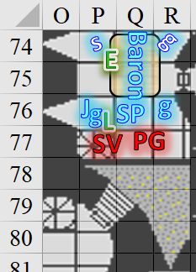

~*~

Solstice picked the lock on the northernmost chest.

|  |  |  |  |  |  |  |  |
| --- | --- | --- | --- | --- | --- | --- | --- |
| **Skill** | **Rank** | **Ability**  **& Mod.** | **Misc.**  **Mods.** | **Total** | **Roll** | **Check** | **Notes** |
| **Open Lock** | 9 | **Dex (+3)** | 2 | 14 | 18 | 32 | Lucky Fingers |

*Success.*

The lock unlatched, and Solstice removed it from the aperture before lifting the chest.

“They’re the Baron’s property,” Saradette said. “I don’t think we should bother them, unless you think there’s something there that shouldn’t be there.”

“I’m just curious as to what they’re coffering,” the musteval shrugged, agreeing with the sultry gnome.

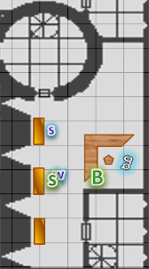

Round 93

“That I do not know,” Barkley replied. “Perhaps if any of them are unlocked they may have something missing, though what, who would know.”

Solstice shrugged, and left the coins and other valuables in the coffer. “These are the riches of Mintar. Who knows where they would have ended up in the hands of the lycanthropes?”

“Let’s keep checking,” Saradette said.

~*~

The guard that had just swung at Father d’Ethic chased after the cleric while the rest of the Baronial faction attacked the two remaining wereserpents.

|  |  |  |  |  |  |  |  |  |  |  |
| --- | --- | --- | --- | --- | --- | --- | --- | --- | --- | --- |
| **Character** | **Attack Type** | **Damage** | **BAB** | **Str Mod+** | **W+** | **Other+** | **Total Score** | **Roll** | **Total** | **Threat** |
| Sgt. Pepper | MW Short Sword | 1d6+3 | 4 | 3 | 1 | 2 | 10 | 4 | 14 | ý |
| Baronial Guard | MW Short Sword | 1d6+3 | 3 | 3 | 1 | 2 | 9 | 5 | 14 | ý |
| Baronial Guard | MW Short Sword | 1d6+3 | 3 | 3 | 1 | 2 | 9 | 20 | 29 | þ |
| Baronial Guard | MW Short Sword | 1d6+3 | 3 | 3 | 1 | 2 | 9 | 12 | 21 | ý |

*Miss, miss, threat, hit. 1d20 = 7 + 9 = 16, not a critical hit.*

*Dmg to Stepmother Virami’in: 4 + 3 = 7. Damage negated.*

*Dmg to Prefect Groshke: 3 + 3 = 6. Damage negated.*

Prefect Groshke attacked the Sergeant’s aide-de-camp.

|  |  |  |  |  |  |  |  |  |  |  |  |
| --- | --- | --- | --- | --- | --- | --- | --- | --- | --- | --- | --- |
| **Character** | **Attack Type** | **Damage** | **BAB** | **Str Mod+** | **W+** | **Other+** | **Total Score** | **Roll** | **Total** | **Threat** | **Notes** |
| Prefect | Venomous Staff | 1d6+Poison | 4 | 1 | 1 | -2 | 4 | 20 | 24 | þ | Fort DC 14, 1d4 Str/1d4 Str |

*Threat. 1d20 = 5 + 4 = 9, not a critical hit.*

*Dmg: 1 + 1 = 2 + Poison.*

|  |  |  |  |  |
| --- | --- | --- | --- | --- |
| **Character** | **Save vs.**  Poison | **Ranks** | **Roll** | **Result** |
| Baronial Guard | Fortitude | 6 | 6 | 12 |

*Fail. Dmg: 1 Str.*

“Welcome back, milord!” Elsabet exclaimed loudly and joyously, to let everyone know the Baron seemed to be snapping out of it.

Elsabet moved around the bed to the open space she could see, tumbling past both of the enemies to try to avoid attacks of opportunity and get next to Prefect Groshke, and shouting “Praise Mayaheine!”

|  |  |  |  |  |  |  |
| --- | --- | --- | --- | --- | --- | --- |
| **Skill** | **Rank** | **Ability & Mod.** | **Misc. Mods.** | **Total** | **Roll** | **Check** |
| **Elsabet, Tumble** | 1 | **Dex (+2)** | 1 | 4 | 6 | 10 |

*Fail. [I assumed that she put at least one foot on the bed in order to avoid the Stepmother’s threat range. You may have assumed this to be impossible or subject to Balance check; but it’s cool.]*

|  |  |  |  |  |  |  |  |  |  |  |
| --- | --- | --- | --- | --- | --- | --- | --- | --- | --- | --- |
| **Character** | **Attack Type** | **Damage** | **BAB** | **Str Mod+** | **W+** | **Other+** | **Total Score** | **Roll** | **Total** | **Notes** |
| Prefect  Groshke | Venomous  Staff | 1d6+1+Poison | 4 | 1 | 1 | -2 | 4 | 1 | 5 | Fort DC 14,  1d4 Str/1d4 Str |

*Miss.*

Elsabet initiated her Foehammer strike and slashed down hard at the foe.

|  |  |  |  |  |  |  |  |  |  |
| --- | --- | --- | --- | --- | --- | --- | --- | --- | --- |
| **Melee Weapon** | **Dmg** | **D+** | **TH+** | **Critical** | **Type** | **Wt.** | **Atk** | **Roll** | **Check** |
| Bastard Sword +1, 1-handed | 1d10+1 | +4 | 4 | 19-20/x2 | Slashing | 6.0 | +13 | 15 | 28 |

*Hit. Dmg: 6 + 1 + 4 + 4 Courage + 10 Foehammer = 25.*

Elsabet grinned at the enemy like she had nothing better to do than slash him to pieces, as she felt her next maneuver being granted.

Stepmother Virami’in struck the guard nearest her.

|  |  |  |  |  |  |  |  |  |  |  |
| --- | --- | --- | --- | --- | --- | --- | --- | --- | --- | --- |
| **Character** | **Attack Type** | **Damage** | **BAB** | **Str Mod+** | **W+** | **Other+** | **Total Score** | **Roll** | **Total** | **Notes** |
| Stepmother Virami’in | Venomous  Morningstar | 1d8+1+Poison | 4 | 1 | 1 | -2 | 6 | 5 | 11 | Fort DC 14,  1d4 Str/1d4 Str |

*Miss.*

Luran’s song boosted his own arms as he stood between Father Jericho and the werecreature before him, weapon steady.

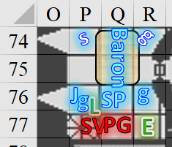

Round 94

The Baronial faction focused on the remaining wereserpents.

|  |  |  |  |  |  |  |  |  |  |  |
| --- | --- | --- | --- | --- | --- | --- | --- | --- | --- | --- |
| **Character** | **Attack Type** | **Damage** | **BAB** | **Str Mod+** | **W+** | **Other+** | **Total Score** | **Roll** | **Total** | **Targeting** |
| Sgt. Pepper | MW Short Sword | 1d6+3 | 4 | 3 | 1 | 2 | 10 | 2 | 12 | Groshke |
| Baronial Guard | MW Short Sword | 1d6+3 | 3 | 3 | 1 | 2 | 9 | 6 | 15 | Groshke |
| Baronial Guard | MW Short Sword | 1d6+3 | 3 | 3 | 1 | 2 | 9 | 8 | 17 | Virami’in |
| Bishop Jericho | Longsword +1 | 1d8+1 | 4 | 1 | 1 | 3 | 9 | 5 | 14 | Virami’in |

*Miss, miss, hit, miss. Dmg: 5 + 3 = 8. Damage negated.*

Prefect Groshke struck the Sergeant.

|  |  |  |  |  |  |  |  |  |  |  |
| --- | --- | --- | --- | --- | --- | --- | --- | --- | --- | --- |
| **Character** | **Attack**  **Type** | **Damage** | **BAB** | **Str Mod+** | **W+** | **Other+** | **Total Score** | **Roll** | **Total** | **Notes** |
| Prefect | Venomous  Staff | 1d6+1+Poison | 4 | 1 | 1 | -2 | 4 | 5 | 9 | Fort DC 14,  1d4 Str/1d4 Str |

*Miss.*

Elsabet realized none of the Baronial guards had silvered weapons, looked over at Sgt. Pepper, and said “Sergeant, use silver!” as she used her left hand to draw her silvered kukri and drop it on the floor at her feet. “Guards, aid Pepper!” She then initiated her crusader’s strike, hoping to punch through the Prefect’s damage reduction, but if not, at least hit and heal the most wounded of her allies nearest her.

|  |  |  |  |  |  |  |  |  |  |
| --- | --- | --- | --- | --- | --- | --- | --- | --- | --- |
| **Melee Weapon** | **Dmg** | **D+** | **TH+** | **Critical** | **Type** | **Wt.** | **Atk** | **Roll** | **Check** |
| Bastard Sword +1, 1-handed | 1d10+1 | +2 | 2 | 19-20/x2 | Slashing | 6.0 | +8 | 16 | 24 |

*Hit. Dmg: 6 + 1 + 2 + 2 Courage = 11. Partial damage negated.*

*Guard 5 healed 2 + 4 Crusader’s Strike = 6 hps.*

Prefect Groshke was pretty badly hurt now.

Stepmother Virami’in swung her morningstar at Jericho.

|  |  |  |  |  |  |  |  |  |  |
| --- | --- | --- | --- | --- | --- | --- | --- | --- | --- |
| **Character** | **Attack Type** | **Damage** | **BAB** | **Str Mod+** | **W+** | **Other+** | **Total Score** | **Roll** | **Total** |
| Prefect | Venomous Morningstar | 1d8+1+Poison | 4 | 1 | 1 | -2 | 6 | 18 | 24  (Fort DC 14  1d4 Str/1d4 Str) |

*Hit. Dmg: 1 + 1 = 2 + Poison.*

|  |  |  |  |  |
| --- | --- | --- | --- | --- |
| **Character** | **Save vs.**  Poison | **Ranks** | **Roll** | **Result** |
| Baronial Guard | Will | 7 | 18 | 25 |

*Success. Effect negated.*

Continuing his attempts to protect Father Jericho, Luran attempted to draw the Stepmother’s eye by attacking her out outright.

|  |  |  |  |  |  |  |  |  |  |
| --- | --- | --- | --- | --- | --- | --- | --- | --- | --- |
| **Melee Weapon** | **Dmg** | **D+** | **TH+** | **Critical** | **Type** | **Wt.** | **Atk** | **Roll** | **Check** |
| Longsword | 1d8 | -1 | 2 | 19-20/x2 | Slashing | 4.0 | +7 | 6 | 13 |

*Miss.*

~*~

Saradette said, “They may have left something important, such as clues as to why they wanted to do this.”

Barkley looked over at Saradette and nodded. “Very well.” He continued to check the desk.

Solstice tried the door to the south, and found it to be open. Pulling down on the latch, he released the mechanism that caused the door to creak ajar. “No one there... just stairs,” he announced.

~*~

Round 95

The Baronial faction did its best to finish off the remaining wereserpents. One guard moved past Luran so they could both help Sgt. Pepper to hit Prefect Groshke with the kukri.

|  |  |  |  |  |  |  |  |  |  |
| --- | --- | --- | --- | --- | --- | --- | --- | --- | --- |
| **Character** | **Attack Type** | **Damage** | **BAB** | **Str Mod+** | **W+** | **Other+** | **Total Score** | **Roll** | **Total** |
| Baronial Guard | MW Short Sword | 1d6+3 | 3 | 3 | 1 | 2 | 9 | 19 | 28 |
| Baronial Guard | MW Short Sword | 1d6+3 | 3 | 3 | 1 | 2 | 9 | 3 | 12 |

*Aid another: Success, success. Sgt. Pepper gains +2 to attack against Groshke.*

Sgt. Pepper—being a woman—picked up the kukri and swung at Groshke.

|  |  |  |  |  |  |  |  |  |  |
| --- | --- | --- | --- | --- | --- | --- | --- | --- | --- |
| **Character** | **Attack Type** | **Damage** | **BAB** | **Str Mod+** | **W+** | **Other+** | **Total Score** | **Roll** | **Total** |
| Sgt. Pepper | Silver Kukri | 1d4+3 | 4 | 3 | 1 | 2 + 2 + 2 | 14 | 12 | 26 |

*Hit. Dmg: 3 + 3 = 6.*

Elsabet said calmly to the wereserpent in front of her, “You know you've lost, right?,” as she just swung her blade casually in time with Luran's most excellent tune.

|  |  |  |  |  |  |  |  |  |  |
| --- | --- | --- | --- | --- | --- | --- | --- | --- | --- |
| **Melee Weapon** | **Dmg** | **D+** | **TH+** | **Critical** | **Type** | **Wt.** | **Atk** | **Roll** | **Check** |
| Bastard Sword +1, 1-handed | 1d10+1 | +2 | 4 | 19-20/x2 | Slashing | 6.0 | +10 | 8 | 18 |

*Hit. Dmg: 3 + 1 + 2 + 2 Courage = 8. Damage negated.*

As she felt her maneuvers fade and refresh in her mind, she glanced over at the Baron to see if he was still okay.

|  |
| --- |
| *Current Maneuvers* |
| Shield Block |
| Crusader’s Strike |
| Battle Leader’s Charge |
| Stone Vise |
| Foehammer |

The Baron was blinking a lot, and looked like he was talking to himself in a surprised way. He was slowly coming to his senses.

Prefect Groshke said, “Fuck this!” and fled. The morale of the wereserpents was piss poor, and as he made his way downstairs, Stepmother Virami’in followed, cursing in Infernal.

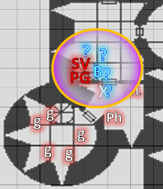

The two werespepents stopped at the bottom of the stairs as Bratislava’s forces pointed their swords at them, surrounding them on the lower floor while the two guards above blocked the top of the stairwell.

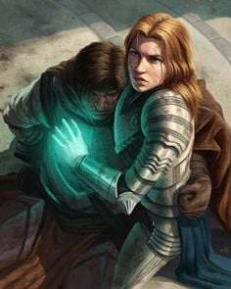

“Stay your blade, Prefect,” Bratislava commanded the frontmost fugitive.

At the top of the stairs, Sgt. Pepper’s two guards started coming down the staircase, also with short swords pointed forward.

As Luran waited for Elsabet to follow the fleeing foes, he purposefully projected his song down the stairs to impact any allies within hearing range on the floor below.

*Bratislava and company gained +2 Courage to attacks and saves.*

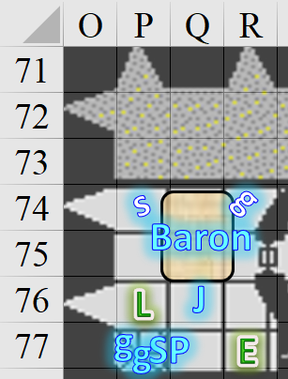

~*~

Having found only stationery inside the drawers, Barkley urged Saradette, “We must continue to check the castle for any more of the foul beasts.”

Solstice agreed, pushing the door wide open, seeing a spiral staircase that went only up. “Let’s see what’s up here.”

Saradette did nothing for the moment.

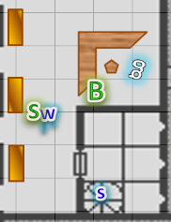

Round 96

Barkley’s intent was to continue their search, and hadn’t seen the door that Solstice had just opened. “Oh!” he then realized its existence as he whispered to Elsabet and Luran: “Have you found the Baron?”

Solstice took the staircase up.

Saradette followed Solstice up the stairs, her launcher at the ready.

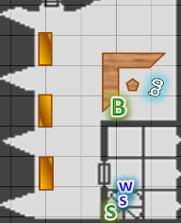

~*~

The Baronial faction had corralled the two wereserpents, who stopped in their tracks, and put down their weapons. Unlike the two previous wereserpents that they’d apprehended, these two didn’t start saying some cryptic things and then dying on the spot... or at least not yet. Perhaps they nursed a glimmer of hope in their hearts, or perhaps whatever had killed the others was no longer in a position to do so.

Prefect Groshke’s wooden staff dropped to the ground alongside Stepmother Virami’in’s morningstar. The soldiers left the venomous weapons where they were as they restrained the wereserpents with manacles and gags.

Bratislava’s voice downstairs could be heard saying, “Make sure they don’t turn to snakes.”

“Bishop Jericho, tend to the Baron,” Elsabet requested, heading for the stairs behind the wereserpents with Luran on her heels. As she was passing through the guards, she smiled at Sgt. Pepper and said, “keep the kukri.”

Sgt. Pepper dispatched one of her guards to go after Father d’Ethic. The guard took the eastern tower down, cautiously.

“Have you found the Baron?” Barkley’s voice resounded in Luran’s and Elsabet’s minds.

Luran deftly shifted his song to a sudden but satisfying end before whispering back to Barkley. “We did. And Els saved him!”

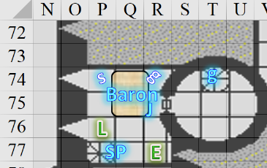

Round 97

Over 10 minutes had passed since the heroes had entered the keep and happened upon Prefect Almodóvar, most of whose lackeys were now presumably all in the hands of the law or their maker.

“Any others?” Bratislava asked.

Sgt. Pepper reported, “Father d’Ethic is one of them as well. He fled down the central tower. I sent Becvar to root him out, but he’s probably slithered away by now.”

Bratislava nodded, “We’ll catch him. Pristina, come with me.” The colonel-priestess led one of the folks she’d liberated from the jail town the spiral staircase that they’d taken to get here as the others remained with the wereserpents, finishing up the binding and gagging.

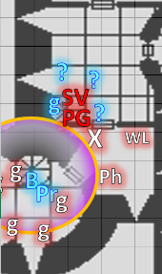

The Baron looked up at Elsabet, Jericho, and Luran, “Who are... oh... Bishop Jericho... what’s happened?”

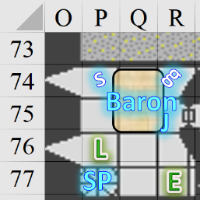

As she headed down the stairs, Elsabet whispered, “Mayaheine saved him, I’m just Her instrument.” Luran followed.

~*~

Solstice led the way up.

Having already heard that they’d found the Baron, and that Elsabet saved him, Barkley saw Solstice and Saradette head out of the room, and followed them.

Saradette pointed her launcher far above Solstice’s head should a Medium-sized foe present itself.

They reached the top of the staircase, and entered a small room with a pitched roof. Solstice and Saradette immediately noticed the secret exit, which had been pushed partly shut, but enough to reveal the crack in the masonry.

Aside from the exit, there were about a dozen wooden crates against the northern wall. There were four rows, each with three crates stacked vertically, in total, and all the crates had hingeless lids that could easily be removed.

Round 98

Elsabet was a bit confused and came back up the stairs. Seeing Bratislava overseeing the prisoners, she nodded to the Colonel-Priestess. “A compulsion has been lifted from the Baron, with Mayaheine’s help. Bishop Jericho and Sgt. Pepper, attend him.”

Sgt. Pepper squinted at Elsabet, who was now delegating directives at the ranked officers. She then turned back around and saw to the restraint of the captives at the foot of the stairs as Jericho kept his attention on the Baron. Bratislava had already headed down to the ground floor, so she didn’t hear the favored soul’s last statement.

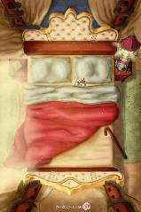

The Baron started to move from his position, revealing a recent urine stain underneath him that had only begun to dry at the edges. “I... owe you all a debt of gratitude,” he said with a clearer tone and a more punctuated cadence, returning to his normal self, albeit fatigued and shivering. “The Speaker in Dreams...” he then said, his eyelids fluttering and his head shaking in seeming disbelief. “He stole days of... lucidity.”

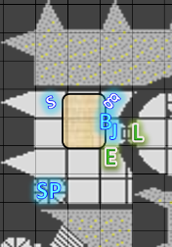

~*~

Saradette went to check the secret door to see what lay beyond. She thought for a moment that she would need help from Barkley’s strong biceps, but was able to pull the doorway inward and reveal a sunlit terrace atop the keep. She and Widget could see the keep’s every tower, along with the pitched rooftops that capped the rest of the structure.

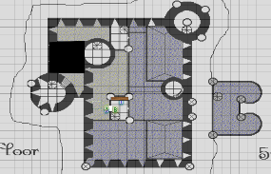

Round 99

Jericho went to comfort the Baron, holding him by the shoulders as the nobleman tried to stand. “Baron, who is this Speaker of Dreams? The wereserpents and traitorous guards spoke of this figure as well.”

The Baron looked up and into Jericho’s eyes before answering, “Bishop of Tyr...” he smiled. “So good to see you.” Then he absorbed the Bishop’s question, and added, “The Speaker... it’s a mind flayer.”

Elsabet and Luran were now on their way down the spiral staircase that Father d’Ethic had taken, and heard a scuffle just below.



Round 100

Elsabet whispered to Luran as they continued down the stairs, “I may try a charm.” She still had her fey *charm monster* ability to call on, and though she loathed the idea, could probably also use her disguise self, but she was pretty low on magic. She cleared another level and could hear the scuffle much more clearly now.

Luran too, and he heard the wereserpent’s hissing in addition to the clanking of blades against armor. Luran also offered, “I could make one or both of us invisible. Either we both sneek in or I act as distraction for you as you get them from surprise...”

“That could be fun” Elsabet whispered back. “Do you, anyways.”

“Die, bitch!” Father d’Ethic’s serpentine voice could be heard downstairs as the two heroes continued downstairs.

Round 101

Luran then gestured to Elsabet to stop, and cast *invisibility [expired on Round 801]* on her.

*Elsabet gained invisibility.*

“Remember, I can see you, but if you can’t see me I can put you hand on my shoulder,” Elsabet whispered as the bard cast on himself.

Then all went dark around them.

Round 102

Luran, Elsabet, Saradette, Barkley, and Solstice stood in a rough circle, quick to realize by now that they’d been pushed into the same (or a similar) dream realm wherein they’d battled foes for the last few nights. This time, however, they were fully lucid and cognizant of their situation.

Their situation, as it were, entailed a new threat: one that they could not yet see, but whose whispers seemed to trickle down with a cool mist, causing them to shiver in their armor for a moment as their eyes adjusted to the darkness.

Time and space seemed to warp—as they had when the heroes had ventured into the Reality Wrinkle—and they now heard footsteps approaching from all directions.

They already had their weapons drawn, and their spells were nearly depleted, but the heroes’ resolve did not waver. They drew upon their faith in their gods to see them through whatever trial was about to befall them.

Solstice now recognized one of the shapes approaching: an illithid.

|  |  |  |  |  |
| --- | --- | --- | --- | --- |
| **Character** | **Save vs.**  *Aura of Menace* | **Ranks** | **Roll** | **Result** |
| Ghaerleth Axom  (and minions) | Will | 9 | 13 | 22 |

*Success. Effect negated. Father d’Ethic is already suffering from previous penalties.*

Elsabet felt a surge of divine inspiration.

|  |
| --- |
| *Current Maneuvers* |
| Stone Vise |
| Battle Leader’s Charge |
| Foehammer |
| Shield Block |
| Crusader’s Strike |

As the other figures came into view, Barkley recognized Bratislava, Pristina, Jericho, and Sgt. Pepper, and also beheld the wereserpent known as Father d’Ethic, whom Barkley had never seen before and did not recognize. Seeing auras of evil around all of the flayer’s minions, Barkley tilted his head and frowned as he witnessed his allies raising their weapons in their approach. The most intense aura of evil was emanating from the illithid.

As his eyes focused on the area around him and he got his bearings, the archon thought he might be going crazy; he’d just seen something quite different a moment ago, and blinked a few times to ensure that the auras of evil were real. As far as he could tell, they were.

Luran let loose with his vocals and holding his longsword aloft for dramatic effect, once again bolstered his companions with his supernatural song.

*PCs gained +2 attack, damage, and fear/enchantment saves.*

Elsabet, seeing herself invisible—thanks to her *see the unseen* invocation—whispered, “I’m here too, just *invisible*.” With a swift action, she settled into her leading the charge stance and looked for a good opportunity to use her battle leader’s charge maneuver. Her eyes on that nearest shadowy form, she initiated her battle leader’s charge strike and charged! Swinging her invisible blade into at the foe, she shimmered into sight as the invisibility faded.

|  |  |  |  |  |  |  |  |  |  |
| --- | --- | --- | --- | --- | --- | --- | --- | --- | --- |
| **Melee Weapon** | **Dmg** | **D+** | **TH+** | **Critical** | **Type** | **Wt.** | **Atk** | **Roll** | **Check** |
| Bastard Sword +1, 1-handed | 1d10+1 | +2 | 4 + 2 Invisibility  +2 charge  + 2 Courage | 19-20/x2 | Slashing | 6.0 | +16 | 14 | 30 |

*Hit. Dmg: 10 + 1 + 2 + 2 Courage + 4 Leading the Charge + 10 Battle Leader’s Charge = 29.*

Upon being his, Jericho lost his humanoid appearance, and his true form emerged, namely, that of a white-eyed grimlock that dropped its battleaxe as soon as Elsabet was done cleaving the monstrous foe with a single slice.

Ghaerleth Axom—illithid sorcerer and mastermind—flew up about 20’ and projected a psionic cone beneath him, capturing all of the heroes within it.

|  |  |  |  |  |  |  |
| --- | --- | --- | --- | --- | --- | --- |
| **Save vs.**  Mind Blast | **Rank** | **Ability**  **& Mod.** | **Misc.**  **Mods.** | **Total** | **Roll** | **Check** |
| **Barkley, Will** | 4 | Wis (+1) | 1 | 6 | 15 | 21 |
| **Elsabet, Will** | 7 | Wis (-1) | 4 | 10 | 13 | 23 |
| **Luran, Will** | 7 | Wis (-1) | 2 | 8 | 10 | 18 |
| **Saradette, Will** | 3 | Wis (+0) | 0 | 3 | 13 | 16 |
| **Solstice, Will** | 7 | Wis (+2) | 0 | 9 | 3 | 12 |

*Saradette and Solstice were stunned until Round 111.*

The other figures moved in closer, raising weapons and no arguments as they did so.

It was then that Solstice and Luran noted that the illithid above them was wounded, and appeared to be about as fatigued and depleted as they were by now. Solstice could also see Elsabet’s invisible form, but because he was stunned, he could do nothing consequential at the moment.

Saradette also did her best to resist the mental blast, but couldn’t do much more than suffer.

Barkley moved south 5’ and watched as his former allies approached. Like the other dreams, he knew it wasn’t really them, but seeing their faces was still disturbing.

Seeing Solstice seemingly out of action, he took a couple of steps southward to protect his companion.

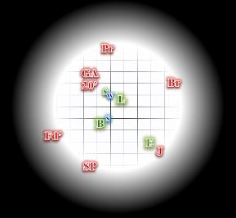

Round 103

|  |  |  |  |  |  |
| --- | --- | --- | --- | --- | --- |
| **Character** | **Group** | **Initiative** | **Roll** | **Modified Roll** | **Move** |
| Saradette | 1 | 3 | 20 | 23 | 20’ |
| Luran | 1 | 1 | 18 | 19 | 30’ |
| Elsabet | 1 | 4 | 10 | 14 | 30’ |
| Axom’s Minions | 3 | 1 | 10 | 11 | 30’ |
| Ghaerleth Axom | 3 | 4 | 5 | 9 | 30’ |
| Barkley | 1 | 2 | 6 | 8 | 40’ |
| Solstice | 1 | 1 | 6 | 7 | 30’/10’ |

Saradette and Widget did nothing.

Luran’s expression went dark and stern, his tune following suit, as he stepped past Saradette, attempting to separate her from the faux Pristina, closing in. To the best of his ability, the bard also kept the floating aberration above him in mind, in relation to their dreamy conflict. His grip tightened on the hilt of his sword as he steeled himself for defense.

*Luran is now occupying the same square as Saradette.*

Having felt foehammer just granted to her moments after the false Jericho turned into a dying grimlock, and trusting Barkley to cover that flank, Elsabet turned and hustled to face the foe to her left, placing herself between Luran and the false Bratislava. With a quick prayer to Mayaheine, and moving in time to Luran’s clear voice in the unclear realm, she initiated her foehammer and swung hard at the foe, perhaps another grimlock, perhaps something even stranger.

|  |  |  |  |  |  |  |  |  |  |
| --- | --- | --- | --- | --- | --- | --- | --- | --- | --- |
| **Melee Weapon** | **Dmg** | **D+** | **TH+** | **Critical** | **Type** | **Wt.** | **Atk** | **Roll** | **Check** |
| Bastard Sword +1, 1-handed | 1d10+1 | +2 + 2d6  Crusader’s strike | 4 + 2  Courage | 19-20/x2 | Slashing | 6.0 | +12 | 2 | 14 |

*Miss.*

As she felt shield block granted to her, she wondered—would her stone vise even work here? Did she feel like there was any connection to earth in this realm?

Axom’s Minions rushed in and attacked whomever they could.

|  |  |  |  |  |  |  |  |  |  |  |
| --- | --- | --- | --- | --- | --- | --- | --- | --- | --- | --- |
| **Character** | **Attack Type** | **Damage** | **BAB** | **Str Mod+** | **Dex Mod+** | **W+** | **Other+** | **Total Score** | **Roll** | **Total** |
| Father d’Ethic | Venomous Staff | 1d6+1+Poison | 4 | 1 | 3 | 1 | -2 + 2 charge | 6 | 13 | 19 |
| Troglodyte | Club | 1d6 | 1 | 0 | -1 | 0 | + 2 charge | 3 | 18 | 21 |
| Krinth | Club | 1d6 | 1 | 0 | -1 | 0 | + 2 charge | 3 | 8 | 11 |
| Wererat | Bite | 1d4+1+Dis | 3 | 1 | 3 | 0 | + 2 charge | 8 | 2 | 10 |

*Miss, miss (Luran successfully blocked attack vs. Saradette), miss, miss.*

Ghaerleth Axom mind blasted some of the heroes again, unable to get Elsabet in the blast, then levitated another 20’.

|  |  |  |  |  |  |  |
| --- | --- | --- | --- | --- | --- | --- |
| **Save vs.**  Mind Blast | **Rank** | **Ability**  **& Mod.** | **Misc.**  **Mods.** | **Total** | **Roll** | **Check** |
| **Barkley, Will** | 4 | Wis (+1) | 1 | 6 | 14 | 20 |
| **Luran, Will** | 7 | Wis (-1) | 2 | 8 | 14 | 22 |
| **Saradette, Will** | 3 | Wis (+0) | 0 | 3 | 19 | 22 |
| **Solstice, Will** | 7 | Wis (+2) | 0 | 9 | 1 | 10 |

*Solstice remained stunned.*

Barkley remained on the defensive.

Solstice did nothing.

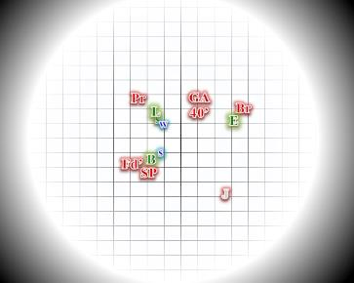

Round 104

Saradette and Widget did nothing.

Luran remained vigilant as he hoped his smaller companion recovered from the mind flayer’s psionic attack.

Deciding not to test whether whatever she was standing counted as earth, Elsabet grinned at the false Bratislava and said “later, faker,” turned, and charged the false Sgt. Pepper threatening Barkley.

|  |  |  |  |  |  |  |  |  |
| --- | --- | --- | --- | --- | --- | --- | --- | --- |
| **Character** | **Attack Type** | **Damage** | **BAB** | **Str Mod+** | **Dex Mod+** | **Total Score** | **Roll** | **Total** |
| Fake Bratislava | Club | 1d6 | 1 | 0 | -1 | 1 | 13 | 14 |

*Miss.*

With a mighty swing at the end of her charge, Elsabet slashed at the creature that looked like Sgt. Pepper, hoping to land a solid blow.

|  |  |  |  |  |  |  |  |  |  |
| --- | --- | --- | --- | --- | --- | --- | --- | --- | --- |
| **Melee Weapon** | **Dmg** | **D+** | **TH+** | **Critical** | **Type** | **Wt.** | **Atk** | **Roll** | **Check** |
| Bastard Sword +1, 1-handed | 1d10+1 | +2 | 4 + 2 charge | 19-20/x2 | Slashing | 6.0 | +12 | 15 | 27 |

*Hit. Dmg: 9 + 1 + 2 + 2 + 2 Charge + 2 Courage + 4 Leading the Charge = 22.*

Sgt. Pepper regained its troglodyte form, and fell to the ground, seconds away from true death.

As she felt her crusader’s strike granted, Elsabet had her shield block counter ready to protect Barkley from the first attack against him.

Axom’s Minions did their best to end the heroes’ lives. Bratislava’s copy charge-attacked Barkley.

|  |  |  |  |  |  |  |  |  |  |  |
| --- | --- | --- | --- | --- | --- | --- | --- | --- | --- | --- |
| **Character** | **Attack Type** | **Damage** | **BAB** | **Str Mod+** | **Dex Mod+** | **W+** | **Other+** | **Total Score** | **Roll** | **Total** |
| Father d’Ethic | Venomous Staff | 1d6+1+Poison | 4 | 1 | 3 | 1 | -2 | 4 | 15 | 19 |
| Fake Bratislava | Club | 1d6 | 1 | 0 | -1 | 0 | +2 charge | 3 | 6 | 9 |
| Fake Pristina | Bite | 1d4+1+Dis | 3 | 1 | 3 | 0 | 0 | 6 | 3 | 9 |

*Miss3.*

Ghaerleth Axom stopped psionically blasting the heroes long enough to try to read the archon’s thoughts.

Barkley could feel the mind flayer’s psionic tendrils creeping into his Celestial consciousness, and snarled, “Nice try foul beast!” before he started swinging.

|  |  |  |  |  |  |  |
| --- | --- | --- | --- | --- | --- | --- |
| **Save vs.**  *detect thoughts* | **Rank** | **Ability & Mod.** | **Misc. Mods.** | **Total** | **Roll** | **Check** |
| **Barkley, Will** | 4 | Wis (+1) | 1 | 6 | 15 | 21 |

*Success. Effect negated.*

The illithid seethed with inner rage as his attempts to bring down his next victims were thwarted, and his minions fell before their foes one by one.

Barkley stared at his two opponents and made an attack against Father d’Ethic on his right side, still trying to keep himself between Solstice and the bad guys.

|  |  |  |  |  |  |  |  |  |  |
| --- | --- | --- | --- | --- | --- | --- | --- | --- | --- |
| **Melee Weapon** | **Dmg** | **D+** | **TH+** | **Critical** | **Type** | **Wt.** | **Atk** | **Roll** | **Check** |
| Longsword +1 | 1d8 | 3 | 2 | 19-20/x2 | Slashing | 4.0 | +9 | ***19*** | 28 |
| Hand Axe, Silver | 1d6 | 1 | 2 | x3 | Slashing | 3.0 | +7 | 17 | 24 |

*Threat, hit. 1d20 = 7 + 9 = 16, not a critical hit. Dmg: (8 + 3 + 2 Courage) + (5 + 1 + 2 Courage) = 13 + 8 = 21. Partial damage negated.*

Barkley cast *continual flame* in hopes of blinding Father d’Ethic.

*Researching this outcome, though if I had an NPC do this to a PC, I imagine there would be some protest over misuse of the spell.*

Solstice could still do nothing but double over in pain, but he and the others started to notice that as light conquered darkness, a lush garden came into existence all around them, and in the midst of it, a stone platform with some etchings on it. The heroes were whisked around the space in a disconcerting but not disorienting way, and within seconds, they were all positioned in a new arrangement. Elsabet’s boots were now drenched as she was knee deep in shallow waters, and to their northeast, there appeared to be a fiery glow that was still not in focus.

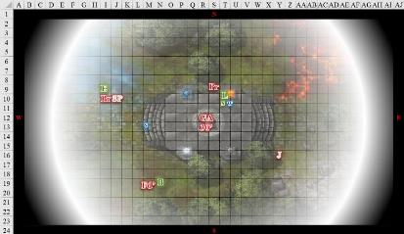

Round 105

Saradette and Widget did nothing.

Luran spit lyric fire for the first few seconds in the new change of setting. His rising and sweeping words verbally gutted the floating, tentacled foe above and its masqued minions, below, all around this Fist of Light, these Agents of BLESS. As his rhyme hit its crest, he took a solid swing of his own at the foe in front of him.

|  |  |  |  |  |  |  |  |  |  |
| --- | --- | --- | --- | --- | --- | --- | --- | --- | --- |
| **Melee Weapon** | **Dmg** | **D+** | **TH+** | **Critical** | **Type** | **Wt.** | **Atk** | **Roll** | **Check** |
| Longsword | 1d8 | -1 | 2 + 1 altitude | 19-20/x2 | Slashing | 4.0 | +7 | 14 | 21 |

*Hit. Dmg: 3 - 1 + 2 Courage = 4. Damage negated.*

With her surroundings changed to a somewhat more natural, albeit damp, setting, Elsabet took a moment to get firmer footing in the muck, twisting and pushing her feet down to reach firmer earth or stone. Then she initiated her **stone vise** strike, feeling the power of the earth rise through her, and slashed hard down at the false Bratislava, grunting as she tried to anchor her foe in its place as well.

|  |  |  |  |  |  |  |  |  |  |
| --- | --- | --- | --- | --- | --- | --- | --- | --- | --- |
| **Melee Weapon** | **Dmg** | **D+** | **TH+** | **Critical** | **Type** | **Wt.** | **Atk** | **Roll** | **Check** |
| Bastard Sword +1, 1-handed | 1d10+1 | +2 | 4 | 19-20/x2 | Slashing | 6.0 | +10 | 9 | 19 |

*Hit. Dmg: 6 + 1 + 2 + 2 + 2 + 6 Stone Vise = 19.*

A krinth stopped looking like Bratislava, and dropped to the ground, dead.

She felt her remaining maneuvers drain away, to be replaced by two newly granted ones.

|  |
| --- |
| *Current Maneuvers* |
| Battle Leader’s Charge |
| Foehammer |
| Shield Block |
| Stone Vise |
| Crusader’s Strike |

Axom’s minions were dropping like flies.

|  |  |  |  |  |  |  |  |  |  |  |  |  |
| --- | --- | --- | --- | --- | --- | --- | --- | --- | --- | --- | --- | --- |
| **Character** | **Attack Type** | **Damage** | **BAB** | **Str Mod+** | **Dex Mod+** | **W+** | **Other+** | **Total Score** | **Roll** | **Total** | **Threat** | **Notes** |
| Father d’Ethic | Venomous Staff | 1d6+1+Poison | 4 | 1 | 3 | 1 | -2 | 4 | 19 | 23 | ý | Fort DC 14, 1d4 Str/1d4 Str |
| Fake Pristina | Bite | 1d4+1+Dis | 3 | 1 | 3 | 0 | 0 | 6 | 20 | 26 | þ |  |

*Hit, threat. 1d20 = 8 + 6 = 14, not a critical hit.*

*Dmg to Barkley: 4 + 1 = 5 + Poison.*

|  |  |  |  |  |  |  |
| --- | --- | --- | --- | --- | --- | --- |
| **Save vs.**  Poison | **Rank** | **Ability**  **& Mod.** | **Misc. Mods.** | **Total** | **Roll** | **Check** |
| **Barkley, Fortitude** | 4 | Con (+3) | 1 | 8 | 19 | 27 |

*Success. Effect negated.*

*Dmg to Luran: 2 + 1 = 3 + Disease [33/36].*

|  |  |  |  |  |  |  |
| --- | --- | --- | --- | --- | --- | --- |
| **Save vs.**  Disease | **Rank** | **Ability**  **& Mod.** | **Misc. Mods.** | **Total** | **Roll** | **Check** |
| **Luran, Fortitude** | **2** | **Con (+1)** | 0 | 3 | 14 | 17 |

*Success. Effect negated.*

Ghaerleth Axom began to get a better picture of the heroes’ virtues and motives.

The new surroundings distracted Barkley for only a moment. However, when he could see and smell the trees and water, he smiled slightly, showing his long canines. Barkley was not fond of being hit, and could feel his body shrug off the poison. “Scum, poison is a weapon of evil and weaklings!” he growled as he swung with his long sword and his axe.

|  |  |  |  |  |  |  |  |  |  |
| --- | --- | --- | --- | --- | --- | --- | --- | --- | --- |
| **Melee Weapon** | **Dmg** | **D+** | **TH+** | **Critical** | **Type** | **Wt.** | **Atk** | **Roll** | **Check** |
| Longsword +1 | 1d8 | 3 | 2 | 19-20/x2 | Slashing | 4.0 | +9 | 14 | 23 |
| Hand Axe, Silver | 1d6 | 1 | 2 | x3 | Slashing | 3.0 | +7 | 7 | 14 |

*Hit, miss. Dmg: 1 + 3 + 2 = 6. Damage negated.*

Solstice did nothing.

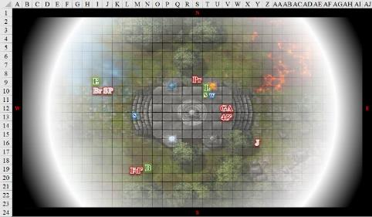

Round 106

Saradette and Widget waited out their pain.

Though he could see his weapon would likely never get through his foe’s supernatural resistances, Luran rose his voice even stronger and kept swinging, keeping the enemy occupied until one of his stronger allies could assist in taking them down.

|  |  |  |  |  |  |  |  |  |  |
| --- | --- | --- | --- | --- | --- | --- | --- | --- | --- |
| **Melee Weapon** | **Dmg** | **D+** | **TH+** | **Critical** | **Type** | **Wt.** | **Atk** | **Roll** | **Check** |
| Longsword | 1d8 | -1 | 2 + 1 | 19-20/x2 | Slashing | 4.0 | +7 | 17 | 24 |

*Hit. Dmg: 5 – 1 + 2 Courage = 6. Damage negated.*

Elsabet thought to herself, ‘three down, three to go,’ as she slogged slowly towards the strange rock platform. The mind flayer was too far away, but perhaps she could give Barkley a helping hand from a distance.

After getting about 15’ closer to the platform, and a bit closer to Barkley, she fired a blast of eldritch energy towards the false Father d’Ethic, careful not to accidentally hit Barkley.

|  |  |  |  |  |  |  |  |  |  |
| --- | --- | --- | --- | --- | --- | --- | --- | --- | --- |
| **Ranged Weapon** | **Dmg.** | **D+** | **TH+** | **Critical** | **Rng.** | **Wt.** | **Atk** | **Roll** | **Check** |
| Eldritch Blast | **1d6** | 0 | 2 – 4 | x2 | 60’ max. | - | +4 | 12 | 16 |

*Hit. Dmg: 4 + 2 = 6 magic.*

The wereserpent was still not dead. As she felt her next maneuver granted, Elsabet grimaced. ‘I don’t like bogs much,’ she thought, not for the first time.

Axom’s minions did their best to please their master.

|  |  |  |  |  |  |  |  |  |  |  |  |
| --- | --- | --- | --- | --- | --- | --- | --- | --- | --- | --- | --- |
| **Character** | **Attack Type** | **Damage** | **BAB** | **Str Mod+** | **Dex Mod+** | **W+** | **Other+** | **Total Score** | **Roll** | **Total** | **Notes** |
| Father d’Ethic | Venomous Staff | 1d6+1+Poison | 4 | 1 | 3 | 1 | -2 | 4 | 7 | 11 | Fort DC 14, 1d4 Str/1d4 Str |
| Fake Pristina | Bite | 1d4+1+Dis | 3 | 1 | 3 | 0 | 0 | 6 | 5 | 11 |  |

*Miss, miss.*

Ghaerleth Axom descended upon Barkley, but did not yet reach him.

Barkley was frustrated that his attack appeared to do nothing. He could not see or hear the incoming illithid, and thus he focused on Father d’Ethic, attacking again with his longsword +1 and silvered hand axe.

|  |  |  |  |  |  |  |  |  |  |
| --- | --- | --- | --- | --- | --- | --- | --- | --- | --- |
| **Melee Weapon** | **Dmg** | **D+** | **TH+** | **Critical** | **Type** | **Wt.** | **Atk** | **Roll** | **Check** |
| Longsword +1 | 1d8 | 3 | 2 | 19-20/x2 | Slashing | 4.0 | +9 | 4 | 13 |
| Hand Axe, Silver | 1d6 | 1 | 2 | x3 | Slashing | 3.0 | +9 | 14 | 23 |

*Miss, hit. Dmg: 3 + 1 + 2 = 6.*

Father d’Ethic was knocking at death’s door, but remained defiant and hostile.

Solstice did nothing.

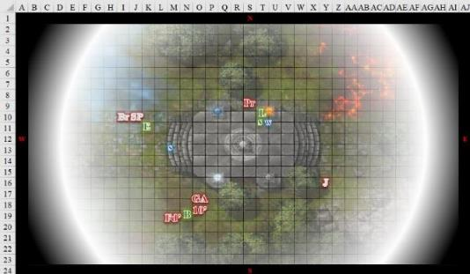

Round 107

Saradette and Widget waited out the stun as the battle came to a resolute state.

Luran remained fully on the defensive.

Elsabet slogged 15’ east, up to the top steps, then fired a blast at Pristina.

|  |  |  |  |  |  |  |  |  |  |
| --- | --- | --- | --- | --- | --- | --- | --- | --- | --- |
| **Ranged Weapon** | **Dmg.** | **D+** | **TH+** | **Critical** | **Rng.** | **Wt.** | **Atk** | **Roll** | **Check** |
| Eldritch Blast | **1d6** | 0 | 0 | x2 | 60’ max. | - | +6 | 3 | 9 |

*Miss.*

Father d’Ethic tried to take Barkley down while Pristina took a 5’ step and tried to cut down Saradette.

|  |  |  |  |  |  |  |  |  |  |  |  |
| --- | --- | --- | --- | --- | --- | --- | --- | --- | --- | --- | --- |
| **Character** | **Attack Type** | **Damage** | **BAB** | **Str Mod+** | **Dex Mod+** | **W+** | **Other+** | **Total Score** | **Roll** | **Total** | **Notes** |
| Father d’Ethic | Venomous Staff | 1d6+1+Poison | 4 | 1 | 3 | 1 | -2 | 4 | 12 | 16 | Fort DC 14, 1d4 Str/1d4 Str |
| Fake Pristina | Bite | 1d4+1+Dis | 3 | 1 | 3 | 0 | 0 | 6 | 10 | 16 |  |

*Miss, hit. Dmg to Saradette: 3 + 1 = 4 + Disease [44/48].*

|  |  |  |  |  |  |  |
| --- | --- | --- | --- | --- | --- | --- |
| **Save vs.**  Disease | **Rank** | **Ability & Mod.** | **Misc. Mods.** | **Total** | **Roll** | **Check** |
| **Saradette, Fortitude** | **1** | **Con (+1)** | 0 | 2 | 3 | 5 |

*Fail. 2 Strength + 3 Constitution. Manifests in 3 days.*

Ghaerleth Axom wasn’t about to get too close to the stalwart archon. He remained aloft, getting a better idea of the enemies’ proclivities.

Barkley still unable to sense that the illithid was above and behind him, continued to focus on Father d’Ethic, wanting to finish off the imposter.

|  |  |  |  |  |  |  |  |  |  |
| --- | --- | --- | --- | --- | --- | --- | --- | --- | --- |
| **Melee Weapon** | **Dmg** | **D+** | **TH+** | **Critical** | **Type** | **Wt.** | **Atk** | **Roll** | **Check** |
| Longsword +1 | 1d8 | 3 | 2 | 19-20/x2 | Slashing | 4.0 | +9 | ***19*** | 28 |
| Hand Axe, Silver | 1d6 | 1 | 2 | x3 | Slashing | 3.0 | +9 | 9 | 18 |

*Threat, hit. 1d20 = 7 + 9 = 16, not a critical hit.*

*Dmg: (6 + 3 + 2) + (4 + 1 + 2) = 11 + 9 = 20. Partial damage negated.*

Father d’Ethic died and slowly regained his own pre-lycanthropic guise.

Solstice tried to transcend being stunned, but could not.

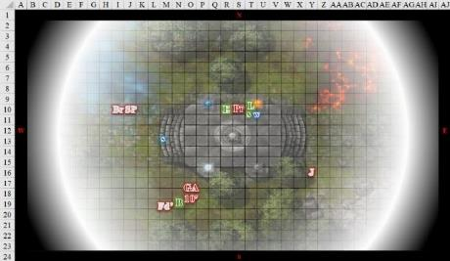

Round 108

Saradette and Widget looked upon their attacker with contempt.

Luran continued to sing defensively.

Seeing the illithid hovering near the archon, Elsabet yelled out, “Barkley! Behind and above you!” as she got up on the platform and moved over to help Luran against the false Pristina.

Getting next to the foe, she initiated her foehammer strike and slashed hard at the creature that menaced the bard, whatever it might be.

|  |  |  |  |  |  |  |  |  |  |
| --- | --- | --- | --- | --- | --- | --- | --- | --- | --- |
| **Melee Weapon** | **Dmg** | **D+** | **TH+** | **Critical** | **Type** | **Wt.** | **Atk** | **Roll** | **Check** |
| Bastard Sword +1, 1-handed | 1d10+1 | +2 | 4 | 19-20/x2 | Slashing | 6.0 | +10 | 11 | 21 |

*Hit. Dmg: 6 + 1 + 2 + 2 = 11.*

Pristina regained the form of a wererat, and slowly died.

“You hurt?” Elsabet asked Luran, as she felt her crusader’s strike being granted.

Luran lifted his free hand, indicated “only a little” and pointed at the still unresponsive Saradette who had just been wounded by their foes.

Ghaerleth Axom had seen enough, and began to levitate, looking upward.

With his current opponent dispatched, Barkley heard Elsabet yelling. Turning and looking up, weapons ready to come up in defense, he saw the illithid. As the foe rose, Barkley dropped his weapons and drew his bow and fired off an arrow (or two if he can as part of a full round action) at the retreating minion of evil.

|  |  |  |  |  |  |  |  |  |  |
| --- | --- | --- | --- | --- | --- | --- | --- | --- | --- |
| **Ranged Weapon** | **Dmg** | **D+** | **TH+** | **Critical** | **Rng.** | **Wt.** | **Atk** | **Roll** | **Check** |
| Composite +2 Longbow +1 | 1d8 | 3 | 1 – 2 altitude | x3 | 110’ | 3.0 | +6 | 2 | 8 |

*Miss.*

Solstice stayed put.

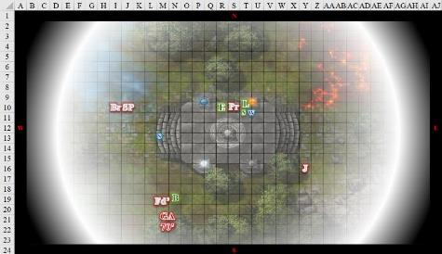

Round 109

Saradette and Widget were glad that the wererat wasn’t attacking them anymore.

Luran ended his song, reached into his haversack for his healing wand and tapped Saradette with its curative tip.

*Saradette gained 6 + 1 = 7 hps [48/48].*

Elsabet considered getting her crossbow out, but by the time she could get a shot off, her chance to hit would be minimal at best, so she didn’t bother—let the cowardly creature flee. She started up her detect magic ability and started the slow process of searching for any magic items the slain foes might possess, assuming they didn’t fade back to reality too quickly.

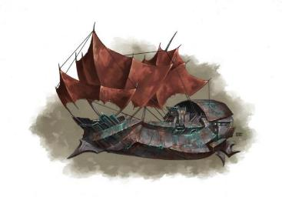

Barkley shot another arrow directly upward at the fleeing illithid as the latter’s airship came into view.

|  |  |  |  |  |  |  |  |  |  |
| --- | --- | --- | --- | --- | --- | --- | --- | --- | --- |
| **Ranged Weapon** | **Dmg** | **D+** | **TH+** | **Critical** | **Rng.** | **Wt.** | **Atk** | **Roll** | **Check** |
| Composite +2 Longbow +1 | 1d8 | 3 | 1 – 4 altitude | x3 | 110’ | 3.0 | +4 | 10 | 14 |

*Miss.*

Barkley cursed as he missed both shots. “Coward,” he yelled after the illithid scum. He was aggravated that the evil scum had gotten away.

Ghaerleth Axom fled upwards to the point that he was likely out of range now, hundreds of feet from the ground.

*Long-range spells would likely still reach him.*

Solstice pooted with relief.

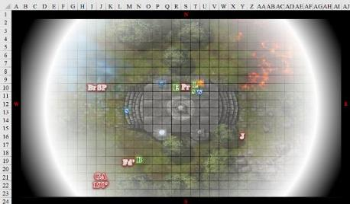

Round 110

The illithid entered his nefarious-looking ship—which Saradette could identify as being of gith design as she struggled to look up—and disappeared within it. The heroes were left with the corpses of the mind flayer’s minions, who no longer looked like the Baron’s loyal women and the Bishop of Tyr.

The heroes began to discern four distinct portals placed equidistantly from the stone platform. One was hellishly rouge; another was beatifically celeste; and the other two were a whirlpool and a cavernous tube that went straight down into the ground.

Elsabet searched the hardest foe to slay first, assuming his loot was the worthiest. He was carrying a spellbook fit for an arcanist, though he’d only cast divine spells before he’d run out of daily favors altogether. There was also an ancient map to a now forgotten archmage tower.

Barkley went up to the platform to have a closer look at the four portals. He looked for any writing or signs that might tell him what they might be or if they were special in any way.

Round 111

Saradette, Widget, and Solstice were no longer stunned.

Elsabet reported to her friends, “This contains two five-page spells for a wizard, and several shorter ones. Saradette, you want these? I can’t tell what the spells are.” She also noted the Venomous Staff and Hand Crossbow of Biting, wondering whether such malicious items would be useful to her team.

Round 112

Solstice also started to search the bodies, starting with the troglodyte that had assumed the likeness of Sgt. Pepper. The brute was only carrying a club, and some mundane seashells and other trinkets of no value.

Saradette looked up from where she was unloading her flechette launcher in preparation to put it away in her haversack. There was no point in wasting ammunition, and the device was too expensive to use to no effect. “Sure, I can take them.” She put the scrolls away with the launcher, and stood to look more closely at the portals.

The rogue looked closely at the spellbook. “Maybe someone else should carry it. With my fortunes in this place, it would probably eat

my haversack.”

The illithid’s ship cranked on the forward thrusters, and the vessel made headway for somewhere else.

Round 113

Elsabet found an unidentified ring on Father d’Ethic.

When Barkley finished inspecting the portals, he offered, “I can carry the book for you if you are truly concerned about your haversack.”

“Oh! May I hold it? I have such a love of arcane things. Books, that’s where such things are found.”

Round 114

Saradette handed it to the bard. “Sure.” The gnome smiled wanly, “All I want is to get out of here, to be honest.”

Barkley accepted the item and took off his pack. Putting it in, he smiled adding, “So do I, then perhaps a nice warm bath.” He gave Saradette a wink as he put his pack back on.

Round 115

The gnome shrugged. “I suppose. I have some work to do, when all of this is over.”

Solstice had not had much luck searching the other minions. The troglodyte, grimlock, and krinth had only weapons and armor on them: not even a ring or bracelet had been given to them in the interest of better serving their master. “You going to keep the wereserpent’s venomous weapons?” he asked Elsabet.

Round 116

Luran looked toward the airier of the four portals for hints on the winds as the conversation led Barkley to take the spellbook out of his haversack and hand it to Luran.

Rounds 117 – 118

Luran placed the spellbook into his own haversack.

Elsabet thought for a moment, then replied. “Let’s keep the venomous weapon, for now, unless it detects as evil to Barkley’s eyes. I would like to confer with wiser folks than I am on the use of poison—it seems unseemly to me, but if we decide not to use it, perhaps the Baron or one of the high priests would want to see it safely disposed of.” She left the ring on the wereserpent’s right annular finger. She thought to herself, ‘it also never hurts to be seen doing the right thing, just gotta figure out what that is...’

Rounds 119 – 120

Barkley noted no evil aura around the staff, though its venomous quality did not please him, and a similar thing could be said for the hand crossbow of biting.

Glancing at the portals, Elsabet remarked, “One looks kind of Celestialish; that gets my vote. If we end up in a Celestial realm, we can probably manage to get sent back to Mintar from there and maybe whatever glorious being we might encounter could fix up any of our wounds and possibly poisons or diseases. Speaking of which, if anyone did get poisoned or diseased maybe those of us with heal skill can take a look.”

Saradette raised her hand. “That is one thing I did manage to accomplish today. I got bitten, and I think it’s infected.”

Round 121

“Is there anything we need in Mintar?” Solstice asked, then caught Saradette’s look and recalled her pony grazing in the Radnars’ backyard.

“Everything I have is on my cart in Mintar,” Saradette replied more sharply than she really meant to, and she sighed. “I’m sorry, Solstice. It’s not been a good day.”

After the spellbook hand off, Luran considered stepping off the stone platform and walking over to take a closer look at the portals.

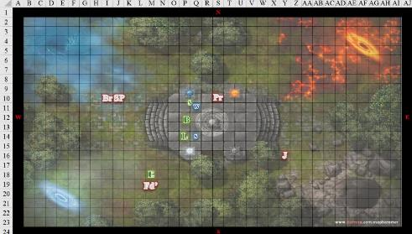

Round 122

Saradette noticed the orb closest to her, and, as it piqued her curiosity, she stepped over to take a closer look. The sphere was about as big as she was tall, but it rested about a foot above the pedestal underneath it, which was itself about a foot tall. She could not see within it.

Barkley nodded when going to the Celestial plane was mentioned. “I would agree; should we go there, they would likely help us. Once back in Mintar, we need to confirm that the threat from the evil lycanthropes is ended and that the Speaker in Dreams has been silenced.” Barkley then walked over to stand next to Saradette, looking at the blue orb. He then looked around the platform, noting, now that he was not distracted by combat, that there were 4 portals and 4 orbs. He wondered what, if any connection there was between them.

Luran stepped gingerly up to the portal that gave off the most beneficent vibe to get a closer look.

Elsabet headed over to Saradette to take a look at the bite. “Hmm, bitten by a ratperson? Could be filth fever, but could be rat lycanthropy—I think we are going to want to have a priest do some preventive magic for that.” Elsabet began to inspect Saradette’s bite wound.

Round 123

Luran continued towards the portal at a gingerly pace.

Round 124

Luran got up close to the portal, and noted some cloud-like formations on the other side, as well as some geometric—perhaps geodesic—shapes among them.

Barkley looked at Luran and began walking in his direction. “What can you see?” he asked as he neared Luran. He wondered if it truly was a portal to the Celestial plane.

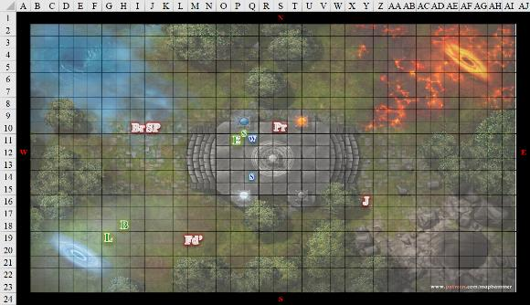

Round 125

Having inspected Saradette’s wound, the crusader was able to ascertain that this was indeed a lycanthropic infection, and would settle in her blood within a few days’ time, whereupon the gnome would become a wererat and would likely betray them all to the path of evil.

As the artificer examined the orb, Elsabet postulated a theory. “Maybe the orbs can be used like a crystal ball to look upon a location and then open the portal to that location?”

Saradette suspected not. There was nothing much to see within the orb, at least not at the moment.

Barkley looked over the bard’s shoulder into the portal, seeing the same thing that the bard had made out.

Luran deduced, “This could be a portal to the Plane of Elemental Air; I’m not entirely sure.”

Round 126

Barkley did not feel confident that the portal was to the celestial plane. “I am unsure that the portal goes to the celestial plane.” He slowly turned counterclockwise, looking at each of the portals. Once he looked at all of them his eyes widened. “I think they are all portals to the Elemental Planes.”

“At this point, I’d have to agree,” Luran offered.

“Okay,” Elsabet said, “I’m going to try something.” She cast *guidance* on Saradette. “Gonna give your body another chance.”

Round 127

Barkley looked and Luran and smiled. He then turned to Elsabet and Saradette who were still on the platform. “What say the two of you, do you agree they are elemental portals? And do we know if there is a way to turn them off?” He wondered why, after defeating their enemies why they hadn’t just woken up. Then he wondered if they had been sleeping at all. Perhaps they had been teleported to some other location and now needed to find their way home.

“I don’t really know,” Saradette said. She rubbed at her bite, and then she pulled her hand away and turned to the orb she’d been examining. She ran her hand across the surface, looking for anything that might be a switch, but there was no such thing.

The gnome examined the pedestal, and then she moved to the other orbs in turn and examined them.

In response to the archon, Elsabet held up one finger while she stayed focused on Saradette’s wound and her hope of solving the issue before it got a lot harder. She heard the archon, but wanted to pay close attention as she used her spells to try to help Saradette shake off the potential affliction.

“Hey, stand still just a bit longer,” Elsabet urged Saradette as she cast *resurgence* to give the gnome another save vs the lycanthropy before it settled in to stay.

|  |  |  |  |  |  |  |
| --- | --- | --- | --- | --- | --- | --- |
| **Save vs.**  Disease | **Rank** | **Ability**  **& Mod.** | **Misc.**  **Mods.** | **Total** | **Roll** | **Check** |
| **Saradette, Fortitude** | **1** | **Con (+1)** | 1 *guidance* | 3 | 16 | 19 |

*Success. Effects negated.*

The gnome’s scarred-over wound disappeared, and her lungs felt a bit more able to draw in oxygen.

Round 128

“Yes! Praise Mayaheine!” Elsabet exclaimed, breathing a sigh of relief. She then joined the discussion of the overall situation, and started to examine the nearest pillars. She wondered if, in fact, they were back in the normal world, but somehow far from Mintar.

Saradette took a breath, and it seemed that her spirits lifted a bit. “Thank you, and yes, praise Mayaheine.” She continued to examine each pedestal and orb. “Maybe they are activated another way, like with a word.”

Barkley looked from Elsabet to Saradette and nodded, glad that Saradette was healed. He then approached the orb that appeared to be the one related to the air portal and began looking for any trigger word, phrase or switch.

Round 129

Luran walked away from the cloudy hole in their current reality and joined the others’ investigation of the orbs on the stone platform.

Standing on the grassy field, Barkley noted no writing or switches on the white orb.

Elsabet cranked up her *detect magic* ability once more, this time focusing on the orbs and columns that were clearly somehow related to the portals further out, to try to see if she could determine what sort of magic they were. Her spellcraft abilities needed more sharpening, as it were, but perhaps she could spot something useful. She immediately sensed the presence of at least one aura near her.

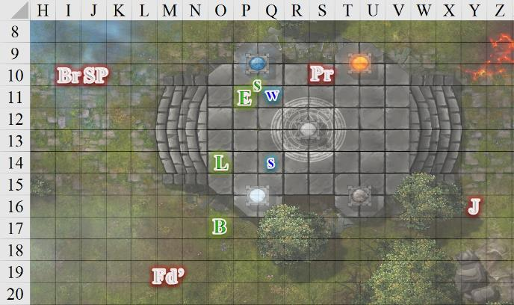

Rounds 130 – 131

The presence of magical auras was evident in all four orbs, and all four portals. All eight auras appeared to be equally potent, and though she wasn’t sure about all of them, she discerned a Conjuration signature emanating from most of the portals, while three of the four orbs glowed with Enchantment auras. The other auras were ambiguous.

Barkley walked up the steps and stood next to Luran.

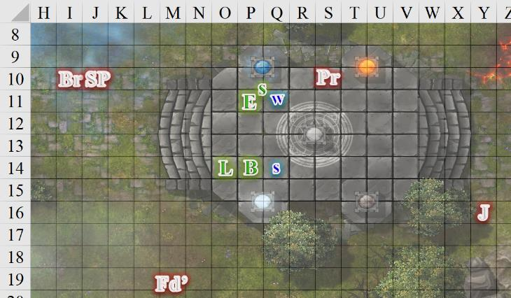

Rounds 132 – 133

Elsabet began to pass all that info on to the others, continuing to focus on magical auras and the platform, and trying to see if there was any magic connected to the pattern engraved or inscribed in the center of the platform, which looked like it might be some planar diagram, which was outside her areas of expertise.

Round 134

Barkley waited for Elsabet to complete her inspection of the magics put out by the portals, but his experience of having lived on Celestia wasn’t resonating with anything that he was now seeing.

“Conjuration? That’s what I would’ve expected...” the magically oriented bard’s voice trailed off with the discovery making sense to his arcane understanding.

As they continued to peruse the portals, orbs, and the concentric etching with nary a word scribed on them, Solstice noted not one, but two airships now headed straight for them. They must’ve been at least 2500’ away, and perhaps 100’ above the waters to their west, but the two vessels’ bearings had them approaching at a moderate speed, and within seconds, the Fist of Light would likely be overrun.

Saradette ran for the tree just off the platform to gain concealment and a little cover. Arriving there, she pulled out her flechette launcher, and rendered her Shiftweave into a green ghillie suit.

Barkley looked around at the others. Seeing Saradette run to a tree, he asked, “So, are we staying to fight or are we going to head through one of the portals? I suggest we decide quickly so we can make preparations either way.” Barkley then pulled his bow from his back and nocked an arrow just in case the verdict was to stay and fight.

Round 135

The ships were now about 2200’ away and continuing on a direct course for the platform.

“I am for fighting,” Elsabet replied, readying her light crossbow, in the hopes of getting a few shots in herself. “Solstice? Luran?”

Barkley, bow still in hand looked at Elsabet and Saradette, “Are you both 100 percent sure about this decision? I will back you if you are, but I do not believe the odds will be in our favor, especially if they have cannon or long-range siege weapons aboard.” He looked at each, a slight bit of concern in his expression. He did not want to die at that moment, but if his friends were to stand against the evil illithid once more, he would stand by their sides.

Round 136

The ships were now about 1900’ away.

“Oh yeah, cannons. Crap. Air portal it is, let’s go people!”

Elsabet looked around for Widget, but the raccoon had been stuck to Saradette’s side since they’d battled the scribes in the Treasurer’s bureau back at the keep, and was now hiding under the tree with the gnome. Elsabet then headed for the southwestern portal.

Barkley nodded as he put his bow and arrow back. He ran over to Solstice to allow the musteval to jump on board for a ride to the portal. He also looked over to Saradette and Luran to make sure they were following.

“Good call, B—when we’re ready, take point, I’m rear guard.”

Saradette ran after Elsabet at her best speed.

Luran, face a little paler than it was before the two flying battleships showed up, quickly joined the exodus of his friends.

Round 137

A single beam of cannon fire razed the stone platform as Elsabet followed the rest of the heroes into the portal.