*Chapter 2: The Glimmerwood Trail*

It was now spring in 1369, and the band had hitched a ride across the Spine of the World, earning coin as caravan guards for a human named Floyd “PJ” the Urban, a know-it-all merchant and jack-of-all-trades who had gotten a more-than-fair price for his last shipment of silks than most of his stature could have wangled, and was now taking three wagonfuls of foodstuffs from the east to the west.

It had been a good year for all of them, in terms of experience, though they hadn’t fared very well monetarily, and so their most recent adventuring decisions had been made with fiscal intentions; they now looked forward to arriving at their next destination, where they would be paid one of the four lump payments for their services, once PJ liquidated the assets that were stored and organized all around them.

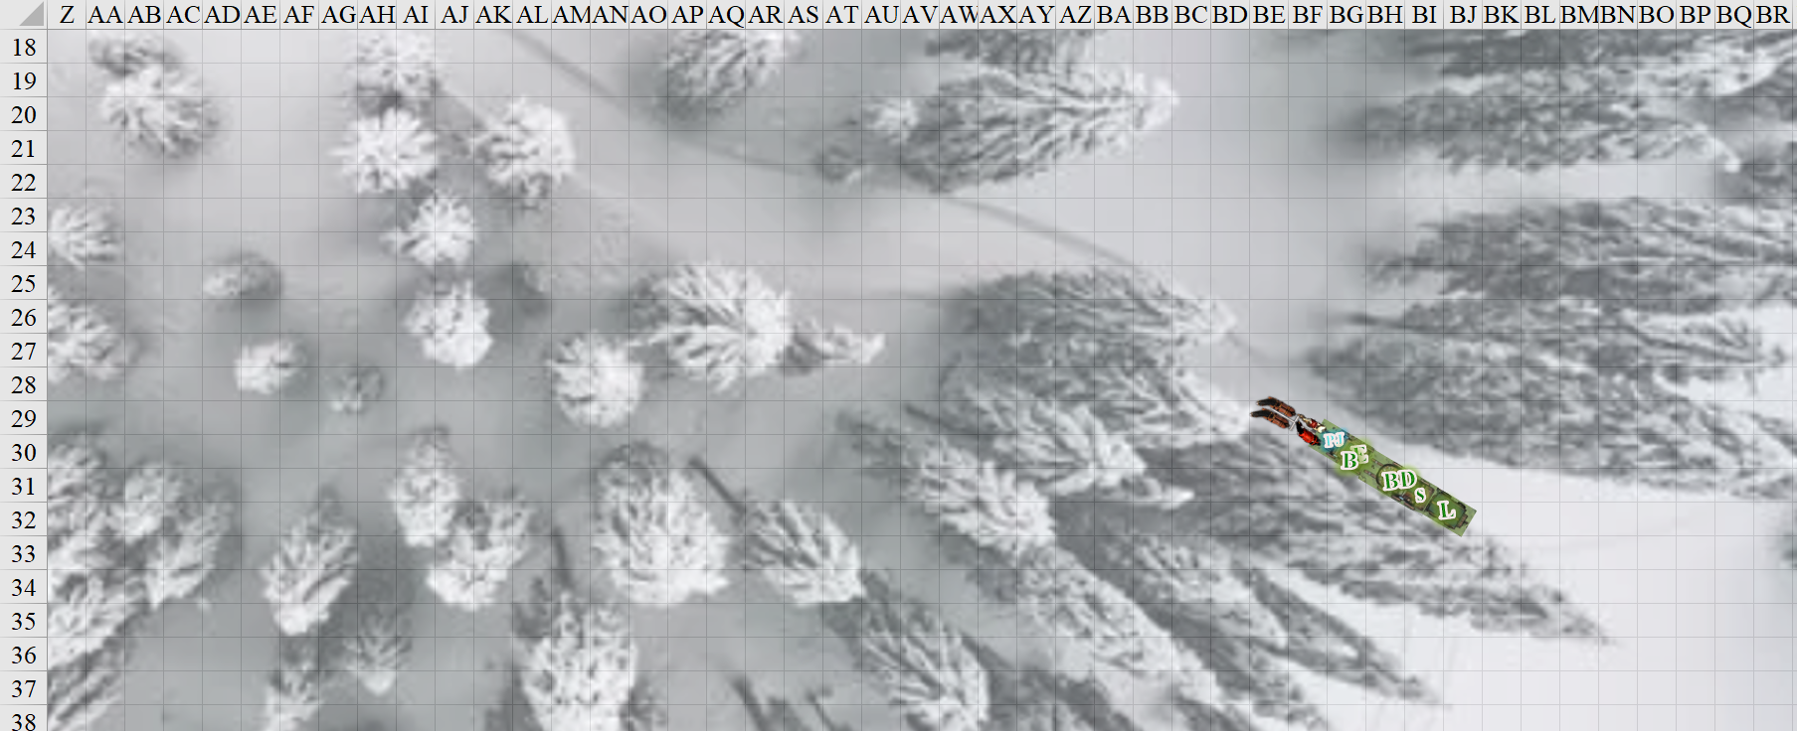

They expected to reach Luskan in a few tendays, stopping a few times along the way to rest the horses for more than a day before reprising their trek across the northern confines of the Faerûnian subcontinent. It was late afternoon, and though a few inches of snow had fallen for most of the night, the day had been clear and there had been ample melt-off along the parts of the caravan’s path that were further from trees and topography.

Just over a day ago, they had fought off a topiary-looking treant that was out for revenge and beyond reasoning with, and they had since acquired healing at a roadside temple of Fharlanghn, whose adherents they had met all along their travels. The pious heroes were now holding two different conversations in three different wagons, while PJ conducted the four horses that drew the lightweight wagons.

Outside the wagons, a snow owl perched under a shadowy, snow-capped copse, turning its neck and opening its eyes at the same time as the horses and wagons came into view. Perfectly camouflaged by the snow and shadows, the bird remained motionless, studying the incoming entourage as snowflakes melted or even evaporated under the direct sunlight of a clear, blue sky. Nearby, PJ could hear the babble of a tributary delivering fresh melt off to the lower altitudes.

Inside the frontmost wagon, Barkley and Elsabet discussed tactical differences in their styles and philosophies of combat, while BelDamon and Saradette sat in the middle wagon holding a debate with Laryssa—who sat alone in the rearmost wagon—on the finer ethnical nuances of when to slay an opponent and when to walk the merciful path.

As they were operatinonalizing the definition of “merciful”, they heard a roar, which sounded initially like the grinding of metal upon metal. The horses slowed, urged by PJ.

Then a second roar—which some might have discerned to have been coming from another creature, though the party did not—alerted them to something living, non-ferrous, and ferocious. There was a thud felt and heard by the heroes as the horses came to a full halt. It was a sound and vibration that shook the ground, suggesting a powerful downward force had just made an impact nearby.

The ears of those more astute pointed their attention to their southwest, but they would have to exit the wagons to have a line of sight to whatever the commotion was about. Then the cacophony of roars quieted.

“We aren’t alone,” PJ warned from just on the other side of the frontmost tarp, spurring Barkley and Elsabet to attention.

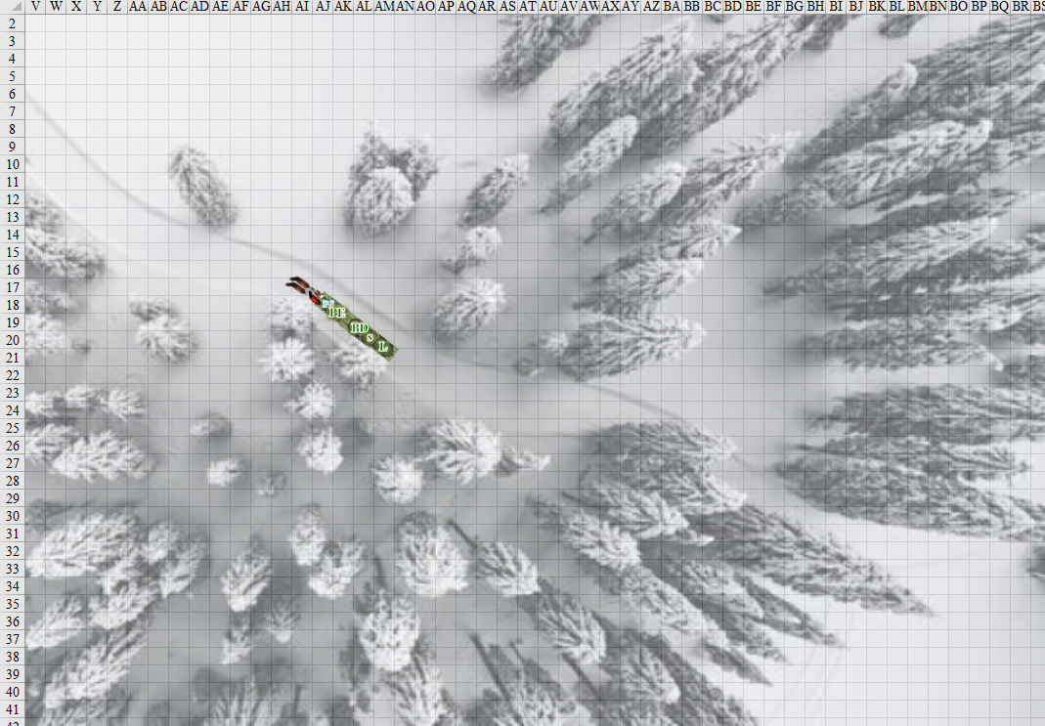

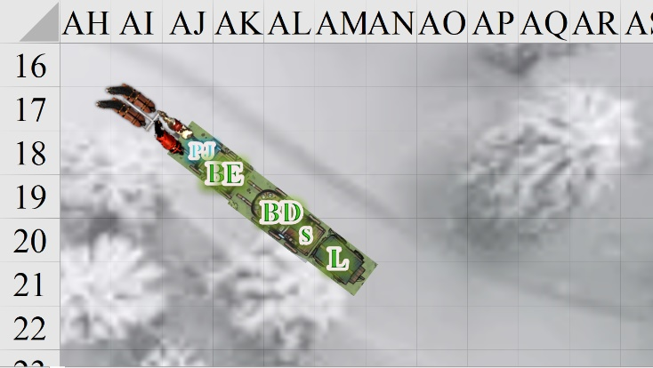

Round 1

|  |  |  |  |  |  |
| --- | --- | --- | --- | --- | --- |
| **Character** | **Group** | **Initiative** | **Roll** | **Modified Roll** | **Move** |
| Laryssa | 1 | 3 | 19 | 22 | 20’ |
| Elsabet | 1 | 4 | 11 | 15 | 30’ |
| Saradette | 1 | 1 | 11 | 12 | 20’ |
| ogres | 2 | -1 | 12 | 11 | 30’/40’ |
| Barkley | 1 | 4 | 6 | 10 | 30’ |
| BelDamon | 1 | 2 | 8 | 10 | 30’ |

Laryssa had prepared and cast *endure elements* just about every day since they’d encountered freezing conditions, including today *[expired tomorrow]*. The paladin-cleric of Mayaheine hopped out the back of the rearmost wagon, having no need to bundle herself against the cold. Readying her bow, she scanned the area for the source of the roars, but saw none at the moment, then turned towards the sound of branches snapping and something big making its way through melting snow and slush.

Elsabet cast *protection from evil [expired on Round 20]* upon herself, then got out of the lead wagon to the right, rather than climbing past her comrade to the left, and moved to the rear corner of the wagon caravan. She scanned the woods nearest her first, then looked towards the southwest past the end of the wagon, but saw nothing in that direction. She’d had her crossbow in hand, but first she’d need to see a target... or possibly someone in trouble? She shaded her eyes against the glare with her right hand.

Saradette followed suit, jumping to land gracefully beside Laryssa.

|  |  |  |  |  |  |  |
| --- | --- | --- | --- | --- | --- | --- |
| **Skill/Save** | **Rank** | **Ability & Mod.** | **Misc. Mods.** | **Total** | **Roll** | **Check** |
| **Jump** | 0 | **Str (+0)** | 0 | 0 | 15 | 15 |

*See below.*

About 5’ from the human paladin-cleric, the gnome wore a fitted winter coat, gloves designed for archers, and lined, knee-high leather boots, all courtesy of her mother. She brought up her bow and nocked an arrow, then she moved southwestward towards the trunk of the tree whose branches were now above her, watching and listening as she went. Leaning up against the tree, she heard the stomps of a bipedal creature that was easily 10 times her weight.

An evidently injured—and not-so-evidently female—ogre emerged from behind the thicket of trees, and those with keener ears could tell that a second one would soon emerge just to her southeast. Bleeding from her right shoulder, the spear-wielding ogre snarled. Aside from the wound, another thing the majority of the heroes—familiar enough with ogres—noticed was her emaciated state. Wearing only tatters of furs, the monstrous woman’s ribcage protruded from her bestial hide, and she now roared as she advanced with her spear at a walking pace, picking out her first target.

When PJ mentioned that they weren’t alone, he quickly jumped out of the lead wagon and looked to the south. He began sniffing at the air and turned his ears in every direction to try and determine if there was anything moving towards them. When the last roar came, he tried to see the monster on the other side of the wagons.

BelDamon also emerged from the wagon on the side that wasn’t blocked by tree branches, and listened for the commotion, then faced the southwest where the she-ogre now eyed the caravan that was upwind of her. She could surely smell the foodstuffs, not to mention the flesh of the heroes half her size. The ogre was well outside of the warlock’s eldritch blast range, so the human manifested his beguiling influence *[expired tomorrow]*.

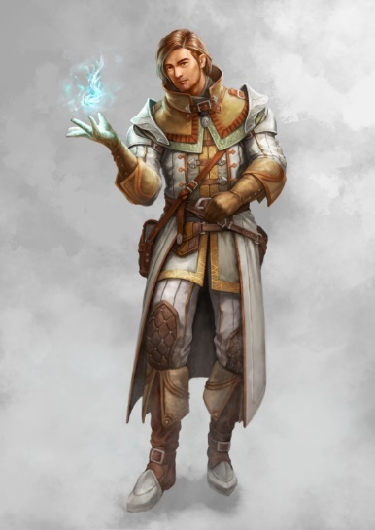

PJ stayed seated on the waggoneer’s seat, and withdrew his masterwork crossbow as a second raggedy ogre—this one more masculine but comparably emaciated—grimacing with a spiked club in its hand and a gash through its left leg. The scent of ogres’ blood and adrenaline wafted away from the heroes, but they would soon smell it once the distance between parties was eliminated. The factotum ensured that the crossbow was loaded, then aimed it at the female, who was now passing the last tree before it would be in their path.

Sandy—the mule at the rear of the caravan—and the four horses were visibly nervous, and would likely kick and rampage at anyone getting close once the club-and-spear festivities got started. Elsabet noted this as she made eye contact with Sandy.

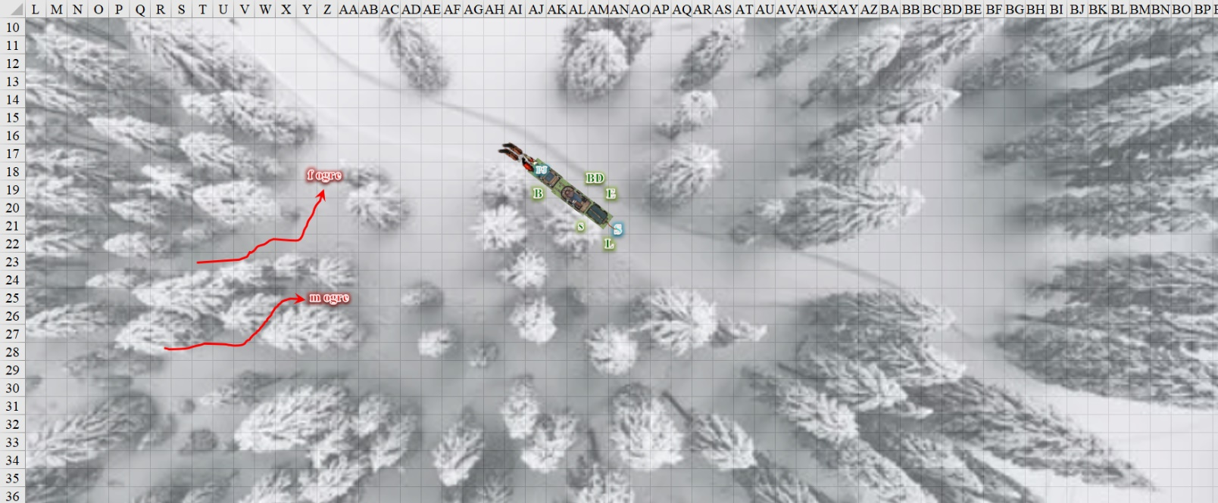

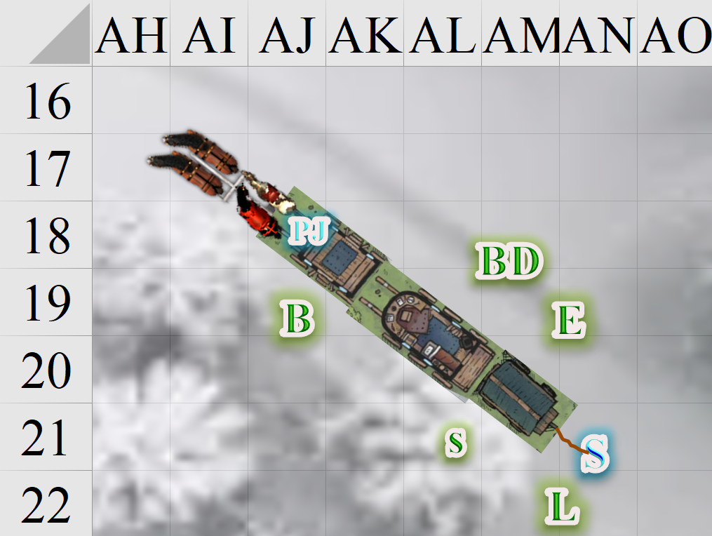

Round 2

*[Now that all PCs are on the ground, it’s evident that movement will be attenuated by about 5’ to 10’ per round, depending on where you’re walking. On the trail and under trees there’s less snow left. The west edge of the map is slightly lower than the east edge, meaning that the horse and wagons are headed downhill at a grade of about 2 degrees. The melted slush is flowing in that direction, which is where the afternoon sun is (about 35 degrees from the horizon), in case it makes any difference.]*

Laryssa eyed the monstrous humanoids emerging from the woods appraisingly. While she had never heard of such being anything other than malevolent, it was possible some individuals would be less so. Since she was too far away from them to detect any evil intent they might bear, she began making her slow way closer.

Bold was Laryssa!

Elsabet hoped Sandy wouldn’t be too spooked yet, but even so, Elsabet moved carefully around the mule, muttering softly to it, as she saw Laryssa heading away.

|  |  |  |  |  |
| --- | --- | --- | --- | --- |
| **Character** | **Check** | **Ranks** | **Roll** | **Save** |
| Elsabet | Charisma | 2 | 10 | 12 |

*See below.*

The favored soul of Mayaheine could tell by the mule’s lips that she was uneasy, though the human’s soothing words *did* seem to help a bit as she passed by. Once past the mule, she took a look around and, spotting an ogre off in the direction Laryssa was heading, she hustled to catch up to her. “Hello there,” she called out, first in Common and then in Goblin. Then, again in both languages, “Truce, parlay?” << Truce, parlay? >>

|  |  |  |  |  |  |  |
| --- | --- | --- | --- | --- | --- | --- |
| **Skill** | **Rank** | **Ability & Mod.** | **Misc. Mods.** | **Total** | **Roll** | **Check** |
| **Elsabet, Diplomacy** | 5 | **Cha (+2)** | 2 | 9 | 5 – 10 | 14 – 19 |

*See below.*

The horses neighed. Sandy said, “Hee-haw!”

As Elsabet sought a pacifistic resolution to this confrontation, Saradette took advantage of the commotion made by the animals and moved toward the trees, intent on flanking the ogres and hitting them with her bow. She tried to stay low and use the snow and vegetation as cover.

|  |  |  |  |  |  |  |
| --- | --- | --- | --- | --- | --- | --- |
| **Skill** | **Rank** | **Ability & Mod.** | **Misc. Mods.** | **Total** | **Roll** | **Check** |
| **Saradette, Hide** | 4 | **Dex (+3)** | 4 | 11 | 15 | 26 |

*See below.*

The female stopped, and spat, “Parlay... lunch?” The male stopped to look at the female, but kept his spiked club raised. He said something in Giant, which only PJ understood. << Bak-chihuq glomditaas! >>

Barkley turned to face the female ogre as it emerged from the tree line. He pulled his greatsword from his back and squared off, facing the giant creature. He was about to take a step forward when he heard someone trying to communicate with them. At that point Barkley stopped moving forward and instead held his ground, taking a slightly more relaxed position. His sword still in his hands, ready to be used, but no longer advancing on the ogre.

BelDamon froze in his tracks at the sight of the ogre woman.

PJ lowered his crossbow, and translated Elsabet’s message in Common.

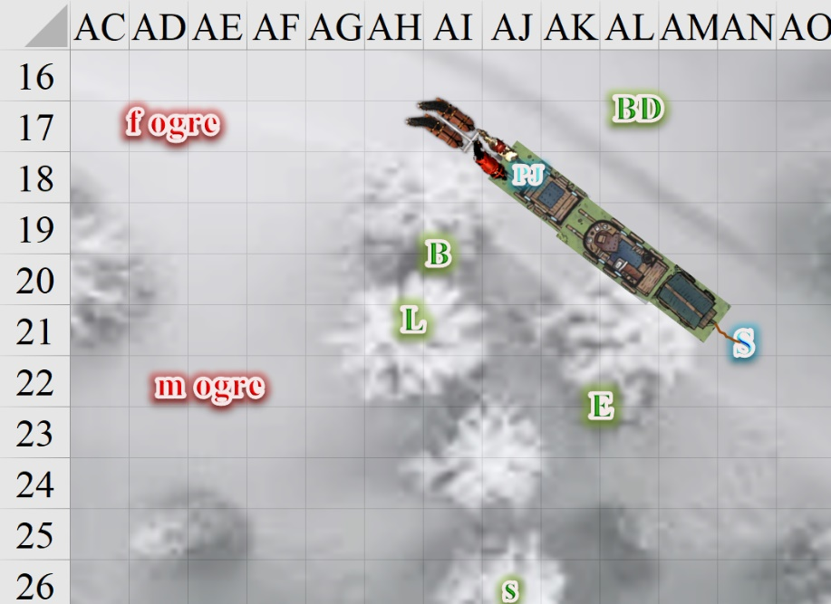

*OOC: I just realized that this may seem like I looked for a language that no PC spoke (in this case, Giant), and introduced a friendly NPC who speaks Giant to negotiate for you, but this was completely random and unintentional. Consequently, PJ will not take over the conversation, but will translate for each party what the other is saying (unless and until hostilities resume). He speaks Common, Chondathan, Dwarven, Undercommon, Elven, Giant, and Gnome, but not Goblin, so he only understood what Elsabet said in Common. The female ogre’s Intelligence is not quite 10, so she understands a little Common, but communication without a translator from Common to Giant will likely result in significant Diplomacy penalties. The male is your usual, dumber-than-a-box-of-rocks type ogre (Int = 7ish).*

Round 3

BelDamon did nothing for the moment.

Laryssa got within 60’ of the male ogre, and activated her Detect Evil ability.

*Laryssa began to detect evil in both ogres.*

Sandy and the horses settled down a bit as tensions were curbed.

Barkley also stood his ground, lowering the sword that he continued to grip with both hands.

As Elsabet spoke and muffled the sounds of Saradette’s footsteps in the now crunchy and slushy snow, the rogue continued working around the south flank, and attacked if she was able to come within 30’ of the closest ogre without being detected.

|  |  |  |  |  |  |  |
| --- | --- | --- | --- | --- | --- | --- |
| **Skill** | **Rank** | **Ability & Mod.** | **Misc. Mods.** | **Total** | **Roll** | **Check** |
| **Saradette, Hide** | 4 | **Dex (+3)** | 4 | 11 | 17 | 28 |
| **Saradette, Move Silently** | 4 | **Dex (+3)** | 4 | 11 | 9 | 20 |

*See below.*

Unaware of the gnome’s presence, the ogre man protested this “parlay” by banging his spiked club onto the ground, breaking one of the spikes. The ogre woman roared for him to shut his vomit hole, which PJ would later translate, if they survived.

Elsabet saw that there was progress in diplomacy, and that at least the woman ogre could be dealt with. When the female ogre responded in broken Common, and it looked like a fight might be avoided, Elsabet spoke carefully and slowly in Common, towards the female. “We have food, and are willing to share.” She moved slowly up to stand between Barkley and Laryssa, her crossbow pointing to the ground.

PJ translated what Elsabet said into Giant.

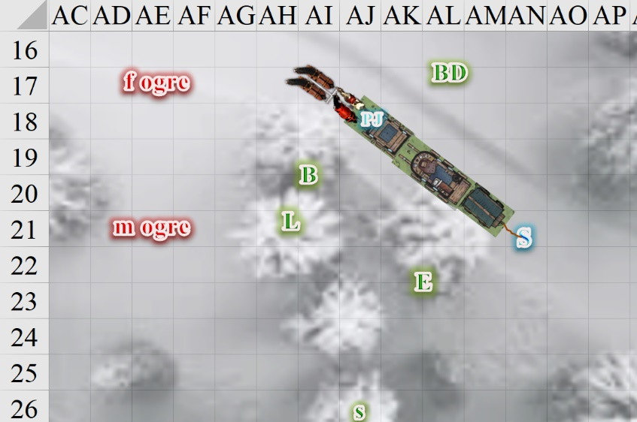

Round 4

It sounded like PJ might understand the ogres’ speech, so after waiting for him to translate, and for the ogre to respond, she waited after this initial sentence, and allowing the ogress to reply if she wished.

The feral woman sniffed the air, took a step forward, and confirmed that Elsabet’s words—translated by PJ—were true. She said, << Turuukh ziarr fa jheg khat’whuaram. >> The male took a step northward, closer to the female, keeping an eye on Laryssa, Elsabet, and Barkley, who now stood in a single row, looking mighty, before the ogres. The male’s nose ran with both blood and mucus, and half his teeth were rotten out.

PJ said, “Let us see the food you speak of.”

Out of sight of the ogres, BelDamon started to creep eastward, passing the mule with a look of despair.

Laryssa said to the others nearby, “Though both emanate an evil aura, I sense no overt evil intent from the female but the male is another matter. I suggest keeping close eye on both.” She followed her own advice, preparing to fire should he move to attack.

Saradette stayed quietly hidden, watching for either of the ogres to attack. She also made sure to watch her back, and glanced around for any other dangers.

Elsabet nodded as the ogres huffed. The favored soul manifested her Protection Devotion *[expired on Round 14; please watch to make sure I apply the bonus, if applicable]*.

*Barkley, Elsabet, and Laryssa gained +2 to AC.*

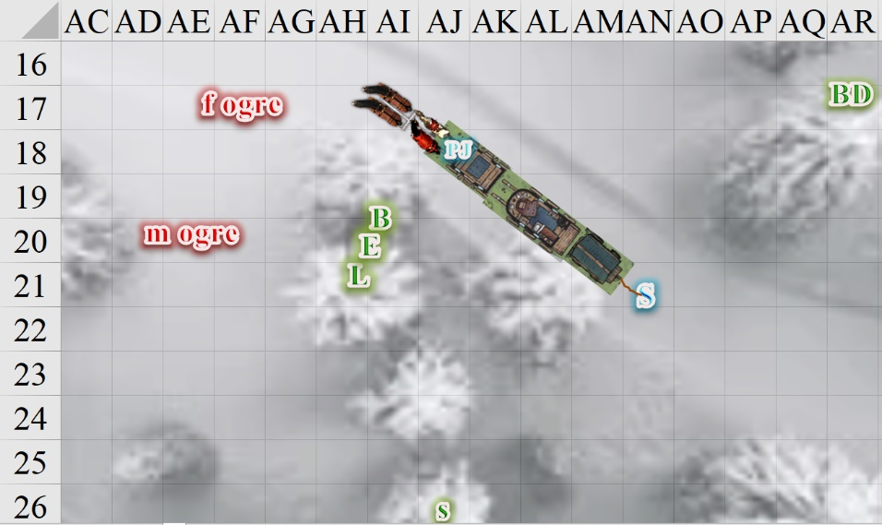

Round 5

“Also, you appear to be injured, I can heal some of your wounds, for peace between us, thanks to power granted to me by my goddess.”

Round 6

PJ translated.

BelDamon was out of sight now, behind a clump of trees they’d passed only moments before the horses had stopped. Only his footsteps in the snow would reveal where he went.

Round 7

The smarter ogre turned back and took another step towards Elsabet, turning to her male counterpart, who shrugged and said something that PJ would later translate into, “This is *your* party.”

The woman with the spear then looked at the puny—but well fed—humanoids before her, and responded with an emphatic nod. Using her right hand to stick her spear tip into the slushy mud and snow, she approached with her left arm extended and her left hand down, a gesture of gratitude in this situation.

The male ogre watched on with distrust, mumbling something about not believing it until he saw it, PJ would later relate to the group.

Barkley smelled the strong swirl of testosterone and adrenaline emanating from the male now that he was much closer and the breeze had died down.

The horses and mule had settled down by now, but the stench of blood and guts in the air still kept them on edge.

Rounds 8 – 10

With her *protection from evil* spell half-expended, Elsabet spoke softly now as the distance between her and the ogre became nil. “While obviously strong and fearless, you are not at your best; my companions and I are well rested and courageous as well, and would not run from a fight, but I see no reason for blood to be shed between us.”

PJ said the closest thing to that in Giant.

“If you have information to share about the land hereabouts, that would be welcome in return for food and healing.”

The factotum translated that too, and then produced one of his ration packs, and holding it out for the ogres to grab.

Round 11

<< I can toss it over if you like... and here’s me eating some of it so you don’t think this is a trick, >> PJ told the ogres in Giant.

The ogre woman looked at PJ, nodded, and kept her gaze down in deference, stinking of blood and carnage, and Elsabet cast *cure light wounds*, assessing the severity of the damage to her shoulder prior to and after the casting.

*Ogre woman gained 8 + 2 = 10 hps.*

The male ogre witnessed the act, and grimaced with disbelief until the woman’s gash—which he had caused during a dispute brought on by hunger and delirium—then his shoulders and lower jaw dropped in a sense of resignation to the fact that he would not be eating these wee folk today. His hunting instinct would have to be satisfied at a later date, but at least they would eat, and maybe the woman with the chain shirt would heal the gash on his leg.

With only a slight bruise on her shoulder, the ogre woman did her best to smile, but it was evident that tears were forming in her eyes, which were twice as large as Elsabet’s. When she turned back to PJ, the human lifted the sack of rations he’d procured, and tossed them gently onto the snow, feet away from the female.

Round 12

The male ogre—stricken with jealousy—demanded healing with a roar.

PJ said as much to Elsabet as the ogre woman ate the rations in a single munch and gulp, sighing with frenzied delight afterwards. She loved cranberries, and PJ had added a lot of these to his trail mix.

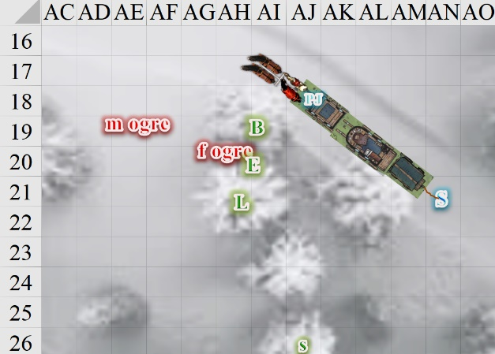

End of Rounds

Barkley watched and listened to the exchange. He was surprised that the ogres seemed to be willing to negotiate, though the male much more reluctant than the female. Barkley kept shifting his gaze between the two ogres. When the female ogre stuck her spear in the ground, Barkley sheathed his sword as a mutual show of peace and to support Elsabet’s efforts.

The male ogre made eye contact with Barkley, and bared his teeth with rancor, though he did not advance or lift his spiked club.

Laryssa approached the male ogre, motioning it to come closer while wary of its club. When close enough, she intoned a brief prayer to Mayaheine while touching the worst of its wounds.

*The male ogre gained 3 + 1 = 4 hps.*

The male relaxed a bit, and groaned with the sensation that maybe the evil path was wrong.

Saradette remained hidden and on guard during the whole exchange. She was perfectly willing to send the ogres on their way without a fight, although she debated the wisdom of being kind to such a powerful enemy. Elsabet seemed to be a wise woman, so Saradette was willing to follow her lead.

Elsabet looked at the two ogres, and while the paladin had further reported that both ogres were evil, clearly they were not demons or devils, and thus potentially redeemable. She nodded at Laryssa as the paladin healed the male ogre. Elsabet was wary of the ogres’ obvious brute strength, and while certain she and her companions could defeat them, it would be unwise to risk a single blow from one of those large weapons killing someone through sheer luck. She looked for BelDamon, hoping the man wouldn’t do anything imprudent; where had he gone?

She nodded at PJ, then spoke to the ogress again, trusting PJ to translate. “You both look very hungry. I have additional rations I will share with you; they are loaded on my mule.”

She didn’t understand the interchange in Giant, but by the end of their verbal volley, the ogres seemed much more reasonable.

Elsabet looked to PJ. “Would you be so kind as to retrieve my rations? They are in a sack at the front left top side of the pack saddle bundle.”

Then looking back to the ogress, she pointed to herself, and said “My name is Elsabet. Eat food, be better.”

When PJ came back with the sack of rations, Elsabet followed his lead, reached into the sack and pulled out some hardtack, and started chewing, nodding to PJ to hand over the sack with the rest of her rations inside. “You both eat more,” she said, after swallowing the first bite. There was some dried salted meat in the rations as well, probably more to the ogres’ taste... And with some healing for both ogres, along with the food, hopefully even the irritable male would keep the peace. If they were still a little hurt, they could heal that on their own.

The male wolfed down an entire day’s worth of rations that would’ve sustained Elsabet tomorrow. No matter; there were plenty of grains in the wagons.

Elsabet was also careful not to look in Saradette’s direction at any point; let the ogres remain unaware of the gnome’s presence, just in case things got...tricky. She wanted to engage in further discussion, with PJ’s help, to see what information the ogres might be willing to impart—and oh, so carefully, talk to them about the advantages of not attacking everyone you meet who looks different than you. She hoped that some kind acts now might be the catalyst for an eventual change in their attitude and behavior, but at the very least, hoped to dissuade the ogres from attacking other random travelers in the near future, even those who might not be so capable as her friends. Planting the idea that even smaller people could have mysterious and powerful abilities was a start... She smiled at the ogress—without baring her teeth—and took another bite of the hardtack.

Barkley, seeing Elsabet turn over some of her rations, went back to his backpack and pulled out what would have been 3 days’ rations for him and offered them to the male ogre. It was an unusual way to deal with an ogre, but Barkley was willing to treat other sentient creatures with respect so long as they showed respect back.

The rest of the afternoon was significantly less tense. The party laid out some of the foodstuffs that would have gone bad soon had they not been in such a frigid climate, and by the time the ogres were fully healed and fed to their satisfaction, their gratitude had been shared in more than one way, and translated by PJ.

The male ogre—in particular—grew quite fond of Barkley, and even tried to pet him a few times.

Saradette moved south for a bit, rejoined the road, and came walking up as if she’d been hunting. She considered adding her rations, but they were morsels compared to what the much larger folk ate, so she kept them in her pack. She was visibly amused at Barkley’s plight, and the gnome managed to contain herself until the ogres left. Then, every time she looked at the archon, she dissolved into a fit of giggles.

Barkley didn’t mind the male ogre trying to pet him. However, after a couple of times, Barkley transformed into the largest breed of dog in Faerûn and had PJ explain the concept of ‘Fetch’ to the ogre, stressing that the ogre shouldn’t throw with all of his strength.