Chapter 20: The Cloud Fortress

Round 138

The light all around them was extremely distorted for a moment, and then the more planarly astute could infer that as things came into focus, they were conveyed along a dimensionless wormhole from the end of which they were spat out onto a icy, glass floor. They all pretty much landed on their backs or sides, and did their best to gather their bearings, noting first the geodesic dome above them, and next the transparent floor that separated them from a seemingly endless sky. With clouds above and below them, they surmised that they might be on the Elemental Plane of Air, but could not be sure.

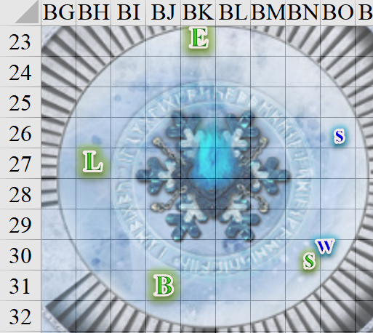

Thirdly, they noted the blue flame portal from which they’d just emerged, and saw within it yellow flashes that were likely cannon fire laying waste to the realm on the other side of the portal. Lastly, they noted the large print runes that Luran could only identify as Giant, but Elsabet could actually read. The words nearest her read, “… and unto eternal glory…”

Round 139

Luran hopped up, onto his toes. He took a short second to stare at the floor and sky below them. Popping his gaze up and rapidly around his companions, his ears also sought clues to their environs.

Saradette carefully climbed to her feet and started to examine the floor and walls for traps or anything else of interest.

Barkley got up onto his feet and looked around. He focused on the writing on the floor. He also looked to see that the others were alright, especially Saradette and Solstice.

The sound of footsteps—large ones—could be heard from the southwest, beyond the only opening to the rest of this level.

“Guys,” Saradette said as she moved to the opening and peeked out.

Elsabet carefully climbed to her feet, and put away her crossbow. “Giantish,” she commented, and read the words out loud. “Probably cloud giants—be respectful!”

She prepared herself to address the approaching creatures—hoping they were noble giants, and mustering her most diplomatic and respectful voice. She was very glad to have learned to tongue of giants, though many giants did speak the common tongue.

Round 140

Solstice was relieved to find that the two giants who came into view were not wearing black and red. It wasn’t so much that this meant that they were not evil, but the last few days of conditioning in Mintar had somewhat traumatized the musteval.

Barkley was relieved to find no evil auras emanating from the two guards—a bearded male and a woman with the wispy mane indicative of a cloud giant.

As the others got to their feet and prepared for what may have come, the giants held their drawn short swords in a defensive manner, and the woman asked in her own tongue, << What’s the meaning of this? Who are you? >>

Round 141

Barkley looked at the two giants and smiled. He remained silent, allowing Elsabet to do the talking for them. He stood, hands clasped behind his back trying to look as friendly as possible, then his mind began to magically piece together the words in Giantish.

Remaining peaceful and honest, Elsabet replied in the giants’ language. << Please forgive our intrusion, noble giants. I am Elsabet, Favored of Mayaheine. I and my companions came here via a portal from someplace else, fleeing from illithids; we come in peace and seek hospitality. >>

Round 142

<< My friends do not speak your language; they do all speak the common tongue of the world we come from. >> In Common, she then said, “This is the language we speak.”

Luran also put on his best, most charming face. While he wasn’t able to grok any of the giant speak, he was more than ready to be a social support to Elsabet if the conversation turned Common.

The giants cringed at the sound of the wee tongue, but retained their calmly vigilant demeanor as other footsteps approached.

As soon as Elsabet had finished her sentence, the blue-flame portal burst into orange and yellow flames, and the infrastructure that housed it shattered into a few dozen chunks of glassy stone.
Dmg to all PCs: 2. Damage negated for Barkley.
Dmg to giants: 1.

The two giants did their best to block the shrapnel and rubble that peppered them, witnessing the destruction of the transplanar conduit that had conveyed these five strangers here.

Round 143

<< By the gods! >> a booming voice proclaimed as a third giant came into view. He was dressed like a cleric, and asked, << What is this intrusion? Explain yourselves! >> The heroes could tell that the cleric suspected them of having blown up the portal.

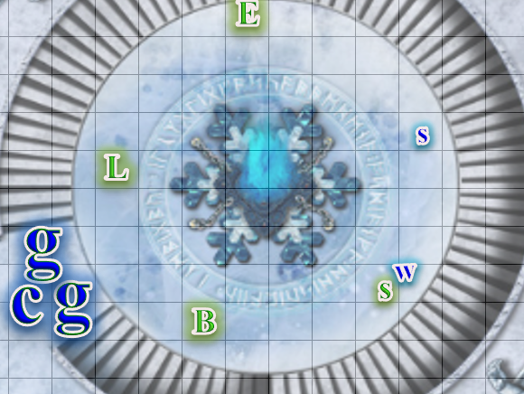

Rounds 144 – 145

Elsabet bowed to the giant cleric respectfully and then stepped forward slowly, empty-handed. << Please forgive our intrusion, holy one. We arrived here escaping from an enraged illithid and his strange flying vessels, firing cannons at us for thwarting his evil plans in the Barony of Mintar in Faerûn. I am Elsabet, favored of the Shieldmaiden, Mayaheine, and I apologize for bringing trouble to your realm—we merely fled through the least deadly looking portal out of the place this illithid, called Speaker in Dreams, had brought us. We ask hospitality, sanctuary, and aid returning to our own realm. >>

The priest surveyed the contents of the room, and heard the woman guard’s corroborating phrase. He stared at the newcomers as Solstice approached Widget and Saradette, bowing his weasely head slightly. The guards stepped aside, letting the cleric step through the threshold to get a better look at the heroes. He was clad in fine silks, and adorned in a variety of platinum accessories, including braid beads, and a nose ring. Inhaling for a few seconds to fill his lungs with air before deliberating, the cleric chose his words carefully.

Round 146

<< Mayaheine... no doubt.... >> He noted the holy symbols that identified the Shieldmaiden’s worshippers, and cast a detect evil spell before proceeding.

Round 147

Staring at the heroes one by one, the unarmed priest put his fists to his waist and proclaimed, << You will join us for a meal as we discuss your plight. >> The invitation was more of an imperative than an option, and the giants then exited the room, and motioned for the heroes to follow them.

Round 148

Elsabet replied, << Thank you, it is an honor. I will inform my companions; most do not speak your language. >>

Round 149

She then repeated the giant cleric’s invitation precisely to her companions in the common tongue, and followed the giants as instructed.

Barkley listened and was pleased when the cleric invited them in. He did not need Elsabet’s translation, but let her tell the others just the same. Barkley stood to the side and waited as the others went in ahead of him so he could bring up the rear. He was confident that the giants would help them to return to Faerun, and hopefully to Mintar. Though, if they did offer assistance going after the illithid, then he would gladly take them up on that offer instead.

Saradette put up her launcher and followed Barkley, though he insisted that she go first, as he wanted to bring up the rear.

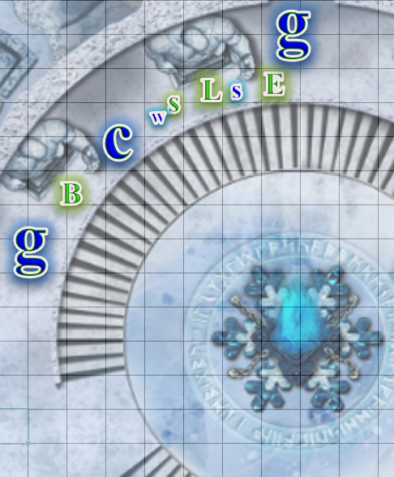

They were led along an ample corridor held up by marble pillars, and into a room that defied the laws of spatial physics. Saradette and Luran identified the craftsmanship to be Ysgardian, and within seconds, it became clear that the extradimensional space entailed security considerations on the part of its designers, for even seconds after they’d traversed the room, they knew not what path to take to return to its entrance.

A few seconds later, they were heading down a staircase, and as the woman leading them announced the newcomers to the Queen, the heroes could gather by the lavishness of the chamber they were now entering that this was indeed a throne room.

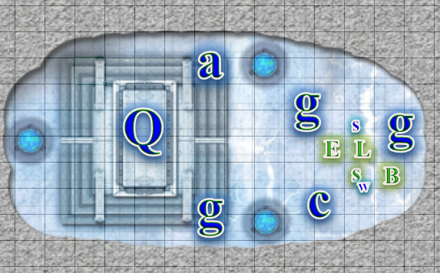

The throne was made of a nearly invisible glass, atop which sat the monarch, who had just been discussing a matter of seeming importance with an advisor, and now turned her gaze directly towards the humanoids. The female guard and cleric took turns describing what had just transpired on the floor above them, with the cleric concluding, << The portal is destroyed. Our conduit to the Beastlands is no more. >>

Elsabet’s and Barkley’s ears perked up when they realized they’d been shunted away from Mintar unto the Beastlands by the illithid. Whatever magics that villain had been able to wield were far beyond the reaches of the average illithid, and it stood to reason that he was in league with other formidable ne’er-do-wells whose power over transplanar teleportation would have been formidable. They’d not been in a dream at all... not this time, anyway... and now they were... floating over Ysgard perhaps?

<< State thy names, >> the Queen simply said in her own tongue, dressed in the silk robes and platinum jewelry that now seemed to uniformly characterize the giants’ wardrobe and jewelry.

Elsabet bowed low to the obvious monarch of this place. << Your majesty, I am Elsabet, favored of Mayaheine, of the Dales in Faerûn. Not all my companions speak your language, allow me to relay your command to them. >> She then turned to her companions and said in the Common tongue, “She says state our names.”
Skill | Rank | Ability  & Mod. | Misc.  Mods. | Total | Roll | Check
Elsabet, Diplomacy | 9 | Cha (+2) | 4 + 4 Giant | 19 | 13 | 32
See below.

The giant queen was impressed by the favored soul’s eloquence in the Tongue of the Greats, and smiled favorably upon them as Solstice spoke.

“Solstice Equinox... at your service,” he said in Common.
Skill | Rank | Ability  & Mod. | Misc.  Mods. | Total | Roll | Check
Solstice, Diplomacy | 0 | Cha (+2) | 2 | 4 | 19 | 23
See below.

The woman was not nearly as taken by the wee-rogue’s curtsies, but nodded nonetheless, and smirked a bit.

When it came to her, Saradette said “Saradette Tarapple Febble Tallniss Nensy Gwaella Grangytee of Clan Warblerivet.”
Skill | Rank | Ability  & Mod. | Misc.  Mods. | Total | Roll | Check
Saradette, Diplomacy | 0 | Cha (+0) | 0 | 0 | 7 | 7
See below.

The queen looked with distaste at her advisor, who also cringed at the shrilly voice that came out of the cannon-toting gnome and emitted a name far too long for their taste, particularly in that disdainful tone. It was evident that they now looked forward to the next courter’s introduction, and Elsabet could tell that she would have to carry the artificer’s burden of pleasing the monarch if they were to make a good first impression as a band of heroes.

“Luran Ebonchord, servant of good, singer extraordinaire, Your Loftiness.”
Skill | Rank | Ability  & Mod. | Misc.  Mods. | Total | Roll | Check
Luran, Diplomacy | 2 | Cha (+5) | 4 | 11 | 7 | 18
See below.

The queen seemed to sigh at the sound of the bard’s sweeter coos as the half-elf pronounced his much shorter name.

Barkley blandly stated his name for the record... in Giant.
Skill | Rank | Ability  & Mod. | Misc.  Mods. | Total | Roll | Check
Barkley, Diplomacy | 0 | Cha (+1) | 4 Giant | 5 | 2 | 7
See below.

Though Barkley’s speech was magically guided, his was a horrible delivery of the self-introduction, and the guards felt duly sorry for the archon’s linguistic blunder, shaking their heads.

Nevertheless, a conversation ensued, involving Elsabet as the only liaison between the two groups, and within a few minutes, they learned:

- They were in a fortress wrested from a legion of frost giants whom these cloud giants had bested: a boast-worthy accomplishment.
- They were floating atop Ysgard, specifically miles above the cluster of layers and floating islands also collectively named Ysgard.
- There were niches for each of them to fill, namely:
  - Brewer
  - Weaponsmith
  - Court Performer
  - Engineer
  - Alchemist
- The queen was a bit nonplussed with the band in general, but would consider ferrying them back to Faerûn when their floating fortress was near a convenient conjunction with the Material Plane.
  - This was expected to be about a year from now.
  - In the meantime, they would be compensated for their talents with food, lodging, and sanctuary within the fortress.

Taking in the new information, it initially seemed like a melancholy prospect, but as they considered their bleak alternatives, the idea grew on them little by little.

Elsabet was pleased at the outcome of the audience with the cloud giant queen, and enthusiastically embraced the offer of hospitality in return for temporary service. She said as much, after looking around at her comrades and seeing at least some support for the idea.

In addition to her admittedly meager weaponsmithing skills, she inquired as to whether an ability to speak with animals could be of use to the Queen. There were pets, mounts, and guard beasts who would likely have a lot to impart in due time.

She also indicated an interest in learning more of the deities followed by these noble giants, if their cleric had the time to spare in discussion of matters theological. She would take notes, of course, and share stories of her own adventurers and strange personal journey.

Finally, while freely admitting she was no match for the giants in terms of size and strength, she asked to be able to work out with the guards, to keep her martial skills fresh—and if any giant guards inquired as to her strange stances and maneuvers, she would happily share some crusader techniques with them.

She would even be up for some non-lethal sparring, knowing she was likely to be outclassed, but willing to take a beating in order to experience new styles of fighting and test her skills. If she could put up at least something of a good fight, it would help her gauge how dangerous other, lesser, giant foes of less honorable nature might be.

Saradette turned to Widget. “Well, I guess poor Gadget is on her own, now. Maybe the Radnars will take care of her.” She set about discovering what trades were available for her to study with the giants.

~*~

15 Mirtul, 1372

The Fist of Light had been living with the cloud giants for over a month now, and although time could not be tracked on Ysgard in the same way as on Faerûn—by lunar and solar cycles—Saradette had been keeping a calendar, which was quite conducive to her projects. Aside from one-hundred or so cloud giants, the floating citadel boasted an elderly but fit gnome named Argent the Salubrious.

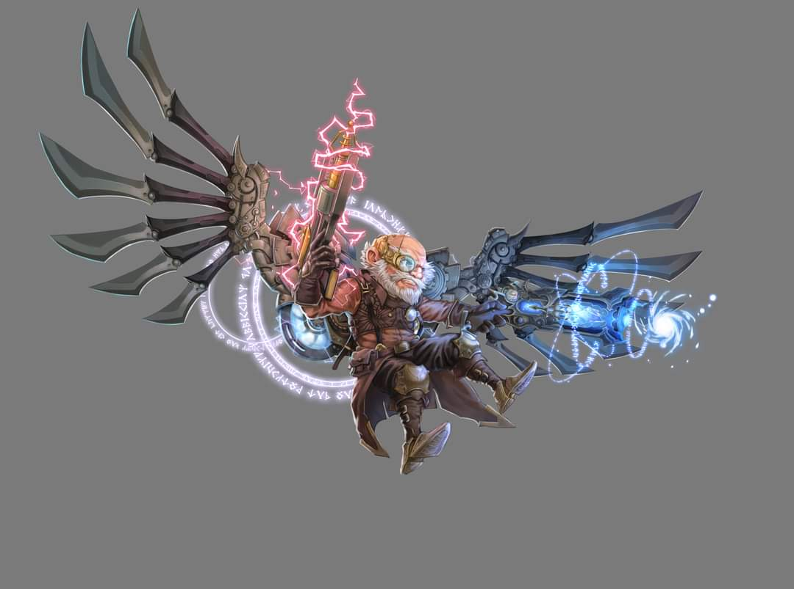

Saradette had been learning from this master artificer a variety of new skills, and augmenting her existing ones, during the last month, and had produced a handful of giant-sized weapons, shields, and other gadgets. She was also working on something for her own use, but had not shown it to anyone but Argent, who advised her on technique and aesthetic from time to time, but pretty much let her follow the course of her own discovery and experimentation.

Luran had been taken in by the citadel’s resident troupe of troubadours—who called themselves the Nimble of the Nimbus—and had learned to play one of their lyres, which he used as a standup harp, fingering the thick strings to produce a baritone arpeggio among the band’s syncopated rhythms and melodies.

Elsabet had inadvertently fostered quite an appreciation from the Queen, and the monarch’s affinity for the wee woman had grown into a relationship characterized by hour-long conversations in the throne room, spanning in subject from the geography of Faerûn—as best as Elsabet knew it—to matters of philosophy and theology. The favored soul was now well versed in the giants’ pantheon, the history behind the ascension of Nicias’ ascension to godhood, which kicked off the lineage of immortal cloud giants among the rest of the cosmos’ deities and demigods.

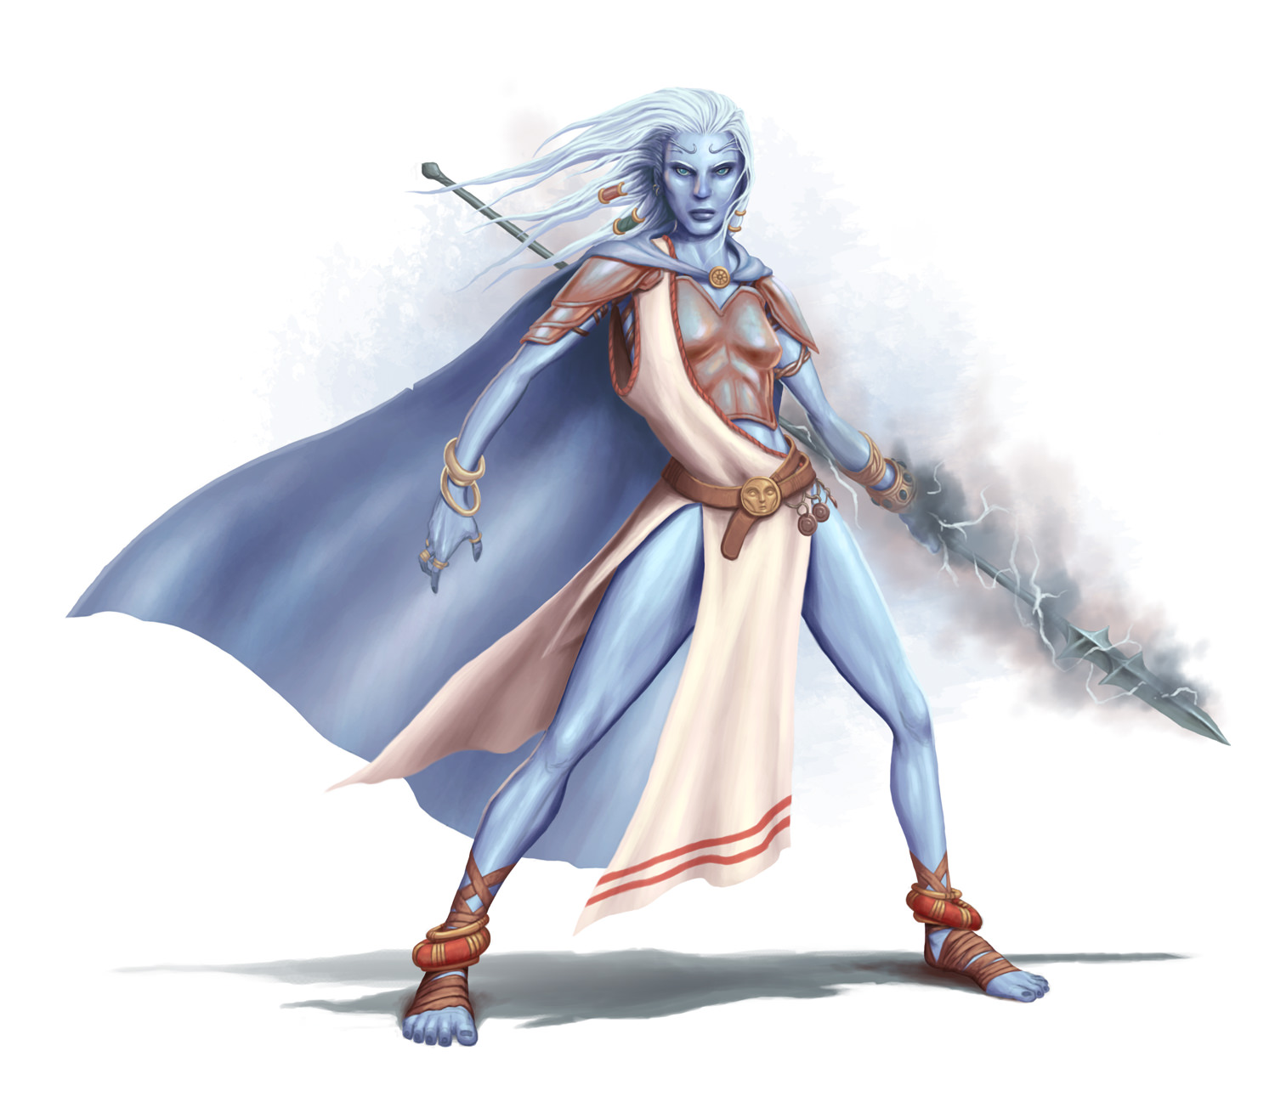

She’d also befriended a ranger-favored soul of Nicias named Anæsthesia, one of the Queen’s most trusted bodyguards, and together they’d trained in the fighting styles of giants and humanoids alike. The crusader-warlock-favored soul of Mayaheine had fostered a worthwhile—and likely lifelong—bond with the warrior woman, and she was honored to have earned a place among the guards as their equal, though she did note the occasional jealous scoff from some of the pettier guards.

Barkley had been making a name for himself among the bards and the rest of the giants as a brewer, distiller, and winemaker, and in conjunction with Luran’s musical prowess, had developed a dance technique that facilitated the winepressing process: namely, the giants would dance inside the enormous vat filled with millions of grapes collected from a vast, sprawling, natural vineyard they’d come across a few weeks earlier, and within an hour, dozens of freshly bathed giants would be swimming in a grape juice that Barkley would later purify and ferment. Aided by one of their arcanists’ ability to accelerate the aging process, wine that would have taken years to be ready for enjoyment was available to all within a matter of weeks, and Barkley had grown quite proud of his accomplishments, partaking in the imbibing of this nectar twice by now.

Much like Saradette and Barkley, Solstice had been placed in a craftsman’s role, serving as a replacement for their now retired alchemist, whose memories and coherence had begun to dwindle and fail. His knowledge of alchemical agents had never been all that keen, but he was able to follow his predecessor’s recipes and formulae to render the reagents and compounds needed to augment the giants’ arsenal. He’d also collaborated with Barkley, mostly in the capacity of a consultant, in the distillery process, and together they’d improved upon an existing recipe for a spirit called mist schnapps.

~*~

In addition to his duties with the band, Luran continued his arcane and academic studies among the giants. The other planar surroundings gave his brain many niches to look into as the group awaited their return to Faerûn.

Luran’s adaptation of the giant-sized lyre for standup use was only the first of his unusual additions to the Nimble of the Nimbus’ repertoire. While his ability with stringed instruments was passable enough, he eventually convinced the other bandmates that his vocals would be a worthy extension of the music they offered. The slightly alien tone of his voice beside the giant instruments did, indeed, create a unique attraction that brought in more of an audience.

One particular new fan of the miniscule bard was a cloud giant of arcane leanings by the name of Dalenn Wellsinger, one of the caretakers of the mystical power source at the core of the cloud island. As Luran’s giant speech gained fluency, the two of them would sit and discuss and debate all sorts of arcane and magical theories and philosophies, after the band’s regular performances. These conversations increased both Luran’s giantish vocabulary and his comprehension of their other planar environment.

A handful of months into the year long journey home, Dalenn let slip that the island’s energies were experiencing occasional, unexplained hiccups and outages. Upon pressing his new friend and mentor, Luran was able to learn for the first time about the mysterious power source that kept so much of their habitat running. At the center of sky island, there stood the Sky Tree, its branches expanding up and out, above a crystalline pool, the Mind Well.

At Luran’s gentle suggestion, Daleen eventually agreed to let the arcane-minded bard have an up close look at this towering centerpiece. The majestic plant was alive with both magical energies and living fauna. The pool below sparkled with life and brilliance. The area around it fairly buzzed with power in the very air.

Dalenn approved Luran’s request to sit and meditate in the space in an attempt to help unravel the mysterious fluctuations in the island’s operations. The bard found a comfortable spot to sit and clear his mind, allowing the ambience of the mystical space to surround and infuse his consciousness. Within the mental realm this infusion created, Luran became temporarily aware of the vast, magical network that the Sky Tree connected to, native to the outer plane of Ysgard. As a part of that network, his finely tuned ears picked out the slightest, most subtle hint of discordance in the sounds and songs of the tree’s inhabitants. The many birds that made the tree their home were seemingly expressing a displeasure that was only evident in their birdsongs.

Able to confirm the bard’s findings when they were pointed out to Dalenn, the giant caretaker approved an unorthodox experiment to rectify the situation.

Settling himself in for a performance that would test his vocal endurance, Luran began an improvised chant that started low, like the roots of the tree, but gradually, patiently reached higher and higher, eventually emulating and interacting with the birds’ whistles and whorbles. As his own utterances found and fluidly blended with their calls, he could feel his influence impacting them. The discord diminished over the hours-long vocalization. When he finally heard their song return to perfect intonation and hold, Luran allowed himself to finally rest his now strained vocal cords. Collapsing from the exertion, the tiny bard was picked up by a grateful Dalenn and returned to his quarters to rest, confident that the island would, once again, flow smoothly along their journey.

~*~

02 Mirtul 1372 I think, close enough anyways. Saradette keeps pretty good track.

Today I ruined a perfectly good chunk of iron, let it cool off too quickly. Well, not ruined, but I had to reheat it and reforge it. The master smith thought it was hilarious, the face I made when I realized what I had done, and his laughter was contagious, so I just chuckled, shook my head and started over. The forges here get a lot hotter a lot faster than I had been used to before; they are fueled by this black rock they call firestone that burns really hot. I singed my braids a bit the first time I got too close. I just don’t have the reach these guys have, but one of them got me a pair of what he called “kid gloves”, which I guess means gloves made for really young cloud giants—they fit perfectly and seem to be nicely heat resistant—along with a similarly sized apron, and now I can get close enough for short periods of time. It is hot, sweaty, exhausting work—I love it. I am curious though, I haven’t actually seen any cloud giant children or even adolescents. They are probably in some area that is off limits. I might ask the Queen about that, if I can do so without being rude. Maybe talk about my own upbringing in the village, and meeting the fey folk of the nearby woods.

03 Mirtul

Findler, the guard who keeps frowning in my direction during weapon drill when he thinks I’m not looking, is beginning to get on my nerves. I don’t know what his problem is, and I am not sure whether I should ignore him or confront him. I can’t get a good sense of what his motives are, why he seems not to like me. Maybe he just resents me hanging out with Anæsthesia so much, maybe he has a crush on her or something. I can’t figure why else he might be annoyed with me.

05 Mirtul

Ow ow ow! Accidentally dropped a hammer on my foot. I’m glad Tony—that’s what the master smith told me to call him, his actual name is a real tongue twister—has a sense of humor, he practically fell on his not inconsiderable ass laughing. Okay, I probably shouldn’t have tried swinging the huge hammer just to see if I could, the damn thing must weight 50 lbs. and my hands were sweaty. Luckily, I didn’t break any bones, a cure light wounds took care of the sprain just fine, and I did NOT piss my pants, I don’t care what the other apprentice says, plus I did win the bet, I was able to swing over my head just fine! It was holding on to it on the downswing that was the problem. I need to think of something equally silly to bet the apprentice he can’t do.

06 Mirtul

Yes! Decided to stop playing it safe and just went all out on the furniture on the hilt for the huge longsword the master smith is crafting, and it came out very nice if I do say so myself. Tony actually said “it will do”, which is pretty high praise, considering the blade is for one of the queen’s cousins. Getting along a lot better with the other apprentice since yesterday, I guess the new nickname “Hammertoe” I got yesterday fits me and I have a new appreciation for how he must have picked up the nickname “Smokebutt”—though I am NOT going to ask. We hung out for a while after work and he said he’s thinking about becoming an armorer as well. He a good guy, if a bit of a wanker at times.

08 Mirtul

Had an interesting chat with Anæsthesia today. It turns out Findler had a younger sister who died as a child, and I remind him of her. So I went over to Findler after practice and got him talking, out on one of the battlements where we couldn’t be easily overheard. Got him to open up, and told him how sorry I was that my presence dredged up sad memories. I have a bit more insight on how to read cloud giant facial expressions now; what I had been taking as annoyance or resentment was just sadness and emotional pain. He also asked why I wanted to work out with them when I was so easily bruised. I told him straight up, I don’t mind a little pain if it leads to learning how to fight better, and ended up telling him about some of the things I’d faced off against. The scariest to me, of course, was that death giant thing, but I told him I was pretty sure that was a mere dream version of the real thing or I would have likely been squashed flat. But he nodded when I explained I would rather die than be a coward and let my friends down. He agreed—said that’s one of the advantages of being a good guy, you know you can count on your comrades to take care of each other, whereas bad guys like the frost giants are more likely to run if they think they are going to lose, abandoning their fellows. It was a good long talk, he’s a lot smarter and wiser than I expected to be honest.

11 Mirtul

Had a good chat with the Queen today. She asked how I was getting along with the guards, and I told her it was going well. I told her about the long conversation with Flinder, he’s one of the younger guards but I told her how impressed I was with his intelligence and insight, and how he missed his sister. I mentioned off-hand that I hadn’t noticed any children around, but figured they were in a separate area. She smiled but didn’t say anything so I just moved on. I suggested that Flinder might be a good one to keep an eye on, he seems like the kind of guy that would make an excellent member of her guard someday, though he doesn’t know I think so or that I planned to recommend him. Just thought she might keep him in mind for future advancement.

13 Mirtul

Tony gave us the day off, I guess he was working on something tricky and didn’t want us apprentices underfoot—literally, in my case. Took a stroll on the battlements. Saw a roc today. DAMN those are freaking big birds!

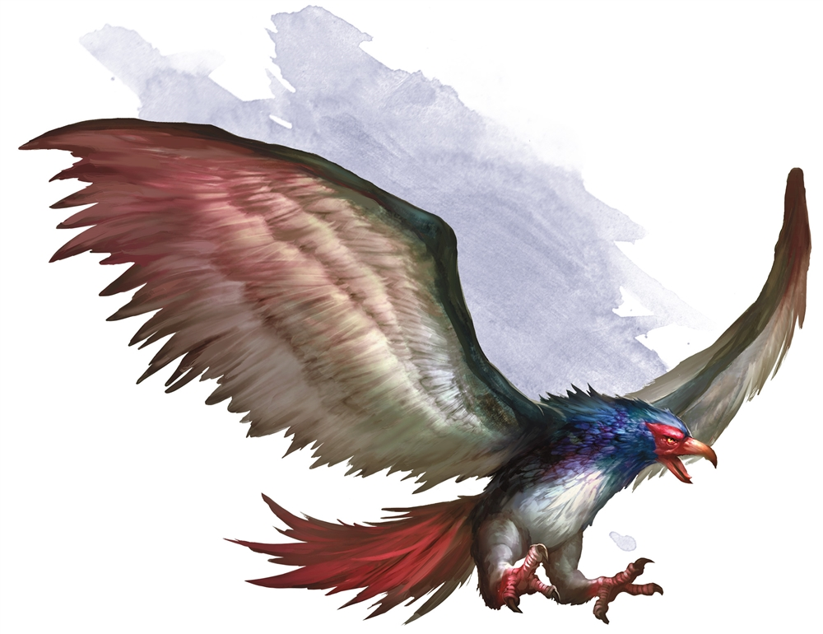

It was pretty far away, and it looked like somebody was riding it, but hard to make out what, something about halfway in size between me and the average cloud giant. Anyways it was pretty awesome. This is what it looked like, though I’m not that great at drawing... <picture of condor-like bird with small, cloaked form mounted ahead of the wings>

~*~

The first few days amongst the giants took a bit of getting used too. The only part that wasn’t odd was sharing a quarter with his friends. Based on the other rooms that they had shared in the past, their new accommodations were palatial.

As Barkley settled into a routine, he became familiar with the techniques used by the giants to make their wines and other liquors. The vast quantities that they made, though not substantial to the giants, boggled Barkley’s mind. If he could produce wine and spirits on the giants’ level, he could get a year’s worth of production completed in a week.

He found that the giants were easy to get along with and were eager to hear his input on techniques as well as recipes. It seemed that they were as eager to learn new customs and techniques as he was, so when the giants tasted his Dragon Fruit Brandy, it was a hit.

With his daytime activity taken up with making wines and spirits, Barkley would often spend his evenings wandering the castle. He would join whatever activity he could. From leatherworking to pottery as well as helping with the rocs and giant eagles that the giants kept as guards and hunting companions. Barkley found the birds to be very interesting and had small conversations with a few of them. He became fond of one giant eagle that the giants referred to as ‘White Cloud’ though he was much more grey than white. White Cloud, after several attempts, finally got Barkley to get on his back for a ride one afternoon. When they returned from that ride, Barkley was glad he had taken the bird he now called Cloudy up on the offer. The view was amazing and the feel of the air rushing by was intoxicating. Barkley had his mouth open and his tongue dangling out the side of his mouth the entire ride.

Another activity that Barkley took part in was the giants’ religious ceremonies. When he could, he would attend and listen to their chants and prayers. Though he was not a follower of their gods, he was interested in their beliefs and rituals. He would often speak with the priests after observing a ritual or hearing a chant that he found interesting or wanted more clarification on. After those talks, he often found himself doubting his own beliefs and his faith not only in his deity, Tyr, but also in the concepts of law and order. It seemed that in so many instances, on Faerûn and other places, that what was right was much less important than what was legal or lawful. Even criminals who were seen killing someone by guards or city officials were let go because they didn’t follow a certain procedure.

Taking the advice of some of the clerics, Barkley spent some time meditating. On occasion, while meditating, Barkley saw images of a man. The man was either out in the forest, or sitting drinking some type of ale. When Barkley mentioned the images to the cloud giant clerics, they suggested that Barkley meditate more and focus on the man in the visions. They said, “If he is a deity reaching out to you, he will reveal himself eventually.”

With the advice of the clerics, Barkley began did just that. He would spend an hour or more each night meditating before he went to bed in the hopes that this strange man would reveal himself. Slowly, the man to reveal himself, though he did it through images, images Barkley was still trying to sort through. He saw visions of animals at first. Then he would see the famous statue of blind justice with its scales. The statue would take off its blindfold and tip the scales, wiping the side of law and order clean.

~*~

Saradette had been learning from this master artificer a variety of new skills, and augmenting her existing ones, during the last month, and had produced a handful of giant-sized weapons, shields, and other gadgets. She was also working on something for her own use, but had not shown it to anyone but Argent, who advised her on technique and aesthetic from time to time, but pretty much let her follow the course of her own discovery and experimentation.

The gnome had set up her work area next to Argent’s shop, complete with a small bunk area in the next room. Most of her work time was spent with Argent, helping him with various and sundry projects their hosts needed. She learned a lot about using hoists, jacks, and work stands, since many of the giant-sized items were too heavy for a gnome to handle alone. Another major advancement for her was in processing large amounts of metals, both in smelting, and in fabrication. The chemistry was the same, but the equipment needed to heat, forge and assemble large metal items was something new.

For herself, Saradette was able to finish a sonic blaster that could disable an opponent, and rebuild her flechette launcher to be both smaller and more capable. The blaster could be wielded with one hand, while the launcher required both hands. The launcher now featured a revolving cylinder that held six rounds, and a longer, single barrel that doubled its effective range to sixty feet. It also had a new air pump and a reinforced air reservoir that could support six shots before reloading, and took half the time to recharge.

She spent some of her time writing down what she’d learned, and applying what she’d learned earlier to the giants’ technology. Her progress in the Giantish language was slow, and Saradette used gestures and bits of languages she did know to get her points across. Argent was a helpful fellow and a good teacher, but he wasn’t attractive to her. Saradette used what little time she allowed herself away from her work to explore the environs around the castle.

~*~

Solstice enjoyed being the smallest resident in the floating fortress atop the icy cloud. His personal and professional development was not quite as punctuated as that of his colleagues from the Material Plane, but he made a lot of friends by offering back scratches, head massages, locksmithing, and other services that exploited his fine motor skills.

He had shadowed some of his friends in their training, brewing, and other endeavors, and was duly wary of Flinder’s reservations about Elsabet until she’d discovered their origin, couched in her likeness to his late sister.

All in all, the first month of their stay on the cloud fortress was pleasantly uneventful, which suited the musteval just fine. His lack of proficiency in the Giant language made it difficult for him to forge any deeply meaningful relationships with the locals, but the universal language of massages made up for any ambiguity as to his intentions, and he was sure that if he’d wanted to, he could’ve scored with Anæsthesia and some of the more adventurous females.

~*~

15 Kythorn

Barkley was accompanying a pair of giants as they were gathering berries and hops from a field for their next batches of wine and beer. While the giants were doing the gathering, Barkley was riding on the back of Cloudy, circling high above. The fields were among the many naturally growing fields in this part of Ysgard, so it did not specifically belong to the giants.

As Barkley and Cloudy circled above, Cloudy spotted a band of ogres approaching the giants. There was a large wall of trees blocking the stealthy approach of the ogres. Cloudy circled one more time before breaking into a dive and let out a loud screech. The ogres looked up, startled by the large bird and surprised by the hound archon that leapt from its back. Cloudy pulled out of his dive as his claws grabbed one ogre, throwing it into two more. Meanwhile, Barkley, with his sword out, fell towards the ground. His sword found its target in the chest of an ogre. The impact of the strike along with the slicing open of the ogre’s chest slowed Barkley enough that he landed without injury, his sword slipping out of the ogre’s chest as it fell backwards, dead.

Looking around Barkley saw three ogres on the ground, slowly getting up, and one left standing. He quickly charged the one standing and was able to dodge his strikes. With two quick strikes, he had sliced open the ogre’s gut with his axe and thrust his sword through the ogre’s throat, finishing off the ugly beast.

As Barkley turned to the other three, Cloudy had just completed another dive. The remaining ogres had turned and began running. A moment later, Barkley both felt and saw why. The two giants he had been with were chasing after the ogres. With their element of surprise ruined and their numerical advantage dissipated, the ogres had no stomach for any further fighting.

Cloudy landed and Barkley hopped back on the giant eagles back. Craning his neck back to look at Barkley and said, “You are one crazy archon,” then gave a series of screeches that sounded like laughter.

~*~

15 Flamerule

[Round 0 and before]

Elsabet watched Flinder walk away down the battlements, appreciating the way his muscles moved. They had just had a fine chat about this and that, while admiring the view out into the wide skies, and he was now continuing on his patrol, while she remained near an entryway back into the interior, planning to go back inside... once she finished admiring the young cloud giant’s back side. She grinned as he turned and waved just before going around a curve.

But wait, what was that? As he turned and disappeared from sight, over 100’ away, she spotted a strange distortion in the air, about 40’ up and 40’ over from the edge of the battlements. The dim outline of a cloud-shaped form nearly 10’ across seemed to be swooping past where Flinder had been without the giant taking notice, and was now heading straight for her. As her surprise wore off, she realised it was some invisible thing coming towards her, which was now only about 80’ away and perhaps 20’ above the battlements stone walkway.

[Round 1; Initiative: E 15 + 4 = 19, IS 10 + 8 = 18.]

Feeling a couple maneuvers being granted to her, Elsabet assumed that whatever it might be, it was likely hostile. Swiftly shifting into her new thicket of blades stance, she called out in common and then the giant tongue, “Halt! Who goes there?” Then, to make sure no foe could take over her mind, she cast protection from evil on herself. If the cloud was evil, the spell would boost her defenses, and in any case prevent any mental control. As she felt a 3rd maneuver granted, she knew she was being tested.

The invisible cloud moved straight towards her, with no response that Elsabet could hear—it was now only about 20’ away and 10’ above the walkway. Perhaps it would try to blow her off the battlements!

Off in the distance, she thought she heard Flinder’s voice call out “What?”

[Round 2; Initiative: F 5 + 1 = 6.]

Elsabet moved back 10’ to get closer to the entryway and, more importantly, away from the battlements and a possibly fatal drop, while drawing her sword. “Flinder, to me!” she yelled in giant, hoping the invisible cloud didn’t block the sound. Figuring combat would be imminent, she cast bull’s strength on herself, and with a swift action then activated her protection devotion, which thanks to her recent experiences had gained slightly in effectiveness. As she felt her 4th maneuver granted, she grinned—her favorite maneuver! She braced herself....

The invisible cloud rushed forward and stopped about 10’ away, and slammed at her with an invisible amorphous blast of solidified air which looked like it was going to smash her down—only to dissipate a foot away from her! It had slammed into the barrier created by her protection from evil spell! A summoned air elemental perhaps? Her knowledge of such creatures was sadly lacking, but it was some summoned thing, that she was sure of. Mostly sure of, anyways.

Flinder reappeared around the curve about 100’ away, and looked puzzled. He could see Elsabet was in a defensive posture, with her blade out, but what was she facing? “What is it, woman?” His voice boomed a lot louder than Elsabet’s....

[Round 3]

The cloud had stopped just out of reach, so Elsabet took a 5’ step forward, used a swift action to activate a charge from her brute gauntlets, initiated her foehammer strike, and took a mighty swing at the center of the cloud. The cloud swirled but could not quite avoid the blade!

<5 + 1 2 = 17, hit AC 17; d10 + 7 + 2d6 = 13 damage; 39/52>

She yelled back to Flinder, “large, invisible cloud creature thing!” She felt her 5th maneuver granted.

The invisible stalker—though Elsabet didn’t know its nature—had specific orders it had to obey, so it focussed on destroying this obstacle that had gotten in its way. The spell the puny priest had cast would no longer prevent it ftom hitting her, since she had cancelled the barrier when she attacked, so the elemental attacked with two powerful slams, but both failed to land, thanks to some other intangible protection.

<12 + 10 = 22, 13 + 10 = 23, vs. 20 + 4 = 24 AC thanks to devotion; neutral so spell no help.>

Believing his ears, Flinder double moved forward until he could smell something strange, and sidle forward enough to determine he was right next to the thing that was attacking Elsabet. He had not drawn his weapon, thinking to slam the thing.

[Round 4]

Elsabet used a swift action to activate a second charge from her gauntlets, and then rather than initiating a strike, used her new-found mastery of basic combat to make a full attack, swinging twice at the cloud. To her surprise, she hit it easily—if it had actual vitals she probably would have slashed deep into them!

<6 + 12 = 18, nat 20; d10 + 7 twice, 10 and 8 (lame!); 21/52>

She felt her maneuvers fade and two new ones granted, nothing exciting, but the full attack seemed like a good tactic to continue with in any case.

The invisible stalker, cranky from having been sent on a long time-consuming and fairly annoying mission by a frost giant, tried again to smash this annoying mortal.

<2 + 12 = 12, 16 + 10 = 26, one hit, 2d6+4 = 10 damage; 51/56, and 5 damage in pool>

Flinder, relying on his nose to sniff out the foe, swung two massive fists in the direction of the invisible thing, but missed wildly!

<50% miss; two swishes, sigh>

[Round 5]

Elsabet used a swift action to activate the last charge from her gauntlets, and with her furious counterstrike, made another full attack, and her first attack would have threatened a critical against most foes, but her second swing went wide.

<19 + 13 = 32, 2 + 8 = 10, one hit, d10 + 8 = 14; 7/52>

As her 3rd maneuver was granted, she felt the residual hurt affect her. <46/56>

The invisible stalker tried once more to take down the divinely protected human, ignoring the cloud giant, launching two more slams of solid air, landing both!

<15 + 10 = 25, 19 + 10 = 29, 2d6 + 4 twice, 9 and 11; 31/56, and 5 damage in pool>

It then tried to shift 5’ away from the cloud giant to avoid its attacks, not realizing that, in her new stance, Elsabet could take advantage of any movement whatsoever to take an attack of opportunity!

Elsabet, her furious counterstrike once again enabled by the new damage, siezed her chance and slashed at the cloud the moment it started to shift—successfully!

<17+13=30, hit, d10+8=12 damage; -5/52, dismissed>

The invisible cloud creature dissipated, leaving behind only a strange odor that slowly faded in the breeze, aided by Flinder’s large fists pummeling the space it had been.

[Round 6+]

“It’s gone,” Elsabet wheezed, as the remaining pain from the last blow hit <26/56>, “hold up a bit while I fix myself up.” Three cure light wounds spells later, only a few bruises remained <53/56>, which she figured to sleep off later. “Who should we report this to? The head of the guard first, I suppose?” Flinder nodded, and they went inside to make an official report of the unidentified invisible creature they had just fended off....

~*~

15 Eleasis

Over the months, Luran had come to treasure his time spent at the base of the Sky Tree, meditating, gaining kinship and connection with the various beings and entities that made the towering timber their home. He would regularly commune there, at varying times in the day. Little did he know that one particular nighttime trance would prove to be his biggest challenge of the journey, yet.

Having decided to attempt a full night’s vigil, the bard set out his space, preparing for the event. Unbeknownst to him, far, far above, at the peak of the Tree’s branches, a sliver of interplanar portal was starting to seep its way into the air, there. The neighboring plane of Limbo was encroaching in a small, but stable spring of chaos energy, drawn to the magic of the Sky Tree beneath which Luran sat this night. Simply sparking and occasionally snapping and popping, the unusual phenomenon stayed mostly unnoticed, at first. Only a small handful of birds trembled slightly in their nocturnal rest and one owl, at the very top of the branches hooted righteously. Below, the bard’s quiet meditation began, all the while unaware of what else was transpiring.

The burgeoning hole in reality continued to sizzle and spark with a chaotic spectrum of light, color and energy. As it reached a peak in its activity, a bolt of stochastic, transformative power shot out and down the length of the Sky Tree’s trunk and branches. Its journey down the tree ended as it struck a slumbering squirrel in its nest, a number of yards from Luran’s contemplative consciousness.

The sound of splintering wood and startled screeches brought the half-elf out of his revery. The screeches descended in tone as they became deeper and more growl like. The splintering increased until the now transformed (and greatly enlarged) tree denizen crashed to the ground, now awake and quite angry.

Seeing the aggressive intent in the creature’s eyes, Luran was quick to take a suitable, answering stance, although he was fully aware that any support of a more martial nature was far from immediately available. He determined he would need to deal with this development on his own, at least for the time being. While most of his equipment was back in the companions’ room, he still had his dagger on his belt and quickly pulled it free for use.

The bard’s reflexes were no match for his quick moving foe, however, as it leaped toward him, jaws wide. Smashing into the skinny bard and chomping down on his unarmored shoulder, the rodent’s first attack set Luran into survival mode, as an incredibly uncomfortable amount of his lifesblood flowed from the wound.

Knowing he would do far better to focus on his arcane abilities than his melee mastery, Luran staggered a step back and first attempted to blind the rampaging mega-rodent with a casting of glitterdust centered far enough back to just hit the dire chaos squirrel (now the size of a bear, incidentally!) and avoid his own eyes. The magic went off just as the monster was readying its next attack. As such, when it snapped and clawed at the bard, its scream was filled with impotent rage when its sight was taken from it by the stinging glitter that covered a 20’ wide circle.

Thanking Tyr and His triad that his first action in the combat was successful, Luran avoided the massive squirrel’s gnarly, gnashing incisors and enlarged claws in its stumbling attempt to harm him. Hoping to further impede the creature, Luran readied his next arcane attack, praying he would be able to continue one step ahead. Luran shot magical grease at the ground under the thing’s feet as the next part of a divinely inspired plan took shape in his mind.

A few weeks ago, the flying island fortress of the cloud giants had visited a Ysgardian community of winged elves, named avariels. Meeting them and seeing them effortlessly soaring through the skies had inspired Luran to attempt something with one of his, thus far, lesser used spells. This moment gave him the opportunity to try his own hand at winged flight. As the enlarged, enraged squirrel slipped and slid on the magical lubricant, its eyes still stinging and blinded, Luran cast alter self, transforming into one of those graceful, full elven humanoids he had come to respect and admire. Testing his new wings and lifting himself into the air, the bard stumbled a bit, getting used to the new mode of locomotion. Not having enough mastery to hover, he realized, Luran set his new form on a spiraling pattern, approximately fifteen feet above the now thoroughly vexed creation of chaos below.

Completely confused by its blindness and the inability to move without falling flat, the massive creature lashed out in all directions, jaws snapping shut on air and claws rending nothing. Confident in his new, unrecognizable form, Luran awaited the next part of his plan to come. In just a few short moments, the glittering dust that blinded the dire squirrel cleared and the rage filled rodent looked around for his erstwhile foe. While the creature could not lay eyes on the magical menace any longer, a powerful, yet soothing voice projected down on it from above.

Having finally mastered a new, powerful enchantment, Luran attempted to put the dire squirrel under his sway with his first casting of charm monster. Knowing it would work better from someone the bear-sized rodent did not immediately recognize as a threat, Luran counted on the creature’s confusion at his new face and form. He shifted his voice to a much deeper register than he had previously used, laying the magical manipulation down with one final, internal prayer to his good gods.

After a heart stopping second of uncertainty, Luran watched the squirrel’s entire demeanor calm and turn placid as his spell caught hold. Landing somewhat gracefully (though wincing severely at the heavy wound from the first round’s attack) Luran reached a hand out to reassure the creature. It eagerly stepped toward him, seeing him as a friend.

While he had reached a peaceful resolution, he was nonetheless overjoyed to see his cloud giant, Dalenn, rushing to see what the commotion was. With the giant’s help, the half-elf was able to keep the magically altered rodent calm until the strange energy from Limbo dissipated on its own and the squirrel returned to its normal, diminutive size and demeanor. Thankful he had been able to end the emergency without harming the innocent creature itself, Luran finally allowed himself to relax.

~*~

15 Eleint

Saradette sighed and leaned back in the almost-too-warm spring water. She closed her eyes and willed her aching muscles to relax in the steaming water. Stratus, her cloud giant friend, reclined in the deeper part of the pool, where he’d gingerly lowered his eighteen-foot-tall body into the water so as to not wash Saradette away. He was one of the apprentices in the giants’ shops, and, over time, they’d gone from strangers to friends. Saradette closed her eyes for a moment, imagining what “more than friends” would be like with a man his size. She smiled at the mental picture.

“What is it?” Stratus asked.

“Oh, nothing,” Saradette smiled at him. “I have odd thoughts sometimes.”

“So I noticed,” the giant’s soft laughter rumbled back at her like distant thunder.

The gnome laid her head back against the rock that Stratus had so thoughtfully arranged in making her a private hot tub. She took a deep breath, and she started to drift into slumber.

All at once, she was underwater, and her leg cracked painfully against something. She instinctively held her breath, and then she was rolling across the ground. After being battered for a few more seconds, the motion stopped, and she lifted her head. She was fifty feet from the pool, where Stratus was in a desperate grappling match with a fire giant who was armed with a huge axe! Water sloshed everywhere as Stratus tried to hold his opponent in the water, while the fire giant tried to break his grip.

Saradette looked around, and spotted her clothes lying where she’d left them – and where she’d left her experimental sonic blaster. It was still more a project than a weapon, but, as she watched, the fire giant began to overmatch Stratus. She picked up the blaster, and ran for the giants. As she drew close, Stratus took a vicious blow to the jaw from the axe’s haft, and he fell to his knees. The fire giant grinned evilly and lifted his axe high, intending to strike down Stratus.

Saradette skidded to a halt, lifted the weapon, and pressed the activating lever. The device hummed loudly, and the fire giant dropped his axe and clapped his hands over his ears. Stratus struggled back to his feet, and Saradette shot the fire giant again. This time, he let out a howl of agony, turned tail, and ran away with earth-rumbling strides.

Stratus picked up the fire giant’s axe, and climbed slowly out of the water. He strode over to Saradette and knelt in front of her. Even on his knees, he towered over the diminutive woman. “Thank you, Saradette. He nearly had me.”

“I’m just glad this thing actually works,” Saradette said with a grin.

~*~

15 Marpenoth

The seasons on Ysgard inversely coincided with those on the Material Plane. Argent had schooled Saradette and some of her friends on this phenomenon—which was really rather simple in nature—shortly after they’d arrived, and now, as cities like Neverwinter and Waterdeep experienced the first bouts of snowfall and the icing of the shorelines to their north, the whole of Ysgard seemed to melt under their floating fortress. Snowmelt from glaciers and mountaintops fed the streams, brooks, and tributaries that trickled into the main waterways that irrigated the countryside, and valleys previously coated in layers of blue and white now grew verdant, peppered with flowerbeds across the plains and valleys. Fields of spice and lilies were now commonplace across the panorama below the clouds, and their sweet and heady scents wafted upward, driving the cloud giants into joyous bouts of dancing and frolicking as spring peaked and receded to early summer.

The frosty cloud at their feet also melted, and the previously icy firmament that sustained the stone-masoned fortress became more of a padded foam atop which the giants and their humanoid guests could bounce like children celebrating their innocence. Tribulations had come and gone over the last few months, and each of the protagonists of this story had proven themselves beyond the shadow of a doubt. Having spent half a year on this floating island, the Fist of Light now felt themselves as truly integrated into the clan of a hundred or so giants whose hospitality they enjoyed, and if they were to leave this place once a year of service had been carried out, it would be with a bittersweet sense of longing to bring some of their newfound friends with them.

Nostalgia was the bane of all adventurers, however, and the Agents of BLESS—as they sometimes informally referred to themselves—were glad that at least their floating home could pass over the shifting topographies and biomes that separated each Ysgardian metropolis from the other.

Over the course of the last few months, Barkley had abandoned the notion that Law was greater than Justice. His take on life had been nuanced not only by the shortcomings of the Barony of Mintar—whom he had witness collapsing under an unquestioning submission to procedure over reason—but also by the palatable arguments that more than a few of the giants had posited in casual parlance and more focused discussions and treatises.

The Queen herself ruled by virtue of righteousness, and without a formal body of legislation, and in time, Barkley had come to view the written word as deficient in its capacity to contain all contingencies and address all the complexities of sentient conduct and consequence. The Queen’s advisors provided intertwining layers of logic and reason, and the archon noted the monarch’s penchant for trying to find ideal compromises within the various tension points in her advisor’s viewpoints. This was far more manageable in an isolated community floating atop a more complex and populated world, but even the world over which they floated was ruled by chaos, and sustained by the well-meaning lifeforms—sentient and otherwise—that roamed its surface.

All in all, Barkley felt that living among those who ubiquitously placed Justice before Law had been a salutary experience for him, and though he still revered Tyr as much as Luran did, his take on Tyrian tenets had been significantly watered down, and was now much more in line with the half-elven bard’s interpretation of how Good should be promoted, and how heroism was to be carried out.

Elsabet had often, when not engaged in her official duties, continued visiting the Queen to continue their conversations, and would stand quietly off to the side observing the cloud giant monarch in action, impressed with her diplomatic skills and how she used her knowledge of the individuals involved to help craft her rulings, such that the most common result of her resolution of differences managed to leave both sides feeling they had been fairly treated. She resolved to learn more about the rulers—both monarchs and nobles—of her own realm, upon their expected return to Faerûn, for she too valued Justice higher than Order.

When the Queen was free to chat with her, Elsabet inquired as to how she could learn to keep so much information about everyone in her head, and the Queen chuckled. “Time and practise, and attention to details, little one,” she answered, “and a true care for the welfare of others.” Elsabet decided that should she need to solve conflicts between others, she would ask herself, ‘what would the Queen do?’ and try to act accordingly. Later, she engraved WWTQD on the side of her cold iron spiked knuckles as a visible reminder of that thought.

Solstice and Saradette had felt at home here since the onset of their stay. Both being almost fanatically drawn towards Chaos, the two folks relished the departure from the rigidity of the Lawful Barony of Mintar, and other polities they’d frequented while on the Material Plane. They—too—longed to return to their home plane... in time... but for the duration of their stay, both had enjoyed their tenure here more than the rest of the Fist.

Argent had trained Saradette well, and in the last few weeks had given her a freer rein over his workshop. This was very well received by the Dalelander, but she also wondered where her mentor spent much of his waking time now that he was absent from her workstation. He would occasionally come in to look in on her progress, and offered a kind word of praise, or a thoughtful phrase of caution or advice, but something itched at her curiosity as to his whereabouts and doings.

On one occasion, she mustered the courage to ask him, though she felt it was not her place to question the master of artifice who had taught her so much in so little time. Nevertheless, he did not take it as a breach in decorum, and answered that he had secured a secondary space for his own research and manufacture, allowing her more space in which to work and experiment. However, though enough was said to quench her curiosity, it seemed to her that even more remained unsaid. What was he working on? What manner of discoveries was he making, and would he, in time, impart this knowledge on her, or would she have to someday do the same in a laboratory of her own? She only had six moons or so to go before her internship here would conclude, and wondered what would transpire afterwards, and the curiosity gnawed at her peace of busied and active mind.

Her knowledge had increased by leaps and bounds under Argent’s tutelage and mentorship, and at times the master even admitted that her insights were duly taken, and informed his own hypotheses and philosophy. He was a Gondar by faith and upbringing, but in the last few months had come to quote some of Saradette’s Mayaheinite jingles and proverbs.

~*~

4 Uktar

Since his realization of winged flight through his spell alter self, Luran would frequently look for opportunities to join Barkley and Cloudy, soaring through the divine skies of Ysgard beside their sky-bound, temporary home. This bright dawn brought them, all three, to a majestic view of the surrounding plane. The weather in their vicinity was clear enough that Luran could make out several similar earthen rivers and earthbergs that made up the flowing, chaotic outer plane.

At Barkley’s prompting, Cloudy took a spiraling swoop that purposefully crossed over the distracted half-elf’s ariel path. Shocked back into his immediate surroundings, Luran laughed, having sky wrestled like this with the other two, before. He pumped his wings as hard as he was able to rise up and attempt to gain some advantage in the made up game of almost tag they had enjoyed a few times before on these airway tours. The three dimensional strategy of the game pushed his instincts in a direction different than the melee lessons he had been enjoying with Elsabet, in the evenings.

Catching sight of Cloudy and Barkley coming around in a circle, also elevating, Luran tucked his wings and dove down in what he hoped would be a deft move just to the side of the giant eagle’s own path. Unfortunately, the bard’s intent was not perfect and the resounding THWACK as he slammed directly into the others shook him from his crown, down his spine. Barkley woofed at the bird-boned bard he suddenly found in his lap.

Barkley shook his head then turned his attention to Cloudy, asking the giant bird if he was OK. Cloudy replied with a series of loud screeches that Barkley translated for Luran. “Cloudy is fine but not happy. He asks if you are able to fly. If not, he will need to set down for a couple of minutes. He cannot carry us both for long.” Barkley then patted Cloudy’s neck as he waited for Luran to reply. He hoped that the Bard had not been injured, or they would all need to rest for a few minutes.

Scrambling to regain his composure and bearings, Luran replied, “No, no, I’m fine. So sorry, Cloudyyyyyyyy!” The last bit stretching out as he rolled to the side and leaped off the giant eagle’s back, soliciting a shake of relief from the bird and a shake of the head from Barkley.

Sufficiently embarrassed by the airborne fumble, Luran took a much more relaxed path upon the winds, beside the pair. “Well, fun’s fun. Feels like it’s time for breakfast, friends!” And having recovered from the thankfully non-damaging collision, the trio turned back to their floating fortress island to officially start the day.

“OK, Cloudy, let’s show him some basic maneuvers,” Barkley urged the giant eagle. With that, Cloudy let out a loud screech and dove after Luran. After passing the bard, Cloudy pulled up into a loop. At the top of the loop Barkley let go and went into a free fall. For a moment, Barkley rolled over to look up at Luran as he continued his fall to the ground below. After a couple of seconds, he rolled back over and Cloudy swooped in under the Archon, catching him on his back once more as the pair banked and twisted before climbing once more to reach Luran’s altitude.

“Tyr’s Holy Hand, Cloudy! You’ve been taking it easy on me, haven’t you! Hahah!” Luran exclaimed in response to the talented avian’s display. Spirits lifted from the playful start to the day, the bard let loose with a rousing rendition of a relatively well known hymn (well known amongst Tyrians, anyway) that overcame the wind in his companions’ ears. As his song drove them home, Luran was happy and appreciative of how his life had found meaning and friendship among these divinely chosen adventurers. ---

Later that same morning, Luran approached Saradette, in her workshop, and asked what her thoughts were on crafting a three dimensional model of the heavens with his guidance and design. Not realizing the request was a little outside her usual frame of reference, it took the excited bard a moment to realize she was looking at him with a blank stare of non-recognition before she interrupted him and responded.

Saradette put down her calipers and lifted her magnifying glasses, perching them in her hair like a headband. She wore a light leather apron over her customary sleeveless blouse, along with heavy linen pants and low boots. “I understand the terms, but I don’t understand what it is you want.”

Luran gladly launched into a rapid, sometimes rambling, always entertaining lecture on astrology and the moving parts, both figurative and literal, of what he was asking her to make.

Saradette reached under her worktable and pulled out a leather folder. Within were several large sheets of blank paper, and she removed one and spread it out on the table. She produced a stylus – a charcoal stick in a metal holder – and began to sketch as Luran talked. Finally, she looked at the bard with a smile. “I think I can do this. Give me a few days to work on it.”

Luran left the industrious gnome to her work, looking forward to the advancement in his astrological guidance the new tools would give him, once they were back on Toril firma.

~*~

The rest of the day was largely an idle one for the bard. After midday, he ran into Dalenn and shared his earlier moment of clearly viewing their plane’s geography, something that the arcane cloud giant had been helping Luran get a handle on mentally. Ysgard’s spot on the chaotic spectrum of the Great Wheel of the outer planes was where its ever-shifting and moving nature got its beginnings. Luran had also been picking the giant’s brain for further understanding regarding some of the other planes, as well. His grasp on it all had been gradually strengthening from their talks.

The afternoon consisted of continuing work on his magnum opus, the praise and explanation of music as a divine, fundamental, benevolent force of creation. He mused that while there was every chance this work may be many more years from completion, his inspiration raged just as strong as it did when he was first struck by the vision, so many years ago. The goal wasn’t what supported him, but rather the continual teasing out of this truth.

Realizing he had let time get away from him, Luran jumped up, gathering his papers and pens, rushing back to the group’s quarters to meet with Elsabet for their regular training time. The sword maiden had taken it upon herself to be certain that the party’s bard would be able to inspire not only with this song, but his actions in combat, also. In truth, Luran enjoyed his time with the warrior woman a great deal and had become quite fond of her and (today’s near tardiness aside) looked forward to these sessions of theirs.

When he returned to the room the cloud giants had set aside for them, Elsabet was there, smiling warmly as he entered. Luran admitted, “Sorry, I almost let it slip by me, today! I was making such progress on my symphony that time nearly got away from me!” The arcane-minded musician then shared a bit of what he had worked through, that afternoon. Elsabet had shown an interest in Luran’s beliefs and magical, musical thinking from his first mention of it. He had introduced her to his views that night in the inn in Mintar the two of them stayed up, after the others, getting to know each other for the first time.

Today’s revelations had been centered on the vibrations at the core of all things (even inanimate, seemingly “dead” materials) that different pitches and tones interacted with on a subtle level. He had managed to put his deeply philosophical, ephemeral ideas into a rather clear, concrete framework that he was happy to see sparked immediate understanding in Elsabet’s expression.

Elsabet enjoyed watching Luran launch into his explanations, it was fun seeing the unbridled enthusiasm in the bard’s voice and facial expressions. It was a side of him that had attracted her attention soon after he had joined the group, and over the past few months, starting with the final events in Mintar, she had watched him become more confident in his thinking and his beginning to master the secrets of the branch of musical magic called ‘lyric thaumaturgy’—which when you thought about it was just a fancy way to say musical magic. She followed along as best she could, and managed to ask a couple relevant questions, which he quickly answered. His lips threatened to distract her for a bit but she managed to stay focused, it really was interesting, and she compared it to the divine magic Mayaheine had granted her, as well as the eldritch magic she had discovered in her own bloodline.

Once he ended his tale of the day’s endeavors, the two moved on to the area they had blocked off for their training sessions. “You’ve shown some good progress in general combat capability, Luran. But, I want to work on getting your movements in combat a bit more versatile, as we move forward.” With that in mind, the two worked hard on the bard’s basic understanding of tumbling, jumping and rolling through the battle scene with what dexterity he had. While certainly not the gymnast or acrobat that some other bards were, the half-elf was able to do some small amount of the tricks they were known for, if not to the level those other entertainers achieved. In fact, with her tutelage, Luran already felt more confident with some of those actions.

Elsabet complimented Luran on his progress—his tumbling skills had, in fact, eclipsed her own, once he applied himself, and she said as much. “One of these days I will need you to help me improve my own tumbling skills—it is always easier to see the mistakes others make than it is to see one’s own, I will happily submit to your tutoring when I get the chance.” She winked at him.

The mutual exertions of their training over the months had created a physical intimacy between the two that gradually evolved to a flirtation and eventually a casual, non-exclusive sexual attraction between them. As such, it had become not uncommon for them to spend additional, more intimate time, later, after cleaning up and sharing dinner with their companions and giant friends. This day had been a good one for Luran, prompting him to inquire whether today was a day for such “personal time” at the end of it all. Elsabet’s eager grin told me all he needed to know for an answer.

“I think we can fit in a little more exertion tonight,” she replied. “Perhaps you’d like to sing me that little ditty you’ve been working on, it sounds... intriguing.” She grinned even more widely, looking forward to just a bit more exercise....

~*~

15 Deepwinter

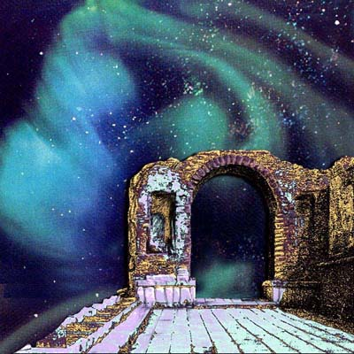

It was a clear summer night over Ysgard, and the ice that constituted the foundations of the cloud fortress had all melted by now, leaving behind a puffy material that was just as sturdy under the pressure of the stone masonry, but was quite elastic and conducive to bouncing games during the summer months.

It was Deepwinter, which earned its namesake on the northern hemisphere of Toril, while here, the name was often pronounced in jest. Luran himself had just finished writing a sonnet that spoke to this temporal misnomer, and with each passing day, the bard felt more and more at home recanting his odes and lyrical treatises among his cloud giant friends.

The portal to the Beastlands through which the heroes had first come to be here had by now been fully repaired, and though they’d joined the giants on a few hunts there, there was no way of returning to Mintar from that placid place. Indeed, the region was so rich in wildlife that the giants considered it the source of their mainstays during the warm season, which coincided with Ysgard’s.

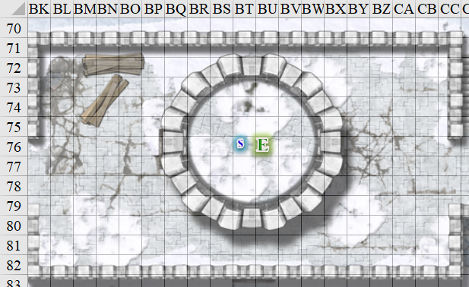

Elsabet and Solstice were lounging under starlight while Saradette and Luran fidgeted with a string instrument that the artificer had just modified for the bard. It was a miniature lyre—according to the giants—but for him, it was more of an upright harp, and now that Saradette had just finished retuning it, Luran went ahead and plucked a few bars of an arpeggiated melody that he’d composed as an accompaniment to his current ode.

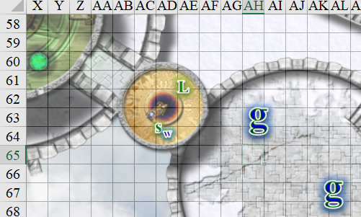

“Here I sit beside my soul
I’ve learned enough to survive
Listen to your conscience and you’ll
Stay alive…”

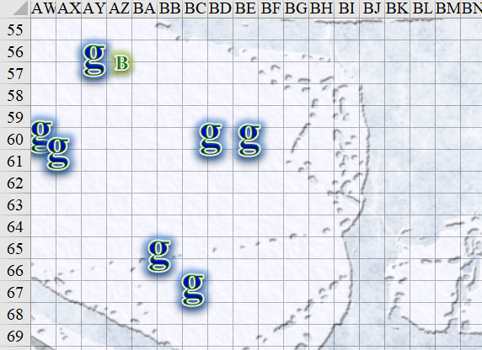

Barkley had brought some barrels of wine for the occasion, which could now be said to comprise about 20 adult giants who frolicked and bounced atop the clouds like innocent children.

The festivities had been in effect for almost an hour when a dutiful lookout blew a horn and announced, “Incooommiiiing!”

In the starlit darkness, the incoming figures had not yet been fully identified, but what Saradette’s night vision could confirm was that it was at least four giant sized people, each riding atop a winged dragon. They must have been 2000’ away still, but at this speed, they would be upon the fortress within less than a minute.

Widget clung tight to Saradette’s leg, fearing that the evening would end in much bloodshed. Most of the giants were unarmed and unarmored, and the few ballista operators atop the towers were ill experienced, so it was likely that at least some of the strangers approaching from the south would reach the fortress and wreak havoc on them.

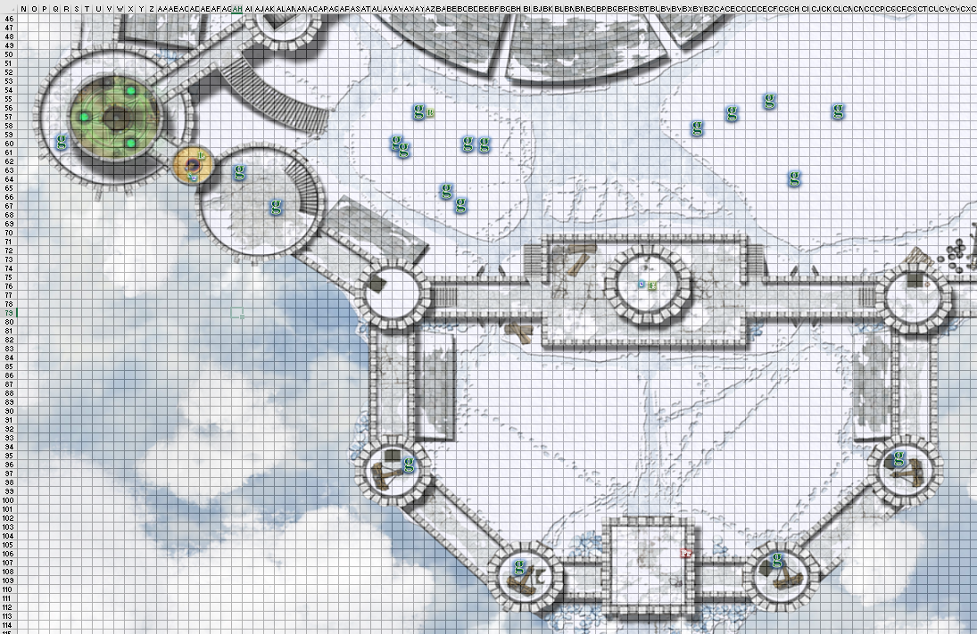

Round 1

Elsabet, remembering seeing what looked like a pile of rocks not far from where she was perched, moved to the north parapet of the building, pointed to the pile off near the wall to the east, and called, “Get ready to rock, guys!” She then turned towards the incoming fliers and tried to identify the type and size of the dragons and the nature of their riders.

Without further clue as to the incoming individuals’ intent or the giants’ judgement and response, Luran could only await such enlightenment.

Saradette ran to get her weapons.

The ballista operators had—of course—already loaded their defensive artillery, and now aimed at the incoming quartet of dragons and their giant riders. “Hoooold,” the lead siege engineer instructed his team, gauging the distance to make their first attack moot.

The other giants began to scramble to and fro, and some went for the armory where an assortment of morningstars and longbows awaited.

Hearing the alarm, Barkley rat to his quarters as quickly as possible to retrieve his weapons, resolving to head back to the top of the wall to help the giants defend against the incoming threat.

Solstice would do his best to detect magic and evil once the dragons and their riders got close enough. For now, he became invisible and stood atop the tower’s crenellation, bracing for the worst and hoping for the best. He then drew his blowgun.

The four dragons were about 1400’ south of the cloud fortress now, and about 100’ higher.

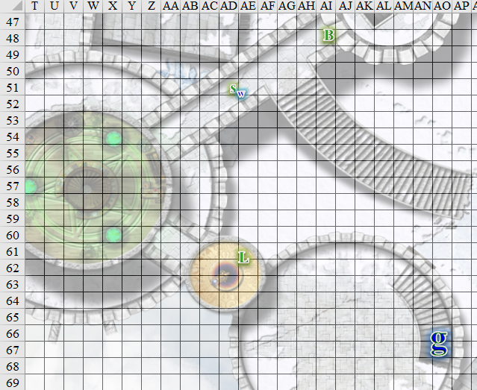
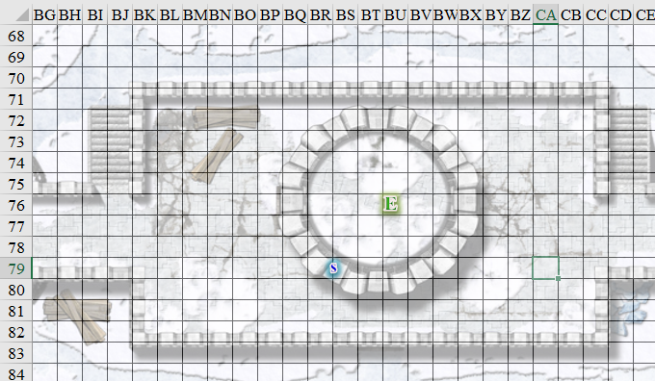
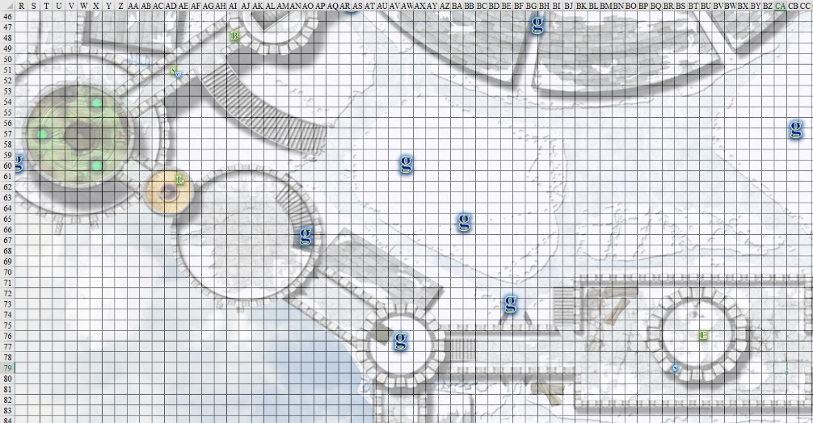

Round 2

Solstice loaded his blowgun with a single pellet, watching the dragonriders approaching at top speeds.

From his position, Luran could tell that the dragons were shadow dragons, and were probably mature adults. This spelled utter disaster for the likes of any of the agents of the Fist of Light if they were to confront one head-on. Furthermore, the riders were surely giants of some sort, but from this distance, the bard gauged them to be slighter than the cloud giants, which—if they were adults—ruled out most types of giants. Could they be goliaths perhaps? If so, they would have traveled a great cosmic distance to reach Ysgard, particularly with a pack of shadow dragons.

Luran also second-guessed himself, knowing that under any conditions other than full daylight, these dragons would have been almost entirely concealed, but he was at a loss as to what they might have been.

Elsabet was far less familiar with dragons than her half-elven friend, and suspected them to be white dragons, and for all they knew at this point, that might have been correct.

Barkley, Saradette, and Widget continued to run to their quarters in order to retrieve their weapons.

The dragons were about 800’ south and about 50’ above the cloud fortress’ southern edge.

The grenadier commander identified the assailants. “Frooossssst giants incoming! Fire upon them!”

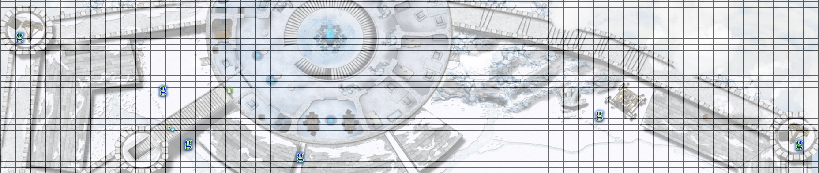

At their grenadier commander’s command, the ballista operators fired upon the four dragons.
Character | Attack Type | Damage | BAB | Dex Mod+ | W+ | Other+ | Total Score | Roll | Total
Cloud Giant, Ballister | Ballista +1 | 3d8+1 | 12 | 0 | 1 | -12 range -2 height | -2 | 3 | 1
Cloud Giant, Ballister | Ballista +1 | 3d8+1 | 12 | 0 | 1 | -12 range -2 height | -2 | 13 | 11
Cloud Giant, Ballister | Ballista +1 | 3d8+1 | 12 | 0 | 1 | -10 range -2 height | 0 | 11 | 11
Cloud Giant, Ballister | Ballista +1 | 3d8+1 | 12 | 0 | 1 | -10 range -2 height | 0 | 1 | 1
Cloud Giant, Ballister | Ballista +1 | 3d8+1 | 12 | 0 | 1 | -8 range -2 height | 2 | 17 | 19
Cloud Giant, Ballister | Ballista +1 | 3d8+1 | 12 | 0 | 1 | -8 range -2 height | 2 | 15 | 17
Miss⁶.

“Reloooaaaaad!” the lead siege engineer commanded, manning one of the ballistae himself.

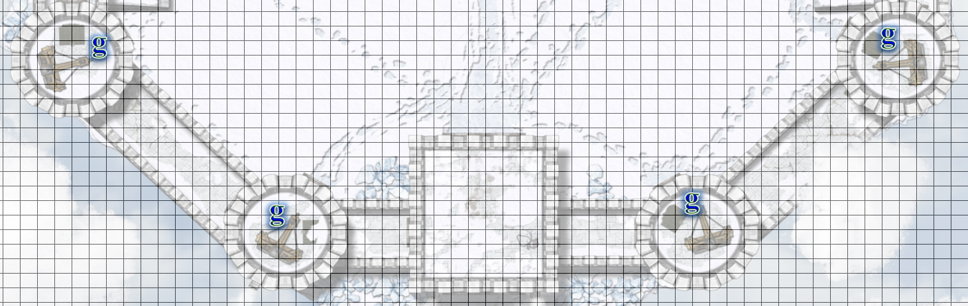

At this distance, and with his vision, Luran could now confirm that the dragons were indeed shadow dragons, though they were not concealing themselves as a typical specimen would have. Furthermore, their riders were not goliaths, but adolescent frost giants who looked intent on executing an all-out assault on the fortress. Waving greataxes—and one with a heavy crossbow—they guided their dragon mounts downward still until they were on a collision course with the southern portion of the fortress. Elsabet could guess that they none of them were coming directly for her.

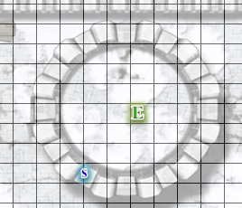

Barkley entered the main hall and Saradette rushed to do the same, though she and the raccoon were slower of foot than the archon.

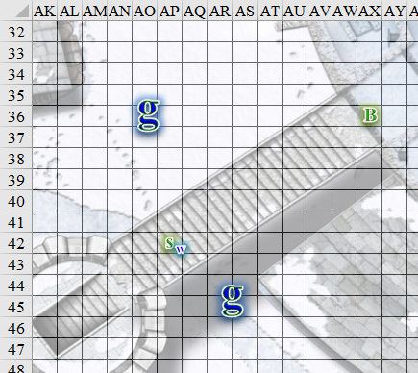

Cloud giants were now dispersed throughout the surface of the cloud and fortress, and some had grabbed what weapons they could—mostly morningstars and rocks. If roc mounts were going to be deployed, they would likely be mounted soon enough.

Elsabet cast protection from evil [expired on Round 42] on herself, then moved over to take cover behind the crenellation Solstice, whose invisible form was visible to her, stood on, and asked the musteval “do you want a protection from evil spell?” She hoped the crenellation would give her total cover from any breath weapon the dragons might send her way, or at least partially protect her.
Elsabet gained +2 to AC and Saves vs. evil creatures.

In the midst of the incoming giants and dragons, the now invisible Solstice answered, “No, I’m able to do this for myself,” meaning that he had the innate ability to bestow this protection unto himself, “but thank you.” Her magical vision could also read in the invisible musteval’s body language that he was about to cast another spell of some sort.

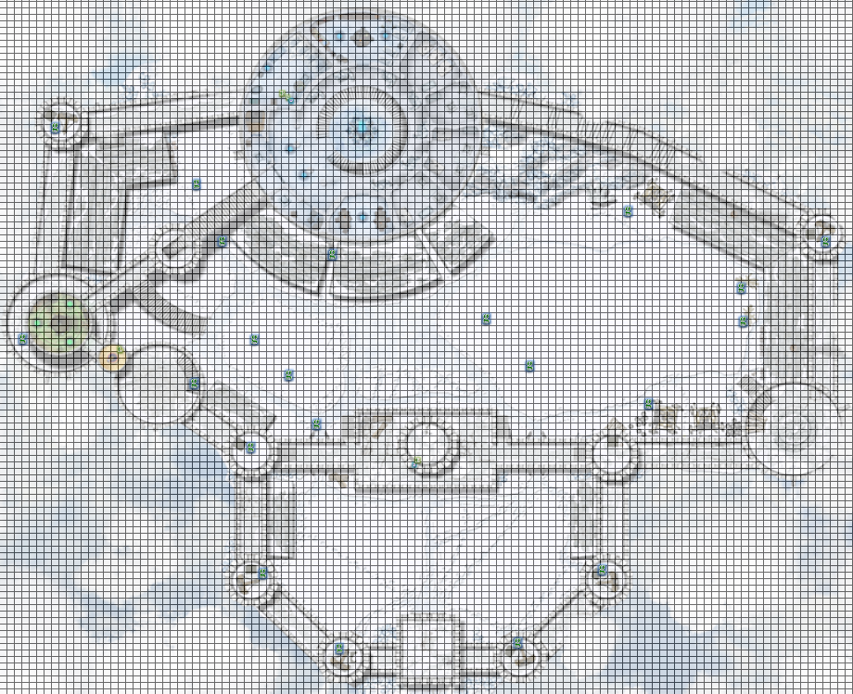

Round 3

Barkley, Saradette, and Widget were now inside the fortress, and could not see what has happening outside.

The dragons were now about 250’ from the southernmost ballistae, and all ballistae were now being reloaded. This blunder in timing might prove to be a decisive error on the siege commander’s part, but the giants on the cloud and stone atop it might save the day after all.

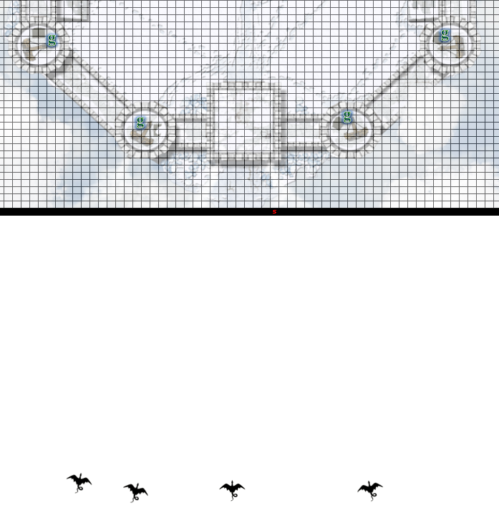

With the drakes that close to home, Solstice placed his blowgun to his lips, but did not yet waste a shot that would likely miss. Within seconds, he anticipated that at least one dragon would be nearly directly above him, and prepared to turn his gaze and aim upward to fire a pellet into the underbelly of one of them.

The ballistae were now reloaded and ready to fire once again. The engineers anticipated their enemies flight paths, and aimed carefully, not yet releasing their spear-sized volleys.

Elsabet cast divine favor [expired on Round 13] on herself, figuring she needed all the help she could get, and then got her crossbow out; the giants might actually be hittable.
Elsabet gained +1 to BAB and weapon damage.

With a complex manipulation of his hand and an intoned word of power, Luran prepared for mobility in the coming conflict by casting alter self, transforming into his favorite, second skin, an avariel with his facial features (though extended to full elfin grace.) His raven wings (to match his hair) shook in preparation to move him across the battlefield.

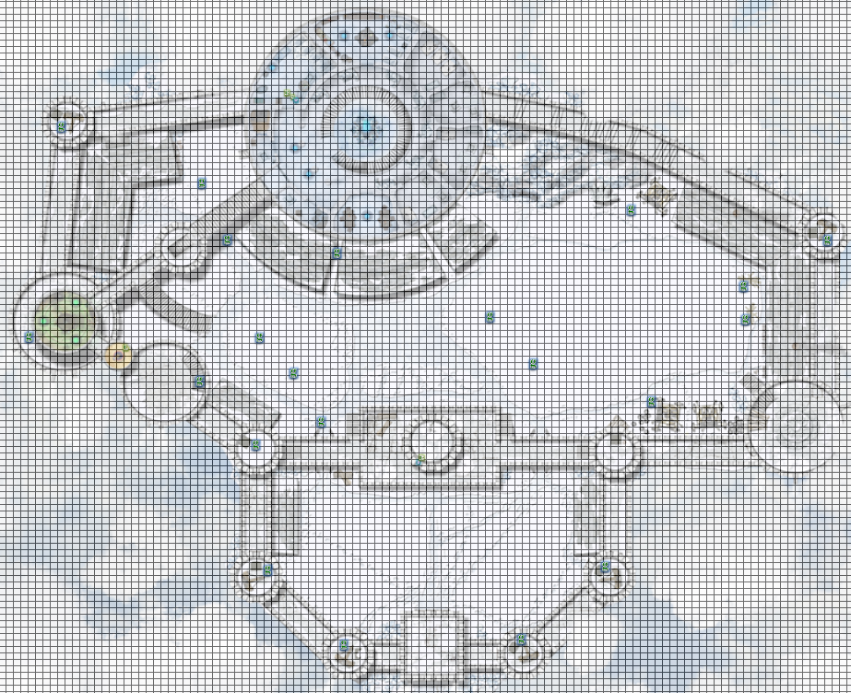

Round 4

Barkley and Saradette reached their respective weapons, and grabbed them. [All possible actions expended for this round.]

Realizing none of the enemy were in range just yet, Elsabet figured she might as well get strong, and cast bull’s strength [expired on Round 44] on herself, then loaded her light crossbow.
Elsabet gained +4 to Strength.

Luran flew within earshot of as many cloud giant guards as was feasible within 50’ from AE61.
Luran and 3 cloud giants gained +2 to BAB, weapon damage, and saves vs. fear and charm.

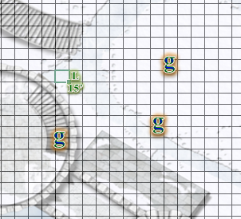

Three of the shadow dragons descended upon the southernmost ballistae while the fourth headed straight for the open area where giants now prepared to do battle.
Save vs.  Frightful Presence | Rank | Ability & Mod. | Misc. Mods. | Total | Roll | Check | Notes
Elsabet, Will | 7 | Wis (-1) | 6 | 12 | 20 | 32 | +3 vs. Enchantments
Luran, Will | 8 | Wis (-1) | 2 | 9 | 9 | 18
Solstice, Will | 7 | Wis (+2) | 0 | 9 | 4 | 13 | +2 vs. Sleep/Charm, +2 if Lucky
Success, fail, fail. Luran and Solstice became Shaken, incurring –2 to attack rolls, saving throws, skill checks, and ability checks.
Character | Check | Ranks | Roll | Result
Cloud Giant | Will | 10 | 7 | 17
Cloud Giant | Will | 10 | 1 | 11
Cloud Giant | Will | 10 | 16 | 26
Cloud Giant | Will | 10 | 12 | 22
Fail, fail, fail. Southernmost ballista operators became Shaken, incurring –2 to attack rolls, saving throws, skill checks, and ability checks.

The shadow dragons all released their cones of billowing, smoky shadows with energy drain effects. The giants manning the ballistae cringed and did their best to shrug off the life-draining effects.
Character | Check | Ranks | Roll | Result
Cloud Giant | Reflex | 6 | 1 | 7
Cloud Giant | Reflex | 6 | 5 | 11
Cloud Giant | Reflex | 6 | 10 | 16
Fail, fail, fail. Giant ballista operators gained 5 negative levels: –5 on all skill checks and ability checks, attack rolls, saving throws, and effective level, plus –25 hit points.

Failing to spot Elsabet atop the tower, the lead dragon targeted two giants on the cloudy ground, but was not yet in range to attack.

Elsabet resisted the chilling sensation that came with being approached by the massive dragon.
Current Maneuvers
Stone Vise
Foehammer
Shield Block
Battle Leader’s Charge
Crusader’s Strike

The ballista operators fired upon the dragons overhead.
Character | Attack Type | Damage | BAB | Dex Mod+ | W+ | Total Score | Roll | Total | Threat
Cloud Giant, Ballister, energy drained | Ballista +1 | 3d8+1 | 5 | 0 | 1 | 6 | 20 | 26 | þ
Cloud Giant, Ballister, energy drained | Ballista +1 | 3d8+1 | 5 | 0 | 1 | 6 | 8 | 14 | ý
Cloud Giant, Ballister, energy drained | Ballista +1 | 3d8+1 | 5 | 0 | 1 | 6 | 20 | 26 | þ
Cloud Giant, Ballister, energy drained | Ballista +1 | 3d8+1 | 5 | 0 | 1 | 6 | 18 | 24 | ý
Cloud Giant, Ballister | Ballista +1 | 3d8+1 | 12 | 0 | 1 – 2 range | 11 | 8 | 19 | ý
Cloud Giant, Ballister | Ballista +1 | 3d8+1 | 12 | 0 | 1 – 2 range | 11 | 3 | 14 | ý
Threat, miss, threat, miss, miss, miss. 1d20 = 3, 13; not critical hits.
Dmg to dragon 2: 9 + 1 = 10.
Dmg to dragon 3: 13 + 1 = 14.

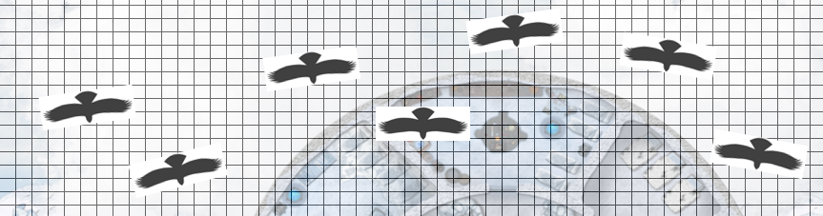

A contingent of rocs with cloud giant defenders mounted atop them emerged from the northern underside of the fortress, and turned southward to face off against the dragons.

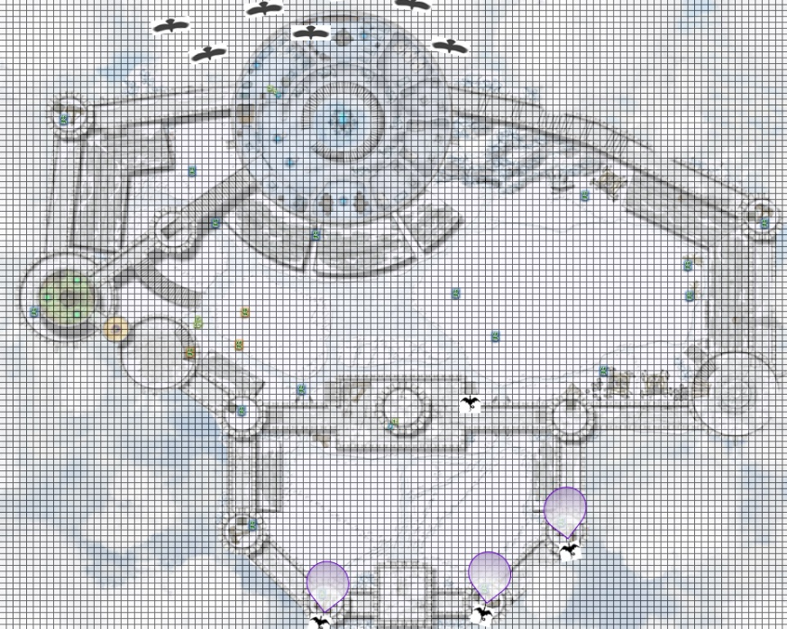

Round 5

Barkley and Saradette headed back out to the ensuing battle.
Save vs.  Frightful Presence | Rank | Ability & Mod. | Misc. Mods. | Total | Roll | Check | Notes
Barkley, Will | 4 | Wis (+1) | 1 | 6 | 15 | 21
Saradette, Will | 3 | Wis (+0) | 0 | 3 | 10 | 13 | +1 vs. Fear
Fail, fail. Barkley and Saradette became Shaken, incurring –2 to attack rolls, saving throws, skill checks, and ability checks.

Seeing one dragon passing by on her left, to the east, Elsabet, holding her loaded crossbow in her left hand, moved over to the east side of her tower, and peering between the crenellations, didn’t think she had much of a shot at the frost dragon on top of it, too much dragon in the way. But it looked like from her new vantage point that the dragon was now no more than 60’ away, so with her right hand she launched an eldritch blast at the dragon’s underbelly.
1d100 = 92, buckler did not cause a misfire.
Ranged Weapon | Dmg. | D+ | TH+ | Critical | Rng. | Wt. | Atk | Roll | Check
Eldritch Blast | 1d6 | 0 | 0 | x2 | 60’ max. | - | +9 | 5 | 14
Hit. Dmg: 5 + 1 = 6 magic.
Ranged Weapon | TH+ | Atk | Roll | Check
Bypass Spell Resistance | 0 | +4 | 19 | 23
Success. Damage not negated.

Luran noticed that Elsabet’s eldritch blast was able to bypass the dragon’s spell resistance, which was a surprise for him. He would’ve thought it would be impossible to do so, but the dragon cringed with pain.
Character | Save vs.  flinching | Ranks | Roll | Result
Shadow Dragon | Reflex | 14 | 18 | 32
Success.

The injured dragon maintained its position, keeping the rider atop its back as another dragon pounced down on a ballista operator.
Character | Attack Type | Damage | BAB | Str Mod+ | Total Score | Roll | Total
Shadow Dragon, Old | Bite | 2d8+6 | 25 | 6 | 31 | 15 | 46
Hit. Dmg: 9 + 6 = 15.

The rocs advanced against the dragons, most of them converging on the apparent leader whom Elsabet had just zapped.
Character | Check | Ranks | Roll | Result
Roc | Will | 9 | 5 | 14
Roc | Will | 9 | 13 | 22
Roc | Will | 9 | 9 | 18
Roc | Will | 9 | 2 | 11
Roc | Will | 9 | 18 | 27
Roc | Will | 9 | 4 | 13
Roc | Will | 9 | 1 | 10
Cloud Giant | Will | 10 | 13 | 23
Cloud Giant | Will | 10 | 9 | 19
Cloud Giant | Will | 10 | 16 | 26
Cloud Giant | Will | 10 | 5 | 15
Cloud Giant | Will | 10 | 16 | 26
Cloud Giant | Will | 10 | 17 | 27
Cloud Giant | Will | 10 | 12 | 22
All rocs and their riders became Shaken, incurring –2 to attack rolls, saving throws, skill checks, and ability checks.

Character | Attack Type | Damage | BAB | Str Mod+ | W+ | Other+ | Total Score | Roll | Total
Roc | Talon 1 | 2d6+12 | 13 | 8 | 1 | -2 | 20 | 8 | 28
Roc | Talon 1 | 2d6+12 | 13 | 8 | 1 | -2 | 20 | 11 | 31
Roc | Talon 1 | 2d6+12 | 13 | 8 | 1 | -2 | 20 | 12 | 32
Roc | Talon 1 | 2d6+12 | 13 | 8 | 1 | -2 | 20 | 2 | 22
Roc | Talon 1 | 2d6+12 | 13 | 8 | 1 | -2 | 20 | 17 | 37
Miss, miss, miss, miss, hit. Dmg to dragon 4: 4 + 12 = 16. Partial damage negated.

Barkley drew his bow and nocked an arrow. He took aim on the closest dragon and let the arrow fly.
Ranged Weapon | Dmg | D+ | TH+ | Critical | Rng. | Wt. | Atk | Roll | Check
Composite +2 Longbow +1 | 1d8 | 3 | 1 | x3 | 110’ | 3.0 | +6 | 5 | 11
Miss.

Saradette aimed her flechette launcher at the same dragon and fired.
Ranged Weapon | Dmg. | D+ | TH+ | Critical | Rng. | Wt. | Atk | Roll | Check
Sabot Launcher | 1d6x6 | - | 0 | 15º cone | 50’ | 5.0 | 4 | 13 | 17
Miss.

Luran’s mind teetered from the horrific display of power the dragons laid down upon the scene like lead sheets. Somehow working through the quaking terror of these old dragons, Luran pushed himself to reach the next wall tower, hoping to inspire the giant guards, as well. He knew Elsabet and Solstice were not far away. They would all be better suited away from these titanic fights, so much beyond their ability, as soon as possible, the lyric thaumaturge thought. He had kept his gaze on the crusader since she’d zapped the dragon, but could not see Solstice.

The ballista operators reloaded their hefty weapons.

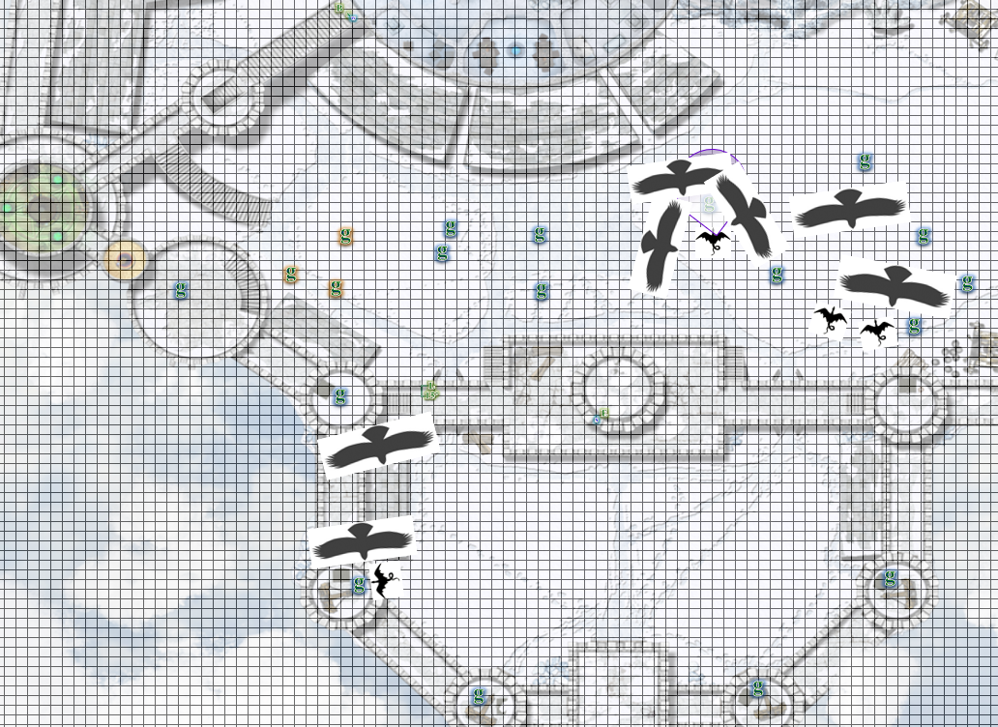

Round 6

The ballista operators released the next volley, targeting the those who did not have a roc in their line of attack.
Character | Attack Type | Damage | BAB | W+ | Other+ | Total Score | Roll | Total | Threat
Cloud Giant, Ballister, energy drained | Ballista +1 | 3d8+1 | 5 | 1 | -2 – 2 range | 2 | 6 | 10 | ý
Cloud Giant, Ballister, energy drained | Ballista +1 | 3d8+1 | 5 | 1 | -2 – 2 range | 2 | 19 | 23 | þ
Cloud Giant, Ballister, energy drained | Ballista +1 | 3d8+1 | 5 | 1 | -2 | 4 | 1 | 5 | ý
Cloud Giant, Ballister, energy drained | Ballista +1 | 3d8+1 | 5 | 1 | -2 | 4 | 3 | 7 | ý
Cloud Giant, Ballister, energy drained | Ballista +1 | 3d8+1 | 5 | 1 | -2 | 4 | 1 | 5 | ý
Cloud Giant, Ballister, energy drained | Ballista +1 | 3d8+1 | 5 | 1 | -2 | 4 | 15 | 19 | ý
Miss, threat, miss, miss, miss, miss. 1d20 = 10 + 2 = 12, not a critical hit. Dmg to dragon 2: 12 + 1 = 13.

The rocs did their best to bring down the giants riding atop the dragons, seeing as the latter were too formidable to deal with.
Character | Attack Type | Damage | BAB | Str Mod+ | W+ | Other+ | Total Score | Roll | Total | Crit | Threat
Roc 1 | Talon 1 | 2d6+12 | 13 | 8 | 1 | -2 | 20 | 2 | 22 | 20 | ý
Roc 1 | Talon 2 | 2d6+12 | 13 | 8 | 1 | -2 | 20 | 19 | 39 | 20 | ý
Roc 1 | Bite | 2d8+6 | 13 | 6 | 1 | -2 | 18 | 19 | 37 | 19 | þ
Roc 2 | Talon 1 | 2d6+12 | 13 | 8 | 1 | -2 | 20 | 6 | 26 | 20 | ý
Roc 2 | Talon 2 | 2d6+12 | 13 | 8 | 1 | -2 | 20 | 19 | 39 | 20 | ý
Roc 2 | Bite | 2d8+6 | 13 | 6 | 1 | -2 | 18 | 1 | 19 | 19 | ý
Roc 3 | Talon 1 | 2d6+12 | 13 | 8 | 1 | -2 | 20 | 7 | 27 | 20 | ý
Roc 3 | Talon 2 | 2d6+12 | 13 | 8 | 1 | -2 | 20 | 12 | 32 | 20 | ý
Roc 3 | Bite | 2d8+6 | 13 | 6 | 1 | -2 | 18 | 2 | 20 | 19 | ý
Roc 4 | Talon 1 | 2d6+12 | 13 | 8 | 1 | -2 | 20 | 7 | 27 | 20 | ý
Roc 4 | Talon 2 | 2d6+12 | 13 | 8 | 1 | -2 | 20 | 13 | 33 | 20 | ý
Roc 4 | Bite | 2d8+6 | 13 | 6 | 1 | -2 | 18 | 8 | 26 | 19 | ý
Roc 5 | Talon 1 | 2d6+12 | 13 | 8 | 1 | -2 | 20 | 2 | 22 | 20 | ý
Roc 5 | Talon 2 | 2d6+12 | 13 | 8 | 1 | -2 | 20 | 1 | 21 | 20 | ý
Roc 5 | Bite | 2d8+6 | 13 | 6 | 1 | -2 | 18 | 1 | 19 | 19 | ý
Roc 6 | Talon 1 | 2d6+12 | 13 | 8 | 1 | -2 | 20 | 12 | 32 | 20 | ý
Roc 6 | Talon 2 | 2d6+12 | 13 | 8 | 1 | -2 | 20 | 7 | 27 | 20 | ý
Roc 6 | Bite | 2d8+6 | 13 | 6 | 1 | -2 | 18 | 12 | 30 | 19 | ý
Roc 7 | Talon 1 | 2d6+12 | 13 | 8 | 1 | -2 | 20 | 11 | 31 | 20 | ý
Roc 7 | Talon 2 | 2d6+12 | 13 | 8 | 1 | -2 | 20 | 5 | 25 | 20 | ý
Roc 7 | Bite | 2d8+6 | 13 | 6 | 1 | -2 | 18 | 19 | 37 | 19 | þ
Hit, hit, threat, miss, threat, miss, hit, hit, miss.
Hit, hit, hit.
Hit, miss, miss.
Hit, hit, hit, hit, hit, threat.
1d20 = 15, 17, 9; 3 critical hit.
Dmg to Frost Giant Leader: (8 + 12) + (3 + 12) + [(2 x 8) + 6] + [(2 x 7) + 12] + (8 + 12) + (8 + 12) = 20 + 15 + 22 + 26 + 20 + 20 = 123.
Dmg to Frost Giant Scout: (12 + 12) + (7 + 12) + (8 + 6) = 24 + 19 + 14 = 47.
Dmg to Frost Giant Berserker: 7 + 12 = 19.
Dmg to Frost Giant Rogue: (15 + 12) + (5 + 12) + (10 + 6) + (9 + 12) + (6 + 12) [(2 x 4)+ 6] = 27 + 17 + 16 + 19 + 18 + 14 = 111.

The leader and his rogue accomplice fell off their mounts, already dying.
Falling damage to both: 4.

Both would bleed to death within moments, leaving only two mounted dragons and two unmounted ones.

The frost giant scout and berserker were notably stunned by the realization that their fearless leader was dead. The two adolescents pressed the offensive nonetheless, as the berserker became the new makeshift leader.

The dragons’ breath weapons were spent for the moment, so they simply attacked the rocs with their claws, teeth, wings and tails.
Character | Attack Type | Damage | BAB | Str  Mod+ | Total  Score | Roll | Total | Crit | Threat
Shadow Dragon, 1 | Bite | 2d8+6 | 25 | 6 | 31 | 15 | 46 | 20 | ý
Shadow Dragon, 1 | Claw 1 | 2d6+3 | 25 | 6 | 31 | 13 | 44 | 20 | ý
Shadow Dragon, 1 | Claw 2 | 2d6+3 | 25 | 6 | 31 | 2 | 33 | 20 | ý
Shadow Dragon, 1 | Wing 1 | 1d8+3 | 25 | 6 | 31 | 19 | 50 | 20 | ý
Shadow Dragon, 1 | Wing 2 | 1d8+3 | 25 | 6 | 31 | 5 | 36 | 20 | ý
Shadow Dragon, 1 | Tail | 2d6+6 | 25 | 6 | 31 | 16 | 47 | 20 | ý
Shadow Dragon, 2 | Bite | 2d8+6 | 25 | 6 | 31 | 20 | 51 | 20 | þ
Shadow Dragon, 2 | Claw 1 | 2d6+3 | 25 | 6 | 31 | 20 | 51 | 20 | þ
Shadow Dragon, 2 | Claw 2 | 2d6+3 | 25 | 6 | 31 | 11 | 42 | 20 | ý
Shadow Dragon, 2 | Wing 1 | 1d8+3 | 25 | 6 | 31 | 17 | 48 | 20 | ý
Shadow Dragon, 2 | Wing 2 | 1d8+3 | 25 | 6 | 31 | 4 | 35 | 20 | ý
Shadow Dragon, 2 | Tail | 2d6+6 | 25 | 6 | 31 | 2 | 33 | 20 | ý
Shadow Dragon, 3 | Bite | 2d8+6 | 25 | 6 | 31 | 17 | 48 | 20 | ý
Shadow Dragon, 3 | Claw 1 | 2d6+3 | 25 | 6 | 31 | 15 | 46 | 20 | ý
Shadow Dragon, 3 | Claw 2 | 2d6+3 | 25 | 6 | 31 | 19 | 50 | 20 | ý
Shadow Dragon, 3 | Wing 1 | 1d8+3 | 25 | 6 | 31 | 20 | 51 | 20 | þ
Shadow Dragon, 3 | Wing 2 | 1d8+3 | 25 | 6 | 31 | 15 | 46 | 20 | ý
Shadow Dragon, 3 | Tail | 2d6+6 | 25 | 6 | 31 | 16 | 47 | 20 | ý
Shadow Dragon, 4 | Bite | 2d8+6 | 25 | 6 | 31 | 9 | 40 | 20 | ý
Shadow Dragon, 4 | Claw 1 | 2d6+3 | 25 | 6 | 31 | 13 | 44 | 20 | ý
Shadow Dragon, 4 | Claw 2 | 2d6+3 | 25 | 6 | 31 | 16 | 47 | 20 | ý
Shadow Dragon, 4 | Wing 1 | 1d8+3 | 25 | 6 | 31 | 8 | 39 | 20 | ý
Shadow Dragon, 4 | Wing 2 | 1d8+3 | 25 | 6 | 31 | 20 | 51 | 20 | þ
Shadow Dragon, 4 | Tail | 2d6+6 | 25 | 6 | 31 | 17 | 48 | 20 | ý
All attacks rendered hits/threats. 1d20 = 1, 13, 3, 8; 3 critical hits.
Dmg to roc 1: (6 + 6) + (5 + 3) + (9 + 3) + (4 + 3) + (9 + 3) + (2 + 6) = 12 + 8 + 12 + 7 + 12 + 8 = 59.
Dmg to roc 3: (10 + 6) + [(2 x 9) + 3] + (2 + 3) + (4 + 3) + (8 + 3) + (4 + 6) = 16 + 21 + 5 + 7 + 11 + 10 = 70.
Dmg to roc 4: (9 + 6) + (7 + 3) + [(2 x 4) + 3] + (6 + 3) + (1 + 3) + (4 + 6) = 15 + 10 + 11 + 9 + 4 + 10 = 59.
Dmg to roc 7: (6 + 6) + (9 + 3) + (6 + 3) + (7 + 3) + [(2 x 2) + 3] + (3 + 6) = 12 + 12 + 9 + 10 + 7 + 9 = 59.

Though the four assaulted rocs were wounded, they were still rearing to continue their defensive strikes.

Cloud giants rushed towards the dying frost giants and clubbed them a bit just to make sure they weren’t getting up.

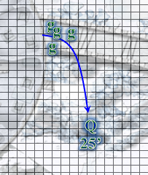

The Queen of the cloud giants emerged from the northeastern entrance to the central dome, and cast fly [expired on Round 86] upon herself, then took flight towards the rocs and dragons. A few clerics and other elite giants also appeared along that entrance, and began casting spells of their own.

Barkley moved towards the edge of the causeway as he nocked an arrow and fired on the dragon once more.
I interpreted this to mean that he moved closer without having to jump down 15’ to be on level with the majority of the giants.
Ranged Weapon | Dmg | D+ | TH+ | Critical | Rng. | Wt. | Atk | Roll | Check
Composite +2 Longbow +1 | 1d8 | 3 | 1 – 6 | x3 | 110’ | 3.0 | +0 | 17 | 17
Miss.

He was happy to see that the giants and rocs had succeeded in taking down two of the attackers.

Saradette took aim and fired again.
Ranged Weapon | Dmg. | D+ | TH+ | Critical | Rng. | Wt. | Atk | Roll | Check
Sabot Launcher | 1d6x6 | - | -12 | 15º cone | 50’ | 5.0 | -8 | 10 | 2
Miss.

Excited to see her blast affect the dragon, Elsabet used a swift action to activate one charge on her brute gauntlets, stepped up between the crenellations, jumped down to the next level and hustled over to the wall.
Skill | Rank | Ability & Mod. | Misc. Mods. | Total | Roll | Check
Elsabet, Jump | 5 | Str (+4) | -1 + 2 | 10 | 14 | 24
Success.

Taking no damage from the drop, she then fired another eldritch blast at the injured dragon which had just lost its rider.
1d100 = 51, buckler did not cause a misfire.
Ranged Weapon | Dmg. | D+ | TH+ | Critical | Rng. | Wt. | Atk | Roll | Check
Eldritch Blast | 1d6 | 0 | 0 | x2 | 60’ max. | - | +9 | 18 | 27
Hit. Dmg: 3 + 1 = 4 magic.
Ranged Weapon | TH+ | Atk | Roll | Check
Bypass Spell Resistance | 0 | +4 | 3 | 7
Fail. Damage negated.

Luran flew near to Elsabet so that she might gain the benefits of his inspiration and continued to steer clear of the larger combatants.

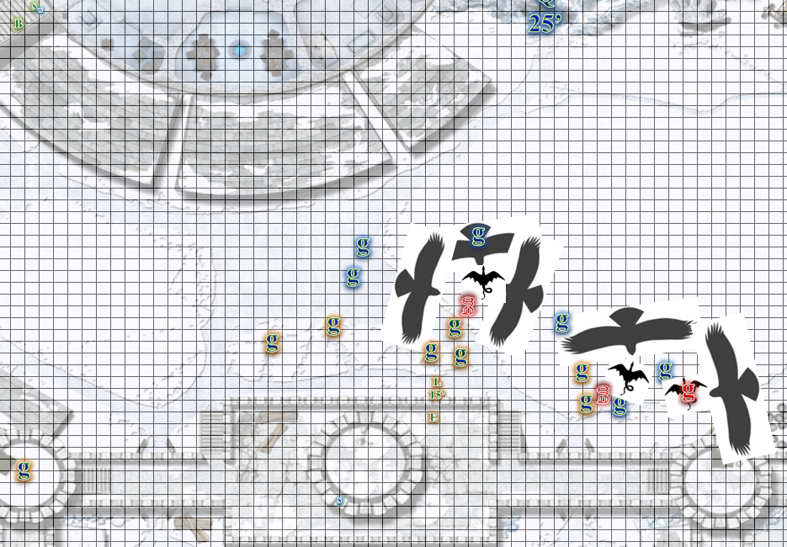

Round 7

Barkley, a bit frustrated by his last two shots not penetrating the dragons hide, instead aimed for the giant riding the dragon, hoping this shot would penetrate.
Ranged Weapon | Dmg | D+ | TH+ | Critical | Rng. | Wt. | Atk | Roll | Check
Composite +2 Longbow +1 | 1d8 | 3 | 1 – 6 range | x3 | 110’ | 3.0 | +0 | 14 | 14
Miss.

Saradette switched to her sonic blaster and fired at the nearest enemy.
Ranged Weapon | Dmg. | Rng. | Notes
Horizikaul’s Boom | 1d4 Sonic | 25’ + 2½’/lvl | Will DC or deafened for 1d4 rounds
Maximum range exceeded.

The rocs turned their attacks on the remaining giants, pretty much ignoring the dragons for now.

Character | Attack Type | Damage | BAB | Str Mod+ | W+ | Other+ | Total Score | Roll | Total
Roc 1 | Talon 1 | 2d6+12 | 13 | 8 | 1 | -2 | 20 | 3 | 23
Roc 1 | Talon 2 | 2d6+12 | 13 | 8 | 1 | -2 | 20 | 7 | 27
Roc 1 | Bite | 2d8+6 | 13 | 6 | 1 | -2 | 18 | 5 | 23
Roc 2 | Talon 1 | 2d6+12 | 13 | 8 | 1 | -2 | 20 | 12 | 32
Roc 2 | Talon 2 | 2d6+12 | 13 | 8 | 1 | -2 | 20 | 3 | 23
Roc 2 | Bite | 2d8+6 | 13 | 6 | 1 | -2 | 18 | 8 | 26
Roc 3 | Talon 1 | 2d6+12 | 13 | 8 | 1 | -2 | 20 | 8 | 28
Roc 4 | Talon 1 | 2d6+12 | 13 | 8 | 1 | -2 | 20 | 14 | 34
Roc 5 | Talon 1 | 2d6+12 | 13 | 8 | 1 | -2 | 20 | 11 | 31
Roc 6 | Talon 1 | 2d6+12 | 13 | 8 | 1 | -2 | 20 | 3 | 23
Roc 7 | Talon 1 | 2d6+12 | 13 | 8 | 1 | -2 | 20 | 9 | 29
Hit¹¹.
Dmg to frost giant scout: (4 + 12) + (7 + 12) + (11 + 6) + (4 + 12) + (4 + 12) = 16 + 19 + 17 + 16 + 16 = 84.
Dmg to frost giant berserker: (11 + 12) + (5 + 12) + (7 + 6) + (4 + 12) + (7 + 12) + (11 + 12) = 23 + 19 + 13 + 16 + 19 + 23 = 103.

The scout passed out from the carnage bestowed upon him, leaving the berserker to make a mad dash upward and away from the fortress.

The ballista operators reloaded their weapons.

The Queen flew towards that dragon as the three riderless dragons scampered away in different directions. The battle had ended in a clear defeat of the frost giant forces, but the Queen was resolute in ensuring that no frost giant escaped justice. She commanded all roc-riding giants to pursue the berserker, and up they went into the stars.

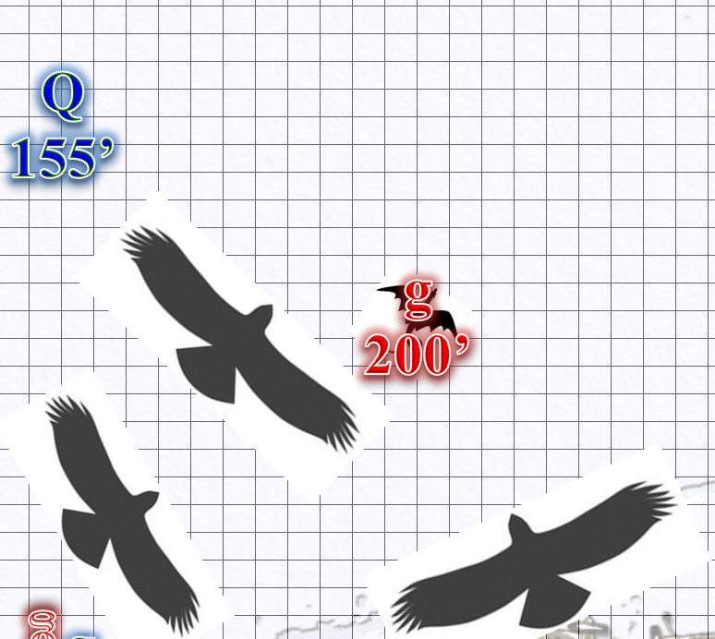
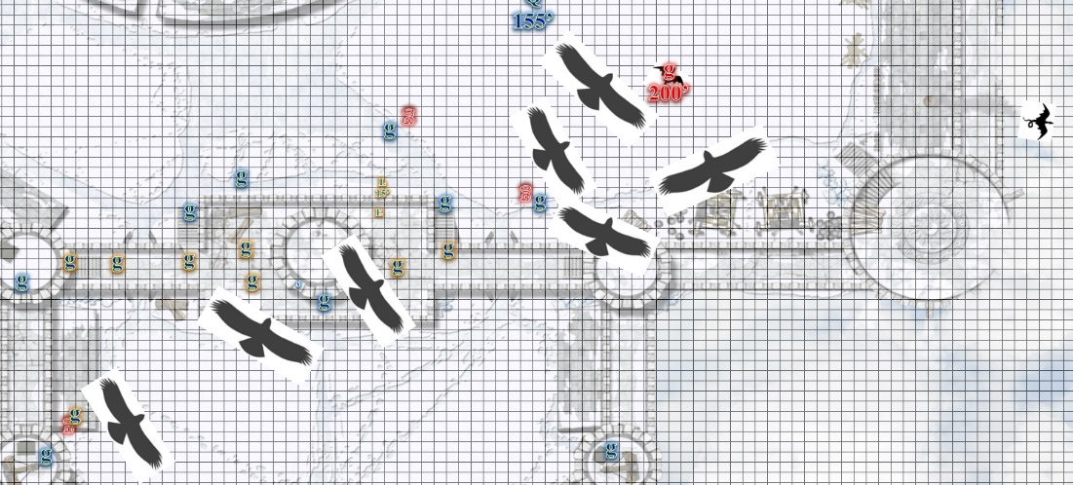

Luran was left wondering if he should join in the pursuit. He was under no obligation to do so, as he was not a conscripted soldier, but was curious to see how they would bring down the remaining culprit as the giants on the ground began to run towards the felled scout in order to hack him up.

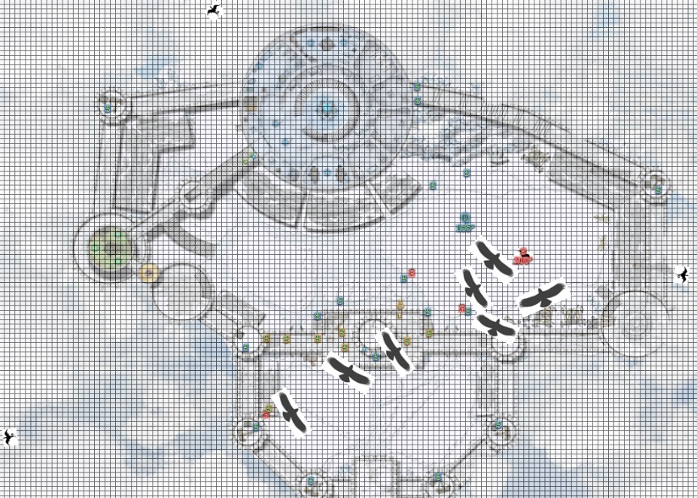

Round 8

The ballista operators fired their volleys once again.
Outcomes unclear.

The three shadow dragons who had lost their riders sped off into the distance, though some may have been hit by the mighty spears shot forth by the ballistae.

The Queen and her septet of rocs and cloud giant jousters continued to pursue the fleeing dragon and frost giant rider up and towards the Astral sky.

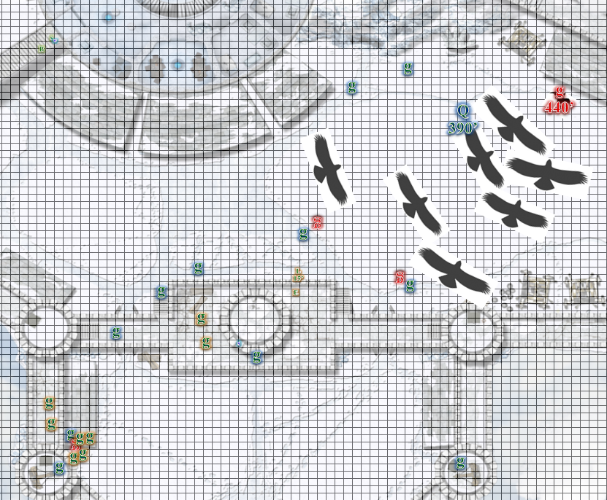

His voice no longer projecting vocalization, Luran’s wings swept up and down as he began to climb in a spiral to gain altitude and line of sight on the pursuit of the last dragonrider. He had no intention of actually following, as the gargantuan avians were far faster in flight. But he wanted to have a good visual of the action for later, when he would improvise and set the scene down into song.

Barkley, though satisfied with the outcome, was displeased with his involvement. He’d hardly scratched the hide of the dragon let alone it’s rider. Tonight would be a night to drink and forget his inability to provide any assistance. Perhaps he would listen to the giants tell their stories of what happened and revel in their glory. As these thoughts went through is mind, an image of a holy symbol went through his mind. First was the symbol of Tyr, but that quickly faded and he saw a beer mug. Barkley shook his head as if to clear his thoughts, but the image of the mug and a roguish looking man sitting at a table drinking from that mug would not leave his mind.

“Well, that was exciting,” Elsabet said, in the giant tongue, seeing a few cloud giants nearby below, and one nearby on the level she was at. “Any of you guys get blasted by that shadowy dragon breath?” She didn’t think her lesser restoration spell could help, but she was willing to give it a try. Or perhaps a resurgence could help, if there was an ongoing effect that could still be resisted.

The weariest of the ballista operators came over and nodded with a huff. “I’d be much obliged, Crusader of the Shieldmaiden,” she said. Elsabet cast resurgence upon the siege engineer.
Character | Check | Ranks | Roll | Result
Cloud Giant | Reflex | 6 – 5 | 16 | 17
Fail. Effects retained.

Within another minute, they spotted the frost giant’s body falling lifelessly. It crashed upon the portion of the cloud to the northwest of the keep, bounced off, and fell another half mile down to the grassy field below the fortress, followed by one of the rocs and rider who wanted to ensure the berserker’s death. Moments later, the largest of the shadow dragons crashed into the stony dome of the fortress, likely damaging the third and second floors in the process. The other six rocs and their riders swooped down diligently after it, and the bulk of the landborne giants entered the keep as quickly as possible in an effort to control the situation.

The Queen’s descent was far more orderly and collected, and as she floated down towards the same causeway where she’d first cast her fly spell. Her voice bellowed across the surface of the cloud fortress, calling for high alert in case any of the other three dragons returned. Her clerics ushered her inside as the ballista operators did their best to keep vigilant.

Saradette put up her blaster and sighed in annoyance. She’d used three shots, and scored no hits at all. Although, she reflected, pissing off a dragon probably wasn’t the smartest thing she possibly could have done. Survival was a win here, and she went to see if there was anything she could do to help the injured.

She also considered that—had they been alone, without the giants—they would surely have been vanquished within seconds, so this was not a lost cause, but rather an event from which Luran could fashion a tale worthy of heroic merit and inspirational value.

“Barkley, though satisfied with the outcome, was displeased with his involvement. He’d hardly scratched the hide of the dragon let alone it’s rider. Tonight would be a night to drink and forget his inability to provide any assistance. Perhaps he would listen to the giants tell their stories of what happened and revel in their glory. As these thoughts went through is mind, an image of a holy symbol went through his mind. First was the symbol of Tyr, but that quickly faded and he saw a beer mug. Barkley shook his head as if to clear his thoughts, but the image of the mug and a roguish looking man sitting at a table drinking from that mug would not leave his mind.”

Elsabet cast guidance on that giant, saying “hmm, the effect may be too strong, but let’s try again,” and the following round cast another resurgence on her. “Second time lucky? If not, will try on someone else.” She was eventually successful in reducing the reduction in the giant’s prowess, but not before depleting her least spells, and what she could not accomplish, the giant clerics could restore before the end of the next day.

The three surviving dragons did not return, much to the relief of the fortress’ residents, and the rest of the night was spent in a vigilant session of moderated drinking and recounting of events.

Saradette plopped down on Stratus’ thigh and drank the last of her ale. The giant rumbled a low laugh, and Saradette looked up at him sharply. “What?”

“Did you ever consider just hiding? If you’d pissed off one of those dragons, he’d have turned you into an hors’d’oeuvre.”

“I’m just tired of feeling useless,” she replied as she laid back on his leg. The two of them had grown as intimate as people with their size difference physically could. “I’m either equipped with the wrong weapon, or just plain too late. Besides, they don’t need a rogue or an artificer.”

“Yes, but you make a great backscratcher.” Stratus held up a hand to forestall the gnome’s caustic response. “Look, all I’m saying is, you’re learning, right? Old Gadget Breaker himself has said that you’re doing well. You know a lot of stuff that no one else knew, and the whole shop has made some important improvements because of you. Your sonic thing worked on a giant, and that’s saying something. The others would have had to fight him to the death, and it could have been theirs. You popped him with something he’d never seen, and he ran. That’s a win, Saradette.”

The gnome stood, stripped off her light tunic, and stalked up his body to kneel in front of his face. “I wish I were a lot bigger, sometimes.”

“We all like you just the way you are.” He smiled. “You are a downright delicious little snack.”

Saradette snorted and reached out to kiss him...

