*Chapter 21: The Fugue*

15 Ghes, 1373

The heroes’ year with the cloud giants was almost up, and the floating fortress’ convergence with the portion of Ysgard that could convey them to the Material Plane was nigh. The Queen of the giants had conferred upon the humanoids more than one honorific by now, and each of the heroes had now learned enough functional Giant to get by with no translators.

It was a mostly sunny Ghes day as the first hints of autumn presented themselves with a brisk breeze and a few rainclouds in the farthest horizons, and Barkley and Solstice conferred on what they would do in a month’s time when the planar convergence would allow them to be propelled unto Faerûn. Extensive calculations had been made by Argent and Saradette, who now emerged from their shared laboratory as the master finally entrusted his student with the secret project he’d kept from her until now.

<< So it’s like a time machine? >> she asked as Widget kept up.

<< No, not at all. It has no bearing on the time component of spacetime, >> he clarified in Gnomish. << It simply manipulates the fabric of the Weave, and of the space that comprises it, so that it can transport one—or several—to another plane. >>

<< Fascinating, >> she thought and said, asking, << and how would one select the place? >>

<< That is—I’m afraid—a limitation of the machine, >> Argent took a moment to choose the most precise phrasing. << I cannot simply choose any portion of spacetime in the current moment to visit. There are only a few discrete possibilities from which to choose, though with refinement, there may be methods to increase the versatility of these options. >>

She wanted to say << fascinating >> again, but instead asked, << Why did you keep this from me, Master Argent? >>

He smiled and blushed, << Truth be told, I was hesitant to believe that it would succeed, and did not want to disappoint you, or—worse yet—cause a harmful malfunction near you. I’ve been able to teleport to various parts of Ysgard undetected, and while the Queen has been kept abreast of my progress all the while, we agreed that her security force should be kept unaware, mostly in the interest of testing its clandestine abilities. >>

<< And she is fine with this? >>

<< She is, and is enthusiastic to see it work. I mean to unveil it tonight, but wanted to brief you first so you’d be up to the task of co-piloting it. >> He went on to reveal several technical aspects that would further prepare her for what she was about to see as they kept walking from their shared laboratory to his private workspace.

Widget nearly bumped into the back of Saradette’s left leg as they stopped about 10’ short of the door. Argent cautioned her, << Now, you keep this little bugger off of the controls, yes? >>

She looked at her racoon friend and tilted her head, conveying caution and prudence. Widget chirped twice, communicating acknowledgment and agreement.

They continued towards the locked door; Argent unlocked it, then pulled down on the handle, and opened it. They walked inside, and Saradette beheld a very unexpected contraption. She had expected something like a box or a bubble into which they could get before being transported to another place, but instead, she saw before her several flat discs: one circular and the rest hexagonal.

Argent invited her to sit at one of the two benches, and he sat at the other, activating two control panels that were comprised of crystalline flatscreens and gemstone knobs. Brass panels and platinum conduits adorned each console, and the swiveling benches were made of the sturdiest oakwood with stained bronze accents.

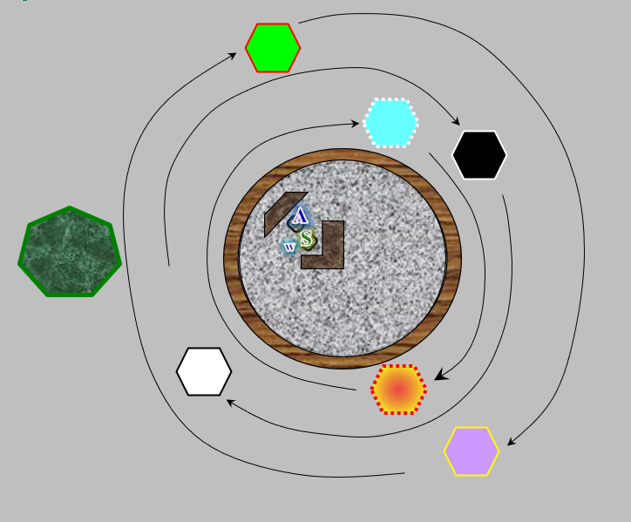

<< What do the hexagons do? >> she asked.

He explained as she pressed a few ruby-hued buttons, causing the hexagons—all but the largest, green one—to lift off the ground a few inches and orbit the central circle clockwise, << A person can stand atop each of these unharmed and unwavered by momentum. Each has a wall of force around it in an oblong, hemispherical shape so that even a giant can stand inside it and not be knocked off the platform, but more importantly, each hexagon is a geo-planar honing positron that allows the machine to pinpoint a component of a rather exact place to which the machine can be transported. As of now, only four of the six smaller ones are needed to facilitate a successful, accurate jump, but I’m keeping six intact in case of any accidents. The large heptagon is part of the circle, and will not move relative to where we are now. I added it in case we need to transport something—or someone—larger than a cloud giant. >>

It came to Saradette’s attention that this contraption might circumvent any need to wait until the convergence was reached, and asked to confirm this.

<< Yes, that’s the idea. It’s an idea that has been on my mind for years, but with your advent last Tarsakh, I found myself motivated to take it to fruition. Many a sleepless night has been devoted to this project, >> he boasted with a sigh, nearly ready to display its abilities to the residents of the fortress, << and what better way to inaugurate it than to send you all back to your homeland? >>

She nodded, << And you? Would you leave the fortress for good? >>

<< Naaayy! >> he said with nearly a scolding tone, << This is my home. I merely wish to add capabilities to the fortress, which floats at the will of this plane’s orbital currents. In time, I may be able to expand the prowess of the spatial transmigration to encompass the entire cloud and fortification, which would allow us to exist virtually anywhere we want, and perhaps even to avoid sieges like that one from a few months back. >>

<< The frost giants and shadow dragons, >> Saradette recalled, shaking her head.

<< Aye, >> he nodded.

~*~

Luran was nervous, for the first time in his recent memory. As exciting and challenging as his activities with his companions in the Fist of Light had been, today he was standing before an actual monarch, preparing to entertain. Not only a monarch, but a literal giant, towering over his relatively miniscule frame. He breathed in deep as he continued to fine tune the strings of his family yarting. Exhaling slowly and completely, he turned to Queen Ghym and addressed her and her court.

“In honor of the bravery and ability put on display, today, I wish to share my musical rendition of the events. Should it please your majesty.” His bow was deep and sincere. And with a nod from the queen, he stood straight and began his song.

It started as a rousing history of the cloud giants’ routing of the prior occupants of the floating sky island. The bard’s words painted the community in the most complimentary of lights, shining illumination on the scourge that had been the frost giants, in the past. Recognizing the improvement their removal created for the plane as a whole, Luran crafted an image of Queen Ghym and her closest advisors as saviors of this layer of the outer plane. The benevolence of her reign, after taking the fortress was paramount.

This middle section shifted from the rousing tempo of the beginning of the song to a broader, more lilting portion that encouraged the audience to bask in contented peace until that tranquility was challenged by a resurgence of the enemies and themes from the start of the tale.

Going into heroic detail of the afternoon’s happenings, Luran surged into the third act of his vocal epic. Describing the valiant and successful efforts of the citadel’s guardians, his words brought appreciation from a number of the gigantic audience members. Reserving the highest praise for their monarch, the song lifted her high, showing that she was a leader to be admired, her bravery inspiring others to action. Queen Ghym’s charge to the front of the combat was detailed in the climax of the piece, as the strings of the narrative all came together in a rousing finale that brought cheers from all assembled.

Drained but empowered, the lyric thaumaturge gladly received the applause and silently thanked the Musica Beneva for flowing through him so purely and clearly. Tyr, Torm, and Ilmater also had a place in his mental gratitude. The past year had truly shown a light on his life’s path. As he stood in this otherplanar, royal court, doing what he had trained so many years to do, Luran allowed himself to bask in the accomplishment and praise.

~*~

Solstice had been in a nervous state for some reason. He had half-expected a platoon of frost giants to besiege them while Luran had recounted the high deeds on the part of the cloud giants’ defense of the home they’d wrested from the frost giants, but in the end, it came to nothing: his suspicions had been dispelled. Perhaps it was a bit of a guilty conscience, as in his view, the frost giants had somewhat of an argument for reclaiming this floating fortress as their rightful home. They had—after all—forged it, chiseled it, and cast spell upon spell upon it in order to render it to its full splendor, while the cloud giants—noble as they might have been—were merely its occupiers, and at best, restorers of the frescoes and caryatid columns that supported the massive dome and smaller chambers that comprised it.

Still, it had been a grand spectacle that Luran had put on as his words took everyone through the recollection of the evening when—out of nowhere—four mad, impetuous frost giants and their mighty dragon mounts had done their level best to breach the fortress, lay out its occupiers, and take back what they held to be their home... at least the frost giants’ home.

They had never seen nor heard from the three surviving shadow dragons, and were all the better off for it, and with the floating fortress now so far away from where it had been, chances were unlikely that they ever would.

But all was not rosy, for that very same afternoon, merely hours after Luran had spoken his last words summarizing that fateful night, there came a crashing boom upon the outer frame of the fortress, and everyone was spurred to alarm. Horns were blown, giants’ voices were heard throughout the halls, and Solstice now opened the door to the cupboard that had become his quarters, finding Saradette hefting her flechette launcher and Barkley grabbing his pack.

“What is it?” he asked the two in Common.

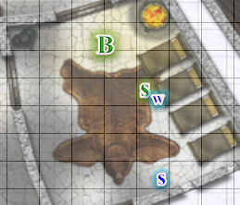

“They’ve just announced that we’re under siege,” Saradette relayed what she’d just heard outside the door to the chamber as Widget clung to her leg.

By the time the four had gone out to the hall, it was evident that this was not a mere quartet of dragons and their riders—which itself was enough to rouse their fears—but rather a full-scale assault on the fortress, and as the next volley of debris crashed into the main dome and shattered part of the stony wall that encased it, Barkley’s mane stood on end.

Luran and Elsabet had been together when the first alarm was raised, and now came running down the hall from the other direction where the food was usually prepared. They were about to ask Barkley, Saradette, and Solstice what was going on, but could tell from their faces that they were just as confused and uninformed at the moment.

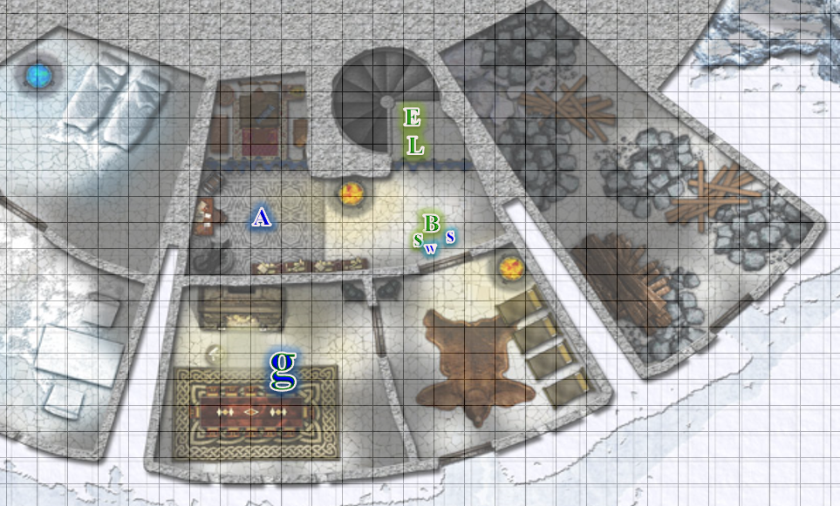

It was when they saw Argent approaching from the west, they looked to him as if he was privy to some news that he’d just heard, and to some degree, he was. He’d been outside when a flying ship approached from the far northeast, and had witnessed the first volley of debris from a mangonel affixed to the bow of the vessel, which was slowly gaining on the cloud. He took a moment to relay this to the heroes, and said, “Come, friends: we’ve no time to spare. This keep will not withstand such a siege.”

And as soon as he’d said this, another blast shook the wobbly foundations of the cloud under their feet, confirming that this place would either be destroyed or restored to the frost giants’ domain in little time. He motioned for them to follow him to his private lab, where their only chance for escape awaited in the form of the planar fugue machine that Argent was set to unveil later that evening.

As they followed, Stratus entered and looked primarily at Saradette, << What in the blazes is happening? >>

Solstice simply said, << We’re under siege! >> and followed Argent towards his private workplace.

Saradette ran to him and hugged his leg. << I, we, need to go, Stratus. I will find you again, I promise. Or, you can come with us, if you’d like. >>

Elsabet hoped the cloud giants would be able to fend off the attackers, but the earlier attack had shown that the Fist of Light would not be very effective vs foes willing to attack a cloud giant fortress. Perhaps they could use their abilities to generate *obscuring mists*,and *fog clouds* could put up an effective cloud to interfere with the attackers’ aim, and their roc riders might be able in the meantime to disable their machines of war or something.

For now, it looked like Saradette’s mentor had a plan. She looked around to make sure everyone was together and then hustled along behind the others as rear guard.

Elsabet looked at the giant, then at Saradette, and back to the giant. << You’re welcome—I trust Saradette’s judgment implicitly. >>

They made it into the senior artificer’s dedicated workspace, took in the sight of the contraption that looked like several separate platforms, and saw Argent approaching the central console. Earlier that day, he’d given Saradette the training necessary to co-pilot the contraption, and now hastily asked Saradette to join him at the control center. She sat where she’d sat before, stepping on a pedal and pressing down on an emerald-green gem, then a ruby-red one.

Argent had by now pressed about ten multifaceted gemstones, and motioned for the giant, archon, half-elf, human, and musteval to take up positions. << Stratus, you’d better take the heptagon. The rest of you are small enough to fit pretty much wherever you’re comfortable. No time to be choosy! >>

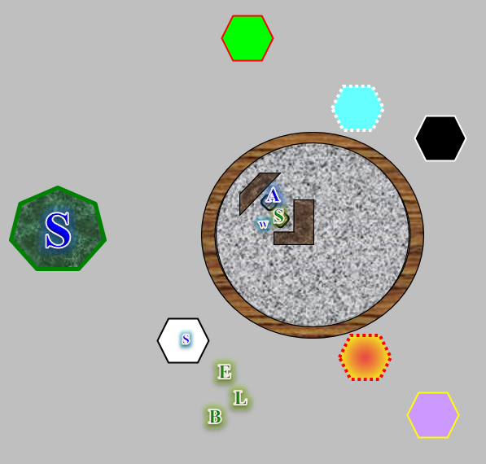

~*~

It was a confusing moment for the natives of Faerûn as the giant stepped onto the heptagon and the others onto various other platforms.

With the sounds and description of the attack, Barkley wondered if it was the illithid that had tried to kill them once already trying to finish the job. Not having time to find out, he followed the others.

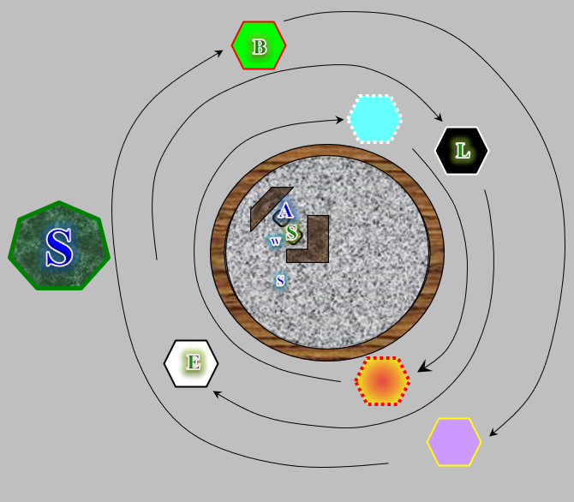

Within seconds, the smaller platforms began orbiting the larger disc, and as the volleys of rubble thrown at the fortress by the invading ship’s mangonels struck the outer shell of their domicile, they began to note that all around them went dark, and then light again, glowing with a celeste hue. They appeared to be somewhere on the Elemental Plane of Air, but were instead—as Argent just told them—in the heart of the Astral Plane, which acted as a conveyor (he called it a catalyst) to their next destination. The artificer had hastily plugged in some coordinates based on a heuristic guess as to what was safer than where they’d just been, but now he was at a loss as to why the monitor was displaying readings consistent with the inability to go anywhere else.

The senior gnome scratched his head, and said, “Oh! Alright,” in Common before continuing.

Stratus had learned enough Common to understand, and replied, “Wha’ you mean, ‘alright’?”

“This’ll take some time to recalibrate,” Argent explained, “but I should be able to get us near solid ground soon.”

Soon became several minutes, and at one point, Saradette began to realize that they’d be here for the better part of an hour. By now, Barkley and the others had grown nervous that they’d be stuck in Limbo—or actually, the Astral Plane—indefinitely, but Saradette could tell that things were beginning to fall into place, and explained as much in as simplified a form as possible.

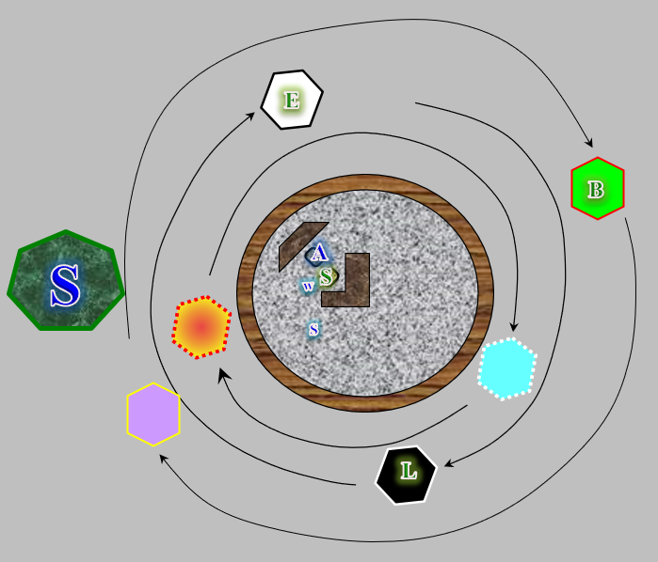

Stratus had by now emptied his barrel-sized flask of spirits into his belly, and cursed a bit more than usual, trying to hurry up the process, “I’ve go’a’ pee soon!”

Luran put on a brave face and awaited the next step in the magical process happening before them.

<< Hey Stratus, >> Elsabet called out in giant, << just turn your back, whip it out and let it rip out into the Astral—what are they gonna do, send the Astral guard to arrest us? I for one am curious to see what happens! >>

The giant tilted his head, turned to Argent, and asked, “You fink you c’d lowa’da forcefield?”

The gnome nodded, and in no time, the drunk giant was pissing centrifugally into the largest plane in the multiverse.

As Stratus urinated, Barkley shook his head, feeling sorry for anyone that had the giant’s urine land on them.

Elsabet, while initially uneasy, was happy with the two gnomes’ activities. But then she thought, and called over to Luran, “Hey L, how about firing up an inspire competence to boost our driver’s skill?”

As time went on, Barkley became less sure of Argent’s ability and was concerned they would all end up dead somewhere. Saradette’s assurances did help a little, but not much. Barkley was also concerned about the reaction that they would receive when they arrived with a giant. Whether good aligned or not, most people considered all giants bad.

It took Stratus about a minute to drain his bladder, and by the time he was done, the gnomes were pretty sure they could get the contraption working properly. The forcefield around the heptagon was again activated, and off they went, moments later coming down over the Lake of Steam with the fair city of Mintar to their direct northwest.

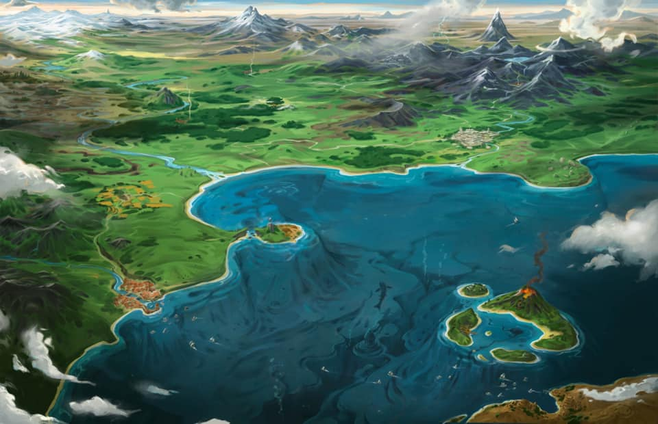

It was a clear day, with only a peppering of clouds here and there, and the water was as clear as the sky. They approached the city noting that fleets of ships were still leaving the harbor in record numbers, which led them to assume that there was still a problem in Mintar.

Argent and Saradette slowed the craft so as to seem less threatening, given its alien design, and the fact that the city had been assailed by a mind flayer less than a year ago. Barkley was the first to spot the multitude of cannons added to the sea-facing walls, and now those cannons were being pointed upward. He mentioned as much, and then a tense voice boomed in Common towards them, “You are in violation of our airspace. Identify yourselves, or we will open fire.”

As they approached Mintar and the voice boomed out, Barkley was concerned that their return would end badly. He hoped that Argent had some way of replying to that call.

The artificers slowed the craft’s descent, and Argent spoke into a device he called a microphone, though it sounded like a megaphone. “We come in peace. I bring you your city’s heroes who last year vanquished the illithid mastermind,” he couldn’t recall the name Saradette had told him, “and his lycanthropic ilk.”

As they got closer, Elsabet and Luran noted a few sentries atop the towers peering upward at them with telescopic lenses, and the cannons were lowered as a few cheers were now evident atop and within the city walls.

Elsabet, assuming that if she could hear the voice, whoever sent it could hear hers, called out loudly, “Elsabet, Favored of Mayaheine, and friends, with tales to tell! How fares the Barony?”

Luran was visually taken by the view before them. Although he registered both the call from the city below to their newly arrived flying object and the response from his companion, he could only stand and stare at the panorama of the landscape. He awaited the next few moments with his eyes wide and watching.

~*~

Guided by some guys and gals with flags, the two gnomes set the fugue machine—for that was its tentative name—down between the Eastgate and the West Hill quarter.

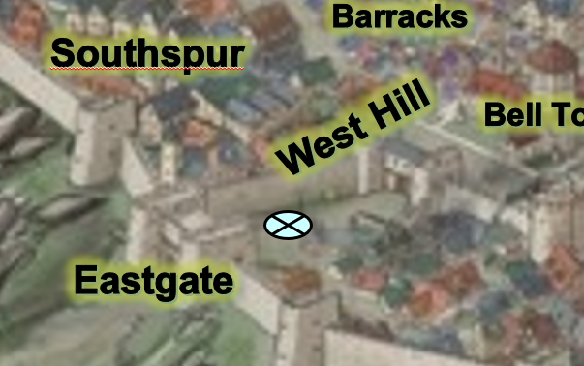

They almost immediately got caught up on the skinny regarding the happenings since they’d left. From the sounds of it, it was like ten years had passed, though really, it was only 11 months or so. They spent about half an hour by the teleportation device as Argent perform after-action diagnostics, and recalibrated the machinery based on these readings. Gondars had shown up, as news traveled fast in Mintar, and were marveling at the artificer’s contraption.

Barkley, Elsabet, Luran, Saradette, and Solstice were at the center of a circle of conversations, and by now they’d learned that:

* Ghaerleth Axom had come back at the end of Flamerule, intending on ruining Midsummerfest for everyone, and had finally been vanquished by a much more prepared defense force. They’d implemented a number of contingencies that had been laxly eschewed in years past, and the Barony was all the better for it, even if taxes were higher now.
* Lycanthropy—even strains associated with Good and Law—was expressly and strictly dealt with by way of magic, and anyone unwilling to submit themselves to purges of this affliction was exiled... or worse.
* The Baron had implemented a system of rule that was more transparent, mostly to safeguard the city from future clandestine takeovers and attempts to usurp the crown from within, and turnover in advisors was now set at 2-year intervals; previously, appointments were potentially lifelong at the Baron’s discretion.
* The Baron’s Keep had been refurbished, and the new belltower had been retrofitted with magical wards that also rendered it a base of operations for a special investigative unit called Mintar’s Eyes. They’d been initially commissioned to deal with the chaos that had fomented in the Southspur, that which had emanated from the Reality Wrinkle, but since last year, they’d taken on other cases, and now oversaw internal affairs within the Barony’s Municipal Security Force.

All in all, the city seemed to be in better hands, and they’d heard more than once by now that much of this success was owed to the Fist of Light, which had been labelled the Agents of BLESS by the Barony, as they were not aware of the band’s holy charge.

Bishop Jericho was among those who had come to bid welcome to the heroes, and though he was saddened to hear that Barkley had fallen out of faith in Tyr and had gotten himself mixed up in some drunkard cult, he could tell that they were all still righteous people, and invited them to his temple that evening.

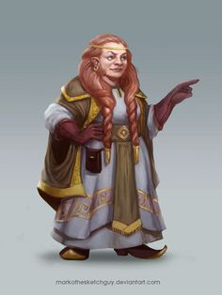

Shoomma—the kindly dwarven shopkeeper—had also strolled over, and hugged them all tightly, offering to sharpen their blades for free when they next came to see her. She’d been impressed at Saradette’s ability to land such a strapping cloud giant boyfriend, and gave the gnome more than one look of discreet admiration and wonder.

Argent portrayed a kind demeanor, but was in a hurry to get out of Mintar, and told Saradette, << You’ve been a wonderful pupil. >>

<< And you a patient and wise mentor, >> she replied.

He continued, << I must continue now. I believe I can find my way back to the giants’ fortress... in a month’s time, if it still stands, and is still under Queen Ghim’s rule, perhaps we can return briefly when the planes converge. >>

He and Stratus had just been talking, and the giant said in his broken Common, “I really can’t leave my pe’ol behind like this. We mus’ ge’ back t’the fortress before all is lost.”

Saradette gestured for Stratus to lift her up, and she stood on his palm as they spoke. “I will miss you, but I do agree that you must return. We will see each other again, so you keep after Argent to bring you back someday.” She kissed him, and let him put her down.

Elsabet greeted Bishop Jericho warmly, and filled him in on how the crazy squidhead had pulled the group to the Beastlands apparently, and after his minions were defeated, flew away and returned with a flying warship, etc. She said she would love to come to his Temple. She wanted to get his thoughts on the cloud giants’ deities and how they fit into cosmology at large. She planned to check in at her own temple first, of course, assuming there was time.

But she thought the group’s first stop would be at the inn they had never gotten back to. They needed a place to sleep, and to check on Saradette’s belongings... and Elsabet at least really wanted to check in with her contacts at the Keep, perhaps the next morning if not immediately.

~*~

Argent and Stratus waved as the fugue machine lifted off and soon thereafter dematerialized. There was a bittersweetness about the moment for the Fist of Light: two friends departed while the five heroes stayed in Mintar, where they’d longed to return for almost a year, and as the crowd began to die down with rejoice for the heroes, a contingent of Baronial Guards—dressed in new uniforms with almost no black or red in their regalia—approached them with dutiful body language.

One of them was a young man who’d fought alongside them on the day they disappeared—Brezhnev—and he immediately smiled upon seeing them, saying, “Friends, it *is* you!”

His commanding officer was a bit more stern, but nonetheless expressed his gratitude for their service after initial greetings and before saying in Mintari Common, “News just reached the Baron of your return, and he wishes to convey his heartfelt gratitude to you. Will you please join him for brunch?”

Barkley was glad to hear that many things had improved, however, he was concerned by the treatment of the Lycanthropes. Though many were evil, and the city had to deal with many of them, treating them all the same could give people the encouragement to deal with them vigilante style. Another case where doing the right thing (or good thing) was more important than the Law as far as Barkley was concerned.

Barkley was glad to see Shooma and returned the woman’s energetic hug. “It is good to see you and I would gladly accept your offer to sharpen my blades. I’d be interested to see if you have anything new in your shop as well.”

“Do I? Why, I have things that don’t take names and are all out of chewing gum,” the dwarf responded.

Barkley smiled and nodded, accepting Bishop Jericho’s invite to the temple of Tyr. Though he had lost faith in the god and his adherence to law and order, he still saw the deity and his faithful as servants of good and did not want to be rude.

Barkley smiled and replied to Brezhnev, “It is good to see you are well.” He then turned to the commanding officer and nodded, “That would be acceptable, but we cannot stay long, we need to check on other belongings,” he glanced at Saradette as he thought about her wagon and pony. “We also have some other friends that we need to check on,” he added as he thought about the family of inn keepers. Barkley also wanted to ask the Baron about a man named Fitzroy Quentine and what happened to the kid that was arrested with the warrant signed by this Fitzroy character.

Saradette nodded in agreement, though she was anxious to see what had happened to Gadget and her tools. She’d stashed her new toolkit in her haversack, but she needed her forge and other tools from the cart.

“Of course, we’d be honored,” Elsabet replied to the officer. “It will great to see him again. And I hope to be able to catch up with some folks in the Guard.” She grinned at one of those folks. “Brezhnev, good to see you again, you are looking well!”

Looking around at her friends, she saw agreement on their faces, though they also had other things on their mind. “Let’s not keep the Baron waiting—and I, for one, am looking forward to good human-sized Mintari fare.” It was nice not to have to crane her neck so much, after months of conversing with huge giants, and she couldn’t keep the smile off her face.

~*~

At the Baron’s Keep...

The modest castle had been refurbished along most of its façades, and new stonework now decorated its outer perimeter wall. There were slightly more guards than they remembered, but they were back to wearing the khaki-dominant color scheme that the heroes had seen upon first entering Mintar last Tarsakh.

The heroes were ushered in by Brezhnev and company, and in no time, they were following their noses towards the banquet being served in the new dining area. Before being seated, they saw Bratislava entering, and noted that she was dressed in the manner of a Prefect; she’d been promoted over the course of the last year, and was now the Baron’s most trusted confidante. The Baron came in after her, and once he’d reached the head of the table, all were seated and served a variety of vegetables, as well as a few pig- and dog-based meats to suit the outlanders’ tastes. Neither animal was commonly consumed in Mintar, but the Baron knew the heroes hailed from the north, and thus an exception was made.

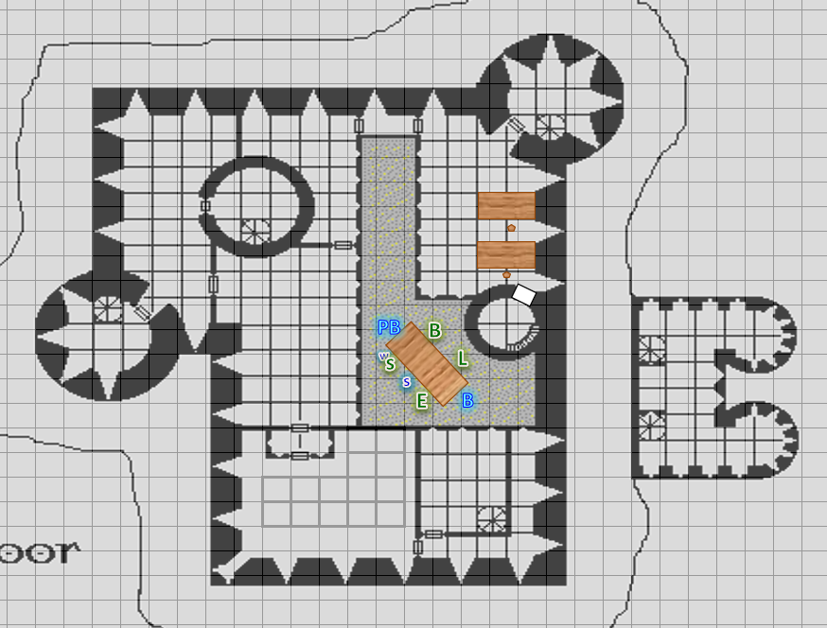

Saradette was led to her chair, which was cleverly designed with an adjustable seat for the smaller folk. She smiled and said only, “Thank you, Milord,” when the Baron spoke to her. The gnome ate less than her usual amount, which meant she still put away a surprising amount of food, mostly fruits and vegetables.

The Baron spent the first few minutes thanking the heroes for their selfless acts, and passed around a thin, leatherbound account of their heroism, which he’d just approved for inclusion into the local history curriculum, and as they took bites from the various dishes, each partook in thumbing through the leaves that recounted the tale of that fateful Tarsakh day last year, and the events that followed directly thereafter, including a purge of the traitors that left no bloody detail unwritten.

Barkley nodded and smiled at Bratislava as she entered, glad to see that she had moved into a position of the highest trust and authority, next to the Barron at least. Barkley then smiled and nodded as the Baron entered. However, Barkley was a bit embarrassed by the praise, not used to having his deeds recorded or lauded.

When the food was served, Barkley was more inclined to the pork based foods but did take some cruncher fruits as well.

When he had to opportunity, Barkley inquired of the Baron and Prefect, “There was a young boy that lived across from the inn we were staying at. He was arrested at the outbreak of all of the madness last year. The warrant for his arrest was signed by a Fitzroy Quentine. Is there any way to find out what happened to that boy and this Fitzroy character?” Barkley had wanted to look into this before they were swept away from Faerûn, but that opportunity was taken from him. Now, if the Baron or Bratislava could not help him, all he could do was hope that the boy was fine. “Radnar Radnar, Junior, is his name,” Barkley recalled. “The family runs the Missing Minotaur, the inn adjacent to here.”

Prefect Bratislava did not recall the case, and had probably not presided over it, given the bustle that had ensued during that cleansing. She called out to her assistant, who was in the next room at his desk, and when he entered, she bade him to look up the case by name.

Within a minute, the Deputy Prefect entered, unfurled a parchment that had been stored along the adjacent bureau’s northern wall, and read the details, notifying the Fist of Light of a summary annulment of the case. The boy had no formal record attached to him, and the family remained in good standing with the Barony. They’d even been compensated for their trouble with a scholarship for young Radnar, should he ever wish to attend the Guardians’ Academy.

“All’s well that ends well,” the Baron chewed as politely as he could while speaking. His manners were of a true southerner, dispensing with the tawdry folkways that northerners often boasted, and as he rested his elbows on the sturdy table—a sign of a well-educated and pacifistic adult in these parts—he summed up, “I am so glad that we finally got to meet in person. I am told that the last time you beheld my person, I was in the midst of coming out of my illithid-induced stupor.” He sighed, “I’ve no recollection of that day—that entire tenday, in fact—but having reviewed the anecdotal evidence of my guards, I cannot think of anyone more deserving of these.”

And as he finished speaking, Bratislava produced a wooden case and stood up to present a medal to each of the members of the Fist of Light. There was even a miniscule one for Solstice.

Barkley smiled, and thanked the Deputy Prefect as well as the Baron and Bratislava. When the medals were given out, Barkly accepted his with pride and modesty. “There is no need for medals,” Barkley said as he looked at the Baron, “we simply did what was right and what was needed.”

A smile evident on his face as he saw his friends received their medals as well. When it came time for Solstice to receive his medal, Barkley offered his hand for the musteval to step onto and lifted him to stand on Barkley’s shoulder. Looking at his small friend, he said, “It looks good on you.”

“Likewise, brother,” one theromorph said to the other.

Elsabet bowed to and thanked the Baron, as well as Prefect Bratislava, saying “I will wear this with pride, and am happy we were able to be of service in those dangerous days. Doing the right thing is its own reward in some ways, but to be recognized publicly by noble lords such as yourselves brings us both honor and joy. Your beautiful city is privileged to have you at its helm.”

She bowed even more deeply, her words sincere and heartfelt, for she had become enamored of Mintar and its people, despite their ways being so different from the ways of her homeland. She had definitely enjoyed the taste of meat, but had also made sure to at least sample the various vegetables, and her tongue was as delighted as her heart at this warm reception.

As the medals were presented, Saradette nodded in response, preferring to let the others speak.

Luran accepted the medal and praise humbly, remaining largely quiet and introspective during the meal.

Barkley then produced a bottle of his dragon breath bourbon, and asked one of the servers for some small glasses. Once they brought them, he poured the contents into the glasses, offered them to the others, and proclaimed, “To the Baron, and all of those that serve Mintar, may their future and the cities future be bright!”

When the last course was served, and the conversation was saturating to a standstill, they’d half-expected the Baron to entrust them with some charge, perhaps to root out some evil splinter cell of a wereserpent cult or something the like. Instead, the sovereign noble thanked them again, and asked if they were staying in Mintar. “Should you decide to stay, we can secure lodging for you at the Minotaur, or if there’s no vacancy there, perhaps something closer to the harbor?” he ended the sentence with an inquisitive inflection.

~*~

Having been granted a writ that secured payment to any willing innkeeper to lodge them, the heroes expressed their gratitude to the Baron, as he did to them, and they were then off to the Missing Minotaur.

The Radnars were so glad to see them, and welcomed them with open arms. Their kid was a few inches taller by now, and a bit more strapping around the shoulders and biceps. He was even a bit more talkative than he had been before, and introduced them to his girlfriend, Yajaira.

As the members of the Fist of Light entered the familiar inn, Elsabet noted that her single row of silver spiked knuckles was hanging from a hook affixed to the wall behind the counter. The Radnars had been saving it for her should she return, but they served as an adornment between some other kitchy knickknacks that also decorated the wall. It didn’t take long for Radnar, Sr., to remember to return them to her, and he boasted that he’d even had to use them a few months ago to discourage a mugger from robbing their till.

Elsabet grinned as she took the knuckles back. “I’m glad they proved of use, but even more glad that you didn’t have to use them against werecreatures!”

“A pint?” Mrs. Radnar proposed, seating them at their usual table for five.

“I’d love one,” Saradette replied. “Are my pony and my wagon still here, perchance?”

Mr. Radnar showed Saradette to the back yard, where the cart had been placed in the corner, covered by a tarp, and where Gadget munched uneventfully on the grass that was beginning to grow in the space she’d called home since the heroes left.

“I put the pony to work,” joked Radnar. “Had her out front entertaining some of the guests’ kids from time to time, and set aside some space in the shed to stable her during the winter.”

Saradette approached Gadget slowly. “Gadget, honey, I’m so sorry I had to leave.” The critter allowed Saradette to hug her neck. “I missed you.” The gnome went to her cart, and looked for her coins. Radnar handed her the sack of gold that he’d kept safe for her, and from it she extracted a hundred gold coins to give to Radnar. “Will this cover her boarding?”

“Phew!” he was pleasantly surprised. “I’d say! Much obliged, Saradette.” Once he and Saradette came back in, Barkley asked Radnar, Sr., to bring him one of their small, empty kegs.

When he returned, Barkley pulled two bottles from his pack and poured one and a half on them into the keg. As he put the bunghole plug back in, he said, “That is for you and your family’s personal consumption. This,” he said, holding up the remaining half bottle, is for us to share now.” He then got some goblets and poured everyone, including all three Radnars, an equal share and toasted, “To health and good fortune.”

“Aye!” agreed the father, and with this, they all partook in the toast.

Elsabet happily accepted a pint, and continued, “My apologies for disappearing without being able to send word. It wasn’t by choice, I assure you! You’d be amazed at where we ended up stuck for a while, it was literally out of this world.”

“Oh?” Mrs. Radnar was intrigued. “Where exactly?”

Solstice gave a brief account of their battle in the Beastlands, followed by the 11 months spent floating over Ysgard.

Elsabet took a deep swig. “Anyways, I’m very glad to see you folks are doing well and that the city seems to be much better off than that fateful night we ended up fighting the bad guys and helping the Baron regain control. It looks like we might be staying a while, if you can put up with us and put us up, as it were.”

Elsabet wanted to visit the Temple of Mayaheine soon, and would be happy to have some of her friends to join her if they wished, though she expected Saradette would be spending time getting reacquainted with Gadget and sorting out her cart, tools, etc. The gnome had already gone out back...

“Barkley, do you want to hang out with Saradette here and give her a hand moving stuff if she needs it? To be honest, I’m still a little skittish and would like it better if we didn’t have anyone going off on their own for a while, at least until we get settled back in. Luran, Solstice, care to join me? I want to head over to the Temple of Mayaheine and get caught up with the people there. And then we can all meet up later for our thing with Bishop Jericho at the Temple of Tyr.”

Barkley nodded, “I agree we should not go about alone. I do need to see about a new symbol though, and find out the god whose symbol is the tankard. I feel that he has been calling me. Perhaps on the way to Shooma’s later we can stop in a few other shops.” He then tilted his head slightly, “Or perhaps someone at your temple may know which god that would be. Travel safely, Saradette, and I will be here, or leave word with the Radnars should we leave before your return.”

Luran asked if she had that cider he had liked so well, completely uncertain whether it was the proper season for that particular local libation or not.

“We’ve a few swigs left,” Mrs. Radnar said as she went to get the bard his favorite cider.

Seeing the family of innkeepers, good folk he remembered from a year ago, brought him to a much more expressive state than the Baron’s Keep had. As the reunions continued, the bard sang and made jokes as interjections, always supporting others’ points, never pulling center topic, himself.

“I’d like to see about getting a small wagon, and a partner for Gadget,” Saradette said. “I have some ideas, but I need a better work area to realize them.”

Barkley nodded, “We can look around town for one. I’m sure we can find something to suit your needs. Perhaps I can even set up a sleeping area in the back if there is enough room.”

“I had that same thought. Do you snore?” Saradette grinned at him.

“Only if I transform into a pug,” Barkley replied with a wink.

“You can sleep with Gadget,” Saradette growled.

~*~

Cider and other pleasantries were enjoyed, and within the hour, the party found itself entering the Chatterstreet Market quarter and crossing the main street towards Shoomma’s shop. Shoomma was glad to see the heroes, and could tell that they were tired, so she didn’t make too big a fuss about them staying for dinner, but mentioned it in passing with the casual no-pressure invitation to join her and her son.

As Shoomma’s son was sharpening their swords and daggers, Barkley found a Quiver of Elhonna that he considered purchasing, but she didn’t have the magic bedroll that he’d also hoped to pick up. “Maybe o’Fey’s down the street will have it,” the dwarven elder mentioned.

Barkley thanked Shoomma and offered her 1,900 gold for the quiver, saying, “I will check o’Fey’s shop, but I do need to know when dinner is.” He paid her 1,600 in gold, and 60 platinum, and shouldered the quiver.

|  |  |  |  |  |  |  |
| --- | --- | --- | --- | --- | --- | --- |
| *Equipment Carried* | | | | |  |  |
| **Item** | **Qty.** | **Wt.** | **Effects/** | **Notes** |  | **Value** |
| Quiver of Ehlonna | 1 | 2.0 |  |  |  | 1800 |
| *Heward’s Handy Haversack* | | | | |  | 2000 |
| **Item** | **Qty.** | **Wt.** | **Effects/** | **Notes** |  | **Value** |
| Gold Coins | 42 | 0.4 |  |  |  | 42 |
| Platinum Coins | 715 | 7.2 |  |  |  | 3575 |

He gave the dwarf shopkeeper a smile. Though he was tired, spending time with friends and good hosts like Shoomma was worth it.

Barkley then looked around Shoomma’s shop for any javelins and spears to add to his new quiver. He located several regular javelins and some masterwork javelins. He was also very interested in the magical spears that he found. He brought 12 regular javelins, 5 masterwork javelins and 3 regular spears plus the longspear +1, spear +1 and shortspear +1 up to Shooma’s counter and inquired, “How much for the lot?”

“Hmm, let’s see now...” she tallied the prices on a parchment:

* Javelins: 12 x 1 = 12
* Javelins, masterwork: 5 x 301 = 1,505
* Spears: 3 x 2 = 6
* Longspear +1: 2,305
* Spear +1: 2,302
* Shortspear +1: 2,301

“So 2305 + 2302 + 2301 + 1505 + 12 + 6 = 8431... let’s make it 8400 and call it even,” she posed. “Impressive arsenal for your new quiver.”

Barkley smiled and nodded at Shooma’s remark. “Sadly,” he replied, “I cannot afford all of them. I will take 16 javelins, the 3 spears and the long spear. The other two I may claim at a later time.” He then opened his haversack and pulled out his platinum and gold pieces and placed them on the counter. “Will this cover those items?”

She counted the rolls of coins. “That’s an equivalent of 3,617 gold,” she absentmindedly sang to herself, so that’ll cover one of the spears and some of the javelins. She listed the prices down:

* Longspear +1: 2,305
* Spears: 3 x 2 = 6
* Javelins, masterwork 5 x 301 = 1,505
* Javelins, 16 x 1 =16
* Total: 3,828

“That leaves you with 314 gold,” she pushed the coins towards him.

Barkley looked at the change, and asked, “Can I get half in platinum?” He tilted his head sideways and gave Shoomma his puppy-eyed look.

While Luran knew he would never focus solely on his martial skill, his time with Elsabet, training, and the varied spectrum of foes they had come across inspired him to be as prepared as possible. As such, he looked around Shoomma’s shop for a specialty blade, one made of cold iron, appropriate for the more wicked fey that there was every chance the group could eventually come up against. It might even be effective against other foes, as well. Scanning through the selection of the shop, he discovered a lightly embellished dagger that, when he put it in his hand, had the sense of more weight than it looked like it ought to have. Recognizing it as the cold iron he was looking for, he brought it to Shoomma for checkout, smiling at his new acquisition. As it happened, not only was it the material he sought, but its craftsmanship was of an even higher caliber. While it had the sense of more weight, it moved in his grip as if it didn’t. Strange. But it’s not for his bardic sensibilities to question, really. He just knew he would be walking out better equipped than he came in.

As he brought the dagger to Shoomma, he also inquired about improving the magical protect that his mithral shirt gave him. While she wouldn’t have it ready for another day or three, Shoomma was more than happy to help him with that improvement, as well.

He refrained from mentioning it, but he also intended to speak with Saradette about what she might be able to do, adding silver to the masterwork dagger he had previously made his own. He knew the artificer took such pleasure in her work, well done. But better to have that conversation away from the kindly craftsperson he was currently patroning.

At Shooma’s, Elsabet first inquired about armor and weapon crystals, as she had really appreciated the shield crystal she’d gotten before. Hearing the list of possibilities, she mused for a while.

She’d been rather concerned about a potential trip to a watery environment while near that strange portal. “I’ll take that lesser crystal of aquatic action,” she said. “The elimination of the armor hindrance is a minor bonus, but the swim speed is what really sells it. Maybe if we end up in the water a lot, I’ll come back to get it upgraded to the greater version—the freedom of movement and water breathing do sound really cool, but not immediately needed, I hope!”

She grinned at the proprietor, and moved from the armor crystals to the weapon crystals. Browsing through the options, two in particular caught her eye. She couldn’t decide between fiendslayer, for use vs evil outsiders, and truedeath, for use vs undead—both seemed like creatures the Fist of Light might face, and even a little extra damage per hit could be useful. The least version could even be attached to a masterwork weapon, hmmm.

“Fine,” she said, “I can’t decide which is better, so I guess I will just get both! Just the least version though.” The giants had rewarded the group generously for their parts in protecting the cloud island, but she was determined to use the wealth as wisely as she could, rather than spending too much on any one item. “I have been meaning to get a masterwork weapon for backup anyways,” she muttered, looking over the selection. With two least weapon crystals, she decided fiendslayer would best suit her bastard sword, and so perhaps she should replace her morningstar.

A fine looking masterwork flail caught her eye, and she took it down from the rack and felt its heft and balance. She’d been going back and forth in her head whether to get a better silvered weapon; this one wasn’t, but Shoomma assured her that if she wanted it silvered, that would be no problem, it would be ready the next day. She paid the dwarf woman, arranging to come back the next day, barring unforeseen circumstances of course. “When I come back to pick up the flail, you can have this old morningstar,” she joked, “it has served its purpose well enough, but a woman can only carry so many weapons comfortably!” She would attach the truedeath crystal once she had the silvered flail in hand.

Then, going back to the armor and shield section, she inquired whether she could arrange to get her least crystal of arrow deflection upgraded to the lesser version. Shoomma had a lesser version in stock, and said she’d take the least version in trade, so Elsabet happily made up the difference and they swapped the crystals right then.

Before they left the shop, Elsabet inquired as to where she might acquire a couple other items she’d heard about. The important one was the amulet of tears, which could be used to gain temporarily an extra ability to absorb hits, much like Barkley’s *aid* effect provided—the hound archon was always willing, but sometimes the action was so fast and furious that he just didn’t have time, and Elsabet had taken some big hits over the past year. The other—an everfull mug—was more a convenience than a need, but if they somehow got transported to a desert realm where water proved scarce, that might be a lifesaver.

~*~

Having left Shoomma’s shop, they were now in the heart of the Chatterstreet Market quarter, and Saradette was contemplating purchasing a collapsible workshop. The quarter was quieter than they remembered it from the year before, when the streets had been filled with itinerant performers and traveling merchants. The infrastructure damaged by the wystes and lycanthropes had by now been fully renovated, and signs of a single year of weathering were evident throughout. Parents held the hands of their children as they crossed the busy streets crisscrossed by wagons and horses, and the heroes felt right at home in the bustling marketplace.

The workshop that Saradette was considering had a 10’ x 10’ base, and was 5’ tall inside. The weatherproof, fireproof, and windproof magical forge that could contain up to 1000 lbs. of nonliving materials, and measured 12” x 12” x 6” when folded. It folded and unfolded in one minute with a command word. The gnome was duly impressed, but her friends counseled her to consider the decision conservatively, given the cost.

“I can carry all of my tools and supplies without a cart,” the gnome explained. “The pack is a bit heavy, but I can manage it without too much trouble. I’m not about to get caught without my things, like just happened.”

“Makes sense to me,” replied Elsabet. “I definitely agree that having one’s belongings available even if suddenly relocated to random locations by weird magic is a good idea. Not that *that* would ever happen.” The sarcasm in that last statement was so heavy it attracted some glances from a few nearby pedestrians. Elsabet grinned at them and shrugged.

This reminded Barkley not only of the brewery, distillery, and winery that he’d had to leave behind on the cloud fortress, but of an entire tavern—with smaller-scale versions of these alcohol-producing facilities—back in Saradush, which was only about 6 days’ march from here.

“Perhaps when we are done here, we can head back to Saradush for a visit. I’d like to see how the tavern is doing and pass on what I have learned this past year to the staff there.” Barkley looked at the others to gauge their responses.

A half-elf child of perhaps 15 years spotted the dog-faced hero and his friends, recognizing them from the year earlier, and approached them. Saradette was the first to spot the youth coming over as his mother purchased a few yards of fabric from a street vendor. She sensed no hostility in him, and stayed her sword hand, and pointed him out as he got within earshot and greeted them.

“And greetings to you,” Solstice replied.

“I... you don’t remember me,” he began, “... but you’re the ones who saved my life from a wyste last year.”

“Ah!” Elsabet smiled.

“I just... wanted to thank you... for my life,” the youth found the words to articulate his gratitude. He was genuinely thankful to them, but his social skills were still immature. “Anyway, my name is Quillogh Velashmyah. If you ever need a sidekick, I’m pretty good at darts.”

“Darts?” Solstice squinted. “Like throwing darts?”

“Uh... yeah,” the half-elf confirmed with a sense of accomplishment. “I’m pretty good at hitting things with them.”

Elsabet crouched down to be eye-to-eye with the young half-elf. “Hey Quillogh, I’m Elsabet. Pleased to meet you! Throwing darts is a good skill to have. Keep practising! But there are a lot more things to learn before becoming an adventurer—and lots of ways to be a good person that don’t involve adventuring, too.”

She looked up to see the child’s mother looking over at them with a bit of concern, winked and smiled at the woman, and then continued, raising her voice just a little so that it would carry better.

“One thing I like to do when I’m not adventuring is I like to work at a forge, getting all hot and sweaty and tired banging on hot pieces of metal and turning them into tools and weapons. My mom taught me how to do that! And even though it is hard work, it is actually more enjoyable than fighting big monsters, for sure. And my dad was an herbalist, and taught me ways to help heal people even without using magic!”

As the mother drew closer, she finished up.

“I expect you will find lots of things you like doing, and lots of things you will get good at, and hopefully those will overlap. You still have plenty of time to figure out what sort of path you will be taking through life; over the next few years I expect you will grow a bit more, and learn a lot more, and will make your mom proud of you, like I hope my mom is proud of me.”

The mother had no doubt heard tell of the hound archon and his humanoid friends who’d saved Quillogh last year, and approached with the premise that these were the folks of whom her son had spoken so fondly. She looked at her son with a quizzical expression, and he nodded, “These are *them*!”

She was fully human, and spoke with the accent of a human from the northwest of the continent, “By the gods, we owe you a debt of gratitude.” She also acknowledged her understanding that this group was the same one heralded as the saviors of the Baron from the clutches of the wereserpents, and offered praises and even her hospitality should they ever need it. “It’s not a large home by any means, but you’re welcome to our cots anytime.”

Elsabet nodded at the woman, and got her name and address. She told the woman where she could be contacted in the near future, at Radnar’s establishment, and also indicated that she might come visit them if circumstances allowed, it wasn’t clear yet how long they be staying in Mintar.

People like this were just the sort of folks that inspired Elsabet to face the darkness on their behalf.

Barkley smiled and nodded at the boy, listening to him and then to the mother in turn. After Elsabet had spoken, Barkley added, “There is no need for thanks. We do what we do to protect good people like you from the evil of the world.” Barkley looked at the young boy, “Keep practicing and trying new things until you find what you love and enjoy. If that is adventuring, then perhaps we will cross paths someday. If you find you have a passion for something else, then pursue that. For if you do what you love, then you will never work a day in your life. That is what my father told me, and I can say that I have never worked a day in my life.” He gave the mother and son a warm smile.

Seeing the fabric, Barkley asked, “Madam, do you do embroidery by chance? If so, I would like to commission you to do an emblem for my tabard and cloak.”

She nodded, and agreed. Barkley then paid her 5 gold to do the tankard on his cloak and tabard. She gave him her address, and said to come by tomorrow after dinner to pick up the emblem.

“May the blessings of Lathander be with you,” Quillogh’s mother said, and with this, they took their leave and headed back towards the house with a few yards of fabric.

Saradette nodded. “That sounds good to me.”

As they continued shopping, Barkley sought out a new holy symbol for his necklace, but an authentic one would have to be found in a temple of Cayden Cailean, and the location of such a temple was still unknown to the heroes. Maybe asking around would prove useful.

Though Luran refrained from commenting directly, he had managed throughout the others’ responses to catch the boy’s eyes and share knowing looks acknowledging their shared, cross-cultural heritage.

“Hey, Luran,” Elsabet exclaimed, “I think Shoomma suggested that shop over there.” She pointed at a small storefront with thw sign, ‘Exotic Equipment Emporium’, and in smaller letters, ‘Wondrous Widgets for Wandering Warriors and Wizards’.

She led the bard towards the shop, eager to acquire the last items on her wish list. Sure enough, the proprietor, a gnome who introduced himself as Walterin, indicated that the shop had a variety of items available - though not on display. “Tell me watcha lookin’ fer, an’ I’ll see if I got one.” The shop seemed very small and dusty, with a curtained doorway behind the counter - reminding Elsabet of some pawn shops.

She told him what she was looking for, and he ducked through the curtain, returning a few minutes later with both items she had asked about. She paid, and Walterin then turned to Luran, “An’ fer you, sir?”

“I do love alliteration!” Luran lilted and ducked into the mystically scented incense that layered the air in the gnome’s shop.

Within, he inquired upon the broach of valor and spell scrolls he hoped to acquire, offering a solid market value for them.

Saradette walked past a collection of street vendors, browsing as she considered her options. She needed to have her workshop to pursue her craft as an artificer. Argent had lent her some tools, and she’d made some of her own during her time with the giants, but it was a frustrating and time consuming experience. A covered wagon was an option, but even a small one would require a second pony, and it would be even less portable than her cart.

Then, one vendor caught her eye. A gnomish wizard was extolling the virtues of a magical tent to a customer, and she stopped to listen to the older woman. After the customer was done, she looked at Saradette. “How may I help you, Sister?” She spoke in Gnomish, and Saradette stepped up to her with a smile. “I need a workshop – but I need to travel with it, and my cart is too bulky and too slow.”

The wizard took in her workman’s garb. “You one of those artificer folk?”

Saradette looked startled. “Uh, yes. Yes, I am.”

“That contraption you’re carrying gave it away, Sister.” The wizard pointed to Saradette’s sonic blaster. “Magic I understand; those things, I don’t. But, to each her own.” She sat down on her stool. “Your goddess smiles on you this day, though. I was commissioned by a gnomish company to design shelters that they could carry with them. They bought nine, and I had made ten.” She stood and leaned down to rummage under her table for a moment. Then, she brought up a canvas pack and set it on the table. “It’s heavy, but it will carry a wagonload of whatever will fit inside.” She lifted up a pair of padded straps that attached to more leather straps that bound the pack. “You’ll not want to put this in your magic haversack, I’ll warn you. They will destroy one another if you do.”

“Now, take this and set it there in the street. Be sure to leave room for it to open.” The wizard helped Saradette to set it up, and gave her the command word to open it.

Saradette stepped back and spoke the word. The pack began to unfold as the artificer watched in delight. After a minute, it was done. Made of heavy canvas with a wooden frame, the small building stood empty. She stepped inside. “This is perfect, she said as she noted the gnome-height ceiling. She’d have to use hammers carefully inside, or, more likely, set the forge up outside. There were canvas loops to attach a fly, and those were easy enough to find.

“I have some items and coins I can trade,” Saradette said as she produced what she had. “I don’t know if it’s enough.”

The wizard smiled. “I was paid handsomely for my work, and I can use the items you have to trade. Take it with my blessing.”

“Thank you.” Saradette spoke the command word again, and the pack slowly returned to it’s original form. She arranged the pack so it was close to her back, and the haversack hung over it. “Oh, this will take some work to carry, but that’s fine with me.”

“Good day to you, then,” the wizard said with a smile.

Saradette walked over to Barkley. “Did you see that?”

Barkley smiled and nodded, “Yes, that was quite impressive. It will come in very handy while we are out on the trail. Also,” he offered with a smile, “I could carry it should you need to ease your load. With my new quiver, my own load has gotten a little lighter, even with the additional arsenal of projectiles.”

Saradette smiled back. “Thank you, I appreciate that.”

As Barkley walked through the Chatterstreet Market, he looked into several windows and followed his friends as they went into various shops.

When they walked into one jeweler, something caught Barkley’s eye. It was not fancy or shiny, it was, in fact, rather plane looking. It was a dark silhouette of a tankard on a chain. Picking it up, Barkley looked at it and smiled at its simplicity and unassuming nature. Yes, this was a symbol he could support and one he would be proud to wear for many reasons.

Walking over to the shop keeper, he inquired, “How much for this necklace?”

The shopkeeper looked at it then at Barkley, “That thing: you’re sure you want it? There are many more decorative pendants, charms and necklaces that would look much better on you.” The halfling behind the counter smiled up at the much taller archon.

Barkley smiled, “No, thank you,” he replied politely, “I am not one for fancy things.”

The halfling took another look at the archon and his simple apparel and shook his head, “What a shame.” He then looked at the necklace again, pausing for a moment. “You can have it. You’re the first person to show any interest in it since I got it 6 months ago.”

Barkley nodded his thanks and then paused himself. Six months ago was when he had begun having his regular visions of the tankard and the god he believed it represented. He looked at it again, and decided he needed to find out more about this deity and see if there were a temple of his in Mintar.

Barkley would try talking with other priests or stop in a library in Chatterstreet Market if there was one to see if they had any information.

~*~

They’d finished their shopping for the time being, and Elsabet was poised to return to Shoomma’s tomorrow to pick up her silvered weapon. In the meantime, Barkley had asked around for the location of a temple devoted to Cayden Cailean, and after about an hour of failed attempts, he was about to give up. Then, serendipitously, a drunkard overheard him complaining to Luran about the dearth of worshippers of the Accidental God—as he was known in some circles—and wandered over, stinking of the brew he’d recently imbibed. “You seek the true knowledge of the truest of deities, do ye?”

And—shifting his eyes first—the archon tilted his head and responded, “Uh, yes?”

“Aaahh!” the man sounded like he’d just relieved himself, and then pointed Barkley to where he could find such a temple. “’Tisn’t rightly a temple, though, lad.” And then he went on to explain that to find such a place of worshippers, he had to venture into a tavern called the Rampant Tankard, and upon inquiring, had to flash the symbol now worn around his neck, making a reference to the Accidental God by that title specifically.

“You don’t say,” Barkley’s eyebrows rose, one after the other.

“Aye,” the drunkard was apparently one of the faithful, and reminded Barkley, Elsabet, and Saradette—who had come from Saradush a year earlier—of the drunken master named Bornoflove. The drunkard added, “Tell’em Phrancis sen’cha, and don’t be surprised when they take you underground.”

“Oh!?” Solstice asked a question without words.

“It can seem a bit off at first, but the place of worship is in the cellar,” said Phrancis.

His mannerisms were jovial, and anything but underhanded, and the group felt a unanimous sense that he wasn’t trying to trick them into ending up in some dungeon.

Barkley nodded, “Thank you Phrancis, I will seek them out this afternoon.”

As Phrancis left, Barkley turned to the others, “I must go to this temple and see if this is truly the calling I have been feeling these last several months. You all do not need to go with me, this is something I must experience firsthand though, go be sure.”

“I will go with you,” Saradette said.

Barkley looked at Saradette and smiled.

Elsabet was intrigued and would go along with Barkley as long as Luran was willing to go as well, but didn’t want anyone going solo in the near future, so if the bard had other plans, she would stick with him. “Luran, what do you say?”

Luran addressed the question, “A seemingly unknown, Accidental God? Sounds fascinating! I would indeed like to join you and learn more, Barkley.”

“Just be ready with some drinking songs.” Elsabet winked at her half-elf friend. “And don’t get drunk.”

Barkley smiled at each of his friends, “I appreciate you all for accompanying me. This is a change that I am both hesitant and excited about. I feel that this ‘Accidental God’ has been calling me while we were away with the giants. Now I must see why he has been calling.”

~*~

The sign above the Rampant Tankard read “rAmpAnt tAnkArd”, and sported a horse reclining against a barrel while holding a bottle in its front, right hoof. It was a nondescript place, pretty much like any other tavern in the area, and as they walked inside, they noted the holy symbol of Cayden Cailean above what appeared to be the back door, though it likely led to the cellar.

The barkeep was a lady of human stock, with buxom boobs that had likely fed a half-dozen children by now, and as she looked at the newcomers and spotted the archon’s holy symbol hanging from his necklace, she locked eyes with him and raised her eyebrows as if asking something.

As the woman looked at him, Barkley noted her well-endowed chest and gave her a smile in return. He then stepped forward, “Phrancis sent me, I am here to speak with the Accidental God if I may.”

The woman smirked upon hearing Phrancis’ name.

Barkley then turned to the others, “These are my friends. If they are not allowed to accompany me, they will gladly wait here in your fine establishment.”

“Any friend of Phrancis....” Without finishing the sentence, the woman dusted off her hands on her apron and led Barkley and his friends towards the cellar door.

Solstice followed Barkley as did the others, and the woman opened the door. “You’ll want to watch your step. Devotion is in session, so there’re only a few candles lit down below.”

The rickety staircase conveyed an upward waft of freshly brewed ale, and as the heroes entered, she kept the door cracked open to let in a few rays of light so they wouldn’t fall on their way down. Reaching the bottom, they happened upon six humanoids sitting on the ground around a low table, each with a wooden tankard.

“Strangers, come, and join us, for we have just cooled this fine brew,” the stout dwarf among the men and women around the table invited them. “I am Zym, Priest of Cayden, and what be yer names?”

Saradette nodded to the cleric, preferring to let Barkley keep the man’s attention. She faded back a little, allowing the others to shield her.

Barkley bowed, “I am Bazazath Anath or Barkley to my friends. “ Straightening up, he continued, “I believe that Cayden has been calling to me recently. I have seen this emblem,” he said as he pointed to the pendent around his neck, “in my dreams for many months now. Only recently have I discovered it is the symbol of the ‘Accidental God.’ These,” he turned to indicate the others with his outstretched arm, “are my good friends, Elsabet, Saradette, Luran and Solstice.” He turned back towards the dwarf, “I have come seeking advice from the ‘Accidental God’ or one of his priests. My friends have come to show their support.”

“I am Elsabet, Favored of Mayaheine, friend of Barkley. Well met, Zym.”

The dwarf nodded, and stood up, motioning for them to approach the barrel of new ale. He grabbed a few tankards—one at a time—filled them, and handed them to the newcomers. “Here, lads. Drink heartily, and I will impart some wisdom as you take in the heady hops and contemplate the moment.”

Solstice took the wee cup handed to him first, and sipped the still warm ale as he sat atop the table after being invited to do so by a half-orc with impressive lower canine teeth.

Elsabet accepted a mug, and as usual, sipped it slowly rather than gulping it down.

Luran accepted the offered mug. Recognizing the ritual weight of the proceedings, his first quaff was strong. Although, he made sure to do little more than sip on any further libation asked for.

“Now,” began Zym, “I was just about to get started with the origin story of our patron deity. Sit back and enjoy this recounting of the legend of Cayden Cailean. Before he successfully completed the Test of the Starstone in 765 DR, the man known as Cayden Cailean was a Amnish sellsword and freedom fighter working out of Athkatla. He strongly believed that no man should hold power over another, and went so far as to leave jobs unfinished rather than violate his principles. His refusal to compromise his ideals was as well known as his love for drink, and the combination of the two resulted in a less-than-favorable reputation among potential employers. Ultimately, however, the latter would lead to the man’s apotheosis.

“Cailean never planned to become a god, but when a drunk friend challenged him to take the Test of the Starstone, an equally inebriated Cailean accepted, forgetting that only two mortals, Aroden and Norgorber, had passed the test. Another story claims that Cayden was prompted to take the Test after his advances had been rejected by the goddess Lliira herself. Legends abound regarding the challenges Cailean faced at the Starstone, but no one knows the truth of what happened. Regardless, after three days had passed, the sellsword—to everyone’s surprise, including his own—emerged as a deity. He could not remember how he had passed the test, but continued as a god in much the same way as he had when he was a mortal: doing whatever he wanted, fighting for just causes, and enjoying the drink.

“Today, friends, Cayden Cailean holds freedom and adventure in high regard, and opposes tyranny and oppression on principle. He willingly accepts challenges when they are issued, although not as a point of honor; he sees no shame in retreating when necessary. One instance of note is the fall of the devil Salicotal, who grew infuriated with Cailean during a duel of dares, and attacked—only to be defeated—at the hands of the god.”

By this time, the heroes were feeling the buzz of the ale, and Solstice had gone to the tap to serve himself a second helping, hiccupping on his way back to the round table that stood perhaps 18” from the ground, which was comprised of dusty, weathered, wooden planks that separated them from the coastal, sandy soil.

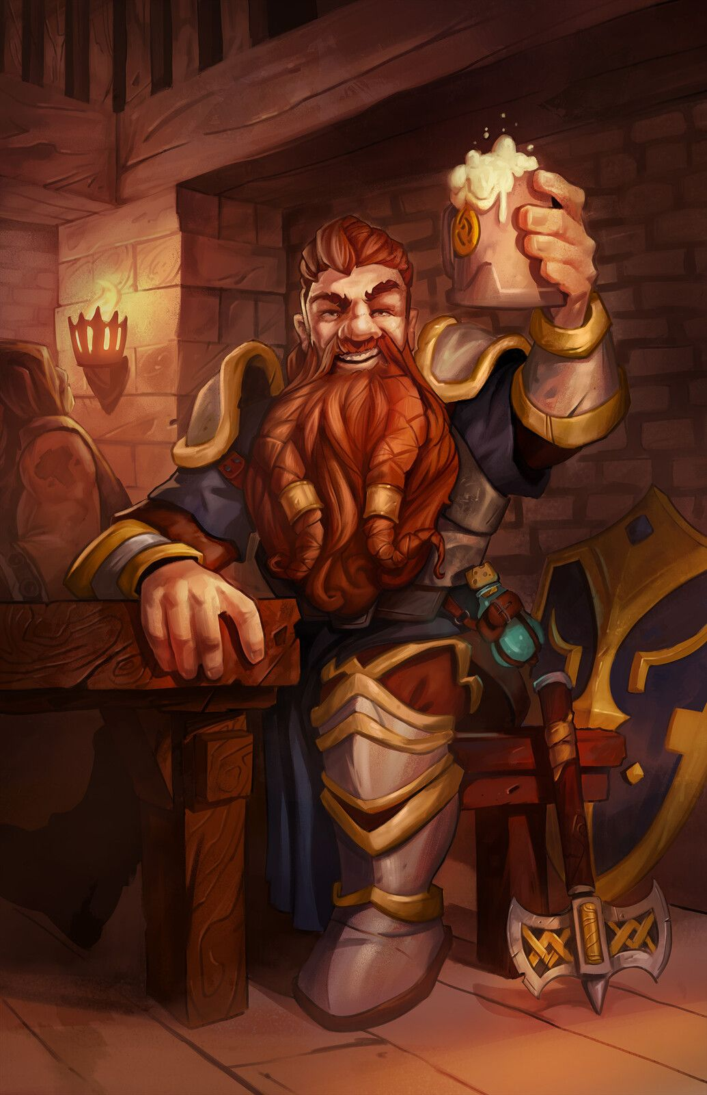

They drank for quite some time, and it then came to relevance that Barkley’s holy symbol had yet to be blessed, and Zym—who was the only ordained member of the Caydenite Order—promptly remedied that flaw in the situation. Returning to top off his tankard and that of a few others, he concluded, “Remember, friends, all that exists is the moment.... Who you are at any moment is dictated by your actions and mental state, and as such, you must strive to be as elastic as the moment... as fluid as this here ale. May Cayden Cailean bless you during every moment of your lives.”

Elsabet vaguely recalled a similar philosophy being shared by Priestess Uma of Mayaheine, and saw a great convergence in the wisdom this mid-aged dwarf and in her own spiritual advisor here in Mintar, whom she’d not seen in almost a year.

Elsabet nodded at several of the priest’s points, as she herself occasionally had doubts as to the purpose of some laws, though not all. And then a thought occurred to her, and she approached the priest after he had finished blessing Barkley’s new holy symbol.

“Wise Zym,” she began, “today is an auspicious one, and it occurs to me that just today I acquired a magic item that your god would surely approve of.”

She pulled the everfull mug out of her haversack, and continued, “This mug magically fills 3 times per day, with water, wine or ale depending on the word used. I would think it most fitting if you would bestow the blessing of your god upon it, that it never lose its mojo.”

“Ah, yes, I am aware of such a mug... old Xythemak here has one at home, but none refill with as satisfying a brew as that which one’s own hands and recipes can muster,” the dwarf proclaimed. “There’s something to be said for the crafting of one’s own meal and drink.”

“What?” asked the human stranger at the table, whose name was Quiroz.

“What ‘what’?” Zym needed clarification from his friend.

“You said there was something to be said; what is to be said?” asked the human.

“It’s a figure of speech, Stretch!” Zym shook his head at the human with the weak liver. “Meaning ‘there’s a lot to be desired about a homecooked meal and a homebrewed beer, lad! You shouldn’t even have that explained to ye....”

They bickered like friends did for a few more volleys of words, and then the group settled into jovial laughter until Zym asked, “Another pour for anyone?”

The mid-afternoon happiness would eventually yield to a nap for some of these regulars at the Rampant Tankard, while others would continue drinking well into the night and likely further. The cleric of Cayden Cailean kept his wits about him all through the drinking, as his was the duty of managing the wellbeing of the others, and see that they all got back to their respective homes before their wives, husbands, and other loved ones came looking for them. “Have you any loved ones waitin’ for ye?” he asked the heroes at some point. “I never want to be the cause of domestic tension, not the kind of challenge our deity invites.”

Saradette thought wistfully of Stratus, and shook her head. She was well used to strong drink, but she finished her mug and set it down. “I have work to do, so I am ready to go back.”

Luran took that opportunity to inquire whether the gnome artificer could find time in her work to add silver to his dagger.

“Yes, I can do that,” Saradette replied.

Elsabet agreed. “I have a lot to record in my journal. And do we have a dinner date to attend somewhere? If not, a hot bath and a good night’s sleep in a comfortable bed are calling me...”

Solstice agreed, and with this, they all turned to Barkley.

Barkley was a bit disappointed at his companions’ urge to leave so abruptly, but understood they had other tasks and things they wanted to do. When they turned to him, he smiled, “I will meet you all at Shoomma’s later. I wish to talk with Brother Zym a bit longer, perhaps compare recipes of our respective brews.”

As the others left, Barkley moved over and sat closer to Zym and the others. Taking a drink from his mug, he turned to the cleric. “I thank you for blessing my pendant and, if you have time, I have a few questions.”

“Go ahead,” said the dwarf.

“First, over the last several months, I have had dreams with this,” he holds up his now holy symbol, “emblem in it. I’ve also seen visions of a man, dressed in leather armor, reclining in a chair and drinking from a mug. In some of these visions he seems to be toasting me, lifting his mug in my direction. In others I have seen a large dog, a mastiff I believe. In all of them, I get the impression of peace and a welcoming feeling.” He looked into Zym’s eyes, “Is it the Accidental God Cayden calling to me? I want to be sure because I have felt nothing from Tyr even when I have prayed to him.”

By now, Zym was sitting down, taking in the anecdote, and processing it through the logic of his interpretive faculties. “That’s a real scuttle,” he used a turn of phrase common with his clan. “If t’were my dream, I’d surely interpret it as Cayden Cailean calling to ye, but seeing as Tyr has been your established deity, I’d be remiss if I didn’t counsel you to go to the Temple of Tyr and speak with a man named Jericho. The temple is...”

“Oh, I know of Bishop Jericho, and of the temple’s location. I was here about a year ago, until the siege upon the Barony,” Barkley had failed to mention earlier.

“Ah, yes...” Zym shook his head. “Terrible days...” he sighed. “Well, I’d go speak to him about this before drawing any conclusions, but I’ll be glad to have ye as a congregant and fellow faithful.”

Barkley nodded. “I will pay a visit to the temple of Tyr and speak with Jericho tomorrow. We have an invitation for dinner.” He took a long drink and finished his mug, “Perhaps, if you have time we can discuss your recipe. I have a couple of ales that I brew myself. I think you would like my ‘Dwarven Axe Dark Ale’. It has just a hint of bitterness that goes well with the oats and barley.”

“I’m here nearly every day; at night, you’ll find a fellow down here by the name of Guiskie. He’s a bit harsher in his doctrine, but once you get to know him, he’s a real sugar bear,” Zym assured him. “Our recipes are nearly the same; he uses a bit of chili-P in his so it has a bit of an extra kick.”

“Noted,” Barkley said, and with this, he bid the dwarf and the others well, and took his leave.

~*~

Late Afternoon

The Missing Minotaur

Saradette had emptied her cart of its functional components, and stocked her tent, both of which were safely out of sight in the yard that separated the inn from the outer wall of the Baron’s Keep. The Radnars came out to check on her from time to time as she bolstered Luran’s masterwork blade with a silver coating. All was going well, and it seemed that once they were good and stocked up, there would be little hero work for them to undertake in the fair city of Mintar. She’d meant to go visit Deremahr the Alacritous and Sacerdôt Fritz at the Gondar Temple before long, but wanted to get better familiarized with her new workshop before anything else.

After leaving the Rampant Tankard, Barkley headed back to the Missing Minotaur to see if Saradette was still there. He arrived to see her tent and new shop set up. He could hear her working on something as he approached. When she took a break from her hammering, Barkley spoke up, “How is your new shop working?”

~*~

Meanwhile, at the Shrine to Mayaheine, Solstice mused one of the statues of the Shieldmaiden while Elsabet and Luran conferred with Priestess Uma. They were saddened to hear that Deacon Tariq had been slain on the day that they were whisked away by Ghaerleth Axom, and had just met Deacon Farleigh, a half-dragon human of brassish descent whose quick wit and coaxing tongue needed a bit of curbing. He was still young for a half-dragon, and in time would mature to use his tongue to develop more worthwhile topics, but for the moment, the youth was as eager to learn of Mayaheine’s doctrine as he was to gain knowledge of Elsabet’s—and possibly Luran’s—carnality.

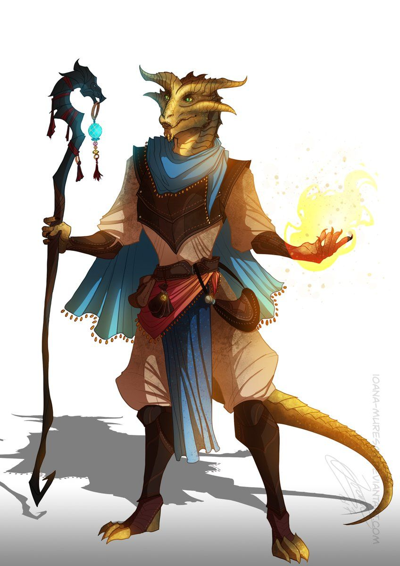

As Solstice finished appreciating the new sculptures, Priestess Uma delegated some mundane duties to Farleigh in the back of the temple, and the warlock and bard were then left with her undivided attention as they paced along the eastern wall of the shrine, appreciating the restored architecture of the structure with no ceiling. “I am glad to see the three of you. Tell me, on what adventures has our goddess taken you over the last year?”

Each of them took a few minutes to divulge the highlights of their time with the cloud giants, after which, Elsabet came to the subject she’d most wanted to discuss.

Elsabet was saddened by the news of Deacon Tariq’s demise, and expressed her condolences. She was happy to meet Deacon Farleigh, and secretly amused and charmed by the young half-dragon’s poorly disguised interest.

After the young deacon went off to do the tasks assigned to him, she asked Priestess Uma quietly, “would he be considered still an adolescent, or is he an adult? Because while he is cute and has clear potential, I don’t want to encourage his advances if he isn’t mature yet, I don’t take advantage of those too young to make mature decisions.”

She was eager to tell Uma of their adventures, including learning some of the cloud giants’ theology, her defeat of an invisible stalker, and so on. Then she broached the subject of the scroll spells.

“When we were here last year, I had acquired a few scrolls, but there were a few that needed to be scribed the next day. Then we got caught up in helping to thwart the conspiracy to take over Mintar, and that bedamned illithid took us off to the Beastlands before I could come get them!” Elsabet chuckled. “It is a bit silly perhaps, but I was wondering if those scrolls I commissioned are still here sitting dusty on a shelf waiting for me to pick them up.” She listed the particular spells, and continued, “to be honest, I don’t even remember whether I paid for them up front or planned to pay for them when I picked them up the next day.”

Priestess Uma chuckled in kind, and said, “I doubt they’d be the same ones, but we’ve since scribed plenty more, and are likely to have them in stock now.” They were led to the modest cell in the back of the shrine, which was also open to the sky. Deacon Farleigh was sitting at a waterproof desk, and nodded as the Priestess went over to the cabinet where all paper goods and other perishables were kept. She opened the cabinet, and pulled out a box full of alphabetically organized scrolls and other parchments, and asked Elsabet to remind her of which scrolls had already been paid for.

~*~

Saradette tapped the silvered blade twice more, and then she lifted it and examined it critically. “I need to put this on to temper.” She stepped over to her forge, which she’d set up just outside the shop’s door. The forge’s upper section had sides and a top made of fire brick, with another chunk of brick for a door. The gnome grasped the door’s handle, lifted it up, placed the blade inside, and put the door back in place. “There. That needs to heat for a few minutes. Then, I quench it, give it a quick polish, and Luran will have his silvered blade.”

She turned to Barkley with a smile. “I love this! I can pack it all up and carry it anywhere. I still have to pull things out to set them up, but that was also true with the cart. And, I don’t have to lift anything, so I can just leave the forge mostly assembled and wheel it where I need it.” She pointed to the forge, which was set up on ironbound wooden wheels.

Barkley nodded, it was an impressive set up. “Repairs on the road, quite a convenient thing to be able to do.” He then looked at the donkey, “And what will become of Gadget?”

“We will keep her and the cart. She can carry extra supplies, any goods that we might want to sell in other cities, and, of course, her own feed.” Saradette stepped over to the cart and gestured to an empty barrel sitting in the bed. “She will also have this. It won’t smell very good, but I want to try something I learned about from Argent. Do you know what methane gas is? Some people call it swamp gas.”

Barkley walked over to the pony, “Good,” he said as he ran his hand along Gadget’s neck, “though I’m sure the Radnars would have taken very good care of Gadget.” He turned back to Saradette, “As for methane, I am a bit familiar with it. If I am recalling correctly, it can be flammable.”

“You recall correctly,” Saradette said with a nod. “It certainly is flammable, and it’s a better fuel than wood or coal. It takes much less to heat something up, and there are other advantages, too.” Barkley saw that there were two barrels on the cart, one that held eighteen gallons, and a small one that held about four gallons. “The way this works is that I put manure and food waste in here,” she tapped the larger barrel. “Then, I connect this smaller barrel to the top of the big one. As the stuff rots, it releases the methane gas, and it collects in the small barrel. I can take it from there, and put it in the same kind of container that powers my flechette launcher. It’s under pressure, which means I can put more of it in the small tank.”

Barkley nodded, “Fascinating and impressive. Just do me one favor,” he gave Saradette a smile and a wink as he continued, “make sure that I’m upwind when you open that larger barrel, ok?”

Radnar, Jr., opened up one of the windows of the room adjacent to the one they’d been offered. “A fair afternoon to you,” he called down to them, now far more articulate than he’d been a year earlier. “You want I should open your windows as well? The upstairs rooms tend to get a bit stuffy with the afternoon sunlight beating down on the rooftops all day.”

Barkley looked up at the young Radnar, “That would be very much appreciated, thank you.”

“I’ll keep that in mind,” Saradette said with a laugh.

~*~

Elsabet said, “Let’s see, looking at my notes—I had ordered a 3rd-level spell, *dispel magic*, and two 2nd-level spells, *resist energy* and *shatter*.”

“We got those,” the half-dragon Deacon said, being quite familiar with their inventory.

She chuckled. “I had picked fire as the energy type to be resisted, but that’s because I had been thinking about potions, where the potion maker has to decide things like that when brewing the potion, but a caster reading a scroll makes such choices for herself. Hey, I hadn’t used scrolls before, I’ve learned more about them since. And yeah, according to my notes I had paid for them in advance.”

When Uma asked about their time away, Luran was happy to share his Ode to the Cloud Giant Queen, as well as his own growth and learning at the foot of the mystical Sky Tree, throughout their time.

The Priestess, Deacon, and the few worshippers nearby all cheered the bard as he finished his tale of the Sky Tree and the giants who dwelled within it. The Priestess had by now handed the three scrolls over to Elsabet, and as they concluded their conversation, she bade them well, and hoped they’d stay in town and come visit regularly.

All in all, it had been a fortuitously prosperous day.

As the trio of companions headed back to the Minotaur, Luran brought up that from the sound of things, a number of Elsabet’s scrolls could be ones he could put to use, if the situation required it. He asked if it would be acceptable to her (and knowing her penchant for extreme preparedness, he figured it would be) that he took a look at them all with *read magic*. Doing so would have him instantly ready to activate them without the need to decipher their magical writing; just finish the casting.

~*~

By the time the five heroes were reunited at the Missing Minotaur, Saradette was nearly done with Luran’s dagger. She likely did not have time to finish before they had to head back out to dinner at Shoomma’s, so the decision of whether to continue and dine alone or stop and get ready was now hers to make.

Elsabet agreed that this was a good idea. “How about doing that once we get back to Radnars’ place and settle in tonight? I’ll pull out all my scrolls and you can check them out. And maybe at some point you can show me how that works, the skill to use magic devices outside your own areas of expertise.” She snorted. “I want to learn all sorts of things... there’s just not enough time to learn everything though.”

~*~

With barely enough time to make it before Sunset, the heroes were spiffed up and ready to go. They bid the Radnars well and took their leave, making way for the opposite end of the city, and by the time they entered the dwarf’s shop, the last rays of direct sunlight were dipping down into the shining sea known as the Lake of Steam.

Good evening,” Saradette said formally as she entered.

Wearing a manly apron, Renton—Shoomma’s son—greeted them and asked them to come to the back where their domicile was. His mother was setting the table, and he started serving a peppered stew as Shoomma made pleasantries and sat everyone down to dine.

Barkley smiled and greeted Renton, “Good evening, I hope you will be joining us for dinner.” He hoped the young dwarf was just finishing his work and that was why he still had on his apron.

Luran made a heart-felt joke musing on the extremity of their postponed dinner, promised a year ago. He expressed his relief to finally return the invitation, long ago offered.

“It is a real pleasure to finally be sharing a meal with you all,” Elsabet said.

Barkley walked into the domicile area as directed and smiled when he smelled the stew and saw Shooma. “Good evening,” he greeted her with a smile and a slight bow. Sniffing the air, “The stew smells delicious. Did you add ever spice? I thought I smelled a hint of it.”

“You did indeed,” admitted both dwarves.

“Now sit yerselves down and divulge all. I want to know more about this city of cloud giants that you teased us about,” Shoomma served the stew into each bowl before she sat down herself.

Elsabet described their arrival and their eventually friendly acceptance into the community, and noted that she had written several pages worth of stories of daily life and some exciting events in her journal. But she didn’t want to dominate the discussion, so she let the others tell of their own exploits while floating through the sky.

Saradette told of working with Argent, and the difficulty of learning their language. She related that she’d found romance with Stratus, although they’d had to part.

“Ohhh! Whelll!” Shoomma blushed. “That must’ve been a feat or a treat fer ya, darlin’!” she exaggerated her accent to punctuate the excitement that she imagined the gnome must have had during the last year. “Once ya go giant, forever stay pliant, so they say.”

Some nervous giggles followed, and the conversation turned back to Elsabet’s anecdotes before Luran, Solstice, and Barkley shared their highlights.

“For me,” the fuzzy faced musteval continued, “the stay was less of a learning experience than a forging of friendships among the men and women of the floating fortress.”

“The Sky Tree,” Luran called it by its proper moniker.

“Right,” Solstice continued. “My main duty—if you can believe it—was as a backscratcher. Giants are mighty: no doubt; but they’re a rather inflexible genus of creature, and their stubby fingers do little to relieve itches, so these,” he held up his hands and moved his fingers about, “made quite the impact on the permissive Queen and her loyal subjects.” He divulged a few intimacies of his own, and then let the archon and half-elf tell their tales.

Barkley listened and smiled as Solstice talked. When the musteval finished, Barkley told of his work with the brewers, wine makers and distillers amongst the giants. He talked about what he learned from them as well as what he taught them. His expression became brighter when he talked about the giant eagles and how he became good friends with one such eagle named ‘Cloudy’. He even told of the attack by a group of ogres that he and Cloudy had helped break up when a group of giants were gathering grapes for their wine.

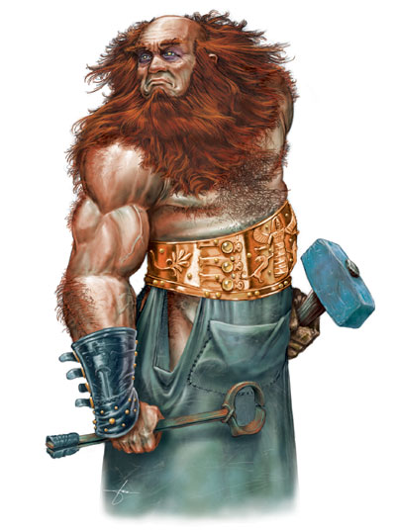

When the meal was done, and the conversation was winding down, Shoomma looked at Renton and announced, “Well, I think by now the spiked balls have cooled down enough.” She motioned for Renton to go and get Elsabet’s flail, which was finished a day ahead of schedule, and he did so.

Coming back not a minute later, he handed the flail to Elsabet, who stood up and marveled at the three shinier balls dangling from the wooden heft. Taking the weapon, she was duly thankful for the quick silvering, and impressed at the handiwork.

When it came time to leave, Barkley gave Shoomma a warm, hearty hug and shook Renton’s hand, “Thank you both for dinner and your hospitality. When I have a chance to get to Saradush, I will send you a barrel of my brandy.”

“Aye!” Renton gave a hearty cheer at the sound of the promise. “‘Twill be a good day indeed.”

**The bard shared the novelty of his time with the Nimble of the Nimbus. The strangeness of using a lap instrument as a standup harp brought some amusement from the dwarves. He also shared what he considered his greatest take away being the better understanding and year-long communion with the outer planes as their floating home traversed Ysgard. Rather than sharing the epic ode to Queen Ghym, feeling it was a bit high-minded and heavy for this more familial meal, Luran ended his sharing with an improvised ditty about the fondly remembered individuals and the city he had left behind in the unexpected, other planar journey. Shoomma seemed particularly taken by the sentiment of the song.**

Minutes later, with bellies full, the heroes took their leave, promising to return soon. “I’ll be getting’ shipments of magic items from the western isles over the coming tenday. By the end of the month, I should have a better selection of goods for ya.”

~*~

Evening

The heroes walked casually back to the Missing Minotaur, having checked off everything on their to-do list, save for a visit to Bisohop Jericho at the Temple of Tyr.

As they walked back to the Missing Minotaur, Barkley mentioned his trip he would need to make in the morning. “After breakfast, I intend to go to the Temple of Tyr and speak with Bishop Jericho. You are all welcome to join me or find something else to do while I am there.” It was something he didn’t necessarily want to do but had to do. He hoped that after the meeting his mind and spirit would finally be settled and balanced.

Saradette went back to her forge to clean out the coals and store it for the evening. “I do need to visit the smithy to see if anyone here can draw metal tubing,” she mentioned when the subject of what to do next came up.

Elsabet indicated she would like to accompany Barkley to visit Bishop Jericho at the temple of Tyr, if he was okay with her coming along as witness—she also wanted to get caught up on more details of how things have been going in Mintar from the Bishop’s perspective, since that exciting battle at the keep. “I would happily sit by and listen while you talked with the Bishop, or else give you privacy, whichever you preferred,” she told the young archon, who still seemed a little nervous, though much less so after his time talking to the priest of the Accidental God.

Barkley smiled, “Thank you; you are welcome to come along. I have nothing to say to Jericho that I would not say to any of you.”

“It will be an honor. I know you’ve been struggling with this—but really, your natural talent and enthusiastic embrace of the brewer’s path seems like you were headed for this deity’s service long before you realized it. I am sure Bishop Jericho, a wise man, will understand.”

Luran also offered to join the archon. After touching base with the church of Mayaheine, he felt it important to do the same with the other half of the team’s divine sponsors.

~*~

Morning, 16 Ghes

Barkley and friends had made it to the Temple of Tyr, and were greeted by Bishop Jericho just outside the temple grounds. “Come, come, friends, and let us catch up.” The Bishop had anticipated their visit since the day before when they’d landed by the Eastgate along with Argent and Stratus, and was very receptive to Barkley’s theological change of heart. Two paladins were discussing tactics and ethics near the entrance, and bid the heroes well as the heroes entered.

Barkley had wanted the meeting to go well, so he did not have on his new tabard with the tankard silhouette on it. He also made sure his new holy symbol was tucked inside of his shirt. As they walked, he turned to Bishop Jericho, “Thank you for taking the time to meet with us. I feel that, over this past year, I have drifted from the path of Tyr and left his favor. Though upsetting, I believe I have found a new calling and a new deity that has reached out to me.” Looking over to Jericho, he added, “I still hold respect for all of those that follow Tyr, you are all examples of what good can do in this world. I have just been having trouble with the role or law in this world as it relates to justice.”

The Bishop had pulled Barkley aside before the archon had confided in him, apparently on the basis of the others not being part of the conversation, but now it was evident to Barkley that there was something else. In a wordy, cleric-like way, Jericho confided in the former believer that he himself was beginning to feel as though his faith in Tyr was being shaken. “It has been some time since I have felt his presence in my actions and experiences, and it is with great displeasure that I now face the melancholy prospect of discarding the mantle of bishophood in favor of a layman’s life.” He went on to clarify that it wasn’t another deity—or even a less noble alignment—that was swaying him, but merely a silence that had replaced the voice of the Maimed God.

“You’ve made your decision then?” Barkley asked.

Jericho sighed, “Nay... I’ve confided in the rest of the clergy, and have been counseled to remain steadfast for the moment, and pray for further guidance. Tendays have passed, and I’ve recently resolved to make a decision by the end of the month.”

Barkley understood what Jericho was going through and, as he was about to reply, a thought struck him. “If you have not heard from Tyr, perhaps there is something more at work here. Perhaps some other god or gods have cut Tyr off from his followers. Perhaps that is worth looking into through some of the other temples in town.”

He sighed, “I appreciate your thought, but alas, the other clerics have not suffered the same fate as I have. The cosmos appear to be in order, and it would seem at this point that my path along this order lies elsewhere.”

Barkley nodded his understanding, “Though I am sorry to hear this, it is Tyr’s loss. I am sure you will find your way and will serve yourself and your new deity well.” He extended his hand, “Good luck in your search my friend. I hope our paths cross again some time in the future.”

“Likewise, friend,” Jericho put his aged hand upon the archon’s shoulder to comfort the Celestial. “I hope to see you around town... and who knows? My decision is not yet made.”

Barkley had a mix of emotions as he left the temple of Tyr. He felt sorry for Jericho and wondered how a bishop like him had fallen out of favor with Tyr. He also felt better about his decision to pursue the calling of the Accidental God.

~*~

In the meantime, Saradette went in search of a smithy that produced drawn copper tubing. Her own drawing bench was set up for wire, not tubing. It took her a bit more than an hour, but finally, in the Southspur, not far from the now closed Reality Wrinkle, she was able to find a place that could help her out.

The artificer purchased thirty feet of half-inch copper pipe in five-foot lengths, a selection of copper fittings, two pounds of soldering flux, and two pounds of solder. She also bought a tubing bender, a three-foot iron sizing mandrel (helps with the soldering), and a swaging die to round the pipe ends for the fittings.

|  |  |  |  |  |  |  |
| --- | --- | --- | --- | --- | --- | --- |
| *Gnomish Artificer Workshop* | | | | |  | 15000 |
| **Item** | **Qty.** | **Wt.** | **Effects/** | **Notes** |  | **Value** |
| 30’ of ½” Copper Pipe | * | 1.0 | 6-count of 5’ Lengths |  |  | 5 |
| Copper Fittings | 15 | 0.8 |  |  |  | 2 |
| Soldering Flux | * | 2.0 |  |  |  | 10 |
| Solder | * | 2.0 |  |  |  | 5 |
| Tubing Bender | 1 | 2.0 |  |  |  | 25 |
| 3’ Iron Sizing Mandrel | 1 | 1.0 |  |  |  | 15 |
| Swaging Die | 1 | 0.0 |  |  |  | 1 |
| **Total Weight** |  | **8.8** |  |  |  |  |