*Chapter 22: Ghes Who*

The next five days were as fruitful as they were conflict-free. Luran had found a few astrology clients, and although he’d looked for an arcane mentor, the people to whom he’d been referred were not quite what he’d hoped for. Most had ulterior motives or were simply unfit to take him further on his path than where he was already. One had even ended up trying to pickpocket him right then and there. He imagined a larger, more cosmopolitan city would be needed to find what he hoped for. While the humble but stern people of this harbor town had their gifts and goodly labors, they were not the style of folk to seek where his mind was searching. The coin he managed to make through his astrological predictions and omens had allowed him to eat well during these last few days, and he’d even given some alms to the poor on his way from one place to another.

~*~

Elsabet’s exploits had mostly involved a few visits to see Priestess Uma to discuss matters of ethics and prophecy. The Priestess was always praiseful of Elsabet, and continued to mention that greater purposes were in store for her and her friends, but could not specify beyond what vague images Mayaheine bestowed upon her.

Elsabet had thanked her, and responded that she was ever willing to face and challenge the Shield Maiden led her too. She also asked Uma is the Priestess had any knowledge of what might have become of the books at what called the Reality Wrinkle. “Before things got ugly, I had gotten the impression there were a lot of interesting books there, but we got whisked away before I had a chance to inquire. Perhaps I will check with the Guard, they keep pretty good records.”

~*~

After a couple of days of not getting yanked into a dream world or another plane, Elsabet started to relax a bit more. On one late afternoon, having let her friends know where she was going and asking Luran if he wished to come with her, she made a point of picking up a nice but not too fancy gift, a set of 4 darts in an adjustable bandolier, and visiting the family of the young half-elf boy—Quillogh Velashmyah—who was proud of his prowess with darts. She gave the gift to the youngster with the playful admonishment not to throw them in the house, and gladly accepted the mother’s invitation to stay for dinner.

“Holy geez!” the half-elf exclaimed as his elven father offered Elsabet and her friends—Barkley, Luran, and Solstice had come as well—some tea. “Look, Baba! These are *beyond* flagroosh!”

His parents raised their eyebrows in agreement. “You really shouldn’t ‘ave,” the father—who looked only slightly older than the boy—sighed. “We’re certainly gryateful for this, but we’ll not be able to repay you with anythun’ but kuyndness.” His accent revealed northeastern origins; he was likely from lands beyond Elsabet’s and Saradette’s homeland, but his mannerisms and dress indicated that he’d lived in Mintar for quite some time.

Elsabet smiled at the elven man who loved a human woman, knowing it was a brave thing, to love someone whose life was running by at such a rapid rate relative to his own, and for the woman too, to love a man who would look the same even as she grew old and wrinkled—it was the sort of quiet courage that humbled her.

The bard stood, quietly, watching the family interact. He envied the younger half-elf for the shortest second. His own familial memories only barely included parents aside from his human uncle who raised him after his own mother and father were killed. His selfish emotion was short-lived for, though it was true he never really knew his parents, the years spent, growing up in the city of Darromar under his father’s brother’s roof were ones he greatly treasured. All the same, he remained silent and smiling through the gathering.

“Kindness, friendship, and basking in the warmth of a loving family’s home, no matter how humble, is a gift far greater than any pile of treasure.” She took a sip of the tea, which was a flavor she’d not had before. “You remind me of my own family in the Dalelands; my mother was the village smith and my father an herbalist healer, but above all else they were good parents, and just being here reminds me of home, a reward in itself. It is for families such as yours and mine that I do what I do. It is I who thank you!”

She raised her cup of tea in salute, and continued, “This is excellent tea! I don’t think I have had it before, I should pick some up for my travels!”

“It’s called goblin tea, but only for its green hue,” the boy’s mother said. “A hint of seaweed and lots of cherub herbs.”

“Have you had Zakharan tea? I try to keep a supply handy, it is very flavorful too. I would like you to have some, so that when you drink it you can think of my comrades and I and wish us well.” She reached into her haversack and pulled out a packet of Zakharan and handed it to the woman.

“We do get some of that in once in a while,” the father admitted, taking the teabags offered to him. “Much obliged.”

Elsabet then whispered in a voice Quillogh shouldn’t hear, “what in the planes does flagroosh mean? It’s a good thing, right?”

“Oh, you know these youngsters with their cryptic words. I think ‘tis a good thing,” Quillogh’s human mother said before presenting the archon with his embroidered emblem of Cayden Cailean, stating, “Don’t you even *think* of offrin’ me coyne for this. The boy’s dreams are comin’ true as we speak.” She made no distinction between Elsabet’s expense and Barkley’s. “Just by comin’ ‘ere you’ve given ‘im enough to talk about for the next year.”

“Wait until Rafferty and Premna see these!” Quillogh referenced his two besties.

~*~

On another afternoon, she mentioned her intention of visiting the Baron’s Keep to check in with the various guards and officers whom she had met when the group was in town the last time, during those far-too-exciting times. She saw Sgt. Pepper and reassured her that, yes, the silvered kukri was indeed a gift. Had Sgt. Pepper been promoted? Elsabet wasn’t certain, some of the insignia were unfamiliar to her.

“Yes, I’m a Colonel now,” Col. Pepper proudly pronounced, sharing other personal and collective tidbits about the perils they’d faced over the last year. “Nothing like those lycanthropes, but it’s been a busy year.”

“Congratulations, Colonel, and well-deserved, I would say!” Elsabet meant every word. The woman had been fearless and shown great initiative during that crazy night. “I was wondering, do you know what happened to the books and such that were part of the inventory at the Reality Wrinkle, where the foul plans of that evil illithid first began to unravel? It seemed like the books on the lower floor were a front for their operation, but nonetheless a few titles caught my eye.” She chuckled. “I was going to follow up on that before but, you know, we got side-tracked by him pulling us into the Beastlands. I guess we might have annoyed him just a bit. Though at this point I can’t even remember any titles, so it is just curiosity.”

“I do not, but I would guess that they’re in an evidence locker in the basement of the keep. Prefect Bratislava would likely be able to help you out. What do you want with that rubbish?” she asked.

Elsabet grinned. “Yeah, most of it is probably rubbish, but sometimes you can find something of use amidst a pile of cast-offs... and, yeah, admittedly I collect a lot of weird stuff. I was thinking I might find a book on various peoples and places, and learn about them. Nothing of any great significance, I just like learning about stuff. Do you think Bratislava would have time for a chat? I wouldn’t want to interrupt her for too long. In any case, it is good to see you are doing well!”

“If she’s occupied when you show up, you can make an appointment,” Col. Pepper let Elsabet know.

“Thanks! I think I will go see if she’s available now.” Elsabet bid Col. Pepper a good day without too many emergencies, and went off to see the Prefect or at least make an appointment to do so.

~*~

Barkley’s spiritual journey took him back to Zym’s a few times, and he had to be careful to not overdo it with the brews and spirits, lest he end up a regular in the cellar and have to give up his life as a true hero. While at the Rampant Tankard, he convinced Zym to let him start brewing a batch of his Dwarven Axe Dark Ale. When he wasn’t doing that, he accompanied his friends around town to make sure they were not alone.

~*~

Solstice mostly remained at the Missing Minotaur helping out with a few tasks that the Radnars could not tend to themselves, mostly involving getting into tight spaces in the cellar, clearing out vermin, and fixing things that required less knowhow than Saradette’s but more fine motor coordination.

~*~

Saradette had managed to arrange her workstation in the way that best suited her, and was on her way to fabricating some really cool gadgets. Her work kept her in the back of the Minotaur, and with Gadget and Widget nearby, her frequent but brief breaks were emotionally satisfying. Her friends stopped by at various times during the day to check in on her, and the Radnars looked in on her from the windows without bothering her, with the exception of lunchtime, when they brought her a few scoops of stew or whatever they were serving guests that day.

The artificer set up a 30-gallon barrel on her cart, and connected it to an 8-gallon keg with some of the copper pipe she’d bought. She fastened the whole assembly securely to the cart’s bed, and began loading the barrel through the loading pipe with food scraps, chopped hay, and some animal waste. The device was tightly sealed, so there was no odor. It would operate for a week before she would have to add more material. In the meantime, she was able to pump the end product (methane gas) into her spare air bottle. Saradette fashioned a torch tip for the bottle, and began experimenting with the torch’s design to optimize it for her metalworking.

~*~

Afternoon, 20 Ghes

Barkley had just returned from the Rampant Tankard, not quite as drunk as a skunk but enough to have proven himself one of the faithful. He was becoming an expert in hops, though some would have said he was more of an expert in stumbles, and as they sat in the dining area in the ground level of the Missing Minotaur to discuss their respective accolades and adventures since their return to Mintar, the Radnars walked through the adjacent lobby and announced that they were headed to the market for a bit to stock up on foodstuffs and other provisions. “We’ll hang the “be back” sign out front, but if someone happens to come in, please let them know that we should return by Sunset. Rooms 3 and 7 are vacant, in case anyone wants to take them; just have them sign in and point them to the price chart,” Mrs. Radnar pointed up at the wooden sign.

“Will do,” Solstice nodded, sitting atop the table munching on some grapes.

Minutes passed, and the Fist of Light team got to talking less about the recent past and more about the immediate future. They’d garnered some prospects for busying themselves in the last few days, and were now discussing them. Namely:

* A caravan was commissioning an able band of security specialists for a trip to Saradush. The wagonmaster—a half-orc named Kafi One-eye—had let Luran know that his employer—a dwarven merchant—had a four-wagon convoy ready to set off early the next day, but they would not leave without the proper protection for the shipments that were to be sold upon arrival to Saradush. They still had space for up to 10 passengers, but wanted to make sure that at least 3 of these were competent combatants or spellcasters, and would pay 50 gold per day for their services, which might amount to nothing if there was no trouble along the way.
* There were other expeditions headed elsewhere, including some across the Lake of Steam to its southern shores, that would pay comparably. Most of these were also motivated by mercantilism, but one involved a field trip to a nearby grove with purely academic intentions, namely botanical and divine.
* A wizard had spoken with Solstice about an opportunity to help her find some thieves who had broken into her home and stolen some magic items. Compensation was negotiable.
* The Frivolous Frigate—a tavern along the southern wall of the Eastgate quarter—had a bulletin board listing several private commissions for bounty hunters, ranging from 100 to 1000 gold per head, depending on the caliber of the bounty. They’d passed by it without looking too closely, but some of the prospects seemed to be within their collective scope.
* Saradette had visited briefly with Dromedar the Alacritous and Sacerdôt Fritz at the Gondar Temple, and the Sacerdôt had tried to confide in Saradette that something was wrong, but she’d gotten the impression that he was reticent to do so in Dromedar’s company.

All in all, they were doing alright, but had a gnawing desire to set some purpose back into their lives, and mobilize their skills and assets towards the cause of good. Mayaheine’s presence remained strong in Elsabet’s, Saradette’s, and Solstice’s lives, as did Tyr’s in Luran’s, and Cayden’s in Barkley’s, but no specific calling was on the forefront of their attention.

“I would like to find out more about what may be happening at the Gondar Temple,” Saradette said.

“That’s fine with me,” Elsabet replied. “I have no particular preference as to our next travels or trials, so to speak. If you need help, just let us know what you need. Perhaps you can find an excuse to meet with this Fritz fellow—a dinner, say, to introduce him to some friends of yours—to get him out of the Temple into a more comfortable environment, and he could tell you and us what’s on his mind?”

“That’s a good idea,” Saradette replied. “I will find a messenger to send an invitation for dinner here tomorrow, if that’s okay.”

Some additional travel definitely appealed to Elsabet, whether it be a return to Saradush or a jaunt across the water to a fancy grove; she knew Barkley wanted to get back to Saradush at some point, and she remembered several folks there fondly. Getting paid to travel was always appealing. She smiled to herself, thinking of certain folks back in Saradush, while listening to the others discuss their options.

Elsabet thought the other possibilities were also intriguing. She wasn’t positive they would be great at finding either stolen magic items or alleged criminals, though she was willing to try, and she was pretty sure that the attempt would be interesting and teach them new lessons along the way. But the Gondar Temple was right there in Mintar, and Saradette clearly had a personal interest in it, so for now she would back up the artificer. And establishing more allies and possibly friends in the city seemed a worthy goal, especially at a Temple important to her friend.

“Well, my appointment with Prefect Bratislava is coming up,” Elsabet cleared her plate from the table and prepared to go see the Prefect regarding the Reality Wrinkle’s inventory. “Going to do some light reading if the Barony will allow me access.”

As they discussed their future plans, Barkley added his thoughts. “I would certainly like to get back to Saradush, if even for a short spell to check on the Obstinate Loaf as well as have a barrel of brandy sent to Shoomma. However,” he paused and turned towards Saradette, “I am intrigued by what this friend of yours has to say. If he is willing to leave the temple and disclose his concerns, and they warrant our investigation, I am happy to put off the trip back to Saradush a bit longer.”

“So, whom do we get to deliver the message so as to not look suspicious?”

Elsabet suggested that she could get close to the Temple of Gond, use her fey spell-like ability to disguise self as a messenger, and deliver a message for Saradette...

Saradette nodded. “I’m sure as the Ninth Hell not trying it. Go ahead.”

“Write a message, and I will carry it.”

The gnome wrote: “Sacerdôt Fritz, please join me and my companions at dinner tomorrow evening at the Missing Minotaur. Saradette.”

Barkley, “And if Elsabet is caught that could make things worse. Just hire a local messenger to deliver it. That looks more legit and if he is challenged, he is just a messenger, nothing more, nothing less.”

“Okay, okay,” Elsabet replied.

~*~

Luran had been speaking to Solstice just outside, trying to get a better sense of the profit involved in the bargain that the woman was proposing.

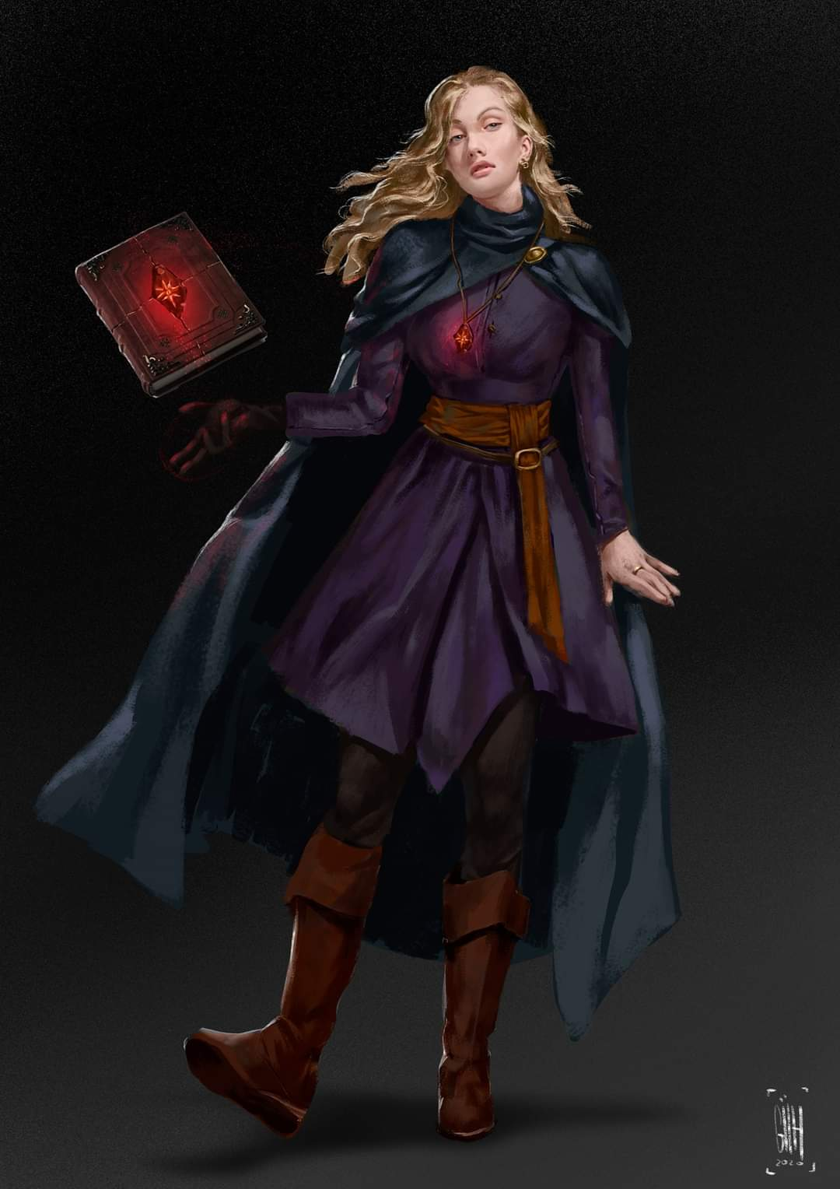

“Her name’s Palmyra,” Solstice recalled. “Said she’d bested some murder hobos along the road to Saelmur, and they’d tracked her down to Mintar and burglarized her domicile, so we can assume they had some type of Divination magic or a really able tracker among them.”

Barkley overheard the conversation between Solstice and Luran, and chimed in. “If this guy that Saradette knows doesn’t have anything worth pursuing, perhaps we should pay this wizard a visit.”

~*~

Late Morning, spilling into Highsun, 21 Ghes

Elsabet decided she needed to get a scroll case to better organize her scroll collection, which she had realized was pretty disorganized when she got them all out for Luran and others to check out.

So in the morning, she mentioned her plan to go shopping, asking Solstice if he felt like joining her; others were welcome to come too, if they wanted, but she felt like chatting with the musteval about improving her basic skill with use magic device and thought he might have some pointers.

“Sure,” Solstice replied. “I need to stretch my legs a bit.”

A scroll case should be easy enough to find, and she might browse around looking at potions too.

That afternoon, Elsabet spent some time reorganizing her belongings to fit more small stuff into her haversack and figuring out how best to carry fewer but heavier items efficiently.

~*~

Sunset

The Radnars had prepared a special dinner for Saradette and her intended guest, as well as for the rest of the crew. Luran was donning his new armor, opting to keep the lightweight suit on during dinner mostly for show, and Barkley had come home that morning with a barrel of ale that was to help wash down the meal of mutton and bok choy served over Derluskan couscous.

The invite to dinner had been delivered to the Gondar Temple over a day ago, and the party had assumed that the Sacerdôt would show up eventually, but as Sunset drew to Evening, no Gondar priest arrived at the Minotaur.

“Do you think the crier delivered the message?” Saradette asked her friends, but all the others could do was shrug.

“The boy will likely be at his post in the northern end of the Southspur by late Morning if we want to go ask him tomorrow,” Barkley was fairly certain.

With the no-show for dinner and the suggestion to visit the messenger in the morning, Barkley added, “If it was delivered, then we should probably pay the temple and Saradette’s friend a visit. I also think we should see the wizard that Luran and Solstice have been talking about if we have time.”

Solstice nodded, “We could go to the Gondar Temple tonight and pay Palmyra a visit tomorrow when she’s expected back.

“I’m really concerned now,” Saradette said. “I agree with Solstice.”

With Solstice and Saradette’s statements, Barkley stood up as if the matter had been settled. “Then let’s go and see what is going on at the temple of Gondar.” Perhaps it was his new found faith or the third pint of ale, but Barkley’s spirits were high and he was ready to go.

“I’ll get my armor,” Saradette said as she stood and drained her ale.

“I’m in, of course,” said Elsabet.

~*~

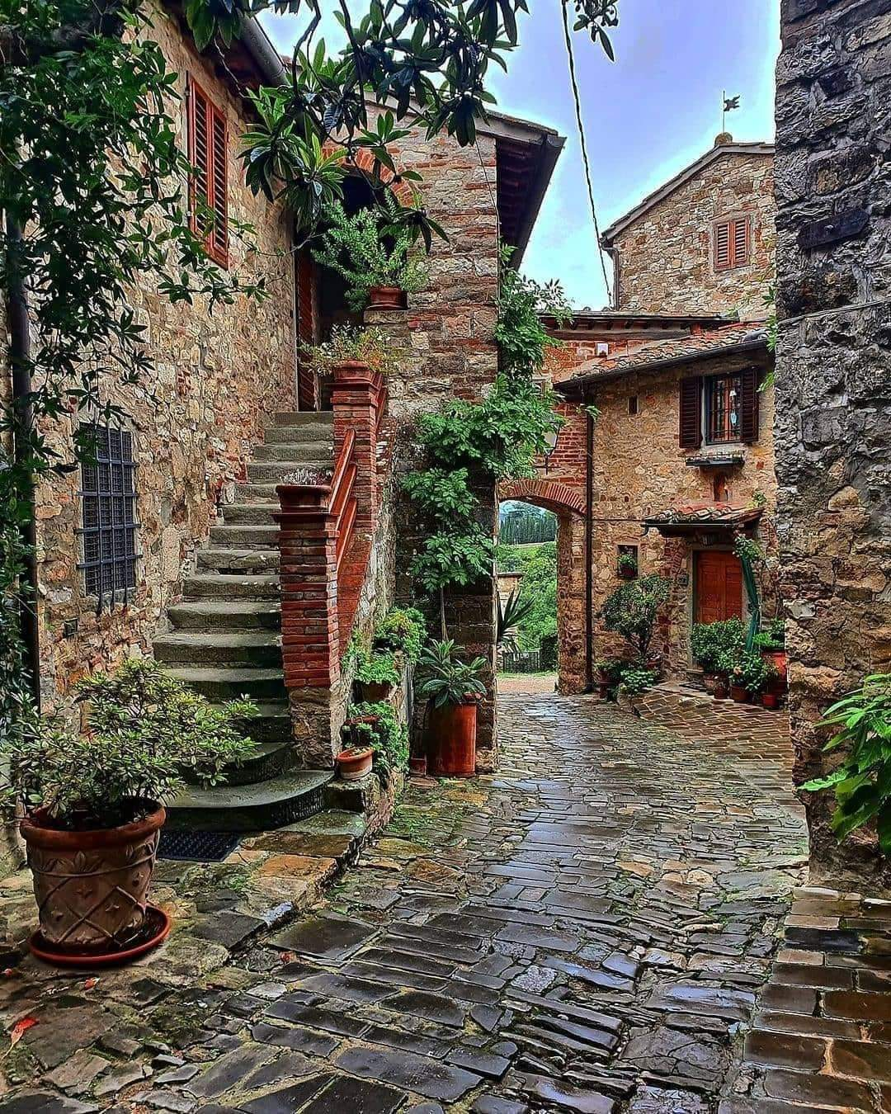

The path through the streets was a pleasant one, and the city streets and alleyways between them were sparsely trodden as the sun set over the western shores and the celeste sky began to turn a darker blue. It didn’t take long for the heroes to reach the Gondar Temple, whose single front door was unusually closed.

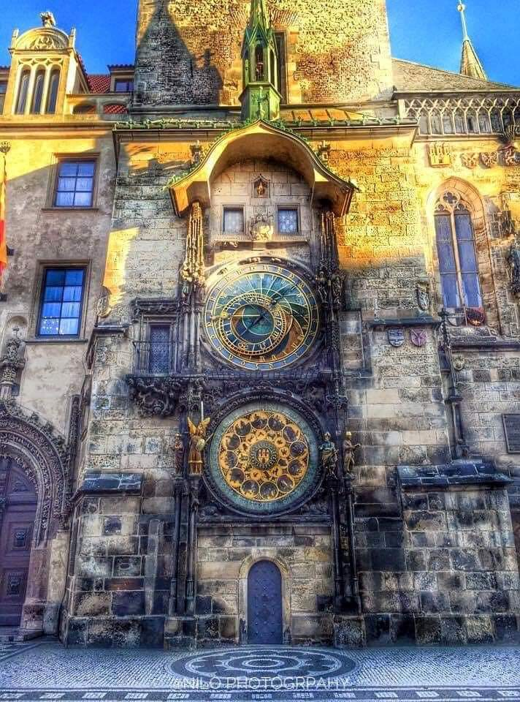

19:00, Round 1

Barkley tilted his head slightly to the side as he looked at the closed door curiously. “This is rather odd and unwelcoming,” he said as he looks at Saradette and the others. “Shall we knock?”

Saradette stood by while the others did their divinations. “Let me go in first,” she said.

Luran stood by, ready to react to the outcome of the next moment.

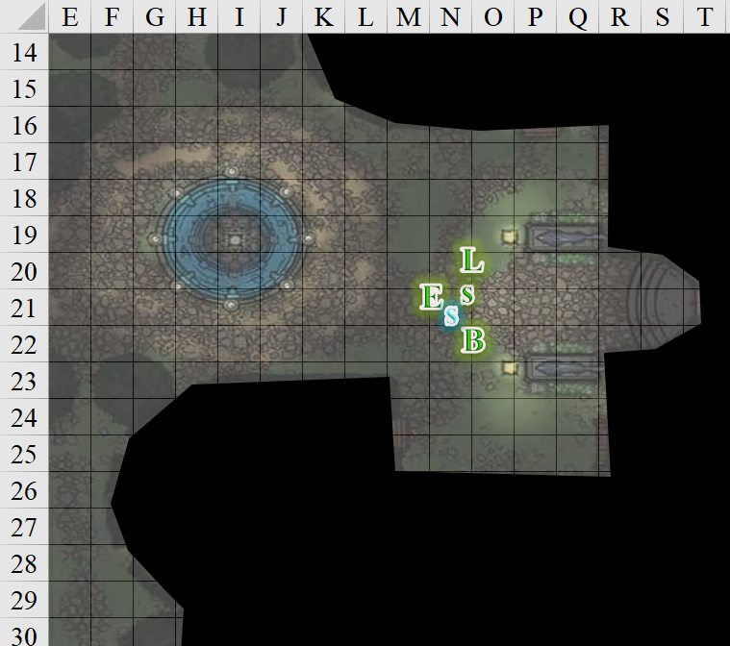

Barkley nodded and focused his spell-like ability on the door and the area beyond. Detecting no evil aura within 60’, he reported the non-finding.

“Just a second,” Elsabet said, “let me check for magic, and Barkley, you could check for evil, either on the door or perhaps through it.” She proceeded to focus on her detect magic ability, scanning on and, if possible, through door and beyond. After stepping up and briefly concentrating, Elsabet said, “there is magic, getting more info,” while continuing to concentrate.

Round 2

Elsabet stood there concentrating, and indicated how many auras she sensed, and how strong the strongest appeared to be. She could tell that the number of magic auras around her was dozens if not hundreds—in any event, too numerous to count—and she said as much.

Rounds 3 – 4

Elsabet stood there concentrating, and indicated where and how powerful the auras she sensed were. “They range in strength from faint to strong,” Elsabet added, “and the door’s magical aura is of a Divi-, oh...” She heard the door’s metal latch clicking.

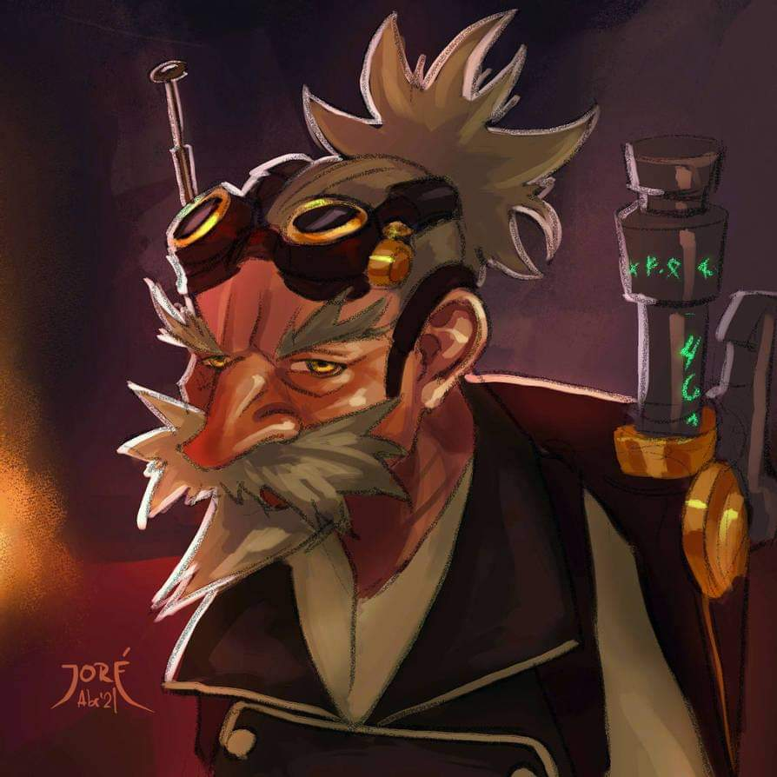

The door without a peephole opened slightly without a squeak or a creak. A gnomish tinker poked his head out, and said, “Good evening, brethren.” He squinted and smiled as he took a measure of Saradette—evidently an artificer—and opened the door wider. “We *are* open; just our doors are shut per new policy.”

Rounds 5 – 7

Saradette smiled. “I’m here to see Sacerdôt Fritz. We’d made arrangements to take him to dinner this evening.”

“Oh, the Sacerdôt’s been ill for the last few days. I’m afraid he’s not seeing visitors. If you’d like to speak with the vice-Sacerdôt—Dromedar—you’re welcome to come in. He’s with another faithful at the moment... shouldn’t be too long a wait.”

Barkley detected no evil on the man, and no one noted any suspicious tone or reticence. The man seemed rather neutral and indifferent to whether the strangers entered.

Round 8

‘Hmmm,’ Elsabet thought, ‘I wonder if that is actually a passageway covered by the illusion of a wall?’ She didn’t say anything about it yet. Relaxing her concentration, she studied the surroundings and said, “I have some hea-”

Rounds 9 – 10

“Oh, that’s too bad,” Saradette said, interrupting Elsabet. “And I wanted to show him this.” She casually drew her sonic blaster, and then pointed it at the man’s chest. “Don’t even twitch,” she said coldly.

|  |  |  |  |  |  |  |
| --- | --- | --- | --- | --- | --- | --- |
| **Skill** | **Rank** | **Ability & Mod.** | **Misc. Mods.** | **Total** | **Roll** | **Check** |
| **Saradette, Bluff** | 2 | **Cha (+0)** | 10 cold and convincing | 12 | 14 | 26 |

*See below.*

|  |  |  |  |  |
| --- | --- | --- | --- | --- |
| **Character** | **Check** | **Ranks** | **Roll** | **Result** |
| Cobol | Sense Motive | 4 | 14 | 18 |

*Fail to disbelieve.*

When Saradette made the bold move and pointed her device at the other gnome, Barkley smiled, a bit impressed by Saradette’s bold move. He placed his hands on the hilts of his weapons, prepared to draw them if needed. “I’d do as she says,” Barkley says to the other gnome and smiled a little wider, showing his pointy canines.

Round 11

The man was taken aback, and immediately shouted, “What? Robbers!” Before the gnome closed the door, Luran spotted two temple acolytes immediately reacting to the apparent ambush by relaying to others in the temple, “We’re under attack!”

|  |  |  |  |  |  |  |
| --- | --- | --- | --- | --- | --- | --- |
| **Save to**  take action | **Rank** | **Ability & Mod.** | **Misc. Mods.** | **Total** | **Roll** | **Check** |
| **Barkley, Reflex** | 6 | **Dex (+2)** | 1 | 9 | 20 | 29 |
| **Elsabet, Reflex** | 4 | **Dex (+2)** | 1 | 7 | 8 | 15 |
| **Luran, Reflex** | 8 | **Dex (+1)** | 0 | 9 | 1 | 10 |
| **Saradette, Reflex** | 7 | **Dex (+3)** | 0 | 10 | 12 | 22 |
| **Solstice, Reflex** | 12 | **Dex (+3)** | 0 | 15 | 3 | 18 |

*Barkley, Saradette, and Solstice can use a move OR standard action before the gnome closes the door. Solstice will follow the PCs’ lead.*

Despite her threat, Saradette stayed her blaster.

Barkley rushed the door, throwing his shoulder into it to force it open. He also quick drew his longsword as well, thrusting that through the opening to force the gnome that was closing the door to step back or at least hesitate a bit, possibly giving Barkley the edge in holding the door open.

|  |  |  |  |  |
| --- | --- | --- | --- | --- |
| **Melee Weapon** | **TH+** | **Atk** | **Roll** | **Check** |
| Slam 1 | 0 | +7 | 16 | 23 |

*Success. Door is held open by Barkley.*

|  |  |  |  |  |
| --- | --- | --- | --- | --- |
| **Character** | **Save vs.**  falling prone | **Ranks** | **Roll** | **Result** |
| Cobol | Fortitude | 1 | 6 | 7 |

*Fail.*

Saradette followed Barkley, using him as a meat shield, put up her weapon, and opened her hands. “We aren’t here to attack anyone,” she called loudly. “We are here to ensure that Fritz is well, and that we will do. If you attack us, we will defend ourselves.”

Barkley maintained a stern expression and a close eye on the gnomes inside, watching for any of them to pull a weapon or magical device.

Cobol activated his *haste* device [expired on Round 14] mechanism.

*Cobol gained +1 to BAB, AC, Reflex, and extra attack or 30’ of movement.*

Fortran activated his *ring of invisibility* *[expired on Round 41]* disappearing.

Apex activated his *amulet of sanctuary*.

*Apex gained sanctuary ward.*

Averest activated her *see invisibility* device *[expired on Round 211]*.

Axum activated his *shatter* device, targeting Barkley, who had no brittle items on him, so it came to nothing. However, Saradette was right next to him, and the flasks of acid in her haversack cracked open.

***Pending confirmation from hivemind that items inside extradimensional space are affected; probably not, though.***

Linux activated her *mage armor* device *[expired on Round 1211]*.

Cobol was knocked back and fell onto the floor as the other gnomes activated various magic items. One man named Fortran—whom Saradette had met just days ago—went *invisible*, while the others were shrouded in auras that Elsabet could not yet magically discern, though Barkley identified one of them as a *sanctuary* cylinder.

Solstice looked at Elsabet and Luran with a question mark atop his head.

Shocked by the sudden escalation to forcible entry, Luran was hesitant to immediately consider the gathering Gondar devotees as foes. He stood, ready to support his companions, should the situation turn to full on fighting blows.

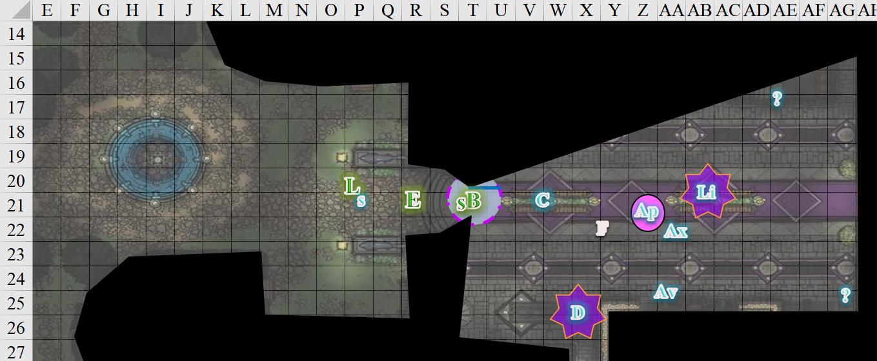

“I am Elsabet, Favored of Mayaheine, who—with my friends here—helped free the Baron from magical compulsion and thwart the attempted coup.”

Luran and Solstice stood by to see what would happen.

Round 12

Apex activated his *acid arrow* device, shooting Barkley.

|  |  |  |  |  |  |  |  |  |  |
| --- | --- | --- | --- | --- | --- | --- | --- | --- | --- |
| **Character** | **Attack Type** | **Damage** | **BAB** | **Dex Mod+** | **W+** | **Other+** | **Total Score** | **Roll** | **Total** |
| Apex | Acid Arrow | 2d4 acid | 3 | 3 | 0 | 0 | 6 | 6 | 12 |

*Miss.*

Fortran activated his *flame blade* device [expired on Round 31], now holding a dagger with a blade of fire.

Elsabet continued, trying to save the moment, “My friend Saradette has legitimate concerns that Sacerdôt Fritz is in trouble, and we are here to determine whether that is the case. As you can see, she is quite worried! My apologies for the intrusion, but I would hope we could resolve this in a peaceful, friendly manner, between people of faith, and not involve the Baron or the City Guard. Please, show us to the Sacerdôt so we can resolve these questions.”

|  |  |  |  |  |  |  |
| --- | --- | --- | --- | --- | --- | --- |
| **Skill** | **Rank** | **Ability & Mod.** | **Misc. Mods.** | **Total** | **Roll** | **Check** |
| **Elsabet, Diplomacy** | 9 | **Cha (+2)** | 4 | 15 | 12 | 27 |

Linux was about to activate her *fog cloud* device, and waited for Dromedar to reply as did the rest of the faithful.

Round 13

“How *dare you* force your way into the house of Gond under the pretense of peace?” Dromedar asked rhetorically, not waiting for a response. “You!” the robed gnome pointed at Saradette. “I know *you*. You were here the other day. What manner of heresy is this? Axum, go summon the Baronial Guard.”

Barkley smiled and nodded at the comment about summoning the guard. He tied off his peace bonds once again.

Round 14

Barkley then said, “Yes, summon the Guards so that we may all make sure that Sacerdôt Fritz is well and not under some form of curse or spell. We know what has happened in the past here, and perhaps it is starting here in the temple of Gond.”

Round 15

He then looked at the gnome that shot the acid arrow, “And you, you need to work on your aim. That arrow wasn’t even close.” Barkley laughed at the last comment, hoping that it lightened the mood after his rather blunt comment a moment before.

Round 16

“Trust that I shan’t miss again, heretic,” the Gondar male answered before making his way towards the door in order to go to the precinct office a few buildings over. The rest of the gnomes converged there as well, seeing the strangers out.

Dromedar peered at Barkley, Saradette, and at Elsabet who now stood in the doorway, shaking his head. “Heathens, know that this intrusion will not be met with indifference by law enforcement.”

Round 17

Barkley’s smile widened, at the gnomes quipped and looked at Dromedar, “Should we find that the Sacerdôt is safe and only ill as you say, we will be happy to pay whatever penalty. However, if it is not just an illness, then we will be happy to accept your apology.” Barkley gave Dromedar a bow as he finished speaking.

Round 18

Elsabet stepped up the stairs, to stand behind Solstice. “Fine, summon the Guard! Solstice, accompany Axum; do not hinder his progress.” She paused. “Cease your hostile magics, we await the Guard. *Invisible* guy, I see you. Barkley?”

“Your rat comes near me, and I *will* skewer him with this here spear!” Axum told the human. “Nonbelievers have no claim to disrespect this consecrated ground, and presume the right to vigil us as we seek justice.” The gnome was entirely on the defensive, and it appeared that the heroes had disrespected the sanctity of the temple irrespective of the Sacerdôt’s state of being.

Round 19

Solstice began to follow at a distance until the gnome turned the corner, then slowed to get into an angle where he could see Axum flagging down the guard who stood right outside the precinct office.

Round 25

Solstice returned to announce the return of Axum.

“What’s this about?” two guards—a gnome and a dwarf—came back with Axum. “You all, what’s the meaning of this?” the dwarf asked Barkley, who still stood in the doorway, preventing anyone from trying to close the door.

Round 26 – 38

“Greetings. I am Elsabet, Favored of Mayaheine, perhaps you have heard of me. I and my friends here were instrumental in helping rescue the Baron back during the attempted takeover by that foul illithid. I was just having a nice chat with Colonel Pepper recently, and discussing some unrelated things with Prefect Bratislava.” Elsabet then provided her badge as proof of her claims.

The dwarf and gnome looked at one another, then listened more attentively to the favored soul.

“But as for today... my friend Saradette here has come to this Temple on more than one occasion. Two or three days ago I think—she can provide specifics, I am not sure of the exact timing—she was visiting a priest friend of hers here, one Sacerdôt Fritz, and she later told us that she felt the priest seemed nervous about something, like he wanted to tell her something privately rather than in the presence of another priest who was there.”

Elsabet took a breath, giving Saradette a chance to confirm the details, and continued.

“Saradette sent a messenger with a letter to Sacerdôt Fritz here at the temple, inviting Fritz to join us for dinner, where we figure he could tell her whatever he wanted to get off his mind in a less formal, more comfortable setting, while consuming good food and drink. As it happens, some of us have had our own heart-to-heart discussions with members of our own temples recently; we thought this might be something similar—nothing earthshaking in the grand scheme of things.”

“No answer was received, and the priest did not show up, so we came here to see him. Upon arrival, the temple door was closed—supposedly a new policy—and the doorman said Fritz was ‘ill’ and appeared to be giving my friend the brush off, seeming to prevent her from seeing her allegedly ill friend. Saradette was already rather stressed, and reacted badly, threatening the doorman with a weapon.”

“Is that correct?” the gnome guard asked Saradette to confirm.

*[DM assumption]* Saradette nodded truthfully.

“This obviously did not go over well. My friend Barkley moved to keep the door open, and the folks here reacted with numerous spells, thinking they were under attack, though Saradette realized her attempt to intimidate the doorman had failed, and put away her weapon. None of us cast any hostile spells at the enemy, and while harsh words may have been exchanged, and a few spells were cast at us, we managed to avoid further conflict beyond that point.”

“What any temple warden would do to protect his flock,” Dromedar interjected.

“We have not proceeded any further into the temple than the entryway here, but we do truly believe that we need to be able to see Fritz for ourselves, and determine whether something more sinister is going on. Has some evil taken root here? Is Fritz truly physically ill and if so, why can divine magic not be used to heal him?”

“It was by gradual infiltration that the Barony nearly fell less than a year past, so I have some concerns that something similar might be at work here. I don’t accuse any of those present of evil designs—as far as I am concerned, they acted to defend the sanctity of their temple—but I do wonder who, or what, is behind these new policies, and I wonder why seeing Sacerdôt Fritz seems to be a problem.”

Dromedar’s posture became less defensive upon hearing Elsabet’s humble admission as Luran offered subtle, almost imperceptible noises and reactions that upheld and supported Elsabet’s words and points in the ears of those around her.

The dwarven guard aske, “Dromedar, it is true that I’ve not seen Fritz for the last few days. Is he really ill?”

“Go see for yourself. He’s in his bedchamber now,” Dromedar pointed to the door.

The dwarf looked at his gnomish partner, and asked, “You alright here?”

“Don’t take long,” replied the gnome guard.

Dromedar began to lead the way, but the dwarven guard said, “I know my way. Please remain here with Oshmir.”

“As you wish,” Dromedar shrugged, eyeing the Fist of Light members with mistrust, but less hostile than when they’d first burst in.

~*~

Round 56

The dwarf came out of the temple, nodding and pursing his lips a bit. “I can attest that the cleric is indeed under the weather. I’m no healer, but the pallor on his face bespeaks a tough bout of fever,” he naively diagnosed the gnome.

“Aye,” Dromedar agreed. “He’s had a temperature, and the usual magic has done him little good.”

The dwarf continued, “He refuses to leave, but spoke of a man named Who, saying he’d be by tomorrow to check on him.”

“That’s his herbalist. He’s come by a few times to administer holistic healing. Fritz swears by it,” Dromedar clarified.

Oshmir—the gnomish guard—had produced a parchment, and was now noting the information. “Dromedar, do you vouch for this Who?”

“I neither vouch nor denounce him,” Dromedar the Alacritous admitted. “He’s little more than a stranger to me, but Fritz has improved somewhat in the last day, and attributes the recovery to Who’s herbal teas; that’s good enough for me unless and until I see evidence to the contrary.”

The majority of the heroes were satisfied with the testimony, but Saradette still had her doubts. She shook her head ever so slightly, hanging on Fritz’s concerned words from a few days ago. Perhaps he was concerned that he was falling ill, or perhaps there were far more sinister forces at play.

Saradette sighed. “I don’t like this whole situation. He was fine a few days ago, and now he supposedly has something the healers here cannot cure. In my experience, a healer can cure nearly anything, save some magical ailments. Given what we’ve experienced in the past, I would like him seen by a healer who is known to us. I am not willing to leave without this being done. I am not trying to trespass here, but there could be a life at stake.”

“The gall!” Axum said, his mouth staying open.

Cobol followed up with, “Captain Slatestein, this woman aimed that blaster at me and said, ‘don’t even twitch’. She’s a menace, and now she speaks of compassion?”

Elsabet frowned. “If some potent malady has taken hold of Fritz, perhaps I can offer the Sacerdôt a chance to resist the malady. Mayaheine has gifted me with the resurgence spell, allowing the subject of the spell another change to throw off an ongoing effect. It is the same magic which, after a couple castings, boosted by guidance spells, which helped the Baron cast off the compulsion magic which held him in thrall. I offer these spells freely.”

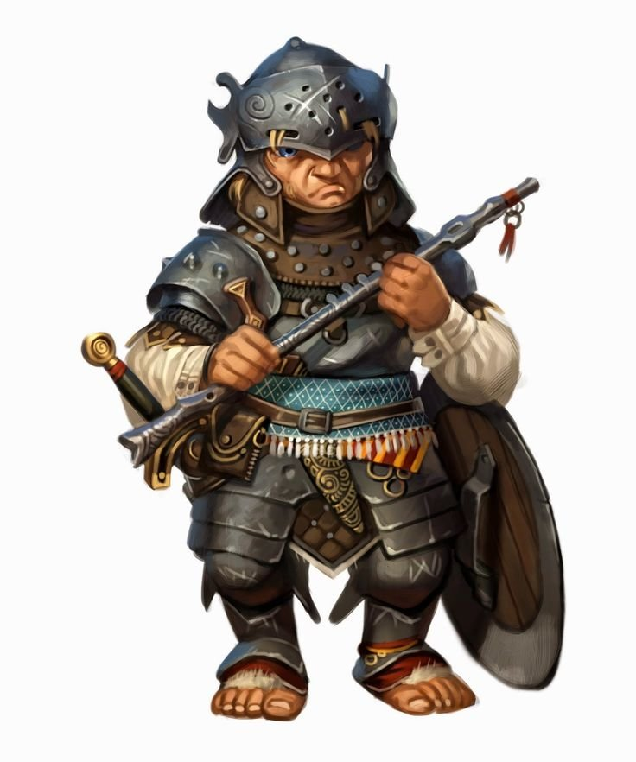

Slatestein sighed as he read the report that Oshmir was writing. He could not disagree in his interpretation of the law. “Citizens, I’m afraid that—badges or not—you can’t simply barge into a temple, threaten practitioners with lethal violence, and hide behind those provisional badges. I’ll ask that you peacebond that cannon at once, and that you...” he looked at his partner’s parchment for the names of the two offenders, “... Barkley and Saradette, relinquish your badges before we let you continue about your day. We’ll need your address for our records, and if the Magistrate overrules our interpretation of Ordinance 732.4-D, I will personally return the badges to you both. The case will be processed by tomorrow afternoon. I will add: should you encounter such a situation in the future, our precinct office is right around the corner, and there are eleven others scattered throughout the city. As for Fritz, if any of you are healers, I will usher that individual into the sacerdotal chambers, but if he refuses your care, it is not within my power to force him to accept your magic or other aid.”

Barkley, as he said he would, accepted the Captain’s judgement and handed over his badge. He then spoke up, loud enough for all to hear. “Does anyone know anything about this Doctor Who that has been visiting the Sacerdôt? Perhaps he needs to be checked on to see if he is actually helping the Sacerdôt or up to some other mischief.”

“Dromedar, when is this Who expected back?” asked Oshmir.

“He didn’t say, but he’s been coming in just before the Highsun bell, and again in the mid-Afternoon,” Dromedar responded.

Solstice agreed with Saradette that something was amiss, and asked, “Do you know his address?”

“Alas, I do not,” Dromedar responded, “but Fritz may.”

Slatestein bid him, “We’ll get that from him before we submit the report.”

Saradette removed her badge and handed it over. “It appeared that they were lying about the Sacerdôt’s condition, and, given our experiences in such things, we forced our way in.”

“Why would it appear that I was lying?” Cobol asked, not expecting an answer. “I was *about* to let you in to see for yourself.”

“I won’t apologize for being concerned about a friend’s welfare. I do apologize for upsetting folk, but it wasn’t out of mischief.” She fished in her haversack and pulled out a section of thin wire and a pair of pliers. She used the wire to peace bond her blaster to its holster.

Barkley was interested to see who this Who was and to find out to whom he reported, why he was visiting the Sacerdôt, what his motive was, and where he got his healing skills.

“I have some healing skill,” Elsabet replied, “and would like to see him. I have no objection to one of these fine folk observing me, either.”

“Very well,” Slatestein seemed satisfied that the matter had been mostly settled. “Let’s see if you can patch up the Sacerdôt.” And in went Elsabet, led by the dwarf and followed by the majority of the gnomes.

Cobol guarded the door, still ruffled from the slam to the floor.

Oshmir stayed outside with the rest of the members of the Fist of Light, putting away the parchment, and asking more casually now, “So, how long have you been in Mintar? Your clothing suggests you’ve had quite a few outlandish travels.”

Barkley turned to Oshmir, “We have only been back in Mintar a few days. The past year was spent living amongst cloud giants. They were very pleasant hosts. We learned some things from them and taught them some of our skills as well. We even fought alongside them on a couple of occasions. Prior to that year, we were here to help with ridding the city of the wererats and other evil ilk that had infested and almost took over this fine city. It is the primary reason we were concerned about the fine priest here and came to see him.” Barkley bowed his head, “I am sorry our intentions became a bit clouded and overzealous; please understand we meant no ill will to the fine gnome worshipers of Gond or their temple.”

Luran was demure in his posture, awaiting the next outcome of the group’s always exciting activities.

~*~

Elsabet entered the Sacerdôt’s office and residential area, seeing the man lying on his bed in the middle of the room. Nothing seemed out of place: papers and quills were on his desk, and the room was neither sterilely tidy nor notably unkempt. Perhaps a few days’ worth of neglect was evident, and certainly justifiable if the man had been ill during this time. A platter rested atop the nightstand adjacent to the bed, and on it were two empty cups and a few herbs that Elsabet identified as fennel, gingko, and echinacea root.

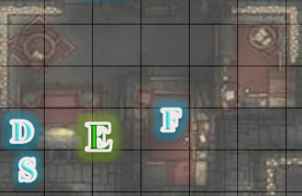

“Fritz?” she asked, never having met the man.

Dromedar and Captain Slatestein stayed back near the doorway, letting the healer do what she’d said she intended to do.

The gnome was barely able to open his custard-encrusted eyes, but he did so. “What? Who?” He smelled as if death was near, and she could not confirm from visual cues whether this was the case.

“No, my name is Elsabet. I am a friend of Saradette, the artificer who came to see you a few days ago. We sent you an invite to dinner yesterday, expecting that you’d reply or attend tonight, but Saradette noted that you had some concerns to share with her, and we felt it our duty to come to verify that you were well. I am here to try to cure your condition.”

“Ah, yes,” he forced the words through a raspy throat. “Sardedh,” he mispronounced her name due to the limited air in his lungs. “How is she?”

Elsabet could tell that the man was delirious, and took a few moments to gauge his condition more closely, looking him over both normally and then concentrating on her *detect magic* ability.

First, she tried to determine the nature of his illness, getting out her healer’s kit.

|  |  |  |  |  |  |  |
| --- | --- | --- | --- | --- | --- | --- |
| **Skill** | **Rank** | **Ability & Mod.** | **Misc. Mods.** | **Total** | **Roll** | **Check** |
| **Elsabet, Heal** | 4 | **Wis (-1)** | 2 | 5 | 16 | 21 |

*See below.*

It perplexed her that she could not determine the pathogen or source of the man’s ailment, though—with some certainty—she concluded the symptoms were consistent with an immunodeficiency of some sort.

“What manner of healing is this?” Dromedar complained that Elsabet appeared to be doing nothing consistent with the magical healing of which she’d spoken.

“He is delirious, and not in good shape. The herbs on the table would not have harmed him, at least according to what I learned from my herbalist father, but he appears to be beyond what simple herbology can cure. He is in no condition to give informed consent,” she said honestly, “but he did ask after Saradette, so clearly he cares about her.”

She then concentrated for a few rounds, as she checked for magical auras and tried to determine the nature of any she had found. She also checked the body for any puncture wounds, to see if something like a vampire had been feeding on the Sacerdôt. After a due moment, her pupils constricted at the realization that it was not a mundane disease, but Necromancy, that was at work here.

She went on to describe exactly what she had attempted and discovered—that Fritz was under no normal disease, but rather under a necromantic magical effect—then explained what she would like to attempt. “By the grace of the Shieldmaiden, I have been granted several magics, all of which your divine casters should be able to verify as I cast them. I need your blessing—or official permission from the Guard—to attempt these magics. This would be my emergency plan to aid Fritz as best I can.”

“You may proceed,” Slatestein said.

She mentioned that—if possible—she would like Luran to be able to look at the magic aura as well, as he might well have greater spellcraft and arcane knowledge than she did.

She took a deep breath.

“First, I would cast some *lesser restoration* spells, using up some or all of my store of 2nd-level spells. This spell takes 3 rounds of prayer, after which I would lay my hand upon Fritz. The spell reduces a state of exhaustion to mere fatigue, or removes fatigue entirely, and it can either remove a magical penalty to an ability score or heal a small amount of ability damage—it is not powerful enough to restore abilities drained, such as by undead. These spells might give Fritz more energy, and hopefully restore some health immediately, as many diseases attack a person’s ability scores, and hopefully he will be able to talk with us more clearly.”

“Second, once the *lesser restoration* spells no longer appear to be helping—or I run out of them—if it seems needed, I will attempt what I call the one-two boost to help Fritz use his own stamina and willpower to overcome whatever affliction he is under. The one-two combination is to cast the orison of guidance which will boost Fritz’s own competence to resist, followed by the 1st-level spell resurgence, which will give Fritz a new chance to resist, possibly throwing off that affliction.”

“If one of the priests here can provide a resistance orison to increase the Sacerdôt’s chance of recovery, that could help as well. If none are available, then with your permission and assistance I will place my own magical cloak of resistance around his shoulders for this effort.”

“Dromedar, what say you?” the Captain asked. “Has your clergy tried this already?”

“Uh... we are Gondars, not Ilmaterites,” the second-in-command at the temple was at a loss for an explanation, providing a plea that raised Elsabet’s suspicions once again. Was this alleged Gondar hiding something?

“Go on with the cloak, if you must, priestess of Mayaheine,” Slatestein said. “You seem to know your business.”

Rather than correcting the man on the fact that she wasn’t an ordained priestess, but a chosen of her goddess, she continued, “I can attempt this one-two boost a total of six times—and if needed, I can do a seventh resurgence without benefit of a guidance. It took two such boosts to free the Baron from the foul enchantments that had overwhelmed him—but the magic merely gave the Baron extra chances to break free—his own willpower did the work. So it will be with Fritz, if the *lesser restoration* spells are not enough on their own.”

“I’m glad to try, for his sake.” Elsabet tried to show that she was willing to do everything in her power to revive this man from his near-death condition.

Captain Slatestein poked his head out, and called to Cobol, who was still manning the front door, “Clergyman, be so good as to call in the one they call Luran.”

By the time Luran came in, Elsabet had removed her cloak, and was starting to position Fritz in such a way as to put the cloak on him, but it was at that moment that—removing the covers and pulling him up—she felt something quite unusual under the man’s arms. Her knowledge of symptoms immediately raised a red flag for her, and she undid the two top buttons of his shirt, parting the flaps that covered his chest and armpits, and revealing black lumps under the man’s arms.

“By the gods!” she exclaimed.

“What is it?” asked the Captain and Luran simultaneously as the bard approached.

Elsabet had only ever seen such a thing in illustrated books; never as a real-life case. If she was right, this spelled not only grave danger for Fritz, but the risk of contagion for them all. “It’s an affliction called Misery’s Blight. It’s the work of necromancers and demonologists, and will eventually claim the Sacerdôt’s life.”

“Ugh!” the bard could not hold back a gag reflex at the smell of the man, coupled with the sight of the boils.

Elsabet continued, “This disease can only be contracted by exposure to prolonged, deliberate attempts to harm the victim, or via contact with one who is already suffering from this vile condition. Luran, stand back; I may already have been infected.”

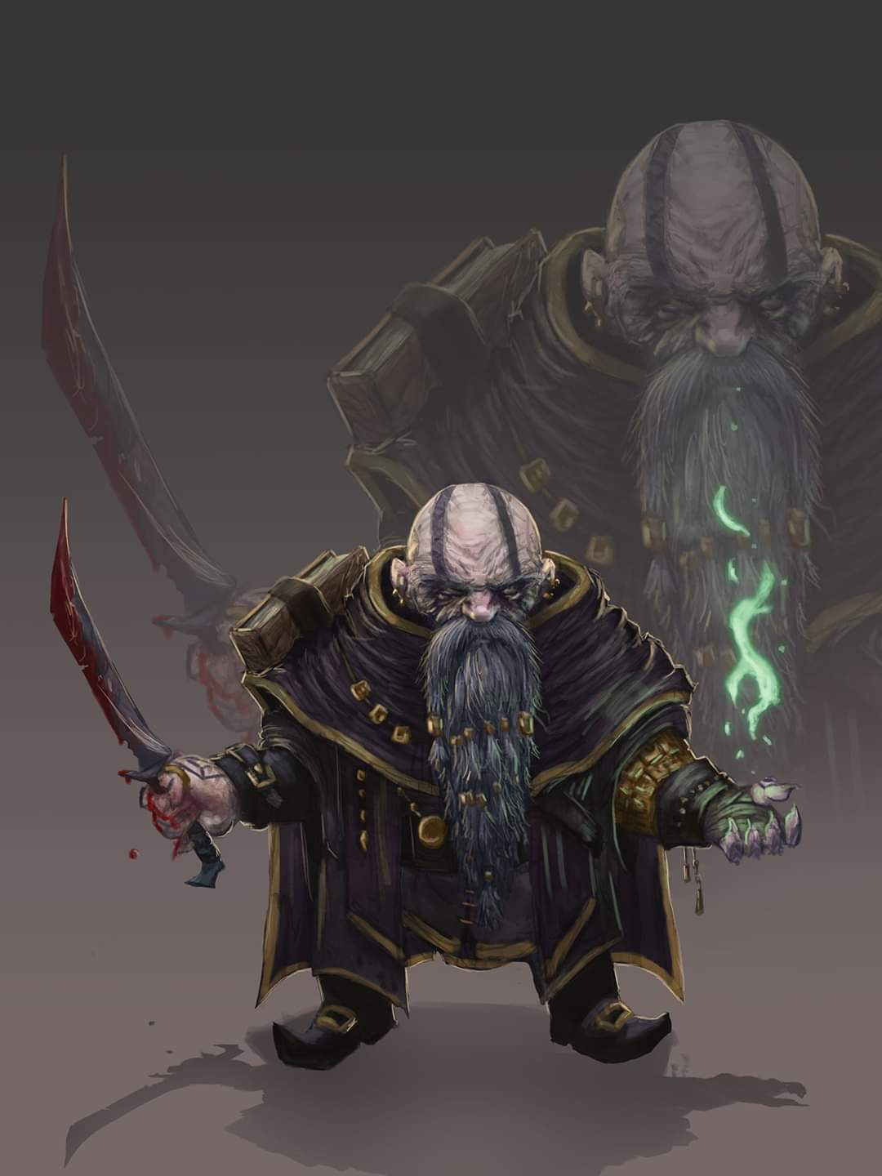

Dromedar began to speculate, “Fritz *has* been treating the sick more than usual... perhaps it was one of those who entered our temple in the last few days.”

Luran didn’t turn around, but felt the need to study Dromedar’s body language after hearing the gnome’s voice speaking with a tinge of rash anxiety. His nonchalant composure caused him to take a few steps back as Elsabet put the cloak on Fritz in preparation of her casting.

Elsabet paused for a moment. “In case this is an actively evil effect, I am going to first cast *protection from evil* upon myself before proceeding, as I will have to touch Fritz several times I expect. Everyone else should stand back. Captain, it might be wise to consider a quarantine of the temple until we can discern whether and how far this has spread amongst those who have come into contact with Fritz. And that doctor should be found. Luran, make sure nobody touches me or interferes with my castings.”

“Dromedar, what do you make of this? Surely, your training would give you some indication of what in the blazes is going on,” Slatestein said before hollering for his gnomish partner to come in.

Oshmir entered the temple and his Captain told him, “Grab some backup. We may need to quarantine the temple.”

“Done.” And with this Oshmir left the temple, headed to the precinct office around the corner.

When Oshmir entered the temple and spoke with the Captain, Barkley became a bit concerned. Luran had left earlier to join the others in the Sacerdôt’s room, and now Oshmir had been called. Barkley focused on his Detect Evil ability once more, turning his attention towards the room where all of the others gathered. He was beginning to get concerned that there was truly something seriously wrong going on.

Oshmir had stood in the front doorway while speaking to Slatestein, and as he exited to go around the corner to the precinct office, Barkley asked, “What is wrong, what it going on in there?”

“Looks like we’re going to have to close up the temple for the evening. Fritz isn’t well at all,” Oshmir responded.

19:13

Elsabet followed up her words with action, casting *protection from evil [expired in 4 minutes]* on herself. Then she began carrying out her plan, starting with the 3 rounds needed to cast the first *lesser restoration* spell, hoping to see some improvement in the Sacerdôt’s condition. But whether any improvement was immediately obvious or not, she then spent another 3 rounds to cast a second *lesser restoration*, calling upon Mayaheine to help restore some of Fritz’s vitality. It looked to the crusader like these spells were helping a bit, so she cast one more before moving on.

“Now for the next phase,” Elsabet muttered. “Attempt number one.”

She cast *guidance* on Fritz, and after a quick “come on Fritz, you can resist this,” seconds later cast *resurgence* on him. “Now to see if it worked,” she said, focusing her detect magic on the necromantic aura to see if it is still in effect.

*See below.*

Dromedar stepped out of the room nonchalantly, and with everyone’s attention on Fritz, they didn’t notice.

The aura began to wane. Elsabet was pleasantly surprised that the lumps under the man’s arms were beginning to subside as Fritz opened his eyes wide, and looked directly at her, gasping for air. He took a deep breath, then sounded like he was gargling as a black substance was coughed out—no—it actually jumped out of him and towards Elsabet.

|  |  |  |  |  |  |  |
| --- | --- | --- | --- | --- | --- | --- |
| **Save vs.**  being touched | **Rank** | **Ability & Mod.** | **Misc. Mods.** | **Total** | **Roll** | **Check** |
| **Elsabet, Reflex** | **4** | **Dex (+2)** | 1 | 7 | 2 | 9 |

*Fail. Fluid came into contact with Elsabet.*

“Holy Mayaheine!” Elsabet exclaimed. “Yuck!” She cast *resurgence* on herself to try to shake the substance off, and then said, “Kill it!”

|  |  |  |  |  |  |  |
| --- | --- | --- | --- | --- | --- | --- |
| **Save vs.**  being touched | **Rank** | **Ability & Mod.** | **Misc. Mods.** | **Total** | **Roll** | **Check** |
| **Elsabet, Reflex** | **4** | **Dex (+2)** | 1 | 7 | 10 | 17 |

*Secondary success.*

The woman’s clothing was stained as the black fluid spilled onto the cloth that covered her torso, seeping in, but Elsabet was quick enough to hold the fabric away from her skin, and would now have to remove the garment in order to stave off the threat of contact.

Fritz breathed in again, looking around him as he now pushed himself up onto a sitting posture. “Aaagh!” he seemed to complain as he came out of his stupor. “Slatestein! What in the blazes?!” he spoke with much more strength in his diaphragm, but with black fluid still coating his lips and chin.

“Fritz, it looks like you fell ill. This woman is a healer, and Drome...” the guard looked behind him to see that Dromedar was gone. “Dromedar! What on Toril?” He stuck his head out into the hallway again, and saw Cobol watching those outside as attentively as before. “Cobol! Where’s Dromedar?”

“I thought he was in there with you,” Cobol answered.

When Barkley heard the Captain calling about Dromedar, his ears perked up straight and his eyes opened wide. He looked at the other gnomes around him. “It looks like we were right; perhaps you need to start looking at each other to determine what foul plot is afoot within your *own* temple.” He spoke in a flat, even tone, keeping any accusation from his words.

Saradette watched the others’ reactions. She’d peace-bonded her blaster, but her dagger was still available.

Elsabet, as quickly as she could while being careful not to touch the stained areas, shrugged off her haversack, unbuckled her weapon belt, and stripped out of the tainted clothing, and tossed it into a corner as far from everyone as she could.

Barkley and Solstice began to search for Dromedar by scent, entering the temple. Fortran and Axum helped, with the latter saying, “I’ll check his quarters,” and inviting the heroes to join him to make sure he was being completely above board.

While using one hand to keep the tainted clothing from touching her, Elsabet carefully unbuckled her weapon belt with her other hand and dropped it behind her, while saying “everyone, clear away from that corner,” nodding at a corner away from flammable furniture.

She then used her free hand to tug the straps of her haversack off her shoulders and let it slip to the floor at her feet, within reach, while saying, “I am going to toss this over there.”

Finally, she carefully removed the tainted clothing, tearing away buttons as needed, and tossed it where she indicated, while saying, “I think acid and fire might destroy it; any other ideas?”

Captain Slatestein was preoccupied with Dromedar’s disappearance, and had to ignore Elsabet for the moment. “Damnable priest!”

Saradette unlimbered her flechette launcher and helped Barkley look for the now-*invisible* priest.

Barkley, as he sniffed the air to pick up Dromedar’s sent nodded to Axum when he mentioned Domedar’s quarters. “Lead the way.” As they went, he undid the peace bonds on his weapons, adding to the others, “Stay alert and arm yourselves. I would prefer we capture him alive, but will not hesitate if given no other choice.” Once the peace bonds were undone, he drew his axe and longsword.

As they followed Axum up the stairs, Barkley wondered why he’d not been able to *detect evil* on the culprit earlier, and deduced that the gnome was likely using some magical means of masking his malignant disposition. Solstice—on the other hand—could *see invisibility*, and if the man was anywhere in the vicinity, the musteval would be likely to spot him.

Axum got to the door that led to Dromedar’s chambers, and found it to be locked. “I smell him,” Solstice said as Axum asked, “Anyone able to pick this?”

Before Saradette could put down her sabot launcher, Solstice said, “Lift me up, acolyte.”

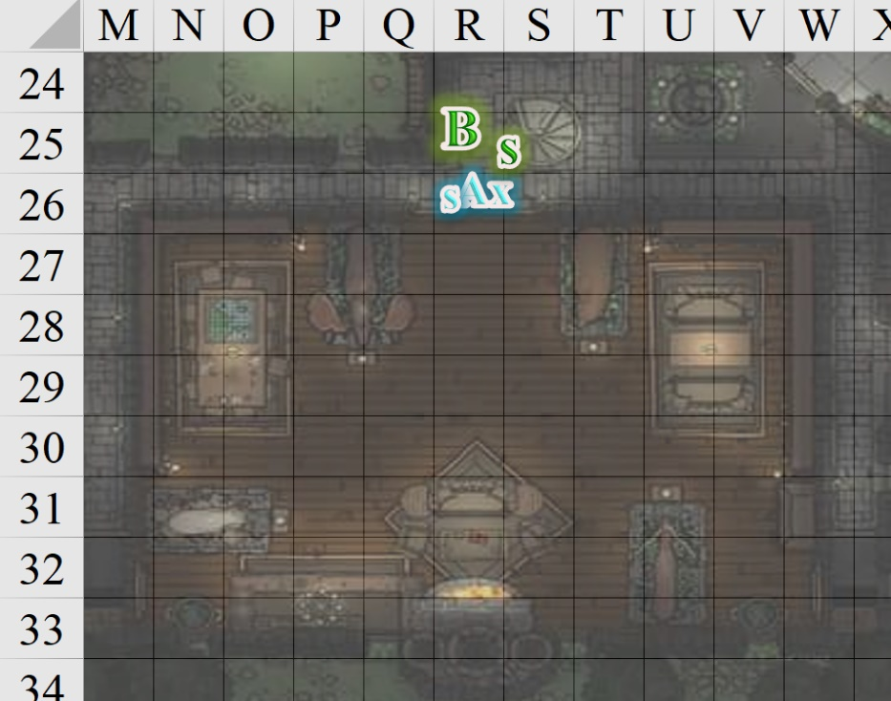

Axum did as asked, and Solstice got to work.

|  |  |  |  |  |  |  |  |
| --- | --- | --- | --- | --- | --- | --- | --- |
| **Skill** | **Rank** | **Ability & Mod.** | **Misc. Mods.** | **Total** | **Roll** | **Check** | **Notes** |
| **Open Lock** | 9 | **Dex (+3)** | 2 | 14 | 15 | 29 | Lucky Fingers |

*Success.*

The lock turned, and they heard a hurried scuffle inside. Once Solstice turned the handle, Axum eagerly pushed the door open.

“There he is!” Solstice proclaimed, seeing the *invisible* gnome casting a spell from a scroll, which Barkley could hear and identify as *dimension door*. With any luck, they could interrupt the casting before the effect manifested, and the gnome disappeared into some alley outside the temple.

*Red blob indicates Dromedar’s general location.*

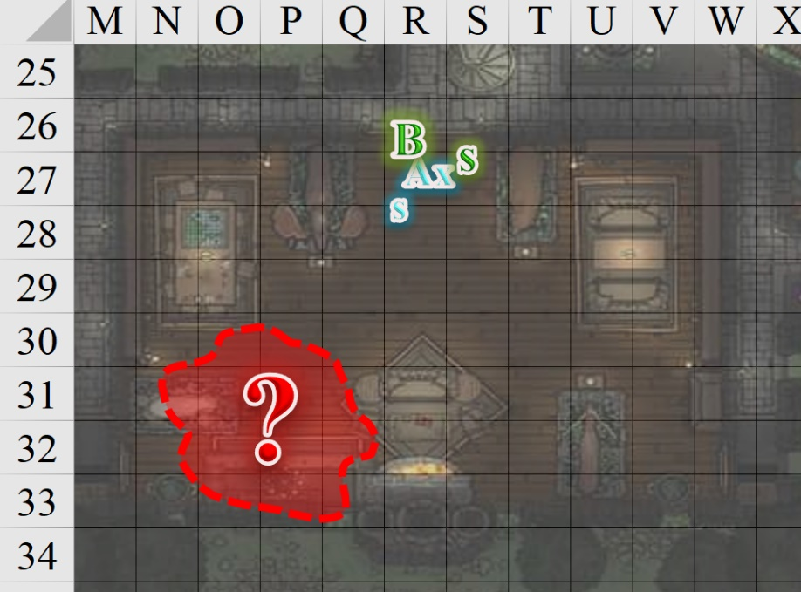

Round 168

|  |  |  |  |  |  |
| --- | --- | --- | --- | --- | --- |
| **Character** | **Group** | **Initiative** | **Roll** | **Modified Roll** | **Move** |
| Barkley | 1 | 2 | 20 | 22 | 40’ |
| Saradette | 1 | 3 | 17 | 20 | 20’ |
| Dromedar | 2 | 2 | 16 | 18 | 20’ |
| Axum | 2 | 3 | 2 | 5 | 20’ |
| Solstice | 1 | 1 | 1 | 2 | 30’/10’ |

|  |  |  |  |  |
| --- | --- | --- | --- | --- |
| **Character** | **Save vs.**  Aura of Menace | **Ranks** | **Roll** | **Result** |
| Dromedar | Will | 4 | 15 | 19 |

*Success. No effect.*

Dromedar beheld Barkley’s countenance, but bit back the reflex to cringe before him.

Unable to see the gnome, but hearing his voice, Barkley relied on the combination of his sense of smell and hearing, and charged forward *[O31]*, his arms out and slightly bent at the waist. He hoped to hit the gnome as he yelled to Saradette, “Fire to my left!” He hoped her spread of shot and his charge would be enough to stop the gnomes chanting even if they didn’t hit him.

|  |  |  |  |  |  |  |  |  |  |
| --- | --- | --- | --- | --- | --- | --- | --- | --- | --- |
| **Melee Weapon** | **Dmg** | **D+** | **TH+** | **Critical** | **Type** | **Wt.** | **Atk** | **Roll** | **Check** |
| Longsword +1 | 1d8 | 3 + 2  charge  - 4 *invisible* | 2 charge | 19-20/x2 | Slashing | 4.0 | +6 | 18 | 24 |

*Hit. Dmg: 4 + 1 weapon + 2 Strength + 2 charge = 9.*

|  |  |  |  |  |
| --- | --- | --- | --- | --- |
| **Character** | **Save vs.** | **Ranks** | **Roll** | **Result** |
| Dromedar | Concentration | 6 | 7 | 13 |

*Fail.*

The spellcasting was wasted, and the archon was able to prevent the gnome from teleporting.

Also unable to spot the *invisible* spellcaster, Saradette leveled her launcher and fired past Barkley’s left side, as directed by the sound of the spellcaster.

|  |  |  |  |  |  |  |  |  |  |  |
| --- | --- | --- | --- | --- | --- | --- | --- | --- | --- | --- |
| **Ranged Weapon** | **Dmg.** | **D+** | **TH+** | **Critical** | **Rng.** | **Wt.** | **Atk** | **Roll** | **Check** | **Notes** |
| Sabot Launcher | 1d6x6 | - | -4 invisible  target – 4 firing  into mele | 15o cone | 50’ | 5.0 | -2 | 18 | 16 | 48 charges (Launch Item) |

*Miss.*

The sabot missed its mark, hitting the southern wall, but at least it didn’t hit Barkley.

Dromedar cast *inflict moderate wounds* upon Barkley.

|  |  |  |  |  |  |  |
| --- | --- | --- | --- | --- | --- | --- |
| **Character** | **Attack Type** | **Damage** | **BAB** | **Total Score** | **Roll** | **Total** |
| Dromedar | Touch Attack | ILW | 4 | 4 | 3 | 7 |

*Miss.*

The cleric lost his *invisibility* as soon as he reached over to Barkley, and Axum threw his javelin at him, aiming for the side furthest from Barkley. “Traitor! To think I thought you a decent man!”

|  |  |  |  |  |  |  |  |  |  |
| --- | --- | --- | --- | --- | --- | --- | --- | --- | --- |
| **Character** | **Attack Type** | **Damage** | **Ranged?** | **BAB** | **Dex Mod+** | **W+** | **Total Score** | **Roll** | **Total** |
| Axum | MW Javelin | 1d6+1 | þ | 2 | 3 | 1 – 4 firing  into melee | 2 | 4 | 6 |

*Miss.*

Solstice didn’t have his blowgun drawn, and thus fired two *magic missiles* at Dromedar.

*Dmg: 6 + 2 = 8 magic.*

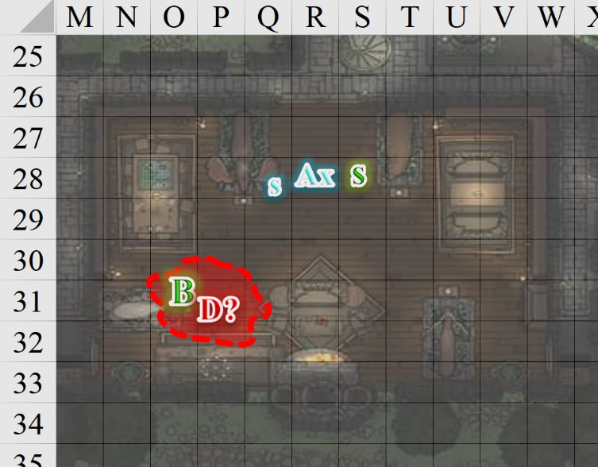

~*~

Downstairs, Luran reached into his magical bag, retrieving a flask of acid. He began to carefully approach the pile of discarded garments. “Seem like a good option?” he asked Elsabet as he watched the goo for movement.

Elsabet took Luran up on his offer to help destroy her clothing using alchemical fire or acid. “Let’s use fire first, and acid if the fire doesn’t do the job.”

The goo was still wriggling, but Luran only had acid to use. He applied this after Elsabet expended her fiery means.

How is Sacerdôt Fritz reacting? Did he just move away from the exctement? He appear to be recovered, mostly?

After dumping alchemist’s fire on her tainted clothing, and watching Luran follow up with acid, Elsabet got a flask of acid out of the haversack and dumped that on the clothes as well. “Do you think that did it?” She looked at Luran, then back at the smoldering, bubbling ruins of her outfit.

~*~

Round 169

Barkley was glad he had stopped Dromedar from casting his spell and even happier that he could now see his target. Turning to face Dromedar, Barkley attacked again, using his sword and axe as he yelled, “Surrender or die where you stand!!”

|  |  |  |  |  |  |  |  |  |  |
| --- | --- | --- | --- | --- | --- | --- | --- | --- | --- |
| **Melee Weapon** | **Dmg** | **D+** | **TH+** | **Critical** | **Type** | **Wt.** | **Atk** | **Roll** | **Check** |
| Hand Axe | 1d6 | 2 | 0 | x3 | Slashing | 3.0 | +8 | 5 | 13 |
| Longsword +1 | 1d8 | 3 | 1 | 19-20/x2 | Slashing | 4.0 | +9 | 10 | 19 |

*Miss.*

Saradette aimed her launcher and fired again, careful to not hit Barkley.

|  |  |  |  |  |  |  |  |  |  |  |
| --- | --- | --- | --- | --- | --- | --- | --- | --- | --- | --- |
| **Ranged Weapon** | **Dmg.** | **D+** | **TH+** | **Critical** | **Rng.** | **Wt.** | **Atk** | **Roll** | **Check** | **Notes** |
| Sabot Launcher | 1d6x6 | - | 0 | 15o cone | 50’ | 5.0 | 6 | 12 | 18 | 46 charges (Launch Item) |

*Miss.*

Dromedar realized that he wasn’t going to be able to best these stalwart heroes, so he did something rash, and crashed through the southern window of the second-story bedroom.

*Dmg: 6.*

“Blast!” Axum cursed. “He won’t get away.” The artificer then ran to the window, placed his hands on the windowsill, and called out for a guard across the street, but because Slatestein and Oshmir were downstairs, there was no one posted outside the precinct office. Axum was wrong, and Dromedar was, in fact, getting away, running eastward.

Solstice immediately ran back down the stairs at top speed in order to alert the guards, screaming, “Dromedar’s getting away. He’s on the street!”

~*~

Downstairs, Elsabet and Luran heard the musteval, as did the guards.

“Where?”

Seeing the goo might still be active, Elsabet thought maybe a blast of energy might help, and fired an eldritch blast into the mess. She left it to the Captain to decide what to do about that Dromedar fellow.

|  |  |  |  |  |  |  |  |  |  |
| --- | --- | --- | --- | --- | --- | --- | --- | --- | --- |
| **Ranged Weapon** | **Dmg.** | **D+** | **TH+** | **Critical** | **Rng.** | **Wt.** | **Atk** | **Roll** | **Check** |
| Eldritch Blast | **1d6** | 0 | +4 stationary  Object – 2  Size | x2 | 60’ max. | - | +10 | 12 | 22 |

*Hit. Dmg: 2 magic.*

The goo began to sizzle, and Elsabet considered that her blast was having the desired effect, but perhaps more was needed.

Luran stayed with Elsabet to make sure she dealt with the goo.

Round 170

Saradette cursed roundly, activated her Dimension Stride boots, and put herself on the street, where she dashed off after her quarry. She took the precaution of slinging her launcher so as to not raise even more alarms.

Dromedar disappeared eastward into the alleys that led towards the Eastgate, and Saradette followed close behind.

Axum riled his comrades and the Oshmir into following Dromedar, though they had a significant lag to compensate for as they exited the temple and rounded the corner, barely spotting Saradette in pursuit before she was out of sight. “There!” Fortran yelled, and they hustled to catch up.

Despite being smaller, Solstice was actually faster than the gnomes, and had the best chance of catching up to Saradette, and possibly Dromedar, so he hustled too.

Barkley ran after Dromedar and leapt out the window behind the gnome.

*Dmg: 3. Damage negated.*

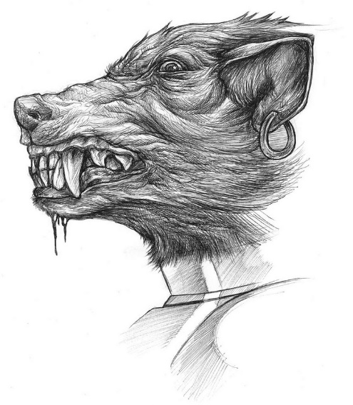

Once he hit the ground in the midst of the other gnomes already in pursuit, Barkley transformed into a wolf and ran after Dromedar, quickly catching up to Saradette.

~*~

Bordering on well-warranted panic over the evil goo, Elsabet ignored Solstice and continued to blast the black liquid on her clothing.

|  |  |  |  |  |  |  |  |  |  |
| --- | --- | --- | --- | --- | --- | --- | --- | --- | --- |
| **Ranged Weapon** | **Dmg.** | **D+** | **TH+** | **Critical** | **Rng.** | **Wt.** | **Atk** | **Roll** | **Check** |
| Eldritch Blast | **1d6** | 0 | +4 stationary  Object – 2  Size | x2 | 60’ max. | - | +10 | 14 | 24 |

*Hit. Dmg: 4 magic.*

Luran stayed vigilant all the while.

Round 171

Elsabet zapped the goo again.

|  |  |  |  |  |  |  |  |  |  |
| --- | --- | --- | --- | --- | --- | --- | --- | --- | --- |
| **Ranged Weapon** | **Dmg.** | **D+** | **TH+** | **Critical** | **Rng.** | **Wt.** | **Atk** | **Roll** | **Check** |
| Eldritch Blast | **1d6** | 0 | +4 stationary  Object – 2  Size | x2 | 60’ max. | - | +8 | 1 | 9 |

*Critical miss.*

“Rats!” the warlock cursed as Luran thought to help out, though he didn’t want to get his weapons dirty with the goo.

Fritz blinked as he began to regain his senses, albeit slowly.

Captain Slatestein approached him without touching the afflicted Sacerdôt. “Fritz, what happened? When did you fall ill? I saw you merely days ago, and you looked just fine.”

“I... ah... I really don’t recall.”

~*~

Barkley followed where he’d seen Saradette heading, spotted her, and quickly gained on her, thereafter spotting Dromedar. He passed her, with Solstice and the other gnomes in pursuit behind him, and continued towards the fleeting Dromedar.

Round 172

Barkley charged towards dromedary and with a leap, bit at him.

|  |  |  |  |  |  |  |  |  |  |
| --- | --- | --- | --- | --- | --- | --- | --- | --- | --- |
| **Melee Weapon** | **Dmg** | **D+** | **TH+** | **Critical** | **Type** | **Wt.** | **Atk** | **Roll** | **Check** |
| Bite | 1d8 | 2 | 2 charge | 20 | Piercing | - | +10 | 6 | 16 |

*Miss.*

Dromedar flinched and turned the corner into a narrow alley between a house and a shop. Saradette followed and Barkley changed course to also continue his pursuit. Behind them was Solstice—who had almost caught up to Saradette—and trailing behind the musteval were Dromedar’s former followers, now intent on bringing their traitor to justice. Oshmir called out, “In the name of the Baron’s justice, I command you to stop at once, Dromedar. The charges you face are bad enough.”

~*~

Elsabet zapped at the cloth once again.

|  |  |  |  |  |  |  |  |  |  |
| --- | --- | --- | --- | --- | --- | --- | --- | --- | --- |
| **Ranged Weapon** | **Dmg.** | **D+** | **TH+** | **Critical** | **Rng.** | **Wt.** | **Atk** | **Roll** | **Check** |
| Eldritch Blast | **1d6** | 0 | +4 stationary  Object – 2  Size | x2 | 60’ max. | - | +10 | 11 | 21 |

*Hit. Dmg: 2 magic.*

The goo began to bubble and fizzle, smoking even.

Slatestein continued speaking with Fritz. “... and who is this Who character? I’ve never heard of such a person from anyone here at the temple.”

“Who? Oh... Dromedar’s healer. He’s been looking after me, I think. Hasn’t he?” Fritz recalled, barely.

“What does he look like?”

Rounds 173 – 174

“Well... for one, he’s human, but he wears robes, and is always hooded, so all I can tell you is that he’s a paler man than most in Mintar,” Fritz began, going on to describe a fairly shady—if not sinister—man who could easily be imagined drinking blood from the skull of one of his victims.

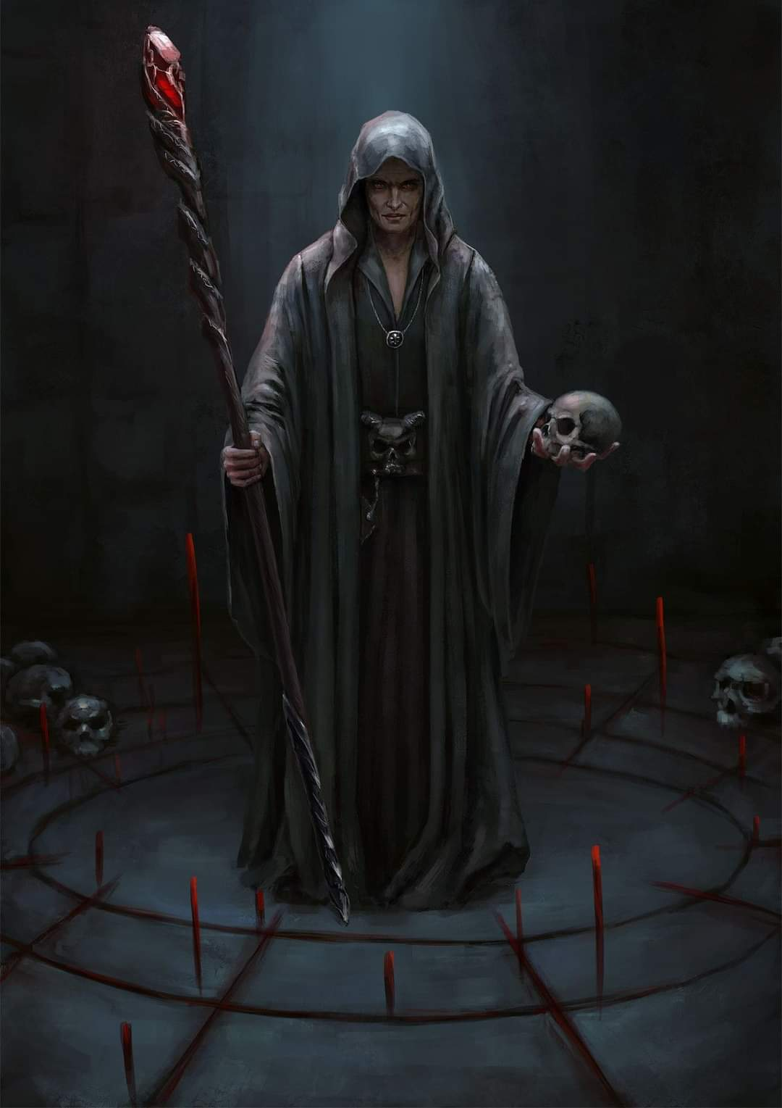

Luran listened to the conversation as he watched Elsabet trying to finish off the gooey substance’s existence.

|  |  |  |  |  |  |  |  |  |  |
| --- | --- | --- | --- | --- | --- | --- | --- | --- | --- |
| **Ranged Weapon** | **Dmg.** | **D+** | **TH+** | **Critical** | **Rng.** | **Wt.** | **Atk** | **Roll** | **Check** |
| Eldritch Blast | **1d6** | 0 | +4 stationary  Object – 2  Size | x2 | 60’ max. | - | +10 | 16 | 26 |
| Eldritch Blast | **1d6** | 0 | +4 stationary  Object – 2  Size | x2 | 60’ max. | - | +10 | 7 | 17 |

*Hit, hit. Dmg: 5 + 4 = 9 magic.*

And with the last shot, the clothing and goo were both obliterated beyond recognition.

~*~

The next few moments of Dromedar’s life were likely the most decisive as Barkley did his best to bring down the renegade priest.

|  |  |  |  |  |  |  |  |  |  |
| --- | --- | --- | --- | --- | --- | --- | --- | --- | --- |
| **Melee Weapon** | **Dmg** | **D+** | **TH+** | **Critical** | **Type** | **Wt.** | **Atk** | **Roll** | **Check** |
| Bite | 1d8 | 2 | 0 | 20 | Piercing | - | +8 | 9 | 17 |
| Bite | 1d8 | 2 | 0 | 20 | Piercing | - | +8 | 5 | 13 |

*Miss, miss.*

The best he could do was slow down as he bit down on the gnome’s *mage armor*, which was unfortunately too viscose to allow the archon to grasp the fugitive with his prehensile jaws.

By this point, Solstice was able to catch up, and instead of releasing another *magic missile*, got in front of him and said, “Dromedar, we have you surrounded. None of us can likely stop you alone, but together, we *will* bring you down.”

The gnome wasn’t intimidated by the wee creature, but had to agree that with Saradette, Oshmir, and his own artificer acolytes behind him, he would only prolong his capture, and thus, dropped his hooked hammer, and put up his hands, palms facing forward. With a chagrin and even a tear released from his left eye, the junior Sacerdôt surrendered.

Round 175

A few seconds later, Oshmir grabbed the man’s wrists, brought them behind his back, and cuffed Dromedar, thanking Barkley, Saradette, and Solstice for their solemn and altruistic aid. “As soon as we’ve brought the suspect into custody,” he assured the artificer and archon, “I’ll return your badges to you. The Barony is grateful to you.”

“Better gag him, he’s a spell caster,” Saradette advised. He looked at Dromedar. “I should charge you for ammunition expended, too.”

Oshmir did as Saradette suggested, already having produced the gag to do so.

Before the gag was placed in Dromedars mouth, Barkley asked one simple question, unsure if he would get an answer. “Why? Why did you do it?”

The priest said nothing, but merely smirked at the question. Barkley wondered if Dromedar was the one who had suggested this Who character to the Sacerdôt in order to replace him.

~*~

With the petroleum-like goo destroyed, Elsabet and Luran turned their attention back to Fritz as the latter looked over at the herbs with seeming disgust, and closed his eyes, “Ugh... if I have to drink any more of that tea, I’ll surely end up dead.”

Elsabet turned away from the mess on the floor with a shudder, and introduced herself. “I am Elsabet, Favored of Mayaheine, and more importantly today, a friend of Saradette. You are lucky to have her as a friend too, it was her concern for your well-being that brought my companions and me here today. If you permit it, I have one more lesser restoration spell I can cast on you, which might give you a bit more energy now that the foul necromantic energy goo—whatever—has been removed and destroyed.”

Fritz agreed, and she cast the spell, depleting that tier’s spell reservoir for the day.

Realizing she was still wearing just a chain shirt over undergarments, and was getting a few covert glances, she grinned and said, “feel free to look, I don’t mind,” as she bent down and retrieve a spare outfit from her haversack. She grinned even wider as the dwarven captain rolled his eyes, then winked at Luran as she put on the outfit. The captain seemed more amused than scandalized, and once redressed, Elsabet happily provided more details for his report about what she had seen, and helped fill Fritz in on what she had personally observed.

~*~

Within minutes, Dromedar had been brought to the precinct office and charged, all of the gnomes except for Fortran—who was Dromedar’s closest disciple—had gone back to the temple, and Fortran was presenting testimony as to Dromedar’s allegiances. They would eventually get to the bottom of the treason, and Barkley, Saradette, and Solstice presented their own testimony of the situation. Oshmir returned the two badges he’d confiscated, and the report posed the Fist of Light in a duly favorable light.

Back at the temple, the gnome artificers all coalesced around Fritz, whose condition had been greatly aided by Elsabet, and the goo and rags were being disposed of. Averest took the remains to the Gondar furnace, where they watched the filth sparking as the flames consumed it and the clothing.

“The Temple of Gond owes you a debt of gratitude,” the still frail but sound of mind Sacerdôt admitted. “I apologize that I was not able to join you at your place for dinner, but I would now invite you to join me here for a meal and some proper tea—none of this echinacea crap.”

*[Elsabet’s and/or Luran’s reactions]*

“You’re welcome to join us as well,” Fritz told Slatestein.

Slatestein nodded and added, “There’s still the matter of finding Who. With Dromedar’s sinister partner at large, I’d join you for a bite or two, but I should get back to the office to look over the report that Oshmir is surely finishing as we speak,” he correctly guessed.

Barkley, Saradette, and Solstice returned a few minutes later as the scent of baked bread began to fill the temple’s main chamber, and Fritz was now walking to the lavatory to freshen up after days of being distended and infirm.

Barkley asked the gnomes, “This Who: did Dromedar bring him to the temple? Or did he show up on his own?”

The gnome named Linux said with no uncertainty that Dromedar had indeed presented Who to the others, and had vouched for his healing abilities.

Barkley, though a bit hungry, did not stay long. He grabbed a large slice of bread and cut it in half again. He placed some meats and cheeses between the slices and ate it as he drank some tea.

Once done, he got up, “I do not mean to eat and run, but I want to see what success has been made in gathering information from Dromedar. I would prefer to find and put an end to Who’s tactics no matter who he is or where he is.”

Elsabet thanked Sacerdôt Fritz for the invitation, and said she would love to join them for a meal. “I enjoy tea myself,” she said, “even more than I enjoy ale, to be honest. My favorite is Zakharan, but I like trying new varieties.”

“Captain, I would like to get a copy of the report later, if I may. I know the *amanuensis* spell for copying writings, so no need to scribe an extra copy for me—just a few moments to scan it magically into my journal would suffice.” She informed him where she was staying in case he needed to get in touch, with the caveat that sometimes events led her and her friends off in strange directions at a moment’s notice.

Slatestein agreed.

When Barkley indicated he was heading to the precinct house, she suggested Solstice accompany him. “‘Nobody travels alone’ seems to be a solid plan these days! This Doctor Who fellow might attempt to rescue Dromedar.”

“In fact, some of the things that he had handled in the Sacerdôt’s chambers might still bear his scent—before you head over, perhaps you two might see if you could get a good whiff of it? I don’t think that side table of herbs, etc. has been disturbed yet, and he might have wiped his hands on a towel or something. Sacerdôt Fritz, what do you think?”

Barkley nodded, and looked at Fritz, “If you have no objections to my sniffing around, I will endeavor to pick up the foul Who’s scent.”

“Please do,” Fritz urged Barkley.

Barkley then saw if he could pick up any unfamiliar odor in the room, then attempted to confirm to whom it may have belonged, and if Who handled it. The results led him to conclude that Who had only really been inside Fritz’s chambers, and had likely purposefully stayed clear of the rest of the temple. The scent was definitively human, and carried with it tinges of rotting tissue reminiscent of a morgue.

~*~

By the time Barkley got back to the precinct office around the corner, Dromedar had been stripped of his jewelry and clothing, all of which were placed in an evidence locker along with his gnome hammer. The archon could clearly see the aura of evil around the man behind bars now, and was told that one of his rings had been identified as having the *undetectable alignment* property, a simple enough ruse to obfuscate his true intentions, even from his own congregants and superior.

Barkley nodded, a simple explanation to how he was able to hide his identity. “Just like a typical coward: hiding who you really are from others.” He looked at Dromedar and shook his head, “Pathetic.” He then emphatically turned his back on Dromedar and walked over to the city guards, not reacting to anything Dromedar might say, just listening. “Has he given you any indication of where we can find his co-conspirators?” Barkley gave the impression of caring little that Dromedar was there, as if his presence was insignificant.

“We’ll get there,” the guard on duty assured Barkley. “An investigator-diviner is on his way. We’ll have a *zone of truth* in place soon enough.”

Barkley nodded, “Excellent. My friend,” he indicated Solstice on his shoulder, “and I would like to stay for the questioning. I do have one thing to add. Prior to coming here, I checked Sacerdôt Fritz’s quarters and picked up the scent of a human, likely our suspicious Who character. I also got the scent of rotting or decaying flesh, possibly like a morgue or cemetery. Perhaps guards can be sent to watch any locations like that in or around town. I would not go in, though, until we know more.”

The young clerk responded, “We’ve two such places here in the city.” He jotted down Barkley’s notable comment in the case file, and agreed that these were sensible places to follow up, but given the references to necromancy in the file, this made just about any necromancer’s residence a viable place to follow the trail.

~*~

It wasn’t more than a tenth of a bell’s toll before the aforementioned diviner entered the precinct office, having come over from a nearby precinct after a *sending* spell had summoned him. Introductions were made, and the male halfling—named Ja’ir—looked at Dromedar as he took the case file from the young clerk.

As he took a few minutes to read it over, Elsabet and Captain Slatestein entered the office. The favored soul of Mayaheine expressed once again an interest in copying the documents contained therein, and once Ja’ir was finished with it, and Captain Slatestein approved it, Elsabet was handed the portfolio for her to cast her *amanuensis* spell.

Casting *zone of truth* and making a bit of small talk with Dromedar to ensure that the spell was working, Ja’ir was able to glean a significant amount of information. “Understand that reticence on your part will be considered by the Magistrate a falsehood, and will be treated as perjury when a verdict and sentence are rendered. I urge you to absolve yourself as much as possible of further prosecutive liability, and speak clearly that the clerk might record as complete a testimony as possible.”

|  |  |  |  |  |
| --- | --- | --- | --- | --- |
| **Character** | **Save vs.**  *zone of truth* | **Ranks** | **Roll** | **Result** |
| Dromedar | Will | 4 | ?? | ?? |

*See below.*

Within a few more minutes, as Saradette and Luran joined them, it seemed that a trip to the city’s morgues and mortuaries would have proven to be fruitless, for in his testimony, Dromedar confessed that Who was not a resident of Mintar, but had been staying in a safehouse for a few tendays, funded by Dromedar himself. This left more questions than clarification, and as the agents of the Fist of Light listened from afar, they learned that Dromedar was motivated by a known but now largely outdated position taken by the most conservative Gondar clergy, a position that today was only publicly espoused in Lantan, where artificers were the most numerous.

Solstice was taken aback by the audacity of the cleric’s ambition, which was to secretly seek to gain influence over the rulers of this city and surrounding region that the works of Gond should be embraced by all, and eventually by force, if necessary. Saradette—upon hearing this—recalled the warnings by her own friends and family in the Dalelands to steer clear of these extremist artificer fanatics, and shook her head at the words that she was now hearing, which confirmed the shortcomings of Gondar philosophy.

Slatestein himself had had more than one conversation with Fritz on this subject, and sighed at the confirmation that although Fritz had proven himself beyond the shadow of a doubt to be devoid of such supremacist and absolutist notions, he had inadvertently fostered within his own house of worship the very embodiment of this nearly obsolete hubris.

Before the confession was through, the Captain mobilized a strike team to go to the address that Dromedar had just provided—which was not far from Shoomma’s shop in the Chatterstreet Market quarter—and arrest the necromancer if he was there. If he could not be found, the case would remain unresolved, and the city would have one more active villain at large. “The capture of this Who fellow will impact the charges levied upon you, Dromedar,” Slatestein warned the prime suspect. “Either he or you will pay for his misdeeds. Pray that we find him, and that none of my women and men are harmed in his arrest.”

~*~

The interrogation was concluded, and off-duty specialists had been summoned. The strike team was assembled: a band of three officers with specialized skillsets, and allegedly two more with whom they would connect in the adjacent precinct on their way to the Chatterstreet Market. Two had just clocked in, this being their official day off, but they were glad to serve such a cause. Slatestein led them, and as they left the office, he bid the heroes well. “The city owes you yet another debt of gratitude, Deputies. I shall be in touch, but feel free to drop by tomorrow for periodic developments.” And with this, the strike team left the precinct office.

Oshmir was now the highest-ranking officer in the room, and approached Barkley and Saradette, noting that they were once again wearing their badges on their lapels, and had unbonded their weapons. He smiled, saying, “It has been an eventful shift; I’ll say that much. I will convey my heartfelt appreciation in the report once we’ve apprehended Who and added his confession to the documents. The Baron’s Council will be pleased to know how instrumental you’ve been to safeguarding peace and stability in Mintar, heroes.”

The handful of other clerks and guards in the office cheered them and threw them several other compliments.

Luran was satisfied with a day supporting his companions and watching them take the spotlight for their actions. He intended to take it easy, that night, in preparation to move on to the next day’s potential good deed investigating the case of the magic user, Palmyra.

Elsabet looked at her friends, and said, “I am of a mind to see if we can find some ordinary entertainment to end the day on a more pleasant note. Does anyone know of a tavern where there might be music playing? Maybe dancing?” She turned to Oshmir, and asked, “Do you have any recommendations for a decent tavern that might have live entertainment this evening?”

“The Rampant Tankard has live shows at this time of night,” Barkley noted.

“New to the fold and already trying to convert us, my friend?” Luran made the jest with a wide, sincere grin. “That said, it does seem like a fine idea to take a celebratory moment of ease together. Gods know this life doesn’t always offer an abundance of those opportunities.”

Barkley smiled at Luran and his remark, “I didn’t say you had to come to the cellar,” he replied with a smile.

“I think I’ll take a walk,” Saradette said. “I will see you back at the inn.” With that, she stepped out onto the street.

Luran asked the artificer if she remembered the general agreement of “no one ever alone.” He gently pressed her for a reason not to keep with the rest of the party.

“I will be fine,” Saradette said from the street.

Barkley then turned to Saradette, “Too much has happened, one of us should accompany you. I’ve spent enough time at the Rampant Tankard, I could accompany you if you have no objections.”

Saradette smiled. “I’ve no objections, but you’ll have to stand quietly for a while.”

Barkley smiled at Saradette, “I can be quiet when I have to be.”

The artificer walked back to the Temple of Gond, and, finding a place in the shadows, settled own to watch the temple’s front door from the outside for a while. Barkley stood against a wall nonchalantly, keeping an eye on both the door and his friend.

Axum and Cobol occasionally opened the door, took note of her, and left them to work out their contemplation, nodding with gratitude when their eyes met.

~*~

The Rampant Tankard

The rest of the heroes were enjoying a good lyre and lute duo doing their duty. Dromedar was behind bars, and Who would likely be joining him in a nearby cell by sunrise.

Luran, Elsabet, and Solstice had a grand time, swaying to the plucked strings of the musical duo. The bard did not drink unless asked for ritual purposes.

~*~

22 Ghes, Morning, approaching Highsun

The Missing Minotaur



It had been about an hour since Averest and Linux had hand delivered a note to Saradette from Fritz, and both had taken the opportunity to thank her and the rest of the heroes—who had been breaking fast downstairs—for their heroic deeds the evening before. They were to be received at Highsun for lunch, and Fritz had a surprise for each of the members of the Fist of Light, but Linux had also added that their Sacerdôt intended to inform them of a prospect for a mission to Lantan, where the source of Dromedar’s dogma originated and fomented.

The female cleric-artificer went on to say, “Fritz does not expect anything else from you; you’ve already done our temple a great service, but if you should choose to investigate the situation there, we would secure your transportation.”

“Please tell the Sacerdôt that we will be there for lunch, and that we will think on his proposal,” Saradette said. When the clerics had left, she turned to her companions. “This whole situation bothers me. What could anyone possibly gain from coopting a temple here? It makes no sense to me.”

“Isn’t that what all temple staff are doing?” Solstice asked, maybe having misunderstood the gnome’s use of the word coopting. “Even Barkley’s newfound faith could have the potential to render the whole city drunk with fervor and love, weakening its moral fabric.”

Saradette gazed at Solstice for a moment with a lurking grin. “I’m still trying to see the down side in that.”

Barkley smiled at the musteval as well, “Then they have already succeeded where I am concerned. I am planning to put a temple to Cayden in the cellar of the Obstinate Loaf when I have the chance to return to Saradush. You will all be welcome as honorary members.” He raised the mug he held and took the last swallow.

Solstice wasn’t exactly an ascetic, but his notion of worship was a soberer one than that of his larger friends. “So what’s on the agenda today? Lunch at the Gondar Temple, followed by carousing at the Caydeanite Cellar?”

Elsabet was busy writing in her journal, but looked up to giggle at the interchange before writing down some passing musing about her friends in today’s entry.

Luran’s sensibilities were more in line with the tiny, Celestial outsiders. He knew that Tyr did not condone overly chaotic behavior. That said, the magic musician definitely had no oaths holding him too sober. And while no interest in converting was found in the half-elf, he could see the good in Barkley’s new god and his followers.

Elsabet mused a bit. “It seems that there is something about Mintar, perhaps its strategic location, that attracts those who dream of gaining power over others. Both the Speaker in Dreams and this archaic cult pursued power over others. But dominating others through force is different than persuading others through non-violent and non-coercive ways. Barkley’s god appeals to some, our goddess appeals to others, but neither seeks to take away the will and freedom of those who do not agree with our belief. Indeed, Mayaheine’s way is to protect others from such coercion, whether or not the people we protect worship her.”

Solstice stood in contemplation of what had just been presented to him. He was always impressed by the depth with which each of his brethren in arms approached their respective spiritual paths, and though he shared a deity with Elsabet and Saradette, he had no more affinity for their positions than for Barkley’s and Luran’s. Barkley himself had recently converted from Tyrism to Caydenism, and though the smell of brew was often on him now, it seemed to have made his character as stout as the ales he’d brewed on the Sky Tree. The musteval was glad to be in this company of heroes. He had had enough conversations with Barkley to know that the archon was restless to leave Mintar, and longed to return to his establishment in Saradush, where the ascetic elf—Bornoflove—was surely giving patronage to his tavern, which he’d entrusted to a fellow brewer-distiller. Solstice wondered what that might do to the solidarity of the band, and as the group’s primary healer, looked to Elsabet, Luran, and Saradette, wondering what trials and tribulations might present themselves in the near future.

~*~

Highsun

The heroes arrived at the Temple of Gond as Fritz stood outside talking to Captain Slatestein, “Ah!” they both seemed to say at the same time as they spotted the Fist of Light. “Speaking of which,” the dwarf continued, “we’ve news to our mutual relief. While Who was not apprehended, we seized his apprentice—a boy named Ripley—and seized the whole of his accoutrements in his hideout here in the city. Less than a toll ago, the human captive, this Ripley youth, revealed the location of the necromancer’s lair about an hour outside the city walls, just upstream. Ripley uses the full moniker, ‘Who, the Bone Whisperer’ when referring to his master, and confidently claims that we’ll be met by an ‘army of undead’ should we have the stupidity to seek him out.”

Barkley nodded at the news, the mention of the ‘army of undead’ not phasing him. With a necromancer involved, he expected no less. “We may need to employ a cleric or two to assist with this undead army. However, with or without, my blades will be ready.”

Elsabet grimaced. “An army of undead, eh? Not too worried if they are mostly animated skeletons and zombies, though none of us can turn them. I’m guessing his moniker means mostly skeletons. But it sounds like it definitely needs to be investigated quickly, and this Who fellow apprehended. I suspect we have disrupted his plans and he isn’t actually ready to move against the city.”

Barkley nodded as Elsabet spoke. He hoped that her assessment of the situation was accurate. Better to go after Who before he is ready.

Fritz then proposed, “Now, then, before we get any deeper into this conversation, let us break bread inside.” The dwarven Captain had also been invited, and they went inside as the rest of the gnome artificers and clerics were setting the table.

When Fritz mentioned going inside, Barkley bowed and motioned for the others to proceed as he brought up the rear.

With the potential threat—however hyperbolic the description of “army” may be—looming outside the city’s walls, Luran agreed this development demanded a rapid response. The investigation for Palmyra could definitely—or perhaps indefinitely—wait, and he said so as he followed Barkley’s motion and entered into the temple to break bread.

~*~

The conversation had wandered less towards Who and Ripley, and more into the topic of the Gondar philosophy of technology’s manifest destiny.

“… the goblin faiths concur...” and “… kobolds also believe...” had been used by those arguing for and against the idea that this philosophy was a detriment and a blemish upon some of Gond’s faithful. With diplomats and skilled orators all around, the conversation had convinced Slatestein—for that’s at least in part what he was here to settle—that Fritz and the others had no covert complicity in Dromendar’s folly. The dwarf had been there earlier in the day to take everyone’s statements within a *zone of truth*, and all their testimony put them in the green.

Nevertheless, Barkley—and to a lesser degree, Elsabet—could tell that the guard’s official business had not stopped at the door, and more power to the Barony for having such men and women within its force.

*[Point for interaction]*



The meal began to wind down, with a low-calorie dessert following the main course. Irrespective of ambitions for world domination, Gondars ate well, and efficiently so, thanks to their domestic gadgets. Gondar was great, indeed!

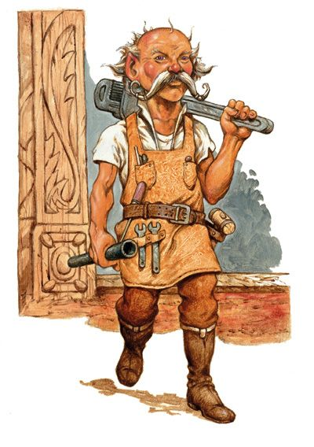

“Now, friends, as I’ve already told the good Captain,” Fritz spoke after the rest of his acolytes had shared in pleasantries and the more technical exchanges, “seeing as we cannot employ Mintar’s forces to pursue this investigation beyond its territory, it appears that my responsibility to see to this conspiracy’s origins must go outside of formal municipal circles. Lantan is a mighty stone’s throw from here and into the Trackless Sea, so I don’t ask this lightly, nor do I expect you to contemplate this lightly. If you would be willing to investigate this blasphemy on behalf of the peace-loving Mission of Gond that we’ve established in our city, I will share with you further information on what you can most likely expect.”

Fritz then turned and nodded to Captain Slatestein, as if to say, “The floor is yours.”

“Ahem,” the dwarf then gulped on of his final bites left of the soufflé, and added, “And regardless of that decision, it goes without saying that we would be honored to have you join us in our hunt for Who this very afternoon. The Guard may be able to assist with any last-minute items that you might require to aid our efforts to seize this renegade necromancer by the heels.”

Solstice was resting on Barkley’s shoulder, and asked, “What was your timetable to return to Saradush?”

“Haven’t decided yet,” answered the archon. “Why?”

The musteval replied, “Just seeing if it’s necessary to all go on this necromancer hunt. I’m more of a city slicker, and not sure I’d be able to do much out in the woods.”

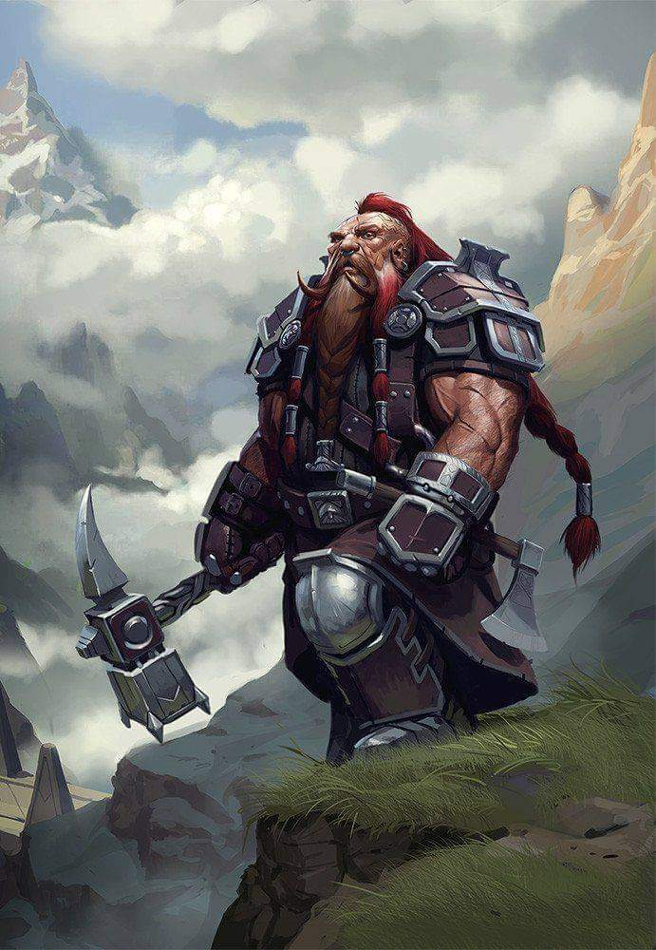

The Captain clarified, “Oh, no pressure. Whoever wishes to join us can.”

“We just have a buddy system, never a sole member of the team: that sort of thing,” explained Solstice.

“Understood,” the Captain said, in that case having a few others in mind who had a particular distaste for the undead.

Barkley looked at the Captain and at Fritz, “I shall see this mission through before I depart for Saradush.” He looked at Solstice, “I couldn’t live with myself if I walked away without putting a stop to the Who and his army.”

Saradette sat back at the table. “My concern is that this Who might try something else. I’m willing to help deal with him.”

After a while, it seemed as though Elsabet, Luran, and Saradette were going to take up the Baronial Guard on its offer to help. Already deputized, they didn’t need to go through that formality again, and the Captain said he’d get the paperwork in order once they got back to the precinct office.

Barkley, on the other hand, felt a tinge of restlessness to set out on the road tonight, and already knew of a caravan that was leaving and willing to hire him out as a security specialist. Solstice excused himself, saying that he had some contemplating to do at the Shrine to Mayaheine. “The Shieldmaiden has been calling lately, I feel, and I should see to that vocation to duty.”

As Averest and Cobol started to clear the table, the Sacerdôt handed Saradette a note with information regarding the ship that would take them to Lantan. He hadn’t stated this before, but it was by airship that he’d meant to convey them, a vessel capable to ferrying them to Lantan with significantly more velocity than a sailing ship. She took it as he asked her to let him know by tomorrow if they were interested in this longer-term prospect.

Saradette’s eyes opened wide. “Fly? Uh, yes, I’d love to go!”

~*~

At the precinct office, Elsabet, Luran, and Saradette once again saw Dromedar festering in his cell, and took a gaze upon Ripley, and unseeming and meek human with freckles and an unkempt mop of hair. He looked like nobody’s son, and it was perhaps by his own corruption that his botchy skin made him look sickly, and about 10 years older than he was. There were a few guards on duty, two of which had volunteered to find Who last night, and who’d instead brought in Ripley, and while the others who’d assisted in that arrest were now clocked out, the two that were once again on duty reported that they were ready to go.

“Let’s see if we can rustle up that duo of undead hunters from Precinct 11,” Captain Slatestein suggested, having thought it over at the temple.

“Sir?” the guards initially didn’t recognize the two deputized volunteers. “Oh, Brother Tore... and Aliya,” one of the two now identified the cleric of _____ and his sorceress co-adventurer.

“Them’s the ones,” the Captain cheerfully affirmed. “Would you be so kind as to go see if they’re available for something like this today? The file cabinet has their addresses filed under Stoneblood and Evergress.”

“Yes, sir,” one of them said as the other went to the file cabinet to get their contact information. “We should be back within the hour.”

~*~

They returned within the hour, and though the aforementioned Tore wasn’t with her, Aliya Evegress presented herself to Captain Slatestein and greeted the others. Like the Fist of Light, she’d done some volunteer work for the Baronial Guard in the last few months, and had made a bit of a name for herself—alongside her fighter-cleric collaborator—here in the city.



Aliya was tall and skinny teenage human and didn’t look very strong. Her moves were very feminine, graceful, and suave. She had copper red hair cut in a long bob, with piercing, playful and observant blue eyes. Her skin was pale with gentle freckles around her nose. She dressed in travel clothes of the upper class with subdued colors and with delicate blue adornments. They consisted of a double, extreme split, slinky, maxi skirt, a corset, and a fine leather shrug, all completed with black knee-high strappy sandals, a backpack and belt with pouches.

With a confident smile, she nodded to everyone as she entered the room. “Hello, I am Aliya Evegress, sorceress from Neverwinter.” She introduced herself with noticeable northern accent with a clear and warm voice.

“Well met, Aliya,” Elsabet said, “I am Elsabet, Favored of Mayaheine, though my path has wandered a bit in terms of mastering different disciplines in the service of my goddess. Feel free to ask me anything you wish to know about me.” She grinned at the lovely woman, whose eyes and hair were quite striking. “I have learned some of the combat techniques of the crusader, which is a bit like a paladin but less rigid, and I have some fey and eldritch abilities based on, apparently, one of my forebears getting frisky with a fey.”

Aliya nodded with a friendly smile. “Nice to meet you Elsabet, Favored of Mayaheine.” The redhead said. “I am just a human, nothing special behind my red hair and blue eyes.”

“Oh, I wouldn’t be so quick to say that,” Elsabet replied. “The ability to handle sorcery is rather special indeed.”

“Greetings and good meet, Aliya. I am Luran Ebonchord, originally of Darromar in Tethyr. A humble musician of some magical means. I use the primal, creative force of music to craft spells and other wonders, all in the name of good. I look forward to learning more of your own connection to the Weave. Welcome.” The bard dipped his head politely at the end of his introduction.

“Ah,” Slatestein sighed, “And Tore? I take it he’s indisposed?”

“He’s out somewhere on the Lake of Steam taking a break from the bustle,” Slatestein was told by the newcomer.

With introductions out of the way, Slatestein went on to provide a rough and ready map, on which he drew two lines: one indicating the beaten path from Mintar to the bridge that led up and unto the Southern Thornwoods, and a thinner, dashed line outlining a less known but viable shortcut through the woods and hills overlooking Mintar.

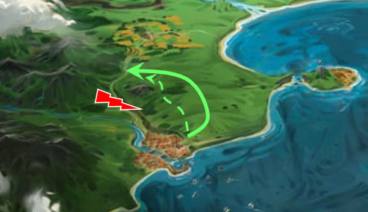

He pointed to the bridge, saying, “By Ripley’s testimony, the suspect is not far from this river crossing. We’ll be in a still untamed patch of barbaric wilderness between Mintar and the gnome settlement of Bartergoldustshire, and recent accounts from there state that the bridge has fallen into disrepair, which I’ll wager means that trolls smashed it up.” The dwarf then etched a jagged image across the river between points A and B, and added, “This is all cliffs and untamable bramble. We shouldn’t try to just follow the river upstream. Some of the locals among you should know this.”

“And of course,” Fritz posited the obvious, “Ripley’s magically induced truthful testimony could itself be misinformed. Or if Who got wind of Ripley’s arrest, knowing that he’d have to squeal, the necromancer’s probably taken up refuge elsewhere.”

“We would do well to leverage our diviners’ abilities before we set off,” Slatestein told the clerk, who nodded and went down the street to see if Ja’ir—the diviner who’d cast *zone of truth* on Dromedar yesterday—was available.

“If we need extra supplies, Gadget can take them,” Saradette said. “Although, I should probably get a stronger cart if we’re going into the mountains, or just get Gadget a pack saddle.”

Elsabet reviewed her gear, and mentioned, “I have a scroll of *hide from undead*. If we find this Who’s lair and have a moment to prepare, I can use it on one person, making them unable to be sensed by undead for 10 minutes. It is guaranteed to work against unintelligent undead, but intelligent types get a chance to resist. Interacting with undead will break it, as will attacking anything, undead or otherwise—but it could allow someone to sneak past some undead to scout or get into position to get a sneak attack on a foe. And I can cast *bull’s strength* on myself and others, which will last 4 minutes.”

Elsabet paused for a moment, then continued, “I can also cast *silence*, either on an object we carry until we want to get rid of it to allow us to get close unheard, or at a long range to block sound from passing through an area, but it has obvious drawbacks when we are within it.”

They had brought forward the whole of Dromedar’s effects by now, and one item in particular had a necromantic aura and was recently identified by the previous team hours earlier. “And you’re just telling us now?” Slatestein grumbled at the information clerk.

“Sorry sir,” the humbled youth replied, continuing with the debrief, “It was clearly a communication device that allowed Dromedar immediate access to guidance or other complicity from Who.

As the clerk spoke, the on-duty diviner cast an unidentified spell that Luran—and to a lesser extent, Elsabet and Aliya—party identified as sharing properties with *find the path* and *discern location*, in which case, it was beyond the scope of any of the current heroes of the Fist of Light company. Solstice turned to Barkley and said, “I’m glad you stuck around for this. Here comes the good part, I think.”

Ja’ir recited the articulated depiction of the vision before him, “It is to come to pass that you take the more direct, and likely more perilous path across the wooded hillsides, and cross the bridge you shall. After that, the spell is unable to trail the location of the other communication device needed to establish a remote link of locution between Dromedar and Who.

“With any luck, we’ll have our man before dawn,” Slatestein suspected under an optimistic light as Ja’ir inhaled and prepared for a second layer of revelatory information that he could reduce to words. “And it comes to be that you find...” and then the diviner gasped. Within second, he was bleeding from both eyes, and coughed up a hack of black goo that had stuck to the necrotic transceiver in anticipation of such a moment and latched itself to the diviner just moments before.

The heroes could not believe their eyes, but quickly realized that they still lived in that multiverse where all things—including the malice meaning to do this to Ja’ir—were possible, and thus stood on guard.

Round 1

|  |  |  |  |  |  |
| --- | --- | --- | --- | --- | --- |
| **Character** | **Group** | **Initiative** | **Roll** | **Modified Roll** | **Move** |
| Precinct Personnel | 2 | 3 | 18 | 21 | 20’ |
| Elsabet | 1 | 4 | 14 | 18 | 30’ |
| Aliya | 1 | 2 | 14 | 16 | 30’ |
| Saradette | 1 | 3 | 12 | 15 | 20’ |
| Unknown Force | 2 | 2 | 13 | 15 | 20’ |
| Barkley | 1 | 2 | 10 | 12 | 40’ |
| Solstice | 1 | 1 | 7 | 8 | 30’/10’ |
| Luran | 1 | 1 | 6 | 7 | 30’ |

“Blast!” Captain Slatestein cursed as Ja’ir dropped to his knees, then fell over on his side, seemingly dead. The junior agents of the force looked to the Captain to react, and he took a moment to make decisive steps.

Recognizing the threat, Elsabet shouted, “Let me reach him!” as she leapt forward and cast *resurgence*—with a second chance the diviner would be able to shake off the goo before more harm would be caused.

|  |  |  |  |  |
| --- | --- | --- | --- | --- |
| **Character** | **Save vs.**  *Unidentified goo* | **Ranks** | **Roll** | **Result** |
| Ja’ir | Fortitude | 3 | ?? | ?? |

*Result unknown.*

Ja’ir writhed as black foam emerged from his mouth.

Things were happening fast. Aliya stepped back. There were others more capable to fight directly in this small room. With a wave of her hand and arcane word, Aliya reached into the magic currents, drawing on them, and then releasing the energy in the form of a magic missile spell aimed at the goo.

*Dmg: 9 + 4 = 13 magic.*

Saradette stepped back with a gnomish curse and drew her blaster. “Watch it!” Her device would be shockingly loud in this room, but the dangerous effect would be confined to a hand-sized part of the floor. So, she aimed at the center of the goo, and fired a shot.

|  |  |  |  |
| --- | --- | --- | --- |
| **Ranged Weapon** | **Dmg.** | **Rng.** | **Notes** |
| Horizikaul’s Boom | 1d4 Sonic | 25’ + 2½’/lvl | Will DC or deafened for 1d4 rounds |

*Dmg: 1 sonic. No save possible; the goo was probably deafened for 2 rounds.*

*DM question: Doesn’t this sonic damage harm the others within the vicinity as well, or is the base spell unidirectional?*

The goo writhed but did not seem to die.

Barkley stepped back, assuming a defensive posture, his sword instantly in his hand. Against the goo, there wasn’t much he could do. His edged weapons would likely have little to no effect.

The other clerks and officers did as Barkley, bracing for some explosion of goo, or worse.

Solstice *magic missiled* the damnable goo.

*Dmg: 6 + 2 = 8 magic.*

“It’s the same blight that was on Fritz! Everybody just stay back. It’s persistent but beatable. Hopefully Elsabet could work her wonders of rejuvenation, once more...” The bard stood with his hands slightly out, on his toes, ready to react should the black slime turn out more mobile than the last encounter.

And then, from the shock of being zapped so many times at once, the goo did finally subside to an inert rust stain across the floor. The remnant on the now dead diviner’s chin was gone, noted some of the heroes with a line of sight to the man’s face.

Round 2 into end of rounds

The Captain stabbed at the caulked-over goo, now graying and ashing before their eyes, then declared it inert as the only clerk with healing skills approached the corpse, and soon thereafter found it to be lifeless. “This was a far fiercer force than that which slowly sickened Sacerdôt Fritz,” said the healer, a man named Balish.

Elsabet wasn’t sure if the spell had worked, but it had sometimes needed more than one try, so she cast resurgence again. She tried to quickly assess the diviner’s condition - and to avoid touching the goo herself, as once was more than enough. She was glad others were blasting the active goo on the floor, and moved around Ja’ir to get further from it and not block the others’ lines of sight.

Captain Slatestein asked, “Who here feels ill in any way, especially if you were just fine earlier?”

No one felt particularly ill in any way.

The Captain continued, “Alright, get him up and into the *gentle repose* chamber, and see about a *resurrection* appointment with Fritz. If Fritz isn’t able to, he’ll be likely to recommend anyone else who is today.”

“Yes, sir.”

The Captain shook his head, sighing, “We’ll get you back, Ja’ir.”

The goo did nothing, as it was now merely just flaking away into inexistence.

Saradette shouldered her blaster, and wondered who this aforementioned Tore fellow was, and how pro-Mayaheine he likely was.

Barkley moved a little closer as Elsabet was tending to the diviner. “Let’s get him outside and get him a healer.” He tilted his head to the side as he took one of the diviners’ arms to steady him, “Perhaps *cure poison* would help.”

“Not when he’s this far gone, brother,” one of the officers had seen enough cases to say with confidence.

“Healer couldn’t get here fast enough,” Elsabet replied as three officers lifted the body onto a stretcher that had just been stretched out from its resting place along the corner, and proceeded to carry away the deceased for holy preservation.

Solstice said nothing, noting that the dwarf in the room was starting to pace as his underlings did their best to save his friend’s life.

Aliya _____.

“Alright, we should leave imminently,” the Captain ordered, whispering something to himself about a Cogitor. “We’ll need to make a stop at the Gnome Depot in Silver Hill on our way out of the city, but since we’re taking the Fishersgate, it’s not a detour.”

“We’re prepared to serve the-” one of the two who had volunteered began to say before she was interrupted.

Captain Slatestein said, “Nonsense, Cadet. Not yet. First you need a proper teaching. I don’t need to look at the chart to know you’re still months away from being ready for this. Your post is here, in the city, in known territory, working with the rest of your unit.” He and the Cadet looked around.

The dwarf paced, a bit more collected now, adding as he addressed everyone, “This is a decisive moment. The current team consists of a favored soul of the goddess, Mayaheine; an artificer in good standing with our very own Temple of Gond...” he got some nods from the others as he took a deep breath to continue, “... a bard of this fair city; a Celestial archon ranger; a musteval spy, potentially; and our very own friendly neighborhood sorceress, plus me, a fighter-marshal by trade. These two squires want to come along for academic purposes, job shadowing”

Some smirked as Slatestein wrapped it up, “Everyone here who’s been on enough missions of this caliber is aware of how much danger we’d be putting you in. Most likely case scenario with a necromancer of this caliber is that you’d be turned to zombies and we’d have to cut you down ourselves. And the prospects of coming back from that are nil. At least Ja’ir...” he grumbled a tear back into its duct. “At least *he* still has a chance.”

The two knaves nodded in agreement, looking forward to a different day as the dwarf spoke again, “Now that’s not to say that I think our contingent is fully staffed. Let’s go see the Cogitor,” he called to mind the functionary of the town archivists, with which the heroes were as of yet unfamiliar, even Luran. “Their office is right by the Gnome Depot.”

Donning a helmet, and grabbing the hefty crossbow and battleaxe that hung on the rack behind the open door, the dwarven Captain led the way out.