*Chapter 24: The Hunt for Who*

A few minutes passed, and they made the assessment that nothing else was coming after them. The bridge haunt would likely have to regenerate before it would become a threat again, but how long that would take was beyond their ability to guess.

“The path continues westward and uphill,” Solstice stated the obvious.

Elsabet, once she finally crossed the bridge, was pleased to see that Barkley’s combination of damage reduction and *aid* effect had left him unscathed—it had been hard to tell from her spot off the end of the bridge. “Better redo your *aid*,” she reminded him, assuming it had absorbed a fair amount. Of all the group, Barkley was far and away the most durable among them, unless the attacker had a magic weapon, and luckily the haunt had only its touch and push. “Nicely done, B; it chose poorly when it attacked you!”

Barkley shrugged off the comments about his durability and looked at the map and then their surroundings. “I think I should join Saradette on point and see if I can pick up any scent of Who. From here on out, I believe he can be anywhere and might know we are coming.”

Before they headed off from the bridge, Barkley took some time to renew his *aid [expired in 6 minutes]* upon himself and the others.

“Why not try to track the necromancer?” asked Solstice. “If we have divine intelligence that led us here, it stands to reason that some of the tracks here on the ground are his.”

“And if he has skeletal minions with him, those tracks should be even more distinctive,” the Captain added. “Zombies are likely to have made these skidding tracks here,” he then pointed out.

Barkley began to exercise his recently learned tracking ability.

|  |  |  |  |  |  |  |
| --- | --- | --- | --- | --- | --- | --- |
| **Skill** | **Rank** | **Ability**  **& Mod.** | **Misc.**  **Mods.** | **Total** | **Roll** | **Check** |
| **Barkley, Survival** | 8 | Wis (+1) | 0 | 9 | 5ish | ?? |

*See below.*

It was hardly a challenge for Barkley to track the footprints of two humanoids and five skeletons to the cemetery where the party now stood. They passed grave after unearthed grave, each one emptied of its sacred contents, and by the time they cleared the boneyard, there were about fifteen skeletons’ footprints following the necromancer southward and down the hill.

“The path ahead gets a bit more difficult to navigate,” warned the dwarf. “It’s been years since I’ve been on this trail, but from what I recall, it winds around quite a bit as we approach the decline back towards Mintar.”

“Could Who get back to Mintar this way?” asked Solstice.

“In theory, yes, but it would be a very difficult path to negotiate, particularly with a pack of skeletons in tow.”

Then an arrow struck a tree trunk near Saradette, who led the group through the darkness.

Round 1

|  |  |  |  |  |  |
| --- | --- | --- | --- | --- | --- |
| **Character** | **Group** | **Initiative** | **Roll** | **Modified Roll** | **Move** |
| Elsabet | 1 | 4 | 19 | 23 | 30’ |
| Barkley | 1 | 2 | 19 | 21 | 40’ |
| Solstice | 1 | 1 | 16 | 17 | 30’/10’ b |
| Captain Slatestein | 2 | 3 | 11 | 14 | 20’ |
| Undead Forces | 2 | 1 | 13 | 14 | 30’ |
| Saradette | 1 | 3 | 10 | 13 | 20’ |
| Aliya | 1 | 2 | 7 | 9 | 30’ |
| Luran | 1 | 1 | 3 | 4 | 30’ |

The thunk of an arrow into a tree up ahead alerted Elsabet to an ambush, but she couldn’t immediately see where it came from. Not knowing if this was merely a delaying tactic or the main event, she moved towards the front of the group while actively looking to both sides of the trail trying to spot the foe. She hoped to provide the enemy with a more appealing target, buckler with crystal ready to fend off arrows. Elsabet then spotted two skeleton archers up ahead: one to her northwest and one to her southwest.

Barkley followed the trajectory of the arrow back to see what had fired it at them, standing ready with his longsword in one hand and his silvered hand axe in the other. With weapons drawn and at the ready, Barkley moved north a bit and kept his eyes open.

|  |  |  |  |  |
| --- | --- | --- | --- | --- |
| **Character** | **Save vs.**  Aura of Menace | **Ranks** | **Roll** | **Result** |
| All Skeletons | Will | 2 | 17 | 19 |

*Success. No effect.*

Solstice drew his blowgun and hid within a bush.

|  |  |  |  |  |  |  |
| --- | --- | --- | --- | --- | --- | --- |
| **Skill** | **Rank** | **Ability**  **& Mod.** | **Misc.**  **Mods.** | **Total** | **Roll** | **Check** |
| **Solstice, Hide** | 5 | **Dex (+3)** | 8 | 16 | 16 | 32 |

*Probably succeeds against all enemy observers.*

Captain Slatestein immediately changed his aura from Watchful Eye to Demand Fortitude, then drew his crossbow, ready to fire at anything that moved around them. He was, however, unable to spot any enemies at the moment.

The undead forces fired shots at Saradette, who was still in the lead, despite Elsabet’s advance.

|  |  |  |  |  |  |  |  |  |
| --- | --- | --- | --- | --- | --- | --- | --- | --- |
| **Character** | **Attack Type** | **Damage** | **BAB** | **Dex Mod+** | **Other+** | **Total Score** | **Roll** | **Total** |
| Skeleton, M | Longbow | 1d8,x3, 100’ | 0 | 1 | 0 | 1 | **20** | 21 |
| Skeleton, M | Longbow | 1d8,x3, 100’ | 0 | 1 | 0 | 1 | 6 | 7 |
| Skeleton, M | Longbow | 1d8,x3, 100’ | 0 | 1 | -2 range | 1 | 11 | 12 |
| Skeleton, M | Longbow | 1d8,x3, 100’ | 0 | 1 | -2 range | 1 | 10 | 11 |

*Threat, miss, miss, miss. 1d20 = 12 + 1 = 13, not a critical hit. Dmg: 6, partial damage negated [43/48].*

Saradette scampered to the nearest hard cover, took cover, and drew her sonic blaster.

Aliya was disoriented with the new arrow and seemingly with a new threat, she looked around for cover. Whatever was happening, observing from behind the cover sounded like the best idea now.

Recognizing that the time for stealthy travel was finished, Luran let loose his inspirational song as he and his companions set themselves for whatever foes were preparing to confront the band.

*All friendlies gained +1 to attack and weapon damage.*

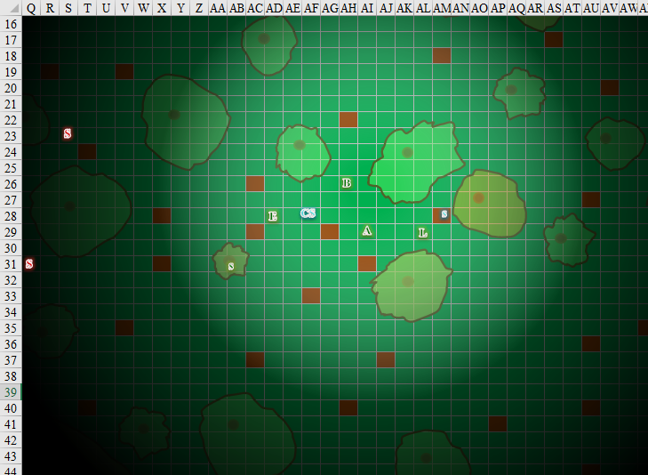

Round 2

“Skeleton archers ahead, two at least,” Elsabet called out loudly, as she strode forward another 30’ and into a bush, drawing her bastard sword with her right hand as she moved, and then, realizing her companions likely couldn’t see them, with her left hand she retrieved her everburning torch and held it out to illuminate the area around her. She was pretty sure she had drawn the skeletons’ attention at that point.

Hearing Elsabet call out about enemies, Barkley sheathed his longsword as he stepped forward. He then (quickdraw) pulled a javelin from his magical quiver. Quickly, he cast *continual flame* upon the javelin where his hand gripped it as he prepared to throw it.

Solstice saw one of the skeletons within Elsabet’s illuminated sphere, and—unable to do much to it with his blowgun—blasted it with a *magic missile*.

*Dmg: 4 + 2 = 6 magic [force].*

Captain Slatestein fired a fire bolt at the nearest skeleton, then moved forward to support Elsabet.

|  |  |  |  |  |  |  |  |  |  |
| --- | --- | --- | --- | --- | --- | --- | --- | --- | --- |
| **Character** | **Attack Type** | **Damage** | **BAB** | **Dex Mod+** | **W+** | **Other+** | **Total Score** | **Roll** | **Total** |
| Captain Slatestein | MW Heavy Crossbow | 1d10;19-20, 120’ | 8 | 1 | 1 | 2 Courage | 12 | 6 | 18 |

*Hit. Dmg: 6 + 2 + 5 fire = 13.*

One skeleton moved right up to Elsabet and fired upon her. Another one got within 10’ from her and did the same.

|  |  |  |  |  |  |  |  |  |  |
| --- | --- | --- | --- | --- | --- | --- | --- | --- | --- |
| **Character** | **Attack Type** | **Damage** | **BAB** | **Dex Mod+** | **W+** | **Other+** | **Total Score** | **Roll** | **Total** |
| Skeleton, M | Longbow | 1d8,x3, 100’ | 0 | 1 | 0 | 0 | 1 | 17 | 18 |
| Skeleton, M | Longbow | 1d8,x3, 100’ | 0 | 1 | 0 | 0 | 1 | 12 | 13 |

*Miss, miss.*

The crusader took the opportunity to slash at the adjacent archer.

|  |  |  |  |  |  |  |  |  |  |
| --- | --- | --- | --- | --- | --- | --- | --- | --- | --- |
| **Melee Weapon** | **Dmg** | **D+** | **TH+** | **Critical** | **Type** | **Wt.** | **Atk** | **Roll** | **Check** |
| Bastard Sword +1, 1-handed | 1d10+1 | +2 | 4 + 2 DK + 2 Courage | 19-20/x2 | Slashing | 6.0 | +16 | 19 | 35 |
| Least Truedeath Crystal | 1d6 | vs. | undead | - | - | - | - | - | - |

*Threat. 1d20 = 14 + 16 = 30. Critical hit. Dmg: (2 x 7) + 1 + 2 + 2 Courage + 2 positive energy + 5 DK = 26.*

|  |  |  |  |  |  |  |
| --- | --- | --- | --- | --- | --- | --- |
| **Save vs.**  Destruction Retribution | **Rank** | **Ability & Mod.** | **Misc. Mods.** | **Total** | **Roll** | **Check** |
| **Elsabet, Reflex** | **4** | **Dex (+2)** | 1 | 7 | 18 | 25 |

*Success. Saves for ½ damage. Destruction Retribution dmg to Elsabet: ½ x 10 = 5 negative energy [43/48].*

Elsabet then saw other skeletons approaching and firing upon her.

|  |  |  |  |  |  |  |  |  |  |
| --- | --- | --- | --- | --- | --- | --- | --- | --- | --- |
| **Character** | **Attack Type** | **Damage** | **BAB** | **Dex Mod+** | **W+** | **Other+** | **Total Score** | **Roll** | **Total** |
| Skeleton, M | Longbow | 1d8,x3, 100’ | 0 | 1 | 0 | 0 | 1 | 12 | 13 |
| Skeleton, M | Longbow | 1d8,x3, 100’ | 0 | 1 | 0 | 0 | 1 | 12 | 13 |
| Skeleton, M | Longbow | 1d8,x3, 100’ | 0 | 1 | 0 | 0 | 1 | 5 | 6 |
| Skeleton, M | Longbow | 1d8,x3, 100’ | 0 | 1 | 0 | 0 | 1 | 17 | 18 |
| Skeleton, M | Longbow | 1d8,x3, 100’ | 0 | 1 | 0 | 0 | 1 | 14 | 15 |
| Skeleton, M | Longbow | 1d8,x3, 100’ | 0 | 1 | 0 | 0 | 1 | 5 | 6 |

*Miss, miss, miss, miss, miss, miss.*

Then she saw something that would have been no more horrific to her than anything they’d already seen, but to her, it was quite unsettling: a hound archon zombie! It was unarmed, but approaching at zombie speed, and would soon be upon her. The warlock also noted the dim, blue sheen around all the undead that they’d seen before, which explained the blast that just zapped her.

Saradette used the tree trunk for cover as she tried to pick out a target for her blaster. There was only one skeleton within her blaster’s range, so she targeted it before it could do anything to Elsabet.

*Dmg: 1 sonic.*

|  |  |  |  |  |
| --- | --- | --- | --- | --- |
| **Character** | **Save vs.**  Sonic Blaster | **Ranks** | **Roll** | **Result** |
| Skeleton, M | Will | 2 | 8 | 10 |

*Fail. Skeleton deafened for 3 rounds.*

Aliya got into a bush and hid with her crossbow ready in case of any hostiles.

Luran continued singing and moved forward, toward the rising conflict, stepping past the well-hidden sorcerer. Preparing to further support his fighting friends before dipping his toes into the fray, directly, the arcane performer pulled a scroll *[summon monster iii]* from his beltcase.

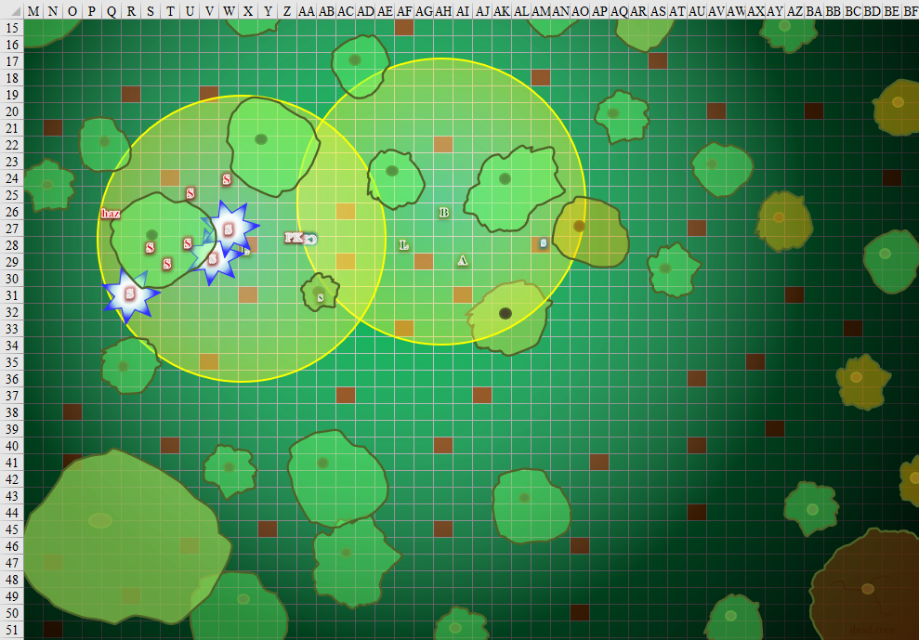

Round 3

Elsabet laughed as she had avoided some of the blast of negative energy, and then looking around, she quickly reviewed her options as she shouted out “Watchful Eyes!” She hoped the Captain realized the blasts could be dodged, and switched his aura, as she anticipated getting in more such bursts of energy soon.

The dwarf nodded and switched his aura to Watchful Eyes.

Seeing the zombie off in the distance, but with a tree trunk in the way of a charge, she used a swift command word to teleport 10’ to get a clear straight line to the zombie, and then initiated her battle leader’s charge strike, streaking across the ground to slash hard at the undead archon, slashing as hard as she could at it! She hoped to spare Barkley the sight of one of his people as a zombie....

|  |  |  |  |  |  |  |  |  |  |
| --- | --- | --- | --- | --- | --- | --- | --- | --- | --- |
| **Melee Weapon** | **Dmg** | **D+** | **TH+** | **Critical** | **Type** | **Wt.** | **Atk** | **Roll** | **Check** |
| Bastard Sword +1, 1-handed | 1d10+1 | +2 | 4 + 2 DK  + 2 Courage | 19-20/x2 | Slashing | 6.0 | +17 | 4 | 21 |
| Least Truedeath Crystal | 1d6 | vs. | undead | - | - | - | - | - | - |

*Hit. Dmg: 7 + 1 + 2 + 2 DK + 2 Courage + 2 charge + 4 LtC + 10 BLC + 3 positive energy = 33.*

Barkley threw his javelin to try and provide some light for those that might need it.

*Javelin impaled the ground.*

Seeing the skeletons blowing up, he sheathed his axe and (quickdraw) drew his longbow, intending in the next few moments to move forward, nock an arrow, and fire at the closest skeleton.

Solstice let another *magic missile* strike the skeleton he’d already struck.

*Dmg: 6 + 2 = 8 magic [force].*

The skeleton burst into a negative energy pop.

Out of fire bolts, Captain Slatestein now reloaded his crossbow with a regular bolt, saving the 5 electric bolts he’d brought along for the encounter with Who. Perhaps he was nearby.

An unseen spellcaster with a feminine voice cast *phantasmal killer [identified by Luran only]* upon Captain Slatestein.

|  |  |  |  |  |
| --- | --- | --- | --- | --- |
| **Character** | **Save vs.**  *phantasmal killer* | **Ranks** | **Roll** | **Result** |
| Slatestein | Will | 5 + 2 | 6 | 13 |

*Fail.*

|  |  |  |  |  |
| --- | --- | --- | --- | --- |
| **Character** | **Save vs.**  *phantasmal killer* | **Ranks** | **Roll** | **Result** |
| Slatestein | Fortitude | 8 + 2 | 3 | 13 |

*Fail.*

Captain Slatestein died and fell to the ground as the *phantasmal killer*—invisible to all others—ceased to exist altogether. Both of the marshal’s auras instantly faded, and his body withered to a shriveled, frozen husk. Solstice was shocked to see the dwarf be slain in his mind and body before their very eyes, and wondered what manner of magic had done that to Slatestein.

The sluggish hound archon zombie had limped over towards Barkley as the remaining skeletons in sight took a few steps closer to the heroes and fired upon Elsabet and Barkley.

|  |  |  |  |  |  |  |  |  |  |
| --- | --- | --- | --- | --- | --- | --- | --- | --- | --- |
| **Character** | **Attack Type** | **Damage** | **BAB** | **Dex Mod+** | **W+** | **Total Score** | **Roll** | **Total** | **Targeting** |
| Skeleton, M | Longbow | 1d8,x3, 100’ | 0 | 1 | 0 | 1 | 17 | 18 | Barkley |
| Skeleton, M | Longbow | 1d8,x3, 100’ | 0 | 1 | 0 | 1 | 5 | 6 | Barkley |
| Skeleton, M | Longbow | 1d8,x3, 100’ | 0 | 1 | 0 | 1 | 11 | 12 | Barkley |
| Skeleton, M | Longbow | 1d8,x3, 100’ | 0 | 1 | 0 | 1 | 2 | 3 | Elsabet |
| Skeleton, M | Longbow | 1d8,x3, 100’ | 0 | 1 | 0 | 1 | 14 | 15 | Elsabet |

*Miss, miss, miss, miss, miss.*

The zombie now slashed at Elsabet.

|  |  |  |  |  |  |  |  |  |  |
| --- | --- | --- | --- | --- | --- | --- | --- | --- | --- |
| **Character** | **Attack Type** | **Damage** | **BAB** | **Str Mod+** | **Total Score** | **Roll** | **Total** | **Crit** | **Threat** |
| Hound Archon Zombie | Bite | 1d8+3+1d6 cold | 6 | 7 | 13 | 20 | 33 | 20 | þ |

*Threat. 1d20 = 10 + 13 = 23, critical hit. Dmg: (2 x 2) + 3 + 3 cold = 10 [33/48].*

Elsabet winced and snarled as some of the pain from the zombie’s bite got past her steely resolve, making her furious. Realizing the zombie was more dangerous than she had thought, she immediately activated her Protection Devotion aura *[expired on Round 13]*, calling upon Mayaheine to shield her from this foul perversion of a creature.

*Elsabet, and all allies within 30’ feet of her at any given time, gain a +4 sacred bonus to AC.*

Saradette targeted the nearest enemy and fired another shot.

*Dmg: 3 sonic.*

|  |  |  |  |  |
| --- | --- | --- | --- | --- |
| **Character** | **Save vs.**  Sonic Blaster | **Ranks** | **Roll** | **Result** |
| Skeleton, M | Will | 2 | 20 | 22 |

*Succeed. Deafness negated.*

Aliya watched things from her bush, waiting and ready with the crossbow. “I can’t see anything....” She was actually able to see quite well now that Elsabet and Barkley had fired up their light sources. Who knew? Maybe the skeletons were able to hear her.

|  |  |  |  |  |  |  |  |  |  |
| --- | --- | --- | --- | --- | --- | --- | --- | --- | --- |
| **Ranged Weapon** | **Dmg.** | **D+** | **TH+** | **Critical** | **Rng.** | **Wt.** | **Atk** | **Roll** | **Check** |
| Light Crossbow | 1d8 | 0 | 2 DK +  2 Courage | 19-20/x2 | 80’ | 4.0 | +10 | 9 | 19 |

*Hit. Dmg: 4 + 2 + 13 = 19. Partial damage negated.*

Luran’s song remained strong, in fact it lifted a bit as he brought up the inscribed parchment and began the casting of *summon monster iii*. Though it was an intricate spell, one that took a bit longer to cast than most, the magic musician maintained his supportive vocalizations as he coaxed the Weave to give up the arcane energy for his summoning.

By now, five skeletons had gone down.

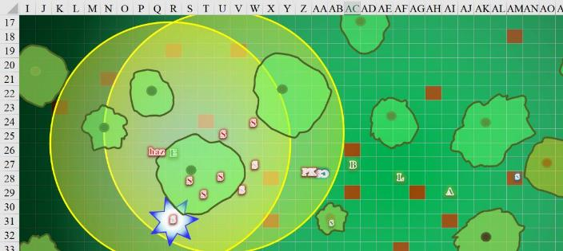

Round 4

Furious at being struck by the zombie, but not too worried after having activated her protection devotion, Elsabet decided that the zombie was too tough to take down with a single strike, so to buy more time, with a furious counterstike she initiated her crusader’s strike, trying to heal herself if she hit. Then she took a step back and away from the zombie, towards a nearby bush, to give her friends a chance to shoot at it.

|  |  |  |  |  |  |  |  |  |  |
| --- | --- | --- | --- | --- | --- | --- | --- | --- | --- |
| **Melee Weapon** | **Dmg** | **D+** | **TH+** | **Critical** | **Type** | **Wt.** | **Atk** | **Roll** | **Check** |
| Bastard Sword +1, 1-handed | 1d10+1 | +2 | 4 + 1 FC +  2 DK + 2 Courage | 19-20/x2 | Slashing | 6.0 | +18 | 1 | 19 |
| Bastard Sword, 2nd Attack | 1d10+1 | +2 | 4 + 1 FC +  2 DK + 2 Courage | 19-20/x2 | Slashing | - | +13 | 8 | 21 |
| Least Truedeath Crystal | 1d6 | vs. | undead | - | - | - | - | - | - |

*Miss, hit. Dmg: 3 + 1 + 2 DK + 1 FC + 3 positive energy = 10.*

Elsabet then took a 5’ step back and away from the hound archon zombie. As her fury faded, and she felt the remaining pain from the bite wound, she felt her maneuvers fade and two new maneuvers granted.

Barkley fired off arrows at the closest skeleton.

|  |  |  |  |  |  |  |  |  |  |
| --- | --- | --- | --- | --- | --- | --- | --- | --- | --- |
| **Ranged Weapon** | **Dmg** | **D+** | **TH+** | **Critical** | **Rng.** | **Wt.** | **Atk** | **Roll** | **Check** |
| Composite +2 Longbow +1 | 1d8 | 3 | 1 + 2 Courage  + 2 DK | x3 | 110’ | three | +14 | 10 | 24 |
| Longbow, 2nd Shot | 1d8 | 3 | 1 + 2 Courage  + 2 DK | x3 | 110’ | three | +9 | 8 | 17 |

*Hit, hit.*

*Dmg to skeleton 6: (2 + 3 + 2 + 11 DK) = 18. Partial damage negated.*

*Dmg to skeleton 7: (7 + 3 + 2 + 13 DK) = 25. Partial damage negated.*

Another skeleton bit the dust.

Solstice targeted one of the already injured skeletons, and thought he’d be able to finish it off before it got too close to Elsabet.

*Dmg: 7 + 2 = 9 magic [force].*

An unspotted but heard spellcaster to the west cast *doom [expired on Round 94]* upon Elsabet.

|  |  |  |  |  |  |  |
| --- | --- | --- | --- | --- | --- | --- |
| **Save vs.**  *doom* | **Rank** | **Ability**  **& Mod.** | **Misc.**  **Mods.** | **Total** | **Roll** | **Check** |
| **Elsabet, Will** | **7** | **Wis (-1)** | 6 | 12 | 6 | 18 |

*Success. Effect negated.*

The hound archon zombie snapped at Elsabet.

|  |  |  |  |  |  |  |  |  |  |
| --- | --- | --- | --- | --- | --- | --- | --- | --- | --- |
| **Character** | **Attack Type** | **Damage** | **BAB** | **Str Mod+** | **W+** | **Other+** | **Total Score** | **Roll** | **Total** |
| Hound Archon Zombie | Bite | 1d8+3+1d6 cold | 6 | 7 | 0 | 0 | 13 | 5 | 18 |

*Miss.*

Saradette again targeted the nearest enemy and fired.

*Dmg: 2 sonic. Skeleton 5 destroyed.*

*Destruction Retribution dmg (healing) to hound archon zombie: 5 negative energy.*

Aliya moved closer, just north of a bush, reloading the crossbow. She aimed at one of the remaining skeletons and fired again.

|  |  |  |  |  |  |  |  |  |  |
| --- | --- | --- | --- | --- | --- | --- | --- | --- | --- |
| **Ranged Weapon** | **Dmg.** | **D+** | **TH+** | **Critical** | **Rng.** | **Wt.** | **Atk** | **Roll** | **Check** |
| Light Crossbow | 1d8 | 0 | -2 range + 2 DK  + 2 Courage | 19-20/x2 | 80’ | 4.0 | +8 | 13 | 21 |

*Hit. Dmg: 5 + 2 Courage + 9 DK = 16.*

That skeleton also burst, but caused no damage.

Having activated the scroll, and now noting the Celestial black bear of Tyr (LG) that appeared, Luran stepped forward carefully, trying as hard as he could to ascertain the location of the spellcaster based on the two spells he had successfully heard, including the one that had sadly ended the Captain, a moment ago. He was not able to make much sense of the little he could hear.

The Celestial bear charge-attacked the last archer skeleton.

|  |  |  |  |  |  |  |  |  |  |
| --- | --- | --- | --- | --- | --- | --- | --- | --- | --- |
| **Character** | **Attack Type** | **Damage** | **BAB** | **Str Mod+** | **Charge+** | **Other+** | **Total Score** | **Roll** | **Total** |
| Celestial bear | Claw 1 | 1d4+4 | 2 | 4 | 2 | 4 | 12 | 19 | 31 |

*Hit. Dmg: 4 + 4 + 2 Charge + 2 Courage + 12 DK = 24. Partial damage negated.*

The last archer was struck by the mighty blow, and burst into negative energy, not quite near any of the injured (but not destroyed) undead, so its effects only weakened the bear.

|  |  |  |  |  |
| --- | --- | --- | --- | --- |
| **Character** | **Save vs.**  Destruction Retribution | **Ranks** | **Roll** | **Result** |
| Celestial bear | Reflex | 4 | 4 | 8 |

*Fail. Destruction Retribution dmg: 4 negative energy.*

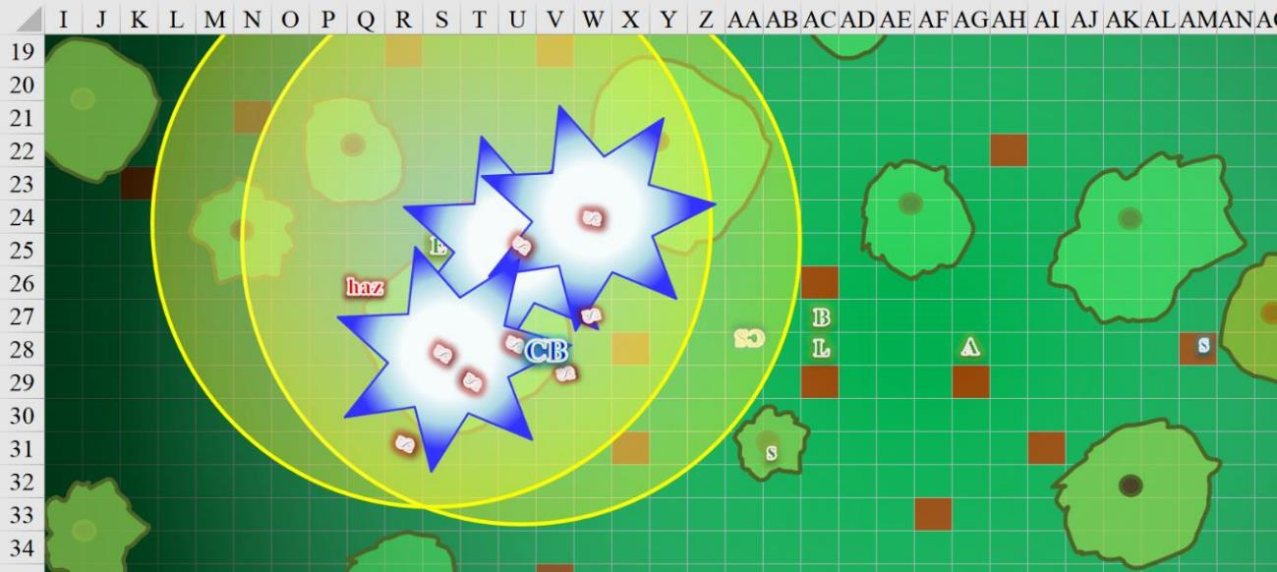

Round 5

Laughing as she felt impotent magic try to weaken her willpower, and feeling much better after the healing she had gotten from her crusader’s strike, Elsabet decided to take advantage of her improved combat prowess and engaged in a full attack against the hound archon zombie. She took a 5’ step towards the zombie and slashed with full might and prowess. “Find the caster!” she yelled, as she slashed twice at the creature, and then took a quick step towards where she thought the spellcaster was lurking, and took a quick glance in the direction of the voice she had heard.

Elsabet felt her stone vise maneuver being granted. The skeletons were almost gone and she was confident the zombie would soon be defeated, but if she caught sight of the caster she might take other measures and let the zombie last a bit longer—it was unlikely to try to escape, at least.

|  |  |  |  |  |  |  |  |  |  |
| --- | --- | --- | --- | --- | --- | --- | --- | --- | --- |
| **Melee Weapon** | **Dmg** | **D+** | **TH+** | **Critical** | **Type** | **Wt.** | **Atk** | **Roll** | **Check** |
| Bastard Sword +1, 1-handed | 1d10+1 | +2 | 4 + 2 DK | 19-20/x2 | Slashing | 6.0 | +15 | 11 | 26 |
| Bastard Sword, 2nd Attack | 1d10+1 | +2 | 4 + 2 DK | 19-20/x2 | Slashing | - | +10 | 19 | 29 |
| Least Truedeath Crystal | 1d6 | vs. | undead | - | - | - | - | - | - |

*Hit, threat. 1d20 = 18 + 10 = 28, critical hit [negated]. Dmg: (5 + 1 + 2 + 2 Courage + 1 positive energy + 2 Stone Vise) + (4 + 1 + 2 + 2 Courage + 6 positive energy) = 9 + 13 + 7 positive energy = 29.*

|  |  |  |  |  |
| --- | --- | --- | --- | --- |
| **Character** | **Save vs.**  Stone Vise | **Ranks** | **Roll** | **Result** |
| Bridge Haunt | Fortitude | 4 | 4 | 8 |

*Fail.*

The zombie’s legs were immobilized by the downward blows as the former hound archon resisted utter destruction.

Barkley, hearing Elsabet call for someone to find the spellcaster, and seeing her glance off into the western distance, he decided to see if he could locate said spellcaster. He altered his form into that of a wolf and ran off in the direction Elsabet had looked. He made it about 50’ west, spotted a crow swooping down towards a robed woman already walking with her back to him until she turned around to make eye contact.

Solstice zapped at the hound archon zombie with a pair of *magic missiles*.

*Dmg: 5 + 2 = 7 magic [force].*

The nearly downed hound archon zombie bit once again at Elsabet.

|  |  |  |  |  |  |  |  |
| --- | --- | --- | --- | --- | --- | --- | --- |
| **Character** | **Attack Type** | **Damage** | **BAB** | **Str Mod+** | **Total Score** | **Roll** | **Total** |
| Hound Archon Zombie | Bite | 1d8+3+1d6 cold | 6 | 7 | 13 | 9 | 22 |

*Hit. Dmg: 6 + 3 + 1 cold = 10. Partial damage negated [24/48].*

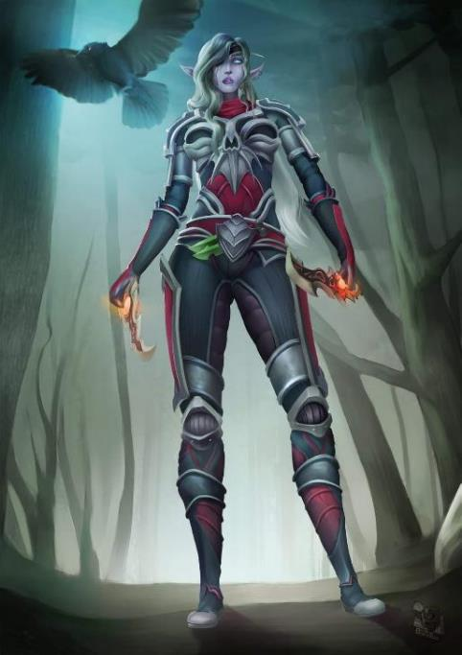

The unidentified spellcaster cast *blindness* upon Barkley, who was in the form of a wolf at the moment.

|  |  |  |  |  |  |  |
| --- | --- | --- | --- | --- | --- | --- |
| **Save vs.**  *blindness* | **Rank** | **Ability & Mod.** | **Misc. Mods.** | **Total** | **Roll** | **Check** |
| **Barkley, Fortitude** | 6 | Con (+3) | 1 + 3 DK | 13 | 13 | 26 |

*Success. Effect negated.*

Barkley was vaguely familiar with the fact that some necromancers—notably, dread necromancers—were able to become undead themselves without any adverse effects with enough mastery of their dark arts, and this was likely one such wizard.

Saradette had had enough of the hidden spellcaster, so she left her cover and began to stealthily work her way westward.

|  |  |  |  |  |  |  |
| --- | --- | --- | --- | --- | --- | --- |
| **Skill** | **Rank** | **Ability**  **& Mod.** | **Misc.**  **Mods.** | **Total** | **Roll** | **Check** |
| **Saradette, Hide** | 5 | **Dex (+3)** | 4 | 12 | Poor | ?? |
| **Saradette, Move Silently** | 5 | **Dex (+3)** | 4 | 12 | 15ish | ?? |

*Result unknown.*

Aliya winced and that was it for her. The redhead moved further, her lower hand lowered and still holding the crossbow, but her right hand traced the air with a gentle move adding to the spoken softly arcane words. The next move of her hand would have finished with a finger pointing ahead and a bead of fiery energy winked out of magical currents and appeared streaking toward the skeletons, but instead, she saw that there was only the hound archon zombie left, and thus fired into the melee with Elsabet.

|  |  |  |  |  |  |  |  |  |  |
| --- | --- | --- | --- | --- | --- | --- | --- | --- | --- |
| **Ranged Weapon** | **Dmg.** | **D+** | **TH+** | **Critical** | **Rng.** | **Wt.** | **Atk** | **Roll** | **Check** |
| Light Crossbow | 1d8 | 0 | -2 range -4 firing  into melee | 19-20/x2 | 80’ | 4.0 | +0 | 3 | 3 |

*Miss.*

The bolt nearly got Elsabet as it flew past both combatants.

The Celestial black bear smite-charge-attacked the hound archon zombie.

|  |  |  |  |  |  |  |  |  |
| --- | --- | --- | --- | --- | --- | --- | --- | --- |
| **Character** | **Attack Type** | **Damage** | **BAB** | **Str Mod+** | **Other+** | **Total Score** | **Roll** | **Total** |
| Celestial bear | Claw 1 | 1d4+4 | 2 | 4 | 2 DK + 2 Courage  + 2 Charge | 12 | 5 | 17 |

*Hit. Dmg: 1 + 4 + 2 Courage + 2 Charge + 3 Holy Smite = 12.*

As he continued to sing, Luran looked to Aliya’s eyes, if he could catch them. He was about to hop up to the rest of the group and nodded to her, hoping to suggest it without words. He then moved purposely forward to join the others against the hulking, undead foe.

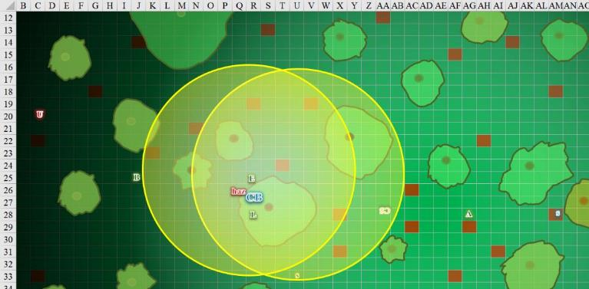

Round 6

Barkley, after transforming took a few more steps towards the dread necromancer, trying to put her inside of his 20’ Aura of Menace.

|  |  |  |  |  |  |  |  |
| --- | --- | --- | --- | --- | --- | --- | --- |
| **Save vs.**  Aura of Menace | **Rank** | **Ability & Mod.** | **Misc. Mods.** | **Total** | **Roll** | **Check** | **Properties** |
| **Urmeena, Will** | **9** | **Wis (+3)** | 0 | 12 | 14 | 26 | +2 vs. Fear, Mental Bastion |

*Success. Effect negated.*

Solstice fired off what he hoped would be the last volley of *magic missiles* against the zombie.

*Dmg: 6 + 2 = 8 magic [force].*

Elsabet decided it was worth a try, and tumbled 10’ forward to get into flanking position on the opposite side of the zombie from the celestial bear.

|  |  |  |  |  |  |  |
| --- | --- | --- | --- | --- | --- | --- |
| **Skill** | **Rank** | **Ability**  **& Mod.** | **Misc.**  **Mods.** | **Total** | **Roll** | **Check** |
| **Elsabet, Tumble** | 1 | **Dex (+2)** | 1 | 4 | 3 | 7 |

*Fail. Provokes Attack of Opportunity.*

|  |  |  |  |  |  |  |  |  |  |  |
| --- | --- | --- | --- | --- | --- | --- | --- | --- | --- | --- |
| **Character** | **Attack Type** | **Damage** | **BAB** | **Str Mod+** | **Other+** | **Total Score** | **Roll** | **Total** | **Crit** | **Threat** |
| Hound Archon Zombie | Slam | 1d6+3+1d6 cold | 6 | 7 | 0 | 13 | 20 | 33 | 20 | þ |

*Threat. 1d20 = 4 + 13 = 17, not a critical hit. Dmg: 2 + 3 + 6 cold = 11 [13/48].*

It might be time to heal herself a bit, so she initiated her crusader’s strike and slashed at the hound archon zombie.

|  |  |  |  |  |  |  |  |  |  |
| --- | --- | --- | --- | --- | --- | --- | --- | --- | --- |
| **Melee Weapon** | **Dmg** | **D+** | **TH+** | **Critical** | **Type** | **Wt.** | **Atk** | **Roll** | **Check** |
| Bastard Sword +1, 1-handed | 1d10+1 | +2 | 4 + 2 DK | 19-20/x2 | Slashing | 6.0 | +15 | 18 | 33 |
| Least Truedeath Crystal | 1d6 | vs. | undead | - | - | - | - | - | - |

*Hit, hit. Dmg: (3 + 1 + 2 Courage + 5 positive energy) = 6 + 5 positive energy = 11.*

*Elsabet gained 3 +5 Initiator = 8 hps [21/48].*

She then looked around to gauge what was going on, having lost track a bit, being rather focused on the undead in front of her.

The necromancer cast some nasty thing *[expired on Round 96]* upon Barkley.

|  |  |  |  |  |  |  |
| --- | --- | --- | --- | --- | --- | --- |
| **Save vs.**  *crushing despair* | **Rank** | **Ability & Mod.** | **Misc. Mods.** | **Total** | **Roll** | **Check** |
| **Barkley, Will** | 4 | Wis (+1) | 1 | 6 | 9 | 15 |

*Fail. Barkley suffered –2 to attacks, saves, checks, and weapon damage rolls.*

Nearly destroyed, the zombie bit at Elsabet again.

|  |  |  |  |  |  |  |  |
| --- | --- | --- | --- | --- | --- | --- | --- |
| **Character** | **Attack Type** | **Damage** | **BAB** | **Str Mod+** | **Total Score** | **Roll** | **Total** |
| Hound Archon Zombie | Bite | 1d8+3+1d6 cold | 6 | 7 | 13 | 7 | 20 |

*Miss.*

The unholy creation then began to stagger as if it were going to explode soon.

Solstice saw Elsabet getting wounded beyond her usual capacity, and put on his healer cap, putting away his blowgun.

Aliya shook her head and moved toward the captain (or more like his body). With a wave of her hand, she uttered arcane words and flung volley of *magic missiles* at the zombie.

*Dmg: 13 + 4 = 17 magic [force].*

The heavenly bear tore into the zombie archon with all its natural weapons.

|  |  |  |  |  |  |  |  |  |  |
| --- | --- | --- | --- | --- | --- | --- | --- | --- | --- |
| **Character** | **Attack Type** | **Damage** | **BAB** | **Str Mod+** | **W+** | **Other+** | **Total Score** | **Roll** | **Total** |
| Celestial bear | Claw 1 | 1d4+4 | 2 | 4 | 0 | +2 DK  + 2 Crg | 10 | 3 | 13 |
| Celestial bear | Claw 2 | 1d4+4 | 2 | 4 | 0 | +2 DK  + 2 Crg | 10 | 16 | 26 |
| Celestial bear | Bite | 1d6+2 | 2 | -1 | 0 | +2 DK  + 2 Crg | 5 | 15 | 20 |

*Miss, hit, hit. Dmg: (4 + 4 + 2) + (1 + 4 + 2) = 10 + 7 = 17.*

The hound archon zombie exploded, wounding the Celestial bear, bard, and warlock.

|  |  |  |  |  |  |  |
| --- | --- | --- | --- | --- | --- | --- |
| **Save vs.**  Destruction Retribution | **Rank** | **Ability & Mod.** | **Misc. Mods.** | **Total** | **Roll** | **Check** |
| **Elsabet, Reflex** | **4** | **Dex (+2)** | 1 | 7 | 14 | 21 |
| **Luran, Reflex** | **8** | **Dex (+1)** | 1 | 10 | 13 | 23 |

*Success, success. Both save for ½ damage.*

*Dmg to Elsabet: ½ x 21 = 10 negative energy [11/48].*

*Dmg to Luran: ½ x 22 = 11 negative energy [25/36].*

|  |  |  |  |  |
| --- | --- | --- | --- | --- |
| **Character** | **Save vs.**  Destruction  Retribution | **Ranks** | **Roll** | **Result** |
| Celestial bear | Reflex | 4 | 18 | 22 |

*Success. Bear saves for ½ damage.*

*Dmg: ½ x 19 = 9 negative energy.*

The bear was nearing its end.

Saradette kept moving west in a bid to flank the enemy spellcaster.

As the exploding undead blasted the surrounding heroes, Luran thought his little bit of healing might be some small amount of support before (he assumed) Elsabet ran to join Barkley against the necromancer. He stepped to her side, laying a quick hand upon her shoulder and cured the lightest of her wounds.

*Elsabet gained 2 +5 = 7 hps [18/48].*

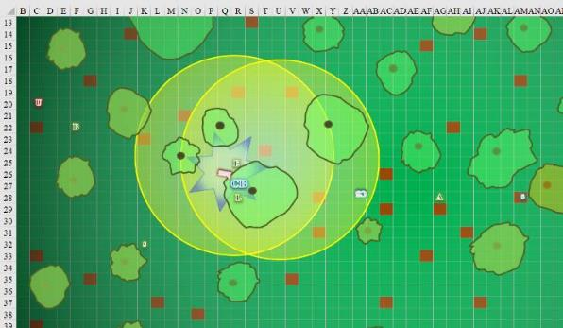

Round 7

Elsabet nodded to Luran in thanks for the healing, and spotting Solstice ahead and to her left, moved quickly in that direction, attempting to get even closer by jumping and using her extreme leap skill trick to leap swiftly ahead for a bit of extra distance, as well as positioning herself for a possible charge on the necromancer. “Barkley, step right!” she called out, hoping the archon would not block her possible charge.

|  |  |  |  |  |  |  |
| --- | --- | --- | --- | --- | --- | --- |
| **Skill** | **Rank** | **Ability & Mod.** | **Misc. Mods.** | **Total** | **Roll** | **Check** |
| **Elsabet, Jump** | 5 | **Str (+2)** | -1 + 10 running | 16 | 5 | 21 |

*See below.*

Getting close enough to Solstice that the musteval could reach her and use his wand, Elsabet also cast a *cure light wounds* spell on herself. Barkley was keeping the necromancer busy for the moment, but she needed to get over there quickly.

*Elsabet gained hps 8 + 4 = 12 hps [26/48].*

Elsabet had confused Saradette with Solstice as they’d advanced, and the warlock now identified the gnome for who she was.

Barkley shot arrows at the caster who’d cast back her cloak, revealing bone-themed armor and a will to end his life and get herself a new hound archon zombie.

|  |  |  |  |  |  |  |  |  |  |
| --- | --- | --- | --- | --- | --- | --- | --- | --- | --- |
| **Ranged Weapon** | **Dmg** | **D+** | **TH+** | **Critical** | **Rng.** | **Wt.** | **Atk** | **Roll** | **Check** |
| Composite +2 Longbow +1 | 1d8 | 3 | 1 + 2 DK + 2 Crg | x3 | 110’ | three | +14 | 14 | 28 |
| Longbow, 2nd Shot | 1d8 | 3 | 1 + 2 DK + 2 Crg | x3 | 110’ | three | +9 | 11 | 20 |

*Hit, hit. Dmg: (3 + 3 + 2 Courage) + (2 + 3 + 2 Courage ) = 8 + 7 = 15.*

The woman’s armor took some of the momentum, but the spellcaster’s arm was visibly wounded by the archon’s arrow.

Solstice produced his main wand and approached Elsabet hastily, not quite able to catch up now that she’d gone west.

Urmeena cast *ray of exhaustion* *[expired on Round 97]* upon Barkley.

|  |  |  |  |  |  |
| --- | --- | --- | --- | --- | --- |
| **Ranged Weapon** | **Dmg.** | **Rng.** | **Atk** | **Roll** | **Check** |
| Ranged Touch Attack | Exhaustion | 50’ | +5 | 18 | 23 |

*Hit.*

|  |  |  |  |  |  |  |
| --- | --- | --- | --- | --- | --- | --- |
| **Save vs.**  *ray of exhaustion* | **Rank** | **Ability & Mod.** | **Misc. Mods.** | **Total** | **Roll** | **Check** |
| **Barkley, Fortitude** | 6 | Con (+3) | 1 | 10 | 4 | 14 |

*Fail. Barkley suffers –6 penalty to Strength and Dexterity.*

Saradette moved west some more, and shot the spellcaster.

|  |  |  |  |
| --- | --- | --- | --- |
| **Ranged Weapon** | **Dmg.** | **Rng.** | **Notes** |
| Horizikaul’s Boom | 1d4 Sonic | 25’ + 2½’/lvl | Will DC or deafened for 1d4 rounds |

*Dmg: 2 sonic.*

|  |  |  |  |  |  |  |
| --- | --- | --- | --- | --- | --- | --- |
| **Skill** | **Rank** | **Ability**  **& Mod.** | **Misc.**  **Mods.** | **Total** | **Roll** | **Check** |
| **Urmeena, Will** | **9** | **Wis (+3)** | 0 | 12 | 20 | 32 |

*Success. Deafening effect negated.*

Looking around briefly, Aliya focused on the captain’s body, seeing that there was likely nothing that could be done for him with their immediate means. A *resurrection* or perhaps *raise dead* spell might have restored him. Aliya stopped at the body and took defensive position waiting for others. She didn’t have such spells but maybe one of them had.

Luran and his conjured bear rapidly made their way toward the bone encrusted foe. Registering Elsabet’s intent to charge the spellcaster, the arcane musician and his ursine summoning kept to the other side of her likely path.

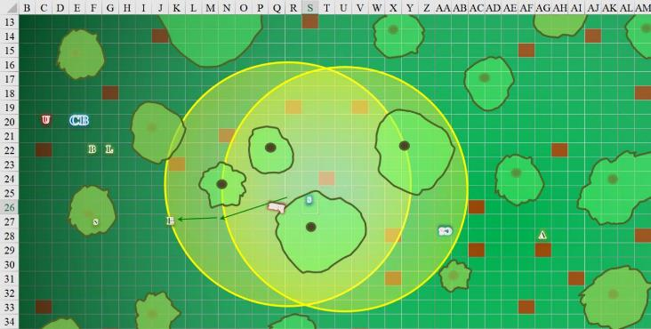

Round 8

Seeing Barkley look back and nod at her after hesitating, Elsabet delayed her action to see what her friend had in mind, hoping he opened up a path.

Barkley, feeling drained from the spell cast upon him, decided it would be better to keep his distance. Hearing Elsabet, he shifted to his left and let loose with another volley of arrows (maximum number he can fire this round).

|  |  |  |  |  |  |  |  |  |  |
| --- | --- | --- | --- | --- | --- | --- | --- | --- | --- |
| **Ranged Weapon** | **Dmg** | **D+** | **TH+** | **Critical** | **Rng.** | **Wt.** | **Atk** | **Roll** | **Check** |
| Composite +2 Longbow +1 | 1d8 | 0 | 1 + 2 DK | x3 | 110’ | three | +7 | 16 | 23 |
| Longbow, 2nd Shot | 1d8 | 0 | 1 + 2 DK | x3 | 110’ | three | +2 | 10 | 12 |

*Hit, miss. Dmg: 2 + 1 + 2 Courage = 5.*

Elsabet grinned, as Barkley had opened up a straight line for her to charge the necromancer. As soon as he finished firing his last shot, she sprang into action. She initiated her battle leader’s charge and nearly flew across the ground, slashing hard at the woman in the bone armor.

|  |  |  |  |  |  |  |  |  |  |
| --- | --- | --- | --- | --- | --- | --- | --- | --- | --- |
| **Melee Weapon** | **Dmg** | **D+** | **TH+** | **Critical** | **Type** | **Wt.** | **Atk** | **Roll** | **Check** |
| Bastard Sword +1, 1-handed | 1d10+1 | +2 + 2 charge  +2 Courage | 4 + 2 charge  +2 Courage +2 DK | 19-20/x2 | Slashing | 6.0 | +19 | 6 | 25 |
| Least Truedeath Crystal | 1d6 | vs. | Undead | - | - | - | - | - | - |

*Hit. Dmg: 3 + 1 + 2 charge + 2 Courage + 2 Str + 15 LtC= 25.*

As she completed her attack and rocked back on her feet, Elsabet felt her maneuvers fade away, and new ones granted.

Solstice reached Elsabet with his wand, preparing to heal her on the next round.

The necromancer did bad things *[inflict serious wounds]*.

|  |  |  |  |  |  |  |  |
| --- | --- | --- | --- | --- | --- | --- | --- |
| **Skill** | **Rank** | **Ability & Mod.** | **Misc. Mods.** | **Total** | **Roll** | **Check** | **Properties** |
| **Concentration** | 8 | **Con (+1)** | 0 | 9 | 13 | 22 | +4 Casting defensively (Combat Casting) |

*Success. No AoO.*

|  |  |  |  |  |
| --- | --- | --- | --- | --- |
| **Melee Weapon** | **Dmg** | **Atk** | **Roll** | **Check** |
| Melee Touch Attack | 3d8 + 9 negative energy | +4 | 6 | 10 |

*Miss.*

Saradette no longer had a line of attack to the necromancer, so she could not shoot at her with her sonic cannon. Then, she remembered that the shot was unerring, and that it would strike only her intended target. She aimed and fired at the necromancer.

|  |  |  |  |
| --- | --- | --- | --- |
| **Ranged Weapon** | **Dmg.** | **Rng.** | **Notes** |
| Horizikaul’s Boom | 1d4 Sonic | 25’ + 2½’/lvl | Will DC or deafened for 1d4 rounds |

*Dmg: 4 sonic.*

|  |  |  |  |  |  |  |
| --- | --- | --- | --- | --- | --- | --- |
| **Save vs.**  *Horizikaul’s boom* | **Rank** | **Ability & Mod.** | **Misc. Mods.** | **Total** | **Roll** | **Check** |
| **Urmeena, Will** | **9** | **Wis (+3)** | 0 | 12 | 19 | 31 |

*Success. Deafness negated.*

Aliya deferred all actions for the moment.

Ursa Bearington and its summoner, Luran moved into melee with the dread necromancer and attempted to put her that much closer in spirit to her chosen wards.

|  |  |  |  |  |  |  |  |  |  |
| --- | --- | --- | --- | --- | --- | --- | --- | --- | --- |
| **Melee Weapon** | **Dmg** | **D+** | **TH+** | **Critical** | **Type** | **Wt.** | **Atk** | **Roll** | **Check** |
| Longsword | 1d8 | -1 | 2 + 2 | 19-20/x2 | Slashing | 4.0 | +7 | 8 | 15 |

*Hit. Dmg: 5 – 1 + 2 Courage = 6. Partial damage negated.*

|  |  |  |  |  |  |  |  |  |
| --- | --- | --- | --- | --- | --- | --- | --- | --- |
| **Character** | **Attack Type** | **Damage** | **BAB** | **Str Mod+** | **Other+** | **Total Score** | **Roll** | **Total** |
| Celestial bear | Claw 1 | 1d4+4 | 2 | 4 | 2 Courage  + 2 DK | 10 | 19 | 29 |

*Hit. Dmg: 3 + 4 + 2 = 9. Partial damage negated.*

The necromancer cringed at the bite, and knew her end was nigh, so she chose to say some deep shiznit before dying for her cause, “The Master owns you all now. He will make zombies of us all tonight.”

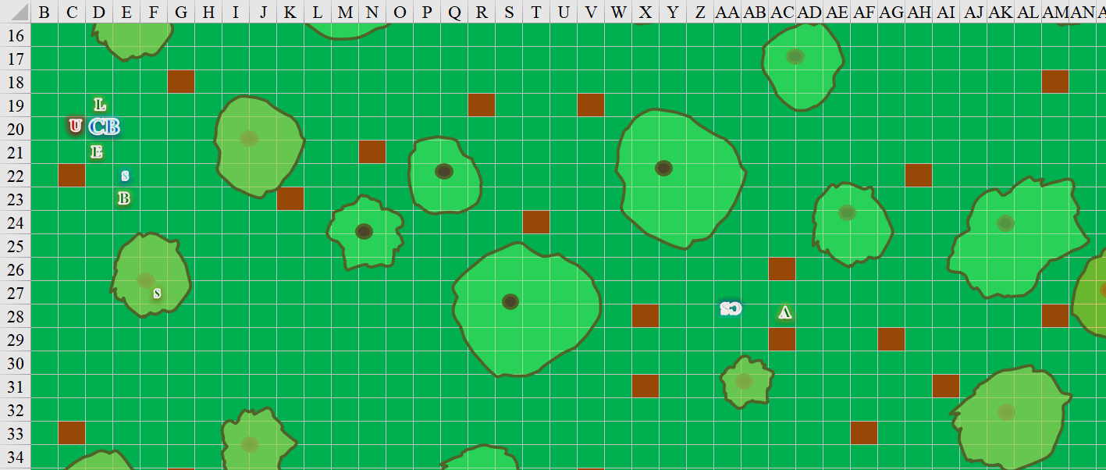

Round 9

Solstice saw the necromancer fixin’ to zap Elsabet with a nasty spell, and thought he’d put an end to this with two *magic missiles*.

*Dmg: 5 + 2 = 7 magic [force].*

Urmeena dropped to her knees, stared at the others, and smirked. She sat down to die, resigned to what she considered to be her next stage of development.

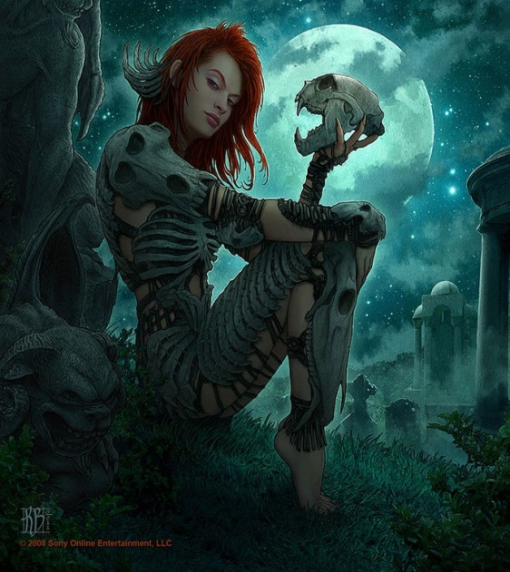

“May your hatred consume you,” Urmeena cursed them with her dying breath.

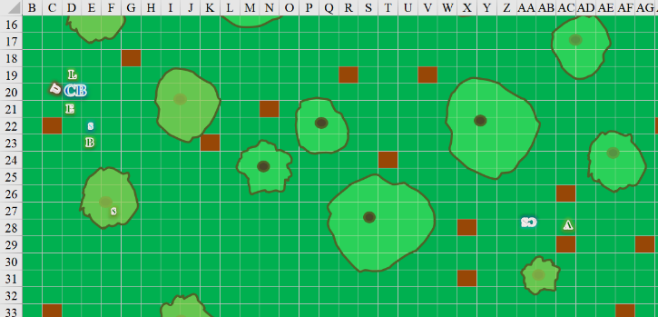

Elsabet looked down at the dying necromancer, and in case the woman wasn't completely dead, decided to make certain, as well as to make it less likely the woman would be brought back as an undead thing. Lining up carefully, taking her bastard sword in two hands to provide more chopping power and holding it above her head, she muttered, "this is for the Captain," and brought her blade straight down on the woman's neck, separating the woman's head from her shoulders.

*Automatic success.*

The woman hissed and seemed to even continue to do so after being beheaded.

Barkley looked at Elsabet and Luran, and then at the celestial bear before it vanished. He then turned and ran back to the Captain’s body; he didn’t think there was anything anyone could do, though. Barkley then said a quick prayer to Cayden for the Captain.

*CONFIRMED. AID SPELLS BELOW WILL BE NEGATED.*

Saradette continued working her way west, looking for more enemies.

The bear sniffed around, pointing its muzzle westward, and looking at Luran, who kept singing a luring taunt to the real necromancer they were seeking.

Luran laid a hand on the large creature’s shoulder, giving a good bit of scratching in appreciation for its efforts.

The bear licked the humanoid affectionately, as if to say, “Nice existence in your plane of being. Thanks for the brief chance to rock.”

Round 10

Barkley raised a quick toast with the Dragon’s Breath Bourbon in his pack, took in the moment, then said, “We must finish this and soon. Heal up whatever you can, then we need to move on. I will cast *aid* upon you all to help for the short term.”

Solstice tapped Elsabet with his wand of *cure moderate wounds*.

*Elsabet gained 7 + 5 = 12 hps [38/48].*

Rounds 11 – 16

Now expired, the Celestial bear disintegrated.

As the heavenly bear dissipated and returned to his other planar home, Luran raised his hand in farewell. Turning to the fallen necromancer’s body, he began helping Elsabet to search for items or information that might aid the heroes.

Solstice tapped Elsabet with his wand of *cure moderate wounds*.

*Elsabet gained 10 + 5 = 15 hps [48/48].*

He then turned to Luran, tapping him.

*Luran gained 8 + 5 = 13 hps [36/36].*

Meanwhile, Barkley cast *aid* upon Elsabet, Solstice, Luran, and himself *[expired on Rounds 61 through 64]*.

As he finished the castings, Barkley caught wind of whatever the Celestial bear was already keen on: the scent of a much more putrefacient necromancer that the archon already found familiar, due to having sniffed some of the evidence, including the communication device that had been found in Dromedar’s. “Who is further west,” he stated, though it might’ve sounded like a question to the passerby. “He’s on the run!” the archon anticipated a fun chase through the woods.

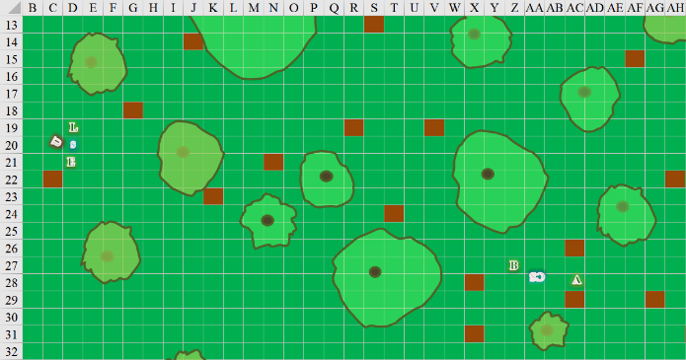

Round 17

“We’ll need to go through his effects,” Barkley pointed out meaning to continue but stopping as his hears perked back.

“Tiiimmme willlll heal most scaaaaarrrrrsssss!!” a voice to the far west cackled as if taunting them. “Fodder for my fiddle, follow further still!”

Elsabet had found a few weapons on the necromancer:

|  |  |  |  |  |  |  |
| --- | --- | --- | --- | --- | --- | --- |
| **Melee Weapon** | **Dmg** | **D+** | **TH+** | **Critical** | **Type** | **Wt.** |
| Bodyfeeder Scythe | 2d4 | 1 | 1 | x4 | Prcg/Slsh | 10.0 |
| Returning Dagger +1 | 1d4 | 1 | 1 | 19-20, x2 | Prcg/Slsh/20’ | 1.0 |

Luran contemplated how much time it would take to remove the armor:

|  |  |  |  |  |  |  |
| --- | --- | --- | --- | --- | --- | --- |
| **Armor & Shield** | **AC Mod.** | **Dex** | **Check** | **Arcane** | **Speed** | **Wt.** |
| Ring of Protection +2 | 2 | - | - | - | - | 0.0 |
| Bone Armor +2 | 5 | 4 | -3 | 20% | 20’ | 20.0 |

The bard and crusader then noted an expended scroll that was still on the woman’s person despite its uselelessness, though she couldn’t make out the spell that she’d had incanted on it.

|  |  |  |  |
| --- | --- | --- | --- |
| **Scrolls and Potions** | **Qty.** | **Level** | **CLev** |
| Scroll of *Fly* | 1 | 3 | 6 |
| Wand of *Cure Critical Wounds* | 1 | 4 | 11 |
| Scroll of *Greater Invisibility* | 0 | 3 | 6 |
| Antitoxin | 10 | - | - |
| Poison | 10 | - | - |

The woman’s cloak was magical, and probably fetched a bundle on the fair market.

|  |  |
| --- | --- |
| **Item** | **Wt.** |
| Cloak of Charisma +6 | 2.0 |

The rest of the items on her were of nominal to middling value, and Elsabet wondered what to do with them.

|  |  |  |
| --- | --- | --- |
| *Equipment Carried* | | |
| **Item** | **Wt.** |
| Waterskin | 2.0 |
| Everlasting Rations | 1.0 |
| Healing Belt | 0.5 |
| Bag of Bones | 1.0 |
| Grave Soil | 1.0 |
| Candles | 1.0 |
| Component Pouch | 1.0 |

Elsabet’s and Luran’s notions of Urmeena began to conjure in the warlock’s mind a tormented spirit.

~*~

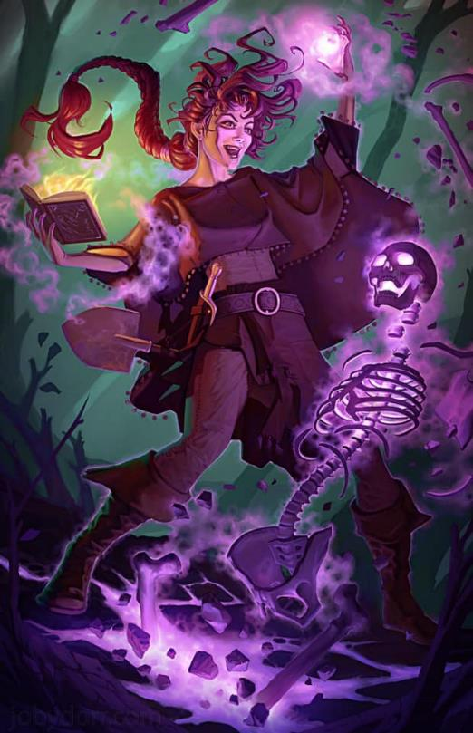

As a young initiate to the powers of undeath, Urmeena had since believed that her life had already been given to her dark deity. She’d been the property of a cambion for a short time, and that alone was a fate worse than death. By the time she’d come to come into her own necromantic womanhood, the aspects of her earlier self were altogether gone, and replaced with grim plots and intrigues fomenting in a mind twisted by flirting with negative energy.

As her head now lay on the earthen floor a few feet from the rest of her body, the last semblance of life crept from her body as only the other thing lingered.

Elsabet’s understanding of Urmeena started to form, even if under the shadow of doubts.



~*~

Rounds 25 – 30

By this time, the dwarf’s battleaxe, crossbow, armor, and ring were accounted for, and Aliya and Barkley were deciding what to do with each item, let alone his body.

Luran somewhat missed that bear he’d conjured. Of the dread necromancer’s effects, he’d decided to take the majority of the necromancer’s items. Elsabet had taken the scythe, and a few other useful items.

Saradette had looked over the items they’d taken from the necromancer. “I’ll take the Everlasting Rations, if no one else wants them. The ring should go to whomever will benefit from it most. I don’t plan to get hit.” She smiled at the others. “That’s your job.” Luran handed her the sack of rations, which she put into her pack.

Solstice noted that Barkley still needed some healing love, so he tapped the archon on his shin once.

*Barkley gained 11 + 5 = 16 hps [45/45].*

Then he did the same to Saradette.

*Saradette gained 10 + 5 = 15 hps [48/48].*

Now that they were all together, Barkley cast *aid [expired on Rounds 75 – 80]* on all of them.

*All friendlies gained +1 to attacks and saves against fear effects.*

*Aliya gained 5 + 6 = 11 temporary hit points [32/21].*

*Barkley gained 1 + 6 = 7 temporary hit points [52/45].*

*Elsabet gained 6 + 6 = 12 temporary hit points [60/48].*

*Luran gained 2 + 6 = 8 temporary hit points [44/36].*

*Saradette gained 5 + 6 = 11 temporary hit points [59/48].*

*Solstice gained 2 + 6 = 8 temporary hit points.*

Round 31

They were depleted of some spells and powers, but were back in full health, and *aided* by Barkley’s boosts as well. Someone had proposed burning Slatestein’s body, which caused the others to suspect the use of a *confusion* spell in their midst. “The Temple of Gond can likely restore him,” Solstice and others had said in different ways.

The sound of the mad voice to the west was no more.

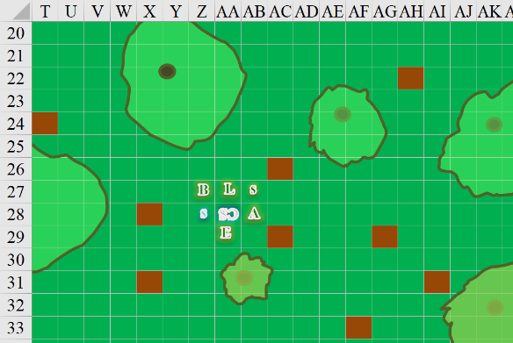

A few of them paced around the dwarf’s body, speculating how best to carry it back to Mintar. He must’ve weighed at least 220 lbs. without his gear. Solstice offered, “I once knew a halfling who could manifest what she called a Spell Hand ability. One of the powers associated with this was a *Tenser’s floating disc*, which could be used as a floating ferry for a fallen comrade or some heavy loot.”

Elsabet nodded, familiar with the rare ability. While Barkley cast *aid* on everyone, Elsabet cast *lesser restoration* on Barkley, which took the same period of time, first reducing his condition from exhausted to fatigued, and then from fatigued to his normal energetic self.

*Barkley’s Strength, Dexterity, Attacks, Saves, and Checks were restored to default values.*

Round 32

Barkley took two vials of antitoxin that Luran handed him, nodding and saying, “We should each carry a couple of these, no sense in one person carrying them all and losing them should something happen to that one.”

As darkness prevailed and their conversation drew to a close for the moment, the sound of a twig snapping to the west alerted them to the possibility of someone either approaching from the west or perhaps being there for quite some time.

Saradette, who still had her odd-looking suit of green and brown dyed burlap straps, moved westward, using the bushes and trees as cover. “Widget, move up, but be careful,” she said softly.

The racoon had scarcely been noticed on their way across the forest; she’d been creeping around on the periphery of the path the rest had taken, being both perfectly capable of keeping up with the group and naturally drawn to the details of the forest floor. It was a social medium of olfactory and other sensory information that she didn’t often get in the cobblestone-paved boulevards of Mintar. Widget now jumped to Saradette’s side, nuzzling at the gnome’s waist before they set off west.

Round 33

Before the gnome got too far separated, Luran mumbled something mystical and traced a simple symbol in the air with a tiny snip of copper wire for arcane focus. He then cocked a finger and pointed at Saradette’s back and activated his *message* spell, ensuring the stealthy archivist didn’t risk falling out of contact as she did whatever scouting she had in mind.

*Luran and Saradette became linked by message spell.*

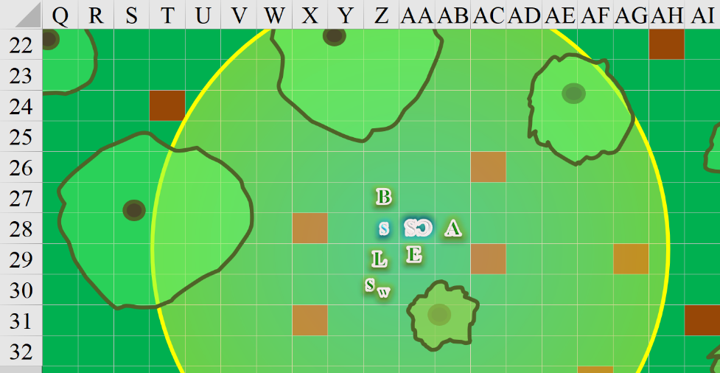

As usual, Solstice abstained from partaking in the spoils, mostly because the goods were too large for him to carry. Having lived among the cloud giants had exaggerated this habit of traveling light, since anything he needed was on the Sky Tree, and could be stored in a microcompartment in any of his giant friends’ garments.

Saradette set off westward as the night persisted in bringing the hoots of owls and warnings of other feathered friends, such as, “Let me sleep!” as far as Elsabet could discern.

Rounds 34 – 39

Saradette and Widget moved westward at 40’ per round.

“Go on,” Aliya urged the others—whose body language betrayed a restless party—to follow Saradette. “I’ll look after the Captain’s body, and fend off any other undead.”

Having made it about 150’ westward, she could only faintly hear the sounds of movement a few hundreds of feet further to the west, and even this could have been due to the breeze blowing through the trees’ branches. Intermittently, the somewhat eastward breeze brought with it the hint of rotting flesh. The racoon was becoming increasingly nervous at the thought of venturing further.

Saradette motioned for Widget to stop and climb the closest tree, while the artificer herself crept a bit closer, noting that Barkley was about 30’ behind her in wolf form.

Elsabet spoke to the young woman as the she insisted on guarding the body. “Good luck, Aliya, and don’t get killed! We’ll be back this way as soon as possible. In the meantime, perhaps you should climb up and hide in one of these trees so you’ll be better hidden and less able to be attacked by these ground-bound undead.”

Elsabet set out to the west, grateful they didn’t have to carry the body but worried at the same time. Her sword sheathed, she held her everburning torch in her left hand, and her potion of *enlarge person* in her right hand. “Guys, for the next fight, I am planning on getting big, this seems like a good opportunity to use the potion. Barkley, thanks for the aid—here’s hoping we catch up to the enemy soon.

“Reminds me of that time with the cloud giants last year when...” Solstice began to say, but then caught his colleague’s facial expression, “... that we don’t really talk about much.”

The vegetation grew ever greener as they continued downhill and towards the river.

Round 40

Barkley had almost caught up with Saradette by the time Saradette spotted the cranial structure up ahead. With her whisper gnome night vision, she surveyed the faux bone masonry against the backdrop of the moon now in the horizon.

