*Chapter 25: Who, the First*

With every second of gazing upon the structure, it was ever more evident that this was not a real skull, but served as a fairly stylistic portal to someone’s lair, presumably: Who’s. A gnome zombie had been crouched by the trunk of a tree right next to the skull, and now giving Saradette and Widget its undivided attention, snarled an alarm, and roused the attention of others around it.

This was confirmed by the visible head of another undead slowly rising from the darker eye of the skull-like enclosure.

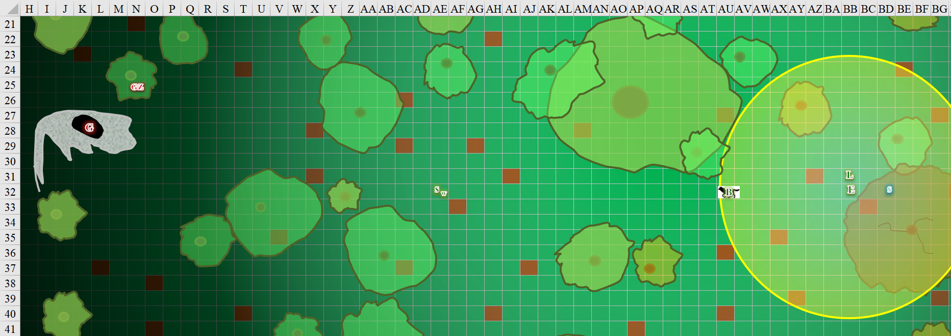

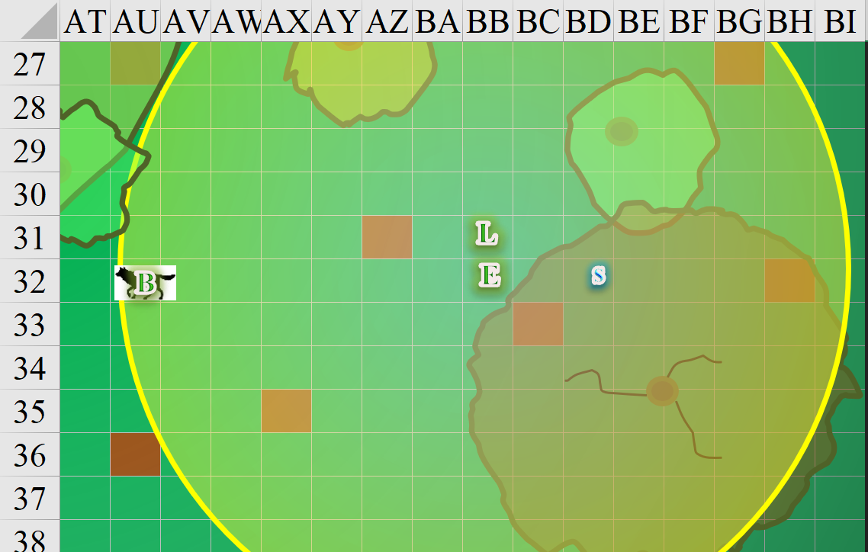

|  |  |  |  |  |  |
| --- | --- | --- | --- | --- | --- |
| **Character** | **Group** | **Initiative** | **Roll** | **Modified Roll** | **Move** |
| Barkley | 1 | 2 | 20 | 22 | 40’ |
| Aliya | 1 | 2 | 16 | 18 | 30’ |
| Luran | 1 | 1 | 14 | 15 | 30’ |
| Saradette | 1 | 3 | 9 | 12 | 20’ |
| Solstice | 1 | 1 | 11 | 12 | 30’/10’ b |
| Elsabet | 1 | 4 | 5 | 9 | 30’ |
| Undead Forces | 2 | 3 | 1 | 4 | 30’v |

Barkley ran west, attempting to hide in the shadows or underbrush when he reached his destination.

|  |  |  |  |  |  |  |
| --- | --- | --- | --- | --- | --- | --- |
| **Skill** | **Rank** | **Ability & Mod.** | **Misc. Mods.** | **Total** | **Roll** | **Check** |
| **Barkley, Hide** | 10 | Dex (+2) | -8 (running) | 4 | 5ish | ?? |
| **Barkley, Move Silently** | 0 | Dex (+2) | -8 (running) | -6 | 15ish | ?? |

*Probably not too slick.*

With such a commanding and menacing presence, the wolf was scarcely missed.

*Aura of Menace not yet in range.*

Luran whispered to Saradette through the message connection so she could report, “See anything, Saradette?” as he continued moving forward in the direction Barkley had taken off in.

Saradette moved to her left, intending to circle around to a point about 30’ south of the structure. She leaned up against a young tree as the curious Widget caught up.

Solstice followed Saradette, hoping to stay out of sight.

|  |  |  |  |  |  |  |
| --- | --- | --- | --- | --- | --- | --- |
| **Skill** | **Rank** | **Ability**  **& Mod.** | **Misc.**  **Mods.** | **Total** | **Roll** | **Check** |
| **Solstice, Hide** | 5 | **Dex (+3)** | 8 – 8 running | 8 | Poor | ?? |
| **Solstice, Move Silently** | 2 | **Dex (+3)** | 8 – 8 running | 5 | Good | ?? |

*See below.*

Having tucked away his wand as he ran, the musteval didn’t quite reach Saradette, but then again, he didn’t need to; he just needed to be able to see what was going on. Both he and Saradette could more plainly see that aside from the taddling zombie, there was now a ghoul to contend with emerging from the topmost hole in the cave, what would have been the hypothetical creature’s left eye in life.

It made no secret of its alacrity relative to the zombie who was even now pacing over towards Saradette’s new position as it jumped out of the skull and tilted its head, crawling over cautiously like a dog-like monster in a person’s body.

Taken aback by the sudden rapid movement of Barkley and Luran, and the initial granting of her maneuvers, obviously someone saw foes ahead somewhere, so Elsabet hustled forward to keep up with Luran. She wasn’t sure whether to drink the potion or not, but kept it in her hand until she could determine more about the situation. Adrenalin starting to pump, she was ready to protect Luran from any missile attack, as she peered into the dim light ahead.

The blue-haloed ghoul got into a charge, and prepared to joust with the wolf as the zombie continued on a staggered path towards Saradette. From a nearby bush to the north, a human skeleton fired an arrow upon the wolf.

|  |  |  |  |  |  |  |  |
| --- | --- | --- | --- | --- | --- | --- | --- |
| **Character** | **Attack Type** | **Damage** | **BAB** | **Dex Mod+** | **Total Score** | **Roll** | **Total** |
| Skeleton, M | Longbow | 1d8,x3, 100’ | 0 | 1 – 2 range | -1 | 9 | 8 |

*Miss.*

Luran—but not Elsabet—heard some movement to their northeast, and then to their south. To the south, Luran then spotted a Large zombie bumbling sort of towards them, or perhaps towards the gnome zombie.

A skeletal archer to Saradette’s south came out from behind a tree and fired upon her.

|  |  |  |  |  |  |  |  |
| --- | --- | --- | --- | --- | --- | --- | --- |
| **Character** | **Attack Type** | **Damage** | **BAB** | **Dex Mod+** | **Total Score** | **Roll** | **Total** |
| Skeleton, M | Longbow | 1d8,x3, 100’ | 0 | 1 – 2 range | -1 | 2 | 1 |

*Miss.*

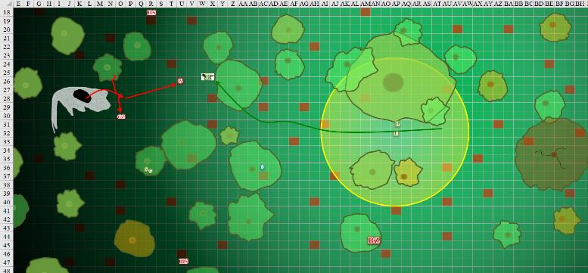

Round 41

Seeing the zombie coming his way, Barkley transformed back into this hound archon form (Standard Action) when drew (QuickDraw) his silvered hand axe. He now stood ready for the undead enemy to approach, longsword in one hand and axe in the other.

*Defensive: +4 to AC.*

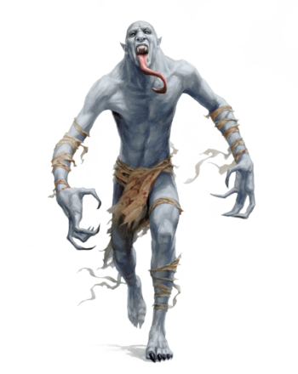

The ghoul hopped towards Barkley on all fours as if madly in love with the ranger initiate.

Solstice wasted no time in producing his blowgun and *magic missiling* the blue-sheen-covered skeleton to the southwest as he produced a pellet to load into his blowgun and studied the situation a bit better.

*Dmg: 6 + 2 = 8 magic [force].*

The musteval then moved a bit towards the west-northwest to a tree adjacent to the one next to Saradette’s. Lightning struck in the far-off distance, piercing partly through the late winter canopy.

With indications of foes in multiple directions, Elsabet called out “let’s get together,” then decided there was a good chance being bigger would be worth it. She popped the cork, gulped down the potion, dropped the vial, and rapidly grew to twice her height and eight times her weight. She then strode 30’ westwards in the direction Barkley had gone, drawing her large bastard sword as she went.

*Elsabet gained +2 to Strength, and incurred -2 to Dexterity.*



The heroes braved the undead forces as the latter came at the former.

|  |  |  |  |  |  |  |  |  |  |  |  |  |  |
| --- | --- | --- | --- | --- | --- | --- | --- | --- | --- | --- | --- | --- | --- |
| **Character** | **TAC** | **FFAC** | **AC** | **Damage Reduction** |  | **Melee** | **Cold** | **Evil/ Neg** | **Total Damage** | **Temp** | **Healing** | **HPs** | **Current HPs** |
| **Aliya** | **15** | **13** | **15** | none | 0 |  |  |  | 0 | 11 |  | 21 | 32 |
| **Barkley** | **12** | **22** | **24** | /+1 | 5 | 6 |  |  | 6 | 7 | 6 | 45 | 52 |
| **ElsabetPfE** | **13** | **20** | **21** | none | 0 | 20 | 10 | 15 | 45 | 12 | 45 | 48 | 60 |
| **Luran** | **11** | **18** | **19** | none | 0 |  |  | 11 | 11 | 8 | 11 | 36 | 44 |
| **Saradette** | **14** | **19** | **22** | none | 0 | 5 |  |  | 5 | 11 | 5 | 48 | 59 |
| **SolsticePfE** | **15** | **15** | **18** | none | 0 |  |  |  | 0 | 8 |  | 44 | 52 |

The ghoul charge-attacked Barkley.

|  |  |  |  |  |
| --- | --- | --- | --- | --- |
| **Character** | **Save vs.**  Aura of Menace | **Ranks** | **Roll** | **Result** |
| ghoul | Will | 5 | 6 | 11 |

*Fail. Ghoul suffered -2 to attacks, AC, and saves for 1 day.*

|  |  |  |  |  |  |  |  |  |
| --- | --- | --- | --- | --- | --- | --- | --- | --- |
| **Character** | **Attack Type** | **Damage** | **BAB** | **Str**  **Mod+** | **Other+** | **Total**  **Score** | **Roll** | **Total** |
| Ghoul | Bite | 1d6+3+paralysis+1d6 cold | 0 | 3 | 2 charge | 5 | 12 | 17 |

*Miss.*

The two human skeletons already in sight fired upon Barkley and Saradette while a third skeleton’s attention was roused, and it came around the skull to find Saradette and Widget.

|  |  |  |  |  |  |  |  |  |  |
| --- | --- | --- | --- | --- | --- | --- | --- | --- | --- |
| **Character** | **Attack Type** | **Damage** | **BAB** | **Dex**  **Mod+** | **Other+** | **Total**  **Score** | **Roll** | **Total** | **Targeting** |
| Skeleton, M | Longbow | 1d8,x3, 100’ | 0 | 1 | 0 | 1 | 8 | 9 | Barkley |
| Skeleton, M | Longbow | 1d8,x3, 100’ | 0 | 1 | 0 | 1 | 11 | 12 | Saradette |

*Miss, miss.*

Luran spotted an owlbear skeleton to the northeast at this moment, and it apparently just spotted him, as it broke into a spirited charge. The nimble bag of bones appeared far more capable of combat than the shambling bugbear zombie to the south. For one, it was a skeleton—not a zombie—plus the bones of owlbears—while still too dense for flight—were more porous than those of mammalian bears. Without its flesh, it ran and was upon him in very little time.

The bugbear zombie shambled along northward towards Elsabet, who was now the juiciest target with the largest brain.

The gnome zombie was too intent on eating Saradette’s brains to even notice Elsabet’s giant form farther to its east, and it kept on heading towards the artificer. The former woman was nearly upon her now.

*[I moved Luran and Saradette down in the sequence for this round in case the NPC actions above are useful to react to. If not, please let me know, and I’ll move your PC’s post to its original place in the round.]*

Luran started singing bardic music with an inspirational boost.

*Allies within audible distance gained +2 to attacks, weapon damage, and saves vs. charm or fear.*

“Just a crappy looking necromancer’s lair. What a goofball.” Saradette brought her flechette launcher around on its sling, and fired at the gnome zombie that was closing in on her. Widget scrambled higher into the tree, and looked out over the battle to help her mistress.

|  |  |  |  |  |  |  |
| --- | --- | --- | --- | --- | --- | --- |
| **Ranged Weapon** | **Dmg.** | **Rng.** | **Atk** | **Roll** | **Check** | **Notes** |
| Sabot Launcher | 1d6x6 | 50’ | 7 | 5 | 12 | 42 charges (Launch Item) |

*Miss.*

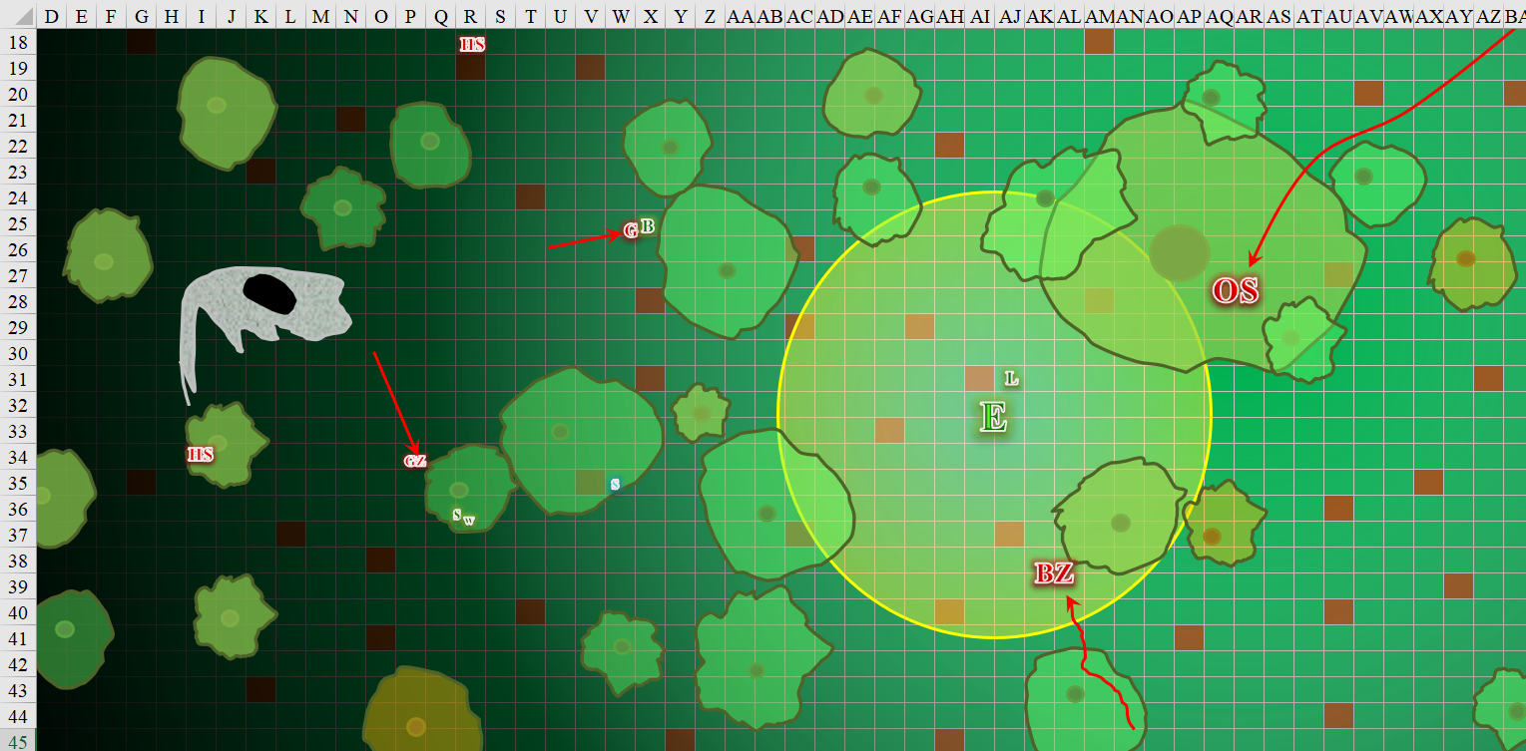

Round 42

With the ghoul next to him, Barkley attacked with his longsword +1 and silvered hand axe then stepped back from his opponent.

|  |  |  |  |  |  |  |  |  |
| --- | --- | --- | --- | --- | --- | --- | --- | --- |
| **Melee Weapon** | **Dmg** | **D+** | **TH+** | **Critical** | **Type** | **Atk** | **Roll** | **Check** |
| Longsword +1 | 1d8 | 3 | 3 + 2 DK | 19-20/x2 | Slashing | +14 | 14 | 28 |
| Hand Axe, Silver | 1d6 | 1 | 3 + 2 DK | x3 | Slashing | +13 | 8 | 21 |

*Hit, hit. Dmg: (4 + 3 + 2 Courage + 9 DK) + (4 + 1 + 2 Courage + 13 DK) = 18 + 20 = 38.*

Barkley had not accounted for the Dark Knowledge to be so helpful against this new type of foe. He’d destroyed the thing outright. He now did his best to step to the southeast to avoid the worst of the blast, but alas, he was hurt by the negative energy burst.

|  |  |  |  |  |  |  |
| --- | --- | --- | --- | --- | --- | --- |
| **Save vs.**  Destruction Retribution | **Rank** | **Ability**  **& Mod.** | **Misc.**  **Mods.** | **Total** | **Roll** | **Check** |
| **Barkley, Reflex** | 6 | **Dex (+2)** | 1 + 3 DK | 12 | 2 | 14 |

*Fail. Dmg: 6 negative energy [46/45].*

Luran’s song lifted, hopefully reaching the ears of all his slightly scattered companions as he braced himself beside Elsabet for the coming undead hulks. As he sang, he directed his magical music to activate the badge at his neck, bringing yet more strength to the group’s sword arms and will.

*Badge of valor increased inspiration bonus to +3.*

Saradette repeated her flechette maneuver.

|  |  |  |  |  |  |  |  |  |
| --- | --- | --- | --- | --- | --- | --- | --- | --- |
| **Ranged Weapon** | **Dmg.** | **TH+** | **Critical** | **Rng.** | **Atk** | **Roll** | **Check** | **Notes** |
| Sabot Launcher | 6d6 | 3 Courage + 2 DK | 15o cone | 50’ | 12 | 18 | 30 | 41 charges (Launch Item) |

*Hit. Dmg: 31. Partial damage negated.*

The gnome burst as its negative energy partly zapped Saradette. Widget was just out of the 10’ radius of the zombie.

*Automatic Reflex save succeeds. Evasion renders all damage moot.*

Solstice deduced that *magic missiles*—while middling in their outcomes, were reliable, and thus went with that option, continuing to bombard the skeletal archer to the south.

*Dmg: 3 + 2 = 5 magic [force].*

This second volley was almost enough, but not quite, to bring down the archer. These were apparently more robust skeletons than the ones they’d encountered minutes earlier. They were surely getting closer to Who’s big guns, or perhaps it was the undead bugbear and owlbear that would fill these roles in tonight’s caper.

Elsabet stepped to the other side of Luran to block the owlbear skeletons charge towards the bard, while eyeing the bugbear zombie shambling towards her as well, dropping her everburning torch and using a swift action to change her stance to thicket of blades, so that even minor movement adjustments within her reach would provoke attacks of opportunity.

“Bull’s strength?” she asked, looking at Luran, and at the bard’s nod, cast *bull’s strength [expired on Round 82]* on him, tapping him on the shoulder gently to grant him the boon.

*Luran gained +4 to Strength.*

Looking at the incoming undead, she grinned—she intended to get an attack of opportunity on each of the incoming undead as they moved through her extended reach to get to her, against one as usual and activating her bracers of opportunity to get an extra attack against the other undead. She got ready *[Thicket of Blades stance]* to swing fast as the undead closed in.

The human skeletons fired upon Barkley and Saradette.

|  |  |  |  |  |  |  |  |  |
| --- | --- | --- | --- | --- | --- | --- | --- | --- |
| **Character** | **Attack Type** | **Damage** | **BAB** | **Dex Mod+** | **Total Score** | **Roll** | **Total** | **Targeting** |
| Skeleton, M | Longbow | 1d8,x3, 100’ | 0 | 1 | 1 | 18 | 19 | Barkley |
| Skeleton, M | Longbow | 1d8,x3, 100’ | 0 | 1 | 1 | 3 | 4 | Saradette |
| Skeleton, M | Longbow | 1d8,x3, 100’ | 0 | 1 | 1 | 7 | 8 | Saradette |

*Miss, miss, miss.*

The owlbear skeleton charge-attacked Elsabet, who got in its way, but Elsabet took an attack of opportunity just before the owlbear skeleton reached her.

|  |  |  |  |  |  |  |  |  |
| --- | --- | --- | --- | --- | --- | --- | --- | --- |
| **Melee Weapon** | **Dmg** | **D+** | **TH+** | **Critical** | **Type** | **Atk** | **Roll** | **Check** |
| Bastard Sword +1, 1-handed | 2d8+1 | +3 | 4 + 2 DK | 19-20/x2 | Slashing | +16 | 14 | 30 |
| Least Truedeath Crystal | 1d6 | vs. | undead | - | - | - | - | - |

*Hit. Dmg: 8 + 1 + 3 + 3 Courage + 14 DK + 5 positive energy = 34.*

|  |  |  |  |  |  |  |  |  |  |
| --- | --- | --- | --- | --- | --- | --- | --- | --- | --- |
| **Character** | **Attack Type** | **Damage** | **BAB** | **Str Mod+** | **W+** | **Other+** | **Total Score** | **Roll** | **Total** |
| Owlbear Skeleton | Bite | 1d8+3+1d6 cold | 3 | 2 | 4 | 2 charge | 11 | 8 | 19 |

*Miss.*

The bugbear zombie continued towards Elsabet. With an immediate action, Elsabet activated her bracers and also took an attack of opportunity against the incoming bugbear zombie before it reached her as well!

|  |  |  |  |  |  |  |  |  |  |
| --- | --- | --- | --- | --- | --- | --- | --- | --- | --- |
| **Melee Weapon** | **Dmg** | **D+** | **TH+** | **Critical** | **Type** | **Wt.** | **Atk** | **Roll** | **Check** |
| Bastard Sword +1, 1-handed | 2d8+1 | +3 | 4 + 3 DK | 19-20/x2 | Slashing | 6.0 | +17 | 16 | 33 |
| Least Truedeath Crystal | 1d6 | vs. | undead | - | - | - | - | - | - |

*Hit. Dmg: 7 + 1 + 3 + 5 DK + 4 positive energy = 20.*

|  |  |  |  |  |  |  |  |
| --- | --- | --- | --- | --- | --- | --- | --- |
| **Character** | **Attack Type** | **Damage** | **BAB** | **Str Mod+** | **Total Score** | **Roll** | **Total** |
| Bugbear Zombie | Claw | 1d6+8 | 3 | 8 | 11 | 11 | 22 |

*Miss. (Protection from Evil made the difference.)*

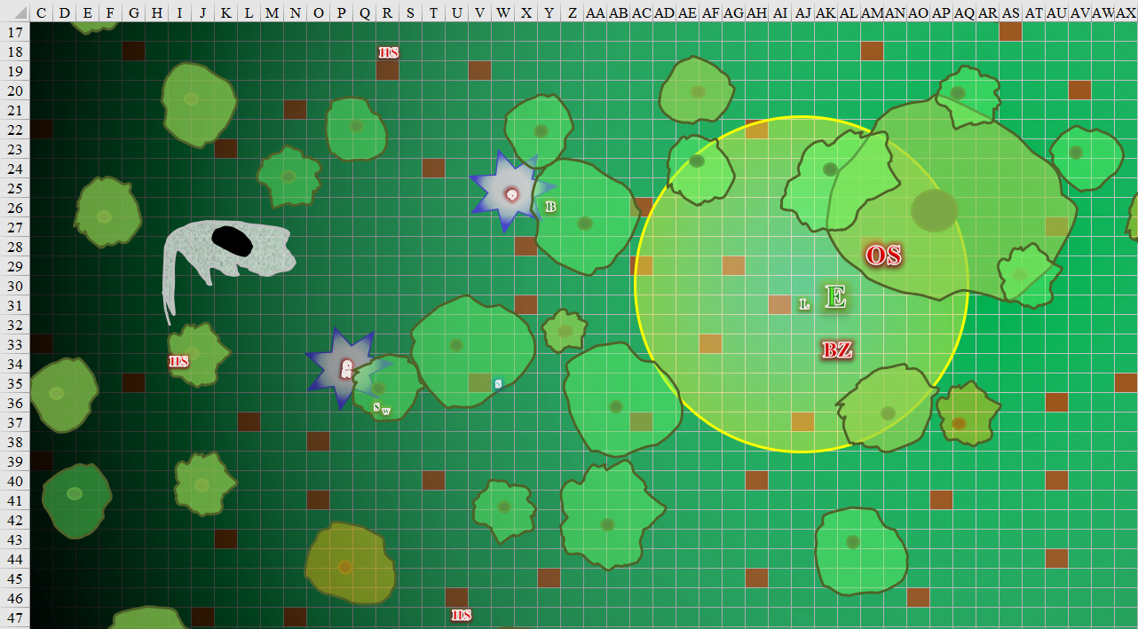

Round 43

Surprised at how easily he had dispatched the ghoul, Barkley decided to charge the human skeleton that was 55’ to his northwest. He sprinted off at top speed, striking hard at the skeleton.

|  |  |  |  |  |  |  |  |  |  |
| --- | --- | --- | --- | --- | --- | --- | --- | --- | --- |
| **Melee Weapon** | **Dmg** | **D+** | **TH+** | **Critical** | **Type** | **Wt.** | **Atk** | **Roll** | **Check** |
| Longsword +1 | 1d8 | 1 + 3 + 2 charge | 3 + 2 charge  +2 DK | 19-20/x2 | Slashing | 4.0 | +16 | 18 | 34 |

*Hit. Dmg: 8 + 3 + 2 charge + 3 Courage + 11 DK = 27.*

The archer exploded with negative energy, leaving behind only a bow, a quiver with about 10 arrows in it, and a feathered cap.

|  |  |  |  |  |  |  |
| --- | --- | --- | --- | --- | --- | --- |
| **Save vs.**  Destruction Retribution | **Rank** | **Ability & Mod.** | **Misc. Mods.** | **Total** | **Roll** | **Check** |
| **Barkley, Reflex** | 6 | **Dex (+2)** | 1 | 9 | 5 | 14 |

*Fail. Dmg: 3 negative energy [43/45].*

Hearing the exploding undead to the west, Luran realized that the others were, indeed, engaged and holding their own against whatever scourge attacked them. But the two shambling forms around Elsabet and himself held his primary focus as he put his now stronger arms to use.

|  |  |  |  |  |  |  |  |  |  |
| --- | --- | --- | --- | --- | --- | --- | --- | --- | --- |
| **Melee Weapon** | **Dmg** | **D+** | **TH+** | **Critical** | **Type** | **Wt.** | **Atk** | **Roll** | **Check** |
| Longsword | 1d8 | +1 | 3 + 2 DK | 19-20/x2 | Slashing | 4.0 | +12 | 15 | 27 |

*Hit. Dmg: 2 + 1 + 3 Courage = 6.*

Saradette spotted a skeleton to the west. She took aim, and fired her flechette launcher at the undead creature.

|  |  |  |  |  |  |  |  |  |
| --- | --- | --- | --- | --- | --- | --- | --- | --- |
| **Ranged Weapon** | **Dmg.** | **TH+** | **Critical** | **Rng.** | **Atk** | **Roll** | **Check** | **Notes** |
| Sabot Launcher | 6d6 | 2 DK + 3 Courage | 15o cone | 50’ | 7 | 2 | 9 | 40 charges (Launch Item) |

*Miss.*

Solstice thought he could finish off the archer to their south.

*Dmg: 5 + 2 = 7 magic [force].*

The third attempt finally brought down the archer.

Sandwiched between a bugbear zombie and an owlbear skeleton, Elsabet grinned, as she expected both foes were badly damaged. Rather than use a strike, she decided to go with a full attack, swinging first at the skeleton, and with her second swing also at the skeleton if it was still up, but switching to the zombie if the skeleton had collapsed. She nodded to herself and proceeded to carry out that plan.

|  |  |  |  |  |  |  |  |  |  |
| --- | --- | --- | --- | --- | --- | --- | --- | --- | --- |
| **Melee Weapon** | **Dmg** | **D+** | **TH+** | **Critical** | **Type** | **Wt.** | **Atk** | **Roll** | **Check** |
| Bastard Sword +1, 1-handed | 1d10+1 | +3 | 4 + 3 DK | 19-20/x2 | Slashing | 6.0 | +17 | 19 | 36 |
| Bastard Sword, 2nd Attack | 1d10+1 | +3 | 4 + 3 DK | 19-20/x2 | Slashing | - | +12 | 11 | 23 |
| Least Truedeath Crystal | 1d6 | vs. | undead | - | - | - | - | - | - |

*Hit owlbear skeleton. Dmg: 2 + 1 + 3 + 3 Courage + 9 DK + 1 positive energy = 19.*

*Hit bugbear zombie. Dmg: 8 + 1 + 3 + 3 Coruage + 2 positive energy = 17.*

As she felt her maneuvers fade and new ones be granted, she took a 5’ step to the northwest, but not before getting popped by the skeleton’s and zombie’s blasts.

|  |  |  |  |  |  |  |
| --- | --- | --- | --- | --- | --- | --- |
| **Save vs.**  Destruction Retribution | **Rank** | **Ability & Mod.** | **Misc. Mods.** | **Total** | **Roll** | **Check** |
| **Elsabet, Reflex** | **4** | **Dex (+1)** | 1 | 6 | 3 | 9 |
| **Elsabet, Reflex** | **4** | **Dex (+1)** | 1 | 6 | 9 | 15 |

*Fail, success. Saves for ½ damage against the bugbear’s explosion.*

*Dmg: 9 + (½ x 11) = 14 negative energy [46/48].*

|  |  |  |  |  |  |  |
| --- | --- | --- | --- | --- | --- | --- |
| **Save vs.**  Destruction Retribution | **Rank** | **Ability & Mod.** | **Misc. Mods.** | **Total** | **Roll** | **Check** |
| **Luran, Reflex** | **8** | **Dex (+1)** | 1 | 10 | 13 | 23 |

*Success. Saves for ½ damage.*

*Dmg: ½ x 5 = 2 negative energy [42/36].*

The remaining human skeleton fired upon Saradette.

|  |  |  |  |  |  |  |  |
| --- | --- | --- | --- | --- | --- | --- | --- |
| **Character** | **Attack Type** | **Damage** | **BAB** | **Dex Mod+** | **Total Score** | **Roll** | **Total** |
| Skeleton, M | Longbow | 1d8,x3, 100’ | 0 | 1 | 1 | 14 | 15 |

*Miss.*

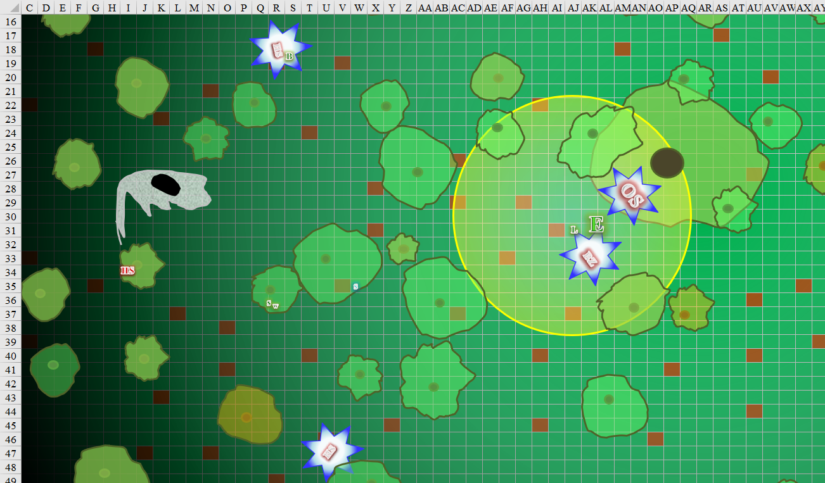

Round 44

Saradette cursed softly, adjusted her aim, and fired on the skeleton again.

|  |  |  |  |  |  |  |  |
| --- | --- | --- | --- | --- | --- | --- | --- |
| **Ranged Weapon** | **Dmg.** | **Critical** | **Rng.** | **Atk** | **Roll** | **Check** | **Notes** |
| Sabot Launcher | 6d6 | 15o cone | 50’ | 7 + 3 Courage + 2 DK | 4 | 16 | 39 charges (Launch Item) |

*Hit. Dmg: 21.*

The last skeleton archer exploded, leaving the heroes alone on the makeshift battlefield.

Barkley began to move towards the last skeleton as Saradette was able to destroy it. Barkley then stopped near the artificially created skull, looking to see if there were any other enemies ready to emerge. Seeing nothing, he kept his blade and axe held at the ready.

Solstice was ready with both his blowgun and his *magic missile*. “Came out of nowhere,” mostly said to himself as he headed towards Saradette.

Elsabet nodded at Luran, picked up her everburning torch, and hustled west in her enlarged size, clomp, clomp, clomping her way towards the entrance of the necromancer’s lair. “I’m going to dismiss this spell effect,” she warned Luran as she got some distance between them.

While his volume lowered considerably, the fervor of Luran’s song abated not at all. His blood was high and these cold, bloodless foes only kept his rumbling hymns coming on strong. He stayed put as Elsabet shrunk back to normal size.

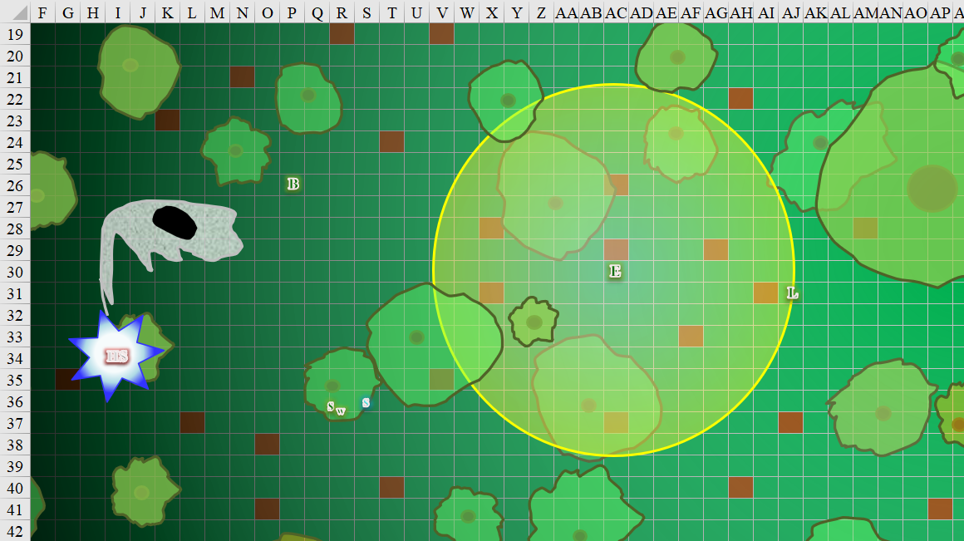

Rounds 45 – 47

Elsabet’s torch lit the way westward, as the hushed voices of the heroes drew them all towards Saradette’s position.

Luran moved along with Elsabet, deciding to end his quiet song as they got closer to the entrance.

Seeing that Elsabet was hurt, Solstice intercepted her and tapped her with his wand.

*Elsabet gained 9 + 5 = 14 hps [48/48].*

He then noticed that Barkley—too—was a bit below tiptop, and did him a solid too, asking, mostly himself, “I wonder how Aliya is doing?”

*Barkley gained 7 + 5 = 12 hps [45/45].*

“We’re a scream away,” Barkley looked eastward. “As a wolf, I’m less than a minute away from where the Captain’s body lay.”

They stood around the entrance to the necromancer’s keep, looking at one another, then at both the lit and unlit entrances as the moon continued to rise in the horizon.

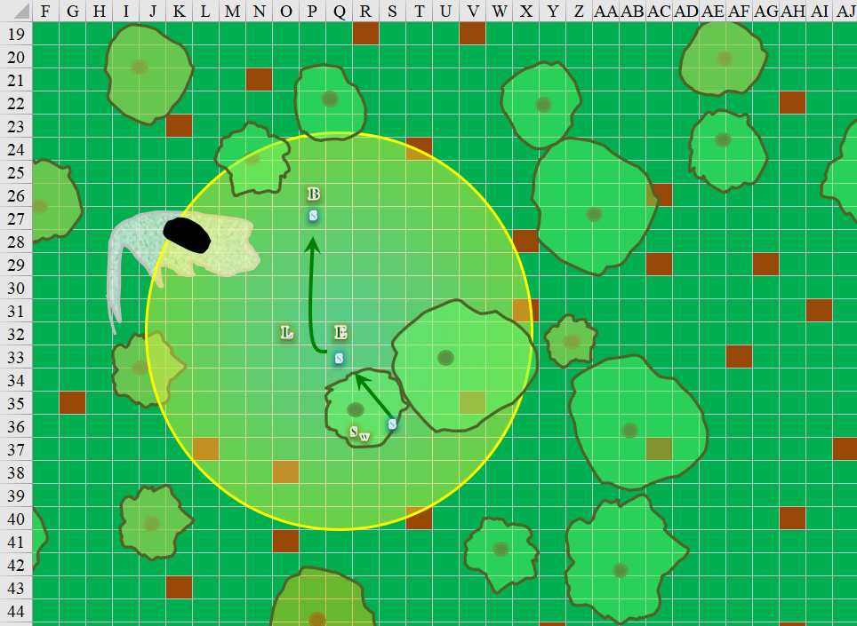

Round 48 – 53

The word << Ѭᴓƺҿȵɶʧǘӗᾓ >> was carved into the ground, and while Barkley could intuit the meaning of every spoken word, this Abyssal script was entirely unknown to the current company.

“Is this Infernal?” Luran asked, knowing Celestial, and being sensitive to the mutual commonalities between Infernal and Abyssal insofar as they were different from Celestial.

“Nay,” Barkley said once he came closer, knowing how to read both Celestial and Infernal. “All these inflections at the end are variants within Abyssal, which, as you might imagine, likes to switch it up.”

“Break the pattern once it’s set,” Saradette repeated something she recalled from a field trip on chaos theory.

And though Barkley would have found cause to argue for the side of Law months or even weeks ago, since he’d left the giants, that penchant seemed to have gone away, much like Bishop Jericho’s calling to Tyr’s will, and the swaying faith of many others. It was not uncommon, though it was a difficult path for those who were on it. It hadn’t dawned on the aspiring ranger until now that he was no longer bound to the path of Law.

*Barkley is officially no longer lawful.*



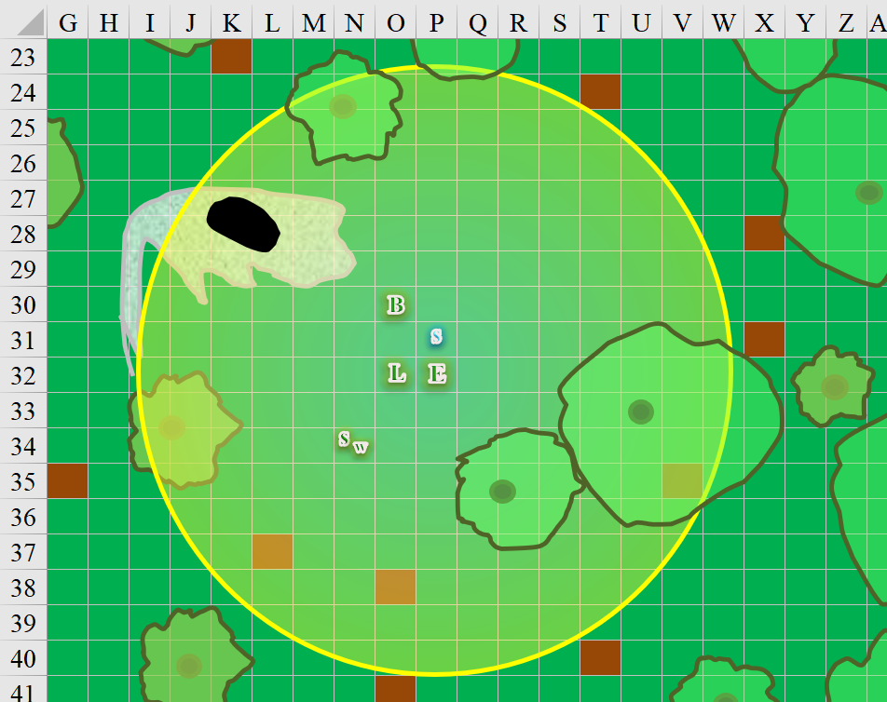

“Do you want to lead, checking for traps and such, or shall Barkley or I lead?” Elsabet asked Saradette quietly. “And should Widget come with us, or perhaps climb a tree and keep a lookout out here?”

“Can I have a minute to recharge my launcher, or do we need to go now? Either way, Widget can come with me.”

“Luran has a bit over 3 minutes to go on the strength spell, and I have over a minute left on my largeness but cannot take that inside. I think another minute won’t hurt, I say go for it.” Elsabet thought the launcher was cool, and loading it worthwhile. Plus she was kind of hoping Who would send more minions out while she was still big.

She did wonder if Who had a back door or escape tunnel. “If you do reload, maybe Barkley could use some of that minute to do a quick lope around the area, see if he can sniff out where someone might have another exit from the place.”

Elsabet looked to see if any mammals or birds might have been brave or foolish enough to live in the vicinity of a necromancer’s lair, but there were no nests or dens that she could see. If she happened to hear an owl hooting by, she might try to flag it.

Barkley nodded at Elsabet’s suggestion to check for a back door. However, prior to changing into his wolf form to complete the task sooner, he used *message* to connect him to each of the others in the group, including Widget.

Barkley then circled around the area, sniffing and looking about. Two minutes later, he came back to center, having scoured over 1000’ along the circumference of the skull’s wide orbit. He knew the layout of the land around them, which might prove to be a tactical advantage should they be ambushed again or have to flee this place in a hurry.

Specifically, the river flowed to their south, and was almost entirely comprised of rapids as the water proceeded towards Mintar. Along the portion that he’d seen, it was anywhere between 35’ and 55’ to cross the wide waterway, and not a well-ending one if they should choose to do so.

The hills were mostly rolling ones, and wooded less sparsely to the south where the river flowed. One bit of high ground to the north broke through the tree line around it and had allowed Barkley to survey the majority of the south-facing slope where they were, and the moonlit valley beyond it, dark as it was.

Widget stayed by Saradette’s side as the two peered into the skull’s eye-socket entrances. One was lit by a constant fire that burned below while the other went to a dark place.

It was then that Barkley noticed the fresh tracks of a humanoid in a hurry. They were headed further west, and though he hadn’t caught them earlier during his perimeter check, they surely had to cross that area, unless someone was still within that perimeter. “These are fresh,” he pointed to the trail of the well-spaced steps of a runner with a hastened stride.

“A skeleton, perhaps?” Solstice countered.

Barkley shook his head. “Too passionate in how they dig in on the heels.”

Some of them looked westward where the fugitive might be. Others peered into the abyss of the skull’s eye sockets. Others still looked at one another, then eastward towards Aliya and the late Baronial Guard, Captain Slatestein.

Solstice posed, “Perhaps these undead we just downed weren’t exactly a ‘last line of defense’; perhaps they were a diversion to stall our pursuit.”

“Let’s follow those tracks, I expect it is Who,” Elsabet said, “and the lair will still be here if it isn’t him.”

“Um, sure. I’ll keep my ears pricked as we follow the trail.” Luran had no argument with her suggestion.

Barkley nodded his agreement. “I will take the lead so I can follow the tracks. My scent ability will also be helpful as well.”

Saradette finished reloading her launcher and nodded. “Go ahead. I’m ready.”

~*~



With Barkley in the lead now, they headed west some more, leaving the skull cave unattended, and with

|  |  |  |  |  |  |  |
| --- | --- | --- | --- | --- | --- | --- |
| **Skill (Tracking)** | **Rank** | **Ability & Mod.** | **Misc. Mods.** | **Total** | **Roll** | **Check** |
| **Barkley, Survival** | 8 | Wis (+1) | 0 | 9 | poor | ?? |

*See below.*

After about 15 minutes, the archon gave up, feeling rather like a failure. His sense of tracking was not yet what it should have been, and he knew it, and there were surely telltale signs that he plain, old missed. Then, he stopped and shook his head, about to divulge to his friends that he’d lost the footprints at an outcropping of rocks, and beyond that, he’d been following older tracks, it seemed, for they’d already turned back towards the skull. There were also several marching tracks all around the area, mostly made by undead, and these could have obfuscated the actual tracks, but as he began to turn around, one, then both nostrils flared as the wind turned from northbound to eastbound for a few moments, bringing with it the faintest hint of Who and his necrotic paraphernalia.

His head immediately pointed to the southwest, and he crouched as if to become a wolf once more, though he just remained sniffing the air and getting a better sense of where the wind had been carrying it from.

“Does he smell something?” Solstice asked Elsabet, who could see better.

“I think so.”

Their trajectory turned decisively from westward to southwestward, and the archon took advantage of the prevailing wind of the moment, walking more briskly than before, and urging the others to hustle with him. While the scent was faint, it made more sense to him to compromise stealth for speed.

|  |  |  |  |  |  |  |
| --- | --- | --- | --- | --- | --- | --- |
| **Skill (Tracking)** | **Rank** | **Ability**  **& Mod.** | **Misc.**  **Mods.** | **Total** | **Roll** | **Check** |
| **Barkley, Survival** | 8 | Wis (+1) | 0 | 9 | middling | ?? |

*See below.*

By the time the wind had shifted once again, and Barkley could not rely on his nose, he’d found a matching set of very fresh tracks—less rushed at this point—and his ears perked up with a sense of accomplishment when they got close enough to smell the nearby carcasses.

Barkley let Saradette and Widget catch up, then whispered, “Our mark is surely up ahead.” He pointed down to the shoeprints in the soft ground, and added, “This is the man we want.”

Now—perhaps—it made sense to use stealth, and as Luran, Elsabet, and Solstice saw Barkley’s discrete and circumspect posture, they tried to walk a bit more cautiously.

|  |  |  |  |  |  |  |
| --- | --- | --- | --- | --- | --- | --- |
| **Skill** | **Rank** | **Ability & Mod.** | **Misc. Mods.** | **Total** | **Roll** | **Check** |
| **Elsabet, Move Silently** | 0 | **Dex (+1)** | -1 | 0 | 14 | 14 |
| **Luran, Move Silently** | 0 | **Dex (+1)** | 0 | 1 | 10 | 11 |
| **Solstice, Move Silently** | 2 | **Dex (+3)** | 8 | 13 | 5 | 18 |

*See below.*

Solstice drew his blowgun, also smelling death in the air, and the funk of a living human.

“Let me look,” Saradette said.

Once all of the others caught up, Barkley suggested, “We should move quickly now. I can take Solstice on my shoulder, then he can leap off and do his thing once we get close enough.”

The rogue agreed and hopped on, and they continued southwestwardly.

~*~



They walked for another 850’ and could now hear the mumblings of what sounded like a drunkard. It was the voice of an adult human male, and was likely the man they sought. The area was wooded, so they would likely have to pass two or three large trees before they got to the source of the sound.

Luran strained his half-elven ears to better pinpoint what he was hearing. It was probably some kind of prayer, and the strain in the voice suggested that the man was wounded near his diaphragm. The bard’s heuristic sense of hearing told him that this prayer was something vile, and not the kind of prayer he would ever offer to Tyr.

With longsword and silvered hand axe in his hands, Barkley began to lead the others forward once again. Trying to remain silent, he motioned for the others to spread out so they could approach over a wider front. Barkley remained alert, scanning for any other undead in the area.

Saradette and Widget followed Barkley, as did Elsabet, behind the bard, admiring the way he walked. She couldn’t see Who yet, and she was feeling a bit disgruntled, hating the way people who played with undead disrupted the natural order. This area should be more alive, with racoons and owls and other nocturnal creatures, but no, people like Who tainted the area with their necromantic dabbling. It pissed her off. But Luran did have a nice butt. She’d tell him so later.

Between the trees, Barkley and Solstice momentarily caught sight of a moving, human-sized fellow shifting in and out of their line of sight among the trees. They were about 150’ away from the robed figure, who had heard them coming, and had already started running. The sounds of his hurried footsteps were clear.

“He’s running,” Barkley called to the others, stealth no longer a concern. He then looked at Solstice on his shoulder, “Hold on my friend!” Barkely then took off at a full run in pursuit of Who. He will do his best to watch out for any traps in his path but his main concern is to close the gap with Who.

“Sic ‘im, Barkley!” Elsabet yelled out, and then started hustling as fast as she could manage.

Luran once again brought his musical support to his companions’ and his own benefit, bolstering them in the pursuit to come.

*Friendlies gained +2 to attacks, weapon damage, and saves.*

And what a disconcertment it must have caused the necromancer to be chased by a hound-faced hero and a singing humanoid in tow. Who knew that the precipice and river were close by, and might make a glorious plea to Velsharoon while swan diving to his death and into the river. Glorious, indeed.

Who was nearly out of spells, having been double-crossed by his apprentice. What a twist of fate that such a grand man should meet his end at the hands of knaves during a moment of weakness. He cast one of his few remaining spells—caltrops—covering an area between two trees where he led the archon and the singing elf with the shrilly voice.

Barkley ran right through the area.

|  |  |  |  |  |  |
| --- | --- | --- | --- | --- | --- |
| **Melee Weapon** | **Dmg** | **Type** | **Atk** | **Roll** | **Check** |
| Caltrops | 1 | Piercing | 4 | 7 | 11 |
| Caltrops | 1 | Piercing | 4 | 8 | 12 |
| Caltrops | 1 | Piercing | 4 | 15 | 19 |
| Caltrops | 1 | Piercing | 4 | 17 | 21 |
| Caltrops | 1 | Piercing | 4 | 6 | 10 |

*Miss5.*

Neither he nor Solstice noticed the caltrops, so as Barkley prepared to transform into a wolf again, Luran stepped over the same path.

|  |  |  |  |  |  |
| --- | --- | --- | --- | --- | --- |
| **Melee Weapon** | **Dmg** | **Type** | **Atk** | **Roll** | **Check** |
| Caltrops | 1 | Piercing | 4 | 13 | 17 |
| Caltrops | 1 | Piercing | 4 | 1 | 5 |
| Caltrops | 1 | Piercing | 4 | 17 | 21 |
| Caltrops | 1 | Piercing | 4 | 18 | 22 |
| Caltrops | 1 | Piercing | 4 | 15 | 19 |

*Miss, miss, hit, hit, miss. Dmg: 2 [40/36].*

***NOTE: This damage was supposed to be 2 x 5 = 10, but I’ll leave it as is.***

|  |  |  |  |  |  |  |
| --- | --- | --- | --- | --- | --- | --- |
| **Save vs.**  Pain | **Rank** | **Ability**  **& Mod.** | **Misc.**  **Mods.** | **Total** | **Roll** | **Check** |
| **Luran, Fortitude** | **2** | **Con (+1)** | 1 | 4 | 6 | 10 |

*Fail, but see below.*

“Ow!” the unexpected pain nearly caused the bard to stop singing momentarily, but he improvised the exclamation into a bridge for the next chorus.

Saradette did her best to keep up with the others, spotting a shortcut to the sound of the fleeing man.

Elsabet also stepped into a field of caltrops.

|  |  |  |  |  |  |
| --- | --- | --- | --- | --- | --- |
| **Melee Weapon** | **Dmg** | **Type** | **Atk** | **Roll** | **Check** |
| Caltrops | 1 | Piercing | 4 | 13 | 17 |
| Caltrops | 1 | Piercing | 4 | 1 | 5 |
| Caltrops | 1 | Piercing | 4 | 17 | 21 |
| Caltrops | 1 | Piercing | 4 | 8 | 12 |
| Caltrops | 1 | Piercing | 4 | 15 | 19 |

*Miss, miss, hit, miss, miss. Dmg: 5 [43/48].*

Elsabet stopped where she was and took out a caltrop from the thinnest part of her boot sole.

|  |
| --- |
| *Current Maneuvers* |
| Crusader’s Strike |
| Stone Vise |
| Battle Leader’s Charge |
| Shield Block |
| Foehammer |

Barkley warned Solstice, “I’m going wolf, hang on!” and began his transformation into a wolf.

Solstice knew nothing of horsemanship, let alone wolfsmanship, so he hopped off.

Once in wolf form, Barkley took off running after Who. With Who in his sight, Barkley was looking forward to ending the necromancer’s reign of terror.

Round 222

It did not take long for Barkley to dash in the night and catch up to Who, particularly since he’d cast *caltrops*, and now that Barkley was close enough, *enervation*.

|  |  |  |  |  |
| --- | --- | --- | --- | --- |
| **Ranged Weapon** | **Dmg.** | **Atk** | **Roll** | **Check** |
| Ranged Touch Attack | 1d4 Negative Levels | +8 | 16 | 24 |

*Hit. Dmg: 4 negative levels: -4 to BAB, Saves, Checks, and -20 HPs [25/25(45)].*

The wolf came ever closer, and *[move action or standard action]*.

|  |  |  |  |  |  |  |  |
| --- | --- | --- | --- | --- | --- | --- | --- |
| **Save vs.**  Aura of Menace | **Rank** | **Ability & Mod.** | **Misc. Mods.** | **Total** | **Roll** | **Check** | **Properties** |
| **Who, Will** | **10** | **Wis (+4)** | 1 | **15** | 12 | 27 | +2 vs. Fear |

*Success. Effect negated.*

Elsabet got a good look at Who among the bushes and cast *silence [expired on Round 262]* upon him.

|  |  |  |  |  |  |  |
| --- | --- | --- | --- | --- | --- | --- |
| **Save vs.**  *silence* | **Rank** | **Ability**  **& Mod.** | **Misc.**  **Mods.** | **Total** | **Roll** | **Check** |
| **Who, Will** | **10** | **Wis (+4)** | 1 | **15** | 9 | 24 |

*Success. Effect negated.*

Solstice followed Barkley, then turned southward to fire from a sniping position, then got his blowgun out.

|  |  |  |  |  |  |  |
| --- | --- | --- | --- | --- | --- | --- |
| **Skill** | **Rank** | **Ability & Mod.** | **Misc. Mods.** | **Total** | **Roll** | **Check** |
| **Solstice, Hide** | 5 | **Dex (+3)** | 8 | 16 | Poor | ?? |
| **Solstice, Move Silently** | 2 | **Dex (+3)** | 8 | 13 | Awesome | ?? |

*Probably successful.*

Saradette and Widget kept running southwest in a bid to flank the necromancer. “Watch his spells,” she warned Widget.

|  |  |  |  |  |  |
| --- | --- | --- | --- | --- | --- |
| **Melee Weapon** | **Dmg** | **Type** | **Atk** | **Roll** | **Check** |
| Caltrops | 1 | Piercing | 4 | 7 | 11 |
| Caltrops | 1 | Piercing | 4 | 14 | 18 |
| Caltrops | 1 | Piercing | 4 | 18 | 22 |
| Caltrops | 1 | Piercing | 4 | 7 | 11 |
| Caltrops | 1 | Piercing | 4 | 11 | 15 |

*Miss, miss, hit, miss, miss. Dmg: 5 [35/36].*

Luran bit down on the partly immobilizing pain to get out of the field of caltrops, but failing to do so. Once he staggered out of the obstacle, he focused the magic of his song on himself, casting *cure light wounds* and curing what damage the necromancer’s efforts had given him.

*Luran gained 6 + 5 = 11 hps [36/36].*

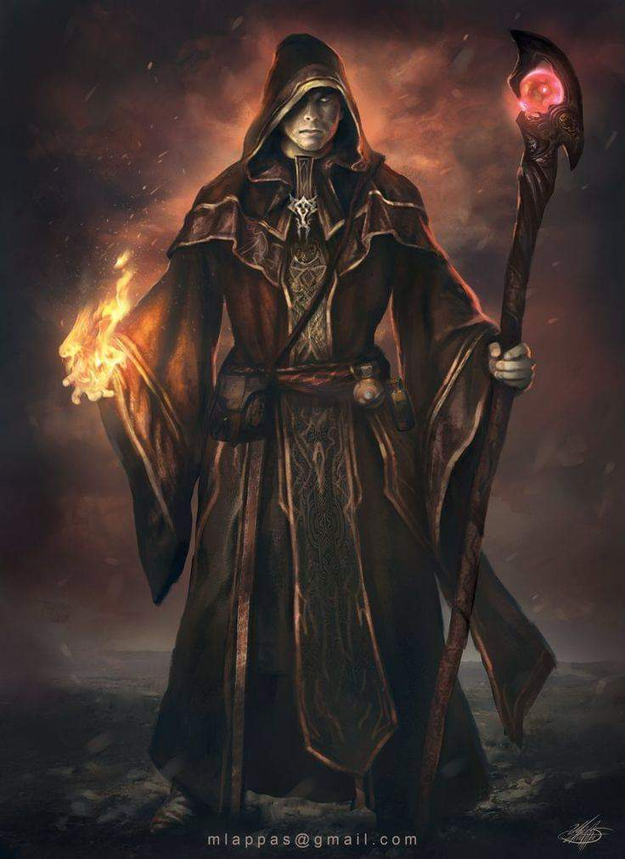

Who cast *ray of exhaustion [expired on Round 324]* upon Barkley.

|  |  |  |  |  |
| --- | --- | --- | --- | --- |
| **Ranged Weapon** | **Dmg.** | **Atk** | **Roll** | **Check** |
| Ranged Touch Attack | Exhaustion | +8 | *1* | 9 |

*Miss.*

“Blast!” the necromancer’s Thayyanesque accent became apparent.

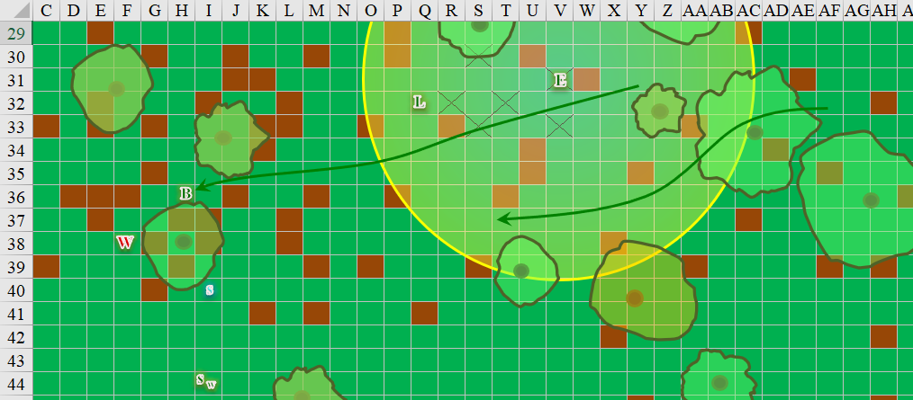

Round 223

Barkley could see the evil aura around Who’s robed form, which was *protected from good* creatures. The archon continued to charge at Who, hoping to gain some advantage from his charge even in his weakened state.

|  |  |  |  |  |  |  |  |  |  |  |
| --- | --- | --- | --- | --- | --- | --- | --- | --- | --- | --- |
| **Melee Weapon** | **Dmg** | **D+** | **TH+** | **Critical** | **Type** | **Wt.** | **Atk** | **Roll** | **Check** | **Properties** |
| Bite | 1d8 | 2 | 2 + 2  Charge | 20 | Piercing | - | +9 | 2 | 11 | Sanctify Natural  Attack +1 dmg |

*Miss.*

“Curses!” exclaimed Elsabet! Her foot hurt, and her *silence* spell had failed to silence the necromancer. She took a moment to cast *cure minor wounds*, then moved forward *[randomly determined, SW path]* slowly, shining her light upon the caltrops-peppered ground and picking her way carefully, trying to avoid the caltrops.

*Elsabet gained 1 hp [44/48].*

From their vantage point, Saradette and Solstice could now see the precipice of a cliff perhaps 80’ to the southwest, and they could hear the river clearly now. Solstice wasted no time in trying to bring down Who.

|  |  |  |  |  |  |  |  |  |  |  |
| --- | --- | --- | --- | --- | --- | --- | --- | --- | --- | --- |
| **Ranged Weapon** | **Dmg.** | **D+** | **TH+** | **Critical** | **Rng.** | **Wt.** | **Atk** | **Roll** | **Check** | **Notes** |
| MW Blowgun | 1 | 1 | 2 | x2 | 10’ | 0.1 | +12 | 18 | 30 | +3d6 Sneak |
| Blowgun, 2nd Attack | 1 | 0 | 2 | x2 | 10’ | - | +7 | 10 | 17 | +3d6 Sneak |

*Hit, miss. Dmg: 1 + 9 = 10.*

Saradette moved westward, and fired on the necromancer with her launcher.

|  |  |  |  |  |  |  |  |  |  |  |
| --- | --- | --- | --- | --- | --- | --- | --- | --- | --- | --- |
| **Ranged Weapon** | **Dmg.** | **D+** | **TH+** | **Critical** | **Rng.** | **Wt.** | **Atk** | **Roll** | **Check** | **Notes** |
| Sabot Launcher | 6d6 | - | 0 | 15o cone | 50’ | 5.0 | 7 | 4 | 11 | 38 charges (Launch Item) |

*Miss.*

Widget chirped and sneered at Who.

Seeing a path forward among the bushes, and having *hopefully* made his way past the tiny towers of pin-pricking pain, the bard joined Barkley in engaging the necromancer, his voice continuing to bolster his friends and himself. Given his speed, he failed to spot another handful of caltrops that got in his way.

|  |  |  |  |  |  |
| --- | --- | --- | --- | --- | --- |
| **Melee Weapon** | **Dmg** | **Type** | **Atk** | **Roll** | **Check** |
| Caltrops | 1 | Piercing | 4 | 5 | 9 |
| Caltrops | 1 | Piercing | 4 | 15 | 19 |
| Caltrops | 1 | Piercing | 4 | 8 | 12 |
| Caltrops | 1 | Piercing | 4 | 16 | 20 |
| Caltrops | 1 | Piercing | 4 | 18 | 22 |

*Miss, hit, miss, hit, hit. Dmg: 15 [20/36].*

The bard miraculously pulled off another acapella feat of staying in tempo as he stepped on three caltrops. He did, however, come to stand about 25’ short of where he’d intended to be by now.

Realizing how powerful the archon was, Who backed away 5’, then cast *hold person* on Saradette after she shot him. He knew he could not affect the archon Outsider with this spell, but he had little other recourse at this point, and it was evident on his face.

|  |  |  |  |  |  |  |
| --- | --- | --- | --- | --- | --- | --- |
| **Save vs.**  *hold person* | **Rank** | **Ability**  **& Mod.** | **Misc.**  **Mods.** | **Total** | **Roll** | **Check** |
| **Saradette, Will** | **3** | **Wis (+0)** | 0 | 3 | 14 | 17 |

*Success. Effect negated.*

The necromancer saw his own failure in bringing the gnome to a standstill, and shook his head, exhaling with a look of calculating despair.

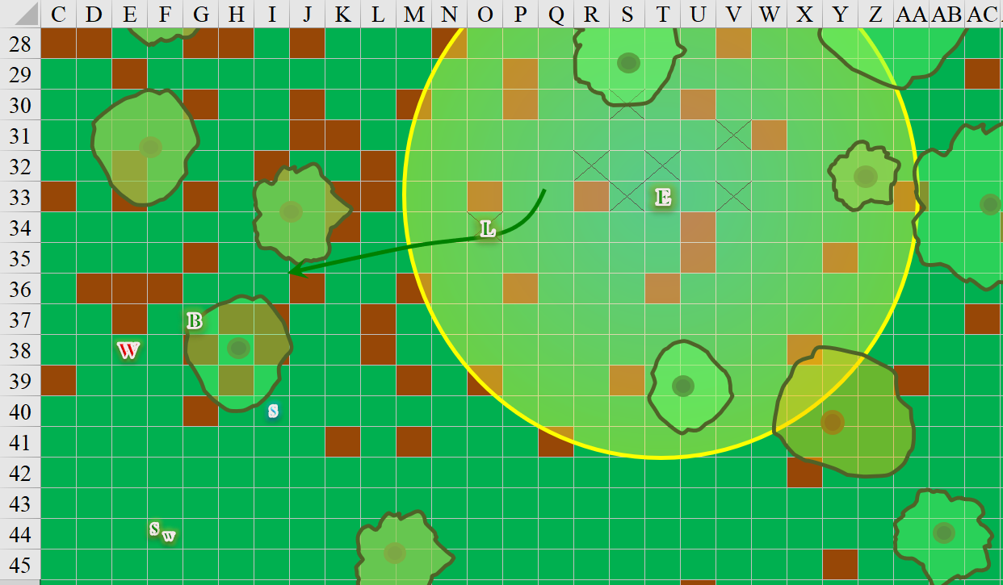

Round 224

Elsabet began to hustle again. If she had misjudged, hopefully she would get lucky and none of the caltrops would penetrate her boots, but if it did, she planned to stop and use another orison to fix the movement issue again.

Solstice fired at Who with his blowgun again.

|  |  |  |  |  |  |  |  |  |  |  |
| --- | --- | --- | --- | --- | --- | --- | --- | --- | --- | --- |
| **Ranged Weapon** | **Dmg.** | **D+** | **TH+** | **Critical** | **Rng.** | **Wt.** | **Atk** | **Roll** | **Check** | **Notes** |
| MW Blowgun | 1 | 1 | 2 | x2 | 10’ | 0.1 | +12 | 10 | 22 | +3d6 Sneak |
| Blowgun, 2nd Attack | 1 | 0 | 2 | x2 | 10’ | - | +7 | 17 | 24 | +3d6 Sneak |

*Miss, miss (due to protection from good).*

Barkley closed with Who once more and attacked with his teeth and claws. He wanted to end the necromancer’s existence right here and now. He wanted to put an end to the man’s evil.

|  |  |  |  |  |  |  |  |  |  |  |
| --- | --- | --- | --- | --- | --- | --- | --- | --- | --- | --- |
| **Melee Weapon** | **Dmg** | **D+** | **TH+** | **Critical** | **Type** | **Wt.** | **Atk** | **Roll** | **Check** | **Properties** |
| Bite | 1d8 | 2 | 2 | 20 | Piercing | - | +7 | 4 | 11 | Sanctify Natural Attack |
| Claw 1 | 1d4 | 1 | 2 | 20 | Bludgeon | - | +6 | 18 | 24 | Sanctify Natural Attack |
| Claw 2 | 1d4 | 1 | 2 | 20 | Bludgeon | - | +6 | ***20*** | 26 | Sanctify Natural Attack |

*Miss, hit, threat. 1d20 = 18 + 6 = 24. Critical hit. Dmg: (2 + 1 + 1 + 2 Courage) + ([2 x 3] + 1 + 1 + 2 Courage) = 6 + 10 = 16.*

Saradette got a pop in too.

|  |  |  |  |  |  |  |  |  |  |  |
| --- | --- | --- | --- | --- | --- | --- | --- | --- | --- | --- |
| **Ranged Weapon** | **Dmg.** | **D+** | **TH+** | **Critical** | **Rng.** | **Wt.** | **Atk** | **Roll** | **Check** | **Notes** |
| Sabot Launcher | 6d6 | - | 2 Courage | 15o cone | 50’ | 5.0 | 9 | 10 | 19 | 37 charges (Launch Item) |

*Miss.*

Luran sang with more certainty of success now that the group had converged on the villain whose fanny pack of material spell components was almost depleted.

Who cringed at the flechettes that his *mage armor* deflected, then opted for the path that would prolong his life; self-preservation and the opportunity for immortality were the principal predictors of a certain necromancer’s actions. Those few who had by some means acquired lichdom or some other form of undead immortality were an exception, so it stood to reason when this fool put up his hands and got on his knees, begging for mercy in the Common tongue, that he was still a living being in every sense.

Barkley and the others who could now see Who were fully cognizant that the man likely still had some spells up his sleeves, though it could be assumed that he’d spent the biggest jewels in his crown already, leaving him with minor nuisances, or the like. Then again, he may have had at least one deadly touch spell still in his portfolio.

As she got closer to the action, Elsabet could sort of see Who, who seemed to be pleading for his life, but she suspected a trick. With a swift action, she shifted into her leading the charge stance, in case she or one of her allies needed to suddenly charge Who or some other foe lurking nearby.

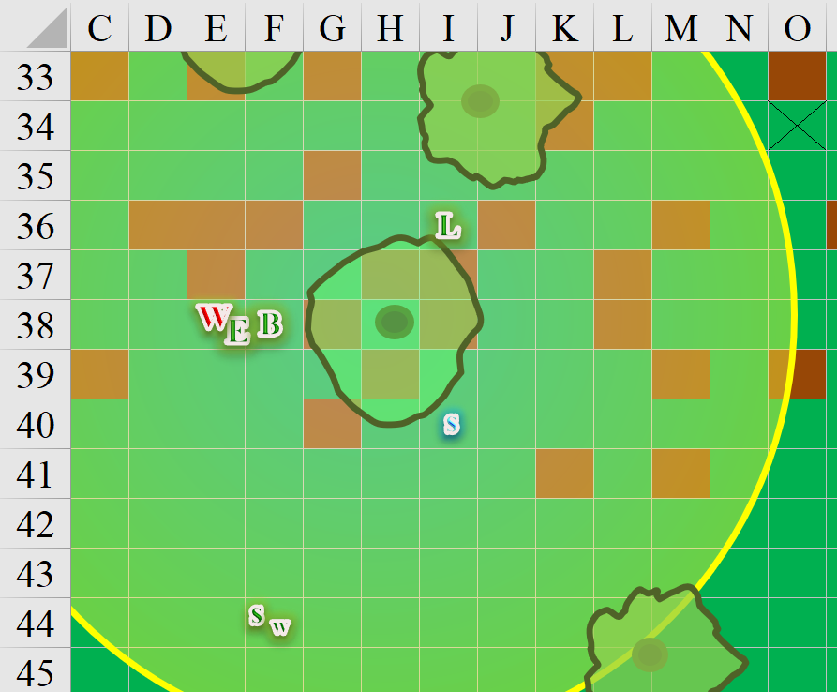

Round 225

Barkley stepped up to Who, placing his sword at the man’s throat. “My friend is going to cast *sleep* on you. If you resist, I will slit your throat.” Barkley looked directly into Who’s eyes, and bared his teeth to reinforce his threat to Who.