Chapter 29: Rockhard Spatworst

4 Tarsakh

Saradette woke up next to Stratus, having slept consistently, though not soundly, throughout the night. She rose quietly as to not disturb her massive lover, donned a robe, and padded down to the bath to wash and prepare for the day.

~*~

Back at the Missing Minotaur, Elsabet woke up early, quickly took care of her morning ablutions, got dressed and geared up, and went down to breakfast. While enjoying her meal, she pulled out her journal and started recording the events of her dream, and smiled as she remembered how the dire wolves had shredded her enemy.

It occurred to her that she hadn’t bothered to loot the body in the dream, and shrugged. It was unusual for her, but who knew, maybe unlike some previous dreams the gear wouldn’t have come back to the waking world anyways. When Tore came down, she asked him to join her, and wondered if he remembered dreaming the same dream. If so, she asked him, if he pleased, to recount his own experiences. She noticed he seemed intrigued by her writing in what appeared to be a wizard’s spellbook, and she told him it was the easiest way to get a goodly amount of high-quality paper already bound and ready for the quill.

~*~

Tore awoke, and found himself in his room at the Missing Minotaur. He sat upright in bed and looked around the room. For several seconds he was puzzled as to what had happened. It had seemed as though he was in a desert, yet now he was back in his room at the in. Getting up, he quickly dressed, wondering if the dream had been a warning of coming events of if it had been something different. Once he was dressed, he headed for the door, intent on checking on Saradette and Elsabet.

Tore and the Fist of Light ladies had been asked to return to the Baron’s Keep at Highsun for a more specific set of directives, and the three were now simultaneously preparing themselves for such a meeting.

Stratus would be there too, and he now combed the platinum locks that draped down from his pale, barely celeste head.

Barkley and Solstice were already missed, but their words and deeds lived in the hearts of their friends, and as Elsabet, Saradette, and Tore looked to the future, the sun rose and shone in through their respective windows, announcing the promise of fair weather and good omens.

When Tore finally met up with Elsabet and Saradette, he asked, “Did either of you have a dream or vision of being in the desert? I had the most unusual and vivid dream last night.”

~*~

Highsun
The Baron’s Keep

The heroes were once again in the conference room, but this time they and about ten others were asked to stand as the Queen of the Sky Tree and the Baron of Mintar sat at opposite ends of the rectangular table, finalizing the officiated parameters of the armistice between the two. It did not take long for the point to be made that Elsabet, Saradette, and Tore had been selected for a special diplomatic mission. They were to intercept the orcish advance, effect a parley with their leader—Rockhard Spatworst (CE cleric of Gruumsh)—and by way of posing Mintar as a serious force to be reckoned with, and by gaining a better understanding of the orcish army’s motives, broker an understanding that avoids bloodshed at the gates of Mintar.

In the event of their failure, two other teams of specialists—comprised of the ten or so other folks not seated—would be dispatched to weaken and otherwise discourage the orcs.

One team was called the Woodland Striders, and was comprised of a satyr, a centaur, a wemic, a hybsil, a jungle elf, and a ghostwise halfling. The other five were a band of Humanoids known as the Supermuscled, and excelled in straightforward, brawn-based combat, while the Striders were more of a sniper force better suited to subterfuge-oriented guerilla tactics. In most cases, it would have been arrogant and foolish to presume that a group of less than 20 specialists was a match for a force of hundreds of war-hungry warriors, but in this case, Elsabet’s and Tore’s knowledge of history, and Elsabet’s deeper knowledge of the local nobility, were enough to project a fairly confident light on the perception that the Baron likely had other cards up his sleeve. Intuition led the cleric and the favored soul to assume that there might be an additional, deeply covert team acting in tandem with theirs, perhaps gathering intelligence that could be quickly conveyed by magical means. Elsabet was aware of a few diviners in the Baron’s employ who were qualified to engage in such espionage.

At the same time, the Euphemes II of Ulfren and Queen Ghym knew full well that the most likely response to a diplomatic overture would be a scoff and a beheading of any emissary who couldn’t hold their own, hence the recruitment of the highly skilled specialists present.

Stratus had been selected to navigate a small (for a giant), roc-drawn air-wagon that would take the Fist of Light—including Tore, who had been queerly mistaken for Barkley twice during the meeting—eastward. The Supermuscled and the Woodland Striders would each also be ferried by another giant on another air-wagon. They were to fly as a convoy at first, and then the Fist of Light’s wagon would take front point while the others lagged far enough behind to be able to dart away if the lead ship was spotted.

Each air-wagon would have a Wand of [divine] Sending (CL 7), and Tore had been designated to be the user of the wand on her vessel, as he was the most appropriate person to manipulate it. The wand was affixed to the co-pilot’s console, and removing it would disable its properties, which were partly powered by the vessel. The wands had hundreds of charges, and they were urged to send as many messages as were warranted to communicate noteworthy intel as they progressed.

“When would we set out?” asked Stratus.

“We will eat shortly,” his Queen stated, “on the Sky Tree. The banquet should be ready soon. Once we’re all fed and ready, you’ll make way.”

Elsabet looked at all the people assembled at the war council and gulped a bit at the responsibility she and her team were shouldering, but she would do her best. She joked, “I don’t suppose we have anyone capable of causing an earthquake, do we? I’m thinking that could swallow up a bunch of troops and knock their war engines apart.” She knew that was very high level magic, but figured she would ask.

Saradette knew a guy, but hadn’t seen him in years. The Baron and Queen conferred a bit, and partly addressed the question with the statement that both forces had capable evokers, but the earthquake spell was a tricky one to pull off. There was mention of a treaty with a band of goliaths to the northwest whose leader had such a power, but they were allegedly dealing with a xorn infestation and unable to do much for others at the moment.

“On a more serious note, assuming the orcs honor a flag of parley, I will need to know some basic rules for what I am allowed to reveal to threaten them with, what I can imply, and what I am not allowed to mention. In particular, do I let them know Mintar has Cloud Giant allies or not? Is Stratus joining us at the parley or staying with the air-wagon? If they have scouts or spies, they may already be aware of this, and of course they will likely see our reports—it is hard to miss the broad wings of a roc, after all.”

“Excellent questions, heroine,” Queen Ghym began. “It would be best if we presented a position of strength and unanimity between us and the Barony. If the orcs perceive us as squabbling enemies of one another’s enemies, they are likely to be emboldened—not dissuaded—and I fear you would become their sacrificial offering to Gruumsh and other deities of the Orcish Pantheon.”

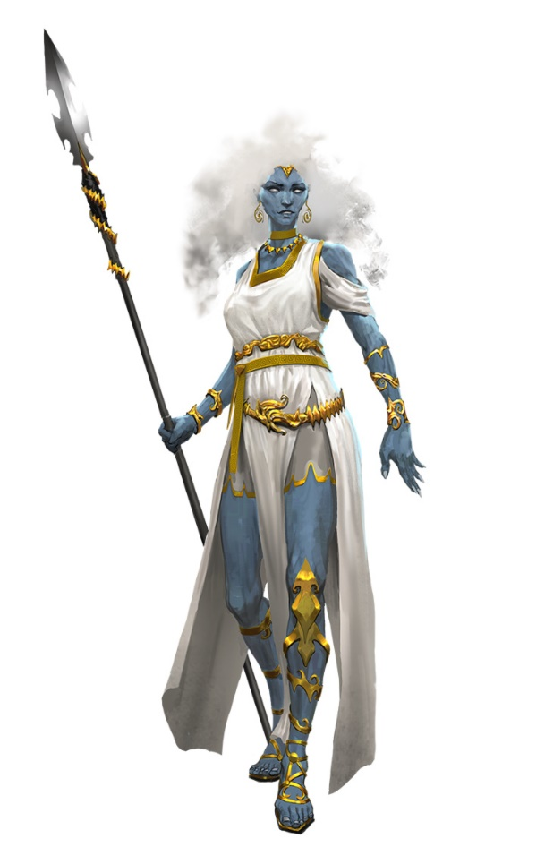

Stratus [played by Benedict Cumberbatch] added once his Queen had stopped speaking, “I’ll be glad to join you all, but I’m not much of a talker. I should just flex while you all speak to the orcs.”

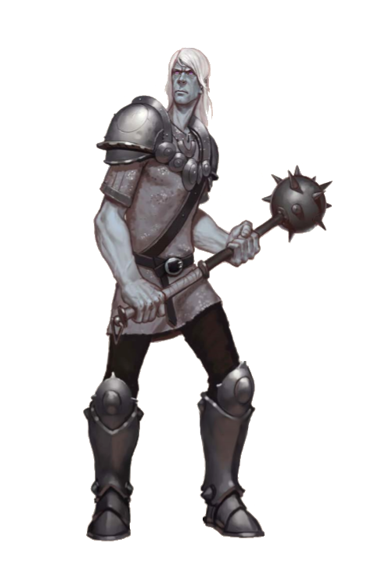

“Right, nobody our size brings a fella your size to a negotiation unless they’re trying to say something without talking,” the wemic purred and smirked.

She paused as a few folks chuckled. “Do I reveal how much we know of their forces, including their reinforcements, or not?”

“Play it by ear, warrior of the Shieldmaiden,” the Baron urged her. “If it is to our advantage in the discussion to present humility to test the orcs, then conserve that information in your sleeve until the moment when it is preferable to make Rockhard know that he has been under our spyglass.”

“And most of all, I assume that while we expect the orcs to reject our offer to let them live as long as they turn away from Mintar and its outlying holdings; if we do succeed, what exactly do we require of them, and are we offering them any other incentive besides their lives? Of course, we may first need to hear their demands, but if they ask for tribute, say, is that negotiable or do I insult them with an offer of a pittance?”

“One thing we have not ascertained is the true motive for Rockard’s Exodus from his homeland. He would likely face dishonor if he were to turn back emptyhanded, so asking him to do that amounts to picking the fight we want to avoid,” Prefect Bratislava interpreted the Baron’s and Queen’s earlier statements.

“Aye,” the Baron concurred. “I have half a mind to supply him with what he needs, and turn his attention on Thay and other polities that have historically brought misery upon Murghôm, particularly upon its monstrous humanoids.”

Elsabet informed the Baron, the Queen, and the others that she and her companions had an odd, partially shared dream the previous night, and briefly described it. “And if I see that orc plague speaker in reality, I intend to ask him how it felt to be devoured by dire wolves in a nightmare...”

A cleric of Azuth stepped forth from the periphery of advisors and analysts, and proclaimed, “I as well... and I saw three figures speaking near a ruined coliseum in the desert. I could not make out their faces, but their silhouettes bore a resemblance to you three.”

Some of the oracle adepts who regularly interpreted such visions and dreams nodded to one another, and a general accord ensued that this mission was divinely guided by the forces of Good, and would triumph because its cause was blessed, and supervised by the deities themselves.

“Yes,” the Queen half-joked, “but let us not depend on divine intervention to succeed. We would still do well to make an effort to succeed as if the odds were stacked against us.”

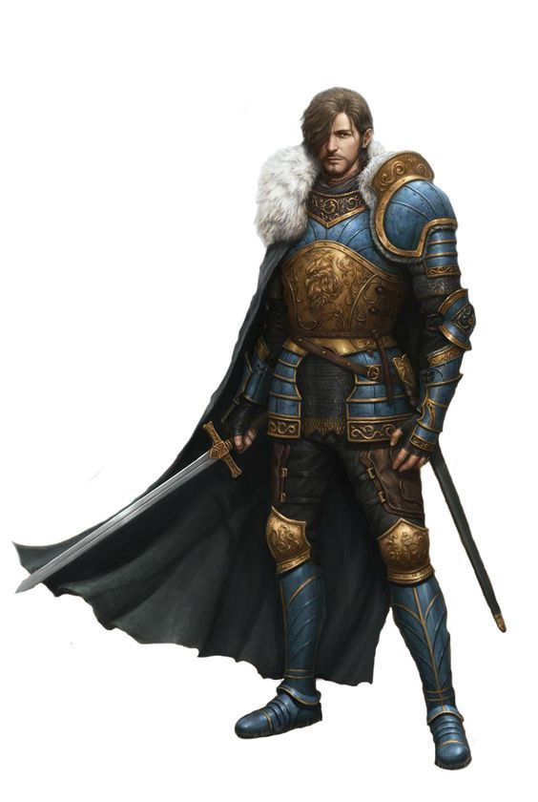

Just then, the Baron’s son—Euphemes III of Ulfren—entered the room without announcing himself. The guards knew better than to stop him, and as he paced towards the table with haste, he simply said, “I hear we’ve reached a consensus on the orc advance. I would represent you, Father, in our negotiations with the-”

“Silence!” the Baron interrupted him. “We’ve discussed this, and I cannot afford to have my son be taken hostage by these orcs. You will remain here!” There was undoubtedly some history of tension between the two nobles.

“Father, you cannot send these foreigners to represent us,” the son pled.

“These are no foreigners,” the Baron motioned to the heroes attending the discussion. “Were it not for them, we would be in a precarious state indeed. Why, these two women—” he pointed to Elsabet and Saradette, “they saved your father not a year ago from the wereserpents that had infiltrated our sanctum.”

“Father, I...”

“You will stay! That is my final decree on the matter.”

The younger man was about to continue to protest, but his face then showed that he likely had an alternative strategy for defying his father’s wishes, so he remained silent, chin up, as his father regained his composure and adjourned the meeting. “I am grateful to you all for your service to our City,” he looked at the recruited heroes, “and for your armistice,” he added, facing the Queen.

“And now,” the Queen invited, “we dine.”

~*~

The Sky Tree was as they remembered it. Saradette had already visited the night before, and Elsabet now nodded as she walked along the familiar causeways and towards the ample courtyard where a banquet had been prepared.

“You know,” Saradette mused as they walked along, “I can’t understand what the army would gain by attacking Mintar. By now, the Baron, and every other place around, is raising their militias. Individual skill matters little when they are outnumbered twenty to one.”

Tore was glad that Elsabet did most of the talking. She was much more familiar with all of those present, especially the giant guests. He would have been happy to offer assistance and advice once they were in the field and he got a feel for the orcs’ reactions.

When the Viscount had come in and argued with the king, Tore was a bit surprised. Tore was certain that this would not be the last they saw of the Viscount. When they went to the Sky Tree for dinner, Tore followed behind Elsabet and Saradette, as they seemed to be familiar with the layout of the structure. Tore sat and ate his fill, and thanked his hosts when the meal was over.

Elsabet called out to the giant warriors she remembered from sparring sessions as they walked towards the banquet, exchanging greetings and good wishes. In a lower voice, Elsabet conferred with her friends, including Stratus. “I suspect Lord Euphemes might be planning to stow away on our vessel in order to be present at the parley. I think we should search the vessel carefully before casting off. If we find him, we’ll need to persuade him to remain behind without causing great offense, or embarrassing the young lord.”

Tore nodded, “Yes, it would be good not to embarrass him, but should he be persistent we may have no choice but to make it embarrassing.”

Whatever the result, Tore thought, it would be the princes fault if it went badly.

Tore shrugged his shoulders, “Perhaps they have been displaced by a more powerful tribe or creature. Perhaps their leader needs to prove his worth in order to establish his legacy. Until we meet with them, there is no knowing. They may also think that we will not unite to fight them. Who knows?”

~*~

As they were boarding their craft they heard a barely familiar voice behind them, and turned to see that—sure enough—the Baron’s son was now making his way over with an entourage of bards and scribes. Stratus rolled his eyes, turning back to the reins that kept the rocs in place for now.

“You!” Euphemes III called out, misremembering their collective name: “Heroines of the Light, I will join your ship.”

Upon hearing this, Stratus turned to look at the half-dozen sycophants behind the man who held the title of Viscount, and was even destined become Baron due to the death of his elder brother on the battlefield. As the intended successor of the Mintari Barony approached, the cloud giant protested politely, “Milord, I doubt we can take all of your scribes.”

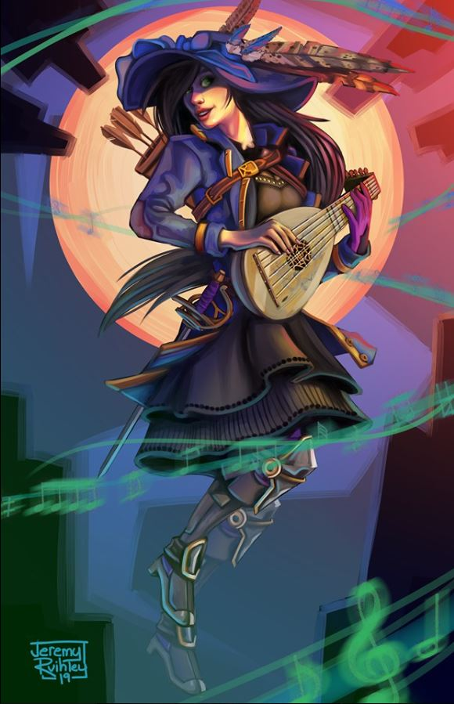

It took the Viscount no time to reply, “Not to worry. It will just be Jazz and me,” he motioned to the well clad woman who was already saying goodbye to the rest of the poets and amateur historians behind Euphemes III. “She’ll be sure to wring a tale of this mission that will be sung for generations.”

They boarded the giants’ craft as if it belonged to the Viscount, inspecting its interior for notable flaws, and greeted each of the heroes aboard with a bit less pomp than before. Jazz sat near the window, where the light allowed her to write down the names of the heroes she was now meeting, and finding words that rhymed with each name. “Tore: that’s a good one,” she congratulated the cleric on his parents’ chosen moniker for him.

Tore would have been more than happy to step in the lord’s path and block his way. Stating what was said by his father earlier, “As the Baron has said, you will stay. This task has been entrusted to us and you will be needed to lead and inspire the Barons army should we fail.” That was the extent of Tore’s attempt at diplomacy. Next would be embarrassment.
Skill | Rank | Ability & Mod. | Misc. Mods. | Total | Roll | Check
Tore, Diplomacy | 0 | Cha (+1) | 0 | 1 | ?? | ??
See below.

“Fool!” the nobleman stepped up to the cleric with an air of civility and pomp. “My father has reconsidered, and has placed you beneath me!” he pointed out, revealing a rigid and rustic sense of hierarchy indicative of living within stone walls one’s entire life. “Prefect!”

Bratislava had heard the disagreement, and was already making her way over, “Milord, we were under the misconception that you were to remain, but if the Baron has decreed this, then it will be so.” She tried to amend the rupture in the pecking order that would no doubt develop throughout the journey.

Tore was disappointed that Bratislava didn’t have anything more substantial, but he still trusted her gut. He made a mental note to keep an eye on the giants should things begin to make a turn for the worst. He turned to Bratislava, “If he speaks the truth then there should be no problem in using the communication wand in the chariot to confirm this.” Tore then looked into the Viscount’s eyes. “If you are telling the truth, you are welcome to join us. If not, I will be more than happy to escort you back to the keep like a disobedient little brat.” Again, everything is said in an even and matter of fact tone.
Skill | Rank | Ability & Mod. | Misc. Mods. | Total | Roll | Check
Tore, Diplomacy | 0 | Cha (+1) | 0 | 1 | Middling | ??
See below.

The Viscount had had enough of this stranger. “Prefect, see that this insolent upstart is taught a lesson in civility.”

“Sire?” Bratislava was unsure as to what that meant.

The Viscount looked the Neverwinterite up and down, and proclaimed, “I take great umbrage before this outlander who would presume to interpret my father’s wishes. If you feel we need him on this expedition, by all means, do disarm and cuff him to that bronze bar there. Otherwise, see that your women and men accommodate him in the stockaded brig.”

Bratislava gazed at Elsabet with a regretful look, and asked, “Do you trust this man?”

In response to Bratislava's query, Elsabet gave a brief nod.

The Viscount was preparing to escalate the condemnation of the cleric to confinement in the brig when Elsabet placed a hand on Tore’s shoulder and tried to defuse the situation. “Milord Viscount, I suspect in your laudable and enthusiastic attempt to prove yourself to your father, that you heard what you wanted to hear. We all know of your courage and honor. But do consider, if your father were to lose his only remaining son, it might break his heart beyond repair. And this mission, even were you to lead it, has only a small chance of success—this orc priest may well be unreasonable or even insane. Let us be the ones to risk our lives. And, if things go badly, let us bear the dishonor of running from a fight rather than dying heroically against impossible odds.” She nodded to the bard behind him, with a plea for her support here.
Skill | Rank | Ability & Mod. | Misc. Mods. | Total | Roll | Check
Elsabet, Diplomacy | 9 | Cha (+2) | 4 | 15 | Middling | ??
See below.

The nobleman nodded, scratching the black hair on his chin that looked like an attempt to copy his father’s gray goatee. The favored soul of the Shieldmaiden continued.

“Such deaths are often sung about by the bards—though only if one lives to write the song about them. Living well in service to one’s people, denying oneself the glory of a last bloody fight in order to help them prosper, is truly the more noteworthy path. The job of a true ruler is to look out for all their people, and sometimes that means staying behind and ordering others to carry out tasks the ruler yearns to do themself. I have no doubt your father the Baron would also prefer to meet this orc priest face to face, but a good leader knows when it is needful to delegate such tasks to others.”

She looked the Viscount straight in the eyes, and concluded, “As a favored of Mayaheine, my goddess has shown me that you have the potential to be, not just a good ruler, but a great one, beloved by all your people for many decades to come. Do not let today’s disappointment cause that potential to be lost, my lord, for your peoples’ sake.”

She then bowed deeply to the Viscount, praying he would take her words to heart.
Skill | Rank | Ability & Mod. | Misc. Mods. | Total | Roll | Check
Elsabet, Diplomacy | 9 | Cha (+2) | 4 | 15 | Middling | ??
See below.

The human noble was won over by Elsabet’s eloquence. She had managed to build a rapport with Yufi that might have been sustained by anything short of another verbal blunder.

Saradette then stood up next to Elsabet. “Perhaps we should save the fighting for the enemy,” she said calmly. “We are not your subjects, and so we are not subject to your orders. If you persist, then we will leave you to fight this battle on your own.”
Skill | Rank | Ability & Mod. | Misc. Mods. | Total | Roll | Check
Saradette, Diplomacy | 0 | Cha (+0) | 0 | 0 | Poor | ??
See below.

The Prefect stepped in before Elsabet’s friends could do any more harm, stating, “Comrades in arms, the point that we have a common enemy is well taken, and should be our grounding premise this day. I urge everyone to take a seat that we might lead this convoy eastward.”

The heroes knew the Baron to be an honorable man—weak willed on his worst day—but fair minded, and as Bratislava confirmed that the Viscount was indeed to “commandeer” the air wagon, it was confirmed that Yufi would not take part in the parley with the orcs. He would remain within the craft, and no mention of his presence should be made. Bratislava informed everyone of this, and as she placed Tore’s weapons in a locker along the cloud giant wagon’s wall, she studied Yufi’s face to ensure that he wasn’t planning on deviating from his father’s conditions.

The Viscount made eye contact, and nodded, then returned his gaze towards Saradette’s bosom.

Saradette moved up to stand next to her lover. “We have a slight problem. It seems that the good Viscount here has taken offense to Tore’s tone.”

As they continued to fight over who was really in charge, Bratislava reluctantly asked Tore to disembark. “These guards will escort you back out,” she added.

As Bratislava went to cuff Tore, he held up his hands, “No need, I can see myself out. I can see when my services to the Baron are no longer needed.” He then turned and eyed the Viscount, “If you think the medal is not deserved, try achieving your own.” He then stepped out of the chariot and awaited his escort back to the Baron’s Keep.

Frustrated, Saradette goes back to Elsabet. “What do we do, now?”

Elsabet spoke calmly and quietly to Saradette. “We do the job. To be honest, we haven’t known Tore very long; if he doesn’t know how to play nice with entitled nobility, I worried how he would act in ‘negotiations’ with this nasty orcish piece of work we are supposed to chat with. Hopefully he’ll be fine once he cools down and we will get back and be able to rejoin him for less political activities. I think his heart is in the right place, and I have similar concerns as he did. But I think the Viscount will do fine if we treat him right without licking his behind.”

She paused, in case the gnome artificer wanted to respond, and then continued. “I have been working on getting along with folks my whole life. You gotta be able to understand how they see things, before you can bring them around at least partway to you own viewpoint. If you have a wheel on your fancy wagon squeaking a lot, sometimes you just gotta oil it, but sometimes you got broken bits you gotta replace.”

She took a breath, knowing the analogy was pretty rough. “And you can’t just go bossing people around all the time - intimidation may work in the short term on some folks, but lasting cooperation requires a more subtle touch, as we found out last year when we had to get into the Keep to save the Baron. I had a spoiled brat younger brother back home—that was my first exposure to the concept of diplomacy. My dad, the herbalist, said, ‘you catch more flies with honey than with vinegar’, which I eventually figured out you get more accomplished by being nice to people than by being rude. Took me a while to learn that lesson though.”

“You can catch even more flies with manure,” Saradette muttered darkly. “I will stay with you, but I won’t tolerate being manhandled.” She lightly touched her blaster as she spoke.

Elsabet thought aloud: “If there are animals, I can talk to them. If the orc priest has guard dire wolves or something, my abilities could come in handy, particularly if I can befriend them. Befriending such creatures could even raise the orcs’ opinion of me, if played properly.”

~*~

Tore was promptly and politely escorted to the Keep’s outer gate. The guards that did so had been apologetic of their Viscount. “With any luck, he may see some action today, and get some hair on his chest,” one of them tried to make Tore feel better, but it was evident that the cleric was more than just a bit offended by the knave aboard the air-wagon that even now coursed over their heads from the Sky Tree to wherever the horde marched.

Tore thanked the guards adding, “You do not need to apologize for someone else’s behavior. I wish you all well and pass on the blessing of Lurue.”

When they mentioned the Viscount seeing action, Tore shook his head. “Though a good fight not inside of a practice ring may do him good, I fear that in this case it would mean the death of the entire negotiation team. That is one of the reason the Viscount should not be there.”

~*~

Jazz and Yufi were busy whispering lewd things to one another and giggling. In the front cabin—an open air bench with some scaffolding and harnesses—Stratus guided the rocs ever eastward, and had been doing so for a few hours now. The sending spells had been useful to Elsabet for transmitting a few key landmarks that let the Baron’s lead diviner—Calypso the Steady—know where they were. He, in turn, sent back some estimates of when they might begin to spot the horde. The diviner’s estimates to a rendezvous had been 6, 4½, and then 2 more hours or so if the orcs were marching at the same pace they’d maintained the day before when his scouts had last reported. They kept the main road in sight, expecting the march to use this convenient path.

As they flew over the norther shores of the Lake of Steam, they spotted a migrating flock of aarakocra flying in a V formation, and even saw a copper dragon in the distance. Later, they’d evaded a social gathering of balloon-riding socialites over the city of Saelmur, which—by the amount of siege engineers manning the tower-top ballistae, looked like it was mobilizing for a defensive stance against the orcish army.



They noticed that Ankhapur—the next city along their route—was already building palisades and other makeshift defenses outside the greater metropolitan area that had been built up over the course of the last century or so. Having passed this ancient city, Calypso asked them to fly along the path of the road to ensure that they didn’t miss the horde. “They can’t be far now.”

About an hour after Calypso’s last communiqué, as the still yellow sun dropped towards the oranging horizon behind them, Stratus announced, “There they are.” He immediately slowed down the birds’ flight.



The orcs were on full march westward, and perhaps still a diagonal mile or so away. It was probable that the aircraft had already been spotted by now, and as the giant maneuvered downward, the Viscount took his mind off his lustful pursuits to stand and peer out through the giant window. Elsabet, Jazz, and Saradette—the only other passengers—made eye contact for a moment, and Jazz emitted the confident smile of someone who’d never known stage fright.

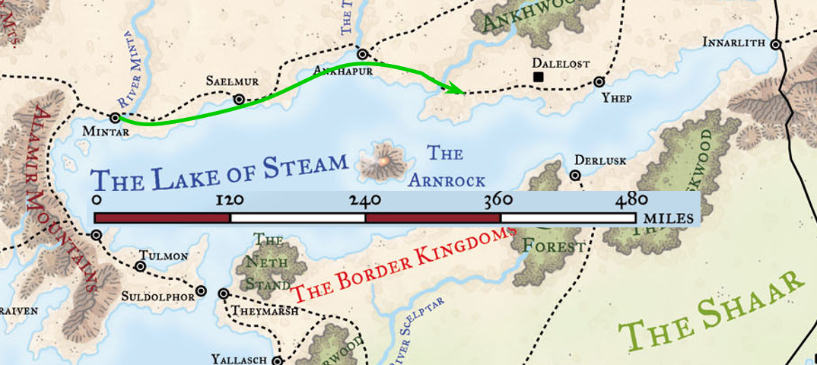

Elsabet stood up and made her way to the console that activated the sending wand in order to report to Calypso that the moment was at hand. This would let the other two air-wagons know to land and remain covertly on standby.

Stratus had half-expected Saradette or Elsabet to provide some tactical guidance, but instead they all waited for a reply from Mintar as the craft descended calmly, headed for a spot about a quarter of a mile from the frontmost marchers.

30 seconds after Elsabet’s sending message was conveyed, Calypso the Steady responded, and she relayed the telepathic reply, “Stratus, give ½-mile of distance. Don’t rush them. Support the envoys of the Baron’s and Queen’s diplomatic will. Viscount and Jazz, stay inside the vessel.”

The Viscount was triggered by what sounded like Elsabet’s words, but stayed his mouth in light of the leeway that had already been accorded to him. Even the brown-bearded knave knew the limits of his caprice, and he knew Elsabet was not making up words at the moment. The tiresome and insufferable heir scoffed, and turned to whisper to Jazz as his hand returned to the flesh under her clothing.

~*~

They’d landed, and four arbalists, an orog, an orc, a goblin, and a half-orc, had ridden ahead of the formation, though the formation continued to march at a sustainable pace, and would be upon them soon enough. “We see you!” said the half-orc ambiguously.

Elsabet could not tell whether that was meant in the present or past tense, but before she could respond, the male orc plague speaker finished looking the crusader up and down and decreed, “You come for terms of surrender. We sack Dalelost, and now we sack Ankhapur.”

“And then Saelmur, and on and on,” the orog was sure to add.

“You come we take you to Rockhard,” the goblin invited them with a spear pointed at them.

They were standing about 50’ from the air-wagon, and the rocs were getting restless, witnessing the body language and tone of voice of the dire-wolf-riding elites of the horde that still came at them. Stratus was trying to stand between the rocs and the orcs so as to minimize the stress, and remained quiet, mostly communicating that it would be a bad idea to mistreat Elsabet or Saradette.

After they landed, Elsabet had spoken briefly to the rocs, reassuring them they we would not let them be harmed. She held the parley flag in her left hand. Elsabet took a step forward, and chuckled, looking them over. First she called out to the dire wolves, saying << Hail, you magnificent beasts! We’ll talk; don’t be too hasty. >>

Then she glared at the goblin, and in her best goblin-boss accent, in Goblinoid, barked out, << Best lower your spear, mister; you have no idea who you face. >>

Then looking at the orog, she just nodded her head slightly, after which she turned to the orc, switching to Common.

“Plague speaker, greetings. We are from the Baron of Mintar and his ally, the Queen of the Sky Tree, and we will have parley with the renowned Warlord Rockhard Spatworst, Priest of the One-Eyed God. I am Elsabet, Favored of Mayaheine, here to speak to Rockhard on behalf of the Baron and the Queen, and these are my companions. Will you swear by the wrath of The White Hand to grant us safe passage as emissaries to and from your Warlord? I believe he will wish to speak with us, and perhaps benefit.”

She stood waiting to hear their replies and see their reactions, hand resting lightly on the hilt of her bastard sword, spiked knuckles shining over her studded black leather gauntlets, mithral breastplate shining in the light of the setting sun.

The orog and the orc squinted at one another and seemed to ask one another questions without answering any of them. Though both Elsabet and Saradette spoke Goblinoid, this language shared few cognates with Orcish, which was far more tonal and less mandibular than the former. Thus, the dialogue was not understood, but when it was done, both of the lead spokespersons turned to Elsabet, then back to one another, and then the orog said, “You tel’im.”

The plague speaker snarled and turned back to the human and gnome, saying, “OK.”

~*~

The human and gnome—along with their giant companion following behind—walked towards the approaching army, at the front of which was a sedan manned by four trolls, who held the stilts that sustained the chassis aloft as if it were a gurney.

One of the wolves—the one carrying the goblin—had replied earlier to Elsabet, saying that she smelled nice.

At a distance of perhaps 100’ from the heroines and four wolf riders who rode in tandem with them, a whip cracked, a command was issued, and the trolls stopped and placed the sedan firmly on the ground, whereupon the door opened, and a stout orc let himself out, studying the favored soul and artificer as he approached. He—of course—noticed the giant behind them, but had already taken a measure of Elsabet’s posture, presenting her as the lead envoy in this group, so he kept an even gaze upon her as he used his spear as a walking stick.”

“Ankhapur, I presume,” the eloquent orc spoke with a nearly humanized Common, and mistook Elsabet to be a representative of the very next city on their crime spree list. “You come to hear my terms for surrender? You come here to bargain for leniency?”

Elsabet smiled slightly—without baring her teeth—at the orc priest’s assumptions, and replied.

“No, mighty Warlord Rockhard Splatworst of Murghôm, Ankhapur is not our concern at this time. I am Elsabet, Favored of Mayaheine the Shieldmaiden. I—we—speak for the alliance of the Baron of Mintar and Queen Ghym of the Sky Tree, a cloud giant floating fortress.”

The orc leader frowned and squinted, never having heard of these people, or of the Sky Tree. “I may take you for a bride,” he simply said as if it was the most sequitur statement.

Elsabet paused for only half a second more, then continued, “As I and my friends have been of some help to both rulers in the past, they chose us to represent them both.”

By this time, Rockhard had turned his attention to the plague walker, and emitted two syllables. The plague walker dismounted, produced a map, and showed it to Rockhard as Elsabet spoke again.

“Surrender is not an option, but perhaps a mutually beneficial armistice may be arranged, through some honest discussion. But first, would you rather continue to converse in the Common tongue, or would you prefer either the tongue of giants or the tongue of goblins? You speak Common very well; alas, I have not yet learned the tongue of orcs, though someday I shall, but I have mastered those two tongues, and I suspect you have as well, given the giants and goblinoids you have gathered to your banner.”

She nodded with a show of respect to the orc, while keeping her eyes locked on his, trying to determine how her words were being received, trusting Saradette and Stratus to cover her flanks.

Saradette stood a half-pace behind and to Elsabet’s left, protecting her weak side. The gnome watched everyone and no one as she scanned constantly for the first sign of trouble.

Stratus sucked in the small gut he’d developed over the last year.

Rockhard continued to speak in Common, “You represent the rulers of a Sky Tree, yet we know of no such tree. Mintar, yes, we will pass by it, and if your Baron chooses to pay tribute to our cause, we shall pass without hostility.”

Elsabet was presented with a possible solution more quickly than she’d anticipated, though she had no idea of how much “tribute” was being suggested, let alone the nature of the orcs’ “cause”.

Elsabet explained, “The Sky Tree is the cloud giants’ name for their flying cloud island fortress; it will not be on your maps. This big fellow is from that place, we arrived in the wagon drawn through the air by the great rocs which they also ride like some of your people ride dire wolves.”

The cloud giant tipped a hat he didn’t have and held a respectful and attentive gaze.

She grinned. “I helped them fend off a foolish attack by young frost giants riding shadow dragons. I don’t believe any of the frost giants survived. It was exciting.”

She took the opportunity, since Rockhard had broached the subject, “Perhaps, if you would describe your cause, your reasons for this march, and how Mintar might aid you, some form of tribute could be arranged.”

She continued, “Let us discuss the details, so I can bring your proposals to the Baron and the Queen. I would also enjoy hearing the story of your victorious campaign so far, and your longer term goals. Certainly you have a fairly strong force, once your reinforcements catch up. Of course, numbers aren’t the whole story—size also matters...” She glanced at Stratus, then back at the rocs on the hill.

~*~

A few minutes passed, and it became clear that the orcs did actually have a cause other than sheer mayhem. The horde was now all around them, and some were sitting down to rest their feet now that they’d been ordered to halt. As he waved his hands to point out all of his extended family around him, Rockhard alleged an exodus of his people from the tyrannical clutches of a blue dragon named Borak, who was obsessed with the amassing of power, eliminating all other known dragons from Murghôm and its surrounding marchlands, and breeding a caste of half-dragons that even now overthrew chiefdom and sedentary city-state alike.

Chieftain Rockhard briefly summarized the other polities that had fled, and via sending spells—quite a popular spell lately, it seemed—he and other leaders had coordinated a westward pilgrimage on a loosely bound collection of divine inspirations imparted upon the dozen or so Chieftains who led their intrepid masses westward. They sought to converge in Ankhapur, and had reached out to as many of the cities on their path to propose an armistice against Borak, but all of these political centers’ rulers had denied the orcs an audience.

Now, every city in their path had fallen—though not without heavy casualties to Rockhard’s formerly massive horde—and the remaining cities stood little chance if the coalition of which Rockhard spoke did come to pass.

Saradette and her lover had remained calm and silent as they took in the information that the Chieftain was imparting upon the warlock. Elsabet asked if the orcs had actually reached out to Mintar’s Baron as well, and the Chieftain confirmed that Mintar had been among the first to reply with condolences. “I tell you this,” he leaned forward, “I’d heard tell of high deeds attributed to this Euphemes II, but I am not impressed, and will enjoy seeing the inside of the room where he plotted to try to buy my sensibility.”

Elsabet searched for the proper words to pivot the perception of her counterpart in this dialogue.
Skill | Rank | Ability & Mod. | Misc. Mods. | Total | Roll | Check
Elsabet, Diplomacy | 9 | Cha (+2) | 4 | 15 | Middling | ??
See below.

“Warlord,” Elsabet noted a few priorities and internal issues with which the Barony had been struggling as of late, and added that perhaps there had been some sort of misunderstanding. “Your message was not part of the evidence discussed before our dispatching,” she speculated, “It may be that it never reached the Baron.”

The Chieftain scratched his chin and looked down at the earthy road, nodding. “Perhaps... I will consider your plea to spare your city, and I care not for your friend’s Sky Tree,” he motioned to the giant with a hardwired resentment for giants. “In any case, tonight we feast! Yes!”

“I am pleased that we are able to discuss these issues openly, and honored to feast with you. As thanks for your treatment of us as guests, I offer you a gift,” Elsabet said, as she retrieved her everfull mug and held it up. “Three times per day, this mug will fill itself with water, ale, or wine, depending upon the command word spoken.” She offers it to him, and assuming he accepts, will give him the command words; she also offers to drink from the same cup.

“With your permission, Warlord Rockhard, I ask leave for us to contact the Baron and the Queen from our air wagon, to inform them of developments, that they might investigate as to why they did not know of the sendings made by your people, and that they might also set their diviners to learning what they can of this Borak and her progeny.” She paused, and continued, “We will also bid the rocs settle down for a bit of rest—your people should not approach them too closely, for they are animals and might be getting hungry—after which we would be honored to join you in feasting.”

“Aye, convey my well wishes to you leaders, and let them know that we will speak in person... in good time. Mutters!” he called the plague walker over. “Escort them to their bird ship.”

~*~

The four wolf-riding captains rode at a slow pace as Elsabet and Stratus walked with Saradette on the giant’s shoulder.

“I could get used to this,” Saradette whispered in the giant’s ear.

When they got around the slight bend around an outcropping, they spotted Yuri and Jazz petting the rocs.

“And who have you brought?” the goblin rider asked Elsabet.

Now within speaking distance, Jazz explained, “The rocs were getting hungry, and restless.”

Yuri added, “They cannot fly at night. Do you intend for us to sleep out here?”

“Who is this fool?” the plague walker conducted his wolf towards Elsabet and asked in such a way that he was only heard by her.

In a low voice, Elsabet replied honestly to the orc, “A hotheaded young aristocrat and his girlfriend. Had to take him along, but deemed it a bad idea to put his arrogance in front of your leader—it would serve neither Rockhard’s cause nor Mintar’s.” She looked at the plague speaker, hoping he would get the hint.

As they got closer, Elsabet called out to the Viscount, in a respectful tone of voice, “Milord, I am afraid we remain here tonight and leave in the morning. I have a report to make to the Baron’s people back in Mintar to inform them of our discussions thus far, with your permission—you should be present as well of course. Let us go inside the air car while our escort remains nearby. They will be escorting the three of us back for further discussion once my report is complete, while you two remain with the air wagon ensuring it and the rocs are not interfered with. They seem to like you.”

“Mmmyes, they do,” the human was affectionately rubbing one of the lead rocs behind its sensitive earhole, causing it to coo and rumble against Yufi like an approaching stampede.

She smiled, hoping the nobleman cooperated—and he did seem to be getting along with the giant birds. She called out to the rocs, << Are you fine folk comfortable? Is there anything you need at the moment? We should be flying back in the morning. >>

<< He is very nice, >> one of the rear rocs said. << Time to sleep soon. >>

<< Right. Going to sleep, >> another one concurred as she cooed.

Elsabet turned to Saradette and Stratus, and informed them of the rocs’ responses. “Can you make sure they are settled in while I make my report?” If the rocs needed something that wasn’t immediately available, perhaps she could negotiate with the orcs for it.

Elsabet spoke briefly to the dire wolves. << I admire your graceful movement and powerful muscle. Your riders are lucky to have you bear them. Will you honor me with your names? I am called Elsabet. >>

Then, to the plague speaker, she said, “Please rest here a bit while I make my report and get responses to bring back to Warlord Rockhard. And if I may say so, your dire wolves are fine animals, very well trained, and I expect very fierce in battle. I would not mind having such powerful creatures at my side.”

She headed for the air wagon to report.

Once inside, after carefully considering what to say, the crusader activated the wand on the console, waiting for the auditory static that confirmed the device’s activation, then said, “Ancient blue dragon Borak, minions, forced mass orc exodus. Rockhard amenable, wants armistice against Borak. Claims sendings sent rulers; investigate? Converging Ankhapur. Parley continues. Orders?”

She then waited for the reply, while asking Jazz to see if she could recall any songs or lore regarding Borak.

~*~

Earlier that day...

Tore had run into a sailor friend—Connor—and now found himself afloat his boat in the Lake of Steam, exploiting a southerly front as he and Connor headed for a desolate stretch of sand called Asper’s Flats. Inaccessible by wagons, and difficult enough to reach by horse or foot, the area was once overrun by feral humanoids, but had in recent decades been depleted of such biodiversity. It lacked any sort of harbor or permanent structure, though huts and shanties seemed to brave the coastal erosion, occupied by whosoever could make it out there.

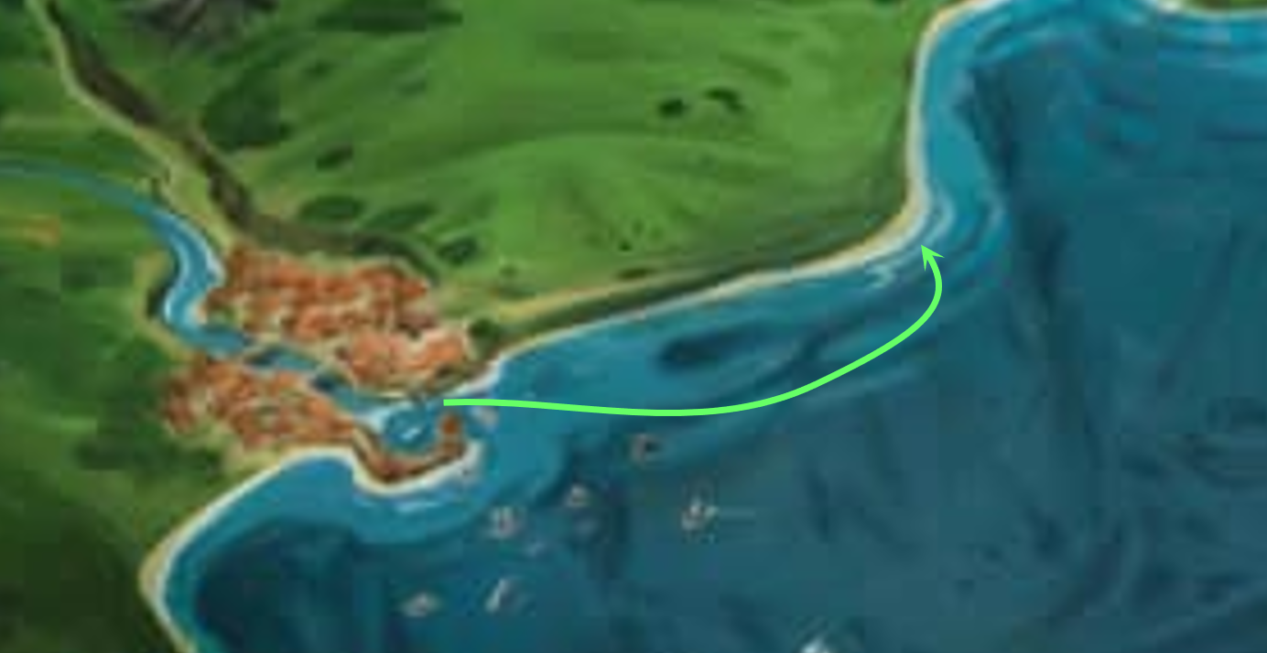

It was a wonderful place to visit, and despite the claims that the land had been “tamed”, he still had his rod of force and other adventuring accoutrements aboard. There was nothing onto which to moor the 24’ daysailer, so they lowered a modest anchor down about 40’ and got into the dinghy they’d been towing behind them, which they’d just packed with food, drink, and some camping gear in case they decided to stay the night.

It took a few minutes to row along the shallow, rippling waves.

Connor was slightly shorter than Tore and of about average strength. However, he more than made up for it with his agility and charm. As Tore got to know Connor, he found that the man seemed to have two personalities. On land he was the ultimate charmer and seemed to never take anything seriously. Once on his ship, though, Connor was ALL business. Perhaps it was that contrast, or just the contrast between their personalities that had made them friends. Whatever the case, Tore was more than happy to go with Connor to investigate Asper’s Flats.

Connor had mentioned something about an information gathering mission and possibly some salvage operation. Tore reluctantly agreed to go just to get his mind off the pending doom. As they arrived at the beach, Tore stepped out of the dinghy and took the rope, pulling it towards the shore. Connor leapt gracefully from the small boat a moment later and helped Tore get the dinghy up onto the beach.

“Ah,” Connor said as he spread his arms to take in the entire beach, “welcome to paradise.”

Tore looked around and just grunted, unconvinced. “What do you expect to find here besides scraps?”

“If you mean literally, those coconuts are a good start, and further inland we’ll run into guava, papaya, and wild berries. Oh, and I brought my bow in case we want to follow some fowl tracks and dine like locals.”

“I could have just cast create food and drink,” the priest of Lurue noted.

“It’s not the same,” Connor opined.

Sunset drew near, and twilight would follow. “So what do we do?” the swashbuckler asked the fighter-cleric. “Head back using the stars to guide us or camp?”

Tore shook his head, “We can camp here for the night. However, you still have not answered my question. Why are we really out here? Does the Baron suspect the orcs may have some naval resources? Is he looking for a way to get behind the orcs lines?” Tore set down his backpack and pulled out his magic bedroll as he waited for a reply from his friend. If they weren’t on an intelligence gathering mission, then he’d likely opt for heading back in the morning.

“No, I just want to get as much out of this boat before I sell it next tenday,” explained Connor. “It would be a waste of wonderful weather to just let it float in the dock.”

“Why would you sell the boat? You seem to be so at home on the waves. Almost as home as you are talking up the maidens in the bars.” Tore laid back on his bedroll and looked up at the sky as the stars began to emerge. He was hoping this was more than just a joyride, but it seemed that it was just that.



Connor was about to start talking about the new job he’d gotten. He’d mentioned it earlier, but in passing, and now realized he hadn’t elaborated on it, but now was not the time. There were several monstrous crabs now making their way onto shore, and seeking to make a meal of the two humans.

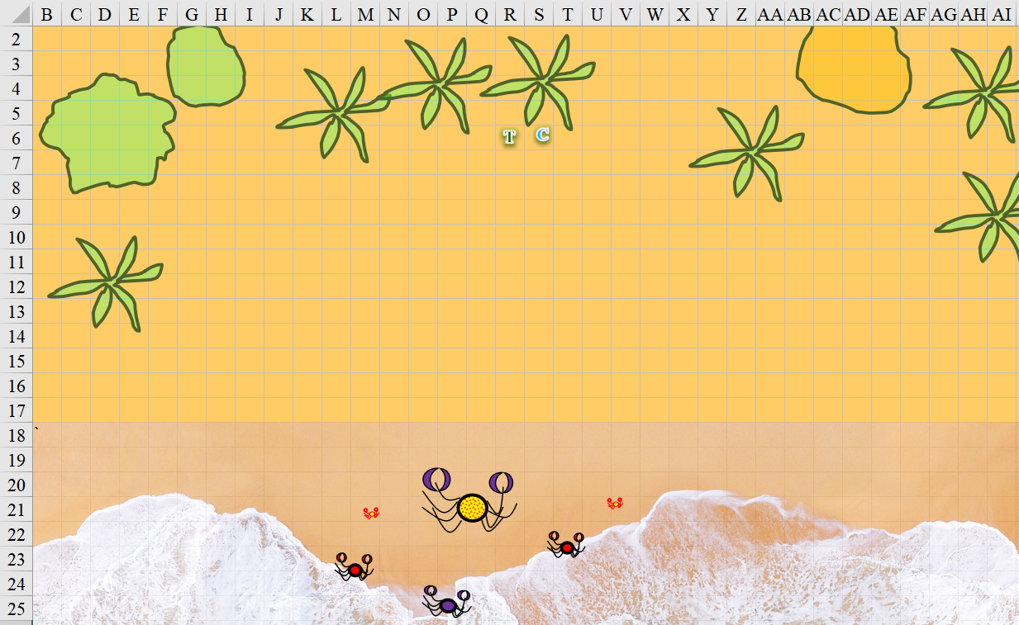

“We have company,” Connor said instead.

With their weapons and gear on a straw mat at arm’s reach, the two combatants rose to their feet.

Round 1

Character | Initiative | Roll | Modified Roll | Move
Tore | 2 | 15 | 17 | 40’
Connor | 3 | 13 | 16 | 30’
Monstrous Crabs | 2 | 3 | 5 | 30’

Character | ECL | Levels
Tore | 7 | Cleric of Lurue
Connor | 7 | Swashbuckler
Total Levels | 14 | Average Level: 7
Party Members | 2
Campaign CR | 3.5 | Multiple encounters
Arena CR | 7.0 | Single encounter

Character | TAC | FFAC | AC | Good | Chaos | HPs
Tore | 12 | 20 | 21 | Imm | Imm | 54
Connor (+Dodge) | 14 | 15 | 19 | Imm | Imm | 60

“Well,” Tore replied as he picked up his Rod of Defiance and buckler shield, “you wanted something fresh for dinner.” Tore then began casting hold animal [expired on Round 5] on the Large crab.
Crabs are Vermin, not of the Animal Type. Spell should not work, but I’ll allow it once at -4 to DC.
Character | Save vs.  hold animal | Ranks | Roll | Result
Monstrous Crab, L | Will | 2 | 14 | 16
Fail. Penalty made no difference.

Tore then spoke as if to a vertebrate, “We mean you no harm. You may scavenge the beach and leave us alone or return to the sea.”

The vermin didn’t understand, and seemed nonplussed by the priest’s plea.

Connor had his rapier by now, and charged to strike at the Large crab.
Character | Attack Type | Damage | BAB | Dex Mod+ | W+ | Other+ | Total Score | Roll | Total
Connor | Rapier +1 | 1d6+2+2 Insightful Strike | 7 | 3 | 1 | 2 charge | 13 | 17 | 30
Hit. Dmg: 3 + 2 + 2 IS + 2 charge = 9.

The monstrous crabs went for Connor, but the smaller ones did not yet reach him.
Character | Attack Type | Damage | BAB | Str Mod+ | Other+ | Total Score | Roll | Total
Monstrous Crab, L | Claw 1 | 1d8+5 | 4 | 4 | 2 charge | 10 | 12 | 22
Hit. Dmg: 7 + 5 = 12.

Round 2

Tore cast luminous armor [expired on Round 2402] and approached the largest crab.
Tore gained +5 to AC + 4 luminosity bonus vs. melee combatants.

Connor full-attacked the Large crab as the crabs attacked both humans.
Character | Attack Type | Damage | BAB | Dex Mod+ | W+ | Total Score | Roll | Total
Connor | Rapier +1 | 1d6+2+2 Insightful Strike | 7 | 3 | 1 | 11 | 9 | 20
Connor | Rapier +1, 2nd Attack | 1d6+2+2 Insightful Strike | 2 | 3 | 1 | 6 | 5 | 11
Hit, miss. Dmg: 6 + 2 + 2 IS = 10.

A Huge crab came out of the sea to join them.

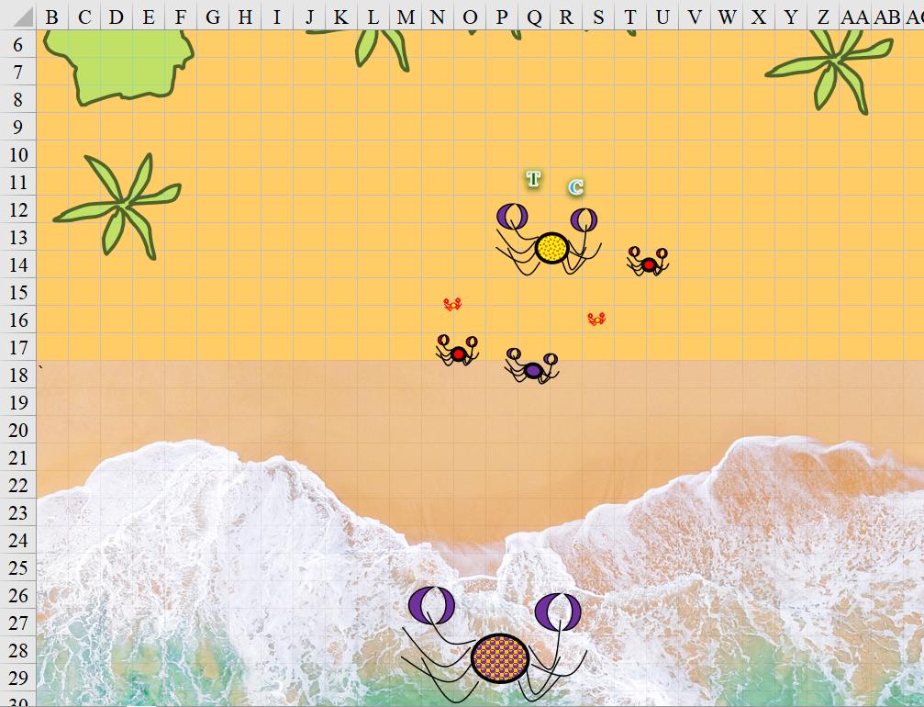

~*~

Soon after Elsabet sent her message, she received the reply: “Proceed as planned. State dragon’s whereabouts. Barony and Monarchy will provide reinforcements. We await more details before providing more guidance. Blessings and congratulations!”

Elsabet smiled wearily at the Viscount. “It seems I do have to go back and continue chatting with Rockhard. On a side note, when I spoke to the rocs, they said they really liked you, and then that they needed to sleep. You and Jazz should stay here, make sure nobody messes with them or the air wagon. Do you have food and drink? I think they might have stocked some basic supplies.”

She paused momentarily, then continued. “We are about to be ‘treated’ with a ‘feast’, during which we can hopefully make more progress and then eventually get back here to sleep. Meanwhile, if you and Jazz wish, I have some magic which should remove the fatigue of a long day, it would be a matter of about half a minute to cast it on you both—the lesser restoration spell. What do you say, milord?”
Skill | Rank | Ability & Mod. | Misc. Mods. | Total | Roll | Check
Elsabet, Diplomacy | 9 | Cha (+2) | 4 | 15 | Middling | ??
See below.

“We do have food and drink, and would extend our own hospitalities should you find the conditions with the orcs insufferable. Jazz and I will be ‘summoning genies’, as they say,” he motioned to the woman, who was packing a waterpipe with tropical herbs. “Bring back snacks if you can.”

“I like mutton sausages,” Jazz called out.

“I bet,” Elsabet muttered.

“As for fatigue, I’ll gladly accept any nonevil magic that you might have for my admittedly delicate frame,” Yuri added.

Elsabet grinned at the man, who was charming enough given the chance, and replied, “It is a fine frame, sir.” She proceeded to cast lesser restoration on him, which took about 18 seconds of prayer, washing away the fatigue of the day. “How about you, Jazz?”

“Oh, uh...” she contemplated, then shrugged, “Sure. Thanks!”

She cast lesser restoration on the bard as well, and with this, both herbal dilettantes were restored to full vigor.

Elsabet then stepped out to rejoin Saradette, Stratus, and their escort back to Rockhard.

Saradette looked down from her perch on Stratus’ shoulder. “How did it go?”

Elsabet replied, “Good, I think. They requested dragon location info, and offered reinforcements to the cause of defeating the dragon I think.” She then recited the message she’d received, to get her companions’ take on it. She did so within earshot of the escorts, having nothing to hide, at least with respect to the reply.

The plague walker nodded as he overheard, walking over slowly and producing from his haversack a map and some notes. Sharing with Elsabet and Saradette the details of the dragon’s encroachment and other details, he began to draw with a wave of his hand a few bards among the tribe who could better render a comprehensive account of Borak’s exploits and prowess.

~*~

When the poets and spoken word artists were finished embellishing the tale of their wicked nemesis, one of the more level-minded historians leaned in and dispelled some of the more fantastic elements of the lore they’d just heard.

~*~

The sun had set an hour earlier. The night was young.

Orcs and goblinoids howled and growled as they danced around a fire. The more sadistic fuckers had been segregated to what had started as a moshpit and was now a site of torture for pigs, goats, and other unfortunate creatures who’d been brought for sacrificial purposes.

Elsabet and Saradette could see this, even without Stratus’ help to raise their vantage point, and were quite disturbed by the animals’ screams before being tossed into the mouths of dire wolves and other cleanup monsters.

~*~

Round 3

For now, Tore focused on helping Connor with the monstrous crab that he was confronting.
Melee Weapon | Dmg | D+ | TH+ | Critical | Type | Wt. | Atk | Roll | Check
Rod of Defiance | 1d8 | +1 | 1 | x2 | Bludgeon | 8.0 | +8 | 19 | 27
Rod, 2nd Attack | 1d8 | +1 | 1 | x2 | Bludgeon | - | +3 | 4 | 7
Hit, miss. Dmg: 5 + 1 = 6.

Tore hoped to deal with the vermin quickly so that he would have time to cast a summon monsters spell before the others got involved in the melee.

“Sorry, this might not be the best tactic,” the swashbuckler said as he ducked to avoid the swipe of a claw, then turned to the crab that weighed half as much as him, and attacked it instead.
Dodge +1 AC vs. Large monstrous crab.
Character | Attack Type | Damage | BAB | Dex Mod+ | W+ | Total Score | Roll | Total
Connor | Rapier +1 | 1d6+2+2 Insightful Strike | 7 | 3 | 1 | 11 | 11 | 22
Connor | Rapier +1, 2nd Attack | 1d6+2+2 Insightful Strike | 2 | 3 | 1 | 6 | 16 | 22
Hit, hit. Dmg: (5 + 2 + 2 IS) + (3 + 2 + 2 IS) = 9 + 7 = 16.

The human’s rapier cut off the crab’s left pincer and front leg, then slashed at its mouth, tearing open its facial area, and causing it to flee and shriek before collapsing and giving out.

A crab that weighed almost as much as Connor was about to attack, but one of the tiny buggers got in front and took the frontline.
Character | Attack Type | Damage | BAB | Dex Mod+ | Other+ | Total Score | Roll | Total
Monstrous Crab, T | Claw 1 | 1d2 | -1 | 1 | 2 charge | 2 | 12 | 14
Miss.

Tore was now confronting three crabs.
Character | Attack Type | Damage | BAB | Str Mod+ | Dex Mod+ | Other+ | Total Score | Roll | Total | Targeting
Monstrous Crab, T | Claw 1 | 1d2 | -1 | -1 | 1 | 2 flank | 2 | 12 | 14 | Tore
Monstrous Crab, S | Claw 1 | 1d4 | 0 | 0 | 0 | 2 flank | 2 | 10 | 12 | Tore
Monstrous Crab, L | Claw 1 | 1d8+5 | 4 | 4 | 0 | 0 | 8 | 11 | 19 | Tore
Monstrous Crab, L | Claw 2 | 1d8+5 | 4 | 4 | 0 | 0 | 8 | 18 | 26 | Connor
Miss, miss, miss, miss.

The cleric was well warded for such a situation, and considered his next move, noting that the largest of crabs was now emerging from the surf, dripping with foam and seaweed, and headed straight for them to get first helpings on the fleshy ones.

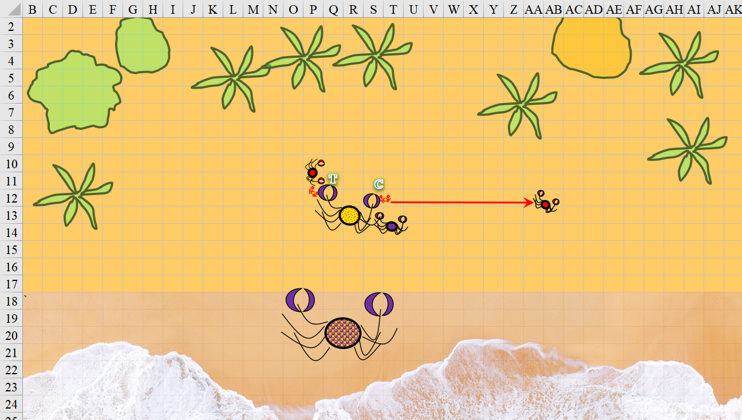

Round 4

Tore yelled “We need to fall back before we get surrounded!” Tore then took a 5’ step back before fully attacking the smaller crab to his right.
Melee Weapon | Dmg | D+ | TH+ | Critical | Type | Wt. | Atk | Roll | Check
Rod of Defiance | 1d8 | +1 | 1 | x2 | Bludgeon | 8.0 | +8 | 18 | 26
Rod, 2nd Attack | 1d8 | +1 | 1 | x2 | Bludgeon | - | +3 | 9 | 12
Hit, miss. Dmg: 1 + 1 = 2.

The blow would not have been enough to even faze the largest crab in sight, but it did enough damage to this dog-sized one to make it take a step back instinctively.

The Tiny crab at Tore’s feet tore away at his boots.
Character | Attack Type | Damage | BAB | Dex Mod+ | Total Score | Roll | Total
Monstrous Crab, T | Claw 1 | 1d2 | -1 | 1 | 0 | 5 | 5
Monstrous Crab, T | Claw 2 | 1d2 | -1 | 1 | 0 | 11 | 11
Miss, miss.

The Tiny crab at Connor’s feet also nipped at the swashbuckler’s footwear.
Character | Attack Type | Damage | BAB | Dex Mod+ | Total Score | Roll | Total
Monstrous Crab, T | Claw 1 | 1d2 | -1 | 1 | 0 | 4 | 4
Monstrous Crab, T | Claw 2 | 1d2 | -1 | 1 | 0 | 15 | 15
Miss, miss.

The Small crab that had backed away, rethought its stance on this advance, and retreated into the waves.

The Huge crab [in Q16:S18] intercepted its fleeing offspring and swiped at it.
Character | Attack Type | Damage | BAB | Str Mod+ | Total Score | Roll | Total
Monstrous Crab, H | Claw 1 | Touch to Grapple | 9 | 5 | 14 | 20 | 34
Threat. Crit irrelevant.
Character | Attack Type | Damage | BAB | Str Mod+ | Total Score | Roll | Total
Monstrous Crab, H | Grapple | Grapple | 9 | 19 | 28 | 8 | 36
Monstrous Crab, S | Grapple | Grapple | 0 | 1 | 1 | 19 | 20
Grapple in place.

The matriarch now used both claws to rend and eat one of her more recent hatchlings.

Despite its wounds, the Large crab [in Q12:R13] snapped at Connor as menacingly as ever.
Character | Attack Type | Damage | BAB | Str Mod+ | Total Score | Roll | Total
Monstrous Crab, L | Claw 1 | 1d8+5 | 4 | 4 | 8 | 16 | 24
Monstrous Crab, L | Claw 2 | 1d8+5 | 4 | 4 | 8 | 9 | 17
Hit, miss. Dmg: 6 + 5 = 11.

Connor did his best to end this, swiping first at the Tiny crustacean, then at the Medium one.
Character | Attack Type | Damage | BAB | Dex Mod+ | W+ | Total Score | Roll | Total
Connor | Rapier +1 | 1d6+2+2 Insightful Strike | 7 | 3 | 1 | 11 | 4 | 15
Connor | Rapier +1, 2nd Attack | 1d6+2+2 Insightful Strike | 2 | 3 | 1 | 6 | 11 | 17
Hit (T), hit (M).
Dmg to Tiny monstrous crab: 4 + 2 + 2 = 8.
Dmg to Medium monstrous crab: 2 + 2 + 2 = 6.

The Tiny crab was fileted in such a way that it would go nicely in a soup once the sand was washed off of it. The one that weighed nearly as much as him was upset, but still coming at him.

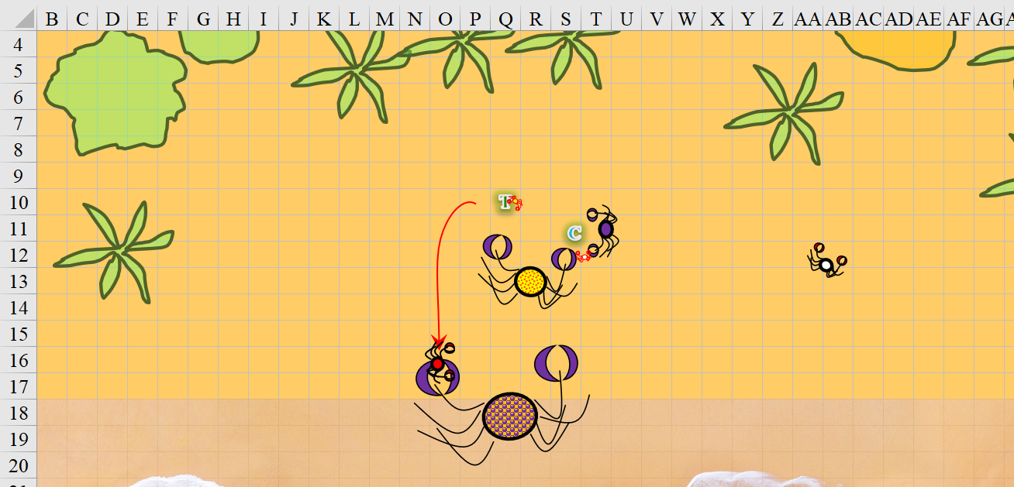

Round 5

Tore, seeing the small crab run away, took a step to his right and cast cure moderate wounds on Connor. “I think that big one is hungry,” Tore commented as he anticipated one of the crabs attacking him.
Connor gained 9 + 5 = 14.
No slot specified; bull’s strength slot used.

“Much obliged, my good man,” the swashbuckler swiped and slashed at the human-sized crab.
Character | Attack Type | Damage | BAB | Dex Mod+ | W+ | Total Score | Roll | Total
Connor | Rapier +1 | 1d6+2+2 Insightful Strike | 7 | 3 | 1 | 11 | 6 | 17
Connor | Rapier +1, 2nd Attack | 1d6+2+2 Insightful Strike | 2 | 3 | 1 | 6 | 12 | 18
Hit, hit. Dmg: hit, hit. Dmg: (2 + 2 + 2 IS) + (3 + 2 + 2 IS) = 6 + 7 = 13.

The Medium crab collapsed at Connor’s feet with little fanfare.

The remaining Tiny crab nipped at Tore.
Character | Attack Type | Damage | BAB | Dex Mod+ | Total Score | Roll | Total
Monstrous Crab, T | Claw 1 | 1d2 | -1 | 1 | 0 | 15 | 15
Monstrous Crab, T | Claw 2 | 1d2 | -1 | 1 | 0 | 10 | 10
Miss, miss.

The Huge crab began to consume its offspring’s eyes and frontal area, effectively killing the youngling as its appendages twitched and writhed.

The Large crab still wanted to get a bite of these fleshlings, so he attacked them both again.
Character | Attack Type | Damage | BAB | Str Mod+ | Total Score | Roll | Total | Targeting
Monstrous Crab, L | Claw 1 | 1d8+5 | 4 | 4 | 8 | 7 | 15 | Connor
Monstrous Crab, L | Claw 2 | 1d8+5 | 4 | 4 | 8 | 11 | 19 | Tore
Miss, miss.

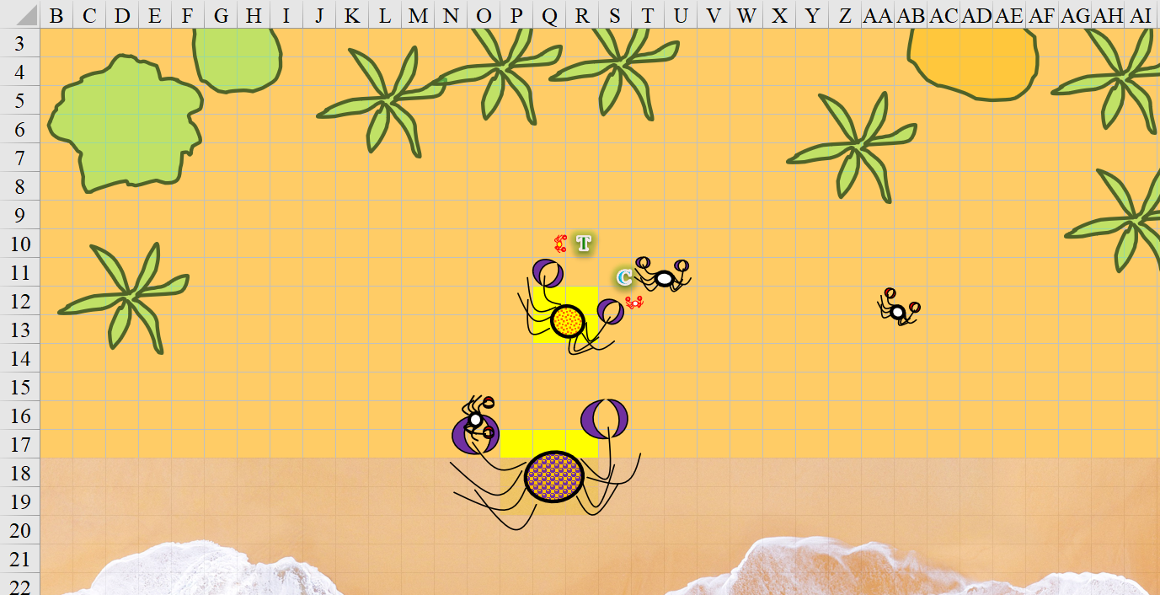
Bright yellow squares indicate crabs’ canonical positions.

Round 6

The Huge crab got a good whiff of the much tastier humans and dropped the juvenile crab in its left claw before joining the Large crab’s partaking of the fleshy ones.
Move action begun, but the Huge crab won’t reach the humans until the Large crab’s turn.

Tore focused his attention to the Large crab in front of him.
Melee Weapon | Dmg | D+ | TH+ | Critical | Type | Wt. | Atk | Roll | Check
Rod of Defiance | 1d8 | +1 | 1 | x2 | Bludgeon | 8.0 | +8 | 4 | 12
Rod, 2nd Attack | 1d8 | +1 | 1 | x2 | Bludgeon | - | +3 | 19 | 22
Miss, hit. Dmg: 3 + 1 = 4.

“Really, you still won’t die?” Tore shook his head.

Connor added, “Let’s see if we can fix that,” then swung twice at the Large crab before them.
Character | Attack Type | Damage | BAB | Dex Mod+ | W+ | Total Score | Roll | Total
Connor | Rapier +1 | 1d6+2+2 Insightful Strike | 7 | 3 | 1 | 11 | 10 | 21
Connor | Rapier +1, 2nd Attack | 1d6+2+2 Insightful Strike | 2 | 3 | 1 | 6 | 14 | 20
Hit, miss. Dmg: (5 + 2 + 2) + (1 + 2 + 2) = 9 + 5 = 14.

The first swipe likely killed the crustacean, but a second swipe for good measure added assurance to the deed.

The Tiny crab at Tore’s feet nipped again as its matriarch stepped over the body of her largest offspring, reached Tore, and snapped at him as well.
Character | Attack Type | Damage | BAB | Str Mod+ | Dex Mod+ | Total Score | Roll | Total
Monstrous Crab, T | Claw 1 | 1d2 | -1 | -1 | 1 | 0 | 18 | 18
Monstrous Crab, T | Claw 2 | 1d2 | -1 | -1 | 1 | 0 | 20 | 20
Monstrous Crab, H | Claw 1 | 2d6+7 | 9 | 5 | 0 | 14 | 6 | 20
Miss, threat, miss. 1d20 = 2 + 0 = 2, not a critical hit. Dmg: 1 [53/54].

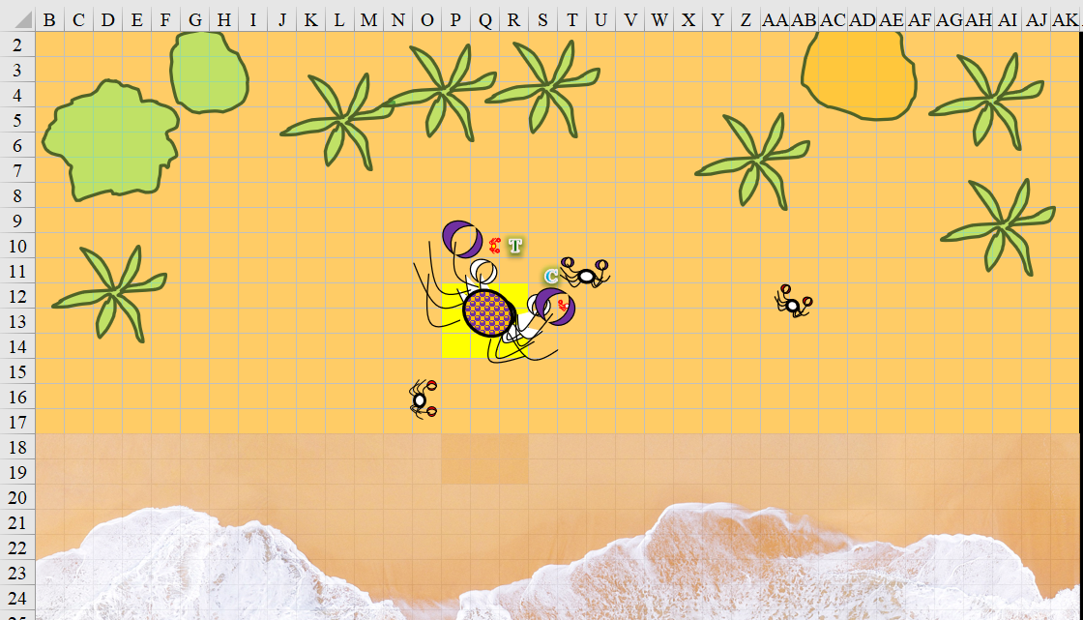

~*~

Saradette sat in silent contemplation for a moment. “All she has to do is wish anyone who seriously threatens her to vanish forever. I’d say this is something we can’t possibly fight.”

“We may be able to interfere with some of her minions...” Elsabet mused.

After thinking over what she had just learned, Elsabet composed as succinct a report as she could manage that included the most relevant locations and descriptions the orcs had provided, along with a request to confirm intent to provide aid. She then broke that down into several 24-word blocks, added ‘more’ at the end of each of them except for the last, which she ended with ‘done’. She reviewed its final form in her journal with Mutters to confirm what she was sending, and reentered the air wagon.

She grinned at Yuri and Jazz who were rather wrapped up in each other’s company, with a brief apology for interrupting them. Taking a deep breath, she then used several sendings in a row to go through those blocks of text, being careful to get them all in the proper order to avoid confusion. Then she waited patiently for a reply, pen poised over her journal ready to scribe whatever she was told for future reference.

Stratus had been relatively quiet. He was a bit inhibited by the orcs’ interpretations of chaos and festivities, and as they waited for a reply from the human Baron and the giant Royal. Well out of the orcs’ earshot, the blue-skinned, white-haired, the giant spoke so that only Elsabet, Jazz, Saradette, and Yuri could hear, “By the gods! I do hope the night will pass quickly. I cannot stomach these orcs, and fear that my contempt will trigger them into fighting.”

“Stratus,” Yuri had learned everyone’s names. “No doubt you would take a good dozen down with you, but you do well to steer clear of them. Despite exceptions, there is something inherently savage about the orc. Nev-”

Jazz shushed her lover, “You don’t think they have a spy nearby making sure we’re not plotting against them?”

“Oh, nonsen...” the nobleman smiled, then looked up in the branches for owls or other possible familiars, animal companions, imps, and really anything other than leaves and branches. “Well, you all know what I’m trying to say,” he then nonchalantly murmured before passing the water pipe to Stratus. “A puff is better than a huff.”

The wispy giant blinked as he smirked, “Oh, alright. I’ll sleep better at least.”

The warlock received a sending spell, and penned the transmission for others to read. “We’ll have numbers for you at morrow. Saelmur and Ankhapur contacted: possible reinforcements. Gather intel on Borak’s forces: location, bearing, rate of travel, numbers, magic.”

Elsabet put her journal away, and conferred with the others.

“I personally need to return to the ‘festivities’—but Saradette, Stratus, if you wish to stay here and bed down early, I am willing to endure the feast alone—I believe I will be safe enough, if Rockhard truly wishes allies.”

She paused briefly, then continued. “If things go sour, I can dimension door away on my own. Sadly, I don’t yet have the mojo necessary to move his mighty awesomeness here,” she slapped Stratus’ thigh with a grin, “so it would make me feel better if you were both safe up here. I’m going to remove my own fatigue as well, so I will be awake and alert as long as necessary and can crash tomorrow.”

While her two friends considered the idea, she cast lesser restoration on herself, washing away the fatigue of the day, ready to go all night if that was what the job required.
Elsabet regained her daily vigor.

“Just be careful,” Saradette said. “I have some work to do in my shop, so I will set it up for a while before I go to bed.”

Saradette and Stratus reclined against a slanted boulder, gazing up at the passing puffs of clouds amidst the starry sky. The occasional blow of a horn or a war cry reminded them of their whereabouts, and as they heard the Viscount and his girlfriend making love inside the air wagon, the giant and gnome talked and occasionally turned to make sure the rocs were staying asleep amidst the bard’s moans.

“Oh, great,” Saradette sighed as she leaned back against her lover’s chest. “There’s no way I’m going to be able to focus on my work.” She sat up on Stratus’ abdomen and scooted around to face him. “I suppose I will have to find something else to do.” She reached down, grasped the hem of her tunic, and stripped it from her body. “Do you have any ideas?”

~*~

Elsabet had returned to what seemed like a fray of nonlethal violence best summarized as sticks and stones.

<< Yeaaaah, son of three sows! >> one orc taunted another. Elsabet was beginning to pick up on the swear words, which were many and varied. She listened with the intention of getting more cultural context by morning.
Skill | Rank | Ability & Mod. | Misc. Mods. | Total | Roll | Check
Elsabet, Diplomacy | 9 | Cha (+2) | 4 | 15 | 11 | 26
+4 to subsequent Gather Information checks specific to this horde.

<< I’ll weaponize my pubes and prick your eyeballs out with them! >> the crusader thought she made out the words.

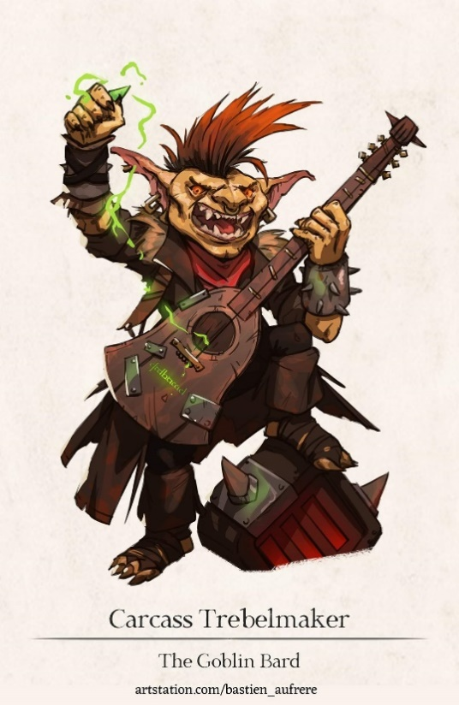

A veritable mosh pit manifested quite organically amidst a decentralized collection of drummers, chanters, horn blowers, castanet clappers, and other performative artists who marched by day and let loose a little before returning to a hastier marching schedule tomorrow.

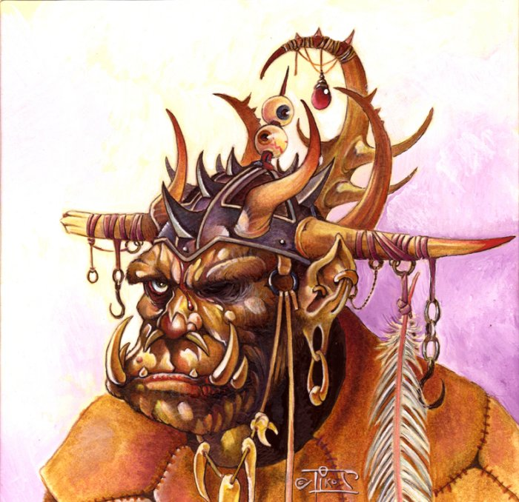

Mutters’ acolytes offered her platters with all manner of meats, including a surprising variety of reptiles, and was instructed on how to refuse the dozens of dance proposals that she had already gotten without offending her suitors.

She’d eaten and drunk enough for now, and noted that others had as well. Though rowdy, this would not be an all-nighter, as even now, entire platoons were being ordered to wrap up their festivities and get some shuteye before the sun rose and the march would resume.

~*~

Round 7

Tore and Connor had dealt with the Large crab, and the Huge crab was now threatening both combatants. Tore couldn’t cast without concentrating, so he took a 5’ step back and cast summon monster II [expired on Round 11] summoning 2 Celestial dogs behind the Huge crab. He then prepared for the Huge crab to advance on him or to heal Connor if needed.

The two dogs bit at the Huge crab.
Character | Attack Type | Damage | BAB | Str Mod+ | Other+ | Total Score | Roll | Total
Celestial dog | Bite | 1d4+1 | 0 | 2 | 2 flank | 4 | 15 | 19
Celestial dog | Bite | 1d4+1 | 0 | 2 | 2 flank | 4 | 1 | 5
Miss, miss.

Connor slashed at the Huge crab, whose shell was far thicker than the juveniles’ carapaces.
Character | Attack Type | Damage | BAB | Dex Mod+ | W+ | Total Score | Roll | Total
Connor | Rapier +1 | 1d6+2+2 Insightful Strike | 7 | 3 | 1 | 11 | 13 | 24
Connor | Rapier +1, 2nd Attack | 1d6+2+2 Insightful Strike | 2 | 3 | 1 | 6 | 8 | 14
Hit, miss. Dmg: 3 + 2 + 2 IS = 7.

The Tiny crab saw that these guys weren’t having it, and made a beeline southwestwardly.
Character | Check | Ranks | Roll | Result
Monstrous Crab, T | Tumble | 1 | 13 | 14
See below.

The critter was able to creep away without being stepped on by its ancestor, who now clawed at Connor exclusively.
Character | Attack Type | Damage | BAB | Str Mod+ | Total Score | Roll | Total
Monstrous Crab, H | Claw 1 | 2d6+7 | 9 | 5 | 14 | 14 | 28
Monstrous Crab, H | Claw 2 | 2d6+7 | 9 | 5 | 14 | 3 | 17
Hit, miss. Dmg: 7 + 7 = 14.

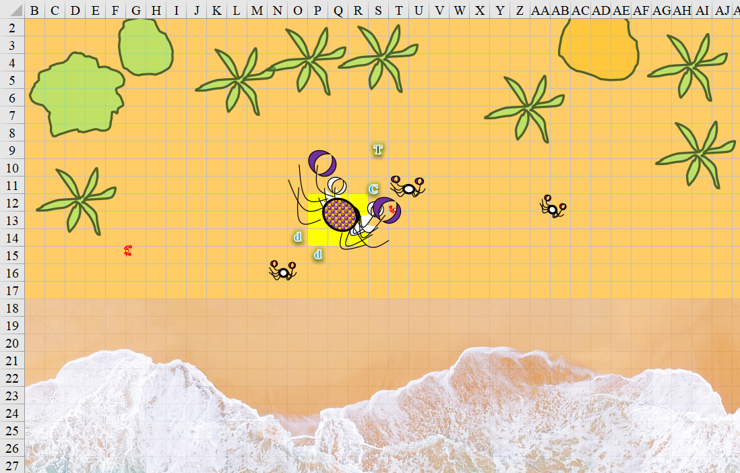

~*~

Elsabet thought the ‘entertainment’ had indeed given her more insight into the nature of orcs, and hoped to be able to leverage that insight as she made conversation with various of the more intelligent leaders of the horde. Her best approach, she figured, was getting them to boast of their powers in an attempt to impress her—knowing that their claims might be exaggerated a bit. She attempted to identify and remember as many names and titles of leader types as she could, as well as clan, tribe, or warband names.

She also made a point of admiring and complimenting all the dire wolves she came near—for one thing, she truly admired the massive lupines, and for another, she thought she might be able to call upon them for aid should some drunken orcs decide they wanted her to ‘play’ with them.

She partook of some of the orcish beverages, but as had been her tendency when trying out Barkley’s brews, did so in moderation, along with enough food to keep the alcohol from going to her head. She hoped Rockhard appreciated the everfull mug she had gifted him, though the ale and wine it created was much weaker in terms of alcohol content than some of the stuff the orcs had. Some of it, of course, was loot from the sacking of cities, so she said a prayer for the souls of those who had died at those places.

Rockhard did appreciate the mug, and was even now drinking plain water from it, staying level headed as the bulk of his minions lost their inhibitions. As festivities wound down, he would confer with individual captains and commanders.

With luck and, hopefully, no diplomatic errors on her part, Rockhard and the other leaders coming to gather at this next city would be willing to hold off from sacking the city in return for supplies and the possibility of an alliance of necessity against the ancient dragon, brokered by the Baron of Mintar and the Queen of the Sky Tree.

In the back of her mind, she did wonder if she was being used merely to delay and distract the orcs while the cities banded together against them, but she would trust the Baron and the Queen unless events proved otherwise.

As the orcs finally started settling in, she bade a good sleep to those around her and returned to the air wagon to nap for a bit.

Elsabet politely declined the offers of courtship, saying she is not looking for a mate at this time, but she made certain to thank them for their interest. Similarly, the offer to join an orgy was appreciated, but she indicated to the offerer that she preferred to entertain fewer lovers at a time, so that she could give them the attention they deserve.

“Innavoytive!” one of them complemented her on her forward thinking.

As for the offers of casual sex, she was intrigued. Never a prude, but nonetheless selective in her partners, Elsabet sized up those potential partners based on their social skills, their approach, etc.

She was not interested in the obvious braggarts talking about the size of their equipment, those got her raised eyebrow and a simple “thanks, but it sounds like you are too much orc for me.” But she tried to sort out whether there were two or three half-orcs who had either invested in social skills or were innately more adept and both self-confident and respectful as to earn a shot. They needed to impress her, and not by flashing body parts.

If so, then she decided she would be willing, provided she called the shots—she was not a submissive kind of woman. And perhaps in the process she would be able to gather more information.

~*~

Elsabet had sorted three possibilities out of the crowd of offers.

One, Rebtar Soren, had led the pack, until she met his wife Gerdgren. “Sorry, Rebtar, but I don’t get between a woman and her husband—and I don’t appreciate being... misinformed.”

“Aww, what?!” the half-orc though he’d had it made, having weaved quite the romantic tale of love and loss with the beastly woman now at his side with a rolling pin conveniently in her hand.

She turned to the orc woman, not sure if the woman wanted sex or violence, but she would rather avoid the drama either way. “Gerdgren, you are more woman than I will ever be.”

“Tru’nuff!” nodded the woman whose mouth smelled like anyone’s arse on its worst day.
Save vs.  Cringe & Gag | Rank | Ability & Mod. | Misc. Mods. | Total | Roll | Check
Elsabet, Fortitude | 7 | Con (+1) | 1 | 9 | 10 | 19
Success.

Elsabet continued, “Strong, with your magnificent breasts, I could not truly compete with you. And I think maybe Rebtar here might need a spanking for being not entirely truthful.” She grinned. “A hard spanking.”
Skill | Rank | Ability & Mod. | Misc. Mods. | Total | Roll | Check
Elsabet, Diplomacy | 9 | Cha (+2) | 4 | 15 | 5 | 20
See below.

The orcish woman said something in Orcish that Elsabet couldn’t understand, then everyone laughed, and some of the men pointed at Elsabet’s womb before the Mr. Soren held his face down and Mrs. Soren pulled him away so he could be rectified.

Meanwhile, both Ka-plutchke and Deemotiv intrigued her—the former seemed like a strong warrior type, about whom she wished to learn more, and while the latter might be a bit boastful, she looked forward to finding out what sort of invocation he has mastered. Furthermore, the former might well have some pertinent military information, while the latter might know more about the army’s casters and other support types... “You two: think you can share without getting weird about it? If so, let’s find some place with a little privacy and get to know each other better.”

They looked at one another, preferring to duel to the death, but not finding Elsabet nearly as luscious a motive as the average orcish gal. They both laughed and wandered off to seed someone else’s womb.

There were plenty of others who’d given her the eye, and there was certainly no want of available flesh upon which to impose one’s lust.

Elsabet kept her face impassive as she inwardly smiled. Avoiding casual sex with the best of the lot was fine, she’d thought maybe their pride might not let them share, so things had worked out fine.

She wandered back towards Rockhard, to try to get an idea of his reaction to what she’d passed along from Mintar and perhaps get a clue as to his immediate plans. She didn’t expect to be brought into the orc leader’s council, but wanted to see whether she could get a good sense of his current mood and suchlike. After checking in with him, she intended to return to the air wagon.

She also mused on the idea of learning orcish. Perhaps eventually—the small amounts of the language she had picked up so far clearly showed it wasn’t that similar to either goblin or giant....

“Oh, there you are,” Mutters spotted her and walked over. “Rockhard is about to retire, and wants to know where your people stand.”

The two walked over to the Chieftain as he was getting into his comfortable sedan, and he bade her well, “I see the festivities put some color on your cheeks,” he said, though it was unclear as to how literal that observation was.

Elsabet grinned and said with a chuckle, “your people party hard, and are a hardy bunch.” She then proceeded to get out her journal, and used her notes to inform Rockhard of what the Baron and Queen had offered. “Perhaps the example of Mintar choosing to send aid to your cause against the dragon’s plans will convince other cities to see the wisdom of helping you reclaim your homelands,” she suggested.

~*~

Round 8

Tore charge-attacked the Huge crab.
Melee Weapon | Dmg | D+ | TH+ | Critical | Type | Wt. | Atk | Roll | Check
Rod of Defiance | 1d8 | +1 | 1 + 2  Charge | x2 | Bludgeon | 8.0 | +10 | 11 | 21
Miss.

Connor was like, “Aw, what?” and lunged forward as he swung twice at the bold arthropod.
Character | Attack Type | Damage | BAB | Dex Mod+ | W+ | Total Score | Roll | Total
Connor | Rapier +1 | 1d6+2+2 Insightful Strike | 7 | 3 | 1 | 11 | 6 | 17
Connor | Rapier +1, 2nd Attack | 1d6+2+2 Insightful Strike | 2 | 3 | 1 | 6 | 10 | 16
Miss, miss.

“Oh, hells, no!” he then protested how hard the mother crab’s shell was to breach.

The dogs nipped at the crustacean’s carapace.
Character | Attack Type | Damage | BAB | Str Mod+ | W+ | Total Score | Roll | Total
Celestial dog | Bite | 1d4+1 | 0 | 2 | 0 | 2 | 6 | 8
Celestial dog | Bite | 1d4+1 | 0 | 2 | 0 | 2 | 10 | 12
Miss, miss.

The Huge crab felt the dogs’ scratching it with their teeth, and turned to attack them instead.
Character | Attack Type | Damage | BAB | Str Mod+ | Total Score | Roll | Total
Monstrous Crab, H | Claw 1 | 2d6+7 | 9 | 5 | 14 | 4 | 18
Monstrous Crab, H | Claw 2 | 2d6+7 | 9 | 5 | 14 | 8 | 22
Hit CD₁, hit CD₂.
Dmg to CD₁: 12 + 7 = 19.
Dmg to CD₂: 5 + 7 = 12.

Both dogs dematerialized in the crab’s claws.

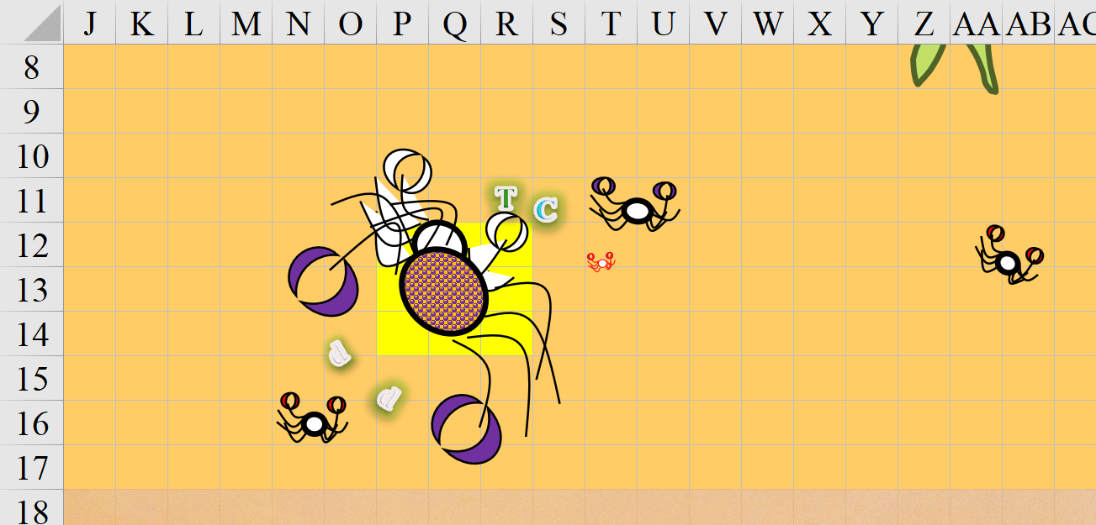

Round 9

The Huge crab turned around, took a step to the southwest, and prepared to attack Tore and Connor again.

Tore was fine with the distraction provided by the Celestial dogs but frustrated by his failure to damage the Huge crab. Tore redoubled his focus and swung at the crab again.
Melee Weapon | Dmg | D+ | TH+ | Critical | Type | Wt. | Atk | Roll | Check
Rod of Defiance | 1d8 | +1 | 1 | x2 | Bludgeon | 8.0 | +8 | 11 | 19
Rod, 2nd Attack | 1d8 | +1 | 1 | x2 | Bludgeon | - | +3 | 6 | 9
Miss, miss.

Connor did the same.
Character | Attack Type | Damage | BAB | Dex Mod+ | W+ | Total Score | Roll | Total
Connor | Rapier +1 | 1d6+2+2 Insightful Strike | 7 | 3 | 1 | 11 | 12 | 23
Connor | Rapier +1, 2nd Attack | 1d6+2+2 Insightful Strike | 2 | 3 | 1 | 6 | 9 | 15
Hit, miss. Dmg: 6 + 2 + 2 IS = 10.

“Ooh! Nice one,” the fighter-cleric congratulated his swashbuckler friend as the crab—no longer constrained by the flanking doggies—backed away towards the surf.

The crab was nowhere near dead, and could likely have kept going until he killed one of them and dragged him away, but it would have been a risky gambit, for the ten-legged invertebrate. Unlike their frailer counterparts, these monstrous crabs could locomote forward and backward as well as sideways, and this mother did so with the alacrity of a hunter that recognized her role as potential prey. Having turned tail with nary a minion at her side, the vanquished predator would not likely return for a rematch.

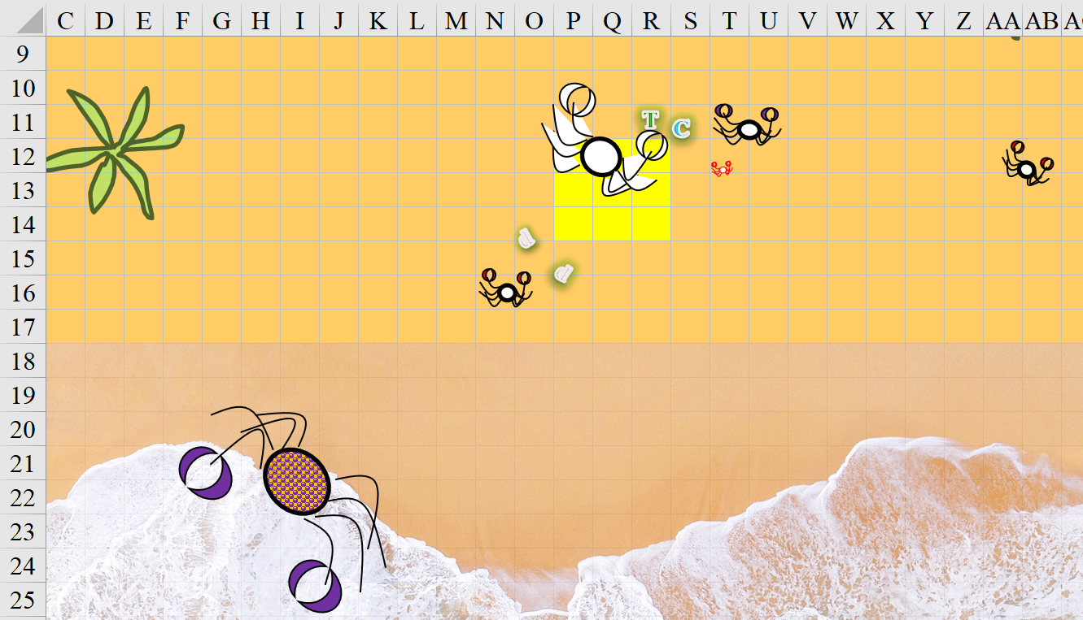

Round 10

“Bloody bastard!” Connor cried out in Common. “We will eat your ilk today!” he felt the need to add to the brute monster that fled into the waves as a handful of pelicans flew overhead.

Tore was more than happy to see the crab head off into the sea once more. “That was fun. So, you up for some fresh seafood?”

~*~

Rockhard had commended Elsabet on a well forged armistice, and though he awaited further details in the morning, he had told his delegates to let their troops sleep a little extra, as he would have much to discuss with his viziers once Mintar’s numbers came in.

She walked back 1000’ to the air wagon, noting the two men following her at a distance of about 100’. She turned around once she had a line of sight to the rocs, and they veered to their left, eventually making their way back to their camp as Elsabet stood just outside the giant wagon.

Stratus and Saradette were sleeping just to the side, while the Viscount and his lover were inside. Conversations had died down a while back, and now Elsabet stood alone in her wakefulness amidst crickets and mosquitoes.

She looked around, her eyes piercing the darkness looking for orcs trying to sneak closer, just in case, as well as for any nocturnal animal life, though she figured most had fled the area, what with the rocs and the orcs.

Elsabet sighed, then got out her journal and started recording names and details about some of the orcs she had met, things she had learned that she thought would be of interest to the Baron and the Queen, as well as words and phrases of Orcish that she had learned and what they meant, or at least she though they meant. That kept her occupied quite a while...

~*~

6 Tarsakh

Dawn came and Morning followed.

Elsabet, Saradette, Stratus, Yufi, and Jazz were now awake, and Rockhard’s four favorite dire wolf riders came to about 100’ of the rocs and stopped, noting their skittishness around the lupine monsters. Rockhard’s sedan followed behind more slowly, pulled by a quartet of orogs who were trying to prove something.

Drummers rolled and beat their instruments within tempo, but in counterrhythm to one another. The syncopation set the pace of the march that even now approached, though it was still 1000’ away.

Mutters dismounted, as did the orog, goblin, and half-orc riders, and the plague speaker nodded in greeting to the giant and his friends. “So? What news have you for us that we might pray appropriately?”

Elsabet had committed to memory the spirit of the message, which she now conveyed, “Mintar is willing to match every one of your men and women with one of theirs. The Sky Tree only has about five-dozen boots to spare, but every pair will be filled with the feet of a stalwart fighter, including this gentleman,” she motioned to Stratus.

The orc smirked, “So is that 60 giants or 30 giants who all presumably still have both feet intact?”

“Good question,” noted Stratus, knowing more than a few giant amputees.

“60 able-bodied combatants the size of him,” Saradette was now the one motioning to her man. “Some of them, spellcasters.”

“We will join you at Ankhapur, where you will be received by a hospitable and sympathetic people who have about half as many combatants to pledge as Mintar. Saelmur’s forces—also about half the strength of Mintar’s—march towards Ankhapur now,” she informed him comfortingly, though this was also a soft reminder that there would be a formidable coalition at Ankhapur capable of dealing with the orcs decisively. She followed up with more assurances of good faith on their part, “The reinforcements that you expect from other eastern lands will be added to by our cities’ most capable representatives.”

“Noted,” Mutters was duly impressed, seeing and hearing no deception in the faces and voices of the conveyors of their leaders’ intentions. He shrugged as the sedan stopped, and Rockhard stepped out and down onto the path. “Well, I suppose this is farewell for now. I long to see you all again on the battlefield.”

“The big problem I see in whacking this dragon is the wishes she has in reserve with that efreeti. We can either present her with irresistible targets, which is hard on said targets, or, better, free the efreeti.” The gnome shrugged. “If we hit her with an entire army, she’s going down. It might kill a lot of the good guys in the process, but, between all these cities and other groups, she will go down.”

~*~

With the huge crab running off back into the sea, Tore took a moment to cast his healing spells on Connor to return him to full health. Then Tore collected the smaller crabs while Connor began removing the legs and claws from the large crab.

As Connor was finishing up, Tore began prepping the smaller crabs to be cooked as well. With some wood collected from the surrounding area just beyond the beach, Tore got a fire going. Unfortunately, he didn’t have a pot of water in which to cook the crabs, so he opted for more of a rotisserie style. Though not a professional cook, he still had some idea of what he was doing.
Skill | Rank | Ability  & Mod. | Misc.  Mods. | Total | Roll | Check
Profession: Cook | 2 | Wis (+2) | 0 | 4 | 10 | 14
See below.

Next time he’d prepare a create food & water spell, but for now, the crab kabobs would do tonight. “You have to spit out the shells,” he warned Connor.

Using his Everfull mug, he created some wine for the two to share as they feasted on crab meat. As the sun sank in the distance, Tore wondered how Elsabet and Saradette were doing with the horde of orcs. He wished he’d been a bit more diplomatic with the Baron’s son, or just left it to Elsabet. He had never been fond of arrogant, spoiled brats.

As he looked up at the stars, he pointed out a bright one and asked, “What star is that?” knowing that Connor would have an answer, either valid or just made up.

Connor looked up and smiled, “That is Selûne, goddess of the stars and navigation. She is also a friend of Valkur.” As he spoke, Connor pulled out a pendant he wore around his neck. It showed a storm cloud with three lightning bolts coming down. “Valkur is the god of sailors and favorable winds. I’ve called upon him many a times. Though he has not always answered my calls,” he continued as he tucked the pendant back under his shirt, “he has never abandoned me or my ship when we needed him most.” There was almost a fondness in Connor’s eyes as he spoke, a reverence that Tore had rarely seen from the man.

Tore smiled and nodded. “The gods do tend to let us find our own way, but do intervene when their faithful are in true need of assistance. At least that has been my experience.” Tore then put his hands behind his head as he laid on top of his bedroll, his stomach full from their meal. “Do you want to take the first watch or should I?”

Connor stood up and stretched, “I’ll take the first watch. I’ll wake you in a couple hours so you can pray for your spells then I’ll crash after that.”

Tore nodded his thanks and closed his eyes. After their earlier encounter, he had his mace and shield close by.

~*~

“Friends!” the head orc opened his robed and braceleted arms wide and smiled as he heard Mutters’ translated synopsis of what he’d just learned. “Aaah, then this is indeed cause for the celebration we enjoyed only hours ago. We shall have cause to celebrate even more once we’ve vanquished Borak’s forces.”

They talked for a few minutes before Stratus climbed into the wagon’s jockey box and took the reins, rustling the rocs into the anticipation of a long flight. The birds stretched their wings, hissing a long screech of delight for the morning’s sunlight and a chance to see the panorama of this land once again.

Saradette fed them all the rest of the food that they’d brought, lightening their load by the equivalent of about two humans.

Jazz was running a fishbone comb through her hair while Viscount Euphemes III met the orc and actually made nice with him as best as he could. Rockhard took advantage of the moment to study the Viscount as if he were taking a measure of his father, and nodding as he heard the human’s inflections and Mintari adaptations of the Common tongue.

“Go then, and tell your superiors that we will cross swords with them and not against them, and together, we shall put an end to the pestilence that follows in Borak’s wake!” Rockhard almost choked on his words as he expressed utter contempt for Borak.

Elsabet nodded to Rockhard and wished him well.

After the orcish commander left, Saradette turned to Elsabet. “So, what happens now? Are you going to command the whole expedition?”

Elsabet turned to Saradette and replied quietly, “Goddess, no! There has to be some elite missions we could carry out, but I would be horrible as a military commander. Small unit tactics, I kind of get. Strategy and logistics, those require experience and wisdom, a professional officer.”

~*~

6 Tarsakh

Dawn came and Morning followed.

Tore and Connor had awoken an hour or so ago, and had broken fast by now: more crab from some of the larger specimens, who kept better overnight. Now they were striking camp, rolling up bedrolls and folding up chairs. The dinghy was half-way loaded up by now, and as they continued to get their camping gear into the rowed vessel, they were both startled by a humanoid emerging from the sea. A shallow wave broke behind her, coursing across her hips as her torso now made evident that this was some form of aquatic species.

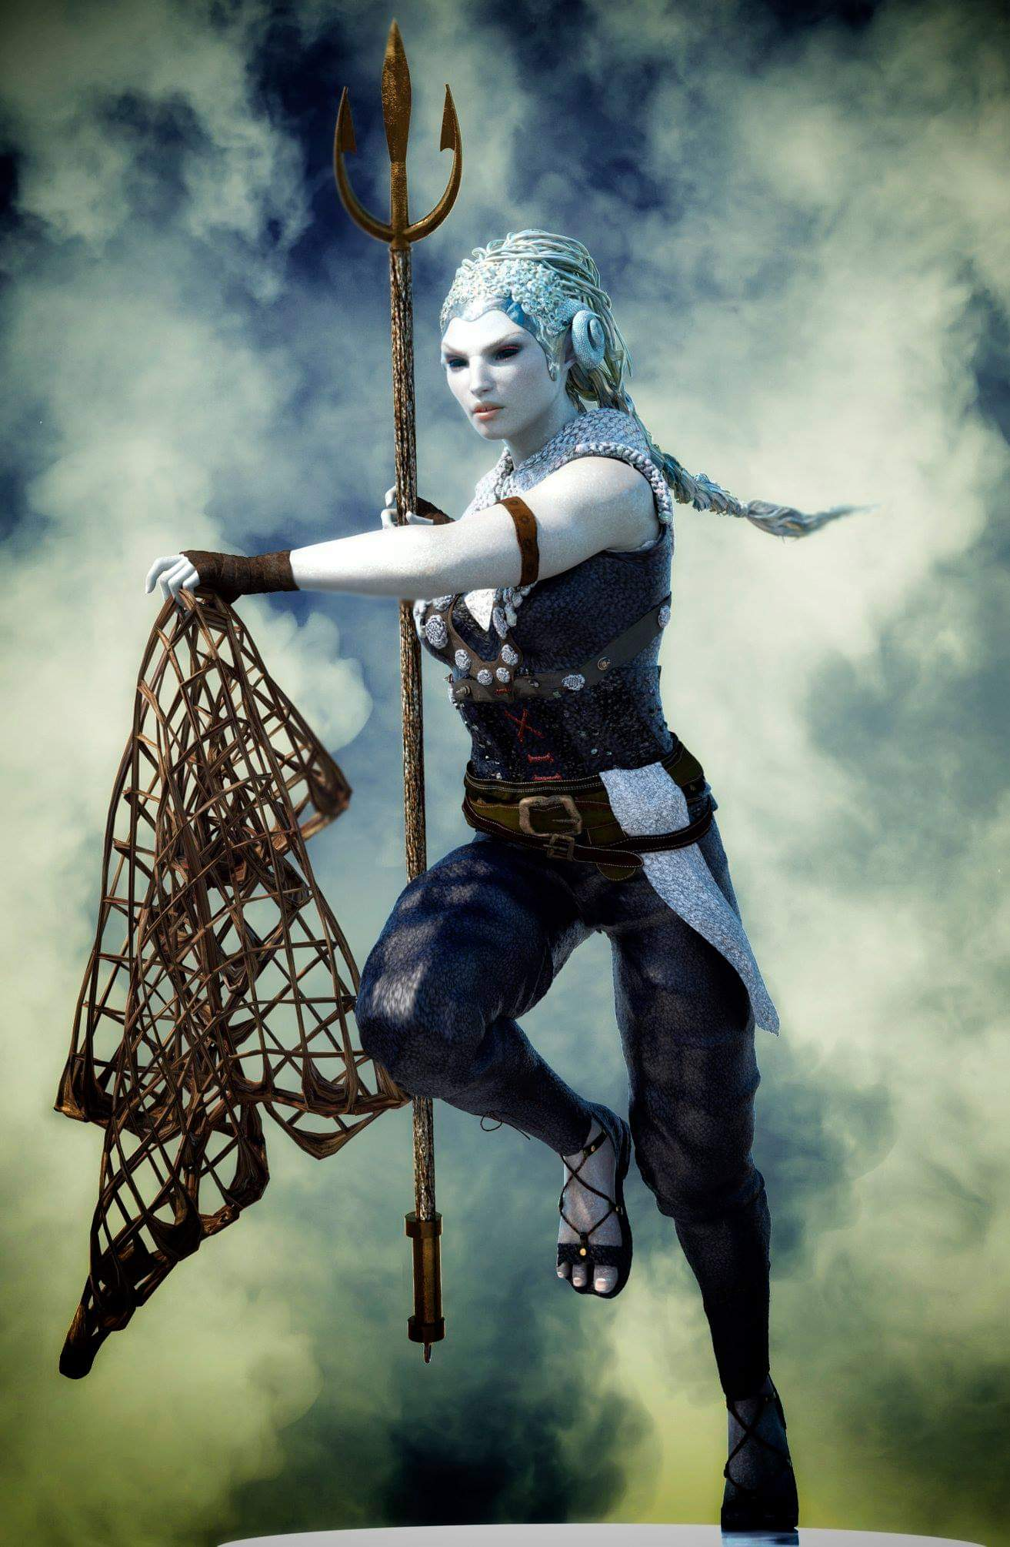

She held a trident and a net in her hand, but did so in a non-threatening manner, and lowered both further as she beheld the two unarmed men carrying tents and other landlubber stuff towards their rowboat. The woman squinted as if getting a sense of the humans’ motive, then surveyed the assortment of crab carcasses, and knew that she’d followed her nose to the source.

The aquatic humanoid did not speak, and remained cautious, ready to spring back into the shallow waters and undulate her way out to safety.

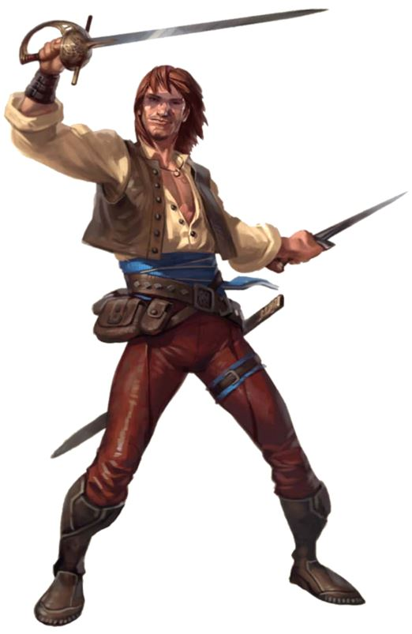

When Tore looked up and saw the figure as she approached, he quickly noted that she was not in an offensive or aggressive stance. Tore gave her a slight smile and said, “Good morning, what brings you to this stretch of sand?” He placed the items he was carrying in the dinghy and stood there as he waited for her reply.
Skill | Rank | Ability & Mod. | Misc. Mods. | Total | Roll | Check
Tore, Diplomacy | 0 | Cha (+1) | 0 | 1 | Pretty Good | ??
See below.

The woman’s name was Vierk-Oua with an accent on the “a”, and she was a scout from a nearby enclave of aquatic folks, including darfellans. She herself was an aquatic human, and she would very much like to trade some of the already cooked crab that had not yet been taken off the rotisserie and packed away.

Tore smiled, and nodded, “Sure,” Tore replied, “we have more than we can eat before it goes bad. Please,” he motioned towards the remaining food, “help yourself. We require nothing in trade.” Tore then looked over at Connor who was about to say something but didn’t when he caught Tore’s look.

“Sure,” Connor added, his tone showing little conviction behind his words, “take whatever you want.” He then tossed the items he was carrying at Tore, a bit harder than he need to.

Tore caught the items and placed them in the dinghy, a slight smirk on his face. He then headed up the beach as Connor waited by the small boat.

“If you can’t take it all now, we will leave it behind and you can return for the rest later,” Tore said as he walked up near Vierk-Oua.

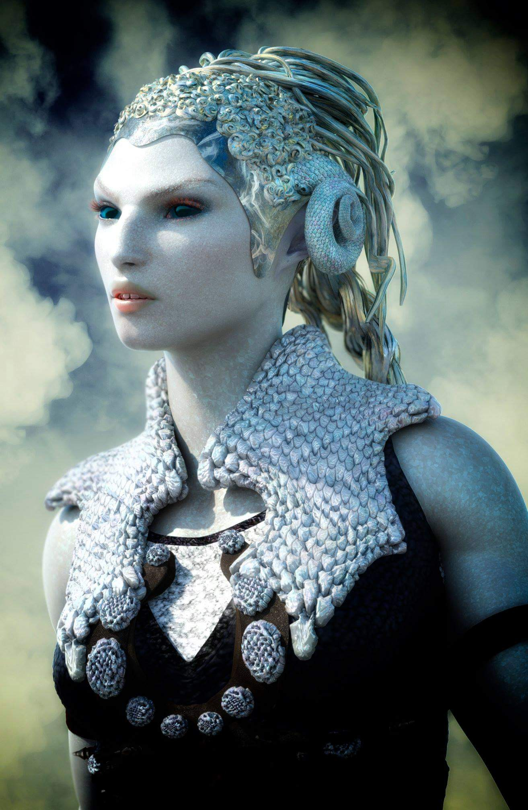

Vierk-Oua inhaled air through her nostrils, anticipating using her gills again, and exhaled it as she inventoried the crabmeat in her head. There was a lot to tow, and the Large crab hadn’t even been butchered yet. “I’m no druid, the seafaring woman smirked, but I have a friend who is, and she says...” she then took her trident and pierced the Large crab’s shell a few times and kicked in the area riddled with holes now, rendering an even bigger hole along the side of the crab. “‘Leave a little for the homies.’”

The flesh was now exposed to the scavengers that had no doubt waited for them to leave before approaching this behemoth. Seagulls above noted the opportunity.

“I have a friend who double-dabbles as a druid and a rogue,” Connor mentioned as a tangent, then saw his friends’ faces and followed up with, “I once asked him, ‘So what do you do? Break into people’s houses and water their plants?’”

Tore laughed immediately, but it took an awkward moment for Vierk-Oua to get into the seldom needed mindset that plants outside the water also needed water. It wasn’t that she was unaware of this, but by the time she’d gotten it, the two men had already turned to her as if asking why she hadn’t gotten it.

All in all, it was a good time spent, and they were glad they didn’t have to roll the proverbial dice with the aquatic human. They would likely never meet again, but if they did, she would offer the sailors a meal.

By the time they’d rowed their dinghy to the boat that Connor would likely sell the next day, Vierk-Oua was gone, and the winds were ideally positioned for a swift return home. They could now see the seagulls feasting on the Large crab and the shreds of the smaller ones, and as they lifted the anchor, Tore congratulated Connor on a last boat trip well spent.

~*~

The rocs flew at a higher altitude on the way back, using the prevailing winds above the clouds to get an edge on their westward trajectory. They flew over land and sea, and were back in Mintar by Highsun. The debriefing was briefer than the briefing had been, mostly given the constant flow of communication with Calypso the Steady and his team.

The participants were commended for their heroism, which the Queen and Baron agreed were not limited to combat prowess. “You have likely saved countless of innocent lives,” Queen Ghym had said as she presented Elsabet and Saradette with miniature versions of the ribbon that Stratus was also given.

Viscount Euphemes III had taken sleight yet again with some misunderstanding that that resulted in him not receiving a ribbon. Jazz had rolled her eyes at the presumption, but she was playing the long game, so she’d stood by his side as he’d vented for a moment to his father before storming off with his lover at his arm.

Elsabet in particular was regaled with praise for her brokering of an unlikely armistice with a growing polity of nomadic orcs and those who loved them. Elsabet shook her head at the recollection of the Sorens as humans, elves, gnomes, dwarves, and giants all threw praises upon her diplomatic finesse.

Saradette and Stratus got some love too, and were asked numerous intimate questions by bard storytellers who were trying to find words that rhymed with story.

It was a golden moment in the biographies of the heroes, and though Elsabet and Saradette missed Barkley, Luran, and Solstice, they were in good company, and increasingly hailed as the most notable contemporary heroes of Mintar. Such was the stuff of epics, legends that would transcend the ages, reaching to times unknown and touching generations yet unconceived.

“You have proven yourselves to be of noble heart,” the Baron told Elsabet and Saradette on their way out as the Queen spoke to Stratus. “You have my utmost gratitude, and I consider you to be trusted confidants to my Barony. Please consider yourselves honorary advisors to the Barony henceforth,” Euphemes II was careful to say Barony, meaning that their status transcended his natural lifetime, and extended into his successor’s reign.

As they left the Baron’s Keep, intending to return tomorrow for updates, they were informed that the bulk of the city’s forces were already on their way to Saelmur, where they would join the second battalion from that city on their way to Ankhapur. Stratus would have the rocs rest a day, then get the wagon ready for them to return east with munitions, magic, and their own skillsets and prepare for Borak’s advent. “It will be glorious,” Saradette unexpectedly said.

Elsabet added, “I expect tales of this will be embellished for centuries.”

Stratus shrugged, “They may not need much embellishing based on the scale of what we’ve heard is fomenting.”

The heroes walked along the now familiar cobblestone street towards the Missing Minotaur with the Tarsakh sun hanging at a slight southward angle as birds flew and chirped overhead, seemingly announcing the procession of the heroes in the midst of the unknowing townsfolk.

Elsabet and Saradette had spent years vanquishing gnolls and trolls, ogres and orogs, and stirges and sphinxes across the land, having at times compromised some of their alleged morals in the process, and perhaps becoming more ethical in their struggles to humble themselves enough to rise to the state of heroes: of advocates and champions of justice. And after all these years of strife, for once they felt redeemed of their flaws, even if they should never be rid of them. For the first time, they knew what it felt like to be a heroine.

Somewhere nearby, trumpets blared as if for the heroines of the day.

~*~

Afternoon

Stratus and Saradette played a game called “No-magic Wild Shape”, and while they looked nothing like the creatures they said they were emulating, it was a wholesome, erotic time.

~*~

After leaving the beach behind, the ship sailed west. Tore did his best to handle the sails under Connor’s instructions. He’d been getting better at it, but was still no expert sailor. Connor had to tack back and forth to make progress until the winds changed direction later in the morning near noon. So the trip back took a little longer than the trip to the beach.

After the wind changed direction, there was less work for Tore to do, so he took the time to enjoy the breeze and spray of the sea. He stood out on the bow of the ship, his shirt off enjoying the sun. He also watched as the dolphins as they raced ahead of the ship. He was impressed by their agility and speed as they darted back and forth in front of the ship.

As they arrived back at Mintar, Tore had put his shirt on and prepared to help get the ship tied off to the dock. He tossed the line to the dock hands and, when they were finally secured, headed down the gang plank. When Connor followed him a minute later, Tore extended his hand. “Thank you for the little trip. It was good to have another little adventure before you get rid of the old girl,” Tore said referring to the boat. “If you have time, stop by the Missing Minotaur. If not, then until we cross paths again.” He gave his friend a hug and patted him on the back.

As Tore began to walk back into town he took a last glance over his shoulder at the small schooner. He’d gone out on it several times with Connor and she always brought them back. She was a good ship and would serve her knew owner well.

~*~

Evening

Outside the Missing Minotaur, Stratus sat cross-legged with Saradette, Elsabet, and Tore. The Radnars were inside dining while the heroes had procured for themselves the makings of a picnic, and were now looking up at the Sky Tree, talking about what a great year it had been while they lived there and how awesome it would be to go back to Ysgard.

Tore had invited Connor to their lunch via a messenger, but he hadn’t been able to make it for lunch, so instead the swashbuckler strolled into the inn’s front yard with his peace-bonded rapier right around dinnertime. Tore had asked how the negotiations had unfolded. He knew that Elsabet and Saradette had succeeded, but he wondered how. As he listened, he saw Connor approaching. As Connor walked over, looking up at Stratus, the unasked question of what the giant was doing there evident on his face.

“Everyone,” Tore said, “this is Connor, a friend of mine. He is an expert with his rapier, his sword and his silver tongue.” After he said it, Tore realized that the ‘expert with his tongue’ idea might be taken a few different ways. Brushing the though aside, he added. Indicating each in turn, “This is Elsabet and Saradette, the remaining members of the ‘Fist of Light’ and this is their friend Stratus.”

Elsabet nodded to Connor, and asked the pair to join them. She gave them a somewhat redacted account of what had transpired, sticking mostly to the diplomatic efforts, leaving out the bulk of the shenanigans, details she didn’t think the others had a need to know.

She made a point about how diplomacy, like politics, sometimes needed one to make morally gray decisions, but in this case, she was glad that the alliance between Mintar and the Sky Tree had led to saving Mintar as well as other communities from war with the orcish horde, instead resulting in an alliance with the admittedly evil army against a more powerful evil that, left unchecked, could be a much greater threat. Opposing the evil dragon and her enslaved genie directly could, as Saradette had said, prove suicidal. But thwarting the dragon’s plans through a large armed force plus special groups might prevent her from focusing on any one foe to use her wish against.

“Come to that,” she said, “Rockhard, as the charismatic leader of the largest force in the opposition, might be the most likely target of a wish. Without him, the orcs might fight amongst themselves and with their human and giant allies.”

She made one other point. “This war might still cost the lives of many brave soldiers and heroes from the cities and the Sky Tree itself—though you cloud giants are pretty badass,” with a grin towards Stratus, “so hopefully won’t take too many casualties.”

“But many more people, mostly innocents, ordinary folk trying to get on with their lives, would likely have died if peace with the orcs had not been achieved. As a champion of Mayaheine, considering the protection of those innocents as the greater good, I had to do my best to convince Rockhard to change his course, no matter how stomach-turning he and his people in general were.”

She became quiet, still dealing with some of those stomach-turning moments, such as the torture of animals before eating them...

“The enemy of my enemy is my friend. Or, perhaps, the lesser of two evils. If an alliance hadn’t been established,” Tore said after listing to Elsabet, “Then even more people on both sides would have died at the hands of the orcs then the talons of the dragon and its minions.”

Stratus added, “There is, of course, the possibility that the lesser of two evils is Borak, and that we’ve simply accepted the first thing we heard for want of a counternarrative.”

Anyone who knew anything about blue dragons could dispel the notion that Borak was a sweetie, and while history was witness to the depravity of both chromato-draconic and orcish lineages, the children of Gruumsh didn’t hold a candle to the scope of evil elicited by the descendants of Tiamat throughout the ages.

Saradette sighed, not knowing quite what to believe at this point. “The Barony should have more intel tomorrow.”

“So I heard you’re selling a boat,” Stratus asked Connor.

“Yeeeeesss, she’s been a loyal vessel, and we’ve seen almost the entire coastline of the Lake of Steam together, but I’m headed off on a security mission with a caravan tomorrow, so my sailing days are over for a while, and she deserves a captain who will let her take to the winds.”

“You found a buyer?” Elsabet asked.

“I did; the sale is tomorrow morning,” reported the swashbuckler.

“Where are you headed?” asked Saradette.

“Northeast, to the Kingdom of Thar.”

“Ah, another land riddled with orcs and dragons,” Elsabet knew of the icy land from her youth spend in the Ride.

Tore said, “Cold country. You sure you want to leave this for that?”

“It’ll be midsummer by the time we’d be arriving, and there’s a pretty penny to be made along that trade route,” Connor explained his motives. “The merchants make it worth my while to guard their cargo. I did it two years ago, and this time, I’m that much more prepared.”

Tore nodded, then turned to Elsabet and Saradette. “So, what about the two of you? What is the Fist of Light, or what remains of it, going to do? Do you plan to stay together, perhaps recruit new members?”

Stratus didn’t exactly answer the question, but posed the caveat: “Perhaps it is best to commit to such things after our encounter with Borak’s forces.” Secretly, he was hoping that Saradette would leave Mintar and rejoin him on the Sky Tree as they made yet another revolution around Ysgard before returning to this plane-convergent spot.

The gnome shook her head. “We are committed to seeing this dragon defeated. After that, I don’t know.”

~*~

7 Tarsakh

At the Baron’s Keep

There was no general meeting held at this time, and as they all walked along the ample room with the long conference table—now empty of occupants—Elsabet, Saradette, and Tore noted the many parchments and schematics atop the table. Stratus had sat this meeting out, having been asked to attend a congregation in the Sky Tree instead.

Led by Prefect Bratislava, who spoke to them rather hastily but as politely as she could while facing multiple deadlines to prepare other groups for other tasks. She was preoccupied with an internal affair that had her assistants coming periodically for further guidance on an investigation involving the murder of a guava farmer just outside of town. Apparently, the farmer held a noble title, though they were being duly secretive, given the nature of the investigation. “Can’t involve you in the details; I’m sure you understand by now,” she admitted.

She provided them some documents specifically tailored to their mission. They read the briefing abstract and gleaned within a minute that an expeditionary force of bluespawns had been identified approaching Ankhapur from the east. The battalion consisted of a single half-dragon, about a dozen godslayers leading twice as many stormlizards, and a variety of blue burrowers. Elsabet, Saradette, and Tore—now officially commissioned as a unit under the moniker “Fist of Light”—were to be flown to a cliff overlooking the canyon through which the enemies would most certainly be passing by tomorrow, and engage in an offensive involving acid and fire flasks to weaken this expeditionary group so they’re more of a burden than an asset to the rest of Borak’s forces when they arrive.

Elsabet reviewed the abstract and also wondered if Stratus would be their driver and companion. “One thought I have,” she said, “is that targeting individuals with flasks from a height will be tough, so mostly we’d have to saturate the area, and a number of flasks should hit something.”

“Yes, that’s what we have in mind: a carpeting of acid and fire should weaken them enough to demoralize their comrades,” Bratislava replied, after clarifying that Stratus was needed on a coordinated assault with other giants.

“Also, hmmm...” She mused for a moment. “Giants are renowned for being able to hurl rocks great distances with pretty good accuracy. Can we load up casks about the size of such rocks with gallons of alchemist’s fire that Stratus could hurl down? More bang, more damage quickly in addition to physical damage from the cask?”

“That’s also something we have in mind, but not for this task. We need to put our specialists where they can make the most impact on the greater outcome,” the Prefect sounded fairly confident of the intel that had informed the tactical divisions of labor thus far.

“I also know the spell guiding light, and I can use that to help target a specific creature or area,” Tore commented.

“Nice!” one of Bratislava’s aides-de-camp nodded.

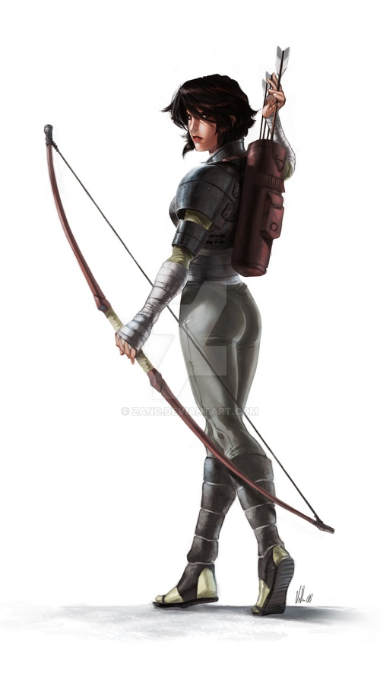

“Ah, Astrid,” Bratislava turned to the woodsy woman with the reinforced dragonbone composite longbow and a scout’s headband, noting the ranger’s stance as she beheld those before her.

“Milady,” Astrid nodded. “Is this the crew I am to ferry?”

“The very one: the Fist of Light,” proclaimed Bratislava, then turning to the three heroes. “Astrid will be taking you aboard a large flying carpet that will accommodate you all, plus a chest of potions. Though armed, her primary function will be to jockey the carpet so everyone can lob down flasks without having to worry about balance issues.”

Tore turned and looked at Astrid. Before he knew it, his eyes were going over her body from head to toe and back again. Giving her a slight bow of his head, he smiled, “I am Tore Stoneblood; it is a pleasure to meet you.”

“Now then,” Bratislava clapped her hands together with resolution. “Please make your way to the mess hall downstairs before leaving. The trip is several hours long, and you can either pack up some of today’s meal or eat before setting off. You can also pass through the commissary to stock up. Your badges are good for any low-stakes item; if you need anything fancier, you’ll have to requisition it. In any case, you can meet Astrid out front when you’re done, and the carpet will lift off at the next half-hour toll.

That gave them almost half an hour to eat and prepare. It would just be the three of them, plus this ranger.

Tore turned to Bratislava, “I do not need any food, but some upgrades in weapons and equipment might be helpful. I’ll also be sure to spend the time in transit adjusting my spell allotment if Lurue grants it.”

“See the folks at the commissary, and tell them Bratislava approved an E-level allotment,” the Prefect nodded and replied to Tore, who would soon find out what E-level meant. “Be sure to mention the Frostbiter. It’s a longsword weighted for a man of your build. There’s also a belt that has just been identified as having multiple properties, including healing, and a ring to match. These should suit you as well.”

“Will do,” Tore committed the items to short-term memory.

“You should be able to get some other things, but I can’t recall what we have right now,” she admitted.

At Bratislava’s instructions, Elsabet smiled, and said “I’ll go down to the commissary as well, I need a new everfull mug to replace the one I gave to Rockhard to help adjust his attitude. And then I’m definitely heading for the mess hall, a light meal would be perfect, and I can say hi to some of my friends in the guard.”

Elsabet started to head down, but had a sudden thought, and turned back to Bratislava. “I just had a sudden thought! Do we know if the half-dragon or any of the other anticipated targets are spellcasters?”

“We shall have a briefing packet prepared for you tomorrow,” Almitra assured Elsabet, who asked the squire if he was allowed to eat with them of if he had other duties to tend to after getting us to the Sternum.

“Assume magic will be within the scope of our enemy,” Bratislava said this of just about any dragons and dragon-descended folks.

Elsabet paused briefly, then continued. “I carry a thunderstone of my own for possible use against casters, but it just occurred to me: at the start of our bombardment, hopefully before the targets have a chance to notice us or react, what if we dumped a sack or bucket of thunderstones on them, trying for a dispersal pattern to try to get the leader and as many other creatures in their area as possible? The spread of the stones would clearly be a bit random, but a series of loud sonic bursts could potentially deafen multiple foes. Any creature that got deafened would be unable to hear orders, and would be slower to react, and any spellcaster might screw up their spells! Just a sudden idea, not sure how well it would work, but maybe worth a try?”

“Would that we had such munitions in our stores...” sighed Bratislava. “And be mindful in your tactics,” she then warned, seeing too much confidence in Elsabet’s eyes. “We live in a world wherein any wizard worth her salt can cast a fireball spell on you from over 400’ away.”

They all knew this, but it merited being put into perspective, given their vulnerability while flying.

~*~

Tore found himself at the commissary, just feet away from where an imp had bonked Solstice on the head and assumed the musteval’s likeness nearly a year ago; today was the anniversary of the exorcism of the Wererat Lord and his associates from the Reality Wrinkle, which preceded by two days the even more thickened caper with the wereserpents that were about to completely replace the Barony had it not been for the Fist of Light.

Tore reported to the commissary and quickly found out what an E-level allotment was. As he browsed around, he found the sword that Bratislava had mentioned. He followed the clerk around and located several items that suited his wandering style and would also be helpful during the trip.

As he was almost done, he wandered into the section with camping supplies. After the attempt to cook on the beach, Tore decided he needed to be better prepared. He collected two differently sized pots, two differently sized pans and several utensils. Within several minutes, Tore had all of the items and equipment collected and packed. He then headed out to meet with the others and prepare to leave.

Elsabet entered and greeted the guard at the commissary warmly. “So, I used my old everfull mug as a gift to the orc leader, to get him a bit more willing to listen, so I am hoping I can pick up a replacement.” She grinned, and noted, “Hey, a girl’s gotta have a drink on occasion! New sword?” she turned to Tore, who nodded and unsheathed it half-way.

“You bet!” the commissar said now that Tore was all stocked up. He fumbled through a manifest log, found the correct locker number, and went to grab a nearly identical replica of her previous mug. “Everfull!” he said as he handed her the item and made an entry in his log.

“How’s about a shine job for that buckler?” he noted the scuffs and oil stains.

~*~

Elsabet and Saradette mingled with others, passively gleaning information from the conversations in their midst.
Skill | Rank | Ability & Mod. | Misc. Mods. | Total | Roll | Check
Elsabet, Appraise | 0 | Int (+2) | 0 | 2 | Poor | ??
Elsabet, Diplomacy | 9 | Cha (+2) | 4 | 15 | Awesome | ??
Elsabet, Gather Information | 0 | Cha (+2) | 0 | 2 | Poor | ??
Elsabet, Knowledge: Arcana | 1 | Int (+2) | 0 | 3 | Middling | ??
Elsabet, Knowledge: History | 1 | Int (+2) | 0 | 3 | Middling | ??
Elsabet, Knowledge: Nature | 1 | Int (+2) | 0 | 3 | Good | ??
Elsabet, Knowledge: Nobility & Royalty | 1 | Int (+2) | 0 | 3 | Awesome | ??
Elsabet, Knowledge: Religion | 1 | Int (+2) | 0 | 3 | Awesome | ??
Elsabet, Elsabet, Listen | 0 | Wis (-1) | 0 | -1 | Middling | ??
Elsabet, Sense Motive | 9 | Wis (-1) | 0 | 8 | Middling | ??
See below.

Elsabet’s casual conversations revolved around the Barony and the Sky Tree’s Monarchy, and most of what she picked up confirmed her current understanding, though she did catch a hint of gossip about Viscount Yuri vying for control of a battalion of dragon slayers. She managed to gain the favor of several of the Baron’s up and coming Prefects, including a retired merchant from the Dalelands who’d moved here decades ago.

Skill | Rank | Ability & Mod. | Misc. Mods. | Total | Roll | Check
Saradette, Appraise | 0 | Int (+3) | 0 | 3 | Awesome | ??
Saradette, Diplomacy | 0 | Cha (+0) | 0 | 0 | Middling | ??
Saradette, Gather Information | 0 | Cha (+0) | 0 | 0 | Good | ??
Saradette, Knowledge: Arch. & Eng. | 4 | Int (+3) | 0 | 7 | Poor | ??
Saradette, Knowledge: Geography | 2 | Int (+3) | 2 | 7 | Great | ??
Saradette, Knowledge: Metallurgy | 7 | Int (+3) | 0 | 10 | Poor | ??
Saradette, Listen | 0 | Wis (+0) | 2 | 2 | Good | ??
Saradette, Sense Motive | 1 | Wis (+0) | 0 | 1 | Poor | ??
See below.

Saradette had not so much gained favor, but had noted several details suggesting the conspicuous consumption of a trendy but uncomfortable cut of vestments, and noticeably heavy jewelry. She had passed several tailors and wardrobers who showcased such trends in the heart of Chatterstreet Market, and they were just as ostentatious on the wire models as they were on live aristocrats.

She’d also met the fellow Dalelander—Prefect Rylance the Resplendant—whose background as a chevalier was notable in his speech and posture. Aside from Rylance, she noted mostly the local accent, along with other Lake of Steam variants. At one point she fumbled on a comment on the subject of architecture, blushing before one of the Baron’s engineers.

Saradette picked up an elaborately decorated wooden tankard filled with a really good summer ale, and circulated around the room. She kept her conversation to polite nods and brief greetings, since her social skills weren’t up to the task in this company.

Elsabet really enjoyed reconnecting with old friends and making new friends; she kept her food consumption to light snacking on fruits and vegetables, and perhaps a small pastry or two. She made certain to congratulate the various new prefects on their elevation to such an honored post, and was especially interested in the retired merchant’s tale, giving their common regional origins. She made sure to make plans to meet up with him later, provided all went well.

~*~

Outside the keep and within the wall, they met up with Astrid once again. She’d laid out the carpet 1’ above the ground, and now assessed the weight of each fully equipped hero, deciding where to place them in the distribution. “This is an exact science,” she said as she evaluated the stuff on Tore that she’d not previously accounted for. “Nice sword,” she commented when she saw Frostbiter. “If you die, can I have it?” she contained her giggle only until the end of the question, then apologized for the gallows’ humor and reassured them all, “I’ll fly at a safe enough speed, but it’s always a good idea to sit on a shield when doing something mischievous like this from above.”

Tore laughed at Astrid’s comment, “No need to apologize, and yes, should I die in combat it’s yours if you can retrieve it.”

Elsabet chuckled at Astrid’s joke, but when she mentioned sitting on a shield, she remarked, “this buckler wouldn’t make a very good seat, but it is pretty good at blocking missiles. Sitting on my left arm sounds rather uncomfortable, though.”

Tore looked at Astrid and did not see a shield. “Should we need to sit on our shields, perhaps you would like to use mine. We can’t have our pilot shot in her backside,” he added in a friendly and almost too serious a tone.

As the conversation continued, the Fist of Light could tell that Astrid was a more seasoned veteran of warfare than they were, and they’d all seen their fair share of challenges. Still, this was no ordinary ranger.

When Astrid instructed Tore where to sit, he boarded the carpet and sat where he’d been told.

Elsabet nodded to the woman, taking her measure and liking her confident stance. “Good to meet you, Astrid. A flying carpet, eh? Sounds like it could be exciting. Hopefully there will be no fliers in the group we’ll be messing with. But if there are, I should be able to summon a flying ally of some sort, I need to review my options.”

The chest had 20 acid flasks and 20 alchemist’s fire flasks, and Saradette had a good mind to throw the whole chest down onto the dragons once they got down to about 5 or 6 flasks left. She giggled a bit as they boarded the carpet.

Having tallied the flasks, Saradette checked her gear, having settled her pack and her stowed workshop on her back while still at the Missing Minotaur. Before she’d left the inn, she’d made sure the methane digester had been working properly, and that the storage tanks for the compressed methane had been securely locked. “Come on, Widget; let’s go bomb some people,” she now said, feeling some déjà vu coming on.

