*Chapter 3: The Omlarandin Mountain Trail*

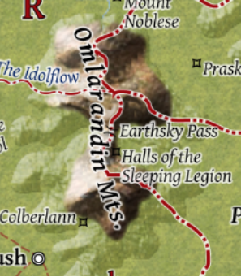

*[… partly adapted from FRCS and online sources…]*

Once a haven for dwarves—who named this range the Omlarandin, or Magical Peaks—and jutting barely higher than the foothills around them, the Omlarandin Mountains had become legendary for omlar gems, which were very suitable for magical uses. Only a few rare omlars had been discovered in centuries, but those had fetched princely sums from wizards. Wyverns and displacer beasts inhabited the area, but the party had yet to see one on their trek.

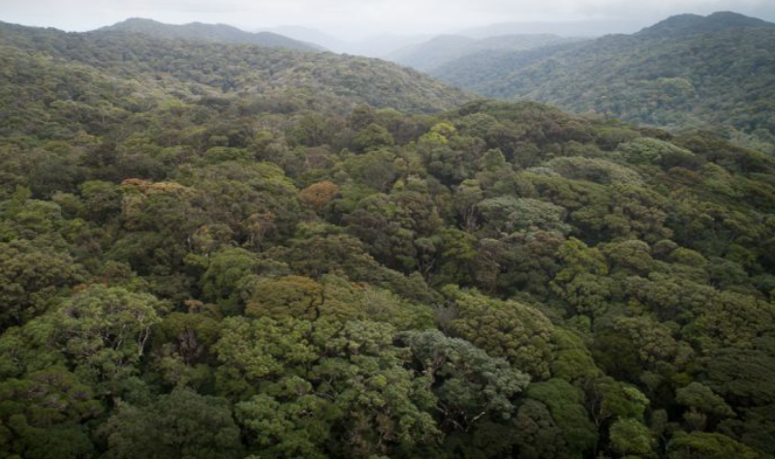

Still hanging with PJ these days, in late Marpenoth of 1370 DR, the party had acquired an enviable set of weapons and armor, and they were now making their way along the western foothills of this mountain range, having just braved the windiest and steepest incline, followed by an even more intense descent, which involved the heroes occasionally pulling back on the wagons in order to keep gravity from rushing the horses and wagons down, and causing a cavalcade. North of them—a few miles away—was the Idolflow River, and eventually they would run into a bridge that crossed it, which offered an excellent rest stop.

They were still using the same three wagons, but the contents of this shipment were far more precious, including less of the usual sundries that PJ conveyed from place to place, and more of the preciosities that fetched higher returns on investment, depending on where one sold them. Spell components, precious gems, and even some magic items now rested in the locked coffers that the party helped secure.

“The road is nowhere near as steep,” PJ has assured them, having traversed it only once before, as soon as they got to the flatter field of tropical bushes overlooking a valley fertile with palms and guavas.

It had been half an hour since then, and in the meantime, they’d told stories of what had transpired since their first gig with PJ over a year ago along the Spine of the World.

“Those ogres were something else,” stated Saradette, who had mostly stayed back while the others did the talking.

“I hope they’re alright,” Elsabet shook her head. “They were so *emaciated*!”

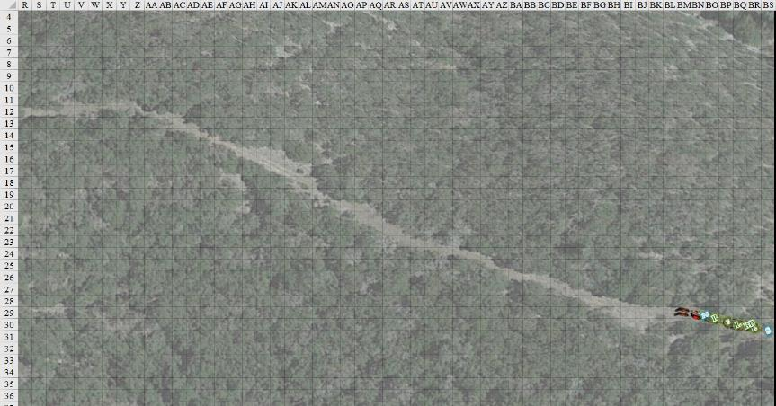

Having already been crossing the foothills at a slow and safe speed, the horses stopped shortly after rounding a bend in the road. Barkley’s eyes shifted at the unexpected halt, and the hound archon poked his head out through the tarp, hearing a woman’s voice in the distance.

PJ whispered. “See those tracks?”

Barkley noted them, and nodded.

“See how only the front of the foot is depressed? That’s a sneak,” PJ surmised. He was no proper rogue, but the next best thing to one in Saradette’s absence.

By now, Saradette had gotten out of the wagon, and had intuitively already looked on the ground, spotting and now studying the footprints. She got to the front of the wagon, where the whispering conversation was ensuing.

Now that the horses and mule weren’t walking, and the wagon wheels weren’t spinning, they could hear the laughter and yelling of at least one woman, possibly a human. This wasn’t like a few years ago, when they’d happened upon some gnolls. No, these weren’t screams of terror, but rather of a person in the midst of deliberating some bold consequence to someone else.

It had to be coming from only a few hundred feet away—maybe 300’—but the vegetation dampened the acoustics in these rolling hills.

Elsabet and Laryssa now looked at where they were. Both tacticians, they noted the 30- to 40-degree downward slope south of the road, which got only slightly less steep going upward and northward from the road, which was a two- or three-horse wide trail that wasn’t regularly maintained.

About 250’ ahead of them was another bend in the trail, this one veering leftward.

“*I* killed him,” the heroes then distinctly heard one woman with a rather hoarse and bellowing voice telling someone else. “*I* get the charm!”

“Murder hoboes,” PJ turned back to Barkley. “Wish I had a *clairvoyance* scroll right about now.”

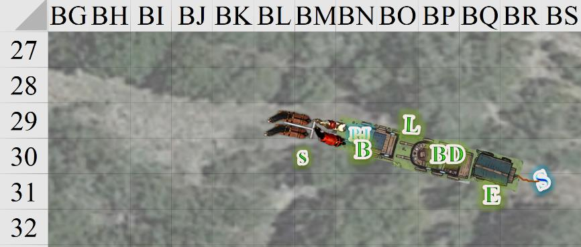

Round 1

Elsabet headed for Barkley and Saradette, and quietly spoke. “Let me give one or both of you Mayaheine’s blessing, in the form of a *protection from evil* spell, in case they are evil—Saradette first.

Elsabet intended to cast the *protection from evil* spell on each of them—first Saradette, then Barkley—figuring Saradette will need to get moving first and Barkley can catch up. As usual when traveling, she had her light crossbow in her left hand.

Saradette turned to the others Saradette as Elsabet recited the blessing. “This probably isn’t a trick, but I suggest that Barkley and I go investigate, while the rest of you stay with PJ and the wagons. Ooh, thanks,” she then said to Elsabet as the latter cast *protection from evil [expired on Round 31]* on her.

*Saradette gained +2 to AC and saves vs. Evil characters’ offenses.*

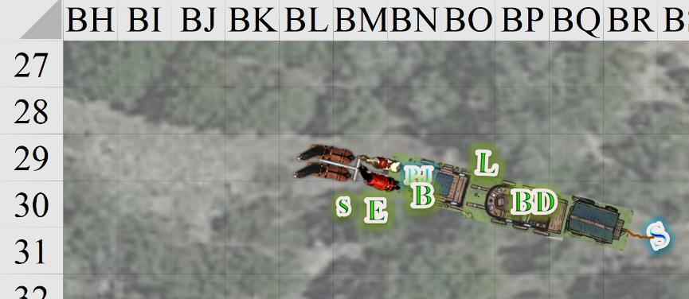

Round 2

Barkley nodded, “I agree, we should investigate and see what is going on.” Barkley waited until he could see the source of the voices before using his Detect Evil ability.

Barkley got out of the wagon.

Elsabet warded Barkley with a *protection from evil [expired on Round 32]* spell.

*Barkley gained +2 to AC and saves vs. Evil characters’ offenses.*

Barkley gladly accepted the blessing, bowing his head as Elsabet recites her enchantment.

PJ grabbed his heavy crossbow and prepared to descend from the wagon and calm the horses.

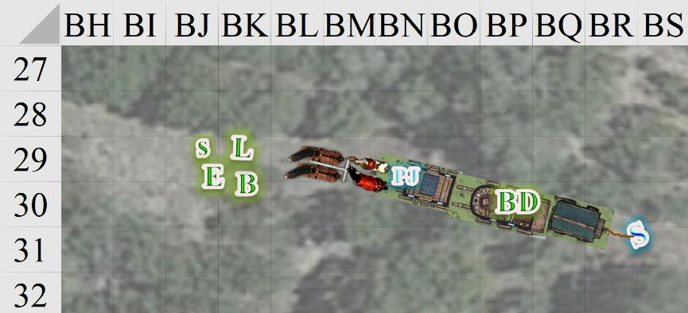

Round 3

PJ drank a potion of *aid [expired on Round 33]*, and descended from the wagon, stepping down softly on one booted leg, then on the other, looking to his hired security detail for direction. While he was in charge when it came to the talking, bartering, and other socially apt things, he always deferred to his team when it came to things tactical.

Barkley cast *aid [expired on Round 33]* on Saradette.

*Saradette gained a +1 morale bonus on attack rolls and saves against fear effects, and 3 + 3 = 6 temporary hit points [20/14].*

The gnome moved off down the trail, walking on parts of the road that were not covered in leaves or loose rock. She was prepared to duck into cover at the first sign of movement, and she carried her bow stave in her right hand as she moved along.

After receiving the blessing from Elsabet, and blessing Saradette, Barkley then followed the gnome with empty hands and ready to shapeshift. His intent wasn’t to catch her, though he could easily do it; his focus was on moving quietly and as stealthily as possible.

Elsabet cast *protection from evil [expired on Round 33]* on herself, and kept alert for any new developments.

*Elsabet gained +2 to AC and saves vs. Evil characters’ offenses.*

Laryssa did not even consider going with the advance party—while her armor made her the most protected against attack, joining the advance party was neither quiet nor speedy. Instead, bow in hand, she scanned the general direction of the voices for any evil auras, should they be a diversion from sneaky foes.

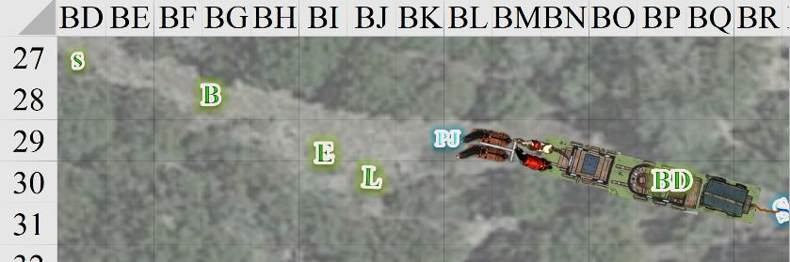

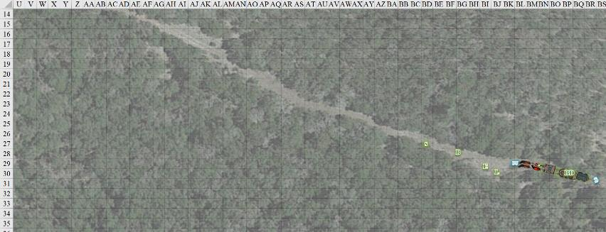

Round 4

Barkley cast *aid [expired on Round 34]* upon himself as quietly as possible while the women in the distance were busy arguing and yelling as if a bit inebriated.

*Barkley gained a +1 morale bonus on attack rolls and saves against fear effects, and 4 + 3 = 7 temporary hit points [28/21].*

Barkley and Saradette then started walking more quietly.

|  |  |  |  |  |  |  |
| --- | --- | --- | --- | --- | --- | --- |
| **Skill** | **Rank** | **Ability & Mod.** | **Misc. Mods.** | **Total** | **Roll** | **Check** |
| **Barkley, Move Silently** | 4 | Dex (+1) | 0 | 5 | 15 | 20 |
| **Saradette, Move Silently** | 4 | Dex (+3) | 4 | 11 | 11 | 22 |

*Outcome unknown to PCs, but see below.*

“Woohoo!” panted the deep, exotic, throaty voice, sexier than the other two voiced they’d already heard. “It’s been a while since we had such a close one. Did you see how I smashed this one’s skull? Look at that!”

Elsabet scanned the area in all directions, looking carefully for any signs of hidden foes. “So,” she muttered to PJ and Laryssa, “I guess

we wait here and guard the wagons until we hear from the scouts. Laryssa, PJ, do you want *protection from evil* as well?” She took a step and cast the spell on Laryssa, who was closest.

“Ahforsuredude!” PJ said in a single huff, feeding a carrot to his skinniest horse and coming over for some love.

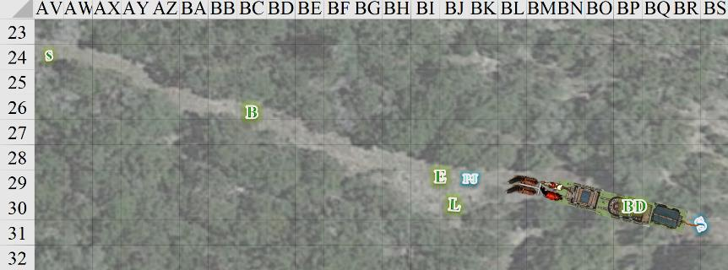

Round 5

BelDamon had taken ill yesterday, and was in a deep sleep at the moment, so the rest of the heroes let him be.

Barkley continued his less-than-silent approach, trying to close the gap with Saradette, now that it seemed that the people they were searching for were making enough noise to cover any slight noise he might have made.

With PJ’s acceptance, Elsabet cast the spell on him as well, then turned her eye back on the expeditionary force comprised of a hound archon and a rock gnome. She’d seen stranger things in her day.

*PJ gained +2 to AC and saves vs. Evil characters’ offenses.*

Saradette kept moving, staying alert and ready to hide if anyone appeared.

|  |  |  |  |  |  |  |
| --- | --- | --- | --- | --- | --- | --- |
| **Skill** | **Rank** | **Ability & Mod.** | **Misc. Mods.** | **Total** | **Roll** | **Check** |
| **Saradette, Move Silently** | 4 | **Dex (+3)** | 4 | 11 | 20 | 31 |

*See below.*

“*I* called the potions, bitch!” a shrilly elven throat voiced the harsh words from afar.

“D’you even know what they *are*?” a distinctly human voice asked. “What if it’s *cursed*?”

As Saradette got closer, she could tell that she was about to happen upon a human, an elf, and some other woman whose origins she could not discern by the sound of her voice. It wasn’t a hound archon—that was for sure.

The hound archon behind her could pretty much sense the same thing, but *his* experience told him that the third ne’er-do-well was likely to be a genasi. An elemental wouldn’t have had such humanoid enunciation, but that reverb in her bellowing voice: that was reminiscent of a liquid diaphragm. He’d battled a few water elementals, and ooze para-elementals in recent years, and prepared to do so now, as he couldn’t think of any other creature whose guttural cant reverberated like that.

Farther away, Elsabet, PJ, and Laryssa soothed the horses. PJ then said, “Well, look, if you two are staying with the noble steeds here, I’m going to go cover them as much as I can.” And with this, he began to make his way west-northwest along the trail.

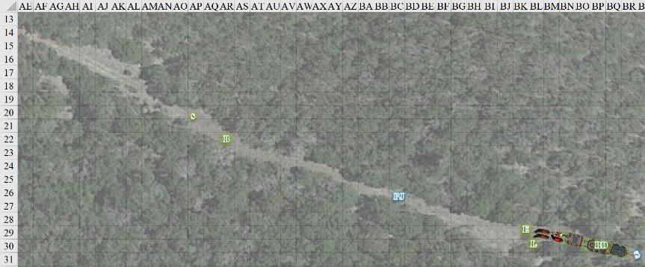

Round 6

Saradette kept moving, staying alert and ready to hide if anyone appeared.

|  |  |  |  |  |  |  |
| --- | --- | --- | --- | --- | --- | --- |
| **Skill** | **Rank** | **Ability**  **& Mod.** | **Misc.**  **Mods.** | **Total** | **Roll** | **Check** |
| **Saradette, Move Silently** | 4 | **Dex (+3)** | 4 | 11 | 19 | 30 |

*See below.*

Barkley came up behind Saradette, spoiling her relative silence, though it probably didn’t matter at this point, given the strangers’ chatter.

“Look what *I* fouuuuund!” the elven voice reeled with insecure excitement.

PJ slowed his pace slightly as he, too, got closer to the epicenter of the women’s voices.

Laryssa continued scanning about for any whiffs of evil. She reflected that it would behoove her to look into enchanting her armor to make it less cumbersome and noisy.

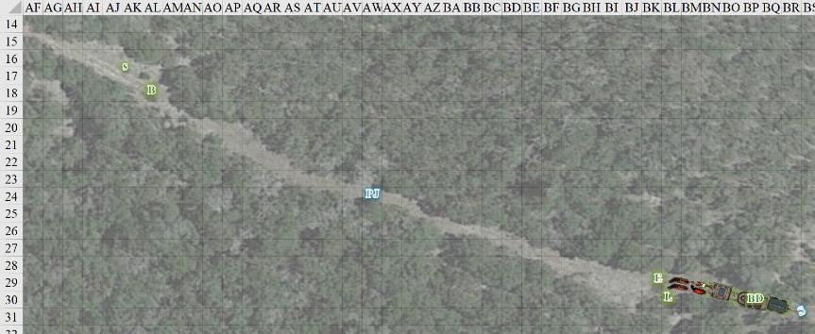

Round 7

As Saradette approached the corner, she looked for a way to leave the road and use the trees and brush to mask her approach. Her decision depended on how easy it would be to move quietly through the ground cover, versus staying on the road and risk being seen.

|  |  |  |  |  |  |  |
| --- | --- | --- | --- | --- | --- | --- |
| **Skill** | **Rank** | **Ability & Mod.** | **Misc. Mods.** | **Total** | **Roll** | **Check** |
| **Saradette, Move Silently** | 4 | **Dex (+3)** | 4 | 11 | 20 | 31 |

*Outcome unknown to PCs.*

Since the moment she’d started thinking about this, she’d identified 7 veer-off points, four of which provided a height advantage.

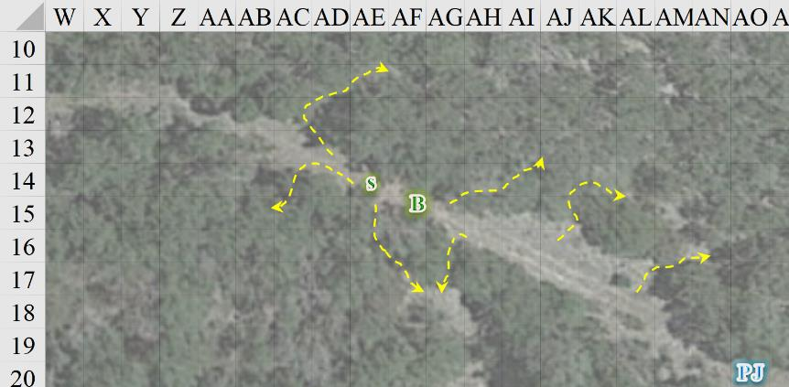

Barkley inhaled deeply, though he could not smell anything more specific than some type of carnage. It was not unlike a butcher shop, but faint due to the fact that the light breeze was blowing southwestward. This also meant that as soon as they rounded the bend, they’d likely be upwind of the foulmouthed women.

PJ had been catching up a bit, but still needed to gain another 50’ or so on Barkley. No hurry. As he made his way, he started to make out the dialogue as well, “By the wickedest gods! It’s a beauty!” the human voice remarked.

“You’ll slay a thousand or more with that before you fall in battle,” the elf’s voice proclaimed.

Elsabet and Laryssa could hear BelDamon snoring in the rear wagon, and consoled the anxious horses in the front with carrots and turnips. Laryssa continued her scan of the immediate area.

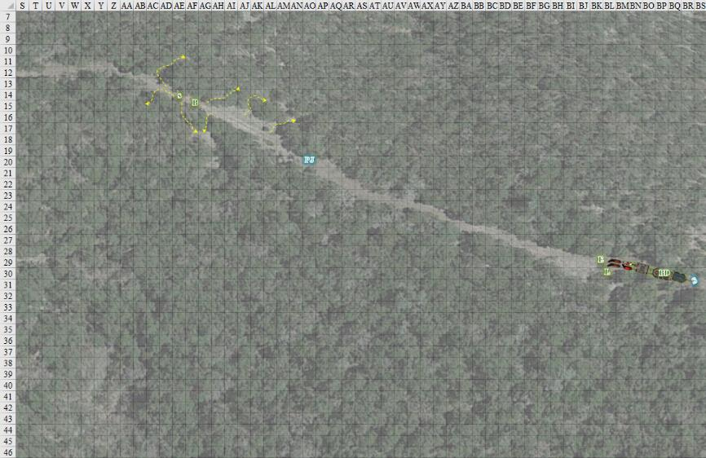

Round 8

“I will *never* fall!” the exotic voice gurgled and maintained, though the woman seemed like she was still winded from the recent killing spree. “I will glisten for an Age, and then retire to become a ripple in the Pond of Oblivion.”

“If you *say* so,” the elf scoffed. “I’m going the lich route for sure.”

*BelDamon burst into the room, with a fanfare of horns. “BEHOLD: it is I, BelDamon the beautiful. Vanquisher of evil and world renown lover.” He pointed, his demon lord’s minions started to laugh, the demon lord started to laugh, some garden gnomes in the corner started to laugh.*

BelDamon snored heavily; the noise disrupted his sleep for a moment, breaking the dream. He rolled over to get into a different position. Had anyone been watching him in the wagon, they would have seen a silly grin play out over his face as he enjoyed his dream time, and continued to snore.

Barkley moved up quietly by Saradette, “I think we should have them bring the wagons up,” he whispered.  “We can hide then ambush them when they try and ambush the wagons.  What do you think?”

PJ walked up quietly, smiling and saying nothing.

It now became evident to Barkley and PJ that folks their height would have to crouch [i.e., use the Hide skill while walking] if they were to preserve the element of surprise.

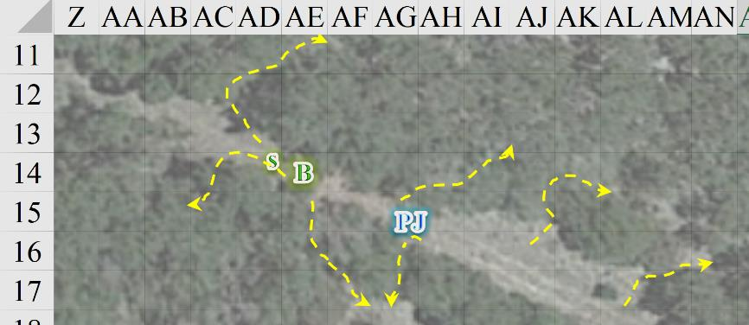

Round 9

The cackle of the three women to the west suggested to PJ that he’d neither been spotted nor heard so far.

The gnome stopped and looked at Barkley as PJ approached. “I’d rather not do that just yet. Can you change, and then go see what we’re facing? Then, we can decide what to do.”

Barkley shrugged his shoulders, “sure”, then transformed into a wolf and slowly moved towards the voices using stealth and cover.

|  |  |  |  |  |  |  |
| --- | --- | --- | --- | --- | --- | --- |
| **Skill** | **Rank** | **Ability & Mod.** | **Misc. Mods.** | **Total** | **Roll** | **Check** |
| **Barkley, Hide** | 2 | Dex (+1) | 0 | 3 | 5 | 8 |
| **Barkley, Move Silently** | 3 | Dex (+1) | 0 | 4 | 7 | 11 |

*See below.*

Barkley could tell that he’d botched any plans for sneaking up on the three women as he rounded the bend.

Nevertheless, Saradette and PJ followed as quietly as possible to at least mask their numbers

|  |  |  |  |  |  |  |
| --- | --- | --- | --- | --- | --- | --- |
| **Skill/Save** | **Rank** | **Ability & Mod.** | **Misc. Mods.** | **Total** | **Roll** | **Check** |
| **Saradette, Hide** | 4 | **Dex (+3)** | 4 | 11 | 6 | 17 |
| **Saradette, Move Silently** | 4 | **Dex (+3)** | 4 | 11 | 5 | 16 |
| **PJ, Hide** | 5 | **Dex (+3)** | +3 | 11 | 1 | 12 |
| **PJ, Move Silently** | 4 | **Dex (+3)** | +3 | 10 | 16 | 26 |

*See below.*

Saradette watched in fascinated disbelief as Wolf Barkley started up the road. She didn’t wait around to see when he would get spotted – the halfling stepped off the trail and into the woods.

PJ realized he’d been acquired once he made eye contact with the black-haired, green-skinned woman over the top of a bush.

“What’s *this*?” asked the green woman with renewed excitement as a third woman—wearing padded armor—came into view.

Barkley could now see a corpse on the ground between the green woman and himself.

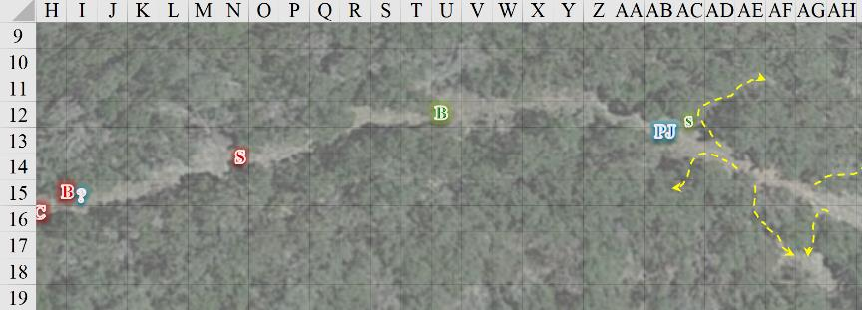

Round 10

|  |  |  |  |  |  |
| --- | --- | --- | --- | --- | --- |
| **Character** | **Group** | **Initiative** | **Roll** | **Modified Roll** | **Move** |
| Elsabet | 1 east | 4 | 19 | 23 | 30’ |
| Sultry | 2 | 1 | 19 | 20 | 40’ |
| Beflinne | 2 | 1 | 18 | 19 | 30’ |
| Laryssa | 1 east | 3 | 14 | 17 | 20’ |
| Barkley | 1 | 4 | 10 | 14 | 30’ |
| Copper | 2 | 3 | 8 | 11 | 30’ |
| Saradette | 1 | 1 | 9 | 10 | 20’ |
| PJ | 1 | 3 | 2 | 5 | 30’ |

Barkley and a green-skinned woman with black hair made eye contact now that the women’s laughter died down. She said, “Well, well. If it isn’t lunch?”

“Shut your trap!” an elf came into view of the wolf, wearing the verdant tatters of a druid, or a really woodsy ranger. This one studied the wolf momentarily as the green-skinned genasi hefted her greatsword and approached the wolf at a slow pace with a menacing stare.

“Come on, ladies: let’s double down,” the masculine she-warrior almost commanded trying not to sound winded, and the other two set into motion their respective tactics.

Sultry was an acid genasi—something that was new to Barkley. She had recently been Raging, but during the looting of the bodies at their feet (there were others that Barkley couldn’t see), she had had sufficient time to recover from the Fatigue that that had brought on, and now entered her second fit of the day, screaming obscenities in Aquan as she spat.

*Sultry gained +4 to Str & Con, 10 hps, and a -2 penalty to Touch AC and AC.*

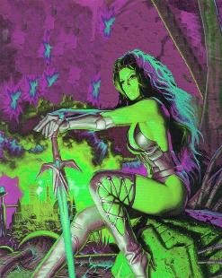

Beflinne shook her head at her partner in crime, suspecting that the human she’d just spotted coming behind the wolf would surely be trouble, and hoping to kill at least one person today, since she hadn’t delivered a lethal blow just yet. She stepped further behind a bush and produced her masterwork longbow, drawing an arrow from her quiver.



Barkley turned and headed back 10’ towards Saradette and PJ until he had a line of sight to both.

Seeing the fleeing wolf, Sultry maintained her course, and now targeted PJ while calling Barkley a cowardly cur.

Seeing the fleeing wolf, Copper BeNève cast a spell that none of the frontline heroes could identify by its casting. No effect was evident either. *[ghost sound, expired on Round 13]*

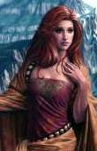

The wolf—unable to speak—could not inform the others of what he saw, so instead, he ducked off the road into the woods and out of sight he transformed back to his natural form.

|  |  |  |  |  |  |  |
| --- | --- | --- | --- | --- | --- | --- |
| **Skill** | **Rank** | **Ability**  **& Mod.** | **Misc.**  **Mods.** | **Total** | **Roll** | **Check** |
| **Barkley, Hide** | 4 | Dex (+1) | 0 | 5 | 12 | 17 |
| **Barkley, Move Silently** | 4 | Dex (+1) | 0 | 5 | 12 | 17 |

*Outcome unknown to PCs.*

The wolf reverted to hound archon form, then crouched and tried to discern the location of each stranger.

Saradette moved to the high ground and waited for her chance to strike.

|  |  |  |  |  |  |  |
| --- | --- | --- | --- | --- | --- | --- |
| **Skill** | **Rank** | **Ability & Mod.** | **Misc. Mods.** | **Total** | **Roll** | **Check** |
| **Saradette, Hide** | 4 | **Dex (+3)** | 4 | 11 | 18 | 29 |
| **Saradette, Move Silently** | 4 | **Dex (+3)** | 4 | 11 | 17 | 28 |

*Outcome unknown to PCs.*

Still a bit wounded, and with most of her spells already cast for the day, Beflinne cast *cure light wounds* upon herself.

*Beflinne gained 6 + 3 = 9 hps.*

PJ took a few steps forward, peeked through a bush, saw Sultry looking right at him, assumed he’d been made, and stepped out, pointing the crossbow at the green barbarian. He released the bolt.

|  |  |  |  |  |  |  |  |  |  |
| --- | --- | --- | --- | --- | --- | --- | --- | --- | --- |
| **Ranged Weapon** | **Dmg.** | **D+** | **TH+** | **Critical** | **Rng.** | **Wt.** | **Atk** | **Roll** | **Check** |
| MW Heavy Crossbow | 1d10 | 0 | 1 | 19-20/x2 | 120’ | 8.0 | +6 | 8 | 14 |

*Miss.*

“Rats!” the eloquent factotum blurted when the bolt passed the now charging barbarian.

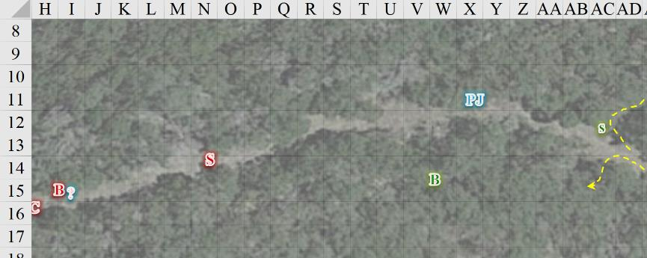

Further east…

Elsabet struggled to make sense of what she could hear, but her ears were not as good as her eyes, and the forested trail wasn’t straight, so she couldn’t see much of anything. She hoped that her companions weren’t doing anything foolish... “Laryssa,” she said, “don’t you think we should wake up BelDamon?”

“Yes, it sounds like combat may be in the offing. I’ll head up the trail to back them up since I’m slower than you unencumbered folk.” The paladin then took off down the trail at the best pace her armor would allow. Unable to run faster than 80’ per 6-second stretch, she reached that distance and maintained her momentum for the moment.

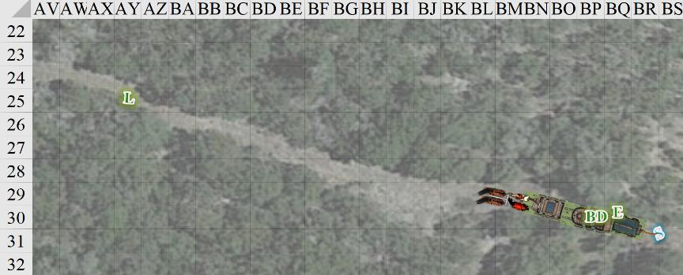

Elsabet went over to the easternmost wagon to wake the warlock.

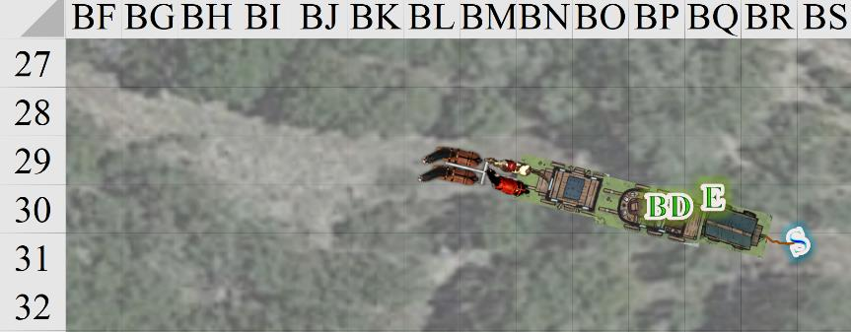

Round 11

Sultry charged towards PJ, who was prepared to take on the hulking wench with a magic dagger.

|  |  |  |  |  |  |  |  |  |  |
| --- | --- | --- | --- | --- | --- | --- | --- | --- | --- |
| **Melee Weapon** | **Dmg** | **D+** | **TH+** | **Critical** | **Type** | **Wt.** | **Atk** | **Roll** | **Check** |
| **Corrosive Greatsword** | 2d6 (+5 x 1½) | 1d6 | +2 charge | 19-20/x2 | Slashing | 8.0 | +11 | 8 | 19 |

*Hit. Dmg: 8 + 7 + 2 + 4 acid = 21.*

PJ was sliced open, and was nearly finished.

Beflinne was nowhere in sight, but Barkley was pretty sure that it was her whose movements he heard approaching from the west. The druid had gone into the bushes, and would likely ambush the wolf-turned-archon. Beflinne, drank a potion of *blur [expired on Round 41]* and situated herself a bit more conveniently.

*Beflinne gained 20% concealment.*

Laryssa continued to run at her top speed.

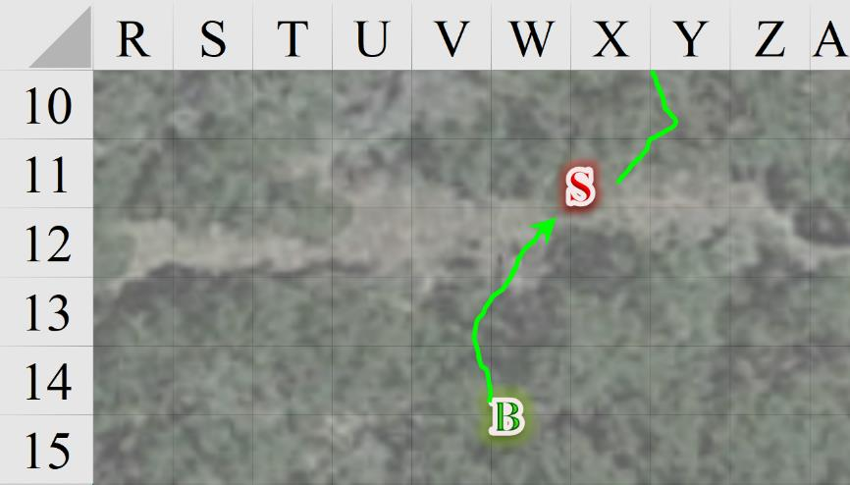

Once again in archon form, and barely spotting PJ, who was injured badly, Barkley howled and rushed through the tropical foliage *[impeding charge attack]* towards the green barbarian, slashing with his greatsword as he got close enough.

|  |  |  |  |  |  |  |  |  |  |
| --- | --- | --- | --- | --- | --- | --- | --- | --- | --- |
| **Melee Weapon** | **Dmg** | **D+** | **TH+** | **Critical** | **Type** | **Wt.** | **Atk** | **Roll** | **Check** |
| Greatsword | 2d6 x 1½ | +2 | 0 | 19-20/x2 | Slashing | 8.0 | +6 | **20** | 26 |

*Threat. 1d20 = 7 + 6 = 13. Not a critical hit. Dmg: 1½ x (4 + 2) = 9.*

Copper drank a potion of *blur [expired on Round 41]* and made her way back along the trail in order to better attack the newcomers.

*Copper gained 20% concealment.*

Saradette cursed softly and worked her way to a spot where she could ambush anyone headed down the road toward the wagons.

|  |  |  |  |  |  |  |
| --- | --- | --- | --- | --- | --- | --- |
| **Skill** | **Rank** | **Ability**  **& Mod.** | **Misc.**  **Mods.** | **Total** | **Roll** | **Check** |
| **Saradette, Hide** | 4 | **Dex (+3)** | 4 | 11 | 4 | 15 |
| **Saradette, Move Silently** | 4 | **Dex (+3)** | 4 | 11 | 1 | 12 |

*See below.*

Saradette could tell by the snap of the twig under her feet, and the body language of the barbarian who heard it, that her position had been compromised.

Unable to reload his heavy crossbow *and* shoot it within the time that it would take Sultry to reach him, PJ fled up the hill, hoping to not die in the next 6 seconds.

|  |  |  |  |  |  |  |
| --- | --- | --- | --- | --- | --- | --- |
| **Skill** | **Rank** | **Ability & Mod.** | **Misc. Mods.** | **Total** | **Roll** | **Check** |
| **PJ, Climb** | 0 | **Str (-1)** | +3 | 2 | 4 | 6 |

*See below.*

The factotum didn’t get very far.

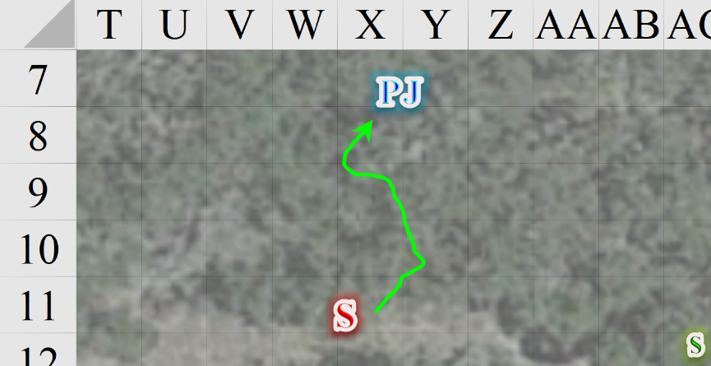

Carefully, Elsabet reached into the wagon and grabbed BelDamon’s foot.

BelDamon was not roused.

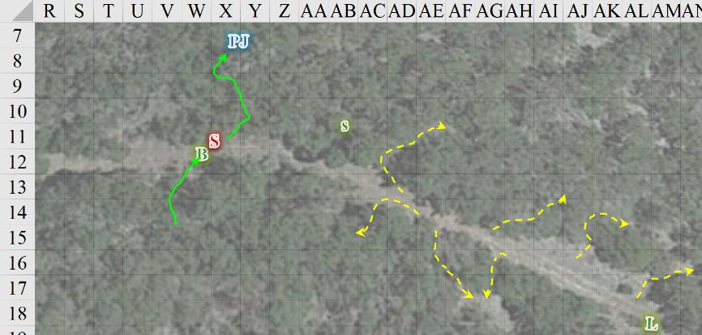

Round 12

Sultry proclaimed, “You’re all about to die at the hands of the Sordid Claw, knavesss!” The then swung meanly at Barkley.

|  |  |  |  |  |  |  |  |  |  |
| --- | --- | --- | --- | --- | --- | --- | --- | --- | --- |
| **Melee Weapon** | **Dmg** | **D+** | **TH+** | **Critical** | **Type** | **Wt.** | **Atk** | **Roll** | **Check** |
| **Corrosive Greatsword** | 2d6+5 x 1½ | 1d6 | 0 | 19-20/x2 | Slashing | 8.0 | +9 | 15 | 24 |

*Hit. Dmg: 5 + (1½ x 5) + 4 acid = 16 [15/21; temporary hps expended].*

Beflinne cast *summon nature’s ally I [expired on Round 15]*, and conjured a wolf right behind Barkley. “You are no wolf! *This* is a wolf!” she yelled at the hound archon.

The wolf flank-attacked Barkley.

|  |  |  |  |  |  |  |  |  |  |
| --- | --- | --- | --- | --- | --- | --- | --- | --- | --- |
| **Character** | **Attack Type** | **Damage** | **BAB** | **Str Mod+** | **W+** | **Other+** | **Total Score** | **Roll** | **Total** |
| wolf | Bite | 1d6+1 | 1 | 2 | 0 | +2 flank | 3 | 13 | 18 |

*Miss.*

Laryssa considered invoking Mayaheine’s blessing to improve her allies’ combat capability but decided it would be far better to close with the enemy and continued making her best speed to do so.

Seeing and hearing Laryssa’s approach, Barkley stayed in close combat with the barbarian, but maneuvered so that he was between PJ and the evil, green woman.

|  |  |  |  |  |  |  |  |  |  |
| --- | --- | --- | --- | --- | --- | --- | --- | --- | --- |
| **Melee Weapon** | **Dmg** | **D+** | **TH+** | **Critical** | **Type** | **Wt.** | **Atk** | **Roll** | **Check** |
| Greatsword | 2d6 | +2 | 0 | 19-20/x2 | Slashing | 8.0 | +6 | 19 | 25 |

*Threat. 1d20 = 18 + 6 = 24, critical hit. Dmg: 2 x [8 + (1½ x 2)] = 22.*

And as formidable as the strike to the barbarian’s chest was, it still did not bring down the raging acid genasi.

Copper shot at Barkley.

|  |  |  |  |  |  |  |  |  |  |  |
| --- | --- | --- | --- | --- | --- | --- | --- | --- | --- | --- |
| **Ranged Weapon** | **Dmg.** | **D+** | **TH+** | **Critical** | **Rng.** | **Wt.** | **Atk** | **Roll** | **Check** | **Notes** |
| Hand Crossbow +1 | 1d4 | 1 | 1 – 2 range  – 4 target in melee | 19-20, x2 | 30’ | 2.0 | 3 | 15 | 18 | WF & PB bonuses included |

*Miss.*

A crossbow bolt lodged itself into Barkley’s mithral chain shirt, but did not pierce the archon’s natural armor.

Saradette cast *mage armor* on herself, and ignored the urge to curse at the total mess unfolding before her.

*Saradette gained +4 to FF AC and AC.*

PJ drank his only potion of *cure light wounds*, and wondered how he was still alive.

*PJ gained 7 + 2 = 9 hps.*

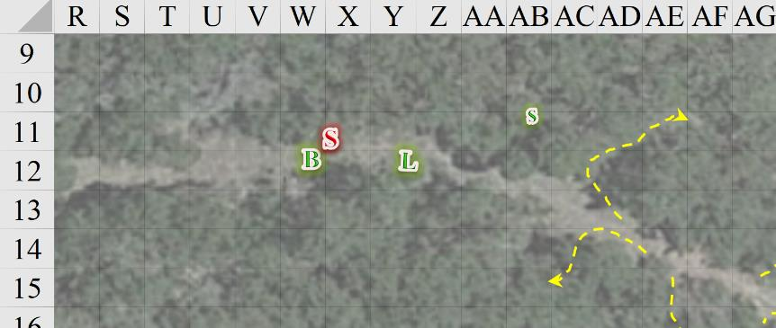

BelDamon gave no indication of being awake, or of fixin’ to become so, so Elsabet squeezed past the foliage and then took off at full speed with her sword in her hand, running down the trail after Laryssa.

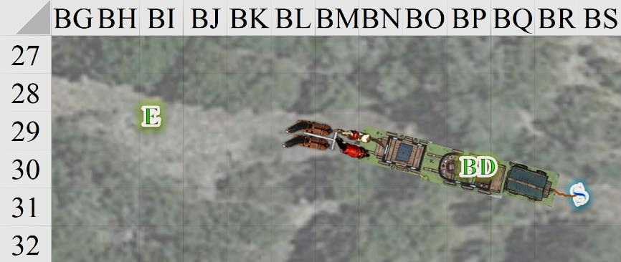

Round 13

Copper’s *ghost sound* spell expired.

Elsabet ran 120’ towards the epicenter of the fight.

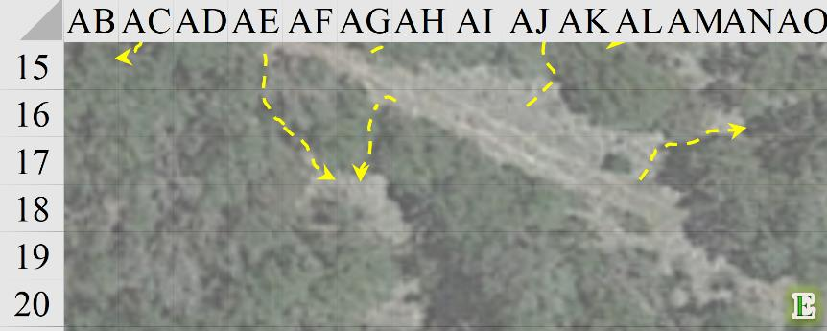

Sultry listened to Lizzo, and saw herself as a consummate bitch, so she tried to end Barkley’s life.

|  |  |  |  |  |  |  |  |  |  |
| --- | --- | --- | --- | --- | --- | --- | --- | --- | --- |
| **Melee Weapon** | **Dmg** | **D+** | **TH+** | **Critical** | **Type** | **Wt.** | **Atk** | **Roll** | **Check** |
| **Corrosive Greatsword** | 2d6+5 | 1d6 | 0 | 19-20/x2 | Slashing | 8.0 | +9 | 2 | 11 |

*Miss.*

It was a hefty swing that would surely have decapitated Barkley, but the hound archon dodged.

Beflinne fired upon Barkley, saying something in Elven that none of the heroes could hear.

|  |  |  |  |  |  |  |  |  |  |
| --- | --- | --- | --- | --- | --- | --- | --- | --- | --- |
| **Ranged Weapon** | **Dmg.** | **D+** | **TH+** | **Critical** | **Rng.** | **Wt.** | **Atk** | **Roll** | **Check** |
| MW Longbow | 1d8 | 0 | 1 – 2 range | x3 | 100’ | 3.0 | +4 | 18 | 22 |

*Hit. Dmg: 3 [12/21].*

Slightly out of breath but gratified she’d arrived to assist Barkley, Laryssa issued a scream of challenge as she charged against the enemy seeking to down him.

|  |  |  |  |  |  |  |  |  |  |
| --- | --- | --- | --- | --- | --- | --- | --- | --- | --- |
| **Melee Weapon** | **Dmg** | **D+** | **TH+** | **Critical** | **Type** | **Wt.** | **Atk** | **Roll** | **Check** |
| Bastard Sword, 1-handed | 1d10 | +2 | 1 + 2 charge | 19-20/x2 | Slashing | 6.0 | +7 | 19 | 26 |

*Threat. 1d20 = 12 + 7 = 19, critical hit. Dmg: 2 x (9 + 2 + 2) = 26.*

Though not “dead” dead just yet, the barbarian was out for the count, dropping to her knees and beginning to seep acidic blood, which was even now damaging Laryssa’s mundane bastard sword.

The wolf bit at Barkley’s buttcheeks.

|  |  |  |  |  |  |  |  |  |  |  |  |
| --- | --- | --- | --- | --- | --- | --- | --- | --- | --- | --- | --- |
| **Character** | **Attack Type** | **Damage** | **BAB** | **Str Mod+** | **W+** | **Other+** | **Total Score** | **Roll** | **Total** | **Crit** | **Threat** |
| wolf | Bite | 1d6+1 | 1 | 2 | 0 | +2 flank | 5 | 2 | 7 | 20 | ý |

*Miss.*

Barkley turned around to face his next target now that he had some support and the genasi was gurgling green stuff. He swung at the conjured canine.

|  |  |  |  |  |  |  |  |  |  |
| --- | --- | --- | --- | --- | --- | --- | --- | --- | --- |
| **Melee Weapon** | **Dmg** | **D+** | **TH+** | **Critical** | **Type** | **Wt.** | **Atk** | **Roll** | **Check** |
| Greatsword | 2d6 | +2 | 0 | 19-20/x2 | Slashing | 8.0 | +6 | 7 | 13 |

*Miss.*

Copper—a human rogue-diviner who’d already spent most of today’s spells—catcalled Barkley, “Can’t even hit a conjured animal. Now you die!”

|  |  |  |  |  |  |  |  |  |  |
| --- | --- | --- | --- | --- | --- | --- | --- | --- | --- |
| **Ranged Weapon** | **Dmg.** | **D+** | **TH+** | **Critical** | **Rng.** | **Wt.** | **Atk** | **Roll** | **Check** |
| Hand Crossbow +1 | 1d4 | 1 | 1 – 2 range | 19-20, x2 | 30’ | 2.0 | 7 | 16 | 23 |

*Hit. Dmg: 4 [8/21].*

Saradette worked her way west though the woods in a bid to sneak attack the green woman, or whomever else showed her their back.

PJ moved 5’ south to get a better vantage point, impaled his sword into the ground, and reloaded his heavy crossbow, saying, “Pretty sure that kill tipped the scales. Let’s finish them.”

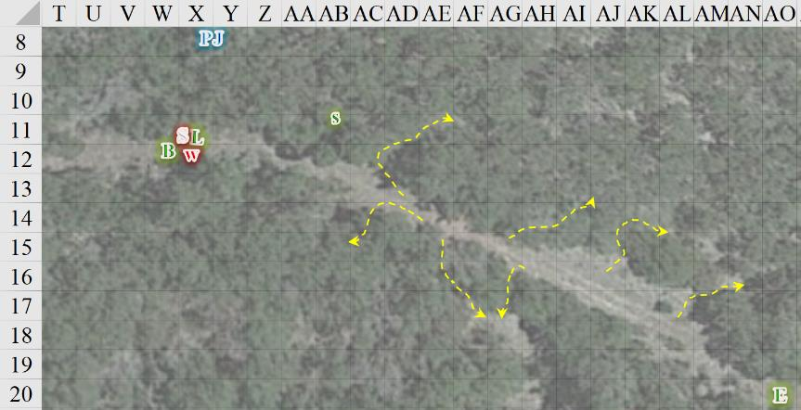

Round 14

Elsabet continued running towards the battle, anticipating emanating her Protection Devotion. She prepared to charge-attack the wolf if Laryssa or Barkley didn’t finish it off.

Sultry bled out, seeming to deflate.

Beflinne—an elven druid-ranger—shot at Barkley with her longbow.

|  |  |  |  |  |  |  |  |  |  |
| --- | --- | --- | --- | --- | --- | --- | --- | --- | --- |
| **Ranged Weapon** | **Dmg.** | **D+** | **TH+** | **Critical** | **Rng.** | **Wt.** | **Atk** | **Roll** | **Check** |
| MW Longbow | 1d8 | 0 | 1 – 2 range | x3 | 100’ | 3.0 | +4 | 11 | 15 |

*Miss.*

Laryssa swung at the wolf.

|  |  |  |  |  |  |  |  |  |  |
| --- | --- | --- | --- | --- | --- | --- | --- | --- | --- |
| **Melee Weapon** | **Dmg** | **D+** | **TH+** | **Critical** | **Type** | **Wt.** | **Atk** | **Roll** | **Check** |
| Bastard Sword, 1-handed | 1d10 | +2 | 1 | 19-20/x2 | Slashing | 6.0 | +5 | 12 | 17 |

*Hit. Dmg: 4 + 2 = 6.*

Barkley swung at the wolf.

|  |  |  |  |  |  |  |  |  |  |
| --- | --- | --- | --- | --- | --- | --- | --- | --- | --- |
| **Melee Weapon** | **Dmg** | **D+** | **TH+** | **Critical** | **Type** | **Wt.** | **Atk** | **Roll** | **Check** |
| Greatsword | 2d6 | +2 | 0 | 19-20/x2 | Slashing | 8.0 | +6 | 14 | 20 |

*Hit. Dmg: 7.*

The wolf yelped, then disappeared into thin air.

Copper looked back at Beflinne, then cast *obscuring mist [expired on Round 44]*.

Saradette worked her way west though the woods in a bid to sneak attack whomever else showed her their back. Saradette abandoned her cover and rejoined the others. “You *do* know that we were just supposed to scout them out, first, right?”

PJ had had a perfectly good shot at Copper before she’d conjured the 20’ cloud of mist around herself. Now he couldn’t even see Beflinne. He came down from the hill, still quite wounded, and joined the others. “They don’t have much juice left, and they *know* it,” the merchant-tactician offered.

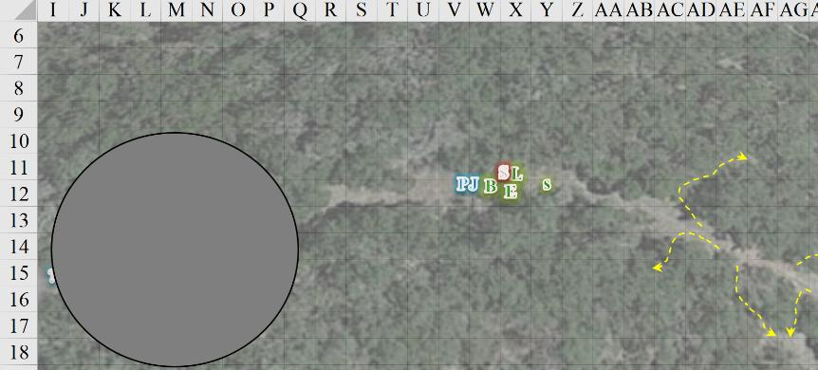

Round 15

Barkley wanted to make sure that the green acid spewing barbarian was finished, to swung his great sword to decapitate the evil creature, stepping back as he did in anticipation of some acid spewing form the now open neck.

“Awww! Coup de grace!” PJ narrated the scene with a sentiment between disgust and vindication.

Saradette looked at the *obscuring mist*, wondering what the enemy was doing. “After you,” said the rogue-illusionist. “I’m not much for leading a charge.” She looked more closely at PJ. “On second thought, you should hang back, too, PJ.”

Elsabet took a quick glance at the carnage, avoiding stepping in the gooey remains, and said loudly, “Let’s do some quick healing and then find those bitches and remove their taint from the world.” She cast *cure light wounds* on Barkley, and more softly, asked “How good is your nose? If they have a scent you can follow, we can find them, and with the concealment offered by that mist, they shouldn’t be able to stab us in the back.”

*Barkley gained 4 + 3 = 7 hps [/21].*

She thought for another second, and then whispered, “Perhaps you and Saradette can circle the mist to see if and where they left if, while Laryssa and I look for them in the mist. I think someone should cast a cure on PJ, and PJ, you should probably then hustle back towards the wagon, to stay between them and our horses etc. What do you think?”

Barkley gladly accepted the healing and when Elsabet mentions her plan, he replied, “I can move a bit faster alone, and will avoid combat on my own this time.”

Laryssa saw that Barkley’s wounds were being tended to, so cast a cure on to PJ, as he was severely hurt.

*CLW for 1d8+1*

With a bolt loaded onto his heavy crossbow, PJ reported, “I could *definitely* use some more healing love.” He then hung back behind Laryssa and Elsabet, waiting for the healing that someone mentioned.

Beflinne and Copper were nowhere to be seen, and thus either within or behind the black and gray hemisphere.

The barbarian’s headless body continued to seep out acid into a pooling puddle. All those around her torso and limbs took a step back.

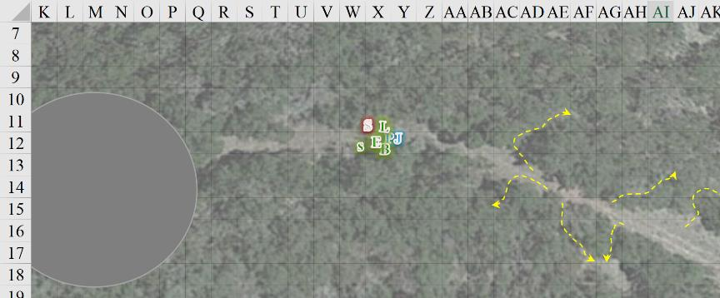

Round 16

“So, whom do I see for healing?” the factotum asked his staff.

Having cast *protection from evil* four times, and *cure light wounds* twice, Elsabet was fresh out of her most powerful spells for the day, so she Elsabet asked, “Laryssa, can you lay on hands or cast another cure on PJ, and then follow me in?” Elsabet then moved up near the misted area and readied an attack, should any foe step next to her.

“Of course,” replied the paladin-cleric. “Bright Lady, ease these wounds.” With her touch, healing power flowed into PJ’s body. “I still have one light and 3 minor cures left to me but might be best to hold them in reserve until we know all our foes have been dealt with.”

*PJ gained 4 hps.*

Still bloody, PJ smiled and nodded, “Thanks, Laryssa.”

Elsabet moved 40’ towards the *obscuring mist*.

Barkley transformed into a fox and began to run around the south side of the cloud, staying at least 50’ from it.

Saradette followed behind Barkley-fox trying to remain quiet as she moved.

The bush was thick, and the succulents that dotted the larger gaps between the larger shrubs had to be watched out for, even for the booted and armored gnome, who had just gotten her left arm scraped a bit by one out of carelessness.

In his shoeless, vulpine form, Barkley covered a better distance than Saradette, though not as silently as most foxes would, since speed was his current priority.

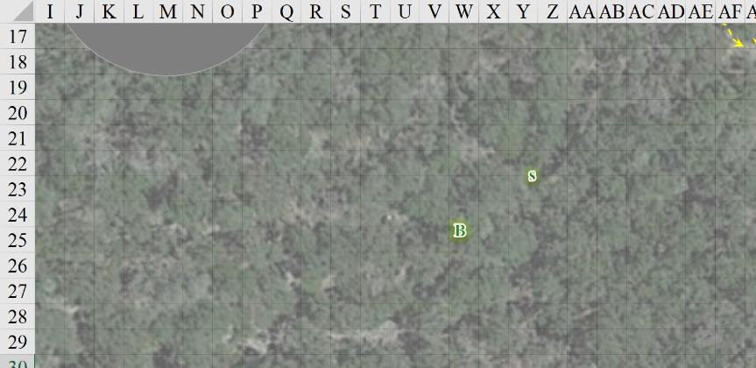

PJ followed Elsabet westward. The favored soul reached the edge of the *obscuring mist*, and PJ was not far behind her.

No enemy could be seen or heard at the moment.

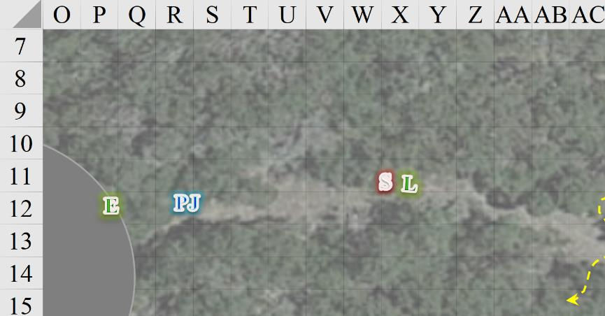

Rounds 17 – 18

With the breeze blowing towards the southwest, Barkley sprinted ahead, dodging behind cover and then stop and waited for Saradette to catch up.

Saradette came into view, and Barkley turned his foxy face westward again.

Then they heard from the far west a whip cracking, followed by the distinctive sound of multiple horses setting off, coupled with the wheels of at least one wagon being pulled.

“They’re getting away!” PJ proclaimed, heading west through the mist.

Elsabet heard the foes trying to escape as well, and thinking that if the wagon was anything like those PJ drove, that at least some of the group should be able to catch up. She turned to PJ, and took only 12 seconds to say: “PJ, perhaps you and Laryssa should get back to your wagons. We don’t want to leave them totally unguarded after all, as we don’t know for sure that both the surviving women are on their wagon. I’ll chase after them and probably be able to catch up eventually; knowing Barkley he’ll probably be right on their tail before I even get through the mist.”

Elsabet then moved into the mist, following the trail as quickly as she could. Unfounded, with her Devotion still available, she wasn’t too worried about possibly encountering one of the enemies in the mist, given at least one had to be driving the wagon. It didn’t immediately occur to her that there could, possibly, be a fourth enemy or even more, though the thought did cross her mind after she had gotten well into the cloudy area.

Hearing the wagon wheels, Barkley wanted to at least see if he could ID their enemies should they cross paths again. He transformed into a wolf and angled for the path with the intent of getting behind the wagon and chasing it a short distance.

Saradette turned and headed northwest toward the road.

Having descended until this point, it was now time to turn back upward and climb a bit.

Elsabet and PJ had trodden carefully through the *mist*, and both had failed to spot the trail’s edge a few times, having almost fallen downhill. They were now just west of the *mist*, and three bodies lay dead before them.

A half-elf female and two dwarven males were lying face up, all bleeding from various parts of their bodies, and it looked like some hasty looting was done, though some of their valuables were still on them. They had scabbards for daggers, and were dressed like merchants, not mercenaries.

Elsabet and PJ continued westward, vowing to return and see these poor souls properly cremated or buried. Within seconds, they could see three wagons being pulled by four horses; the same setup that PJ had, though these wagons were smaller and almost identical to one another, while PJ’s wagons were a hodgepodge of styles from Thay, Cormyr, and Amn.

Barkley and Saradette did their best to go back up the hill.

|  |  |  |  |  |  |  |
| --- | --- | --- | --- | --- | --- | --- |
| **Skill** | **Rank** | **Ability**  **& Mod.** | **Misc.**  **Mods.** | **Total** | **Roll** | **Check** |
| **Barkley (wolf), Climb** | 0 | Str (+2) | 0 | 2 | 4 | 6 |
| **Saradette, Climb** | 6 | Str (+0) | 0 | 6 | 11 | 17 |

*See map.*

The two heroes did their best to run up hill through bushes and succulents, but it was a difficult jaunt to get back up to the road.

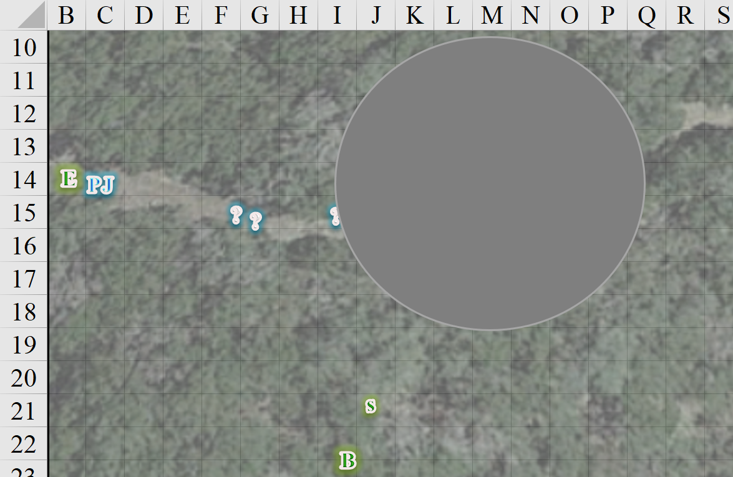

Round 19

Elsabet glanced over her shoulder at PJ following her, and shrugged. Laryssa would probably be fine guarding their wagons and Sandy. She turned back to the chase, and redoubled her efforts to catch the wagon. No mercy would be shown to these murderers. “*No* mercy,” she called out, saving the rest of her breath for running.

“We’ll hire a bard to write a song about this day,” PJ huffed as he kept up the pace with the favored soul of Mayaheine. “And we’ll call it the Ballad of No Mercy.”

Rounds 20 – 27

They gave chase for about a minute to the two bastard daughters of no particular fathers, and although Saradette struggled and lagged behind quite a bit, even the rogue-illusionist was now within her maximum firing range.

By the looks of the human atop the frontmost wagon with the wooden rooftop, she was under the effect of a *blur* spell, which would hamper the likelihood of hitting her for the duration of the spell.

The heroes were winded—borderline fatigued—and contemplated their options as the human shot Barkley with a magical hand crossbow, now that the cur-man was in short range.

|  |  |  |  |  |  |  |  |  |  |
| --- | --- | --- | --- | --- | --- | --- | --- | --- | --- |
| **Ranged Weapon** | **Dmg.** | **D+** | **TH+** | **Critical** | **Rng.** | **Wt.** | **Atk** | **Roll** | **Check** |
| Hand Crossbow +1 | 1d4 | 1 | 1 | 19-20, x2 | 30’ | 2.0 | 9 | 19 | 28 |

*Hit. Dmg: 3 + 1 = 4 [4/21].*

The other so-called lady spurred the horses onward.

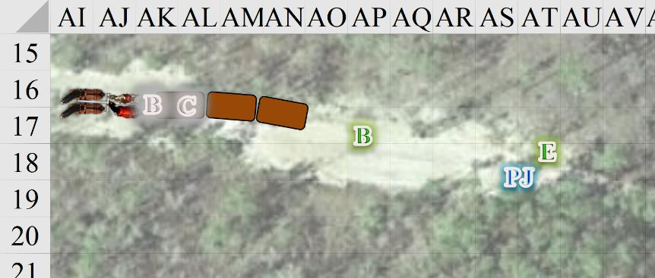

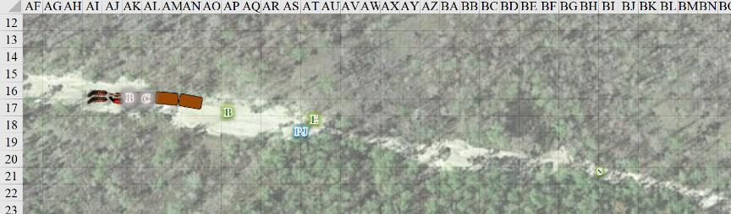

Round 28

The human rogue-diviner reloaded her hand crossbow and shot at Elsabet once again.

|  |  |  |  |  |  |  |  |  |  |
| --- | --- | --- | --- | --- | --- | --- | --- | --- | --- |
| **Ranged Weapon** | **Dmg.** | **D+** | **TH+** | **Critical** | **Rng.** | **Wt.** | **Atk** | **Roll** | **Check** |
| Hand Crossbow +1 | 1d4 | 1 | 1 | 19-20, x2 | 30’ | 2.0 | 9 | 6 | 15 |

*Miss.*

Even without running, the heroes would eventually be able to take these runaway hooligans down, which was Elsabet’s express intent. Hoping to get on the same wagon with the murderers, she had a flask of alchemist’s fire and a flask of acid she was willing to throw at them, as long as it didn’t endanger Barkley. Burning the wagon, well, that would have been a shame; she would have preferred get into melee distance and slash with the bastard sword. Ready to crank up the Protection Devotion at an instant’s notice, Elsabet did her best to save her breath for moving and fighting. She had no more words for these murderers.

PJ, on the other hand, was one for ominous goodbyes to evildoers. He’d been caught in more than one crowd of peasants in his younger days, reveling in the beheadings of witches and other accused. He’d come realize in later years that many of those hanged, beheaded, quartered, clapped in the pillory, and subjected to other torture and gruesome executions had likely been innocent, and he had developed a reservation for indulging in the witnessing of such public punishments. The execution of these two—based on the bodies he’d just seen on the ground and the outward hostility of Sultry and these two surviving witches—would be quite justice-thirst-quenching, and he *would* say a few things to the dying bandits who would have slain him with no compunction. He ran in tandem with Elsabet, finding her sexy.

With several injuries, Barkley decided to avoid direct pursuit, using his canid agility, he moved off the road and broke into a run, weaving past trees and bushes, trying to get in front of the wagon.

|  |  |  |  |  |  |  |
| --- | --- | --- | --- | --- | --- | --- |
| **Skill** | **Rank** | **Ability**  **& Mod.** | **Misc.**  **Mods.** | **Total** | **Roll** | **Check** |
| **Barkley, Sense Motive** | 2 | Wis (+1) | 0 | 3 | 11 | 14 |

*See below.*

The archon could tell that his stride through the foliage was making the horses nervous, and so he kept a distance of at least 15’. He would have to make a successful climb back onto the road to accomplish his desired goal, and was confident that he would.

Saradette could see through the bushes that lined the barely winding road that the hound archon had chosen to get in front of the wagons, and had veered off the trail to avoid getting run over by the wagons’ wheels. She huffed and puffed to catch up with the wagons and her friends.

PJ and Elsabet were at the heels of the rear wagon, and prepared to hop on.

A wheel hit a rock, and Copper wasn’t quite ready for the rock to the wagon.

|  |  |  |  |  |  |  |
| --- | --- | --- | --- | --- | --- | --- |
| **Skill/Save** | **Rank** | **Ability & Mod.** | **Misc. Mods.** | **Total** | **Roll** | **Check** |
| **Copper, Reflex** | **4** | **Dex (+3)** | 0 | 7 | 4 | 11 |
| **Balance, Balance** | 1 | **Dex (+3)** | 0 | 4 | 3 | 7 |

*See below.*

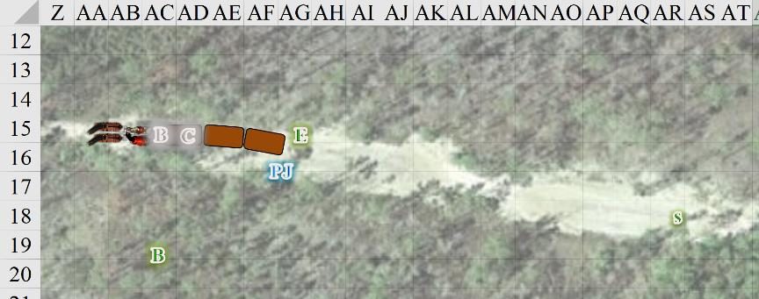

Meanwhile, back at their wagons, Laryssa checked in on BelDamon again, and made sure no other bandits had stolen their stuff while they were being heroes. She could no longer hear the sounds of the fleeing wagons, and hoped her friends had fared well against the fugitives.

Round 29

Copper fell flat on her face. Being of light frame, and carrying only 19 pounds of goods on her, she did not break through the boards of the wagon’s roof. Now prone and unable to see those in pursuit, she began to despair.

Barkley jumped and climbed the hillside to get back onto the level trail and in front of the horses.

|  |  |  |  |  |  |  |
| --- | --- | --- | --- | --- | --- | --- |
| **Skill** | **Rank** | **Ability**  **& Mod.** | **Misc.**  **Mods.** | **Total** | **Roll** | **Check** |
| **Barkley, Climb** | 2 | Str (+2) | 0 | 4 | 8 | 12 |
| **Barkley, Jump** | 3 | Str (+2) | 0 | 5 | 15 | 20 |

*See below.*

The canid hero got in front of the horses, and decided to leap onto the back of the closest horse. From its back, he would launch himself at the driver of the wagon.

|  |  |  |  |  |  |  |
| --- | --- | --- | --- | --- | --- | --- |
| **Skill/Save** | **Rank** | **Ability & Mod.** | **Misc. Mods.** | **Total** | **Roll** | **Check** |
| **Barkley, Reflex (timing)** | 3 | **Dex (+1)** | 0 | 4 | 14 | 18 |
| **Barkley, Jump (on horse)** | 3 | Str (+2) | 0 | 5 | 8 | 13 |

*See below.*

Barkley perched on the unsaddled herbivore’s back, taking the reins from Beflinne’s hands as she let go of them, reached for her bow resting on the wagon bench, and drew an arrow.

Saradette used her ability to conjure *dancing lights [expired on Round 39]* to create a set of four spheres of light, as bright as she could make them, and set them to whirl rapidly around the driver woman, right at their face level. Though she’d had to slow her pace to properly cast the spell, the gnome kept moving toward them at her best speed, while still maintaining control of the lights.

Seeing the woman in top of the front wagon firing at her, Elsabet reacted immediately and brought up the aura of Protection for herself and her companions, silently giving thanks to Mayaheine as the bolt missed.

*Elsabet and PJ gained 2 to AC.*

The human favored soul matched speed with the wagon, attempting to gauge her moment carefully, and leapt up into the wagon, using her left hand to grab ahold of anything that might help. If she made the jump but lost her balance, she intended to roll forward rather than fall back, using what she little had learned about tumbling if she could.

|  |  |  |  |  |  |  |
| --- | --- | --- | --- | --- | --- | --- |
| **Skill** | **Rank** | **Ability & Mod.** | **Misc. Mods.** | **Total** | **Roll** | **Check** |
| **Elsabeth, Jump** | 5 | **Str (+2)** | -1 | 6 | 4 | 10 |
| **Elsabeth, Reflex** | 3 | **Dex (+1)** | 0 | 4 | 3 | 7 |
| **Elsabeth, Climb** | 0 | **Str (+2)** | -1 | 1 | 15 | 16 |

*See below.*

She had thought she would need greater anticipation and better timing, but in the end, she realized that it would have been difficult to botch this up. She now had one leg atop the rear wagon’s roof.

PJ did the same as Elsabet.

|  |  |  |  |  |  |  |
| --- | --- | --- | --- | --- | --- | --- |
| **Skill/Save** | **Rank** | **Ability & Mod.** | **Misc. Mods.** | **Total** | **Roll** | **Check** |
| **PJ, Jump** | 0 | **Str (-1)** | +3 | 2 | 1 | 3 |
| **PJ, Reflex** | 3 | **Dex (+3)** | 0 | 6 | 16 | 22 |
| **PJ, Climb** | 0 | **Str (-1)** | +3 | 2 | 19 | 21 |

*See below.*

And though the factotum’s initial leap was piss poor, his subsequent strides did more than enough to compensate, and he used the force of the wheel’s spokes to propel him up so he could be on part with Elsabet.

The horses stopped, and the one carrying Barkley reared up rampant.

|  |  |  |  |  |  |  |
| --- | --- | --- | --- | --- | --- | --- |
| **Save** | **Rank** | **Ability & Mod.** | **Misc. Mods.** | **Total** | **Roll** | **Check** |
| **Barkley, Reflex** | 3 | **Dex (+1)** | 0 | 4 | 14 | 18 |

*See below.*

Barkley was thrust upon the horse between himself and Beflinne. Seeing the woman quite well through the *blur* spell and the *dancing lights* that now haloed the frontmost wagon, the hound archon prepared to finish this.

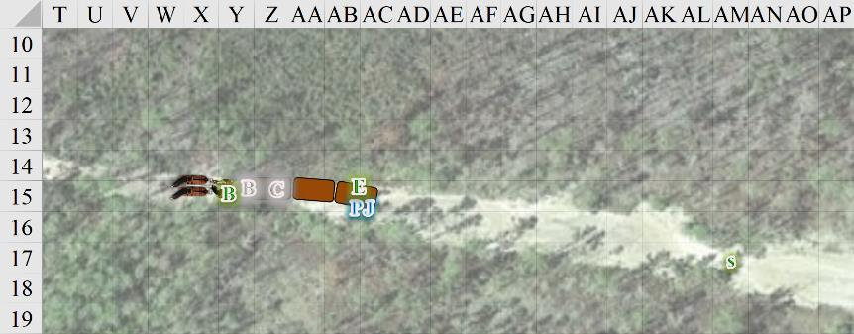

Round 30

Saradette advanced toward the wagons, which had come to a halt, while steering her lights to blind their enemies, and not blind her companions.

*Blurred,* Copper got up onto her feet and loaded her hand crossbow.

Beflinne shot an arrow at Barkley point-blank.

|  |  |  |  |  |  |  |  |  |  |
| --- | --- | --- | --- | --- | --- | --- | --- | --- | --- |
| **Ranged Weapon** | **Dmg.** | **D+** | **TH+** | **Critical** | **Rng.** | **Wt.** | **Atk** | **Roll** | **Check** |
| MW Longbow | 1d8 | 0 | 1 | x3 | 100’ | 3.0 | +6 | 12 | 18 |

*Miss.*

The arrow bounced off of his mithral chain shirt, after which Barkley leapt at the driver of the wagons, intent on biting and clawing at the evil minion.

|  |  |  |  |  |  |  |
| --- | --- | --- | --- | --- | --- | --- |
| **Skill** | **Rank** | **Ability & Mod.** | **Misc. Mods.** | **Total** | **Roll** | **Check** |
| **Barkley, Jump** | 3 | Str (+2) | 0 | 5 | 4 | 9 |
| **Barkley, Reflex** | 3 | Dex (+1) | 0 | 4 | 15 | 19 |

*See below.*

The jump was not well placed, and it was only thanks to his agile reflexes that he was able to get onto the bench.

At this point, the archer was defenseless, and dropped her bow, using both hands to fend off the archon’s claws *[just for flavor]* while his real weapon, his toothy maw snapped at her *[resolved on the next round]*.

Elsabet and PJ finished climbing onto the rear wagon’s roof.

|  |  |  |  |  |  |  |
| --- | --- | --- | --- | --- | --- | --- |
| **Skill** | **Rank** | **Ability & Mod.** | **Misc. Mods.** | **Total** | **Roll** | **Check** |
| **Elsabet, Climb** | 0 | **Str (+2)** | -1 | 1 | 17 | 18 |
| **PJ, Climb** | 0 | **Str (-1)** | +3 | 2 | 18 | 20 |

*See below.*

Both good guys used the leg that they already had atop the platform to leap up onto both feat and get themselves onto two feet. PJ aimed his crossbow at the *blurred* diviner-rogue as the favored soul advanced a few feet.

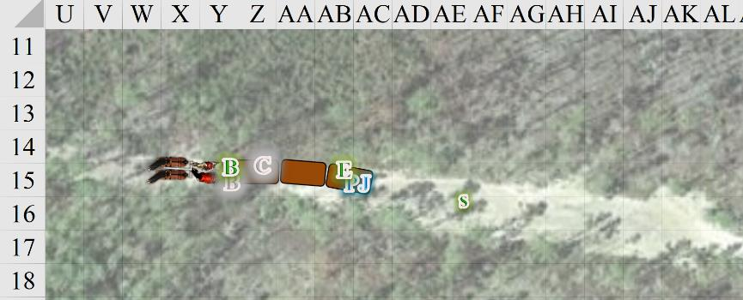

Round 31

Elsabet made her way carefully forward over the wagons—a stern look on her face—but said nothing. She intended to slay the blurry-looking murderess firing at her, in the name of the poor souls who lay dead back along the trail. It might or might not be proper justice, but she recalled these women laughing over their kills, with no remorse, so no pleas would stay her hand. She fought the temptation to charge over the uneven footing, keeping just enough forward momentum to make sure to get from each wagon to the next. Though she didn’t realize it, a sneer of contempt twisted her lips briefly.

PJ fired upon Copper from his standing position.

*1d100 = 73, blur bypassed.*

|  |  |  |  |  |  |  |  |  |  |
| --- | --- | --- | --- | --- | --- | --- | --- | --- | --- |
| **Ranged Weapon** | **Dmg.** | **D+** | **TH+** | **Critical** | **Rng.** | **Wt.** | **Atk** | **Roll** | **Check** |
| MW Heavy Crossbow | 1d10 | 0 | 1 | 19-20/x2 | 120’ | 8.0 | +6 | 14 | 20 |

*Hit. Dmg: 8.*

Copper cringed from the pain of the large crossbow bolt, then looked at Elsabet and nodded, “So it’s *you*!”

Elsabet could tell the woman was buying herself time; the bluff was poorly executed, and Elsabet had no words for this slaughterer. The favored soul could hardly hold back a scoff as she exhaled and jumped onto the middle cart, then took a few more steps and charge-attacked the blurred thief-witch.

|  |  |  |  |  |  |  |
| --- | --- | --- | --- | --- | --- | --- |
| **Skill** | **Rank** | **Ability & Mod.** | **Misc. Mods.** | **Total** | **Roll** | **Check** |
| **Elsabet, Jump** | 5 | **Str (+2)** | -1 | 6 | 19 | 25 |
| **Elsabet, Jump** | 5 | **Str (+2)** | -1 | 6 | 7 | 13 |

*Success +2 charge bonus.*

*1d100 = 32, blur bypassed.*

|  |  |  |  |  |  |  |  |  |  |
| --- | --- | --- | --- | --- | --- | --- | --- | --- | --- |
| **Melee Weapon** | **Dmg** | **D+** | **TH+** | **Critical** | **Type** | **Wt.** | **Atk** | **Roll** | **Check** |
| MW Bastard Sword, 2-handed | 1d10 | 3 | 2 + 2  charge | 19-20/x2 | Slashing | 6.0 | +5 | 10 | 15 |

*Hit. Dmg: 2 + 3 + 2 charge = 7.*

The witch fired at the favored soul point-blank.

|  |  |  |  |  |  |  |  |  |  |
| --- | --- | --- | --- | --- | --- | --- | --- | --- | --- |
| **Ranged Weapon** | **Dmg.** | **D+** | **TH+** | **Critical** | **Rng.** | **Wt.** | **Atk** | **Roll** | **Check** |
| Hand Crossbow +1 | 1d4 | 1 | 1 | 19-20, x2 | 30’ | 2.0 | 8 | 19 | 27 |

*Hit. Dmg: 1 + 1 = 2 [19/21].*

The small crossbow bolt lodged itself into Elsabet’s side.

Elsabet took the opportunity to attack Copper as she left herself defenseless while reloading.

*1d100 = 51, blur bypassed.*

|  |  |  |  |  |  |  |  |  |  |
| --- | --- | --- | --- | --- | --- | --- | --- | --- | --- |
| **Melee Weapon** | **Dmg** | **D+** | **TH+** | **Critical** | **Type** | **Wt.** | **Atk** | **Roll** | **Check** |
| MW Bastard Sword, 2-handed | 1d10 | 3 | 2 | 19-20/x2 | Slashing | 6.0 | +5 | 13 | 18 |

*Hit. Dmg: 5 + 3 = 8.*

And now it was Barkley’s turn. He snapped at the druid-ranger’s throat.

*1d100 = 60, blur bypassed.*

|  |  |  |  |  |  |  |  |  |  |
| --- | --- | --- | --- | --- | --- | --- | --- | --- | --- |
| **Melee Weapon** | **Dmg** | **D+** | **TH+** | **Critical** | **Type** | **Wt.** | **Atk** | **Roll** | **Check** |
| Bite | 1d6 | +2 | 0 | 20 | Piercing | - | +6 | 2 | 8 |

*Miss.*

Beflinne did her best to wrestle the archon off of her.

|  |  |  |  |  |  |  |  |  |  |
| --- | --- | --- | --- | --- | --- | --- | --- | --- | --- |
| **Melee Weapon** | **Dmg** | **D+** | **TH+** | **Critical** | **Type** | **Wt.** | **Atk** | **Roll** | **Check** |
| Grapple | Grapple | 0 | 0 | - | - | - | +2 | 11 | 13 |
| Grapple | Grapple | 0 | 0 | - | - | - | +6 | 7 | 13 |

*See below.*

Holding his wrists with both hands, the half-elven archer only managed to keep the archon from overpowering her.

Saradette dispelled her spell with a growl of annoyance, and did her best to catch up with the wagon. If she had a clear shot, she would shoot at one of the opponents with her bow.

~*~

Laryssa tended to the horses and mule.

Still in his fever dream, BelDamon’s psyche took him on another trip of self-reflection. He flashed back to an afternoon of fishing, with his brother and father. Their father was prone to long speeches and parables to explain lives mysteries. Bards were like that. This little chat their father was trying to explain the difference between intentions and actions.

Damionte: “How do you know when your intention justify your actions?”

Father: “You don’t always. At least not right away. The real world is messy an unorganized. You don’t always know the full ramifications of your actions in the moment. Sometimes only history can tell you if you made the right choice. You try your best in the moment to do the right thing though.”

“Take for example our great great uncle Damion. From all recollections he thought he was doing the right thing at the time. And he was at the start, but over time he let himself slide into a moral grey area. Then after many more years he slid even further. In his own mind he justified a great many tragedies as ‘the right thing to do.’ History has not been kind to his legacy, and with it our family name at times.”

“Reclaiming our good name is part of why you’re named after him BelDamon. The prefix Bel on your name means Love in the old tongue. Uncle Damion was a man who did not truly understand the notion or meaning of love in the end. That lack of empathy I believe is what doomed him. It is hoped that one day you’ll have a chance to reclaim his name from the tarnish of the past.”

BelDamon started to say something to their father but a tug on his line grabbed his attention.

BelDamon: “Oh hey I got a bite!”

Damionte: “Pull, stupid, before you let it get away!”

BelDamon pulled on the line, battling with his catch for some time when suddenly the line went slack, and his “prey” leaped out of the water. Monstrous in nature and with 3 rows of teeth the demon fish went right for his face.

BelDamon awoke with a start. Drenched in sweat from the sickness and feeling light headed from lack of water. “Unnnnng.... where are we?” He asked the darkness, as he looked around the inside of the wagon trying to remember where they were and why.

Then he recalled that he’d been serving as a caravan guard for a few years now, and had seen quite a bit of the open road.

Laryssa came over and lifted the rear flap of the rear wagon, tilting her head to get a better look at her friend of two years.

Round 32

Beflinne used the last of her energy to try to push the dog-faced man off of her.

|  |  |  |  |  |  |  |  |  |  |
| --- | --- | --- | --- | --- | --- | --- | --- | --- | --- |
| **Melee Weapon** | **Dmg** | **D+** | **TH+** | **Critical** | **Type** | **Wt.** | **Atk** | **Roll** | **Check** |
| Grapple | Grapple | 0 | 0 | - | - | - | +2 | 3 | 5 |
| Grapple | Grapple | 0 | 0 | - | - | - | +6 | 3 | 9 |

*See below.*

Gaining leverage over the half-elf, Barkley wrested his wrists free, blocked two attempted grabs, and went for the jugular.

*1d100 = 66, blur bypassed.*

|  |  |  |  |  |  |  |  |  |  |
| --- | --- | --- | --- | --- | --- | --- | --- | --- | --- |
| **Melee Weapon** | **Dmg** | **D+** | **TH+** | **Critical** | **Type** | **Wt.** | **Atk** | **Roll** | **Check** |
| Bite | 1d6 | +2 | 0 | 20 | Piercing | - | +6 | 5 | 11 |

*Miss.*

With her feet only inches away from the edge of the wagon, and with Barkley and Beflinne wrestling just beyond that edge, Copper reloaded and shot at Elsabet.

|  |  |  |  |  |  |  |  |  |  |
| --- | --- | --- | --- | --- | --- | --- | --- | --- | --- |
| **Ranged Weapon** | **Dmg.** | **D+** | **TH+** | **Critical** | **Rng.** | **Wt.** | **Atk** | **Roll** | **Check** |
| Hand Crossbow +1 | 1d4 | 1 | 1 | 19-20, x2 | 30’ | 2.0 | 8 | 17 | 25 |

*Hit. Dmg: 2 + 1 = 3 [16/21].*

PJ tagged her back.

*1d100 = 11, blur not bypassed, bolt wasted.*

Saradette dispelled her spell with a growl of annoyance, and did her best to catch up with the wagon. If she had a clear shot, she would shoot at one of the opponents with her bow.

*Automatic kill.*

Copper then keeled over and bled out, dropping her hand crossbow all the way down on the ground.

Barkley bit at the ranger-druid again.

*1d100 = 38, blur bypassed.*

|  |  |  |  |  |  |  |  |  |  |
| --- | --- | --- | --- | --- | --- | --- | --- | --- | --- |
| **Melee Weapon** | **Dmg** | **D+** | **TH+** | **Critical** | **Type** | **Wt.** | **Atk** | **Roll** | **Check** |
| Bite | 1d6 | +2 | 0 | 20 | Piercing | - | +6 | 13 | 19 |

*Hit. Dmg: 5 + 2 = 7.*

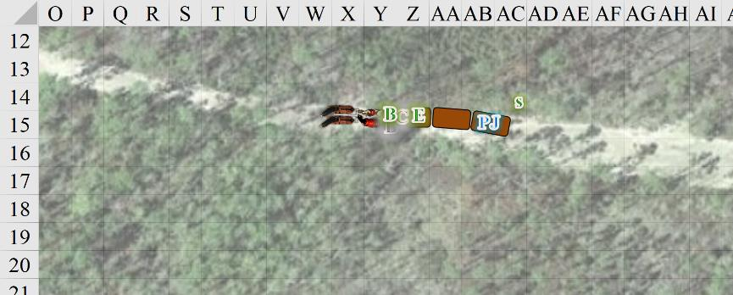

Round 33

Barkley continued to snap at his foe, looking to sink his teeth deep into his target’s throat.

*1d100 = 33, blur bypassed.*

|  |  |  |  |  |  |  |  |  |  |
| --- | --- | --- | --- | --- | --- | --- | --- | --- | --- |
| **Melee Weapon** | **Dmg** | **D+** | **TH+** | **Critical** | **Type** | **Wt.** | **Atk** | **Roll** | **Check** |
| Bite | 1d6 | +2 | 0 | 20 | Piercing | - | +6 | 19 | 25 |

*Hit. Dmg: 2 + 2 = 4.*

“Woooo! Nooo!” screamed the horrified half-elf as the hound archon bit away her nose, lips and cheeks. Begging for her life, she tried to fend off the archon with no leverage to do so.

Elsabet now stood atop the archon, who straddled the half-elf atop the bench. The horses began to move the gnome-sized wagons forward again, rearing their necks in an effort to wrench themselves away from the mayhem.

|  |  |  |  |  |  |  |
| --- | --- | --- | --- | --- | --- | --- |
| **Skill** | **Rank** | **Ability & Mod.** | **Misc. Mods.** | **Total** | **Roll** | **Check** |
| **Elsabet, Balance** | 0 | **Dex (+1)** | -1 | 0 | 17 | 17 |

*Success.*

Elsabet crouched, grabbing the edge of the wagon roof with her left hand, and looked for a chance to slash one-handed past Barkley at the driver, who was still fighting back. She wouldn’t risk hitting the archon however. “PJ,” she called out, “can you get the horses under control?”

PJ nodded, and got down carefully.

Saradette ran to the front wagon and waited with bow in hand to shoot the half-elf if she could do it without endangering her comrades.

~*~

Laryssa came over and lifted the rear flap of the rear wagon, tilting her head to get a better look at her friend of two years.

“Well, you managed to miss the excitement. Did you break into PJ’s booze supply or something? We ran into a bit of a situation that turned into a chase which I’m ill-equipped for.” Laryssa filled in the bard with what had occurred while making a mental note that once funds allowed, seeing about enchanting her armor or obtaining other items to improve her ground speed... or maybe flight somehow? Hmmmm...

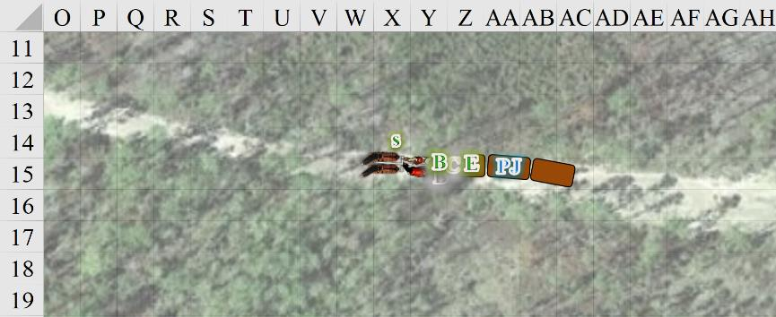

Round 34

PJ went to the horses.

Barkley took a moment to cast *aid*, then transformed into his archon form and drew his greatsword, offering Beflinne a chance to surrender. “Throw down your weapons and surrender or I WILL kill you.”

|  |  |  |  |  |  |  |
| --- | --- | --- | --- | --- | --- | --- |
| **Skill** | **Rank** | **Ability & Mod.** | **Misc. Mods.** | **Total** | **Roll** | **Check** |
| **Intimidate** | 0 | Cha (+2) | 0 | 2 | 18 | 20 |

*See below.*

“I yield! I yiiieellld!” pleaded the half-elf.

With the fight done, and the last evildoer surrendering, Barkley sheathed his sword and toughly took the half-elf by the arm and pulled her/him from the wagon. Looking at the others, the archon said, “I will remain here with the prisoner. PJ should bring up our wagon after you check on the others on your way back. If someone wants to stay with me to go through these wagons, that is fine.”

Saradette turned and walked back to where the wagon’s owners were to see if anyone was still alive.

The druid—with half her face chewed off—pleaded some more, and Elsabet felt so bad for her, she almost wanted to cure her a little bit.

Rounds 35 – 50

Saradette trotted back towards the bodies at a pace not quite arduous enough to tax her stamina. What took her a minute to run would take her a minute and a half to jog.

Barkley suggested, “PJ, go with Saradette and fetch your wagons to bring them here.”

“These horses will need some soothing then,” PJ replied, and did not immediately return to his wagons.

Barkley turned his attention to their prisoner. With his short sword in hand he asked, “So what were your friends doing here and are there others of your band in the area? How many caravans have you ambushed?” If the half-elf refuses to answer or gives what Barkley believes to be false answers, he will interject, “If you don’t want to cooperate, we can leave you here tied to a tree and gagged, or I can cut off your head. If you cooperate we can see about healing you enough to bring you to the closest town to face a trial. Perhaps they will show mercy.”

Elsabet glared at the half-elf, then glanced at Barkley. “Do you sense evil in her?” she asked.

The evil was seeping from the ranger-druid. Laryssa nodded.

“Perhaps she will repent and mend her ways? And we could turn her over to the authorities at the next town or city, to face whatever justice the magistrate there determines appropriate.”

Turning back to the captive, in a gentle voice, as diplomatically as possible, she spoke for a while. “You really should answer his questions, and thank him for offering you the chance to live. He’s really the nice one here—a few seconds more and I’d have taken your head *myself*. Did you give those other travelers a chance, or did you just slaughter them with no mercy? Believe me when I tell you, what you have done is an affront to the Goddess I serve. Perhaps, if you truly repent and confess your crimes, you’ll be given a chance to make amends in this world.”

Barkley was grateful for Elsabet’s support and the fact that she didn’t counter his efforts. He nodded to Elsabet and the glared at the half-elf once more.

Elsabet stared into the woman’s eyes as she slowly wiped the blood off her sword. “But if you keep anything back, anything at all...” She smiled, a cold smile that did not reach her eyes. “My sword is still sharp, and thirsty. Start talking.”

As the woman started talking, Elsabet almost immediately sensed the ill delivered deceit. *They’d been attacked... self-defense... three damsels in distress in the middle of nowhere…*. It was about the most distasteful display of impromptu groveling the favored soul had seen in a while.

Elsabet scowled. “She’s lying her conniving ass off, B. Her story is as fake as it gets. She’s twisted beyond redemption. Just a few minutes ago she was cackling over the bodies of their victims, squabbling over the spoils of their foul act. Now she’s claiming to *BE* the victim?!? Let me put her out of her misery, like a wounded animal, please? The karma will be mine to bear. For all we know, she could escape justice if she has influence in the next town...”

Elsabet held her sword ready to strike; she’d ask forgiveness from the Goddess later, if necessary, but her patience with this bitch was nearly ended. Still, it was Barkley’s call, she wouldn’t strike if he said no. She looked down at the pitiful excuse for a person. “Last chance to save your soul and tell the truth, bitch.”

The groveling face turned to a grimace reminiscent of a hag, and the half-elf with half a face bitten off spat, “Piss off, cunt! I’ll see *you* in the next world!”

When Elsabet informed Barkley of the deception, he turned towards the half-elf, and growled. “Go ahead and finish it off,” he said through gritted teeth to Elsabet. “It had its chance.”

Elsabet nodded, and struck quickly down at the woman.

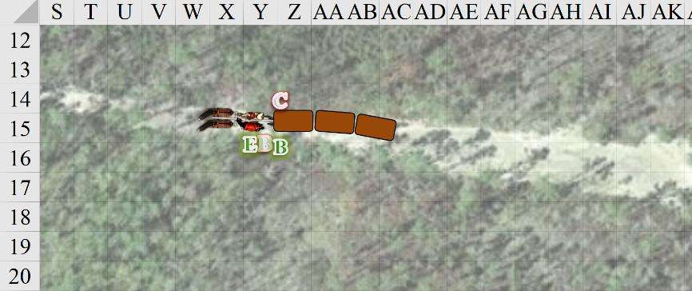

~*~

Round 99

“I take it it didn’t go well,” PJ said atop the cart as his four horses drew his wagons forth.

Saradette rode one of the frontmost horses, shaking her head at the site of *[Ernie, edit as needed]* the bastard sword impaled in the ground through Beflinne’s throat... not so much for carnage factor, but to ensure the forest witch was dead.

“She was unrepentant,” Barkley proclaimed.

Round 100

“Her prolonged life would have would have meant prolonged sin,” Elsabet posited. “And misery would have followed in her wake.”

The hound archon nodded and looked at his friend, glad to be among the followers of Mayaheine after all these months.

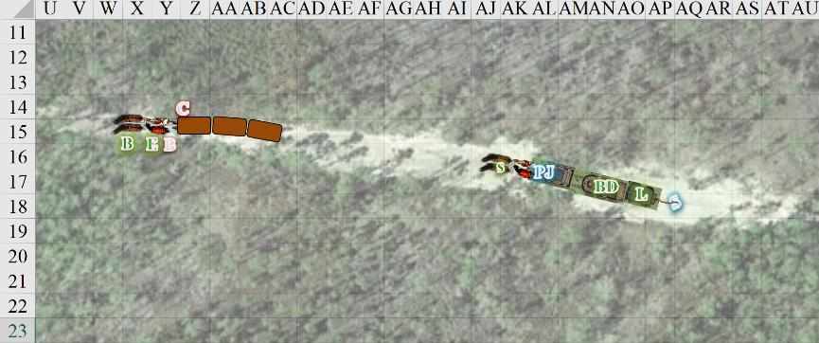

End of Rounds

PJ slowed the wagons to a gradual halt, and exhaled as he descended calmly from the carriage. “We’ll need to water the horses soon,” the human factotum said. “And this being the only trail across this part of the hills, those horses can’t have drunk any more recently than ours.”

PJ’s frontmost horses could smell the mule in front of them, and as the heroes coalesced around said mule, Saradette produced the contents of the things she’d brought back. “I couldn’t bring the armor—of course—but I managed to drag the acid woman’s greatsword. Looks like an improvement on your, Barkley. I left the shield too.”

|  |  |  |  |  |  |  |
| --- | --- | --- | --- | --- | --- | --- |
| **Picked Up** | **Dmg** | **D+** | **TH+** | **Critical** | **Type** | **Wt.** |
| **Corrosive Greatsword** | 2d6+5 | 1d6 | 0 | 19-20/x2 | Slashing | 8.0 |
| **Left Behind** | **AC Mod.** | **Dex** | **Check** | **Arcane** | **Speed** | **Wt.** |
| MW Chainmail | 5 | 1 | -5 | 30% | 30’ | 40.0 |
| MW Shield, Heavy Steel | 2 | - | -1 | 15% | - | 15.0 |

A wiggly line in the dirt followed Saradette, proving that—yep—she’d pretty much dragged the blade across the ground the entire way, and this being a Corrosive Greatsword, the earth along that line was now a fizzing mixture of acid and soil. Not worthy of mentioning to the others, she’d also dispensed with bringing the woman’s crowbar and mirror, though she did filch the potions that Sultry had just taken off of the gnomes and halfling they’d coldly murdered. “I’ll have to identify them later.”

They all marveled at the greatsword’s craftsmanship for a moment before Saradette asked, “Did you search these two?”

“Oh... not yet,” one of them said to the only rogue standing as they took a measure of how much damage they’d taken.

Saradette had looked over the gnome and halfling corpses, and knew that they were too far gone to heal. They’d been stripped of all valuables but their leather armor and vestments.

|  |  |  |  |  |  |  |  |  |  |  |  |  |  |  |
| --- | --- | --- | --- | --- | --- | --- | --- | --- | --- | --- | --- | --- | --- | --- |
| **Character** | **TAC** | **FFAC** | **AC** | **Melee** | **Ranged** | **Acid** | **Good/ Pos** | **Chaos** | **Law** | **Total Damage** | **Temp** | **Healing** | **HPs** | **Current HPs** |
| **BarkleyPfE** | **11** | **18** | **19** | 9 | 11 | 4 | *Imm* |  | *Imm* | 24 | 7 |  | 21 | 4 |
| **ElsabetPfE** | **11** | **16** | **17** |  | 5 |  | *Imm* |  |  | 5 |  |  | 21 | 16 |
| **Laryssa** | **11** | **19** | **20** |  |  |  | *Imm* |  | *Imm* | 0 |  |  | 27 | 27 |
| **SaradettePfE** | **14** | **19** | **22** |  |  |  | *Imm* | *Imm* |  | 0 | 6 |  | 14 | 20 |
| **BelDamon** | **11** | **12** | **14** |  |  |  | *Imm* | *Imm* |  | 0 |  |  | 5 | 5 |
| **PJPfE** | **12** | **15** | **18** | 18 |  | 4 | *Imm* | *Imm* |  | 22 |  | 13 | 21 | 12 |

~*~

Saradette had done a thorough search of the half-elf and human witches, and now laid out the confiscated items. “They had good taste,” Saradette admitted.

Beflinne’s goods—a bit dirty but in great working condition—were displayed on the open platform of one of the wagons whose tarp had been flipped open.

|  |  |  |  |  |  |  |
| --- | --- | --- | --- | --- | --- | --- |
| **Melee Weapon** | **Dmg** | **D+** | **TH+** | **Critical** | **Type** | **Wt.** |
| **MW Daggers, 2** | 1d4 | +0 | 1 | 19-20, x2 | Prcg/Slash | 2.0 |
| **Ranged Weapon** | **Dmg.** | **D+** | **TH+** | **Critical** | **Rng.** | **Wt.** |
| MW Longbow | 1d8 | 0 | 1 | x3 | 100’ | 3.0 |
| Shortbow | 1d6 | 0 | 0 | x3 | 60’ | 2.0 |

At the front of the wagon, there was also a heavy mithral shield that the druid had most likely come to call hers, though she hadn’t used it in this battle.

Copper’s goods were on a rock right next to where her body still lay.

|  |  |  |  |  |  |  |
| --- | --- | --- | --- | --- | --- | --- |
| **Melee Weapon** | **Dmg** | **D+** | **TH+** | **Critical** | **Type** | **Wt.** |
| MW Kukri | 1d4 | +0 | +1 | 18-20/x2 | Slashing | 2.0 |
| **Ranged Weapon** | **Dmg.** | **D+** | **TH+** | **Critical** | **Rng.** | **Wt.** |
| Hand Crossbow +1 | 1d4 | 1 | 1 | 19-20, x2 | 30’ | 2.0 |
| **Armor & Shield** | **AC Mod.** | **Dex** | **Check** | **Arcane** | **Speed** | **Wt.** |
| Padded Armor | 1 | 8 | 0 | 5% | 30’ | 5.0 |

There were over a dozen potions in all, as well as three scrolls, which they could discern in time as they made their way to their destination.

PJ had been seeing what the gnomes and halfling merchants had been ferrying along these hills, and although the frontmost wagon was locked, the other two contained mostly spices, silks, and spellbooks. There was a locked chest in the middle wagon that PJ asked Saradette to take a look at, but all in all, this was a good find.

“Looks like we have twice as many wagons and horses,” PJ said, counting their blessings, and wishing they could do more for the merchants. “Is it worth it to take the gnomes and halfling to town?”

Laryssa said and asked rhetorically, “They’ll have been dead far too long to raise properly, and who knows if a temple cleric even would?”

“Well, I’m not leaving them here to rot or burying them without a proper ceremony. We can wrap them up and take them in their rearmost wagon,” Saradette said. “The others, drag them off into the woods and leave them. We can collect everything, so that no other brigands can use the weapons or armor to do more of this. I agree with you, Barkley. We can sell what they had for them.” The gnome set about wrapping the victims’ bodies in whatever clothing and blankets she could find.

Barkley examined the greatsword, but was not fond of the acid that it seeped as soon as its blade was hefted. He saw the use of poison and acid as something evil and not something an honorable warrior would use.

He also suggested, “Perhaps we should bring all of the armor and sell it to send to the families of the slain caravan owners.”

Elsabet finished cleaning, and now sheathed, her bastard sword.

“If you wish to bury the victims here, I can pray to Mayaheine in the morning for spells to help two rest undisturbed,” said Laryssa.

Barkley agreed with Saradette, the dead caravan owners deserved a decent burial. He was also in favor of leaving nothing behind for any other bandits to use. Though, he suggested, “Perhaps we leave the bandits’ bodies in the roadway as a warning to other bandits?”

PJ responded, “I like that idea. Might do some lasting good to leave the cautionary evidence.”

Saradette wrinkled her nose. “That sounds like we’re a barbarian tribe marking our territory.” She then shook her head. “I think we should carry them and keep moving.”

Once all the group were gathered together, Elsabet looked at the various wounded folks. She herself didn’t feel too badly. “I’ve got a little healing left,” she said. “I can spread out some cure minor wounds, who is worst hurt?” It looked like Barkley was probably the worst off, and PJ was second in the triage order. She shrugged, and healed each of them 3 points, using *cure minor wounds* thrice on each of them. Laryssa might then use a cure on whoever needed it most.

“I wonder if the brigands had a camp close by,” Saradette looked around uneasily, repeating, “I think we should keep moving.”

Elsabet conferred with PJ, who found it optimal to keep the horses and wagons as they were, and to have two conductors. She figured he could best determine how to organize the extra wagons. As for the slain bodies... “Friends, I think we need to bring all the slain bodies with us, except of course the one that melted into acid goo. We should wrap them as best we can, and pray to the goddess that the next town isn’t far from here. I believe we should report this to the authorities, because it is the right thing to do, and incidentally, if we don’t, and the wagons or goods are recognized, we could be falsely accused.”

“Even if the victims are not able to be raised, a cleric may be found who can speak with the dead, to verify our story and provide information on their families and any last wishes. If they have family, their goods should be returned to their family, and if that cannot be arranged, the least we can do is try to ensure they receive a proper burial and donate their wealth to the temple or temples of their chosen gods.”

“If we wrap them well and carry them in the rear most wagon, hopefully it won’t bother the horses too much. I may have to lead Sandy ahead of the wagons though. PJ, you know a lot of things, it seems. Are there herbs or flowers, or perhaps pine boughs or something, that we could use to lessen the scent of decay?”

“Hmm, not so much here,” he looked around. “We may do well to place the bodies on the rearmost of the gnomes’ wagons, and make that the rear caravan. It’ll minimize the amount of smell that’s likely to hit the horses and mule. We want them calm and alert.”

“Saradette, did you find any identifying letters or papers on the slain merchants?” Elsabet thought for a moment, then continued.

“They’re from Bartergoldustshire,” she related the highlights of what she’d uncovered. “Their domiciles are all there.”

“Great,” PJ said. “That’s actually on the *way* to Saradush. We can be there tomorrow.”

~*~

And the heroes did just that, arriving just before sunset on the next day in the halfling-gnome settlement of Bartergoldustshire, and conveying the sad news of the demise of the three merchants. Their bodies were buried in family plots—as per local convention—right behind the residences of their descendants, and the heroes attended a short service for them.

As for the bodies of Beflinne and Copper, they were cremated and purified that their ashes might never rise as wicked undead or worse, and the matter was documented by the village archivist. They stayed in the village overnight, and ate a hearty meal on the morrow before setting off for the city of Saradush to their southwest.

During the party’s downtime recovering from their recent adventure, Laryssa spent some of her free time when not training in assisting the local clerics in dealing with those seeing help from injuries. Laryssa’s powers were still not up to more severe cases, but she could ease those with minor problems with spells and healing hands. Careful not to actively proselytize in another deities’s temple, she preferred to let her actions help spread the word of the Bright Lady.

When one of the locals whose burned arm Laryssa was tending mentioned he was having trouble with something that was raiding his flock of sheep at night, she offered to help. That evening, she was keeping watch when movement approaching the farm. Luckily, it was a moonlit night and she was able to make out that the invaders were a pair of goblins riding wolves. Preparing for battle, Laryssa invoked the power of the Shield Maiden to enhance her combat capability via Divine Favor and Magic Weapon spells. It was fortunate that Laryssa had increased the effectiveness of her armor because once battle was joined, she realized these were not wolves at all, but worgs, their more dangerous cousins. The fray raged on for some time and even though the goblins were easily downed, the worgs were another matter. The duration of her attack spells exhausted and narrowly escaping being tripped by the murderous beasts, Laryssa was beginning to fear they might have the best of her when a lucky strike into the vitals of one of her assailants ended its life. The other decided a sheep dinner wasn’t worth it and turned tail. Too slow in her armor to give chase, she grabbed her how and managed to sink an arrow into the fleeing worg’s haunch. While not enough to kill it, Laryssa hoped it would be sufficient to convince the beast not to return. Tending the worst of her wounds with the spells remaining to her while the elated farmer repeatedly gushed his thanks.