Chapter 32: The Siege of Ankhapur

The next 18 hours or so had passed quickly. They’d returned uneventfully, were given high commendations for their deeds, and their names were gilded in the municipal annals of the age. Heralded as heroes already, tales of their exploits against Borak’s forces were already legends in the making as the heroes awoke the next morning and made their respective ways back down to the courtyard, where Prefect Margo Seti-Ryam greeted them and presented them with their day’s dossiers.

Elsabet, Saradette, and Tore took a moment to look over their briefing packets, which—unlike the previous ones—were individualized. “It looks like we are being dispatched to different assignments,” Tore deduced, seeing neither Astrid, nor the Elmore Gang, nor Those Who Do Not Fumble.

Instead, Saradette was to be joined by—oh, joy!—Stratus, who now made his way over with open arms and picked up his tiny gnomish girlfriend with affection. They were to team up against a battalion of kobolds.

Elsabet and Tore, on the other hand, had been requested by the tacticians to bolster two of the offensive forces that had already been dispatched to deal damage where it would make the most difference.

~*~

Elsabet had been airdropped from a roc, aided by a feather fall spell, and had by now taken out a young bluespawn ambusher by herself. Now, three more came at her from mutually equidistant positions, meaning to devour her if she wasn’t careful.

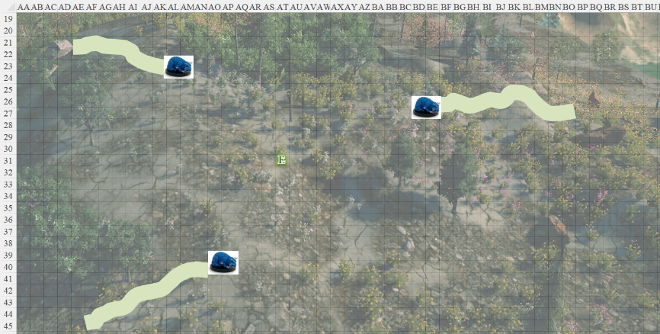

~*~

Tore, once informed of his mission, had cast luminous armor [expired in 8 hours] just as they took off, and now as he landed, bull’s strength [expired on Round 32]. He had also been airlifted to a predetermined location based on intel only minutes old, and—having taken out a dozen kobolds singlehandedly moments ago—he now beheld a full-grown bluespawn burrower bursting out from the ground below, and prepared to meet his mettle with the beast’s own prowess.
Tore gained +5 to FFAC and AC, plus daylight spell effects, causing -4 to enemies’ melee attacks against him.
Dmg to Tore: 2 Strength.
Tore gained +4 to Strength.

~*~

Saradette straddled Stratus’ shoulders and clavicles, having just cast [2 long-term spells], and now facing the largest group of kobolds she’s ever seen in her life. Sure, Stratus could likely step on all of them in due time, but they were squirrely, and reputed to be armed with poison-tipped arrows.

~*~

Round 1 (full initiative table)

Character | Group | Initiative | Roll | Modified Roll | Speed
Elsabet | 1 | 4 | 14 | 18 | 30’
Stratus | 1 | 1 | 13 | 14 | 50’
Dragons | 2 | 2 | 10 | 12 | 40’/20’/150’
Saradette | 1 | 3 | 3 | 6 | 20’
Tore | 1 | 2 | 1 | 3 | 40’

~*~

Character | Group | Initiative | Roll | Modified Roll | Speed
Elsabet | 1 | 4 | 14 | 18 | 30’
Ambushers | 2 | 0 | 10 | 10 | 20’/20’

In her leading the attack stance, Elsabet pondered her inspired maneuvers.
Current Maneuvers
Stone Vise, Fort DC 16
Crusader’s Strike 1d6+5
Shield Block +7
Foehammer +2d6
Battle Leader’s Charge +10

She then looked around and gauged the locations of the incoming bluespawn, worrying that there could be more she hadn’t spotted. She used a swift command to use a charge from her amulet to give her a bit more vitality, and then took a step eastward to get a bit further from the closest ambusher. Perhaps it was time to change the odds, she thought, and tapping into her fey powers, began her summon nature’s ally V [expired on Round 9] spell-like ability, thinking the ambushers were far enough away to give her enough time to bring in some lions.
Elsabet gained 12 temporary hps [82/70].

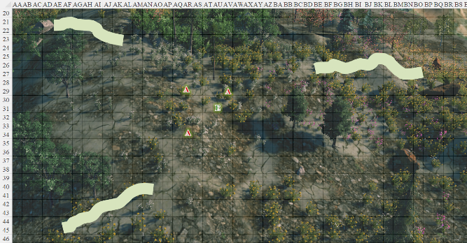

~*~

Character | Group | Initiative | Roll | Modified Roll | Speed
Stratus | 1 | 1 | 13 | 14 | 50’
Kobolds | 2 | 2 | 10 | 12 | 30’
Saradette | 1 | 3 | 3 | 6 | 20’

Stratus took a moment to survey the battlefield, and noted a plate-armored knight walking among the kobold officers.

The kobolds either took to the trees for cover, or knelt in place and fired upon Stratus and Saradette. The giant had a tower shield today, as well as a suit of magical chainmail woven from cloudstuff-infused steel, forged by the air elemental Gassy Gus.

Saradette had cast mage armor [expired in 1 hour] on herself, and had started using her sonic blaster to pick off the kobold archers while Stratus stomped the others. She was fast running out of uses for the blaster, but it didn’t miss its targets. She aimed at yet another archer and fired. “I’ll have to change weapons in a few moments,” she told her lover.
Ranged Weapon | Dmg. | Rng. | Notes
Horizikaul’s Boom | 2d4 Sonic | 25’ + 2½’/lvl | Will DC 14 or deafened for 1d4 rounds
Dmg: 6 sonic.
Character | Save vs. | Ranks | Roll | Result
Kobold Underling | Will | -1 | 2 | 1
Fail. Stunned, but also unconscious and probably dying.

That seemed to take out their lone scout.

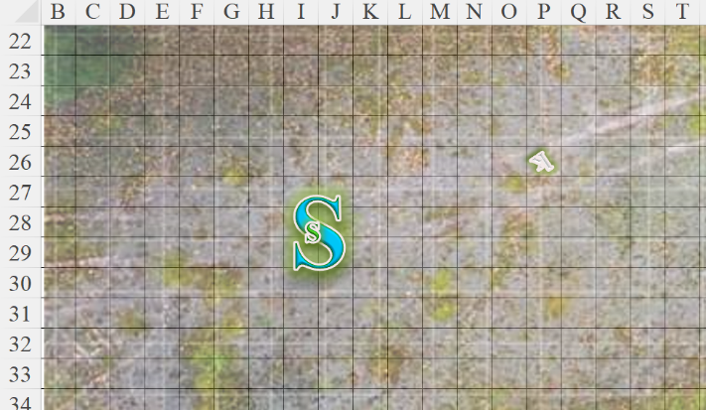

Stratus nodded as he knelt down. It was a good day to smash kobolds, and as he hunkered down behind his shield to bower himself and his lover from the first volley, he planned the best moment and trajectory for a good bull rush. “They have a few elite combatants,” he mentioned behind the shield. “If they rush, we hold this ground; otherwise, I’ll charge them, and you can hang back and deal with the stragglers,” he suggested, though she could just as easily have remained on his shoulder casting and blasting [subject to Ride and/or Balance checks].
Character | Attack Type | Damage | BAB | Dex Mod+ | W+ | Other+ | Total Score | Roll | Total
Kobold Elite | MW Heavy Crossbow | 1d8 | 6 | 5 | 1 | 0 | 12 | 16 | 28
Kobold Warrior | Shortbow | 1d4 | 3 | 3 | 0 | 0 | 6 | 16 | 22
Kobold Warrior | Javelin | 1d4 | 3 | 3 | 0 | -2 range | 4 | 9 | 13
Kobold Underling | Sling | 1d2 | 1 | 3 | 0 | -4 range | 0 | 2 | 2
Kobold Warrior | Shortbow | 1d4 | 3 | 3 | 0 | -2 range | 4 | 3 | 7
Kobold Warrior | Shortbow | 1d4 | 3 | 3 | 0 | 0 | 6 | 17 | 23
Kobold Warrior | Shortbow | 1d4 | 3 | 3 | 0 | -2 range | 4 | 9 | 13
Kobold Warrior | Javelin | 1d4 | 3 | 3 | 0 | -2 range | 4 | 18 | 22
Kobold Warrior | Javelin | 1d4 | 3 | 3 | 0 | -4 range | 2 | 15 | 17
Miss⁹.

A handful of arrows bounced off the shield that might have served as a wall for Saradette’s house.

Now kneeling, Stratus grabbed a potion of bull’s strength [expired on Round 41] and gulped it down, resolving to draw his morningstar on the next round.
Stratus gained +4 to Strength.

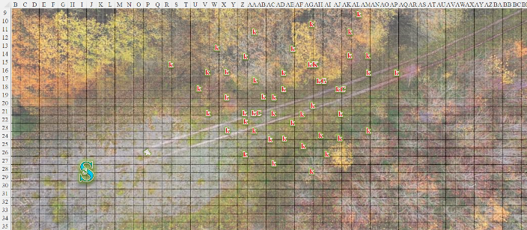

~*~

Character | Group | Initiative | Roll | Modified Roll | Speed
Burrower | 2 | 2 | 10 | 12 | 30’/20’
Tore | 1 | 2 | 1 | 3 | 40’

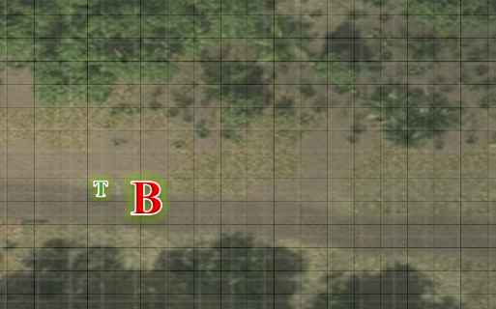

The burrower charge-attacked Tore.
Character | Attack Type | Damage | BAB | Str Mod+ | Dex Mod+ | Other+ | Total Score | Roll | Total
Bluespawn Burrower | Tail Slap | 1d8+10+shock | 12 | 6 | -2 | 2 charge | 18 | 16 | 34
Hit. Dmg: 7 + 10 + 4 electric = 21 [50/71].

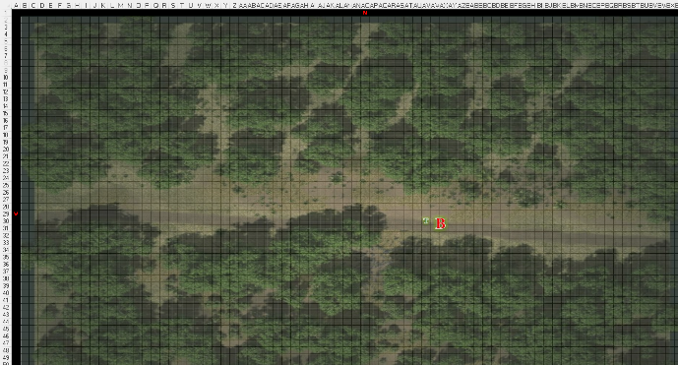

Tore grunted from the impact, and a solid impact it was. He then went right back at the burrower with his sword.
Melee Weapon | Dmg | D+ | TH+ | Critical | Type | Wt. | Atk | Roll | Check
Longsword +1 | 1d8+1 | +2 | 1 | 19-20/x2 | Slashing | 8.0 | +9 | 1 | 10
Longsword, 2nd Attack | 1d8+1 | +2 | 1 | 19-20/x2 | Slashing | - | +4 | 15 | 19
Miss, miss.
OOC: Having confronted enough of these by now, Tore recognizes that without magic he will have a hard time bringing down a burrower.

~*~

Round 2

The three lions appeared in the midst of the ambushers.

Elsabet grinned fiercely as the ambushers did not quite reach her and she felt 3 awesome lions answer her summons. She placed the first one right beside her to her west, next to the ambusher coming from the southwest, and the second one to the south of that ambusher, giving both those lions flanking and full attacks. She placed the third lion east of the second lion, and speaking to that one, pointed to the ambusher northeast of her, said, << Faster, pussycat, pounce, kill! >>

The lions pounced upon their prey.
Character | Attack Type | Damage | BAB | Str Mod+ | Dex Mod+ | W+ | Other+ | Total Score | Roll | Total | Crit | Threat
Lion 1 | Claw 1 | 1d4+5 | 3 | 4 | 1 | 2 | 2 charge  + 2 flank | 13 | 16 | 29 | 20 | ý
Lion 1 | Claw 2 | 1d4+5 | 3 | 4 | 1 | 2 | 2 flank | 11 | 17 | 28 | 20 | ý
Lion 1 | Bite | 1d8+2 | 3 | -1 | 1 | 0 | 2 flank | 4 | 2 | 6 | 20 | ý
Lion 1 | Rake | 1d4+2 | 3 | 4 | 1 | 0 | 2 flank | 9 | 17 | 26 | 20 | ý
Lion 1 | Rake | 1d4+2 | 3 | 4 | 1 | 0 | 2 flank | 9 | 2 | 11 | 20 | ý
Lion 2 | Claw 1 | 1d4+5 | 3 | 4 | 1 | 2 | 2 charge  + 2 flank | 13 | 5 | 18 | 20 | ý
Lion 2 | Claw 2 | 1d4+5 | 3 | 4 | 1 | 2 | 2 flank | 11 | 19 | 30 | 20 | ý
Lion 2 | Bite | 1d8+2 | 3 | -1 | 1 | 0 | 2 flank | 4 | 12 | 16 | 20 | ý
Lion 2 | Rake | 1d4+2 | 3 | 4 | 1 | 0 | 2 flank | 9 | 13 | 22 | 20 | ý
Lion 2 | Rake | 1d4+2 | 3 | 4 | 1 | 0 | 2 flank | 9 | 20 | 29 | 20 | þ
Hit, hit, miss, hit, miss, hit, hit, miss, hit, threat. 1d20 = 19 + 7 = 26, critical hit.
Dmg: (1 + 5 + 2 charge + 6 Leading the Charge) + (4 + 5) + (1 + 2) + (3 + 5 + 2 charge + 6 Leading the Charge) + (2 + 5) + (2 + 2) + ([2 x 2] + 2) = 14 + 9 + 3 + 16 + 7 + 4 + 6 = 59.

The ambusher was now fit to be buried, and the lions didn’t bother with any additional grappling.
Character | Attack Type | Damage | BAB | Str Mod+ | Dex Mod+ | W+ | Other+ | Total Score | Roll | Total
Lion 3 | Claw 1 | 1d4+5 | 3 | 4 | 1 | 2 | 2 charge | 11 | 16 | 27
Lion 3 | Claw 2 | 1d4+5 | 3 | 4 | 1 | 2 | 0 | 9 | 16 | 25
Lion 3 | Bite | 1d8+2 | 3 | -1 | 1 | 0 | 0 | 2 | 13 | 15
Lion 3 | Rake | 1d4+2 | 3 | 4 | 1 | 0 | 0 | 7 | 2 | 9
Lion 3 | Rake | 1d4+2 | 3 | 4 | 1 | 0 | 0 | 7 | 2 | 9
Hit, hit, miss, miss, miss. Dmg: (2 + 5) + (1 + 5) = 8 + 7 = 15.

Then Elsabet moved past that first lion to engage the ambusher to her northwest, and initiated her Stone Vise strike, channeling the power of the earth to bring her bastard sword down hard on the creature’s back, hoping to pin it in place.
Melee Weapon | Dmg | D+ | TH+ | Critical | Type | Wt. | Atk | Roll | Check
Bastard Sword +1, 1-handed | 1d10+1 | +4 | 2 | 19-20/x2 | Slashing | 6.0 | +14 | 12 | 26
Hit, miss. Dmg: 10 + 1 + 1 + 1 DF + 1 SV = 13.
Character | Save vs.  Stone Vise | Ranks | Roll | Result
Bluespawn Ambusher | Fortitude | 6 | 15 | 21
Success. Movement unaffected.

She looked back at her pride of lions to see how they had fared. The ambushers had been ambushed by her suddenly appearing nature’s allies!

The remaining ambushers attacked Elsabet.
Character | Attack Type | Damage | BAB | Str Mod+ | Other+ | Total Score | Roll | Total
Bluespawn Ambusher | Claw 1 | 1d8+4 | 4 | 4 | 2 charge | 12 | 5 | 17
Bluespawn Ambusher | Claw 1 | 1d8+4 | 4 | 4 | 0 | 10 | 16 | 26
Miss, miss.

~*~

As he’d stated, Stratus placed his girlfriend gently on the ground, winked, and turned to charge the most stalwart-looking foes, emitting the battle cry, << In a’gadda da vidaaaaa! >>

Saradette told him that she loved him as he positioned himself such that he would optimally bowl over the most kobolds in the next few seconds.

Most of the kobolds within decent range attacked Stratus.
Character | Attack Type | Damage | BAB | Str Mod+ | Dex Mod+ | W+ | Other+ | Total Score | Roll | Total
Kobold Elite | MW Heavy Crossbow | 1d8 | 6 | 2 | 5 | 1 | -2 range | 10 | 9 | 19
Kobold Warrior | Shortbow | 1d4 | 3 | 1 | 3 | 0 | 0 | 6 | 11 | 17
Kobold Warrior | Javelin | 1d4 | 3 | 1 | 3 | 0 | -4 range | 2 | 2 | 4
Kobold Underling | Spear | 1d6-1, x3 | 1 | -1 | 3 | 0 | 2 charge | 2 | 19 | 21
Kobold Underling | Sling | 1d2 | 1 | -1 | 3 | 0 | -4 range | 0 | 18 | 18
Kobold Elite | MW Heavy Crossbow | 1d8 | 6 | 2 | 5 | 1 | -2 range | 10 | 8 | 18
Kobold Warrior | Shortbow | 1d4 | 3 | 1 | 3 | 0 | 0 | 6 | 14 | 20
Kobold Warrior | Javelin | 1d4 | 3 | 1 | 3 | 0 | -4 range | 2 | 11 | 13
Kobold Warrior | Spear | 1d6-1, x3 | 3 | 1 | 3 | 0 | 2 charge | 6 | 6 | 12
Kobold Underling | Spear | 1d6-1, x3 | 1 | -1 | 3 | 0 | 0 | 0 | 19 | 19
Kobold Underling | Sling | 1d2 | 1 | -1 | 3 | 0 | -6 range | -2 | 2 | 0
Kobold Elite | MW Heavy Crossbow | 1d8 | 6 | 2 | 5 | 1 | -4 range | 8 | 7 | 15
Kobold Warrior | Shortbow | 1d4 | 3 | 1 | 3 | 0 | -2 range | 4 | 9 | 13
Kobold Warrior | Javelin | 1d4 | 3 | 1 | 3 | 0 | -8 range | -2 | 10 | 8
Kobold Warrior | Spear | 1d6-1, x3 | 3 | 1 | 3 | 0 | 2 charge | 6 | 19 | 25
Kobold Underling | Sling | 1d2 | 1 | -1 | 3 | 0 | -6 range | -2 | 5 | 3
Miss¹⁶.

Javelins and arrows bounced off of the giant’s armored frame as the man continued to trot towards the best bull rush of the day.

Some of the kobolds attacked Saradette.
Character | Attack Type | Damage | BAB | Dex Mod+ | Other+ | Total Score | Roll | Total
Kobold Warrior | Shortbow | 1d4 | 3 | 3 | -4 range | 2 | 1 | 3
Kobold Warrior | Shortbow | 1d4 | 3 | 3 | -6 range | 0 | 11 | 11
Kobold Warrior | Javelin | 1d4 | 3 | 3 | -6 range | 0 | 5 | 5
Kobold Underling | Sling | 1d2 | 1 | 3 | -10 range | -6 | 17 | 11
Miss, miss, miss, miss.

Saradette noted the knight, and shifted her fire to him. “Watch that knight,” she warned her lover. She used her blaster, then realized the damned kobolds were still out of its range.
Ranged Weapon | Dmg. | Rng. | Notes
Horizikaul’s Boom | 2d4 Sonic | 25’ + 2½’/lvl | Will DC 14 or deafened for 1d4 rounds
No effect.

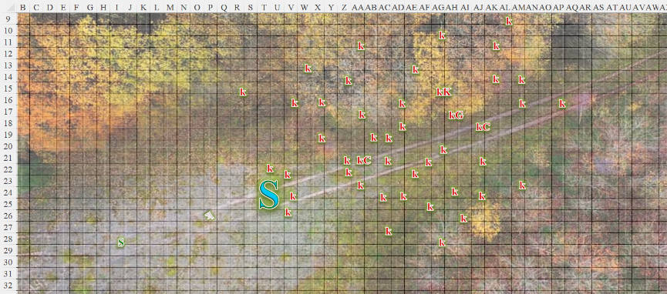

~*~

The burrower full-attacked Tore.
Character | Attack Type | Damage | BAB | Str Mod+ | Other+ | Total Score | Roll | Total
Bluespawn Burrower | Tail Slap | 1d8+10+shock | 12 | 6 | 0 | 18 | 19 | 37
Bluespawn Burrower | Claw 1 | 2d8+3 | 12 | 5 | 0 | 17 | 7 | 24
Bluespawn Burrower | Claw 2 | 2d8+3 | 12 | 5 | 0 | 17 | 2 | 19
Threat, miss, miss. 1d20 = 17 + 18 = 35, critical hit. Dmg: (2 x 1) + 10 + (6 + 3 electric) = 12 + 9 electric = 21 [29/71].

Tore, seeing how futile this would be, took a 5’ step away from the burrower. He then cast sanctuary on himself, hoping to hide from the burrower before deciding his next move.
Tore gained sanctuary benefit, DC 13.

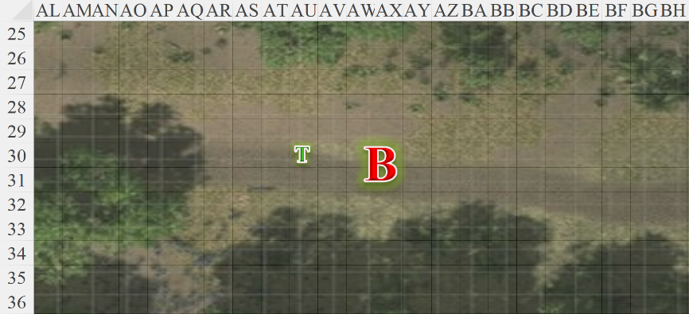

Round 3

Elsabet spoke to the lions who had just shredded one ambusher, saying << You two, finish this one, and thanks. >> as she pointed to the one she had just hit, then turned her attention to the one that had attacked her from the other side.

The lions pounced as best as they could.
Character | Attack Type | Damage | BAB | Str Mod+ | Dex Mod+ | W+ | Other+ | Total Score | Roll | Total
Lion | Claw 1 | 1d4+5 | 3 | 4 | 1 | 2 | 0 | 9 | 15 | 24
Lion | Claw 2 | 1d4+5 | 3 | 4 | 1 | 2 | 0 | 9 | 16 | 25
Lion | Bite | 1d8+2 | 3 | -1 | 1 | 0 | 0 | 2 | 7 | 9
Lion | Rake | 1d4+2 | 3 | 4 | 1 | 0 | 0 | 7 | 3 | 10
Lion | Rake | 1d4+2 | 3 | 4 | 1 | 0 | 0 | 7 | 14 | 21
Lion | Claw 1 | 1d4+5 | 3 | 4 | 1 | 2 | 0 | 9 | 13 | 22
Lion | Claw 2 | 1d4+5 | 3 | 4 | 1 | 2 | 0 | 9 | 7 | 16
Lion | Bite | 1d8+2 | 3 | -1 | 1 | 0 | 0 | 2 | 15 | 17
Lion | Rake | 1d4+2 | 3 | 4 | 1 | 0 | 0 | 7 | 5 | 12
Lion | Rake | 1d4+2 | 3 | 4 | 1 | 0 | 0 | 7 | 18 | 25
Lion | Claw 1 | 1d4+5 | 3 | 4 | 1 | 2 | 0 | 9 | 11 | 20
Lion | Claw 2 | 1d4+5 | 3 | 4 | 1 | 2 | 0 | 9 | 5 | 14
Lion | Bite | 1d8+2 | 3 | -1 | 1 | 0 | 0 | 2 | 4 | 6
Lion | Rake | 1d4+2 | 3 | 4 | 1 | 0 | 0 | 7 | 19 | 26
Lion | Rake | 1d4+2 | 3 | 4 | 1 | 0 | 0 | 7 | 20 | 27
Hit, hit, miss, miss, hit, hit, miss, miss, miss, hit, hit, miss, miss, hit, threat. 1d20 = 10 + 7 = 17, not a critical hit.
Minimum damage slew the beast outright.

Not bothering to move or activate another item, she instead swiftly changed her stance to Thicket of Blades, so that if the ambushers moved at all she would get attacks of opportunity on them.
Any opponent that Elsabet threatened provoked an attack of opportunity, even if withdrawing.

Then the crusader was about to full-attack the ambusher to her east, but mostly nodded in approval at the lions who made short work of the reptile. “It’s a long dirt nap for you,” she bade the creature to give up the fight as its severed sections now collapsed.

She then glanced warily around, looking for new foes, just in case, and heard a commotion along the trail between a thick cluster of trees that led back to the eastern gates of Ankhapur. Squinting, she spotted Tore fighting a burrower.

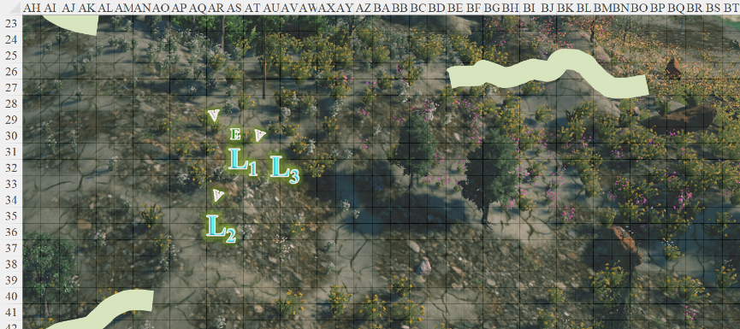

~*~

The ambushers in the midst of the kobolds all took to burrowing underground.

Given his massive stature, Stratus wasn’t bull rushing foes as much as stomping, field kicking, and pile driving, using his gargantuan morningstar mostly for balance and leverage as he made his way to what appeared to be the inner cluster of authority within this contingent.
Stratus automatically killed 6 kobold underlings, and 2 warriors.
Character | Attack Type | Damage | BAB | Str Mod+ | W+ | Other+ | Total Score | Roll | Total
Stratus | Slam | 1d6+12 | 12 | 14 | 2 | 2 charge | 30 | 18 | 48
Hit (kobold cleric). Dmg: 3 + 12 + 2 charge = 17.

The kobold cleric was surprisingly still standing, albeit barely. Wavering in the stance, the cleric cast inflict moderate wounds upon Stratus.
Character | Attack Type | Damage | BAB | Str Mod+ | Total Score | Roll | Total
Kobold Priest | Touch Attack | 2d8 + 7  negative energy | 6 | 1 | 7 | 3 | 10
Hit. Dmg: 15 + 7 = 22 negative energy.

Another kobold came trotting over, and spoke a knight’s Fighting Challenge against the giant, though he did not reach Stratus.
Kobold knight gained +1 to Will saves attacks and damage against Stratus.

Another cleric in the distance cast a spell upon his liege, bestowing some kind of buff on him.
Unidentified buff gained by kobold general.

Three bold kobolds ventured towards Saradette and fired upon her.
Character | Attack Type | Damage | BAB | Dex Mod+ | Other+ | Total Score | Roll | Total
Kobold Warrior | Shortbow | 1d4 | 3 | 3 | 0 | 6 | 9 | 15
Kobold Warrior | Shortbow | 1d4 | 3 | 3 | 0 | 6 | 16 | 22
Kobold Underling | Sling | 1d2 | 1 | 3 | -2 | 2 | 10 | 12
Miss, miss, miss.

The General had by now studied the battlefield, and activated his wand of fireball to light up the gnome before his minions could reach her.
Save vs.  fireball | Rank | Ability & Mod. | Misc. Mods. | Total | Roll | Check
Saradette, Reflex | 8 | Dex (+3) | 2 | 13 | 12 | 25
Success. Saved for ½ damage. Dmg: ½ x 15 = 7 fire [46/53].

The general then commanded something, and pointed towards either Stratus or Saradette.

The rest of the kobolds focused their attention on Stratus’ head, which was far out of danger of being at risk of firing into the melee on the ground.
Assumption of one hit, not critical. Dmg: 3.

Saradette engaged the nearest kobold with her flechette launcher.
Ranged Weapon | Dmg. | D+ | TH+ | Critical | Rng. | Wt. | Atk | Roll | Check | Notes
Minié Ball Launcher | 1d10 | - | 0 | x3 | 100’ + 10’/lvl | 5.0 | 9 | 19 | 28 | 31 musket pellets (Launch Item)
Hit. Dmg: 2.

Despite its delicate constitution, the kobold remained alive and alert, and now drew another arrow intended for her.

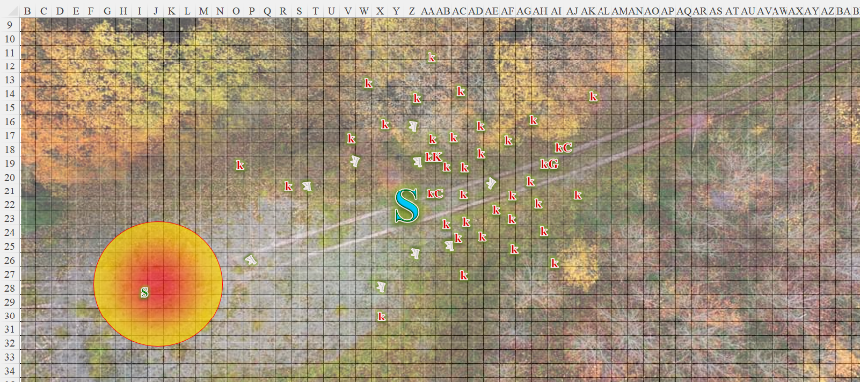

~*~

The burrower tried to swipe at the fighter-cleric once again, but found it difficult to do so.
Character | Save vs.  Sanctuary | Ranks | Roll | Result
Bluespawn Burrower | Will | 5 | 5 | 10
Fail. Attack inexecutable.

Tore then moved away to the north 30’ and activated his Healing Belt of Priestly might, using all 3 charges to heal himself.
Tore gained 18 hps [47/71].

As he did so, he spotted Elsabet in the distance to the west along the road.

~*~

Round 4

Character | Group | Initiative | Roll | Modified Roll | Speed
Elsabet | 1 | 4 | 14 | 18 | 30’
Burrower | 2 | 2 | 10 | 12 | 40’/20’/150’
Tore | 1 | 2 | 1 | 3 | 40’

Having spotted Tore apparently facing a burrower alone, Elsabet knew he needed help as soon as it could be provided. She pointed at the two lions further from her, and said, << You two, attack big blue scaly that way! >>, waving her off hand in the direction of the burrower she had spotted.

The two lions sped off eastwardly along the trail.

Then she turned to the adjacent lion, put her off hand on the lion’s muscular shoulder and said << You, with me, >>, and used her fey spell-like ability of dimension door to teleport herself and the lion into the action, trying to locate herself next to Tore with the lion on her other side. It was hard to see clearly through the trees, but she decided faster was better even if not perfect.

Now right by Tore, she could block a hit or get the burrower to focus on her. Remaining adjacent to Elsabet, the third lion roared in anticipation of another confrontation.

The burrower charge-attacked the menacing lion.
Character | Attack Type | Damage | BAB | Str Mod+ | Other+ | Total Score | Roll | Total
Bluespawn Burrower | Tail Slap | 1d8+10+shock | 12 | 6 | 2 charge | 20 | 13 | 33
Hit. Dmg: 6 + 10 + 10 electric = 26.

The other two lions could now be seen charging from the west.

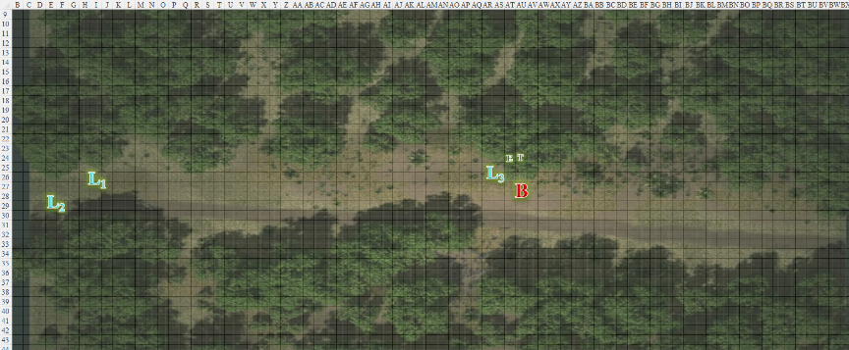

Seeing Elsabet and her ‘friends; show up, Tore decided to use the only offensive spell he had and cast summon monster II [expired on Round 8]. He used the mystical energy to call forth a Celestial eagle 10’ off the ground and directed it to attack the burrower.
Character | Attack Type | Damage | BAB | Str Mod+ | Other+ | Total Score | Roll | Total
Celestial Eagle | Talon 1 | 1d4 | 0 | 3 | 2 charge | 5 | 4 | 9
Miss.

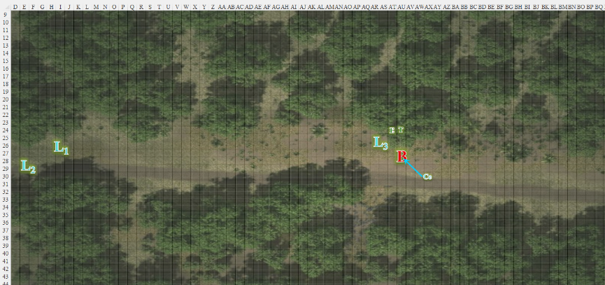

~*~

Character | Group | Initiative | Roll | Modified Roll | Speed
Stratus | 1 | 1 | 13 | 14 | 50’
Kobolds | 2 | 2 | 10 | 12 | 40’/20’/150’
Saradette | 1 | 3 | 3 | 6 | 20’

Stratus full-attacked the kobolds around him, swiping once at each opponent.
Character | Attack Type | Damage | BAB | Str Mod+ | W+ | Total Score | Roll | Total
Stratus | Gargantuan Morningstar +2 | 4d6+18 | 12 | 14 | 2 | 28 | 4 | 32
Stratus | Morningstar, 2nd Attack | 4d6+18 | 7 | 14 | 2 | 23 | 5 | 28
Stratus | Morningstar, 3rd Attack | 4d6+18 | 2 | 14 | 2 | 18 | 6 | 24
Hit, hit, hit.
Dmg to kobold cleric: 13 + 18 = 31.
Dmg to kobold knight: 17 + 18 = 35.
Dmg to kobold warrior: 9 + 18 = 27.

All three struck kobolds ceased to exist upon contact with the morningstar. << Father of the Thunders, roar amidst my foes! >> he proclaimed, and Saradette understood well the common refrain.

The majority of the kobolds trembled, and some even lost morale, fleeing as yesterday’s kobolds had. This did not bode well for Borak’s cause, but a few of the elites did manage to steel their nerves long enough to fire some carefully placed shots.
Assumption of one hit, not critical. Dmg: 4.

One kobold formerly robed and hooded removed his robe and revealed a formidable suit of armor. The elite combatant was already in the frontlines, and now took a 5’ step and lunged at the giant’s shins.
Character | Attack Type | Damage | BAB | Str Mod+ | W+ | Total Score | Roll | Total
Kobold Elite | Longsword +1 | 1d6+1 | 6 | 2 | 1 | 9 | 8 | 17
Miss.

The remaining cleric cast flame strike upon Stratus.
Character | Check | Ranks | Roll | Result
Stratus | Reflex | 6 | 9 | 15
Fail. Dmg: 23 fire.

General Thornside gave commands in Draconic, urging some of the fleeing kobolds to reconsider their fates should they be apprehended as deserters.

The three westmost kobolds repeated their attacks upon Saradette.
Character | Attack Type | Damage | BAB | Dex Mod+ | Other+ | Total Score | Roll | Total
Kobold Warrior | Shortbow | 1d4 | 3 | 3 | 0 | 6 | 11 | 17
Kobold Warrior | Shortbow | 1d4 | 3 | 3 | 0 | 6 | 6 | 12
Kobold Underling | Sling | 1d2 | 1 | 3 | -2 | 2 | 8 | 10
Miss, miss, miss.

Saradette fired on the closest kobold once again.
Ranged Weapon | Dmg. | D+ | TH+ | Critical | Rng. | Wt. | Atk | Roll | Check | Notes
Minié Ball Launcher | 1d10 | - | 0 | x3 | 100’ + 10’/lvl | 5.0 | 9 | 19 | 28 | 31 musket pellets (Launch Item)
Hit. Dmg: 9.

This killed one of the archers before her.

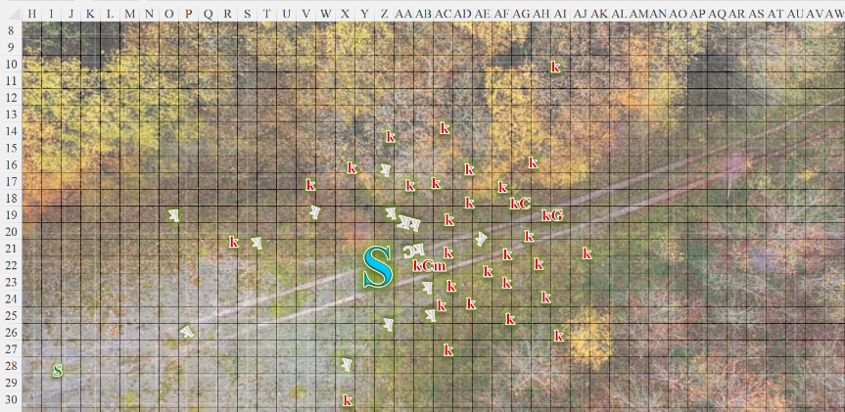

Round 5

Character | Group | Initiative | Roll | Modified Roll | Speed
Elsabet | 1 | 4 | 14 | 18 | 30’
Burrower | 2 | 2 | 10 | 12 | 40’/20’/150’
Tore | 1 | 2 | 1 | 3 | 40’

Seeing that she was outside the burrower’s tail slap reach, and that Tore was indeed a bit torn up, Elsabet activated her healing belt and used all three charges to channel healing energy into the man, then moved around him and then just into the burrower’s reach, not quite threatening it. “Hey!” she grinned at Tore.
Tore gained 14 hps [61/71].
Current Maneuvers
Stone Vise, Fort DC 16
Foehammer +2d6
Shield Block +7
Battle Leader’s Charge +10
Crusader’s Strike 1d6+5

With the eagle Tore had summoned on the opposite side of the burrower distracting it, she suspected her lion might get a flanking as it stepped forward to attack—and it would need the boost, this was a lot tougher foe than the ambushers!
Character | Attack Type | Damage | BAB | Str Mod+ | Dex Mod+ | W+ | Other+ | Total Score | Roll | Total
Lion | Claw 1 | 1d4+5 | 3 | 4 | 1 | 2 | 2 flank | 11 | 19 | 30
Lion | Claw 2 | 1d4+5 | 3 | 4 | 1 | 2 | 2 flank | 11 | 15 | 26
Lion | Bite | 1d8+2 | 3 | -1 | 1 | 0 | 2 flank | 4 | 4 | 8
Hit, hit, miss. Dmg: (3 + 5) + (3 + 5) = 8 + 8 = 16.

She could see the other lions coming, and shaking her head, used a swift action to change her stance right back to leading the charge, hoping the lions could make good use of it with a pounce.

Tore smiled at Elsabet and nodded, “Thanks and glad you could join me. I was not prepared to deal with an enemy like this. If I can help in any way, let me know, even if it’s just to distract the big, ugly beast.”

The burrower attacked the nearby lion as the other two got in position to strike.
Character | Attack Type | Damage | BAB | Str Mod+ | Dex Mod+ | Total Score | Roll | Total
Bluespawn Burrower | Tail Slap | 1d8+10+shock | 12 | 6 | -2 | 18 | 16 | 34
Bluespawn Burrower | Claw 1 | 2d8+3 | 12 | 5 | -2 | 17 | 17 | 34
Bluespawn Burrower | Claw 2 | 2d8+3 | 12 | 5 | -2 | 17 | 8 | 25
Hit, hit, hit. Dmg: (1 + 10 + 8 electric) + (11 + 3) + (7 + 3) = 11 + 14 + 10 + 8 electric = 43.

The lion burst into a semi-transparent glitterdust that fizzled within seconds.

The eagle full-attacked the burrower.
Character | Attack Type | Damage | BAB | Str Mod+ | Dex Mod+ | Other+ | Total Score | Roll | Total
Celestial Eagle | Talon 1 | 1d4 | 0 | 3 | 3 | 0 | 3 | 3 | 6
Celestial Eagle | Talon 2 | 1d4 | 0 | 3 | 3 | 0 | 3 | 14 | 17
Celestial Eagle | Bite | 1d4 | 0 | -2 | 3 | 0 | -2 | 11 | 9
Miss, miss, miss.

Tore activated his Boots of the Battle Charger and charged at the burrower and attacked the beast.
Melee Weapon | Dmg | D+ | TH+ | Critical | Type | Wt. | Atk | Roll | Check
Longsword +1 | 1d8+1 | +2 | 1 + 2  Charge | 19-20/x2 | Slashing | 8.0 | +11 | 16 | 27
Hit. Dmg: 2 + 1 + 2 + (2 + 6 charge) = 13.

With his newly restored health and with the support of the lions and Elsabet, Tore hoped they would bring the beast down quickly. Tore’s sanctuary spell faded, leaving him vulnerable once again. Tore also directed the eagle to continue to attack the burrower from the back, trying to maintain the ability of it or others to flank the burrower.

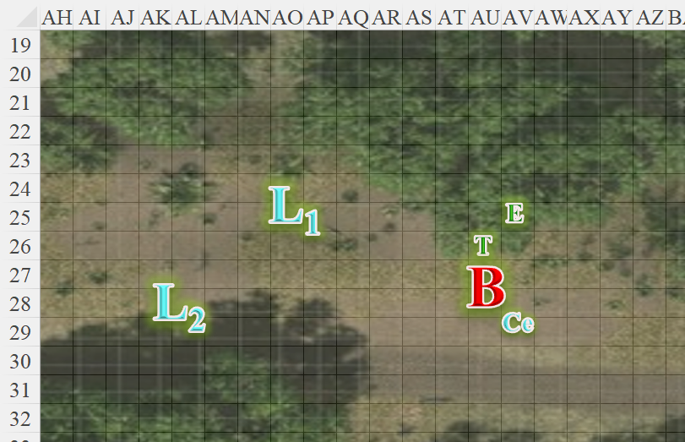

~*~

Character | Group | Initiative | Roll | Modified Roll | Speed
Stratus | 1 | 1 | 13 | 14 | 50’
Kobolds | 2 | 2 | 10 | 12 | 40’/20’/150’
Saradette | 1 | 3 | 3 | 6 | 20’

Stratus full-attacked the elites around him.
Character | Attack Type | Damage | BAB | Str Mod+ | W+ | Total Score | Roll | Total
Stratus | Gargantuan Morningstar +2 | 4d6+18 | 12 | 14 | 2 | 28 | 14 | 42
Stratus | Morningstar, 2nd Attack | 4d6+18 | 7 | 14 | 2 | 23 | 3 | 26
Stratus | Morningstar, 3rd Attack | 4d6+18 | 2 | 14 | 2 | 18 | 16 | 34
Hit, hit, hit.
Dmg to kobold commodore: 6 + 18 = 24.
Dmg to kobold commodore: 16 + 18 = 34.
Dmg to kobold warrior: 11 + 18 = 29.

The kobold minions were now either dead, running, or casting spells, while their general was likely fixing to make an escape before his entire battalion was neutralized. The commodore’s head landed near the remaining cleric, who cast an unidentified buff on himself.

The slinger and archer threatening Saradette also fled.

Saradette ran 20’ toward Stratus, then fired her flechette launcher at the nearest kobold.
Ranged Weapon | Dmg. | D+ | TH+ | Critical | Rng. | Wt. | Atk | Roll | Check | Notes
Minié Ball Launcher | 1d10 | - | 0 | x3 | 100’ + 10’/lvl | 5.0 | 9 | 17 | 26 | 30 musket pellets (Launch Item)
Hit. Dmg: 3.

The already fleeing kobold ran away even faster.

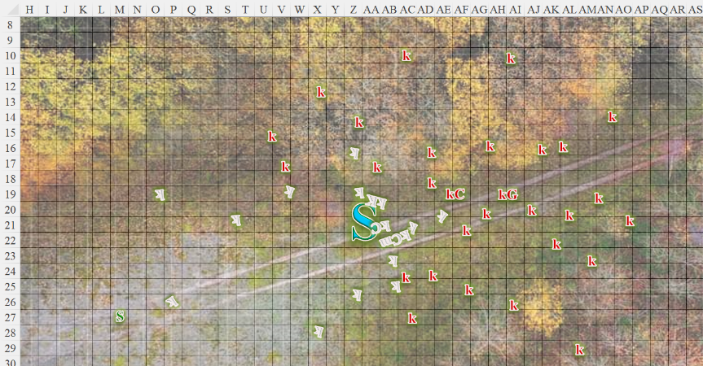

Round 6

The remaining lions charge-attacked the burrower, who—in turn—took the opportunity to tail slap the lead cat.
Character | Attack Type | Damage | BAB | Str Mod+ | W+ | Other+ | Total Score | Roll | Total
Lion 1 | Claw 1 | 1d4+5 | 3 | 4 | 2 | 2 charge | 11 | 14 | 25
Lion 1 | Claw 2 | 1d4+5 | 3 | 4 | 2 | 0 | 9 | 4 | 13
Lion 1 | Bite | 1d8+2 | 3 | -1 | 0 | 0 | 2 | 13 | 15
Lion 1 | Rake | 1d4+2 | 3 | 4 | 0 | 0 | 7 | 8 | 15
Lion 1 | Rake | 1d4+2 | 3 | 4 | 0 | 0 | 7 | 4 | 11
Lion 2 | Claw 1 | 1d4+5 | 3 | 4 | 2 | 2 charge | 11 | 15 | 26
Lion 2 | Claw 2 | 1d4+5 | 3 | 4 | 2 | 0 | 9 | 12 | 21
Lion 2 | Bite | 1d8+2 | 3 | -1 | 0 | 0 | 2 | 20 | 22
Lion 2 | Rake | 1d4+2 | 3 | 4 | 0 | 0 | 7 | 1 | 8
Lion 2 | Rake | 1d4+2 | 3 | 4 | 0 | 0 | 7 | 15 | 22
Hit, miss, miss, miss, miss, hit, miss, threat, miss, miss. 1d20 = 1, not a critical hit.
Dmg: (3 + 5 + 6) + (1 + 5 + 6) + (3 + 5 + 6) = 14 + 12 + 14 = 40.

Elsabet started to wave Tore back but aborted that as she saw him charge the burrower. Good enough, she urged him on instead. She also urged the lions on as they charged forward and pounced! Woohoo! Then she took a 5’ step south to get beside Tore and into flanking position with the southernmost lion, used a swift command to activate one charge on her brute gauntlets to pump up her musclepower even further briefly, and took a full attack at the nearly surrounded burrower.
Melee Weapon | Dmg | D+ | TH+ | Critical | Type | Wt. | Atk | Roll | Check
Bastard Sword +1, 1-handed | 1d10+1 | +4 | 2 + 2 flank | 19-20/x2 | Slashing | 6.0 | +16 | 5 | 21
Bastard Sword, 2nd Attack | 1d10+1 | +4 | 2 + 2 flank | 19-20/x2 | Slashing | - | +11 | 17 | 28
2 + 1 + 4 + 1 divine favor + 2 brute gauntlets = 10.

The eagle gave chase up to the point when the burrower disappeared into the crust of the continent.

~*~

Saradette repeated her actions of running to Stratus, and stopping to fire at one of the kobolds.
Ranged Weapon | Dmg. | D+ | TH+ | Critical | Rng. | Wt. | Atk | Roll | Check | Notes
Minié Ball Launcher | 1d10 | - | 0 | x3 | 100’ + 10’/lvl | 5.0 | 9 | 13 | 22 | 30 musket pellets (Launch Item)
Hit. Dmg: 10.

Making it another 20’ east-northeast, and taking out a kobold now about 60’ east of her, the gnome saw her man making short work of another kobold priest.
Character | Attack Type | Damage | BAB | Str Mod+ | W+ | Total Score | Roll | Total
Stratus | Gargantuan Morningstar +2 | 4d6+18 | 12 | 14 | 2 | 28 | 1 | 29
Stratus | Morningstar, 2nd Attack | 4d6+18 | 7 | 14 | 2 | 23 | 18 | 41
Stratus | Morningstar, 3rd Attack | 4d6+18 | 2 | 14 | 2 | 18 | 11 | 29
Miss, hit, hit. Dmg to defensive cleric: (9 + 18) + (16 + 18) = 27 + 34 = 61.

Both kobold clerics were now neutralized, and General Thornside now issued a final command and bolted eastwardly, urging all other kobolds—committed and otherwise—to stampede towards a mound with three dead bluespawn ambushers serving as a warning to all passersby.

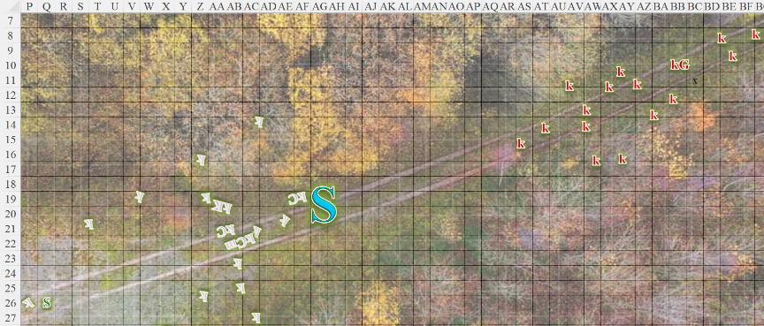

Round 7

Tore turned to Elsabet and nodded, “Thank you and your friends for helping. I don’t think I could have done anything to that beast on my own. “He then looked around, “Where is Saradette and her little friend?” he asked with a bit of sarcasm.

With her Shield Block maneuver recently granted, Elsabet was ready to defend Tore if the burrower attacked him, though she hoped it would focus on one of the summoned lions. Those lions were fierce! However, seeing that the summoners had more mettle to present, the burrower’s calculus led it to withdraw, first scrambling away along the surface, then diving into the ground to burrow to safety.

Elsabet looked around for any other foes to send the lions after, then—along with Tore—heard a commotion growing louder as they could see a handful of kobolds sprinting eastward from the mound where Elsabet had just vanquished three bluespawn ambushers. Elsabet gauged the distance she’d already teleported to have been slightly less than 300’, and considered if these kobolds were even a serious threat. Unable to repeat the dimension door trick, the favored soul of Mayaheine studied the incoming kobolds who looked like they were escaping something rather than charging towards her.

The two remaining lions waited for further instructions as the burrower’s burrowing could no longer be heard or felt.

Tore and his eagle also surveyed the kobolds who now spotted the heroes and turned to one another.

~*~

Stratus pointed to the east, and said to Saradette, “The kobolds are headed towards the mound where I believe Elsabet had been dispatched. Hop on and we can have a careful look.” He let the gnome catch up and lowered his hand so as to save her the trouble of climbing.

Saradette climbed into her lover’s hand. “Let’s go and see.”

Round 8

Upon seeing the kobolds, Tore knew his eagle only had a short time left, but he decided to use as much of it as possible. He directed it to attack the closest kobold.

The eagle flew almost 300’ to place itself in an ideal position to charge-pounce upon the lead kobold, a mace-wielding fool with an oversized helmet. Then the bird disappeared.

Meanwhile, Tore sheathed his longsword and drew (quickdraw) his bow and prepared an arrow gauging the ideal distance for him to start firing, and landing on 250’. He smiled as that distance got nigh.

Elsabet spent a moment to admire her feline friends, and spoke to them, while cleaning off her sword and sheathing it. << Thank you for your help! Go, have fun chasing those kobolds over there. >> She pointed in the direction of the fleeing kobolds, not sure how much the lions would be able to contribute before their minute was up, but figuring they would at least enjoy the prospect of hunting little crunchy prey. If they could catch and crunch some, great, if not, so be it.

<< Rawr! >> the more outlandish of the two male lions said, and they were both off, covering 160’.

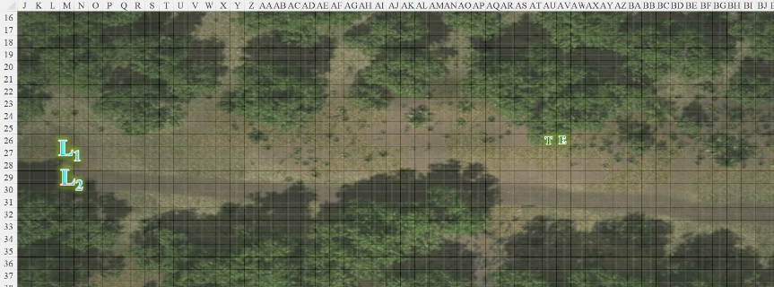

Round 9

Elsabet cast divine favor [expired on Round 19] on Tore.
Tore gained +1 to attack and weapon damage.

After casting the spell on Tore, Elsabet unlimbered her light crossbow, while taking a step to get beside Tore on his south side, the better to watch her lions at play.

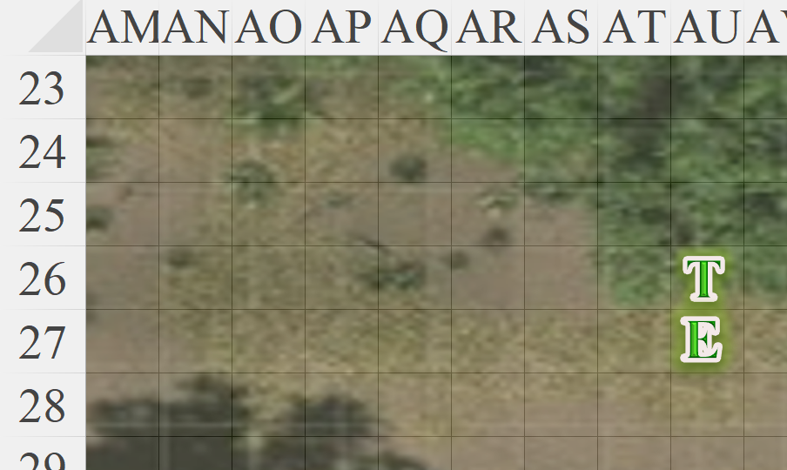

The lions made it another 100’ or so, ready to pounce upon their next prey, then disappeared before they could reach any other targets.

Round 10

Elsabet cast cure light wounds on Tore. Should that burrower return, or some other danger show up, she wanted Tore to be fully healthy.
Tore gained 3 + 4 = 7 hps [68/71].

After healing Tore as best she could, Elsabet then loaded her light crossbow. She wasn’t in a great hurry, she didn’t see any great shots yet, and her crossbow didn’t have as good a range as Tore’s longbow, but at least now she could shoot if she got a clean line of sight on a target.

Tore and Elsabet witnessed the small stampede followed by none other than Stratus and Saradette, who now came over the hill. The wizard was sitting on her boyfriend’s shoulder as the latter took leisurely kicks a the kobolds who could not run fast enough.

Round 11

Elsabet fired her crossbow and then reloaded.
. | Dmg. | D+ | TH+ | Critical | Rng. | Wt. | Atk | Roll | Check
MW Light Crossbow | 1d8 | 0 | 1 – 4  Range | 19-20/x2 | 80’ | 4.0 | +7 | 17 | 24
Hit. Dmg: 5.

Elsabet killed a woman with an exceptionally long snout and tail.

Tore waited, bow held at the ready with an arrow nocked, until the kobolds got within 250’.

~*~

Round 20

Having slain, corralled, or driven the kobolds into the crevices of the land, the Fist of Light had unexpectedly regrouped, and Saradette now pointed out, “This here is their leader.” They looked upon what was left of the kobold’s glorious army: a plated knight, a chainmailed fighter, a leather-clad ranger, and General Thornside, on whom little intel existed.

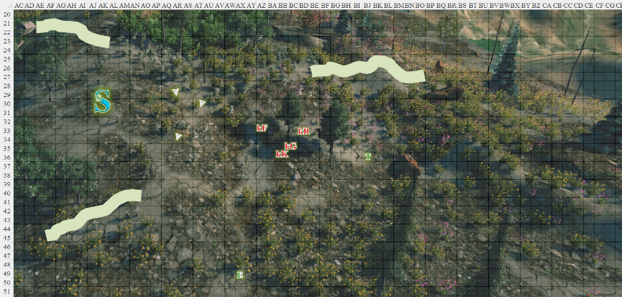

Elsabet’s first impulse was to cast confusion on the kobold leadership, but she quelled that thought—taking prisoners would be superior if she could manage it. They were a bit too far away for her to cast her charm monster or deep slumber effects on them, but she could certainly use her voice. She decided to try diplomacy. Striding towards the small group of small foes, while stowing her light crossbow to leave her hands free, she called out loudly in the Common tongue. “There is no need for you to die today! I am Elsabet, Favored of Mayaheine, of the Fist of Light—surrender to me, and you will live to see another day; cooperate with our leaders and you may even win your eventual release!” She hoped at least one of them spoke the Common tongue—if not, she would try her other three languages: Goblinoid, Sylvan, and Giant.
Skill | Rank | Ability & Mod. | Misc. Mods. | Total | Roll | Check
Elsabet, Diplomacy | 9 | Cha (+2) | 4 | 15 | 20 | 35
Success. Ernie gets to write how this plays out.

Elsabet nodded as the kobolds seemed to be ready to surrender. “Sheathe your weapons for now, and allow me the honor of knowing your names,” she said, as she approached the four leaders. “As my prisoners, provided you cooperate, I pledge by my Goddess to ensure that you are treated honorably and fairly.”

The kobolds did sheathe their weapons. Following the lead of General Evileye Thornside VIII, the knight, fighter, and ranger introduced themselves with little more than their ranks and names: Sir Frightful Cauldronspoon, Kobold-at-Arms; Oozemaster Splooge, and Drakerider Kinshasa.

Sir Frightful wore a breastplate with magical quad and shin guards. He carried a magical, matching shield-and-morningstar set with Tiamatic decorations throughout.

Oozemaster’s chainmail was also impressive, and his ranseur’s acidic burst property was fairly evident to anyone with an inkling of arcana.

Drakerider’s getup was telltale of a lifelong rider, so he’d likely earned his adult name, as had the others. Wearing a custom-fit suit of studded leather, the ranger was armed solely with a spear and a sling.

Elsabet acknowledged each of them by name and title as she deemed appropriate.

Saradette was well aware that kobolds and gnomes were bitter, lifelong enemies, and thus stayed atop the giant’s shoulders for the moment.

Elsabet turned to call Tore over. “Tore, I would have you bear witness to our parley, and to hold me accountable.”

Then she called out to the gnome and cloud giant couple, grinning. “You two, please keep a watch out for any more unfriendly types. And if any of those annoying burrowers pop their heads up, smack ‘em right back down—thanks!”

There were a few epicenters of conflict evident from the giant’s visual vantage, and he reported these, “But they aren’t headed here.”

As she began discussing the terms of their surrender and their likely treatment in return for providing information, Elsabet started to think this could be a great advantage for the alliance side in turning back the blue dragon’s horde, hopefully leading to reestablishing peace and trade in the area.

~*~

The prisoners had surrendered their primary weapons as a gesture of compliance, keeping their slings, darts, and hand crossbow for the moment, and peace-bonding them to prevent a quick draw and stab scenario.

Elsabet had jotted in her journal each prisoner’s names, ranks, specialties, classes, evident scopes, home tribe, weapons surrendered, and any testimonies. They hailed from a nomadic lineage of kobolds called the Upland Licebearers, but Borak seduced their great-great grandfather, “and laid hundreds of eggs that bore our great grandmothers and -fathers, bringing forth the mighty Clan Bledborakblue!”

The General’s underlings responded with a “True to the last!” as their dictums dictated.

Elsabet then asked them to sign or make their mark in her journal to attest that they had been truthful. She then wrote that she was taking responsibility for them, answerable for their conduct, and acting as both their warden and their advocate as necessary.

She wanted to get the Fist of Light (and honored associate Stratus) as well as the kobold prisoners back to headquarters, and to get them debriefed of as much intelligence as possible as soon as possible, as it could impact the ongoing battles.

She took her responsibility seriously, and indeed had longer-term hopes that she might be able to sway one of more of them from their presumably evil ways, though it was evident that they were currently acting on the motive of self-preservation. Once the current war was over, she envisioned repatriating them to their homelands if possible, or else helping them find a new home as civilized immigrants/political refugees in one of the allied cities.

Saradette, Stratus, and Tore remained silent, though they also mulled over the possibilities that now presented themselves as a handful of lesser kobolds approached from the north showing their empty hands. Seeing that their own leader was deserting the cause, they knew that there would be a narrative to which they could cling while still serving their own skins. They’d also ventured too close to neighboring battles, and knew they would be done for if they fought without unity and decisive leadership.

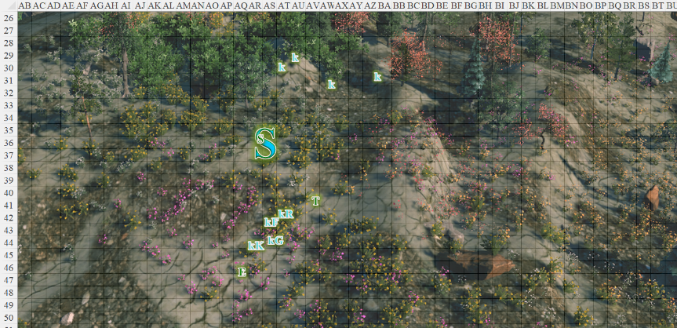

Saradette looked on the scene with scant favor from her vantage point atop her towering lover’s left shoulder. Although she could appreciate the strategy of taking their enemies alive, this group of miscreants was trouble no matter what they did. She quietly spoke into Stratus’ ear to avoid being overheard. “So, now what? We let them go, they will probably go raid a village or something. I see what Elsabet wants, but I don’t know how she can accomplish it without putting others in danger from these... things.”

Stratus knew that even his whisper would carry, so he just smiled and said nothing for the moment.

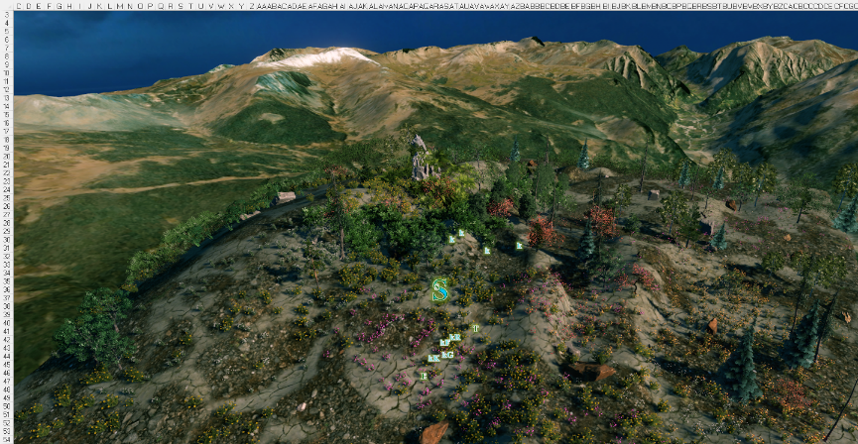

Tore walked over as requested by Elsabet and nodded to the kobolds. Tore suggested, “Before any others arrive, ours or theirs, I suggest we collect their weapons and armor. If they cooperate then I have no qualms returning their property.” Tore was concerned that if friendlies showed up and saw the kobolds armed, they might attack the prisoners. He was also concerned about Borak’s forces showing up, and if the kobolds were armed, they might consider going back on their promise and attempt to free themselves.

Elsabet replied calmly to Tore, while looking confidently over the gathering of kobolds. “I thought about that, but it’s easier if they carry the weight, and easier to keep track of the important ones. I am not concerned about friendly forces getting out of control—these guys won’t have weapons in hand and will be clearly under our control.” While staring in particular at the leaders with a slight smile on her face, she continued, with full certainty on her face. “I am pretty sure that these guys know who will die first if they violate their parole.”

Stratus cleared his throat. “I have pockets, you know.”

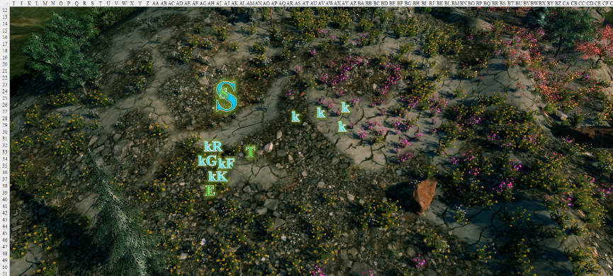

“Uh, we’d like to surrender alongside our Khan and General, and share his fate,” quoth the orator among the quartet of kobolds who had chosen a more rational path than those who now charged into their doom against other heroes within eyesight of the city walls to the distant northwest.

Hearing Stratus mention that he had pockets, Elsabet grinned. “How many kobolds can you fit in your pockets? Just saying...”

“Well, I meant for their armor, but yeah, I could do with a few pet lizards,” Stratus pondered the myriad jokes he could muster with kobolds in his pockets.

“I will hack them out of your pockets,” Saradette growled.

“You want to surrender, you say” Stratus had barely heard the kobold saying earlier. “Line un with your khan, and be grateful that he’s already partly brokered our mercy.”

The kobolds sighed, anticipating a long line of bad jokes.

~*~

The humanoids and giant had disarmed and disarmored the reptilian captives, and they’d sent for additional airlift support. Now, handing over the prisoners of war, Elsabet asked Prefect Seti-Ryam to see to their humane treatment. “I am pledged to them for the duration of this conflict,” the crusader said, and Margo conjured in her memory the municipal code that covered this.

The Prefect nodded, and turned to one of her teammates. “Summon a notary. We need to officiate a Sanctuary between these prisoners and their captor.”

The woman nodded, and went to get the notary on staff, returning a minute or two later with a man who rendered on a parchment the necessary symbols and elements required to bestow provisional custodianship over the prisoners. “They will be housed here for the time being,” the Prefect assured the heroes before asking them to seek healing and food in the lounge.

~*~

The day’s events had gone well, and while most of Borak’s platoons and brigades had been neutralized or scattered to the wilderness to be hunted down in time, the dragon herself was still terrorizing the city, and had knocked out all but a handful of the city’s defensive towers, atop which now stood a powerful wizard named Chartreuse Vermillion. He’d prepared for the day’s events, but had not as of yet been dispatched, given his frail condition as of late.

The defensive siege engines were now nearly depleted, though they’d done a spectacular job at diminishing the clusters of incursions that had come from the east and northeast over the last few hours. Citizens were bringing debris and junk to continue to load the catapults, but most of the siege engineers were dead or injured by now, so the effort would have to rely on ground and air troops at this point.

Prefect Seti-Ryam had asked the Fist of Light to stay in the lounge in case their skillsets were needed further, and now she returned as the heroes were eating grapes and cockatrice wraps. “I know you’ve depleted part of your daily reserves, but our dear Chartreuse has heard of your heroic exploits, and has requested your defense.” She added, paraphrasing, “He stated that he would be honored to die on this day in defense of the city alongside such noble people.”

Stratus had already been recalled by his Queen, and he and his brethren were now fighting in the skies against Borak and a few other dragons. Saradette could see the aerial conflict overhead, wherein a blue dragon and a brass dragon laid into one another amidst flying, vessels, rocs, giant eagles, flying cloud giants, and lesser drakes.

The heroes could tell through experience that the battle was nearly done, and now it was up to the elite forces on both sides to turn the tides one way or another. One thing was clear: Borak was not considering a stalemate or retreat. She was all in, as were her offspring and minions.

