*Chapter 32: Borak’s Demise*

It didn’t take long for the heroes to be ferried aboard a magic carpet to the Eastgate tower. Chartreuse—a centuries-old sun elf from Evermeet—greeted them warmly as if he knew them, but he was just a fan of new talent, and always looking to pass on some of his arcane torches to the right individuals. “I thank you for answering the call to action, brave ones. I regret that my predecessor was scorched by the lightning of one of Borak’s daughters before he slew her,” the wizard-incantator pointed down at a fell blue dragon with a clearly broken neck, now being butchered by young lads whose mothers and fathers were still somewhere defending the city.

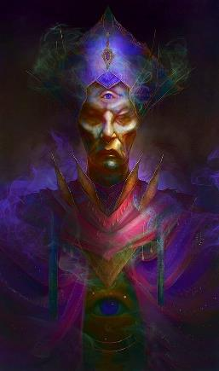

The wizard then proceeded to itemize his prepared spells so as to give the heroes a better idea of what was about to transpire.

|  |  |  |  |  |  |
| --- | --- | --- | --- | --- | --- |
| **Spell** | **Level** | **Metamagic** | **Transm.** | **DC** | **Cast?** |
| Detect Magic | 0 |  | 0 | 18 | q |
| Light | 0 |  | 0 | 18 | q |
| Mage Hand | 0 |  | 1 | 19 | q |
| Prestidigitation | 0 |  | 0 | 18 | q |
| Feather Fall | 1 |  | 1 | 20 | q |
| Magic Missile | 1 |  | 0 | 19 | q |
| Magic Missile | 1 |  | 0 | 19 | q |
| Magic Missile | 1 |  | 0 | 19 | q |
| Protection from Evil | 1 |  | 0 | 19 | q |
| Shield | 1 | Persistent | 0 | 19 | þ |
| Glitterdust | 2 |  | 0 | 20 | q |
| Mirror Image | 2 |  | 0 | 20 | q |
| See Invisibility | 2 | Persistent | 0 | 20 | þ |
| Swift Fly | 2 | Persistent | 0 | 20 | þ |
| Web | 2 |  | 1 | 21 | q |
| Web | 2 |  | 0 | 20 | q |
| Arcane Sight | 3 | Persistent | 0 | 21 | þ |
| Dispel Magic | 3 |  | 0 | 21 | q |
| Dispel Magic | 3 |  | 0 | 21 | q |
| Greater Mage Armor | 3 | Persistent | 0 | 21 | þ |
| Haste | 3 |  | 1 | 22 | q |
| Ray of Exhaustion | 3 |  | 0 | 21 | q |
| Dimensional Anchor | 4 |  | 0 | 22 | q |
| Enervation | 4 |  | 0 | 22 | q |
| Evard’s Black Tentacles | 4 |  | 0 | 22 | q |
| Greater Invisibility | 4 |  | 0 | 22 | q |
| Resist Energy, Mass | 4 |  | 0 | 22 | q |
| Baleful Polymorph | 5 |  | 1 | 24 | q |
| Dismissal | 5 |  | 0 | 23 | q |
| Wall of Stone | 5 |  | 1 | 24 | q |
| Disintegrate | 6 |  | 1 | 25 | q |
| Dispel Magic, Greater | 6 |  | 0 | 24 | q |

The heroes had already warded themselves with spells.

Tore and Saradette had not cast any buffs upon themselves on the way over, Elsabet had by now cast *bull’s strength* on both Tore and herself *[expired on Rounds 45 and 46, respectively]*, leaving her one spell slot at 2nd level, and also cast *protection from evil* on Saradette, Tore, and herself *[expired on Rounds 597, 598, and 599, respectively]*, leaving her 2 spell slots at 1st level.

*Tore and Elsabet gained +4 to Strength.*

*Saradette, Tore and Elsabet gained +2 to saves and AC vs attacks from evil foes, plus cannot be mentally controlled, and summoned non-good creatures cannot physically touch them.*

Round 1

Elsabet had listened to the litany of spells, and had a little bit of arcane power envy for a moment.

They could now see a Large blue dragon coming out from behind a puff of smoke to the east where dozens of kobold bodies lay. The drake was flying towards the heroes at an altitude of 50’ and a slight downward angle. It was still 150’ away, but would be upon them momentarily.

|  |  |  |  |  |  |  |  |
| --- | --- | --- | --- | --- | --- | --- | --- |
| **Save vs.**  Frightful Presence | **Rank** | **Ability & Mod.** | **Misc. Mods.** | **Total** | **Roll** | **Check** | **Results** |
| **Chartreuse, Will** | 9 | **Wis (+0)** | 2 | 11 | 10 | 21 |  |
| **Elsabet, Will** | 10 | **Wis (-1)** | 6 | 15 | 19 | 34 |  |
| **Saradette, Will** | 4 | **Wis (+0)** | 0 | 4 | 19 | 23 | +1 vs. Fear |
| **Tore, Will** | 5 | **Wis (+2)** | 0 | 7 | 16 | 23 |  |

*Success4. No fear penalties sustained.*

“Behold: Acophisinian!” the wizard spoke with an ominous voice, fetching a scroll of *mass resist energy [CL7, expired on Round 700]* and casting it on the quartet.

*Chartreuse and the Fist of Light gained Resistance 20 to electricity.*

*Saradette’s effective Resistance to electricity was now 50.*

The crusader saw her ordained maneuver options before her.

|  |
| --- |
| *Current Maneuvers* |
| Foehammer +2d6 |
| Battle Leader’s Charge +10 |
| Stone Vise, Fort DC 16 |
| Shield Block +7 |
| Crusader’s Strike 1d6+5 |

Seeing the dragon approaching, Elsabet concentrated on her fey powers and used her *confusion* spell-like ability on the dragon, which had entered her 200’ effective range.

|  |  |  |  |
| --- | --- | --- | --- |
| **Ranged Weapon** | **Atk** | **Roll** | **Check** |
| Bypass Spell Resistance | +4 | 18 | 22 |

*Success. Spell Resistance bypassed.*

|  |  |  |  |  |
| --- | --- | --- | --- | --- |
| **Character** | **Save vs.**  *confusion* | **Ranks** | **Roll** | **Result** |
| Acophisinian | Will | 13 | 10 | 23 |

*Success. Effect negated.*

The dragon resisted the enchantment.

Tore cast *shield of faith [expired on Round 81]* upon himself and then readied his bow.

*Tore gained +3 to AC.*

Saradette, who had cast *mage armor [expired]* on herself a few hours ago, braced her flechette launcher on the parapet to steady her aim, and waited for the dragon to come into her range, but it was already in range, so she fired.

*Range stated above is 150’ horizontal and (50 – 20 =) 30’ vertical, the hypotenuse of which is ~155’.*

|  |  |  |  |  |  |  |  |
| --- | --- | --- | --- | --- | --- | --- | --- |
| **Ranged Weapon** | **Dmg.** | **Critical** | **Rng.** | **Atk** | **Roll** | **Check** | **Notes** |
| Minié Ball Launcher | 1d10 | x3 | 100’ + 10’/lvl | 9 | 18 | 27 | 29 musket pellets (Launch Item) |

*Hit. Dmg: 7. [I think this qualifies as a magic weapon, so DR wouldn’t apply.]*

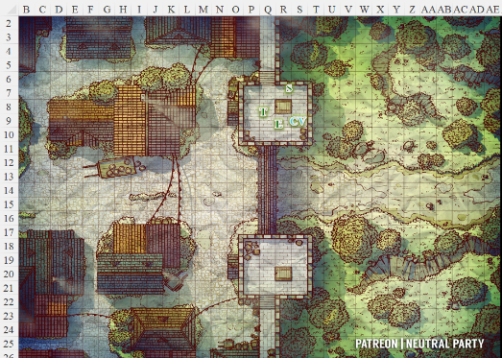

Round 2

|  |  |  |  |  |
| --- | --- | --- | --- | --- |
| **Character** | **Initiative** | **Roll** | **Modified Roll** | **Speed** |
| Saradette | 3 | 20 | 23 | 20’ |
| Chartreuse | 1 | 18 | 19 | 30’ |
| Tore | 2 | 9 | 11 | 30’ |
| Elsabet | 4 | 1 | 5 | 30’ |
| Acophisinian | 2 | 2 | 4 | 40’/20’/150’ |

Saradette was pleased with her strike, and so she cycled the launcher’s loading lever and fired again.

|  |  |  |  |  |  |  |  |
| --- | --- | --- | --- | --- | --- | --- | --- |
| **Ranged Weapon** | **Dmg.** | **Critical** | **Rng.** | **Atk** | **Roll** | **Check** | **Notes** |
| Minié Ball Launcher | 1d10 | x3 | 100’ + 10’/lvl | 9 | 12 | 21 | 29 musket pellets (Launch Item) |

*Miss.*

Chartreuse cast *disintegrate* upon the dragon as it came closer.

|  |  |  |  |  |
| --- | --- | --- | --- | --- |
| **Character** | **Save vs.**  *disintegrate* | **Ranks** | **Roll** | **Result** |
| Acophisinian | Will | 13 | 7 | 20 |

*Fail. Dmg: 92.*

The dragon was badly hurt, but far from disintegrated, and continued on downward and westward.

Tore fired two arrows at the dragon as it flew overhead, then noted something atop its back.

|  |  |  |  |  |  |  |  |  |  |
| --- | --- | --- | --- | --- | --- | --- | --- | --- | --- |
| **Ranged Weapon** | **Dmg.** | **D+** | **TH+** | **Critical** | **Rng.** | **Wt.** | **Atk** | **Roll** | **Check** |
| Longbow | 1d8 | 0 | 0 | x3 | 100’ | 3.0 | +9 | 12 | 21 |
| Longbow, 2nd Shot | 1d8 | 0 | 0 | x3 | 100’ | - | +4 | 4 | 8 |

*Miss, miss.*

Elsabet eldritch blasted the dragon.

|  |  |  |  |  |  |  |  |  |  |
| --- | --- | --- | --- | --- | --- | --- | --- | --- | --- |
| **Ranged Weapon** | **Dmg.** | **D+** | **TH+** | **Critical** | **Rng.** | **Wt.** | **Atk** | **Roll** | **Check** |
| Eldritch Blast | **2d6** | 0 | 0 | x2 | 60’ max. | - | +10 | 20 | 30 |

*Threat. 1d20 = 16 + 10 = 26, critical hit. Dmg: 2 x 8 = 16 magic.*

|  |  |  |  |
| --- | --- | --- | --- |
| **Ranged Weapon** | **Atk** | **Roll** | **Check** |
| Bypass Spell Resistance | +4 | 8 | 12 |

*Fail. Damage negated.*

As Acophisinian swooped down upon the wizard and his defenders, they noted a warrior riding atop the winged lizard. Dressed a bit like Injustine—whom they’d vanquished the day before—she was less armored and dressed more for finesse than the raw power they’d witnessed the previous day. The adversarial woman—played by Elizabeth McGovern—set her sights on Chartreuse, and jumped down from the dragon as the latter released its electrical breath weapon upon the wizard, catching Elsabet in the ray.

|  |  |  |  |
| --- | --- | --- | --- |
| **Character** | **Attack Type** | **Damage** | **Notes** |
| Acophisinian | Breath Weapon | 10d8 electric | 80’ line; Ref DC 23 for ½ |

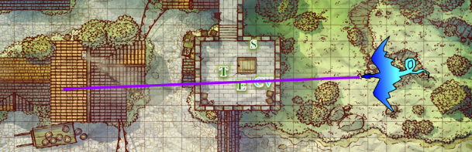

|  |  |  |  |  |  |  |
| --- | --- | --- | --- | --- | --- | --- |
| **Save vs.**  Breath Weapon | **Rank** | **Ability & Mod.** | **Misc. Mods.** | **Total** | **Roll** | **Check** |
| **Chartreuse, Reflex** | 3 | **Dex (+0)** | 0 | 3 | 2 | 5 |
| **Elsabet, Reflex** | 4 | **Dex (+2)** | 1 | 7 | 18 | 25 |

*Fail, success. Elsabet saved for ½ damage.*

*Dmg to Chartreuse: 45 electric. Partial damage negated.*

*Dmg to Elsabet: ½ x 41 = 20 electric. Damage negated.*

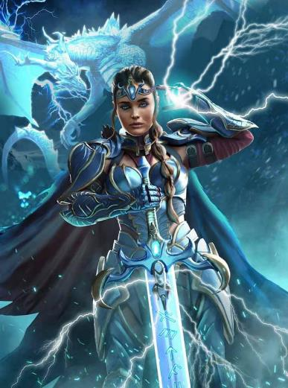

She was known as Dravidia Who Takes No Names, and was intent on neutralizing her primary target, considering the other three to be extra pelts to scalp in exchange for Borak’s favors.

|  |  |  |  |  |
| --- | --- | --- | --- | --- |
| **Character** | **Check** | **Ranks** | **Roll** | **Result** |
| Dravidia | Jump | 8 | 11 | 19 |
| Dravidia | Tumble | 9 | 20 | 29 |

*See below.*

The human was able to attack Chartreuse where he stood upon landing and tumbling, but rolled into Elsabet’s threatened range.

*By my understanding, the Tumble result above staves off an AoO from Elsabet on this round.*

|  |  |  |  |  |  |  |  |  |  |
| --- | --- | --- | --- | --- | --- | --- | --- | --- | --- |
| **Character** | **Attack Type** | **Damage** | **BAB** | **Dex Mod+** | **W+** | **Other+** | **Total Score** | **Roll** | **Total** |
| Dravidia | Rapier +2 | 1d6+2+3 | 9 | 3 | 2 | 2 charge | 11 | 16 | 27 |

*Hit. Dmg: 3 + 2 + 3 = 8.*

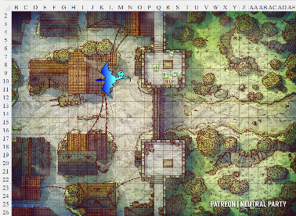

Round 3

Saradette repeated her attack.

|  |  |  |  |  |  |  |  |  |  |  |
| --- | --- | --- | --- | --- | --- | --- | --- | --- | --- | --- |
| **Ranged Weapon** | **Dmg.** | **D+** | **TH+** | **Critical** | **Rng.** | **Wt.** | **Atk** | **Roll** | **Check** | **Notes** |
| Minié Ball Launcher | 1d10 | - | 0 | x3 | 100’ + 10’/lvl | 5.0 | 9 | *1* | 10 | 28 musket pellets (Launch Item) |

*Miss.*

Chartreuse cast *baleful polymorph* on the woman, considering her to be more susceptible to such magic than her dragon mount.

|  |  |  |  |  |
| --- | --- | --- | --- | --- |
| **Character** | **Save vs.**  *baleful polymorph* | **Ranks** | **Roll** | **Result** |
| Dravidia | Fortitude | 7 | 12 | 19 |

*Fail.*

And just like that, Dravidia took on the likeness, size, and physiology of a blue and green tuatara.

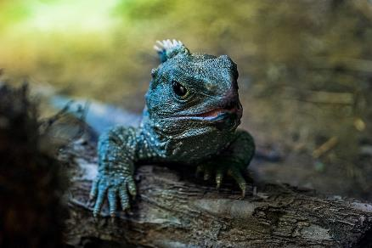

Tore activated his ‘Boots of the Battle Charger’ and drew his longsword, then backed up a few feet to give himself a running start, and charged Dravidia, slashing at her.

|  |  |  |  |  |  |  |  |  |  |
| --- | --- | --- | --- | --- | --- | --- | --- | --- | --- |
| **Melee Weapon** | **Dmg** | **D+** | **TH+** | **Critical** | **Type** | **Wt.** | **Atk** | **Roll** | **Check** |
| Longsword +1 | 1d8+1 | +2 | 1 + 2 charge | 19-20/x2 | Slashing | 8.0 | +12 | 4 | 16 |

*Miss.*

Seeing the incoming warrior intent on striking at Chartreuse, Elsabet immediately called upon Mayaheine to defend them all, activating her Protection Devotion *[expired on Round 13]*.

*PCs and Chartreuse gained +4 to AC.*

Dravidia sought to escape along the northern causeway atop the Eastgate.

Tore’s sword was close enough to the faux lizard that the cleric-fighter got a chance to swipe at the critter.

|  |  |  |  |  |  |  |  |  |  |
| --- | --- | --- | --- | --- | --- | --- | --- | --- | --- |
| **Melee Weapon** | **Dmg** | **D+** | **TH+** | **Critical** | **Type** | **Wt.** | **Atk** | **Roll** | **Check** |
| Longsword +1 | 1d8+1 | +2 | 1 | 19-20/x2 | Slashing | 8.0 | +10 | 3 | 13 |

*Miss (1 away from a hit).*

Though the swipe nicked the tuatara, the tip of the sword was only able to nick the top of its scales, giving it more of a paper cut as it scuttled by.

Acophisinian turned back around and prepared to pounce upon somebody.

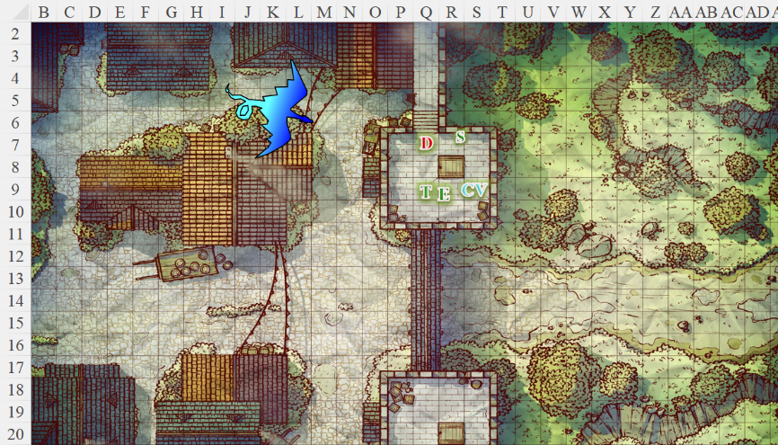

Round 4

“I’ll go after her, you take the dragon,” Saradette called to Tore as she scampered after the shape-shifted woman. She then lifted her blaster in her left hand and fired at the lizard as it tried to escape.

|  |  |  |  |  |  |  |  |
| --- | --- | --- | --- | --- | --- | --- | --- |
| **Ranged Weapon** | **Dmg.** | **Critical** | **Rng.** | **Atk** | **Roll** | **Check** | **Notes** |
| Minié Ball Launcher | 1d10 | x3 | 100’ + 10’/lvl | 9 | 12 | 21 | 27 musket pellets (Launch Item) |

*Hit. Dmg: 5.*

Chartreuse cast *ray of exhaustion [expired on Round 124]* upon Phizzy.

|  |  |  |  |  |  |  |
| --- | --- | --- | --- | --- | --- | --- |
| **Ranged Weapon** | **Dmg** | **+ Mod** | **TH+** | **Atk** | **Roll** | **Check** |
| Ranged Touch Attack | Exhaustion | or Fatigue on Save | 2 | +7 | 4 | 11 |

*Hit.*

|  |  |  |  |
| --- | --- | --- | --- |
| **Ranged Weapon** | **Atk** | **Roll** | **Check** |
| Bypass Spell Resistance | +12 | 18 | 30 |

*Success. SR bypassed.*

|  |  |  |  |  |
| --- | --- | --- | --- | --- |
| **Character** | **Save vs.**  *ray of exhaustion* | **Ranks** | **Roll** | **Result** |
| Acophisinian | Fortitude | 15 | 16 | 31 |

*Success. Acophisinian became Fatigued (-2 to Str and Dex), not Exhausted.*

Tore, went after Dravidia and slashed at her with his sword once again. The approaching dragon concerned him a bit too, but he wanted to try and eliminate the spellcaster quickly if at all possible.

|  |  |  |  |  |  |  |  |  |  |
| --- | --- | --- | --- | --- | --- | --- | --- | --- | --- |
| **Melee Weapon** | **Dmg** | **D+** | **TH+** | **Critical** | **Type** | **Wt.** | **Atk** | **Roll** | **Check** |
| Longsword +1 | 1d8+1 | +2 | 1 | 19-20/x2 | Slashing | 8.0 | +10 | 5 | 15 |
| Longsword, 2nd Attack | 1d8+1 | +2 | 1 | 19-20/x2 | Slashing | - | +5 | 17 | 22 |

*Hit, hit. Dmg: (7 + 1 + 2) + (1 + 1 + 2) = 10 + 4 = 14.*

The polymorphed lizard was as hardy as the woman they’d beheld just moments ago.

Seeing the dragon coming back around and appearing to move in for combat, Elsabet decided to give the dragon a foe worthy of fighting—that hopefully could not be snatched up. She retrieved an *enlarge person* potion, sucked it down, and grew to large size, becoming a bit stronger, a bit clumsier, and a lot bulkier, sliding her left foot forward as she grew.

*Elsabet gained + 2 Str & -2 Dex 12; -1 to attack; -1 to AC.*

*Bastard sword’s base damage became 2d8.*

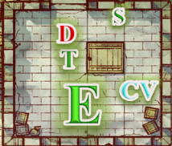



Then she bellowed out, “Come here and die!” in the Common tongue, thinking she really needed to add Draconic to her list of spoken tongues...

|  |
| --- |
| *Current Maneuvers* |
| Battle Leader’s Charge +10 |
| Foehammer +2d6 |
| Shield Block +7 |
| Stone Vise, Fort DC 17 |
| Crusader’s Strike 1d6+5 |

Borak could be seen trying to electrocute the ancient brass dragon she was confronting.

Dravidia fled northward, jumping and climbing onto the ledge, and dropping just a few feet down onto a rooftop.

Now Fatigued, Acophisinian swooped over the gigantesque woman and did a flyby attack as dragons and giants battled overhead and siege engines on the ground exhausted the last bits of debris that the townsfolk could muster.

|  |  |  |  |  |  |  |  |  |
| --- | --- | --- | --- | --- | --- | --- | --- | --- |
| **Character** | **Attack Type** | **Damage** | **BAB** | **Str Mod+** | **Other+** | **Total Score** | **Roll** | **Total** |
| Acophisinian | Bite | 2d6+6 | 23 | -2 | 2 charge + 2 altitude | 21 | 7 | 28 |

*Protection from Evil renders this a miss.*

The grace of her goddess constituted a thin barrier that the dragon’s snapping teeth could only barely graze as he swooped by, probably coming back with a renewed lightning bolt in its gizzard ready for the heroes.

A bard’s singing was barely audible in the southern distance, but it wasn’t close enough to give a boost to the Fist of Light at the moment.

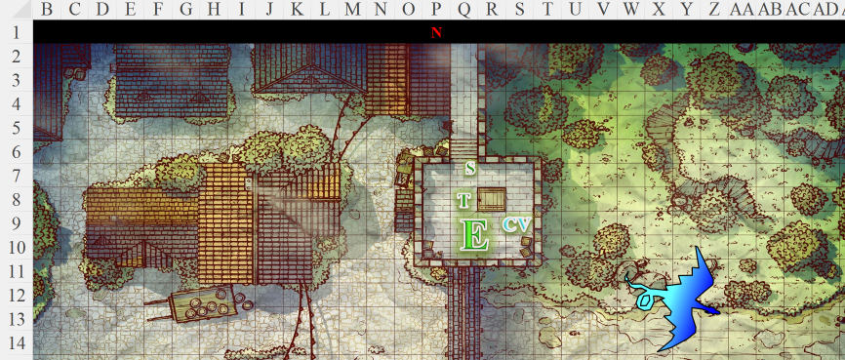

Round 5

Though the heroes were either facing the westward dragon or the fleeing tuatara, they could hear the approaching, lumbering footsteps of what might have been a dragon. Tore turned for a moment to see that it was—instead—a burly cloud giant barbarian whom Elsabet and Saradette would remember as Levi once they spotted him.

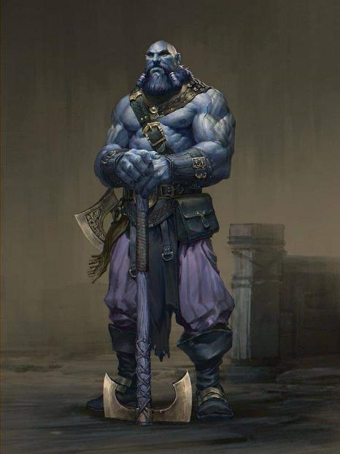

Saradette chased after the lizard, and, switched out her blaster for her sonic weapon as the dragon turned towards its right, coming back around in a clockwise trajectory.

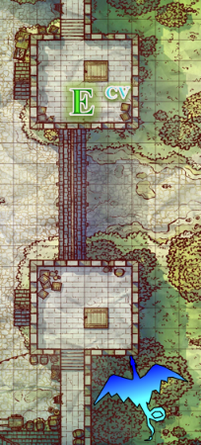

If they’d had more prep time, Chartreuse would have cast *true strike* on each of the heroes from his wand, and possibly applied other buffs. But alas, the moment at hand demanded immediate counteroffensives, so the incantator cast *magic missile* on the dragon as it fled.

|  |  |  |  |  |  |
| --- | --- | --- | --- | --- | --- |
| **Ranged Weapon** | **Dmg** | **+ Mod** | **Atk** | **Roll** | **Check** |
| Bypass Spell Resistance | 3d4 | +3 | +12 | 7 | 19 |

*Success. Dmg: 10 + 3 = 13.*

|  |  |  |  |  |
| --- | --- | --- | --- | --- |
| **Ranged Weapon** | **TH+** | **Atk** | **Roll** | **Check** |
| Ranged Touch Attack | 2 | +7 | 10 | 17 |

*Hit.*

|  |  |  |  |  |  |
| --- | --- | --- | --- | --- | --- |
| **Ranged Weapon** | **Dmg** | **+ Mod** | **Atk** | **Roll** | **Check** |
| Bypass Spell Resistance | 1d4 | Negative levels | +12 | 2 | 14 |

*Fail. SR negates effect.*

“Ah, shiznit!” the eloquent bookworm cursed in Vaasan.

With no real way to attack the dragon, Tore followed Saradette and pursued Dravidia as she attempted to flee. Hopping onto the roof behind Dravidia, he spotted her, and prepared to pursue further before apprehending or killing her.

Elsabet grumbled as the dragon’s fly-by feat let it slip by without granting her an attack of opportunity on the beast, and with a swift action, switched into her thicket of blades stance—in that stance, any enemy movement within her threaten area would provoke, regardless of tumbling, feats, or other tricks. But then she smiled, glad of the protection Mayaheine had provided her, turned to Chartreuse, and said, “here, have some healing.” She cast cure light wound, reached down, gently laid her left hand on his shoulder and channeled the energy into him.

*Chartreuse gained 8 + 4 = 12 hps.*

“Much gratitude, young lady; you remind me of my youngest,” he smiled with pride in his familial and professional accomplishments, ready to perish in the service of his people, but glad to have the second wind from the touch of the favored soul.

Having frantically searched for such a crevasse, Dravidia finally escaped downward into a space about 1’ wide, leaving Tore to catch up and peer downward to try to see if the pursuit could continue.

Acophisinian had protracted his claws in an attempt to engage Elsabet—likely another worthy opponent—but was intercepted by none other than the acrobat-barbarian, Levi of the Nimble Nimbus.

|  |  |  |  |  |
| --- | --- | --- | --- | --- |
| **Character** | **Check** | **Ranks** | **Roll** | **Result** |
| Levi | Jump | 20 | 17 | 37 |

*See below.*

“Aaaarghhh!” the grunt leapt upward onto the city wall’s ledge, and upward again with his greataxe now held aloft in hawk stance. He swung forward and downward so as to slash at the dragon’s underbelly as the later flew by.

|  |  |  |  |  |  |  |  |  |  |
| --- | --- | --- | --- | --- | --- | --- | --- | --- | --- |
| **Character** | **Attack Type** | **Damage** | **BAB** | **Str Mod+** | **W+** | **Other+** | **Total Score** | **Roll** | **Total** |
| Levi | Huge Greataxe +2 | 4d8+20 | 12 | 14 | 2 | 2 charge  -2 altitude | 28 | 15 | 43 |

*Hit. Dmg: 25 + 2 + 18 + 2 charge = 47.*

The dragon was dismayed by the surprise attack, and instead of attacking Elsabet flapped upward and away to reassess.

“Oh, no, you don’t,” muttered Elsabet to herself with the fleeting dragon in close range while nodding at the wizard’s thanks. Elsabet took the opportunity to jump up and swipe at the dragon.

|  |  |  |  |  |  |  |
| --- | --- | --- | --- | --- | --- | --- |
| **Skill** | **Rank** | **Ability & Mod.** | **Misc. Mods.** | **Total** | **Roll** | **Check** |
| **Elsabet, Jump** | 5 | **Str (+5)** | +2 synergy  -2 armor | 10 | 7 | 17 |

*Elsabet got within swinging reach.*

|  |  |  |  |  |  |  |  |  |  |
| --- | --- | --- | --- | --- | --- | --- | --- | --- | --- |
| **Melee Weapon** | **Dmg** | **D+** | **TH+** | **Critical** | **Type** | **Wt.** | **Atk** | **Roll** | **Check** |
| Bastard Sword +1, 1-handed | 1d10+1 | +5 | 2 | 19-20/x2 | Slashing | 6.0 | +14 | 3 | 17 |

*Miss.*

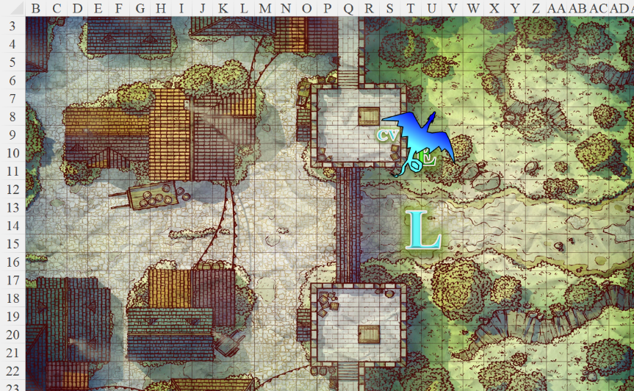

Round 6

Still in the distant south, Luran Ebonchord cast crushing despair upon a juvenile dragon that was giving a handful of guards and volunteers a difficult time.

|  |  |  |  |  |
| --- | --- | --- | --- | --- |
| **Character** | **Save vs.** | **Ranks** | **Roll** | **Result** |
| Juvenile Blue Dragon | Will | 11 | 5 | 16 |

*Fail. Juvenile suffered –2 to attacks, saving throws, checks, and weapon damage.*

Up in the air, one of the lesser brass dragons fell from the sky, then began to catch its fall by expanding its damaged wings, and instead spiraled down into the shore with a less dramatic crash than had been expected.

To the north, the cleric and artificer got to the ledge where the lizard had disappeared. The rooftops were barely able to withstand the weight of Tore’s armored body, and if he didn’t get back on the city wall, he would likely fall through and into someone’s attic soon enough.

“It’s likely that she’s scurried away by now,” Saradette huffed with her sonic blaster in hand now as she made her way back to the others.

Tore, hearing Saradette stopped his pursuit, wondering how long it would be before they saw Dravidia again. He climbed back onto the castle wall and headed back towards Elsabet’s location.

To the south, Chartreuse cast *magic missile* upon the fleeing dragon, and shouted to Levi, “Thank you, great man!”

*Dmg: 8 + 4 = 12 magic.*

With its hindside now smoking, the dragon again turned clockwise, and fled up into the smoky skies, likely to heal himself and come back to destroy them.

“It’s far from over, my friends.” Levi approached the tower and pointed eastward at the godslayer and kobold sycophants coming their way. About 100’ from the tower, the barely wounded godslayer made out the defenders atop it, and pointed, causing the kobolds to charge after his mad, impetuous lead. A few arbalists at nearby towers shot at it, but it was too fast and well armored to be slowed down by the bolts that either missed or ricocheted off of its scaled carapace.

<< Nice hit, Levi! >> she then yelled in Giant, and as she realized the dragon was no longer within reach, she activated a charge from her healing belt, laid her hand on the wizard’s shoulder again, and did some additional healing.

*Chartreuse gained 10 hps.*

“Come, defenders!” the incantator called out to Saradette and Tore to return so that he could cast *haste* on them all, particularly now that the giant was close by. “I’ll *hasten* us all.”

“Huzzah!” the cloud giant bellowed.

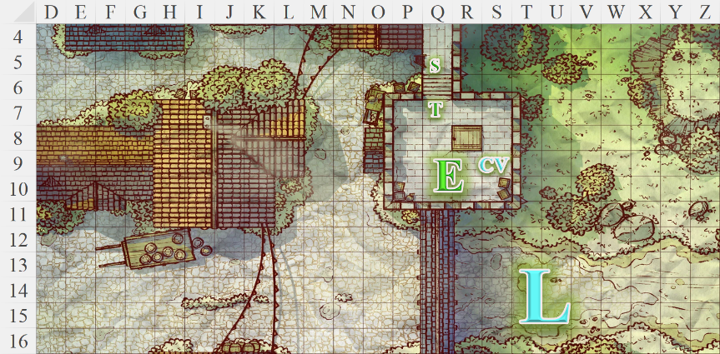

Round 7

Elsabet felt her reflexes improve and magical haste grip her from the wizard’s spell, not only speeding her up but putting a lot of spring in her step.

*+30’ speed 🡺 +4 for each 10’ to Jump.*

Elsabet glanced around, and in the streets below, she noticed a trio of bluespawn ambushers had burrowed into the town and were chasing a group of frightened civilians. Remembering the civilian casualties during the were scare in Mintar, her protective instincts were triggered.

“Stay with the wizard,” she said to her friends, “I gotta go.” She vaulted over the crenellations of the tower and jumped down into the street with new energy, and ran towards the ambushers, taking her protection aura with her, though it would only last few more rounds. She caught up to the bluespawn beasts just after they followed the civilians around a corner, but had moved too far to attack them yet.

And among giants and humanoids alike, the favored soul of Mayaheine cleansed the battlefield of dragonkind.

Chartreuse cast *haste [expired on Round 19]*.

*Chartreuse, Levi, Saradette, and Tore gained haste bonuses.*

Levi also rushed into the fray, now spurred by the incantator’s magic. He met head-on with the godslayer that had presented itself, and both disappeared behind a flurry of smoke and strife wherein Elsabet had ventured to rid this world of inborn evil.

Saradette stayed close to the mage, and looked for another target to shoot. Spotting an ambusher, she shot it with the launcher she had at the ready.

|  |  |  |  |  |  |  |  |
| --- | --- | --- | --- | --- | --- | --- | --- |
| **Ranged Weapon** | **Dmg.** | **Critical** | **Rng.** | **Atk** | **Roll** | **Check** | **Notes** |
| Minié Ball Launcher | 1d10 | x3 | 100’ + 10’/lvl | 9 | **20** | 29 | 26 musket pellets (Launch Item) |

*Threat. 1d20 = 19 + 9 = 28, critical hit. Dmg: 3 x 1 = 3.*

Tore took his spot atop the tower and fired off several arrows as targets presented themselves.

|  |  |  |  |  |  |  |  |  |  |
| --- | --- | --- | --- | --- | --- | --- | --- | --- | --- |
| **Ranged Weapon** | **Dmg.** | **D+** | **TH+** | **Critical** | **Rng.** | **Wt.** | **Atk** | **Roll** | **Check** |
| Longbow | 1d8 | 0 | 0 | x3 | 100’ | 3.0 | +9 | 2 | 11 |
| Longbow, 2nd Shot | 1d8 | 0 | 0 | x3 | 100’ | - | +4 | 11 | 15 |

*Miss, miss.*

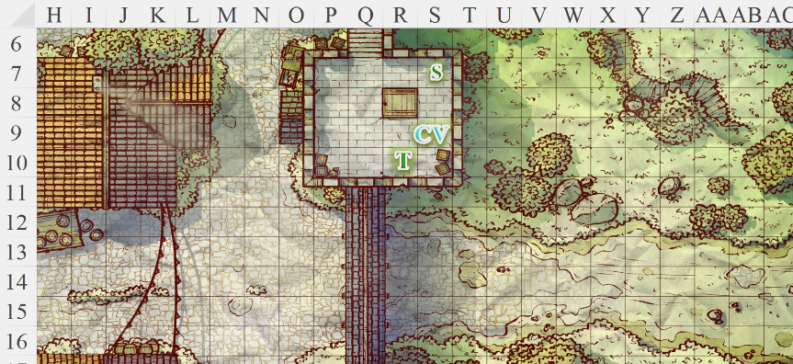

~*~

Tore continued to fire at targets as they came into view. He found the mark a few times and had a few near misses that startled the intended target. As the battle died down, Tore left the tower and headed out to the battlefield. He cast his last couple of healing spells on a couple of soldiers that needed them and used is Blessed Bandages and healing kit in order to aid others on the field as well. He was more concerned about taking care of others than with their enemies who seemed to be defeated and were retreating. How long that would last, Tore did not know. For now, though, he would take advantage of the lull and help those that needed it.

~*~

It had been a thorough trial of their martial talents and magical abilities, but in the end, they stood on the battlefield as the smoke cleared and the catapults ceased at the sound of the cornets’ cadences blaring throughout the city. The giants Levi, Stratus, and Fairweather now conferred and commended one another for their efforts, hacking at the moribund dragons and their half-spawn ilk upon the blood-drenched battlefield.

As the heroes looked upward, the horrific sight of the great brass dragon, Conjazmynabryte, falling from the sky and crashing down onto a domed building gave them pause. “I hope they have the healers and shone shapers to remedy that,” Saradette shook her head.

The dragons and other aerial forces wrapped up the conflict, with the brass dragons remaining in the sky avenging their great Conjazmynabryte’s demise and concentrating all their efforts on bringing down Boraksaghegirak, the Thunder Tyrant.

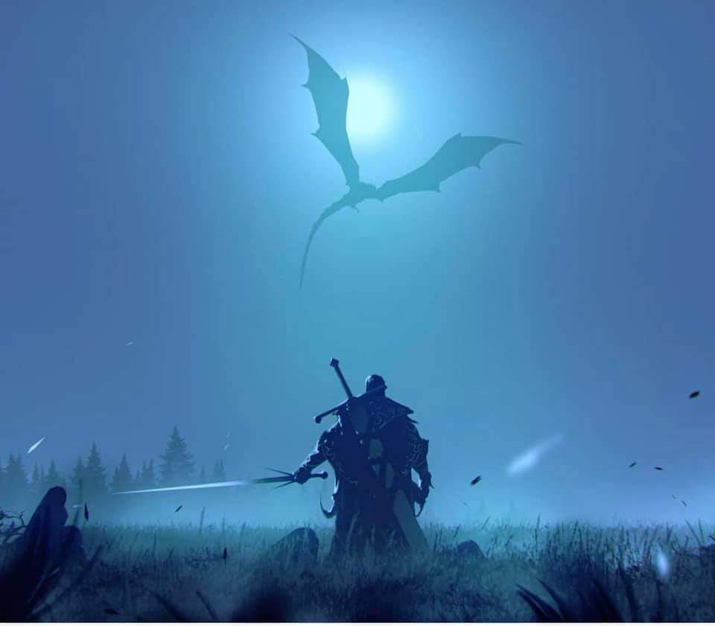

All in all, the armistice with the orcs had proven to be mostly fruitful. Though the goblin contingent that had been expected to reinforce them never arrived, the predominantly orcish battalions were formidable against the less numerous but more powerful draconic units. A few of the more robust orcs now walked northward where General Thornside had camped, nodding and saluting the valor of their humanoid counterparts. << This day our blood proved to be the same, >> one of them said in Orcish, which had enough cognates with Goblinoid for Saradette to understand.

They had briefly spotted Elsabet moments earlier cutting down a godslayer alongside Levi, but now the woman was nowhere in sight. As they made their way back to Ankhapur’s eastern gate, they beheld the decisive strikes that took down Borak. The largest dragon in sight fell with a thunderous peal, crushing the dead bodies beneath her, and sending a shockwave through the shoreline that rippled along the coast for over a hundred leagues into the Lake of Steam.

Townsfolk were now coming out with cutting tools to aid the warriors to cull the twitching bodies of the enemies as well as to try to salvage those who could be *raised* or *resurrected*. It had been an arduous day, but it would be followed by an evening of rejoicing, and by tomorrow, some of the fallen would walk among them again, though not the poor, decapitated soul by whose disembodied head they walked: his torso was eaten by a blue dragon, and his spirit was likely already on its way to the Outer Plane that most gravitated it.

Tore and Saradette anticipated returning to Mintar the next day, though they would surely be invited to stay a little longer. But as they thought about it, they began to see little motive to return to Mintar, at least to stay. Saradette—for one—had traveled with Elsabet, Laryssa, Bel Daemon, PJ, and others for half a decade, and only in recent tendays and months had the group splintered off as individuals went their separate ways. She now found herself in the company of the cleric she’d only known for a few days, and wondered what the near future would bring, and in whose company she might reside now that the Fist of Light was more of an idea carried in the hearts of heroines and heroes who dwelled as separately as the strings of a lyre quivered with harmonic resonances while never touching.

Then, as they got within about 200’ of the city wall, a bluespawn ambusher burst forth and made way for Saradette and Tore.

Tore saw the bluespawn charging and recalled he had one last spell left, *Ayailla’s radiant burst*. He quickly cast the spell, striking the oncoming beast in the chest. At the same moment, Saradette raised her sonic blaster and shot the creature, ending its regretful existence.

~*~

The Ankhapur campaign had proven quite successful. Though it had taxed the cities of the Lake of Steam’s northern coast of many lives, they had together vanquished the forces of Borak, and with the orcs at their side, the metropolitan authorities agreed to a lasting armistice that forged what might in centuries become a confederacy of like-minded nations. Borak’s body was severed into myriad pieces, her essential organs being further destroyed magically to prevent any known manner of resurrection, and her bones being scattered throughout the Realms by willing envoys.

Within days, the contingents of orcs had turned their marching orders eastward once again, leaving Ankhapur and the other convalescing cities east of it to refortify their walls and structures as they mended their hearts and resolves. By 13 Tarsakh, when Astrid had ferried Elsabet, Saradette, and Tore back to Mintar where their bulkiest valuables were, most of those who would be resurrected had been, and the rest were being laid to rest in the cities where they last resided. The two women from the Fist of Light—accompanied by Stratus and Tore—had attended a general memorial ceremony shortly after their arrival, and had spent a few nights at the Missing Minotaur until their ally—Laryssa—returned with news that Elsabet had also been chosen for a higher purpose more closely directed by Mayaheine, and thus the favored soul answered the Shieldmaiden’s call, joining the paladin in a Celestial campaign that would be spoken of by historians and poets for generations to come.