*Chapter 34: The Lantan Voyage*

Sunset, 14 Tarsakh, 1373

The Rampant Tankard

Saradette and Tore sat at a well shaded corner table in Barkley’s favorite Mintar hangout. Now that the archon was back in Saradush with Solstice, the gnome reminisced on the few times she’d joined Barkley down in the basement for a night of spirited spiriting. The mood today was much calmer, and both heroes welcomed it. Though their wounds had been healed magically shortly after sustaining them, their minds were still weary from the days of blood, sweat, and toil that they’d endured, and they were ready for another day or two of relaxation now that the giants had gone back to Ysgard and Mintar was getting back into its usual routine.

Despite their plans to lay low and maybe even nap during the day to make up lost snores, they had also been approached shortly upon their return by Captain Slatestein’s officers, and had been invited to participate in the investigation surrounding the case of Dromedar the Alacritous, who had intended to use the local Gondar Temple as a front for some nefarious operation. During the days of strife in Ankhapur, the Captain’s diviners and investigative team had uncovered that there had indeed been a plot to murder Sacerdôt Fritz. Once in place as the temple’s figurehead, Dromedar intended to send the current clergy back to Lantan, and to replace them with his own agents.

They knew not what the wicked gnome’s ultimate goal was, and Saradette and Tore had already accepted the task of venturing to Lantan to investigate the matter. Little had they anticipated becoming sleuths a tenday ago, but by now the two adventurers had packed their haversacks, notified the Radnars that they would be leaving on business for an indefinite period, and made arrangements for the artificer’s pony and wagon to be seen to. The Radnars had grown quite fond of Gadget by now, and the pony was already a regular resident of the yard adjacent to the Baron’s southern wall.

They drank one of the best house brews they’d tried so far: a hoppy ale that went well with the cockatrice stew that had just been served, and discussed the Ankhapur campaign with an acquired distaste for blue dragons and their mutant ilk.

While they ate and walked around town, Tore asked Saradette to fill him in about this gnome they were looking into. Tore had no objection to the new mission; he was happy to serve. During their time walking around town, he picked up a few items from his temple as well as other locations.

Saradette related the tale of the Fist of Light’s investigation of Dromedar. “Lantan is nearly a legend among artificers, especially with us gnomes. I’m looking forward to the journey, but I am concerned about taking a ship, as I’ve never been aboard one.”

Tore nodded, “I’ve been on a few, but never any long voyages. I’d suggest getting a ring of water walking if you’re concerned about falling overboard. We can also talk to my friend Captain Connor if you want some tips.”

“Maybe a ring of flying would be better,” Saradette said after a moment’s thought. “That would be useful for more than just on water.”

Tore smiled and nodded, “Yes, yes it would.”

“Okay, so let’s go find a couple of them.” Saradette set off to the marketplace to locate a Ring of Flying.

~*~

They had gone to see Chartreuse, who had let them know the availability of some good scrolls and other magic items. Saradette was hopeful that he might have a ring of flying among his higher-order paraphernalia, and indeed, his apprentice, a human named Palahniuk, had forged such a ring a few months ago, and still had it in his inventory.

“Looks like I’ll have to resize it,” Palahniuk said, inspecting the gnome’s hands with a respectful gaze.

“Will that diminish its magical qualities?” the artificer asked.

“No,” the fellow arcanist responded. “I only imbued the mount and garnet with the property; the rest of the band is mundane and can be swapped out if you need to resize it again.”

“Excellent,” she said before seeing the ₲26,000 price tag.

“Ooh, that’s going to set you back,” Tore also noted the price.

“Could have been worse,” the artificer shrugged before [making the purchase] [kindly deferring the purchase for now].

~*~

A few days had passed, and the gnome and human had met with Slatestein, learning of an airship on its way from Lantan that would arrive the next day and ferry them (and others) back to Lantan. The nonstop shuttle service was a holdover form a diplomatic armistice forged by the two maritime nations during the Times of Trouble (i.e., the 1360s).

Saradette and the Radnars had agreed on a sum of ₲100 for a month’s lodging in the yard. The humans had been more than pleased with this arrangement, given that it was more than they could expect in lodging humanoids. She’d paid them upfront, and they’d already used a slice of the money to soundproof the windows facing the backyard in order to make those rooms more comfortable for guests. All in all the Missing Minotaur had fiscally benefitted from the Fist of Light’s stay in the fair city of Mintar since they’d come, minus that year they’d spent on Ysgard. Now, with the Fist of Light scattered to the four winds, Saradette was all that was left here of that heroic band, and they were glad to know that she would at least be returning for Gadget, and possible Widget.

She hadn’t decided what to do with the racoon. Most wizards would take their familiar on such a long journey, but she had reservations about the familiar’s ability to survive whatever unknown conflicts would ensue upon their arrival.

Tore—too—had upgraded his repertoire of magic items, and now sported his attire like regalia, having been accepted by the Barony as one of the city’s heroes and now entrusted with the investigative task before them.

Saradette purchased the supplies to repair all of her devices to full charges, and bought the ring of flying at ₲26,000. It only worked once per day for 5 minutes, but that should be enough for starters. “Come back in a few months’ time, and I’ll have a grander version ready for you,” Palahniuk assured her.

Chartreuse stepped in, “Now, now. No need to rush it.” The master seemed to know the ambitious apprentice’s limitations well enough. “But yes, this one meets the minimum viable product specs as far as I’m concerned.”

“And would you happen to also have a ring of protection?” asked the artificer.

The incantator frowned, “I’m not sure.”

“We do,” Palahniuk noted, opening a case he got from behind the shop counter, and making Chartreuse nod with the recollection.

“Ah, yes, but it’s a bit old... without having much vintage value,” Chartreuse said as his apprentice produced the plain band of electrum that needed no sizing. “It was pawned by a halfling businessman who’d fallen on hard times and couldn’t diversify his trade; it’ll likely fit on your pinky.”

Saradette was glad to have been handsomely paid by both Ankhapur and Mintar, and could now afford both rings, albeit with only a few silvers and coppers to spare.

The artificer regretfully decided to leave Widget to watch after Gadget until she could return. She also made sure to instruct the Radnars on how to operate the methane composter, and set up the device to fuel an outdoor stove burner the family could use. There was a supply of the compressed gas available in the workshop, which, Saradette reckoned, would be enough for her needs.

~*~

Tore and Saradette stood outside the Missing Minotaur, having said their goodbyes to Widget, Gadget, and the Radnars. They now boarded the horse-drawn wagon with Slatestein’s Deputy, a human named Fasmine.

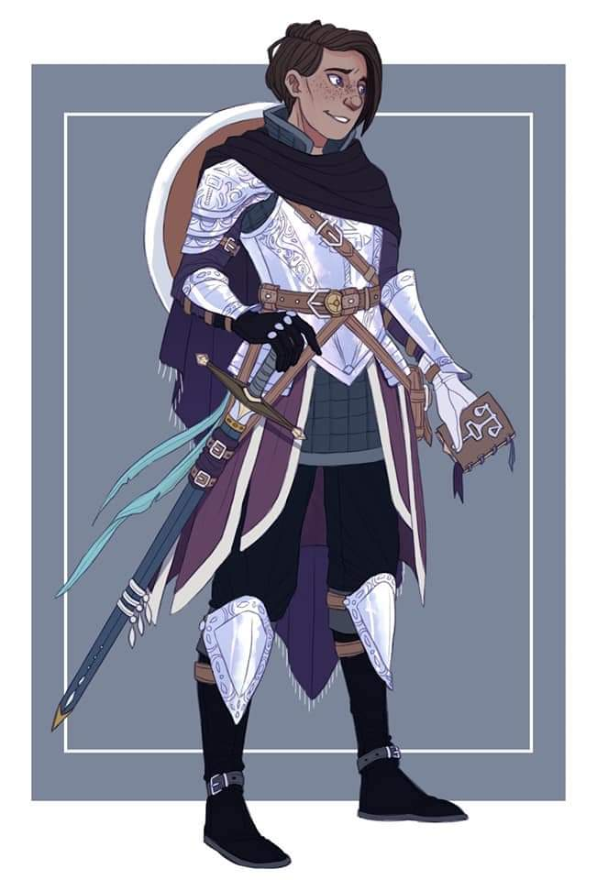

The wagon made way for the Precinct Office across the street from the Gondar Temple in the Southspur Quarter, and Slatestein greeted them all outside the office, inviting them inside.

Once they were all situated at the same table where they’d reviewed the dirt on Dromedar and Who, Slatestein asked about Elsabet, and was told that she had been recruited for a mission on an Outer Plane, and that as far as Saradette and Tore knew, she was faring well.

Satisfied with the knowledge that they were ready to discuss the case, Captain Slatestein turned to Fasmine, who provided some maps and documents. “Thank you,” he murmured politely as he went over in his mind how best to deliver the briefing information. “First, let me say that we’re a bit short-staffed at the moment, so I haven’t had enough of an opportunity to review some of this.”

“Heroes of the strife against the dragons?” asked Tore.

“Oh,” Slatestein sighed, “In one case, yes, an unresurrectable comrade-in-arms, but no, the majority of the Precinct has been subsumed by the Office of the Barony, and though I’ve been promised replacements, I’ve been given no date for this, and can only anticipate that they’ll send an untrained pack of knaves to replace the good women and men who served here until recently. If it weren’t for Fasmine coming from the Chatterstreet Precinct to save the day, I’d be underwater for the foreseeable future. But enough venting; let’s go over what is known….”

And so Saradette and Tore learned of Dromedar’s motives to first establish a clergy entirely loyal to his alleged cause—this being the restitution of a former glory of Gondar influence over the land—then slowly develop the ideology around his true cause—this being the initial subjugation and eventual extermination of all non-gnomish humanoids, coupled with the forced conversion of all gnomes to a non-Good denomination of Gondar faith dubbed Dromedism.

They further learned that Who had little evident motive to promote Dromedism, and though his ultimate goal was unclear, was could be inferred is the likelihood that Dromedar was merely a pawn in a larger scheme, and Who would likely ensure Dromedar’s failure and untimely demise once the scheme had rendered fruit. The necromancer’s criminal history was inexistent prior to 1372, when allegations were soon corroborated by evidence of Who’s malfeasance in and near small villages and hamlets across southwestern Faerûn. His modus operandi involved seeking out cemeteries, raising as many skeletons and zombies as he could, and pillaging ill-guarded settlements, and never left a scene of his heinous crime without having the zombies rape some living soul. Leaving the violated alive to spread the tale of his misdeeds, Who was careful to remain in the shadows, unseen and unrecognized, as he reveled in the visual spectacle of the dead subjecting the living to his perverse will.

“Sick dude,” Saradette wished they had slain him when they’d confronted him. Barkley almost had, but the bugger turned himself into a swarm of bats and fled into the night.

“The intel that follows couldn’t be vetted for validity because the diviner that was on site shortly after Who had fled his domicile had experienced an anomaly in his Divination casting. We believe Who set up a Wild Magic field that was undetected by the Diviner, who, admittedly, was looking for other types of magic. By the time a more comprehensive Divination could be cast, the dweomers in the room had been distorted beyond recognition.”

Tore had to trust this information, while Saradette was following perfectly. The gnomish arcanist now asked, “As a gnome, I can likely blend in quite well in Lantan, but do we have anything that might make Tore stand out a bit less?”

“You mean like a Persistent *reduce person* spell?” Slatestein asked. “We thought of that, and have five such scrolls for you to take. The Persistent property extends the duration to an entire day.”

Tore thanked the dwarf, and asked, “And the airship that is to take us there, is there a cabin large enough for me?”

“Aye,” the Captain assured him. “It’s a converted storage compartment; and while the vertical clearance may require you to crouch a bit, you’ll be able to stretch out when you sleep. The voyage will take at least one night, and depending on the winds, you may have to spend two nights aboard. Still, it’ll be about twenty times faster than aboard a maritime vessel. I will provide you with these copies,” Slatestein said, “as you may have to refer back to some of this, particularly the parts I have yet to look over more carefully when time allows. I have some *sending* scrolls as well,” he looked at Saradette, trusting that she could cast them.

Tore listened to Statestein and waited for the dwarf to finish. He then asked, “What do we know of Who himself? Meaning, is he human, is he a he or a she? Also, is Who a living creature or some kind of lich? The more we know about him or her personally, the better we can be prepared.”

“Based on Barkley’s testimony, Who is a male human,” responded the dwarf.

Tore nodded; at least it looked like they were dealing with a human necromancer, and not a lich... at least for now.

~*~

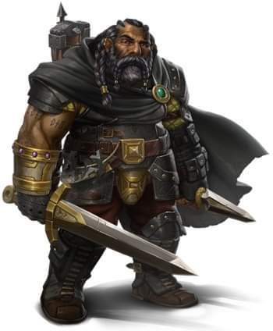

They now stood in an open area just east of the city, where fishing ships came and went, dropping off their daily cargo for fishwives to distribute in the makeshift marketplace. The airship—named the Sweat-and-Shiver—was now completely recharged. The engines were of gnomish design, but the hull of the ship was a wooden vessel of dwarven craftsmanship. Captain Slatestein bid them all well, and provided further instructions to them, and to their pilot, a green-eyed half-elf named Re’ka.



Tore had met Re’ka previously at the Precinct Office, and now had the pleasure of learning that she was also a worshipper of Lurue, so they might have much to discuss during the long and hopefully uneventful journey across the sky.

Tore nodded and smiled when he saw Re’ka. As he approached, he extended his hand and, when Re’ka returned the gesture, he bent over and kissed the back of Re’ka’s hand. As he stood up again, he added, “It is good to see you again, and I am glad to be traveling with a fellow worshipper of Lurue.” Looking around and gesturing with an outstretched arm to indicate the flying ship. “I see you are following the teachings of the Wanderer by flying across this fair land. I’ve done most of my wandering on the soles of my boots.”

Saradette smiled to herself as Tore interacted with the attractive elf. She had gotten through her tearful farewell with Stratus a few days before, but she was happy for the human all the same. The gnome settled into her quarters and proceeded to explore as much of the airship as they’d let her see.

As they prepared for liftoff, Tore stored his items below deck, then returned topside. He told Re’ka, “I’ve done some sailing in my time, and I would be eager to learn how to fly one of these. So, please, let me know what I can do to help.”

“You bet, Brother. I’ll fly better knowing someone aboard can give me respite every now and then,” she nodded.

The airship was neither a luxury liner nor a winged dinghy, but an aerial barge designed with the intentions of a lead gunship, though it lacked all but its two frontmost cannon, which had been miniaturized as fusils that could be more accurately aimed at ground targets.

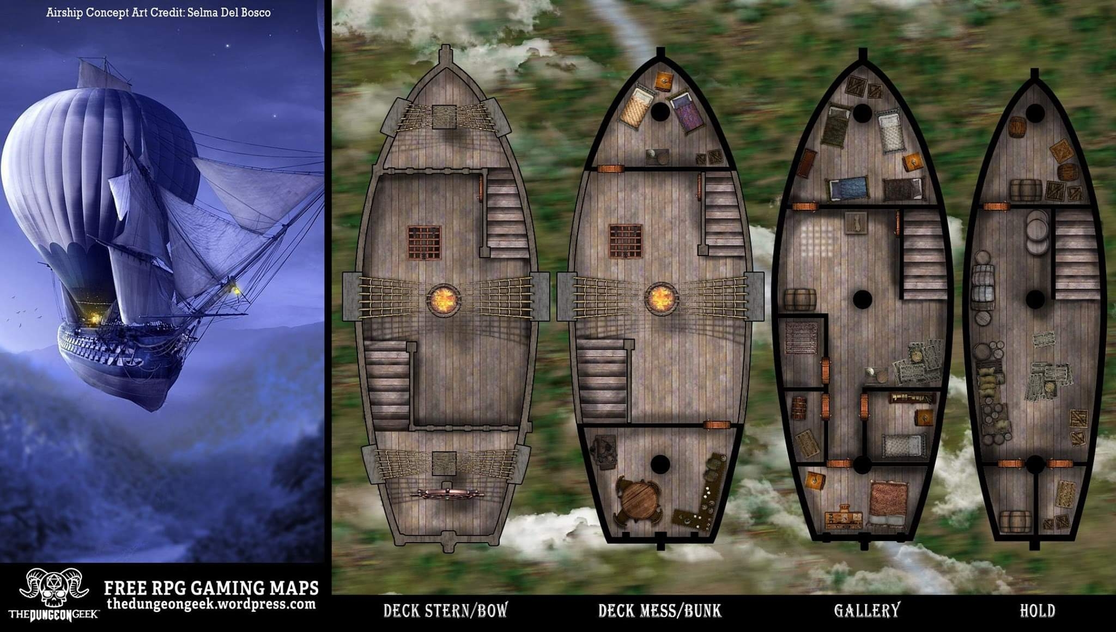

“Alright, let’s be off,” Re’ka then urged herself as she warmed up the arcane rotors and stepped on the pedal by her left foot and activated the Tenser coil that provided immediate freedom from gravity.

~*~

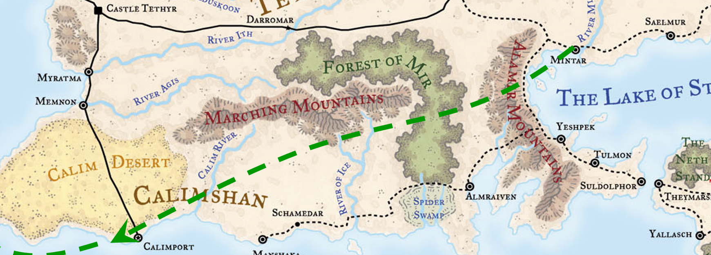

Late in the evening, not long after they’d passed Calimport and cleared the shoreline, the crew noticed lightning on the western horizon, portending a line of thunderstorms coming their way. The ship wasn’t fast enough to bypass the storm altogether, but the helmsman managed to steer it between two cells. Everyone aboard was shaken awake as the airship bucked and rolled its way through the passage marked by towering walls of cloud on each side. Saradette came up on deck, and was immediately admonished to either go back below, or lash herself to the ship. She took at stout line and tied herself to a stanchion, and watched as they flew though the storm.

The turbulent air tossed the airship from side to side as the crew hastily reefed the sails, and the helmsman steered for a gap between the clouds. Then, they ran into torrential rain mixed with small, pea-sized hail that stung the crew as it lashed across the deck. The ship pitched, driven up and down by strong updrafts and downdrafts. One staggering drop was so violent that it snapped one of the foremast’s yards in half, sending the loose part flailing across the deck with two lines still attached. A quick-thinking crewman slashed the lines holding the broken yard, and it disappeared into the darkness, trailing the lines and half of a torn sail with it.

Finally, they were through the storm with no serious injuries to anyone aboard. The violent ride had left a few folk with airsickness, and everyone with the lesson of why no one flies around thunderstorms if it can be avoided.

~*~

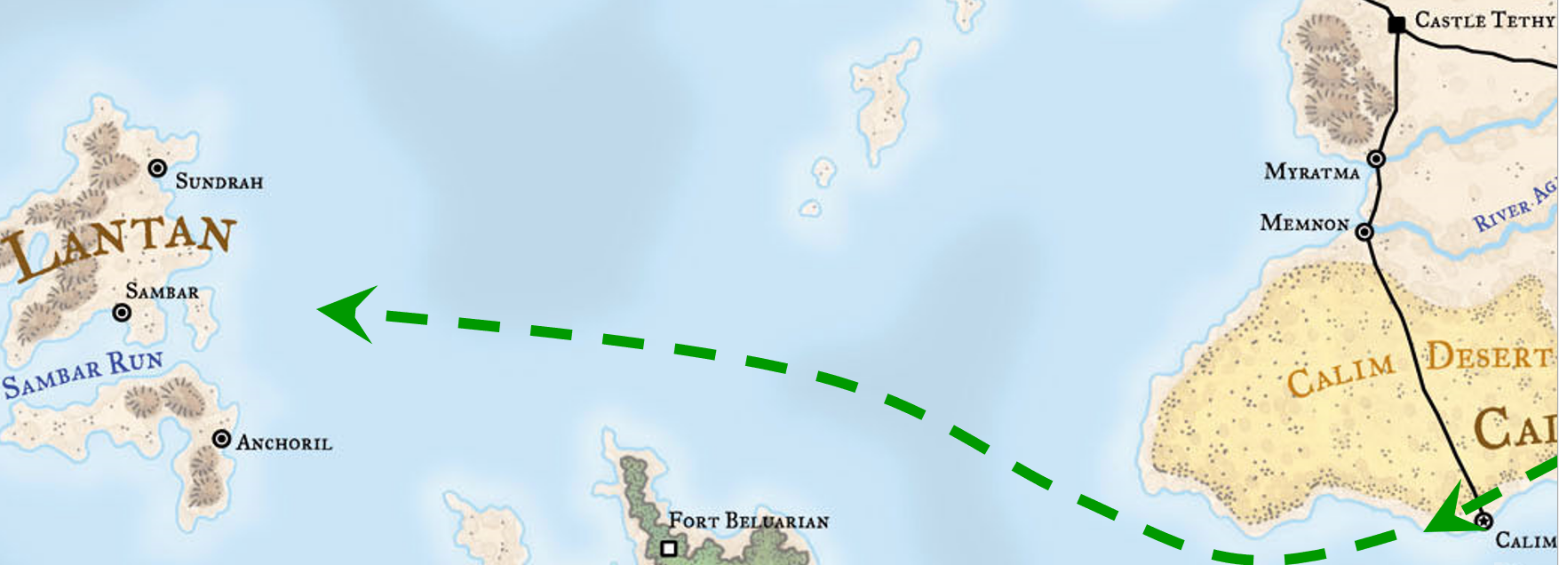

Not long after they cleared the storm, while Tore was up on deck, that they saw a large bird approaching, and noted also a small island below them. The crew wasn’t sure what it was at first, but after a short time, the recognized it to be a roc, though not a full-grown one. It also seemed to be injured as its flight was a bit erratic and seemed to be struggling to maintain its altitude.

As the bird got closer, the Re’ka attempted to stir the ship out of its path, but she wasn’t able to move the ship quick enough. At the last moment, Tore grabbed Re’ka and they pair dove to the side as the roc crashed into the helm, wood splintering everywhere. The loss of the wheel had the ship out of control for several seconds until the crew was able to stabilize the rudder by grabbing the control ropes and tying them off.

Tore got up and walked over towards the injured creature, using some soothing words and motions, trying to get it to calm down. After nearly a minute, Tore was able to get close enough to the large bird to see what was wrong. Several feathers were missing, and others had matted blood in them. The creature had obviously been in some kind of fight. Tore turned to Re’ka, “Be on the lookout for whatever this bird was fighting in case it’s still out there.” Tore then turned his attention back to the injured creature. Closing his eyes, and chanting the healing words he had learned, he cast *cure moderate wounds* on the bird and watched as several of the wounds closed up and some feathers regrew. Nodding, he saw there was more that needed to be done, so he motioned for the bird to follow him. Reluctantly, it climbed down to the main deck so repairs to the wheel could be made. Tore cast another *cure moderate wounds* and the last of the bigger wounds closed up.

The crew pulled some of their food stores, mainly some dried fish, and fed the bird before it finally took flight. It did a couple of loops around the ship and gave a few loud screeches before heading off in the direction it had come from.

~*~

Elsabet had left behind her journal, and Saradette now turned to the last few pages, scribbling in the last few days’ events.

|  |  |  |  |
| --- | --- | --- | --- |
| ***Event*** | º | R |  |
| Elsabet, Saradette, and Tore have dinner at the Heaving Sternum | Afternoon | 6 | Tarsakh |
| Elsabet, Saradette, and Tore report for their first mission against Borak’s forces | Highsun | 7 | Tarsakh |
| The Fist of Light and Those Who Do Not Fumble take out Phem Shiangs contingent of dragonspawns | Afternoon | 7 | Tarsakh |
| The Fist of Light is commissioned for another mission: defeat a blue dragon named Daudhir | Morning | 8 | Tarsakh |
| The Fist of Light and the Elmore Gang defeat Daudhir, destroying a convoy of mangonels and neutralizing another of Borak’s contingents | Afternoon | 8 | Tarsakh |
| Elsabet, Saradette, Stratus, and Tore are dispatched to three different strategic locations to neutralize kobolds and bluespawns | Morning | 9 | Tarsakh |
| Saradette and Tore watch Borak falling to her death onto the battlefield, and return to Ankhapur to be celebrated alongside other heroes | Afternoon | 9 | Tarsakh |
| Elsabet, Saradette, Stratus, and Tore return to Mintar as heroes | Sunset | 13 | Tarsakh |
| Saradette and Tore finish re-equipping before their trip to Lantan | Afternoon | 14 | Tarsakh |
| Saradette and Tore set off for Lantan aboard an airship, and face a storm just outside of Calimport | Morning | 15 | Tarsakh |
| The airship crashes into a roc, and they spend some time healing the bird before continuing their journey | Sunset | 16 | Tarsakh |
| With favorable winds, the airship arrives in Sambar, Lantan a few hours ahead of schedule | Afternoon | 17 | Tarsakh |

The gnome and her new human friend had decided to continue to use the Fist of Light moniker while in Lantan. No one was likely to be familiar with Saradette’s former band of adventurers, and if things went sour while on the island, they could simply abandon the use of this title.

About a third of an hour before they’d spotted the Lantanese mainland—if it could be called that—they’d passed a smaller island haloed by an archipelago of jutting rocks where rocs nested after summer cooled to autumn. Now in the midst of spring, the land below was blooming with red flowers that Re’ka identified as dread blossoms, and the wind was such that it was blowing swarms of these southward as they skirted the islands westwardly along the north, just to be safe. “Individually, they can’t do much more than give you a buzz followed by a headache, but that swarm building over there is going to cause problems to anything flying in its way,” she warned.

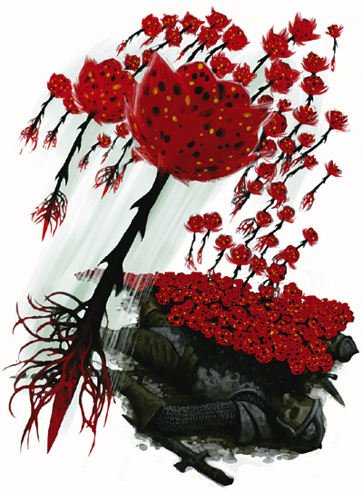

And so it was that they were introduced to the local flora. As they descended and approached the coastal settlement, the passengers peered out through the window as the sun rose behind them, beholding the city that would host them for the duration of this investigation.

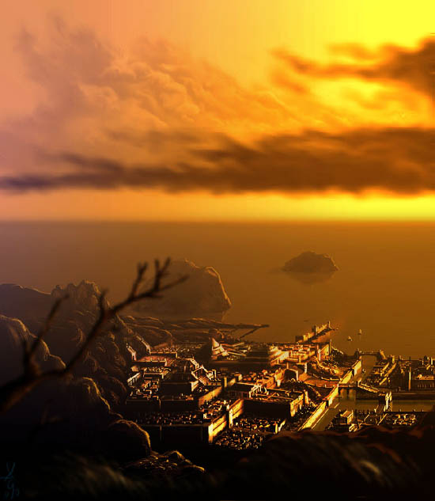

Re’ka and the heroes stepped on solid ground once more, glad to have arrived.

Tore had heard tales of Lantan, and Saradette even more, where Gond’s arcane favor was almost ubiquitously worshiped, and all other magic deemed mundane. Most knew very little more beyond the hearsay that Lantan was a strange and dangerous place where clockwork machines and infernal devices worked great wonders and terrors at their makers’ direction.

The gnomes and other residents of the island of Lantan pioneered technological solutions to problems that citizens of Faerûn solve with magic. The faith of Gond ruled the pleasant island realm, and its inhabitants farmed, crafted things, and experimented endlessly. The Lantanese inventors were constantly creating small wonders for the greater glory of Gond, and sometimes sold or traded these devices for glass, charcoal, and other odd ingredients their clients require.

Some Lantanese devices popular on mainland Faerûn included wagon suspensions and repairable sectioned wagon wheels; self-tilling oil lamps that never went out as long as an oil tank was kept filled; various light-beam and tripwire intruder alarms; intricate hinges, chains, clockwork time-release devices, hasps, locks, and castings with special features (such as “stabbing pins” that could be poisoned to deter thieves, key-hiding cavities, catches that can ring chimes to announce the opening of a portal, and so on). The Lantanese had also treated wind-driven fans, snap-together weapons, grapnels that could be disassembled and concealed in clothing, and a variety of intricate needles and tools for sewing and surgical uses.

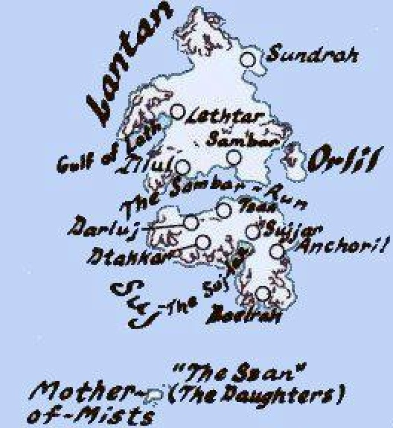

Their mission had been classified under a strict rubric of compartmentalized information, and because of the mysterious nature of the perpetration being investigated, the utmost secrecy was imperative. Re’ka provided a map and a small stipend in a leather pouch to Saradette and Tore for a tenday’s worth of their lodging and meals, and told them the address of a safehouse where they could go if their identities and purposes were discovered by any nefarious Lantanese championing Gondar supremacy. The gnome and human thanked Re’ka, who would be staying at the safehouse under the guise of a merchant, then meandered around the center of the city until they found a row of inns, taverns, and public spaces suited to leisure and the arts.

Saradette let out a low whistle as she looked around. “This place is legendary back home. I never thought I’d see it. If you take me to one of their markets, I may never leave.” She looked up at her towering companion. “First, though, I’d like some breakfast. Flying, as it turns out, isn’t good for my stomach, or my appetite.”

Tore nodded, “Sounds good to me, and I will be happy to try and restrain your shopping, as difficult as that might prove to be.” Tore simply looked around with a more analytical eye as he was less awestruck by the location.