*Chapter 35: The Ambush*

They were breaking fast at the Cyclops’ Third Eye, an establishment with a deck overlooking the south-facing shoreline. Though the animal-based dishes served here were wholly different in both flesh and spice, they took a liking to the emu egg soufflé and the dragonfruit salad. Their server, a gnome about Saradette’s age named Eberc, donned on his otherwise plain uniform a pin that identified him as a volunteer watchperson. He recommended that they visit the neighborhood cartographer, Fodoric Angalstrand, just down the block a bit, to get a detailed map. They hadn’t mentioned that they had been given one as part of their intel dossier, and could certainly use a better annotated folio to navigate the city’s quarters.

“Long way from Mintar,” Tore said to his new partner as they discussed sotto voce the known elements of the case, followed by the most plausible speculations. Re’ka’s safehouse wasn’t far, and they could pass it nonchalantly after breakfast just to make sure they knew how to reach it in a pinch. The nearest Gondar Temple—and there were several in the city—was visible in the distance, and its clergy could be seen in their distinctive brass garments mingling with passersby.

“At least our friend won’t recognize you, since you weren’t with us. For me, I have different gear, and gnomes are plentiful. I’d suggest a disguise, but that didn’t go well for me when I used one before. I still have the wig and other things, though.”

“Well,” Tore replied about the disguise, “anything short of an *alter-self* potion or spell, I’ll still stick out. Plus, since the problem we are investigating was before I came to Mintar, then perhaps I will not need a disguise, at least not right away.”

Saradette nodded. “That’s what I meant about him not knowing who you are.” She took a drink of her ale. “I’m not sure about how to find him, though. If we start asking questions, it might draw unwanted attention.”

“What was his specialty? Do we know if he’s a weapons guy or an invention guy?” Tore took a bit of his dragon fruit salad. “Perhaps we come at it from that angle. We are looking for someone to do a job for us or make something that he can make.”

“I know that he was an associate of the Sacerdôt, and all of Gond’s followers are interested in technology,” she waved her hand, indicating the city around them. “I could pick a subject, say, metallurgy, and say that I’m seeking more of that knowledge.”

“OK,” Tore replied, “and you can say I’m your hired muscle and healer.”

“That works for me,” Saradette said ruminatively. “Our story is close enough to the truth, anyway, as I’m certainly interested in metallurgy.” She tugs at her hair. “The one thing I might want to do is to dye my hair. Green is probably a bit too memorable a color to risk him remembering if he sees me.”

Tore looked around and suggested the most common gnome hair color he saw around them: a sable mélange of sandy, woody hues.

“So, brown it is,” Saradette said. “We should also wear local clothing, so let’s get at least one outfit each.” She went in search of the appropriate hair dye, and a local clothier. That done, she suggested that they find a room, where she could apply the dye while she bathed and changed clothes.

After their meal, they continued along the promenade, and began to make out the proselytizing of the Gondar man at the gates of his own temple, << Behooold, for it hath been foretooold, that the Chosen of Gond shall prevaiiiil, and all those who oppose shall faiiiil. >>

Saradette understood the Gnomish vernacular, but didn’t have the occasion to translate it for Tore as others passed by. “The hardest part about your cover’s going to be the language.... Maybe you can be mute,” she murmured in Common once the pedestrians around them had mostly passed.

“Unless you think you can quickly learn the language, of course.”

Tore shook his head, confirming he couldn’t learn the language that quickly. If there are any shops nearby, he’ll have to see about a potion of tongues or comprehend languages, something like that.

He thing motioned for the Saradette to lead the way, giving a ‘grunt’ to indicate he was going mute for the time being.

The gnome grinned up at him. “That works, too.”

~*~

Within a bell’s toll, they’d walked around the central part of the city and gotten a fair understanding of the layout, the one-ways, the alley complex, and the various industrial quarters that had been arranged with shipping considerations. Purveyors of bulkier goods—vehicles, furniture, raw materials, and the like—were situated along the wider, peripheral throughways that crisscrossed the rural north and led to “inland” waystations and trading posts on this island-nation. Meanwhile, craftsmanship of finer size was concentrated along the more central and compact region bordering the riverbank and its primary piers.

Their map had served them well, and they’d noted several new landmarks, including a handful of Gondar Chapterhouses marked with the holy symbol of their deity, and just about every type of shop an adventurer would want to frequent, all with an arcane theme.

Saradette stood at the street corner, watching as one of the Gondar priests talked to passersby. “You know, maybe we should talk to the skeptics and detractors,” she said quietly. “They would be most eager to talk about any priest who seemed strange or out of place.”

Tore nodded thoughtfully, “Sounds reasonable to me, and an interesting approach as well.”

“Okay, so let’s wait and see who reacts poorly to the priest, and who might talk to us for a bit of coin.”

~*~

It took an hour or so for them to ubicate their ideal targets, but by virtue of asking around and marking several items in their notes and map, they’d learned of the Tibid Korc, a local watering hole for itinerant sailors, merchants, and adventurers. The tavern lay beyond the western edge of the municipal ward just outside the old walls, where the temples were fewer and the outlanders more plentiful. Truth be told, it was a hodgepodge assortment of racial and ethnic enclaves from the Faerûnian mainland and nearby archipelagos, and if there was deviance to be found in Sambar—plots, intrigues, necromancy, and the like—it was likely here in this slum. There was no sign that stated it, but this area was known as the Vestham, short for Western Hamlet, as it was not always joined to the city proper by a contiguous, built-up area. A fellow by the name of Koger Decirc had provided them the name, and a few others had confirmed that it was a likely place to find trouble.

Tore did not cast any defensive spells, instead opting for *detect magic* before they reached the door. He expected to pick up several sources of magic, and was just more interested in the intensity of the magic he detected, plus he wanted to see if he could pick up anything that might be emanating from the building itself.

And sure enough, as might be expected in a tavern of outsiders and others pushed to the margins of the society, there had to be at least two spellcasters, giving the front wall two different emanations spaced out about 20’ apart. This was a far better visualization than he normally got with the casting of this spell, and was pleased with whatever metamagic forces attuned his vision to the auras despite the solid wood that would otherwise have blocked that line of sight. “Two spells in effect at least,” he stated to Saradette.

They stepped onto the wooden boards that led a few steps up onto the doorway of the elevated building facing the coast. The sign read << Tibid Korc >> in Gnomish script, which Tore could only identify but not decipher, and underneath read << Est. 1338 DR – Manager-Proprietor – Lambrac “Lamb” Lamstrand >>.

They hadn’t come this far for nothing, so they stepped into the smoky tavern that appeared to have no second floor or lodging quarters. Their weapons remained sheathed, and they half-thought to cast a buff spell before entering.

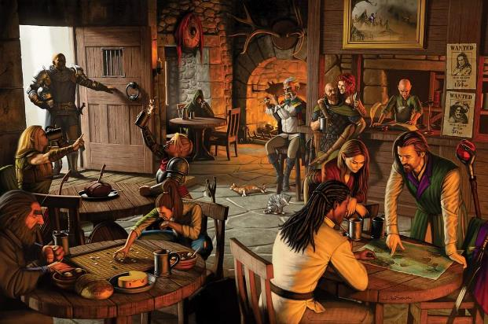

As he stepped into the room, Tore looked around and took in the occupants, trying to determine where they might be from or what their ‘profession’ might be. The outlanders here were mostly human, and Tore and Saradette could tell by their clothing and equipment that they were among seasoned travelers.

Saradette walked ahead of Tore, as befitted her supposed status as his employer. She looked around for an empty table where they could sit. Yes, Tore held the door for Saradette then pulled out the chair for his ‘employer’ when she picked out a table.

“Well, this is interesting,” Saradette said in a low voice. She walked over to one of the human-sized tables, grabbed one of the gnome-sized chairs from another table, and used her stowed workshop pack with it as a booster seat.

Tore assisted Saradette as she took her seat. Anyone that gives her an odd look gets a stare from Tore. Sort of a ‘mind your own business’ look.

“Oh, it’s fine,” Saradette said with aplomb. “You should have seen some of the looks Stratus and I got when we were together out in public. He’s over six times my height.”

Now seated across from one another at a dimly lit table with a few mid-aged gnomish men sitting at an adjacent table, the two conferred further and took further notes of their surroundings.

Tore was careful to keep the robe/hooded figures in mind. Those were the ones he trusted the least. He waited to see if Saradette struck up a conversation with any of the patrons. Since he was supposed to be her guard, it wouldn’t have been appropriate for him to initiate anything at the moment.

Saradette ignored the other patrons as she grinned at his attempt to play a mute. “I think we can talk privately. We don’t have to explain why you don’t speak to others, just that I’ve told you not to speak without permission.” She shrugged lightly as a few diners who had just paid exited through the back door, ushering in a warm, tropical breeze. “If it comes to that, of course.” She ordered food and drink for them. “I don’t know if you like gnomish cuisine. We love our food, so we get fancy with it sometimes.”

Tore nodded, “I’m willing to try just about anything.” He also agreed with the idea of him not talking to others as an ‘order’ from his ‘boss’.

“How about the direct approach, then? We pick a temple, ask for an audience with the Sacerdôt, and see if he knows of our friend.”

Tore again nodded; he certainly didn’t like waiting around. Plus, the direct approach could also get the word out that they were nosing around. That could end up brining the culprit to them. The cleric of Lurue then turned to see that one of the lone, robed patrons had left the table, and Tore had missed seeing him leave.

“Another round?” asked a junior barkeep as he wiped his hands on his apron. The 3’ tall lad reminded Saradette of a childhood friend before they’d both grown up.

“Let’s go, then.” Saradette paid their bill, climbed off her chair, donned her folded shop and her pack, and led the way to the nearest temple of Gond.

~*~

It was a few buildings from the main road, but still quite visible: the Gondar temple. This particular site was considered a shrine, having no regularly posted clergy, and the Sacerdôt that was here now was fulfilling the functions of caretaker, sweeping some debris into a gutter with a push broom. “You look like the sort who are thoroughly lost, or who have just been found,” the elder male took one look at the two and said. He would later introduce himself as Midoc SeLangstra, but for the moment, the Sacerdôt simply asked if he could be of any assistance.

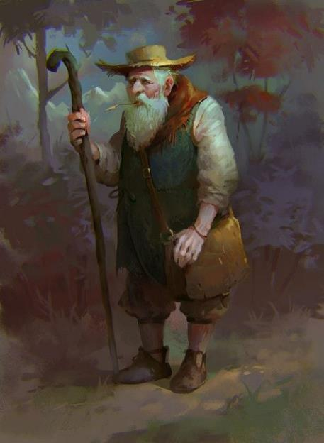

Though he sported visible emblems of Gond, he did not seem like the artificer type, and almost stood out of place among the other clergy they’d seen, who all had at least some mini-gadgets on their wrists or ankles.

Saradette nodded. << Good day, Sacerdôt, >> she said in Gnomish, and then she switched to Common. “My companion and I are here to apprehend a criminal who masquerades as a priest of Gond. Are you willing to help us? Quietly?”

|  |  |  |  |  |  |  |
| --- | --- | --- | --- | --- | --- | --- |
| **Skill** | **Rank** | **Ability & Mod.** | **Misc. Mods.** | **Total** | **Roll** | **Check** |
| **Saradette, Diplomacy** | 2 | **Cha (+0)** | 0 | 2 | 5ish | ?? |

*See below.*

The elder’s smile seemed to crumble into a wrinkled frown that re-scaped the contours of his face into what Saradette now interpreted as defensiveness and Tore couldn’t quite decipher. Tore nodded to the Sacerdôt and let Saradette do the talking. He was supposed to be her quiet assistant after all, so while Saradette talked, Tore looked around, looking for any passersby that might be paying them a bit too much attention.

The cleric spoke in his mother tongue, now cognizant that at least Saradette understood. << Young lady, how on Faerûn do you expect a stranger’s help out of hand, particularly dressed like a mainlander and walking around with a giant? >>

<< I assure you, he’s no giant, >> Saradette could only think to reply at the moment.

<< A figure of speech on the island, lass, >> Midoc fidgeted in his vest pocket and produced a monocle with which to better study the two before him. << No doubt, you are not Gondars, and likely just arrived in Lantan. Since you are here, you must at least know the protocols that govern my office, and that these prevent me from turning you away, as well as compelling me to report you to the authorities if you came with treasonous intentions. >>

And thus, Midoc introduced himself warily, and offered Saradette a seat on the gnome-sized bench. He didn’t know what to say to Tore, so he shrugged and said in Common, “Sorry we have no bigger benches.” He then invited Saradette to elaborate, and studied her gadgets with his prismatic monocle.

Tore simply smiled at Midoc. When the two gnomes sat, Tore found a spot where he could observe most of the approaches to their locations and sat with his legs crossed. He wanted to be close enough to hear the pair, but in a spot where he could observe their surroundings to minimize the chances of them being approached by someone unobserved.

Saradette held her tongue as to not offend the cleric, and instead spoke of her weaponry and gadgets for a few moments. When she could, she went back to the subject at hand. “I am in the City Guard of Mintar, located on the Lake of Steam. I am here in pursuit of a necromancer named Dromedar who attacked and nearly murdered a Sacerdôt of Gond, attempted to take over the local temple, and ultimately killed several people in the process. We captured him, but he escaped. That, Sir, is why I came to seek your help.” She stopped short of saying I hardly think that you’d want such a person walking among you.

<< Don’t suppose you have a badge, >> the gnome stayed in his own language for the moment, << or anything corroborating your claims, child, >> he asked without posing a question.

Saradette bowed her head slightly, and continued the conversation in Common, “I do have a badge.” She fished in her haversack and extracted it for him to see.

The cleric studied it as if to commit the entirety of the identifying contents to memory, then blinked as if he’d just done so. << Hm... >> he nonchalantly raised his eyebrows and then frowned. << And him? Who’s he to you *really*? >> the astute elder smirked and waited for the woman’s next words.

Tore watched as Saradette pulled out her badge. He opened his spell component pouch and pulled his badge up slightly as well, showing enough of it so that the gnome would know the badges were the same. He then continued to look around for any on lookers or anyone paying them a little too much attention.

<< He understand? >> asked Midoc.

Saradette shook her head truthfully.

“Alright,” said Midoc, turning to Tore momentarily as he switched back to Common. “How do you propose to undertake this investigation of yours?”

“Carefully,” was all Tore said.

“I agree,” Saradette said in Common. “If Dromedar is here, he has no doubt begun to worm in way into some key peoples’ confidence. We have not approached the local authorities for just that reason. So, Sacerdôt, if you know of someone you trust, and who is discreet, that would help us.”

“Well, young people, you seem like you’re guided by a moral compass. I wish you all well with your investigation,” the gentleman brushed off his hands before waving and making his way over to his broom to reprise his caretaking.

Saradette stood and walked over to him. “Excuse me, Sacerdôt, but is there someone you trust with whom we could speak next about this matter?”

“Eh?” asked the man now taking a break as if he’d been sweeping all along. “Oh, good day to you fine people!” he then greeted them with the same genuineness as earlier.

Saradette took a breath. “Oh, good day to you, Sacerdôt. Is there someone in the temple with whom I can speak?”

Tore gave the Sacerdôt a rather odd look. However, he let Saradette do the talking while he stepped to the side out of earshot and whispered as he cast *detect magic [expired in 8 minutes]*.

He then looked for magical auras on the Sacerdôt to determine if there was some kind of mind charm or if, perhaps, the Sacerdôt was a powerful illusion.

Their previous conversation seemed to unravel once again, with some deviations, though Saradette mentioned nothing suspicious and remained auspicious in her tone.

<< No doubt, you speak the tongue of the Elders? >> he then asked in Gnomish.

<< I do, yes, >> Saradette replied in Gnomish. << I must take my leave now. Good day, Sacerdôt. >>

She turned and walked out to the street, switching back to Common. “Okay, so let’s find the next temple.”

~*~

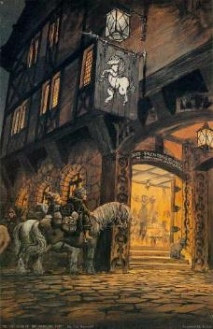

They walked back towards the central plaza for less than a minute and happened upon the Hornless Unicorn, a place they’d only passed before, though they hadn’t gotten a good look from their previous vantage point across the street. Now on the other side of the promenade, the two outlanders could tell that the place was in a bustle when someone opened the door to hiccup and stagger out of there. It was a male half-elf dressed like a woman but bearing the brow ridge, close shave, Adam’s apple, and stature of a man of his twain heritages. He looked at the two heroes for a moment, then laughed at some thought as he made way towards the coast, southward along the alley between the Hornless Unicorn and a cobbler’s establishment.

The door closed and the sound of the music inside was muffled enough for them to hear a flock of seagulls passing overhead, also making way for the coast after having a trash-pile meal a block away. The heroes took notice of the guttersnipes leaning and sitting against the wall outside the Unicorn and a few other establishments, as well as of passersby, some of which were robed and hooded. Saradette did her best to study the few descript features of anyone whose face she couldn’t see.

One rather attractive, young gnome wearing an apron and holding a chef’s hat ran by them looking like he was late for work, and kept on running towards the shrine where the heroes had just been.

They kept walking until she found another temple of Gond, taking one of the few as-of-yet unexplored streets and eventually found themselves between two alleys from which emerged one, then three, then five ne’er-do-wells. Saradette looked back towards the sound of the two behind her, and took a moment to assess the three females’ and two males’ likely skill in battle as they brandished weapons without speaking a word, executing an obviously premeditated attack.

*Unlike most map grids in this campaign, this grid is 10’ x 10’.*

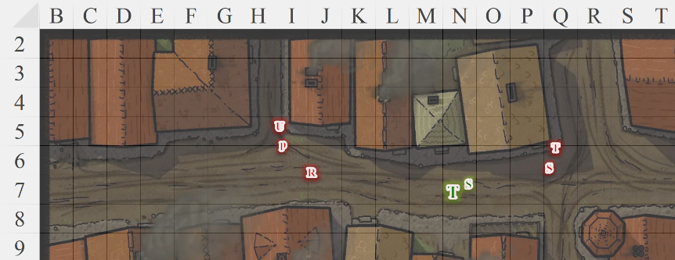

Round 1

|  |  |  |  |
| --- | --- | --- | --- |
| **Character** | **Initiative** | **Roll** | **Modified Roll** |
| Saradette | 3 | 14 | 17 |
| unidentified assailants | 2 | 10 | 12 |
| Tore | 2 | 7 | 9 |

Saradette drew and fired her sonic blaster at the nearest assailant. She then prepared to fire her electric glove next.

|  |  |  |  |
| --- | --- | --- | --- |
| **Ranged Weapon** | **Dmg.** | **Rng.** | **Notes** |
| Horizikaul’s Boom | 2d4 Sonic | 25’ + 2½’/lvl | Will DC 14 or deafened for 1d4 rounds |

*Dmg: 4 sonic.*

|  |  |  |  |  |
| --- | --- | --- | --- | --- |
| **Character** | **Save vs.**  *Horizikaul’s Boom* | **Ranks** | **Roll** | **Result** |
| Samber | Will | 3 | 3 | 6 |

*Fail. Samber was deafened.*

The man dressed in black put her hands to his hears, nearly dropping his hand crossbow, then shot a teeny bolt at Saradette.

|  |  |  |  |  |  |  |  |  |  |  |
| --- | --- | --- | --- | --- | --- | --- | --- | --- | --- | --- |
| **Character** | **Attack Type** | **Damage** | **BAB** | **Dex Mod+** | **W+** | **Total Score** | **Roll** | **Total** | **Crit** | **Threat** |
| Samber | Hand Crossbow +1 | 1d3+1 | 4 | 3 | 1 | 9 | **20** | 28 | 20 | þ |

*Threat. 1d20 = 1, not a critical hit. Dmg: 3 + 1 = 4 [49/53].*

A woman in a matching black assassin’s outfit also fired upon Saradette.

|  |  |  |  |  |  |  |  |  |  |
| --- | --- | --- | --- | --- | --- | --- | --- | --- | --- |
| **Character** | **Attack Type** | **Damage** | **BAB** | **Dex Mod+** | **W+** | **Other+** | **Total Score** | **Roll** | **Total** |
| Ravace | Light Crossbow +2 | 1d3+2 | 3 | 3 | 2 | 0 | 8 | 10 | 18 |

*Miss.*

Then another woman—this one clad in brown leather—fired upon Tore with a light crossbow.

|  |  |  |  |  |  |  |  |  |
| --- | --- | --- | --- | --- | --- | --- | --- | --- |
| **Character** | **Attack Type** | **Damage** | **BAB** | **Dex Mod+** | **W+** | **Total Score** | **Roll** | **Total** |
| Phaerilda | Light Crossbow +1 | 1d4+1 | 12 | 1 | 1 | 14 | 1 | 15 |

*Miss.*

The sorceress among the assailants cast *scorching ray* upon Tore.

|  |  |  |  |  |  |  |  |
| --- | --- | --- | --- | --- | --- | --- | --- |
| **Character** | **Attack Type** | **Damage** | **BAB** | **Dex Mod+** | **Total Score** | **Roll** | **Total** |
| Umbrasy | Touch Attack | 4d6 fire | 12 | 1 | 13 | 8 | 21 |

*Hit. Dmg: 15 fire [56/71].*

The last of the ruffians finished off their first round of offensives with a crossbow bolt aimed at Saradette’s heart.

|  |  |  |  |  |  |  |  |  |
| --- | --- | --- | --- | --- | --- | --- | --- | --- |
| **Character** | **Attack Type** | **Damage** | **BAB** | **Dex Mod+** | **W+** | **Total Score** | **Roll** | **Total** |
| Tibidoc | Light Crossbow +1 | 1d4+1 | 12 | 1 | 1 | 14 | 9 | 23 |

*Hit. Dmg: 2 + 1 = 3 [46/53].*

Tore quick-drew his sword and then charged Ravace, striking at her with his longsword ‘Frostbiter’!

|  |  |  |  |  |  |  |  |  |  |
| --- | --- | --- | --- | --- | --- | --- | --- | --- | --- |
| **Melee Weapon** | **Dmg** | **D+** | **TH+** | **Critical** | **Type** | **Wt.** | **Atk** | **Roll** | **Check** |
| Longsword of Frost | 1d8+1 | +1+1d6 Cold | 1 | 19-20/x2 | Slashing | 8.0 | +11 | 19 | 30 |

*Threat. 1d20 = 16 + 11 = 25, critical hit. Dmg: (2 x 2) + 1 + 1 + 4 cold = 6 + 4 cold = 10.*

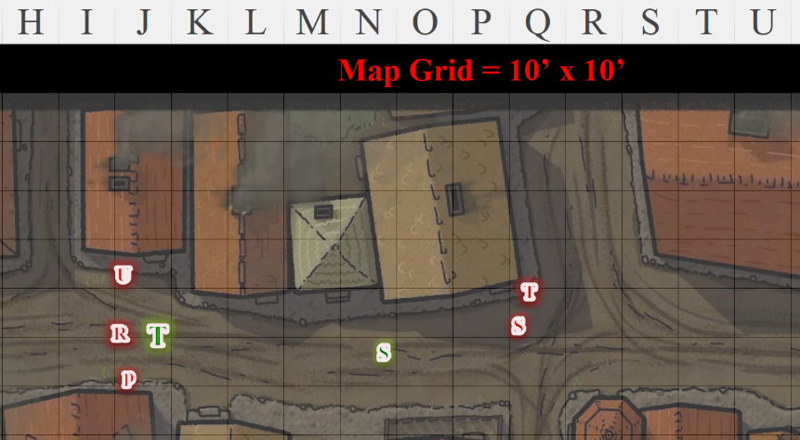

Round 2

Trying to cover the eastern front, Saradette zapped Samber with her glove. “Get that damned mage!” she barked at Tore. She dared not turn around, as that would offer Tore’s back to her assailants.

|  |  |  |  |  |  |  |
| --- | --- | --- | --- | --- | --- | --- |
| **Ranged Weapon** | | | **Dmg.** | | **Rng.** | **Notes** |
| Glove of Lightning Bolt | | | 5d6 Electric | | 120’ | Ref DC 16 for ½; melts most metals |
| **Character** | | **Save vs.**  *lightning bolt* | **Ranks** | | **Roll** | **Result** |
| Samber | | Reflex | 9 | | 20 | 29 |

*Success. Saved for ½ damage.*

*Dmg: ½ x 14 = 7 electric.*

And though he managed to dodge the core zap, the ninja’s kama’s blade and something in his vest pockets melted just a bit.

Ravace dropped his crossbow, drew his rapier, and swiped at Saradette.

|  |  |  |  |  |  |  |  |  |
| --- | --- | --- | --- | --- | --- | --- | --- | --- |
| **Character** | **Attack Type** | **Damage** | **BAB** | **Dex Mod+** | **W+** | **Total Score** | **Roll** | **Total** |
| Ravace | Rapier +1 | 1d4+1 | 3 | 3 | 1 | 7 | 10 | 17 |

*Miss.*

Samber did his best to shoot at the artificer with his damaged crossbow.

|  |  |  |  |  |  |  |  |  |
| --- | --- | --- | --- | --- | --- | --- | --- | --- |
| **Character** | **Attack Type** | **Damage** | **BAB** | **Dex Mod+** | **W+** | **Total Score** | **Roll** | **Total** |
| Samber | Hand Crossbow +1 | 1d3+1 | 4 | 3 | 1 – 2 damaged | 10 | 13 | 23 |

*Hit. Dmg: 1 + 1 = 2 [44/53].*

Phaerilda sneak-attacked Tore.

|  |  |  |  |  |  |  |  |
| --- | --- | --- | --- | --- | --- | --- | --- |
| **Character** | **Attack Type** | **Damage** | **BAB** | **W+** | **Total Score** | **Roll** | **Total** |
| Phaerilda | Poisoned Dagger +1 | 1d3+1 | 12 | 1 + 2 flank | 15 | 4 | 19 |

*Miss.*

Umbrasy cast *rainbow blast* upon Tore.

|  |  |  |  |  |  |  |
| --- | --- | --- | --- | --- | --- | --- |
| **Save vs.**  *rainbow blast* | **Rank** | **Ability & Mod.** | **Misc. Mods.** | **Total** | **Roll** | **Check** |
| **Reflex** | **3** | **Dex (+2)** | 0 | 5 | 3 | 8 |

*Fail. Dmg: 1 acid + 2 cold + 2 electric + 6 fire + 2 sonic = 13. Electric damage negated [45/71].*

Tibidoc cast *magic missile* upon Saradette.

*Dmg: 4 + 2 = 6 magic [38/53].*

Tore drew and swiftly activated his Barricade Buckler Shield, creating a 5’ x 5’ wall of force to his left as he moved to attack Umbrasy. And though he was careful to not give Umbrasy the opportunity to swipe at him, he was not able to prevent his other two assailants from doing so.

|  |  |  |  |  |  |  |  |  |  |  |
| --- | --- | --- | --- | --- | --- | --- | --- | --- | --- | --- |
| **Character** | **Attack Type** | **Damage** | **BAB** | **Dex Mod+** | **W+** | **Other+** | **Total Score** | **Roll** | **Total** | **Notes** |
| Ravace | Rapier +1 | 1d4+1 | 3 | 3 | 1 | 2 flank | 9 | 9 | 18 | Sneak +3d6 |

*Miss.*

As Ravace cursed his luck, Phaerilda stabbed at Tore.

|  |  |  |  |  |  |  |  |  |  |  |
| --- | --- | --- | --- | --- | --- | --- | --- | --- | --- | --- |
| **Character** | **Attack Type** | **Damage** | **BAB** | **Str Mod+** | **W+** | **Other+** | **Total Score** | **Roll** | **Total** | **Notes** |
| Phaerilda | Poisoned Dagger +1 | 1d3+1 | 12 | 0 | 1 | 2 flank | 15 | 1 | 16 | Sneak +4d6 |

*Miss.*

<< Go for the guts! >> Saradette heard Samber tell the others in Gnomish.

Tore had moved away from Ravace, and now moved in to attack Umbrasy slashing at the magic wielder with his longsword ‘Frostbiter.

|  |  |  |  |  |  |  |  |  |  |
| --- | --- | --- | --- | --- | --- | --- | --- | --- | --- |
| **Melee Weapon** | **Dmg** | **D+** | **TH+** | **Critical** | **Type** | **Wt.** | **Atk** | **Roll** | **Check** |
| Longsword of Frost | 1d8+1 | +1+1d6 Cold | 1 | 19-20/x2 | Slashing | 8.0 | +11 | 4 | 15 |

*Hit. Dmg: 4 + 1 + 1 + 2 cold = 6 + 2 cold = 8.*

He them moved away where he stood with his wall of force facing his 3 opponents.

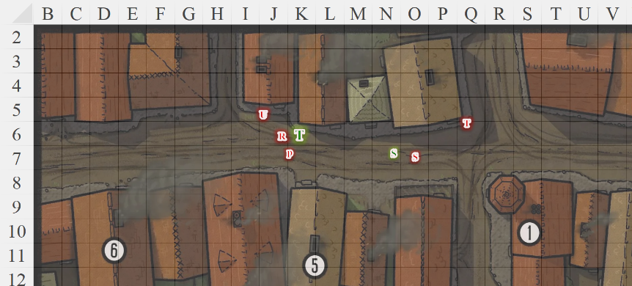

Round 3

Saradette ran about 15’ towards the wall corner, and then she zapped Samber again.

|  |  |  |  |  |
| --- | --- | --- | --- | --- |
| **Ranged Weapon** | | **Dmg.** | **Rng.** | **Notes** |
| Glove of Lightning Bolt | | 5d6 Electric | 120’ | Ref DC 16 for ½; melts most metals |
| **Character** | **Save vs.**  *lightning bolt* | **Ranks** | **Roll** | **Result** |
| Samber | Reflex | 9 | 17 | 26 |

*Success. Saved for ½ damage.*

*Dmg: ½ x 14 = 7 sonic.*

<< Slaglick! >> cursed Samber as the artificer’s electric bolt coursed through him.

Ravace slashed at Tore with his rapier.

|  |  |  |  |  |  |  |  |  |  |  |
| --- | --- | --- | --- | --- | --- | --- | --- | --- | --- | --- |
| **Character** | **Attack Type** | **Damage** | **BAB** | **Dex Mod+** | **W+** | **Other+** | **Total Score** | **Roll** | **Total** | **Notes** |
| Ravace | Rapier +1 | 1d4+1 | 3 | 3 | 1 | 2 flank | 9 | 5 | 14 | Sneak +3d6 |

*Miss.*

Samber fired another bolt from his hand crossbow and reloaded.

|  |  |  |  |  |  |  |  |  |  |
| --- | --- | --- | --- | --- | --- | --- | --- | --- | --- |
| **Character** | **Attack Type** | **Damage** | **BAB** | **Dex Mod+** | **W+** | **Total Score** | **Roll** | **Total** | **Notes** |
| Samber | Hand Crossbow +1 | 1d3+1 | 4 | 3 | 1 | 8 | 7 | 15 | Sudden Strike +4d6 |

*Miss.*

Phaerilda stabbed at Tore with her dagger.

|  |  |  |  |  |  |  |  |  |  |
| --- | --- | --- | --- | --- | --- | --- | --- | --- | --- |
| **Character** | **Attack Type** | **Damage** | **BAB** | **W+** | **Other+** | **Total Score** | **Roll** | **Total** | **Notes** |
| Phaerilda | Poisoned Dagger +1 | 1d3+1 | 6 | 1 | 2 flank | 9 | 14 | 23 | Sneak +4d6 |

*Hit. Dmg: 1 + 1 + 13 Sneak = 15 [30/71].*

|  |  |  |  |  |  |  |
| --- | --- | --- | --- | --- | --- | --- |
| **Save vs.**  Poison | **Rank** | **Ability & Mod.** | **Misc. Mods.** | **Total** | **Roll** | **Check** |
| **Fortitude** | **9** | **Con (+1)** | 1 | 11 | 12 | 23 |

*Success. Effect negated.*

Umbrasy threw a at dart at Tore.

|  |  |  |  |  |  |  |  |  |
| --- | --- | --- | --- | --- | --- | --- | --- | --- |
| **Character** | **Attack Type** | **Damage** | **BAB** | **Dex Mod+** | **W+** | **Total Score** | **Roll** | **Total** |
| Umbrasy | Poisoned Darts +1 | 1d3+1 | 6 | 1 | 1 | 8 | 18 | 26 |

*Hit. Dmg: 2 + 1 = 3 [27/71].*

Tibidoc fired upon Saradette with his light crossbow, then reloaded.

|  |  |  |  |  |  |  |  |  |
| --- | --- | --- | --- | --- | --- | --- | --- | --- |
| **Character** | **Attack Type** | **Damage** | **BAB** | **Dex Mod+** | **W+** | **Total Score** | **Roll** | **Total** |
| Tibidoc | Light Crossbow +1 | 1d4+1 | 5 | 1 | 1 | 7 | 19 | 26 |

*Hit. Dmg: 3 + 1 = 4 [34/53].*

Tore uttered the command word and his Hawkfeather Armor sprouted a set of wings. He then flew into the air, over Ravace and Phaerilda, but not before they could swipe at him.

|  |  |  |  |  |  |  |  |  |  |  |  |
| --- | --- | --- | --- | --- | --- | --- | --- | --- | --- | --- | --- |
| **Character** | **Attack Type** | **Damage** | **BAB** | **Str Mod+** | **Dex Mod+** | **W+** | **Other+** | **Total Score** | **Roll** | **Total** | **Notes** |
| Ravace | Rapier +1 | 1d4+1 | 3 | 1 | 3 | 1 | 2 flank | 9 | 19 | 28 | Sneak +3d6 |
| Phaerilda | Poisoned Dagger +1 | 1d3+1 | 6 | 0 | 1 | 1 | 2 flank | 9 | 2 | 11 | Sneak +4d6 |

*Hit, miss. Dmg: 1 + 1 + 11 Sneak = 13 [14/71].*

Landing next to Umbrasy, Tore then slashed at the magic wielder once again.

|  |  |  |  |  |  |  |  |  |  |
| --- | --- | --- | --- | --- | --- | --- | --- | --- | --- |
| **Melee Weapon** | **Dmg** | **D+** | **TH+** | **Critical** | **Type** | **Wt.** | **Atk** | **Roll** | **Check** |
| Longsword of Frost | 1d8+1 | +1+1d6 Cold | 1 | 19-20/x2 | Slashing | 8.0 | +11 | 3 | 14 |

*Miss.*

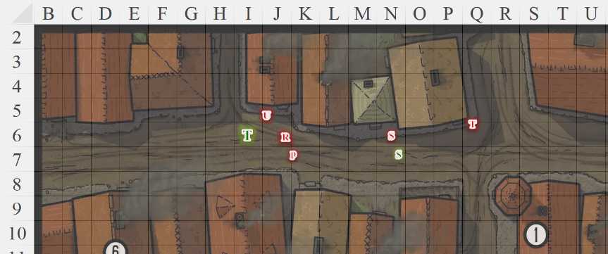

Round 4

A few citizens walked by, witnessed the fight, and fled back around the corner.

Saradette ran toward the wall and zapped Samber once again.

|  |  |  |  |  |
| --- | --- | --- | --- | --- |
| **Ranged Weapon** | | **Dmg.** | **Rng.** | **Notes** |
| Glove of Lightning Bolt | | 5d6 Electric | 120’ | Ref DC 16 for ½; melts most metals |
| **Character** | **Save vs.**  *lightning bolt* | **Ranks** | **Roll** | **Result** |
| Samber | Reflex | 9 | 18 | 27 |

*Success. Saved for ½ damage.*

*Dmg: ½ x 17 = 8 electric.*

Samber sizzled a little more.

Ravace charge-attacked Tore.

|  |  |  |  |  |  |  |  |  |  |  |
| --- | --- | --- | --- | --- | --- | --- | --- | --- | --- | --- |
| **Character** | **Attack Type** | **Damage** | **BAB** | **Dex Mod+** | **W+** | **Other+** | **Total Score** | **Roll** | **Total** | **Notes** |
| Ravace | Rapier +1 | 1d4+1 | 3 | 3 | 1 | 2 charge  2 flank | 11 | 5 | 16 | Sneak +3d6 |

*Miss.*

Samber dropped the crossbow and quick-drew his kama, swinging twice at Saradette.

|  |  |  |  |  |  |  |  |  |  |  |
| --- | --- | --- | --- | --- | --- | --- | --- | --- | --- | --- |
| **Character** | **Attack Type** | **Damage** | **BAB** | **Str Mod+** | **Dex Mod+** | **W+** | **Total Score** | **Roll** | **Total** | **Notes** |
| Samber | Kama +2 | 1d6+2 | 9 | 0 | 3 | 2 | 11 | 15 | 26 | Sudden Strike +4d6 |
| Samber | Kama, 2nd Attack | 1d6+2 | 4 | 0 | 3 | 2 | 6 | 7 | 13 | Sudden Strike +4d6 |

*Hit, miss. Dmg: 5 + 2 + 7 Sudden Strike = 14 [20/53].*

Phaerilda also stabbed at Tore with a charge.

|  |  |  |  |  |  |  |  |  |  |  |
| --- | --- | --- | --- | --- | --- | --- | --- | --- | --- | --- |
| **Character** | **Attack Type** | **Damage** | **BAB** | **Str Mod+** | **W+** | **Other+** | **Total Score** | **Roll** | **Total** | **Notes** |
| Phaerilda | Poisoned Dagger +1 | 1d3+1 | 6 | 0 | 1 | 2 charge  2 flank | 11 | 9 | 20 | Sneak +4d6 |

*Miss.*

Umbrasy cast *magic missile* upon Tore.

*Dmg: 6 + 2 = 8 magic [6/71].*

Tibidoc cursed a few taunts Saradette’s way, and shot her in the back.

|  |  |  |  |  |  |  |  |  |
| --- | --- | --- | --- | --- | --- | --- | --- | --- |
| **Character** | **Attack Type** | **Damage** | **BAB** | **Dex Mod+** | **W+** | **Total Score** | **Roll** | **Total** |
| Tibidoc | Light Crossbow +1 | 1d4+1 | 5 | 1 | 1 | 7 | 4 | 11 |

*Miss.*

Tore, feeling the effects of the hits he had taken, activated his Healing Belt of Priestly Might.

*Tore gained 21 hps [27/71].*

He then flew to the roof of one of the buildings to the southwest of his location. Ravace and Phaerilda swiped at him as he flew up.

|  |  |  |  |  |  |  |  |  |  |  |  |  |  |  |  |
| --- | --- | --- | --- | --- | --- | --- | --- | --- | --- | --- | --- | --- | --- | --- | --- |
| **Character** | **Attack Type** | **Damage** | | **BAB** | | **Dex Mod+** | | **W+** | **Other+** | **Total Score** | **Roll** | | **Total** | | **Notes** |
| Ravace | Rapier +1 | 1d4+1 | | 3 | | 3 | | 1 | 2 flank | 9 | 11 | | 20 | | Sneak +3d6 |
| **Character** | **Attack Type** | | **Damage** | | **BAB** | | **Str Mod+** | | **W+** | **Other+** | **Total Score** | **Roll** | | **Total** | **Notes** |
| Phaerilda | Poisoned Dagger +1 | | 1d3+1 | | 6 | | 0 | | 1 | 2 flank | 9 | 7 | | 16 | Sneak +4d6 |

*Miss, miss.*

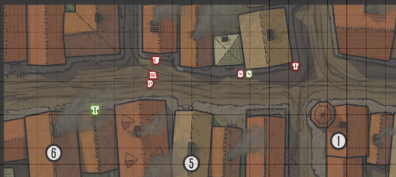

Round 5

Saradette, now being trapped with her back against the wall, zapped Samber once again, cursing softly as the man seemed to dodge the worst of the damage she was putting out.

|  |  |  |  |  |  |  |
| --- | --- | --- | --- | --- | --- | --- |
| **Ranged Weapon** | | | **Dmg.** | | **Rng.** | **Notes** |
| Glove of Lightning Bolt | | | 5d6 Electric | | 120’ | Ref DC 16 for ½; melts most metals |
| **Character** | | **Save vs.**  *lightning bolt* | **Ranks** | | **Roll** | **Result** |
| Samber | | Reflex | 9 | | 2 | 11 |

*Fail. Dmg: 21 electric.*

Samber fell flat onto his face, and passed out.

Ravace turned to face Saradette, running towards her to get in a good charge in a moment, then ghost stepped into his *invisible* mode.

Phaerilda grabbed her crossbow once again, and loaded it, keeping an eye on Tore.

Umbrasy threw a dart at Tore.

|  |  |  |  |  |  |  |  |  |
| --- | --- | --- | --- | --- | --- | --- | --- | --- |
| **Character** | **Attack Type** | **Damage** | **BAB** | **Dex Mod+** | **W+** | **Total Score** | **Roll** | **Total** |
| Umbrasy | Poisoned Darts +1 | 1d3+1 | 6 | 1 | 1 – 2 height | 6 | 7 | 13 |

*Miss.*

Tibidoc fired upon Saradette.

|  |  |  |  |  |  |  |  |  |
| --- | --- | --- | --- | --- | --- | --- | --- | --- |
| **Character** | **Attack Type** | **Damage** | **BAB** | **Dex Mod+** | **W+** | **Total Score** | **Roll** | **Total** |
| Tibidoc | Light Crossbow +1 | 1d4+1 | 5 | 1 | 1 | 7 | 15 | 22 |

*Hit. 1 + 1 = 2 [18/53].*

Tore sheathed his sword and put away his shield.

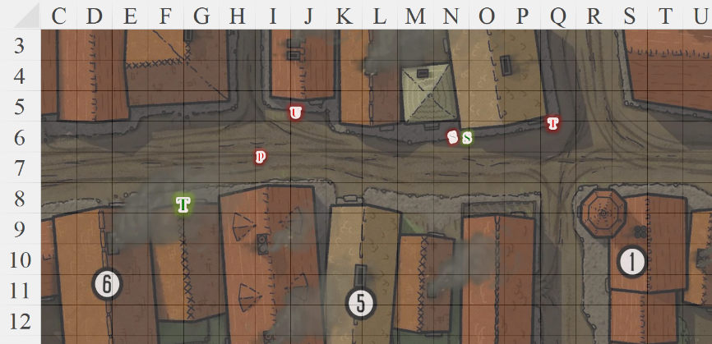

Round 6

Saradette activated her dimension stride boots, seeking to teleport herself onto the rooftop behind Tore. However, she misjudged the distance, and although she’d used up all of the charges in the boots, she landed about 10’ short of her mark, and had to grab onto the rooftop of the building adjacent to where Tore now perched.

|  |  |  |  |  |  |  |
| --- | --- | --- | --- | --- | --- | --- |
| **Save to**  catch oneself | **Rank** | **Ability & Mod.** | **Misc. Mods.** | **Total** | **Roll** | **Check** |
| **Saradette, Reflex** | **8** | **Dex (+3)** | 2 | 13 | 10 | 23 |

*Success.*

|  |  |  |  |  |  |  |
| --- | --- | --- | --- | --- | --- | --- |
| **Skill** | **Rank** | **Ability & Mod.** | **Misc. Mods.** | **Total** | **Roll** | **Check** |
| **Saradette, Climb** | 6 | **Str (-1)** | 0 | 5 | 7 | 12 |

*Fail.*

Saradette hung on to the edge of the rooftop, now vulnerable to ranged attacks to her back.

Invisible, Ravace put away his rapier and smiled as he drew his crossbow preparing to fire a poisoned arrow into Saradette’s back.

Phaerilda fired her crossbow upon Tore.

|  |  |  |  |  |  |  |  |  |  |
| --- | --- | --- | --- | --- | --- | --- | --- | --- | --- |
| **Character** | **Attack Type** | **Damage** | **BAB** | **Dex Mod+** | **W+** | **Other+** | **Total Score** | **Roll** | **Total** |
| Phaerilda | Light Crossbow +1 | 1d4+1 | 6 | 1 | 1 | -2 height | 6 | 1 | 7 |

*Miss.*

Umbrasy got closer to Tore, and hurled a dart at him.

|  |  |  |  |  |  |  |  |  |  |
| --- | --- | --- | --- | --- | --- | --- | --- | --- | --- |
| **Character** | **Attack Type** | **Damage** | **BAB** | **Dex Mod+** | **W+** | **Other+** | **Total Score** | **Roll** | **Total** |
| Umbrasy | Poisoned Darts +1 | 1d3+1 | 6 | 1 | 1 | -2 height | 6 | 9 | 15 |

*Miss.*

Tibidoc was at a loss to do anything other than to reload and fire once again at the defenseless artificer.

|  |  |  |  |  |  |  |  |  |  |
| --- | --- | --- | --- | --- | --- | --- | --- | --- | --- |
| **Character** | **Attack Type** | **Damage** | **BAB** | **Dex Mod+** | **W+** | **Other+** | **Total Score** | **Roll** | **Total** |
| Tibidoc | Light Crossbow +1 | 1d4+1 | 5 | 1 | 1 | -2 flank | 5 | 3 | 8 |

*Miss.*

Tore drew his bow and began firing at Umbrasy.

|  |  |  |  |  |  |  |  |  |  |
| --- | --- | --- | --- | --- | --- | --- | --- | --- | --- |
| **Ranged Weapon** | **Dmg.** | **D+** | **TH+** | **Critical** | **Rng.** | **Wt.** | **Atk** | **Roll** | **Check** |
| Longbow +1 | 1d8 | 1 | 1 + 2 height | x3 | 100’ | 3.0 | +14 | 4 | 18 |

*Hit. Dmg: 6 + 1 = 7.*

Umbrasy was visibly mortally wounded, but was still a threat. She would likely pull the arrow out and drink a potion to cure herself if given the chance, so Tore kept her in his crosshairs as he prepared to fire his next few arrows at her.

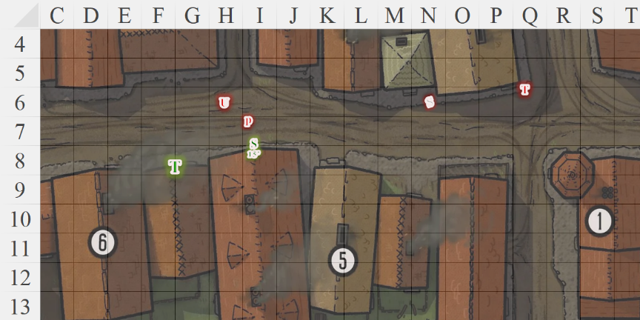

Round 7

Saradette tried to climb onto the roof.

|  |  |  |  |  |  |  |
| --- | --- | --- | --- | --- | --- | --- |
| **Skill** | **Rank** | **Ability & Mod.** | **Misc. Mods.** | **Total** | **Roll** | **Check** |
| **Saradette, Climb** | 6 | **Str (-1)** | 0 | 5 | 3 | 8 |

*Fail.*

Ravace shot Saradette in the back as she hung onto the ledge.

|  |  |  |  |  |  |  |  |  |  |  |
| --- | --- | --- | --- | --- | --- | --- | --- | --- | --- | --- |
| **Character** | **Attack Type** | **Damage** | **BAB** | **Dex Mod+** | **W+** | **Other+** | **Total Score** | **Roll** | **Total** | **Notes** |
| Ravace | Light Crossbow +2 | 1d3+2 | 9 | 3 | 2 | -2 height | 12 | 13 | 25 | Sneak +3d6 |

*Hit. Dmg: 2 + 2 + 8 Sneak = 12 [****6****/53].*

Phaerilda smiled and complimented Ravace on the cheap shot to the kidney as she also took a potshot at Saradette.

|  |  |  |  |  |  |  |  |  |  |  |
| --- | --- | --- | --- | --- | --- | --- | --- | --- | --- | --- |
| **Character** | **Attack Type** | **Damage** | **BAB** | **Dex Mod+** | **W+** | **Other+** | **Total Score** | **Roll** | **Total** | **Notes** |
| Phaerilda | Light Crossbow +1 | 1d4+1 | 6 | 1 | 1 | -2 height | 6 | 11 | 17 | Sneak +4d6 |

*Hit. Dmg: 2 + 1 + 13 Sneak [****-7****/53].*

Umbrasy emitted an expression of elation in her language as Saradette fell to the ground.

*Dmg: 1 [****-8****/53].*

Tibidoc rushed westward to join his friends, pointing his crossbow at Tore.

Tore was torn and unsure what to do to help Saradette, so he opted to focus on the threats still there. He fired off two arrows at Umbrasy, hoping to bring the gnome down.

|  |  |  |  |  |  |  |  |  |  |
| --- | --- | --- | --- | --- | --- | --- | --- | --- | --- |
| **Ranged Weapon** | **Dmg.** | **D+** | **TH+** | **Critical** | **Rng.** | **Wt.** | **Atk** | **Roll** | **Check** |
| Longbow +1 | 1d8 | 1 | 1 + 2 height | x3 | 100’ | 3.0 | +14 | 15 | 29 |
| Longbow, 2nd Shot | 1d8 | 1 | 1 + 2 height | x3 | 100’ | - | +9 | 13 | 22 |

*Hit, hit. Dmg: (3 + 1) + (7 + 1) = 4 + 8 = 12.*

Umbrasy took the first shot without much ado, but the second one got her right in her throat, and took her down.

Tibidoc witnessed the killing of his lover, and raged, aiming carefully to ensure a clean kill.

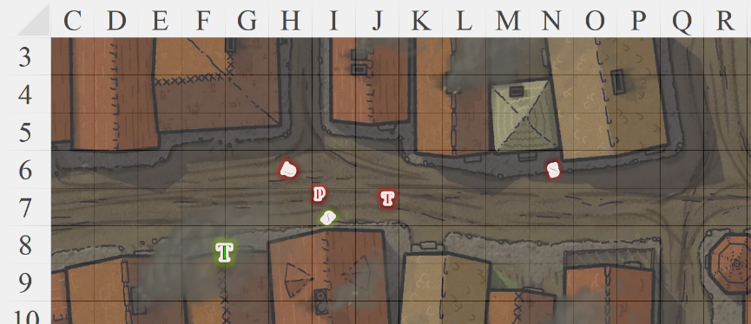

Round 8

Ravace *[greater invisibility]*, Phaerilda, and Tibidoc wasted no time in finishing what they’d been tasked with.

|  |  |  |  |  |  |  |  |  |  |  |
| --- | --- | --- | --- | --- | --- | --- | --- | --- | --- | --- |
| **Character** | **Attack Type** | **Damage** | **BAB** | **Dex Mod+** | **W+** | **Other+** | **Total**  **Score** | **Roll** | **Total** | **Notes** |
| Ravace | Light Crossbow +2 | 1d3+2 | 9 | 3 | 2 | -2 height | 12 | 14 | 26 | Sneak +3d6 |
| Phaerilda | Light Crossbow +1 | 1d4+1 | 6 | 1 | 1 | -2 height | 6 | 6 | 12 | Sneak +4d6 |
| Tibidoc | Light Crossbow +1 | 1d4+1 | 5 | 1 | 1 | -2 height | 5 | 15 | 20 |  |

*Hit, miss, miss. Dmg: 2 + 2 + 13 Sneak = 17 [****10****/71].*

Tore cast *sanctuary [expired on Round 16]* to protect—not conceal—himself from the others. He then flew down and landed near Saradette.

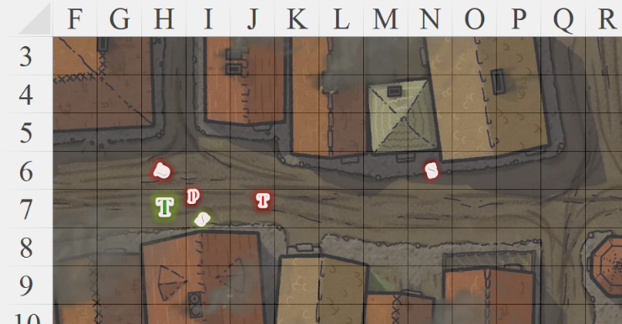

Round 9

“Take down the twiceling!” the invisible gnome told the others.

|  |  |  |  |  |
| --- | --- | --- | --- | --- |
| **Character** | **Save vs.**  *sanctuary* | **Ranks** | **Roll** | **Result** |
| Ravace | Will | 3 | 8 | 11 |
| Phaerilda | Will | 2 | 14 | 16 |
| Tibidoc | Will | 4 | 8 | 12 |

*Fail, success, fail.*

“I can’t!” complained Tibidoc. “Aw, fudge!”

“*I* can,” Phaerilda said as she cast *deep slumber [expired on Round 88]* on Tore.

|  |  |  |  |  |
| --- | --- | --- | --- | --- |
| **Character** | **Check** | **Ranks** | **Roll** | **Result** |
| Phaerilda | Use Magic Device | 9 | 14 | 23 |

*Success.*

|  |  |  |  |  |  |  |
| --- | --- | --- | --- | --- | --- | --- |
| **Save vs.**  *deep slumber* | **Rank** | **Ability & Mod.** | **Misc. Mods.** | **Total** | **Roll** | **Check** |
| **Tore, Will** | **6** | **Wis (+2)** | 0 | 8 | 4 | 12 |

*Fail.*

All went dark around Tore, and the ground rushed up to meet him.