*Chapter 36: A Web of Quests*

Tore awoke a bit sore, and still wounded from the fight in the street. The four stone walls of a candlelit room enveloped them, and the faint smell of cooked flesh insinuated that they would soon be served lunch, or perhaps be served as lunch. He was tied to a chair large enough for the largest of humans, and noted that the ceiling’s height was more human-appropriate than what they’d seen thus far in Lantan. His mouth was gagged, and his hands were clapped in manacles such that he could not emit words or invoke the somatic gesticulations that triggered any of his remaining spells. His armor had been mostly removed, and his weapons and gear were nowhere in sight.

The cleric of Lurue could not see the *arcane eye* that stared perpetually at him from above, but as he turned his head to take in the faintest clues as to where he was, he was certainly being watched, and it did not take long for the door behind him to open as his eyes focused and his consciousness steeled in anticipation of some interrogation.

Two gnomes entered, dressed in black robes. One was the rogue that had put him to sleep, and the other was a man whose face Tore hadn’t seen before. They studied him for a moment before Umbrasy spoke. “Thirsty?”

He tried to take an inventory of the room, looking for anything that he could use as a weapon should he manage to get free. He doubted there was anything though, and saw nothing in the bare room with the single candle sticking up from a bolted-in sconce. When they entered and asked if he wanted water, he nodded ‘yes’.

A third gnome—an adolescent male—came in and brought a wooden cup of water, holding it to Tore’s lips for him to drink.

When they took the gag out, Tore looked at the one that seemed to be in charge. “Where is my friend?” he asked, annoyance in his voice.

“We’re minding after her, lad,” the gnomish rogue replied before asking again if he wanted to drink or if he just wanted to skip straight to the parley. “She’ll be right around in a bit.”

He drank a swig of lukewarm water before Umbrasy spoke again, “You came all the way from Mintar, and we’re aware that you’re acting under the authority of their government. We will be in a position to extract information out of your head in the next day or so; you can help yourself by offering up what we want to know now. It’ll be a far more painless option,” she said as the squeak of two wheels could be heard behind him coming through the door.

“And if I don’t?” asked Tore.

Another stranger wheeled Saradette’s body—bound and semiconscious—around so Tore could see her propped up on a dolly-like gurney for anyone to abuse or scrutinize. She had notable bags under her eyes, and a lump on the left side of her neck. She—too—was without weapons and armor, and looked debilitated and haggard.

Tore stared at Umbrasy, “Too bad I didn’t get to kill a couple more of your friends you filthy cowards.”

The gag from Saradette’s mouth was removed, but she did not immediately seek to speak. Instead, Umbrasy explained. “You took the life of one of my friends, and nearly killed *me*! That may go over well in Mintar, but ‘round these parts,” she changed her accent to sound like a human mainlander, “we take an eye for an eye.”

Tore pointed out, “So knocking me unconscious is the equivalent of knocking you unconscious.”

“Call us square on that; sure,” shrugged Umbrasy. “But the matter of a dead friend remains to be resolved, and Saradette here has been so helpful so far....”

There was a tense moment in the air as Umbrasy chose her phrasing. “You... are a mine of spell components waiting to be reaped. Why... your prostate alone could yield me a good hundred coins. But alas, the Master wishes you both whole, at least for now, and so, just as we’ve done with your girlfriend here,” Umbrasy pointed to Saradette’s neck, “we’re going to implant a necrotic cyst-and-tumor system into you as well.” She smiled a sarcastically innocent grin, standing on her tiptoes twice to emulate enthusiasm.

Saradette had no idea what such a thing was, and could scarcely remember the hours that it had taken to infuse such an ill fate into her body; Tore, on the other hand, was all too familiar with necrotic cysts, and per his understanding, there had to be a spellcaster with a *mother cyst* that had just performed the necromantic surgery on her while he was held here. It had to have been the better part of a day, if not more, if the cyst and tumor had already been implanted.

Saradette’s eyes flirted back and forth with the zigzagging motion indicative of someone whose mental faculties had been compromised, but who still held to some remnant of self-awareness.

A few moments passed during which no one said anything informative; just slurs and taunts back and forth, and then Umbrasy’s posture straightened as she heard a distinctive crescendo of footsteps with the definitive tap of a cane to aid the left side of the body to ambulate.

“Ah, it is time,” Umbrasy said, smiling and taking a few steps back as a human stepped inside room with the ample ceiling and made his way in to study Tore’s face. Saradette recognized him as Who, and then remembered what he’d been doing to her for the last few hours or months—she couldn’t reckon the time it had taken for him to abuse her. She sighed involuntarily as hope seemed to abandon them in this dismal corner of the multiverse, and Tore could see the resignation in her sullen eyes.

Who asked questions of his acolytes, and from these Tore gathered that the necromancer had cast a *lesser* form of *necrotic tumor*, noting that it had taken him hours—not seconds—to manifest. The cleric of Lurue inferred from a portion of the necromancer’s questioning that referenced “during the procedure” that this had taken at least a span of time covering his assistants’ lunch and dinner, and though it was impossible to tell what time of day or night it was in this candlelit, stone-walled chamber, his parched condition confirmed that the date had changed since their capture.

“Well, stranger,” Who turned to Tore. “I can’t say I recognize you, though if you’re cavorting with the likes of this one...” he gestured to Saradette, “... you are squarely in my field of attention.”

Tore took another sip of the cup of water that the servant lifted and offered.

Who continued, “... and, as such, you will divulge everything you know, either with your tongue, or after I cut it out and seek the services of a diviner.” He was wordy in his inquisition, but basically wanted to confirm things that Saradette could not recall saying. Tore contemplated the questions:

* Who sent you? *[Truthful answer is Captain Slatestein of the Mintari Municipal Guard.]*
* Who else is here aiding you? *[Truthful answer is Re’ka.]*
* Why are a cleric of Lurue and an agnostic artificer motivated to undertake this investigation against Who?
* What is the role of the Gondar Temple in Waterdeep in this campaign against him? *[Truthful answer is something around preserving the authenticity and legitimacy of Gondar teachings contrasted against Dromedar’s hubristic interpretations.]*

Tore sat silently for a moment then replied. “We were sent by the government of Mintar and their Municipal guard. There is nobody here aiding us, we booked passage on the Jifrinson Airbus. My association with Saradette is one of common goals, ridding the world of pieces of shit like you. As for the temple of Gondar in Waterdeep, go ask them yourself.”

|  |  |  |  |  |  |  |
| --- | --- | --- | --- | --- | --- | --- |
| **Skill** | **Rank** | **Ability**  **& Mod.** | **Misc. Mods.** | **Total** | **Roll** | **Check** |
| **Tore, Bluff** | 0 | **Cha (+2)** | 0 | 2 | 15ish | ?? |

*Result unknown.*

Tore could not tell if they’d bought the part about working alone.

“Allow me to translate,” Saradette rasped in a thready whisper, speaking in Common. She switched to Gnomish. << Fuck off! >> She slumped as even that effort was almost too much for her, but she took another breath and opened her eyes again.

Umbrasy acted surprised and endeared as she opened her mouth and overly dramatized, << Awwww, look, she’s taaalking almost like... an adult! >>

Others mimed her feigned endearment to the newborn cyst and its defiant hostess. They went on for a few more seconds before Who spoke again. He was robed in his usual drab attire, though this time they could see with more detail the repertoire of accoutrements he had, and although they could not identify every article of jewelry and accessory, they could tell that Who was clad and equipped like a villain of ample prowess.

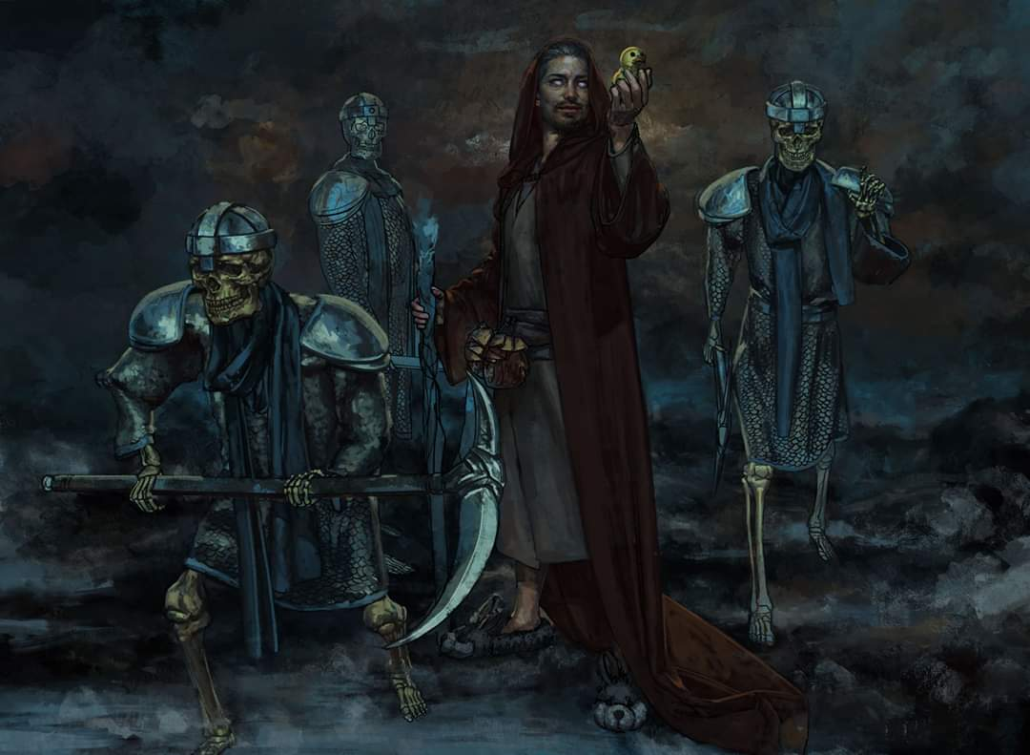

A pair of skeletal minions entered the room, awaiting the true necromancer’s next commands. Who said, “Take this one into the infusion chamber.”

And as commanded, the two chainmail-clad and helmeted skeletons picked up the chair atop which Tore was sitting, and carried it through the door, with one skeleton stepping through first, and then the man in the chair, followed by the other skeleton.

They disappeared around the corner, leaving Umbrasy to toy with Saradette, taking a dagger to poke the cyst on her neck.

“Stop that!” Who commanded her, and she quickly flinched her dagger hand away.

“My apologies, Master!” she whimpered, likely bearing a cyst on her person herself.

Who approached the artificer on the gurney, and asked, “Once you are released, you will be compelled to do my bidding. Insofar as you stray from my will, your body and mind—perhaps even your eternal soul—will surely suffer.”

Saradette could only partly understand what was being imparted on her as she could hear Tore shout in protest down the hall.

“You will eventually be free to return to Mintar, but before you do, you will do something to make up for the inconvenience you’ve caused me,” Who smiled as he motioned to his gnome subordinates to release her once he was certain that his mother cyst would control her necrotic cyst, which would—in turn—control Saradette where it most mattered.

She became increasingly aware as the bonds around her wrists and ankles loosened that she was not only weakened and a bit shaky, but she was unable to muster any resolve to harm Who and his associates, or even to flee.

Who nodded to the male gnome who had brought in Saradette’s gurney, and simply said, “Norbert?”

Norbert nodded back and produced a palm-sized paper, which he then handed to Saradette. “This address is in the Textiles Quarter,” he simply said, then backed away a few feet.

Who continued, “Go there now. You’ll be approached by a woman named Melsany, who will hand you a similar parchment with further instructions. Stray and sufffferrrr...” his voice trailed off as if it were the verbal component that triggered a spell effect.

Saradette could not remember taking the paper in her hand, but there it was, and she now looked at it, reading: 1298½ Bersax Street, Textiles Quarter, Sambar.

Saradette simply nodded, wishing only to leave Who’s presence, insofar as the compulsion would allow.

~*~

Her mind was still a bit fuzzy and airy, and although she was always able to see well at night, she now also beheld the scenery around her with an added layer of infrared vision that became more prominent as she traversed the unlit sections of the city. She passed by a clutch of indigent gnomes around a campfire next to two human-sized tents that likely housed them all. She noted that they were all looking at her with a measure of contempt, their sneering faces illuminated by the flickering flames that kept them warm on a night that should have been warmer than it was, given summer’s approach on this tropical island. Perhaps it wasn’t the warmth they sought in the fire, but the light and camaraderie.

She continued, asking twice for directions, and finally reaching 1298½ Bersax Street. Melsany found the lump-in-her-neck-having artificer with no difficulty, and ushered her down a path of narrow alleyways until they reached a small, nondescript door that Melsany opened, and entered. “Come on,” she urged Saradette.

Saradette entered the studio, which had been partitioned with a plainly fashioned front entryway and a back room wholly devoted to necromancy and the worship of Velsharoon. Two other women were inside, and were already facing Saradette when she came into the back room through the entryway.

<< This is her? >> asked the one named Avilda while the one named Charissa studied the newcomer, taking into her hands a few parchments from the table at which they sat.

<< Aye, >> Melsany said. << An artificer from the mainland... come to kill the Master. >>

<< How original! >> Charissa said with sarcasm. She and Avilda looked at one another as they got up from the table in the corner of the room, careful to walk around the chalk circle with the pentagram in it. Charissa reached Saradette, inhaled the scent of undeath on her, satisfied her sense of self-preservation, and sighed before handing the papers to Saradette one by one, saying, << This fine gentleman goes by the moniker Viscount Jarles III. >> The first parchment had a magically rendered image of a male shade’s bust. << He is reputed to be staying here tonight, >> the next parchment had an address, and some intel with tactically important details, such as the Viscount’s most frequented locales, his associates, and most importantly, his bodyguard: a changeling usually fronting as a courtesan.

<< You are to slay him ultraclean, >> Avilda now spoke, referring to a one-shot-one-kill order. << Should your target survive the first strike, you *will* take him down by any means necessary, but to ensure that you don’t face any complications, this here is loaded with a poison-tipped bolt that will incapacitate muscle tissue instantly as it works its way to the brain. >>

Saradette took a magnificent-looking hand crossbow—indeed loaded with a green coated bolt—and noted its arcane craftsmanship.

<< Don’t break it, >> one of the male gnomes said, seemingly possessive over it.

<< Okie-dokie! >> Melsany spoke again, << Come along now; I’ll take you part of the way to where he was last spotted. >>

With no fancy greetings or well wishes, one gnome led another—both compliant with Who’s will—and within ten minutes or so, Melsany had taken Saradette to a far less seedy section of Sambar. There were few temples here—and those she passed were larger and grander than the missions she’d seen before. Well-groomed storefronts and residential blocks appeared to be singularly suited to gnomes and other wee folk, and the miniscule proportions made Saradette feel at home more than before.

~*~

Tore found himself in a labyrinth, coursing through stone walls that were seemingly clones of one another, arranged in senseless ways such that four right turns did not constitute a full circle or square, but led to a completely different part of his confusion. Pain occasionally jolted his left side as an invisible auger plunged itself into him repeatedly, infusing him with despair and self-contempt.

~*~

Melsany studied the immediate place and situation, ensuring that no one—not even a straggler—could hear her. << The establishment called The S’rpent’s Musings is just a few blocks up the street. He has been seen in the residential space above the shop, which can be accessed via a staircase along the back of the building, but a guard is almost always posted there. >>

Saradette looked down the street as Melsany continued, << He may actually be downstairs dining or discussing business by now, so you may get lucky and catch him there. When you’ve completed the job, come back here, and wait behind that bin in case you were followed. I’ll pass by every hour or so to look for you. You have until noon tomorrow to complete this mission. >>

And with this, Melsany took her leave southward.

Saradette waited until the woman was out of sight, and then she sank down to sit on her backside on the street. She would not commit murder, that much she knew. No matter who the man was, no matter what would happen to her or even to Tore, she would not kill another person at Who’s command. She closed her eyes and prayed to Mayaheine. “Help me to resist this, Shieldmaiden,” she concluded. The artificer, stood, wiped her face with her sleeve, and started toward the address she was given, since she certainly was being watched.

Along the way, she looked at herself to see how she was dressed and what she had with her, and if any of it was hers. She was indeed clad in her own clothing and armor, but lacked her weapons and gear, save for her belt pouch and spell components. All of her gadgets were in Who’s possessions, and all she had was a hand crossbow, 10 poisoned bolts (one loaded, and a poisoned dagger that had also been given to her.

The lump in her neck began to hurt, and she could taste blood in her mouth now.

~*~

The word “no” seemed to have been all that constituted Tore’s vocabulary as he wrested himself free from some agonizing compactor of thorns and thistles, and now that he awoke and realized that at least part of that had been a dream, the cleric realized just how grim the situation had become. He was in a gruesomely decorated and outfitted laboratory, and had just had a nice tumor implanted within an even nicer necrotic cyst, such that he would now be as compelled to comply with Who’s intentions as Saradette. Tore closed his eyes and did his best to ignore the pain as he prayed to Lurue for the strength to resist and overcome the necromantic magic.

He continued praying to Lurue silently. “Lurue, spare me from this pain and protect me from these foul beings so the I can avenge myself on them in your name,” he repeated over and over in his mind.

~*~

Saradette had passed out, and was now standing over the corpse of a fellow gnome whose blood trickled from his neck and Saradette’s mouth and chin. It tasted like milk to her, and she inadvertently found herself going back for more, this time lunging for the jugular to get a nice flow as the night continued. She had dragged the body into a dark alley too narrow for a heavyset human, and no one had passed by since. Midnight took its toll as a bell tolled twelve times in the distance. By the time the last resounding gong subsided, Saradette was off again towards the target’s last known location, unable to resist the *geas*-like compulsion effects of the tumor within her.

Saradette’s mind was a cacophony of thoughts and emotions as she struggled against the compulsion. She was now a murderer, and the thought revolted her. Worse, she was drinking blood like some feral animal. She had killed someone that wasn’t even her target, and who probably wasn’t even a threat. She had to end this madness now; she would not, could not, allow her body to be used in this manner. She plucked the poisoned bolt from her hand crossbow, pressed the tip to the place on her neck containing the tumor, and shoved the tip into it as hard as she could.

~*~

“Reeee’kaaaa,” the words escaped the cleric’s lips as he divulged the name of his accomplice on the island, followed by the location of their safehouse.

“Good,” smiled Who. “*You* have done *well*! And for that, I’m going to reward you with an easier task than your sister had.” The necromancer exposed the bound cleric’s face to an inhalant that nearly instantly brought him to cognizance if not full consciousness.

“Fiend,” Tore pronounced the word that had been on the tip of his tongue for what seemed like an existence.

“Not quite,” admitted the true necromancer. “Though I do break bread with them on occasion, mostly for the spirits they bring to drink.”

One of the assistants was busying himself with some beakers and scrolls as his human master continued to study Tore’s sullen face. “Relax, Tore Stoneblood of Neverwinter. You, your gnomish sister, your friends in Mintar, your entire family back home, will all fall to Velsharoon’s will in time, and that time is nigh. And I—Who, the Bone Whisperer—shall be among the participants in making it so, and with the blood of my offenders shall I cleanse the land of the heathen that it might be fit for the adorers of the Vaunted. Undo his bonds, Norbert.”

Tore used this time to strategize an exit plan in the event that he could retain his will when he was unbound. Who proclaimed other grandiose forecasts of his impending victory, and then got to the point. “There’s a nice lady named Surla SeMilderic. She has stolen something of mine: a scepter with a fist-sized skull at one end, and a silver blade at the other. I fear she will fence it if I don’t recover it with haste, and it has great sentimental value to me, so I need you to go here,” he handed Tore the parchment and Tore’s unbound right hand promptly took it.

“Good man,” said Who. “Norbert will see you part of the way there. When you’ve recovered the scepter, bring it back here, and ensure that you’re not followed. It’s important that you’re not spotted; otherwise, you’ll have to kill anyone who could identify you. To help you along, we’ll outfit you in a comfortable black, hooded robe.”

~*~

Saradette could not recall how she’d returned to Who’s safehouse, but there she was just before sunrise. She had relinquished the weapons given to her, and now stood almost naked listening to Who bringing up old shit. “You’ve done our cause a service this night, new Child of the Darkness, and will consequently be rewarded.” He went on to describe the onset of a condition that was even now befalling her in which she would gradually assume the properties of a gravetouched ghoul, and congratulated her on such a quick ascension along the undead hierarchy.

It was then that footsteps approached and Tore was led in by the two chainmail-wearing skeletal minions. “Ah, you’ve recovered my scepter, and not a drop of blood on you. Good show!” The necromancer took the scepter from the human’s hands, and gave him a sniff of the wide-eyed spritz that had awoken Saradette recently.

“And now we will-” Who’s smile faded as the sound of unexpected sounds coming from the main entrance where Tore had just been. The definitive sound of a gnome squealing with pain as he died alerted Who and the others to an intrusion.

Round 1

Who cast *summon undead IV [expired on Round 12]*, conjuring a ghast in the doorway that then charged towards the main entrance down the hallway, and out of sight.

The two skeletal guards turned to follow after the ghast.

The gnomish acolytes and sycophants drew their weapons, and prepared to fend off the intruders.

“Umbrasy!” Who commanded her with only her name, and the rogue took a rickety staircase upwards, likely to ambush someone from above.

Saradette and Tore looked at one another, both now unbound. They could try to escape, but whatever had just entered the room might be worse than Who and his lot.

Tore quickly looked around for spell components and makeshift weapons, checking counters, drawers, cabinets.

Saradette shook herself and looked down, noting that she only wore one of her linen shifts, and the ratty one, at that. It was thin from being washed so much, and there were holes where the fabric had worn through. She looked at Tore for a heartbeat, and then she realized she could move. She couldn’t cast a spell since she hadn’t studied them in... well, who knew how long? She grimaced at her own choice of mental words, and joined Tore in his search for weapons. “We need to get out of here,” she murmured to him as they searched.

Round 2

As Tore searched, he nodded at Saradette’s comment. He also prayed silently, “Lurue, grant me the strength to resist this evil and the strength to fight in your name.” He repeated that over and over as he searched, finding only marginally useful weapons such as a letter opener and a pointy quill.

Who spotted Tore trying to escape, and cast *hold person [expired no later than Round 13]* on him. “Stay, my pawn!”

|  |  |  |  |  |  |  |
| --- | --- | --- | --- | --- | --- | --- |
| **Save vs.**  *hold person* | **Rank** | **Ability & Mod.** | **Misc. Mods.** | **Total** | **Roll** | **Check** |
| **Tore, Will** | **6** | **Wis (+2)** | 0 | 8 | 5 | 13 |

*Fail.*

Tore remained in place for the moment as Saradette ducked away from the doorway and looked for another way out of the room.

Round 3

One skeletal minion came back into view, crashing into the open doorway and bursting into a few hundred bone chunks coupled with a bubble of negative energy. Fortunately, Saradette had been looking for an exit far from the obvious one, and Tore was also out of reach of the negative energy burst. This was Who’s signature metamagic effect, and Saradette recalled the night they’d dealt with the bridge haunt, skeletons, and zombies that he and Urmeena had left in their trail.

The ghast also now came into view, skewered through its chest by a greatsword that a woman carried effortlessly, using the ghast as a shield before the conjured creature expired and exploded with negative energy, barely scathing the heroine that entered boldly with her emblem of Mielikki on her sleeve and her greatsword now ready to slice and skewer the necromancer. Once again, the explosion was far enough away from Tore that it did not harm him, though it came dreadfully close. Saradette was now on the rickety, upward staircase that Umbrasy had taken moments earlier.

“Aw, Hells, naw!” Who shook his head, cast *dimension door*—identified by Saradette but not Tore—and disappeared.

Three gnomes remained in the room, freezing in their tracks as they were left to fend for themselves against their former captives and this stranger.

Tore flinched in place for a moment.

|  |  |  |  |  |  |  |
| --- | --- | --- | --- | --- | --- | --- |
| **Save vs.**  *hold person* | **Rank** | **Ability & Mod.** | **Misc. Mods.** | **Total** | **Roll** | **Check** |
| **Tore, Will** | **6** | **Wis (+2)** | 0 | 8 | 17 | 25 |

*Success.*

The cleric came out of his *held* state, and flexed his fingers for a moment as he came out of spell effect. He then looked at the stranger that had come in to see if he recognized her. He then said to Who’s minions in the room, “Surrender or I will hold you all down while this woman cuts your heads off!!” After what he had been through, there was truth to that statement.

Saradette thought to pursue Umbrasy up and into the next level of this complex, and decided to not chase the rogue without having a weapon. She called loudly up the stairs. “Umbrasy, you’d best come back down here quietly. Your boss has left your bitch ass with someone who’ll kill you like a roach.”

No sound came back her way, but Tore’s threat—coupled with the prowess of the greatsword-wielding woman who had just entered—was enough to force a surrender from the three remaining gnomes in the room, or rather, two of the three.

One of the gnomes made a mad dash for the door.

The Mielikkian swung her sword, decapitating the poor sot, then swung a second time at the remaining skeletal minion that now charged through the doorway.

Norbert and Melsany shook in their boots as Tore, Saradette, and the Mielikkian took in the situation.

Tore turned to the woman, “Thank you for your assistance. Can I get your name?”

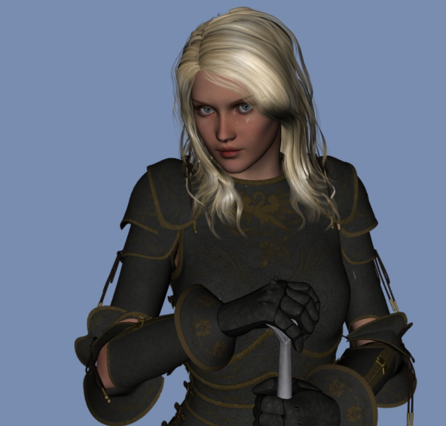

“Liberté,” she said with a Chondathan accent. “No doubt, you are the envoys of Mintar. We must away!”

Resolving to remove Who’s family jewels and choke him with them before Tore decapitated him, Saradette assisted Tore in searching and disarming the gnomes before binding their hands. “Where is our gear?” he asked, also making Norbert open the chest that rested against the wall. Norbert and Melsany seemed earnest in their claims to not know where Saradette’s and Tore’s gear was, but the chest was opened uneventfully, and therein lay a plethora of necromantic goodness.

~*~

Liberté waited as patiently as she could, minding the hallway as she kept one eye on the front door and another on what was happening inside the room. Relieving their enemies of their weapons, spell components, and anything questionably dangerous, Tore, now had some daggers, darts, and spell component pouches in his hands, and movement in the upper levels alerted them to the presence of Umbrasy and/or someone else.

“We cannot stay here. Who will surely muster his local fanatics, and we *will* be overrun,” Liberté said again as Saradette and Tore considered that their stuff may already have been distributed among Who’s local fanatics.

“Well, whichever pile of shit has my workshop, they won’t be able to open it,” Saradette grumbled. “Let’s go.”

She felt her neck to see if the cyst was still there. “Tore, do you still have that cyst in you?”

Norbert and Melsany seemed earnest in their claims to not know where Saradette’s and Tore’s gear was, but the chest was opened uneventfully, and therein lay a plethora of necromantic goodness.

Saradette checked the chest for anything that looked remotely useful, finding a variety of unmarked potion vials, instruments designed for extracting organs with precision, and other vile, necromantic paraphernalia.

Tore turned to Liberté and nodded, “OK, lead the way.” Tore also suggested burning the chest and its contents.

Liberté led Tore out of the room and along the hallway, and Saradette *[burned the chest somehow?]* then followed behind, leaving the other two gnomes inside.

The door to the outside was still ajar, and a door along the wall of the corridor had been bashed open during the scuffle between Liberté and the ghast. They smelled the fresh, night air that seemed to carry with it the hint of copper. “Come,” she said to the cleric and artificer.

~*~

They were in a completely new safehouse, which was in a completely new part of town: a nondescript block within what was unofficially known as the Fishwife Quarter. Re’ka had entrusted Liberté with the task of rescuing the Mintari newcomers, and was now serving up some tea in the gnome-sized domicile wherein everyone but Saradette had to crouch or sit.

Opaque curtains were drawn shut, but this was no base of operations, and had not been chosen with tactical considerations like the last safehouse, which had surely by now been ransacked by Who’s minions.

Tore had, of course, admitted that he had—under magical duress—divulged the location of the safehouse and Re’ka’s name. “I don’t know how much more I said, but none of us are safe as long as Who remains active here... or really anywhere.”

Re’ka had once been in such a situation, and empathized with Tore’s guilt over it. “You weren’t in control; this tumor was. And as much as we have to put Who to rights, we have to also prioritize the removal of these foreign bodies,” she looked at Saradette as well now.

Tore appreciated Re’ka’s sympathy, but that still did not ease his guilt in the matter. As he drank the tea he asked, “Do we have access to any spell components? I need to pray and renew my spells, but need to know what we have available. Also,” he added as he indicated Saradette, “we will need weapons. I don’t expect the two of you to do all the fighting for us. However, the first priority would be to get these cysts and tumors neutralized and removed before they take further control over our bodies.” He then looked at Re’ka and Liberté, “Or do you two have something different in mind?”

Re’ka nodded, and produced a few mundane weapons she’d wrapped inside a blanked and stowed behind a divan. “We have no spare armor, but were able to procure these items for now.” They saw two daggers, a longsword, a shortbow, and a hand axe, as well as 20 arrows in an old, patchy quiver. This modest arsenal was nothing like the quality of wares to which they’d grown accustomed, but it would do for now.

Liberté also provided some material spell components, and Tore found a few among them that would allow him to cast a few of his smaller-scale prayers.

Tore held the longsword and, though, not the quality of the one he had lost, it was not a bad weapon. He then looked through the spell components and thought about the spells he would pray for, but having had his holy symbol removed, he was now unable to prepare most of his most useful spells. He frowned as he selected a parchment with holy text to prepare *shield of faith*, and saw what else he could muster so as to build as full a repertoire of divine favors for the day as he could. With these weapons, magic would likely determine the course of the day.

“It’ll take you the better part of the day to prepare spells, rest, and recuperate,” Liberté cautioned them. “We’ll see to some healing potions to get you both back up to full health... as much as we can expect.”

Re’ka added, “I’ll check with the few trusted sources I have here to see about a surgical solution to the cysts. In the meantime, you mustn’t leave, or open the windows. *Arcane eyes* and other divinations are likely at play in the area if Who is still looking for us.”

“He *may* have fled by now,” Liberté argued the one point on which the two women had differed. “I’m not saying let down our guard, but we need to account for the contingency that we are now in a pursuit of fugitives. After your convalescence,” she said to the cyst-bearing heroes, “We need intel on the whereabouts and activities of anyone affiliated with Who.”

“Who is Urmeena?” Liberté asked, having come across the name in the investigation dossier.

Re’ka recalled, “Isn’t that the dread necromancer that Saradette and her previous crew bested north of Mintar when Who made his escape?”

“The very one,” Saradette confirmed. “Though we don’t really have any idea of who she was or where she was from.”

“Likely a street urchin,” Liberté guessed. “Most of his rabble are guttersnipes and marginalized malcontents who find solace in making an enemy of all living things.”

The paladin of freedom, the airship pilot, the artificer, and the cleric of Lurue now stood in circumstance, evaluating their circumstances. Tore and Saradette felt the urgent need to bone up on spells before anything else, and welcomed the opportunity to do so.

Liberté had just finished doing so, and was now preparing in her mind an itinerary intended to yield some potions and provisions. “If I can find any of the components for the spells you mentioned, I’ll bring them by, but it may be a while, which would delay your spell prep into the night hours.”

“The only spell I need to prepare is the mage armor,” Saradette said. “Surely there is a small piece of cured leather here, like an old belt or something.” She held up her thumb and finger an inch apart. “Even a piece this size will work.”

~*~

Liberté and Re’ka had left, tending to their various priorities, including those associated with Saradette and Tore. The sun had reached its zenith, and was now tipping into decline as the cleric and artificer wrapped up their spell preparation, and resolved to get a little rest while they waited for their rescuers to return.

Saradette sighed. “I don’t have my spellbook, so I can’t prepare spells, anyway.”

After the two left, Tore turned to Saradette, “I am glad to see Re’ka well after Who forced me to give up her name and location. I also hope we are able to recover some of our equipment.” He shook his head as anger and frustration boiled inside. He then walked over to one of the cots (or couches) and laid down, closing his eyes to try and rest before attempting to pray for additional spells.

“Then get some rest for now while we can. If you like, we can take turns on watch while the other rests.”

“That’s fine,” Saradette sat down in a chair. “Go ahead and rest. I’ll wake you after a while.”

Tore nodded and did as instructed. He rested for a couple of hours, got up, prayed for his spells, then took his turn on watch.

They occasionally looked at one another. They had been strangers a mere tenday ago, and now they looked once again like strangers to one another, with new contours across their faces: sunken eyes, pallid complexion, shivering bouts of sweating, and disheveled hair. At certain moments, each one looked at the other as a mortal enemy, though they had the presence of mind to remain civilized in the midst of mentally blaming the other for their predicament. At other moments, they looked past their visual contours and saw in one another only flesh to be eaten, savored, and engulfed, then retreated from their initial advances to slay one another once they got close enough to smell the undeath that emanated from their cysts and pores.

As the day progressed, the afternoon sunlight peeked through the translucent drapes and they felt more alive than undead, though there were times when Saradette looked upon Tore and saw a ready-to-serve meal before her. Soon after the pangs subsided, she would forget that she’d felt this way, and her thoughts revolved over and over around necromancy.

~*~

Sunset

Re’ka and Liberté had rendezvoused less than an hour ago, and now entered the safehouse.

“Ladies,” Saradette noted the two women dressed in fundamentally civilian outfits in order to draw away one type of attention by inciting a different form of attention: a diversionary tactic, unusual for a paladin, unless said paladin was a paladin of freedom, which Liberté was. “You look rather fruitful,” the artificer commented, standing in the dark corner as the sun’s last rays caressed the rooftops.

Both women were dressed in fabrics with fruits depicted on them, and their armor underneath was hidden in such a way that it made both lasses’ torsos and asses look lax and flaccid. They lay down the wares they’d just acquired, and proceeded to brief their two cyst-bearing friends on what they’d learned.

Based on what Tore had mentioned earlier about spellcasting, Liberté was able to find the spell components for these, and he would be able to prepare them tomorrow. There were quite a few things to choose from that overlapped Saradette’s repertoire, and they’d even found her a starter spellbook with all arcane cantrips inscribed, plus a few dozen blank pages, and four scrolls, each reflecting the spells she’d already etched into her previous portfolio: *alarm*, *endure elements*, *mage armor*, and *Tenser’s floating disk*. “It’ll take you a few days to properly copy them into the spellbook,” Liberté stated the obvious, “but in time, you’ll be back to your usual arcane inventory.”

Liberté also handed Tore a rustic, wooden holy symbol of Lurue. “I was able to find a used one at a pawn shop,” she admitted. “This should expand your options as well.”

“And some *cure* potions to put you both at full health,” added Re’ka.

“Much obliged,” stated the artificer, gulping down the only *cure* vial she needed at the moment. “We’ll pay you back when we recover our goods.”

“I fear our goods have been liquidated by now,” Tore suspected drinking the first vial he’d need to fully recuperate. “At least our coin.”

Re’ka was also able to find four vials filled with oil of *magic weapon*, which would come in handy given their mundane wares. “Two each,” she handed two to Saradette and the other two to Tore. “Our weapons won’t be any better off, but yours will, and maybe there is a chance that we can recover your equipment.” They were also given a change of clothing; though not a complete outfit, they each now had a vest with inside pockets, a belt pouch, some snug-fitting boots, and a few other articles that made them look less like they’d been prisoners in a necromancer’s den.

Once they’d placed these oil vials into their new vest pockets, they listened intently as Liberté and Re’ka each shared their portion of the intel. The Mintari duo learned from Re’ka that there was a chirurgeon in the city named Hortenciux, who—for a fee of 9,000 ₲ for each cyst—was willing to perform a discrete removal. He had stressed to Re’ka a mutual non-disclosure policy, and given the vile nature of the affliction, could not provide a guarantee of success.

“And that was the good news,” Liberté transitioned. “In other matters, we believe Who is still at large in or near Sambar. I have consulted with a trusted diviner, and she has confirmed that unless magics more powerful than hers were used to mask his identity, Who has neither passed through a city gate nor embarked upon a vessel.”

Saradette found this dubious grounds to assume that he was still here. “Last time he made his escape in the form of a swarm of bats. Are you confident that this diviner’s magic is strong enough to detect an aerial escape along any path?”

Re’ka interjected, “That’s a good point; we don’t want to presume too much from this, but tell them the rest.”

Liberté nodded, inhaling before adding, “Correct: that alone isn’t enough to ground our suspicions. We believe Who to be here because Urmeena was spotted today by one of my contacts.”

“Where?” Saradette asked, feeling a sense of urgency to rise to heroism.

“You may not like the answer,” Liberté urged Saradette to brace herself before looking at the slip of paper that read: 1298½ Bersax Street, Textiles Quarter.

Saradette’s blood dropped in pressure and temperature, and she felt a little faint, suddenly feeling the bloodlust that had overtaken her the night before. She said nothing, but Tore knew what had transpired.

Re’ka offered, “We believe Urmeena has appropriated the establishment, and we believe she means to use it as a safehouse of their own. If Who is in the city, he’s either there already or will be soon, I’ll wager.”

“So, we must act decisively and concertedly,” the paladin pontificated. “If we’re wrong, and the establishment is only a temporary waypoint, our timeliness is crucial, or we risk losing the trail altogether.”

“I’m hoping we don’t have to pursue him,” Re’ka said, but if we have to leave the city to follow a lead across the island or the greater world, I’ll start making preparations to take the airship.”

“Tore!” Liberté pushed back the cleric as he inadvertently reached out to grab her wrist and help himself to it.

He came to his senses, and blinked a few times before shaking his head and frowning, “I... am sorry. I had no notion of...”

“It’s alright,” the paladin of freedom assured him. “But it’s all the more reason to prioritize the cyst removal alongside the investigation.”

“How long did the chirurgeon forecast for the removal?” Tore asked, sighing as he regained his humanity under a darkening evening.

“In terms of time, about one bell’s toll,” shrugged Re’ka.

Saradette calculated, “If he’s willing to see us both tonight, with any luck, we could be out of there and well into our investigation before Midnight.”

Even though Liberté understood and held no ill will towards him, Tore still felt ashamed of his actions. He vowed to fight the influence of the cyst even harder.

When Saradette mentioned the more expedient removal, Tore nodded emphatically. “Yes,” he added, “the sooner they are removed the better. I do not wish to harm any of you, and I am grateful for your aid in this matter.”

~*~

And so, Re’ka, Saradette, and Tore ventured off to just about the seediest, greediest sector of the city, where the smell of Maztican tobacco permeated throughout the streets and alleys. Re’ka went to talk to a young human, and the knave nodded, took a coin, and ran off. “The surgeon should be by soon,” Re’ka assured them.

They waited about 20 minutes, tempted to buy some of the loose tobacco and a corncob pipe while they stood around, and as the last shades of twilight gave way to starlight, the chirurgeon’s assistant—a gnomish woman—introduced herself as Habrem and led them down a labyrinthine path of alleys and easements until they reached a covered wagon. She waved to the wagon’s open rear swivel door, and held the door open while they entered, following in after them. Sitting next to Re’ka, Habrem asked all three strangers to put on opaque hoods over their heads for the duration of the ride. << My master requires it, >> Habrem shrugged as Re’ka put on hers.

“You’re asking for us to trust you quite a bit,” Saradette commented in Common as she put on the hood.

<< Aye, outlander, and you look like you’re about to succumb to ghoulish anemia. I’ve a good mind to shackle the both a’ ya until you’ve been cleared by the physician, >> Habrem replied.

“What’d she say?” Tore asked in Common.

“She fancies you,” Saradette tested Habrem’s fluency in the mainlanders’ tongue.

“Aw, hells that!” the chirurgeon’s acolyte cursed in workable Common, insisting that Saradette and Tore remain hooded, or the deal was off. “My master will *not* compromise himself to save you; no matter the price, which you must pay upon arrival. Should we stop somewhere so you can withdraw some coin?” she asked, noting no jingling sack on them.

“I was wondering what the plan was for that,” Saradette said.

Habrem smiled upon the two with what became a pitiful smirk before she pulled the wool over Saradette’s eyes and imposed her commanding presence upon the cyst-bearing patient.

~*~

Having arrived at the chirurgeon’s abode, they both had their hoods removed, and saw standing before them a gnome wearing a burlap mask with slits along the eyes, nostrils, and mouth. Habrem whispered a few items of interest to their host, and he took on the same pitiful smile as he gazed on the two newcomers.

“So,” the chirurgeon said in confident Common, “Habrem tells me you’ve no coin to spare, and while I would like to indulge you and work pro-bono, I am already incurring operational costs with my assistants, and the energy pool that I’ve had to kindle to get my gadgets warmed up.”

“Uh, how what do you propose we handle this so everyone wins?” Saradette asked her conspecific.

“I’m glad you ask,” the man with the sharpest blades on the block smiled more eagerly now. “First, I will perform your surgeries. If you should survive, I will ask you to bring me a clutch of red dragon eggs now stowed in a secure container whose location is known only to a handful of mortals. The main issue to deal with will be armed guards patrolling the yard, so I’ll need your cysts removed so you can be alert. I imagine you’ve already lost control at least once, yes?”

They nodded.

He sighed, “Yyyyes, it doesn’t take long....” He shook his head and exhaled through his nostrils as his assistants prepared various instruments on a table adjacent to a padded reclining chair. “So do we have a deal then, adventurers?”

They nodded again.

“I have your word then?”

Tore spoke first. “You do.”

“I’ll hear it from you as well, young lady,” the chirurgeon grinned.

“You have my word,” Saradette anticipated another day of straying with side quests.

“Alright, who’s first?”

“I am,” Saradette was quick to volunteer. She turned to Tore. “You get to see if this process works before you undergo it.” She glanced at the chirurgeon. “No offense.”

Tore nodded, “You have also had it in you longer. I can survive a little longer.”

~*~

Saradette and Tore had been recuperating in a room with an east-facing window that ushered in morning sunrays and began to stir the two patients awake. One of the chirurgeon’s assistants was here cleaning some instruments in a basin with magically flowing water that drained into the downward slope just outside this wooden house. Tore blinked a few times, noting the gnomish dimensions of the room, door, and windows, and remembering that he was no longer in Mintar. How many days had it been since they’d arrived in Lantan? He could not recall or calculate.

“Ah, you’re awake,” the apprentice’s voice reverberated in Tore’s head. “I’ll fetch the chirurgeon.”

Saradette’s wrist was broken and bruised, but she was otherwise feeling fine as she—too—stirred herself back to the waking world. She held her right wrist in her left hand as she came to her senses. By the time she was pulling herself up onto a sitting position, the chirurgeon and his team had entered and were congratulating the two outlanders on their recovery.

He added before Saradette could ask, “You actually turned into a ghast at one point, and struggled so hard to get out of your restraints that you broke that wrist, and nearly killed Fertilda here.”

“Or turned me into a ghast,” Fertilda half-joked.

“That’s not how ghastism works,” the instrument-cleaning apprentice told her. “That’s vampires and other greater undead.”

“Alright, I think we’ve had enough necromancy here for one day,” the chirurgeon got back to the matter at hand. “Now that you’re awake, we can give you this potion so your wrist sets right.” He tossed Saradette a vial marked *cure light wounds*, and she uncorked it, smelled the familiar scent of hops and nutmeg, and swigged it down, experiencing the reformation of her radius and ulna a few inches from the metacarpals.

“We’ll bring you some stew and muffins in a bit, and there’s a spout outside where you can shower,” he introduced a new concept to the heroes.

“Shower?” asked Tore.

“Yes, like a waterfall with warm water pouring down on you,” the chirurgeon pointed to the basin where the instrument cleaner had now gone back to his toiling. “Like that but bigger, and out in the courtyard.”

“It’s a nice place you have here,” Saradette admired the view of said courtyard from the north-facing window.

“Thank you. It could stand to look nicer, but it’s very functional. I’ll soon make some upgrades with payload from the eggs you’re going to fetch me,” the chirurgeon was personable and congenial, but once they were fed and clean, he would reprise the topic of his compensation.

“And Re’ka?” asked Tore.

Their hose answered: “She’s waiting for you at the safehouse, and knows that you have a promise to fulfill before you regroup with her.”

Tore nodded, glad that Re’ka, and he assumed Liberté, were safe. Tore was very hungry and gladly accepted and ate whatever was offered. He was also glad that he no longer had that bloodlust or the feeling of not being in control any longer.

When it was her turn, Saradette stripped off her clothing and stepped under the warm water. The feeling of having the water flow down across one’s body was exhilarating to her, and she resolved to make such a device for herself at some point. After some experimentation, she determined how to wash herself with this novel method of bathing, and she stepped out of the water flow feeling clean for the first time since she’d arrived in Lantan.

~*~

They’d finished eating, and other than a slight tickle where their cystic tumors had existed, they now felt tiptop. The chirurgeon ensured that they’d had their fill while they exchanged pleasantries, gossiped about the neighbors, and argued about ghasts’ abilities to spread their affliction upon the living.

No longer feeling the bloodlust that had haunted them, and now able to taste mutton meat without feeling a frenzy of thirst for living flesh, the heroes began to feel like things were back to normal.

Then the chirurgeon began to clear the table—something the heroes had expected one of the apprentices to do—but this elderly and capable gnome seemed to have a humble streak to him, and slowly, the younger gnomes also began to clear away their own and each other’s dishes. Once the table was clear, the chirurgeon brought out a detailed map of the Textiles Quarter, and pointed to 1298½ Bersax Street. “You may remember the place,” he said to Saradette. “In any case, the job is to acquire what I know to be no less than 5 red dragon eggs that are likely kept in a safe on the second floor of the building: the residential area above the S’rpent’s Musings, a diner and tavern.”

Saradette recalled this, but Tore had never been there, and thus noted the information.

“You have until midnight tonight,” their temporary employer stated, handing them a magical leather satchel. “That gives you about 15 tolls of the city bell. I’ll expect all 5 eggs intact, and will send Grenshaux here to wait around the corner and escort you back once the deed is done. Here’s a haversack for you to stow the eggs.”

Saradette did a quick inventory of what she was wearing, and what she was carrying, which was the pouch, some spell components for the spells she was able to cast today, loose-fitting canvas clothing, a dagger, a shortbow, and two vials of *magic weapon*.

~*~

Tore asked, “Do you have a drawing of this building or,” he looked at Saradette, “can you provide a layout? We need to know all the possible entry and exit points should things go badly.”

“I regret that I do not,” he shrugged.

“I assume the eggs are well protected, do you have anything you can loan us to help us accomplish this task?”

“Alas, the intel on the eggs is nearly a day old. It’s been that long since you agreed to undergo the surgery, and I set espions in motion. It’s not like I can finance a round-the-clock stakeout on the place, particularly if you’re not paying me upfront. And if you fail, I’ll not recoup my costs, so consider my risk here. If I’d been in a worse mood, I might have told you both to piss off with your cysts.”

Ignoring the added berating at the end, Saradette paled when she learned of the intel’s age, and then got angry, angrier that she ever had been. “I will get every single one of the little bastards who did this to me,” she promised herself.

Tore collected the bags and nodded. The pair and their escort then made their way to the location.

~*~

Approaching the location, they began to see a half-dozen uniformed guards and formally dressed investigators huddling outside the establishment in question. They were still the better part of a block away, but it was evident that an investigation of the case was still underway. All looked to be of gnomish height, and the uniform colors were emblematic of the Municipality of Sambar.

“I doubt there are many gnomes here with green hair,” Saradette said quietly. She helped Tore look for another way into the building. “We might want to wait until nightfall, as well. Let’s go to the east and see what’s there,” Saradette suggested.

They passed between a pair of rustic mid-12th century gnomish buildings originally intended for residential purposes, but now refurbished to house a spice, herb, and pill vendor on one side, and a brewer’s storage facility and fallow hops plot on the other. They suspected that—if passed by guards—they’d likely be asked for their identities, and sought to steer clear of the immediate perimeter of their target location, instead veering along the far side of a pitched circus tent for now, making their way along a cactus-lined path formed decades earlier.

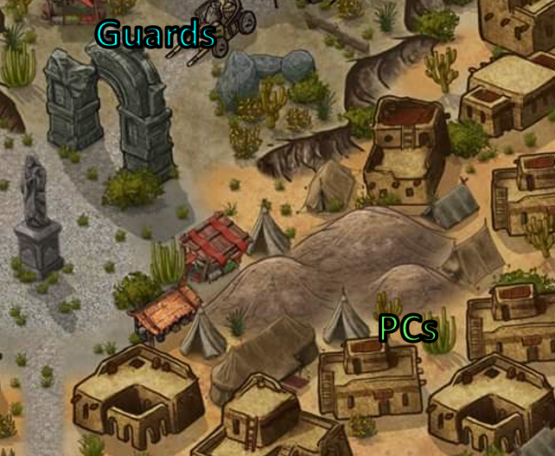

<< You the noobs? >> a carnie pushing a wheelbarrow filled with lion dung asked Saradette, assuming she’d understand Gnomish.

“Nope, just passing through,” Saradette replied with a nod.

They continued along, and when Saradette turned around to look at something she heard moving behind them, she saw no one but the tents, cacti, rocks, and buildings. They continued a bit more until they’d cleared the large tent.

When Saradette looked back, Tore asked, “What is it?”

“I heard something move,” she said in a low voice that wouldn’t carry.

Tore tried to grab a handful of dirt or something when they went around the next corner.

Tore whispered, “Let’s see if there is a back door.”

Saradette put her fingers to her lips and stepped around the next corner to see if the locale in question had a back door.

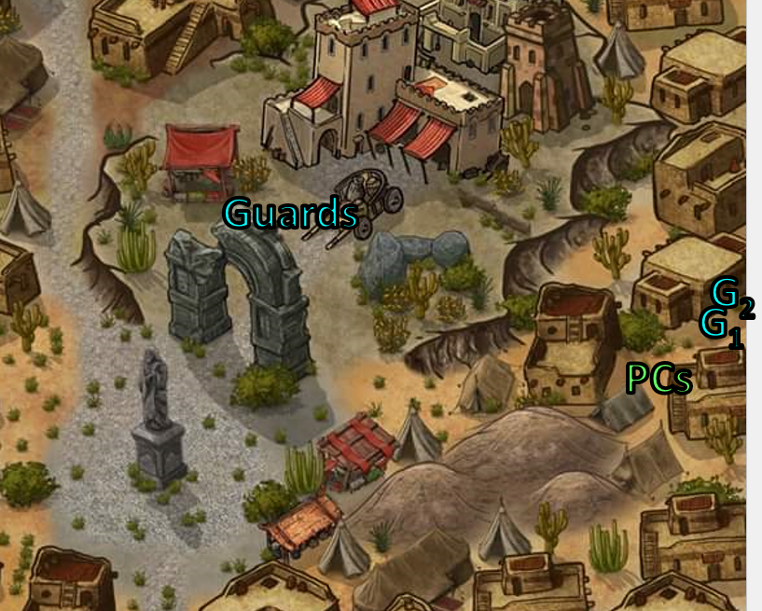

“A pleasant day!” a guard spotted them coming around the corner, and although Saradette dissimulated any guilt, Tore looked a bit too circumspect and out of place to be ignored. The guard and his helmeted trainee approached, both about Saradette’s height, and asked who the two strangers were. “Haven’t seen you with the carnival,” he led with the dispelling of any possible passing off as a roadie for this itinerant attraction.

“We are visiting from the mainland,” Saradette said. “We’re doing a bit of exploring; I hope that’s not a problem.”

Tore nodded in agreement with Saradette’s comments. “I’ve never been here and thought it would be an enlightening trip, and thus far, it’s been rather more than I had expected,” Tore said honestly.

The guards said something to one another, and the guard who had been silent earlier now said, “We’ll need your names and professions.”

And just as they were about to answer, they spotted a robed, halfling-sized figure emerging through the northeast-facing window of the tower adjacent to their target location. The feminine form carried a satchel that was most likely a haversack, and climbing gear that she now used to scale downward undetected by anyone but the two heroes.

Tore thought to immediately alert the guards, while Saradette considered dodging the guards as soon as they could and tailing the sneaky gal still in view.

Tore looked at the gnome guards and stated, “I am Tore Stoneblood, a cleric and warrior of Lurue. Unless there is a problem, I would like to continue touring this interesting town.”

She began with a lie, “I am Nenzy Tarapple, and I would also like to continue on our business.”

The more silent guard wrote down the names on a ledger that already had names on it, and apparently this seemed to satisfy them both. They wished the human and gnome well and by the time they’d gotten out of the outlanders’ path, the halfling-sized figure wasn’t in sight.

Tore followed behind Saradette, and cast *detect magic [lasted no less than 8 minutes]*, thinking that the halfling they saw likely had something magical in his/her possession. Tore focused more on any moving auras he detected, but looked around as much as he could as they moved.

And yes, as they passed the tower heading eastward, Tore did spot the aura of what might have been an *invisible*, crouching halfling just between the tower and the western façade of a wall that once was part of another building that was demolished long ago. Just east of the wall, an untended tent with an open flap contained the wares of a farrier, and a few horses and mules were tethered to the east side of the old wall.

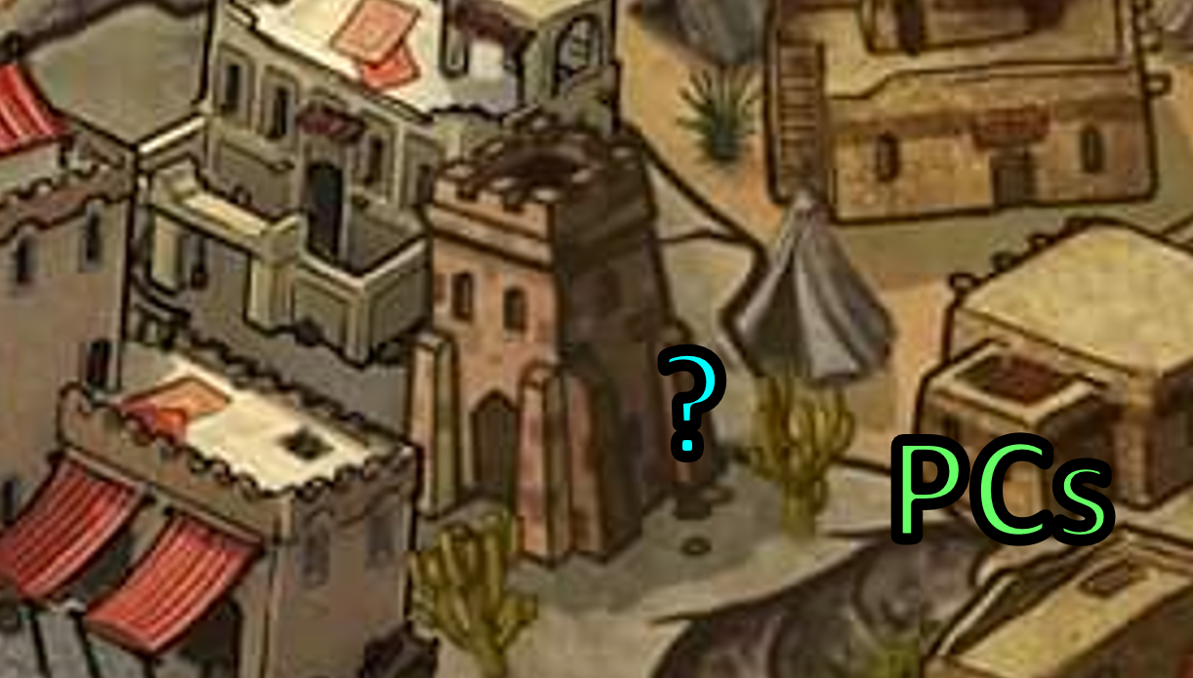

The main cluster of guards had seen then giving their names to the two who stopped them, and Tore kept them in the corner of his eye. Saradette was also aware that they and the guards were in one another’s field of vision, and calculated that this would not be the case as they got closer to the tower, since the main building’s entryway blocked that line of sight.

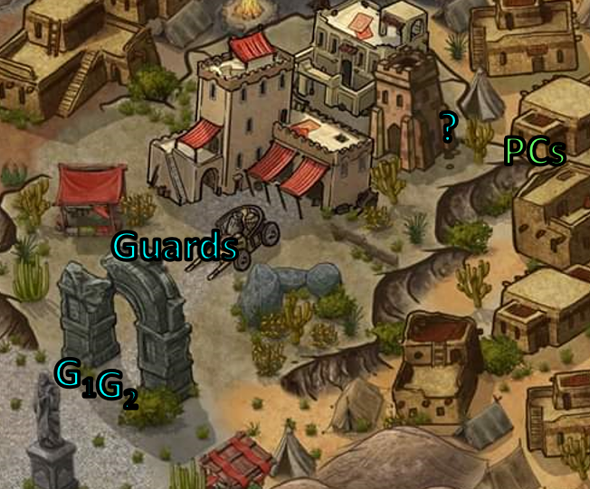

The two seasoned heroes dissimulated their stances by making like they were appreciating the quality of a saguaro cactus.

Once Tore moved around the wall near the horses and mules, he hesitated for a moment and looked back to see if the invisible thing was following them, and it was no longer visible behind the wall.

Instead of moving with Tore, Saradette stayed put and looked around casually to see if anyone else was visible, but was unable to see anyone, or any aura for that matter.

Tore had taken 12 seconds to search for some kind of shovel or other tool to scoop poop with while glancing back to see nothing through the stone wall, and found a d-nose shovel of gnomish proportions. “Oy!” a gnome formerly sleeping in a burlap sack inside the tent piped up as Tore went to grab the item. “Whot you doin’?!”

Tore smiled, “I was going to play a trick on my friend and throw some of this nice dung at her. I don’t intend to hit her, just scare her. I can pay for the use of the items with an hour’s labor later.”

Saradette saw another pair of guards from the main cluster now approaching her, having spotted her just standing there looking at the building where she’d murdered a man the night before.

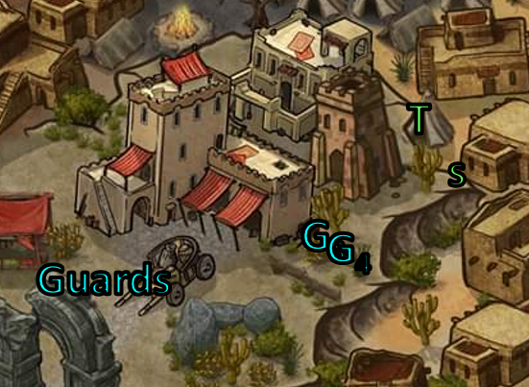

About 20 seconds had passed since Tore had moved away from the line of sight to the magical aura he’d spotted, and one of the approaching guards now greeted Saradette and asked her what she was doing.

Saradette kept her tone deferential. “I’m from the mainland, so I’m not familiar with this city. I’m just looking around. Is that a problem?”

“Not that alone, no,” the guard replied, and was going to say something else before the first two guards that were now barely within earshot whistled.

“They’re clear; we’ve their IDs!” one of them called out.

The two guards eyed Saradette and Tore, then the lead male said, “That man’s shovel is his property, and while I can’t recall the ordinance number, you can’t hurl manure on someone here. It’s a form of petty assault.”

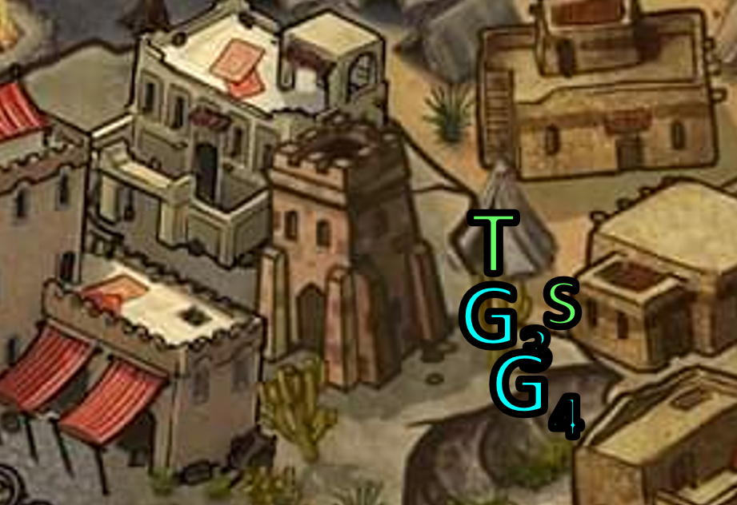

Tore instinctively knew to nod and agree, and did so, rendering the guards’ conclusion of the interaction. “Carry on, citizens.” The guards then headed eastward on their patrol.

Tore—still standing at the mouth of the tent—was none the wiser, but Saradette suspected this was a feign, and the guards would likely be watching them over the next few minutes. They already stuck out at the edge of this murder scene, where a crowd had stood earlier but had by now dispersed.

“Let’s keep moving,” Saradette said in a low voice. “They’re watching us.” She pointed northeast. “We can still look at the building, unless they run us off.”

Tore put the shovel and manure back down as he looked around to see if the invisible figure was where he had last seen it or if he could pick up sight of it somewhere else, then moved back to where he’d been standing when he’d spotted the aura, but now saw nothing magical about.

“Damn,’ Tore muttered. He then turned to Saradette, “I had seen something moving with my *detect magic*, but now I’ve lost it. Those damn nosy guards. You can lead the way, I’ll see if I can pick it up again, but there isn’t much time left on my spell.”

“*Detect magic*? You should have several minutes left,” the artificer told the cleric.

“Anyway, it’s probably someone from our employer,” she concluded. “Not that we won’t expose them if we can, but we need to keep moving. Let’s go northeast and look for a way to get in the building. We can only walk by once, and then we have to go elsewhere until nightfall.”

They walked once by the eastern façade, making their way northeast, and soon, they were out of sight of the target building. They ended up at a public bench and table, contemplating investing in either a fruity drink or a seltzery spring water. One young vendor seemed to have both stations under control, and then an assistant came back from a break and the two half-elf boys then took turns taking orders and making juices.

“I think after a drink, we need to go back to that tour where I saw that,” Tore paused for a moment, “well, detected whatever it was. It might be hiding out in that tower.”

“That sounds good to me,” Saradette said. “How much do you have?”

After their drinks, they worked their way back to observe the tower and the adjacent building where Saradette’s ghastly form had likely murdered someone. They arrived about an hour after they’d left the site, and now saw only the first pair of guards who had stopped them earlier. “Back so soon?!” asked the senior gnome.

“Heading back to our inn now,” Saradette instinctively lied before she could stop herself, feeling a slight urge to attack and eat the man who’d just spoken to her.”

Tore asked, “Have you had any luck determining what happened? Is there anything or anyone we should be concerned about or be on the lookout for?”

One of the guards looked at Tore a bit queerly, while the one who’d spoken before now shook his head and answered, “No luck. You may want to steer clear of this vicinity for the remainder of the day. The area is not fully secured, and mishaps may come your way.”

Tore nodded at the warning provided by the guards. “We will stay clear then. Thanks.” He then walked away and followed Saradette.

Saradette led Tore away from the target building’s immediate vicinity. When they were out of sight and earshot, she looked to Tore. “Well, I think we will have to wait until after nightfall to get in.”

“Yeah,” Tore nodded, “I think that seems to be the only option, unless the guards move away sooner.”

“We need to come back after nightfall,” Saradette said quietly as they walked back the way they came (southwest?).

Saradette looked for a place where they could sit for a while without seeming out of place.

Tore nodded his agreement, though he didn’t like the idea of not keeping the place under observation. He also didn’t want to run the risk of not accomplishing their task.

~*~

They headed back to the chirurgeon’s house.

“I’m hungry,” Saradette said at length. She dug in her pockets to see if she had any money left, and she had a few coins that could be exchanged for a fine meal.

Tore nodded, “Fine by me. We need to kill some time. Who knows, maybe we will happen across some of our stolen equipment as well.”

“Now, *there’s* an idea. I wonder where they might have taken our stuff. My workshop can’t be opened without a command word. I might have told them what it was, though. Either way, they probably would have sold it.” Saradette smiled tiredly. “This is a city of artificers. Maybe we should go to their market and see if my things are there.”

“Yes,” Tore replied, a bit more upbeat, though he realized that finding their equipment was very unlikely, and getting back even less likely. He just preferred to do something more than just sitting around waiting.

Saradette grinned briefly. “Okay, so it’s a street gambling bet, almost a sure loss. It gives us something to do that won’t arouse suspicion.”

~*~

They asked around, and were directed to head to a quarter where they were most likely to find recently hawked items. The row of warehouses was informally called the Clearinghouse, though it was a condemned and unofficially (and minimally) refurbished space operated by multiple factions whose emblems were nonchalantly carved into portions of the wood panels that constituted both façades of the strip along which they now walked.

They could see no Municipal Guards nearby, and had noted a closed and boarded-up Precinct office just around the corner before reaching here. Private security in the form of sellswords and mercenary types was instead commonplace, and as they got a better idea of what was being bought and sold, they made their way to one “vendor” who was most likely to have Saradette’s workshop. The man at the makeshift counter—an artificer himself—declared himself to be called Drumfast, and reminded her of Argent, her mentor on the cloud giant’s floating island: the Sky Tree. He gave the *what-can-I-do-for-you?* type of greeting, and Saradette described the collapsible workshop, and asked if he’d come across one.

“I have, but ages ago... probably not yours. We get a lot of down-the-line hawks here, so it may take a tenday to make its way over if it’s coming at all. I’m sorry for your misfortune,” the unscrupulous but well-meaning-seeming gnome frowned in sympathy. “Perhaps I could ask around,” he insinuated that she should make it worth his while.

Saradette shook her head. “I will come back in a few days,” she replied. With that, she left his shop and walked around, looking for anything that might have been hers. She also looked for vendors who seemed less organized, with merchandise that looked used.

“We need to come back after nightfall,” Saradette said quietly as they walked back the way they came.

~*~

They were heading back when Saradette’s danger sense kicked in again, and a team of black-clad assassins surrounded them on all sides, including from above.

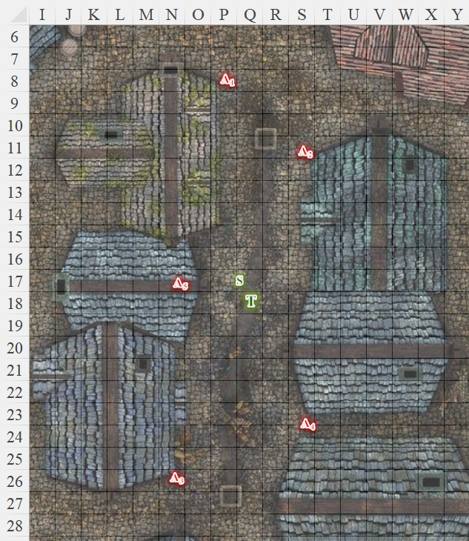

Round 1

The assassins drew wakisashis and came around various corners, making it evident from their various positions that they’d been tailing the heroes undetected.

“What the fuck do you guys want?” Tore nearly shouted as he pulled his sword then just threw it on the ground. He was REALLY getting tired of this town, but at the same time, he knew that Who was free, and these unsavory folks may very well have been in his employ or thrall.

Saradette moved to where she was back-to-back with Tore. “Okay, if they look like they want to take our heads, maybe we should fight.”

They got into position to charge attack.

Round 2

The Sambari ninjas attacked.

|  |  |  |  |  |  |  |  |  |  |  |  |  |
| --- | --- | --- | --- | --- | --- | --- | --- | --- | --- | --- | --- | --- |
| **Character** | **Attack Type** | **Damage** | **BAB** | **Dex Mod+** | **W+** | **Other+** | **Total Score** | **Roll** | **Total** | **Crit** | **Threat** | **Targeting** |
| Ninja 1 | Wakizashi 1 | 1d4 | 6 | 3 | 1 | 2 | 12 | 12 | 24 | 19 | ý | Saradette |
| Ninja 2 | Wakizashi 1 | 1d4 | 6 | 3 | 1 | 2 | 12 | 20 | 32 | 19 | þ | Saradette |
| Ninja 3 | Wakizashi 1 | 1d4 | 6 | 3 | 1 | 2 | 12 | 7 | 19 | 19 | ý | Tore |
| Ninja 4 | Wakizashi 2 | 1d4 | 1 | 3 | 1 | 2 | 7 | 8 | 14 | 19 | ý | Saradette |
| Ninja 5 | Shiruken | 1 | 6 | 3 | 1 | 2 height | 10 | 6 | 18 | 19 | ý | Tore |

*Hit (S), threat (S), miss, miss, miss. 1d20 = 18 + 12 = 30, critical hit.*

*Dmg to Saradette: 2 + (2 x 4) = 10 [43/53].*

Saradette heard the ninjas speaking in an Eastern variant of Gnomish, and made out only the words << expedite >> and << outlander >>.

Tore let out a guttural scream as loud as he could as he charged at the dark clad gnome (Ninja 4) and attempted to grab the smaller opponent.

**Feigning to have lost his mind as he tries to grab the gnome and throw him at the closest ninja.**

Saradette did her best to fight back, swinging her short sword at the nearest enemy.

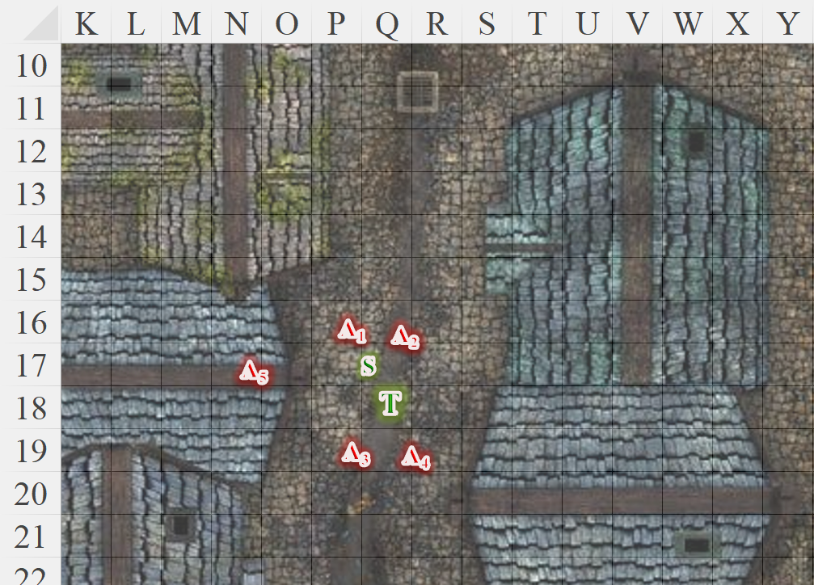

And as fate would deem fit, this was not their day.