*Chapter 37: Daggerford*

20 Kythorn, 1373

Two months had passed, and though they’d only been able to regain one of their magic weapons each, and a handful of other things, such as their armor and Saradette’s workstation, they two had scarcely made it out of Sambar alive. They’d taken a hot air balloon back to the mainland, meandered along the coast as they earned coin and treasure on various missions, and were now about an hour’s trek from Daggerford, on their way north to Neverwinter, where Tore said he had some kin that would take them in while they got their bearings.

They’d replaced the weapons and wares that they hadn’t recovered with nearly identical munitions and provisions, and were now in about the same situation as they had been when they’d left Mintar. Saradette had conveyed to the Baron’s Court via *sending* spell that they had been unable to complete their mission, and added a heartfelt apology. The Baron’s Chief Evoker had replied with a courteous excusal from further responsibilities around this case, with an open invitation to return to Mintar at the Baron’s hospice. Saradette had also considered contacting the Radnars about Widget and Gadget, but had not yet done so.

Tore thought back on a near-death encounter they’d had several weeks back.

~*~

The caravan that Tore and Saradette were hired as guards by had stopped near the Trollbark Forest. Tore had gone off with a small group to collect firewood and pick some wild berries and nuts for the caravan. As they moved through the forest, Tore noticed some webs up in the canopy of the trees. As he yelled his warning, several spiders the size of a medium dog began coming down from the trees. Meanwhile, from behind a large clump of bushes, emerged a drider, its bow at the ready.

Two of the gatherers were slow to respond and were attacked by the spiders which began to overwhelm them. A third gatherer was struck by an arrow from the drider. The other two were able to drop their baskets of berries and nuts and draw their axes to fend off the attackers. Tore, upon seeing the webs, had started drawing his bow. He quickly fired off an arrow, running one of the spiders completely through, startling the other spiders and making them pause long enough for the two axe wielding gatherers to rush in and attack the smaller spiders as well.

The drider quickly focused on Tore, drawing back his bow and firing at the cleric of Lurue. The first arrow nicked Tore’s shoulder while the second hit his chest. Tore then pulled the arrow out and smiled at the evil man/spider mix. Tore charged at the drider, quick-drawing his longsword as he closed the gap. Caught off guard by the sudden charge, the drider was slow to react, Tore’s blade struck home, leaving a massive gash in the drider’s side as the frost from the blade added even more damage.

The smaller spiders turned to help their master, making them easy targets for the axe wielders. Even the wounded man got involved, throwing his axe and striking one of the spiders in the back. As Tore maneuvered around the large abomination, he dropped his bow and pulled his shield, activating the magical barrier as the drider tried to bite him and stab him with his daggers. The defensive stance by Tore kept the drider and smaller spiders at bay until the other finished off the spiders. Realizing he was outnumbered, the drider attempted one last attack, calling forth a spiritual scimitar behind Tore. The spear struck home, piercing Tore completely through from the back and coming out of his abdomen. As Tore dropped to a knee, bleeding badly, he took a moment to focus then extended his hand at the drider, casting *Ayailla’s radiant burst*, striking the drider in the chest with the full force of the spell. Tore could feel Lurue channel his power through Tore as the drider collapsed in front of him.

As he felt himself about to blackout, Tore activated his Healing Belt of Priestly Might and recovered enough to allow him to remain conscious. Getting to his feet as the spiritual spear that had run him through faded, Tore walked over to the others that had been wounded and began healing them enough to enable to group to move out of the area and return to the caravan.

~*~

Saradette, too, recalled the not-so-fond memory of almost falling prey to a young adult black dragon.

1 Kythorn

“That’ll be a silver for ya, Miss,” the waiter said as he plunked a mug down in front of Saradette.

“Thank you,” Saradette smiled at the young half-elf and placed two silver coins in his hand. He nodded and turned to the next customer, while Saradette sighed and took a drink of the refreshing summer ale. She sat at an inn near the fork where the Trade Way from Daggerford met the Coast Way from Baldur’s Gate. The Trollbark forest bordered the road on the west, while the land rose into the High Moor on the east. It was the evening meal, and Tore had gone to take a bath and have a torn belt repaired.

The artificer finished her drink and stepped out to the inn’s courtyard with her packed workshop on her back. She selected an open spot at the edge of the courtyard, which backed up to a creek which ran behind the town. She set the pack down and spoke the command word. Saradette stepped back and watched as the magical tent unfolded into her familiar shop. She stripped to the waist and donned her heavy leather apron to keep her regular clothing from smelling like smoke and being holed by stray sparks. Thankfully, she’d been able to recover her stock of compressed methane gas, so she could complete the small repair to her sonic blaster, the only weapon she’d been able to recover.

A few minutes later, Saradette held up the new sear she’d fashioned and examined it critically in the light of her gas lantern. Maja had taught her about tempering and alloys, and she’d gotten this carbon steel part too brittle the first time, and it had broken under use. A movement caught her eye, and she saw a black-clad figure at the entrance. She set the part down and pushed up her goggles. “Yes, may I help you?”

The figure stepped forward into the circle of light, revealing a human female clad in a close-fitting black cowl. “Yes, uh, do you work in gold and silver?” Her face was gaunt, with deeply sunk black eyes and prominent brow ridges, and her raspy voice sounded almost reptilian. Saradette’s skin crawled as she took in the malevolent appearing woman who smelled faintly of fetid water.

“Uh, I do, but I have none right now, I’m afraid.”

“Ah, there you are, Kaida. Are you bothering this worthy gnome?” The booming voice behind her turned the woman around in a jerky motion.

“Spinzar, no, of course not. I am just asking for some work to be done.” She pulled herself up to her full height of almost a head shorter than the grinning human male who faced her.

His hair was silvery gray, his eyes a piercing blue even in the lantern light, and he was clad in breeches and a tunic that shimmered as he moved. He had no visible weapons, and he crossed his arms as he regarded both women. “Well, that’s good to hear, Kaida. There have been some – unfortunate – goings on around here, and I’d hate to find you involved in them, given your reputation.”

“I need to go,” Kaida hissed as she sidestepped Spinzar on her way out of the tent entrance. As she entered the courtyard, she shifted form into that of a black dragon and flew away into the night, leaving the stench of swampland behind her.

“Thank you,” Saradette said.

Spinzar nodded graciously. “We do try to not involve you little folk in our affairs, no offense.”

Saradette grinned. “I’m comfortable with my inches.”

Spinzar laughed brightly, like the sound of clear bells. “No doubt you are, my young friend. She should not return here again, and she does not dare engage travelers on the road. Stick to the roads here, and you should be safe.” With that, he turned and disappeared into the alley between the inn and the street. leaving Saradette both horrified and amazed at the encounter.

She took at deep, slow breath, let it out, and went back to her work.

~*~

They were now on a wagon drawn by four mules, having paid a fellow named Turtl’ead for the ride from Dragonspear Castle to Daggerford, and being glad the week-long trip was nearly over. The smell of the half-orc rivaled that of the mule dung that occasionally dropped between the axles, fell onto the road, and wafted into the covered wagon.

The wagon stopped suddenly, which was not a common thing, and the two inside the wagon instinctively became alarmed. Turtl’ead was neither speaking nor making sounds like he was being injured for the moment.

Even though they had made frequent halts, Tore still made a habit of looking around to see why they had stopped. Saradette peeked out from the other end of the wagon Tore looked from.

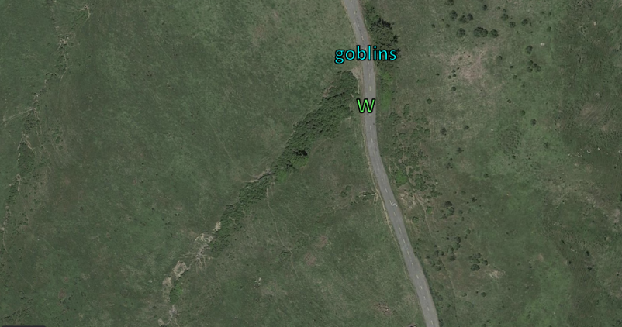

From the southeastern corner of the wagon, Saradette counted six goblins—some on mastiff-back—and Tore counted five from his vantage point at the southwestern corner. Their wagon faced north with the coast about a mile to their west past a slope where a river flowed southwestward and nurtured a cluster of trees from where now a few more goblin foot-soldiers emerged.

This was no chance encounter. The goblins had chosen the thicket as a choice chokepoint for their ambush, and would now do their best to relieve Turtl’ead of his cargo, and now that Saradette’s and Tore’s heads had been spotted, them too. The wagon was now at a full stop, and still about 40’ from the cluster of goblins who now studied the wagoner and horses, calculating.

One of the goblins—a helmeted female in chainmail—yelled over to Turtl’ead, “State your business along our road!”

“*Your* r-?” Turtl’ead began his reply anew. “We seek passage along Daggerford Road to the confines of Daggerford proper. I am but a humble merchant ferrying textiles and spices from the Trollbark Forest and beyond. I come f-. Aargh!”

One of the goblins had had enough, and broke protocol, shooting Turtl’head with a heavy crossbow that to Tore would have served as a light crossbow.

Round 1

“Tore, start the horses! We can’t fight them all!” Saradette aimed at the nearest mounted goblin and zapped him with her glove. Then, she moved to the front of the wagon to help Tore.

|  |  |  |  |
| --- | --- | --- | --- |
| **Ranged Weapon** | **Dmg.** | **Rng.** | **Notes** |
| Glove of Lightning Bolt | 5d6 Electric | 120’ | Ref DC 16 for ½; melts most metals |

*22 electric.*

|  |  |  |  |  |
| --- | --- | --- | --- | --- |
| **Character** | **Save vs.**  *lightning bolt* | **Ranks** | **Roll** | **Result** |
| Goblin Warrior | Reflex | 1 | 11 | 12 |
| Mastiff | Reflex | 5 | 7 | 12 |

*Fail, fail.*

Both the goblin warrior and the mastiff atop which he rode died on the spot, cracking and falling to the ground into a single pile of embers.

They could now hear—but not see—Turtl’ead drawing his light crossbow and shooting someone as he cursed at the goblins in Orcish.

The goblins immediately moved to surround the wagon, keeping their weapons trained away from the horses and towards the two heroes in the back of the wagon. << Make them colorful! >> Saradette heard the lead female commanding in Goblinoid. The phrase implied that they should spill the blood of Saradette and Tore.

Rushing from the back of the wagon to the front and onto the lazyboard, Tore activated his Healing Belt of Priestly Might *[1 charge]* and healed Turtl’ead and told him, “Charge them with the wagon!”

*Turtl’ead gained 15 hps [heals 9 damage].*

<< The big one! Get *him* first! >> A few bolts went Tore’s way, though he did not understand the Goblinoid command that urged them.

|  |  |  |  |  |  |  |  |  |  |  |
| --- | --- | --- | --- | --- | --- | --- | --- | --- | --- | --- |
| **Character** | **Attack Type** | **Damage** | **BAB** | **Str**  **Mod+** | **Dex**  **Mod+** | **W+** | **Total**  **Score** | **Roll** | **Total** | **Targeting** |
| Goblin Ranger | Heavy Crossbow | 1d8 | 4 | 2 | 1 | 1 | 6 | 8 | 14 | Tore |
| Goblin Rogue | MW Light Crossbow | 1d6 | 3 | 0 | 2 | 1 | 6 | 5 | 11 | Tore |
| Goblin Warrior | Light Crossbow | 1d6 | 1 | 1 | 0 | 0 | 1 | 13 | 14 | Tore |
| Goblin Warrior | Grapple | Grapple | 1 | 1 | 0 | 0 | 2 | 6 | 8 | Tore |
| Goblin Ranger | Heavy Crossbow | 1d8 | 4 | 2 | 1 | 1 | 6 | 16 | 22 | Saradette |
| Goblin Ranger | Grapple | Grapple | 4 | 2 | 1 | 0 | 6 | 6 | 12 | Tore |
| Goblin Rogue | MW Light Crossbow | 1d6 | 3 | 0 | 2 | 1 | 6 | 17 | 23 | Tore |
| Goblin Rogue | MW Light Crossbow | 1d6 | 3 | 0 | 2 | 0 | 6 | 12 | 18 | Tore |
| Goblin Warrior | Short Sword | 1d4 | 1 | 1 | 0 | 0 | 2 | 4 | 6 | Saradette |
| Goblin Warrior | Light Crossbow | 1d6 | 1 | 1 | 0 | 0 | 1 | 20 | 21 | Tore |
| Goblin Warrior | Light Crossbow | 1d6 | 1 | 1 | 0 | 0 | 1 | 13 | 14 | Tore |

*Miss, miss, miss, miss, hit (Saradette), miss, hit (Tore), miss, miss, threat (Tore), miss. 1d20 = 1, not a critical hit.*

*Dmg to Saradette: 5 [48/53].*

*Dmg to Tore: 4 + 1 = 5 [66/71].*

Round 2

The moment favored the goblins, who had prepared and anticipated this scenario for a few minutes now while Turtl’ead had approached from upwind, unable to see, smell, or hear them until they emerged from the shrubs and trees. The goblins reloaded and attacked again, their samurai actually charging Tore in a confrontation to the death.

|  |  |  |  |  |  |  |  |  |  |  |  |
| --- | --- | --- | --- | --- | --- | --- | --- | --- | --- | --- | --- |
| **Character** | **Attack Type** | **Damage** | **BAB** | **Str Mod+** | **Dex Mod+** | **W+** | **Other+** | **Total Score** | **Roll** | **Total** | **Targeting** |
| Goblin Chieftainess | Dart +1 | 1d3+1 | 6 | 1 | 3 | 1 | 0 | 10 | 8 | 18 | Turtl’ead |
| Goblin Chieftainess | Dart, 2nd Throw | 1d3+1 | 1 | 1 | 3 | 1 | 0 | 5 | 9 | 14 | Tore |
| Goblin Samurai | Keen Katana | 1d8+1 | 7 | 3 | 2 | 1 | 2 charge | 13 | 13 | 26 | Saradette |
| Goblin Rogue | MW Light Crossbow | 1d6 | 3 | 0 | 2 | 1 | 0 | 6 | 14 | 20 | Saradette |
| Goblin Warrior | Short Sword | 1d4 | 1 | 1 | 0 | 0 | 0 | 2 | 1 | 3 | Tore |
| Goblin Warrior | Light Crossbow | 1d6 | 1 | 1 | 0 | 0 | 0 | 1 | 13 | 14 | Turtl’ead |
| Goblin Ranger | MW Longsword | 1d6 | 4 | 2 | 1 | 1 | 0 | 7 | 9 | 16 | Tore |
| Goblin Rogue | MW Light Crossbow | 1d6 | 3 | 0 | 2 | 1 | 0 | 6 | 2 | 8 | Turtl’ead |
| Goblin Warrior | Light Crossbow | 1d6 | 1 | 1 | 0 | 0 | 0 | 1 | 12 | 13 | Saradette |

*Hit (Turtl’ead), miss, hit (Saradette), hit (Saradette), miss, miss, miss, miss, miss.*

*Dmg to Turtl’ead: 3 + 1 = 4.*

*Dmg to Saradette: (6 + 1) + 2 = 9 [39/53].*

Tore then drew his bow and fired an arrow at the female goblin that had done the talking.

|  |  |  |  |  |  |  |  |  |  |
| --- | --- | --- | --- | --- | --- | --- | --- | --- | --- |
| **Ranged Weapon** | **Dmg.** | **D+** | **TH+** | **Critical** | **Rng.** | **Wt.** | **Atk** | **Roll** | **Check** |
| Longbow +1 | 1d8 | 1 | 1 | x3 | 100’ | 3.0 | +12 | 7 | 19 |

*Hit. Dmg: 6 + 1 = 7.*

The arrow went deep into the side of her chest, but she remained on foot and drew another dart intended just for Tore.

Turtl’ead fired upon one of the goblin warriors.

|  |  |  |  |  |  |  |  |
| --- | --- | --- | --- | --- | --- | --- | --- |
| **Character** | **Attack Type** | **Damage** | **BAB** | **Str Mod+** | **Total Score** | **Roll** | **Total** |
| Turtl’ead | Light Crossbow | 1d6 | 1 | 1 | 1 | 4 | 5 |

*Miss.*

Round 3

|  |  |  |  |
| --- | --- | --- | --- |
| **Character** | **Initiative** | **Roll** | **Modified Roll** |
| Saradette | 3 | 11 | 14 |
| Tore | 2 | 8 | 10 |
| Goblins | 2 | 2 | 4 |
| Turtl’ead | 1 | 1 | 2 |

Saradette turned on the driver. “Drive us out of here, you idiot!!”

|  |  |  |  |  |  |  |
| --- | --- | --- | --- | --- | --- | --- |
| **Skill** | **Rank** | **Ability & Mod.** | **Misc. Mods.** | **Total** | **Roll** | **Check** |
| **Saradette, Diplomacy** | 2 | **Cha (+0)** | 0 | 2 | 16 | 18 |

*See below.*

Though she wasn’t particularly diplomatic, the gnome appealed to the half-orc’s sense of self-worth, and despite his judgment, he did as Saradette insisted, putting down his crossbow, taking the reins, and spurring the horses forward, whereupon the goblins executed their contingency to use their mastiffs to spook the horses. Growling and even attacking the mounts, mastiffs and impetuous goblin warriors did their best to hold the line along the road. A few crossbows were dropped in the process, and swords were drawn.

|  |  |  |  |  |
| --- | --- | --- | --- | --- |
| **Character** | **Skill** | **Ranks** | **Roll** | **Result** |
| Goblin Warrior 1 | Ride | 6 | 16 | 22 |
| Goblin Warrior 3 | Ride | 6 | 1 | 7 |
| Goblin Warrior 6 | Ride | 6 | 20 | 26 |
| Goblin Warrior 8 | Ride | 6 | 2 | 8 |

*Goblins 1 and 6 took a Swift action to spur their mounts.*

|  |  |  |  |  |  |  |  |
| --- | --- | --- | --- | --- | --- | --- | --- |
| **Character** | **Attack Type** | **Damage** | **BAB** | **Str Mod+** | **Total Score** | **Roll** | **Total** |
| Mastiff | Bite | 1d6+3 | 1 | 2 | 3 | 2 | 5 |
| Mastiff | Bite | 1d6+3 | 1 | 2 | 3 | 4 | 7 |
| Mastiff | Bite | 1d6+3 | 1 | 2 | 3 | 9 | 12 |
| Goblin Warrior 1 | Short Sword | 1d4 | 1 | 1 | 2 | 13 | 15 |
| Goblin Warrior 6 | Short Sword | 1d4 | 1 | 1 | 2 | 12 | 14 |

*Miss, miss, hit (vs. Touch AC), hit, hit.*

*Dmg to horse: (1 + 1) + (1 + 1) = 4.*

One of the dogs tried to bite at the horse, instead crashing into it and spooking it nevertheless. The harness that held the horses in place began to buckle. Four mastiffs and goblins fell to the floor amidst the horses’ hooves, and the latter began to trample the former.

|  |  |  |  |  |  |  |  |  |  |
| --- | --- | --- | --- | --- | --- | --- | --- | --- | --- |
| **Character** | **Attack Type** | **Damage** | **BAB** | **Str Mod+** | **Dex Mod+** | **Other+** | **Total Score** | **Roll** | **Total** |
| Horse 1 | Hoof | 1d6+1 | 2 | -3 | 1 | 2 height | -1 | 9 | 8 |
| Horse 1 | Hoof | 1d6+1 | 2 | -3 | 1 | 2 height | -1 | **20** | 19 |
| Horse 2 | Hoof | 1d6+1 | 2 | -3 | 1 | 2 height | -1 | **3** | 2 |
| Horse 2 | Hoof | 1d6+1 | 2 | -3 | 1 | 2 height | -1 | **14** | 13 |

*Miss, threat, miss, miss. 1d20 = 12 – 1 = 11, not a critical hit.*

*Dmg to goblin warrior 1: 1 + 1 = 2.*

Saradette trained her sights on one of the goblin warriors that had slashed at the horse nearest her, and zapped it with her glove.

|  |  |  |  |
| --- | --- | --- | --- |
| **Ranged Weapon** | **Dmg.** | **Rng.** | **Notes** |
| Glove of Lightning Bolt | 5d6 Electric | 120’ | Ref DC 16 for ½; melts most metals |

*Dmg to goblin warrior 6: 14 electric.*

The poor fellow burned up with a crackle of electricity coursing through him.

Tore fired on the leader again.

|  |  |  |  |  |  |  |  |  |  |
| --- | --- | --- | --- | --- | --- | --- | --- | --- | --- |
| **Ranged Weapon** | **Dmg.** | **D+** | **TH+** | **Critical** | **Rng.** | **Wt.** | **Atk** | **Roll** | **Check** |
| Longbow +1 | 1d8 | 1 | 1 | x3 | 100’ | 3.0 | +12 | 8 | 20 |
| Longbow, 2nd Shot | 1d8 | 1 | 1 | x3 | 100’ | - | +7 | 5 | 12 |

*Hit, miss. Dmg: 2 + 1 = 3.*

~*~

Two minutes later…

Turtl’ead had drunk a potion of *cure moderate wounds* that was now healing the bugger. “Phew!” he sighed. “I don’t know if I could’ve staved all these goblins off by myself.”

“I’m sure you could have,” Tore comforted him. “They were many, but weak in their resolve.”

The goblins all lay dead before them, as well as a few of their dogs, while the surviving dogs had by now scurried off downhill and towards the coast. Saradette had searched them, and found some magic weapons—a dagger, a few darts, a katana, a wakizashi, and some masterwork and other mundane stuff.

“Any spell components?” asked Tore as the two males pulled arrows tended to the horses’ wellbeing.

“A few. I’ll see in a moment if there are some good ones for us,” she replied as she removed a ring from the Chieftainess’ finger.

Tore took care of the horses and cast *cure light wounds* and *cure moderate wounds* as needed to get them fully healthy again.

*Both horses returned to full hps.*

He then took a moment to drink water before he went through the items they had recovered. He looked at Turt’ead, “You want any of this stuff? If not, we will likely sell most of it.”

“Most of the weapons are too small for me, anyway,” Tore said, knowing that a goblin’s light crossbow made a find hand crossbow for someone of his stature.

“Yes, I want to see about this ring, though.” Saradette held it up for Tore to see.

Tore looked at it then cast *detect magic [lasted no more than 8 minutes, depending on concentration]* and concentrated on the ring before double checking the rest of the ‘loot’ they had recovered. It took a few moments, but he began to see an aura that would soon have a definitive hue and intensity.

Turtl’head said, “If you can spare that magical wakizashi, that’s the only one I would want to keep for myself. The others—like you said—I’d liquidate.

Saradette hefted the swords to see if any of them felt “right” for her, and most were right for someone her size, even if not someone with her affinities for particular weapons.

Tore’s concentration was saturated on the ring, and with a little more time left on his spell’s effect, he turned to gaze upon the armor of each goblin, and when he got to the last one—their leader—he noted faint auras on her helmet, chainmail, and the solid gold gorget worn over her sternum and chainmail. The symbols of Bargrivyek and Khurgorbaeyag suggested a split fealty to the two greatest gods of the goblin pantheon, and Tore also knew this to highly overlap with the likelihood that they despised clerics, even those who served these goblin gods, preferring instead to rely on ur priests, archivists, adepts, and other less presumptuous interpreters of the divine will.

The artificer removed the wakisashi’s sheath and belt from its former owner, sheathed the blade, and handed it to Turtl’ead. She then put the remaining items in her haversack, excepting whatever Tore took for himself. Tore threw the armor from the leader and any larger items into the back of the wagon. He had no interest in any of the items at this time.

~*~

The rest of the trek north-northwestward to the Lizard Marsh—a place best skirted—and then directly north and uphill towards the quaint but well-known settlement of Daggerford. A few lizardfolk were spotted at one point along the horizon, but unlike the goblins, these guys were in no mood for a scuffle. Tore identified them as belonging to the sharptooth, which often saw itself as a clan, but was actually a subspecies throughout Toril with a variety of political factions, some of which had no knowledge of one another. The poisondusk lizardfolk were actually the more common subspecies here, and thus a quintet of sharptooth walking about in the open plains seemed about as out of place as a half-orc wagoner, a human priest, and a gnome artificer who had just fended off over a dozen goblins with outlandish weapons from the far reaches of Rokugan and Kara-Tur.

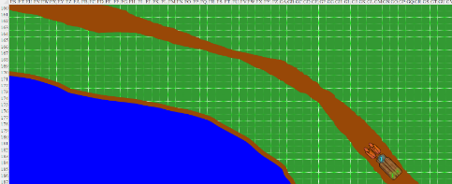

***NOTE:*** *This map is not to scale. The wagon is about 5 times bigger than actual size, and the squares are about 20’ x 20’.*

Tore had been put off by that goblin raid and half-suspected to be greeted by goblins at the town gates, which he could now see as he peeked out of the left rear corner of the wagon.

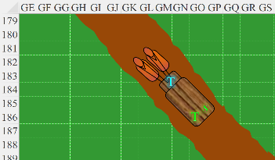

“Should we cast a few spells, you think?” he asked his traveling companion who was already slipping on a belt, a sheath, and her gadgets.

“If we see anything suspicious, then I will,” Saradette replied.

The horses continued, and within a minute they were stopped at the gates, answering a few questions as a diviner cast a few low-level spells.

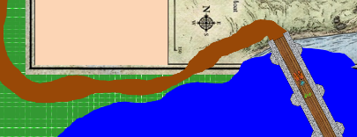

Another few minutes passed, and after enough locals vouched for Turtl’ead’s authenticity, the security protocols were relaxed and information in the way of warnings came their way: most notably, that feral goblins had as of late been scouring the coastline, and not only had they displaced several clutches of lizardfolk, but they’d also successfully raided small villages surrounding the Township of Daggerford, the largest coastal settlement between Baldur’s Gate and Waterdeep. Turtl’ead had passed through here about a dozen times in half as many years, and had a working knowledge of the town’s amenities and complexities. An characteristically lax clergy of Lliira oversaw the little legislation and jurisprudence that was needed here, and consequently a laissez faire type of frontier law prevailed, emphasizing individualism over the collectivism that held a much larger municipality like Waterdeep together. The guards’ choice of words confirmed this, and as they were allowed through the now open gates, one of the guards—a handsome enough gnome—threw Saradette a raised eyebrow and wished her a pleasant stay.

They passed a makeshift stockpile for cruder resources—mostly freshly cut lumber—just outside to the south of the gates, and noted that it had two sentry towers to guard the raw materials before they were taken to the carpenters inside the town for refining.

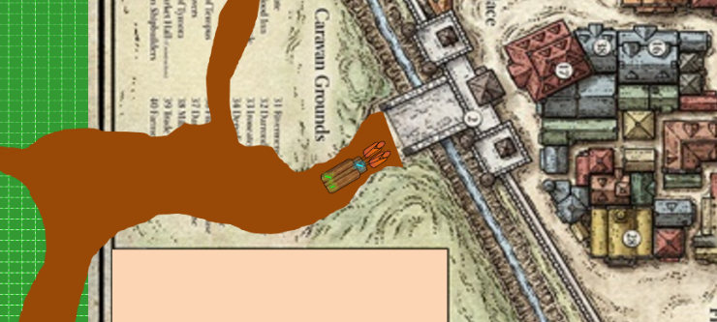

The composition of humanoids here was far woodsier than they were used to: there were satyrs, a few centaurs, and even some rarely seen woodlings among the humans, halflings, surface elves, and representatives of other races that once would see on any given day along other Sword Coast settlements. Still, the woodsy folks were few and far between, and this was just as bustling a fishing and logging town as any of its size.

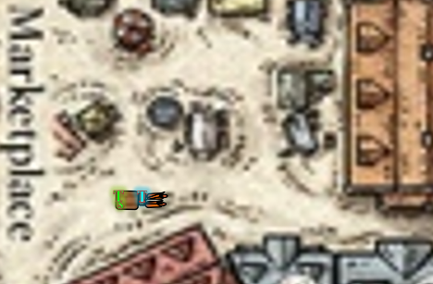

***NOTE:*** *This map is closer to scale, but the wagon and horses are still about twice as large as they should be relative to the buildings.*

They reached the marketplace, a central clearinghouse just inside the city walls where the majority of commodities were ferried and sold. Many of the finished products that only days or tendays ago had rested outside in the stockpile in the form of logs were now being displayed and traded alongside perfumes, spices, meat, vegetables, and other necessities and preciosities.

As they approached, and nothing seeming out of the ordinary, Tore held off casting any spells though he had prepared his *luminous armor* spell components just in case.

For Tore, the first order of business was to see what they could get for the loot that they were not keeping. Then he looked for a place in the 3- to 4-bell range with reasonable accommodations before finding a place to eat.

Saradette put the remaining armor in her haversack before she got down from the wagon. “There’s room for it,” she explained to Tore. Once on the ground, she followed her companion’s lead in looking for a place to eat and lodge.

Turtl’head thanked the heroes for their time, paid them 100 gold pieces each—which was about five times the going rate for the security work they’d been hired to do, and added, “You’re a fine pair of heroes, and I hope you find your way. I’ll be staying at the Marmalade Maven tonight, and heading to Waterdeep the day after tomorrow. I’m sure I can find some muscle, but if you two change your mind about the City of Splendors, I won’t start looking for new blood until noon tomorrow.”

~*~

They did find a strip of outdoor gambling halls where stakes were low, chances were almost never skill-dependent, and there was no *house* to speak of; only independent players against one another in games involving horseshoes, chess pieces, miniature wooden hammers, and other oddities.

These partitioned streetside attractions were hosted by the city itself, and as the sidewalk receded to buildings, the heroes could also see inns that were neither the cream of the crop nor below average. There was the Tenacious Tanarukk, the Sphincterous Sphinx, the Gifted Gabber, and the Dropdead Basilisk. Sure, there were others with less suggestive names, but part of the adventure was in the telling, and neither Saradette nor Tore wanted the real story to read, “so they took lodging at Fred’s Inn…”

“We’ll be treated well at any of these, I’ll wager,” Tore looked up at the signs of the establishments, as well as the support shops separating them—an apothecary’s brewery and herbal teahouse, a wand-maker’s studio, a tinkerer’s shop, a fashion boutique, and a bakery.

“I imagine *really* well if we go to the Sphincterous Sphinx,” she said as she pointed with her lips at women dressed in feline themes outside the place escorting some tourist inside.

Tore looked at the women in front the Sphinx inn and nodded. “I cannot argue with that logic,” he replied with a grin. “Shall we see if they have any rooms available,” he continued as he walked towards the Sphinx.

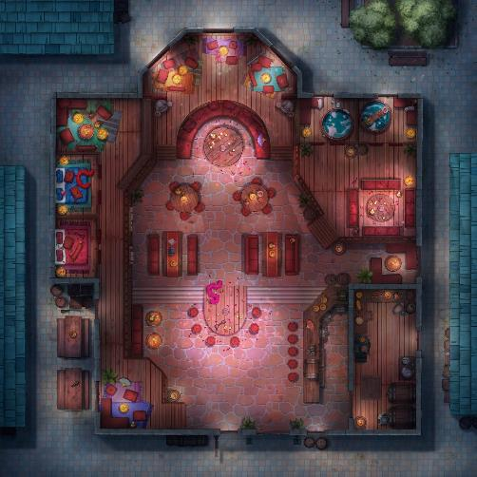

The cat-themed establishment was as flamboyant inside as its façade suggested, the racy shades of fire and flame flaunting themselves in all their irreverent splendor across the walls and décor. Saradette rolled her eyes at a girl of her height and build, wondering what manner of madness they were getting themselves into as they approached the lobby clerk.

“Welcome to the Sphincterous Sphinx. One room?” the half-elven girl of 30 or 40 years with the leopard-print uniform asked.

“Seriously?” Saradette rolled her eyes. “At least they probably have nice baths.”

~*~

Saradette empirically confirmed the bath’s quality as she soaked in a bubbly water that was all the novelty. While Tore was in the next room changing and ensuring that all his equipment was in order, she rubbed goblin blood off of her neck and used a variety of sponges to rinse herself.

The chore of cleaning herself done, Saradette dropped the sponge into the water and added more hot water, which along with the cold water, was delivered by clay pipes stoppered with wooden plugs. She admired the clever engineering, and leaned back in the tub. The stone tub was perfect for her, though she suspected humans would find it cramped. She swished in more of the sudsy soap and drained the last of her mead, setting the tankard down on the tub’s edge.

The gnome closed her eyes and felt some of her tension ease as the water and fragrances worked their magic on her tired body. Her menses was nearly over, and she thanked Mayaheine anew that she didn’t have to endure the thing every moon like human women. Still, it hurt, and it was messy, which made traveling doubly difficult. The other effect was that it made her want sex, and the bath had inflamed her desire as she’d cleaned herself. It had been too long since she’d seen Stratus; even longer since they’d had intimate time together. She leaned back and closed her eyes as she ran her hands over her belly and cupped her breasts. Self-pleasure wasn’t something she indulged often, but the release would help her menstrual pain. She sighed as she pictured Stratus’ face and body, and let herself go as her hands moved.

A few minutes later, the water had cooled enough to make the bath less relaxing, so Saradette stood, rinsed off, and stepped out of the tub. She dried herself with a towel, dressed in her clean shift, and went back to her shared room.

~*~

Tore didn’t know what was in store for them in the town, and hadn’t yet decided on Turtl’ead’s proposal. He considered praying, not for spells, but as a form of grounding, particularly now that he was in a town where his deity’s kindred spirit was the goddess of favor.

Once he had gone through and cleaned his gear, he took a moment to thank Lurue for his protection and asked for his guidance in the coming days. Should they stay in town for a few days, or continue on with Turtl’ead to Waterdeep? For now, though, he had decided that they would find a good place to eat and take advantage of any other services the inn might provide.

A few minutes later, he was paying in advance for the reasonably priced meal that had just been described to him as his type of comfort food.

The place was relatively empty, but allegedly it would be bustling in a few more hours. Tore took advantage of the silence to appreciate the sights, contemplating the next few days of his and Saradette’s lives.

“How is the mutton?” Saradette asked as she walked up and sat down across from him. She seemed more relaxed, and she carried at hint of some flowery perfume with her.

“Tender,” Tore tendered. Having had his fill, he was now eating to not waste all that had been put on the plate. “They err on the side of large portions.”

She could tell he was full, and asked, “Why not get a box?”

“This stuff spoils by the time a man like me is hungry again,” Tore exaggerated.

Saradette smirked, “Can I try a bite?”

“Oh, sure,” the priest pushed the plate closer to her, and within a minute of small talk, she’d actually finished the meal.

They reminisced on the way back to the mainland from Lantan, and were sorry to see the last of that fair land, albeit under grim circumstances. For all they knew, Who was still at large, and the Barony of Mintar still had an open investigation into that case. That topic led to the recollection of their year on the Sky Tree, where Saradette learned from Argent some well kept secrets in her trade.

Then they heard a bit of a commotion outside. Though the open windows, the voices of humanoids making their way along the main promenade could be heard getting closer. Two of the five patrons in the room got up to stand by two separate south-facing windows, and one of them said, “Oh, Lliira!”

“What is it?” said another client as she, too, got up and went to see what the hubbub was about.

Saradette rose and went to the door to see what was happening, and witnessed a pair of adults, each carrying a child that looked like their own, both dead, surrounded by at least twenty other indignant and vengeful townsfolk making a ruckus about goblins and vowing to end their scourge.

Tore and others still seated could now make out statements amidst the cacophony, all aimed at violence to end the goblins’ threat to the town.

Tore swallowed his bite of mutton before replying, “It is very good. Not the best I have ever had, but it is very good. How are you,” he gave Saradette a glance before adding, “now that you have washed the dust of the road from your body?” He took another bite of his mutton as well as a bite of the fresh made bread.

Tore joined the group going to look out the windows, wondering if it was something interesting or something exciting.

“I miss Stratus,” she replied with a sad smile.

Tore smiled, “A guy his size is hard to miss,” he replied with a wink.

Saradette sipped from the cup of cider she’d brought to the window, harshening her voice momentarily, and silencing her “h”. “Yea’, and ‘appiness like I had with ‘im is ‘ard to find.”

Tore raised an eyebrow and said, “I’ll bet.”

It was now evident that a posse was being riled up to go take the battle to the goblinoids, and the excitement was likely to pass across the Sphinx’s front porch.

Saradette sighed and looked to Tore. “Should we go help find the goblins?”

“Sure,” Tore replied after he had swallowed his last bite of food. “Someone needs to protect the townspeople from themselves.”

The gnome shook her head. “I’m not about to put myself up as some sort of leader or hero. I will go out and look, but nothing else beyond defending myself.”

Before they could reach the door, there was already a small crowd shuffling in from the breezy promenade. “Look at *these* two!” a human woman pointed out the armed-to-the-teeth adventurers who had left no possession unattended.

“Oh, you are—no doubt—heroes, or at least leaders,” one thin half-elven male had to say to Saradette.

“No, they’re not! They’re aristocrats donning the wares of their ancestors,” a drunken dwarf with a heavy Human accent provided a counterpoint in the ensuing debate, and within seconds, the group had expressed a spectrum of positions on who Saradette and Tore were—particularly among the rest of the patrons here.

“Surely, sir and madam,” one ridiculously attractive female, whose ears were covered but who was probably a half-elf, posed, “you are both trained in the weapons and, uh...” the woman frowned, not knowing what word was most appropriate for the gnome’s gadgets, “... artifi...ces... in your possession. While we are hopeful that the felled children,” she pointed at the bodies now being paraded along the promenade, “will be *raised* by Lliira’s favor, their suffering will leave them scarred for life.”

Saradette and Tore both understood this. “Our families have little coin to offer someone as well clad as yourselves, but we can offer armistice and hospitality if you would help us avenge our fallen, and as importantly, prevent future assaults and murders upon our people.”

*[DM assumption/interpretation that you’re willing to join in the goblin hunt.]*

With their consent, and no other patrons present being combatants or spellcasters, the entourage coalesced outside the cluster of inns after heroes had been sought out, and Saradette and Tore found themselves among a cadre of about two dozen locals armed with rudimentary weapons and joined by a handful of better equipped foreigners whose prowess seemed to range from knavehood to something more comparable to Saradette’s and Tore’s own abilities. The conversation became fragmented, and the heroes could pick up important bits here and there.

“What do we know so far?”

“They have no single base of operations.”

“We’ve uncovered a cave where they’d stayed recently, but found none there.”

“When do we eat?”

“How can you think about eating at a time…”

“They are rabid, or in some way afflicted.”

“There’s always illithids behind something like this.”

“No, there isn’t!”

“Is so.”

“We’ll need at least ten strong swords, and magic, whatever magic we can muster.”

“I’m going to go get some provisions, and will supply you all...”

“You’re going to help yourself to another serving of mutton, aren’t you?”

“Aw, I had the smallest bit!”

“We need to end those goblins once and for all. I’m sick and tired of living in fear every night, like a sacrifice lottery.”

“Yeah, *fuck* those goblins!”

“Kill them!”

“Killl them!”

“Kiiill them!”

“Kiiiiillllll them!”

While the people talked, Saradette stood to one side, next to Tore. “I really hope that most of these people just go home,” she sighed.

“I agree,” Tore replied, “or they will have more to resurrect or bury in the not-so-distant future.”

~*~

One thing had led to another, and after some talking down to some of the more eager but less capable commoners, the posse of more than 30 had become a party of less than 10, and would dwindle down as they put the town behind them and some of the locals would turn back. The core group of those would do more than talk consisted of five, including Saradette and Tore, who had forgotten the names of those who talked more.



There was Carthage, a sorceress specializing in *orb* magic, though she had quite a few other tricks up her sleeve. Next to her was a black-clad non-necromancer named Redvelvet.

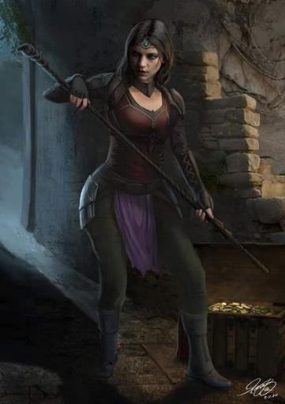

She carried a covetable shortspear that collapsed into a quarterstaff whose craftsmanship matched that of her crossbow, and did not hide her attraction for Carthage as they followed the fellow who knew these woods the best. To Saradette’s left, there walked a modestly clad cleric of Lliira. Tore knew this to be the clerical garment of an active practitioner who had taken a vow of poverty, but not of celibacy.



Revered here in Daggerford, the ascetic cleric would never have turned down a plea to end evil around her beloved town. Tore was in the company of a handful of very capable women, led by a few knaves and would-be heroes wielding sickles and pitchforks.

Having followed a few tracks up to this point, the oldest guide—a guy named Batrik—pointed to a thickening of trees where a stream widened, and said in Chondathan-affected Common, “Your best bet be through that thicket. From there, you want to-.”

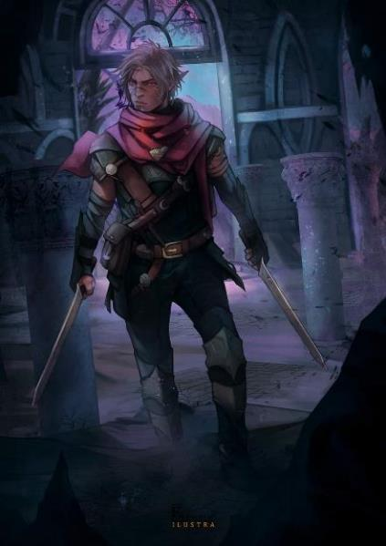

“Are you seriously gonna turn tail?” asked a novice ranger named Throughmad. “Don’t bother with the directions; *I’ll* lead them through the woods.”

Batrik had already made up his mind, and shook his head as he wished the heroes well, then made way for the town, which was back towards the northwest.

They were a few miles further inland and a few hundred feet higher up than Daggerford, and now only Throughmad was familiar with this particular stream and its surroundings. The latter said to the rest of the less experienced folks, “Perhaps you should accompany Batrik.”

And much as had been expected, only the stalwart remained behind, and this was arguable in Throughmad’s case, for though he was confident, his mettle might not be as mighty as might be needed.

“We thank you, Brother Throughmad,” Viola commended her neighbor, “for the sacrifice of your time and risk to your health. Lead us, and we shall strive to end this strife quickly.”

Tore stood listening to the non-intelligence that was being bandied about. He found most of it to be assumptions or guesses. When they had worked themselves into a frenzy, he shook his head. This would not end well for some of them if they came with.

Tore was glad to see the lesser qualified to fall back. As he had time, he approached Carthage and inquired what offensive or defensive spells she had in her arsenal. He also asked the cleric what spells she had prepared for this encounter.

|  |  |  |  |  |  |  |
| --- | --- | --- | --- | --- | --- | --- |
| **Skill** | **Rank** | **Ability & Mod.** | **Misc. Mods.** | **Total** | **Roll** | **Check** |
| **Tore, Diplomacy** | 0 | **Cha (+2)** | 0 | 2 | *5ish* | *??* |

*See below.*

She left out the cantrips, but listed her signature powers and noted that she was oft to Empower and/or Maximize some of them.

|  |
| --- |
| **Spell** |
| Backbiter |
| Hail of Stone |
| Lesser Orb of Acid |
| Lesser Orb of Sound |
| True Strike |
| Combust |
| Ice Knife |
| Web |
| Dragonskin |
| Rainbow Blast |
| Orb of Acid |

“And you?” asked the sorceress, revealing that she liked to blast enemies, or rather, as an innate spellcaster, had evolved to do just that. “What favors from Leira have you in store today?”

As for the other woman, Tore admired her weapons and asked where she had acquired the shortspear/quarterstaff.

|  |  |  |  |  |  |  |
| --- | --- | --- | --- | --- | --- | --- |
| **Skill** | **Rank** | **Ability & Mod.** | **Misc. Mods.** | **Total** | **Roll** | **Check** |
| **Tore, Diplomacy** | 0 | **Cha (+2)** | 0 | 2 | *10ish* | *??* |

*See below.*

“It came at a price... the outdoorsy warrior’s voice trailed off as her memory crystallized. “I don’t like to talk about it.”

Tore was intrigued by the spell selection and also the shortspear, but didn’t press any further about the details of the story behind it.

As for the Throughmad, Tore left him to his duties and tried to stay out of the man’s way when it came to tracking. He hoped that the ranger would at least be able to hold his own in combat but was certainly glad he had offered to guide them.

Saradette activated her woodland ghillie suit to help her blend into the terrain, opting out of the conversation that her gallant traveling companion had fomented with the others.

Thoroughmad also kept to himself, staying on the business at hand, as he was here to avenge his cousin’s children; not make friends with passersby.

They walked for about another half-mile, and Thoroughmad put up a hand to indicate that others should stop following. After a few minutes of silence, he crouched back over to the group and whispered, “We’re about to come up on a proper trail, and there are two goblins posted there.”

Saradette moved up to stand next to Tore so she could hear the conversation. “Do we bypass them, or ambush them?”

“It would be nice to know how close we are to their camp,” Tore asked.

Round 1

The ranger replied. “I’d say we’re far enough for you all to cast spells now while we can. The ranger then cast *bless [expired on Round 31]* upon the group.

*The party gained +1 to attacks and saves against fear effects.*

Carthage cast *mage armor [expired in 1 hour]* from a scroll. She then produced her wand of *summon monster I* and stood vigilantly as the others prepared to confront the goblins.

*Carthage gained +4 to FFAC and AC.*

Redvelvet drank an unlabeled potion from an opaque vial.

*Redvelvet gained +4 to Cha [expired on Round 31].*

Viola cast *entropic shield [expired on Round 81]* and kept a lookout for goblins getting the best of them.

*Viola gained 20% Concealment vs. ranged attacks.*

Saradette cast *mage armor [expired in 5 hours]* on herself.

*Saradette gained +4 to FF AC and AC.*

Tore cast *luminous armor [expired in 8 hours]* on himself.

*Tore lost 2 Strength, and gained +5 to FF AC and AC, plus daylight spell aura [counters darkness spells of 2nd level or lower]; opponents*

*suffer –4 to on melee attacks.*

Round 2

“It appears that Saradette is the stealthiest among us,” Tore suggested. “Perhaps her skillset could be exploited while we have the element of surprise.”

Redvelvet drank another unidentified potion. “I enjoy the element of surprise—gulp, gulp—I’m a rational girl living in an irrational world.”

*Redvelvet gained +4 to Str [expired on Round 32].*

Viola smiled and suggested, “I can also cast *unseen servant*—a Night Haunt ability—and have it rustle up some leaves to create the illusion of an *invisible* foe coming at them when we’re ready to strike.” She then reminded the others that while she’d prepared spells that were normally useful in town, she also had a reserve of spells that could be put to good use if executed properly.

|  |  |
| --- | --- |
| **Spell** | **Cast?** |
| Create Water | q |
| Guidance | q |
| Mending | q |
| Message | q |
| Purify Food & Drink | q |
| Resistance | q |
| Aid | q |
| Bless | q |
| **Charm Person** | q |
| Entropic Shield | þ |
| Longstrider | þ |
| Shield of Faith | q |
| **Calm Emotions** | q |
| Comprehend Languages | q |
| Consecrate | q |
| Detect Thoughts | q |
| Spiritual Weapon | q |
| Clairvoyance | q |
| **Magic Circle v Evil** | q |
| Remove Curse | q |
| Remove Disease | q |
| Speak with Plants | q |
| Discern Lies | q |
| **Holy Smite** | q |
| Shield of Faith, Mass | q |
| Summon Hound Archon | q |

“I’ll ward us all with a *shield of faith [expired on Round 81]*,” the cleric of Lliira then said and cast.

*The party gained +3 to TAC and AC.*

Carthage cast *dragonskin [expired on Round 801]*, her smooth surface becoming mottled with green and black scales. “Girl can never be too careful around goblins.”

*Carthage gained +3 to FFAC and AC.*

Saradette stepped up to the ranger and was prepared to sneak ahead. “Perhaps I should lead my bigger gadgets here.”

“I’ll heft them for now,” offered Tore.

“Oh, wait. I almost forgot.” Saradette cast *Tenser’s floating disk [expired in 10 hours]*. “I can just put my stuff on this.”

A floating disc appeared before Saradette, who removed her pack, the stored workshop, and her launcher, placing them on the disk.

As the others made preparations, Tore asked Viola, “Would you mind if I cast *shield of faith* on you for additional protection?”

Round 3

“Let me move on ahead,” the gnome said as she drew her blaster, keeping her lightning glove on.

“Sure,” said Viola, casting *comprehend languages [expired on round 803]*, and adding, “Thank you.”

Tore cast *shield of faith [expired on Round 83]* upon Viola.

*Viola gained +3 to TAC and AC.*

As Saradette headed off, Tore stood ready with his sword in one hand and barricade buckler shield in the other. He was also preparing to cast *summon monster II* and call forth a Celestial giant bombardier beetle to assist them.

Redvelvet concentrated, and the dim aura that a *detect magic* spell would have discerned switched from a pine green to a brick orange, and suddenly everyone’s perception was slightly piqued.

*Friendlies within 60’ gained +3 to Initiative, Listen, and Spot checks.*

Round 4

Saradette moved carefully forward, sneaking closer to the goblins.

|  |  |  |  |  |  |  |
| --- | --- | --- | --- | --- | --- | --- |
| **Skill** | **Rank** | **Ability & Mod.** | **Misc. Mods.** | **Total** | **Roll** | **Check** |
| **Saradette, Hide** | 6 | **Dex (+3)** | 4 | 13 | 10ish | ?? |
| **Saradette, Move Silently** | 6 | **Dex (+3)** | 4 | 13 | 5ish | ?? |

*See below.*

Tore was prepared to cast *summon monster II* and call forth a Celestial giant bombardier beetle to assist them before himself rushing into any fray.

Round 5

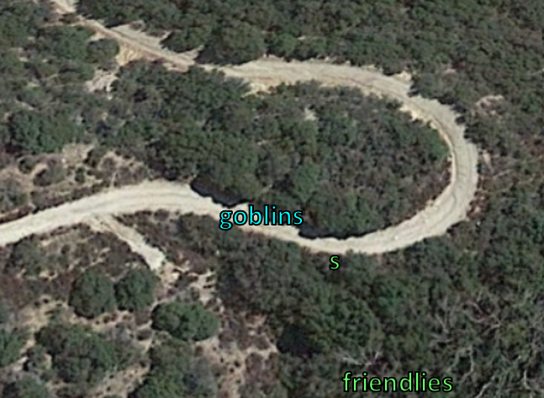

Saradette could see two goblins now talking, facing one another as they stood about 30’ northwest of her. If she moved any further, she would no longer be behind the concealment of the thickly wooded forest, and would be on the southern edge of the road wide enough for two wagons.

About 40’ to the south, her allies conferred quietly.

“I’ll probably summon some giant beetles,” Tore whispered in answer to Thoroughmad’s question about tactics.

“Sounds good,” said the ranger. “We should try to subdue one to get some intel, if possible.”

As they waited, Tore suggested, “I could go up that other trail west of the goblins and draw their attention. They may not sound the alarm for a lone cleric. Once they come after me, I can call forth the beetle and you can all jump them, taking one of both prisoner if possible.”

Carthage, Redvelvet, Viola, and Thoroughmad looked crookedly at Tore, wondering if he knew something of his gnome friend’s tactics that they didn’t.

Round 1

Saradette headed back to the others the way she came in.

Viola asked for the information that Saradette intended to share, and now did.

“Only two then,” Thoroughmad seemed to state, though he was asking for confirmation.

“Yes,” Saradette shrugged, “as far as I could tell. And-” she was about to describe their weaponry, but stopped as she and others heard the goblins approaching.

Round 2

The heroes were all already crouching, and remained so as the goblins made their way east and then northeast along the winding road.

Once their voices gave them away as being far enough away, Carthage asked, “Any of you speak Goblinoid?”

Saradette nodded, “They were talking about being paid in ale rations, while others were being paid in gold, *and* being given ale along with their food.”

“In a disgruntled way, I take it?” Redvelvet smirked.

Round 3

The gnome again nodded, realizing she would likely have been made if she hadn’t turned back to rejoin the others. The goblins had probably finished rounding the bend on their continued patrol, and they contemplated whether to follow these two or do something else.

With the goblins moving off, Tore asked, “Should we follow them, or head the other direction down the trail?”

Saradette thought for a moment. “I’d like to take these out, but it might draw more of them to us.”

Round 4

“Well,” Tore replied, “if we take them out quickly, we can set an ambush for the others.”

Saradette nodded. “Then we need to act quickly to overwhelm them.”

Round 5

Redvelvet showed part of her origin story as she stated her position, “I—for one—would ensure that a pair of goblins—let alone a whole pack of’em—don’t live to see sunset.” Then she considered, “However, the more information we can get out of them before we end them, the better.”

“I don’t think we should risk them raising an alarm,” Saradette replied.

Round 6

Tore disagreed, “I think we should take them out now, we wait any longer we lose the chance. Even if they do raise the alarm, we will have time to prepare for any attack.”

Redvelvet nodded, and sided with Tore.

Round 7

Saradette patted her blaster. “I can hit them without fail, but the shots may not kill them. I suggest that we divide them up among us and attack all at once.”

“Well then,” Tore replied, “let’s get moving. You,” he said and looked at Saradette, “take the one on the right with the others. Redvelvet and I will take the one on the left. If they are walking in a row, Redvelvet and I will go after the lead one, you guys take the trailer.”

Saradette nodded and drew her blaster. “Let me walk ahead of you and get settled first. When I shoot, you all shoot.”

Leading the way through the woods and then up the road, the gnome was hoping to be able to rush the goblins from behind or open fire once they were in sight.

Tore followed close behind and kept his smaller comrade in view, ready to cast his spell.

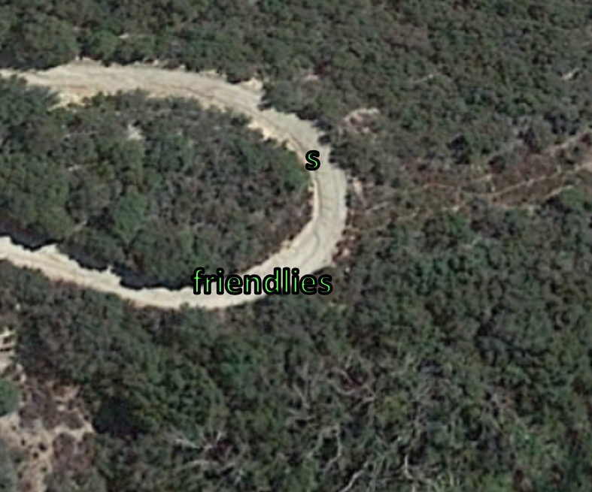

Saradette walked about 20’ ahead of the others for the moment, and though she could faintly hear the movement of the goblins, they’d likely stopped talking as they resumed their patrol.

They continued to follow her for another twelve seconds. The gnome walked to the outside of the turn and carefully moved forward, looking for the goblins.

Tore kept his distance, but was ready to cast his *summon monster II* spell.

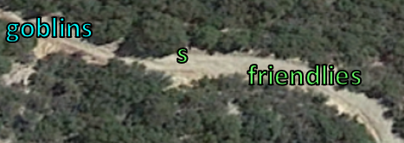

Saradette finally spotted them at the moment that one of them heard her sneaking up from behind. At a distance of 50’, the leftmost goblin turned around, but did not see the gnome who had ducked back behind a bush.

Tore saw the gnome’s sudden dash behind a bush and knew the goblins were not far. The unstealthy human moved to the southern edge of the trail, making his way along slowly along the tree line, trying to stay out of sight.

|  |  |  |  |  |  |  |
| --- | --- | --- | --- | --- | --- | --- |
| **Skill** | **Rank** | **Ability & Mod.** | **Misc. Mods.** | **Total** | **Roll** | **Check** |
| **Move Silently** | 0 | **Dex (+2)** | -1 | 1 | 10ish | ?? |

|  |  |  |  |  |
| --- | --- | --- | --- | --- |
| **Character** | **Check** | **Ranks** | **Roll** | **Result** |
| Goblin | Listen | 6 | ?? | ?? |

*See below.*

Redvelvet and Carthage followed close behind, worried that the cleric might be thwarting the rogue’s attempts at surprising the goblins on patrol.

The priest caught up to Saradette, and spotted one of the goblins, who wasn’t about to ignore the sound of twiceling footsteps behind him. The goblin had backtracked a few steps, and now pointed a light crossbow at Tore, firing as the priest cast *summon monster II [expired on Round 15 (converted to Round 7 below)]*.

|  |  |  |  |  |  |  |  |  |  |
| --- | --- | --- | --- | --- | --- | --- | --- | --- | --- |
| **Character** | **Attack Type** | **Damage** | **BAB** | **Str**  **Mod+** | **Dex**  **Mod+** | **W+** | **Total**  **Score** | **Roll** | **Total** |
| Goblin Rogue | MW Light Crossbow | 1d6 | 3 | 0 | 2 | 1 | 6 | **20** | 26 |

*Threat. 1d20 = 4 + 6 = 10, not a critical hit. Dmg: 3.*

<< Humansss! >> Saradette understood the goblin yelling out in Goblinoid as he reloaded, satisfied with the bolt that lodged itself into Tore’s left arm.

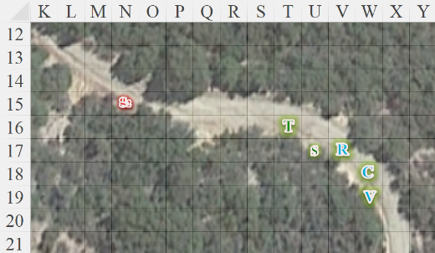

Round 1

|  |  |  |  |  |  |
| --- | --- | --- | --- | --- | --- |
| **Character** | **Group** | **Initiative** | **Roll** | **Modified**  **Roll** | **Speed** |
| Redvelvet | 1 | 3 | 10 | 13 | 30’ |
| Saradette | 1 | 3 | 8 | 11 | 20’ |
| Carthage | 1 | 7 | 3 | 10 | 30’ |
| Goblins | 2 | 2 | 7 | 9 | 20’ |
| Viola | 1 | 0 | 7 | 7 | 30’ |
| Tore | 1 | 2 | 1 | 3 | 30’ |

Seeing Tore get shot, Redvelvet activated her Aura of Toughness, bestowing upon her allies its benefits.

*Friendlies gain DR 2 against all damage.*

The dragon shamaness then made way for the goblins, drawing her shortspear.

Saradette stepped into view, lifted her gauntleted right hand, pointed, and fired on the goblin with the crossbow.

|  |  |  |
| --- | --- | --- |
| **Ranged Weapon** | **Dmg.** | **Notes** |
| Glove of Lightning Bolt | 5d6 Electric | Ref DC 16 for ½; melts most metals |

*Dmg: 17 electric.*

|  |  |  |  |  |
| --- | --- | --- | --- | --- |
| **Character** | **Save vs.**  *lightning bolt* | **Ranks** | **Roll** | **Result** |
| Goblin Warrior | Reflex | 3 | 3 | 6 |

*Fail.*

And that took care of the first goblin, but the second one could already be heard behind a bush fumbling with his weapon.

Carthage came forth to join the others, seeing the goblin fall, hearing the other one, and casting *true strike* in anticipation of more coming around the corner.

The second goblin from this patrol could now be heard running away.

Viola deferred for the moment.

Tore managed to summon two Celestial beetles, and had placed them conveniently adjacent to the goblin that Tore commanded them to attack.

|  |  |  |  |  |  |  |  |  |
| --- | --- | --- | --- | --- | --- | --- | --- | --- |
| **Character** | **Attack Type** | **Damage** | **BAB** | **Str Mod+** | **Dex Mod+** | **Total Score** | **Roll** | **Total** |
| Celestial beetle | Bite | 1d4+1 | 1 | 1 | 1 | 2 | 14 | 16 |
| Celestial beetle | Bite | 1d4+1 | 1 | 1 | 1 | 2 | 1 | 3 |

*Hit, miss. Dmg: 4 + 1 = 5.*

Tore readied his shield *[move action]*, and advanced *[move action, DM interprets this to be at 2x speed]*, barely spotting the other goblin before it wound further around the bend, and trying to get north or northwest of the goblins current position.

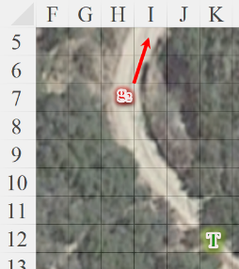

*Line of sight lost by end of round*

Viola moved to stay in tandem with Redvelvet, who seemed to know what she was doing.

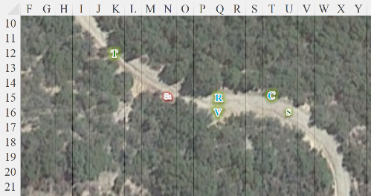

Round 2

Redvelvet followed after Tore, spear in hand, manifesting an Aura of Senses for the moment.

Saradette activated her Ring of Flying and went after Tore, climbing to just over the 15’ treetops as she went.

Carthage also briskly paced westward around the bend, seeing no goblins about.

The fugitive goblin probably continued to book.

Viola kept up with the others, unable to see any enemies.

Tore activated his armor’s magical wings, then flew upwards and above the brush and small trees, not yet spotting the runaway goblin.

<< Humannsss! >> the goblin yelled out in the distance, alerting his platoon to the humanoids who had just killed his friends.

Following his ears, the cleric then saw the goblin making way north and downhill towards an encampment. He planned his next action, realizing that he had just been spotted by at least a few soldiers in the encampment.

The beetles remained in place.

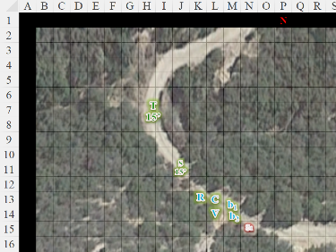

Round 3

<< Huuuumannnssss! >> several captains called out as a few dozen goblins began to mobilize.

Redvelvet continued to make way along the trail.

Saradette continued to fly after Tore.

Once in the air, Tore headed north, flying as far as he could in search of the goblin they were following and any that might have heard its call. As he flew upwards from an altitude of 15’ to 25’, Tore commanded his beetles to chase after the goblin with hostile intentions. He positioned himself for a peregrine falcon-styled swoop down upon the fleeing goblin as dozens of his friends prepared to fire on the cleric.

Carthage, Viola, and the beetles kept up with Redvelvet.

The goblins attacked Tore, mostly with crossbows. Some took cover behind the eleven pitched tents and some mastiff mounts, while others shot and reloaded from out in the open.

|  |  |  |  |  |  |  |  |  |  |  |
| --- | --- | --- | --- | --- | --- | --- | --- | --- | --- | --- |
| **Character** | **Attack Type** | **Damage** | **BAB** | **Str Mod+** | **Dex Mod+** | **W+** | **Other+** | **Total Score** | **Roll** | **Total** |
| Goblin Chieftainess | Dart +1 | 1d3+1+1 | 6 | 1 | 3 | 1 | -2 height  -2 range | 6 | 14 | 20 |
| Goblin Ranger | Heavy Crossbow | 1d8+2 | 4 | 2 | 1 | 1 | -2 height | 4 | 8 | 12 |
| Goblin Rogue | MW Light Crossbow | 1d6 | 3 | 0 | 2 | 1 | -2 | 4 | 5 | 9 |
| Goblin Warrior | Light Crossbow | 1d6+1 | 1 | 1 | 0 | 0 | -2 | -1 | **20** | 19 |
| Goblin Ranger | Heavy Crossbow | 1d8+2 | 4 | 2 | 1 | 1 | -2 | 4 | 5 | 9 |
| Goblin Warrior | Light Crossbow | 1d6+1 | 1 | 1 | 0 | 0 | -2 | -1 | 15 | 14 |
| Goblin Warrior | Light Crossbow | 1d6+1 | 1 | 1 | 0 | 0 | -2 | -1 | 17 | 16 |
| Goblin Warrior | Light Crossbow | 1d6+1 | 1 | 1 | 0 | 0 | -2 | -1 | 17 | 16 |
| Goblin Warrior | Light Crossbow | 1d6+1 | 1 | 1 | 0 | 0 | -2 | -1 | 2 | 1 |
| Goblin Warrior | Light Crossbow | 1d6+1 | 1 | 1 | 0 | 0 | -2 | -1 | 11 | 10 |
| Goblin Warrior | Light Crossbow | 1d6+1 | 1 | 1 | 0 | 0 | -2 | -1 | 16 | 15 |
| Goblin Warrior | Light Crossbow | 1d6+1 | 1 | 1 | 0 | 0 | -2 | -1 | 2 | 1 |
| Goblin Warrior | Light Crossbow | 1d6+1 | 1 | 1 | 0 | 0 | -2 | -1 | 1 | 0 |
| Goblin Warrior | Light Crossbow | 1d6+1 | 1 | 1 | 0 | 0 | -2 | -1 | 11 | 10 |

*Miss, miss, miss, threat, miss, miss, miss, miss, miss, miss, miss, miss, miss, miss. 1d20 = 14 + (-1) = 13, not a critical hit.*

*Dmg: 2 + 1 = 3 [68/71].*

More goblins emerged from within tents as others reloaded, and the next volley would surely be less forgiving.

Redvelvet switched back from her Aura of Senses to her Aura of Toughness, protecting those near her as Tore flinched from the one bolt that got him good as others whizzed by or ricocheted off of his *luminous armor*.

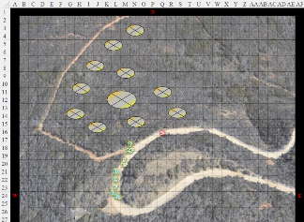

Round 4

Redvelvet, Carthage, and Viola hastened their pace until they got a line of sight to some of the tents.

Saradette spotted the goblins closest to her, slowed down to stop moving, and fired her gauntlet at one that was emerging from one of the eleven tents.

|  |  |  |
| --- | --- | --- |
| **Ranged Weapon** | **Dmg.** | **Notes** |
| Glove of Lightning Bolt | 5d6 Electric | Ref DC 16 for ½; melts most metals |

*Dmg: 18 electric.*

|  |  |  |  |  |
| --- | --- | --- | --- | --- |
| **Character** | **Save vs.**  *lightning bolt* | **Ranks** | **Roll** | **Result** |
| Goblin Rogue | Reflex | 5 | 12 | 17 |

*Success. Saved for ½ damage.*

*Dmg: ½ x 18 = 9 electric.*

Tore rose to 35’ above the ground and shifted to his right before casting *Ayailla’s radiant burst* at a cluster of goblins *[N14:O15]*.

|  |  |  |  |  |
| --- | --- | --- | --- | --- |
| **Character** | **Save vs.**  *Ayailla’s radiant burst* | **Ranks** | **Roll** | **Result** |
| Goblin Chieftainess | Fortitude | 4 | 6 | 10 |
| Goblin Samurai | Fortitude | 8 | 3 | 11 |
| Goblin Ranger 2 | Fortitude | 8 | 7 | 15 |
| Goblin Rogue 1 | Fortitude | 2 | 3 | 5 |
| Goblin Warrior 6 | Fortitude | 2 | 16 | 18 |

*Fail, fail, success, fail, success. Ranger 2 and Warrior 6 save for half damage and negate blindness.*

*Dmg to Chieftainess: 18 good.*

*Dmg to Samurai: 14 good.*

*Dmg to Ranger 2: ½ x 7 = 3 good.*

*Dmg to Rogue 1: 18 good.*

*Dmg to Warrior 6: ½ x 15 = 7 good.*

*Tore suffered -1 Str.*



The rogue goblin that Tore had hit died, and the others were pretty badly hurt.

The goblins that could attack did so.

|  |  |  |  |  |  |  |  |  |  |  |
| --- | --- | --- | --- | --- | --- | --- | --- | --- | --- | --- |
| **Character** | **Attack Type** | **Damage** | **BAB** | **Str Mod+** | **Dex Mod+** | **W+** | **Other+** | **Total Score** | **Roll** | **Total** |
| Goblin Chieftain | Dart +2 | 1d3+2+1 | 7 | 1 | 3 | 2 | -2 altitude | 10 | 8 | 18 |
| Goblin Chieftainess | Dart +1 | 1d3+1+1 | 6 | 1 | 3 | 1 | -2 altitude | 8 | 8 | 16 |
| Goblin Chieftainess | Dart, 2nd Throw | 1d3+1+1 | 1 | 1 | 3 | 1 | -2 altitude | 3 | 1 | 4 |
| Goblin Ranger | Heavy Crossbow | 1d8+2 | 4 | 2 | 1 | 1 | -2 altitude | 4 | 10 | 14 |
| Goblin Ranger | Heavy Crossbow | 1d8+2 | 4 | 2 | 1 | 1 | -2 altitude | 4 | 4 | 8 |
| Goblin Ranger | Heavy Crossbow | 1d8+2 | 4 | 2 | 1 | 1 | -2 altitude  -2 range | 2 | 1 | 3 |
| Goblin Ranger | Heavy Crossbow | 1d8+2 | 4 | 2 | 1 | 1 | -2 altitude | 4 | 16 | 20 |
| Goblin Rogue | MW Light Crossbow | 1d6 | 3 | 0 | 2 | 1 | -2 altitude | 4 | 5 | 9 |
| Goblin Rogue | MW Light Crossbow | 1d6 | 3 | 0 | 2 | 1 | -2 altitude | 4 | 15 | 19 |
| Goblin Rogue | MW Light Crossbow | 1d6 | 3 | 0 | 2 | 1 | -2 altitude | 4 | 16 | 20 |
| Goblin Rogue | MW Light Crossbow | 1d6 | 3 | 0 | 2 | 1 | -2 altitude | 4 | 18 | 22 |
| Goblin Rogue | MW Light Crossbow | 1d6 | 3 | 0 | 2 | 1 | -2 altitude | 4 | 16 | 20 |
| Goblin Rogue | MW Light Crossbow | 1d6 | 3 | 0 | 2 | 1 | -2 altitude  -2 range | 2 | 9 | 11 |
| Goblin Rogue | MW Light Crossbow | 1d6 | 3 | 0 | 2 | 1 | -2 altitude  -2 range | 2 | 11 | 13 |
| Goblin Rogue | MW Light Crossbow | 1d6 | 3 | 0 | 2 | 1 | -2 altitude | 4 | 13 | 17 |
| Goblin Warrior | Light Crossbow | 1d6+1 | 1 | 1 | 0 | 0 | -2 altitude | -1 | 2 | 1 |
| Goblin Warrior | Light Crossbow | 1d6+1 | 1 | 1 | 0 | 0 | -2 altitude | -1 | 14 | 14 |
| Goblin Warrior | Light Crossbow | 1d6+1 | 1 | 1 | 0 | 0 | -2 altitude | -1 | 18 | 17 |
| Goblin Warrior | Light Crossbow | 1d6+1 | 1 | 1 | 0 | 0 | -2 altitude | -1 | 3 | 2 |
| Goblin Warrior | Light Crossbow | 1d6+1 | 1 | 1 | 0 | 0 | -2 altitude | -1 | 17 | 16 |
| Goblin Warrior | Light Crossbow | 1d6+1 | 1 | 1 | 0 | 0 | -2 altitude  -2 range | -3 | 7 | 4 |
| Goblin Warrior | Light Crossbow | 1d6+1 | 1 | 1 | 0 | 0 | -2 altitude | -1 | 13 | 12 |
| Goblin Warrior | Light Crossbow | 1d6+1 | 1 | 1 | 0 | 0 | -2 altitude | -1 | 10 | 9 |
| Goblin Warrior | Light Crossbow | 1d6+1 | 1 | 1 | 0 | 0 | -2 altitude | -1 | 16 | 15 |
| Goblin Warrior | Light Crossbow | 1d6+1 | 1 | 1 | 0 | 0 | -2 altitude  -2 range | -3 | 18 | 15 |
| Goblin Warrior | Light Crossbow | 1d6+1 | 1 | 1 | 0 | 0 | -2 altitude | -1 | 16 | 15 |
| Goblin Warrior | Light Crossbow | 1d6+1 | 1 | 1 | 0 | 0 | -2 altitude  -2 range | -3 | 10 | 7 |
| Goblin Warrior | Light Crossbow | 1d6+1 | 1 | 1 | 0 | 0 | -2 altitude | -1 | 12 | 11 |
| Goblin Warrior | Light Crossbow | 1d6+1 | 1 | 1 | 0 | 0 | -2 altitude | -1 | 11 | 10 |
| Goblin Warrior | Light Crossbow | 1d6+1 | 1 | 1 | 0 | 0 | -2 altitude | -1 | 17 | 16 |

*No hits.*

More goblins came out of tents, most of them already armed, and prepared to take down Tore, Saradette, and the others who were now coming into the scene. Assault mastiffs were mounted and mobilized, and within seconds would be on trajectories towards the land-borne intruders.

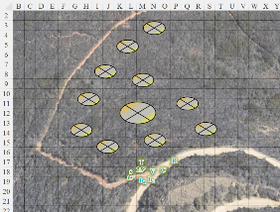

Round 5

With a good line of attack to the Chieftainess’ tent, and several of them standing in front of one another, Redvelvet moved 5’ to maximize her number of targets, and vomited a 60’ line of acid that doused her posse as the Chieftain and his own entourage took warning.

|  |  |  |  |
| --- | --- | --- | --- |
| **Ranged Weapon** | **Dmg.** | **D+** | **Rng.** |
| Breath Weapon (line of acid) | 6d6 | +1d6 | 60’ |

*DC 10 + 2 focus + 5.*

|  |  |  |  |  |
| --- | --- | --- | --- | --- |
| **Character** | **Save vs.**  Breath Weapon | **Ranks** | **Roll** | **Result** |
| Goblin Chieftainess | Reflex | 6 | 12 | 18 |
| Goblin Samurai | Reflex | 4 | 7 | 11 |
| Goblin Ranger 2 | Reflex | 6 | 18 | 24 |
| Goblin Rogue 3 | Reflex | 5 | 16 | 21 |
| Goblin Rogue 4 | Reflex | 5 | 17 | 22 |
| Goblin Warrior 3 | Reflex | 1 | 12 | 13 |
| Goblin Warrior 5 | Reflex | 1 | 3 | 4 |
| Goblin Warrior 6 | Reflex | 1 | 5 | 6 |

*Success, fail, success, success, success, fail, fail, fail.*

*Goblin Chieftainess, Ranger 2, and Rogues 3 & 4 saved for ½ damage.*

*Dmg to Chieftainess: ½ x 24 = 12 acid.*

*Dmg to Samurai: 27 acid.*

*Dmg to Ranger 2: ½ x 29 = 14 acid.*

*Dmg to Rogue 3: ½ x 32 = 16 acid.*

*Dmg to Rogue 4: ½ x 27 = 13 acid.*

*Dmg to Warrior 3: 33 acid.*

*Dmg to Warrior 5: 31 acid.*

*Dmg to Warrior 6: 25 acid.*

Redvelvet was now emanating her Aura of Toughness, and all of her friends were once again within it, and would thus have an added layer of protection against the goblins’ bolts and maces.

The groups only samurai died from the acid, as did the three warriors standing between the samurai and the dragon shamaness. This should have demoralized the rest, but it seemed to throw them into an indignant rage.

*Map after Redvelvet’s 5’ step.*

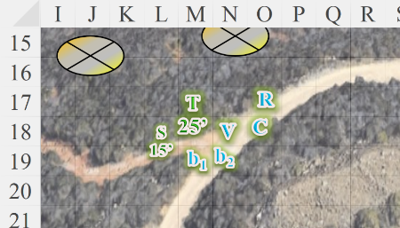

Saradette muttered darkly to herself as she recognized the adroitness of a fellow rogue. She shifted her aim to one of the heavy crossbow wielders and zapped him with her glove.

|  |  |  |  |
| --- | --- | --- | --- |
| **Ranged Weapon** | **Dmg.** | **Rng.** | **Notes** |
| Glove of Lightning Bolt | 5d6 Electric | 120’ | Ref DC 16 for ½; melts most metals |

*Base dmg: 21 electric.*

|  |  |  |  |  |
| --- | --- | --- | --- | --- |
| **Character** | **Save vs.**  *lightning bolt* | **Ranks** | **Roll** | **Result** |
| Goblin Ranger 1 | Reflex | 6 | 16 | 22 |

*Success. Saved for ½ damage.*

*Dmg: ½ x 21 = 10 electric.*

The ranger flinched and felt the need to avenge such an injury. Firing upon her, then beginning to reload.

|  |  |  |  |  |  |  |  |  |  |
| --- | --- | --- | --- | --- | --- | --- | --- | --- | --- |
| **Character** | **Attack Type** | **Damage** | **BAB** | **Dex Mod+** | **W+** | **Other+** | **Total Score** | **Roll** | **Total** |
| Goblin Ranger 1 | Heavy Crossbow | 1d8+2 | 4 | 1 | 1 | -2 height | 4 | 16 | 20 |

*Miss.*

Carthage targeted that same stalwart ranger, and zapped him and all those near him with a Shaped *rainbow blast* that spread out conically instead of linearly.

*Base dmg to all affected: 8 acid + 4 cold + 6 electric + 1 fire + 7 sonic = 26.*

|  |  |  |  |  |
| --- | --- | --- | --- | --- |
| **Character** | **Save vs.**  *rainbow blast* | **Ranks** | **Roll** | **Result** |
| Goblin Chieftainess | Reflex | 6 | 3 | 9 |
| Goblin Samurai | Reflex | 4 | 10 | 14 |
| Goblin Ranger 1 | Reflex | 6 | 9 | 15 |
| Goblin Rogue 2 | Reflex | 5 | 12 | 17 |
| Goblin Warrior 2 | Reflex | 1 | 20 | 21 |
| Mastiff 1 | Reflex | 5 | 13 | 18 |
| Goblin Ranger 3 | Reflex | 6 | 10 | 16 |
| Goblin Rogue 3 | Reflex | 5 | 9 | 14 |
| Goblin Warrior 4 | Reflex | 1 | 7 | 8 |
| Mastiff 2 | Reflex | 5 | 3 | 8 |
| Goblin Rogue 5 | Reflex | 5 | 2 | 7 |
| Goblin Warrior 11 | Reflex | 1 | 19 | 20 |
| Mastiff 3 | Reflex | 5 | 18 | 23 |

*Warrior 2 and mastiff 3 saved for ½ damage.*

*Dmg to warrior 2 and mastiff 3: 4 acid + 2 cold + 3 electric + 1 fire + 3 sonic = 13.*

That not only killed the reloading ranger, but a good handful of his friends as well.

<< Fire at willlll! >> Saradette could understand the Chieftain shouting as his bride and her contingent were assailed by these fleshy humanoids.

The bulk of the goblins attacked every enemy in sight. The rest mounted up and prepared to get some use out of their maces and flails.

|  |  |  |  |  |  |  |  |  |  |  |
| --- | --- | --- | --- | --- | --- | --- | --- | --- | --- | --- |
| **Character** | **Attack Type** | **Damage** | **BAB** | **Dex Mod+** | **W+** | **Other+** | **Total Score** | **Roll** | **Total** | **Targeting** |
| Goblin Chieftain | Dart +1 | 1d3+1+1 | 6 | 3 | 1 | 0 | 10 | 1 | 11 | Tore |
| Goblin Chieftain | Dart, 2nd Throw | 1d3+1+1 | 1 | 3 | 1 | 0 | 5 | 11 | 16 | Tore |
| Goblin Chieftainess | Dart +1 | 1d3+1+1 | 6 | 3 | 1 | 0 | 10 | 2 | 12 | Saradette |
| Goblin Chieftainess | Dart, 2nd Throw | 1d3+1+1 | 1 | 3 | 1 | 0 | 5 | 5 | 10 | Saradette |
| Goblin Ranger 3 | Heavy Crossbow | 1d8+2 | 4 | 1 | 1 | 0 | 6 | 17 | 23 | Saradette |
| Goblin Rogue | MW Light Crossbow | 1d6 | 3 | 2 | 1 | 0 | 6 | 9 | 15 | Saradette |
| Goblin Warrior | Light Crossbow | 1d6+1 | 1 | 0 | 0 | 0 | 1 | 18 | 19 | Carthage |
| Goblin Warrior | Light Crossbow | 1d6+1 | 1 | 0 | 0 | 0 | 1 | 13 | 14 | Carthage |
| Goblin Warrior | Light Crossbow | 1d6+1 | 1 | 0 | 0 | 0 | 1 | 19 | 20 | Carthage |
| Goblin Warrior | Light Crossbow | 1d6+1 | 1 | 0 | 0 | 0 | 1 | 15 | 16 | Redvelvet |
| Goblin Warrior | Light Crossbow | 1d6+1 | 1 | 0 | 0 | 0 | 1 | 6 | 7 | Redvelvet |
| Goblin Warrior | Light Crossbow | 1d6+1 | 1 | 0 | 0 | 0 | 1 | 18 | 19 | Redvelvet |
| Goblin Warrior | Light Crossbow | 1d6+1 | 1 | 0 | 0 | 0 | 1 | 12 | 13 | Viola |
| Goblin Warrior | Light Crossbow | 1d6+1 | 1 | 0 | 0 | 0 | 1 | 5 | 6 | Viola |
| Goblin Warrior | Light Crossbow | 1d6+1 | 1 | 0 | 0 | 0 | 1 | 9 | 10 | Viola |
| Goblin Warrior | Light Crossbow | 1d6+1 | 1 | 0 | 0 | 0 | 1 | 9 | 10 | Tore |
| Goblin Warrior | Light Crossbow | 1d6+1 | 1 | 0 | 0 | 0 | 1 | 4 | 5 | Tore |
| Goblin Warrior | Light Crossbow | 1d6+1 | 1 | 0 | 0 | 0 | 1 | 12 | 13 | Tore |
| Goblin Warrior | Light Crossbow | 1d6+1 | 1 | 0 | 0 | 0 | 1 | 13 | 14 | Saradette |
| Goblin Warrior | Light Crossbow | 1d6+1 | 1 | 0 | 0 | 0 | 1 | 4 | 5 | Saradette |
| Goblin Warrior | Light Crossbow | 1d6+1 | 1 | 0 | 0 | 0 | 1 | 20 | 21 | Saradette |
| Goblin Warrior | Light Crossbow | 1d6+1 | 1 | 0 | 0 | 0 | 1 | 5 | 6 | Carthage |
| Goblin Warrior | Light Crossbow | 1d6+1 | 1 | 0 | 0 | 0 | 1 | 18 | 19 | Carthage |
| Goblin Warrior | Light Crossbow | 1d6+1 | 1 | 0 | 0 | 0 | 1 | 11 | 12 | Redvelvet |
| Goblin Warrior | Light Crossbow | 1d6+1 | 1 | 0 | 0 | 0 | 1 | 3 | 4 | Redvelvet |
| Goblin Warrior | Light Crossbow | 1d6+1 | 1 | 0 | 0 | 0 | 1 | 17 | 18 | Viola |

*1 critical hit vs. Saradette. 1d20 = 1, not a critical hit.*

*Dmg to Saradette: 3 + 1 = 4. Partial damage negated [due to Redvelvet’s Aura of Toughness] [51/53].*

Before they dispersed, Viola cast *holy smite*, centering it on one of the unfortunate mastiffs who happened to be central to the largest clustering of goblins.

*Base dmg to each goblin: 18 good + blindness.*

|  |  |  |  |  |
| --- | --- | --- | --- | --- |
| **Character** | **Save vs.**  *holy smite* | **Ranks** | **Roll** | **Result** |
| Goblin Chieftain | Will | 8 | 11 | 19 |
| Goblin Ranger 3 | Will | 4 | 1 | 5 |
| Goblin Ranger 4 | Will | 4 | 17 | 21 |
| Goblin Rogue 4 | Will | 1 | 3 | 4 |
| Goblin Rogue 7 | Will | 1 | 14 | 15 |
| Goblin Rogue 8 | Will | 1 | 7 | 8 |
| Goblin Warrior 2 | Will | 0 | 8 | 8 |
| Goblin Warrior 7 | Will | 0 | 12 | 12 |
| Goblin Warrior 9 | Will | 0 | 11 | 11 |
| Goblin Warrior 10 | Will | 0 | 12 | 12 |
| Goblin Warrior 12 | Will | 0 | 8 | 8 |
| Goblin Warrior 13 | Will | 0 | 19 | 19 |
| Goblin Warrior 15 | Will | 0 | 19 | 19 |
| Goblin Warrior 16 | Will | 0 | 12 | 12 |
| Goblin Warrior 17 | Will | 0 | 20 | 20 |
| Goblin Warrior 18 | Will | 0 | 4 | 4 |
| Goblin Warrior 19 | Will | 0 | 9 | 9 |
| Goblin Warrior 20 | Will | 0 | 19 | 19 |
| Goblin Warrior 21 | Will | 0 | 10 | 10 |
| Goblin Warrior 22 | Will | 0 | 3 | 3 |
| Goblin Warrior 24 | Will | 0 | 12 | 12 |

*Success, fail, success, fail, fail, fail, fail, fail, fail, fail, fail, success, success, fail, success, fail, fail, success, fail, fail, fail, success.*

*Chieftain; ranger 4; and warriors 13, 15, 17, and 20 saved for ½ damage (9 good) and negated blindness.*

*All mastiffs are Neutral, damage inapplicable.*

Viola’s spell sewed discord amongst the ranks of the goblins. Their Chieftainess was dead, and though their Chieftain was still standing, and not blinded, his underlings were ill-prepared to deal with what these humanoids still had left to deliver. Mastiffs meandered as their blind and injured riders writhed with pain; others simply died where they were, and fell off their saddles. A few mastiffs even bolted away, seeing the long-awaited opportunity to flee this whole goblin business.

With only about 12 seconds left to exist, the beetles could now see the frontmost goblins through the bushes and among their dozen or so tents.

Tore directed his beetles to charge the closest goblin to them.

|  |  |  |  |  |  |  |  |
| --- | --- | --- | --- | --- | --- | --- | --- |
| **Character** | **Attack Type** | **Damage** | **BAB** | **Str Mod+** | **Total Score** | **Roll** | **Total** |
| Celestial beetle | Bite | 1d4+1 | 1 | 1 | 2 + 2 charge | 15 | 19 |
| Celestial beetle | Bite | 1d4+1 | 1 | 1 | 2 + 2 charge | 14 | 18 |

*Hit, hit.*

*Dmg to warrior 13: 2 + 1 + 2 = 5.*

*Dmg to warrior 17: 1 + 1 + 2 = 4.*

One of the two already wounded warriors died, while the other got really close to that moment.

Tore then pulled an arrow and fired at the goblin Chieftian, firing as many arrows as he could while hovering.

|  |  |  |  |  |  |  |  |  |  |
| --- | --- | --- | --- | --- | --- | --- | --- | --- | --- |
| **Ranged Weapon** | **Dmg.** | **D+** | **TH+** | **Critical** | **Rng.** | **Wt.** | **Atk** | **Roll** | **Check** |
| Longbow +1 | 1d8 | 1 | 1 + 1 height | x3 | 100’ | 3.0 | +12 | **20** | 32 |
| Longbow, 2nd Shot | 1d8 | 1 | 1 + 1 height | x3 | 100’ | - | +7 | 17 | 24 |

*Threat, hit. 1d20 = 5 + 12 = 17, not a critical hit. Dmg: (7 + 1) + (4 + 1) = 8 + 5 = 13.*

With an arrow sticking out of his arm, the Chieftain, proclaimed, << Retreeeatt! >> and with this the remaining goblins fled northward and downhill, either atop mastiffs or on foot. The Chieftain himself—no longer having the hefty samurai around to heft him—let his own feet carry him as he joined the stampede.

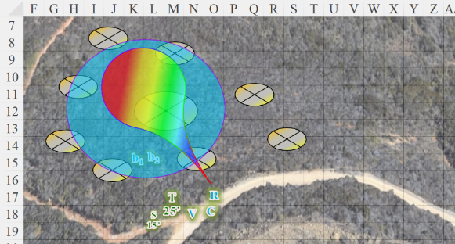

Round 6

Redvelvet ululated a zagarit of excitement as they caused their enemies to flee like deer before hounds. She then took a gratuitous potshot at the closest fugitive.

|  |  |  |  |  |  |  |  |  |  |
| --- | --- | --- | --- | --- | --- | --- | --- | --- | --- |
| **Ranged Weapon** | **Dmg.** | **D+** | **TH+** | **Critical** | **Rng.** | **Wt.** | **Atk** | **Roll** | **Check** |
| Returning Shortspear +2 | 1d6 | +5 +2 +2 | 2 | x3 | 10’ | 9.0 | 14 | 16 | 30 |

*Hit. Dmg: 3 + 5 + 2 + 2 = 12.*

The spear went through the woman warrior, then boomeranged back to Redvelvet’s hand as the warrior collapsed.

Saradette held her fire, preferring to use her limited supply of shots on attacking targets, not retreating foes.

Carthage also stayed her casting hand, preferring to conserve her mana for the rest of the day’s challenges.

The goblins fled in terror, having been halved in number in the span of a few seconds. Those that were dead or twitching on the ground dying posed no threat to the group, and as Tore began to descend, it became evident that these evildoers would not be regrouping for a vengeful reprise; they would likely make it to yonder hills and eke out a bleak existence as a dishonored band of ne’er-do-wells who couldn’t keep it together.

Tore had his beetles continue to chase the goblins.

Viola sang a lyrical song of praise to Lliira, expressing her gratitude for the deity’s favors, which dealt the decisive blow unto the goblin forces.

Tore landed next to Redvelvet and nodded, “Some rather impressive moves.” He then deactivated the wings from the armor and watched the goblins as they fled.

“Yes, I acquired this spear in a ritual battle, and it has served me well ever since. I hardly ever have to resort to *this*,” she pointed to the crossbow slung across her back as she switched her Aura of Toughness out for her Aura of Senses.

*All friendlies gained +2 to Listen, Spot, and Initiative checks, and lost DR 2/— bonus.*

Carthage changed the subject, “That’s definitely not all the goblins that are reputed to be in the area. From the accounts of the townsfolk, there are twice as many goblinoids about.”

“Putting these to rights is a good start, though,” Redvelvet argued to press on and finish the job. “The other contingents are likely to have hobgoblins and other elite forces. This pack here,” she pointed northward towards the fleeing goblins, “seems like the least of what was described to us by Thoroughmad and the other Daggerfordians.”

“It’s fortunate that we didn’t set their tents on fire,” Carthage pointed out. “Perhaps we can find evidence left behind of the whereabouts of the rest of the goblin scourge.”

Saradette landed in the camp and proceeded to search the tents and bodies for anything of value.