*Chapter 38: Goblins Galore*

The tents had been searched, and among the handful of magic items, the dozens of mundane items, and a heap of trash and guts were a few clues as to the goblins’ intentions, and their associates’ whereabouts.

“They mean to pillage all of the towns surrounding Waterdeep,” Redvelvet spoke as she thought while they looked at a map marked with several Goblinoid symbols, which Saradette had translated as names followed by the word << Outpost >>. This was a typical goblin tactic in remote regions of the continent, but Waterdeep’s peripheries were hardly remote, and were populated in part by affluent and powerful recluses who would surely not stand for this. When a town fell, supply chains suffered, and good and services became scarce, so those who lived on vast private plots or in the patches of wilderness between the coastal metropolis and its smaller neighbors would surely do something to drive away the goblins.

This was a theory espoused by Viola and Carthage, at least.

“Or in some cases, a powerful hermit becomes so by virtue of wicked pursuits, and perhaps this is the exact profile of someone with the motive to enable the goblins to carry out their campaign. Some of these trinkets suggest it,” posed Redvelvet, pointing to some of the magic items on the ground, which likely boosted Charisma-based powers. “What *need* do goblins have for such things?”

“Neither the Chieftain nor Chieftainess were wearing them,” admitted Saradette. “They rule by force and might, and have all the charm they need.”

“Well, we have at least spoiled their plot in this area. We should continue our search for their larger group and the possible leader.” Tore looked around, “Any suggestions on where to start, or do we follow the trail left by the fleeing goblins?”

“The map should help,” Viola pointed to the markers for the other contingents, and to arrows that pointed to their convergence.

“Let’s head there,” Redvelvet grinned with closed lips. “I’m calling dibs on their leader.”

~*~

It took two hours to reach the convergence point, and with the help of the three local gals, they were able to approach it from a far less accessible but far more advantageous direction, well away from the easy inlets onto the plateau, and ensconced by clusters and colonies of cacti and succulents.

To exit this place without flying, they would have to backtrack, but while here, they would have a discrete position from which to survey all that took place on the plateau that was only about 40’ below their altitude.

By the time they’d arrived, a platoon of 40 or so hobgoblins had already set up camp in the center of the open-air mesa dotted by only a handful of trees and twice as many bushes. The area was about a quarter of a mile in diameter—over 1,200’—and the heroes how had only to wait for others to amass before taking them all by surprise.

Or... given their limited reserves for the remainder of the day, perhaps it was better to cut these ruffians down before reinforcements arrived, and hopefully have the opportunity to prepare a new plethora of divine favors and arcane spells for the next row of goblins.

They could identify one Poobah based on the hat, and a few Chieftains with smaller hats like those of the Chieftains they’d just vanquished, adjusted for the size of the towering hobgoblins who would surely prove a mightier threat than their predecessors.

Saradette leaned close to Tore. “What do you think? That’s a lot of them to take on without every spell we can muster.”

“We may end up with the element of surprise on our side. They likely won’t expect us to intercept them at that point.” Tore looked at the others, “Does anyone have a way of getting a message back to town? If so, perhaps we can ask them to send more support to meet us at the location.”

Saradette looked to see if they had a way out if they tried to attack the hobgoblins and they counterattacked. “It looks like flight is our best option out of here,” she sighed. “This causeway is the only land-based inlet, and by logic, outlet for us.”

Redvelvet was confident that their powers would be sufficient to bring down the goblinoid lot—at least the present platoons—but this was typical of dragon shamans and others whose might and prowess did not have to be replenished after a dozen or so exertions.

Carthage scoffed, “Speak for yourself, warrior. The only way we execute an offensive today... against *these* many... is with an ironclad escape plan.”

“The expeditious retreater has voiced her vote,” Redvelvet had to poke at the sorceress’ dignity.

Viola—a trained campfire diplomat—chimed in, “Sisters, and come—you too, brother—we mustn’t factionalize at a moment like this. If we’re casting votes, mine is to retreat, camp about a mile downwind, prepare for the heartiest offensive of the season, and come back to take this lot before they’re joined by others.”

“And what if they *are* joined by others?” asked Redvelvet. “Many more, and I’ll agree that it’s too impetuous a plan to just attack.”

“Is there not some way that we could use subterfuge to turn them against one another?” one of them posed, opening the conversation to topics of Transmutative magic, Enchantments, Illusions, and the like.

“We’ve a pretty limited repertoire of spells among us. Tore and Viola—both clerics—are the most versatile, but I only rock these powers:” Carthage listed each by scope of might, ascendingly.

|  |  |  |  |  |
| --- | --- | --- | --- | --- |
| **Spell** | **Level** | **School** | **Reference** | **Page** |
| Detect Magic | 0 | Universal | PHB | 219 |
| Detect Poison | 0 | Divination | PHB | 219 |
| Launch Bolt | 0 | Transmutation | Spell Compendium | 130 |
| Launch Item | 0 | Transmutation | Spell Compendium | 130 |
| Mage Hand | 0 | Transmutation | PHB | 249 |
| Ray of Frost | 0 | Conjuration | PHB | 269 |
| Read Magic | 0 | Universal | PHB | 269 |
| Sonic Snap | 0 | Evocation | Spell Compendium | 195 |
| Backbiter | 1 | Necromancy | Complete Arcane | 98 |
| Hail of Stone | 1 | Conjuration | Complete Arcane | 110 |
| Lesser Orb of Acid | 1 | Conjuration | Complete Arcane | 115 |
| Lesser Orb of Sound | 1 | Conjuration | Complete Arcane | 116 |
| True Strike | 1 | Divination | PHB | 296 |
| Combust | 2 | Evocation | Spell Compendium | 50 |
| Ice Knife | 2 | Conjuration | Tome & Blood | 112 |
| Web | 2 | Conjuration | PHB | 301 |
| Dragonskin | 3 | Transmutation | Spell Compendium | 73 |
| Rainbow Blast | 3 | Evocation | Spell Compendium | 165 |
| Orb of Acid | 4 | Conjuration | Complete Arcane | 115 |

Tore thought for a moment before replying. “I have used up my best offensive spells, though I do still have my weapons available. I agree that we should not charge into the fray, but I do not want to delay long. A short rest and good plan for an organized withdraw is a wise choice. Let us determine where to strike them that will allow us the best to do them harm and give us a good line of exodus should the tide turn against us.”

Unconcerned with the prospect of a druid’s flying spy acquiring them, they talked for a few more minutes—not long enough for the sun to sink into the horizon, though it soon would—and contemplated their longer-term plans. Their private spot couldn’t have been bigger than a 10’ x 15’ rhombus surrounded by a mélange of succulents and proper cacti reminiscent of those that thrived on Lantan, from where Saradette and Tore had escaped many tendays ago.

The 1,200’ circle beyond the 100’ or so of thickly vegetated slope constituting a 40’ height differential that provide the heroes with an ideal vantage to those who could not see them unless they were deliberate. On the other hand, there now flew a raven overhead, and if they did not do their best to hide in the next six seconds, they would surely be found out. Viola and Carthage spotted it, and the former pointed it out discretely to the others, suspecting it to be a minion of one of the goblin elites.

*[30% chance that the bird flies within 100’ + 80’ = 180’ of Tore. 1d100 = 80, see below.]*

“I’ll cast *hold animal* when the crow gets within range,” Tore whispered, also suggesting putting it in a sack and leaving it for its master to come looking for.

But the bird did not get less than 300’ from the cleric, and had surely made them by now.

Still, the hobgoblin horde did not mobilize, not just yet, anyway.

With the bird keeping its distance, Tore suggested, “We should get moving or prepare to be attacked, possibly surrounded. If the bird follows us, we can attempt to kill it or subdue it by going into more dense foliage, forcing it to come closer to spot us.”

“We should get moving,” Carthage—the most strategically balanced of the group—suggested, and Viola—the most strategically conservative—agreed. Redvelvet—the most ambitious among them—voiced no disapproval.

Tore preferred an area of thicker forest that could force the bird to get closer to them if it was truly tracking them, but their instincts told them that they were being watched, and as the crow circled back towards the encampment, they surmised that this was exactly what a druid or similar goblinoid would beckon it to do for its own safety.

Tore articulated this, adding, “There’s not much it would have to gain by spying on us further. It has sized us up, and while it cannot convey these details to its master, it *can* express a level of concern or distress about us that might trigger a more rigorous investigation.”

They made their way up and along the causeway, and just as they were about to make a run for the downward slope, Saradette spotted a trio of tall, slender hobgoblins patrolling the transversal path that circumvented the rim of the entire plateau.

The artificer flinched back behind the foliage that obfuscated their line of sight to the three patrolmen who were nonchalantly making their way over on a routine tour of the rim. They were talking calmly, and were still too far—about 100’—to be understood by Saradette.

Saradette made her way back to the others and spoke quietly. “Our way out is through those three. Once we raise the alarm, we will need to move quickly.”

Viola spoke: “And by ‘move quickly’, you mean that we must continuously outrun the hobgoblins and some of their mounts for an indefinite amount of time?”

Redvelvet miscalculated, “Perhaps we *can* take them all!”

Carthage shook her head, “Not likely. Do we have a means to cast *mass invisibility*, or a similar subterfuge?”

Saradette proposed: “If we are to die today, we should at least get a message back to Daggerford before we meet our doom. Do either of you have a *sending* spell prepared?”

The two clerics—the only two with that spell available to them—shrugged. Viola whispered, admitting, “I prepared my spells *before* I knew about today’s quest.”

“Me too,” Tore raised his empty hands a bit.

Tore looked in the direction of the voices, “We will need to take them out and take them out quickly. If we can, we may not have to run, at least not right away.” Glancing in the direction of the approaching voices, Tore adds, “I suggest we take them out either way.”

“Everyone hide,” Saradette said quietly as she changed her shiftweave to a woodland ghillie suit to match her surroundings. Viola, Redvelvet, and Carthage did their best to hide between succulents and cacti, resigning themselves to having to pick out needles from their boots later.

|  |  |  |  |  |  |  |  |
| --- | --- | --- | --- | --- | --- | --- | --- |
| **Skill** | **Rank** | **Ability & Mod.** | **Misc. Mods.** | **Total** | **Roll** | **Check** | **Notes** |
| **Viola, Hide** | 0 | **Dex (+1)** | 0 | 1 | 6 – 10 | ?? |  |
| **Saradette, Hide** | 6 | **Dex (+3)** | 4 | 13 | 11 – 15 | ?? |  |
| **Redvelvet, Hide** | 13 | **Dex (+3)** | 1 | 17 | 16 – 20 | ?? | Totem skill |
| **Carthage, Hide** | 0 | **Dex (+3)** | 0 | 3 | 11 – 15 | ?? |  |

*See below.*

Viola—an ascetic with no boots to speak of—stepped around thorns so large and barbed that she got stuck and started getting jabbed in the ankles and shins. Carthage also got into the same patch of cacti, though her boots would at least keep her from the worst of it.

|  |  |  |  |  |  |  |
| --- | --- | --- | --- | --- | --- | --- |
| **Skill** | **Rank** | **Ability & Mod.** | **Misc. Mods.** | **Total** | **Roll** | **Check** |
| **Viola, Suffer Silently** | 0 | **Dex (+1)** | 0 | 1 | 16 – 20 | ?? |
| **Carthage, Suffer Silently** | 0 | **Dex (+3)** | 0 | 3 | 6 – 10 | ?? |
| **Ernie, Suffer Silently** | 10 | **Dex (+0)**  while in cast | *-6 bullshit skill* | 4 | 16 – 20 | ?? |

*See below.*

Viola focused on the inner ecstasy of life, on her heartbeat and blood flowing through her capillaries, and avoided moving as much as possible as barbed cactus quills dug into her ankles. Ernie held back 3.5 groans.

Carthage groaned with pain as her more delicate extremities also took a few jabs and pokes while they crouched in the cactus.

Saradette huddled down under her camouflage and waited...

Tore ducked behind the closest cacti and succulents, his shield and longsword in hand and ready.

|  |  |  |  |  |  |  |
| --- | --- | --- | --- | --- | --- | --- |
| **Skill** | **Rank** | **Ability & Mod.** | **Misc. Mods.** | **Total** | **Roll** | **Check** |
| **Tore, Hide** | 0 | **Dex (+2)** | -1 | 1 | 6 – 10 | ?? |

*See below.*

Tore stuck out like a sore thumb with his weapon and shield out (even without them), and Saradette noticed.

A few more seconds passed, and the hobgoblins came around the corner a few seconds earlier than expected.

It took them 3 seconds to spot Tore and possibly one of the women, at which point Saradette could act—since she noted their expressions when they spotted the humanoid(s)—and the artificer could act before they could react. Saradette understood the Goblinoid tongue well enough to discern one of the male guards saying, << Trespasser! Surrender or die! >> They then headed straight for Tore.

Saradette brought up her glove and zapped the nearest enemy.

|  |  |  |
| --- | --- | --- |
| **Ranged Weapon** | **Dmg.** | **Notes** |
| Glove of Lightning Bolt | 5d6 Electric | Ref DC 16 for ½; melts most metals |

*Dmg: 15 electric.*

|  |  |  |  |  |
| --- | --- | --- | --- | --- |
| **Character** | **Save vs.**  *lightning bolt* | **Ranks** | **Roll** | **Result** |
| Hobgoblin Raider | Reflex | 5 | 16 | 21 |

*Success. Saved for ½ dmg: 7 electric.*

Round 1

|  |  |  |  |  |  |
| --- | --- | --- | --- | --- | --- |
| **Character** | **Group** | **Initiative** | **Roll** | **Modified Roll** | **Speed** |
| Carthage | 1 | 7 | 15 | 22 | 30’ |
| Hobgoblins | 2 | 2 | 19 | 21 | 30’ |
| Saradette | 1 | 3 | 17 | 20 | 20’ |
| Viola | 1 | 0 | 17 | 17 | 30’ |
| Tore | 1 | 2 | 8 | 10 | 30’ |
| Redvelvet | 1 | 3 | 4 | 7 | 30’ |

Carthage *[defers to Saradette for now]*

The hobgoblins drew and pointed their crossbows at Tore, and the taller,

Saradette zapped the same hobgoblin again.

|  |  |  |
| --- | --- | --- |
| **Ranged Weapon** | **Dmg.** | **Notes** |
| Glove of Lightning Bolt | 5d6 Electric | Ref DC 16 for ½; melts most metals |

*Dmg: 22 electric.*

|  |  |  |  |  |
| --- | --- | --- | --- | --- |
| **Character** | **Save vs.**  *lightning bolt* | **Ranks** | **Roll** | **Result** |
| Hobgoblin Raider | Reflex | 5 | 2 | 7 |

*Fail. Full damage taken.*

Redvelvet switched her radiance to an Aura of Power.

*Friendlies gained +2 to melee weapon damage.*

Seeing that Saradette had not *quite* laid out the tall, slender guard, Carthage then cast *lesser orb of acid* upon the deathbound guard.

|  |  |  |  |  |  |  |  |  |  |
| --- | --- | --- | --- | --- | --- | --- | --- | --- | --- |
| **Ranged Weapon** | **Dmg** | **+ Mod** | **TH+** | **Critical** | **Rng.** | **Wt.** | **Atk** | **Roll** | **Check** |
| Ranged Touch Attack | 4d8 acid |  | 2 | n.a. | varies | 0.0 | +9 | 13 | 22 |

*22 acid.*

That took the first guard out of commission as the second one turned tail and grabbed a horn to sound an alarm.

Viola did not have an ideal spell prepared for such a moment. She’d once tried to cast *hold person* on a hobgoblin, and remembered that such magics didn’t work on monstrous folk. Sighing, she cast *spiritual weapon [expired on Round 9]*—about the only thing that would help the others stop him in his tracks—and conjured a totemic shuriken named Sparkle in the fleeting hobgoblin’s path.

Sparkle attacked the running man.

|  |  |  |  |  |  |  |  |  |  |
| --- | --- | --- | --- | --- | --- | --- | --- | --- | --- |
| **Ranged Weapon** | **Dmg.** | **D+** | **TH+** | **Critical** | **Rng.** | **Wt.** | **Atk** | **Roll** | **Check** |
| Spiritual Weapon | 1d2 | 1 | 1 | x2 | 10’ | 0.0 | +8 | 19 | 27 |

*Hit. Dmg: 1 + 1 = 2 magic [force]. [It’s probably outside of canon, but I’m going to rule that the Aura of Power +2 bonus applies to this weapon as well, so 2 + 2 = 4 total damage.]*

That didn’t do much to slow the hobgoblin down, though a little blood spurted from his leg as he drew the horn.

Tore activated his Boots of the Battle Charger, stomped out of the spiny cactus, and attacked the hobgoblin with his longsword

He continued moving past the hobgoblin, putting himself between the hobgoblin and the camp exploiting his superhuman Mobility and Spring Attack.

|  |  |  |  |  |  |  |  |  |  |
| --- | --- | --- | --- | --- | --- | --- | --- | --- | --- |
| **Melee Weapon** | **Dmg** | **D+** | **TH+** | **Critical** | **Type** | **Wt.** | **Atk** | **Roll** | **Check** |
| Longsword of Frost | 1d8+1  + 2 Power | +1+1d6 Cold  + 2 charge | 1 + 2  charge | 19-20/x2 | Slashing | 8.0 | +13 | 13 | 26 |

*Hit. Dmg: 1 + 1 + 1 + 4 cold + 2 charge + 2 Power = 11.*

The hobgoblin nearly dropped the horn, and was now instinctively covering the gash that Tore had made with the hand that held the horn while wielding his own longsword with the other hand.

Redvelvet had by now begun to charge, and now tried to finish off the remaining hobgoblin before it could blow the crude war bugle.

|  |  |  |  |  |  |  |  |  |  |
| --- | --- | --- | --- | --- | --- | --- | --- | --- | --- |
| **Melee Weapon** | **Dmg** | **D+** | **TH+** | **Critical** | **Type** | **Wt.** | **Atk** | **Roll** | **Check** |
| Returning Shortspear +2 | 1d6  + 2 Power | +5 +2 +2 | 2 | x3 | Piercing | 9.0 | 16 | 2 | 18 |

*Miss.*

Round 2



Seeing the effect of the cleric’s frostflame longsword, Carthage cast *ice knife*, not having much else up her sleeve for a moment like this.

|  |  |  |  |  |  |  |  |  |  |
| --- | --- | --- | --- | --- | --- | --- | --- | --- | --- |
| **Ranged Weapon** | **Dmg** | **+ Mod** | **TH+** | **Critical** | **Rng.** | **Wt.** | **Atk** | **Roll** | **Check** |
| Ranged Touch Attack | 1d8 + 2 Dex | +1d8 Cold | 2 + 8 CL | n.a. | varies | 0.0 | +9 | 14 | 23 |

*Hit. Dmg: 6 + 2 Cold = 8 + (-2) Dex penalty.*

|  |  |  |  |  |
| --- | --- | --- | --- | --- |
| **Character** | **Save vs.**  *ice knife* | **Ranks** | **Roll** | **Result** |
| Hobgoblin Raider | Fortitude | 7 | 14 | 21 |

*Success. Saved for ½ Cold and 0 Dex damage.*

*Dmg: 6 + 1 Cold = 7.*

The hobgoblin blew the horn, alerting scores if not hundreds of hobgoblins to what their leadership likely already suspected.

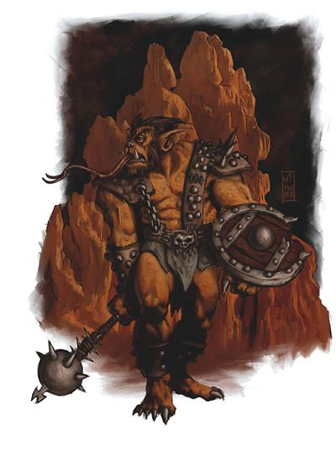

“Well, shit,” Saradette swore. She activated her ring of flight and lifted straight up. She then zapped the hobgoblin that had given them away.

|  |  |  |
| --- | --- | --- |
| **Ranged Weapon** | **Dmg.** | **Notes** |
| Glove of Lightning Bolt | 5d6 Electric | Ref DC 16 for ½; melts most metals |

*Dmg: 13 electric.*

|  |  |  |  |  |
| --- | --- | --- | --- | --- |
| **Character** | **Save vs.**  *lightning bolt* | **Ranks** | **Roll** | **Result** |
| Hobgoblin Raider | Reflex | 5 | 15 | 20 |

*Success. Saved for ½ damage.*

*Dmg: 6 electric.*

And still the horn-blower continued to run.

*Since the shuriken is a ranged weapon, it gets no AoO.*

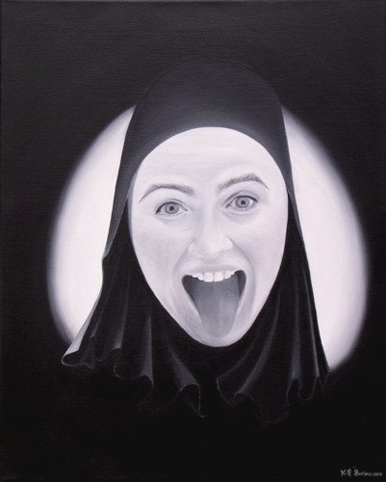

Viola saw little recourse but to run away from the plateau, making way downhill with a speed she’d not achieved since her younger days. “For the love of Lliira, live to fight another day, heroes!” she called out

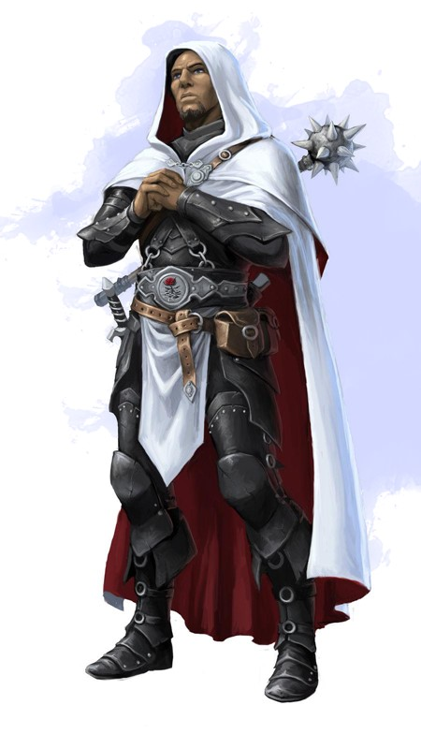

With his buckler strapped to his left forearm and his longbow in his left hand, Tore sheathed his sword with his right hand as he activated his Hawkfeather Armor and quick drew his bow. He meanwhile rose up in the air and fired an arrow at the hobgoblin with the bugle.

|  |  |  |  |  |  |  |  |  |  |
| --- | --- | --- | --- | --- | --- | --- | --- | --- | --- |
| **Ranged Weapon** | **Dmg.** | **D+** | **TH+** | **Critical** | **Rng.** | **Wt.** | **Atk** | **Roll** | **Check** |
| Longbow +1 | 1d8 | 1 | 1 + 2 altitude | x3 | 100’ | 3.0 | +12 | 14 | 26 |

*Hit. Dmg: 2 + 1 = 3.*

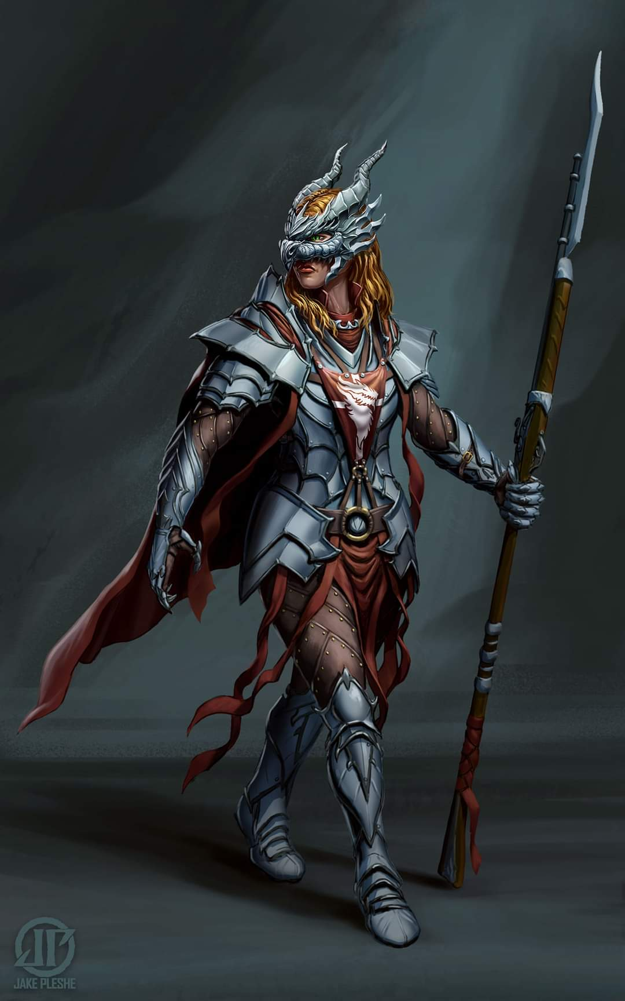

Seeing that the bugle blower was still running away and trying to alert his comrades some more, Redvelvet said, “Aw, skullfucks!” and turned to run after Viola.

Round 3

Carthage shook her head and bolted away, seeing no hope of fending off this many foes. Viola and Redvelvet were already in the lead, with Saradette and Tore now flying, and the sorceress did her best to catch up.

The hobgoblins ran or rode horses—along with a few goblins on mastiffs—towards the heroes, and in less than a minute, they estimated, they would be surrounded or overrun. One imp flew overhead, suggesting that its master was nearby.

Saradette swore vehemently, dismayed at how much ground the enemy had gained on them so quickly. She looked for a place in the rocks where they could make a stand without being overrun.

|  |  |  |  |  |  |  |
| --- | --- | --- | --- | --- | --- | --- |
| **Skill** | **Rank** | **Ability & Mod.** | **Misc. Mods.** | **Total** | **Roll** | **Check** |
| **Saradette, Search** | 3 | **Int (+3)** | 0 | 6 | 19 | 25 |
| **Saradette, Spot** | 4 | **Wis (+0)** | 2 | 6 | 20 | 26 |

*See below.*

Tore flew 60’ away from the approaching mob, then hovered and looked for the imp in the sky, shooting at it.

|  |  |  |  |  |  |  |  |  |  |
| --- | --- | --- | --- | --- | --- | --- | --- | --- | --- |
| **Ranged Weapon** | **Dmg.** | **D+** | **TH+** | **Critical** | **Rng.** | **Wt.** | **Atk** | **Roll** | **Check** |
| Longbow +1 | 1d8 | 1 | 1 – 2 altitude  - 4 distance | x3 | 100’ | 3.0 | +6 | 6 | 12 |

*Miss.*

Round 3

Saradette was disheartened that the best place she could find to make a stand would not be much of one, this being an outcropping where she would likely receive the lethal arrow that would pierce her brain or throat and end this life of strife forever.

The hobgoblins came, and the first few arrows lodged themselves in the earth near their feet as if staking their fates as a second volley went flying upward towards them.

Carthage, Redvelvet, and Viola continued running, and an arrow stuck in Viola’s shoulder, though it didn’t slow her escape.

The imp had seen the arrow aimed at it, and returned to the stampeding horde that would soon overrun them with murderous intent.

Saradette used her flying speed to move ahead of the others, searching for a place that would shelter them before they were overrun.

Tore yelled to the others, “Keep running!!” He then turned to the mounted hobgoblins and goblins in the lead, activating the +4 CHA bonus from his armor, and attempted to INTIMIDATE them. As he fired two arrows at the lead mount, he yelled as loud as he could. “DIE YOU FILTHY SCUM!! TURN AND FLEE BEFORE YOU ALL PERISH!!”

|  |  |  |  |  |  |  |
| --- | --- | --- | --- | --- | --- | --- |
| **Skill** | **Rank** | **Ability & Mod.** | **Misc. Mods.** | **Total** | **Roll** | **Check** |
| **Tore, Intimidate** | 1 | **Cha (+2)** | *See below* | 3 + 1 | 1 – 5 | ?? |

*Skill automatically fails. See below.*

|  |  |  |  |  |  |  |  |  |  |
| --- | --- | --- | --- | --- | --- | --- | --- | --- | --- |
| **Ranged Weapon** | **Dmg.** | **D+** | **TH+** | **Critical** | **Rng.** | **Wt.** | **Atk** | **Roll** | **Check** |
| Longbow +1 | 1d8 | 1 | 1 + 2  altitude | x3 | 100’ | 3.0 | +14 | 6 | 20 |
| Longbow, 2nd Shot | 1d8 | 1 | 1 + 2  Altitude | x3 | 100’ | - | +9 | 17 | 26 |

*Hit, hit. Dmg: (3 + 2 + 1) + (2 + 2 + 1) = 6 + 5 = 11.*

Having fired off his arrows, he thought to stand defiantly now to get the full effect of his statement and his arrows.

*If you take a move action or less on the next round, the intimidate roll can be resolved/executed.*

Round 4

Tore waited to see what the hobgoblins would do, and given the language gap and the fact that they were outnumbered by hundreds, the charge continued, and within seconds, they were pierced by multiple arrows and other missiles.

~*~

Saradette awoke to find Viola and Carthage bent over a log being violated by hobgoblins. Saradette, Tore, and Redvelvet were now being dragged to said log for what would likely be the same fate. They had been shot with arrows, knocked unconscious, and were now being had as spoils of a war that never was. Their hands were bound behind their backs, and they were gagged such that not a single verbal or somatic spell component could be manifested.

Their knowledge of goblinoids chilled their spine, for they knew that after having their way with their captives, they would surely slay them and make displays of their skulls and carcasses.

Saradette was not about to have her will violated again this year, or this lifetime. She clamored, sneered, taunted, and finally really hurt the feelings of one of the guards, who gave her head a coup de grace with his waraxe and split the top of her skull right down the middle.

This—of course—caused much dismay in Tore, and in his outburst, he also scuffed the other fellow’s self-esteem, so he lost his head completely upon the second swing.