*Chapter 39: The Ibixians*

Saradette awoke from uneasy dreams, having no immediate recollection of who she was. The darkness and a warm moisture all around her were reminiscent of her mother’s womb, or would have been, had she the memory of being in such a place. She made an effort to align her identity with her situation, but found only a nebulous entity in the stead of her self-conception, and realized that she’d been clawing her way through the earth around her, apparently in the direction opposite to the gravitational pull that held the soles of her feet firmly to part of the earth.

Saradette—perplexed by the suddenness of her confusion if such it was—tried to listen for something... anything... but heard nothing.

It did not occur to her, all the while, that she had no need to breathe at the moment, but remembered this need now, albeit vaguely.

It would have been easy to stay here, nestled in the soothing, comfortable warmth of this wet void. After all, what reason did she have to do anything else? Still, the one and only thing she knew is that she had purpose before and that purpose involved clawing forward, trying to progress through the earth. Apparently, at some point, that had been a thing to do. Perhaps if she continued on that path, she’d learn why she’d been on the path in the first place?

So Saradette, lost and alone, continued to try to crawl her way through the loam surrounding her, pursuing something she could not and did not know, but would hopefully discover.

She crawled, hacked and dug away at earth, and gained altitude, it seemed. Whether it was countless hours in the end or merely long-drawn minutes was irrelevant now; she was beginning to grasp at roots. She was no druid, but something told her innate sense that she was nearing the end of this fastidious digging.

She paused momentarily, not only feeling the percussive waves of motion above her, but hearing faint vibrations reminiscent of speech.

She vigorously picked up her pace, and not long thereafter, she was emerging from a gnome-sized gopher hole atop a grassy knoll overlooking a sunset whose flame licked the tide in a thousand flickers of light that nearly blinded Saradette.

Saradette crawled instinctively out of the hole, staggering a bit as an unfamiliar form reached out to catch her, and steadied her. “A virtuous life to you, heroine,” a woman’s voice spoke softly into her ear as she gained her bearings.

Blinking, she took a deep breath—unexpectedly, not quite as desperately as a full gasp—and stretched her hitherto sinless form with zero shame.

The form next to her let go of Saradette’s arm, now that she seemed more stable on her feet. She was nude, except for a layer of mud, as were another half-dozen gnomes in her midst, and then there were just as many gnomes clad in translucent robes and quasi-vestigial armor plates along their shins, elbows, and solar plexuses.

This was what had been foretold to her of the afterlife for one whose predilections for justice far outweighed any consideration for law.

She yawned, needing a second deep breath now, and caught herself smiling at those around her.

So many friendly, smiling people! She looked down and saw that she had arms and legs and toes and fingers. Blinking, she paused and looked around as the realization came to her that she was dead. She beamed a toothy, white grin at the figure who’d steadied her.

“We are glad to see you gaining your new consciousness so quickly,” the woman’s voice behind Saradette caused her to turn around, as now a handful of paladin-like aasimars of gnomish stock were approaching. How she knew to recognize the aasimar for their features was all part of the legends and folktales she’d been told.

Saradette then noticed the cornucopias of fruits and other edibles on a table amidst the trees. “Welcome to Arborea,” a male voice said a moment after the first woman spoke. She turned around to find Tore clad in a toga, still bearing some dried mud on him that would soon fizzle into nothing.

The woman spoke again. “We will wait until you and the other newcomers are feeling up to it, and then we’ll head back to Goldenhill.”

What took place afterwards was within minutes a blur, but it involved some succession of sitting, getting one’s bearings, getting dressed in light robes, and meeting one another.

Dressed now, Saradette walked with the others among her in a direction that seemed to be westerly, chanting a song germane to the Luruen tradition. Rich in imagery, and with a quickened tempo, the lyrical melody strengthened their steps as they made their way down a slope and towards a sun slowly setting over a sea of treetops spanning the panorama through to the horizon.

Tore knew the words well and led the chant forth with his tenor timbre, and when the song was done, a Mayaheinite cant in Gnomish followed. Saradette and Tore had come to their eternal home; both souls had traversed across the multiverse, being drawn by the forces of moral gravity towards the plane most hospitable to their dispositions and ethical compasses.

The sun almost never directly shone here, and as the sun dipped motionlessly, the shade plants began to bloom along the forest floor, lighting their path with luminescent petals and polyps.

And in little time, they were in a gnome-dominant settlement under a singular canopy spanning thousands of trees for miles around. Saradette’s cursory memory of a settlement involved peasants, pigs, goats, manure here and there, but all of that was missing. This was more of a sprawling monastery of nature.

There was a plethora of deities represented in the architecture, sculpture, topiaries, and other artwork here. The forest still belonged to the animals and fey; the gnomes here dwelled within the earth underfoot.

The two risen heroes were now ushered down to the place where they were told they would be outfitted with instruments specific to their bestowed specializations.

It was 38 steps down to the level lit by holy blue fire in bronze bowls laid out along the longer dimension of the rectangular room. Three priests were already seated, and behind them there stood four others—one looked like a scarred, rugged veteran of more wars than he had fingers—some with their arms crossed, as if to communicate, “I’m not sure about these.”

Saradette seemed confused, mostly because she was confused. She watched as everyone seemed to be sitting or standing in judgment of them. The ambiguity of the moment was then broken when Sumer smiled and explained that they were chosen for great purposes. The details varied with every metaphor he used, but the general message was that as long as chaos and good were being served, they would be graced with the favors of their respective patron deities. A few clauses were added for balance, specifying the consequences of walking the paths of law and evil, but they were neither inscrutable nor unreasonable tenets.

“And now,” Sumer announced, clapping her hands together once and wearing a grandmotherly smile, though she was agelessly young, “you will be defenders, liberators, and avengers.”

~*~

They were now fully cognizant, and had full memories of dying after being overrun and captured by hobgoblins. All in all, it had been a rough but honorable death, and they hoped the other three gals survived.

The artificer had been outfitted with equipment replicating her previous getup with uncanny fidelity to the original items, and the same could be said for Tore. In addition, as fate would have it, they had effectively become a new form of being, creatures made—in part—of light: aasimars.

*Saradette and Tore gained 1 level in aasimar (which is an ECL +1 race), and the following consequent traits:*

* *Outsider type*
* *+2 Wisdom, +1 Charisma.*
* *Resistance to acid, cold, and electricity 5.*
* *Light (Sp) once per day as cast by a sorcerer of their ECL.*
* *+2 to Listen and Spot.*
* *Darkvision to 60’.*

Saradette had kept her own council during the introduction to her new life. Curiously, she wasn’t dismayed at her own death, given that she’d clamored so hard for it at the end. She lifted her hand and gazed at it, curious about her new body. The poisons of the necromancer were gone for good, she hoped.

The artificer looked up from her restored inventory and smiled crookedly at Tore. “Think we can survive our next quest?”

*The PCs’ equipment is mechanically identical to their previous gear.*

~*~

The heroes were led into a teleportation platform, where Saradette was surprised to find Laryssa, her former traveling companion.

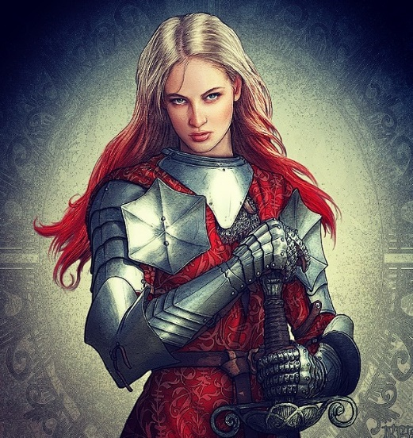

They exchanged warm greetings, took a moment to catch up, and Saradette introduced her to Tore, who was smitten by her personage. They were told that there was a congregation of Mayaheinites on the Material Plane that was currently praying for their goddess’ favors, and Saradette and Tore were to be conveyed there to represent the causes of freedom and justice.

“We can only hear their prayer, but are unaware of the nature of the conflict,” Laryssa admitted, “but it is always safe to assume that the threat takes the form of monsters or a band of evildoers.”

Tore asked around to find out the fate of the others he was with and either visit them or their graves. In the spirit of chaos itself, Saradette walked with him as if to say, “This is normal; we’re normal!”

“What do you know of the others who surely died in our midst? Viola? Carthage? Redvelvet?” asked the cleric-fighter.

“If you fell among others that day, their souls have by now transmigrated the planes and likely have reached one of the Outer Planes—perhaps this one,” Laryssa answered, providing a few more details.

*The PCs are now aware of most of the information on Arborea in the Manual of the Planes, including its petitioners, which is what they have become.*

The artificer checked her devices, and took note of the fact that she had the same spells prepared as she did before dying, plus a *light* spell at her avail.

|  |  |  |  |  |
| --- | --- | --- | --- | --- |
| *Memorized Spells* | | | | |
| **Spell** | **Level** | **Bonus** | **DC** | **Cast?** |
| Detect Magic | 0 | 0 | 13 | q |
| Daze | 0 | 0 | 13 | q |
| Message | 0 | 0 | 13 | q |
| Mage Armor | 1 | 0 | 14 | q |
| Tenser’s Floating Disk | 1 | 0 | 14 | q |
|  |  |  |  |  |
|  |  |  |  |  |
| *Rock Gnome Spells* | | | | |
| **Spell** | **Level** | **SF** | **DC** | **Cast?** |
| Ghost Sound | 0 | 1 | 14 | q |
| Dancing Lights | 0 | 1 | 14 | q |
| Prestidigitation | 0 | 0 | 13 | q |
| Speak with Animals | 1 | 0 | 14 | q |
|  |  |  |  |  |
| *Aasimar Spells* | | | | |
| **Spell** | **Level** | **SF** | **DC** | **Cast?** |
| Light | 11 | 0 | 24 | q |

Tore, too, felt Lurue’s favors refilling his soul, and he was now ready to face whatever came their way.

|  |  |  |  |  |
| --- | --- | --- | --- | --- |
| *Daily Spells* | | | | |
| **Spell** | **Level** | **Heal?** | **DC** | **Cast?** |
| Detect Magic | 0 | 0 | 12 | q |
| Detect Magic | 0 | 0 | 12 | q |
| Light | 0 | 0 | 12 | q |
| Message | 0 | 0 | 12 | q |
| Purify Food and Drink | 0 | 0 | 12 | q |
| Divine Favor | 1 | 0 | 13 | q |
| Nimbus of Light | 1 | 0 | 13 | q |
| Sanctuary | 1 | 0 | 13 | q |
| Shield of Faith | 1 | 0 | 13 | q |
| **Calm Animals** | 1 | 0 | 13 | q |
| Ayailla’s Radiant Burst | 2 | 0 | 14 | q |
| Luminous Armor | 2 | 0 | 14 | q |
| Summon Monster II | 2 | 0 | 14 | q |
| **Hold Animal** | 2 | 0 | 14 | q |

“May your hearts be steeled with compassion for your fellow congregants,” Sumer said to Saradette, then turned to Tore. “The worshippers of your goddess will also need your strength in time. Go forth, and right what wrongs now manifest.”

Laryssa motioned for them to step onto the platform, and saluted them in the Mayaheinite custom, removing her helmet to do so. “The Shieldmaiden will convey you back here when her will is done.”

Saradette looked down as her unnaturally clean attire and gear as she prepared herself for the journey ahead. “Okay, let’s do this.”

Tore gave Saradette a weak smile, “I certainly hope so,” he replied. As they looked over their gear, he wondered what exactly had happened to the others. If they had survived, how were they doing mentally? If they were resurrected, did they remember what happened to them or were they sparred the memory. If they were dead, then he wanted, no, he needed to find their graves and pay his respects. The events of those moments before his death Tore would not forget. Those events would not allow him to have pity on any goblin or hobgoblin that he came across.

Round 1

As they walked towards the platform, Saradette specifically checked her devices’ state of repair, with an eye to determining how many charges each had remaining before they had to be rebuilt. They were in pristine condition, and it looked like she had as many charges now as she had when the hobgoblins relieved her of her equipment.

Standing before the teleportation platform, Tore looked at Sumer and Laryssa as Saradette checked her devices’ state of repair, with an eye to determining how many charges each had remaining before they had to be rebuilt.

Tore gave Saradette a weak smile, “I certainly hope so,” he replied. As they looked over their gear, he wondered what exactly had happened to the others. If they had survived, how were they doing mentally? If they were resurrected, do they remember what happened to them or were they sparred the memory. If they were dead, then he wanted, no, he needed to find their graves and pay his respects. The events of those moments before his death Tore would not forget. Those events would not allow him to have pity on any goblin or hobgoblin that he came across.

Tore then bowed to Laryssa, a bit distracted by her beauty. He listened as she spoke and nods at the end adding, “Gods willing, we will meet again.” He gave Laryssa a deep bow then stepped onto the platform and smiled as Saradette bid them all well.

~*~

Round 2

They found themselves in a clearing, and stood together under the only beams of sunlight that penetrated the otherwise omnipresent canopy of leaves and branches above them.

“Huzzah! Our Redeemers have arrived!” shouted one worshipper who got up from his genuflexion. “Surely we are *saved*!”

Tore had not yet chosen a weapon, and now that they got their bearings, they realized that they were on a ceremonial platform surrounded by a ring of sacrificial flower petals and leaves. The flat top was itself about 10’ in diameter—approximating a circle—and constituted the top of a mound 20’ high. All around them, at the foot of the mound, was a crowd of curious warrior-priests, monks, and commoners.

And in the periphery, a few hundred feet away, there were a dozen or so ibixians—goat-headed humanoids—fighting with a few of the defenders of this small village.

Round 3

|  |  |  |  |  |  |
| --- | --- | --- | --- | --- | --- |
| **Character** | **Group** | **Initiative** | **Roll** | **Modified Roll** | **Speed** |
| Tore | 1 | 2 | 15 | 17 | 30’ |
| Ibixians | 2 | 0 | 15 | 15 | 30’ |
| Congregants | 1 | 3 | 11 | 14 | 30’ |
| Saradette | 1 | 3 | 10 | 13 | 20’ |

Tore saw the ibixians turning to the mound and shouting to one another. He activated his Hawkfeather Armor and flew directly 60’ east. He cast *summon monster II* and summoned a Celestial riding dog. As he flew closer, Tore quick-drew his longbow and prepared to engage from range.

The ibixians continued to engage the commoners, warrior-priests, and monks in their midst. The one with the biggest pair of horns pointed to the mound, and blurted a bleating command, urging the others to their arch-adversaries.

Those that could swung and finished off the adjacent commoner, while others merely took to charging westward with their greataxes and horns trained on their marks.

A handful of congregants fell where they’d fought, while others followed westward, and one remained behind to try to heal those that had fallen.

Saradette cast *mage armor [expired in 1 hour]* on herself, and then she activated her ring of flying to lift up vertically 20’, surveying the incoming goat-men and their humanoid counterparts.

*Saradette gained +4 to TAC and AC.*

Round 4

The dog could not possibly be summoned where Tore had tried to place it, and thus it appeared 35’ east and 20’ below him on the ground. As one ibixian ran past the dog, the dog got a good snap in.

|  |  |  |  |  |  |  |  |  |  |
| --- | --- | --- | --- | --- | --- | --- | --- | --- | --- |
| **Character** | **Attack Type** | **Damage** | **BAB** | **Str Mod+** | **Dex Mod+** | **Total Score** | **Roll** | **Total** | **Notes** |
| Celestial riding dog | Bite | 1d6+3 | 1 | 2 | 2 | 3 | 13 | 16 |  |
| Celestial riding dog | Bite | 1d6+3 | 1 | 2 | 2 | 3 | 19 | 22 | Attack of  Opportunity |

*Hit, hit. Dmg: (4 + 3) + (4 + 3) = 14.*

Two good wounds did not discourage the badly wounded caprine male as he followed his leader who leapt onto the mound to fight the so-called Champions of Mayaheine.

Tore commanded the Celestial riding dog to attack the closest ibixian *[move action]*.

|  |  |  |  |  |  |  |  |  |
| --- | --- | --- | --- | --- | --- | --- | --- | --- |
| **Character** | **Attack Type** | **Damage** | **BAB** | **Str Mod+** | **Dex Mod+** | **Total Score** | **Roll** | **Total** |
| Celestial riding dog | Bite | 1d6+3 | 1 | 2 | 2 | 3 | 6 | 9 |

*Miss.*

Tore then fired an arrow at the ibixian below him.

|  |  |  |  |  |  |  |  |  |  |
| --- | --- | --- | --- | --- | --- | --- | --- | --- | --- |
| **Ranged Weapon** | **Dmg.** | **D+** | **TH+** | **Critical** | **Rng.** | **Wt.** | **Atk** | **Roll** | **Check** |
| Longbow +1 | 1d8 | 1 | 1 + 2  height | x3 | 100’ | 3.0 | +14 | 5 | 19 |

*Hit. Dmg: 2 + 1 = 3.*

The ibixians continued onto the mound or up against some foe near it. The one the dog had missed left herself vulnerable to a second bite.

|  |  |  |  |  |  |  |  |  |
| --- | --- | --- | --- | --- | --- | --- | --- | --- |
| **Character** | **Attack Type** | **Damage** | **BAB** | **Str Mod+** | **Dex Mod+** | **Total Score** | **Roll** | **Total** |
| Celestial riding dog | Bite | 1d6+3 | 1 | 2 | 2 | 3 | 18 | 21 |

*Hit. Dmg: 6 + 3 = 9.*

That wasn’t quite enough of a hurting to bring down the goat lady.

The congregants took care of the stragglers to the east and braced for impact with those that had made it to the mound or thereabout.

*Auto-resolving melees to render balanced encounter.*

*One warrior-priest and two ibixians died before reaching the mound.*

*Others were wounded.*

Saradette zapped the nearest ibixian.

|  |  |  |  |
| --- | --- | --- | --- |
| **Ranged Weapon** | **Dmg.** | **Rng.** | **Notes** |
| Glove of Lightning Bolt | 5d6 Electric | 120’ | Ref DC 16 for ½; melts most metals |

*Dmg: 16 electric.*

|  |  |  |  |  |
| --- | --- | --- | --- | --- |
| **Character** | **Save vs.**  *lightning bolt* | **Ranks** | **Roll** | **Result** |
| Ibixian | Reflex | 3 | 8 | 11 |

*Fail. Full damage taken.*

She slew the charging leaper dead in its tracks.

Round 5

Seeing that the dog’s opponent was now dead, Tore commanded his Celestial dog to charge-attack the nearest ibixian (I2)to the west, and fired an arrow at that ibixian to help his summoned ally.

|  |  |  |  |  |  |  |  |  |
| --- | --- | --- | --- | --- | --- | --- | --- | --- |
| **Character** | **Attack Type** | **Damage** | **BAB** | **Str Mod+** | **Dex Mod+** | **Total Score** | **Roll** | **Total** |
| Celestial riding dog | Bite | 1d6+3 | 1 | 2 | 2 | 3 + 2  Charge | 2 | 7 |

*Miss.*

|  |  |  |  |  |  |  |  |  |  |
| --- | --- | --- | --- | --- | --- | --- | --- | --- | --- |
| **Ranged Weapon** | **Dmg.** | **D+** | **TH+** | **Critical** | **Rng.** | **Wt.** | **Atk** | **Roll** | **Check** |
| Longbow +1 | 1d8 | 1 | 1 + 2  Height | x3 | 100’ | 3.0 | +14 | 16 | 30 |

*Hit. Dmg: 4 + 1 = 5.*

That ibixian dropped to the ground, also dying.

While the conjured heroes flew overhead, the other ibixians clashed with the grounded defenders of this apparent outpost. Two attacked a longhaired monk.

|  |  |  |  |  |  |  |  |  |  |  |
| --- | --- | --- | --- | --- | --- | --- | --- | --- | --- | --- |
| **Character** | **Attack Type** | **Damage** | **BAB** | **Str Mod+** | **Total Score** | **Roll** | **Total** | **Crit** | **Threat** | **Notes** |
| Ibixian 7 | Greataxe | 1d12+3 x3 | 3 | 3 | 6 + 2 charge | **20** | 25 | 19 | þ | +2 to AB if 30’  from conspecific |
| Ibixian 8 | Head Butt | 1d6+2 | 3 | 2 | 5 + 2 charge | 12 | 19 | 19 | ý | +2 to AB if 30’  from conspecific |

*Threat, hit. 1d20 = 8 + 6 = 14, not a critical hit.*

*Dmg: (6 + 3 + 2) + (4 + 2 + 2) + 11 + 8 = 19.*

The monk fell onto the ground, bleeding as two others overcame a commoner.

|  |  |  |  |  |  |  |  |  |  |
| --- | --- | --- | --- | --- | --- | --- | --- | --- | --- |
| **Character** | **Attack Type** | **Damage** | **BAB** | **Str Mod+** | **Dex Mod+** | **Total Score** | **Roll** | **Total** | **Notes** |
| Ibixian 9 | Head Butt | 1d6+2 | 3 | 2 | 0 | 5 | 7 | 12 + 2  charge | +2 to AB if 30’  from conspecific |
| Ibixian 11 | Head Butt | 1d6+2 | 3 | -2 | 0 | 1 | 15 | 16 + 2  Charge | +2 to AB if 30’  from conspecific |

*Miss, hit. dmg: 6 + 2 = 8.*

The stalwart commoner held her ground and her gnarled club.

Two ibixians were already next to the riding dog, and one charged it from behind.

|  |  |  |  |  |  |  |  |  |  |
| --- | --- | --- | --- | --- | --- | --- | --- | --- | --- |
| **Character** | **Attack Type** | **Damage** | **BAB** | **Str Mod+** | **Dex Mod+** | **Total Score** | **Roll** | **Total** | **Notes** |
| Ibixian 10 | Greataxe | 1d12+3 x3 | 3 | 3 | 0 | 6 | 2 | 8 + 2  Charge | +2 to AB |
| Ibixian 2 | Head Butt | 1d6+2 | 3 | 2 | 0 | 5 | 17 | 22 | +2 to AB |
| Ibixian 3 | Head Butt | 1d6+2 | 3 | -2 | 0 | 1 | 15 | 16 | +2 to AB |

*Miss, hit, hit. Dmg: (3 + 2) + (5 + 2) = 5 + 7 = 12.*

The dog was left barely standing, but fiercely growling.

One of the stragglers tried to take out a balding monk to the southeast.

|  |  |  |  |  |  |  |  |  |
| --- | --- | --- | --- | --- | --- | --- | --- | --- |
| **Character** | **Attack Type** | **Damage** | **BAB** | **Str Mod+** | **Total Score** | **Roll** | **Total** | **Notes** |
| Ibixian | Greataxe | 1d12+3 x3 | 3 | 3 | 6 | 9 | 15 | +2 to AB |

*Hit. Dmg: 11 + 3 = 14.*

The balding monk died.

A shaven-headed monk also braced for impact against a ramming opponent.

|  |  |  |  |  |  |  |  |  |  |
| --- | --- | --- | --- | --- | --- | --- | --- | --- | --- |
| **Character** | **Attack Type** | **Damage** | **BAB** | **Str Mod+** | **Dex Mod+** | **Total Score** | **Roll** | **Total** | **Notes** |
| Ibixian | Head Butt | 1d6+2 | 3 | -2 | 0 | 1 + 2  charge | 18 | 21 | +2 to AB |

*Hit. Dmg: 5 + 2 = 7.*

The congregants of Mayaheine did their best to overcome their adversaries. A commoner and a fighter-priest met the goat-man now in the lead at the mound, and flanked the bastard while a monk fended off another ibixian to the northeast.

|  |  |  |  |  |  |  |  |  |  |  |
| --- | --- | --- | --- | --- | --- | --- | --- | --- | --- | --- |
| **Character** | **Attack Type** | **Damage** | **BAB** | **Str Mod+** | **Dex Mod+** | **Other+** | **Total Score** | **Roll** | **Total** | **Targeting** |
| Commoner | Studded Club | 1d6+1 | 1 | 1 | 1 | 2 flank | 4 | 9 | 13 | I6 |
| Fighter-Priest | Longsword | 1d8+2 | 2 | 2 | 1 | 2 flank | 6 | 14 | 20 | I6 |
| Monk | Quarterstaff | 1d6+2 | 3 | 2 | 1 | 0 | 5 | 19 | 24 | I4 |

*Miss, hit, hit.*

*Dmg to I6: 5 + 2 = 7.*

*Dmg to I4: 2 + 2 = 4.*

Seeing the already arrow-pierced ibixian on the mound dying from the fighter-priest’s blow, a commoner, a cleric-monk and another monk knave came to assist in the northeastern melee.

|  |  |  |  |  |  |  |  |  |  |  |
| --- | --- | --- | --- | --- | --- | --- | --- | --- | --- | --- |
| **Character** | **Attack Type** | **Damage** | **BAB** | **Str Mod+** | **Dex Mod+** | **W+** | **Other+** | **Total Score** | **Roll** | **Total** |
| Commoner | Studded Club | 1d6+1 | 1 | 1 | 1 | 0 | 2 flank  +2 charge | 7 | 8 | 15 |
| Monk-Priest | Quarterstaff | 1d6+2 | 2 | 2 | 1 | 0 | 2 flank | 6 | 11 | 17 |
| Monk | Quarterstaff | 1d6+2 | 1 | 1 | 1 | 0 | 2 flank | 5 | 1 | 6 |

*Hit, hit, miss.*

*Dmg to I4: (3 + 1) + (5 + 2) = 4 + 7 = 11.*

And while it was clear that the ibixian would not make it through the next few moments, he retained his stance, bleated with contempt, and struggled for his life.

One burly commoner to the south fought against two ibixians.

|  |  |  |  |  |  |  |  |  |  |
| --- | --- | --- | --- | --- | --- | --- | --- | --- | --- |
| **Character** | **Attack Type** | **Damage** | **BAB** | **Str Mod+** | **Dex Mod+** | **Other+** | **Total Score** | **Roll** | **Total** |
| Commoner | Studded Club | 1d6+1 | 1 | 1 | 1 | 0 | 2 | 13 | 15 |

*Hit. Dmg to I11: 3 + 1 = 4.*

Saradette zapped the nearest enemy with her glove.

|  |  |  |  |
| --- | --- | --- | --- |
| **Ranged Weapon** | **Dmg.** | **Rng.** | **Notes** |
| Glove of Lightning Bolt | 5d6 Electric | 120’ | Ref DC 16 for ½; melts most metals |

*Dmg to I11: 14 electric.*

|  |  |  |  |  |
| --- | --- | --- | --- | --- |
| **Character** | **Save vs.**  *lightning bolt* | **Ranks** | **Roll** | **Result** |
| Ibixian | Reflex | 3 | 17 | 20 |

*Success. Saved for ½ damage = 7 electric.*

The zapped goat-person reared upward and vowed to kill Saradette.

Round 6

Tore knew his summoned dog would only have one more attack left in him, unless it was lucky. He swooped down, quick-drawing his longsword as he landed behind an ibixian near his summoned beast.

*AT19 behind I10.*

Tore lashed out at the ibixian and yelled, “Die, foul beasts!” He hoped his cry would draw the ibixians to him and lessen the pressure on the others, enabling them to finish off the monsters.

|  |  |  |  |  |  |  |  |
| --- | --- | --- | --- | --- | --- | --- | --- |
| **Melee Weapon** | **Dmg** | **D+** | **TH+** | **Critical** | **Atk** | **Roll** | **Check** |
| Longsword of Frost | 1d8+1 | +1+1d6 Cold | 1 + 2  Charge | 19-20/x2 | +13 | 17 | 30 |

*Hit. Dmg: 4 + 1 + 1 + 2 charge + 6 cold = 14.*

The ibixian before Tore almost died, but bleated in broken Common, “*You* are the *foul*!”

|  |  |  |  |  |  |  |  |  |
| --- | --- | --- | --- | --- | --- | --- | --- | --- |
| **Character** | **Attack Type** | **Damage** | **BAB** | **Str Mod+** | **Total Score** | **Roll** | **Total** | **Notes** |
| Ibixian 10 | Greataxe | 1d12+3 x3 | 3 | 3 | 6 | 17 | 23 | +2 to AB if 30’ from conspecific |

*Hit. Dmg: 3 + 3 = 6 [65/71].*

“*Evil*!” another ibixian called Tore as she charged at him and swung her axe in his direction.

|  |  |  |  |  |  |  |  |  |  |
| --- | --- | --- | --- | --- | --- | --- | --- | --- | --- |
| **Character** | **Attack Type** | **Damage** | **BAB** | **Str Mod+** | **Other+** | **Total Score** | **Roll** | **Total** | **Notes** |
| Ibixian 5 | Greataxe | 1d12+3 x3 | 3 | 3 | 2 charge  2 flank | 10 | 6 | 16 | +2 to AB |

*Miss.*

Two goatfolk attacked the dog.

|  |  |  |  |  |  |  |  |  |  |
| --- | --- | --- | --- | --- | --- | --- | --- | --- | --- |
| **Character** | **Attack Type** | **Damage** | **BAB** | **Str Mod+** | **Other+** | **Total Score** | **Roll** | **Total** | **Notes** |
| Ibixian 2 | Greataxe | 1d12+3 x3 | 3 | 3 | 2 flank | 8 | 7 | 15 | +2 to AB |
| Ibixian 3 | Head Butt | 1d6+2 | 3 | 2 | 2 flank | 7 | 15 | 22 | +2 to AB |

*Miss, hit. Dmg: 6 + 2 = 8.*

The doggie turned back into a puff of shadowstuff and returned to the Plane of Shadow painlessly, and Tore was thankful for the aid that it had brought them.

The enemy to the northwest fought off several congregants.

|  |  |  |  |  |  |  |  |  |  |  |
| --- | --- | --- | --- | --- | --- | --- | --- | --- | --- | --- |
| **Character** | **Attack Type** | **Damage** | **BAB** | **Str Mod+** | **Total Score** | **Roll** | **Total** | **Crit** | **Threat** | **Notes** |
| Ibixian 4 | Head Butt | 1d6+2 | 3 | 2 | 5 | **19** | 24 | 19 | þ | +2 to AB |

*Threat. 1d20 = 16 + 5 = 21, critical hit. Dmg: (2 x 3) + 2 = 8.*

The monk was hit hard, but remained in a defensive stance, waiting to strike back.

At the base of the mound, a warrior-priest and a commoner were finishing off one ibixian, but another charged in to the rescue.

|  |  |  |  |  |  |  |  |  |  |
| --- | --- | --- | --- | --- | --- | --- | --- | --- | --- |
| **Character** | **Attack Type** | **Damage** | **BAB** | **Str Mod+** | **Other+** | **Total Score** | **Roll** | **Total** | **Notes** |
| Ibixian 7 | Head Butt | 1d6+2 | 3 | 2 | 0 | 5 | 1 | 6 | +2 to AB |
| Ibixian 12 | Head Butt | 1d6+2 | 3 | 2 | 2 charge | 7 | 5 | 12 | +2 to AB |

*Miss, miss.*

And to the southwest, the burly woman with the burlier club fended off three of the invaders.

|  |  |  |  |  |  |  |  |  |  |  |  |
| --- | --- | --- | --- | --- | --- | --- | --- | --- | --- | --- | --- |
| **Character** | **Attack Type** | **Damage** | **BAB** | **Str Mod+** | **Other+** | **Total Score** | **Roll** | **Total** | **Crit** | **Threat** | **Notes** |
| Ibixian 8 | Greataxe | 1d12+3 x3 | 3 | 3 | 2 flank | 8 | 16 | 24 | 19 | ý | +2 to AB |
| Ibixian 9 | Head Butt | 1d6+2 | 3 | 2 | 2 flank | 7 | 15 | 22 | 19 | ý | +2 to AB |
| Ibixian 11 | Head Butt | 1d6+2 | 3 | 2 | 2 flank | 7 | **19** | 26 | 19 | þ | +2 to AB |

*Hit, hit, threat. 1d20 = 3 + 7 = 10, not a critical hit. Dmg: (10 + 3) + (5 + 2) + (1 + 2) = 13 + 7 + 3 = 23.*

The woman died valiantly.

The congregants of Mayaheine did their best to fend off their horned assailants. At the base of the mound, a peasant and his monk son swung at the two enemies before them.

|  |  |  |  |  |  |  |  |  |  |  |
| --- | --- | --- | --- | --- | --- | --- | --- | --- | --- | --- |
| **Character** | **Attack Type** | **Damage** | **Ranged?** | **BAB** | **Str Mod+** | **Dex Mod+** | **Other+** | **Total Score** | **Roll** | **Total** |
| Commoner | Studded Club | 1d6+1 | q | 1 | 1 | 1 | 0 | 2 | 16 | 18 |
| Fighter-Priest | Longsword | 1d8+2 | q | 2 | 2 | 1 | 0 | 4 | 14 | 18 |

*Hit, hit.*

*Dmg to I7: 6 + 1 = 7.*

*Dmg to I12: 2 + 2 = 4.*

This mostly upset the injured ibixians further.

One of the warrior-priests to the northwest now cast *bless* *[expired on Round 36]* while the other cast *doom [expired on Round 36]* upon

*Congregants and PCs gained +1 to attacks and saves vs. fear effects.*

|  |  |  |  |  |
| --- | --- | --- | --- | --- |
| **Character** | **Save vs.**  *doom* | **Ranks** | **Roll** | **Result** |
| Ibixian | Will | 2 | 17 | 19 |

*Success. Shaken effect negated.*

The commoner and two monks next to them fended off the sole ibixian that would surely perish next.

|  |  |  |  |  |  |  |  |  |  |
| --- | --- | --- | --- | --- | --- | --- | --- | --- | --- |
| **Character** | **Attack Type** | **Damage** | **BAB** | **Str Mod+** | **Dex Mod+** | **Other+** | **Total Score** | **Roll** | **Total** |
| Commoner | Studded Club | 1d6+1 | 1 | 1 | 1 | 2 flank | 4 | 15 | 19 |
| Monk | Quarterstaff | 1d6+2 | 3 | 2 | 1 | 2 flank | 7 | 4 | 11 |
| Monk | Quarterstaff | 1d6+2 | 3 | 2 | 1 | 2 flank | 7 | 15 | 22 |

*Hit, miss, hit. Dmg: (1 + 1) + (2 + 2) = 2 + 4 = 6.*

They brought down the goatfolk as the warrior-priest next to Tore swung at the goatfolk that had just dealt the final blow to the Celestial riding dog.

|  |  |  |  |  |  |  |  |  |
| --- | --- | --- | --- | --- | --- | --- | --- | --- |
| **Character** | **Attack Type** | **Damage** | **BAB** | **Str Mod+** | **Dex Mod+** | **Total Score** | **Roll** | **Total** |
| Fighter-Priest | Longsword | 1d8+2/19 | 2 | 2 | 1 | 4 | 19 | 23 |

*Threat. 1d20 = 3 + 4 = 7, not a critical hit. Dmg: 3 + 2 = 5.*

“Ouch!” the ibixian complained as Saradette contemplated her next move. Tiring of the enemy dodging her attacks, Saradette used her already drawn blaster to fire on the nearest enemy.

|  |  |  |
| --- | --- | --- |
| **Ranged Weapon** | **Dmg.** | **Notes** |
| Glove of Lightning Bolt | 5d6 Electric | Ref DC 16 for ½; melts most metals |

*Dmg: 21 electric.*

|  |  |  |  |  |
| --- | --- | --- | --- | --- |
| **Character** | **Save vs.**  *lightning bolt* | **Ranks** | **Roll** | **Result** |
| Ibixian | Reflex | 3 | 17 | 20 |

*Success. Saved for ½ damage = 10 electric.*

And that did the trick. Her target fell, dead or dying about 10’ from the base of the mound.

Round 7

Tore Swift-activated his Hawkfeather Armor *[expired in 9 minutes]*.

*Tore gained +4 to Charisma.*

Seeing his longbow on the ground now, the warrior-priest of Lurue then attacked both of the Ibixians in front of him, hoping to finish one or both of them quickly.

|  |  |  |  |  |  |  |  |  |  |
| --- | --- | --- | --- | --- | --- | --- | --- | --- | --- |
| **Melee Weapon** | **Dmg** | **D+** | **TH+** | **Critical** | **Type** | **Wt.** | **Atk** | **Roll** | **Check** |
| Longsword of Frost | 1d8+1 | +1+1d6 Cold | 1 | 19-20/x2 | Slashing | 8.0 | +11 | 8 | 19 |
| Longsword of Frost | 1d8+1 | +1+1d6 Cold | 1 | 19-20/x2 | Slashing | 8.0 | +11 | 15 | 26 |

*Hit I5, hit I10.*

*Dmg to I5: 2 + 1 + 1 + 6 cold = 10.*

*Dmg to I10: 6 + 1 + 1 + 5 cold = 13.*

Tore killed one of the two ibixians. One of the ibixians to his north (I2) eyeballed the longbow, and grabbed it, though he had no arrows. He shouldered the bow and yelled, << Gri’i’bhe’e’er sho’gh’oola! >>

The ibixians turned tail and ran away radially from the mound.

“Yeah!” cheered the warrior-priest of Mayaheine, “You bitches need to learn your place!”

Some of the congregants threw rocks or their daggers at the fleeing goatfolk.

*Auto-resolve dmg: 2 to I8, I9, and I14.*

Cheers from the congregants announced the cessation of the conflict, with the ibixians running for the hills to tell the tale of resilient humanoids who would not back down.

Saradette floated down to land, and the gnome used her healing belt charges to aid those she could. She accompanied Tore to speak with the villagers about the attack.

Round 8

Having shouldered their axes by now, the swift chargers turned to sprint on all fours, increasing their retreat speeds considerably.

Tore watched as the Ibixians ran off to the south. He let them go, hoping that they learned their lesson and would leave the village alone.

Cheers were already overwhelming Saradette and Tore, who kept their weapons at the ready just in case one of them returned. The remaining commoners approached the summoned heroes while their monastic and ecclesiastic representatives saw to the fallen, trying to identify those who could be healed before they were pronounced dead.

The warrior-priests now looked to the battlefield to triage the casualties versus their healing capabilities.

Round 9

Turning to the closest the residents, Tore also began offering his healing abilities.

|  |  |  |  |  |  |  |
| --- | --- | --- | --- | --- | --- | --- |
| **Tore, Skill** | **Rank** | **Ability & Mod.** | **Misc. Mods.** | **Total** | **Roll** | **Check** |
| **Heal** | 7 | **Wis (+3)** | 2 | 12 | 18 | 30 |

*Successfully stopped bleeding; stabilized monk @ AP22.*

With clubs and other weapons also still in hand, some of the survivors drank a few potions of *cure light wounds* that they had on them.

One of the healers cast a *cure* spell, and the burly woman to the southwest opened her eyes. At the other end of the battlefield, another cleric shook his head as a monk lowered the corpse’s eyelids.

Saradette helped out with the healing as well.

Round 10

Tore sacrificed his *Ayailla’s radiant burst* spell to cast *cure moderate wounds* upon the stabilized monk.

*Monk gained 10 + 10 = 20 hps.*

The monk raised his head—mostly healed now—and expressed his gratitude to Tore as the cleric smiled and spotted another needy combatant on the battlefield *[monk @ BH27]*.

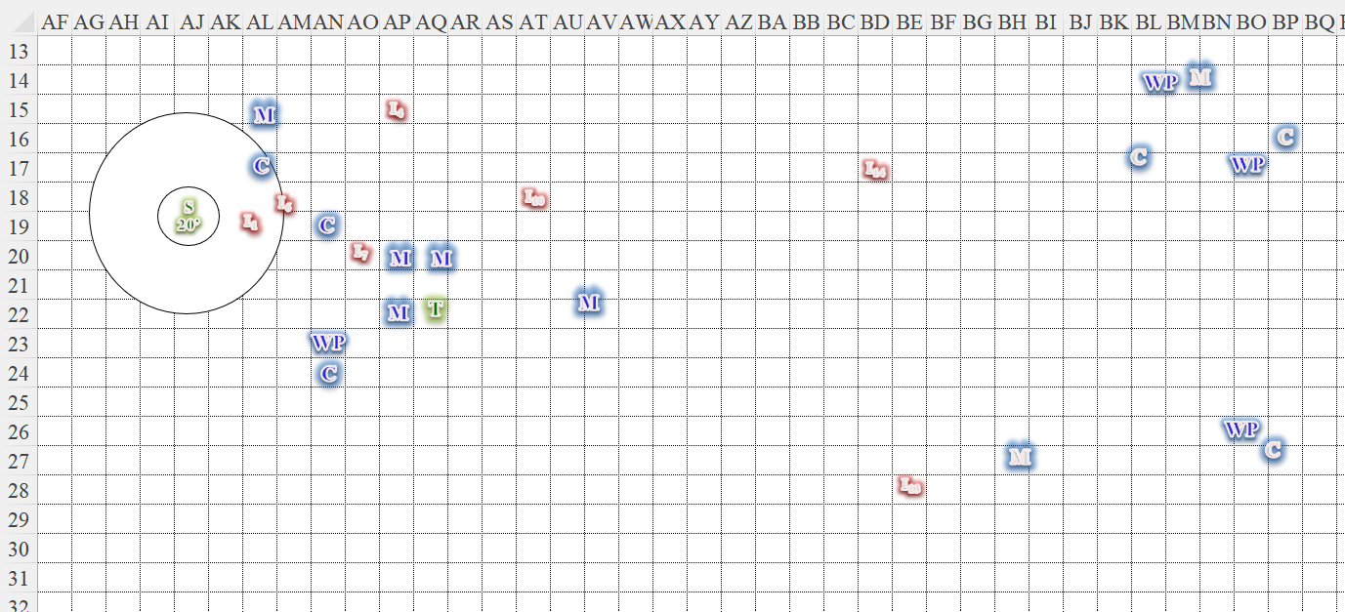

Round 11

Tore made his way eastward toward the main cluster of fallen congregants, and could tell that some of these folks were beyond life. They would need a *raise dead* or some such favors to bring them back. He perceived that only the monk was alive, but moribund.

Those that could be healed were healed, and the warrior-priests now argued about how best to take the bodies back to their temple to determine who would be *raised*.

Round 12

“We are grateful to you heroes,” one monk approached Saradette, and looked up to her with gratitude. “Please join us at our temple that we might present you with offerings.

End of rounds

“Celestial saviors,” one warrior-priestess introduced herself, “I am Mother Zulia of Mayaheine.” She was dressed in the likeness of a clergywoman, reminding Saradette of both Laryssa—a paladin of Mayaheine—and Elsabet—a favored soul of Mayaheine—in different ways. “We are grateful to our goddess that you were sent, and I hereby invite you to our village that we might present you with a token of our appreciation.” She was a few inches shorter than Tore, and looked and sounded to be Cormyrean in origin and accent; most of the humans among them did. A dwarf, two halflings, and a half-elf were among the survivors.

Tore greeted Mother Zulia and the others, then asked, “So, where exactly are we, and do you know why those fiends attacked?”

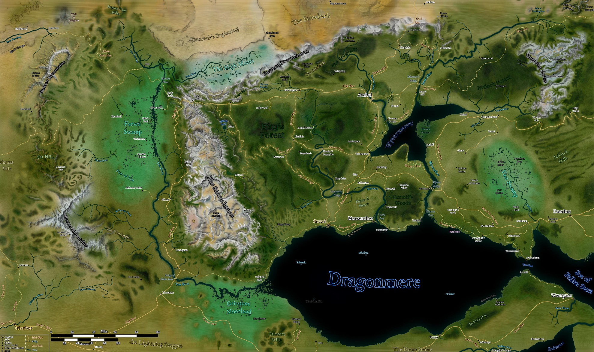

Monks and commoners joined in the greetings and gratitude-giving, and Zulia answered, “You are in the free lands of the High Moors. The Anau River runs yonder and through our settlement, feeding the wetlands to the east and south. To our north is...” she was cut off by Saradette, who knew the geography.

“... Anauroch...” sighed the gnome.

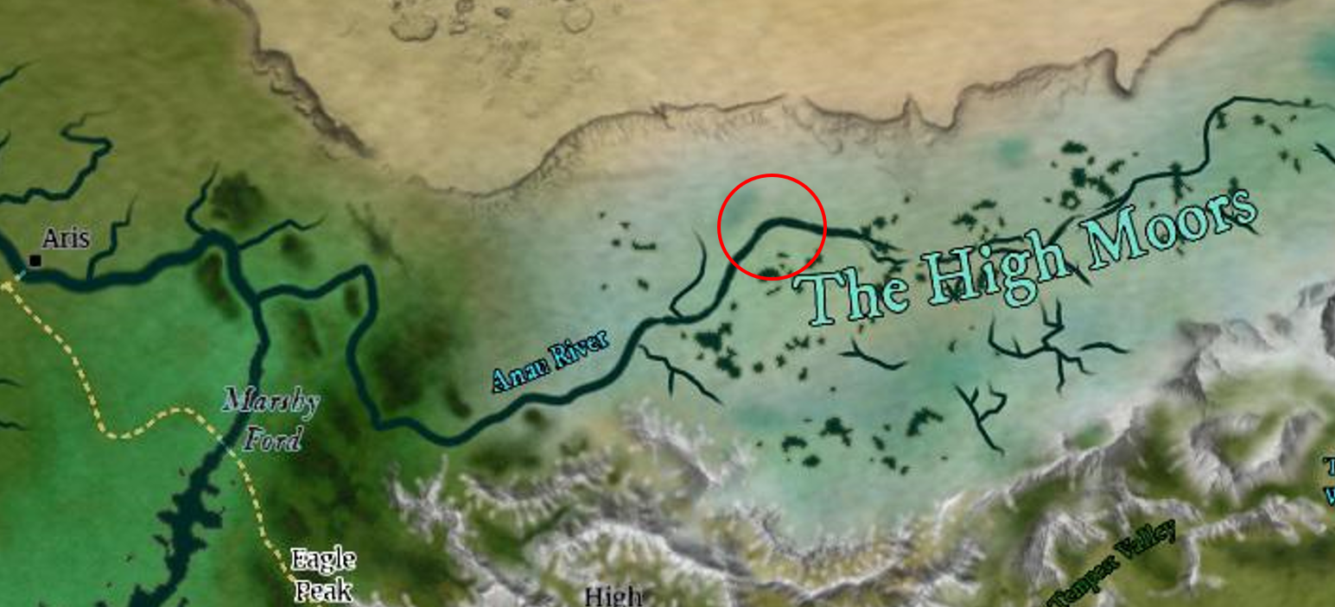

“That’s right,” Zulia said as she introduced the others. “We have been fending off the raids, taunts, and skirmishes of these barbaric goatfolk for months, and have been pleading to Mayaheine to deliver us from this scourge. Praise!”

“Praise!” most of the locals cheered.

Zulia continued, “Praise you, heroes, for now that you are with us, we shall surely triumph.”

“... and live by no goat’s leave,” added the barbarian woman who had just been brought back to full health. She had shouldered her club, and now it was her turn to clasp forearms with Saradette and Tore. “A privilege,” she simply said as she did so.

They began to walk towards the village, leaving the dead ibixians for the crows and vultures, and carrying those fellow villagers whom they could not raise here. Zulia continued, “If you are hungry, thirsty, we will prepare a banquet. I have spent all my daily favors on healing, but we have others back at the village who can cast *create food and drink*. Our senior clergyman—Interpreter Orion of Mayaheine—professed that if our prayers should truly be answered as was foretold to him, then we are to bestow you with a relic now in our custody.”

“Oh?” Saradette liked relics. Tore listened intently as well.

“Aye, it is why we were led here... by Interpreter Orion’s vision... from Wheloon and other parts of the Cormyrean confines,” the priestess elaborated as they cleared a rolling hilltop, and could now see the rooftops of some of the outlying houses that comprised the settlement. “The prophecy impelled us here, and we liberated the relic and have kept it safe ever since.”

“Liberated?” Tore asked.

“Oh, yes, from the ibixians,” she said with no hesitation. “They meant to wreak havoc upon the land with it.”

“You don’t say...” Saradette’s interest was piqued by the McGuffin.

Tore nodded, “So the ibixians feel they have some claim to this relic as well. May I enquire the name of this relic?” Tore was curious, but also a bit impatient about finding out more.

“So it has been revealed to Interpreter Orion that it is to be called the Authorsephodium,” Zulia said with reverence.

“What powers does this item possess, and is it tied to any specific deity?” Tore inquired.

“Why, yes! Mayaheine, of course! It gives Interpreter Orion the power to foresee possible futures, and should do the same for you.”

“Like an *oracle*?” Saradette wasn’t sure.

“YYyyyes, maybe,” the priestess didn’t know.

Saradette glanced at Tore and shook her head minutely. “Would you show us this artifact?”

“By all means,” replied Zulia as the congregants began to chant a hymn that announced the triumph of the faithful. Rejoicing, the village folk began to exit their hovels and houses, and waved with gratitude as the heroes passed along the road that led into the denser settlement they now heard called Orionstand. Were there not a standing chapel, this would be—by definition—a hamlet. As it was, the Mission to Mahaheine was located in the former agora, and it wasn’t even complete yet, though a makeshift palisade ensconced a stone-walled room. Zulia and the other warrior-priests led Saradette and Tore to the very core of that ensconced, *consecrated* area.

And therein was a handful of decorated clerics of Mayaheine—each one bearing insignia betraying their respective statuses in the ecclesiastical hierarchy—who now received the heroes with glad tidings and gratitude.

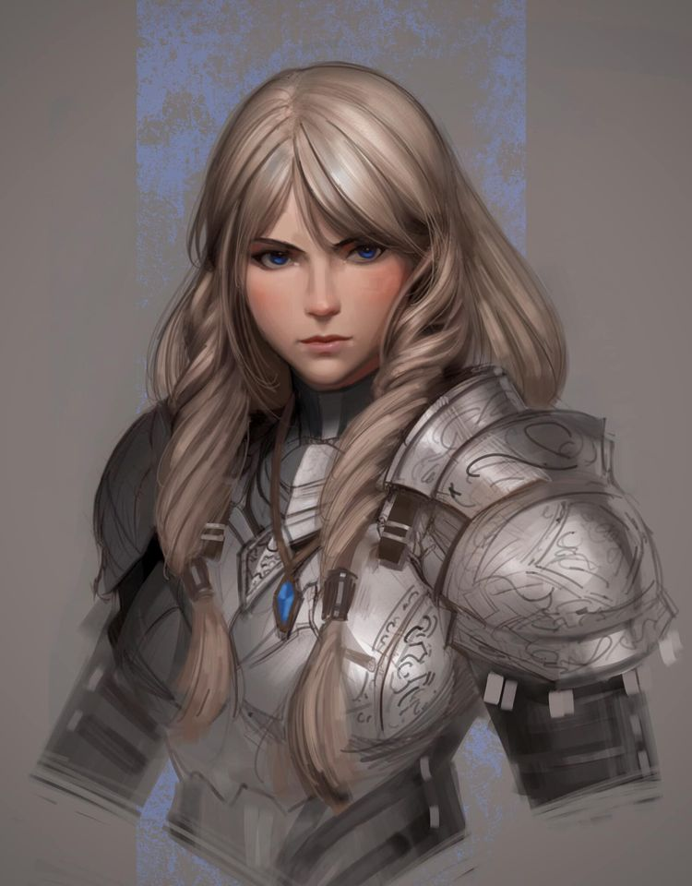

Aside from the red velvet-lined throne in the room, two armored figures were depicted by statues hewn from zircon-rich monoliths. One was of a male warrior unrecognized by the newly arrived heroes; the other was the spitting image of Laryssa before her ascension to a Celestial form.

And then there was Interpreter Orion of Mayaheine, who introduced himself as such in an accent reminiscent of lands north and east of here, certainly not Cormyrean. “We bid you great thanks, and are preparing a banquet—a feast!!—in your honor this evening. We know not when you’ll be returned to Arborea, though the scriptures speak of Night’s Heart being the appropriate time. No doubt, you’ve met those who brought you here; we will tend to the resurrection of those that can be raised, but in the meantime, Zulia, please see to our guests’ comfort.”

Tore interjected, “If I may... Zulia mentioned a powerful relic that you guard here. Is that why the ibixians attacked?”

“Alas, yes, if they were to regain control of these lands, we would surely be doomed to wander the roadside begging for scraps. The Shieldmaiden rewards those who seek to carve out their own fortunes and fates, not meander by and wait for handouts,” Orion stated as if he were reciting the ingredients of an item on a menu.

Saradette waited patiently to be shown the relic.

Tore nodded, “Well, can we see the relic and learn a bit more of its history, why it concerns you so much that the ibixians could do so much damage with it?”

“But, of course, once the proper rites have been enacted, you will witness the magnificence of our lifeblood,” Orion—a human of about fifty years—assured them. “Zulia, won’t you escort our heroes to the promenade? The banquet is surely ready for us by now.”

Tore nodded to Orion then turned to Zulia. “So, Zulia, how long have you been here? Much of the structures seem to be fairly new.”

~*~

They were presented with the aforementioned banquet near the center square—a makeshift area ensconced by a partial palisade and some bleachers from which competitive games, performances, and deliberations could be witnessed. Dozens of heads of ram-horned humanoids were mounted along the outside wall of the longhouse from which the townsfolk were now emerging with trays of savory dishes, and the gamut of Mayaheinite symbolism decorated the wooden architecture only a few seasons old.

Cheers from dozens of folks from a handful of extended families—mostly human—regaled the heroes as they were presented with two seats of honor at one end of a single, long table as Orion sat at the very opposite end with a half-elf about his age—who undoubtedly looked half his age—smiled politely and took the seat next to him.

Tore was not fond of the attention but did not want to be rude. He accepted the food as it was passed and partook of the beverages provided, careful not to over indulge in any intoxicating liquids.

As he ate, he tried to engage those around him, asking them where they came from, how long they had lived in the area and what brought them there. They were all pretty much from Anauroch, Cormyr, or somewhere in-between, with maybe a few outlanders from farther off. It seemed to Tore that it had been scarcity, and the raids that often came with it, that had driven most of them from their farmsteads and other rural stomping grounds. He and Saradette could tell that this had been nothing more than an encampment not long ago; the first hovels they’d seen in the periphery were actually modified tents whose leather flaps had seasons ago been switched out for wooden planks.

The occasional abandoned hearth they’d passed along the way suggested a household had either moved into a proper house or left, and from what Saradette and Tore could gather, there were not a lot of deserters in the fledging settlement. The solidarity and joviality alone were testament enough to the success of this stand in the wilderness. Saradette didn’t mind the food and drink as she listened to the conversation and observed the other people around the table. She thought of her mother’s lessons about investigations, and she silently sought to understand the power dynamic of their hosts.

After a few minutes of studying the hierarchy, it appeared that Orion delegated authority directly to Zulia and another warrior-priest—Macoute—and they—in turn—had under their provision a handful of lesser priests, who oversaw the welfare of the monks and commoners and others. They definitely skewed Lawful, and Saradette had already noted arcane and divine indicators of this.

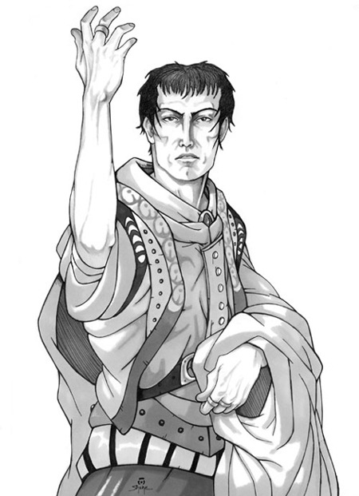

About an hour passed, and at one point, the people of Goldenhill began to tire of their own festivities, with only the younger ones remaining afoot, some even dancing around the fire stoking in the center square. Orion nodded a few times and said a few words to Zulia and Macoute, and the three ventured over to where Saradette and Tore were standing.

“Come friends,” Orion invited them. “It is time to bestow upon you the honor of the evening.”

|  |  |  |  |  |  |  |
| --- | --- | --- | --- | --- | --- | --- |
| **Skill** | **Rank** | **Ability**  **& Mod.** | **Misc.**  **Mods.** | **Total** | **Roll** | **Check** |
| **Saradette, Sense Motive** | 1 | **Wis (+1)** | 0 | 2 | 15 – 20 | ?? |
| **Tore, Sense Motive** | 0 | **Wis (+3)** | 0 | 3 | 6 – 10 | ?? |

*See below. [IC info for Saradette sent privately to JR.]*

Tore smiled back, eager to see this relic they’d hyped up so much.

Saradette on the other hand, was a bit more than nonplussed. While she noted the same earnest look in Zulia’s eyes, the reticent Macoute had been barely able to hide his contempt for the heroes throughout the evening, and the way she’d read Orion from just about every facet posed him as a calculative speculator playing to the crowd with layers of duplicity and compartmentalization within his ranks. She had tried to rule out what she’d heard throughout the night as the necessities of a rugged outdoorsman, but this was no freedom-loving band of pioneer settlers; they were a rule-based structure that with every moment betrayed more features of a cult or a gang.

Saradette had remained uncharacteristically quiet during the meal, and she talked with Zulia more than the others. She walked beside Tore as they were led to the relic, and she seemed to be ill at ease, although she kept up a good front to their hosts.

They went through some ordeals and rituals before opening a wooden chest that creaked as the hinges scraped against one another. Saradette did not identify the item as the befabled Ephod of Authority, which the believers had called “Authorsephodium”.

Tore may not have known Saradette for long, but he did pick up on her out-of-the-ordinary silence and behavior. This put him a bit more on edge and on alert. They had been treated well, but possibly too well.

Was it possible that the relic had affected the residents, or still was affecting them, for that matter?

Tore tried to pay more attention to his surroundings and the other actions, trying to determine if they had other motives. Those present were definitely committed to their cause, and if anyone had cause to gain from duplicity, it was Orion, and perhaps his trusted confidantes.

If they have a moment alone or some distance from the others where they can’t overhear, Tore will ask Saradette what’s wrong. The fighter-cleric stood among others of his kind, though his Mayaheinite counterparts preferred the term warrior-priest; still, he couldn’t shake the feeling that these faithful were not of the same cut as Saradette.

Saradette smelled inauthenticity in Orion, and though she’d seen a handful of indicators in his interactions with Zulia to suggest that she was outside his immediate circle of trust, the amount of whispering and facial communication between the leader and Macoute told her that Orion imparted more information with him than perhaps with any other living soul.

Tore began to focus a bit more on Orion, especially as they neared the relic. He wondered a bit more about what the relic was, as not much had been said. Tore also decided to push the subject a bit more. “Orion, can you tell us a bit about this item before we see it? My curiosity is piqued by the devotion you all have for it.”

He said about forty words that he’d obviously rehearsed, perfectly chosen to assuage any discomfort over the uncertainty around the object. Then he concluded with, “In short, it allows us to turn back the undead marauders that have swept through these hinterlands, but more importantly, it had guided our faith and conduct out here. It has been revealed to me that once you take this bestowment with you, its powers will be replicated within me, and I—in turn—will pass on the gift to my successor when I am called to join the Shieldmaiden.”

Saradette continued to quietly observe their hosts as Tore and Orion spoke, noting inconsistencies in the latter’s demeanor and philosophical stances. She could be excused for a bit of sightseeing, she supposed, given her lofty status as a representative of their deity, but it seemed like things were getting interesting.

“Ah,” Tore sighed as a celeste aura began to form around him. “I believe I *have* heard of this legendary relic! What a fortunate bestowment from your goddess!” he knew to say to his host.

Macoute squinted quizzically at Tore as Orion replied, “Indeed! Now, I see that the goddess is poised to retrieve you from this plane.”

Saradette—too—noticed that she and Tore were now glowing a bit. Their return to Arborea was nigh, and Orion ceremonially presented bequeathed the Ephod to Tore, and bid him, “Safe travels, friends. We are grateful for your contribution to our wellbeing; you will always be welcome here, and tales of your heroism will be sung for generations....”

Seeing the opportunity, Tore donned the Ephod of Authority, and Saradette stayed alert as their time at this location ran out.

The worshippers of Mayaheine waved and bid their saviors a good return to the Outer Planes.

~*~

The rematerialization process was fairly uneventful; they reappeared in the same place in Goldenhill from which they’d left, and a few folks posted here now approached and greeted them. “Heroes!” one of them smiled. “You are returned.”

Sumer was just around the corner, and came to greet the two heroes. “You look tired,” she said as they took in their surroundings once again, still in shock over having died and been reborn under the hills just outside this gnome-dominant settlement under a singular canopy spanning thousands of trees for miles around.

Tore smiled, “It was an interesting adventure. Perhaps a little rest and we should be ready for whatever tasks lay ahead.”

~*~

They had rested, and were now ready for whatever tasks lay ahead. Before that, however, there was a debriefing convened in one of the private chambers where Sumer was waiting. There was a mutual exchange of information, and the authentic of the Ephod of Authority was confirmed by diviners and priestesses.

They sat at a round table. Eight chairs seated as many beings, some of whom were on par with Saradette and Tore. After brief introductions, the two had a vague sense of who was who:

* Akilesh, M dwarven favored soul of Lurue
* Everest, M lizardfolk druid
* Grungebop, M grig scout
* Hrawa, F ghaele paladin of Lurue
* Lakshmi, F Astral deva
* Laryssa, F human paladin of Mayaheine
* Rasha, F woodling rogue
* Sardon, M satyr ranger
* Serenity, F trumpet archon
* Solange, F half-elven bard
* Sumer, F human cleric of Lurue
* Zvetlana, F wereserpent aristocrat

Tore enjoyed the rest, but not the attention. He was also impressed by the wide range of species at the table. Some he had heard of, but had never met. He smiled when he saw Laryssa once more, and greeted the others, asking them about their recent travels or adventures.

Tore spent time talking with several of those in the group. He met with Laryssa and asked about her time with the Fist of Light and what she had been doing since in service of Mayaheine.

“I ascended to this state when Saradette and I had just arrived in Mintar,” she began, adding a few details of their years together before then. *(Chapters 1 through 6 are available as lore, if needed.)*

He spoke to Akilesh and Sumer, asking about their service to Lurue, and what sorts of adventures and jobs they had done outside of Temple work. Sumer had been here longer than any of the others, and was the type to spend her spare time in contemplation of the greater ecstasies that Lurue bestowed upon the faithful, while Akilesh led the children spirits on what he smirkingly termed *adventures*, which were essentially nature outings comingled with feyfolk diplomacy. He also spoke of having killed hundreds of orcs and goblinoids in his previous life, and did so with a fond longing in his dreamy, brown eyes.

Tore also spoke with Everest, asking how he had come to the area and where he had lived. Everest proved to be about the most polite reptile with whom Tore had ever spoken, and his eloquent tongue bespoke of a lineage of well-to-do lizardfolk, though it was just as evident that he was as rugged outdoorsman as he was an eloquent orator. “I studied under Zhstrasse,” he finally explained his articulate eloquence, referencing the locally famous warrior-poet. “But prior to my ascension, I lived among the Sharptooth Clan near Wheloon, in the confines of the Kingdom of Cormyr.”

“Ah,” Tore nodded. “We were just in the mountains north of there, I believe still within the jurisdiction of Cormyr, but facing Anauroch, which lay at the bottom of the north face.”

“I know the general area... too arid for my taste... scales wilt,” admitted the lizardman. “And what were your exploits in your past life?”

Tore was also very interested in talking to Serenity, having never met a trumpet archon.

She mostly spoke about music theory, specifically the ratios of pitches to one another and why a 6:5 frequency ratio between two notes conveyed melancholy feelings while a 5:4 ratio manifested a more optimistic state of mind, and the role of percussion in all of this. Most of it was of little interest to Tore, but the archon was successful in tying it all back to Lurue’s patronage for the performing arts, and the implications this had for a community’s wellbeing.

Tore asked about where she came from: was she born into the mortal realm or did she come from a divine plane?

“I have never perished, and when I do, it will be permanent, as will your next end be,” she kept her tone light, and sated his curiosity as they talked.

The fighter-cleric was a bit distracted by Laryssa, Sumer and Serenity as he talked with them.

Saradette had set up her shop, and now went about examining her devices to see what repairs they required. She also considered how to set up another biogas generator to produce the gas she used in her welding torch and in her improved forge. Her gadgets were mostly in good condition, and she gave each a little bit of love to get them tiptop.

In conversation with Tore and some of the others, a question came to her mind. “I have left some items back home, or what was home, I suppose. Is there a way for me to recover them?”

“Where specifically?” asked Sumer. “I believe you perished at the hands of hobgoblins; they don’t leave much behind.”

Everest, Grungebop, Rasha and Sardon—a team called The Woodland Striders—recounted their exploits against a band of demons that threatened a settlement in the Whalebones, after which Zvetlana’s tale of her father’s “Serpent Kingdom” lured them into the twisting layers of intrigue and betrayal that had characterized her mortal life. “Now, I specialize in hunting down evil lycanthropes,” she concluded.

They talked for a bit more as everyone got to know everyone else.