*Chapter 4.2: Elsabet, the Feyborn*

As she went around town arranging to use the proceeds from their most recent excursion, Elsabet thought she might be losing her mind. At times, it was almost like she could understand the squawking of the crows and pigeons, the meowing of alley cats, the barking of dogs... She’d always liked animals, even though she’d never learned how to handle them properly, but she’d never thought to be able to understand their speech, not like Saradette and Barkley could sometimes.

And recently, she’d occasionally see someone mistreating a person or animal at some distance, and not only would she have an urge to call them out on such behavior; she felt a strange energy seem to gather at her fingertips, like static electricity yet different somehow, but feeling like she might be able to reach across the street or plaza and chastise the abuser with a touch, somehow. Or she might feel like, despite not having a divine spell that could do such things, that maybe she could somehow use some kind of arcane power to intervene.

These things distracted her from her previous routine of practice with Xavier, and she knew she needed someone else to talk to about this. She tried to recall what little she remembered from her early classes in knowledge arcana and spellcraft, because it seemed like she might have read about something like this, but it had been too long. So, she thought, Lauren, as a duskblade, might well know more about weird arcane abilities, or even if she didn’t know much, she might know about this!

She eventually tracked down the duskblade, who partway through Elsabet’s description of her troubles, started grinning and then laughing. “It isn’t that funny, Lauren?” Elsabet said, frowning at her friend.

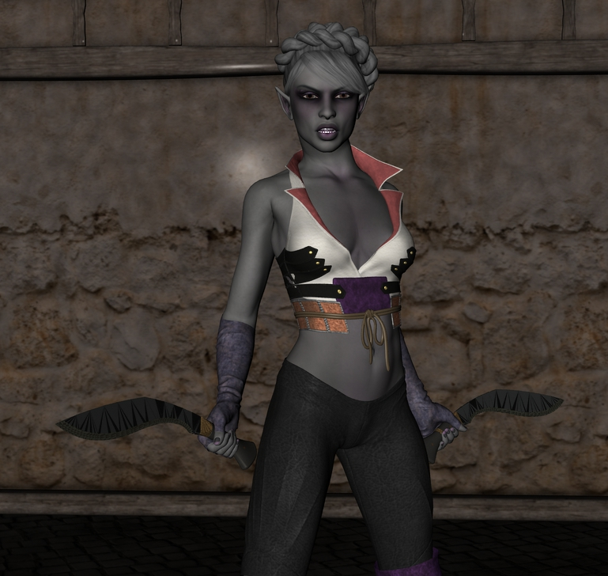

“It kind of is,” replied the half-drow. “I think you actually have a couple of things going on. Growing up,” Lauren continued, “because I was different from most of the people I knew, I learned to see differences in the heritage of others. And while learning my own abilities, I met a variety of other arcanists. Here’s what I think is going on.”

The half-drow paused to take a sip of her wine—Elsabet was buying dinner, so she’d gone for the top shelf. And while thinking of just what to say, she saw Barkley start towards them, and called out, “It’s girl talk, Big B; you know how it is.” Barkley nodded and headed back to his perch near the bar, alert for trouble as always.

Putting her wine glass down, Lauren leaned forward to be able to talk quietly to Elsabet, who was trying not to be impatient, and starting to lose that battle. “Here’s the thing, girl. I’ve thought you might have a trace of elven blood in you somewhere, since I met you. But now, I think it’s a bit more exotic than that, I believe you have a fey of some kind in you ancestry, probably Summer Court, they’re the bright Fey, a lot prettier and better behaved than the Winter Court, though just as dangerous if you cross them. Anyways, it’s likely that a Nobleman of the Summer Court dallied with a mortal human woman, and one of your ancestors was the result of that union. It is even possible that the Fey Noble made a pact with his mortal lover.”

She paused for another sip as Elsabet waited for more revelations, and continued. “Fey bloodlines are strong, and can manifest in some descendants even after generations. I suspect, while you may never have noticed, that you’re a bit more resistant to enchantments than others, that’s usually the first manifestation of Fey Heritage. But as you’ve grown more powerful, other abilities can manifest, if embrace them. You’re feeling the beginnings of what some call Fey Presence - if you work to sharpen those feelings, you should be able to call forth certain arcane magic - if i recall correctly, you’ll gain the ability to Charm a Monster to be your friend for a few days, to cause weak-minded creatures to fall into a Deep Slumber, and to use the classic Fey power, glamer, to Disguise your Self as someone quite different! You’ll have to devote some effort to mastering these powers, and if you do master them, much like a lesser Fey like a Sprite, you’ll only be able to use them once per day, but I think it is worth doing. Embrace your heritage!”

Elsabet mused on that for a bit, then said, “Okay, that makes sense of some of what has been going on, but you said a couple things?”

“Indeed,” Lauren replied. “The other thing I think is going on - and it is related to your Heritage, as well, is that I believe, as I mentioned, your ancestor - indeed, your family, for the Fey a pact may stay in place through many mortal generations - probably gained eldritch power through that initial liaison. Warlocks are pretty rare, and to be honest most are tied to Fiendish patrons rather than Fey, but not all. That energy you feel isn’t electricity, though it may feel similar - it is pure eldritch energy, which no creatures that I know of can resist.”

Lauren chuckled. “It is kind of lame in terms of dealing damage when you blast someone with it - not nearly so powerful at first as that scorching ray I burned you with! But fire resistance would protect you against my ray - and unlike like my admittedly awesome arcane spell power, and your own cool divine spell power - you could use that eldritch blast all day long, so that’s pretty cool. Warlocks are kind of weird that way, they don’t learn too many arcane tricks - they call them invocations because they are invoking that eldritch power granted by their Fey or Fiendish source - but the invocations they do learn, they can use at will, spell-like abilities much like their patrons can use. I believe you’re subconsciously starting to try to invoke the one called Call Of The Beast - I knew a guy who had that - it let’s you talk to animals and even use that druid/ranger thing, Wild Empathy. Seems kinda Fey-like too, heh.”

She shrugged - talking to animals seemed like kind of a waste of time to the duskblade, but Elsabet had always struck her as a lot more sociable in nature, and was definitely kind to animals anyways. She drained her wine glass, and said, “Look, if you ignore these things, if you don’t want to embrace them, they’ll probably fade and lie dormant. But it may be a sign from your goddess, right? You’d use such powers for good, to defend and help people, right? So if you want, I know a guy in town who could help you master the eldritch stuff. I wouldn’t trust him to back you in a fight, but he owes me a favor, so if I introduce you and ask him to train you to control this stuff, he will.” <If he knows what’s good for him, she thought.> “And in return, you can owe me a favor instead, if he does what we ask. Deal?”

Elsabet spent a moment reflecting, praying for insight. She got a sense of amusement, maybe that was just the look on Lauren’s face, but maybe it was more. She decided she should do it - and felt acceptance and encouragement along with the amusement, as she swore she would indeed use any such powers for good, in the service of her Goddess. “Deal!” She held out her hand and the two women shook on it, light and dark hands clenched in mutual respect. “Xavier may not be amused,” she joked, “but he’ll get over it!”

And so it happened. Elsabet mastered the Fey Presence feat, and embarked on yet another path, taking up the Warlock class. She filled in her companions a little later, and Xavier took it well enough, giving her a few thin training sheets to take with her should she later return to the Crusader path.