*Chapter 5.1: Saradette’s Springtime Slumber*

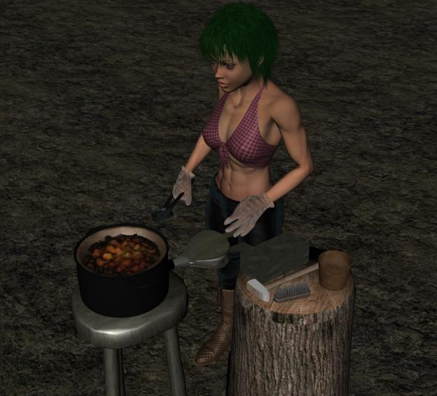

Saradette was now a nimble-fingered pickpocket, and able smith in her own right. Taking a break from the bustle of Saradush, the gnome was on her way to a Gondar temple-monastery-academy to begin the process of becoming an artificer. Traveling to meet the contact of a trusted contact, at this point just a name on a parchment, she rode a paisley-patterned pony across a field of spice and lilies that stretched out for two horizons, and when her pleasant and scenic ride under a turquoise, springtime sky was through, the rogue-illusionist descended from the gallant pony and straightened her legs a bit. The monolithic structure lay in the middle of a fey-rich wilderness that had not been farmed, mined, or otherwise exploited since time immemorial... and yet, the gnomes and others in the temple toiled every day with a steady influx of metals, and consumed fresh provisions regularly.

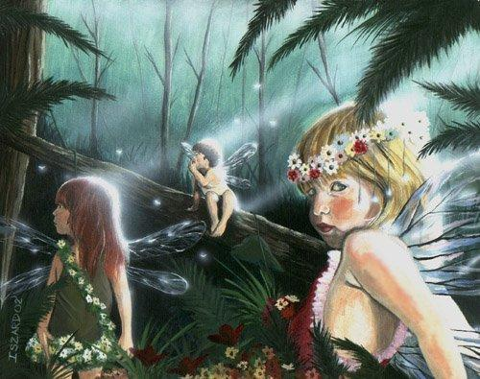

Saradette was approached by a dozen or so fey on her way to her waypoint, and held silly conversations about navels and fey philosophy with more than one of them. Some came back before disappearing for good, and called her name out several times: “Saradette! Saradette!” She’d also had to fight off a pack of stirges that wanted to drain her of every drop of her blood. She was itchy just from the thought of having been bested by those fiendly beasts.

Saradette now smelled the myrrh that wafted through the temple before emanating into the dreamy, teal atmosphere outside as fairies, pixies and sprites bid her goodbye, “Saradette! Saradette!” they called and waved.

Saradette wondered where the metal and food came from to build the temple, and what advantage there was in settling here and establishing such a lavish monument to the worship of Gond and the study of some of the most intriguing mysteries in the multiverse.

Saradette noted that the architecture was an exact replica of the High House of Wonders, which was likely the grandest Gondar temple in an urban area in all of Faerûn. She’d been there about a year and a half ago when they’d passed through with PJ’s caravan with a bountiful payload, and here was its exact likeness in the middle of nowhere.

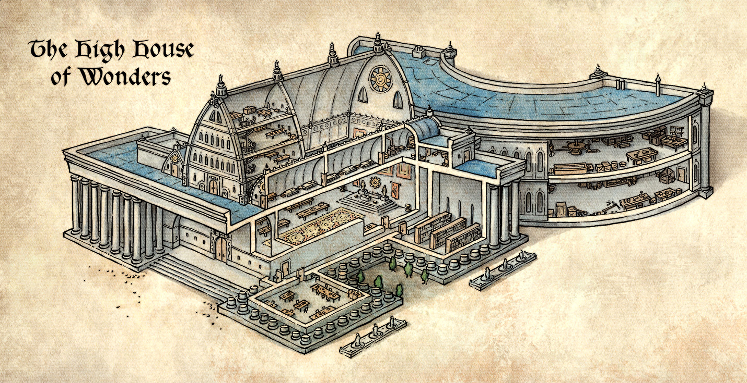

Saradette could now also smell, in addition to the myrrh, the cooking of squashes and peppers nearby, and her stomach growled. She was greeted by a few monks who took the pony to the trough as she entered through the double doors that opened mechanically upon her stepping near them. She made her way to the main altar where two women discussed the specs related to a blueprint at the table closest to the altar. The white-haired half-drow was clearly a taking-matters-into-her-own-hands type, and kept sheathed at her side a hefty blade. Wearing a mithral chain shirt, this woman was not someone whom Saradette would have regarded as a mentor in the art of artificership, not by her looks.

“Saradette?” asked the darker-haired woman—dressed in clothing that Saradette could not place—was clearly a human, though the two women were only about 3 inches apart in height.

“Uh, Maja?” Saradette asked.

“That’s me,” Maja set down a pointer and gave the gnome her full attention. “Glad you could make it. Make yourself at home. Fruitcake and carrot juice are on the table.”

“Yum!” Lauren said, already having had some, but helping herself to a second helping of cake as she introduced herself to Saradette.

“I’m Lauren Fifthdaughter. I understand you want to become an artificer.”

Saradette nodded. “I do.”

Maja spoke up. “I’m Maja Stasiuk, and I’m an engineer in my world, where I work on ships that fly between the stars.”

Saradette’s eyes widened—her closest connection to such things being the Astral Plane—and Maja laughed, “Okay, so that’s a bit much to absorb, but I’m here to help you learn some of the basics of technology. I don’t know about magic, though.”

“I’d like to say I understand, but,” Saradette shrugged helplessly.

“We get it,” Lauren replied with a smile. “Grab something to eat, and we will get started.”

Saradette went to the table, picked up a slice of fruitcake, and took a bite. “Oh, that’s good.” There were small wooden plates there, and she set the cake on it, and walked back to where the two tall women were working.

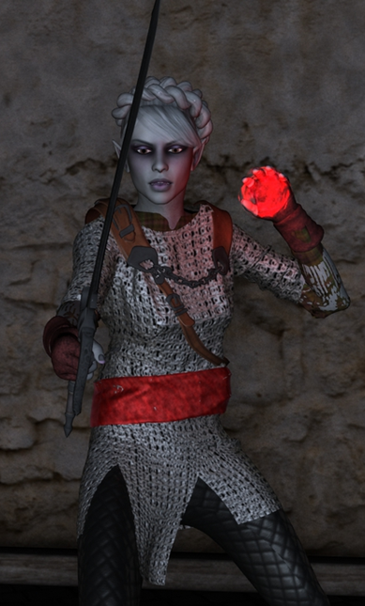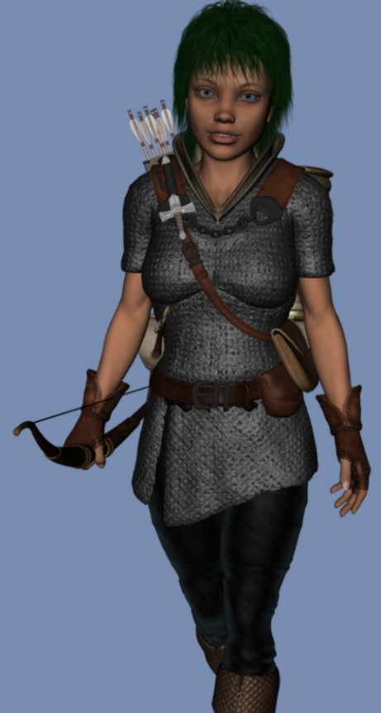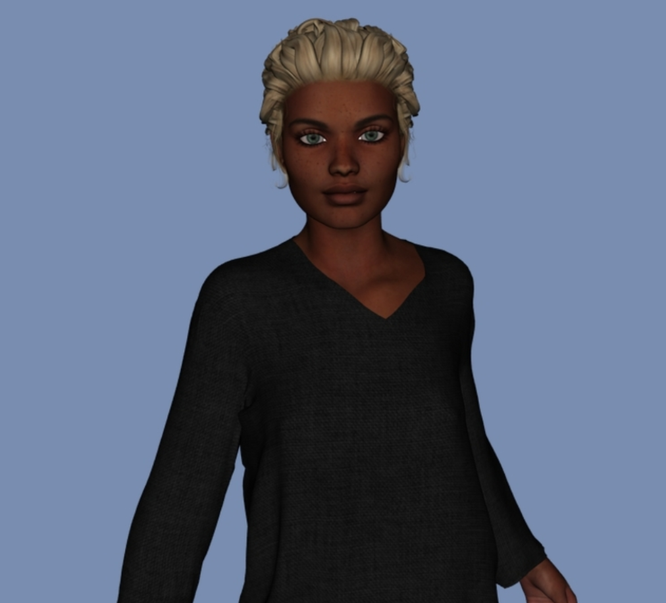

The three women got to know each other with respect to the basics—W*here’re you from? What are your interests?*—and munched on some fruitcake as Maja prepared to distribute the agenda she’d prepared.

Maja cleared her throat as she handed Saradette a pamphlet, and read part of it aloud while Lauren stood closer to the altar, waiting for her part in this.

Maja recited, then read, “Oh, by the power and wisdom of Gond, may the mysteries unfold for us before we awaken…. ‘Manual of Structural Integrity... in order to maintain structural integrity in a work of craftsmanship…’” the human read on for the gnome, and then began to summarize some of the key points on the back of the leaflet.

Maja yawned. “So some things to keep in mind—and I’m learning this myself a little—about structural integrity include: golden ratios, triangulation, and base materials with the proper molecular integrity.”

Lauren was already standing next to Maja once again as the resident tactician at the temple. She’d been consulted twice already by two faithful travelers, and now explained, “An aspect of your endeavored craft that you mightn’t’ve is the ability to embody the technology you wield as if it were an extension of your body.”

The half-drow went over some specifics of mind-body synergy, taught Saradette some asanas that would be useful in minimizing her arcane spell failure when impeded by wrist gear, and admitted, “I, too, am learning from Maja’s tutelage. The House of Gond is indeed a House of Wonders.” The worshipper of Corellon Larethian then asked, “So, tell me, Sister Saradette, what is your greatest takeaway point tonight?”

Saradette realized it was pitch black outside now.

Lauren read aloud a scroll that Saradette could not identify, and a few items were conjured upon the table. Fit for a gnome or similarly sized creatures, the instruments were those of an artificer. She adopted them and donned them, and was then told that she would have to learn how to make use of these ephemerous gifts in battle. “I’ll be your huckleberry,” she simply offered as she led the gnome to the arena behind the temple, an odd juxtaposition of sites in such a remote, fey-rich, and lush wilderness.

Saradette readied the acquired items bestowed upon her by the Gondar clergy, and together with Maja and Lauren, made her way to the arena behind the remote and lavish temple.

~*~

“Alright, so I’m going to opt to deal you nonlethal damage, so I expect you to take it easy on me as well,” Lauren cautioned Saradette. “Oh, and it looks like your friends could join us. We’ll need the healing.”

Barkley, Elsabet, and Laryssa stood to the north. The healers stood by ready to do their thing when the match to unconsciousness was over.

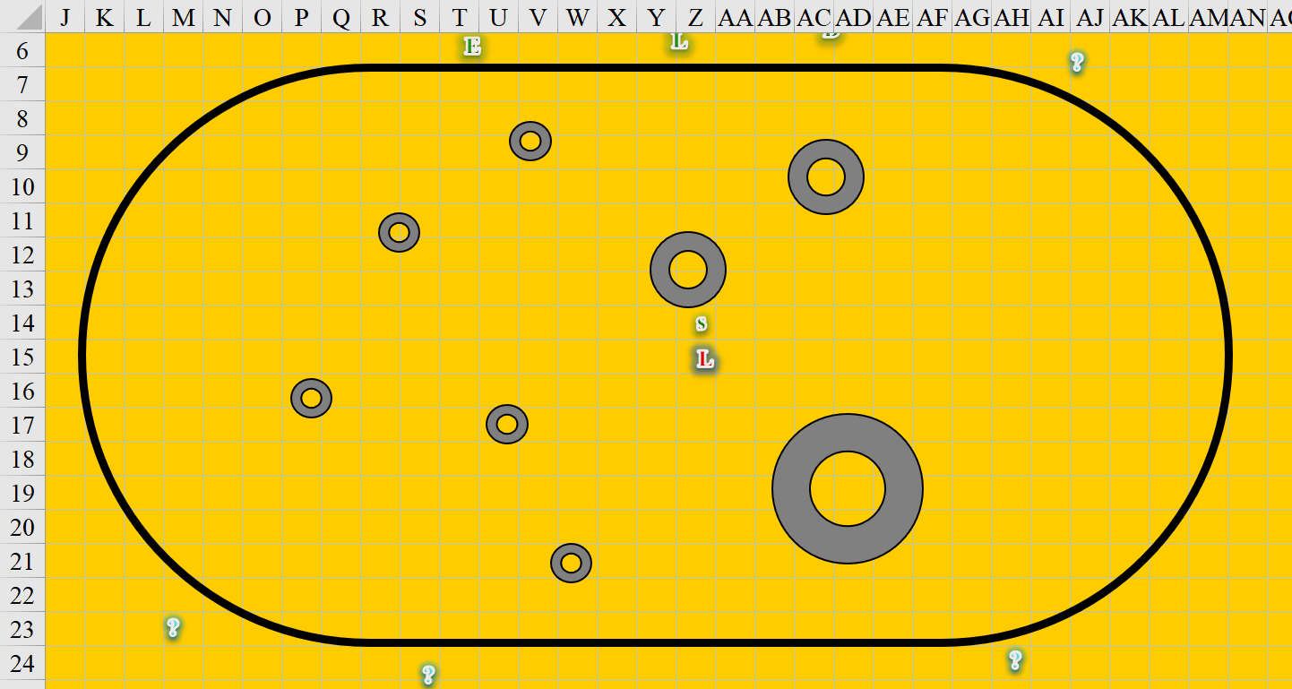

“Take your position,” the half-drow told the gnome as both went their separate ways.

Saradette and Lauren walked together as they entered the arena. “Okay,” Lauren said, “we have healers here, so don’t worry about hurting me, or being hurt.”

The gnome nodded and took a breath. “I just hope this thing works.”

“I might be forgiven for hoping it doesn’t,” Lauren replied with a chuckle. She shucked off her backpack and set it aside, along with everything but her armor, and her sword. She stepped to the further circle in the arena and faced Saradette from sixty feet away. “Ready.”

Saradette set her gear aside save for her armor, her sword and daggers, and her sabot launcher. The odd device was loaded with a charge of compressed air, and two sabot rounds, one in each barrel. She didn’t bother with the pump or spare rounds, as Lauren would run her through before she could reload. She needed to make her shots count. She faced Lauren across the arena from her own circle. “Ready.”

Lauren was not one for the arcane intricacies of artificer technology, and would likely rely on her alacrity to avoid whatever ill-fated fate awaited her at the business end of the device.

The dozen or so spectators who had gathered ‘round were mostly Tempus worshippers, and were already getting rowdy. Unnoticed, the High House of Wonders was no longer a mere few steps from the arena, but about a quarter of a mile away. The climate was so placid!

The Tempusians discussed the various merits and shortcomings of each contender, and placed bets in the name of their deity.

|  |  |  |  |  |  |  |
| --- | --- | --- | --- | --- | --- | --- |
| **Character** | **TAC** | **FFAC** | **AC** | **Good/ Pos** | **Chaos** | **HPs** |
| **Saradette** | **14** | **15** | **18** | *Imm* | *Imm* | 25 |
| **Lauren** | **12** | **17** | **19** | *Imm* |  | 38 |

“Lauren’s the sure bet!” one of them said.

“Nay: the gnome’s got the techie edge.”

“Edge smedge,” another one protested. “Braun is what gets it done in the arena.”

|  |  |  |  |  |  |
| --- | --- | --- | --- | --- | --- |
| **Character** | **Group** | **Initiative** | **Roll** | **Modified Roll** | **Move** |
| Saradette | 1 | 1 | 10 | 11 | 20’ |
| Lauren | 2 | 0 | 3 | 3 | 30’ |

Saradette checked her ammunition – and blanched when she realized she’d loaded lethal rounds. “Hang on,” she called to Lauren. “I have the sharp points loaded.” She quickly extracted the offending loads, and replaced them with flat-tipped flechette rounds. “Okay, I’m ready,” she called.

Lauren shook her head. “I will be really mad if you kill me.” She advanced toward Saradette at a walk, her blunted training falchion in hand. The drow thought about using her Blacklight ability, but this was supposed to be a test for Saradette’s benefit. She sternly reminded herself to not hit the gnomish woman *too* hard.

Saradette hefted the ungainly weapon and placed it on her left shoulder. She’d fired it several times in practice and during construction, but it was odd to be pointing it at another person. Leaning her head to the left, she peered through the sight, which consisted of a number of thin metal rods shaped to form an aiming point, and an estimated distance. She waited for Lauren to close to 30 feet. Lauren obliged her, and Saradette held her breath, centered the sight on the drow’s torso, and pressed the trigger.

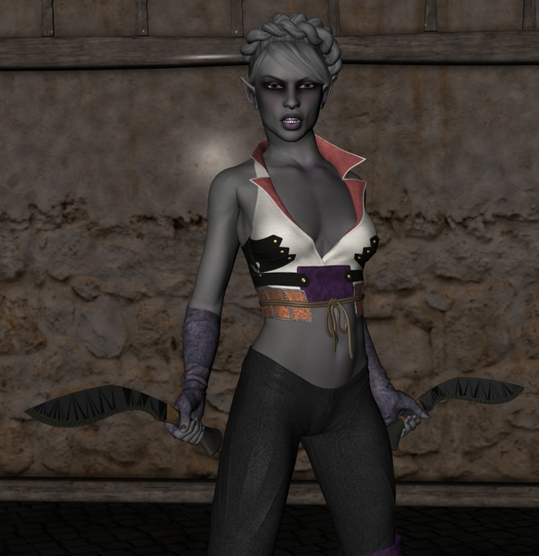

Up along the edges of the pit, the Tempus, Tyr, and Mayaheine worshippers encouraged both contestants with an equal distribution of fans for each lady. The ashen-skinned swordswoman who usually donned twin kukris unsheathed her sword and returned some of the compliments to the handful of cheering spectators whose body language was clearly bolstering, while the artificer-to-be smiled at the crowd that cheered for her, and got into position.

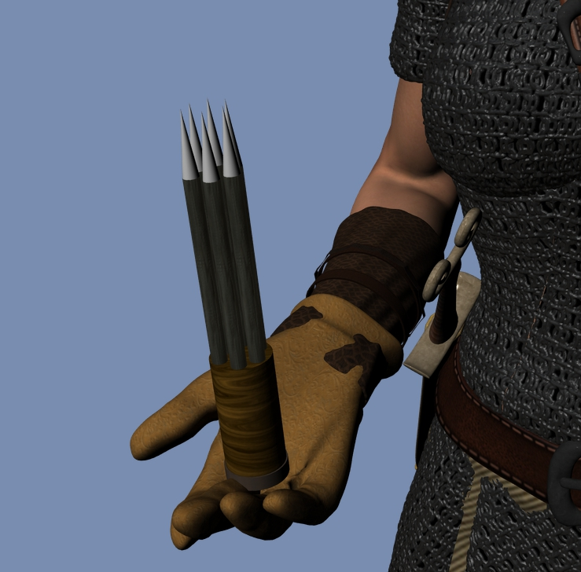

Producing a six-pronged projectile that would disperse into distinct sabots upon being launched, the rock gnome gave her friend one last out, “You need to think about this a little more? Want to reconsider? Then she hefted her new tool of the trade, and loaded the projectile cartridge into it.

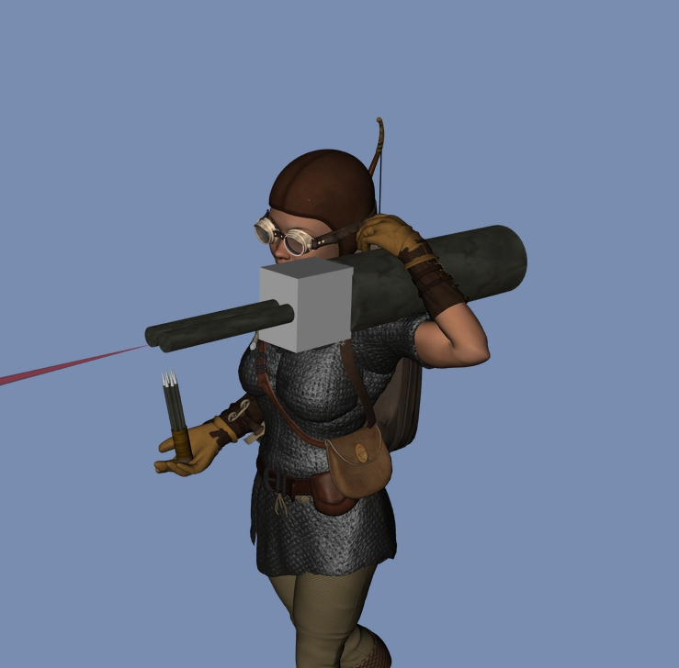

Elsabet watched carefully, nodding as she noted the nonlethal loads being put in the Saradette’s strange device and the dull edge of Lauren’s blade. Provided they stuck to nonlethal attacks the two should be fine.

She was rooting for Saradette, but was also appreciative of Lauren willing to be the target, remember her own recent duel with the drow and the rather more, um, aggressive tactics that had been used. Lauren holding back on her more powerful magic was definitely a significant concession!

“Don’t miss, S,” she muttered under her breath as the gnome aimed her weapon...

Barkley followed Elsabet into the arena. Though he didn’t have any healing ability, he wanted to see how his friends were after their battle.

Suddenly, Barkley felt a little different looking at Lauren, especially her naked breasts.

He had fought alongside her and known her for a couple of years, but now, something just felt different.

After a few seconds, he realized he was staring and turned away, stepping out of the room where he stood next to the door trying to figure out what seeing her like that felt so different, so... enjoyable.