*Chapter 4: The Harvest of the Handy Haversack*

It was a nice, warm night, and the bustle of the day had dwindled, bringing into the Obstinate Loaf a mixture of regulars and tourists here for Midsummerfest. It was now 1371, and the heroes celebrated a fairly prosperous quarter in their respective trades. No ill-fated summons to battle had mustered them to heft their swords and wands in the last few months, but they had trained together on occasion nonetheless. They now dined on the finest portions of mutton and cockatrice, munching on grapes and other fruits in between bites of flesh.

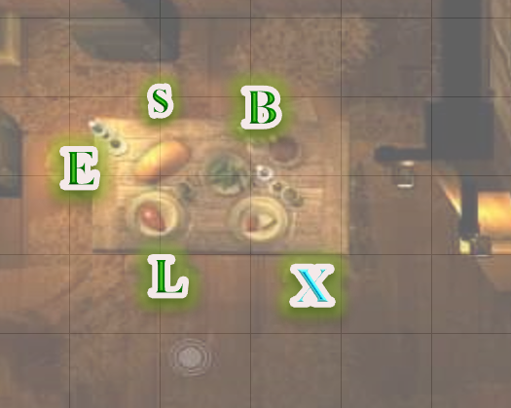

Barkley had been working for and with the owner of the Obstinate Loaf for the last several months. They had exchanged knowledge about distilling hard alcohol as well as brewing beers and ales. The pair had improved on the owners original Dragon’s Blood Wine by changing the mixture. The owner still purchased the Rhubarb Wine but he also purchased a small amount Bloodberry wine and the mix became 50% Rhubarb Wine, 25% Bloodberry Wine and 25% Dragon’s Breath Bourbon. The new mix became more popular than the original Dragons Blood Wine and was named Dragon’s Tears Wine. Barkley explained the process to his comrades and made sure that they each got a bottle of their own.

Elsabet ate heartily, but drank sparingly; she wasn’t one for strong drink, and even mild drink, she didn’t indulge in much, so she planned to make her glass of the beverage Barkley was so proud of last a while. It did taste fine, but to be honest, she much preferred tea. She had been happy to find her favorite, Zakharan tea, here in the city, and had stocked up on it. She listened to the others talk, watching them closely, and when prompted, filled her friends in on her own minor activities, but mostly she listened.

A movement in the crowd caught her attention, and she spotted a familiar brown-skinned face, atop a tall, well-muscled body. She caught his attention, and motioned for him to join her and her friends at their table. He moved confidently through the crowd and sat at the one empty place, next to Laryssa.

“Xavier, it is good to see you,” she said. “These are my friends and sometimes traveling companion. That is Laryssa between us to your left, Barkley across from you, and Saradette here at my left hand. Friends, this is Xavier Trueblade. He shares my love of Zakharan tea, for it is from *his* faraway homeland! We met at the seller of exotic foods and spices, where I picked up enough tea to last me months, if not longer!” She grinned, knowing that tea was not the drink of choice of her friends, but they did not begrudge her the preference, as it usually meant more ale or wine for themselves.

“And you!” a female stranger’s voice called out to another stranger, “You’ve got some nerve talkin’ about me. Talk about the tortoise calling the armadillo shelled!”

Elsabet and Saradette—who were both from the Dalelands—got the expression, and noted that the outlander’s accent was from their fair homeland, though Laryssa had only ever heard the Baldurian version of that expression—which referenced a pot calling a kettle black, and Barkley had never heard any version of such an expression, so he just smiled and hung his tongue out momentarily to cool off after the swig of the gods’ nectar.

“Xavier is the one I was telling you about, as he is a student of what is called the Sublime Way, a style of combat that is not well known in these parts, but apparently is more common in Zakhara. I believe Mayaheine meant for us to meet, for I feel that She has given me her blessing to learn this exotic martial adept training, as a crusader for Mayaheine, just as Xavier is a crusader for his own faith. I have been learning from him many things, but I have not yet mastered the intricacies.” She looked around, having realized she might be gushing a bit; perhaps she had imbibed more of this strong brew than she thought.

Indeed, she was a little flushed, perhaps even blushing a bit, as she recalled the contrast of her pale skin and his dark skin as he showed her certain... maneuvers, he called them. Some of their training sessions had led to more than just... maneuvers.

Down at the corner, Xavier chuckled, a deep, rich sound. “Elsabet has told me of some of her escapades, in your company,” he said, the words in Common but with the accent of someone from a much warmer land. “It seems that while we may serve different gods, we all strive to do what is right, and where possible, what is just. Brave and true hearts, I salute you.”

“Aw, man, fuuuuuuuck youuuuuu!” another rowdy voice in the nearly full establishment called out, rousing the attention of Elsabet, Saradette, and Barkley, who were facing the interior of the room and not the wall.

Xavier was among those facing the wall, and stayed his tongue about the ordinary folks behind him. He held his palms together and bowed his head over them. “May your gods protect you and lead you to righteous glory, wherever you may travel.” Then he grinned. “And now, my stomach tells me it wishes to make closer acquaintance with this fine-looking mutton!” With that, he dug into his meal with gusto.

“Y’otta get impregnated by a goat!” the situation fomenting across two tables in the southeastern corner of the room rendered a suggestion that probably would not be followed up on.

Elsabet, her composure somewhat recovered, kept her eye on the ensuing conflict to her southeast as she began telling the others of her most recent work in town; she’d been working as an assistant to a master weaponsmith not far down the same street from where Saradette had set up her work area at the blacksmith’s place, and the two had often gotten together to discuss the banging of hammers on anvils after a hard day’s work. They laughed at her recounting of a few blunders she’d made that worked out okay in the end, and she finished her story, letting someone else lead the conversation for a while as she winked at the gnome next to her.

Near the rowdy parties sitting at the two adjacent tables to the southeast was a robed and hooded male drinking from a three-pint mug. The man was about human size, so the tankard could have lasted him all day, but in the time that the archon and his friends had been here, Saradette had seen him tip that vessel back further and further every time he drew from it to the point that he was likely to be ready for another round soon.

The favored soul continued to speak of her recent accomplishments in the trades. While Saradette specialized in smaller, more intricate work, much like the gnome herself, Elsabet’s work involved larger pieces of metal, forged for the business of combat, much like Elsabet herself, actually—but there were many similarities between their techniques, even though the scale of the work was different. Both their hands were often soot-smudged, and the occasional burn was an occupational hazard—but it was good, honest work, and Elsabet at least made enough to take care of her expenses. She had been very impressed by Saradette’s new magical haversack, and resolved to get one for herself when she could afford it—her mule Sandy was getting a bit older and probably deserved a less strenuous job eventually, and the magic haversack would hold much of what the mule normally carried. Perhaps it was time to start looking for a more lucrative endeavor soon....

She finished her plate, and pleasantly stuffed, sipped at her drink and listened to the conversation, rather content at that moment.

As he was introduced to the new stranger, Barkley bowed his head towards Xavier. As Elsabet spoke, Barkley listened and smiled. He was picking up the scent of certain pheromones from Elsabet as she spoke of this stranger. Obviously, Barkley thought, there is more than just swordplay going on here.

When Xavier extended his praise, Barkley raised his mug towards their guest and smiled before downing the rest of the mug’s contents. He was glad his friends were enjoying his creation, especially Elsabet, knowing that she was not much of a consumer of powerful spirits.

As they went around telling stories, Barkley had little to add. His patrols with the Militia were uneventful for the most part. He had found several interesting facts about the region’s history and also several books about the various religions that had come and gone in the area as well. He found the rights of many of them interesting, but noted several similarities in their actual beliefs and morals outside of the differences in their ceremonies.

He did, however, tell them of a few scrapes he had gotten into as the Loaf’s bouncer. More than one intoxicated patron had tried to pull a dagger or other weapon on Barkley, only to be summarily slammed face first into a wall and their weapon hand twisted behind their back until they released their grip on said weapon. None had tried a second time.

The conflict at the far corner of the Obstinate Loaf seemed to be settled, though Saradette noted that the hooded drunkard to her south-southeast kept a wary gaze on the two belligerents closest to him.

Saradette drained the last of her Dragon’s Tears, and set the goblet deliberately on the table. As much as she liked making some coin and practicing her craft, she was restless. Looking at Elsabet, she sat up straight and spoke. “How is that long sword coming along?” she asked. “I saw you drawing it out on the forge this afternoon.”

Barkley nodded to Laryssa, “My thanks to the farmer, and you must tell us what deed you did to deserve such a reward.”

Laryssa returned the stranger’s greeting. “I’m glad you like the mutton and you all will be pleased to hear it’s on the house for us tonight. A farmer who I had occasion to help a while back delivered a sheep to the butcher with instructions it be butchered and delivered to the inn for our meal, with some of the lesser cuts to the innkeeper if he didn’t charge us for the meal.”

Barkley listened to Laryssa’s story, then looked at her with a disapproving look, “Why did you not fetch one of us to assist you? It is not wise to go out fighting alone.”

“I did not anticipate such a threat,” replied Laryssa. “If it had been common predators, confronting them would have likely made them immediately turn tail to look elsewhere. Had I known I was dealing with a more cunning and powerful foe, I certainly would have sought out assistance beyond that which Mayaheine had granted me. However, Her gifts helped me win the day.”

Barkley smiled, “Well, I—for one—am glad you are still in one piece.” He raised his mug and went to take a sip, disappointed to see it empty. He refilled the mug, hoisted it again, and took a long drink. The archon thought to requisition another one, but noted that their barmaid was busy taking the order of the drunkard to the south.

As the others were discussing Laryssa’s escapades, Elsabet grinned at Saradette. “It’s coming along great! The master smith is doing the finishing work, I’m just assisting him. Apparently, it has to be masterwork quality; I’m not skilled enough to do that on my own without risk, but with my assistance, he’s assured of getting it right, and done a little bit faster. Some minor aristocrat is getting impatient, but it looks like we’ll finish it early, which should make the lord happy, hopefully earning the smith a bonus and improving his reputation.”

Elsabet took another sip of her drink. “I think it’s for the guy’s eldest daughter, so he wants the balance to be perfect, and the decorations fancy. I’m just honored to have been chosen to assist! And speaking of metalworking, I picked up a set of manacles, look to be serviceable enough, but I was thinking, maybe we should each have a key. I just have the one key, could you make a few duplicates in your shop?”

The barmaid served the robed drunkard his next tankard, and he paid her then and there, nodding and smiling as he slurred some kind words.

Saradette shot a glance at Xavier, and she smiled sweetly at Elsabet. “Why, certainly! In fact, I’ve figured out how to make a forge the size of a flagon that I can use while traveling. All I need are small chunks of fuel, and it gets plenty hot. It’s good for small items, like keys.” Just a few hours earlier, Saradette had been forging away just outside her home, and was eager to get back to her project in the morning.

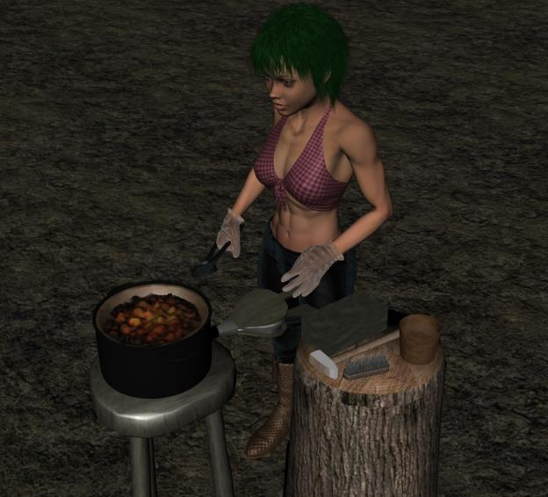

Elsabet blushed a bit, and smiled, remembering how nice Saradette’s abs had looked earlier that day. “He definitely has shown me some moves I’d never seen before,” she confided to Saradette. “Neither of us is looking for a long-term commitment, but we... work well together.”

“I’ll take you at your word,” Saradette replied to Elsabet with a soft smile. “So, I’m thinking I need to find at least one more book on engineering, or go at least a month with some real engineers. The metalworking pays passing well, but I’m wanting to move on for a while.”

Barkley got the barmaid’s attention with his furry hand, and she asked, “Another?” and he nodded.



*Red, double-headed arrow represents the conflict between the two loudest patrons.*

The saloon-type double doors swung open, and a trio of Medium humanoids entered the nearly saturated tavern as one of the more vocal patrons in the problem area made eye contact, and smiled, then reprised his fuckery. “Now I think it’s time to make *you* my next example,” Saradette heard the wicked dude to the southeast say.

The robed, silent drunkard shook his head and drank.

Round 1

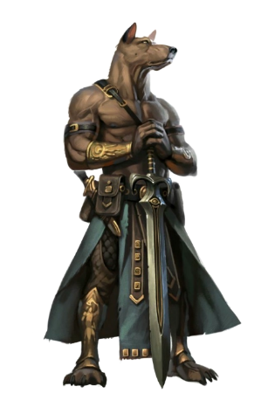

Giving the belligerents quite the haughty stare, Barkley noticed the new entrants and the renewed attitude of the mouthy drunk. Getting up, he looked at his friends, “I will be back shortly; please, continue to enjoy your meal, at least until the trouble starts, then you are welcome to join in.” Barkley then walked towards the mouthy drunk who seemed to be bolstered by the new arrivals.

“Oh, brother,” Saradette said under her breath. She stood and slipped across the room, using her stature to position herself behind the new arrivals. She had her dagger with her, and no armor, as she was dressed for the evening. For the moment, she left her dagger in its boot sheath on her left side.



Elsabet frowned slightly, and stood, slipping on her spiked gauntlets, which she seldom went without, thinking of them more as work gloves than weapons most days, though they were the latter as well. “Excuse me for a moment,” she nodded to Laryssa and Xavier.

The rowdy and belligerent fools to the southeast weren’t even looking at Barkley, Saradette, and Elsabet, who had already gotten up from their seats. The favored soul then raised her voice a bit, and strode up as Barkley and Saradette were making their way over, calling out, in her best Dalelands accent, “Hey, handsome! If yer lookin’ fer a fight, this be not th’ place!” As she did so, she activated her Protection Devotion (expired on Round 11), trusting in Mayaheine to protect allies and hopefully innocent bystanders as well from whoever decided to start a ruckus, should they foolishly do so.

*All PCs plus Xavier gained +3 to AC.*

A few of the spellcasters sitting at yonder tables all began casting *mage armor* at once. This was a low-level bunch for sure, or they would’ve had that cast already, and would have been casting something much more formidable.

*Clavicle, Elvira, and Svarsa gained +4 to FF AC and AC.*

Xavier said, “This is too rich for my blood,” and produced a set of shuriken, hoping to stay far from those dealing blows.

As Saradette rose from and hopped across the table, Laryssa murmured, “Mayaheine protect you,” as she touched her ally’s passing hand. Then rising herself, she eased her sword in its scabbard should it be needed. While she was unarmored, it seemed likely the breakers of the peace would be likely unprotected. However, the holy warrior couldn’t help but yearn for the time when she’d have the funds to enchant her armor to fly into place with a single thought.

*Saradette gained a one-time +2 resistance bonus to any save for up to the next hour.*

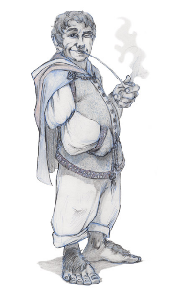

A halfling named Anselm could see the escalation, and ran up the stairs, shaking his head at his friend’s insult of the stranger. “Tollja this’d get weird!” those farther away could barely hear him say as the bystanders got up and started to leave with haste.

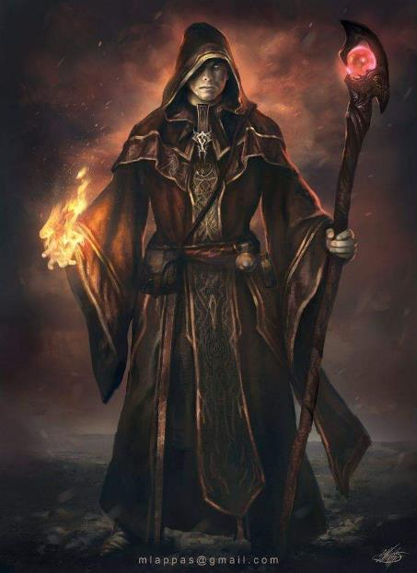

Everyone was yelling at the same time, and it was difficult to discern the dialogue from the cacophony, but the loudest and most foulmouthed of the aggressors—a human named Malcome Neversurrender—cast *scorching ray* upon the dude who’d told him to get impregnated by a goat. “Now it’s time for you to learn your place!”

|  |  |  |  |  |  |  |  |  |  |
| --- | --- | --- | --- | --- | --- | --- | --- | --- | --- |
| **Ranged Weapon** | **Dmg.** | **D+** | **TH+** | **Critical** | **Rng.** | **Wt.** | **Atk** | **Roll** | **Check** |
| Ranged Touch Attack | varies | Varies | 1 point-blank | 20 | varies | - | +3 | 12 | 15 |

*Hit. Dmg: 11 fire.*

The badly injured dude was none other than Tyberius Shaunce, the up-and-coming rogue-swashbuckler prodigy whose tongue was slightly sharper than his blade for the moment.

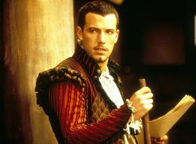

The swashbuckler drew his hand crossbow and declared some valiant things, then shot at Malcome.

|  |  |  |  |  |  |  |  |  |  |
| --- | --- | --- | --- | --- | --- | --- | --- | --- | --- |
| **Ranged Weapon** | **Dmg.** | **D+** | **TH+** | **Critical** | **Rng.** | **Wt.** | **Atk** | **Roll** | **Check** |
| Hand Crossbow +1 | 1d4 | 1 | 1 | 19-20, x2 | 30’ | 2.0 | +5 | 19 | 24 |

*Hit. Dmg: 3.*

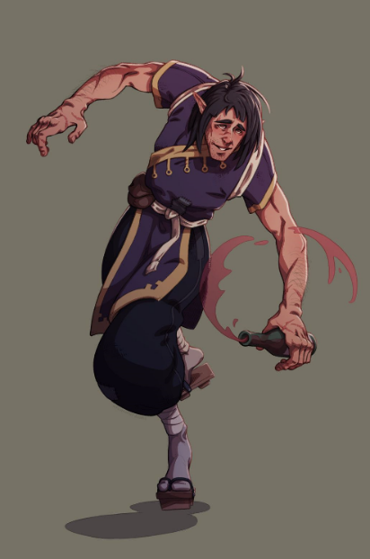

The drunkard got up, revealing his elven ears once his hooded robe came off. The clumsily graceful elf came up behind Malcome in order to restrain him.

|  |  |  |  |
| --- | --- | --- | --- |
| **Melee Weapon** | **Atk** | **Roll** | **Check** |
| Grapple | +9 + 2 flank | 17 | 28 |
| Grapple | +1 | 12 | 13 |

*Successful grapple.*

The drunk elf kept a good grip on the rude spellcaster for the moment.

One young guy was all a-panic in the southwest corner. The rest of the non-heroic types were getting themselves out. Xavier took a few steps towards the door, and helped to usher the patrons out in an orderly fashion, resolving to watch the door in case any of the ruffians tried to get away.

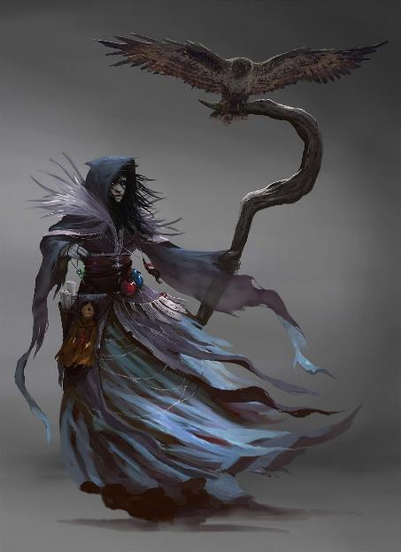

Clavicle—a novice necromancer moon elf who usually hung out with an owl—cast *ray of enfeeblement* upon the drunk elf restraining the charismatic Malcome. She could be heard only by those near her declaring her ancestors’ wrath upon their enemies.

|  |  |  |  |  |  |  |  |  |  |
| --- | --- | --- | --- | --- | --- | --- | --- | --- | --- |
| **Ranged Weapon** | **Dmg.** | **D+** | **TH+** | **Critical** | **Rng.** | **Wt.** | **Atk** | **Roll** | **Check** |
| Ranged Touch Attack | Varies | 0 | 0 | - | - | - | +2 | 15 | 17 |

*Hit. Dmg: 2 + 1 = 3 Strength.*

Elvira said nothing uncouth, and instead cast *sleep [expired on Round 21]* upon Xerxes, who seemed to her like a douchebag.

|  |  |  |  |  |
| --- | --- | --- | --- | --- |
| **Character** | **Save vs.**  *Sleep* | **Ranks** | **Roll** | **Save** |
| Xerxes | Will | 0 | 3 | 3 |

*Fail.*

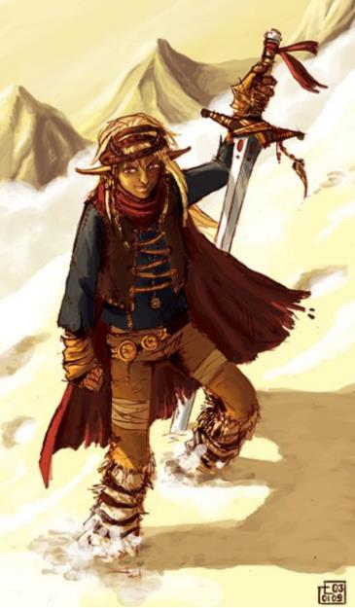

Xerxes fell asleep and bonked his head on the table.

*Dmg: 1.*

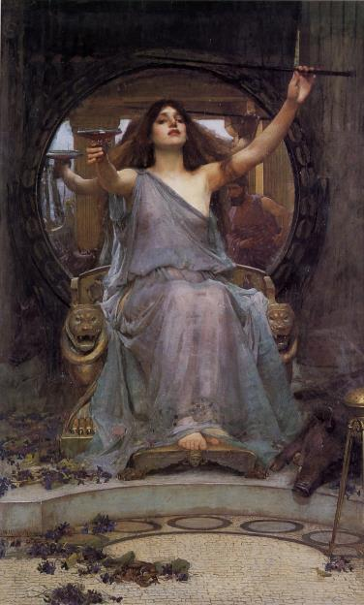

Hagdalène smiled with a wicked collection of gemmed teeth, then cast *magic missile* upon Xiomara the Xylophone Woman.

*Dmg: 3 + 1 = 4 magic.*

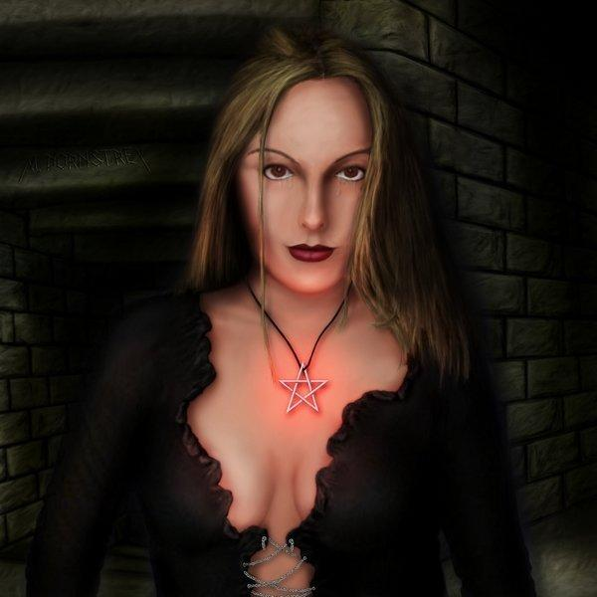

Svarsa cast her favorite spell in the whole world: *Melf’s acid arrow*, having targeted the already injured Tyberius.

|  |  |  |  |  |  |  |  |  |  |
| --- | --- | --- | --- | --- | --- | --- | --- | --- | --- |
| **Ranged Weapon** | **Dmg.** | **D+** | **TH+** | **Critical** | **Rng.** | **Wt.** | **Atk** | **Roll** | **Check** |
| Ranged Touch Attack | varies | - | 0 | - | - | - | +0 | 8 | 8 |

*Miss.*

The acid hit the eastern wall and began to burn a hole in it.

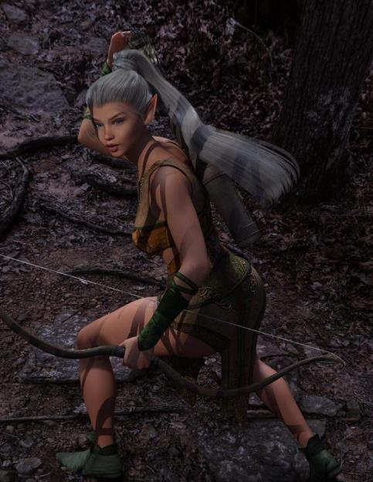

Xiomara the Xylophone Woman—a gray elf rogue-bard—drew her longsword and hefted it forward around the table towards Clavicle. “You dare!?” she asked the necromancer, not expecting much of an answer, positioning herself for a charge-attack.

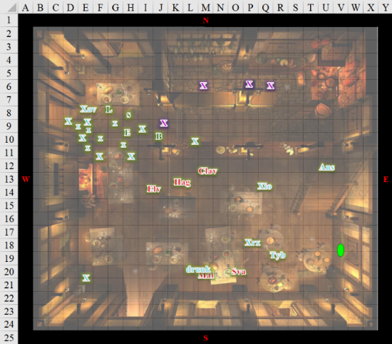

Round 2

|  |  |  |  |  |  |
| --- | --- | --- | --- | --- | --- |
| **Character** | **Group** | **Initiative** | **Roll** | **Modified Roll** | **Move** |
| Elsabet | 1 | 4 | 18 | 22 | 30’ |
| Clavicle | 2 | 2 | 20 | 22 | 30’ |
| Hagdalène | 2 | 1 | 19 | 20 | 30’ |
| Xiomara | 3 | 1 | 19 | 20 | 30’ |
| Commoner 1 | ? | 0 | 20 | 20 | 20’ |
| Commoner 8 | ? | 1 | 17 | 18 | 30’ |
| Xerxes | 3 | 3 | 14 | 17 | 30’ |
| Xavier | 1 | 6 | 10 | 16 | 30’ |
| Bornoflove | ? | 4 | 11 | 15 | 30’ |
| Commoner 5 | ? | 0 | 15 | 15 | 30’ |
| Barkley | 1 | 4 | 10 | 14 | 30’ |
| Commoner 3 | ? | 0 | 14 | 14 | 20’ |
| Commoner 7 | ? | 0 | 12 | 12 | 30’ |
| Laryssa | 1 | 3 | 8 | 11 | 20’ |
| Elvira | 2 | 0 | 11 | 11 | 30’ |
| Saradette | 1 | 1 | 8 | 9 | 20’ |
| Malcome | 2 | 2 | 6 | 8 | 30’ |
| Anselm | 3 | 3 | 4 | 7 | 20’ |
| Commoner 2 | ? | 0 | 4 | 4 | 30’ |
| Tyberius | 3 | 2 | 1 | 3 | 30’ |
| Svarsa | 2 | 0 | 2 | 2 | 30’ |
| Commoner 6 | ? | 0 | 2 | 2 | 30’ |
| Commoner 4 | ? | 0 | 1 | 1 | 30’ |

Elsabet took a 5’ step to get next to Barkley, and cast *bull’s strength [expired on Round 42]* on him. Then, with a move action left, yelled out, “By Mayaheine’s decree, use of deadly magic will not be tolerated!”

*Barkley gained +4 to Strength.*

“Stay outta this, you nosy oaf!” Clavicle replied to Elsabet and cast *cause fear [expired on Round 5 or 3]* on the favored soul.

|  |  |  |  |  |  |  |
| --- | --- | --- | --- | --- | --- | --- |
| **Save vs.**  *cause fear* | **Rank** | **Ability**  **& Mod.** | **Misc.**  **Mods.** | **Total** | **Roll** | **Check** |
| **Elsabet, Will** | **4** | **Wis (-1)** | 3 | 6 | 10 | 16 |

*Success. Elsabet would have been only Shaken, but Blooded feat prevents this effect, so no effect.*

Elsabet smiled as the spell washed over her to no effect, confident in her abilities, and shook her head sadly.

Clavicle’s smirk faded, and instead she got a kind of a scaredy face.

Hagdalène cackled at Elsabet’s smiling face, and cast *magic missile* upon Elsabet.

*Dmg: 3 + 1 = 4 magic [24/28].*

Xiomara completed her charge-attack against the necromancer.

|  |  |  |  |  |  |  |  |  |  |
| --- | --- | --- | --- | --- | --- | --- | --- | --- | --- |
| **Melee Weapon** | **Dmg** | **D+** | **TH+** | **Critical** | **Type** | **Wt.** | **Atk** | **Roll** | **Check** |
| Longsword +1 | 1d8 | 1 + 2  Charge | 1 + 2  charge | 19-20, x2 | Slashing | 4.0 | +6 | 10 | 16 |

*Hit. Dmg: 1 + 1 + 2 charge = 4.*

Clavicle doubled over in pain from the slash, but was not yet down for the count.

Xerxes snored on the ground, though he would soon be roused by the noise of the ensuing scuffle.

The rest of the patrons shuffled out with Xavier’s help.

Xavier saw the frightened young man to the southwest and went over to get him out.

Bornoflove continued to strain to restrain Malcome.

|  |  |  |  |
| --- | --- | --- | --- |
| **Melee Weapon** | **Atk** | **Roll** | **Check** |
| Grapple | +7 | 5 | 12 |
| Grapple | +1 | 12 | 13 |

*See below.*

Malcome got out of the grappling hold, and pulled himself south and east around the tables, hoping to turn the tables around on the drunkard and the other suckers.

Along the way, Barkley grabbed the arm of one of the barmaids, “Go fetch the night watchman.”

The barmaid nodded, knowing Barkley would only ask if trouble was about to start.

Laryssa moved southeastwardly, getting between two of the belligerent newcomers. Lucky for her, the two didn’t yet regard her as a hostile, or they would both have jabbed her.

Elvira cast *color spray* upon the drunk elven monk.

|  |  |  |  |  |  |  |  |
| --- | --- | --- | --- | --- | --- | --- | --- |
| **Save vs.**  *color spray* | **Rank** | **Ability & Mod.** | **Misc. Mods.** | **Total** | **Roll** | **Check** | **Properties** |
| **Bornoflove, Will** | **4** | **Wis (+1)** | 1 | 6 | 2 | 8 | +2 (elf) |

*Fail.*

Bornoflove was stunned for a round, and did nothing but try to get his bearings. “This will *not* stand, man!” he protested with three grunts.

Saradette moved to a spot near the spellcasters and crouched down under the table, hoping for a chance to nail one of them from behind.

|  |  |  |  |  |  |  |
| --- | --- | --- | --- | --- | --- | --- |
| **Skill** | **Rank** | **Ability**  **& Mod.** | **Misc.**  **Mods.** | **Total** | **Roll** | **Check** |
| **Saradette, Hide** | 4 | **Dex (+3)** | 4 | 11 | 20 | 31 |
| **Saradette, Move Silently** | 4 | **Dex (+3)** | 4 | 11 | 9 | 20 |

*See below.*

The gnome felt pretty good about her sneaking about amidst the ruckus. Her stature made it ideal to sneak behind the table and peek under its southern edge where she now crouched.

Having wrested himself free from the drunken monk’s grip, Malcome cast *magic missile* on the drunk.

*Dmg: 4 + 1 = 5 magic.*

“You shouldn’t’ve tangled with us, you old drunk!” Malcome Neversurrender spat, his adrenal gland pumping unusually high amounts of its contents into the wizard’s bloodstream.

“We end this now!” From the top of the staircase, Anselm lobbed a flask of alchemist’s fire at Elvira.

|  |  |  |  |  |  |  |  |  |  |
| --- | --- | --- | --- | --- | --- | --- | --- | --- | --- |
| **Ranged Weapon** | **Dmg.** | **D+** | **TH+** | **Critical** | **Rng.** | **Wt.** | **Atk** | **Roll** | **Check** |
| Alchemist’s Fire | **1d6 fire** | +0 | +2 height  – 6 range | x2 | 10’ | 0.0 | +6 | 13 | 19 |

*Hit. Dmg: 5 fire + splash damage to table and floor.*

That almost did Elvira in. She was screaming with the immolating fluid all over her, and didn’t know where to escape.

Tyberius continued to attack with his hand crossbow, not having brought enough bolts for a fight like this. “I’ll have to get my rapier out and cut you cads down,” he mocked as he reloaded his last bolt and shot it at the burning witch.

|  |  |  |  |  |  |  |  |  |  |
| --- | --- | --- | --- | --- | --- | --- | --- | --- | --- |
| **Ranged Weapon** | **Dmg.** | **D+** | **TH+** | **Critical** | **Rng.** | **Wt.** | **Atk** | **Roll** | **Check** |
| Hand Crossbow +1 | 1d4 | 1 | 1 | 19-20, x2 | 30’ | 2.0 | +5 | 7 | 12 |

*Miss.*

Svarsa cast her favorite spell again—*Melf’s acid arrow [expires on Round 3]*—targeting Tyberius again.

|  |  |  |  |  |  |  |  |  |  |
| --- | --- | --- | --- | --- | --- | --- | --- | --- | --- |
| **Ranged Weapon** | **Dmg.** | **D+** | **TH+** | **Critical** | **Rng.** | **Wt.** | **Atk** | **Roll** | **Check** |
| Ranged Touch Attack | 2d4/round | - | 0 | - | - | - | +0 | 16 | 16 |

*Hit. Dmg: 6 acid + 3 acid on the next round = 9 acid.*

The initial damage took the swashbuckler out of commission, and it looked like the more belligerent party was winning.

Three of the tavern servers were now behind the bar, and damnit if they weren’t going to bust out their crossbows and start laying people out in the interest of self-preservation. The fourth server—the barmaid Barkley had deputized just now—made her way diligently out towards the constable’s office.

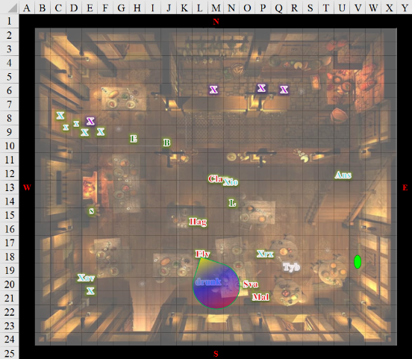

Round 3

Elsabet shook her head at Hagdalène and then moved to flank Clavicle <space L12>, while disgustedly remarking, “Idiots, are you *trying* to get killed?” She swung her bastard sword to hit the injured witch with the flat of her blade.

|  |  |  |  |  |  |  |  |  |  |
| --- | --- | --- | --- | --- | --- | --- | --- | --- | --- |
| **Melee Weapon** | **Dmg** | **D+** | **TH+** | **Critical** | **Type** | **Wt.** | **Atk** | **Roll** | **Check** |
| MW Bastard Sword,  1-handed | 1d10 | +2 | 2 + 2 flank  – 4 nonlethal | 19-20/x2 | Slashing | 6.0 | +3 | **20** | 23 |

*Threat. 1d20 = 16 + 3 = 19, critical hit. Dmg: 2 x (8 + 2) = 20 nonlethal [-18 hps].*

The trauma to the woman’s head was so severe that the woman was unconscious before she even hit the ground, and was out for the count.

“Oooh!” the halfling on the staircase had to narrate, “You just got knocked the fuck *out*!”

Elsabet snarled “Back off!” at Xiomara across the unconscious woman.

|  |  |  |  |  |  |  |
| --- | --- | --- | --- | --- | --- | --- |
| **Skill** | **Rank** | **Ability & Mod.** | **Misc. Mods.** | **Total** | **Roll** | **Check** |
| **Elsabet, Intimidate** | 0 | **Cha (+2)** | 0 | 2 | 12 | 14 |

*See below.*

“You killed my stepsister!” Hagdalène explained to Elsabet before casting *magic missile*.

*Dmg: 4 + 1 = 5 magic [19/28].*

Xiomara put her sword down—keeping it pointed at the floor—and said, “We mean you no harm. *These* are the ruffians who should be jailed!”

Then Xerxes began to wake up from the noise, and got up, ready to continue the fight.

Xavier led the frightened man-child out of the tavern to safety.

“Oaahhh, that *hurted*!” Brother Bornoflove came out of his stunned state, regaining his still very drunken senses.

*[Can’t take actions on this round.]*

With the fight starting, Barkley drew his sword and howled, following that up with, “Everyone, stand down. This is not the place to settle your dispute!” He continued to close the distance between himself and the closest person involved in the fight. He was no longer concerned with who started it; Barkley just wanted to end it before any additional damage was done to the bar.

Having seen the violence escalating, and moved next to Hagdalène while drawing her sword, Laryssa did not wish to add to the bloodshed, so she attempted to render the belligerent spellcaster harmless but alive.

|  |  |  |  |  |  |  |  |  |  |
| --- | --- | --- | --- | --- | --- | --- | --- | --- | --- |
| **Melee Weapon** | **Dmg** | **D+** | **TH+** | **Critical** | **Type** | **Wt.** | **Atk** | **Roll** | **Check** |
| MW Bastard Sword,  2-handed | 1d10 | 3 | 2 – 4  nonlethal | 19-20/x2 | Slashing | 6.0 | +7 | 10 | 17 |

*Hit. Dmg: 7 + 3 = 10 nonlethal [hps between 0 and -10].*

With Hagdalène also knocked the fuck out, Laryssa moved towards nearest spellcaster who’d attacked a party member say, “Stand down or you get the same!”

|  |  |  |  |  |  |  |
| --- | --- | --- | --- | --- | --- | --- |
| **Skill** | **Rank** | **Ability & Mod.** | **Misc. Mods.** | **Total** | **Roll** | **Check** |
| **Laryssa, Intimidate** | 0 | **Cha (+2)** | 0 | 2 | 3 | 5 |

*See below.*

Elvira mocked Laryssa, “Aww, shtang dewn! Shtang dewn! Threw me a friggin’ bewne!” Then she cast *ray of frost*, targeting the holy warrior.

|  |  |  |  |  |  |  |  |  |  |
| --- | --- | --- | --- | --- | --- | --- | --- | --- | --- |
| **Ranged Weapon** | **Dmg.** | **D+** | **TH+** | **Critical** | **Rng.** | **Wt.** | **Atk** | **Roll** | **Check** |
| Ranged Touch Attack | varies | - | 0 | - | - | - | +1 | 14 | 15 |

*Hit. Dmg: 1 cold [34/35].*

Saradette looked to see if she could flank any enemy still standing. Elvira had her left profile turned to the gnome, who worked her way east-southeast, dagger in hand.

|  |  |  |  |  |  |  |
| --- | --- | --- | --- | --- | --- | --- |
| **Skill** | **Rank** | **Ability & Mod.** | **Misc. Mods.** | **Total** | **Roll** | **Check** |
| **Saradette, Hide** | 4 | **Dex (+3)** | 4 | 11 | 13 | 24 |
| **Saradette, Move Silently** | 4 | **Dex (+3)** | 4 | 11 | 2 | 13 |

*See below.*

Reaching across the table now that he’d put some distance between himself and the drunk grappler, Malcome—by now the apparent leader of the bad apples—once again cast *scorching ray*, targeting Bornoflove again.

|  |  |  |  |  |  |  |  |  |  |  |
| --- | --- | --- | --- | --- | --- | --- | --- | --- | --- | --- |
| **Ranged Weapon** | **Dmg.** | **D+** | **TH+** | **Critical** | **Rng.** | **Wt.** | **Atk** | **Roll** | **Check** | **Notes** |
| Ranged Touch Attack | varies | varies | 0 | 20 | varies | - | +3 | 5 | 8 | + point-blank shot bonuses |

*Miss.*

The scorching ray flew past the drunken monk and bored a hole in the wall.

Taking a few steps up the stairs, Anselm urged Elsabet and her friends, “We’ll stand down when *that* douche has been neutralized,” he pointed at Malcome. “And my homie Tyberius could use some healing before he dies.” The halfling then carelessly lobbed another flask of alchemist’s fire, this time able to target Malcome.

|  |  |  |  |  |  |  |  |  |  |
| --- | --- | --- | --- | --- | --- | --- | --- | --- | --- |
| **Ranged Weapon** | **Dmg.** | **D+** | **TH+** | **Critical** | **Rng.** | **Wt.** | **Atk** | **Roll** | **Check** |
| Alchemist’s Fire | **1d6 fire** | +0 | +2 height  – 6 range | x2 | 10’ | 0.0 | +6 | *1* | 7 |

*Miss.*

The alchemist’s fire began to cover the table to Malcome’s immediate east as Tyberius bled to death on the floor, about 5’ away.

Svarsa cast *Melf’s acid arrow* upon Xerxes.

|  |  |  |  |  |  |  |  |  |  |
| --- | --- | --- | --- | --- | --- | --- | --- | --- | --- |
| **Ranged Weapon** | **Dmg.** | **D+** | **TH+** | **Critical** | **Rng.** | **Wt.** | **Atk** | **Roll** | **Check** |
| Ranged Touch Attack | varies | - | 0 | - | - | - | +0 | 5 | 5 |

*Miss.*

The center plate on the table next to Xerxes was now covered in an oval of acid, which would soon seep right through the tabletop.

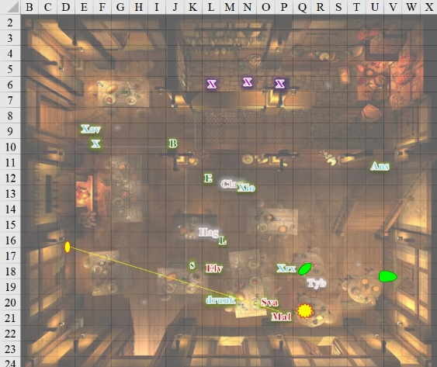

Round 4

The three tavern workers remained with crossbows loaded and trained on several people. They’d initially targeted Barkley on account of his facial features, and now they felt bad about that, so they were targeting Malcome and Svarsa. The elder female among them yelled, “You heard the ladies: stand down, or we *will* finish you off and leave it to the authorities to decide whether or not to resurrect you and make you stand trial.”

Tyberius continued to bleed on the ground, nearly dead now.

Clavicle lay extra unconscious on the floor, as did Hagdalène.

Elsabet—about to tell the witch her sister was just knocked out, held her tongue since she, too, was insinuate—instead yelled, “Stop that!” to the arsonist on the stairs while she rushed to the unconscious Tyberius, preparing to cast *cure light wounds*.

|  |  |  |  |  |  |  |
| --- | --- | --- | --- | --- | --- | --- |
| **Skill** | **Rank** | **Ability**  **& Mod.** | **Misc.**  **Mods.** | **Total** | **Roll** | **Check** |
| **Elsabet, Intimidate** | 0 | **Cha (+2)** | 0 | 2 | 5 | 7 |
| **Elsabet, Diplomacy** | 7 | **Cha (+2)** | 2 | 11 | 19 | 30 |

*See below.*

Elsabet timed her approach, making eye contact with every potential threat, around the furniture and other folks to get to Tyberius. Given that she would not reach the victim *and* cast the spell during these 6 seconds, and instead of bruising her hips on table corner, which she would have been glad to do, she commanded a rather commanding presence with her somatic gestures as she made her way to cast the spell. Malcome and Elvira were nonplussed, but those on the other side of the conflict were now seeing Elsabet as an ally in this conflict.

“I take it we are in league then,” Xiomara then said as she raised her sword again and casually walked closer to Malcome, assisting in surrounding him and protecting Elsabet as she prepared to heal Tyberius.

The southern entrance to the tavern was wide open, and the villain began to eye it, gauging the likelihood of his escape. Elsabet, Barkley, and Laryssa could immediately tell this.

Xerxes took a cue from Xiomara, and although he hadn’t fired a shot—having been rendered asleep at the onset of the engagement—he stayed the arrow that he now nocked back and aimed at Malcome and Svarsa both. “Submit and live.” He kept his eyes and arrow on the enemies as he sidestepped over to his friend Tyberius.

Xavier and the frightened boy got out of the tavern as quickly as they could.

Bornoflove came out of his painful state, and regained his stance, placing himself in the way of Malcome’s most likely escape route, now that others were closing in on the unrepentant human.

Seeing that his words had no effect, Barkley charged forward. Intending to subdue the combatants, he used his Detect Evil ability and targeted the person who radiated as the evilest of the group.

*[The table below identifies evil characters by their immunity to evil damage.]*

|  |  |  |
| --- | --- | --- |
| **Character** | **Party** | **Evil/ Neg** |
| **BarkleyPD** | **1** |  |
| **ElsabetPD** | **1** |  |
| **LaryssaPD** | **1** |  |
| **SaradettePD** | **1** |  |
| **Bornoflove** | **?** |  |
| **Xavier** | **1** |  |
| **Malcome** | **2** | *Imm* |
| **Clavicle** | **2** | *Imm* |
| **Elvira** | **2** | *Imm* |
| **Hagdalène** | **2** | *Imm* |
| **Svarsa** | **2** | *Imm* |
| **Anselm** | **3** |  |
| **Tyberius** | **3** |  |
| **Xerxes** | **3** |  |
| **Xiomara** | **3** |  |

Those who registered as evil did so pretty much with equal intensity, but Barkley’s gut feeling told him to go for Malcome, who had said and done the most malignant things so far. In order to best reach Malcome, he would either have to navigate through the maze of tables and chairs, then get past Xiomara and a few others, or he could hop atop the large table adjacent to Malcome and leap over Svarsa.

He chose the second option.

|  |  |  |  |  |  |  |
| --- | --- | --- | --- | --- | --- | --- |
| **Skill** | **Rank** | **Ability & Mod.** | **Misc. Mods.** | **Total** | **Roll** | **Check** |
| **Barkley, Jump** | 3 | Str (+4) | 0 | 7 | 19 | 26 |
| **Barkley, Jump** | 3 | Str (+4) | 0 | 7 | 5 | 12 |
| **Barkley, Reflex** | 3 | Dex (+1) | 0 | 4 | 3 | 7 |

*See below.*

The archon was able to leap across the table, but found himself in a jimmy to get past Svarsa, who got an attack of opportunity in.

|  |  |  |  |  |  |  |  |  |  |
| --- | --- | --- | --- | --- | --- | --- | --- | --- | --- |
| **Melee Weapon** | **Dmg** | **D+** | **TH+** | **Critical** | **Type** | **Wt.** | **Atk** | **Roll** | **Check** |
| Dagger +1 | 1d4 | 1 | 1 | 19-20, x2 | Piercing | 1.0 | +0 | 6 | 6 |

*Miss.*

The archon lost his mojo for the moment, and had to defer his attack up on Malcome.

Laryssa noted most of the belligerent spellcasters had been dealt with and she was the closest to minister to the dying Tyberius. Skirting the sizzling acid-covered table, she moved to the downed stranger and invoked her divine power. “Bright Lady, save this unfortunate.”

*Tyberius gained 2 hps.*

Elvira had apparently not noticed the gnome coming towards her, and turned the other way to see that the drunken elf had positioned himself in an obstructive way, her primary path to the southern exit was blocked, so she sprinted along the alternate path, circling the table westward and southward. However, in that endeavor, she ran straight into Saradette, who held a dagger in her hand.

Saradette took the opportunity to attack.

|  |  |  |  |  |  |  |  |  |  |
| --- | --- | --- | --- | --- | --- | --- | --- | --- | --- |
| **Melee Weapon** | **Dmg** | **D+** | **TH+** | **Critical** | **Type** | **Wt.** | **Atk** | **Roll** | **Check** |
| Dagger +1 | 1d3 | +0 | 0 | 19-20/x2 | Slsh/Prc | 0.5 | 2 | 5 | 7 |

*Miss.*

Elvira slid past her, but then had to contend with the ale-scented elf renamed Bornoflove. The bastard son of a bastard son kicked Elvira in the jaw.

|  |  |  |  |  |  |  |  |  |  |
| --- | --- | --- | --- | --- | --- | --- | --- | --- | --- |
| **Melee Weapon** | **Dmg** | **D+** | **TH+** | **Critical** | **Type** | **Wt.** | **Atk** | **Roll** | **Check** |
| Unarmed Damage, 1st Blow | 1d8 | +0 | +0 | none | Bludgeon | 0.0 | +7 | 18 | 25 |

*Hit. Dmg: 5.*

The *ray of enfeeblement* really weakened the man’s sloppy but true kick, but it was still enough to knock the black-clad witch out. << Mmh! Q’aphik sherrh! >> the drunken man slurred in his father’s language.

Saradette saw Elvira go down, so she smacked her solidly in the head with the pommel of her dagger. “And stay down,” she snarled.

“You had to put it that way,” Malcome said to Xerxes. “You had to say ‘submit’. You know I will *never* submit!”

Anselm sighed as he shook his head and lobbed another flask at the petty arch-villain in this senseless fiasco. “You’re pretty much toast as it is, and I’ve just run out of flasks, godsdamnit!”

|  |  |  |  |  |  |  |  |  |  |
| --- | --- | --- | --- | --- | --- | --- | --- | --- | --- |
| **Ranged Weapon** | **Dmg.** | **D+** | **TH+** | **Critical** | **Rng.** | **Wt.** | **Atk** | **Roll** | **Check** |
| Alchemist’s Fire | **1d6 fire** | +0 | +2 height  – 6 range | x2 | 10’ | 0.0 | +6 | 11 | 17 |

*Hit. Dmg: 2 fire.*

Svarsa cast *Melf’s acid arrow* upon Xiomara, calling her something horrible in Damaran.

|  |  |  |  |  |  |  |  |  |  |
| --- | --- | --- | --- | --- | --- | --- | --- | --- | --- |
| **Ranged Weapon** | **Dmg.** | **D+** | **TH+** | **Critical** | **Rng.** | **Wt.** | **Atk** | **Roll** | **Check** |
| Ranged Touch Attack | varies | - | 0 | - | - | - | +0 | *1* | 1 |

*Total botch.*

The acid arrow splashed onto the ground, which would require more than a mere *mending* spell to mend by the time all was said and done.

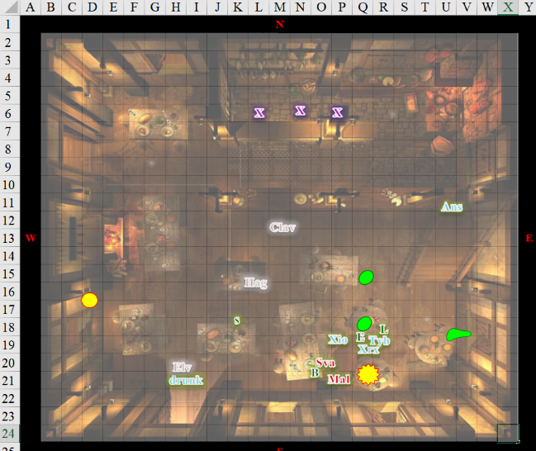

Round 5

Clavicle, Elvira, Hagdalène, and Tyberius remained unconscious.

Elsabet cast *cure light wounds* upon Tyberius.

*Tyberius gained 5 + 4 = 9 hps.*

As the fellow regained consciousness, Elsabet looked down at him and sternly commanded, “Stay down and don’t move.” She then stepped next to the two standing mages, held her bastard out, and snarled “Go ahead, try me.”

|  |  |  |  |  |  |  |
| --- | --- | --- | --- | --- | --- | --- |
| **Skill**  **(highest of 2 rolls)** | **Rank** | **Ability**  **& Mod.** | **Misc.**  **Mods.** | **Total** | **Roll** | **Check** |
| **Elsabet, Diplomacy** | 7 | **Cha (+2)** | 2 | 11 | 20 | 31 |
| **Elsabet, Intimidate** | 0 | **Cha (+2)** | 0 | 2 | 16 | 18 |

*See below.*

Tyberius began to come to his senses, and his biggest scrapes were now diminished. Remaining down as he was told, he thanked Laryssa and Elsabet for the healing, and added, “My friend Anselm up there can get a bit riled up when he feels threatened. He’s normally very reasonable, but I can tell he’s gone limbic. Please be patient, if not merciful, with him.”

Xiomara, having dodged an *acid arrow*, held her longsword pointed towards Svarsa.

Xerxes did the same with his rapier, taking a step towards Malcome.

Xavier now stood in the northwestern doorway, making sure that all had been handled.

Bornoflove stood by the southern doorway, leaning against the frame and burping once.

Laryssa was satisfied the man who’d been at death’s door was no longer in immediate danger due to receiving her own and another’s healing, so she turned her attention to the most violent person still on their feet—Malcome. Circling the table now good for nothing except scrap due to misaimed acid and fire attacks, she attempted to coldcock the belligerent as she had others.

Saradette positioned herself near Bornoflove, and readied herself to flank the bad guys.

Malcome had only one good spell for this occasion, and with the amount of opposition, and the fact that he was on fire, he spent a few minutes padding down the flames with his finely gloved hands, sighing and smirking, “It must’ve been the drink.”

Anselm shouted, “He’s full of it. You lie like a goblin in heat!”

Svarsa had plenty more spells in her daily cache, but was surrounded, and knew that the consequence of harming anyone else would be a hard retaliation. He held up her hands.

The three crossbow-wielding barkeeps stood up straight from their previous leaning onto the bar, maintaining their aim.

Pools of acid and circles of fire continued to consume wood and other fibers.

Still atop the table, Barkley said to Malcome, “Surrender or die.” Since the man had already surrendered by now, Barkley kept up the bravado and secured his hands asking for rope to tie him up. Awkward as it was for the archon to do this while still atop the table, the deed got done.

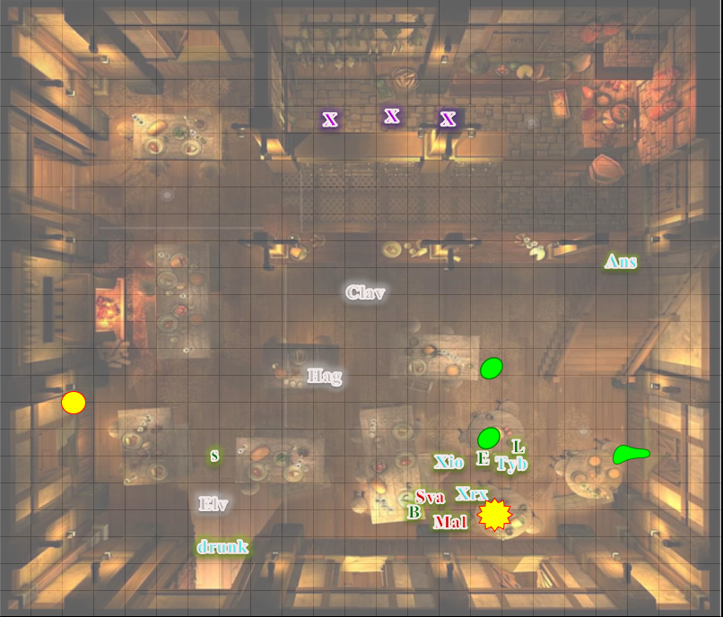

Round 6

Taking note of the fires, Saradette grabbed anything liquid and non-flammable that was to hand, and ran to put them out. “Some help here?”

Xerxes ran over to help Saradette, as did the youngest barmaid, putting her crossbow down by her father’s side.

They were able to restrain the two standing culprits, while the others were carried outside to where the constables would soon show up.

~*~

A few minutes passed, and the constables showed up, asking very few questions, and referring their gaze and dialogue to the barkeep, whom they knew well. The man vouched for the heroes, and gave no fault to the third party, who had probably legitimately antagonized Malcome.

Malcome and Svarsa were arrested, and the bodies that had been taken outside had been identified and sent to the temple of Mystra, which happened to be the closest temple to the tavern. “Raise the innocent,” the constable called out, having tagged each body with a red or green mark, and a name to go with it. “The others, we leave to the judge to decide.”

Such was a day in Saradush. “Lavender,” the barkeep called to his daughter as patrons came back in now to see the damage that had been done. “See to these four fine, young people. Their meal is on us tonight. I salute you, and am honored to feed the bellies of those who fought with such disregard for their own hides when most had fled.”

Some patrons even finished their meals, and one of them offered, “I’ve a few *mending* scrolls at home; if’n you want, I can bring ‘em in.”

Malcome spat near Barkley’s feet as he was led out, his hands cuffed behind his back, and mini-manacles clasped his key spellcasting fingers to prevent him from pulling a fast one on the constables. Svarsa too.

“All’s well that ends well,” Xavier came back in now that the traumatized boy had been returned to his mother. “Looks like you all got a free dinner out of this, though some of you are a bit scuffed,” he looked primarily at Elsabet.

“Each of these whistles has a different tone,” she continued, “in order, with Barkley’s the lowest and Saradette’s the highest. I thought we ought to have a way of signaling our positions that would travel further than yelling and be less informative to any enemies in the area. And maybe we could come up with some simple codes to use too! But in any case, for now, I’d say a single loud blow should probably mean ‘help!’ You know, just in case. What do you think?”

Laryssa took her whistle and admired the workmanship before thanking Elsabet and donning the chain around her neck. “I wish I had the talent for a skill to make fine items like that but the closest I got to learning a trade was working on my family’s farm before it was overrun by vermin. I fear the Bright Lady has other plans for me rather than being a simple craftsman. The gifts She has graced me with allows me to be a healer of sorts, I suppose, but those powers are limited. If I had the patience to apprentice myself to a journeyman healer, I might improve my grasp of mundane practices to deal with injury, but my dedication to the Shield Maiden drives me to feel time not spent honing my combat capability is time wasted. For me, the only craftsman’s tools are the sword and shield and my place of business the battlefield.”

Barkley studied the whistle then tested his out. Satisfied with the tone, he looked at Laryssa, “This is well made. Thank you. I believe your idea is a good one to communicate without yelling.” Barkley hung the whistle around his neck on a silver chain, tucked just inside of his chainmail shirt until he needed it.

Saradette sat back from her meal and looked around the dining hall before turning to her companions. After the brawl, she’d taken to wearing her weapons and armor whenever she went out. “I finally got the lathe I was waiting on, so I can travel and set up shop whenever we stop somewhere. All I need is a level place to set a tent.”

Among other things, the party now had more than one haversack among them, and they now compared how they were compartmentalizing the stuff they’d put in there. It was a great time; they made good friends of the owners of the establishment, and from then on, the Obstinate Loaf would give them discounted food and drink. And they would be locally known here as those who forced Malcome Neversurrender to surrender.