*Chapter 40: Infester*

Saradette stepped outside her workshop, and tugged at her chainmail, settling it in place over her chest. At least she had time to dress and prepare before she was summoned, she thought grumpily. The new trigger mechanism for the launcher sat half-finished on her worktable, but duty called.

The air shimmered around her, and she found herself in a vast, grassy field. The gnome turned in place, and then she gasped in surprise. “Stratus!”

“Hello, love,” the reclining cloud giant said with a gentle laugh that boomed like distant thunder. He smiled as she ran up and climbed onto his arm and chest. “I missed you, Saradette.”

She leaned down and kissed his lower lip. “I’ve missed you, too, Stratus. I didn’t think I’d ever see you again.”

“I had to call in some favors, but I was finally able to summon you here. I wish it was just so we could spend time together, but I’m afraid there’s more to it.” The cloud giant rummaged in his pocket and pulled out a gemmed pendant. “I got you this so we can find each other, no matter where we are. I have the mate to it. It’s supposedly not otherwise detectable.”

Saradette took the pendant and slipped it into one of her pouches. “You were saying?

“The summons is for a friend of yours, Maja, I think? She’s waiting for you, and I need to send you there very soon.”

Saradette sighed. “You’d better summon me back here, and soon.”

“I will, love, I will.” Stratus gently kissed Saradette and sat up. “Be careful, Love.” He lifted a giant-sized scepter and spoke a few words.

The air shimmered again, and Saradette felt a wrenching sensation as she was swept along by the magic. Then, she found herself kneeling on a strange metal floor. She looked up as a woman spoke.

“Saradette? Is that you?”

The artificer saw Maja kneeling a few feet away, next to a closed door. They were in a narrow hallway with smooth walls, pipes running along the ceiling, and doors at both ends. The air smelled strange, and odd, glowing lights lit the hallway in a bluish hue. The engineer wore one of her strange one-piece outfits with black boots. Saradette stood and nodded to Maja. “It’s me, Maja. What is going on?”

“We’re in an asteroid mining colony, and we’re under attack by some strange people with powers that I think are from your universe.” A rumbling boom echoed from somewhere beyond the door. “I think they’re using magic on us!”

“Let me see,” Saradette replied as she drew her blaster.

Maja led the way down more of the hallways until they came to a large cavern, obviously cut by tools of some type; huge ones by the marks in the stone. Near them, four other people dressed like Maja hid behind two large metal wheeled carriages. A third carriage, ahead of the others, burned with an acrid smell.

Across the cavern, Saradette spotted a half-dozen figures in dark clothing. Three of them carried staves, and the other three bore swords and shields. “Drow,” she breathed as she recognized them. “What are they doing here?”

“What are they?” Maja asked.

“They’re drow, a type of elf. They’re good magic users, but they aren’t invincible.”

“Our weapons aren’t hurting them…”

Saradette spied one of the drow mages beginning to cast a spell. “Down!” She ducked behind one of the carriages as a glowing bead raced toward them. The bead struck the front of the vehicle and detonated with a roar. When the fireball spell had dissipated, she jumped up and fired her blaster at the mage. “Shoot them! They can’t keep that up for very long!”

Two minutes later, the battle was over. One of the drow mages was dead, and the other five had vanished through whatever portal they’d use to get here. Saradette had killed the mage herself with her blaster and her lightning glove. Apparently, the shields they’d summoned only worked against the human weapons, but her magic-augmented artifacts were immune to the shields’ effects.

“Thank you for helping us,” Maja said as she stepped up to Saradette. “I don’t know what they want here, but they’ve attacked several outposts in this system over the last few months. Like you saw, we can’t hurt them.”

Saradette handed Maja her blaster and her glove. “Here, take these. They each have forty shots, and they will hurt them. You can also probably use swords or other hand weapons to fight them that way. I will research the problem when I get back home. You can contact Stratus again if you need more help.”

“My shop is over here,” the engineer said as she walked to a door set in the stone wall. It opened when she approached, and the pair stepped inside. “I thought about what you might need, and I remembered that we talked about using methane for heating.”

“Yes, but I have trouble producing it, and the pumps to fill the tanks are cumbersome.”

Maja nodded. “I have a solution for you.” She picked up a cylindrical object the size of a book. “This is a fuel cell. It runs on water, and it produces electrical power. This,” she took up another cylinder about twice as tall, “is a methane synthesizer. Water goes here, and good charcoal goes here.” She pointed to two compartments. “You can make larger hoppers to feed the water and charcoal in, but I’ll leave that to you. Connect these wires like this, and it will run for as long as it has water. Connect this hose to your tank, and it will fill it.” She handed the apparatus to Saradette.

“Thank you, Maja, this is a big help,” the archivist replied. “I need to return home, but I will come back if you need me.”

The pair said their goodbyes, and Saradette contacted Stratus with her pendant. She spent an afternoon with her lover, and then she was returned home.

~*~

As Tore was brought to the chamber once more, he was told of a small village having trouble with a group of undead. It was not known who was controlling the small band of undead. Tore’s task, though, would not include searching for the leader. He was needed to stop the evil beasts from attacking and pillaging the small farming village. Others would look into the source. Nodding, Tore stepped up onto the platform to be transported to the location.

As he emerged, he looked around and saw a small farming village whose fields were burning and several of the buildings were damaged. He began walking towards the town, looking for the source of the destruction. It did not take him long to find it. A large group of skeletons were walking towards a church at the far end of the town. Some were setting fire to the buildings while a large, troll skeleton was using its club to damage the buildings.

A small group of townspeople had set up defensive lines, but they had done no good. They had destroyed a few skeletons, but paid a heavy price for it. Several of the villagers lay dead or dying after trying to stop the undead. Tore increased his stride as he came up behind the mass of skeletons, 64 human sized and one massive troll skeleton. As he got within 30 feet of them, his Amulet of Holy Defiance began to glow. Tore commanded this Hawkfeather Armor to improve his charisma and he held the amulet aloft and began to call out, “Filthy creatures, yield to the power of Lurue and Mayaheine! I command the to flee or be destroyed!”

With that, the mob of bones and rotting flesh turned to face the cleric. As they did, the power of his aura reached out and destroyed 15 of the closest skeletons. As their bones fell to the ground, shattered and turning to dust, the remaining mob advanced on Tore. As they did, he heard a faint cheer from the distance as he saw several people in the windows and steeple of the temple. Tore readied his sword and activated his barricade buckler shield. He knew he would not be able to turn or destroy them all before they reached him, so he prepared for their attacks.

Two of the skeletons did reach him and slashed at him. Their blows deflected by the barrier now in place from Tore’s shield. Again, the amulet in hand, he called out, “Be gone, you beasts of Hades; may the world be free of your evil for all times!” Another surge from his aura destroyed 18 more skeletons. However, there were still plenty more to fill in the gap left behind. This time, the gap was filled by the troll skeleton and several of its smaller friends. Surrounded by 5 bony adversaries, Tore braced himself. Two of the skeletons missed, the barrier deflecting their blows. However, the other two skeletons and the troll skeleton all connected with their attacks.

Tore winced as he felt the pain go through his body. However, he faced his opponents and again called out, “I do not fear you nor will I yield! Go you filthy vermin, back to your graves from whence you came!” Again, the power of his faith and aura radiated out, destroying 14 human-sized skeletons as well as the overgrown troll skeleton. As the last batch fell to the ground, turning to dust and being carried away in the wind, Tore heard the cheer getting louder. Taking a moment to look beyond the skeletons still closing in on him, he could see a group of townspeople rushing out from the church towards the skeletons. Their hope restored, they charged forth to join the fight. Though Tore appreciated their bravery, he did not want to see any of them harmed. Their town had suffered enough, it was time to end this without any more bloodshed.

The last group of skeletons now split. Nine of them advanced on Tore, 6 of them surrounding him and attacking him. He took several more hits as they came around his sides and around his barrier (damage: 27; 33 hp remaining). The other nine turned and went after the emerging towns folks. His rage growing as the pain from the cuts surged through him, he bellowed, “Be gone you evil beasts, torment the living no more, I command this in the name of Lurue!” As he spoke, his aura destroyed (2d6 + 9 = 9 + 9 = 18) 14 of the 18 remaining skeletons (4 were beyond the 60 foot range). As they turned to dust, the townspeople reached the remaining skeletons and began pummeling them with whatever implements they had. Two of the skeletons were destroyed quickly, but the other two each took one final victim before Tore strode in close enough, calling out, “Be gone filth, I command it in the name of Lurue.” The final two skeletons tuned to dust as the towns people cheered. Tore smiled and added, “There is no time for that, let us collect the wounded and put on the fires.”

With the threat gone, Tore aided the residents by healing those that he could an then assisted in the fields with the fires. As the last of the fires were put out and the towns people returned to the temple to give thanks, Tore felt himself pulled back to the other ascended member of Mayaheine. He watched, smiling as the town faded from his sight to be replaced by the celestial temple where he had been not long before.

~*~

5 Flamerule, 1373 DR

A few weeks had passed, and Saradette and Tore had partnered up with about half of the others on the tentative “council” of heroes, usually with one or two at a time. Now, they were told that some pocket plane had been recently discovered, and nefarious designs were in effect that might compromise the safety of much of the Astral Plane. Within this pocket plane, an island was divinely designed with the intention of breeding Abyssal beings and unleashing them into the Astral. They were calling the place Infester QS63, and together with Akilesh and Zvetlana, our two heroes would momentarily be summoned to that very corner of the planes.

Saradette had rebuilt all three of her devices to give them fifty charges each, and set up her methane generator to power her torch and high temperature forge. She now looked over her inventory.

~*~

The fighter-cleric of Lurue and his artificer comrade appeared not atop some conjuring mound as usual, but atop a small dinghy between a miniscule body of land to the north—beyond which was a thick, white fog—and a larger body of land to their south—beyond which was a similar wall of fog.

South of the “mainland”, another dinghy now seated Akilesh, the dwarven favored soul of Lurue, and Zvetlana, an aasimar wereserpent aristocrat.

With only about 200’ of beach and surf between them, Zvetlana and Akilesh rowed with the oars in their dinghy towards the rectangular peninsula with the peculiar rock formation, waving at Saradette and Tore.

No one was about.

Tore looked at Saradette, “Shall we join them?” he asked as he returned the wave to Akilesh and Zvetlana.

“Yes, let’s go,” the artificer replied.

With her agreement, Tore began rowing towards the other two to join them.

Setting their feet on the few inches of receding water atop the sand, they dragged the dinghy until it was safe from even a high tide pulling it away, just as the other two had.

The smell of rotting fish was the first sign that something was awry, and although they could not see past the incline that summited about 100’ to their east, it was evident from the direction of the breeze and the intensity of the smell that whatever flesh or evil lay ahead was close.

Tore had nearly stepped on a 10’ x 10’ square platform that was mostly covered in sand. “Looks like a pressure plate,” he pointed it out.

Those to the south found a similar platform, and began to make their way northward, admiring the very unnatural rock formation to their immediate east. Everything here was divinely morphic, and consequently subject to the limitations of a demigod’s imagination.

“Lovely scent,” Zvetlana said in wereserpent form, completely vague as to whether she was serious or sarcastic. “Though she was an aristocrat, she was trained in the rapier she now held, and some had mistaken her for a swashbuckler more than once.”

A patch of grass covered the high ground that ran eastwardly, and that seemed like the optimal place to get a better view of things.

“I wonder what that’s for,” Saradette eyed the plate as she stepped around it. She walked south toward the other pair, intending to meet them where the grassy area started. She kept her other weapons sheathed or slung, but her lightning glove was unencumbered and available for instant use. She’d elected to leave her workshop at home, since she preferred mobility over the extra weight. The artificer also cast mage armor on herself as she walked.

Tore looked around, deciding, “Let’s head up there,” pointing to the grassy summit, “and see what the deal is with the spring and get a better look at that town.”

“Okay, but let me lead.” Saradette activated her Shiftweave to blend in with the grass and moved toward the spot Tore selected.

They got to the summit, and noted a gradual decline comparable to the incline they’d just traversed. The rotting smell was coming from the bodies of fallen kuo-toa on the beach now before them, and as they got closer to the buildings, they noted that it wasn’t exactly a town, but a collection of haphazard, brutal structures that may or may not have been habitable.

The spring before them appeared to be just a spring, and Akilesh now cast *detect magic* to get a better sense of anything about that they should be aware of. “I’ll let you know what I glean,” he mumbled. They all knew it would take some time for the dwarf to know what—if anything—was magical, but they could assume that nothing here was wholly natural.

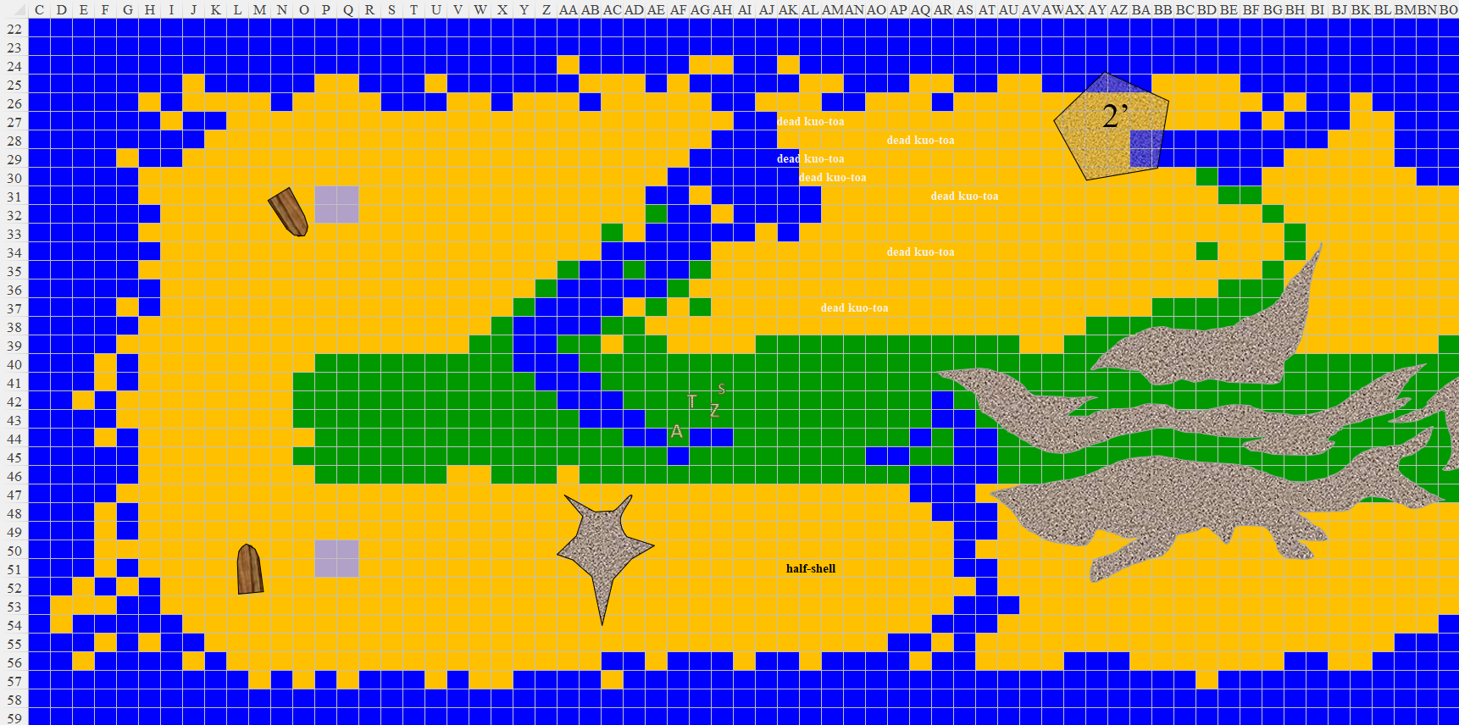

Up ahead, a second spring emanated and wound its way southward, and beyond it was a rock formation with two grooves that served as convenient paths along which to walk. To their southeast, a half-shell missing its other half rested with its concavity facing up, partly filled with sand. It was large enough to serve as a bed for a human, and chipped along parts of its edge.

To their northeast, a pentagonal platform stood about 2’ higher than the sand around it.

Tore looked at the dead kua-toa and the platform off to the northeast. “Perhaps we should go see how they died and investigate the platform before going further east,” Tore suggested.

Akilesh and the wereserpent noblewoman were quite keen on the idea of investigating thoroughly before proceeding. “Nothing worse than missing a divinely morphed clue amongst these oddities,” remarked the currently bipedal woman with the forked tongue.

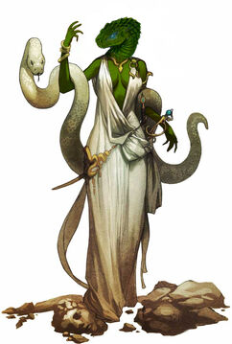

They got close enough to the first kuo-toa to identify the punctures and slashes that slew it, and as they surveyed the panorama before them, they noted similar lacerations, incisions, and a few abrasions that seemed consistent with weapon damage.

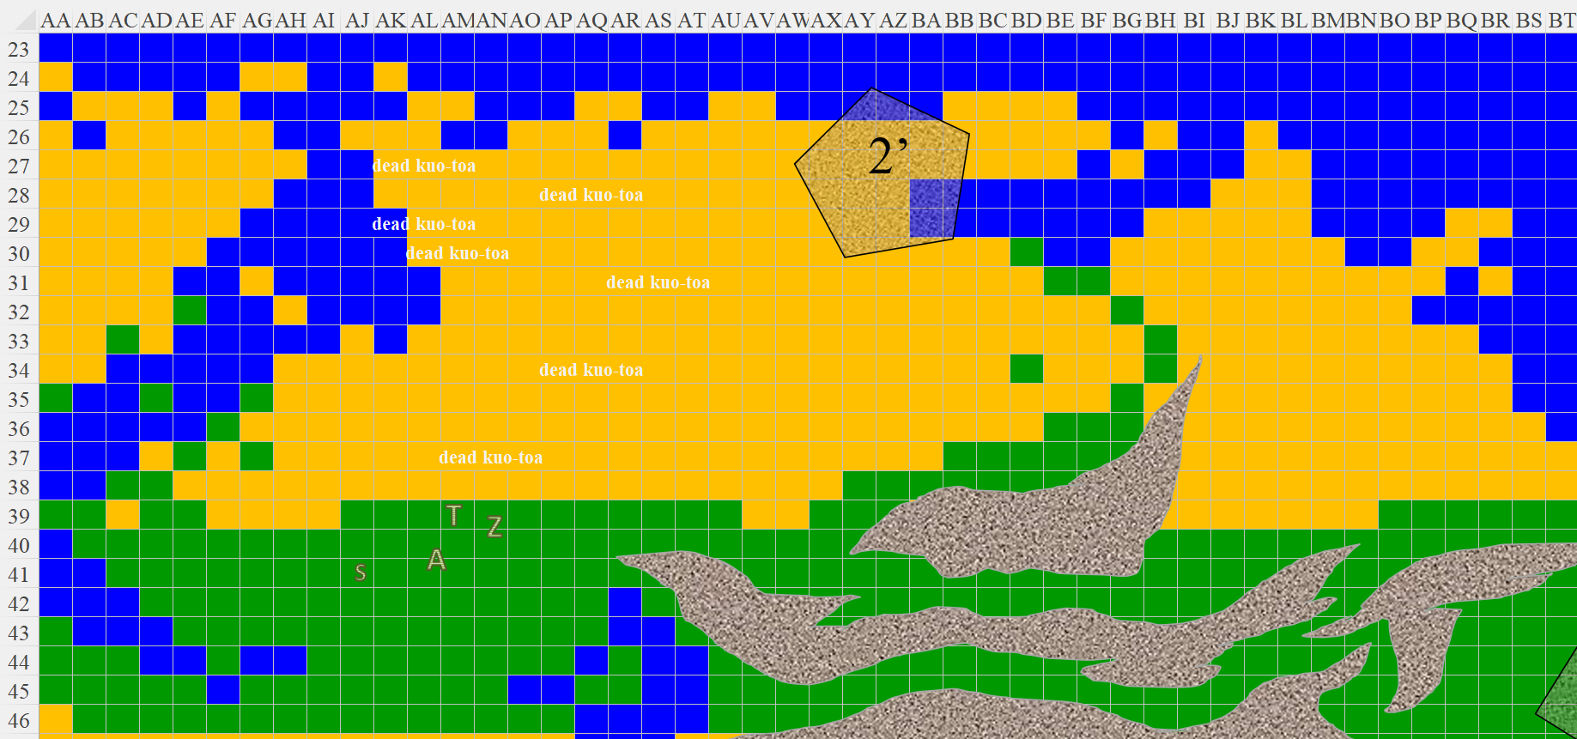

“They didn’t slay *one another*,” noted Akilesh by the color of red blood on some of the spear tips of the fallen despite kuo-toa having bright blue blood.

Having ruled out an internal feud among the deceased, the heroes looked up to see a flock of miniature, flighted cockatrices speeding across the sky westwardly about 50’ above them as the surf to the north brought on a crisp, sharp splash against a rock.

The breeze brought with it also a hint of incense now that they were no longer directly downwind of the dead fish-men.

“They look like warriors, and that one possibly an adept or aquatic beastmaster,” the dwarf pointed out based on his prior experience.

Saradette had initially hesitated to follow the others so close to the kuo-toa, but as she saw that no ill fate befell them, she approached, and then noted the fluttering fey to the east.

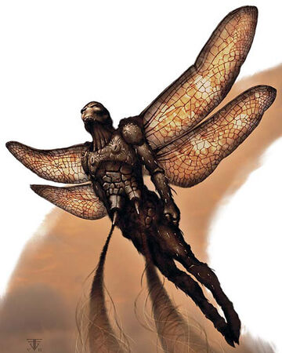

It was the size of a human, and sported a pair of pump-like polyps that dangled from its abdomen. It was about to perch atop the rock formation, but realized that it had been spotted, and thus hovered for a moment before flying eastward with what appeared to be its full effort.

Tore watched as it flew away. “I’m guessing that wasn’t the welcoming committee.” He then looked to the others, “I still say we check out that platform, unless any of you want to see where our winged peeping tom has gone off to.”

Tore stepped closer, examining the platform, noting nothing unusual, gauging it to have been placed here a while ago, given the algal growth around it as a shallow wave splashed near the fighter-cleric, spraying him with saltwater mist. He placed a foot atop it, then some of his weight, then stepped fully onto the platform, gaining a little bit of a vantage of the panorama to the east.

There was a stone cylinder to his east, lodged into the sea floor and breaking some of the wave that was about to splash on the shore. To the southeast, there was a 10’ tall building with no doors or windows—maybe just a brutal sculpture—and a 20’ tall spire. Both were on the grassy summit, and nothing stirred around them. And then there was a 30’ tall structure further south, likely founded in the water, though he couldn’t tell.

“What do you see?” asked Zvetlana.

Tore described the building he had seen, including details about doors and windows, or the lack thereof. Once done, Tore pointed at the 10’ tall structure. Curious about its construction, and if there was a door on the opposite side, he said, “Let’s check that one out first.”

Saradette looked around her immediate area for anything of interest. When Tore mentioned the building, she nodded and started off in that direction, taking the northern path along the stone that crowned this part of the grassy summit. She then spotted a trap, and stopped dead in her tracks. It was a tripwire that looked like it would deliver an arcane reaction if triggered.

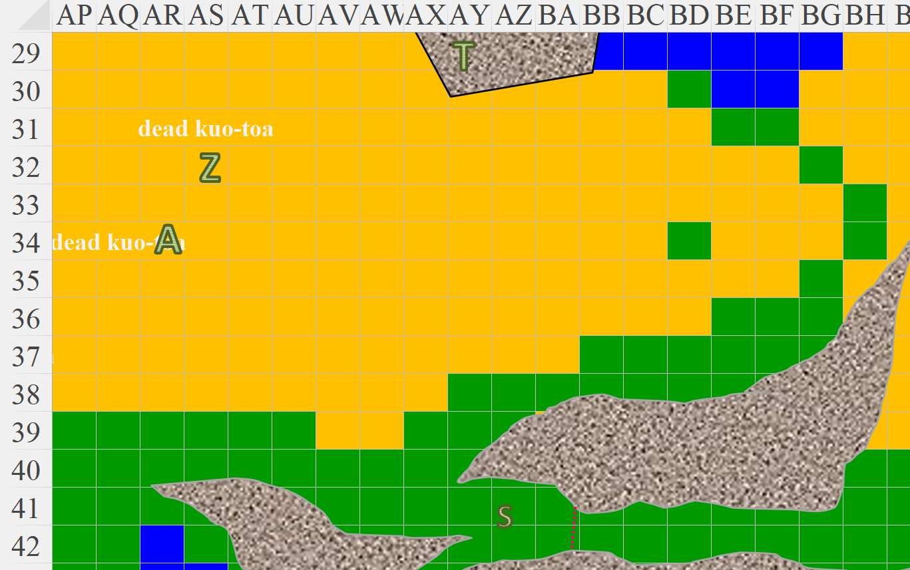

Tore followed Saradette, careful to stay about 20’ or so behind her to not give away her position. When Saradette stopped suddenly, so did Tore. “What is it? Do you need help with something?” he inquired.

The artificer halted when she spotted the wire, and then she carefully backed away. When she was clear of the trap, she walked back to the others. “There are traps here, so I think we should fly in if we all can do that.”

Akilesh and Zvetlana had no such powers or prepared spells, and shook their heads. “What about the beach? Do you see traps there?”

Saradette took a good look, more than just the default, cursory glance that had revealed the trap to her south, and saw nothing trap-like. “Nothing that doesn’t get past my radar,” she caveated to the limits of her abilities.

A flock of pelicans flew overhead now, flapping past them with whoosh-whoosh-whooshes against the thin air here. They were breathing much as they had the last time they were in high-altitude terrain, and there was the coastline surrendering at their feet.

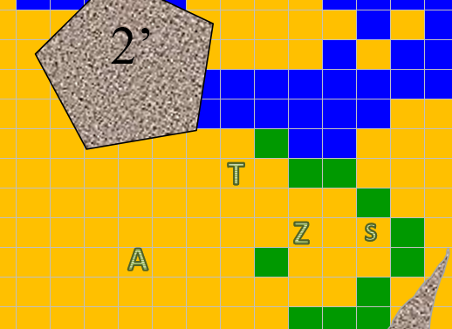

Tore nodded, “Then the beach it is. We should still be cautious, who knows what other surprises this world holds.”

They continued to follow Saradette across the beach, approaching the buildings, taking in their surroundings. The structures had ledges that acted as crenellations, though they were flat and level rather than angled.

“Xhonghibha!” they heard an alien mouth pronounce some syllables to the west, and Tore had a line of sight to a dead kuo-toa that rose as its flesh was seared off. This was the telltale sign of a *create undead* spell that rendered a corpse into an animated skeleton.

“We have company,” Tore pointed, and the others readied themselves.

“Necromancers,” Saradette snarled the word like a vile curse. She activated her ring of flying and lifted up enough to see over the rock, seeing only the dead kuo-toa that were now rising. The caster—if there was one—was probably *invisible*.

Saradette moved down out of view. “The little bastard is invisible, I think. Do any of you have something to counter it?”

Akilesh and Zvetlana did not, and muttered as much as the sandy undead came closer. The one in view hurled its javelin, but it fell short of the heroes by a longshot before lodging itself in the sand.

Round 1

Akilesh cast *sanctuary [expired on Round 10]* upon himself.

Svetlana invoked the breath weapon power in her snake staff, and shot a line of venomous acid onto the skeleton in view.

|  |  |  |  |
| --- | --- | --- | --- |
| **Ranged Weapon** | **Dmg.** | **Rng.** | **Notes** |
| Breath Weapon (line) | 7d6 acid + Poison | 60’ | DC 10 + 2 focus + 6 |

*Dmg: 26 acid + Poison (inapplicable).*

|  |  |  |  |  |
| --- | --- | --- | --- | --- |
| **Character** | **Save vs.**  Breath Weapon | **Ranks** | **Roll** | **Result** |
| Kuo-toa Skeleton (created) | Reflex (Dmg ½) | 1 | 17 | 18 |

*Fail, success. Saved for ½ damage.*

*Dmg: 13 acid.*

The acid took a few moments to make its dent, and then the skeleton withered into nothing as two others came into view.

Saradette aimed her glove at the closest skeleton and zapped it.

|  |  |  |  |
| --- | --- | --- | --- |
| **Ranged Weapon** | **Dmg.** | **Rng.** | **Notes** |
| Glove of Lightning Bolt | 5d6 Electric | 120’ | Ref DC 16 for ½; melts most metals |

*Dmg: 14 electric.*

|  |  |  |  |  |
| --- | --- | --- | --- | --- |
| **Character** | **Save vs.**  *lightning bolt* | **Ranks** | **Roll** | **Result** |
| Kuo-toa Skeleton (created) | Reflex | 1 | 18 | 19 |

*Success. Saved for ½ damage. Dmg: 7 electric.*

The skeleton was left barely standing, but continued to limp forward.

Tore quick-drew his sword and readied his shield as he activated the charisma bonus of the hawkfeather armor. He then said, “Keep moving east. I will bring up the rear and turn them when they get close enough.”

*Interpreting this as “acting defensively.”*

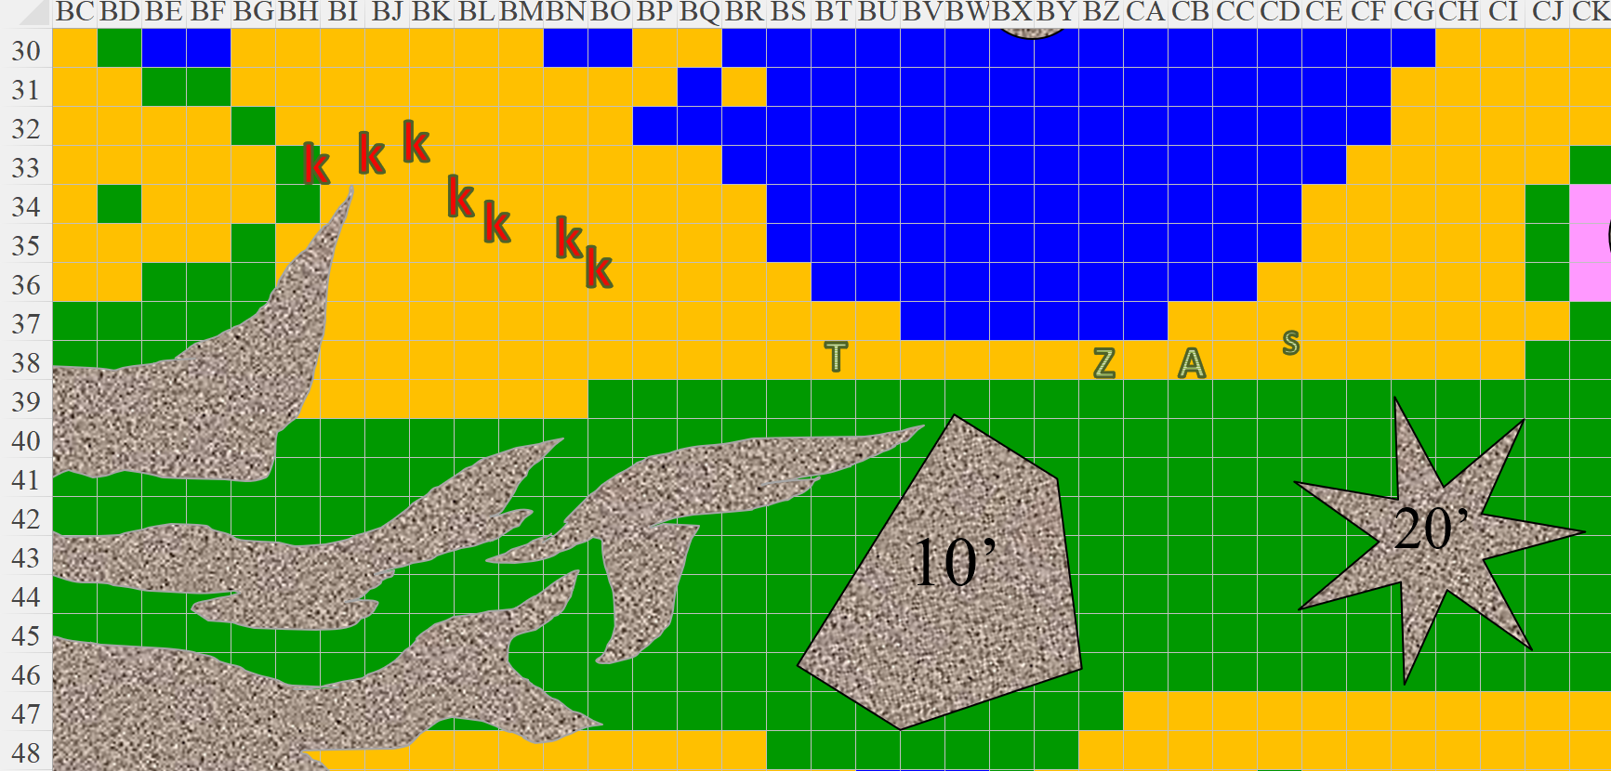

Round 2

The skeletons charge-attacked and flanked Tore as best as they could.

|  |  |  |  |  |  |  |  |  |
| --- | --- | --- | --- | --- | --- | --- | --- | --- |
| **Character** | **Attack Type** | **Damage** | **BAB** | **Str Mod+** | **Other+** | **Total Score** | **Roll** | **Total** |
| Kuo-Toa Skeleton 1 | Claw | 1d4+1 | 0 | 1 | 2 charge | 3 | 5 | 8 |
| Kuo-Toa Skeleton 2 | Claw | 1d4+1 | 0 | 1 | 2 charge + 2 flank | 5 | 17 | 22 |
| Kuo-Toa Skeleton 3 | Claw | 1d4+1 | 0 | 1 | 2 charge + 2 flank | 5 | 1 | 6 |
| Kuo-Toa Skeleton 4 | Claw | 1d4+1 | 0 | 1 | 2 flank | 3 | 13 | 18 |
| Kuo-Toa Skeleton 5 | Claw | 1d4+1 | 0 | 1 | 2 flank | 3 | 6 | 9 |

*Miss, miss, miss, miss, miss.*

Two of the foes did not reach Tore yet, but were circling around to do so as Tore fended off the five that swung menacing, fin-claws at him. As an able cleric, he gauged this to be the perfect moment for a turning of these animated bones.

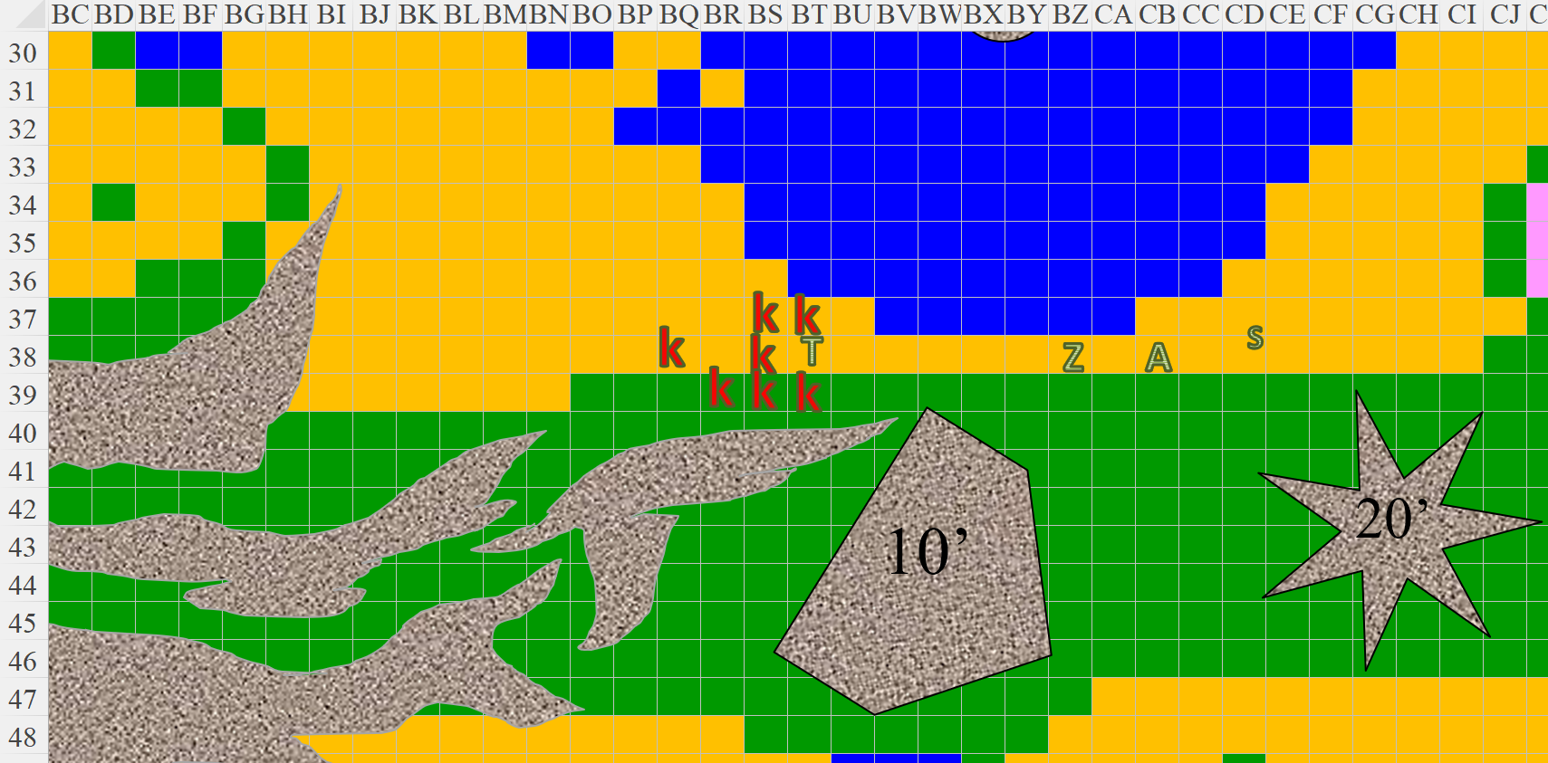

Grasping his Holy Symbol of Defiance, in his shield hand, the diamond in its eye glowing brightly. He held it aloft and called out, “By the power of Lurue, I command you to return to the slumber of death and bother the living no more!”

|  |  |  |
| --- | --- | --- |
| *Turning Undead* | |  |
|  | **Max HD Turned** | 9 |
|  | **1d20 Roll** | 2 |
|  | **Turn Check** | 13 |
|  | **2d6 Roll** | 3 |
|  | **Turn Dmg.** | 13 |
|  | **Turns/Day** | 12 |
|  | **Turns Used** | 1 |

All of the undead became splinters and shards of bone that settled into the sand after Tore’s pious burst of positive energy.

Saradette paused while Tore dealt with the skeletons, not willing to leave him unsupported in case the suspected invisible necromancer showed up.

With the immediate threat dealt with—at least what was visible—Tore turned to the others, “Continue to the east, and keep your eyes peeled for anything suspicious.”

Round 3

They did so, and waited up for the priest as they neared the heart-shaped platform that rested on a constant barrage of positive energy photons. To be exposed to such pure energy directly would kill them within seconds, but Saradette’s understanding of Spellcraft allowed her to identify the arcane tech as a healing pad.

“You sure?” asked the aristocrat after Saradette said as much.

“Pretty sure,” she replied, though she did not have the opportunity to test it before Akilesh pointed out a spellcaster atop the somewhat rectangular structure to their northeast.

Round 4

“Evoker!” Saradette guessed based on the spell she was seeing the man cast. She barely noted the pointy ears of an elf under the hair that escaped his pointy, purple hat with yellow stars and moons. He was standing under an umbrella, and they could see the corner of a desk where he’d probably been working until now. Odd.

Tore yelled, “We come in peace!” He wasn’t expecting the caster to stop, but figured there was a chance, but no, dude kept right on wiggling those digits. As he watched the caster, he kept his sword in hand and prepared to draw his buckler shield in preparation to defend himself and the others.

Saradette did nothing for the moment, studying the caster’s queer quirks.

Zvetlana drank a potion that shrouded her in an abjuration aura, and Akilesh groaned, “Arrgh, I don’t enjoy this part of the adventure.” He lifted his heavy crossbow and aimed, about to shoot in a moment when Saradette stopped him.

“Don’t waste the bolt,” she said. “Look,” she said as she stepped onto a flat, shiny pebble.

The alleged evoker finished his casting, and an *orb of acid* shot out straight for Saradette, seemed to pierce her, then disappeared as the *silent image* repeated its casting.

Round 5

“Keep alert,” Zvetlana said nonetheless. “Good call,” she expressed to Saradette as Akilesh nodded, training his crossbow forward as they took a few more steps.

Round 6

By now, a new anomaly was becoming evident to the east: a black-hued veneer—not entirely opaque, but tinted—seemed to cascade down from a striped, violet sky. Would it impede further passage, or was it another illusion?

Saradette swore reflexively as the illusory orb passed through her. She lifted up ten feet to more closely study the shapes around her. “Do these shapes mean anything,” she asked the group at large. “I don’t recognize any of them.”

Tore inquired, “What do you see?” as Saradette had elevated herself. He couldn’t make any sense of the shapes or their pattern.

Round 7

“More of the same,” she said, then spotted the charcoal-hued, winged fey they’d seen earlier. It was hovering near a portion of the black veneer that seemed thicker than the rest of the thin screen.

The illusory evoker at the top of the building cast another fake *orb of force* that tagged the sand behind them uneventfully.

Round 8

Zvetlana made her way to the top of the grassy mound, studied the fey as much as she could, and transformed back into her humanoid form, while her hair took on the aspects of snakes. With a medusa vibe on, the wereserpent held her python that could turn into a staff, and waved at the stranger.

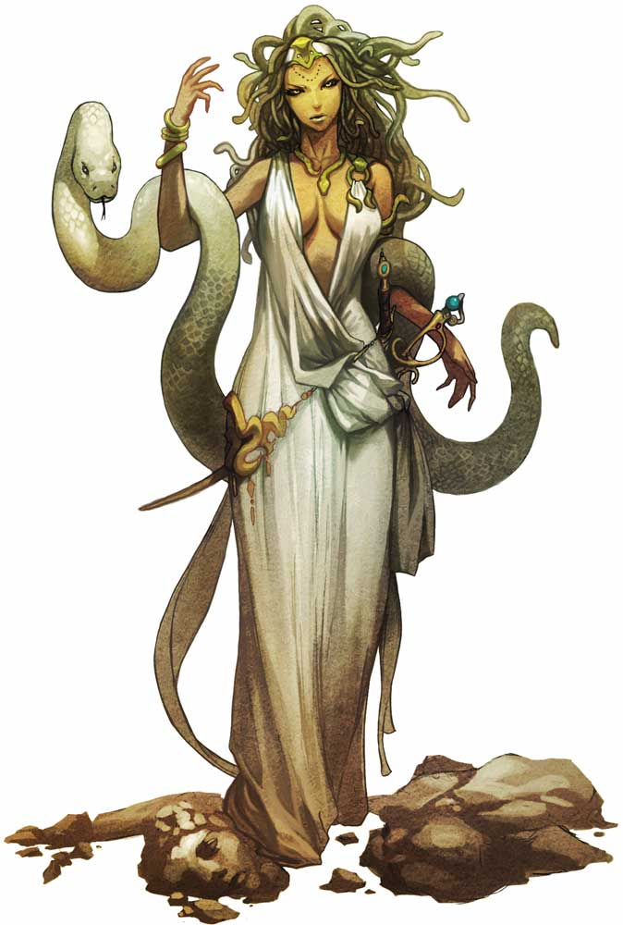

The stranger did not wave back.

Round 9

“That fey is back. He’s about a hundred and fifty paces that way,” Saradette points east. “I have no idea what he’s doing, though.”

Tore yelled to Saradette, “Then perhaps we should introduce ourselves.” Tore motioned to the other two follow and he began walking in the direction of the fey, watching for any traps along the way.

Round 10 – 13

Akilesh’s *sanctuary* spell expired.

They walked cautiously for about 100’ east-southeast, keeping their eyes on the fey, and occasionally behind and above them.

Round 14

Getting within shouting distance, the fighter-cleric yelled out to the fey, “Ho, there. We mean you no harm. We would like to talk if you have the time to sit with us.”

The floating fey retreated into the mass that was part of the otherwise flat screen between them and whatever lay beyond. It disappeared behind what could barely be recognized as a tree to their direct east.

Seeing the fey fly through the ‘curtain’ Tore thought for a moment. “It could be harmless, or it will only allow a certain inclination to good or evil though. A couple of us should get closer, the other two can stay back and provide cover. I’m willing to approach it. Who will come with me?”

Round 15

Tore looked at the fey and the barrier. “Let’s continue and see if we can pass through it as well.”

The fey flew above the tree behind which it was hovering, and bolted eastward, out of sight.

Saradette flew over the freshwater spring, keeping up with her teammates, and took a moment to survey what she could now see. To the northeast, northwest, southeast, and southwest were four periwinkle platforms identically shaped

Zvetlana—still in a medusa-like guise—kept her own eyes forward as the snakes atop her head looked up. Her python, meanwhile, coiled itself around its mistress twice and kept its gaze and tongue back.

Akilesh stared at the python and secretly wondered what a snake with myriad women on its head would be called, then focused on the possible danger ahead as they continued eastward.

Round 16

There were several trees up ahead, it seemed, and the largest of the solid structures they’d spotted so far. As the breeze turned from eastward to westward momentarily, the smell of sulfur and brimstone began to blow into their noses, and it felt almost like a giant door had been opened somewhere, and a warm draft was now emanating from the region beyond the screen that Saradette could now confidently identify as being made of Shadowstuff, the same stuff that comprised most conjured creatures. She iterated this briefly.

“Could it be a portal to the Shadow Plane?”