*Chapter 42: Lolth’s Fanatics*

Round 35

They saw no other immediate threats about.

Zvetlana had just pointed out that the cyan platform produced an electrical current, while the red platform had been where the shaedling leader had appeared. So one of them was damaging and another was a teleportation conduit, maybe. The green one seemed to be emanating a corrosive vapor that wasn’t enough to do much at a distance, but one didn’t want to approach. Akilesh was also pretty sure—as he’d stated—that the blue platform was a positive energy pool, and the periwinkle one remained a mystery.

Saradette went to recover the glasses she’d seen.

Round 36

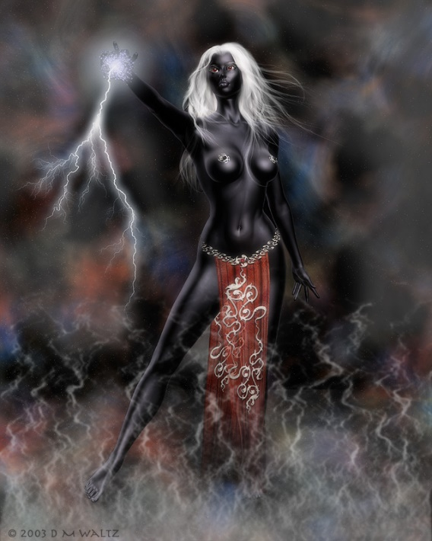

Suddenly, a sole drow appeared to the east. Barely clad, the woman seemed to be a sorceress or something of the sort, and held out a hand emanating an electric arc as she studied the four heroes to her west.

Behind her, a man dressed in the garments of an archmage teleported into view, and looked the heroes over. Holding out a hand emanating what appeared to be shadowstuff—the building blocks of conjured creatures—the spellcaster probably waited for others to pop onto the scene.

And such a being did appear: a sultry ranger type with twin blades at the ready.

The first woman who had appeared spoke in fairly fluent Common, “You have mottled the progress of chaos in this plane. Leave this place now; go back the way you came, or our troglodytes and kuo-toa will be glad to feast upon your remains.”

Saradette could tell that the woman did not want to fight, but would do so in order to safeguard this turf.

Tore and the others weren’t able to read the newcomers, but they suddenly realized that every spell they’d cast was somehow replenished in their daily repertoire. Fully healthy, and as full of mojo as they had been when they’d woken up, the heroes considered obliging the drow despite their mission to investigate the nature and function of this pocket plane in the greater cosmos. Thus far, it appeared that Lolth had harbored drow and shaedling thralls, and built a somewhat sustainable island amidst ethereal mist, but it also seemed that much more of the place remained unexplored.

“Well, we know why this place is here,” the artificer pointed out to Tore. “Does this complete our purpose?”

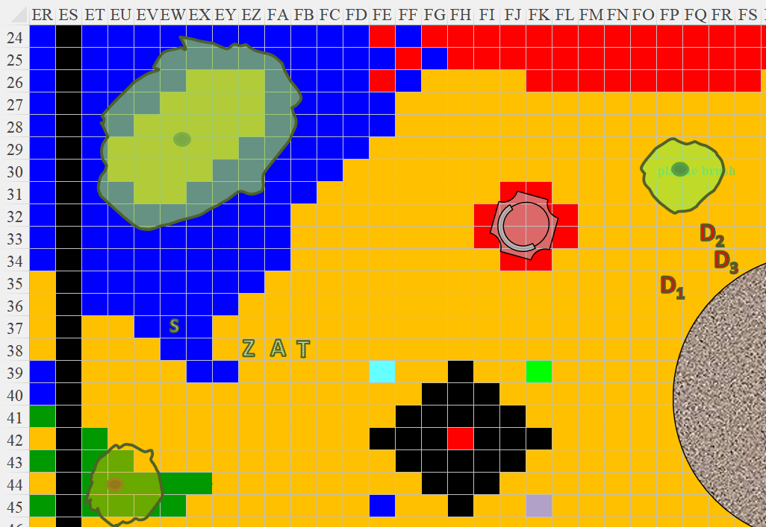

Round 37

The wereserpent was ever the optimist, “I would presume so.”

The drow leader took a step forward, communicating that she was looking for an excuse to get into it with these intruders.

Akilesh said nothing for the moment as Saradette picked up the eyeglasses and returned towards the others.

Tore looked at Saradette, “What say you? Do you want to stay and have a further look around, or should we withdraw with what intel we have?” Tore eyed the drow. Had they been undead, he would have gladly stayed and fought them. Not that he was apt to leave just because a drow threatened them, they just had a mission to complete and it would do the other no good if they never returned.

Then, with no warning or explanation, a fully armored drow dropped out of the sky, fell towards the ground, followed by a horned fiend that also fell after her, and disappeared into a portal that the fiend held open long enough to also slip through.

The two strangers were gone as quickly as they’d appeared, but Zvetlana and Tore both read in the topless drow’s face a sense of unease, and possibly of having recognized one of the two figures that fell.

The three drow on the ground looked at one another.

Round 38

Tore looked at the topless drow, “Trouble in paradise,” he paused looking around for a moment, “sorry, I meant cesspool.”

|  |  |  |  |  |  |  |
| --- | --- | --- | --- | --- | --- | --- |
| **Skill** | **Rank** | **Ability & Mod.** | **Misc. Mods.** | **Total** | **Roll** | **Check** |
| **Tore, Diplomacy** | 0 | **Cha (+5)** | 0 | 5 | 5 – 10 | ?? |

*See below.*

“Explain yourself!” the male archmage with the fancy getup demanded, speaking in a much lower voice than had been expected from him. “Now *I* want to know your purpose here.” His voice had a hollow reverb, as if he had a constant spell effect on that augmented his speech.

Round 39

Tore doubled down on his faux pas, clearing his throat and smiling before speaking further, “We were just looking around, and have seen enough. Now, if you’ll excuse us,” Tore gave a bit of a bow, “we will go find the exit.” Tore wondered if this would become a fight, and if so he was already preparing to cast *luminous armor*. He then caught sight of the specs in Saradette’s hand, and identified them as the Lenses of Revelation, the very pair he had coveted since around the time they’d fought off the ibixians in the hinterlands that gapped Anauroch and Cormyr. Tore already had the Ephod of Authority—the least of the Vestments of Divinity associated with his goddess—and now split his attention between the drow trio and the item in his friend’s hand.

“I tire of this,” said the archmage, then began wiggling his fingers.

Akilesh had quietly studied the situation, and was glad he had reloaded his crossbow. He prepared for what ensued next, and had the reflexes to train it upon the male spellcaster, who was already beginning to manifest some evocation.

|  |  |  |  |  |  |  |  |
| --- | --- | --- | --- | --- | --- | --- | --- |
| **Character** | **Attack Type** | **Damage** | **BAB** | **Dex Mod+** | **Total Score** | **Roll** | **Total** |
| Akilesh | Heavy Crossbow +1 | 1d10+1 | 5 | 2 | 7 | 14 | 21 |

*Hit. Dmg: 9 + 1 = 10.*

|  |  |  |  |  |  |  |
| --- | --- | --- | --- | --- | --- | --- |
| **Skill** | **Rank** | **Ability & Mod.** | **Misc. Mods.** | **Total** | **Roll** | **Check** |
| **The Contemplator, Concentration** | 15 | **Con (+2)** | 0 | 17 | 20 | 37 |

*Success. Spellcasting successful.*

|  |  |  |  |  |
| --- | --- | --- | --- | --- |
| **Character** | **Save vs.**  *lightning bolt* | **Ranks** | **Roll** | **Result** |
| Akilesh | Reflex | 4 | 7 | 11 |

*Fail. Dmg: 35 electric.*

“Not cool,” Zvetlana proclaimed, also firing upon the zapper.

|  |  |  |  |  |  |  |  |  |  |
| --- | --- | --- | --- | --- | --- | --- | --- | --- | --- |
| **Character** | **Attack Type** | **Damage** | **BAB** | **Str Mod+** | **Dex Mod+** | **W+** | **Total Score** | **Roll** | **Total** |
| Zvetlana | Light Crossbow +2 | 1d8+2 | 6 | 1 | 4 | 2 | 12 | 19 | 31 |

*Hit. Dmg: 2 + 2 = 4.*

Zvetlana then reloaded.

The half-nude woman cast *stoneskin* upon herself.

*Xhiru gained 80 points’ worth of dr 10/adamantine.*

Her hands then took on the semblance of spidery claws, and she locked eyes with Tore, smirking with a hunger for his flesh.

The ranger behind them charged at Tore in the meantime, preparing to strike with both kukris.

Holding the pair of spectacles in one hand, Saradette said, “Tore, remind me to not let you haggle at the market. I’ll hold these glasses for you.” Saradette dropped the glasses into her satchel and lifted her blaster, hammering the archmage with sonic energy.

|  |  |  |  |
| --- | --- | --- | --- |
| **Ranged Weapon** | **Dmg.** | **Rng.** | **Notes** |
| Horizikaul’s Boom | 2d4 Sonic | 25’ + 2½’/lvl | Will DC 14 or deafened for 1d4 rounds |

*Dmg: 6 sonic.*

|  |  |  |  |  |
| --- | --- | --- | --- | --- |
| **Character** | **Save vs.**  *Horizikaul’s boom* | **Ranks** | **Roll** | **Result** |
| The Contemplator | Will | 7 | 14 | 21 |

*Success. Deafening effect negated.*

Tore cast *luminous armor* upon himself and readied his Buckler Shield, though he did not activate the barrier at this time. He held his ground and waited for the drow to close the gap before attacking.

Round 40

Saradette shot the archmage again with her sonic blaster. “Asshole!”

|  |  |  |  |
| --- | --- | --- | --- |
| **Ranged Weapon** | **Dmg.** | **Rng.** | **Notes** |
| Horizikaul’s Boom | 2d4 Sonic | 25’ + 2½’/lvl | Will DC 14 or deafened for 1d4 rounds |

*Dmg: 3 sonic.*

|  |  |  |  |  |
| --- | --- | --- | --- | --- |
| **Character** | **Save vs.**  *Horizikaul’s boom* | **Ranks** | **Roll** | **Result** |
| The Contemplator | Will | 7 | 11 | 18 |

*Success. Deafening effect negated.*

Tore met his charging assailant as they exchanged blows.

|  |  |  |  |  |  |  |  |  |  |
| --- | --- | --- | --- | --- | --- | --- | --- | --- | --- |
| **Melee Weapon** | **Dmg** | **D+** | **TH+** | **Critical** | **Type** | **Wt.** | **Atk** | **Roll** | **Check** |
| Longsword of Frost | 1d8+1 | +1+1d6 Cold | 1 | 19-20/x2 | Slashing | 8.0 | +11 | 11 | 22 |
| Longsword, 2nd Attack | 1d8+1 | +1+1d6 Cold | 1 | 19-20/x2 | Slashing | - | +6 | 6 | 12 |

*Hit, miss. Dmg: 8 + 1 + 1 + 2 cold = 12.*

|  |  |  |  |  |  |  |  |  |  |
| --- | --- | --- | --- | --- | --- | --- | --- | --- | --- |
| **Character** | **Attack Type** | **Damage** | **BAB** | **Str Mod+** | **W+** | **Other+** | **Total Score** | **Roll** | **Total** |
| Slitsevere | Kukri +2 | 1d6+2 | 10 | 2 | 2 | 1 WF  +2 charge | 17 | 14 | 31 |

*Hit. Dmg: 3 + 2 + 2 charge = 7 [64/71].*

Akilesh reloaded his heavy crossbow as Zveltana shot the topless woman with her light crossbow.

|  |  |  |  |  |  |  |  |  |
| --- | --- | --- | --- | --- | --- | --- | --- | --- |
| **Character** | **Attack Type** | **Damage** | **BAB** | **Dex Mod+** | **W+** | **Total Score** | **Roll** | **Total** |
| Zvetlana | Light Crossbow +2 | 1d8+2 | 6 | 4 | 2 | 12 | 7 | 19 |

*Hit. Dmg: 2 + 2 = 4.*

The Contemplator saw that he was being singled out as the choicest target, and cast *lesser globe of invulnerability [expired on Round 41]*.

*The Contemplator gained immunity to ≤ 3rd-level spells.*

Xhiru closed in and cast *necrotic skull bomb* upon her enemies.

*Slitsevere gained 2 x 5 = 10 temporary hps.*

|  |  |  |  |  |  |  |
| --- | --- | --- | --- | --- | --- | --- |
| **Save vs.**  *necrotic skull bomb* | **Rank** | **Ability & Mod.** | **Misc. Mods.** | **Total** | **Roll** | **Check** |
| **Saradette, Fortitude** | **2** | **Con (+1)** | 0 | 3 | 20 | 23 |
| **Tore, Fortitude** | **9** | **Con (+1)** | 1 | 11 | 9 | 20 |

*Success, success. Effect negated.*

|  |  |  |  |  |
| --- | --- | --- | --- | --- |
| **Character** | **Check** | **Ranks** | **Roll** | **Result** |
| Akilesh | Fortitude | 7 | 6 | 13 |
| Zvetlana | Fortitude | 2 | 3 | 5 |

*Fail, fail.*

*Akilesh encumbered 1 negative level (i.e., –1 on all checks, saves, and attacks; –5 hit points; –1 effective level; -1 spell slot from highest level available).*

*Zvetlana encumbered 3 negative levels.*

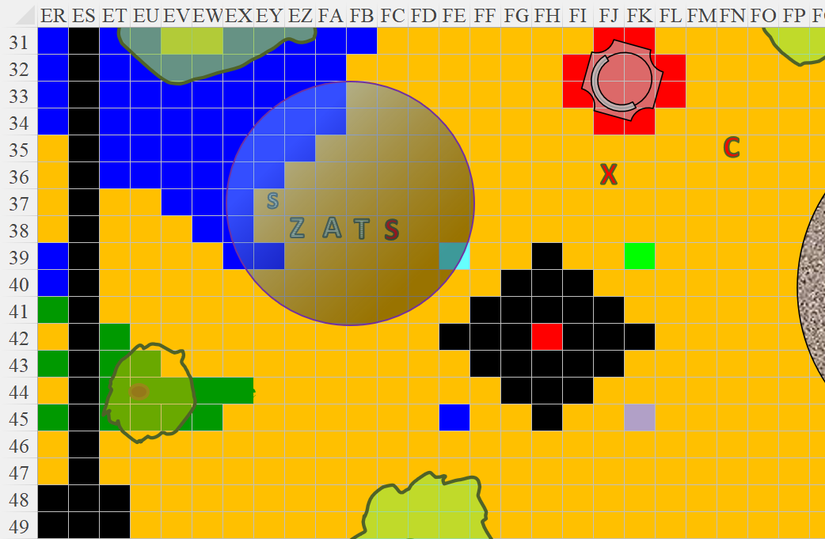n

Round 41

Saradette pointed her gauntlet at the woman attacking Tore and zapped her.

|  |  |  |  |
| --- | --- | --- | --- |
| **Ranged Weapon** | **Dmg.** | **Rng.** | **Notes** |
| Glove of Lightning Bolt | 5d6 Electric | 120’ | Ref DC 16 for ½; melts most metals |

*Base dmg: 12 electric.*

|  |  |  |  |  |
| --- | --- | --- | --- | --- |
| **Character** | **Save vs.**  *lightning bolt* | **Ranks** | **Roll** | **Result** |
| Slitsevere | Reflex | 8 | 12 | 20 |

*Success. Saved for ½ damage = 6 electric. Damage negated.*

The drow with the twin kukris cringed from the pain of the electrical blast, though the zap seemed harmless, and bared two razor-sharp canine teeth that would fit nicely around Tore’s neck.

“Vampire!” called out Akilesh as he identified the undead drow as the vampire healed part of its wounds in seconds.

Tore was having necrotic cyst flashbacks, but smiled, glad they had provoked the drow. He activated the Charisma bonus from his armor (Swift Action +4 CHA Bonus) then took his Amulet of Holy Defiance and held it aloft, chanting, “Be gone you foul beast! Defile this plane no more. By the power of Lurue, be gone!!”

|  |  |  |
| --- | --- | --- |
| *Turning Undead* | |  |
|  | **Max HD Turned** | 9 |
|  | **1d20 Roll** | 13 |
|  | **Turn Check** | 24 |
|  | **2d6 Roll** | 7 |
|  | **Turn Dmg.** | 22 |
|  | **Turns/Day** | 12 |
|  | **Turns Used** | 1 |

*Turn Undead.*

The cleric turned the vampire, who summarily backed away, sprouted wings, and took flight. Tore took a few steps toward the vamp to keep it moving away from the others.

Akilesh and Zvetlana both fired upon the male spellcaster.

|  |  |  |  |  |  |  |  |  |  |
| --- | --- | --- | --- | --- | --- | --- | --- | --- | --- |
| **Character** | **Attack Type** | **Damage** | **BAB** | **Dex Mod+** | **W+** | **Total Score** | **Roll** | **Total** | **Notes** |
| Akilesh | Heavy Crossbow +1 | 1d10+1 | 5 | 2 | 1 | 8 | 4 | 12 | -1 from negative level |
| Zvetlana | Light Crossbow +2 | 1d8+2 | 6 | 4 | 2 | 12 | 13 | 25 | -3 from negative levels |

*Miss, hit. Dmg: 5 + 2 = 7.*

Zvetlana then reloaded her crossbow.

The Contemplator cast *Melf’s acid arrow* upon Saradette.

|  |  |  |  |  |
| --- | --- | --- | --- | --- |
| **Ranged Weapon** | **Dmg.** | **Atk** | **Roll** | **Check** |
| Ranged Touch Attack | 6d4 acid | +7 | **20** | 27 |

*Hit. Dmg: 16 acid [37/53] (+ 14 acid lingering damage on next round if not neutralized [23/53]).*

Saradette was not pleased.

The topless priestess came closer and cast *hold person [expired no later than Round 51]* upon Akilesh.

|  |  |  |  |  |
| --- | --- | --- | --- | --- |
| **Character** | **Save vs.**  *hold person* | **Ranks** | **Roll** | **Result** |
| Zvetlana | Will | 8 | 2 | 10 |

*Fail.*

Zvetlana was *held* for the moment.

Round 42

Turned, Slitsevere walked backwards into the abyss to the southeast, and disappeared.

Akilesh reloaded his crossbow, studying the drow adversaries all the while.

Zvetlana struggled to get free of the *hold* spell.

|  |  |  |  |  |
| --- | --- | --- | --- | --- |
| **Character** | **Check** | **Ranks** | **Roll** | **Result** |
| Zvetlana | Will | 8 | 14 | 22 |

*Success.*

She broke through the spell’s restraints, and fired upon the favored soul of Lolth.

|  |  |  |  |  |  |  |  |  |  |
| --- | --- | --- | --- | --- | --- | --- | --- | --- | --- |
| **Character** | **Attack Type** | **Damage** | **BAB** | **Dex Mod+** | **W+** | **Total Score** | **Roll** | **Total** | **Notes** |
| Zvetlana | Light Crossbow +2 | 1d8+2 | 6 | 4 | 2 | 12 | 15 | 27 | -3 from negative levels |

*Hit. Dmg: 3 + 2 = 5.*

*[DM assumption]* Saradette suffered from the remaining acid on her as it neutralized its pH and ate away at her skin and armor, and repeated her previous blasting, this time targeting the approaching archmage.

|  |  |  |  |
| --- | --- | --- | --- |
| **Ranged Weapon** | **Dmg.** | **Rng.** | **Notes** |
| Glove of Lightning Bolt | 5d6 Electric | 120’ | Ref DC 16 for ½; melts most metals |

*Base dmg: 14 electric.*

|  |  |  |  |  |
| --- | --- | --- | --- | --- |
| **Character** | **Save vs.** | **Ranks** | **Roll** | **Result** |
| The Contemplator | Reflex | 6 | 6 | 12 |

*Fail.*

Tore made sure to keep his friends within 30’ so that they were well within the range of his turning protection against the undead while watching Slitsevere as she continued to fly away. He then turned and looked at the Contemplator and cast Summon Monster II calling forth a Celestial giant bee, directing it to attack the Contemplator, hoping to also break his concentration on his spells.

As Tore concentrated on the extended-time spellcasting, Xhiru cast *mark of doom [expired on Round 52]* upon the gentleman-cleric whom she took to be Lawful Good. << Dozh-dit’laa! >>

*Effect diminished to 1d4/round due to Tore’s Chaotic alignment. Damage incurred upon the next attack or hostile action.*

Tore identified the sigil now floating before him as the *mark of doom* spell, and squinted at the two living drow.

The Contemplator contemplated on whom to attack next. The cleric would likely hesitate to retaliate for now, but the others... he decided on the dwarf, and cast *magic missile* on the favored soul of a loathsome deity.

*Dmg: 10 + 4 = 14 magic.*

Nearly dead, Akilesh took a few steps back in order to have the opportunity to draw and quaff a potion in a moment.

Zvetlana fired upon the favored soul of Lolth.

|  |  |  |  |  |  |  |  |  |  |
| --- | --- | --- | --- | --- | --- | --- | --- | --- | --- |
| **Character** | **Attack Type** | **Damage** | **BAB** | **Dex Mod+** | **W+** | **Total Score** | **Roll** | **Total** | **Notes** |
| Zvetlana | Light Crossbow +2 | 1d8+2 | 6 | 4 | 2 | 12 | 5 | 17 | -3 from negative levels |

*Miss.*

Round 43

Tore conjured a Celestial giant bee, which attacked the Contemplator with no hesitation.

|  |  |  |  |  |  |  |  |  |
| --- | --- | --- | --- | --- | --- | --- | --- | --- |
| **Character** | **Attack Type** | **Damage** | **BAB** | **Str Mod+** | **Total Score** | **Roll** | **Total** | **Notes** |
| Celestial giant bee | Sting | 1d4+Poison | 2 | 2 | 4 | 12 | 16 | Fort DC 11, initial and secondary damage 1d4 Con |

*Miss.*

The archmage’s *mage armor* spell did its job; perhaps the bee was a better match for the unarmored favored soul of Lolth.

Tore knew that further hostility on his part would cause him harm, so he directed the Celestial bee to attack Xhiru.

*Dmg to Tore: 3 Evil [46/71].*

Saradette stepped back just into the water and zapped the Contemplator again with her glove.

|  |  |  |  |
| --- | --- | --- | --- |
| **Ranged Weapon** | **Dmg.** | **Rng.** | **Notes** |
| Glove of Lightning Bolt | 5d6 Electric | 120’ | Ref DC 16 for ½; melts most metals |

*Base dmg: 22 electric.*

|  |  |  |  |  |
| --- | --- | --- | --- | --- |
| **Character** | **Save vs.**  *lightning bolt* | **Ranks** | **Roll** | **Result** |
| The Contemplator | Reflex | 6 | 2 | 8 |

*Fail.*

Akilesh quaffed a potion of *cure critical wounds*, and held his stance.

*Akilesh gained 19 + 14 = 33 hps.*

The Contemplator drank a potion of *cure serious wounds*, and spoke in Drow to his accomplice.

*The contemplator gained 12 + 11 = 23 hps.*

Zvetlana asked if anyone spoke Drow, noted the significant damage that the artificer had dealt the Contemplator, and nodded at the gnome with admiration, firing upon the male spellcaster.

|  |  |  |  |  |  |  |  |  |  |
| --- | --- | --- | --- | --- | --- | --- | --- | --- | --- |
| **Character** | **Attack Type** | **Damage** | **BAB** | **Dex Mod+** | **W+** | **Total Score** | **Roll** | **Total** | **Notes** |
| Zvetlana | Light Crossbow +2 | 1d8+2 | 6 | 4 | 2 | 12 | 17 | 29 | -3 from negative levels |

*Hit. Dmg: 4 + 2 = 6.*

Xhiru took a few steps westward and made like she was about to shake Tore’s hand as she cast *inflict serious wounds*.

|  |  |  |  |  |  |  |  |  |
| --- | --- | --- | --- | --- | --- | --- | --- | --- |
| **Character** | **Attack Type** | **Damage** | **BAB** | **Dex Mod+** | **Other+** | **Total Score** | **Roll** | **Total** |
| Xhiru | Touch | varies | 7 | 1 | 1 | 9 | 15 | 24 |

*Hit.*

|  |  |  |  |  |  |  |
| --- | --- | --- | --- | --- | --- | --- |
| **Save vs.**  *inflict serious wounds* | **Rank** | **Ability & Mod.** | **Misc. Mods.** | **Total** | **Roll** | **Check** |
| **Tore, Will** | **6** | **Wis (+3)** | 0 | 9 | 10 | 19 |

*Success. Saved for ½ damage.*

*Dmg: ½ x (20 + 10) = 15 negative energy [49/71].*

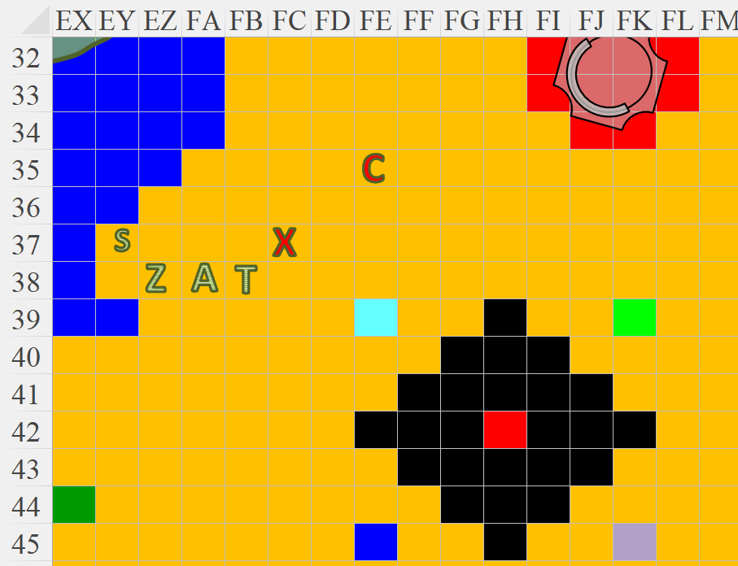

Round 44

Zvetlana fired upon the Contemplator.

|  |  |  |  |  |  |  |  |  |  |
| --- | --- | --- | --- | --- | --- | --- | --- | --- | --- |
| **Character** | **Attack Type** | **Damage** | **BAB** | **Dex Mod+** | **W+** | **Total Score** | **Roll** | **Total** | **Notes** |
| Zvetlana | Light Crossbow +2 | 1d8+2 | 6 | 4 | 2 | 12 | 9 | 21 | -3 from negative levels |

*Miss.*

Akilesh gave the wereserpent some comforting words and tried to finish off the ugly drow spellcaster.

|  |  |  |  |  |  |  |  |  |  |
| --- | --- | --- | --- | --- | --- | --- | --- | --- | --- |
| **Character** | **Attack Type** | **Damage** | **BAB** | **Dex Mod+** | **W+** | **Total Score** | **Roll** | **Total** | **Notes** |
| Akilesh | Heavy Crossbow +1 | 1d10+1 | 5 | 2 | 1 | 8 | 6 | 14 | -1 from negative level |

*Miss.*

“Buckity-buck!” the outlandish outlander dwarf proclaimed as he also missed his mark.

The giant bee stung Xhiru some more.

|  |  |  |  |  |  |  |  |  |
| --- | --- | --- | --- | --- | --- | --- | --- | --- |
| **Character** | **Attack Type** | **Damage** | **BAB** | **Str Mod+** | **Total Score** | **Roll** | **Total** | **Notes** |
| Celestial giant bee | Sting | 1d4+Poison | 2 | 2 | 4 | 10 | 14 | Fort DC 11, initial and secondary damage 1d4 Con |

*Miss.*

Xhiru smirked and blurted in Common, “You would turn our pet vampire?” She huffed, and added, “We shall turn *you*, and chase you down like *fawns*.”

Tore activated the Barrier from his Barricade Buckler Shield (Swift Action) then used a charge from the Healing Belt of Priestly Might upon himself.

*Tore gained 9 hps [55/71].*

Zvetlana had reloaded her crossbow, and was still hopeful that they could take down the male of the species before dealing with his perfectly proportioned consort.

|  |  |  |  |  |  |  |  |  |  |
| --- | --- | --- | --- | --- | --- | --- | --- | --- | --- |
| **Character** | **Attack Type** | **Damage** | **BAB** | **Dex Mod+** | **W+** | **Total Score** | **Roll** | **Total** | **Notes** |
| Zvetlana | Light Crossbow +2 | 1d8+2 | 6 | 4 | 2 | 12 | 18 | 30 | -3 from negative levels |

*Hit. Dmg: 7 + 2 = 9.*

And yes, that *did* do the necessary damage to at least render the drow unconscious as he lay bleeding.

The Contemplator’s resplendent *mage armor* remained intact as the drow fell to the floor.

Xhiru then cast *fear [expired on Round 54]*.

|  |  |  |  |  |
| --- | --- | --- | --- | --- |
| **Character** | **Save vs.**  *fear* | **Ranks** | **Roll** | **Result** |
| Akilesh | Will | 5 | 1 | 6 |
| Zvetlana | Will | 8 | 7 | 15 |
| Celestial giant bee | Will | 3 | 4 | 7 |

*Fail, fail, fail.*

|  |  |  |  |  |  |  |  |
| --- | --- | --- | --- | --- | --- | --- | --- |
| **Save vs.**  *Fear* | **Rank** | **Ability & Mod.** | **Misc. Mods.** | **Total** | **Roll** | **Check** | **Notes** |
| **Saradette, Will** | **4** | **Wis (+1)** | 0 | 5 | 14 | 19 | +1 vs. Fear |
| **Tore, Will** | **6** | **Wis (+3)** | 0 | 9 | 2 | 11 |  |

*Success, fail.*

*Saradette suffered –2 to attacks, saves, and checks.*

The dwarf and the wereserpent dropped their respective crossbows and fled into the waters. The bee also buzzed away frantically.

Tore also whimpered before the spellcaster, and turned tail, following the bee, dwarf, and wereserpent into the tidepool.

Saradette noted that her friends had all been bested by magic that was also having a minor effect on her. She shifted her aim to the remaining drow and zapped her with her glove.

|  |  |  |  |
| --- | --- | --- | --- |
| **Ranged Weapon** | **Dmg.** | **Rng.** | **Notes** |
| Glove of Lightning Bolt | 5d6 Electric | 120’ | Ref DC 16 for ½; melts most metals |

*Base dmg: 25 electric.*

|  |  |  |  |  |
| --- | --- | --- | --- | --- |
| **Character** | **Save vs.**  *lightning bolt* | **Ranks** | **Roll** | **Result** |
| Xhiru | Reflex | 8 | 7 | 15 |

*Fail. Full damage taken.*

Despite the hurt, the favored of Lolth still seemed ready to give them a run for their coin.

Round 45

And verily, with the exception of Saradette, the favored soul of the Spider Queen had rendered each valiant combatant a fugitive. “I may use *your* life essence to heal the Contemplator. He’s the best lick.” The drow then approached Saradette with the selfsame spell being cast as before: *inflict serious wounds*.

|  |  |  |  |  |  |  |  |  |
| --- | --- | --- | --- | --- | --- | --- | --- | --- |
| **Character** | **Attack Type** | **Damage** | **BAB** | **Dex Mod+** | **Other+** | **Total Score** | **Roll** | **Total** |
| Xhiru | Touch | varies | 7 | 1 | 1 | 9 | 18 | 27 |

*Hit.*

|  |  |  |  |  |  |  |
| --- | --- | --- | --- | --- | --- | --- |
| **Save vs.**  *inflict serious wounds* | **Rank** | **Ability**  **& Mod.** | **Misc.**  **Mods.** | **Total** | **Roll** | **Check** |
| **Saradette, Will** | **4** | **Wis (+1)** | -2 Shaken | 3 | 14 | 17 |

*Saved for ½ damage.*

*Dmg: ½ x (11 + 10) = 10 negative energy [****10****/53].*

Saradette was hanging on by a thick wick, and knew it. She heard her accomplices splashing with each step in the shallows behind her, and she zapped the drow again with her glove.

|  |  |  |  |
| --- | --- | --- | --- |
| **Ranged Weapon** | **Dmg.** | **Rng.** | **Notes** |
| Glove of Lightning Bolt | 5d6 Electric | 120’ | Ref DC 16 for ½; melts most metals |

*Base dmg: 19 electric.*

|  |  |  |  |  |
| --- | --- | --- | --- | --- |
| **Character** | **Save vs.**  *lightning bolt* | **Ranks** | **Roll** | **Result** |
| Xhiru | Reflex | 8 | 20 | 28 |

*Success. Saved for ½ damage: 9 electric.*

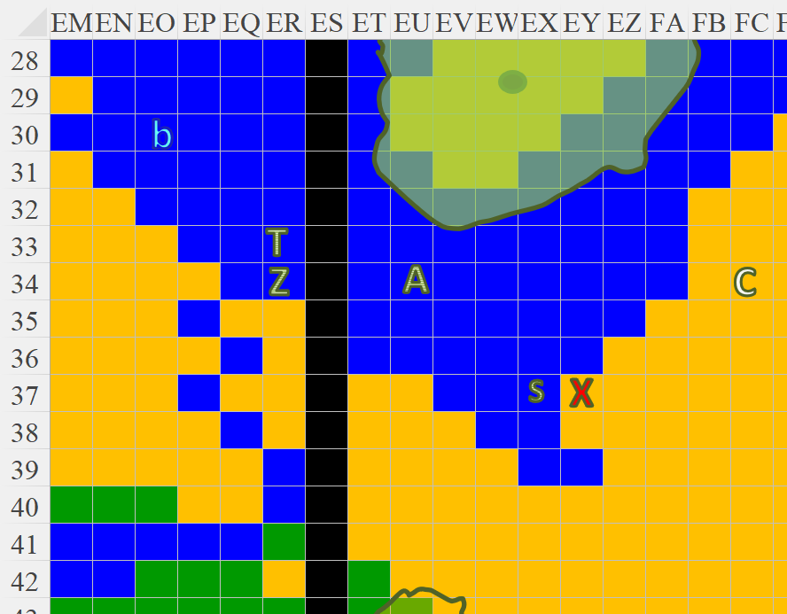

Round 46

Xhiru was nearing the end, and grimaced, not wanting to end up a drow in a drow graveyard, so she cast some type of *teleportation* spell, and disappeared from view.

Saradette turned back to see her friends running straight for the sea, with the bee seemingly leading them yonder.

In the distance, Saradette spotted the vampire way up high flapping furiously away before disappearing behind a low cloud.

A lone shaedling also buzzed shamelessly at an altitude of about 20’, keeping well enough away from the heroes, who’d proven their mettle against the locals.

Saradette stood amidst starfish and corals in the shallow tidepool as she witnessed her friends continuing to dash away. The bee kept its northwestward trajectory, skirting the crashing waves at full speed before it disappeared into an ethereal smoosh.

Those without wings, on the other hand, turned directly westward and kept south of the shoreline, which would eventually take them back to where they’d slain the undead kuo-toa.

Saradette recalled that they’d tethered their two boats to that tip of the peninsula, and now that she was alone on this side of the shadow veneer, she wondered what fate might befall her if her friends should never return.

Saradette waded westward in the shallows, aiming to pass through the barrier while she looked for the others.

When Tore finally was free of the *fear* spell, he looked around for Saradette. Activating his wings, he flew upward, recognized the veneer to the east, assumed she was back there—alive or dead—and flew back, looking for her along the way.

Akilesh and Zvetlana, not capable of flight, shrugged and walked back at a brisk pace along the hilltop that marked the middle section of the island/peninsula.

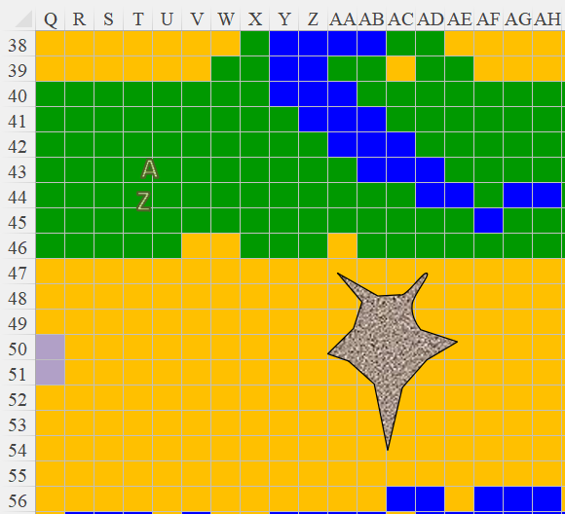

About half-way across the portion to the west of the veneer, as he approached the illusory wizard with the pointy cap casting some evocation over and over, he spotted her coming around from behind the building to his northeast as she explored the northern coastline. She’d meant to cover the entirety of it, then go south and scan the southern portion on her way back, but here was her friend now, flying towards her.

The dwarf and wereserpent saw Tore slow down about 300’ from them, and they picked up the pace in case trouble was again ensuing.

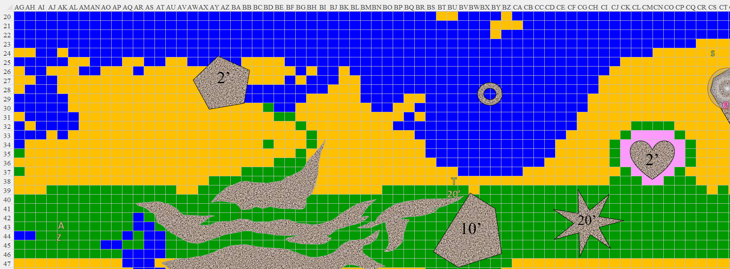

Tore reached Saradette, and cast a *cure moderate wounds* spell on her, then suggested they fly back to meet up with the others before deciding their next move.

*Saradette gained 5 + 10 = 15 hps [28/53].*

Round 56

As they turned back westward, they saw Akilesh and Zvetlana walking towards them. Able to communicate at shouting volume, they exchanged salutations and confirmation that all was well. The dwarf and wereserpent had drunk enough potions to get back to top health, and made their way over to the northern coast.

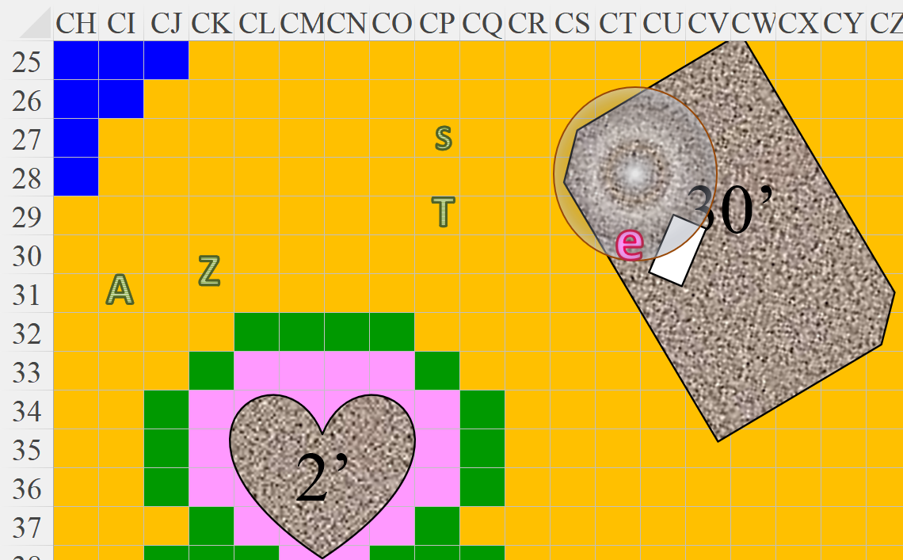

Once they were all back together, Tore asked, “Shall we attempt to return to our plane, or do you want to investigate more of this one?”

Akilesh voted, “We press on! Come on, lad and lasses!”

Zvetlana asked, “What do you opine, artificer?” Her boa-staff remained shouldered as she held her loaded crossbow in her dominant hand.

Saradette listened as the others spoke and then she sighed. “We haven’t been taken back, so there is more to do. I have been weakened, and evidently the pool doesn’t heal me. So, I won’t be as useful in the next fight. However, I don’t think we have a choice but to stay and keep exploring.”

Akilesh held his heavy crossbow in both hands, and spotted a shaedling about 1000’ buzzing about. He pointed it out, and Saradette said, “Yes, I believe it’s one that I saw earlier. There’re likely more of them past the veneer.”

“What’s the mission objective again? Kill everything?” asked Akilesh.

“So far, we know this is the breeding ground for some Abyssal being, and from the evidence before us,” Saradette surmised. “We’re looking at Lolth rustling behind curtain number 1.”

“The veneer?” Akilesh’s Common was not as fluent as that of the others.

“No, a figurative curtain,” Zvetlana explained.

They decided on continuing their investigation.

Tore looked at Saradette, “It is possible that there are platforms out there with healing powers. The one larger concern I have is the inability to replenish our supplies of potions. I will attempt to refrain from spell casting to save my healing abilities as we advance.”

He then looked at all the others and asked, “Do any of you require any additional healing before we go back through the dark curtain?”

“No, we’re cool,” Zvetlana said as they made their way over.

The shaedling they’d spotted buzzed behind the veneer until they got within a few hundred feet of it, then it darted away southeastward.

Coming up on the penetrable wall of shadowstuff, the party discussed further contingencies for proceeding.

Tore looked around, “Can any of you create food? I can *create water* and *purify food and drink*. My concern is we may have to hunt of fish at some point.”

The wereserpent happened to have one spell to create food, but said, “I don’t think we’ll need it here.”

“I’m still weakened from a spell,” Saradette said. “I don’t think we can wait for it to dissipate, though.”

Then she realized that all spell effects, drains and buffs alike, had been reset, as had their spell slots. Saradette paused and looked down at herself. “No, wait. I feel more normal, now. I think I’m fine, so we can go ahead.”

They proceeded eastward, warily stepping through the veneer as they had before, and seeing once again the Lolth-worshipping fey to their east buzzing southward.

And then there was the tree that hadn’t been there before, but had placed itself in a predatory position, and was now coming towards them, making its way between the mundane birch tree and the chasm to its immediate north. It began its signature *despair song*, allowing Saradette and Zvetlana to identify it as a night twist.

|  |  |  |  |  |
| --- | --- | --- | --- | --- |
| **Character** | **Save vs.**  *despair song* | **Ranks** | **Roll** | **Result** |
| Akilesh | Will | 5 | 15 | 20 |
| Zvetlana | Will | 8 | 1 | 9 |

*Fail, fail.*

|  |  |  |  |  |  |  |
| --- | --- | --- | --- | --- | --- | --- |
| **Save vs.**  *despair song* | **Rank** | **Ability & Mod.** | **Misc. Mods.** | **Total** | **Roll** | **Check** |
| **Saradette, Will** | **4** | **Wis (+1)** | 0 | 5 | 14 | 19 |
| **Tore, Will** | **6** | **Wis (+3)** | 0 | 9 | 12 | 21 |

*Fail, fail.*

*All heroes suffer –2 to attacks, saves, checks, and weapon damage.*

All four heroes felt a sensation unlike terror, but with the very similar aftertaste of despair and wondering what motive they had left for living.

Zvetlana named the creature aloud, and added, “This is no assassin vine. We *must* put it down!”

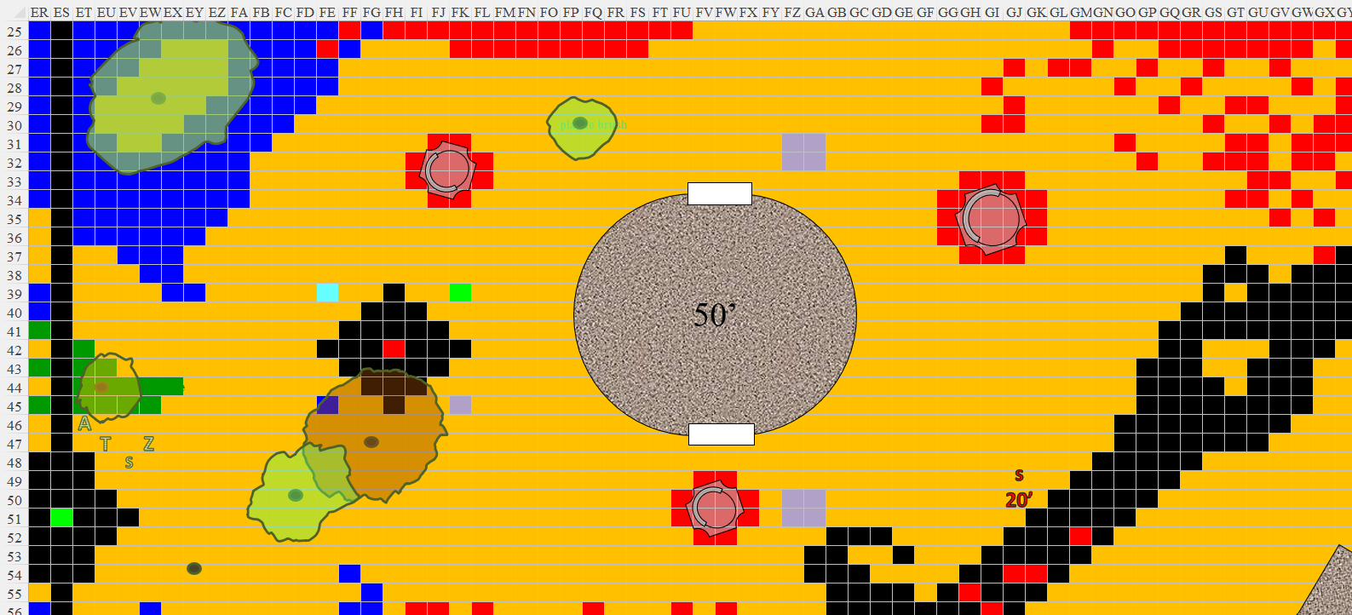

Round 69

|  |  |  |  |  |  |
| --- | --- | --- | --- | --- | --- |
| **Character** | **Group** | **Initiative** | **Roll** | **Modified Roll** | **Speed** |
| Zvetlana | 1 | 4 | 14 | 18 | 30’ |
| Akilesh | 1 | 2 | 16 | 18 | 30’ |
| Tore | 1 | 2 | 8 | 10 | 30’ |
| Saradette | 1 | 3 | 2 | 5 | 20’ |
| Night Twist | 1 | -2 | 4 | 2 | 10’ |

Zvetlana and Akilesh pointed at the incoming tree with tentacle-like roots, and fired.

|  |  |  |  |  |  |  |  |  |
| --- | --- | --- | --- | --- | --- | --- | --- | --- |
| **Character** | **Attack Type** | **Damage** | **BAB** | **Dex Mod+** | **W+** | **Total Score** | **Roll** | **Total** |
| Akilesh | Heavy Crossbow +1 | 1d10+1 | 3 | 2 | 1 | 6 | 1 | 7 |
| Zvetlana | Light Crossbow +2 | 1d8+2 | 4 | 4 | 2 | 10 | 3 | 13 |

*Miss, miss.*

Feeling despair crushing his will, Tore drew his longsword and activated his Barricade Buckler as he walked forward, placing himself between the enemy and his friends.

Zvetlana reloaded her crossbow as Akilesh spread out in anticipation of an area-of-effect spell.

The night twist approached the stalwart and bold cleric of Lurue to test its mettle. It didn’t quite reach him, but the tips of its roots soon would.

For all the good it would do, Saradette shot the night twist with her sonic blaster.

|  |  |  |  |
| --- | --- | --- | --- |
| **Ranged Weapon** | **Dmg.** | **Rng.** | **Notes** |
| Horizikaul’s Boom | 2d4 Sonic | 25’ + 2½’/lvl | Will DC 14 or deafened for 1d4 rounds |

*Dmg: 5 sonic.*

|  |  |  |  |  |
| --- | --- | --- | --- | --- |
| **Character** | **Save vs.**  **H-Boom** | **Ranks** | **Roll** | **Result** |
| Night Twist | Will | 14 | 19 | 33 |

*Success. Deafening effect negated, and probably inapplicable.*

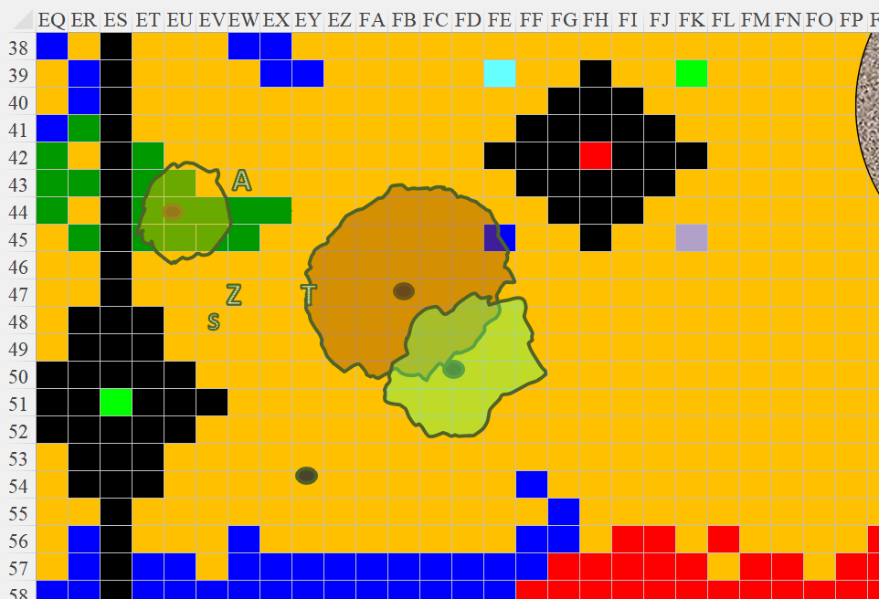

Round 70

Zvetlana fired again upon the hideous tree.

|  |  |  |  |  |  |  |  |  |
| --- | --- | --- | --- | --- | --- | --- | --- | --- |
| **Character** | **Attack Type** | **Damage** | **BAB** | **Dex Mod+** | **W+** | **Total Score** | **Roll** | **Total** |
| Zvetlana | Light Crossbow +2 | 1d8+2 | 4 | 4 | 2 | 10 | 2 | 12 |

*Miss.*

The bolt stuck into the outer layer of the plant’s natural bark armor.

Akilesh reloaded his crossbow and blurted out Dwarven obscenities at the night twist. << Fhahrg-hae khumthrosh! >> and so on.

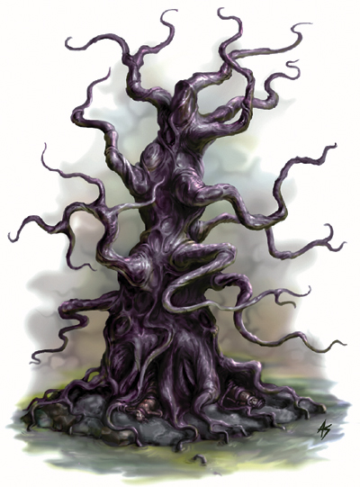

The plant cast *entangle*, a more powerful version of the spell the assassin vine had manifested.

|  |  |  |  |  |  |  |
| --- | --- | --- | --- | --- | --- | --- |
| **Save vs.**  *entangle* | **Rank** | **Ability & Mod.** | **Misc. Mods.** | **Total** | **Roll** | **Check** |
| **Saradette, Reflex** | **8** | **Dex (+3)** | 2 | 13 | 5 | 18 |
| **Tore, Reflex** | **3** | **Dex (+2)** | 0 | 5 | 12 | 17 |

*Success, success.*

|  |  |  |  |  |
| --- | --- | --- | --- | --- |
| **Character** | **Check** | **Ranks** | **Roll** | **Result** |
| Akilesh | Reflex | 2 | 5 | 7 |
| Zvetlana | Reflex | 3 | 16 | 19 |

*Fail, success.*

Zvetlana continued to reload her crossbow while doing her best to get out of the *entangled* area. Akilesh was snugly caught in a clump of vines.

Saradette switched to her gauntlet and zapped the night twist.

|  |  |  |  |
| --- | --- | --- | --- |
| **Ranged Weapon** | **Dmg.** | **Rng.** | **Notes** |
| Glove of Lightning Bolt | 5d6 Electric | 120’ | Ref DC 16 for ½; melts most metals |

*Dmg: 20 electric.*

|  |  |  |  |  |
| --- | --- | --- | --- | --- |
| **Character** | **Save vs.**  *lightning* | **Ranks** | **Roll** | **Result** |
| Night Twist | Reflex | 8 | 11 | 19 |

*Success. Saved for ½ damage = 10 electric.*

Tore sliced away at the night twist, leaving two slashes in the tree’s bark.

|  |  |  |  |  |  |  |  |  |  |
| --- | --- | --- | --- | --- | --- | --- | --- | --- | --- |
| **Melee Weapon** | **Dmg** | **D+** | **TH+** | **Critical** | **Type** | **Wt.** | **Atk** | **Roll** | **Check** |
| Longsword of Frost | 1d8+1 | +1+1d6 Cold | 1 | 19-20/x2 | Slashing | 8.0 | +11 | ** | ** |
| Longsword, 2nd Attack | 1d8+1 | +1+1d6 Cold | 1 | 19-20/x2 | Slashing | - | +6 | ** | ** |

*Hit, hit. Dmg: (3 + 1 + 1 + 6 cold) + (5 + 1 + 1 + 1 cold) = 5 + 7 + 7 cold = 19.*

Round 71

The tree responded to the slashing by unleashing a *phantasmal killer* spell upon Tore.

|  |  |  |  |  |  |  |
| --- | --- | --- | --- | --- | --- | --- |
| **Save vs.**  *phantasmal killer* | **Rank** | **Ability & Mod.** | **Misc. Mods.** | **Total** | **Roll** | **Check** |
| **Tore, Will** | **6** | **Wis (+3)** | 0 | 9 | 20 | 29 |

*Success. Effect negated.*

Tore looked past the apparition, and steeled his resolve as the figment came at him and slashed uneventfully.

Saradette switched repeated her zap against the night twist.

|  |  |  |  |
| --- | --- | --- | --- |
| **Ranged Weapon** | **Dmg.** | **Rng.** | **Notes** |
| Glove of Lightning Bolt | 5d6 Electric | 120’ | Ref DC 16 for ½; melts most metals |

*Dmg: 16 electric.*

|  |  |  |  |  |
| --- | --- | --- | --- | --- |
| **Character** | **Save vs.**  *lightning* | **Ranks** | **Roll** | **Result** |
| Night Twist | Reflex | 8 | 6 | 14 |

*Fail.*

Akilesh quick-cast *dispel magic*, targeting the *entangle* spell.

*Automatic success.*

With the vines around them now disintegrating, Akilesh and Zvetlana shot once more, then shouldered their crossbows.

|  |  |  |  |  |  |  |  |  |
| --- | --- | --- | --- | --- | --- | --- | --- | --- |
| **Character** | **Attack Type** | **Damage** | **BAB** | **Dex Mod+** | **W+** | **Total Score** | **Roll** | **Total** |
| Akilesh | Heavy Crossbow +1 | 1d10+1 | 3 | 2 | 1 | 6 | 11 | 17 |
| Zvetlana | Light Crossbow +2 | 1d8+2 | 4 | 4 | 2 | 10 | 16 | 26 |

*Miss, miss.*

Round 72

The tree tried to slay Akilesh with the same spell as before: *phantasmal killer*.

|  |  |  |  |  |
| --- | --- | --- | --- | --- |
| **Character** | **Check** | **Ranks** | **Roll** | **Result** |
| Akilesh | Will | 3 | 18 | 21 |

*Success. Effect negated.*

“It’s time for the big guns,” the dwarf then said before anyone moved further in. Drawing his spiked club, Akilesh charge-attacked the tree.

|  |  |  |  |  |  |  |  |  |  |
| --- | --- | --- | --- | --- | --- | --- | --- | --- | --- |
| **Character** | **Attack Type** | **Damage** | **BAB** | **Str Mod+** | **W+** | **Other+** | **Total Score** | **Roll** | **Total** |
| Akilesh | Spiked Club +1 | 1d8+1+3 | 3 | 3 | 1 | 2 charge | 9 | 14 | 23 |

*Miss.*

“Its bark is too thick!” warned Akilesh.

Zvetlana saw what she could do with her python staff.

|  |  |  |  |  |  |  |  |
| --- | --- | --- | --- | --- | --- | --- | --- |
| **Character** | **Attack Type** | **Damage** | **BAB** | **Str Mod+** | **Total Score** | **Roll** | **Total** |
| Zvetlana | Python Staff | 1d6+2+2 | 4 | 1 | 5 | 9 | 14 |

*Miss.*

Saradette zapped the night twist yet again.

|  |  |  |  |
| --- | --- | --- | --- |
| **Ranged Weapon** | **Dmg.** | **Rng.** | **Notes** |
| Glove of Lightning Bolt | 5d6 Electric | 120’ | Ref DC 16 for ½; melts most metals |

*Dmg: 16 electric.*

|  |  |  |  |  |
| --- | --- | --- | --- | --- |
| **Character** | **Save vs.**  *lightning bolt* | **Ranks** | **Roll** | **Result** |
| Night Twist | Reflex | 8 | 16 | 24 |

*Fail.*

Tore continued to hack away at the tree, slicing at its trunk. He didn’t want to expend any spells until they could confirm other sources of healing on this plane or pocket dimension.

|  |  |  |  |  |  |  |  |  |  |
| --- | --- | --- | --- | --- | --- | --- | --- | --- | --- |
| **Melee Weapon** | **Dmg** | **D+** | **TH+** | **Critical** | **Type** | **Wt.** | **Atk** | **Roll** | **Check** |
| Longsword of Frost | 1d8+1 | +1+1d6 Cold | 1 | 19-20/x2 | Slashing | 8.0 | +11 | 6 | 17 |
| Longsword, 2nd Attack | 1d8+1 | +1+1d6 Cold | 1 | 19-20/x2 | Slashing | - | +6 | 16 | 22 |

*Miss, hit. Dmg: 4 + 1 + 1 + 6 cold = 6 + 6 cold = 12.*

“At this rate, we’ll never take this thing down,” Akilesh proclaimed.

“We should pull back and consider a better plan,” the wereserpent added.

Round 73

Tore nodded, “Yes, we should fall back.” He then took a 5’ step, then slashed at the night twist once more before moving away from the tree 25’ until he was right up against the chasm that housed the veneer dissecting this pocket plane like a cell in mitosis.

|  |  |  |  |  |  |  |  |  |  |
| --- | --- | --- | --- | --- | --- | --- | --- | --- | --- |
| **Melee Weapon** | **Dmg** | **D+** | **TH+** | **Critical** | **Type** | **Wt.** | **Atk** | **Roll** | **Check** |
| Longsword of Frost | 1d8+1 | +1+1d6 Cold | 1 | 19-20/x2 | Slashing | 8.0 | +13 | 13 | 26 |

*Hit. Dmg: 4 + 1 + 1 + 5 cold = 11.*

Taking note of his remaining spells, he calculated his next steps.

|  |  |  |  |  |
| --- | --- | --- | --- | --- |
| **Spell** | **Level** | **Heal?** | **DC** | **Cast?** |
| Detect Magic | 0 | 0 | 13 | q |
| Detect Magic | 0 | 0 | 13 | q |
| Light | 0 | 0 | 13 | q |
| Message | 0 | 0 | 13 | q |
| Purify Food and Drink | 0 | 0 | 13 | q |
| Divine Favor | 1 | 0 | 14 | q |
| Nimbus of Light | 1 | 0 | 14 | q |
| Sanctuary | 1 | 0 | 14 | þ |
| Shield of Faith | 1 | 0 | 14 | q |
| **Calm Animals** | 1 | 0 | 14 | q |
| Ayailla’s Radiant Burst | 2 | 0 | 15 | þ |
| Luminous Armor | 2 | 0 | 15 | q |
| Summon Monster II | 2 | 0 | 15 | þ |
| **Hold Animal** | 2 | 0 | 15 | q |

“My best plan is to cut this thing down a twig at a time,” Saradette snapped as she zapped the tree creature once again, noting that the electric shocks were doing the most damage to the vile tree.

|  |  |  |  |
| --- | --- | --- | --- |
| **Ranged Weapon** | **Dmg.** | **Rng.** | **Notes** |
| Glove of *Lightning Bolt* | 5d6 Electric | 120’ | Ref DC 16 for ½; melts most metals |

*Dmg: 28 electric.*

|  |  |  |  |  |
| --- | --- | --- | --- | --- |
| **Character** | **Save vs.**  *lightning bolt* | **Ranks** | **Roll** | **Result** |
| Night Twist | Reflex | 8 | 2 | 10 |

*Fail. Full damage taken {90ish/200ish}.*

Flinching from that last zap, the tree backed away, hissing. To the north, the bloodfire ooze had emerged again from the lava, and was contemplating rushing in to flank the heroes, but seeing the tree stung with agony and fleeing, it took a few slithers back and sunk into the liquid minerals with little fuss.

“This isn’t over,” Zvetlana pointed out the bloodfire ooze as it continued to watch them, now floating above a sea of glowing red and noting that the night twist wasn’t fleeing as fast as it likely could. “We are keeping these monsters at bay... for now... but if there are more challenges ahead, we should vanquish these foes first, or we might find ourselves wedged between two unstoppable forces.”

Round 74

Tore looked at the night twist and the bloodfire ooze. He agreed with Zvetlana, “I say that we finish off the night twist.” He then cast *divine favor [expired on Round 84]* as he sheathed his sword and grabbed his bow.

*Tore gained +2 to attack and weapon damage.*

Akilesh and Zvetlana also changed their minds about rushing into melee combat, particularly now that the tree was moving away from them, so they shouldered their spiked club and python staff, and also drew their crossbows once again.

Saradette had nothing to lose by zapping the tree again, so she did.

|  |  |  |  |
| --- | --- | --- | --- |
| **Ranged Weapon** | **Dmg.** | **Rng.** | **Notes** |
| Glove of Lightning Bolt | 5d6 Electric | 120’ | Ref DC 16 for ½; melts most metals |

*19 electric.*

|  |  |  |  |  |
| --- | --- | --- | --- | --- |
| **Character** | **Save vs.**  *lightning bolt* | **Ranks** | **Roll** | **Result** |
| Night Twist | Reflex | 8 | 4 | 12 |

*Fail. Full damage taken.*

The bloodfire ooze retreated fully into the magma, noting that this quartet of intruders had too much mojo for it to handle all alone.

The tree fled even faster now. Stepping onto a 10’ x 10’ periwinkle platform, it began to burn up with positive energy as if it were being struck by a *flame strike* spell.

*Dmg: 26 good.*

“Nice!” one of them said as the tree did its best to step over the platform with the rest of its roots.

“Odd that holy power works in such a vile pocket plane,” observed the favored soul of Leira, scratching his dwarven chin.

Round 75

Saradette moved back toward the barrier, and zapped the night twist again. “Keep after it, we need to kill it.”

The zap traveled 120’, then disappeared before it could reach the tree.

Tore agreed with Akilesh; it did seem odd that there were sources of good on this plane.

He activated his armor’s wings, and flew towards the night twist. He then fired off an arrow at the night twist just before the latter jumped down into an abyss to the east.

|  |  |  |  |  |  |  |  |  |  |
| --- | --- | --- | --- | --- | --- | --- | --- | --- | --- |
| **Ranged Weapon** | **Dmg.** | **D+** | **TH+** | **Critical** | **Rng.** | **Wt.** | **Atk** | **Roll** | **Check** |
| Longbow +1 | 1d8 | 1 | 1 – 2 range | x3 | 100’ | 3.0 | +12 | 19 | 31 |

*Threat. 1d20 = 1, not a critical hit.*

*Dmg: 7 + 1 = 8.*

The tree disappeared into the rift in the ground.

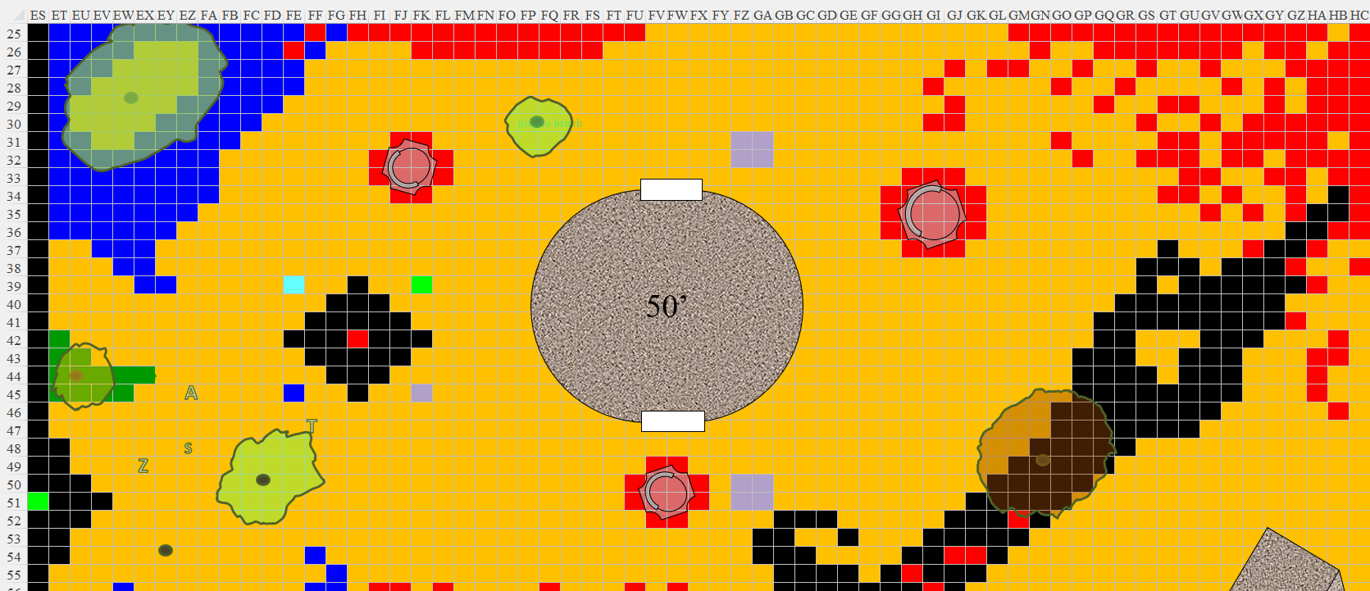

Round 76

Tore flew eastward and landed near the platform that had harmed the night twist. He glanced towards the ravine and then stepped onto the platform. He was hoping that his hunch was right.

*Tore gained 3 hps [74/79].*

GA49

Saradette tried to lift up with her ring of flying, and reached an altitude of 60’.

Akilesh and Zvetlana looked at the bloodfire ooze, which finally gave up and began swimming northward into the hotter lava.

