*Chapter 43: The Horseshoe’s Bend*

Round 77

Tore waved to the others to come to his location. He knew it would take them a little while to cover the distance, so he flew up again, this time trying to get enough altitude to see down into the ravine.

Akilesh and Zvetlana jogged towards the chasm as Tore reached it and looked down to see the night twist falling at near-terminal velocity towards a pitch-black background. It was already too far away for him to effectively attack it.

To Tore’s south and southeast were two buildings with plain façades with what appeared to be a mundane tree between them. South of that, Tore had a partial line of sight to another series of platforms of the same colors they’d already seen.

Round 78

Tore flew back towards the platform before his activation of the wings expired. He landed and waited on the platform for the others to join up with him; Akilesh and Zvetlana were already past him and going to where he’d previously indicated. They would need to cross the chasm, which meant tore carrying two of them across, or they would have to look for another way across.

*Tore gained 3 hps [77/79].*

To the far west, Saradette was hovering at an altitude of 60’, and surveying all around her, though the thick fog to the immediate south impeded any further sight in that direction.

Saradette flew to where Tore waited. “I don’t think I can carry them.”

Tore nodded, “We may have to find another way around. Let’s go talk to the others.”

When they reached the other two, Tore asked, “Do either of you have a way across?” He then asks Saradette, “How many uses does that ring have?”

Round 79

When Saradette had still been 60’ up in the air, and about 100’ east of Tore, she’d surveyed the area to the west of the veneer, and now noted a 5’ gap to the northwest to Tore, who was already thinking of how two flying folks could usher two landborne folks across.

The dwarf and wereserpent turned there, and the former said, “Shouldn’t be too much of a challenge.”

Tore nodded, “Very well, what is your plan? Saradette and I can obviously fly across, what method do you intend to use?” He was curious as he did not know all of the equipment or spells that the dwarf and wereserpent possessed.

Akilesh pointed to the 5’ gap to the northeast and reiterated his and Zvetlana’s intention to hop across.

They then spotted the selfsame vampire that Tore had vanquished minutes ago. “The turning has expired,” the cleric said as he saw the undead drow studying them from atop the taller building to their southeast. She was no match for them together, but if she got them to split up....

Her name was Slitsevere, and she ducked back and out of view once she caught the heroes’ gaze.

Round 80

Saradette fidgeted with the eyeglasses she’d recently liberated from the Shaedlord after they’d slain him, and thought to give chase, but that was perhaps what the vampire was hoping for.

Zvetlana allowed her beckoning staff to return to its python state, and the reptile wrapped itself around the woman’s torso.

Tore nodded, “Very well. Let’s get across, but keep an eye on our friend up there.”

Round 81

Akilesh and Zvetlana made their way over to the jump-off point, and got ready to hop across the chasm amidst fuming pits of magma and other tectonic fluids.

Keeping his Holy Symbol in his buckler-shield hand, ready to hold it out and chase off the undead vermin, Tore put out his hand, “May I have a look?”

Handing the spectacles to Tore, they both look the specs over, further appraising the artifact.

Tore said with certainty, “These *are* Lenses of Revelation! They will reveal evil outsiders and undead when you activate them. I am looking for these, and other items, as together, they make up the ‘Vestments of Virtue’. I already possess the ‘Ephod of Authority’.” Tore pointed to the silver vestment is set with a circle of nine semi-precious gemstones surrounding a raised, silver hemisphere that he was wearing. “If you have no objections, I would like to keep these.” He held them back out to Saradette in case she had an objection to him claiming them.

Round 82

“Keep them,” Saradette said. “Maybe we will find more of the set items as we go.”

Akilesh and Zvetlana took turns hopping across the chasm, finding no challenge in it, but soon thereafter spotting an incoming bloodfire ooze to their north.

They took the opportunity to distance themselves from the ooze while they had the chance, and it raised a few pseudopods, laying them down on the sandy shore as it contemplated lunging forward.

Once Akilesh and Zvetlana were safely across, Tore activated his wings and flew across. He then flew towards the vampire, holding out his holy symbol, and chanting, “Be gone vile beast! By the power of Lurue a banish you from my presence!”

|  |  |  |
| --- | --- | --- |
| *Turning Undead* | |  |
|  | **Max HD Turned** | 9 |
|  | **1d20 Roll** | 7 |
|  | **Turn Check** | 18 |
|  | **2d6 Roll** | 3 |
|  | **Turn Dmg.** | 18 |
|  | **Turns/Day** | 12 |
|  | **Turns Used** | 2 |

The vampire was repelled, and darted away southward. He would not pursue her, but made sure she didn’t try to fly towards Akilesh, Zvetlana or Saradette, keeping himself between them and the vampire or fly along to intercept her.

Round 83

Slitsevere continued to fly on bat-like wings until she disappeared into the fog.

The wereserpent and dwarf made their way to the mundane birch tree between the two buildings. Tore—still hovering atop one—looked to Saradette, who used her ring of flying to join Tore.

Tore and Saradette both spotted a well-placed wooden chest against a wooden ledge of similar grain and color, and in a place like this, thought, “Mimic?”

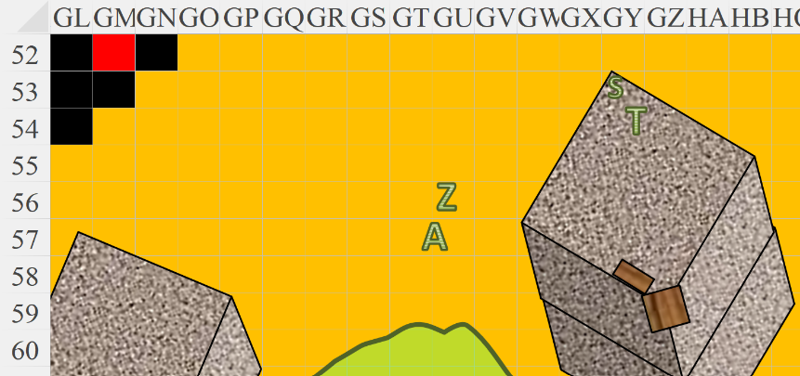

Rounds 84 – 85

When the vampire flew through the mist, Tore flew down to meet with the others, as did Saradette.

Zvetlana asked, “What could you see from up there?”

Tore turned to the others, “Should we attempt to pursue the vampire into the mists or do any of you have a preference for our next move?”

“I’d like to check these buildings first,” Saradette replied. “There’s no telling if they’re significant or not.”



Round 86

“Is there a specific one that you’d like to check out first? One of the gray ones or the multi-colored one?”

Round 87

Tore nodded, “Very well, where do you want to start?”

The gnome looked around for a moment. “Let’s see what’s in one of the gray ones.”

She still couldn’t see any doors or windows on the façades facing her.

Round 88

Zvetlana went southward, passing the birch tree, and also noted no openings to any inside. “Could they be solid inside?”

Akilesh knocked on the stone structure to determine if there was any hollowness within. His dwarven ability to do this was lost on the others, and he nodded his head, saying, “Yeah, I don’t think it’s hollow.”

Round 89

After Akilesh confirmed the monoliths were not hollow, Tore pointed at the structure just to the south. “Why don’t we try that structure there? Perhaps we can find a door of investigate what the different colored platforms do.” They already knew what the **periwinkle** ones did, but the others, Tore had completely forgotten about in the last five to ten minutes.

Zvetlana inadvertently stepped on a hidden pressure plate, and the building to the east began to sink, like a stone weight pushing something down.

As the platform sank, Tore looked around to see if anything else in their surroundings was changing as well, and noted no such motion.

Round 90

The building finished sinking, and was now simply a 5’ platform with a perfectly smooth top.

Once the building had stopped moving, Tore walked over to Zvetlana and tried to examine the pressure plate. As he approached, he said, “Zvetlana, stay still. Let us examine the plate and make sure it is safe.” Tore, not truly sure what to look for, motioned for Saradette to join him. His boot swiped a bit of sand away gently for him to be able to see the entire plate.

Saradette flew over and landed lightly next to Tore, then bent to examine the plate without touching anything. Akilesh caught up with the others, and noted the complete bend in the land that they could traverse. They’d been heading east until now, when they turned south, and now they were facing another bend that would force them to head back towards the west. “I fear we’re about to walk in a full circle and end up nowhere.”

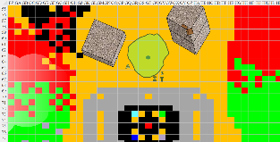

Round 91

Bubbles began to emerge from the eastern and western edges of the land that met a calm body of lava swirling against a calmer body of acid. The bubbles now agitated the calm coastline, spewing both lava and acid onto the sandstone ground. Akilesh, an astute dwarf, noted that the bubbles’ size and number increased at the latitude of the building that had just sunk. He deduced, “The building is a weight that just released or injected something into the lava *and* the acid.” Lava began to overflow around the chasm to the northwest.

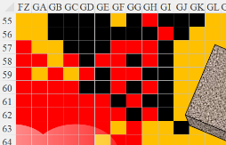

Zvetlana took on the semblance of a wereserpent, and her staff returned to its python form, wrapping itself around her torso. She stated, “This may be the moment to consider a brisk retreat to our lifeboats.”

Round 92

“I’m not so sure that reaching the boats will get us to *shift* back to Arborea,” Akilesh argued as he approached the metallic floor that separated the chasm and platforms from the sandy plate that was beginning to appear horseshoe shaped as they explored it further.

Saradette then spotted what looked slightly like a bloodfire ooze, though it swirled with acid in a roughly equal proportion to its magma composition. The red-and-green swirls mesmerized those who gazed upon it as it emerged from the lava that now comingled with the bubbly acid compound.

A second creature emerged from the western shore, also along the border between the acid and lava. Akilesh pointed it out as they prepared for more conflict resolution.

~*~

A minute had passed, and the Turning effect that had caused Slitsevere to flee Tore subsided. He could likely do this a handful of times before the next reset. (Little did she know just how many daily Turnings the cleric could muster!) The undead wretched one last time in the mists as the thought of the cleric no longer caused her nausea, and she returned to her usual, hateful self. The living beings to her north had vanquished The Contemplator, causing Xhiru to abandon Slitsevere like a mangy mutt to be sicked on mangier mutts. Now the vampire was alone, contemplating her options in the full light of the mist around her under a starless sky. She nodded to herself, hearing the intruders to the north, and turning to fly westward.

~*~

Round 93

Tore looked from one bloodfire ooze to the other, deciding it was time to get moving. “Quickly,” Tore said and pointed to the south, “Get up on the platform and we can fend them off from there.” How Tore wished he had a weapon that could shoot cold rays, not just his frost-capable sword.

“Right behind you,” Saradette said as she followed Tore to the multicolored platform.

Akilesh and Zvetlana deferred to the more cohesive duo as they all made their way towards the multihued platforms.

“I suggest we each take a corner,” Tore said. “I will take the one to the back on the right.” He then headed towards the green, acidic platform. He approached from an angle, making two 5; jumps to the platform.

*Automatic successes. Dmg: 7 acid [70/79].*

Zvetlana opted to avoid the acidic platform, going to the periwinkle platform, while Akilesh took the route across the southwestern route, walking over the blue healing portal and topping off and felt a surge of good-aligned damage course around his pure soul. The night twist that had stepped on it had suffered severe burns, but to Tore, it just lifted the bottom of his robes a bit as he blushed and smiled in a sexy way.

*Automatic successes.*

Then the bloodfire/acid oozes—if that was what they were—lifted themselves from the roiling liquids that nurtured them, and approached the heroes.

Saradette stepped onto the cyan platform, and felt nothing.

*Automatic successes (Jump & Balance).*

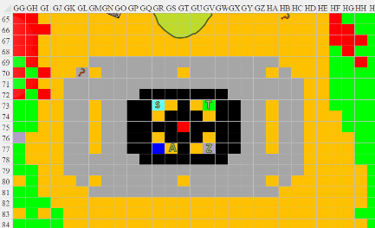

Round 94

The anomalous ooze monsters approached; the one nearest Saradette seemed squeamish about hopping across the chasm to reach her. It would likely develop a specialized limb like the bloodfire ooze had earlier. As Saradette prepared to meet its mettle, she noted a humanoid face forming across the blob’s torso.

Zvetlana’s python hugged her mistress as her mistress drew her crossbow and fired at the ooze to her north-northeast.

|  |  |  |  |  |  |  |  |  |
| --- | --- | --- | --- | --- | --- | --- | --- | --- |
| **Character** | **Attack Type** | **Damage** | **BAB** | **Dex Mod+** | **W+** | **Total Score** | **Roll** | **Total** |
| Zvetlana | Light Crossbow +2 | 1d8+2 | 4 | 4 | 2 | 10 | 3 | 13 |

*Miss.*

Akilesh took on the one to his north-northwest.

|  |  |  |  |  |  |  |  |  |
| --- | --- | --- | --- | --- | --- | --- | --- | --- |
| **Character** | **Attack Type** | **Damage** | **BAB** | **Dex Mod+** | **W+** | **Total Score** | **Roll** | **Total** |
| Akilesh | Heavy Crossbow +1 | 1d10+1 | 3 | 2 | 1 | 6 | 14 | 20 |

*Hit. Dmg: 2 + 1 = 3.*

Saradette cast *mage armor [expired in 5 hours]* on herself.

*Saradette gained +4 to FFAC and AC.*

*Next round resolves the blaster.*

After taking some damage, Tore stepped off the platform, then cast *nimbus of light [expired on Round 174]* on himself.

*Tore gained a 30’ light radius (and dim light for an additional 30’).*

Tore then called to Akilesh, “Step on the platform and let’s see if activating all four does anything.” Tore stepped back onto the acidic platform again when Akilesh stepped onto the one in his corner.

*Dmg: 6 acid [64/79].*

Round 95

Zvetlana and Akilesh kept quiet regarding the red platform out of politeness, and also it wasn’t a good time to debate, what with the oozes coming and all.

|  |  |  |  |  |  |  |  |  |
| --- | --- | --- | --- | --- | --- | --- | --- | --- |
| **Character** | **Attack Type** | **Damage** | **BAB** | **Dex Mod+** | **W+** | **Total Score** | **Roll** | **Total** |
| Akilesh | Heavy Crossbow +1 | 1d10+1 | 3 | 2 | 1 | 6 | 18 | 24 |
| Zvetlana | Light Crossbow +2 | 1d8+2 | 4 | 4 | 2 | 10 | 3 | 13 |

*Hit, miss. Dmg: 6 + 1 = 7.*

Saradette zapped the ooze with her sonic blaster.

|  |  |  |  |
| --- | --- | --- | --- |
| **Ranged Weapon** | **Dmg.** | **Rng.** | **Notes** |
| Horizikaul’s Boom | 2d4 Sonic | 25’ + 2½’/lvl | Will DC 14 or deafened for 1d4 rounds |

*Dmg: 5 sonic.*

|  |  |  |  |  |
| --- | --- | --- | --- | --- |
| **Character** | **Save vs.**  *Horizikaul’s Boom* | **Ranks** | **Roll** | **Result** |
| Oozes | Will | 4 | 15 | 19 |

*Success. Deafening effect negated.*

The oozes lunged with a leap towards Saradette and Tore, and latched onto them with tenacity.

|  |  |  |  |  |  |  |  |  |
| --- | --- | --- | --- | --- | --- | --- | --- | --- |
| **Character** | **Attack Type** | **Damage** | **BAB** | **Str Mod+** | **Other+** | **Total Score** | **Roll** | **Total** |
| Composite Ooze | Touch Attack | 2d8+14 | 8 | 4 | Charge +2 | 14 | 19 | 33 |
| Composite Ooze | Touch Attack | 2d8+14 | 8 | 4 | Charge +2 | 14 | 9 | 23 |

*Hit, hit.*

*Dmg to Saradette: 8 acid + 3 fire = 11 [42/53].*

*Dmg to Tore: 7 acid + 8 fire = 15 [49/79].*

|  |  |  |  |  |  |  |  |  |  |  |  |  |
| --- | --- | --- | --- | --- | --- | --- | --- | --- | --- | --- | --- | --- |
| **Character** | | **Attack Type** | | **BAB** | | **Str**  **Mod+** | | **Total**  **Score** | **Roll** | | **Total** | |
| Composite Ooze | | Grapple vs. Saradette | | 8 | | 4 | | 12 | 2 | | 14 | |
| Composite Ooze | | Grapple vs. Tore | | 8 | | 4 | | 12 | 14 | | 26 | |
| **Melee Weapon** | **Dmg** | | **D+** | **TH+** | **Critical** | | **Type** | **Wt.** | **Atk** | **Roll** | | **Check** |
| Saradette, Grapple | 1d3 | | -1 | -3 | x2 | | Bludgeon | 0.0 | 2 | 17 | | 19 |
| Tore, Grapple | 1d3 | | +1 | 0 | x2 | | Bludgeon | 0.0 | +12 | 14 | | 26 |

*Both grapples failed.*

Tore stepped away from the ooze then leapt over to Zvetlana’s platform. He stood on the edge and turned to face the ooze, activating his barricade buckler shield.

Round 96

“Ow! Bitch!” Saradette lifted straight up to get out of the ooze’s jump range and fired her blaster at her assailant.

|  |  |  |  |
| --- | --- | --- | --- |
| **Ranged Weapon** | **Dmg.** | **Rng.** | **Notes** |
| Horizikaul’s Boom | 2d4 Sonic | 25’ + 2½’/lvl | Will DC 14 or deafened for 1d4 rounds |

*Dmg: 5 sonic.*

Akilesh reloaded his crossbow and urged the others to follow him off the platforms. Zvetlana did the same, then hopped off the platform with a line of attack to the easternmost foe, and fired.

|  |  |  |  |  |  |  |  |  |
| --- | --- | --- | --- | --- | --- | --- | --- | --- |
| **Character** | **Attack Type** | **Damage** | **BAB** | **Dex**  **Mod+** | **W+** | **Total**  **Score** | **Roll** | **Total** |
| Zvetlana | Light Crossbow +2 | 1d8+2 | 4 | 4 | 2 | 10 | 10 | 20 |

*Hit. Dmg: 6 + 2 = 8.*

The oozes turned to one another, then lunged at each other, coalescing into a single blob of swirling green and red, bordered by black, lightning-shaped patterns. It shaped itself so as to not spill into the chasm below, and hissed at Tore as it prepared to gobble him up.

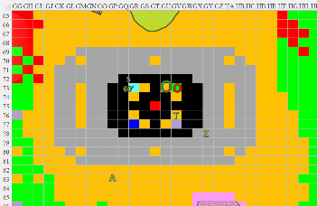

Round 97

“Tore, you need to move,” Saradette called. She switched to her glove and zapped the ooze to see if the lightning would do any better than the sonic blaster.

|  |  |  |  |
| --- | --- | --- | --- |
| **Ranged Weapon** | **Dmg.** | **Rng.** | **Notes** |
| Glove of Lightning Bolt | 5d6 Electric | 120’ | Ref DC 16 for ½; melts most metals |

*Base Dmg: 18 electric.*

|  |  |  |  |  |
| --- | --- | --- | --- | --- |
| **Character** | **Save vs.**  *lightning bolt* | **Ranks** | **Roll** | **Result** |
| Oozes | Reflex | 5 | 10 | 15 |

*Fail. Full damage sustained.*

The ooze was sizzled to such a state that it lost its top half, which limply fell into the chasm, reducing the combined ooze to about the size of a humanoid. Still, it menaced the heroes.

Tore agreed and activated his wings and flew up and towards the south.

Akilesh made his way over to the ooze to get a clear line of sight as it charged towards the closest foe on the ground: Zvetlana. She and Akilesh both fired upon it.

|  |  |  |  |  |  |  |  |  |
| --- | --- | --- | --- | --- | --- | --- | --- | --- |
| **Character** | **Attack Type** | **Damage** | **BAB** | **Dex Mod+** | **W+** | **Total Score** | **Roll** | **Total** |
| Akilesh | Heavy Crossbow +1 | 1d10+1 | 3 | 2 | 1 | 6 | 1 | 7 |
| Zvetlana | Light Crossbow +2 | 1d8+2 | 4 | 4 | 2 | 10 | 8 | 18 |

*Miss, hit. Dmg: 6 + 2 = 8. Pretty sure a magical crossbow damages an ooze.*

Zvetlana barely had time to reload before the ooze smeared her with itself, then pummeled her chest with its dense core.

|  |  |  |  |  |  |  |  |  |
| --- | --- | --- | --- | --- | --- | --- | --- | --- |
| **Character** | **Attack Type** | **Damage** | **BAB** | **Str Mod+** | **Other+** | **Total Score** | **Roll** | **Total** |
| Composite Ooze | Slam 1 | 2d8 + 7 acid + 7 fire | 8 | 4 | 2 charge | 14 | 15 | 29 |

*Dmg: 6 + 7 acid + 7 fire = 20.*

The ooze seemed to emanate a smiling face on its belly; it then melted and swirled into a grimace, and snarled before an orb of force was cast by someone in the mist to the east, and hurled straight towards the blob’s core. The metamagically Enlarged orb then triplicated and pummeled the ooze into oblivion.

A yuan-ti woman emerged from the mist that now quickly receded, floating above the acid sea, and wearing the most elegant, serpentine-themed golden armor that barely covered her body yet emanated a protective forcefield.

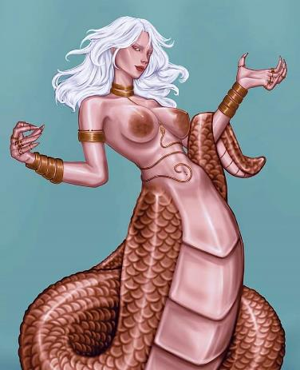

She had just cast the enhanced *orb* spell, and was gesturing that she was ready to cast another as her forked tongue jutted out to smell them indifferently.

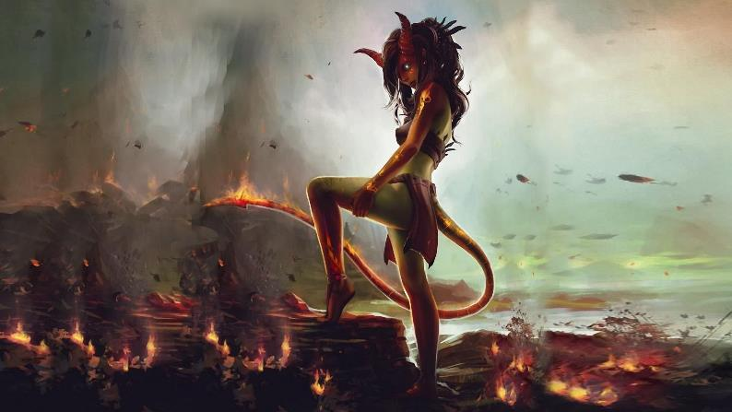

To their southwest, the vampire that had been cursing them off and on re-emerged from the mist, and behind her was a tiefling of halfling-succubus extraction. The mist continued to recede, exposing a 5’ tall wall that might be used as a defensive barrier by ranged combatants.

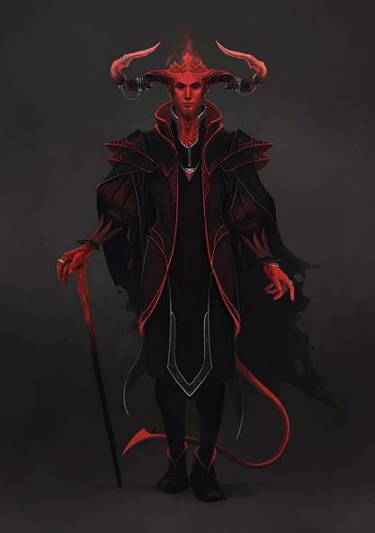

To the heroes’ south, an elegantly dressed tiefling male with pronounced horns approached with caution, displaying no drawn weapons or other intent to fight. Perhaps another parley was in order. The one with the drow had been a learning lesson, and Akilesh now asked, “May I do the talking this time?”

The others deferred to the highly charismatic dwarf, and said dwarf cleared his throat as the yuan-ti reached firm land and lowered her snakelike body onto the gritty ground, resting her arms and hands for the moment.

The tieflings and vampire continued to approach. Slitsevere and the succubus hopped across acidic pools, meandering about, while the large-horned male flew directly towards Akilesh, who now stood facing the south with a serious look upon his face. It was evident that the vampire had just fed, for blood trickled down her chin and neck.

The ooze fizzled into inanimate matter that was still caustic and corrosive, but now rested motionless as it seeped into the chasm.

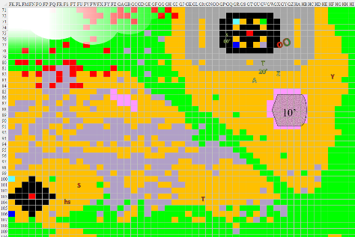

Round 98

*[Assuming neither PC attacks…]* The floating tiefling continued to make way for the heroes, slowing down as he got within a few dozen feet, then touching down, turning back to the succubus and directing in Common, “Keep the vamp back. She’s had enough excitement for now.”

The succubus ordered Slitsevere to remain where she was, and there the two waited as the conversation ensued.

They’d been here ten minutes, and were running out of patience, but maybe this was the parley that would bring about some resolution to their current predicament.

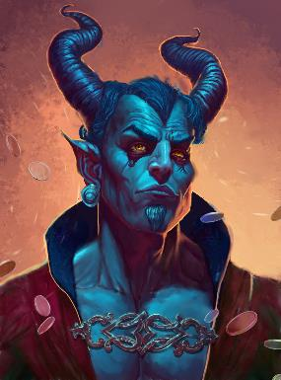

The demonic male spoke, “No doubt you are Leirans.”

“We are,” stated Akilesh. “I am a favored soul, and that is her priest-at-arms,” he pointed upward at the floating cleric-fighter.

Rounds 99 – 101

“The vampire knows no better than to try to drink your blood. She is sated for the moment,” the demonic man proclaimed. “You did well to rid us of her drow keepers, and proved your mettle. You and your fellows may not pass beyond this point, though you are free to leave with your lives intact and the booty you looted. If you agree, turn back and paddle westward until you are in the Astral causeway that leads you back to whence you came.”

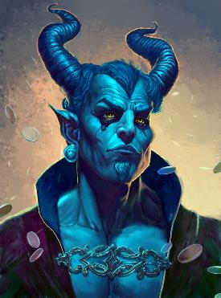

Rounds 102 – 103

Before the heroes could answer, the tiefling lowered the pitch of his voice, and warned, “Refuse our terms and we will feed you to the vampire.”

The yuan-ti hissed inadvertently, reeling from the anticipation of a fight, but stayed her casting hand.

Akilesh looked back at his friends, two of whom were still up in the air and ready to fight, and made a gesture as if to ask, “What’s the consensus?”

Zvetlana was a bit intimidated by the yuan-ti woman, and looked like she wanted to take them up on the offer of a swift retreat.

Tore landed near Akilesh, looked at the vampire, and then the others. He was not afraid of the vampire and knew he could chase her off several more times if needed. However, the others *did* concern him. To Akilesh, Tore replied, “Though the vampire is no concern to me, for the betterment of the group, I suggest we make our way back to the boats and leave this plane. I believe we have learned enough for now.”

They’d expected such fiends—demons or their ilk, specifically—given that they knew the plane was controlled by a Chaotic force, but now the lighting and ambient temperature began to dim and cool, and as the tieflings, yuan-ti, and vampire looked upon the fleshen heroes, Akilesh considered his words carefully.

The light and temperature rose once again, at one point flickering and strobing. Those who understood arcane and divine forces could tell that this was not a spell being cast by the demonic tieflings, let alone the yuan-ti. Saradette—still flying—spotted a salamander—not the amphibian wee-creature, but a descendant of fire elementals—waiting at the lava shores for anyone who might want a good fight.

Another few bloodfire-acid oozes also waded in the shallows of the acid and lava lakes that bordered one another.

Saradette listened to the tiefling’s speech with scant favor. She flew down to land next to Tore. “I’m not much for retreat, but I think you’re right,” she told her companions.

Rounds 104 – 106

“We... accept your terms,” Akilesh had to clear his throat after saying. “By your leave.”

The tiefling smiled, and nodded, remaining where he was as the dwarf and wereserpent began to walk northward again.

Chaos was sweeping over the pocket plane, and Saradette’s understanding of magic and the Planes informed her suspicions that they were about to experience a Chaotic/Evil planar realignment, wherein anyone not of Chaotic *and* Evil dispositions would be dazzled by minor shifts in the fabric of the plane. “Good thing we’re choosing to back down at this point,” she murmured, relating her speculation to Tore and company as they hastened their steps.

Round 107

“Actually, most of us skew Chaotic,” pointed out Zvetlana. “It’s really only Akilesh here who couldn’t care less, so long as the path is a righteous one.”

Round 108

“That’s right,” the dwarf, “when justice conflicts with law, justice should prevail. Same for a conflict with individual determination and self-interest; let justice prevail over those virtues as well.”

Round 109

“Right,” the resident cleric pointed out, “but the skew is aligning Evil as well, if I’m perceiving what’s happening correctly, and in that manner we will all be at a disadvantage if this lot chooses to fight us.”

The halfling tiefling had grown wings, and now flew towards and perched atop the building where Tore had previously spotted the vampire, and later a locked chest once he’d landed there himself.

Round 110

“So far so good,” noted the wereserpent as the yuan-ti followed her with about a 100’ distance.

The vampire—too—followed diligently, perching atop the westernmost building instead.

Rounds 111 – 116

They continued to walk, reaching the shadowy veneer that separated one part of the plane from the other, and could now smell the briny seawater splashing to their north and south.

