Chapter 48: The Wizard and the Seeker of the Misty Isle

They arrived at the Precinct Office, entered, and bid everyone hello as they made their way to Slatestein’s office in the back. The Captain greeted them and invited them back into his chamber, where a man and a woman—both elves—were already sitting. Within minutes, they’d been introduced to the elves, who were the contacts Slatestein had mentioned the day before.

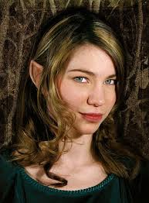

Immaline was a wizard from the Dalelands, and her male associate went by the title “Seeker of the Misty Isle”, a divinely inspired role with which Tore was just familiar enough to want to learn more. They’d been led here by the Seeker’s vision, and had been asked by the Captain to join forces with Saradette and Tore as undercover agents in the investigation detailed in the folder on Slatestein’s desk.

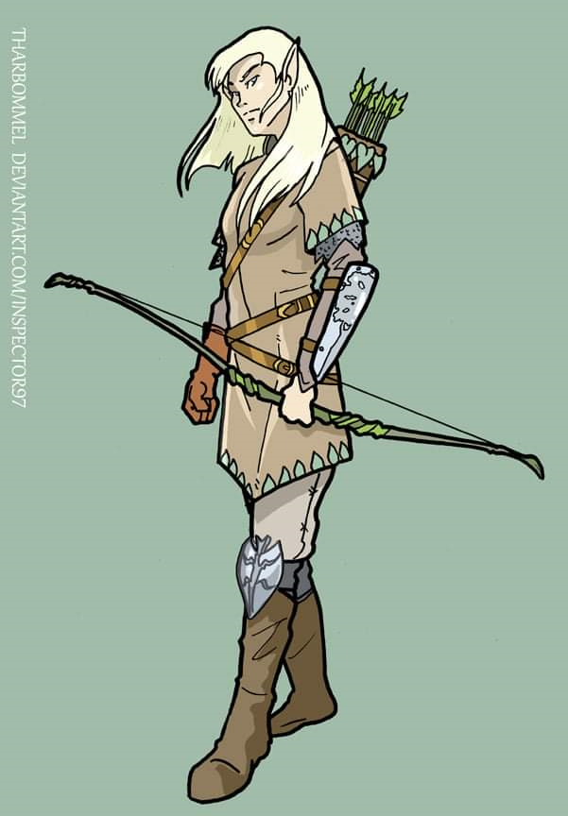
Tore nodded to both as they were introduced. “It is a pleasure to meet you both,” he said as he shook their hands. Looking at the male elf, Tore added, “I would like to know more about your title and name after this meeting if you have time.” Looking at Immaline, he added, “I would also like to get to know what types of spells you cast. We will need to get a good knowledge of your abilities and you ours so that we can operate efficiently against the Malarian cultists, or whomever we go up against.”

“Well met,” Immaline replied. She gave the newcomers a polite nod. “I’m a wizard so I can cast a variety of spells and I’d be interested to learn more about the Malarian cultists.” As always, she was being cautious but didn’t believe that either of the pair would be harmful to her or her companion as they’d been introduced by the Captain.

The green-haired, tawny skinned gnome looked up at Immaline with a cheeky grin. “I am Saradette Tarapple Febble Tallniss Nensy Gwaella Grangytee of Clan Warblerivet from Tasseldale in the Dalelands.” She wore a dagger at her right hip, a fingerless leather glove on her right hand with bits and pieces of metal on its back which ran up to more metal and leather somethings strapped to her right upper arm. A bulky metallic device hung on straps at her left thigh and hip, with a handgrip and a metal bowl at one end of the thing. Her muscular arms were bare up to her vest-like gambeson, over which she wore a chainmail shirt. Natural fabric breeches and low boots in the local style completed her outfit.

The Seeker remained relatively quiet as the others spoke of themselves. His vows allowed for a detachment from his distant past, and a consequent liberation from the limitations of his origins.

Slatestein mentioned having spent some time in the Dalelands as a youth, and when everyone had gotten to know everyone else well enough, he shifted to the intel at hand. “You’ve all been sworn in,” he prefaced, “and are thus deputized to act on behalf of the Barony on this official investigation.”

He lay out a few documents on the wooden table they’d always used for such discussions. “First, a primer on Malar and his followers, who gather in packs they call Hunts. These function like clans with no genetic ties, though they use terms such as bloodline and bloodoath to acknowledge fictitious kinship, particularly when humanoid and other intelligent nonbelievers threaten them.”

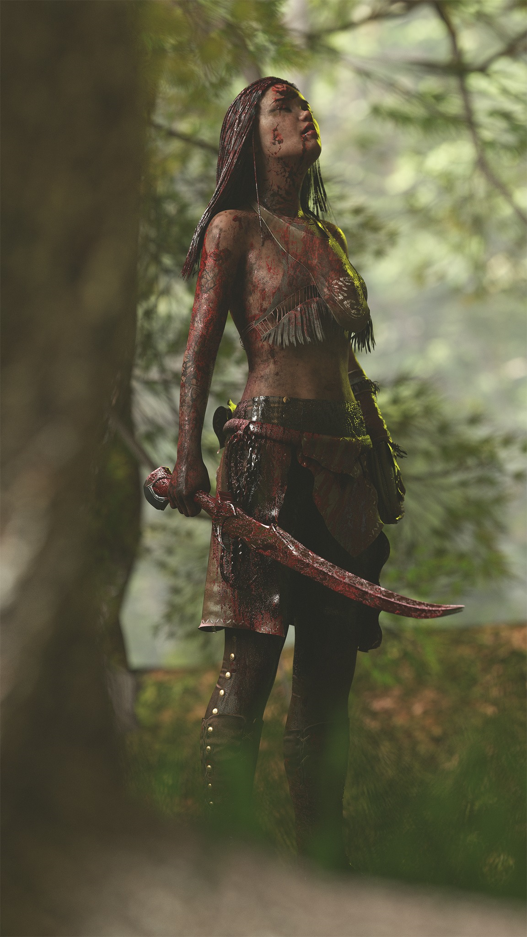

Tore nodded then added, “Many of his followers are evil lycanthropes, so be wary of them should they attempt to bite you. They believe in culling the weak so they value strength and brutality over all things. They even make a sport of hunting intelligent humanoids and beasts, granting them freedom if they evade being killed. If we do get into a fight with them, know that they will likely fight to the death and use any weapon at their means.” He paused for a moment before adding, “We must be wary in the wild as well. While they are not as tolerated in civilized areas, in wilderness areas Malar is worshiped, though many times out of fear. So they will have more allies or tolerance outside of the city than in.”

Slatestein went on to provide the geography of the situation. “I was about to dispatch you to a safehouse occupied by suspects, but our informant was made by one of the sleepers in the cell, and they fled. Tracking magics led us to a base of operations—we believe—a seemingly residential standalone structure that actually operated a gambling house downstairs and a modest brothel upstairs. “It’s referred to as the Broken Die by the local degenerate gamblers that gave us enough cause to cast a prying eyes spell into the residence. From this intel,” he placed some markers on one of the maps, “we expect two courtesans working at any given time, another one downstairs entertaining the guests publicly, no less than seven gamblers, at least three active croupiers, a bartender, two or three security personnel, and a general cleanup guy. You’ll be able to tell the Malarians by their descriptive scars and tattoos—which they may hide with sleeves and high collars—though the recent converts are often used in these frontstage functions, like croupiers, and thus don’t look quite so conspicuously associated with the central cultists who live in the cellar.”

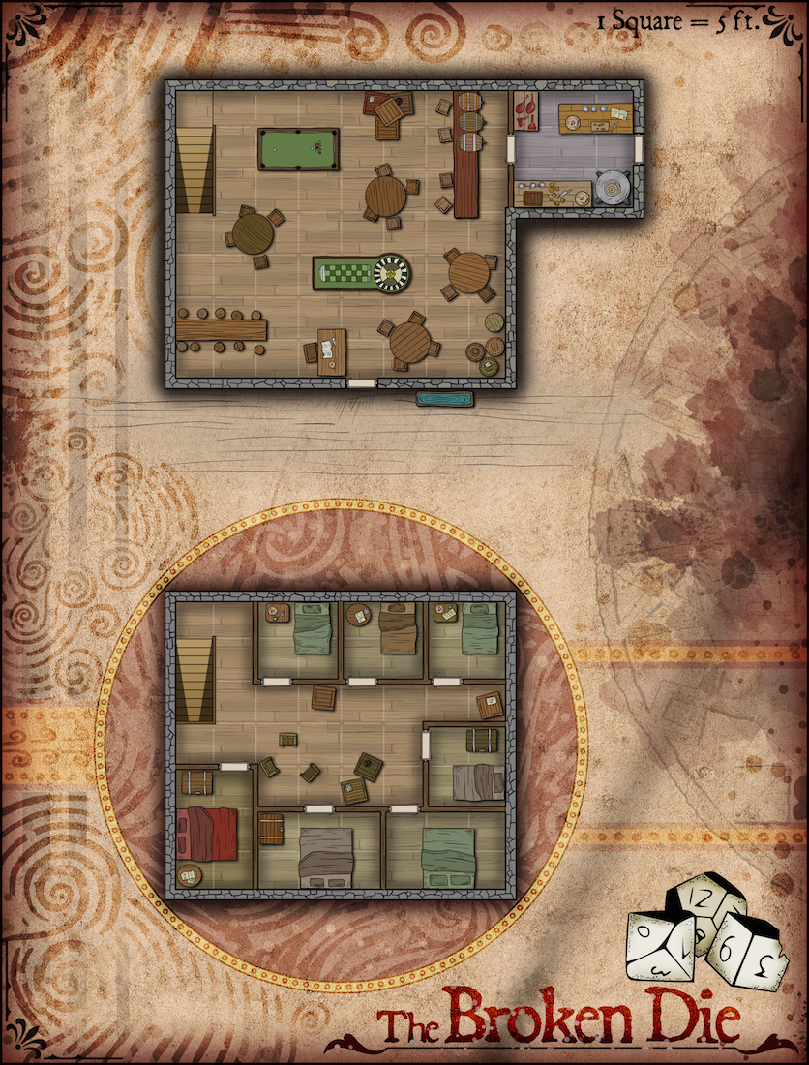

“Are they pretty much an ongoing operation?” asked one of the heroes.

The dwarf answered, “No, they shut down at dawn, and don’t let people back in until at least sunset. We know some of the newer members live, all within a few blocks of the Broken Die. They recruit guttersnipes whose records have caught up with them, and who need a clique that feeds them.”

“Their faith has some compelling points,” Tore shrugged, knowing that the group they were dealing with was not an exemplary of the points he was considering.

Slatestein had already had a theological discussion earlier, and reached for his chai as he regrouped. “The only prying eyes spell cast inside the house was divined by the time we’d finished scouring every room. It was quickly dispelled, and wards have been put in place that prevent us from doing this again.”

“That means they know we’re watching them,” Saradette deduced.

The Captain shook his head, “The spellcaster that cast the spell was in plain clothes, and further reliable intel points to their suspicion of a rival cult: the local Maskerrands. We’ve put a few arcane eyes patrolling the perimeter of the property, and as of last night, things look like business as usual. They’re closed for business, but their members are coming and going. Beyond cursory visuals, we don’t know what specific activities they’re engaged in, as they have been exceedingly stealthy in their travel through the Barony. The Broken Die is in Ford North. The local Precinct Office is aware of this investigation, and has asked us to conduct it, as their small and dedicated squad is too easily recognized by the local rabble.”

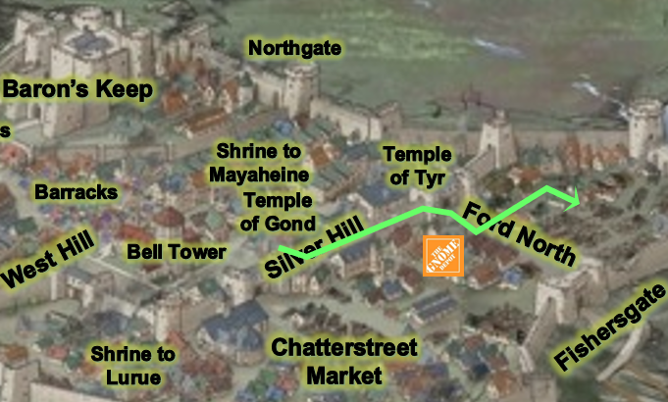

Slatestein then turned to the now familiar city map, and drew a suggested trajectory for the investigators. “Taking a wagon across Silver Hill Boulevard, then doing the rest by foot once you cross the ward arch that brings you to Ford North Way. Be wary of anyone tailing you.”

“What’s the objective?” the Seeker asked.

“Ultimately, we want to bring down their racketeering operations, but we are also trying to understand their motives, and any links to their feral counterparts in the wilderness,” sighed the worshipper of Moradin. “You are authorized to use lethal force, if necessary, but your primary objective is to gather information. If they expect a raid, it would be one from officers they can likely identify. If four rugged adventurers wander in, particularly you, Seeker, your outdoorsy guises will buy you at least a few ticks to leverage some subterfuge before their suspicions are roused, if at all. To get inside, you need someone to vouch for you, which is why one of their regulars has been paid to do so.”



The Captain showed them a magical rendition of their informant and tentative mole, and added, “The man is named Samyul, and he’ll be outside the tavern that’s just across from the house. We’ll have a Rary’s telepathic link spell applied before you’re dispatched, and we expect to have a team of agents from both Precinct Offices a few blocks from your location to breach the walled residence from the front and back entrances. If there’s hostility, allow at least a minute for reinforcements to take up positions outside the perimeter wall, but we’re hoping to avoid a confrontation until we know more.”

Immaline verified, “So this is a mission to infiltrate under the premise that we’re gamblers, and not being a gambler, I imagine I’d give us away within a minute of entering, if we get in.”

Saradette was the person most familiar with games of chance, and probabilities of certain outcomes. “Follow my lead once we get in,” she suggested.

Tore asked, “So we can expect a minimum of three security, likely full members of Malar’s church. I would also assume that others working inside are followers as well. So we should be prepared for at least 7 opponents should things go south.” Looking at the dwarf, he added, “Do you agree with that assessment, Captain?”

He was already nodding, “That’s about right, my friends.”

Tore also looked over the drawings of the building provided. “Do we know anything of the cellar? Are there any other ways in or out of the cellar besides the access from the first floor?”

“Alas, we were not able to reach the cellar with the prying eyes, but given the amount of traffic in and out of it via the staircase, we’ve accounted for everyone entering it also leaving, and their stay in there suggests that the space is about as big as each of the above-ground floors... or maybe there are a few levels. Proceed there with caution if it comes to that.”

Tore nodded, “I hope it does not come to that, but if it does, I will assume they have some sort of escape route down there.” Looking around at the others, “I am prepared to go if all of you are.”

He then turned back to the dwarf Captain, “Do you know if they use any sort of detect alignment at the location? If so, it might be good to have ours disguised or blocked from reading them.”

“Their spellcasting seems to be a day behind most of the time, which suggests that a wizard is prepping spells after realizing what they need to prep,” answered the dwarf. “Dispel magic is understandably one they have on hand every day though.”

Immaline hadn’t really contributed to the discussion, she knew. She was grateful when Saradette suggested she stick by her and gave the gnome a brief smile. “I’m ready when everyone else is,” Immaline said and hoped that the spells she had memorised would be of some use.

“I think I am,” Saradette replied. “I don’t know about taking my blaster. It’s pretty distinctive and impossible to miss.” She lifted her glove, which was covered down to her fingers under her blouse sleeve. “This is more easily hidden.”

The party was given a small stipend for the wagon ride and other minor expenses, but it was just a drop in the bucket compared to the coins they had on them already.

~*~

Reaching the corner where a half-dozen public wagoners were waiting to pick someone up, the party decided their next steps.

Saradette, who was armed only with her hidden daggers and her glove, looked at her companions. She wore a loose fitting, long sleeved tunic that covered her armor and her glove. “So, should I go in first?”

Tore opened the door to one of the wagons and motioned for Saradette and Immaline to enter, “Ladies first,” he added in a polite tone. He was wearing his normal tunic over his armor and had his mace hanging at his side. If the location requested them to leave their weapons at the door, he would oblige them so as to not raise any problems or suspicion.

“I’m agreeable to that,” Saradette said.

Immaline stepped into the wagon with a word of thanks to Tore. She sat down and waited for the others.

Saradette cast mage armor on herself once inside the covered cabin.

Widget, her raccoon familiar, rode in her lap. “When we get out, you will have to hide from the people there. If you can come in without being seen, then you do that, okay?”

Immaline cast mage armour on herself then looked at her companions. “If everything goes wrong,” she began, “and I’m not saying it will, but I can cast dimension door to take us away should that becomes necessary.”

Tore nodded, “That is good to know. Now, if either of you has the message spell available, I think that would be useful. I can then let you know of anyone with an abundance of magic items on them.”

“I can cast it once,” Saradette replied. “And, Widget here can help us, too.” She caressed the raccoon’s pelt.

Tore nodded, “Hopefully he can get inside unseen and provide additional intelligence.” He then looked at Immaline, “What about your familiar? Would it be safe for it to assist us?”

Both wizards had message prepared, and they now agreed on a few tactics to avoid redundancies and counterforces.

~*~

Traversing the greater part of the Silver Hill Boulevard, the wagon dropped them off near the arch that separated Ford North from the Temple District. From there, they walked along Ford North Way for one block, turning left where Captain Slatestein had indicated.

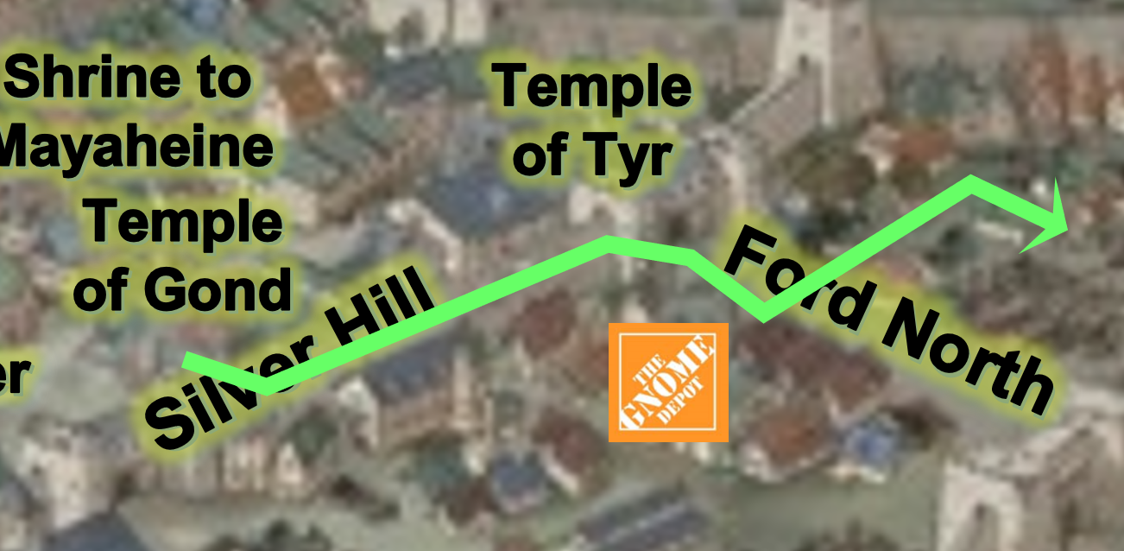

Reaching the unmarked street corner that led to the Broken Die, the quartet looked around more intently than they had as they’d scanned the streets and windows for ill willed individuals.

As they came around the last corner, Tore cast detect magic as he had said he would, and began concentrating on their destination and anyone outside of it. Once they got out of the wagon and enter, he scanned the room, not worried about detailed information, but at least getting an idea of who may be carrying more magic than others.

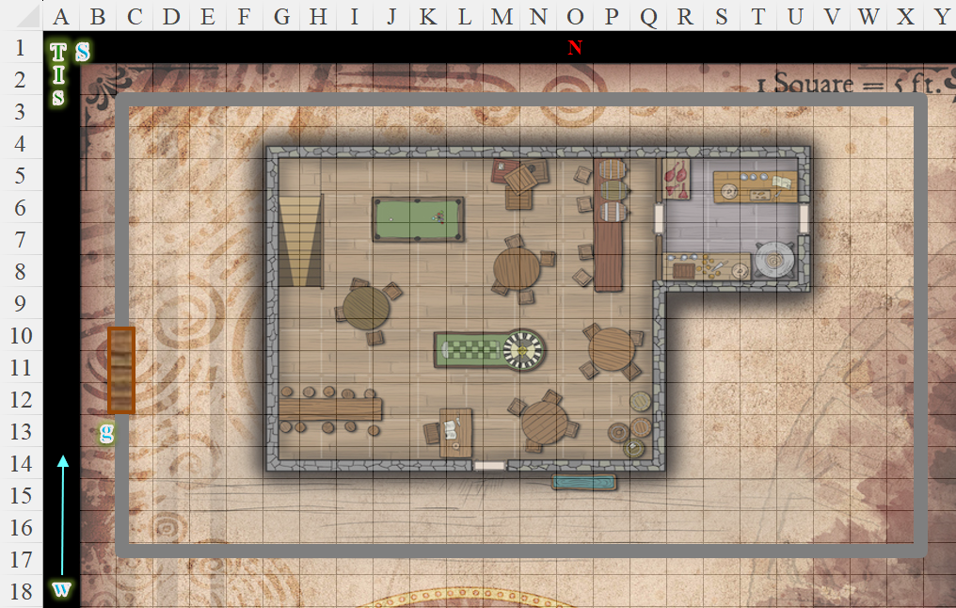

There was a single guard outside, standing by the house’s west wall and smoking a Maztican cigar. The man made eye contact with them before turning back to a young woman walking in the opposite direction as the heroes.

Saradette stopped and looked down at Widget. “See if you can get into the house, but be careful.” She then walked with Tore toward the gate.

Immaline followed behind the pair until Saradette stopped. She had been prepared to cast detect magic but Tore had volunteered instead. She’d be interested to see what he discovered.

Tore looked at the woman walking towards them, looking for any hint that she knew the guard (she glanced his way and smiled or just stared a little longer than normal). Deducing that they were not acquaintances, he then focused on the guard and building as they approached, still trying to see if he could pick up anything magical. The man was not warded with any magic spell, but Tore could see magical auras emanating from his armor.

Saradette walked towards the compound—noting the 10’ “perimeter wall” that Slatestein had referenced—and casually looked around as she mentally followed Widget’s progress. Immaline followed Saradette southward, hoping to be able to cope if they had to do any gambling.

Tore was not surprised to see that the man was likely wearing magical armor, so he did not mention it. As they reached the gate, he wanted to open it but instead faced the guard.

“Yeah?” the guard asked, looking them up and down. “Fuck you want?”

That’s when they remembered that they had to meet some bloke who would vouch for them.

The Seeker deferred to the others to do the talking, taking in visual and other cues from the guard.

Tore looked at the guard, not reacting to his tone or words, “We are supposed to meet a friend here. I thought perhaps he was already inside.” Tore took a step back, “Perhaps you would know him, his name is…” Tore stopped as he looked across the street and saw Samyul sitting in front of the tavern across the street. “Never mind,” Tore said to the guard, I found him there.” He pointed to the contact and began walking over.

Hard experience had taught the gnome that she was not charismatic enough to deal with guards, and thus Saradette was focused on what Widget was doing as she followed Tore’s lead.

Immaline glanced at the guard, then away. He didn’t look happy to see them, and she wondered if they’d even get inside—at least, not without some trouble. Then Tore asked about the person they were going to meet. Immaline looked around and spotted someone watching them from across the street. She was about to mention it when Tore starting walking over to him.
Skill | Rank | Ability & Mod. | Misc. Mods. | Total | Roll | Check
Tore, Diplomacy | 2 | Cha (+3) | 0 | 5 | 16 – 20 | ??
See below.

The Seeker frowned to himself, recalling now that they’d been told to meet in the tavern and then come in together. Suspecting they’d breached some protocol of decorum, the elf used the Rary’s telepathic link spell to relay to Slatestein that they may need those reinforcements after all.

The guard regarded Tore with a wary eye, looking for visual cues of deceit in his reaction, and asked, “What’s the password you were given?”
Skill | Rank | Ability & Mod. | Misc. Mods. | Total | Roll | Check
Tore, Bluff | 0 | Cha (+3) | 0 | 3 | 12 | 15
See below.

Without a clue as to the password, Tore looked back at his friends, searching his mind for the best possible reply.

Samyul—the man they’d been told to meet up with before approaching the guard—approached at that moment and saved the day. “Deus ex machina!”

With the password blurted out, the guard was unsure as to whether to club Samyul for adding doubt to the moment, or delivering these strangers to his friends inside. He opted to reconnoiter a bit more. “These here with you?” the guard asked Samyul up front with a palm facing forward and his other hand pointing at the quartet of armed adventurers.

Samyul looked at the four undercover gamblers who had come fully armed, and giggled out of his nostrils before answering, “Yeah, they brought along some fanciful things to lay on the tables tonight. I’ll be winning most of it,” their contact alluded to swindling the out of their equipment and wealth.

By now, a second guard atop the wall leaned outward and looked downward, asking, “What’s your business here?” with a distrustful tone.

Tore looked up at the guard on the wall, “My business is to show someone he’s not as good as he thinks.”
Skill | Rank | Ability & Mod. | Misc. Mods. | Total | Roll | Check
Tore, Bluff | 0 | Cha (+3) | 0 | 3 | 16 – 20 | ??
See below.

He then looked at Samyul adding, “I intend on getting even.” He then looked at the guard at the gate, “So, are we going to stand here all day talking, or will you allow us to pass?” His tone was even and polite as he spoke to the guard.
Skill | Rank | Ability & Mod. | Misc. Mods. | Total | Roll | Check
Tore, Diplomacy | 2 | Cha (+3) | 0 | 5 | 1 – 5 | ??
See below.

The man at the parapet looked the priest up and down before replying, “Yeah, your wares are good at the check stand.”

The other guard unflinchingly let the five folks in, with Samyul at the rear. With only coin to put up as a stake, the regular walked right in as the others had to leave their weapons in a bin.

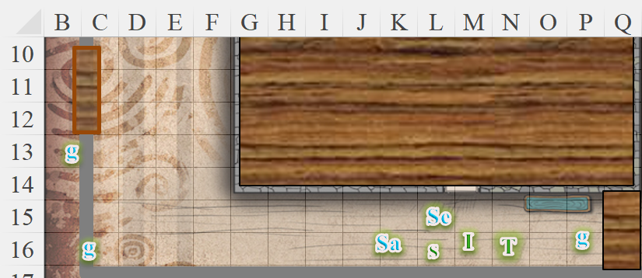

Immaline gazed around with interest. She’d never been inside one of these establishments before so she wasn’t sure what to expect - a brothel upstairs and a gambling den? (was that the right word? - she ought to make a note) downstairs. None of the people, so far, seemed to have the distinctive markings of the Malarians.

After being handed a handwritten slip with barely legible penmanship, Tore nodded to the guards as they walked in and did as asked, leaving his weapons in the indicated container. He refrained from making a comment that he expected them back in the same condition when he left. This also meant that violence would be an absolute last resort in this situation.

Having entered first, Saradette had by now scanned the room for possible red flags or threats to their undercover op. She counted eleven patrons, and identified three regular staff by the periwinkle vests and hats they wore. One of them was the barkeep; the other was the roulette croupier, and the other was dressed as a showgirl of sorts, and now sat at a table with a single male patron, a human.

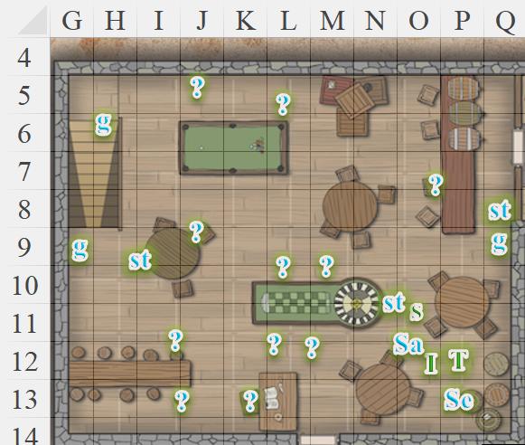

Three guards were visible, and eyed the newcomers up and down, noting the armor on the strange clientele. “Samyul,” one of them nodded in greeting to their contact, and Saradette suspected that the guard suspected something afoul, though he was couth and cool about it.

Saradette followed Tore while she reached out to Widget to see what her familiar was doing. The weasel was feeling fine, with only the minimal stress associated with his tasks at hand.

As Tore looked around, trying to pick up on any magical auras, he simply glanced at the guards, not looking at them too closely. He expected them to be there, so they were no surprise.

As he looked at the various games, he decided to try his luck at a game of poker. Walking over to the table, he motioned for Samyul to join him. “Care to try and win a few gold from me?” Tore asked. He then looked at the others, “Anyone else care to try their luck?”

“I will try it,” Saradette said.

Immaline looked around. There appeared to be a few games of chance, none of which she was really familiar with, and what she really wanted to do was find a quiet corner and take some notes about it all. However, she suspected that that would be frowned upon. Sighing silently, she went to stand behind Tore. “I shall watch you for a while,” she said and hoped that would be acceptable.

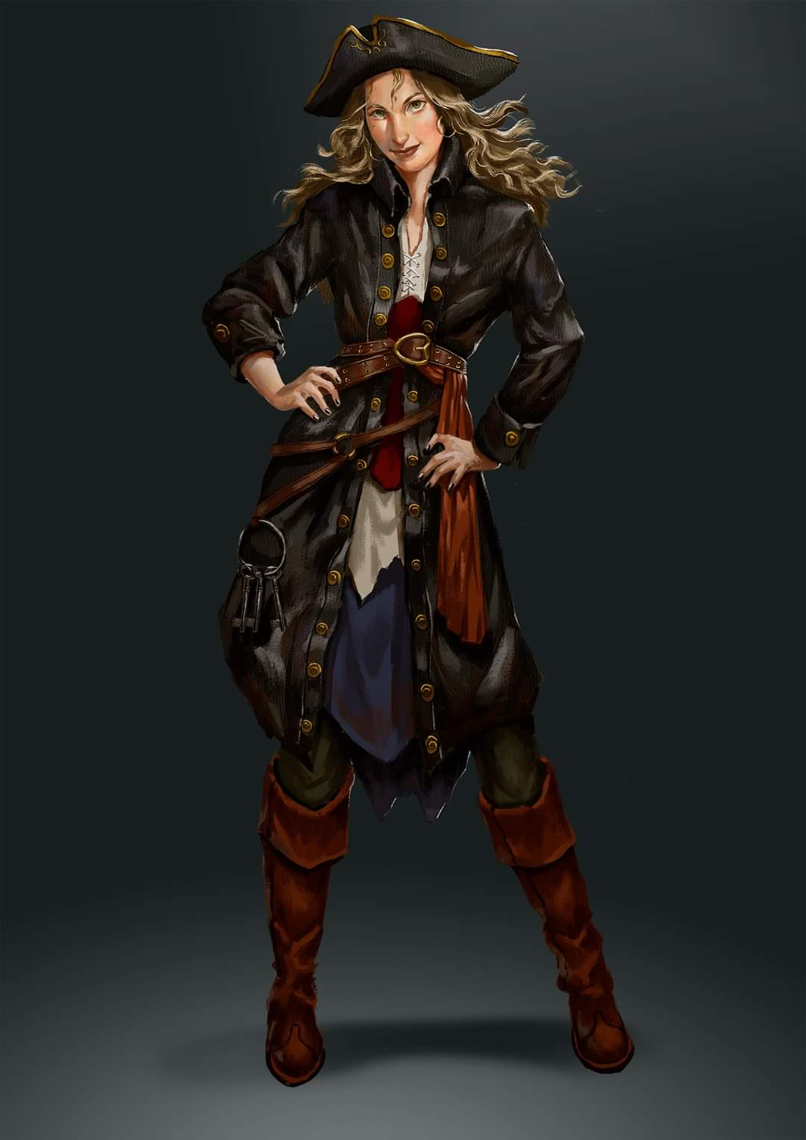

They played a poker-like game against a woman who commandeered a fishing vessel, and a mortal claiming to be part vampire and a descendant of Strahd himself.


The smirk on his face suggested that his guise was all part of a greater ruse to further ambiguate his bluffs, and he played a good hand against the heroes.

Meeting the others at the table, Tore simply smiled. The woman was mildly attractive but not so that she would be a distraction during the game. Tore doubted the male’s claim of being a descendant of Strahd. However, if it came to it, Tore would be happy to put the man down permanently. “I’m a simple cleric that has lost his way. My faith has wavered and I’m looking for a new path. Perhaps this place will help me find it.”
Skill | Rank | Ability & Mod. | Misc. Mods. | Total | Roll | Check
Tore, Bluff | 0 | Cha (+3) | 0 | 3 | 10 – 15 | ??
See below.

The cleric hoped that the others believed him, but it was difficult to read the pokerfaced players. He even feigned some embarrassment by looking down at the table for a moment as he spoke. He ended by giving those at the table a weak smile as the ‘vampire’ dealt the first hand.

Tore smiled at Immaline and nodded, “That is fine. Watch and learn. Hopefully it will be a productive lesson.” As he sat at the table, he again glanced around and advised the others via the link of any magical auras that he could detect. Sure, there were auras in the room, and every guard was rocking at least one. The staff too, and most of the patrons, who—by the looks of their garments and stakes—were all well to do. By the time he and Saradette had decided on a card game, he could discern that most of the dweomers he was amidst were abjurations, the likely wards that he would expect in a place such as this.

They played a poker-like game against a woman who commandeered a fishing vessel, and a mortal claiming to be part vampire and a descendant of Strahd himself. The smirk on his face suggested that his guise was all part of a greater ruse to further ambiguate his bluffs, and he played a good hand against the heroes.

As the Seeker went to the bar to have a beer and decide his next move, the others made themselves comfortable at the poker table. Saradette and Tore each placed a few coins on the table. Tore felt that the woman would be a good challenge, however, he was unimpressed by the males claim of being part vampire and truly doubted his relationship to Strahd.

As they played a few hands of Dragon’s Bluff, Tore still tried to look around the room, but unable to focus, he wasn’t able to pick up much more than the vague magical auras on the guards. After the first four hands had been dealt, Tore began to pick up on the male’s ‘tell’, a slight narrowing of his left eye when he didn’t have a good hand.

Saradette had won the first and third hands, the ship captain the second and Tore the fourth. There was a bit of frustration becoming evident in the supposed vampire during the 5th hand. Tore could tell he was trying to bluff, and slow played his hand, hoping to get the last card he needed for a full nest, and he did, all red dragons. So, when the ‘vampire’ raised one last time, going all in, he was shocked when Tore called him on it. The shock was only there for a moment, but Tore knew he had him.

When they flipped over their cards to reveal their hands, the ‘vampire’ grimaced at Tore and growled, “You’re cheating somehow. I know it! That had should have been mine.”

Tore simply smiled, causing more agitation from his opponent. “It would have been if you had a better hand,” he responded calmly and evenly, looking up at the ‘vampire’ as the man stood, his chair falling over behind him.

Immaline found the poker game fascinating. Her fingers twitched as she longed to be able to make notes of what Tore and Saradette were doing but she knew she couldn’t start writing about it now. Hopefully, she could remember everything for later. Tore had told them that there were several people in the building who had some sort of magical aura and Immaline realised that she should have cast detect magic before entering as well.

Although she was intrigued by the card game, Immaline still tried to keep an eye on the patrons in case the Malarians revealed themselves.

Tore relayed what he could sense to the others via the link during the first couple of hands that he lost because he wasn’t concentrating on the cards as much as he should have. Now, waiting for the ‘vampire’ to make his next move, Tore made sure he wasn’t the one that started any fight, but would be happy to defend himself should the ‘vampire’ start something.

The next sextet of hands was poorly distributed for everyone, and it was mere luck of the draw that landed the mariner woman the bulk of those wins. Then, Saradette took a look at her hand, and looked up to study the others’ faces, meeting Tore’s eyes across the table.

The Strahdesque dilletante smirked with a gleam in his eye, and it seemed for a moment that the shuffling had finally gotten interesting.

They’d been betting gold coins in the dozens, and at most the stakes had gone to hundreds, with the wealth redistributed by dumb luck over the last few minutes. Now, however, “Strahdino” lay down 500 gold, and waited for the wandering croupier to come and verify the stake. The woman’s eyes magically glowed with divine sight and she identified, “503 gold.”

“Ah, there you have it,” the cocky lad shifted in his seat. “Five-hundred and three!”

The ship’s captain squinted, and waited for Tore—whose turn it was now—to either see the vamp’s pot opening for this round.

Tore studied the ‘vampire’ for a moment, then called him, pushing his gold into the pot. He watched for the man’s reaction as he waited for the Captain and Saradette to make their calls.

The Captain kept her cool, and raised the stakes to 1,000 gold, which she’d changed into chips. She was a regular when she was here, and right now, she felt in the moment.

Saradette took out a thousand gold pieces, had the croupier convert them to chips, and placed them on the table. “Call.”

The gothy kid frowned, and sighed, “I... don’t have-” but he was cut off.

“Oh, but you do,” interrupted the woman across from him. “I’d appraise the net worth of the jewelry on your left hand alone to cover it,” she motioned to his bracelet and rings.

The young man squinted and looked downward at his hand, and began to remove some inherited articles, feeling more than lucky.

That left Tore to decide whether to put in another 497 gold, whereupon they could show their cards. If he did so and raised the kitty, things could get even more interesting. The warrior-priest didn’t hesitate as the lad took off the items. He pushed his coins in stating, “Call.” He wanted to see what the ‘vampire’ had and felt good enough about the strength of his own hand to be confident in the move.

That left them all to bear their cards, and while the Captain’s was indeed a better one than Tore’s, it was Saradette’s four aces—one of cups, another of swords, a third of clubs, and a fourth of coins—that took the winnings of 4,000 gold, including her original 1,000.

The vampy boy’s hand was comparatively crap, and as he read everyone else’s cards, he pushed his chair back with a resigned look, and said, “I’m out of here. Laters!”

Tore felt the tension at the table as he watched the ‘vampire’ get up. Then he looked at Saradette, “Well played.” Standing as well, he asked, “Care for a drink, before you go? I’m sure my friend,” he looked at Saradette, “would be happy to buy us each one.”

The sore loser murmured something to the negative, and walked away, collecting his things. Tore tilted his head, then turned to the ship’s captain at the bar to ask if she would join them.
Skill | Rank | Ability & Mod. | Misc. Mods. | Total | Roll | Check
Tore, Diplomacy | 2 | Cha (+3) | 0 | 5 | 1 – 5 | ??
See below.

She looked the fighter-cleric up and down, recalled dozens of regrets and other experiences, then simply said, “Not really thirsty, but thanks. She then went to join some of her crew who were rolling dice at the adjacent table.

Saradette gathered her chips, placing all but a hundred gold’s worth in her haverpack. “Of course,” she answered Tore with a smile. “but just one. What other game do we want to try?”

“Let’s have a drink first before we push our luck,” Tore replied to Saradette. He then turned to Immaline, “Care to join us at the bar as well?”

It had been very interesting. Immaline had managed to follow some, but not all of the play and she was delighted when Saradette won. She nodded when Tore invited her to join them. “Thank you, I will,” she said.

Saradette stepped close to Immaline. “If you need more to gamble with, I will share,” she said in a low voice.

“Thanks,” Immaline murmured “but I do have some coins. It’s just,” she glanced around. “I’m not much of a gambler and I don’t really understand all that’s going on.”

The door opened for the vampy kid as he now left, and as he stepped out, in came a crew of men and women visibly armed, and saying nothing, but studying everyone’s movements. As they meandered along the busy gambling room towards the staircase to the northwest, the sextet of ruffians brought with them the scent of musk and leather along with that of unbathed humanoids.
Skill | Rank | Ability  & Mod. | Misc.  Mods. | Total | Roll | Check
Immaline, Sense Motive | 0 | Wis (+0) | 0 | 0 | 1 – 5 | ??
Saradette, Sense Motive | 1 | Wis (+1) | 0 | 2 | 11 – 15 | ??
Seeker, Sense Motive | 0 | Wis (+3) | 0 | 3 | 6 – 10 | ??
Tore, Sense Motive | 0 | Wis (+3) | 0 | 3 | 11 – 15 | ??
See below.

The four heroes understood by their markings that these were Malarians; furthermore, Saradette and Tore also understood from everyone else’s body language that to make eye contact at this moment would be to identify themselves as outsiders, and possible infiltrators.

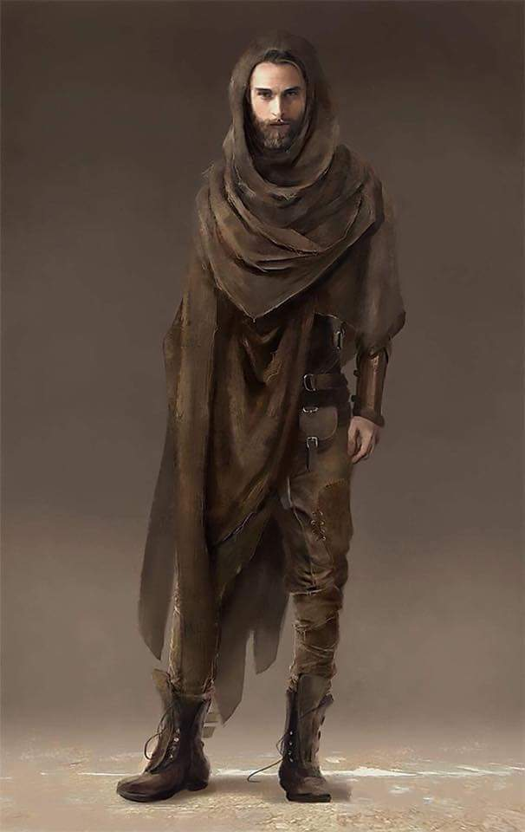

Immaline inadvertently did so with one of them, finding the male ruggedly dashing.

“I’ve’nt seen you here before; what’s your name, darlin’?” asked the raggedy-robed warrior.

When the man spoke to Immaline, Tore looked over at the man, though he remained relaxed and did not show any outward signs of agitation, he just leaned against the bar.

Immaline looked at the man and noticed the markings. She hadn’t meant to look at him but it had been instinct to glance at the door when it opened. When he spoke she knew better than to give him her real name. “I’m Mylara,” she said, shortly not wanting to engage in conversation.
Skill | Rank | Ability  & Mod. | Misc.  Mods. | Total | Roll | Check
Immaline, Bluff | 0 | Cha (+0) | 0 | 0 | 11 – 15 | ??
See below.

As Immaline responded, Tore focused on the new arrivals for any magical auras on them, though he had long ago expired the spell by concentrating on the dragon’s bluff game.

The man smirked and nodded, revealing a certain freedom of movement as he turned to follow his mates down the staircase. That last man then eyed Tore as he descended, wondering more about him than those near him.

Tore watched as the new arrivals headed out of sight. He noticed the last one looking at him, and wondered if there was any chance that the man recognized him. He then turned to the barkeep and ordered a pint of ale and pondered their next move.

Saradette spoke in a low voice. “What are they doing here?”

Tore nodded, whispering back, “I’d like to know that as well.”

When the bartender came over, Tore made out any a few decorative scars that identified him as one of the Malarians.

Immaline watched as the men disappeared down the stairs. She didn’t like the look of them nor the way they’d stared at Tore. She had noticed the Malarian markings so did this mean there was going to be some trouble or were they just there to ‘have a good time’ at either the gambling tables or the brothel?

“Let’s play some other games and see what happens,” Saradette suggested.

Before turning back to the bartender, Tore sent a mental message about the group that just came in and went downstairs, describing their clothing and any tattoos that he saw. He also sent a bit about the ‘vampire’ that they played cards with, giving his description and his claims of being related to a vampire of note. Just in case they are looking for someone matching his makeup.

A few moments later, Captain Slatestein responded, “We’ll look into the Strahd fellow. Let us know if there’s any other traffic up or down those stairs.”

Turning to the bartender, Tore looked for any markings that would give him away as a Malarian. He then ordered, “One pint of ale.”

Immaline looked at Saradette and nodded. “Okay,” she said. “What games do you want to play?” she asked. The elven woman gazed around and her eyes alighted on some men in the corner of the room. “How about that?” she nodded to them. “Do you know that one?” Immaline had indicated a table in the corner behind which a man stood holding a container.

“Place your bets,” the man called. Several patrons did so and once they had put money on the table in front of them the man behind began to shake the container whilst the patrons called either “high” or “low”. After a few moments the man slammed the container on the table. There was a pause then he slowly lifted the lid to reveal 3 dice underneath. There were a lot of groans as two twos and a one showed on the faces of the dice but at least one person looked happy though as they raked in some money.

“The dice are probably weighted, but we can try, anyway,” the gnome said.

As Saradette and Immaline headed over to another table, Tore turned to the bartender, and partook of a hefty swig from the pint they’d just delivered. He then asked the bartender, “Is there a private downstairs? If so, how do you get invited?”
Skill | Rank | Ability & Mod. | Misc. Mods. | Total | Roll | Check
Tore, Diplomacy | 2 | Cha (+3) | 0 | 5 | 6 – 10 | ??
See below.

“A ‘private’, eh?” confirmed the bartender, smirking. “Never heard it called that way before. Wherefrom hail you, outlander?”

Tore smiled, “From the far northwest, Neverwinter. It’s a term I heard a few travelers from Icewind Dale use. I found it rather unique and interesting.” He took a sip of his ale, then continued, “What about you; you from around here?”

Rather than providing a direct answer, the barkeep smiled as if with pleasure, and sighed a bit before proposing, “Yeah, there’s a private lounge below…. I thought your tastes were a bit more exotic than this.” He motioned with his eyes to the gambling taking place around them, then turned to the guard at the top of the staircase and nodded for him to approach.

The wooly haired man walked over, his eyes studying Tore up and down.

The barkeep made it clear that he was observant, saying, “This lad’s been a good sport, and he’s kept a bit of coin after his friend took his and everyone else’s lot. What say you show him the rest of what the Broken Die’s got to offer?” Turning back to Tore, he caveated, “… unless it puts off your girlfriends… or they want to join….”

The fighter-cleric—unarmed but still quite dangerous—contemplated the moment’s opportunities, and followed up with a prompt for clarification.

The barkeep reacted to the priest’s question: “Ah, we have... live entertainment in the cellar, sir, some private dancers if you wish.”

“Costs 10 coin for each of you to watch,” the guard grunted. “20 to touch and 50 to ravage.”

Saradette barely overheard the barkeep, and worked to keep her disgust hidden. There was a job to do, after all. She pasted a smile on her face and spoke to Tore. “Let’s go see.”

Tore smiled and nodded, showing his understanding. He pulled out 10gp, “Let’s start watching, then decide if anything there is worth more than that.” Tore figured he could at least get a layout of the area below ground and report his findings to the authorities. They could then decide what to do from there. If he got into trouble, he could call for help via the link.

It seemed that Tore was going to go downstairs and, as Saradette was interested in joining him. Immaline wasn’t averse to doing the same. She was curious as to what went on below them—though she didn’t like the sound of what happened to the private dancers.

Saradette stood and walked over to Immaline. “We should go downstairs.”

