*Chapter 49: The Malarian Coven*

Immaline glanced at Saradette, then at the game she’d been interested in, then back at the gnome. She was about to ask why, but the way Saradette had said they should go down the stairs made the elf decide against asking. Instead, she nodded. “After you,” she said as they each parted with 10 gold coins.

It was a dark passage once they got to the bottom of the stairs, and the sound of soft, slow drumming and chanting—coupled by the only flames that lit the area and the scent of incense and ointments—led them along the path to a larger room where the heady smoke of hookahs and the vapor of boiling hops comingled with the more dominant frankincense and lavender fragrances.

They entered the area quietly, meeting eyes with some of the other voyeurs as a quartet of women ravaged a bound man sexually while biting and scratching him.

The men who had led them here stood just behind them now, and the burliest of them said, “If you want to fuck any of them, you pay.”

Saradette fought her urge to turn and run away as she walked with Tore and Immaline. Taking a slow breath, she pretended to watch the “action” while observing who else was in the room.

Tore glanced over his shoulder, “Not at the moment. However, do you have anything a little more private?” As he waited for the guard’s reply, he sent a mental message to Captain Slatestein, informing him of what they have seen and a layout of the basement. Tore suspected there was a secret way out, but being human, he didn’t have the same innate ability to detect secret doors or passages like a dwarf or elf.

Immaline was both equally fascinated and appalled at the spectacle before them. She had no interest in joining in the ‘party’ and the level of debauchery was disturbing and yet the way the people behaved—almost like animals—was also interesting. In a purely intellectual kind of way. However, when Tore asked if there was somewhere more private Immaline was quite happy to turn away.

The elven sorceress noted no secret doors within her line of sight, though there were a handful of passages starfishing outwardly into corridors that might have been secret, if not just private.

Tore, by this time, was being led into the southeasternmost exit, and smiled as he made final eye contact with Immaline and Saradette.

Tore motioned for Saradette and Immaline to follow and join him. As he entered the room he looked around for a moment, taking in his surroundings.

~*~

Tore was presented to a young, half-elven man and two younger women—an elf and a human—and the guards then took a few steps back into the corridor as Immaline and Saradette followed in. They wore garlands as anklets and bore the feral markings of Malarians, now that Tore had studied them up close.

The young man presented himself as Pirouit, and—reading the cleric’s face—smiled and took a step back as the two women approached, fondling the cleric’s armor. Pirouit, meanwhile, made his way around the trio towards Saradette and Immaline, smirking with desire all the while.

Tore looked back at the guards, “I thought I had said private? This doesn’t seem very private, or do you not know the meaning of the word?” As he stood waiting for a reply, he sent another message to the dwarf Captain, confirming the additional Malarians in the basement.

Tore relayed to Captain Slatestein via the link about the tunnels branching out and that they likely reach many areas under the city.

“We’re closing in,” Slatestein telepathically replied. “I’d say you have a hot minute before we’re on site. You’ll likely hear the commotion approaching.”

“Noted,” the Seeker of the Misty Isle confirmed, enjoying his drink upstairs, and continuing to pose as just another newbie while actually being the first line of defense against the Malarians once they were alarmed to the raid.

Immaline and Saradette maintained thought-silence for the moment, considering their next words and actions.

Tore nodded mentally at the comment from the Captain. He then looked at the two females and smiled, “Why don’t the two of you entertain me by making out and fondling each other?” His tone was flat and unemotional, hoping to keep the two busy so that when the fighting started he could concentrate on the guards. He had a couple of spells up his sleeve that would be helpful.

*Secret checks rolled.*

Tore got the impression that the guards were far too dull to capture the pretext of his presence here, as did Immaline and Saradette, who now stepped past the guard between her and Immaline, preferring to not be surrounded by the towering men. She fought to keep her expression neutral as she watched what the others were doing.

At first Immaline didn’t notice the young man as she was more interested in their surroundings but when she did she smiled hesitantly and shook her head, moving out of his way. Having seen what had happened in the other room she didn’t particularly want to engage with these people here.

Pirouit read this in the elf’s posture, and studied her with his eyes as his two lovers caressed one another and kissed. This went on for probably 20 seconds before they heard a commotion from the east, where the public orgy was ensuing.

As the two women did what Tore had asked he nodded, “That’s better,” he added as he watched, pretending to be interested.

When the commotion started, Tore turned back towards the guards and the noise. In an accusatory tone, Tore said, “Can you not keep order in this place, what is that noise? Maybe one or two of you should go see.” Then he noted in the dim, flickering torchlight that one of the three guards had already taken leave and was likely seeing to whatever had ensued.

Saradette looked around the chamber for anything that struck her as odd or out of place.

Immaline heard the commotion and thought about what spells she had ready in case they were needed.

Round 1

Tore saw that as their moment. He made sure he wouldn’t hit Saradette or Immaline and cast *knife spray* at both of the guards, trying to catch them both off guard and inside the cone of the spell.

*Dmg: 3 + 5 = 8.*

|  |  |  |  |  |
| --- | --- | --- | --- | --- |
| **Character** | **Save vs.**  *knife spray* | **Ranks** | **Roll** | **Result** |
| Malarian Guard | Reflex | 7 | 19 | 26 |

*Success. Saved for ½ damage: 4.*

The scuffed guard turned to the priest and grimaced, his eyes bulging first and then the rest of him as he and the guard behind him both took on lycanthropic semblances. Ears and snouts grew pointed, and teeth were becoming all the more prominent by the second.

The three courtesans fled via different tunnels.

Saradette took two steps back and zapped the nearest guard with her glove.

|  |  |  |  |
| --- | --- | --- | --- |
| **Ranged Weapon** | **Dmg.** | **Rng.** | **Notes** |
| Glove of Lightning Bolt | 8d6 Electric | 120’ | Ref DC 16 for ½; melts most metals |

*Base dmg: 34 electric.*

|  |  |  |  |  |
| --- | --- | --- | --- | --- |
| **Character** | **Save vs.**  *lightning bolt* | **Ranks** | **Roll** | **Result** |
| Malarian Guard | Reflex | 7 | 7 | 14 |

*Fail. Full damage taken.*

***NOTE:*** *I was under the impression that Saradette had relinquished all of her gadgets; in order to play out the attack above, she would have needed to get it past the guards at the check-in booth, which is a hard roll to make. I’ll assume it succeeded, but all her other gadgets and weapons are by the front door.*

Hastily, Immaline cast *mage armour [expired on Round 7201 (12 hours)]* on herself.

*Immaline gained +4 to AC and FFAC.*

Round 2

|  |  |  |  |  |  |
| --- | --- | --- | --- | --- | --- |
| **Character** | **Group** | **Initiative** | **Roll** | **Modified Roll** | **Speed** |
| Seeker (upstairs) | 1 | 5 | 17 | 22 | 30’ |
| Malarians | 2 | 2 | 18 | 20 | 30’ |
| Saradette | 1 | 3 | 14 | 17 | 20’ |
| Tore | 1 | 2 | 8 | 10 | 30’ |
| Immaline | 1 | 5 | 2 | 7 | 30’ |

The two lycanthropes continued to shapeshift, growling menacingly, their armor being absorbed within their increasingly furred forms.

Saradette zapped her target again.

|  |  |  |  |
| --- | --- | --- | --- |
| **Ranged Weapon** | **Dmg.** | **Rng.** | **Notes** |
| Glove of Lightning Bolt | 8d6 Electric | 120’ | Ref DC 16 for ½; melts most metals |

*Base dmg: 23 electric.*

|  |  |  |  |  |
| --- | --- | --- | --- | --- |
| **Character** | **Save vs.**  *lightning bolt* | **Ranks** | **Roll** | **Result** |
| Malarian Guard | Reflex | 7 | 10 | 17 |

*Success. Saved for ½ dmg: 11 electric.*

The second zapfinished it off for sure, or at least neutralized it for the moment.

As the remaining guards went through their transformation, Tore cast *protection from evil* on himself.

*Tore gained PfE benefits.*

Immaline cast *magic missile* at the nearest standing werewolf, which was the one that Saradette had just zapped. She then identified it as not being a werewolf, but rather bearing the definitive features of a werejackal.

*Dmg: 8 + 4 = 12 force [magic].*

Round 3

The third werejackal stood in the mouth of the tunnel that had led them here, and swung his mace at Saradette with fury as the westernmost one slashed at Tore with a scimitar.

|  |  |  |  |  |  |  |  |  |  |
| --- | --- | --- | --- | --- | --- | --- | --- | --- | --- |
| **Character** | **Attack Type** | **Damage** | **BAB** | **Str Mod+** | **Dex Mod+** | **W+** | **Total Score** | **Roll** | **Total** |
| Malarian Guard 1 | Scimitar +1 | 1d6+3+1 | 10 |  | 3 | 1 | 17 | 15 | 32 |
| Malarian Guard 3 | Light Mace+1 | 1d6+4+1 | 12 | 4 |  | 1 | 17 | 1 | 18 |

*Hit, miss. Dmg to Saradette: 1 + 3 + 1 = 5 [64/69].*

The gnome glanced toward Tore, took a step back, and pointed her gloved right hand, palm down and fingers spread, at the guard attacking Tore. She bent her middle and ring fingers downward, which both formed a very rude gnomish gesture, and set her glove’s mechanism to deliver a double power shot. She flexed her index finger, and the mechanism fired.

|  |  |  |  |
| --- | --- | --- | --- |
| **Ranged Weapon** | **Dmg.** | **Rng.** | **Notes** |
| Glove of Lightning Bolt | 8d6 Electric | 120’ | Ref DC 16 for ½; melts most metals |

*Dmg: 25 electric.*

|  |  |  |  |  |
| --- | --- | --- | --- | --- |
| **Character** | **Save vs.**  *lightning bolt* | **Ranks** | **Roll** | **Result** |
| Malarian Guard | Reflex | 7 | 18 | 25 |

*Success. Saved for ½ dmg: 12 electric.*

The werejackal was now critically wounded.

Without a weapon and no powerful offensive spells, Tore only had one option, he punched the werejackal then took a step back *[Mobility and Spring Attack.]*, moving 10’ from the werejackal, meaning it would have to move to attack him. His magical vestments did help a bit as well.

|  |  |  |  |  |  |  |  |  |  |
| --- | --- | --- | --- | --- | --- | --- | --- | --- | --- |
| **Melee Weapon** | **Dmg** | **D+** | **TH+** | **Critical** | **Type** | **Wt.** | **Atk** | **Roll** | **Check** |
| Grapple, Unarmed Strike | 1d3 | +2 | 0 | x2 | Bludgeon | 0.0 | +13 | 11 | 24 |

*Hit. Dmg: 3 + 2 + 6 vs. evil + 6 vs. evil = 5 + 12 vs. evil = 17. Both rolls maxed out!*

After the punch, Tore smiled at the jackal whose wind he’d just knocked out of his chest, “You are so ugly, I can’t imagine your mother ever loved you.”

***NOTE: If you had a knight level, this taunt would constitute a Knight’s Challenge, which gives a +1 advantage against this foe. Given how you’re playing Tore, a knight level may be a nice ingredient in his build.***

The second werejackal fell to the floor and began to die as the first one to have perished now began to resume its humanoid form.

The fact they were werejackals and not werewolves didn’t change Immaline’s focus. Seeing the two dead ones before her, she turned to the third one in the corridor and decided to cast *Melf’s acid arrow* next. If they could finish it off then they could secure this portion of the illicit enclave.

|  |  |  |  |  |  |  |
| --- | --- | --- | --- | --- | --- | --- |
| **Ranged Weapon** | **Dmg.** | **D+** | **TH+** | **Atk** | **Roll** | **Check** |
| Ranged Touch Attack | 4d4 acid | 4d4 acid,  Delayed | 0 | +7 | 10 | 17 |

*Hit. Dmg: 10 acid + 6 acid on next round = 16 acid.*

The initial damage was enough to cause the lycanthrope to flee southward, where he would surely be stopped by Slatestein’s forces.

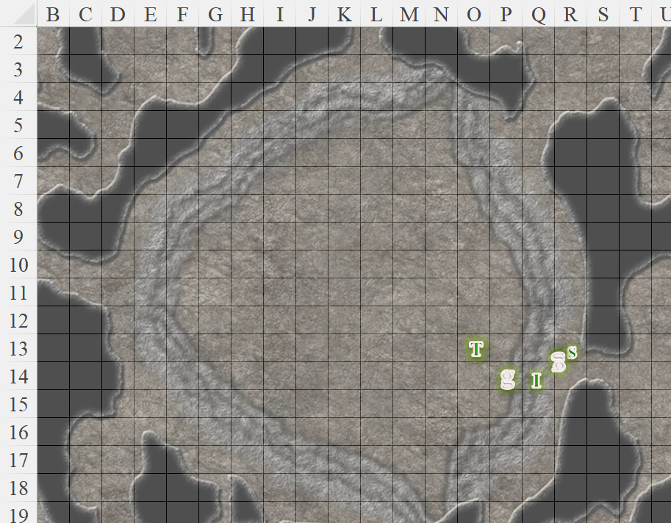

Round 4

Upstairs, the Seeker sent out a mental message, saying, “Don’t shoot. I’m one of the undercover ops.”

He didn’t quite use the terminology of a local, but the elf made himself understood, and Slatestein replied telepathically so those underground could also capture it, “Phew! That was *some* resistance!” his psychic voice was winded, confirming that they’d neutralized or apprehended all hostiles on the ground level. “We’re coming down *now*.”

Saradette looked around for any other threats, and to see what the women were doing.

Immaline had wanted to cast another *Melf’s acid arrow* at any remaining werejackals, but none were currently in sight.

Tore had seen the two females and the male fleeing westwardly, and the hurried steps of the bipedal lycanthrope to their east were heard for another few seconds, then were replaced by the howling scream of the werejackal as it was struck down by several of the Baronial Guards who had now breached the area.

Slatestein confirmed this telepathically, and the heroes knew that the path between them and the Guards was clear. As to all other paths around them, they were not in a position to hazard any guesses.

Rounds 5 – 6

Tore smiled with satisfaction at the death of the last werejackal. He then picked up the sword that was left by one of the other dead werejackals. “Let’s see where those other three went,” Tore said to Immaline and Saradette. He then sent a message to Slatestein, “We are pursuing three others that fled west from our location.”

Saradette followed Tore westward. Immaline nodded and followed the others.

Round 7

They arrived at a junction of passages, and smelled blood and other bodily fluids wafting from a draft that blew towards them from the north.

“Let me look first,” Saradette said, stepping up beside Tore. “I’m a bit quieter than you.”

Tore nodded adding, “Be careful.” He let Saradette get about 10’ in front of him before following her.

It smelled awful, but Immaline guessed they needed to know what was down there. She was happy to let Saradette go first.

Round 8

Saradette continued for another 25’ northward, and happened upon a defiled male dwarf who’d likely been slain within the hour. The body lay face down in a pool of blood; the Malarian vibe had wholly gone from sexy to repugnant within the last minute.

The gnome crept forward, ready to back away if she found something dangerous. Tore followed Saradette, who checked the dwarf, just to make sure he was unable to be saved.

“He is gone and beyond help,” she murmured.

Immaline waited whilst the dwarf was being checked then followed the others.

Rounds 9 – 12

The sounds of footsteps approaching alerted them to someone coming behind them. Readying their weapons, they then lowered them when they recognized one of Slatestein’s ablest swordswomen who nodded at them and commended them.

Round 13

Saradette kept moving along the passage until the dried blood smatters and puddles alerted her to the spike trap that she then spotted.

Immaline kept following until Saradette held up her left hand in a “stop” gesture, and then carefully examined the trap to find its trigger.

|  |  |  |  |  |  |  |
| --- | --- | --- | --- | --- | --- | --- |
| **Skill** | **Rank** | **Ability & Mod.** | **Misc. Mods.** | **Total** | **Roll** | **Check** |
| **Saradette, Disable Device** | 5 | **Int (+3)** | 2 | 10 | 19 | 29 |

*Success.*

“Good?” asked Slatestein’s Lieutenant.

Round 14

“Easy peezy,” Saradette responded, disabling the device. She moved ahead, looking for more traps.

Tore nodded after he watched the gnome disable the trap. “We need to see where these tunnels lead. Let’s continue to check this one,” he said to the other three.

Immaline kept following.

Rounds 15 – 21

“We’ve word of a breach in a ditch behind a neighbor’s house,” Slatestein alerted those within the telepathic bond. “We’ve apprehended almost a dozen Malarians with literal blood on their hands.”

They began to hear footsteps up ahead, and though cautious at first, they lowered their weapons when they identified the Baronial Guard insignia on the five men and women approaching.

Saradette—still at the front of the formation—alerted the Guards to the forks in the passage behind them, and as Immaline was about to add something, she heard Slatestein coming up behind them. “Ah, good. The other passages are being secured now. Let us see to the suspects we have on hand.

“Nasty people, these Malarians” Saradette commented to Tore and Immaline as they walked to the precinct office.

Tore nodded his agreement. “It is one thing to be brutal when fighting for your life or surviving in the wild, but to harm or kill innocents just because they are weaker than you....” he didn’t finish the sentence, he just shook his head.

~*~

They were at the Central Precinct Office where the suspects will be held and interrogated. The heart of the Baronial Guard’s operations was a windowless building situated at the periphery of the Baronial premises, still within the stone wall that separated this family from all others in the city of Mintar.

They’d been at it a few hours, and already they’d broken a few of the junior members of the Malarian cell. What they knew with high confidence was that there was an active enclave just north of the Barony with no fewer than forty berserkers—men and women alike—and poised to recruit more city folks to what they called the *adventuring life*.

What they knew with less certainty was the composition of their leadership structure, which was nearly flat. The elder-based tributary system was coupled with provisions for open challenges for positions of power, which were limited to raider and elder. The rest of the clan—comprised mostly of humanoids, some monstrous—constituted the common rung of the pecking order.

They had also confirmed some points that they already knew to be consistent with Malar’s faith: sacrifice over comfort, wrath over strategy, and death over servitude.

Saradette had called Widget back to her as they left the gambling house. She listened to the reports, and then turned to her companions. “I think forty warriors is a bit much for the three of us.”

Tore smiled, “I would have to agree. If it were 20, then we would have a better chance.” Though he was likely joking, his expression remained serious, making it hard to tell.

He then turned to Immaline, “Thank you for your help down there. You and your friend were very helpful.”

Immaline smiled briefly. “Not at all,” she said and though she didn’t admit to being friends with the Seeker she didn’t deny it either as they’d only met fairly recently.

The elven woman looked over at Saradette. “I agree,” she said. “I think 40 warriors is a lot, especially if we don’t know the composition of the leadership. If they are quite powerful,” Immaline broke off with a shrug.

Saradette nodded. “I’m not keen on going out without enough people, but the Baronial Guard should help us with that.”

~*~

Interrogations had concluded for now, and the prisoners had been transported to underground holding cells for the time being. They’d been led into the third floor of the Baron’s Keep—which Saradette remembered well—and checked in with a scribe at a desk before entering the conference room to the south.

Some of the Baron’s top strategists and tacticians were present, and the main questions on the agenda were directed at selecting specialists needed to neutralize the renegades who were even now plotting the demise of the Barony.

Tore felt the Malarians were a threat, and would have liked to hear what the leaders of Mintar had in mind. If he agreed with their strategy, then he would be happy to help and even lead a small group of soldiers if needed.

“I’m willing to help as I may,” Saradette said at an appropriate point in the meeting.

Tore echoed that sentiment, “I’d like to hear your plan and see if there is any way I can help with it.”

The Seeker deemed this quest to be in line with his own pursuit, and said as much, also accepting a position of leadership in this campaign. The Baron’s women and men—whose names and titles now escaped the outlandish heroes—proceeded to vet a handful of options, ranging from a brute-force style assault with a few dozen infantrymen to an all-magical suite of stealth-oriented tactics with the objective of trapping at least a few of the Malarians and bringing them back to Mintar as examples.