Chapter 6: The Prisoner and the Perimeter

Early Highsun, 25 Ghes, 1372
The Walled Quarter, Saradush

Three innocent newborns were tossed indifferently into the enclosure, squeaking and squealing belly up in a pitch too high for most humanoid ears to hear. The humanoid child leaned in to watch as his pet was roused by the squeaks and scent from her meditative pose, and crept clumsily closer to the newborns.

The scaly adult bearded dragon peered down at the pink newborns whose eyelids had not yet even opened, and tilted her neck before selecting the rightmost one as her appetizer. Opening her grimacing maw, the green, beige, and orange reptile stuck out her adhesive tongue, and drew back the mammalian infant, crushing and mincing it with her serrated jaws.

The pinky had never had a chance, and as the bearded dragon chomped on her protein-rich breakfast, she eyed the remaining two babies, selecting the one now on the right as her main course.

“Threfrim!” a grown man’s distant voice called the boy down for lunch, even though it was not quite ready. The boy was known to be laggard in presenting himself, and washing up was an even lengthier ordeal.

“Threfrim!” his father now stuck his head in the boy’s room after not hearing so much as a, “Yes, Father.”

“Yes, Father?” the boy said without turning his head as the remains of the first pinky settled in the dragon’s stomach and the second one—now partitioned by the jaws’ impressive mastication—started descending along her esophagus.

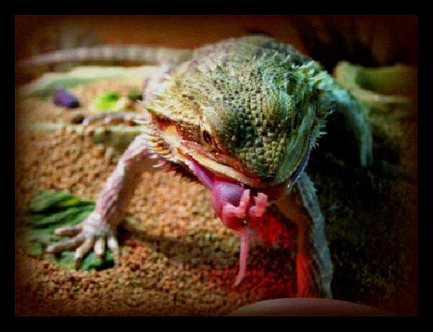

“Lunch. Go wash up.”

“I’ll be right down,” nodded the boy as the remaining pinky became dessert in a feast of grotesque and wanton carnage and butchery inside the reptile’s mouth.

As the two-year-old lizard licked its crescent chops, the seven-year-old Threfrim Samand sighed with satisfaction, and cheered his pet on as he slipped his feet into a pair of leather slippers and headed down the upper-middle-class staircase and into the kitchen where his mother and two servants had lunch preparations underway.

As the boy went outside to wash up, his father made his way back down to ensure that all was in order. Captain Samand—who had lost his life just four years ago during the siege of Yaga Shura—had become quite concerned with order and control since his honorable resurrection. He’d always leaned towards law, but his profession and life experiences had led him to become nearly obsessed with maximizing the management of his family’s affairs with as much precision and deliberation as possible. He’d dealt with insomnia since that fateful day when the fire giant bested him and drove a flaming greatsword through his heart, but in the last year—perhaps year and a half—he’d been able to keep the dream demons at bay and sleep through the night... most nights.

Last night had been an uneasy one, and he was still a bit delirious under the midday sun. He went out to make sure the boy was washing properly, and noticed a westbound caravan of merchants and entertainers proceeding through his street. He nodded to some of the passengers as they looked through the windows of the horse-drawn carriages. The frontmost wagons were all loaded with people, while those that lagged behind were pulled by far heftier draft horses—even a few camels!—and contained a menagerie of beasts.

An amber-skinned human male in his mid-thirties walked by eastwardly and bade the Captain a fair morning, as there was still about an hour’s time to pass before Highsun would ensue. “Top of the day, Captain.”

“Xavier, how are you?” asked the Captain as Xavier passed the tiger cage with a sign above it that read, “Cho Quixotic.”

“The day is young, but lady luck may yet present me with a luscious tulip.”

Captain Samand chuckled, knowing the man’s proclivities, “Yes, well, may you be granted your tulips. May it be four lips, in fact!”

Xavier smiled as well, and said something arguably creepy as he bade the Captain well as he made his way over to Saradette’s smithy.

“Come, son; let us set the table that we might share a meal together before I set out tonight,” bade the father to his son.

Xavier made it another block, and turned the corner, arriving at Saradette’s Metalworks, where Laryssa was being outfitted with a new magical suit of full plate. The enchanter who had worked on bestowing the magically protective properties—a half-elven woman named Francyne—had taken as payment Laryssa’s previous suit of armor, which was a Called suit.

“Not to change the subject, but I want to commend you on your choice,” Francyne now complimented the paladin. “The Ring of Arming is a truly superior means of Calling your entire arsenal at once.”

“Thank you,” Laryssa could be heard saying as Xavier approached, beholding the beauty of the three women before him.

“A good morrow to you all, ladies. I greet you with tidings from the Omlarandins,” Xavier announced.

“Oh, right, you were there all week,” Saradette recalled aloud as she affixed the Lifekeeping Crystal onto the breastplate’s gorget. “There,” she exhaled with satisfaction as the suit of armor pulsated once with the protective properties of the crystal.

“Nice,” Laryssa murmured, satisfied.

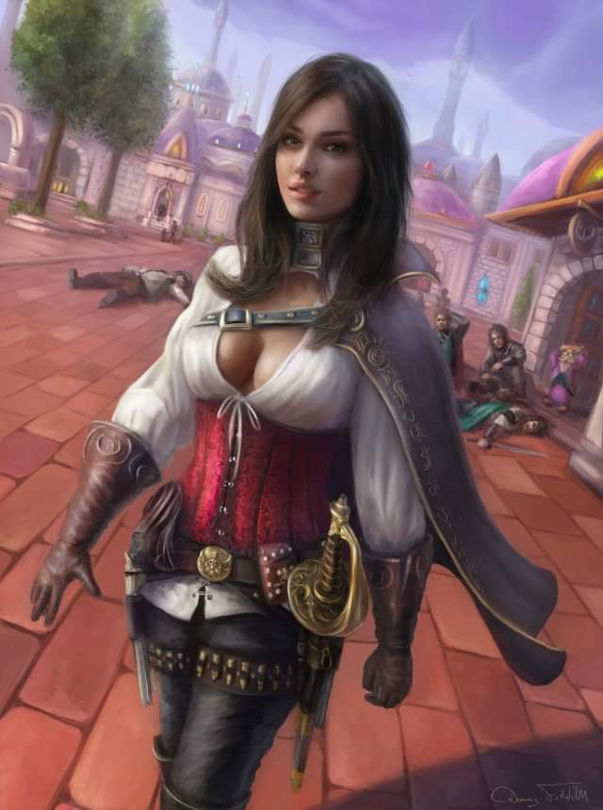

“Xavier,” Francyne nodded, not quite bowing to the man who had once been her lover.

“Francyne, looking enchanting today,” he admitted to the enchanter, then read some tension in her voice and face, and misinterpreted, “Oh, did I just interrupt some girl talk?”

The metalworker came down from the counter, making her way along a flight of gnome-sized stairs in the shop she’d fashioned to her heart’s content over the course of the last year and some change. “Hm, no; no girl talk, really. I was just telling Laryssa about the only non-gnome Lantanese artificers who dabble in this line of work,” she waved to the wall devoted to the craft of artificer items, though only one such item was in operating condition: a sabot launcher. It was quite unconventional for an artificer item, as it did not exactly mimic a spell-like effect, but rather shot out multiple flechettes in a lethal, conic spray.

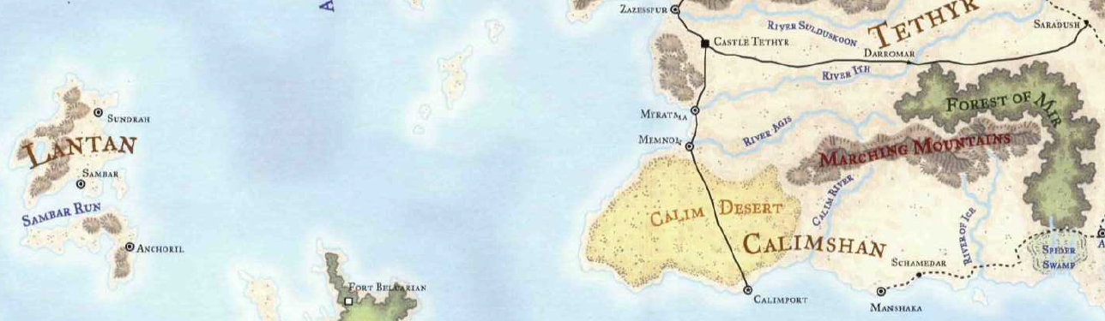

“Oh, right, Lantan, waaay out in the Trackless Sea,” Xavier provided his homocentric perspective.

“Trackless for you,” the gnome protested. “The gnomes of Sambar have been tracking and charting it for centuries.”

Xavier shrugged, “Charting what?”

“The Trackless Sea!” Saradette clarified.

“So you do call it Trackless!” Xavier made the point. He and Saradette got along well enough, but they made it a point to tease one another’s logics, which at times were mutually incompatible. “As a matter of fact,” Xavier divulged, “on my way back from the Omlarandins, I traveled with a band of merchant types—exporters, they called themselves—who just set out today for Castle Tethyr, where some of their goods are to be shipped to Lantan.

The women had been discussing a worshipper of Mayaheine who had gone to Lantan to spread word of the Shield Maiden over a year ago. They had expected the man named Petros to return, as he had said he would, but the advocate for the extension of protection to all who asked for it—irrespective of alignment—had not been heard from since his departure. They had settled the discussion by the time Xavier had entered the shop, and there was no need to reprise what had been concluded.

“So, Xavier, what brings you here?” asked Francyne, being the least pleased of the three to see the charming human.

“I, uh... oh, right. I bring a message from Barkley, who is in his shop now, and says to go ahead and come by for lunch anytime. Something about a new brew. You know how he’s always changing his recipe, and announcing some new and improved batch,” Xavier explained to those who needed no explanation.

“Yes, we heard yesterday about it,” Saradette checked over the suit of plate before patting the part covering the paladin’s left gluteus and deeming the armor fit for the field. “Thanks for this, Francyne,” she whispered to the enchanter as the paladin responded to Xavier.

“It’s his way of finding a focus for a feastly celebration,” Laryssa had come to realize by now. “Barkley is a wonderful entertainer when he wants to be. You ever see him shapeshift for kids?”

“More than once,” Saradette giggled as Widget balanced along a branch-like ledge formed by a beam that crowned the ceiling and walls.

“Is Elsabet there already?” asked Francyne, having an inordinate amount of respect for the favored soul of Mayaheine.

“No, but yesterday she said she’d be by at Highsun, so not too long from now,” Xavier looked outside and noted the very slight angle of the shadows cast on the street.

~*~

Unlike Saradette—who dabbled in just about any kind of metal craftwork—and Barkley—who worked with all things leather—Elsabet specialized in offensive technology, be it made of metal, leather, wood, and any other materials. She was not the metallurgist that Saradette had become by now, but she had learned a good bit of methodology from the budding artificer, and could still make a melee weapon exhibiting more impressive craftsmanship than Saradette... not that either of them was competing for a title.

Working as an apprentice for the city’s finest weapon shop, Alhorza’s Fine Arms and Armor, Elsabet was just finishing up a project: putting the last touches on a three-balled, spiked flail that was meant for a young human named Salim, the son of a prominent noble in the city: the Baron of Ulfren. The Baron’s eldest son—who had not as of yet purchased a noble title—was an inexperienced but talented and promising combatant who seemed far less interested in playing the role of Baron than in excelling in military campaigns against the few nomadic hordes that had dared to attack the city in the two years since he’d been admitted to the Municipal Guard. His incrementally impressive reputation had been Elsabet’s main motive for agreeing to fashion the weapon in question, though the compensation was also well received. She felt honored to have been commissioned with the task of arming the officer, knowing what high deeds he’d already committed, mostly in alignment with her deity’s most noble virtue: Protection.

Wiping down the smooth surface of the weapon’s recently lacquered heft, she inhaled the piney scent one last time before placing it into the bag of holding that she’d been provided by the House Ulfren. She only had to walk a few thousand paces before she would be at the gates of the Ulfren Château, and upon delivering the item and exchanging the expected pleasantries with father and son, she would make her way to Barkley’s establishment to celebrate a prosperous week for her and her friends’ businesses.

The pleasant stroll towards the château was none too eventful; the favored soul waded through a current of townsfolk along one of the busiest throughways in the city, and then took a side street as the pedestrians around her became scarcer and more affluent in their self-presentation. The last hundred steps consisted of an ascent towards the wrought iron gates guarded by two boys whom she could have rendered unconscious before they could draw their swords. She bade the two youngsters a fair day, and they returned the well wishes as they opened the gates for the familiar face. “The Baron and the Lieutenant have been expecting you, milady.”

The maître of the Estate was already outside tending to a flower arrangement, and gave a few last instructions to the florist crew before turning his attention to Elsabet. With a bow and some well-chosen words, the maître led the weaponsmith into the bronze-accented mansion, and presented her to the Baron and his son.

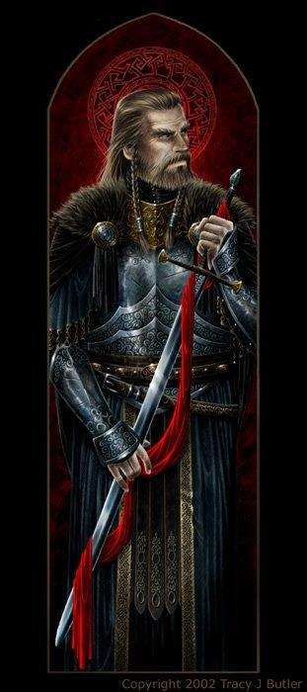

Standing on the granite floor of an ample room adjacent to the entryway, the Baron was dressed in a fine vestment intended for diplomatic purposes covering a suit of magical plate armor, while his son was in the armorless attire of an off-duty Lieutenant in the Saradush Municipal Guard, and each looked like they had their respective diligences to see to.

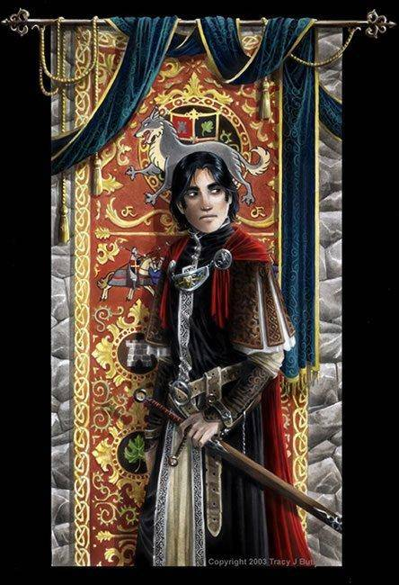

Their demeanor confirmed this. While not curt, the two men were as brief as they were courteous; by the time the maître had returned with the woman’s payment, the topic of their next encounter had been broached in the form of an invitation to Salim’s engagement ceremony, which had just been announced and was to be held in two days’ time once relatives from afar could be gathered.

Elsabet bowed to both the nobleman and his son. “I am honored by your invitation, and will make every effort to attend, of course! My heartfelt congratulations, and I will endeavor to ensure my companions are able to attend as well.”

Judging by the look on the father’s and son’s faces, Elsabet intuited that her folkways had been just right for the tastes of the Saradushite nobles. She could tell that the junior man had meant it about the gifts.

Lieutenant Salim Ulfren expressed his gratitude once again for the handsome and well-balanced flail, and personally saw the weaponsmith to the gates, emphasizing, “And please, I urge you to invite your friends—particularly that archon fellow—and to not bring any gifts to the celebration. The only thing we lack is space to store the things we already have.”

As Salim saw her out, Elsabet smiled at him, and said “I hope your new flail serves you well, Lieutenant.” She spoke more quietly, “I gave it a personal touch, sir—the metal endcap at the end of the handle, which screws on tightly to keep the wood from splintering, if you unscrew it the inside has the letters S U etched inside stars much like the spiked heads of the weapon. May your star ever rise higher, and be a pain in the sides of your enemies! Should any claim the weapon is not yours, you can show them proof it was made for you and you alone.”

She bowed again, and took her leave.

~*~

Elsabet walked downhill now, making her way to Barkley’s, and looking back on the last year of her life. Aside from her own trials and accomplishments, she’d come to hear quite a bit of recent events from the myriad travelers who made their way through Saradush across the southern plains and mountains of southern Faerûn. The swordswoman had become concerned with invasions and establishments of tyrannical orders. Though lawful, she saw the mixture of Law and Evil to be perhaps a worse threat to good folk than its Chaotic counterpart, for it manifested enduring, dysfunctional legacies and based on agreements among the wickedest of enslavers.

To Elsabet, the scope and nature of an invasive campaign mattered less than its motives, and she found them to rarely carry with them the intention of diffused prosperity. Just last year, around the same time as when the forces of Mulhorand invaded Unther, occupying the majority of its territory, Mirtul Trevis Uhl and several other former Zhents founded the settlement of Newfort in Sundabar Vale. To her, these two attempts to oust previous residents of both regions were on par with Nalavarauthatoryl—an elf-dragon known for not taking names—leading an army of goblins and other monsters into Cormyr, despoiling much of the countryside. Elsabet had learned from the group of town criers known as the Reporters that during the resolute culmination of this conflict near Suzail, King Azoun IV slew the elf-dragon hybrid, but was in turn slain in this final battle of what had by now been termed the Goblin War. She had heard of the subsequent advent of the newborn king of Cormyr: Azoun V, whose coronation would be deferred until his fifth birthday, until which his mother would rule by moderated decree.

Elsabet’s mind raced with topics that she and Laryssa and others had already gone over a few times, and as she reached Barkley’s and made her way inside, she found them all discussing some of these. Within minutes, they’d covered some of the events that were transiting between current events into history. Waterdeep had been invaded by a host of sahuagin late last year, streaming forth from the Sea of Swords, and uncovering a festering plot by Umberleans to relieve Waterdeep of much of its population. Further out to sea, the Northlander kings had recently sworn fealty to High Queen Alicia Kendrick, giving birth to a new nation titled the United Moonshae Isles. And closer to home, Sfena—the founder/leader of the Iron Throne, and daughter of Glasya—had been abducted by minions of Asmodeus, and her lieutenants in the Iron Throne were even now squabbling for control, the outcome of which was as uncertain as the temperament of Malar himself.

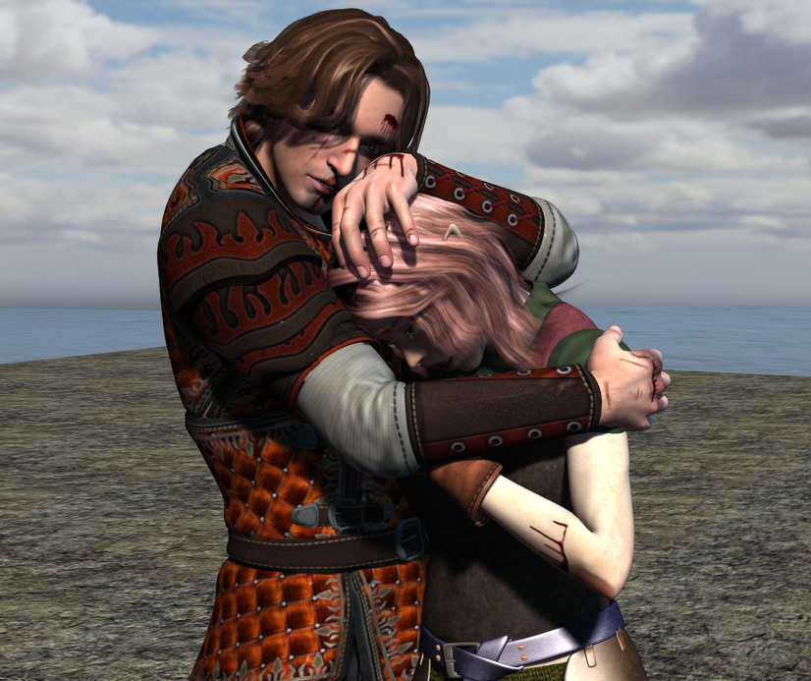

When all of that had been discussed, and Barkley’s new concoction had been adequately sampled, spirits were optimistic, and hearts were content. Francyne and Xavier suddenly excused themselves after one of them probably cast a message spell to communicate something to the other, and the fair skinned Francyne blushed as she got up to leave with her ex-boyfriend. Laryssa knew her well, and knew that she’d be back to complaining about him within a week, but the cycle needed to resolve itself, the paladin had come to learn.

“So,” Saradette broke the flow of the more aimless topics that followed recent happenings, “what else is happening in the way of trade routes?” The artificer had become quite interested in following the economic trends that shifted resources across the roads that cut through Saradush and beyond. This was partly an academic curiosity, but she also found herself embroiled in a bit of a profit motive, hoping to opportunistically ride some wave of fortune or fate. Though comfortable, she and her friends were all starting to feel wanderlust as their feet longed to tread over new earth and trails, and it wouldn’t be long before they would all succumb to this urge, leaving their respective trades to aspiring successors or glad competitors.

“We’ve discussed several options if we’re serious about taking a trip somewhere,” Laryssa recapped. “There’s plenty of guard and mercenary work to be found in the agora and taverns: caravans and traveling VIPs need guarding, monsters in the surrounding countryside need exterminating, and there are plenty of bounties pending. Barkley knows about these better than me.”

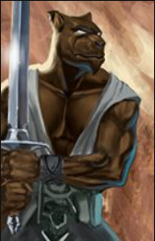

Barkley nodded. “Bounty hunting seems to be a thing lately... I haven’t really put my finger as to why, but it feels like law enforcement is having to shop out a lot of its functions to mercs. Not sure how I feel about that.”

“If nothing else, that’s more opportunity to petition to ‘help out’,” Elsabet commented.

“I just want to confirm that we’re still a band of altruists, right?” the paladin-cleric interjected. “I mean, if coin is what we want, you three are doing perfectly well with your anvils and flagons,” she waved to all around her as a sign of at least Barkley’s prosperity.

“No, no,” Barkley assured her. “It’s not like I’m dying to leave this behind, but it’s been a minute, and we’ve all talked about stretching our legs.”

“Even if it’s on horseback,” Saradette joked, “or in the comfort of a wagon.”

They laughed as Barkley drank his own brew and tried to say something about him running around on foot the most, though no one heard him over the laughter.

While sipping slowly at Barkley’s latest concoction, she told the group of her invitation to Lieutenant Salim’s engagement party. “I couldn’t really refuse at that moment, and I would like to attend. And they did extend the invitation to all of you as well. What do you think? It’s a month away, so perhaps there’s time to do other things in the interim, as long as they don’t take us too far away.” She sipped again. “And to be honest, it’s possible something... interesting... might happen at the party. An assassin to thwart or some such. Do any of you know anything about the Baron or his son that we might find enlightening?”

He nodded and thought for a moment. Seeing all three of the women he traveled with dressed up in ball gowns would be a sight to see. “I would like to attend or you plan on going Elsabet. I have never been to such a fancy party. Perhaps you can help me select an appropriate outfit to wear.”

They returned to the previous topic, with Elsabet verifying, “Alright, so we’re agreed that we’re into freeing political prisoners, and the like, right?”

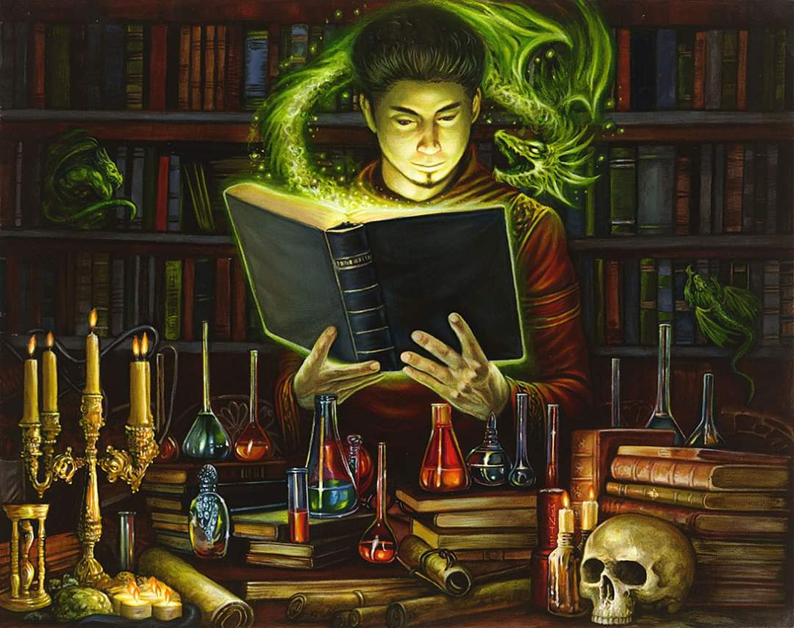

“On a somewhat related note, do you all remember that Malcome Neversurrender guy?” Laryssa asked.

A unanimous affirmation followed. Elsabet added, “Did about two months in the dungeons for his stint at the Obstinate Loaf that time, and upon release went ‘underground’.”

The cleric of Mayaheine smiled and updated her friends, “Right, and then he resurfaced, literally and figuratively, having freed some of his former convict friends from the dungeons, and put together another band of villains.”

“And?” Saradette seemed concerned.

“He was nabbed again just the other day,” Laryssa was glad to report. “Evidence of accomplished, attempted, and as of yet unattempted deeds damns him to hang by Municipal decree. He and his lackeys are to be executed publicly in three days’ time.”

Elsabet shook her head, “Mayaheine brought him to us, and we did our best to reason with him and show him mercy.”

Saradette nodded, “We did what we could, given the circumstances.”

A brief moment of silence ensued.

“I don’t mean to seem insensitive to poor, old Malcome, but how is everyone enjoying the new brew?” asked Barkley as an actual paying customer waved his attention.

They all took a moment to think of how they’d respond to the archon once he came back to the table. In the meantime, Laryssa took a moment to add the relevant tangent to the story of Malcome, “So on the note of the conviction, it turns out that one of Malcome’s associates in his most recent misdeeds—though not quite that culpable in this caper—is wanted for some even more nefarious felonies in Mintar. The City officials are commissioning a band to deputize with the decree of ushering this convict to Mintar for trial there. And before you ask, yes, this is a political favor of sorts across municipalities,” the paladin—now somewhat of an insider—gossiped.

They all knew full well by now where Mintar was. It was the next city to the east of a size comparable to Saradush, and was actually east-southeast along a fairly reliable trail. Though the heroes had reached Saradush by way of the Omlarandins, most entering the city from the east who weren’t from Mintar had just come through Mintar, and tales of the best natural resources that a coastal area could yield had repeatedly filled their ears during their stay here.

The hound archon came back and followed up, “So? The ale? What do you all think?”



Anyone who didn’t like the drink was saved by the bell: the first of twelve bells tolled, resounding throughout the city, announcing the advent and passing of exact Highsun. The scent of lunchtime hung high across all of Saradush, but those inside the homes and establishments here on this five-block, star-shaped intersection came out to hear the quartet of town criers known throughout the city as the Reporters. Curious, they went out to hear, and could see the ensuing crowd by the time the fourth bell tolled.

By the time the twelfth tolling of the bell had vibrated its last, four bards were standing in the star-shaped center of the intersection with instruments in their hands, one of them propped on a Tenser’s floating disk with a 10’ radius and a few props that boosted their voices. Linked to diviners and investigators at the central office by a Rary’s telepathic link spell, they proceeded to take turns announcing in succession the various news feeds that had been collected from prior communiques over the course of the last 24 hours.

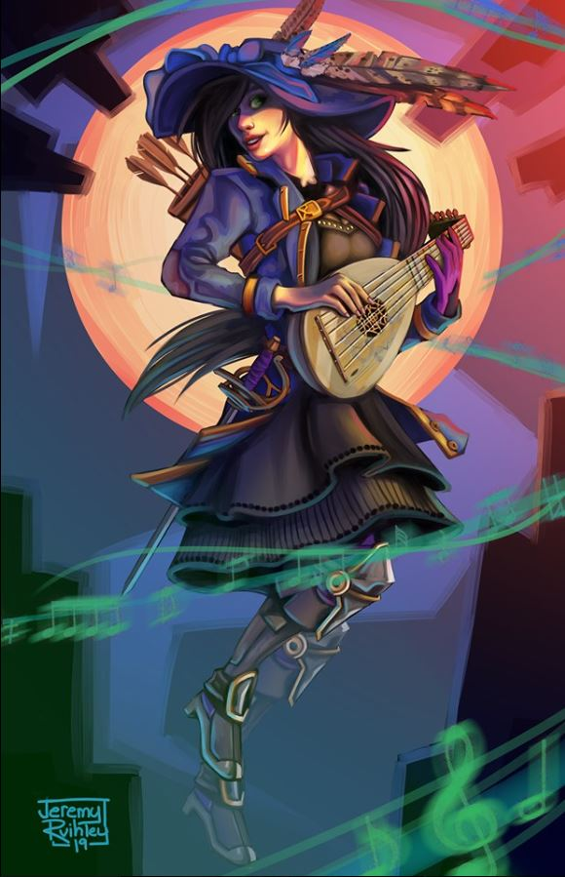

“We report that the City of Thultanthar—otherwise known as Shade—is reputed to have phased out of the Material Plane late last night. The last time this happened, the city phased into the Shadow Plane and back into the Material over a cluster of towns, which it subsequently destroyed. Speculation regarding where on this plane the city might reappear, and what its intentions are towards other polities on Toril has yielded several hypotheses, but governments throughout Faerûn and beyond are putting contingencies in place should Shade plan to carry out hostilities against the peacefaring nations of this world.”

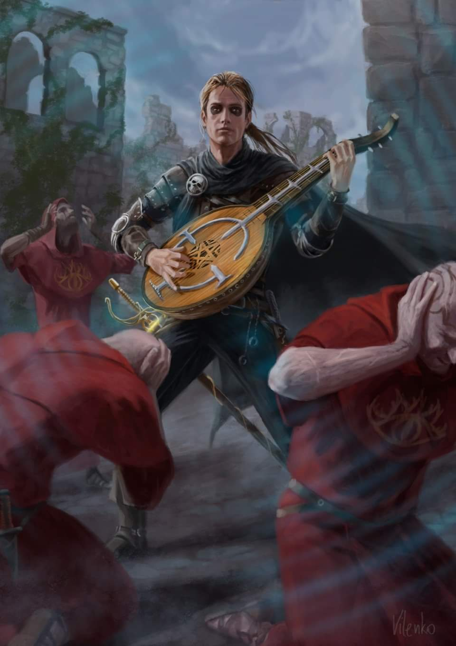

That first bardic woman stepped down and another stepped onto the invisible stage, stating: “As most in Saradush now know, on Midwinter night, the god Bane returned to Faerûn, bursting forth from the skin of his son, Iyachtu Xvim. With his divinity restored, Bane quickly gained the portfolio of fear, restoring him to a Greater Power, confirmed by the consequent powers of his clerics, who have emerged from hiding during their deity’s period of death. Consequently, Banites are now rebuilding Castle Kilgrave in an effort to fulfill the prophecy of Bane’s ascension to uberdeity status!”

“In related news,” a third bard said as he replaced the previous man on the invisible force field, “the church of Tyr is building the Abbey of the Blinding Truth in Westgate, along the Dragonmere, as an effort to counter the prophecy. Theologians dispute the controversial actions and reactions of both churches. In other news, the Treaty of Garumn’s Gorge has finally been signed, officially recognizing the Kingdom of Many-Arrows, this being the first ever orc kingdom!”

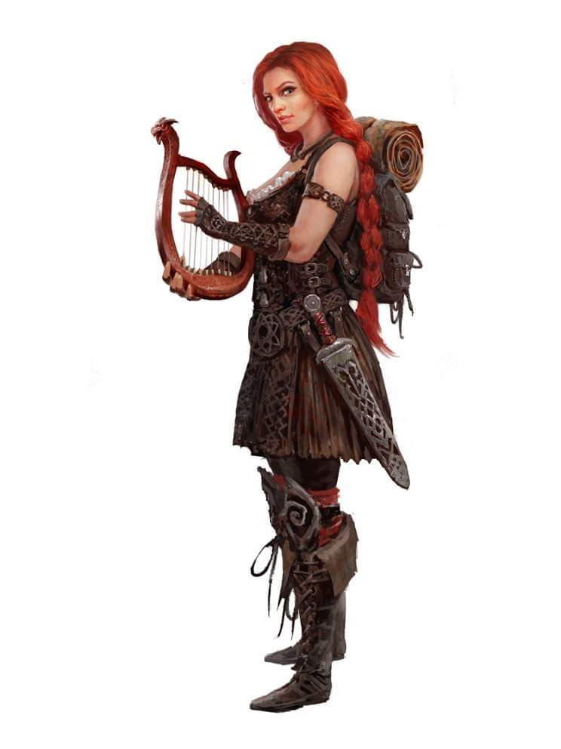

A fourth crier—a really sexy woman—got up on the stage and cried out: “A new and upcoming heroic band, The Order of the Jade Blade, has been incorporated in Loudwater. Two adventuring parties who had earned the respect of the Gauntlets of Loudwater were brought before High Lord Kalahar Twohands whose son, Velvred, has been kidnapped and is being held in one of the Rensha tombs beneath the High Lord’s Hall. Kalahar himself was warned by divinations that if he were to enter the tombs he would surely be killed, so he has commissioned and dispatched the two groups into the tombs in his stead.”

They continued alternating their stances atop the proverbial soapbox, announcing items dictated by others as they were updated in real time in some cases. “Another heroic band—The Guardians of the Weave—are founded by the Waterdhavian wizard Aluvauna Thornym to combat the uptake of the Shadow Weave by magic-users…” … “… Elminster Aumar clashes with the Shadovar, opening a rift to Avernus in the process. By expending his considerable magical repertoire, Elminster closes the rift, only to be allegedly taken captive by the ex-Archdevil Nergal…” … “… This just in: Shieldmeet Otar, a young orc chieftain from the High Forest becomes the new Green Regent, much to the outrage of many influential citizens of Loudwater!”

A few more bits of local and trivial news followed, but that was the meat of the day’s briefings. As they went back inside, they discussed both the global events they’d just heard as well as their own prospects and options.

She mused a bit more. “I wonder if the Lieutenant and that scofflaw Malcome have had any interactions? And in any case, I certainly hope Malcome won’t be able to escape before his appointment with the hangman.” She sighed and shook her head. “I guess he wasn’t interested in redemption...”

Saradette set her tankard down on the table. “Are we taking the duty of escorting him?”

Elsabet replied, “I’m certainly willing to escort him on his last walk.”

“It’s not what I was proposing, but if you want to,” Laryssa said calmly. “It’s definitely in line with our moral code.” Malcome apparently gave up this other guy in the interest of a pardon, but then attacked his attorney and the pardon was rescinded.

Barkley also chuckled as he finished his tankard and licked his lips with his long tongue. “I would too like to see him make it to his execution. After that there seem to be many more concerns about the world. Bane and his clerics for one, I would like to see them not complete their rebuilding of Castle Kilgrave. Perhaps we can visit the Abby of the Blinding Truth in Westgate.” He paused for a moment, not sure how all of them would take his curiosity. “I would also like to visit this orc kingdom in Garumn’s gorge. Perhaps this is a sign of good things to come.”

“The assigned guards might be amenable to us tagging along if we explain we had caught him previously and wanted to see him pay for not mending his criminal ways.”

Elsabet was already resolving to get in touch with the Lieutenant on the very next day, possibly accompanied by one or more of my friends, in order to find out the expected dress code and setting for the party; inform the young nobleman of who would be joining her there, investigate the procedures for an execution by hanging, and find out if the guards would allow or want extra security provided by the party.

“I look silly in a dress,” Saradette said. “I’ll find something nice with pants to wear.”

Elsabet whispered to Barkley, “Down, boy! You’re drooling, and it ain’t pretty!”

As Barkley watched the performance of the four bards, anyone watching would have noticed his tongue out and him panting a bit more when the two female bards performed. Especially the second one in a tighter, more revealing outfit.

Barkley quickly pulled his tongue in and attempted to wipe away the excess drool. His cheeks also turned a slight shade of red, barely visible through his gray fur. Still wearing the same peasant’s outfit that he had on back in 68 when he’d met the girls, Barkley imagined himself far more spruced up than he’d ever been, and tilted his head to the side and replied, “I don’t know, I think something bright and flowery might look good on you.”

Saradette wrinkled her nose, and then she grinned at him. “I’d say bite your tongue, but that’d be especially painful for you. I can do bright colors, but not patterns.”

Laryssa looked doubtful as the others discussed the invitation and what to wear. “Um, I’m not really sure about me and fancied-up frippery. On the farm, we really didn’t hold with clothes that one couldn’t slop the pigs in. I’ve seen some of the getups the high society types wear... how would one be expected to fight in such unwieldy stuff if trouble broke out? If I’m wearing regular clothes when summoning my armor, it fits inside just right to pad against chafing but if I’m wearing something all billowy with yards of cloth and such, I’d hardly be able to move if I summoned my armor over it. I wonder if a new tidy tradesman outfit would suffice without giving offence? New clothes of some sort at least is required... can hardly attend a fancy party in travel-stained duds.” She mentally totted up her ready funds, badly-depleted from her recent purchases, thinking it would be foolish to waste a fistful of gold on a fancy dress she’d likely never have occasion to wear again anyway.

Barkley looked at Laryssa, “So fight without the armor or take off the outfit. If you don’t want to keep the outfit, donate it afterwards. But you must represent yourself and your goddess adequately and appropriately.”

The paladin-priestess frowned, “Hmmm, I doubt that stripping down in the middle of the party would be deemed appropriate either. I suppose it might be possible for a talented dressmaker to rig a quick-release of some sort so the dress falls away at the same moment I summoned my armor. I imagine only a quick glimpse of my undies in the middle of an ambush by persons unknown wouldn’t be too scandalous. But all things considered, I much prefer something simple but tasteful that wouldn’t be too bulky to fit within my platemail.”

“Well, if she can come up with something workable yet elegant, I suppose it’d be alright. Just can’t go overboard with the accessories. I’ve never seen the appeal of sparkly stuff that you buy just to wear... although a brooch with the symbol of the Shield Maiden might not be out of place.” Laryssa got a thoughtful look on her face.

At the mention of a dress for Barkley by Elsabet, he looked at her for a moment, his head tilted to the side. “You know,” he began, “in my studying in the library, I came across a sort of dress for men. It’s called a,” he paused, looking upward as if the answer were written on the wall. “It’s called a kiln,” he said then paused, shaking his head. “No, that’s not right,” he then snapped his fingers as his eyes opened wide in that famous Ah-ha’ fashion, “A kilt. I could wear one of those. Pants are not comfortable for me, but this kilt would be suitable. So, if you ladies do not wear dresses, tight pants would look better on you than on me.” Barkley smiled and looked at each of the ladies. Suddenly, images of them in tight leather pants ran through his mind and he began to pant for a moment before grabbing his now refilled mug and took a long drink.

“Excellent idea, Barkley!” Elsabet grinned. “Are we agreed, pantaloons for the ladies and a kilt for the gent?”

Barkley smiled, glad they had reached a solution and glad that none of the ladies had picked up on his moment of lust. Raising his mug, “Then it is settled. We will go shopping for new clothes tomorrow. Then, after the celebration we seek out and destroy evil wherever it may be hiding!”

“Wait,” Saradette looked up from her mug. “Which evil?” She’d missed the middle part of the conversation.

[IC response]

Elsabet looked at Laryssa and returned to a previous thread. “Hey, I’m just a girl from a village where I worked at the hearth stocking the fire while my mom banged on the anvil, but I cleaned up well enough. You’re a long way from the farm now, if you’re going to master the Negotiation specialization, part of that is learning how to hobnob with the big dogs. And I don’t mean B here.” She winked at Barkley, then turned back to Laryssa.”

“Come shopping with us, girlfriend; we’ll find you something elegant but close cut, with padding at the right places so that it will fit inside your armor if you have to call it. Saradette’s not going for anything frilly or goofy either—and I won’t wear anything I can’t fight in. We’re a team; if we shop together and go together, we can coordinate our outfits, and we’re not gonna mimic the highborn fancy types. We’re gonna be ourselves, just a wee bit prettier.”

She paused briefly to sip again at Barkley’s latest brew. To be honest, she couldn’t really tell them apart all that much—her tastes were fairly simple, and she really didn’t enjoy drinking too much. Then she continued. “Look, if we try to imitate the nobs, we’d be setting ourselves up for backhanded ‘compliments’—but if we pick our own unique look, that says ‘these folks are confident in their abilities and they aren’t afraid to strut their own styles’, they won’t be able to put us in a comfy niche in their pecking order. We’ll have each other’s backs, be it a party or a fight.”

She mused a bit more, “Saradette doesn’t want to wear a dress? None of us have to! I bet Xavier or his ‘ex’ will know a tailor or seamstress capable of putting together something subdued yet elegant, that we’ll be able to maneuver in if we have to. We can all wear pants! Unless Barkley wants to wear a dress?” She looked over at the archon, raised an eyebrow, and waited for him to realize she was just kidding, sort of...

“The thing is, we’re a team. We’ll get us a set of party clothes that are coordinated in style and cut that will make it obvious we’re a team, one for all and all for one, and that will negate any need to try to figure out what passes for high fashion. And if anyone is short on funds, I can spring for some of the fancy duds.” She grinned. “No excuses!”

As Barkley emptied his tankard, he realized it was his 5th mug of his Dwarven Axe Dark Ale and he was starting to feel the effects. As he looked around at his three companions, he wasn’t sure if they had always look so good or if it was the ale. After a moment of looking at each of them, he decided it wasn’t the ale.

Saradette drained her mug, set it on the table, and stood, albeit a bit unsteadily. “Barkley, I need a strong, trustworthy gentle-being to see me safely home. Do you know where I could find such a person?”

Barkley stood and bowed, almost stumbling forward, “I can see you home!” he offered as he gave Saradette a smile.

“After you, then,” Saradette smiled back, her eyes bright. “I think you know the way.”

Laryssa had partaken of far less of the ale than the others, only sampling the various brews to be polite. Her single-minded desire to be ready for a battle at a moment’s notice required keeping a clear head at all times, so she was perhaps better situated to pick up on the body language of her comrades. Thinking to herself there be something in the offing between the two, she dismissed the supposition with a mental —none of her business nor her interest. It was the thrill of combat she craved. Since Barkley hadn’t waited until all his customers had left the establishment, she decided to step in to watch over things and then close up the shop.

“Last call, gentlemen!”

Most of the patrons peacefully finished their drinks and left, but one belligerent drunk decided to get handsy with her. Elisabet began to get up to help but Laryssa motioned her to keep her seat. Looking back at the would-be groper, she just gave him a steely stare before she was suddenly armorclad and armed.

“I think you’d better leave before you have to be carried out.” she spoke menacingly.

The drunk gulped and beat a hasty retreat. Laryssa’s armor disappeared as quickly as it had appeared. She smiled at Elisabet while starting to lock up. “This ring’s starting to pay for itself sooner than I expected.”

~*~

Barkley stepped through the door, then waited for Saradette to stand next to him and he matched her pace on the way back to the boarding house. Once there, he walked her to her door and opened it, “Good night my friend, sleep well.” Barkley gave her a friendly bow and a wide smile.

The gnome reached out and took his hands. “I’m not that drunk, Barkley. I don’t think my bed is big enough for both of us,” she smiled at him.

Barkley blushed slightly, “I did not intend to share your bed,” he said as he glanced into her room, then gave her another smile, “I will see you tomorrow.”

Saradette gazed into his eyes for a moment, and then she smiled and nodded. “Good night, Barkley.” She turned and stepped into her doorway. “I will see you tomorrow.” With that, she stepped inside and gently closed the door.

Saradette was mostly concerned with her craft at this point, so she was perfectly willing to leave their itinerary to the others with more lofty goals. She was excited about traveling and exploring, but not so much about the reasons why.

~*~

Along with the others, Laryssa was at the seamstress’ business describing what she wanted for the party and the paladin happened to be the first to voice her desire. “The blouse should be should be low-cut enough so that this pendant is clearly visible,” instructed Laryssa, as she displayed the pendant she’d had made with the symbol of Mayaheine inscribed upon it. “Both the blouse and pants should be fairly snug, without excess cloth in the way of ruffles or other frills.”

“Pants?” exclaimed the tradeswoman. “But surely you want a dress for a party?”

“Oh no, I believe we’ve all decided on pants, as we are an adventuring company.”

The seamstress gave a ‘customer is always right’ sigh and proceeded taking her measurements.

~*~

Returning for the final fitting, Laryssa was somewhat dismayed to learn that, to the seamstress, ‘fairly snug’ meant skintight. Furthermore, ‘low cut’ was an understatement regarding the blouse. While not nearly as well-endowed as some of her allies, the pendant nestled in the displayed cleavage and swell of her hips made clear her gender. Staring at her image in the mirror, Laryssa thought it was hardly the garb befitting a serious warrior priestess, but sighed reflecting it was far too late for modifications to be made in time for the party. Eyeing the scar that marred the left side of her face, she played with her scarlet tresses to see if perhaps her hair might be styled in such a way to help hide it... perhaps one of the others might know someone.

“Well, it certainly ought to fit under your armor if necessary,” commented one of her friends dryly, causing her to blush slightly.

Barkley accompanied the ladies to the seamstress, and at his mention of a kilt, the Seamstress just looked at the group and shook her head as she went to gather some samples of the colors and materials they had mentioned. She could be heard muttering, “The woman wears pants and the male wears a skirt,” as she disappeared into her back room, embroiled in her own cultural quirks.

When they returned later for their final fitting, Barkley noticed that Laryssa wasn’t completely happy and was about to say something when he heard the comment, “Well, it certainly ought to fit under your armor if necessary.” Since he was about to say something, he couldn’t be sure who had said it. Instead, he said smiling, “You will also certainly turn many heads.” He finished adjusting his kilt and his loose-fitting shirt, and turned to the other two ladies, “As will you all. I do believe the phrase is, you clean up nicely.” Barkley gave a slight laugh at his joke as he turned to let the ladies see his outfit, his holy symbol around his neck hanging over his shirt.

Barkley bowed, “Thank you, and you look stunning as well.” He smiled and winked at Saradette. The diminutive gnome did look very nice in her skirt and heels, surprising Barkley as he thought all three women had opted for pants.

“Very nice,” Saradette told the archon. “That’s really classy.” The gnome had chosen to wear knee-high soft exotic leather heeled boots, topped by a simple scoop neck dress that came to just above her knees, which gave an eye-popping display of her chest.

~*~

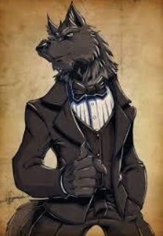

They were looking good, and they were on their way to the gala at the Ulfren Estate, sporting most of their weaponry, and some of them even their armor. Turning the heads of the locals—some of whom were familiar to the party—they waved and smiled as they strutted from the main avenue to the side street that eventually led to the mansion.

Welcomed by the two garçons at the gate, the party walked in schmoozing with a family of humans who had made a relatively swift rise to prominence via the purchase of noble titles and numerous donations to the secular government that regulated the urban area and surrounding boroughs.

Laryssa felt somewhat out of place as she strolled thru the gardened approach to the manorhouse. Although the past few years of clerical duty had exposed her to more sophisticated places, she was still a farm girl at heart and the signs of wealth and power now displayed before her were somewhat overwhelming. The flowering trees and bushes were a familiar sight however and her practiced eye suggested perhaps someone had been overwatering them a bit. Wondering whether it would be taken as insulting if she were to mention it to one of the servants, the priestess approached the entrance where a short line of partygoers were waiting to be announced.

As they had approached the gate, Elsabet had suggested to her friends that they stay in pairs as they mingled; it looked like Barkley and Saradette would work well as partners, so Elsabet strolled along beside Laryssa. Elsabet’s own outfit was a little less revealing than Laryssa’s, a little more neutral, so she’d play the “gentleman” of the two, as it were, and discourage any unwanted advances with a smile and a bit of banter.

As they waited in line, she could see her friend’s discomfort, and sought to relieve it by talking about their similar backgrounds. “Don’t let their display of wealth bother you, L. Think of this instead as a chance to practice our diplomatic skills! We can aid each other, and it wouldn’t surprise me if we surprise some of these gentle folk with our own wit and turn of phrase.”

Saradette noted the opulent surroundings, and she began a discreet survey of the place’s construction, with an eye to how someone with ill intent might sneak in and out. This well-born family spent a bit more coin and effort in the way of opulence than in security, though the infrastructure was mostly sound from a breaking-and-entering perspective. The few possible breaches that she

She noticed the priestess’s discomfiture, and she reached out for Laryssa’s hand, squeezing it gently. “You look good.” The gnome released her hand and smiled up at her.

Laryssa smiled and nodded her thanks at the support of Saradette and Elsabet. She also reminded herself that when all was said and done, these were all just people, intrinsically no better or worse that anyone else. With a reassuring touch of the pendant riding proudly between her breasts, she took a deep breath and mentally vowed to comport herself as befitted one who served the Shield Maiden. Barkley and Saradette having wandered off together for a closer look at the lush gardens, the paladin-priestess entered the manse accompanied by her fellow Mayaheinite, Elsabet. Giving their names to the majordomo at the door, the pair were announced to the roomful of attendees.

They made their entrance.
Skill | Rank | Ability & Mod. | Misc. Mods. | Total | Roll | Check
Barkley, Diplomacy | 0 | Cha (+2) | 2 | 4 | 15 | 19
Elsabet, Diplomacy | 8 | Cha (+2) | 4 | 14 | 2 | 16
Laryssa, Diplomacy | 9 | Cha (+1) | 0 | 10 | 15 | 25
Saradette, Bluff | 0 | Cha (+0) | 0 | 0 | 14 | 14
Saradette, Diplomacy | 0 | Cha (+0) | 0 | 0 | 5 | 5
See below.

The three swordspersons were relatively versed in the way of courtesy in the Tethyrian lands; Saradette, not so much, though she did take a good look at the way her friends were bowing before copying them.

Once they’d been properly introduced to the ladies of the house—Adama, Malin, and Ghertrude—they were free to wander about the spacious indoor area, and were offered distilled drinks. The three human women—the Baron’s sisters—remained near the front entrance, greeting every arriving guest while the Baron and Salim presented the younger’s bride-to-be to the elder males in the room. While most of Faerûn had moved beyond such sexist conventions, Saradush remained a staunchly conservative bastion of colonial rule from abroad, and insisted on resisting change, choosing instead to remain in the mid-1200s when it came to gender equality.

As they moved into the room, Elsabet whispered to Laryssa, “Nice work on the entrance; you nailed it! Hey, look over by the window there, that older gentleman standing alone with a drink looks like a military man, don’t you think? He looks a mite pensive, perhaps he’d enjoy chatting about his campaigns with a couple of young ladies who’ve seen a fight or two themselves... and there’s a table of finger food not far from him. Let’s grab a couple pastries and drift into his orbit!” Elsabet awaited Laryssa’s nod, then started making her way towards the refreshments. She decided to avoid any that were overly sticky or covered in powdered sugar; those would be too messy.

Laryssa also avoided most of the offered tidbits... the clothes she was wearing, while modest in frills, were still fancier than any she had worn before and she was careful to avoid anything that might stain them. Given her militaristic bent, the warrior priestess migrated towards the gentleman Elsabet had pointed out, but it became swiftly clear he was more interested in her cleavage than talking about past battles, and Laryssa quickly excused herself to mingle elsewhere.

As the musicians began playing a tune, couples wandered onto the dance area, moving to the music. Laryssa gave a start from a tap on her shoulder and turned to see a partygoer about her own age, who bowed and asked if he might have this dance. Unable to think of a diplomatic way to decline, she reluctantly agreed with a nod as he led her to the dance floor. Suppressing a shudder as his hand went to her waist, she experienced briefly the memory of the goblin raiders who had swarmed her farm and were only prevented from gangraping her by the timely intervention of the wandering cleric who been passing by and heard her screams. Shoving the memory back into the depths where it belonged, she managed a pleasant smile at her dance partner and did her best to follow the unfamiliar steps of the waltz.

Elsabet hadn’t noticed Laryssa slipping away immediately, but not long afterwards, she looked up to see Laryssa dancing with a young man, who seemed to be oblivious to the paladin’s slight stiffness. Making her excuses to the retired captain by the window, she moved out only to dance floor herself, sashaying solo into position near Laryssa and her dance partner. Sliding behind the young man, she caught Laryssa’s eye, and silently mouthed the words “you okay?” She tried to make out whether her friend was in distress or merely just trying to get the hang of the dance. Would Laryssa want Elsabet to cut in, or butt out? That was the question. Meanwhile, she did enjoy moving to the music, and what she could see of the gentleman’s... hindquarters....

Glancing past her dance partner’s head at Elsabet, Laryssa gave a slight nod to indicate nothing was amiss. What she was unable to communicate was the conditional information that it would depend on her partner not getting overfamiliar with where his hands were. Should he reveal himself to be less than a gentleman and his hands start to rove, she did not trust herself not to overreact... going full armor on the dancefloor would likely be remarked upon—let alone subsequently drawing steel.

Elsabet nodded an acknowledgment, and the evening continued.

Barkley was enjoying the scenery and the people milling about. Several had given him smiles and pleasant greetings as he walked around with Saradette.

Saradette did her best to mingle once the dance was done, but it was difficult to converse with the tall people, especially when she ended up talking at crotch level to many of them. One human teen boy was particularly fascinated with the view down Saradette’s top. She had to shoo him away when he wanted to dance cheek-to-codpiece with her.

The littler girls and boys were a different matter, and soon Saradette became embroiled in a cloud of preteen kids. They were inquisitive, but not mean, so Saradette gathered them around and told them of things she’d seen and done in her travels. One of the stories was about the starving ogres, and how they had helped them instead of fighting them.

Meanwhile, Saradette entertained the tykes by talking about Widget, whom she’d left outside with strict instructions to not crash the party unless she was called. The gnome steered clear of anything alcoholic, but she and the kids executed a daring raid on the dessert table, which netted all of them a treat and a scolding. Saradette grinned at the caretaker, who huffed at her, and then turned away with a smile on her careworn face.

When Barkley spotted Saradette talking to the smaller, younger humanoids present and began telling her stories, the archon decided to wander off on his own. He noticed Elsabet talking to a man off to the side, but could see Laryssa nowhere near. He wondered if the paladin had been scared off by the pleasantries of the evening. Then he did notice her on the dance floor with another male. Barkley felt a brief moment of jealousy until he noticed that Laryssa didn’t seem to be enjoying herself. As he was about to go and cut in, he noticed Elsabet seemed to be checking on their friend. Barkley smiled and watch Elsabet maneuver around the dance floor. She seemed to be enjoying herself. As Barkley decided to see if Elsabet wanted to dance, someone tapped Barkley on the shoulder. It was a female elf with long black hair and emerald green eyes. She smiled and asked, “Would you care to dance? I noticed you looking at some of the dancers and caught you tapping your paw.” Her smile was friendly and her eyes inviting. Barkley smiled back and bowed slightly, “I would be honored,” he replied, adding, “though I may not be very good at it. I shall follow your example.”

Smiling back, she corrected him, “My lead, you will follow my lead is the phrase.” She then took Barkley’s right hand in her left and led him out onto the dance floor. Once there, she guided his left hand to her hip and held his right hand in her left while her right hand went to Barkley’s shoulder. As they started dancing, eventually the elven female began moving her right hand up and down the back of Barkley’s neck causing him to smile and tilt his chin up as he enjoyed the feeling.

Barkley’s nape involuntarily stood on every follicle, and his ears didn’t so much twitch as they did shiver with a heretofore unexperienced sensation. When the dance was over, the woman smiled and skedaddled into the ocean-crowd around them. Barkley was still on the edge of the dance floor at a loss for words. He lacked sweat glands, and thus panted a bit to cool down after the vigorous tango he’d just shared with the elven stranger who’d had to go to the privy.

~*~

The night was approaching its zenith, and everyone that would attend had shown up by now, including the fashionably late. There were three samurai emissaries from Rokugan, bards and celebrities from near and far, and an eccentric Thayyan mage named Balmidovar. Families of well-to-do mingled with rising professionals, prominent government agents, and even a few groups of folks who got their hands dirty for a living, though they could afford to visit the seamstress recently. First-generation nobles and old money alike distinguished themselves from those who’d spent a month’s wages on a dress by color-synchronizing their costumes and suits, and choosing patterns so unique and memorable that it would be unseemly to wear them twice, thus obviating the fact that these were throwaways, so to speak. In truth, most of what was worn here tonight would be sold to merchants making way for... anywhere, really, and those outfits would in time be worn by pettier nobility and gentry in surrounding lands. There was a whole economy built around conspicuous consumption, and the four heroes—likely the humblest of means in the whole property—were quite aware of it.



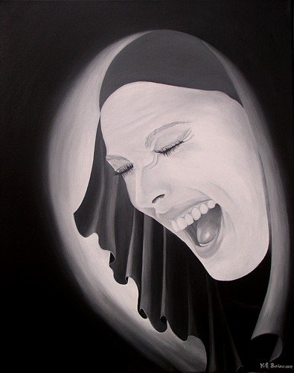

The dancing had climaxed when just about every bard on the guest list joined the paid entertainers on the makeshift but elegant stage, and just about rocked the town inside out with their collective diggity and style. The party wasn’t exactly winding down, but the first few rounds of brews and spirits had gone through everyone’s livers by now, and the larger groups were breaking up into dyads and triads, meandering throughout the gardens and courtyards on this cool, charming evening in late Ghes. Flowers had already begun to bloom throughout this southern land, which bordered the realms where only two seasons—wet and dry—alternated, and no local had ever seen snow falling.

Harpsichords and woodwinds had gone through a few rounds of tuning and retuning by now, and many of those who had partaken of the dance were now cooling off in the spring breeze outside. Those still inside were still cheering at some encore, but the heroes had taken themselves outside by the finest of fountains depicting mermen and mermaids frolicking atop a splashing wave.

The garden was not only a striking display of fire-lit sculptures, topiaries, and rosebush rows; there were also trees and bushes bearing a variety of edibles. Palms were beginning to bear dates and coconuts, and the passion fruits were nearly ready to pick, and clumps of artichokes and soursops grew near a fountain seemingly guarded by four mundane, stone gargoyles. Elsabet had looked for presents, but none were visible.

They had met quite a few people—some full of themselves; others, commanding the curiosity and admiration of the four heroes—and as Midnight approached, the betrothed couple presented themselves at the front balcony and waved to the cheering crowd. They were joined by the Baron, who also waved until the guests in the garden and courtyard settled their cheers and established lines of sight to the balcony.

“My friends who have traveled to Saradush, and neighbors who have graced us with your presence, I thank you for coming,” the human’s deep voice bellowed, peppered with perhaps one drink more than he should have had by now. “It is with great pleasure that I give my blessing to my son—Salim, Heirbaron of Ulfren—to enter into matrimony, and forge this family’s future. I...” he searched for words, then changed his expression, as if he’d decided to not say what he’d been intending to say. “I... wish to you and Evelyn the greatest joy that your entwined lives can make together.”

Holding back a tear, or perhaps something else, the Baron nodded, pursed his lips, and waved goodbye, disappearing into the house as cheers drowned out the doubt in the Baron’s short speech.”

“Well, that was interesting,” Saradette said in a low voice, pitched so only her companions could hear. While they navigated though the end of the festivities, Saradette kept an eye out for trouble. If she were trying to steal, this would be the time she’d pick, as people milled around, distracted by their preparations to leave.

“Interesting indeed,” replied Laryssa. “I can’t quite put my finger on it, but the Baron seemed unwilling to speak his true feelings about the upcoming union.”

The paladin could tell that the man wasn’t at all happy about the marriage to the daughter of a man of considerably lesser means than himself, though it wasn’t clear just how much of it was drunkenness.

Elsabet nodded, also understanding the man, even if she didn’t agree with his doubts. “I’m guessing he has reservations, but they aren’t strong enough to interfere with the engagement and upcoming nuptials.” She was also alert; like Saradette, she thought this might be a time where guests might abuse their hosts’ hospitality. But even more so, once they had left the party, folks might not be as wary as they ought to be heading homewards, especially if traveling on foot rather than by carriage.

Barkley had enjoyed the party and as they went outside he took in the scents of the garden as well as the humanoids milling about. When the Baron gave his speech, Barkley also noted that he seemed to change his mind about something he was going to say. With the way the Baron seemed to be interested in keeping well defined rolls for men and woman, perhaps the prince’s wife to be had different ideas. Barkley had learned, especially from his three companions, that women were capable of just about anything.

Latecomers to the party was a band of about equal renown to that of the four protagonists. They were incorporated under the moniker of “The Celestial Vanguard”, though their Celestial lineage was dubious. Nevertheless, Laryssa noted absolutely no evil coming from even the imp-like fey atop the shoulder of their abjurer. Some of them danced with Laryssa, who was apparently the talk of the clusters of gentlemen gathered round, including a rotund man who stood alone by the punchbowl just watching.

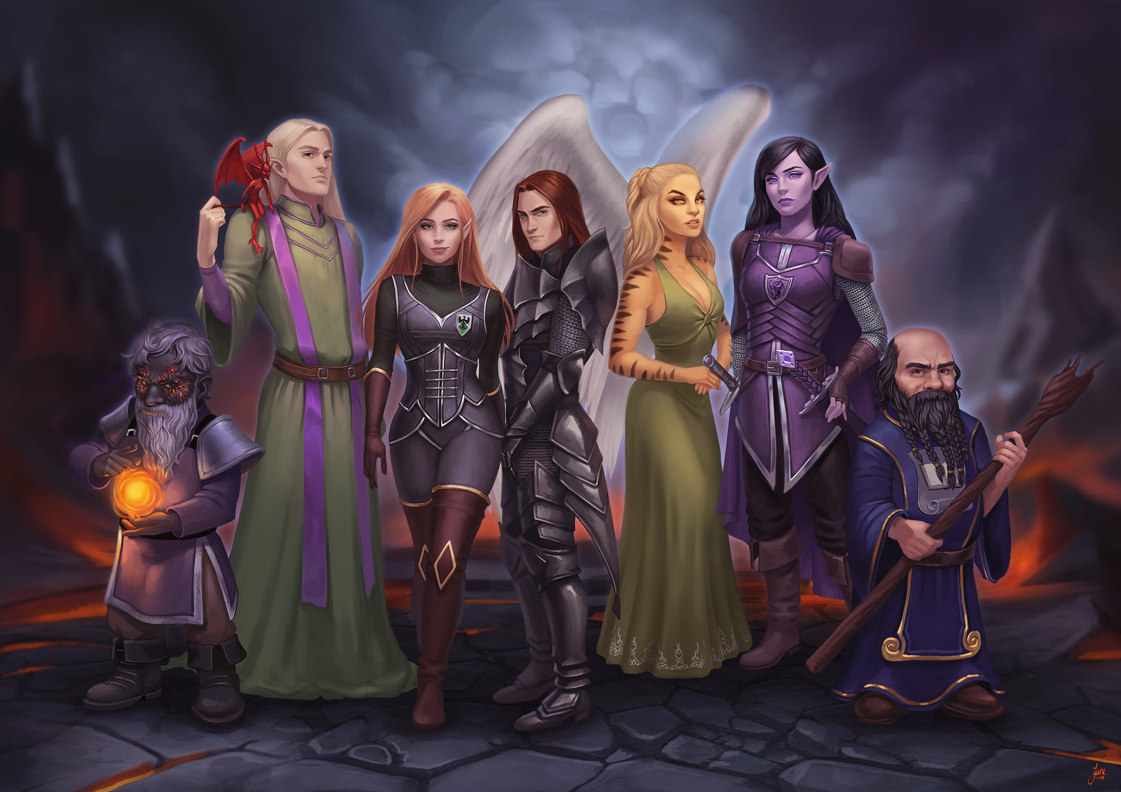

Most of them were not a particularly talkative bunch, but the two gnomes ogled Saradette and bickered about who was going to approach her first. In the end, they both did their best to tag team her, but they were less charismatic than she was accustomed to, and their somewhat rehearsed bits and jingles did little to moisten her loins. The word they heard her say the most was “no”.

As they prepared to leave, Barkley caught the eye of the elf female he had danced with earlier and bowed towards her again as she smiled back and bowed herself. He wondered if he would see her again after the party.

Saradette walked close to the archon. “What’s her name?”

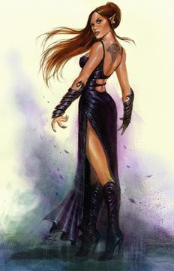

Barkley felt a little embarrassed, “I don’t know,” he said with a bit of a sigh, “I did not ask her and she did not ask for mine.” Looking down at Saradette, “Perhaps if our paths cross again I will ask.” He gave his friend a smile.

“Perhaps so,” Saradette replied. “I don’t believe in Fate, but I know that the gods work in their own ways.”

At the mention of the gods, Barkley smiled and gave a small laugh, “That they do, that they do.”

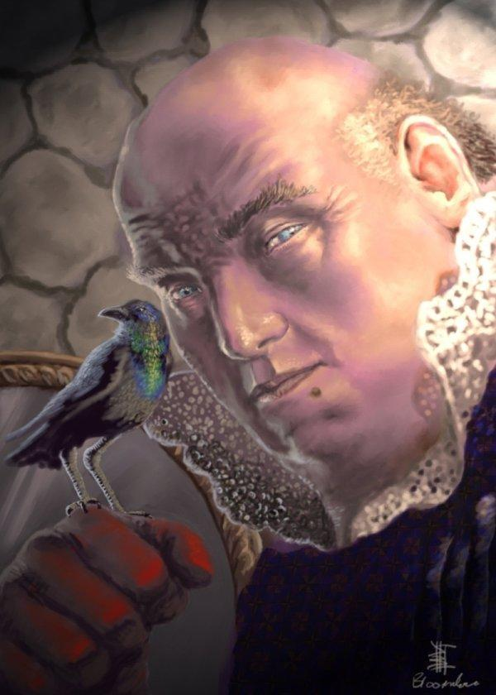

“Milady,” a human twice Laryssa’s age approached her, and bid the paladin a good evening before introducing himself as the Jarnim’len, the Marquis of Mirtul, and prestidigitated an illusory blackbird that perched on his hand. “I must confess: I watched you dance with those younger, flashier men.”

Misunderstanding “flashier” for “fleshier”, she had noted the stationary peeper on more than one dance, the sole noble standing in the shadows, his gaze upon her. He exposed his motives now, “Tell me, I wonder if you might be persuaded to join me for a drink at the Bled Xorn.”

Laryssa did her best to give a polite refusal. It would likely be considered gauche to overtly scan for evil intent in the middle of a party and, given the number of people milling about, difficult to concentrate long enough to zero in on the source of any evil emanation detected anyway. However, from the way the man had been ogling her all evening, she didn’t have to overly analyze his body language to guess what he had in mind. She could only hope she’d given no indication of her combined distaste and fear of the thought of any sort of tryst with the nobleman.

Having concluded their pleasant and not-so-pleasant interactions with the guests, and having greeted the bride and groom at the gates as the bulk of the invitees exited, the four heroes sighed at the evening’s events.

They took their leave on foot, traversing the warm streets of Saradush as Midnight drew into Night’s Heart. Once out past the gate, Elsabet looked down every dark alley as they approached and passed by them. In fact, while the city was fairly well lighted in the area where the nobility lived, it could get pretty dark in some areas; now that they were off the mansion grounds, she paused for a moment, and pulling a copper coin from her purse, cast light upon it, and held it in her left hand. “So we don’t step in anything nasty,” she said to her companions with a wink.

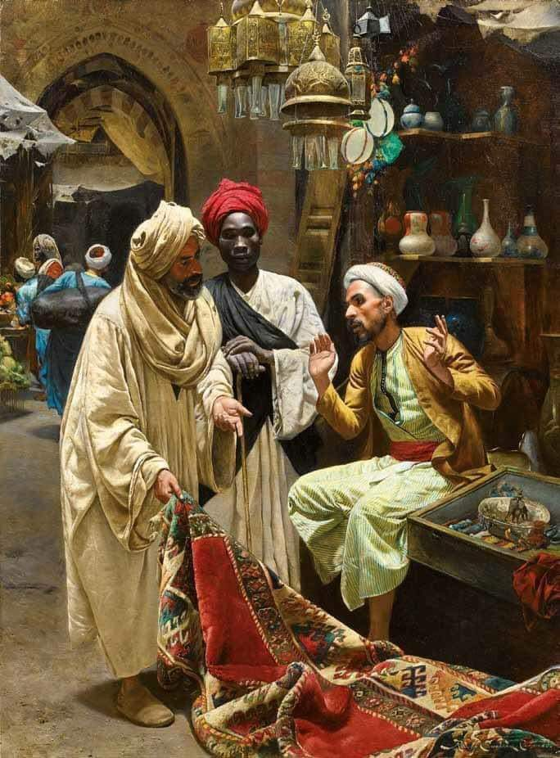

The streets were empty, save for the occasional cat or rat scurrying by as Elsabet’s light spell exposed them. Hours earlier, they’d walked past a row of street vendors and petty merchants whose wares’ prices were negotiable.

A posted parchment on a lamppost beheld the face of a stranger with half-elven ears. A reward was being offered for the capture of the bandit lord known as Bonzo the Adderlader. For his entire body—dead or alive—the crown would pay 5,000 gold; for any of his henchpersons, rewards ranging from 100 to 1,000 gold would be dispensed commensurately with the rank or priority of importance in Bonzo’s hierarchy. The last clause specified that severed heads or body parts would not qualify for the ransom, which Saradette and Laryssa knew to be consistent with an inquisitive body seeking to extract information from resurrected culprits in exchange for leniency.

They noted the bounty, and continued, eventually reaching the town center, stopping at the corner where they would go their own ways to their respective businesses and abodes.

“Evening,” one of their neighbors—a watchwoman for a local fishing businessman—walked by in full gear, headed to her late shift to relieve her cousin.

“Edwina,” Barkley tipped his fancy hat at the disciplined. “Have a good day at work.”

“Thank you. Should be a quiet one,” she truly expected, this being a routinely slow time of the year for the fishwife business. “Not too many hooligans about lately.”

As the fishwife’s bodyguard continued on, Elsabet thought to herself, ‘well now, that sounded like tempting fate to me’, and then muttered to her friends, “you know, it wouldn’t surprise me if there are in fact hooligans hereabouts.” She looked around, and up at the rooftops, trying to spot anyone who might be lurking in shadows... the woman’s offhand comment had made her nervous.

Barkley had enjoyed the night for the most part, though he wasn’t sure all of his friends had felt the same. He had noted that several of the members of the ‘Celestial Vanguard’ had shown interest in his friends, or more specifically Saradette and Laryssa. As they got closer to their quarters, and after passing Edwina, Barkley spoke up, “Well, I hope, that overall, everyone enjoyed themselves. I did notice that a couple of you were the center of much attention.”

One of them curtsied as if posing for a portrait.

He looked at Saradette and Laryssa, “Perhaps we should work out signals for next time should you need to be rescued from any unwanted attention in a tactful manner.” Barkley smiled and gave a slight laugh at his little joke.



“They were nice enough,” Saradette allowed, “but they were trying too hard. Desperation isn’t attractive. They weren’t mean or pushy about it, though.” She stepped around a patch of horse manure in the street. “Who knows, we might have a chance to work together, so I was respectful to them.” She smiled. “I’m curious to know why they call themselves ‘The Celestial Vanguard’.”

Laryssa smiled wanly at Barkley’s attempt at humor, but did not elaborate on her unease at the touch of strange men nor the reason for it, instead making a feeble excuse that dancing was not her forte. At Saradette’s musing, she commented, “It does seem an odd moniker for an adventuring band but perhaps, like us, they all follow a higher calling.” The priestess unsuccessfully stifled a yawn before continuing, “At any rate, the hour is later than I expected to be awake and I must rouse early to make my prayers to the Bright Lady. I wish you all a good night until the morrow.” With that, Laryssa prepared to take her leave of the others.

Barkley noted that Laryssa was not impressed with his joke and wondered if it was the joke or something more. He decided now would not be the time to see if there was something wrong. As Laryssa said good night and turned off towards her destination, Barkley waved and replied, “See you in the morning. I will have breakfast ready for all should you want some.” Barkley then continued along with the other two.

~*~

Late Morning, 28 Ghes, 1372
Outskirts of Saradush, the Benefort Estate

The four heroes had serendipitously been invited to a picnic by one of the handsomer lads with whom Laryssa had danced the night before, and none of them had thought to refuse, not only because the boy was cute, but also because he was well connected to the Baron, whose party they’d attended the night before, and because his aunt was the Marquise of Benefort, a prominent noble house from the southern confines of the savannas that bordered the jungles that led to Chult. The widow owned land just outside the more populated area surrounding the Walled Quarter, and they were all entertaining themselves by the side of a ruined keep whose towers had receded to siege, erosion, and fluvial dynamics.

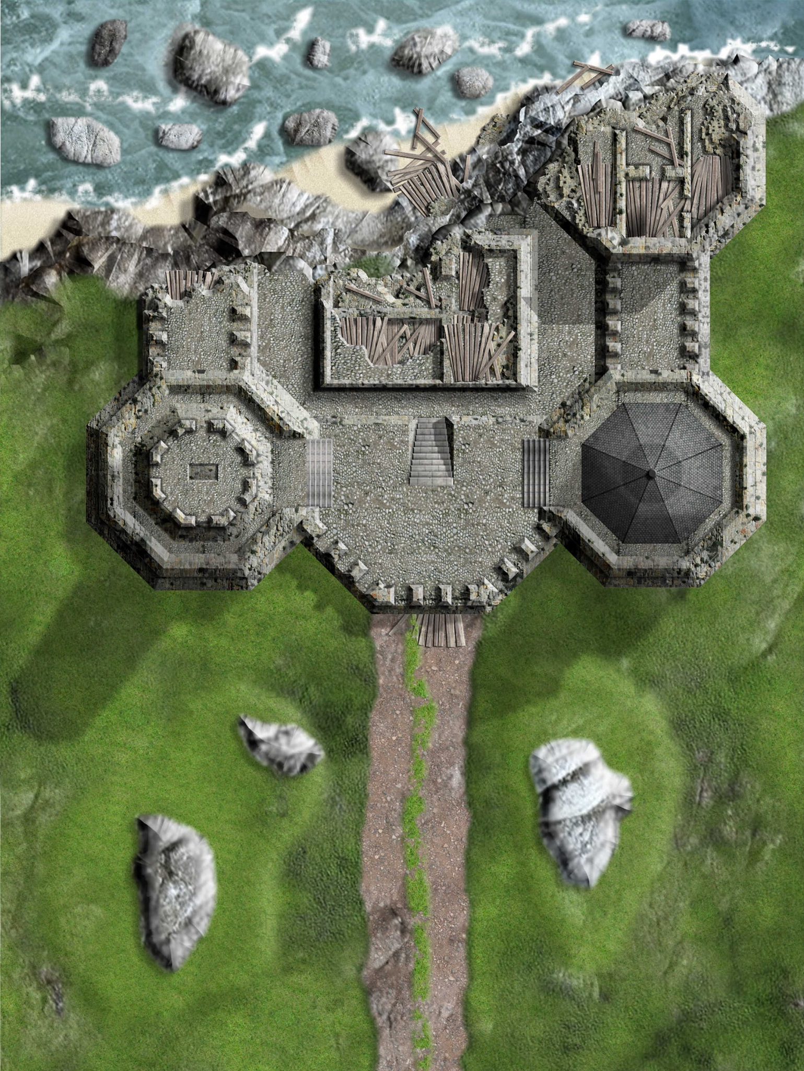

This land had been tamed long ago, and only occasionally were the citizens of Saradush ever plagued by savage beasts or barbaric tribes. Their defenses were now as strong as they had been the day before Yaga Shura had besieged them in 1368, and in some ways stronger, given the people’s recent memories of the tragic event.

They were now playing a game of woohoo, wherein Barkley had the advantage, given his prehensile mouth and springing stride, which allowed him to catch the boomerang in midair, and run past the primates with a sliver more alacrity. It was a fun time for all.

The Celestial Vanguard showed up not long after the woohoo match started, and another band of heroes—the Vexed Enchanted—had gotten there early to help set up some tables and tents for those who were planning to stay the night. It would be a hospitable, starry night, and though blankets would not likely be needed, there were dozens on a cart that a dwarven maiden had just brought by.

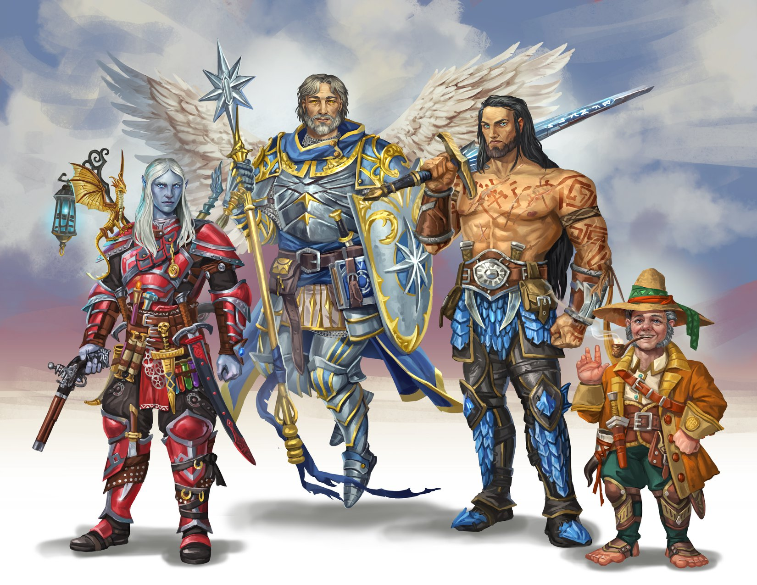
The ‘Chanted—as they referred to themselves about half the time—were far too modest for their own good. Elsabet had heard of their earlier deeds upon arriving to Saradush, but she had to admit that as her adventuring party’s resident expert on the who’s who, they were all at a loss for most of what was going on around them.

The most eloquent speaker among the ‘Chanted was a drow samurai with a queer looking wand of magic missiles that was modeled after a fantasy weapon called a “pistol” from human mythologies. His name was Efri of Zuldess’nar, and he introduced his friend, Eridu of Lliira, an aasimar priest of that goddess, and an amateur poet with no bardic aspirations whatsoever. The priest in turn introduced the human fighter-barbarian simply known as Throbb, as well as the halfling rogue-scout named Phesny.

Saradette greeted each of the newcomers in turn, adding her clan name to her customary surname when introducing herself. She spoke with Efri about his wand that resembled what she called a pistol; “I’m interested in such things, and I’ve built something similar. It doesn’t use magic, though.”

“It was a gift from a former colleague,” Efri replied. “What does your use, if not magic or muscle?”

“It uses technology,” the artificer explained. “That means understanding natural laws, like gravity. You drop something, it falls. That force can be measured and calculated. The same is done with other natural laws.”

Though the party didn’t remember everyone’s names, there were another five to ten familiar faces enjoying the riverfront pasture from the night before, some more hungover than others, and it was nice to have the choice of following up on previous conversations after a night of contemplation and subconscious rumination.

For the picnic, not knowing just what to expect other than it would be outdoors, Elsabet brought her normal traveling gear, in case some impromptu mock-duels or archery contests got organized, and in case they decided to camp there overnight. The woohoo game was fun, but she only played for a little while; she was far more interested in the adventuring groups that were attending, and hearing whatever stories they chose to share.

Indeed, she soon got out her journal, and started taking notes! She attempted to get everyone’s name correctly written into the journal, and whatever they wished to share about their origins, abilities, etc., and at the same time was happy to share her own past and the varying abilities she had gained in the service of Mayaheine. Among other things, she hoped to get a sense of what areas might need the services of the Fist of Light. Perhaps these folks had news of nearby areas that would lead to a new adventure for her and her friends. And she was especially interested in folks from exotic lands far away—how did they end up here, with the people they’re with now?

Social interaction intrigued her much more than physical activities, given the interesting folk that had shown up at this more relaxed event. She’d thought her own group was a bit exotic—but the Celestial Vanguard truly had an intriguing mix of people, and the Vexed Enchanted, while composed of a group more like her own as far as races, had a name that just had to have a story behind it! And she was certainly willing to talk about the things her own group had accomplished, referring to her journal to get the names right.

Garbed in far more casual fashion than the night before, Laryssa felt much more at ease hobnobbing with those in attendance, especially as many of the attendees were of an adventuring bent. Not surprisingly, she gravitated to her fellow servants of the higher powers and soon found herself in a lively debate with Eridu and Throbb as to the relative value of magic and force of arms in a combat situation. Throbb unsurprisingly was firmly on the ‘might’ side, while Eridu leaned firmly towards that of ‘magic’. Laryssa held a position squarely between the two and there was many a telling by each of experiences supporting their respective claims. As to be expected, none of them were able to convince either of the others to shift from their viewpoint, but a pleasant battle of wits was had by all. Laryssa moved on to mingle with others, but took with her some interesting tactical ideas to mull over at her leisure.

So far, being embroiled in intense debate had served to ward off those who had hovered in her vicinity seeking to invite her to dance... or mayhap other possible pursuits. Eridu had been scooped up by one such, but as dance was basically a form of worship for a priestess of Lliira, the priestess of joy showed no signs of restraint. Not so Laryssa, who had hoped that perhaps there was another conversation to join. Noticing her ally jotting notes in a journal, she headed towards Elsabet to see what she’d found so fascinating but, out of the corner of the eye, spotted one of the lurkers bolder than the others headed in her direction.

Shortly after the boomerang flew past Elsabet and nearly hit her head, the subject of Malcome came up, and it was announced by the winged cleric of Lliira that it was them who had apprehended the self-serving wizard and delivered him to the authorities. “The Townships of Saradush and Minbar will do well to entrust you with his extradition,” said Eridu, his friends agreeing.

“The reward is nice too,” said Phesny, the halfling rogue with the outlandish hat and pipe.

Saradette said some Gnomish jingle in agreement with this.

“Have any of you heard anything about that Bonzo guy, on the wanted post?” asked Elsabet as some opportune moment.

“Only what was on the posted bounty,” answered one of the swordspersons.

Efri, the samurai, then nodded, and said, “Bonzo the Adderlader... he and his henchwomen—and a few henchmen—killed more than a few prostitutes, pimps, drug dealers, and other street urchins in an attempt to summon a demon in a basement under a brewery. Some speculate that this was a pilot project for a grander scheme to summon a semipermanent portal to the Abyss, enabling hordes of demons to enter this plane and wreak the havoc that we all know they can.” Being the lawful one in his band of heroes, Efri had a very developed sense for the distinction between Chaotic Good and Chaotic Evil, and while he tolerated his occidental friends’ borderline barbaric ways, he would separate a demon’s head from its body without a second thought.

Later, Elsabet, without thinking too much about it, started chatting with a squirrel, and fed the female tidbits from her pocket of treats. She didn’t think twice about doing something like this, as she had seen other introverts at functions like this taking to talking to the family dog, and petting it the whole night through. The conversation was mundane at best, though she did manage to glean some secrets about where the best nuts where buried in this tree-peppered field.

Barkley packed his armor and his weapons into his Haversack, feeling that they wouldn’t be needed, but wanted to be prepared. He also hired a wagon driver he knew to bring in a couple kegs of each of his 8 concoctions, he was eager to get others to try them and get their opinions on them. Barkley did not intend on charging for the beverages, but would not turn down any donations that would be offered so that he could make more. It wasn’t the money he was interested in, but the opinions of his drinks as well as the conversations they may lead to.

After the last game of woohoo, Barkley mingled from group to group, and as he was headed back towards the tables with his beverages, he noted a stranger walking towards Laryssa. Noting the stranger’s expression, he guessed the gentleman’s intent and beat him to Laryssa, asking Laryssa, “Can you help me with something?” and gave a subtle motion towards the approaching male.

Laryssa nodded gratefully and followed Barkley as her would-be suitor/dance partner/assaulter took a step or two as if to continue his pursuit, then turned away, apparently dejected.

“Thanks for that,” she said to Barkley. “I had enough dancing and more than enough roving hands last night to last me a decade or two.”

Barkley gave Laryssa a bow, “I am always happy to be of service. If you wait here, I should be back shortly with some members of the Celestial Vanguard. I am hoping to get their opinion on my creations as well as exchange stories with them. See where they have been and tell them where we have been.” Barkley was happy that Laryssa was happy as he left to speak with the Vanguard members.

His passionate monologue about his newest brews was more than enough to convince the heroes from both parties to join Barkley for a few rounds that very night, for on the next day, the extradition expedition would be underway.

He spent some moments under the springtime sun talking to Zephira and Cynth about where they grew up and why they have become adventures and shares his stories and reasons for leaving the Celestial plane and adventuring in the prime material plane.

~*~

As mid-Afternoon matured, the worshippers of Mayaheine and Tyr could say that had very much enjoyed the company of the newly met heroes and heroines, and by the time that parting salutations were being exchanged by most of the guests and blankets were being folded, the archon repeated the extension of his welcome to his tavern. “I will make sure the staff knows the first drink for each of you is on the house whenever you come by.”

~*~

The road was bustling with the makeshift caravan of horses, riders, wagons, and a few doggies as everyone made their way along the mile-long road that led from the ruined riverfront keep to the gates of Saradush’s Walled Quarter.

Barkley, Elsabet, Laryssa, and Saradette hopped off the back of one of the wagons, and waved and thanked the members of the Vexed Enchanted, who had let them hitch a ride back to town.

“Phew!” sighed Elsabet with enthusiasm after a flurry of fun under the sun. “That was great. Let’s do that again soon.”

Barkley—ever prudent and on top of it—said, “Now that we’ve had our fun, and before I get to preparing for tonight’s drinks in case these guys decide to show up, let’s head over to see the sheriff and see if we can take the commission to usher that this guy to Mintar.”

“What’s his name?” Saradette asked.

“Who?”

“The guy.”

“Oh.”

Laryssa was the only one who knew, and said, “Oral.”

“Hm...” mumbled Saradette.

~*~

“I just want to explore as much as I can at this point. Coming from the Celestial Plane, I want to experience as much of the Material Plane as I can. What a variety of foods and beverages—let alone people—that inhabit this realm! Perhaps one day I will return to the Celestial Plane and become a leader among the warriors of Tyr,” Barkley made the ladies giggle with his heroic ambitions. He was eager to learn and meet new people and have new experiences so he would have no hesitation on where they went so long as it was in the service of Good and allowed him to expand his knowledge. Though his youth and enthusiasm could sometimes get him carried away, the one thing that would always keep him grounded was the loyalty to his friends.

“Like they say, ‘A Hound Archon is woman’s best friend’,” Elsabet retorted as they struck their mugs against one another in a single clack and drunk a bit more of Barkey’s ale.

~*~

Morning, 29 Ghes, 1372

Rapping on the door to the local lawmaker’s office, Laryssa entered when bidden to come in and introduced the sheriff to her compatriots. Explaining their wish to join the escort.

“Yes, yes, I got your message earlier,” the Chief Constabulary nodded as they all made their way inside the building and into the Chief’s office. He introduced himself as they walked, “Chief Constabulary Percival Musharraf, at your service. I’ve heard a great deal of your high deeds,” he looked at the four as he now opened his door and let them all proceed first. Entering, they found a map already laid out on a central table near the man’s desk, with a few counters representing conversation points that he’d wanted to cover with the group.

A slightly younger and much leaner name entered the office only seconds after the party, and closed the door with a short greeting and introduction that mimicked that of his Chief, “Captain Samand, at your service.”

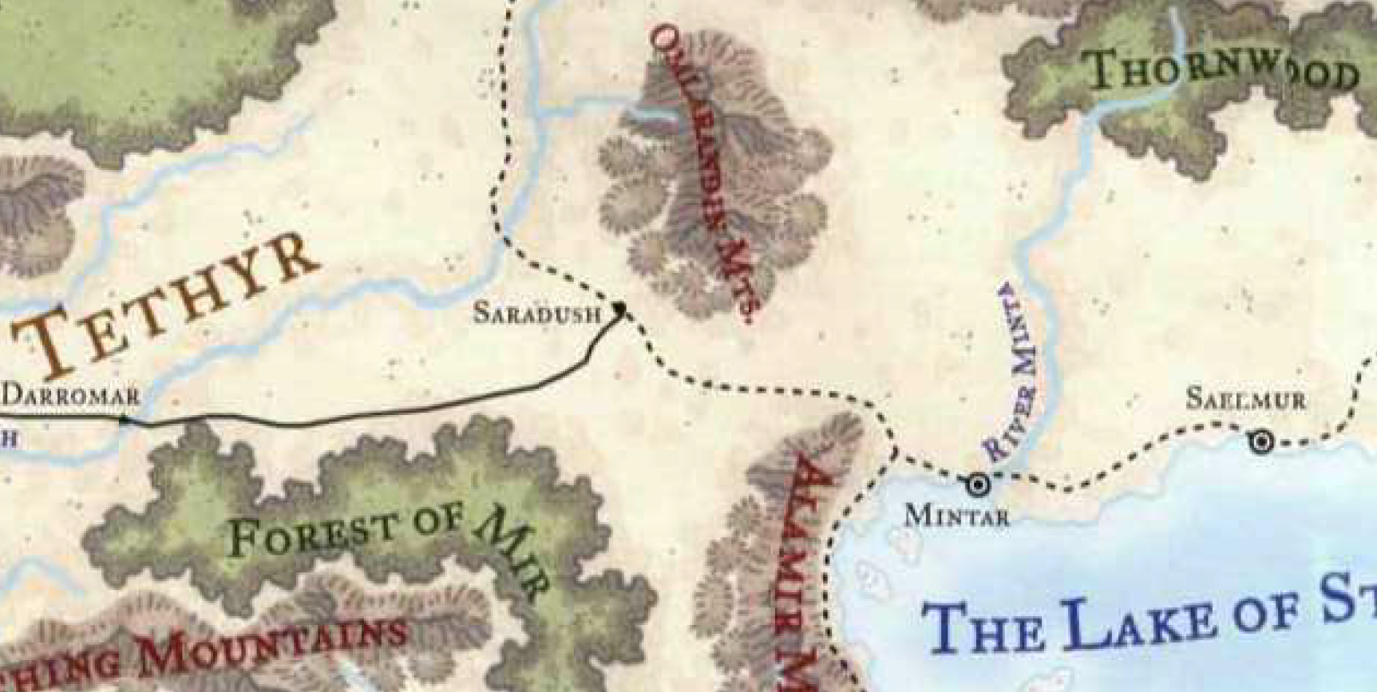

The initial interaction consisted of the usual background questions and alignment verification, and then Chief Musharraf and Captain Samand proceeded to divulge the details of the assignment.

“The prisoner goes by the moniker Oral of Saelmur, though we have yet to ascertain his family background.”

“In 1370, he was exiled from his alleged hometown, Saelmur, and made a living as an apothecary in the estuaries just west of Mintar.”

“Little is known of his deeds outside of the municipal boundary of Mintar, where he was seen about once per tenday for at least the last year bringing tonics, potions, and a miscellany of herbs to peddle to the townsfolk.”

“He was convicted in absentia for the kidnapping and murder of several citizens whose body parts he fed to his swampland pets, Divination has revealed.”

“The deranged and sickly human holds to the narrative that flesh is fodder for mightier flesh,” Captain Samand recalled the pinky mice that his son had just fed to the household-variety dragon as he finished the paraphrasing of the accused’s self-assessment.

“Sounds like a sick puppy,” Barkley blurted.

“Wouldn’t want to go to his birthday party,” Saradette slurred.

Elsabet and Laryssa looked at one another, and the former asked, “And what is to be our compensation for bringing this ruffian to those who will dispatch him to the plane to which his soul has bound itself?”

“The city of Saradush has agreed to offer 100 gold to a party of up to four skilled guards, and the city of Mintar—who is far more vested in this—will bestow upon each of you 1,500 gold upon your delivery of the convict. A pair of wagons has already been secured for the transport, and we can afford you two horses if any of you wish to ride one rather than traveling inside the wagons. Captain Samand will be posing as a civilian wagoner. He knows the 80-mile stretch of road that links our two settlements, and will keep a swift and safe itinerary.”

“It’s a grand scenery this time of year,” Captain Samand added.

“A total bounty of 6,000, eh?” Saradette—who could always use the extra coin—counted aloud. “Pretty pricy head. Who were his victims?”

It was evident to the Chief and Captain that the gnome was quick witted. “You’ve stumbled onto an important element of the case: the authorities in Mintar weren’t aware of—or perhaps concerned with—the disappearances of townsfolk who perished at the hands of Oral until the son of an important landowner and legislator went missing,” the Chief smirked. “Now I’m a poor boy myself,” he admitted, “and though I have to turn a blind eye to their blind eyes, I implore you all to strive to care for the downtrodden as much as for the haughty and well-to-do.”

Laryssa knew this to be more than common among the cities of Tethyr and surrounding lands. These were times when the meek were made to cower, and the avaricious saw to their own ends and needs. The paladin often wondered if her sword striking the hearts of orcs and gnolls was a greater service to Good than her proselytizing to her own kin and kind in the streets of this fair town to save them from the worst within themselves. The paladin and cleric of Mayaheine cared little for the coin that she would earn, which would likely go in part to enhancing her own “game”, and in part to whichever charity presented itself before her.

The party agreed tentatively, though they had a few more questions.

“Excellent,” stated the Chief, truly glad to seal the deal. “If you’ll all sign here, this is a binding agreement. We entrust you with the success of this singular mission, and know that it is not a simple task that we ask. On behalf of Mintar, we also extend gratitude and goodwill to you heroes.”

Once a third guard—a woman named Yasina—entered and bore witness to their declared acceptance of the contract, they all signed their names in black ink, followed by the Chief and Captain. The Chief then imprinted in violet wax the document with the city’s official seal, and handed it to Yasina, who nodded, bowed, bid the heroes well, and took it to the front desk for processing and filing.

Once the woman was gone, Captain Samand closed again the door and upon the Chief’s nod to proceed, divulged some of the classified information and directives of the mission. “In order to ensure the success of this transfer, please do not discuss your mission or its associated criminal case with anyone outside this room until the convict has been delivered. We have reason to believe that Oral still has friends in town who might have motive to see him freed.”

“Understood,” Saradette.

Barkley nodded, “Naturally. Full discretion.”

“Good. The prisoner will be ready at the tolling of the nineteenth bell tonight,” the Chief informed them, now that they were oath-bound to the mission and its secrecy. “We ask that you present yourselves here shortly before then, and be ready to board the wagons and get underway with haste. We have chosen this moment in conjunction with other security measures that Laryssa knows we routinely take.”

Laryssa knew the Chief was referring to shift changes that occurred during the nineteenth bell, also referred to along this southern latitude as the twilight bell. Those on the night shift were considerably more able guards and watchpersons than the daytime volunteers and squires that mostly posed to provide townsfolk the sensation of safety in the company of an active militia. In the event that anyone seeking to free Oral had managed to bribe the one or more of the most capable guards in the city, such professionals would all be expected to be on duty, accounted for, and watching one another, thereby decreasing the probability of a successful security breach.

“You’ve taken the right precautions,” Laryssa commended the Chief.

Barkley nodded; he liked the idea of keeping him gagged the entire 80 miles rather than just until they got out of town. “I can change into a Great Dalehound and go ahead of the wagons like a stray. I’ve recently learned about the breed, so I’ve never changed into one before.” Barkley thought taking a form he had never used might not be as obvious as the others he’d used at the bar or in public.

A few more words of agreement complemented some nods on everyone’s behalf.

“I’m afraid you’ll have to unmuzzle him and spoon feed him twice a day. The Captain has the prisoner’s feeding schedule, which will vary daily to thwart off anyone aided by scrying or other divination,” the Chief said somewhat cryptically. “Can’t be too careful,” he smiled. “And never remove the restraints from his fingers and hands.”

Barkley was satisfied with arrangements, and willing to take turns feeding the prisoner. “Too bad we can’t just feed him once a day and reduce the risk even more, but that would make us as evil and uncaring as our captive.”

Laryssa’s eyes involuntarily shifted to the archon, but she said nothing.

Elsabet spoke up to ask about the specific measures used to secure the prisoner, “Does the prisoner wagon contain a barred cage?”

“Oh, yes, we’ll go down so you can all get a better idea of what you’ll be working with,” the Chief promised as he grabbed his longsword and sheath and strapped them on.

Elsabet stated that she had a set of manacles as well, and that in addition to securing the prisoner’s hands and/or feet to each other, “… perhaps he should be further secured to a bar or ring attached to the wagon.” She suggested that Saradette might want to look over the mechanical security measures, being skilled with devices in general.

Laryssa added, “If the plan is to smuggle the cad out of the city, perhaps t’were best we gag him as well until we’re at least a mile or so away from the vicinity, lest he try and signal any allies who might be watching the exits from the city. Also, did he show any talent for spellcasting? If so, we might want to keep him gagged and bound the majority of the time.”

“Oh, he’ll be restrained and silenced by mundane means,” the Chief assured them. “Standard for a spellcasting prisoner.”

The favored soul of Mayaheine mentioned that, while she had no specific skill in riding, she had no problem keeping up with a wagon on foot, thanks to the Easy Travel enchantment on her armor, so while she appreciated the offer of a mount, she politely passed. “I will feel more capable of quickly responding to trouble if I’m afoot, rather than on or in a wagon.” She also divulged her ability to speak with animals, suggesting, “If the city could provide a barrel of birdseed, I might be able to use that to bribe/hire some birds along the way to scout aerially in the vicinity of the wagons on a semi-regular basis, to try to spot any ambushers that might be lying in wait along their route, or a group blocking the road ahead or coming up the road from behind, to get some advance warning of possible danger. In addition, if something spooks the horses, I might be able to calm them and find out what they heard, saw, or smelled that alerted them.”

The Chief and Captain looked at each other with a look of being impressed, and the Captain admitted, “I don’t think we’d taken that particular possibility into account…”

And the Chief finished the thought, “… buuut, sure. So long as it’s within the balance of natural laws, please do beseech the wildlife to aid you in our cause.”

Barkley suggested, “I can cast aid on myself, then Saradette, the Captain, Laryssa, and finally Elsabet. When I feel the aid wearing off, we repeat the sequence. That way, for the beginning of the trip until we at least get outside the city and possibly until we get outside the immediate environs of the city, we’ll all be almost constantly under the effects of an aid, except for each time the patterns cycle where I take half a minute to reestablish the aid on everyone.”

“But the aid only lasts a minute, right? So you’d be casting constantly for about 30 seconds, taking a 30-second break, and doing it all over again?” asked Saradette, calculating.

“Ummm...” Barkley rubbed his fuzzy chin and lower jaw.

~*~

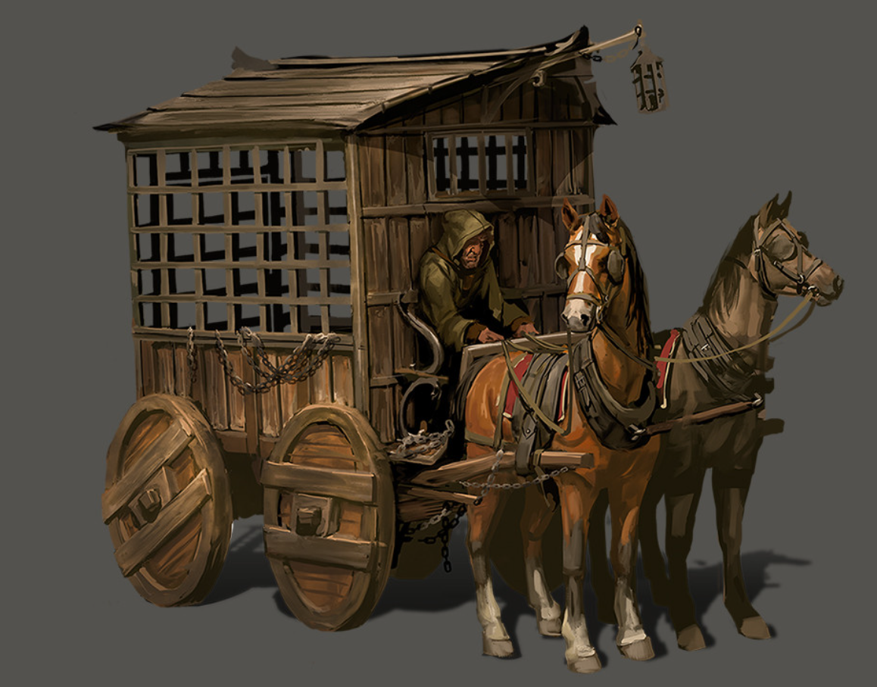

They had gone down to the stables, where four horses had just been selected to draw both the prisoner’s wagon and the rear wagon that would constitute their convoy. The prisoner’s wagon, which was already waiting just outside the stables on a cobblestone causeway, was now being fitted with a center panel that would allow a human-sized guard to occupy half the space while the prisoner remained safely in the other, ensuring a line of sight to the convict at all times.

The second wagon—while not barred—was an indiscreetly military-issue wagon comprised of a wooden enclosure with four open windows along the vertical edges of the box.

“This’ll do,” said the cleric-paladin as they were handed official seals of duty that would identify them as the true bearers of the warrant for Oral’s extradition. The warrant itself was handed to Laryssa—with whom the Chief had the most familiarity—and the heroes were off to settle their affairs before embarking on the journey that they expected to take a fortnight or so.

~*~

The sun had just set, and the nineteenth bell—the twilight bell—would soon resound throughout the boroughs of Saradush. Barkley, Elsabet, and Laryssa had just met Saradette at her shop, and now that they were stocked and resolute, they headed back to the Constabulary to report for the impending mission.

“Eeeeeyyy, look who’s dressed for a full deathmatch rehearsal!” Badnews—the gnome they’d contended with and saved just days ago after he’d nearly sold them all down the river—greeted the heroes as they walked past the Obstinate Loaf, where the gnome and his drunken friend—Brother Bornoflove—were sharing a drink on the wooden deck recently built along the southern façade of the quaint building.

Bornoflove squinted as he recognized the unmistakable mug of the hound archon, “Oh, yeah! Youuu guys! Yeeeah, dude!” he cheered with a clay mug in his hand as the street lights were being lit by a goliath youth with a tiki torch and a ladder. The drunken master—who apparently lived at the Loaf—asked, “You off to kill a dragon or wha-?” he burped at the end, not quite forming the T.

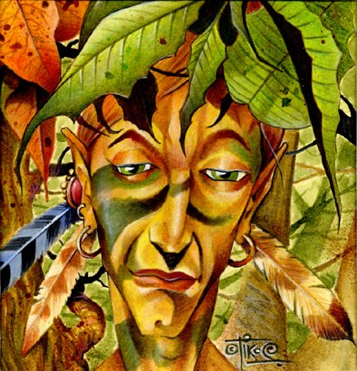

The drunken sun elf had respectable fighting skills, and in his case they were augmented—not diminished—by the drink. They’d fought alongside him in this very establishment back in Flamerule of the year before, and they didn’t know that they had a common acquaintance: Badnews.

Elsabet laughed and waved to Badnews and Bornoflove. “Naw, no dragonslaying today. Hey, have a couple drinks on me! Treat Badnews to one too.” She reached into her pouch, grabbed a gold piece, and flipped it toward Bornoflove, knowing the drunken monk was still quick enough to snatch it out of the air. “Forgot to buy you one after you helped quell that Malcome fellow and his buddies. See ya later!”
Badnews and Bornoflove were now “extra friendly” with the PCs.

“Yesssss! All’s well that ends well, I usually say,” Bornoflove cheered, raising his cup again.

They left the Loaf behind, and made their way back to the Constabulary of what was likely the most liberal-minded town in the area. One of the things that had attracted the heroes initially was the lack of peace bond laws that they would have to exercise upon reaching Mintar. Despite their suffering, only 4 years ago at the hands of the Bhaalspawns Il-Khan and Yaga Shura, Saradushites were an optimistic and resilient people, and their civilized sensibilities fostered an environment of cordiality among townsfolk that the heroes had scarcely seen elsewhere in Faerûn.

~*~

Arriving at the Constabulary, and having done all the shopping they needed for now, the four heroes were led back along the cobblestone causeway to the stables where both wagons were waiting. As they rendezvoused with the Chief and Captain, the latter waved to one of the Watchwomen, who nodded and entered the stockade.

“Good of you to be a bit early,” the Chief commended the heroes on their professionalism, noting their weapons and armor. “I—too—am a faithful of Tyr,” he leaned in to Barkley to tell him. “May the Maimed God wink upon you, heroes, and may the goddess Mayaheine protect you as you act in the way of law and order.”

Saradette held back an eye roll.

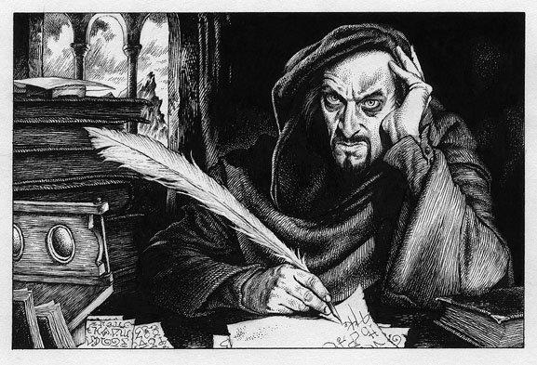

The Watchwoman emerged from the stockade with the prisoner shackled, blindfolded, and gagged. The balding human with a months-long goatee and days-long scruff throughout the rest of his cheeks and neck inhaled the clean air before a black hood was placed over his head, just moments after the heroes saw his face and noted its features.

Captain Samand—who was dressed in the simple garments of a wagoner—placed his longsword in a secret compartment under the prisoner’s wagon’s wagoner’s seat, and complimented Laryssa on her ring of arming, showing her his own.

“Nice.”

Another wagoner—a half-elf woman named Valerie—joined them and greeted everyone.

The Chief introduced the lifelong wagoner woman, then instructed the heroes, “The rear wagon has enough space for four, but one of you should always travel in this compartment,” he pointed to the rear compartment of the prisoner’s wagon as the prisoner was fastened to several restraints. “Food and other provisions are in the pantry, enough for a tenday for seven people” he pointed to the rear wagon’s front wall, “and the Mintari authorities are to restock the pantry upon delivery of the convict.”

Laryssa suggested, “One of you who are clearly armored should probably ride with the prisoner out of sight, at least until we clear town. I could ride in the rear of the other wagon, but it might be better if I were up front with one of the drivers or walking alongside as another pair of eyes keeping lookout. As I seem unable to respond to a threat but can summon my armor and weapons at need, it would be less of a tipoff to any unfriendly watchers.”

Elsabet smiled at Laryssa. “I dunno, the wagons we’ve traveled with in the past typically have armed guards, so I don’t think having an armed guard would be that unusual and attract special attention.” She thought for a moment. “How about we three larger folks take shifts? Split the day up into 3 watches, I’ll take the morning watch in the wagon, Barkley take the midwatch so he’s out of the midday sun, and you take the afternoon watch?”

Saradette saw nothing wrong with that.

She grinned. “And if you want to appear relatively harmless while not inside the wagon, that’s up to you; given that my armor is what lets me carry all my stuff and not slow down or get tired, and is light enough to sleep in, I’m pretty much wearing it all day and all night, except of course when I’m bathing.”

“So Saradette is always in the rear wagon; who’s in the front wagon first?” asked one of them.

Elsabet took the first shift in the front wagon, while the other three heroes took the rear wagon.

Elsabet climbed into the prison wagon with the prisoner, taking the morning shift as she’d proposed, but before doing so, reminded her companions of their signal whistles. “Remember to give a blast if you need help!”

When Elsabet offered to take the first shift with the prisoner, Barkley made sure to cast aid on her last so that it lasted on her the longest. While they were inside out of earshot of eavesdroppers, Barkley reminded the others. “I will change into a Great Dalehound and run a bit in front of the wagon. I’ll check the alleys as well, making sure there is no ambush.”

Barkley changed and then slipped out the back door and wandered back and forth along the main street sniffing the alleys and going up and down a few of them looking for anyone hiding along their route.

Saradette did what she could to help transport the prisoner. She also loaded up her cart and pony, in expectation of possibly going elsewhere after they delivered the prisoner.

“Oh, so three wagons?!” Valerie remarked. “Guess I’ll go in the middle.”

~*~

The precautions the authorities had taken impressed the heroes, and they were glad that they were glad that they hadn’t had to botch someone else’s jailbreak attempts as they exited the city. Once they were out on the trail and the road, visibility was fair under the moonlit night, particularly for those with nocturnal vision. Captain Samand was a disciplined man, and only made conversation when necessary, though he was cordial enough.

Their three-wagon convoy made its way mostly eastbound all through the night, stopping only when the horses needed a rest, and by the time that the first direct rays of sunlight hit their brows, they were fatigued from having been up about 22 hours. A few of them took short naps here and there, but they would have to get a proper rest if they were to continue without risking some great ill.
All characters except Oral accrued a -2 penalty to Strength and Dexterity.

Valerie, the wagoner who had ferried the middle wagon, stretched and yawned as songbirds chirped all around her. Saradette did the same, hopping off her own cart and feeding her pony a turnip.

They were no longer on flatlands, but now among rolling hills, with a minor stretch of mountains about a mile and a half south of them. Barkley and Saradette—the only survivalists in the group—agreed on a spot along the road near a northbound stream where the horses could drink and graze. “We could stack today’s block of alfalfa by the bank there, and tether the horses to that area,” Barkley proposed, having recently returned from his Great Dalehound form to humanoid form.

“A place for the camp needs to have good concealment near us, but a good field of view beyond it,” Barkley remarked, now in humanoid form. “With the north being slightly downhill, we have a few hundred feet of visibility through the foliage there. If something comes at us from the south—unless it’s something big like an ettin—it’s likely to get the drop on us... maybe literally.”

“I don’t imagine we’ll be pushing on just after a short break to feed and water the horses. Does no good to keep moving if it winds up walking the horses to death,” commented Laryssa. At the suggestion of pulling the wagons off the trail and disguising them, she looked doubtful. “We need to be careful how far we try to take the wagons. Getting stuck could be a possibility I’d rather avoid. As for disguising them, not really my area of expertise, but unless we could get them close to other vegetation, I think they’ll still stick out like a sore thumb and might draw trouble instead of avoid it...it might make passers-by think we’re up to something. In any case, we aren’t in the best condition for extensive activity. I think we’d be better off just making camp and most of us turn in for some sleep. As I haven’t used any spells today, it doesn’t much matter which watch I take.” As she suppressed a yawn, it indicated she was perhaps not as ready to delay her rest as she maintained.

Saradette yawned, causing the others to do so. Barkley’s yawn was surprisingly squeaky.

“Not to say that I don’t want to rest,” Elsabet sighed as she stretched, “but it’s time for a round of lesser restoration.” The woman used her quartet of mana units to foment the magic that depleted Barkley, Laryssa, Saradette, and herself of all fatigue. “There,” she said, “that should ease the burden of our long day and night; everyone should feel a bit refreshed, ready to fight without the fatigue riding our shoulders.”

Having seen to the horses, Valerie and Samand looked at the favored soul silently, then at each other, saying nothing, and setting up their respective cots and personal-sized tents.

Saradette stepped over to them. “I will be glad to take your places so you can rest,” she said quietly.

Barkley walked over to Valerie and Samand, offering his assistance in setting up their tents. He also added, “I apologize that my friend does not have enough magic to cast the spell upon you today. Tomorrow I shall forgo the spell if needed so that one of you can be aided by it.”

Widget had slept a good bit of the night, and now crawled out from behind a sack of grain in Saradette’s cart, where she’d curled herself up cozily. Sniffing the air as her head poked out of the cart, the raccoon wondered where they were.

“We just stopped to rest, Widget,” Saradette told her. “You can go out, but don’t go far, okay?” Elsabet looked over at Valerie and Samand, and said, “sorry, I only have 4 of those available; you contracted us to guard, you two should get fully rested while we do so. I meant to say, everyone on the first two watches should feel refreshed. Sleep well, and rest assured, we will do our job.”

When Barkley say Widget come out, he waved, saying, “Good morning, would you care for a treat?” and offered Widget a small piece of fruit.

Ignoring the human and half-elf who had ferried the two larger wagons thus far, the favored soul of Mayaheine grinned at her friends. “Easy Travel only helps for so long, but thanks to the grace of Mayaheine, none of us need nod off immediately, or be slow to react should something happen. I won’t have any bull’s strength spells, etc., today, but I think it was worth it to regain our energy after such a long time awake. Our horses and constabulary companions will need sleep the most; who wants to stand first watch with me?”

“I shall,” replied the refreshed Laryssa. “That should take us to Highsun, which is when I make my prayers to the Bright Lady, and then I can take my rest,” the lax paladin proclaimed.

Elsabet said she’d stand the morning watch while the others tended to their fatigue or hunger. The favored soul sought to chat with the nearby songbirds.

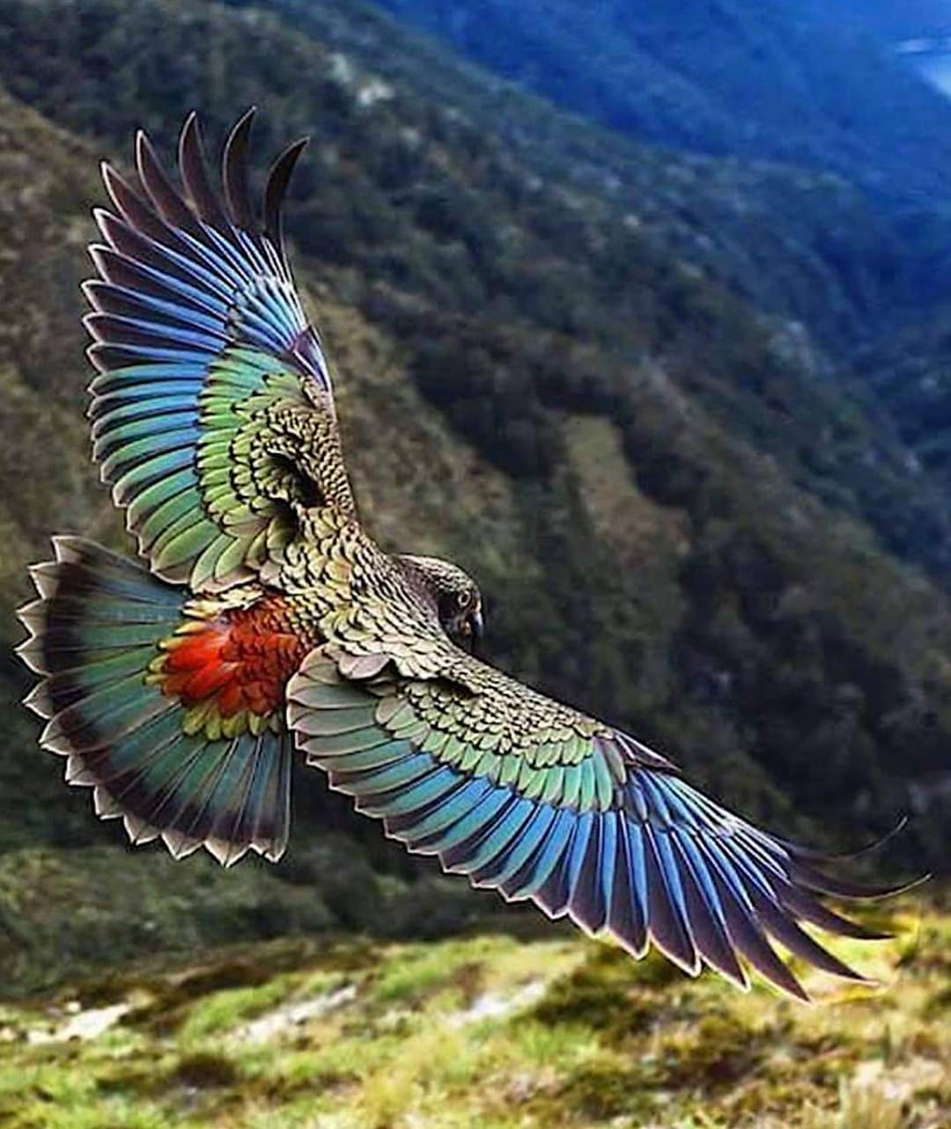

Her meandering around the perimeter took her to an iridescent kestrel perching on a lofty branch. Nearly out of earshot from the others, she chirped up to the kestrel, who hopped and glided in a spiral trajectory towards the branch nearest Elsabet. “Where you from?” asked the female kestrel.

~*~

Back at the campsite, Barkley watched the captive in the wagon as the others tended to their respective needs. He’d urinated about 200 times along the road as a hound, and with the casting of lesser restoration having renewed his vigor, the archon squinted as he beheld the once mighty spellcaster, now reduced by his own misdeeds to a convict facing execution.

Barkley made sure to re-hydrate himself, especially in front of their captive.

Captain Samand and Valerie placed hoods over the horses’ heads, allowing them the comfort of darkness under the shady tree to which they were now tethered. Taking bites of the bread they’d brought, they said little to the heroes, having gotten the message that they wanted to minimize interactions.

Not wishing to disturb the pair once they’d settled in to nap, Laryssa took the opportunity to question them about their familiarity with the route ahead.

Samand waved a hand to Valerie, and admitted, “I know the road a bit, but Valerie here practically owns it.”

Valerie shook her head, “My father was a wagoner as well. I know every stretch of this road; ‘tis true.”

Laryssa pressed further, asking whether there were plentiful sources of safe drinking water for themselves and the horses.

“We’ll hit at least one river, creek, brook, or stream a day along the way; two or three on some days,” forecast the half-elven wagoner. “The horses wouldn’t make it otherwise. As we get closer to Mintar, we’ll also pass by a swamp, skirt a lake, and even cross a bridge that spans the beginning of a delta that widens into a rather visually striking but potentially deadly estuary. For now, the horses’ hooves and wagons’ wheels should stay dry as long as we stay on the road.”

As the horses drank their fill from the stream by the campsite, Samand confirmed, “The next creek we pass is a good four hours off, eh?”

“That’s about right,” Valerie nodded.

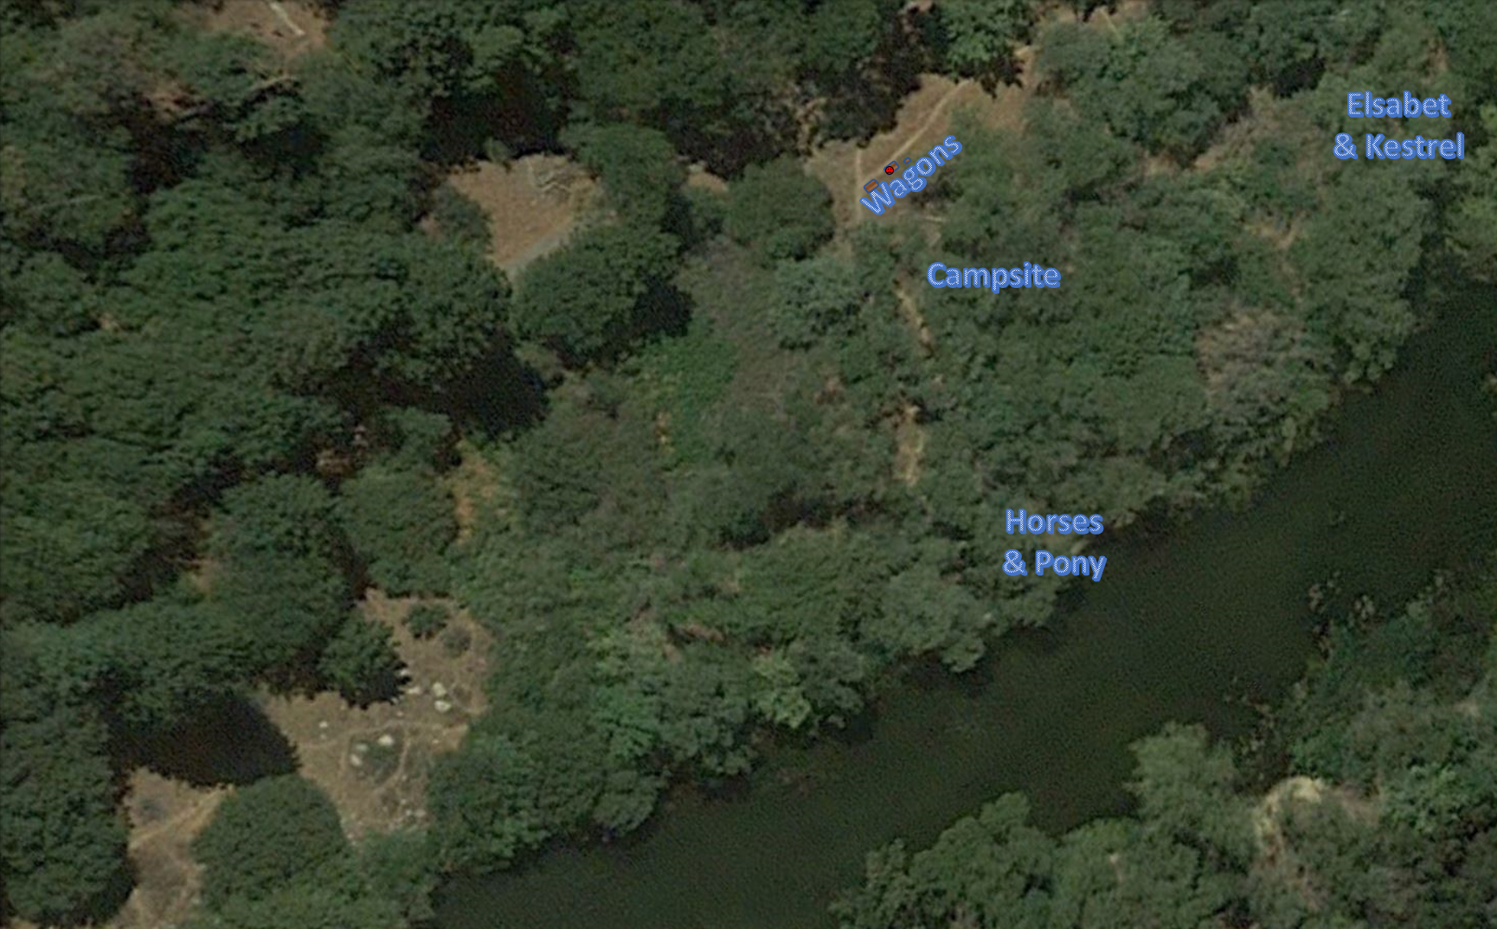

~*~

“Hi! I am called Elsabet, my friends and I are most recently from the big people city back that way,” Elsabet said, “but we have traveled many places, along the roads and trails mostly.” She pulled a handful of seeds out of her pouch, and continued, “Would you like some snacks? I’d like to ask a favor of you, if you are willing to help me! Nothing too dangerous though.”

She held her hand up high, palm up, and opened it, standing very still.

The kestrel squeaked a smile, giggling, “Hm... maybe if you have a mouse or gopher. You smell a bit of raccoon.”

The favored soul was at a loss, but posed in such a way that her charismatic demeanor alone got the tacit trust of the raptor.

“Ah, pardon me for offering you the food of prey!” Elsabet tossed the handful of seeds onto the ground nearby. “I do have some dried meat, that we call jerky, if you like, though it isn’t as good as fresh meat obviously. I might be able to zap you something fresher, though a fine hunter like you probably needs no help from me.” She pulled a bit of jerky off of a different pouch and took a bit for herself, and was willing to share if the kestrel decided to try a bite.

“Not too bad... a bit... not gamy,” evaluated the beaked carnivore perching above Elsabet’s head.

The human continued, “We think that we may be being hunted by a pack of bad people, because we are taking one of their pack to a place where he will face punishment for the bad things he has done. We will be carefully watching for them as we rest for a while, but I know the sharp eyes of the flying folk such as yourself, from the sky or from branches high in the trees, can see much farther and better than my own. Will you lend your eyes to help keep watch over us while we rest? Do you have friends who would be willing to help? I offer more seeds for this aid, and if you have any injured friends, I may be able to help them with my magic.”

“What kind of help are you looking for, She Who Dwells in Cities Yet Keeps with a Procyon?” asked the avian predator. “We have a druid to appease here.”

“Me, a druid? I am not a druid, just gifted through my ancestry with the blood of the fey folk in my veins, which has provided me with this ability. If you mean another, then we would be pleased to meet such a person!” Elsabet paused, then continued.

“As to the form of aid, if you should happen to be soaring high in the sky and see travelers upon the road or groups of people approaching through the woods, I would appreciate it if you would fly down to me, or close to one of my friends who could rouse me if I am asleep, and tell me what your sharp eyes have spotted. Don’t take any chances that they might shoot at you though! Meanwhile, I will see if I can acquire some fresher meat for you to eat.”

“Appreciate the meat, but no, there’s a revenant druid that keeps taxing us for hunting or grazing on his lands,” the bird revealed. “Can’t spot him for the life of me unless he wants me to, and by then, I know it’s payday.”

“Payday?” the human frowned.

“Animals that gather, they have to bring him tribute: dried fruits, mostly. Unless I bring him a trophy—something bigger than a mouse—he drains me of blood.”

“Holy Mayaheine! That sounds like an evil abomination! I will ask my friends if perhaps we can do something about that, once we finish our current task. In the meanwhile I will see if I can scare up a rabbit or something. Revenant, eh?”

“I miskillied,” the kestrel—whose call was called a killy—killed. “I just meant this fool who keeps coming back for more ‘tribute’, as he calls it.”

“Ah,” Elsabet remarked. “Well, I’ll see if I can get you something big enough to be considered tribute. If I can’t snag a rabbit or something, I’ll leave out a small sack of trail rations that you can bring him as tribute, and if he asks, you can honestly say you took it from an unwary traveler.” She smiled, but without baring her teeth. “Do we have a deal? Will you keep a lookout from the sky for us?”

The kestrel nodded, and replied, “She’ll be right, mate!” and then flew off above the tree line.

~*~

Saradette and Laryssa looked in on Barkley and Oral, then the conversation with Samand and Valerie continued. Their campsite was about 50’ away from the road, which some thought to be less than tactically sound, but the alternative would be to camp by the roadside, given that the wagons’ wheels wouldn’t get to where the campsite was now.

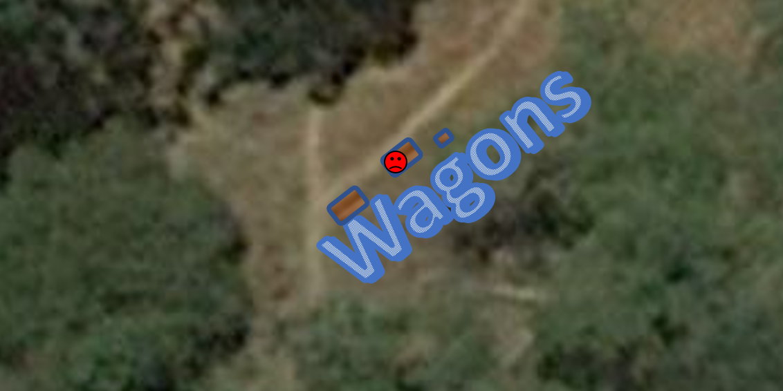

Elsabet then returned to camp and mentioned that she’s made a deal with a bird for some eyes in the sky to help keep watch during the day, filling the group in on the details. “If we could snag something like a rabbit, a gopher, a fat squirrel or three, something the kestrel could fly away with, that would be good payments.”

Laryssa tilted her head, trying to wrap it around the idea of talking to the wildlife, but stranger things had happened. Saradette, Widget, and Barkley didn’t pay the event much mind, and noted it in case they saw a bird of prey suddenly swooping down upon them.

“Also, the kestrel needs something to use as ‘tribute’ for a druid who apparently is charging a toll on the local wildlife in food supplies. Probably not a great evil to defeat, just a lazy druid who can be bothered to use his own skills to live off the land...” Elsabet added.

“I so want to kick his arse,” Barkley ruffed.

“So as for standing watch,” Elsabet returned to logistics. “I’ll keep an eye out for suitable game that might appear within 60’.”

“60’ isn’t going to yield you much,” Barkley stated. “Good game will stay out farther, especially downwind,” he pointed north, which was also downhill.

~*~

An hour or so had passed, and some of the heroes were sleeping in their tents while Barkley sat near the wagons with a line of sight to Oral. Elsabet had planned on using an Eldritch Blast to shoot a hearty meal’s worth of red meat that could be shared with the kestrel, but no more than that, and was now tracking something with her limited ability to do so. With her light crossbow loaded and trained forward, the favored soul finally happened upon her intended prey: a solitary fawn.



~*~

Having used his tongue to free his mouth of the gag, Oral cleared his throat, and spoke to Barkley for the first time, saying, “I need to have a movement... my bowels!”

Raising his head when Oral spoke up, Barkley called out, “Laryssa, can you come to the wagon please?” Barkley suggested taking Oral out, and Barkley could pull down the man’s trousers; then he could lean against a tree or stand and pee. As for cleaning his backside, if he wants that done, Barkley would be glad to splash a bucket of water on his backside. “Under no circumstances should we undo the man’s hands,” he preached to the choir.

Laryssa trained her composite longbow on the spellcaster, while Barkley held his sword aloft. The archon got no fuss from the human, who plopped down and did his duty, then asked for the bucket that Barkley had mentioned. “But don’t splash me; come on! You’re all executing me on the presumption of being civilized people. Just let it trickle down on my ass as I spread’em.”

Reading the body language of the archon, he had to add, “Aw, don’t be such a bitch! No matter what your crimes, you’d want it done to you. Otherwise, you might as well just execute me n-m-mm…”

“That’s enough of you without your gag, son,” Barkley put the gag back in the spellcaster’s mouth and went and got the bucket.

After gagging the talkative captive, Barkley poured the water down the mans backside. He did not splash it, but he also didn’t let it trickle down his back. When done with the bucket of water, Barkley secured him completely once more.

Bemusedly watching the makeshift shower while keeping her arrow trained on the prisoner’s head, Laryssa observed, “This is one of those occasions when a Prestidigitation spell would really come in handy.”

~*~

Elsabet froze, and looked around, trying to spot the fawn’s parents, buck or doe. She sighed, and lowered her crossbow; she’d hoped for an adult of a smaller species. She admitted to herself that she didn’t want to kill a baby, even just an animal baby. Heh, who knows, perhaps it was just that druid in animal form! In any case, growing up, she’d heard hunters talking about how, unless you were starving, you didn’t shoot the does or fawns, just the bucks, so that the deer population would continue to grow.

She settled into a less threatening pose.

“Little one,” she said softly to the fawn, “don’t be afraid, I won’t hurt you. Where are your parents? It isn’t safe to be out here on your own.”

The 3-month-old fawn told the favored soul that her parents had been killed. First, her father went missing; then the fawn and his mother found the father’s antlers; and a few weeks later—at around the time that these heroes met the Vexed Exalted and the Celestial Vanguard at the picnic—the fawn woke from a short nap to find his mother gone. He’d been foraging for the last few days, but was shaky from the last few nights spent in fear and isolation.

Elsabet held back a tear and said some things in the Celestial language of her prayers, then sighed as she regained control of her diaphragm and comforted the little fawn.

~*~

Back at the campsite, the prisoner was back in his shackles. Captain Samand and Valerie had brought the horses back to graze near the wagons, and the hired guards had welcomed a new friend to the camp. Barkley—best of all—was quite taken by the fawn, and the two jumped and pranced around like peas in a pod.

Barkley enjoyed engaging the fawn and played with the infant. He knew that the animal may likely grow up to become someone’s meal unless they kept it with them. He asked the fawn, “Would you like to travel with us for a while as you get your strength and grow bigger?”

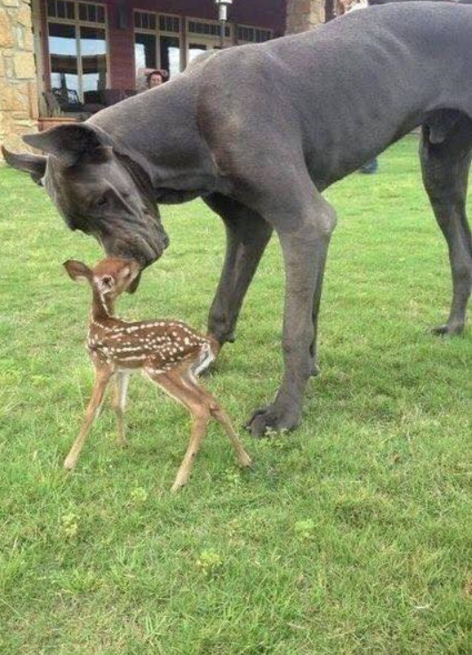

Laryssa suppressed a groan and eyeroll as she saw Elsabet returning to the camp carrying the fawn and Barkley’s subsequent gamboling with it. She thought perhaps a word might be needful with Elsabet about bringing home strays before the Fist looked less like an adventuring group and more like a traveling menagerie. Having a farmer’s mindset of a less-than-flattering opinion of deer and other wildlife that could be ruinous of crops, she felt it would be better to put the critter out of its misery rather than leave it to fend for itself—leading to an almost certain end at some predator’s fangs—or, worse still, be another mouth to feed on the road. However, when she shared these conclusions with her teammates, she was unprepared for the result.

Elsabet grinned at the disgruntled Laryssa, and said “You don’t know the power of the Cute side...but you will! You’re not wrong, we cannot afford too many strays...but I’m not sorry for bringing in this one. Are we not guardians of those who cannot guard themselves?”

Elsabet had nothing but good feelings about her deed, and now left the campsite once again to find some old, male mammal that would sustain their hunger for the next few days if butchered properly. Barkley—a professional—tanner, was skilled in the ways of dismembering a carcass efficiently, and she hoped that she wouldn’t have to bring back a buck that reminded the fawn of his father.

“Oh, how cuuute!” Saradette walked over to see the little fawn.

Widget turned, stood on her hind feet, and sniffed the air, feeling a tinge of jealousy for the recently weaned fawn.

Saradette dug a corn dodger out of her jacket pocket. “Here, little one. Do you like corn? Some of your cousins at home certainly like sweet corn.” She offered the treat to the deer. “Now, what are we going to do with you?” She looked up at Elsabet. “Maybe you can talk another doe into taking it in?”

Elsabet turned to Saradette, and replied, “Yeah, that is my thinking, if we can foster the fawn with another doe, that would be good. I couldn’t shoot it, I just couldn’t.”

Barkley was still in his Great Dalehound form when Laryssa made her comment about the fawn. He now stopped and sat on his hind quarters and looked up at Laryssa as he tilted his head to the side. “You would doom this little one to a horrible fate? Shame on you!” Barkley was partly joking, as he knew that venison was a staple source of nutrition for animals and humanoids alike. But he could not bring himself to harm a young animal that had barely had a chance to live its life.

“Oh, stop!” Saradette giggled. “You brought it over here, too. Now, you can help watch after—is it a him or a her?” Saradette looked to be sure.

“It’s a boy,” Barkley noted the tiny weenie.

“Oooh,” Saradette said. She turned to her familiar. “Come on, Widget, and meet Barkley’s new friend.”

~*~

They’d decided to stay here for 8 hours with two watches, giving the guards 4 hours of sleep each, while the wagoners got as close to 8 as possible. With her signal whistle hanging from a leather strap around her neck, Elsabet had gone on a short hunt, and was now returning to the rendezvous point on which she, Laryssa, and Widget had agreed. Carrying three rabbits slung into a single noose, the carnivore smiled and said, “Lunch.”

Widget had sniffed out some truffles, berries, and basil, and Laryssa had gathered it into a basket; they now all headed back to camp with culinary intentions. By the time they could see Barkley keeping an eye on the prisoner, the sun was high overhead, and the archon was ready for his nap. The kestrel had agreed to take part in the second watch, letting Barkley, Laryssa, Elsabet, and Widget sleep a bit as Saradette and the bird spent a vigilant afternoon minding the prisoner and the perimeter.

“Ooh! Thumpers!” Barkley remarked, licking his chops. “Don’t show Bambi, or he’ll think he’s next!”

Saradette looked up from where she was polishing the blade of a carving knife she hoped to sell in the next town. “I’m sure he’s aware that critters are eaten by other critters.” She lifted the blade to the sun, noted the rough spots, and went back to work with her fine whetstone. Having just slept for four hours while her friends stayed awake and watched the campsite, the gnome wondered, “We should be going soon, yes?”

“Samand and Valerie are still sleeping,” Barkley pointed to the middle wagon. “We need to give them another four hours or so before they’re fit to go back on the road.”

The fawn frolicked with a robin along the southern edge of the campsite, and occasionally grazed on the infant blades of grass that grew under the filtered light under the trees around them.

Elsabet set one rabbit aside, unskinned, for the kestrel to take as payment, and thanked the kestrel for assisting with the second watch.

The kestrel took the rabbit and nodded in return, taking a few minutes to take the meat to its nest and return to perch on a high branch and watch for incoming creatures from all directions.

The horses were tethered to the largest tree in the midst of the campsite.

Barkley enjoyed his meal, mixing in some of the berries and herbs found by Widget into his meal. Once done, he found a shaded spot near the horses to rest. He knew they would be headed out in a few hours and tried to get as much rest as possible. Soothed by the sound of the horses grazing and purring through their nostrils at one another, the archon fell fast asleep.

As the sun approached its zenith, Laryssa prepared to pay her daily homage to her goddess. At first she had intended to make no changes to her usual allotments of spells, but upon reflection decided to plea for a slight modification, suppressing cloud of knives for a make whole instead... mindful of their difficulties with wagon wheels in the past, she did not wish to be caught waiting to make repairs for a protracted period on this outing.

Laryssa’s Spells
Spell | Level | SF | DC | Cast?
Detect Poison | 0 | 0 | 12 | q
Guidance | 0 | 0 | 12 | q
Guidance | 0 | 0 | 12 | q
Light | 0 | 0 | 12 | q
Mending | 0 | 0 | 12 | q
Blade of Blood | 1 | 0 | 13 | q
Bless | 1 | 0 | 13 | q
Divine Favor | 1 | 0 | 13 | q
Magic Weapon | 1 | 0 | 13 | q
Shield | 1 | 0 | 13 | q
Bull’s Strength | 2 | 0 | 14 | q
Make Whole | 2 | 0 | 14 | q
Hold Person | 2 | 0 | 14 | q
Spiritual Weapon | 2 | 0 | 14 | q

Her duty to Mayaheine satisfied, the would-be warpriestess unrolled her bedding beneath on of the wagons for a nap. Having not expending any spells the previous day, a full night’s rest was not needed; just enough to dispel the weariness of a day’s travel on insufficient sleep. While the possibility being disturbed by the noise of passers-by on the road existed, she considered it worthwhile to risk by being situated to respond to trouble by those selfsame travelers... being better shielded should an unexpected shower crop up was just a bonus.

