*Chapter 7: The Road to Mintar*

Late Morning, 4 Tarsakh, 1372

On the road to Mintar

It was the fifth day of the trip, and tonight would be the sixth night. Four relatively uneventful days of travel had passed since they’d struck camp at what they’d now come to call Kestrel Bend River amongst themselves, and the band had made its way past arid groves of eucalypti, mosquito- and stirge-infested valleys pebbled with active bogs and dried-up riverbeds, avoided a catoblepas herd nesting near the road, and were now skirting the foothills of the Alamir Mountains.

Having headed east almost the entire time, they were now slowing verging southward as the horses and pony drew the wagons and cart, respectively. Saradette sat atop her cart, holding on to the reins as she kept her pony at least 20’ behind the rearmost wagon. The frontmost wagon—driven by Capt. Samand—contained the prisoner and Barkley, while the rearmost wagon—conducted by Valerie—contained the majority of the party’s gear, and seated within was Laryssa, who discussed the nuances pertaining to the angle of a blade’s trajectory as it sliced through flesh, bark, bone, plasm, and other tissues with Elsabet as the latter walked at in progress with the wagons and kept her cardio up.

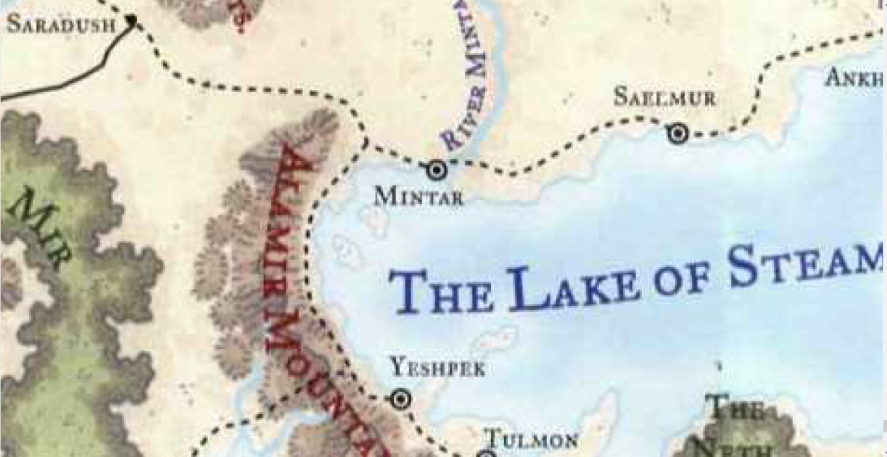

And the fawn? He’d come along, and was gamboling close enough to Saradette’s pony to be able to somatically encourage the fellow ungulate. The uninhibited infant pranced and meant to express, “Hi! These guys call me Bambi, but you have to call me Grassbane!”

The pony completely misunderstood, thinking the deer was talking about things far more sophisticated, and clippity-clopped, “I’m not sure... about that.”

They’d left a bit late from their last campsite, and it was now the time of day when they were usually already stopped and enjoying the scenery of their recently set-up campsite. Valerie—who knew the road best—had suggested continuing on a bit more to a site she knew to have optimal visibility and concealability: a summit ensconced on six sides by jutting rocks and trees between which they could post sentries and have a panoramic view of all around them for the remainder of the day.

Traveling at night had indeed had its advantages, though it was a bit spooky, but given today’s late start and finish, the humans in the bunch really preferred this schedule. Still, they’d been ordered to travel under the cover of darkness. They’d passed more than a few campsites and roadside inns along the way, and were glad to not have to had to explain their situation to roused travelers. The few night guards that they did see simply nodded, bowed, or ignored the heroes as they continued eastward.

Laryssa—ever vigilant—was cautious enough to try to spot anything identifying the people they passed, whether it be an insignia on a wagon wheel, a patch on a cloak, or a discernible face.

Keeping an eye on the terrain near the road as she walked alongside the second wagon, Elsabet chatted about martial techniques and divine capabilities with her friend Laryssa. From time to time, she would accelerate or decelerate and verge over to whichever side had the closest heavy growth or rocks or other likely ambush spots, the better to spot the ill willed, or at least be in position to react. She kept her crossbow loaded and in her dominant hand, and got close enough to the rear wagon to say, “I think we both agree that your ability to request the specific spells you want for the day is a big advantage in many ways,” Elsabet admitted, “but I just don’t have the patience to plan ahead like that. Fortunately, Mayaheine has graced me with fairly useful boons, I think, and while I don’t get to pick different spells, you can select yours while taking mine into account—between the two of us we can cover a lot of possibilities.”

Elsabet thought for a bit, then asked, “do you think we’ll ever face undead, that you might be able to turn or destroy with that boon from the Goddess? I’m wondering if there are other uses you might put that power to? When I was talking to that priest of... Moradin, I think it was... he mentioned something called Divine Vigor, that he said some of his brethren had learned, that used the divine power of turning to instead give them additional speed and extra ability to absorb attacks, kind of like the Aid that Barkley does for us sometimes.”

Elsabet, not one to stay quiet when something occurred to her, turned towards Laryssa and smiled. “So, tell me about this Warpriest thing you’re working on. It sounds like you’ve been planning on that for a long time, developing the capabilities to become such. It seems very focused!” She chuckled. “For myself, I thought I was just going to be a Favored Soul, but the last year or so, I’ve discovered there are so many possible ways to serve the Goddess, it’s how you use the boons you receive that truly matter. I don’t know if I will ever focus on one path, at this point - this whole ‘Fey Heritage’ and ‘Warlock with eldritch power’ thing kind of took me by surprise. I figure I’ll work on that some more, but at the same time the path of the Crusader still calls to me.” She chuckled. “I like having a plan, it’s just that following it doesn’t always seem to work out!”

“I’ve discussed various options with my mentor on those rare occasions when our paths cross. While I considered dedicating myself purely as a cleric in my career going forward, I decided to instead take a different way to honor Mayaheine in her aspect as the Lady of War and, to that end, study the more martial path as a warpriestess. I felt that giving up some degree of casting spells granted by the goddess was well worth gaining increased battle ability along with some specialized powers to succor my allies. While it isn’t beyond possibility that I may someday train myself to utilize power against the undead in a different way, my immediate goal is to make those spells I do have be more potent in effect or duration. Once I’ve mastered that skill, I can then consider other possibilities. In the meantime, should we encounter undead, I will be well positioned to deal with them far more effectively than I currently am once the power of Mayaheine’s Glory is obtained.”

One that dialogue was over, Elsabet moved a bit further forward. “What’s the terrain like up ahead?” asked the crusader, looking at Valerie.

The half-elf from these parts replied, “It’s mostly like the bogs we passed the night before last.”

“Oh, right; with the catoblepas clutch,” the swordswoman recalled.

“But these are saltwater marshes, fens, and an estuary that feeds into the Lake of Steam,” the wagoner informed the crusader with the steel-hard quads. “We’ll want to stop while we’re at about this altitude. Camping closer to sea level adds richness to the things that could come around during the night and bother us.”

“How about the things that dwell along the swampland road at night while we’re traveling on it?” asked Elsabet.

Samand was a wagon behind, and answered, “Our orders are to take the path at night, and Valerie’s done this run a few hundred times by now. I’ve done it, maybe, a dozen, and believe you me: you don’t want to be groggy and half asleep if those bullywugs are about.”

“And lizardfolk...” Valerie added, then referring to the halfling-sized blowgun-loving subspecies: “Poisondusk. About yay high, but mean as a demon. I’ve seen’em and I mean it!” she sort of sang one of her local idioms of emphasis.

“Mayaheine will see us through this,” the do-gooder trusted aloud as she slowed down to walk parallel with Saradette, the pony, and the deer.

In reply to Samand and Valerie, Elsabet said, “Oh, I believe you! You’ve been this way plenty, we haven’t - and it wouldn’t surprise me if our guest’s friends stirred up the scaly folk to attack us, things have been pretty quiet so far, it strikes me that this may be about their last chance to try something.”

She thought for a moment, then asked, “would either of you like the fatigue of this night’s travel removed, through the Lesser Restoration spell Mayaheine has granted me? You’d need less sleep today and be fairly rested if something should happen. I’m thinking of doing that on myself at least, and this time I’ll save one 2nd level spell just in case, but have two others I could cast. You’re welcome to have them, but if you’d rather not, I’ll probably do it on Barkley and Laryssa.”

~*~

They arrived at the second-to-last site where they would have to set up their tents before their arrival into the cosmopolitan, seaside city. Overlooking the vast complex of marshes, dotted with heavily forested hills that jutted above the flooded, mineral-rich plains fed by the alluvial tributaries that eventually coalesced into the estuary of which Valerie had spoken.

The location was mostly out of sight from the road, thanks to the beach cabbage that grew abundantly and vigorously throughout the area. The smell of brine hung high here, but it was altogether different from that of the sea, and was heavily comingled with peat and decaying bark and other plant pulp. Downhill and to the southwest was the water, though the horses would have to drink something else. As the horses were being seen to, each pair removed from its tethers and harnesses and retethered to one another near a yummy patch of grazing grasses, Saradette took her pony and did the same, though she spoiled the miniature mare with a carrot, a beet, and a stalk of celery that a farmer had given them just a few hours ago for magically helping him with *mending* a fence.

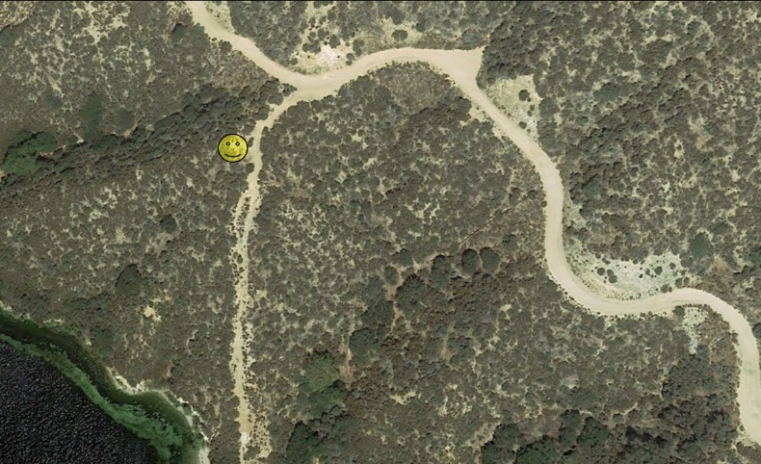

“There’s a spring to the northeast,” announced Valerie. “One or two of us will have to take the horses there to drink.”

Hunting had been bad the last few days, and the group had dipped into its rations—which were sufficient even if they caught nothing else—but the taste of grain had grown tiresome in the mouths of the heroes, and they wanted to eat a vertebrate before long.

Elsabet observed a seemingly erratic but somewhat calculated pattern as she scouted and kept watch over the campsite:



She kept all manner of marching parameters in mind for when they set off: while walking near the front or the back of a wagon, she would be ~5’ ahead or behind the front or back of the wagon respectively so can see both sides of the road, but still within reasonable conversation distance. Spending about half of the time in silence, just checking out the lay of the land, looking for other travelers, ambushes, and random birds and other animals, Elsabet essentially resolved to orbit around the wagons and cart along a sort of oblong circuit, moving ahead or back, walking at the pace of the wagons a while, then continuing on to the next position.... If travelers appeared in one direction or the other, she’d want to get closer to that end of the little procession.

She’d discussed this with the others, and they all felt safer knowing that Elsabet was so keen on security measures while seemingly jovial in her stride and speech.

“Widget, I know that the fawn is getting on your nerves, but he’s just a baby. He likes to run and play, and that includes jumping over and around you.” Saradette tried to keep the amusement out of her voice, but her familiar heard it anyway, and she turned and walk off in a huff. Widget was an orderly soul, and having the deer-child around wore at her patience.

Saradette finished her bath, taken in a convenient stream with a bucket, a washing cloth, and soap. She didn’t want to contaminate the drinking water, so she was careful to not put soap in it. She ran the soapy cloth over her torso and down to her now bushy pubic area. She hadn’t bothered to shave on the trip, not that there was anyone to notice, she thought morosely. She wasn’t promiscuous, but she did enjoy a man’s company on occasion. That was the one aspect of traveling that she didn’t like – there was no time to form friendships apart from those people traveling with them.

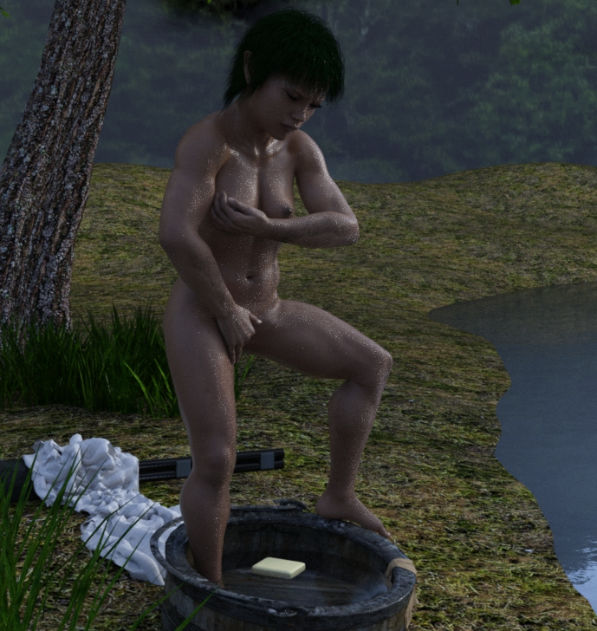

She dried herself with a towel, and slipped into her last clean shift. She’d found several cotton ones a few towns back; they were finely woven and kept her cool under her gambeson. They would wear out more quickly that the linen ones, but that was why she bought several when she found them in her size. The gnome dressed, dumped out the bucket away from the stream, gathered her supplies, and walked back to her cart. Her pony was grazing nearby, and she reflected that she hadn’t thought of a name for the creature.

Saradette put up her bathing supplies, and went to her toolbox to work on her next project. She’d been studying about the artifacts she might be able to make, but inspiration was slow in coming. The flechette launcher worked fairly well, but it was short-ranged and slow-firing. The artificer sighed, and pulled out one of her engineering books to read while she waited for the caravan to start once more.

Laryssa volunteered to assist in watering the horses. She intended to be vigilant while they drank their fill and summon her arms and armor until they were done in case any threats lay in wait at the watering hole. Upon her return, it was near time for her daily prayers to Mayaheine. This close to their destination, the possibility of ambush was likely the greatest and replacing *bull’s strength* and*make whole* spells with a *sound burst*and a second *spiritual weapon* would increase combat capability should a battle ensue.

|  |  |  |
| --- | --- | --- |
| **Spell** | **Level** | **DC** |
| Detect Poison | 0 | 12 |
| Guidance | 0 | 12 |
| Guidance | 0 | 12 |
| Light | 0 | 12 |
| Mending | 0 | 12 |
| Blade of Blood | 1 | 13 |
| Bless | 1 | 13 |
| Divine Favor | 1 | 13 |
| **Magic Weapon** | 1 | 13 |
| Shield | 1 | 13 |
| Hold Person | 2 | 14 |
| Sound Burst | 2 | 14 |
| **Spiritual Weapon** | 2 | 14 |
| Spiritual Weapon | 2 | 14 |

~*~

And though they had done their best to keep an eye out for predators, bandits, and blundering monsters, their time here was spent uneventfully. From their high vantage point, Elsabet and Laryssa had both spotted catoblepas herds grazing along the edges of the swamps to their southwest.

“We move out as soon as you’re ready,” Samand let everyone know, having made a habit of rising slightly before his naptime was over, and washing a little more than the others.

Barkley was another early riser, and one who didn’t bother much with washing. His lack of sweat glands gave his fur and skin a sweet scent of maple that seemed to attract the humanoids on this plane more than he’d anticipated.

The two wagoners—who knew one another well enough—talked while the heroes put away their doodads and hefted them over to the center wagon.

The rear wagon—the pony cart—was almost fully stuffed with the gnome’s things, including her new device, which shot a plethora of spikes.

“How’s Threfrim?” asked Valerie.

“Oh, he’s getting along,” answered Threfrim’s father, Captain Samand. “He’ll be turning eight at the end of the month. If you’re in town, we’d love to have you and Simeon over.”

“Oh, he’d love that,” Valerie replied. “What does he like? Is he into archery yet?”

“Hmmm...” the father and onetime savior of Saradush rubbed his graying beard, and answered, “He’s mostly just into animals.”

~*~

The auger poked laterally through the nascent eyelids and eyeballs of the pinky mouse as it squealed in agony in a pitch to high for the human child to discern. The boy caught a drop of drool about to leave his mouth, and sucked it back in as he tossed the tortured mouse into the pit wherein the bearded dragon took a second to identify the squirming food, two more seconds to wobble over to it, another second to dart its sticky tongue out and retract the newborn into its mouth, and maybe five or six seconds for the visible chunks to be chewed and swallowed by the efficient reptile.

This having been the sixth pinky today, and knowing that this was already probably too much, the kid shrugged and said some truly sadistic things to the two remaining pinkies as he tossed them back into the mouse cage around the corner where their mother could not see what had just happened to six of her babies.

Threfrim farted, then went downstairs to hassle the maidservant for some meat of his own. He was too young yet to appreciate the sexual value of humanoid flesh, though he might grow old enough to acquire such a palate, but for now, he craved the venison that his father had brought home. Pulling the majority of a butchered quadricep out of the ice chest, the seven-year-old asked the maidservant—Ghertrude—”Can you slice some of this up and make me a sanguich?”

The young woman attended to his whim immediately, though lunch had recently been served, and the kid had barely touched his veggies. Within a minute, bread was sliced, meat was sliced to the gauge of the boy’s specifications, and a layer of buttery mustard seed oil stuck all the layers together. Without thanking her, he went back upstairs, ate his sandwich in peace while his mother slept in the adjacent chamber, and then proceeded to masturbate like no kid his age.

~*~

Sunset, 4 Tarsakh

The heroes had set off moments ago. The fawn was eager to get a trot in, and mostly sprinted from plant to yummy plant, grazing at the choicest leaves as they descended gradually into swamp country. The road had been built and maintained over centuries, and consisted of a narrow strip between levees that channeled water ultimately southeastward towards the estuaries that partly ensconced Mintar.

They had an hour or less of dimming light before white and black fabrics were mutually indistinguishable on what was to begin as a moonless night. Valerie had told them once again that they were to ride for about 9 hours, and could expect the horses to be fatigued, but it would be the only safe haven in the guide’s mind between here and Mintar. “All else is predator country, and we’re at a disadvantage if a conflict takes us off the road.

~*~

Evening, approaching Midnight, 4 Tarsakh

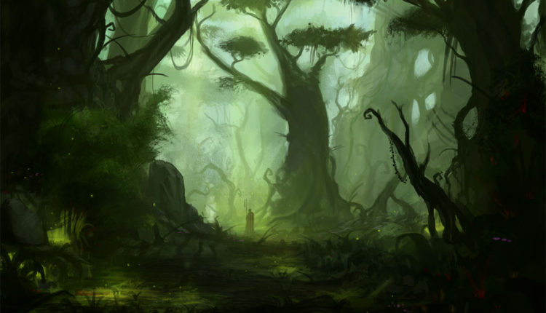

With a few hours of darkness behind them, they’d stopped only twice to pee and rest the horses since setting off during the afternoon, and had passed three separate convoys of merchants making way for Saradush. The road had become rather bumpy due to the difficulty of maintaining it this far out in the periphery of the seaside city. Barkley had spotted some bullywug tracks, suggesting a hunting party of at least a dozen braves, but Elsabet and others agreed that they were hours old by this time. “Still, it doesn’t hurt to keep caution at a maximum tonight,” Barkley huffed.

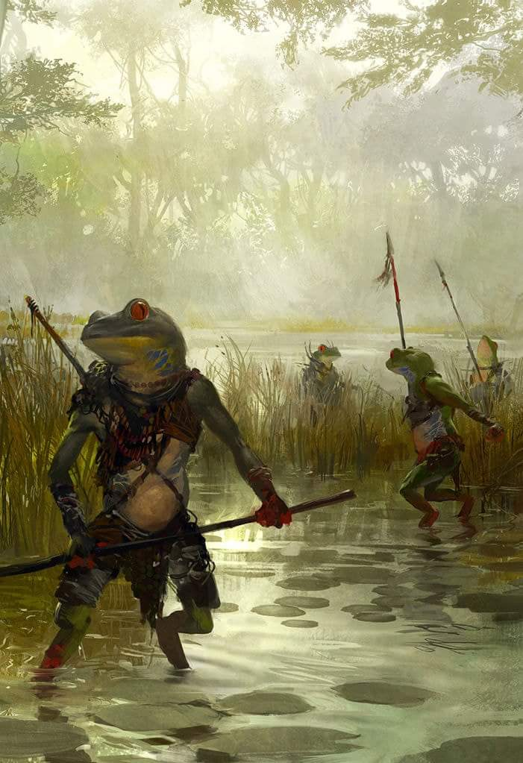

With a few more hours of darkness ahead of them, they pressed on. Valerie assured them that they were on schedule to arrive during Night’s Heart, and once it started to drizzle a bit, she said, “This should delay us a bit, but we’re still on track.”

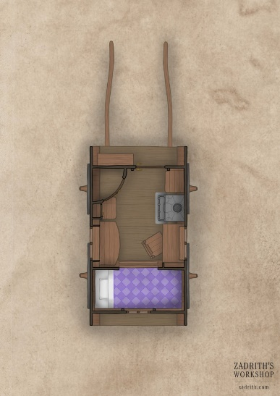

They slowed their wagons down to about two-thirds of their established speed, and the fawn hopped inside the rear wagon, where Laryssa dried his hooves and propped him on onto the single mattress therein. Distant thunder to the south and southeast warned of an impending storm, but they pressed on.

~*~

Midnight, 5 Tarsakh

Several waves of rain and fog had passed over the land as the heroes traversed the road to Mintar. Visibility was poor, and although Valerie knew the road as well as her own home, she was not in a position to identify a single, out-of-place cypress-looking tree for what it was.

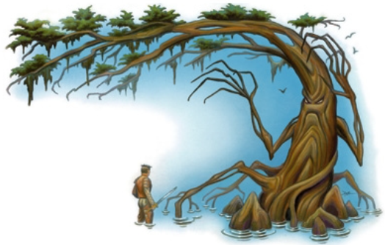

As the lead wagon—with the prisoner inside it—passed the dark tree, the dark tree surprise-attacked Captain Samand.

|  |  |  |  |  |  |  |  |  |  |  |  |
| --- | --- | --- | --- | --- | --- | --- | --- | --- | --- | --- | --- |
| **Character** | **Attack Type** | **Damage** | **BAB** | **Str Mod+** | **W+** | **Other+** | **Total Score** | **Roll** | **Total** | **Crit** | **Threat** |
| Dark Tree | Claw 1 | 2d4+9 | 5 | 9 | 0 | 0 | 14 | 12 | 26 | 20 | ý |

*Hit. Dmg: 5 + 9 = 14.*

The horses—particularly the two at the front—panicked, and reared up. If not properly handled, they would likely get hurt in a clumsy stampede.

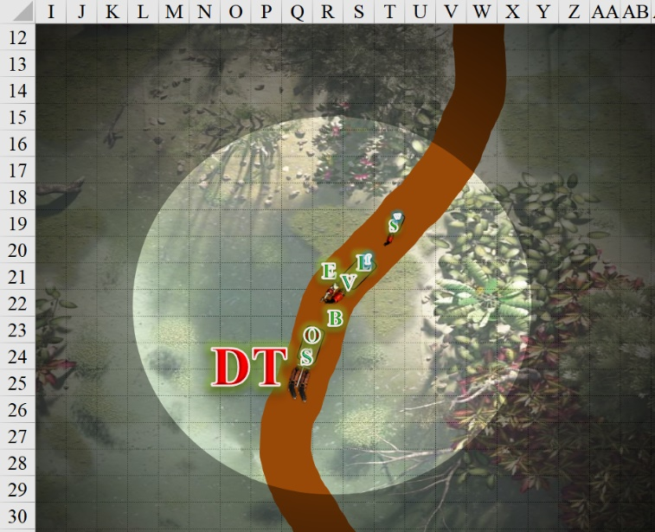

Round 1

|  |  |  |  |  |  |
| --- | --- | --- | --- | --- | --- |
| **Character** | **Group** | **Initiative** | **Roll** | **Modified**  **Roll** | **Move** |
| Laryssa | 1 | 3 | 15 | 18 | 20’ |
| Barkley | 1 | 4 | 11 | 15 | 30’ |
| Dark Tree | 2 | -1 | 14 | 13 | 10’ |
| Saradette | 1 | 1 | 10 | 11 | 20’ |
| Elsabet | 1 | 4 | 2 | 6 | 30’ |

Laryssa heard the commotion from the front of the caravan. Knowing that the time around Night’s Heart on a moonless evening would have her stumbling blindly in the dark, she cast *light [expired on Round 401]* onto her ring and then clambered out of the wagon towards the disturbance.

A bright light emanated in 20’ radius around her, and dim light a further 20’ beyond that.

Barkley was in dog form—as usual—and out of the wagon; seeing the tree, he shouted with his canine jaws, “We mean you no harm, we only wish to pass through!” He stood ready to dodge any attack from the tree that attacked them.

The demonic dark tree appeared to care little or not at all for the words of the dog-faced goodie-good, and continued to attack Samand.

|  |  |  |  |  |  |  |  |  |  |  |  |  |  |
| --- | --- | --- | --- | --- | --- | --- | --- | --- | --- | --- | --- | --- | --- |
| **Character** | **Attack Type** | **Damage** | **Ranged?** | **BAB** | **Str Mod+** | **Dex Mod+** | **W+** | **Other+** | **Total Score** | **Roll** | **Total** | **Crit** | **Threat** |
| Dark Tree | Claw 1 | 2d4+9 | q | 5 | 9 | 0 | 0 | 0 | 14 | 13 | 27 | 20 | ý |
| Dark Tree | Claw 2 | 2d4+9 | q | 5 | 9 | 0 | 0 | 0 | 14 | 6 | 20 | 20 | ý |

*Hit, hit. Dmg: (6 + 9) + 5 + 9) = 15 + 14 = 29.*

Barkley noted the dark tree’s reluctance to parlay, and quick-changed into his humanoid form, then went to the wagon to collect flasks of oil.

Saradette steered her cart hard right and stopped it at the side of the road.

|  |  |  |  |  |  |  |
| --- | --- | --- | --- | --- | --- | --- |
| **Skill (HA untrained)**  **/ Save** | **Rank** | **Ability & Mod.** | **Misc. Mods.** | **Total** | **Roll** | **Check** |
| **Saradette, Handle Animal** | 0 | **Cha (+0)** | 0 | 0 | 16 | 16 |
| **Saradette, Reflex** | 6 | **Dex (+3)** | 3 | 12 | 1 | 13 |

*See below.*

The pony neighed as she stopped a few feet short of the mark, just before she would have slipped into the levee.

Caught totally off guard by a tree turning into an enemy, and staying on the flat road as best as she could, Elsabet pondered her engagement of their opponent, who displayed no intent to parlay.

|  |
| --- |
| *Current Maneuvers* |
| Foehammer |
| Crusader’s Strike |
| Battle Leader’s Charge |
| Stone Vise |
| Shield Block |

With a lit torch in her off hand, she was thinking of casting a spell, kicking of my Protection Devotion, and then getting close, but needed to see how this was going to go before acting. Elsabet then shook herself, mentally chiding herself to snap out of it! As she was granted two maneuvers—Foehammer and Crusader’s Strike—she realized that Mayaheine may have kept back her Charge maneuver to keep her from being too hasty—this was not a good place to charge from.

*[Swift]* First things first—she immediately called upon her Protection Devotion *[expired on Round 11]* to help protect all of her side within 30’.

*All allies gain +3 to AC.*

*[Standard]* Then she cast *bull’s strength [expired on Round 41]* upon herself, deciding she would need extra muscle to slice into a living tree creature, especially if it tried to knock her off the road or something.

*Elsabet gained +4 to Strength.*

*[1st Immediate]* She muttered in the tongue of the equines to the horses nearby, “Easy now.”

*Immediate action has no effect.*

*[Partial Move]* And lastly, she moved carefully a single step forward, then another, wishing she’d had time to draw her bastard sword as she went, trying to gauge just how far the dark tree could reach, intending to stop the moment it seemed she might provoke an attack from one of its long branch-like arms that had just swung at Samand.

*[2nd Immediate]* And as she stepped forward, she called out to it, in the Sylvan tongue, language of many fey and forest creatures. << Stop, tree, or face me! >> As she finished, she felt her Battle Leader’s Charge maneuver being granted, and smiled.

*No apparent effect.*

*[Partial Move]* She then mentally compared the tree’s size to that of the ogres they’d fed three years ago, who had 10’ reach, to figure out of the tree has similar reach or greater... and it was greater. Elsabet consequently took a step southward, sharing a bit of space with one of the animals she’d been talking to when the tree first acted, moving at half speed to avoid upsetting the animals.

*1d100 = 56, animal not spooked.*

*[Partial Move]* Feeling like she was now out of the tree’s reach, she then took another step, closer to the edge of the road.

Badly wounded, Samand fought back.

|  |  |  |  |  |  |  |  |  |  |  |  |
| --- | --- | --- | --- | --- | --- | --- | --- | --- | --- | --- | --- |
| **Character** | **Attack Type** | **Damage** | **BAB** | **Str Mod+** | **W+** | **Other+** | **Total Score** | **Roll** | **Total** | **Crit** | **Threat** |
| Captain Samand | Longsword +1 | 1d8+1 | 6 | 2 | 1 | 0 | 9 | 15 | 24 | 20 | ý |
| Captain Samand | 2nd Attack | 1d8+1 | 1 | 2 | 1 | 0 | 4 | 13 | 17 | 20 | ý |

*Hit, miss. Dmg: 5 + 1 = 6.*

Valerie shot a fire arrow at the tree.

|  |  |  |  |  |  |  |  |  |  |  |  |  |
| --- | --- | --- | --- | --- | --- | --- | --- | --- | --- | --- | --- | --- |
| **Character** | **Attack Type** | **Damage** | **Ranged?** | **BAB** | **Str Mod+** | **Dex Mod+** | **W+** | **Other+** | **Total Score** | **Roll** | **Total** | **Notes** |
| Valerie | Shortbow +1 | 1d6+1 | þ | 4 | 0 | 3 | 1 | 0 | 8 | 17 | 25 | Acid Arrows |

*Hit. Dmg: 6 + 1 = 7 + (1 acid every round over the course of the next 3 rounds) = 10.*

The fawn sprinted north-northeastwardly in an infantile panic. Widget remained in the cart, chirping worriedly to herself. The horses neighed and bucked, and Valerie’s wagon began to turn clockwise towards the west side of the road. One of the horses was in danger of stepping down onto the grade, and while its hooves could likely sustain it there, the second horse’s momentum might be enough to push them and the wagon downward.

Only a little fearful for his life, Oral watched the combat as best as he could through the cracks in the wooden wagon that confined him.

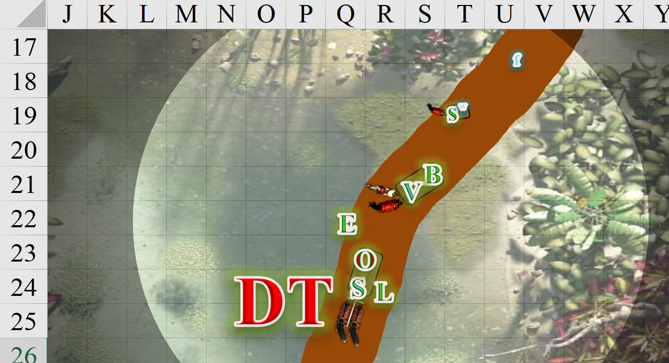

Round 2

Laryssa activated her ring and was instantly armored and ready for action. Seeing Samand get injured badly, and skirting the frightened horses, the martial cleric moved up to confront the belligerent oversized carrot.

|  |  |  |  |  |  |  |  |  |  |
| --- | --- | --- | --- | --- | --- | --- | --- | --- | --- |
| **Melee Weapon** | **Dmg** | **D+** | **TH+** | **Critical** | **Type** | **Wt.** | **Atk** | **Roll** | **Check** |
| Bastard Sword +1, 2-handed | 1d10 | +3+1 | 1 | 19-20/x2 | Slashing | 6.0 | +8 | 15 | 23 |

*Hit. Dmg: 5 + 3 + 1 = 9.*

Barkley found and produced the box with the flasks of oil, and had a Tindertwig, which lit easily. With an ingenious idea in mind, he exited the wagon, and saw that the horses tethered to it were a bit spooked.

The dark tree full-attacked Samand.

|  |  |  |  |  |  |  |  |  |  |  |  |  |  |
| --- | --- | --- | --- | --- | --- | --- | --- | --- | --- | --- | --- | --- | --- |
| **Character** | **Attack Type** | **Damage** | **Ranged?** | **BAB** | **Str Mod+** | **Dex Mod+** | **W+** | **Other+** | **Total Score** | **Roll** | **Total** | **Crit** | **Threat** |
| Dark Tree | Bite | 1d6+13 | q | 5 | 9 | 0 | 0 | 0 | 14 | 8 | 22 | 20 | ý |

*Hit. Dmg: 5 + 13 = 18.*

Samand fell over onto the ground, seemingly dead.

Oral cheered, “Yushhh...” The spellcaster then tried to offer the tree material rewards for killing his captors.

With no clear line of attack to the tree, Saradette sighed as she abstained from unlimbering her flechette gun and instead turned and watched the group’s rear in case the tree had friends who were planning an am-bush.

Elsabet used the Anklet of Translocation as a swift action to teleport 10’, putting herself into the tight space between the tree and her friends, adjacent to the tree, and attack the tree with a strike, using Crusader’s Strike.

|  |  |  |  |  |  |  |  |  |  |
| --- | --- | --- | --- | --- | --- | --- | --- | --- | --- |
| **Melee Weapon** | **Dmg** | **D+** | **TH+** | **Critical** | **Type** | **Wt.** | **Atk** | **Roll** | **Check** |
| Bastard Sword +1, 1-handed | 1d10+1 | +4 | 2 | 19-20/x2 | Slashing | 6.0 | +10 | 13 | 23 |

*Hit. Dmg: 2 + 4 + 1 = 7.*

With her successful strike, Elsabet pushed the healing power it gave her towards the Captain’s body, praying to Mayaheine that it was not too late to save him.

*Samand gained 1 + 3 = 4 points.*

Samand stabilized, but did not regain consciousness.

As she set her feet solidly on the road, Elsabet swore at the tree in Sylvan, << You have sealed your fate, splinters and kindling you shall be! >> She felt the Stone Vise maneuver being granted.

Valerie cursed in Elven at the tree that killed her longtime friend, and shot again.

|  |  |  |  |  |  |  |  |  |  |  |  |  |
| --- | --- | --- | --- | --- | --- | --- | --- | --- | --- | --- | --- | --- |
| **Character** | **Attack Type** | **Damage** | **Ranged?** | **BAB** | **Str Mod+** | **Dex Mod+** | **W+** | **Other+** | **Total Score** | **Roll** | **Total** | **Notes** |
| Valerie | Shortbow +1 | 1d6+1 | þ | 4 | 0 | 3 | 1 | 0 | 8 | 19 | 27 | Acid Arrows |

*Hit. Dmg: 4 + 1 = 5 + (1 acid every round over the course of the next 3 rounds) = 8.*

Saradette spotted the fawn fleeing, and Widget now poked her head out of the cart, asking, “WtF?”

The horses drawing the front wagon said something like what Widget had asked, and started moving forward again.

Oral giggled, “Mmmhwuwww!”

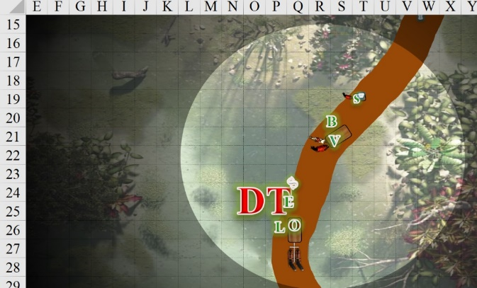

Round 3

Seeing their leader felled, Laryssa decided to forgo accuracy and protection for damage to end things as quickly as possible. Grasping her blade two-handed, she swung at the tree with all her might.

|  |  |  |  |  |  |  |  |  |  |
| --- | --- | --- | --- | --- | --- | --- | --- | --- | --- |
| **Melee Weapon** | **Dmg** | **D+** | **TH+** | **Critical** | **Type** | **Wt.** | **Atk** | **Roll** | **Check** |
| Bastard Sword +1, 2-handed | 1d10 | +3+1+6 | 1 – 3 | 19-20/x2 | Slashing | 6.0 | +5 | 9 | 14 |

*Miss.*

Barkley threw two flasks.

|  |  |  |  |  |  |  |  |  |  |
| --- | --- | --- | --- | --- | --- | --- | --- | --- | --- |
| **Ranged Weapon** | **Dmg** | **D+** | **TH+** | **Critical** | **Rng.** | **Wt.** | **Atk** | **Roll** | **Check** |
| Thrown Item | varies | 0 | -6 range | - | 10’ | - | -1 | 17 | 16 |
| 2nd Thrown Item | varies | 0 | -6 range | - | 10’ | - | -6 | 11 | 5 |

*Hit, miss. Dmg: 3 fire. Damage negated.*

“Aw, what?” the archon saw one flask drop into the swamp, while the other splashed its fiery liquid upon the tree’s bark, but it seemed to do nothing.

Shaking off the ignited droplets, the dark tree seemed pleased to have killed Samand, and grabbed his stable but limp body, seeing to eat the corpse once it had had time to marinate and fester, held down to the riverbed by the dark tree’s roots.

|  |  |  |  |  |  |  |  |  |  |
| --- | --- | --- | --- | --- | --- | --- | --- | --- | --- |
| **Character** | **Attack Type** | **Damage** | **BAB** | **Str Mod+** | **Total Score** | **Roll** | **Total** | **Crit** | **Threat** |
| Dark Tree | Claw 1 | 2d4+9 | 5 | 9 | 14 | 19 | 33 | 20 | ý |
| Dark Tree | Grapple | Grapple | 5 | 9 | 14 | 18 | 32 | 20 | ý |

*No opposed grapple check possible; grapple is successful.*

“Not so fast, bark boy,” Elsabet thought; as the tree took its attention off of her to pick up the Captain’s body, she saw an opportunity and hacked at the tree with her bastard sword, hoping to chop deeply into the cursed wood creature.

|  |  |  |  |  |  |  |  |  |  |
| --- | --- | --- | --- | --- | --- | --- | --- | --- | --- |
| **Melee Weapon** | **Dmg** | **D+** | **TH+** | **Critical** | **Type** | **Wt.** | **Atk** | **Roll** | **Check** |
| Bastard Sword +1, 1-handed | 1d10+1 | +4 | 2 | 19-20/x2 | Slashing | 6.0 | +10 | 4 | 14 |

*Miss.*

The tree then took a 5’ step back and indicated with its irregular body language that it was about to flee.

<< Hey, not done! >> Elsabet shouted in Sylvan as the tree started to step away with the Captain’s body held high. She glanced back at her comrades and nodded briefly, and carefully, slowly, teleported using the anklet for the second and last time this night to get 10’ up and left, and was now furthest from Barkley to avoid blocking his shot.

Teleporting into the swamp, she slid into the water waist deep.

|  |  |  |  |  |  |  |
| --- | --- | --- | --- | --- | --- | --- |
| **Save vs.**  Slipping  **+ Skill** | **Rank** | **Ability & Mod.** | **Misc. Mods.** | **Total** | **Roll** | **Check** |
| **Reflex** | **4** | **Dex (+2)** | 1 | 7 | 16 | 23 |
| **Balance** | 2 | **Dex (+2)** | -1 | 3 | 12 | 15 |

*See below.*

Thanking Mayaheine for inspiring her and keeping her feet stable upon the mud, she hewed at the tree once more, using Foehammer to cut deeper if she hit.

|  |  |  |  |  |  |  |  |  |  |
| --- | --- | --- | --- | --- | --- | --- | --- | --- | --- |
| **Melee Weapon** | **Dmg** | **D+** | **TH+** | **Critical** | **Type** | **Wt.** | **Atk** | **Roll** | **Check** |
| Bastard Sword +1, 1-handed | 1d10+1 | +4 | 2 | 19-20/x2 | Slashing | 6.0 | +10 | 16 | 26 |

*Hit. Dmg: 6 + 1 + 4 + 6 Foehammer = 17.*

Saradette hopped down to the road, and, grabbing her pony’s bridle, turned him back onto the road and toward the back of the next wagon. She intended to tie the critter off to the wagon to keep it from shying away.

Widget chirped to Saradette, alerting her to the fact that the fawn had just disappeared northward into the night.

“Go after her,” Saradette replied. “But be careful. Got it?”

The cross between a wolf and a weasel obliged her gnome.

Valerie shot at the tree once again.

|  |  |  |  |  |  |  |  |  |  |  |  |  |  |
| --- | --- | --- | --- | --- | --- | --- | --- | --- | --- | --- | --- | --- | --- |
| **Character** | **Attack Type** | **Damage** | **Ranged?** | **BAB** | **Str Mod+** | **Dex Mod+** | **W+** | **Other+** | **Total Score** | **Roll** | **Total** | **Crit** | **Threat** |
| Valerie | Shortbow +1 | 1d6+1 | þ | 4 | 0 | 3 | 1 | 0 | 8 | 18 | 26 | 20 | ý |

*Hit. Dmg: 4 + 1 = 5 + (1 acid every round over the course of the next 3 rounds) = 8.*

The horses to the south continued to flee southward, taking Oral with them.

Oral laughed, through the gag.

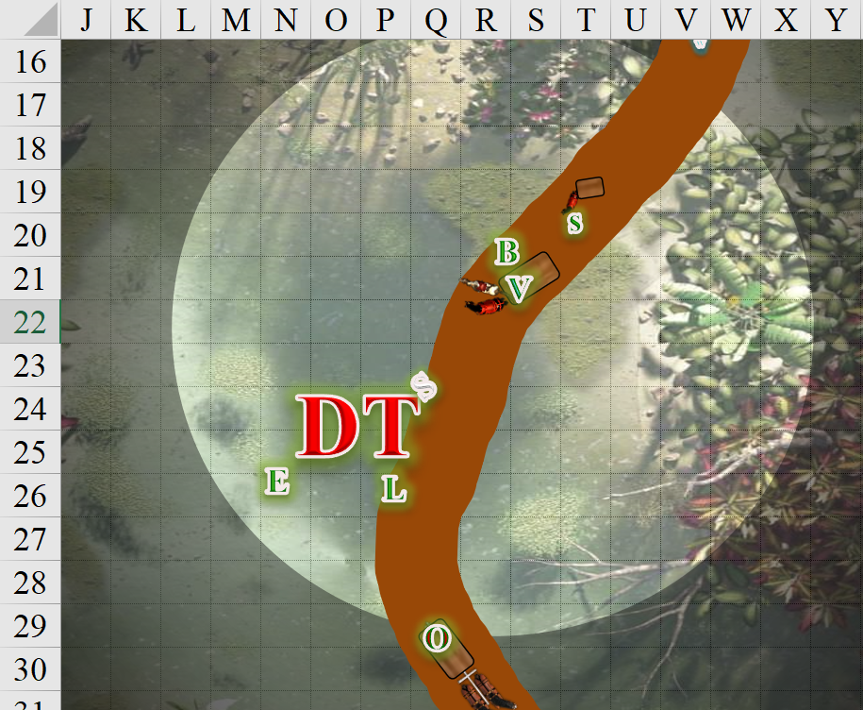

Round 4

Laryssa Power-Smite-attacked the tree somewhat less ambitiously.

|  |  |  |  |  |  |  |  |  |  |
| --- | --- | --- | --- | --- | --- | --- | --- | --- | --- |
| **Melee Weapon** | **Dmg** | **D+** | **TH+** | **Critical** | **Type** | **Wt.** | **Atk** | **Roll** | **Check** |
| Bastard Sword +1, 2-handed | 1d10 | +3+1+2 | 1 + 2 – 1 | 19-20/x2 | Slashing | 6.0 | +9 | 9 | 18 |

*Miss.*

Hearing Saradette yell, and seeing their prisoner’s wagon rolling away, Barkley sprinted after the wagon. With the horses in his way, he did his best to steer through that fine line between the horses and the slope.

|  |  |  |  |  |  |  |
| --- | --- | --- | --- | --- | --- | --- |
| **Save vs.**  Slipping | **Rank** | **Ability & Mod.** | **Misc. Mods.** | **Total** | **Roll** | **Check** |
| **Barkley, Reflex** | 4 | **Dex (+1)** | 0 | 5 | 20 | 25 |
| **Barkley, Balance** | 0 | Dex (+1) | 0 | 1 | 7 | 8 |

*See below.*

And though the archon—now transformed into a greathound—was less than graceful as he made his way along the grade, he was able to keep the two horses from bucking.

The dark tree perceived that it was doing alright against the fleshy beasts, so it kept going. With its branches and roots in concert, it used its special Grab attack to slap at and grapple Elsabet simultaneously.

|  |  |  |  |  |  |  |  |  |  |
| --- | --- | --- | --- | --- | --- | --- | --- | --- | --- |
| **Character** | **Attack Type** | **Damage** | **BAB** | **Str Mod+** | **Total Score** | **Roll** | **Total** | **Crit** | **Threat** |
| Dark Tree | Claw 1 | 2d4+9 | 5 | 9 | 14 | 14 | 28 | 20 | ý |
| Dark Tree | Grapple | Grapple | 5 | 9 | 14 | 2 | 16 | 20 | ý |

*Hit, hit. Dmg: 5 + 9 = 14 + grapple initiated. Partial damage delayed [33/42].*

|  |  |  |  |  |  |  |  |  |  |
| --- | --- | --- | --- | --- | --- | --- | --- | --- | --- |
| **Melee Weapon** | **Dmg** | **D+** | **TH+** | **Critical** | **Type** | **Wt.** | **Atk** | **Roll** | **Check** |
| Grapple | - | +4 | 0 | - | - | 0.0 | +8 | 8 | 16 |

*Grapple successful.*

Then, Saradette noticed the lead wagon. “BARKLEY, GET THE LEAD WAGON!” she yelled at the archon, but he was already on it.

Valerie did the only thing she could do.

|  |  |  |  |  |  |  |  |  |  |  |  |
| --- | --- | --- | --- | --- | --- | --- | --- | --- | --- | --- | --- |
| **Character** | **Attack Type** | **Damage** | **Ranged?** | **BAB** | **Dex Mod+** | **W+** | **Other+** | **Total Score** | **Roll** | **Total** | **Notes** |
| Valerie | Shortbow +1 | 1d6+1 | þ | 4 | 3 | 1 | 0 | 8 | 10 | 18 | Acid Arrows |

*Hit. Dmg: 4 + 1 = 5 + (1 acid every round over the course of the next 3 rounds) = 10.*

The tree was starting to lose branches at this point, and seemed more flustered than satisfied with its success.

Then the heroes felt a sudden sense of *confusion*.

|  |  |  |  |  |  |  |  |
| --- | --- | --- | --- | --- | --- | --- | --- |
| **Save vs.**  *confusion* | **Rank** | **Ability & Mod.** | **Misc. Mods.** | **Total** | **Roll** | **Check** | **Notes** |
| **Barkley, Will** | 4 | Wis (+1) | 0 | 5 | 19 | 24 |  |
| **Elsabet, Will** | 6 | Wis (-1) | 4 | 9 | 19 | 28 | +3 vs. Enchantments |
| **Laryssa, Will** | 4 | Wis (+2) | +1 | 7 | 17 | 24 |  |
| **Saradette, Will** | 3 | Wis (+0) | 3 | 6 | 19 | 25 |  |

*Success4. No effect.*

|  |  |  |  |  |
| --- | --- | --- | --- | --- |
| **Character** | **Check**  *confusion* | **Ranks** | **Roll** | **Save** |
| Valerie | Will | 3 | 16 | 19 |

*Success. No effect.*

“What in the planes was that?” asked Laryssa, shaking off the disorientation.

“Not sure,” one of her friends admitted amidst the conflict.

The raccoon and fawn were nowhere in sight now.

Hurt and furious, while grappled, Elsabet muttered a swift command word to activate her Brute Gauntlets, using all 3 changes at once. She let her sword fall from her right hand to free it up, clenched her fist and gave a hard jab at the dark tree from inches away her Cold Iron Spiked Knuckles, praying to the goddess to help her make this punch count.

|  |  |  |  |  |  |  |  |  |  |  |
| --- | --- | --- | --- | --- | --- | --- | --- | --- | --- | --- |
| **Melee Weapon** | **Dmg** | **D+** | **TH+** | **Critical** | **Type** | **Wt.** | **Atk** | **Roll** | **Check** | **Notes** |
| Cold Iron Spiked Knuckles | 1d4 | +6 | 0 | x2 | Piercing | 1.0 | +10 | 11 | 21 | Right Hand |

*Hit. Dmg: 4 + 6 = 10.*

The horses at the frontmost wagon continues southward and away from the fight.

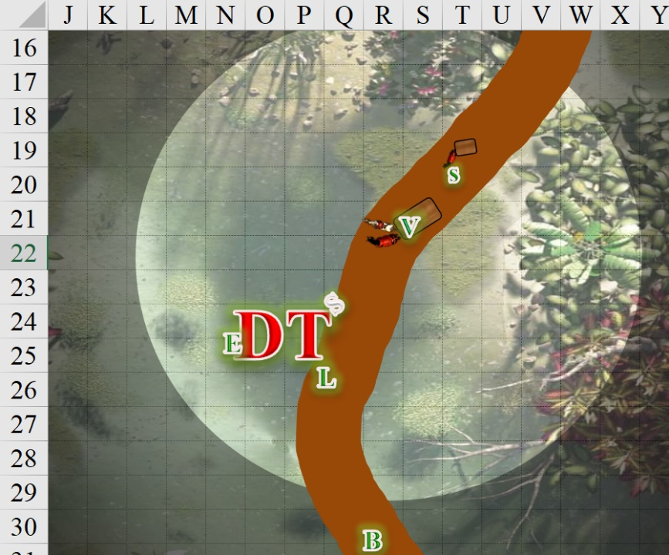

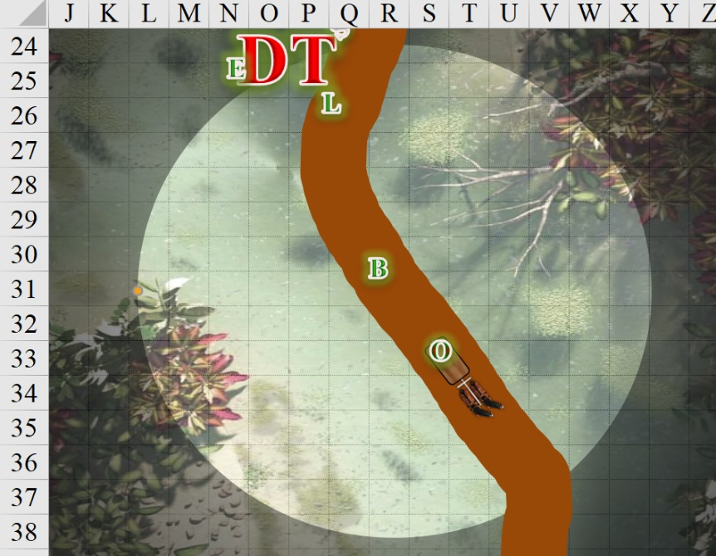

Round 5

The dark tree took the initiative to try to drown Elsabet now that it had her in its grip. It would take a while to shuck the armor off of her, festering flesh once she was about ready to become a snack, but she’d do.

|  |  |  |  |  |  |  |  |  |  |  |
| --- | --- | --- | --- | --- | --- | --- | --- | --- | --- | --- |
| **Character** | **Attack Type** | **Damage** | **BAB** | **Str Mod+** | **Total Score** | **Roll** | | **Total** | **Crit** | **Threat** |
| Dark Tree | Claw 1 | 2d4+9 | 5 | 9 | 14 | 2 | | 16 | 20 | ý |
| Dark Tree | Grapple | Grapple | 5 | 9 | 14 | 17 | 31 | 20 | ý | |

*Miss, miss, see below.*

|  |  |  |  |  |  |  |  |  |  |
| --- | --- | --- | --- | --- | --- | --- | --- | --- | --- |
| **Melee Weapon** | **Dmg** | **D+** | **TH+** | **Critical** | **Type** | **Wt.** | **Atk** | **Roll** | **Check** |
| Grapple | - | +4 | 0 | - | - | 0.0 | +8 | 4 | 12 |

*Grapple remained in place.*

The tree dropped Samand into the water.

Valerie shot at the tree again.

|  |  |  |  |  |  |  |  |  |  |  |
| --- | --- | --- | --- | --- | --- | --- | --- | --- | --- | --- |
| **Character** | **Attack Type** | **Damage** | **Ranged?** | **BAB** | **Dex Mod+** | **W+** | **Total Score** | **Roll** | **Total** | **Notes** |
| Valerie | Shortbow +1 | 1d6+1 | þ | 4 | 3 | 1 | 8 | 6 | 14 | Acid Arrows |

*Hit. Dmg: 1 + 1 = 2 + (1 acid every round over the course of the next 3 rounds) = 10.*

Still in canid form, Barkley reached the horses, got past them, and stood in front of them, barking once.

|  |  |  |  |  |  |  |
| --- | --- | --- | --- | --- | --- | --- |
| **Skill** | **Rank** | **Ability & Mod.** | **Misc. Mods.** | **Total** | **Roll** | **Check** |
| **Barkley, Diplomacy** | 0 | **Cha (+2)** | 2 | 4 | 9 | 13 |

*See below.*

The hoofed herbivores began to slow to a stop, neighing as if clamoring for peace already.

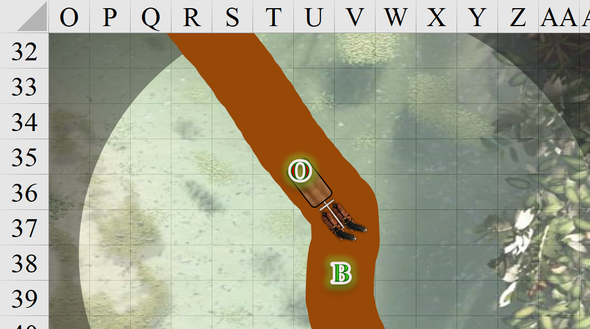

Saradette steadied the cart *[move action]*, and readied her flechette gun for action against the tree.

Widget and fawn were gone now.

Laryssa gave up on trying in increase her damage, since the tree’s bark seemed too tough to strike with reduced accuracy, instead swinging normally.

|  |  |  |  |  |  |  |  |  |  |
| --- | --- | --- | --- | --- | --- | --- | --- | --- | --- |
| **Melee Weapon** | **Dmg** | **D+** | **TH+** | **Critical** | **Type** | **Wt.** | **Atk** | **Roll** | **Check** |
| Bastard Sword +1, 2-handed | 1d10 | +3+1 | 1 | 19-20/x2 | Slashing | 6.0 | +8 | 8 | 16 |

*Miss.*

Elsabet activated her Brute Gauntlets, using all three charges to get a +4 on all STR checks and weapon damage this round.

*Elsabet gained +4 to Strength in addition to the existing +4 bonus from bull’s strength.*

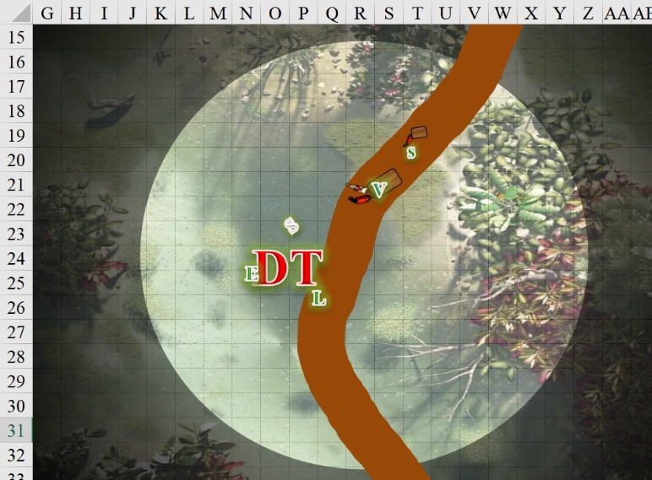

Round 6

The horses tried to rear away from the tree, but the elven woman calmed them down enough to settle them for the moment.

Laryssa attacked once again.

|  |  |  |  |  |  |  |  |  |  |
| --- | --- | --- | --- | --- | --- | --- | --- | --- | --- |
| **Melee Weapon** | **Dmg** | **D+** | **TH+** | **Critical** | **Type** | **Wt.** | **Atk** | **Roll** | **Check** |
| Bastard Sword +1, 2-handed | 1d10 | +3+1 | 1 | 19-20/x2 | Slashing | 6.0 | +8 | 7 | 15 |

*Miss.*

The dark tree attacked Elsabet again.

|  |  |  |  |  |  |  |  |  |  |  |  |
| --- | --- | --- | --- | --- | --- | --- | --- | --- | --- | --- | --- |
| **Character** | **Attack Type** | **Damage** | **BAB** | **Str Mod+** | **W+** | **Other+** | **Total Score** | **Roll** | **Total** | **Crit** | **Threat** |
| Dark Tree | Claw 1 | 2d4+9 | 5 | 9 | 0 | 0 | 14 | 1 | 15 | 20 | ý |
| Dark Tree | Claw 2 | 2d4+9 | 5 | 9 | 0 | 0 | 14 | 7 | 21 | 20 | ý |
| Dark Tree | Grapple | Grapple | 5 | 9 | 0 | 0 | 14 | 19 | 33 | 20 | ý |

*Miss, hit, hit. Dmg: (3 + 9) + (6 + 9) = 12 + 15 = 27. Partial damage banked [11/42].*

At the end of her action, Elsabet felt her last maneuver, Shield Block, granted, though she had no allies adjacent to her.

|  |  |  |  |  |  |  |  |  |  |
| --- | --- | --- | --- | --- | --- | --- | --- | --- | --- |
| **Melee Weapon** | **Dmg** | **D+** | **TH+** | **Critical** | **Type** | **Wt.** | **Atk** | **Roll** | **Check** |
| Bastard Sword +1, 1-handed | 1d10+1 | +6 | 2 | 19-20/x2 | Slashing | 6.0 | +12 | 10 | 22 |

*Hit. Dmg: 9 + 1 = 10.*

Samand began to roll down the levee and further into the water.

Valerie wanted to take a shot at the tree again, but had to steady her horses, who had done their best to remain calm, but were now not having it.

|  |  |  |  |  |
| --- | --- | --- | --- | --- |
| **Character** | **Check** | **Ranks** | **Roll** | **Save** |
| Valerie | Handle Animal | 8 | 4 | 12 |

*See below.*

To the south, the horses neighed, upset and taking it out on Barkley. Inside the wagon, Oral shook his head.

Barkley transformed back into his archon form and talked to the horses to calm them as he moved to check the back of the wagon for their captive. Barkley approached with some caution, just in case he’d somehow freed himself from his bonds and gag.

The archon noted that Oral was still restrained as before, and the horses now seemed to beckon Barkley for some comfort.

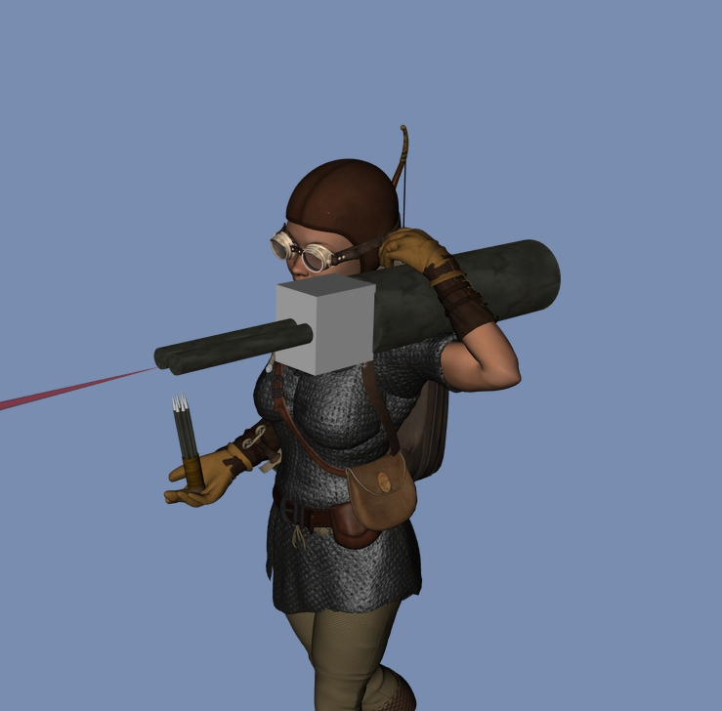

To the north, Saradette stepped around the wagon, aimed her launcher well above her companions’ heads, and fired on the tree.

|  |  |  |  |  |  |  |  |  |  |
| --- | --- | --- | --- | --- | --- | --- | --- | --- | --- |
| **Ranged Weapon** | **Dmg.** | **D+** | **TH+** | **Critical** | **Rng.** | **Wt.** | **Atk** | **Roll** | **Check** |
| Sabot Launcher | 5d6* | - | 0 | 15o cone | 50’ | 5.0 | 6 | 19 | 25 |

*Hit. Dmg: 14.*

*\* Is this damage right?*

Round 7

Laryssa cursed at her ineffectiveness, “Bright Lady, have I offended you? Please guide my blade!” The frustrated swung once again at the dark tree whose bark continued to withstand her attacks.

|  |  |  |  |  |  |  |  |  |  |
| --- | --- | --- | --- | --- | --- | --- | --- | --- | --- |
| **Melee Weapon** | **Dmg** | **D+** | **TH+** | **Critical** | **Type** | **Wt.** | **Atk** | **Roll** | **Check** |
| Bastard Sword +1, 2-handed | 1d10 | +3+1 | 1 | 19-20/x2 | Slashing | 6.0 | +8 | 6 | 14 |

*Miss.*

The paladin’s self-confidence began to shake before the evidence of her inability to cut down a mere tree. Still, she was distracting the damnable, wounded vegetable.

Elsabet had held her vomit and poop like a champ, and now _____.

The tree’s facial features subsided, its mouth now gaping open as the plant instantly died, its wood rotting by the second as the integrity of its fibers now failed to grip Elsabet further.

“Yeah, take that, bark boy!” Elsabet yelled in exultation as she felt her fist punch a fist-sized dent in the part of the tree she could reach. Her feet now touched the mucky ground, and she was waist deep in water. She then felt her remaining maneuvers drain away, and then two maneuvers be granted.

|  |
| --- |
| *Current Maneuvers* |
| Stone Vise |
| Foehammer |

Saradette was about to fire her second charge at the tree, and Valerie had just nocked another arrow back, but there was no need. The fight was over.

There was a sensation of irresolute uncertainty, however, but Saradette suspected this was a lingering magical effect from the evil tree’s ill will towards them.

Valerie jumped off the wagon now that she’d steadied her horses, and made her way down into the muck where Samand was now sinking.

Saradette could neither see nor hear her familiar and the fawn.

With the tree finished and their captive still in captivity, Barkley lead the horses and wagon back to the group.

Saradette looked for Barkley. “Barkley, I need your help when you get a moment.”

When he heard Saradette, Barkley nodded, “Of course I can look for them.” He then transformed into a scout hound and tried to pick up Widget’s or the fawn’s scent and follow it.

She focused and mentally reached out to Widget. *Where are you?*

While she waited for responses, she reloaded the spent chamber in her flechette gun, and used the pump to recharge the cylinder.

Elsabet first made sure that Captain Samand was being tended to. They’d gotten him out of the water and onto the road by now, and his head was breathing. The favored soul of Mayaheine then got him conscious with *cure light wounds*.

*Samand gained 4 + 4 = 8 hps.*

“Hooah!” the revived man exhaled as he tried to sit up slowly, then clenched his teeth and exhaled again from the pain of ribs still broken, “Fwwaahgh!”

“There, Captain,” Valerie placed a hand on his shoulder, helping him to get stable before he got up in a clumsy but masculine way. “You nearly died in the clutches of that one.” She pointed to the now decaying mass of woody fibers sinking slowly into the swamp.

They smelled horribly, particularly Elsabet and Samand, who were doused from head to toe in the nitrates and sulfates of the swamp’s floor, which the tree’s roots had strewn around. Valerie—whose night vision was best among them—could still see tiny bubbles rising to the surface near the tree, causing the rotten egg smell to waft over even more.

“Not to sound like a prissy, little town louse, but... anyone have a spell to clean this off?” Samand asked, gesturing to the filthy mud all over him, his voice raspy and strained from his ruptured spleen and broken ribs.

Elsabet cast *cure light wounds* on herself, hoping she could find the sword she dropped into the swamp.

*Elsabet gained 3 + 4 = 7 hps [18/42, not counting 10 points of delayed damage].*

~*~

Having expended two lesser spell slots in finding her sword, Elsabet emerged once again from the nast and filth.

Samand had fetched a potion of *cure medium wounds* from the knapsack that Mrs. Samand had prepared for him, and chugged that bad boy.

*Samand gained 8 + 6 = 14 hps.*

It would still take some days (or spells) for his bones to set just right, but at least he’d restored integrity and function to his inner organs.

The horses were calm, and had been repositioned bout 140’ south of where the battle had taken place. It smelled better here, and as Barkley—in the form of a wagging doggie—returned with the raccoon and fawn, Saradette’s heart felt like it began to beat again.

All the women were cuted out by the returning beasts, and made more than a half-dozen “Awwwww” and “Ooooo” sounds as they all reunited. Samand shook his head at such things, and longed to arrive in Mintar and rest his head on a proper pillow and slumber amidst the faint, soothing sounds of faraway strums, arpeggios, and the percussion of castanets in the streets of that fair city.

Oral sat in the lead wagon, plotting the myriad ways he’d kill these foul fools if and when he got the chance.

Elsabet suggested we (who are filthy) get out of our icky clothes, wash up, and get dressed in clean clothes. She had extra outfits; they were pretty non-gendered, and one might fit Samand well enough if he had nothing clean.

She reached into her Haversack and pulled out an iron pot, soap, and a waterskin, stripped down and started cleaning up, dumps out the filthy soapy water and said others were welcome to use it. Elsabet had no real modesty—”it’s just a body; get over it, guys.”

“I wouldn’t say ‘just’, darlin’” Samand chuckled, acting like he felt better than he did. “If I were a younger man, I’d...”

Valerie’s slap on the shoulder interrupted his thought, “You’d what? I *ought* to tell Mrs. Samand!”

“Ahghhwwww!” the Captain rubbed his sore shoulder. “My clavicle’s still broken, and both shoulder plates are bruised.”

“Bosh sholdur bladesh are brooshed!” Valerie mocked him. “If you were my husband, flirting with your protectors like that, I’d give you a learning!”

The huff settled, and the group began to gather themselves, and Valerie took the horses to an elevated patch of ground with grazable grass. The water was not good to drink yet, but they would eventually reach an estuary with much cleaner water.

Saradette brought her pony to join the horses, then called over, “I will stand guard while you clean up,” She wrinkled her nose at Elsabet as she approached the wagons again. “I have a water cask on my cart, and a washcloth. And soap. And a bucket. Take your time.”

The gnome looked for a place to stand where she could best see the immediate area around them. “Widget,” she called. “Stay close to me, please.”

~*~

It took a while for Elsabet to wash to her satisfaction with the limited soap and water that she nursed as if they were in a desert, but after a good hour, they were all relatively clean, and ready to go. Valerie tethered the horses to the wagons once again, and Saradette did the same with her pony and cart, and off they went.

~*~

Cusp of Night’s End and Dawn, 5 Tarsakh

The party had continued throughout the night, and as the first hint of light showed itself in the far east ahead of them, the silhouette along that horizon became clearer, and as they continued eastward toward Mintar, they put more and more distance between themselves and the rows of rolling hills they’d just crossed. The swamp was far behind them now, and as they descended in altitude once again towards the coastal city, they could smell the faint scents of urban life, still miles away.

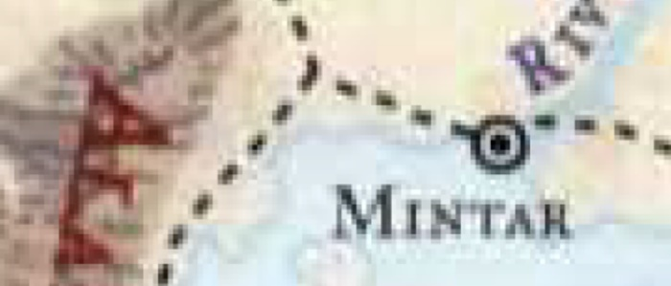

“We shall soon be arriving at the estuaries, where the horses can drink freely and we can fill our canteens,” Valerie had said a while back, and here they now were, arriving upon a splendorous delta complex that fed minerals to the coastal marshes that ensconced Mintar’s periphery.

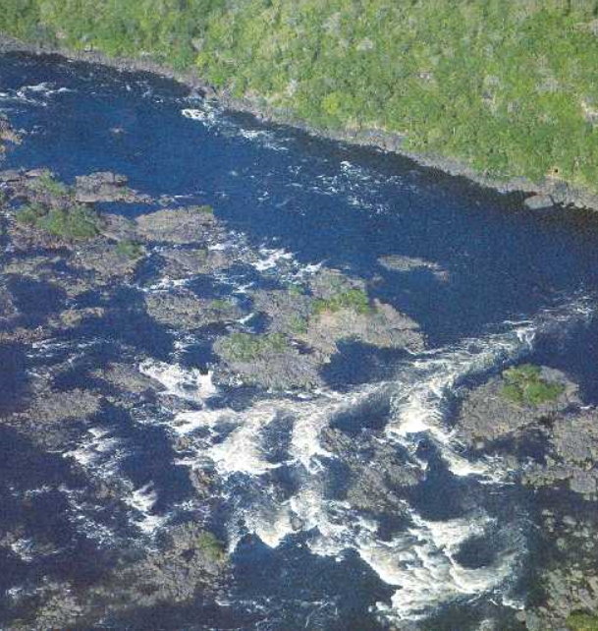

It did not take long for the equines to be led to the bank of a river that pierced the estuary, and gave it much of its momentum. Storks, cockatrices, herons, egrets, and sandpipers began to awaken at the clippity-cloppity noise of the horses and the grinding of the wagon wheels upon the pebbles amidst the sandy dirt.

Coconut-bearing palms were evident along the shore where the thirsty plants could get enough water, and smaller tropical bushes dotted the rest of the countryside’s otherwise pale amber landscape.

“How close is Mintar?” asked Barkley as Elsabet and Saradette looked in on Oral.

“Not far now,” Valerie assured them all as impatience began to be voiced. “A bell tolling... two at the most,” she used the Saradushite term for hour, given that they had a bell and bellringer in that city. Mintar, on the other hand, had dozens of town criers who would announce the times of day optimal for prayer and spell preparation.

They’d been schooled on a few things by now on some of the differences between Saradush—which was influenced more by Amnish and Tethyrian cultures—and Mintar—which was a conglomerate bastion of Calimshite and Shaarite cultures. Saradush’s surplus exports—given its landlocked position—tended towards wood, minerals, crafts made from wood and minerals, and foodstuffs that could be easily preserved, while Mintar was a prime coastal presence with bustling ports that exported a vast variety of raw and produced goods, mostly consisting of freshwater fish and magical beasts from the River Minta and saltwater fish and kelp-based foodstuffs from the Lake of Steam.

A few egrets took flight near the road to the east, which was now bordered on both sides by cattails and other reed-bearing water plants. The flowing, brackish water murmured as it undulated and meandered southward all around them. This miles-long section of the road that traversed the estuary had been carefully built over the course of a century, and maintained constantly by stonemasons and spellcasters who reinforced the elevated structures that allowed water to flow under them. Even in spring, when heavy rains flooded the area, the surface of the road was reliably above the surface of the river.

They were now discussing the geography of their surroundings and the impressive stonework when Widget, then Saradette, then Valerie, then Barkley spotted a figure trotting along the road up ahead.

“Someone approaches,” Samand murmured.

“Looks distraught,” Valerie noted by the haggard way the stranger was trying to run but only really jogging.



The stranger stopped, its long mane hanging past its muscular shoulders. It must’ve been 1000’ away, appeared to be nude, and seemed to also spot them. However, since it had the light of dawn behind it, they could see its silhouette much better than the stranger could see them. It was obvious that there were at least two wagons—as Saradette’s cart had no line of sight ahead—and upon doing a rough count of humanoid shapes, the stranger bolted northward towards slightly higher ground and into the thicket of reeds that fed on the mineral rich, alluvial soil.

Round 1

Barkley watched as the figure ran off the road. Looking at the others, “Would you like me to follow him, see where he went?”

“Yes, but be careful,” Saradette replied. ‘‘It could be a trap.”

Round 2

Barkley smiled, “I’m always careful,” he replied knowing full well that was a significant stretching of the truth.

“Sure you are,” Saradette chuckled.

Rounds 3 – 4

Laryssa frowned, “I’m less curious about him then what he might be running from.”

Elsabet spoke up. “Barkley, before you head out, let me give you a blessing from the goddess—and you should do the *aid* upon yourself.” She moved next to Barkley and cast *bull’s strength [expired on Round 41]* on the hound archon.

*Barkley gained +4 to Strength.*

Barkley paused to accept the blessing. “Rawr! Thanks!”

Elsabet said, “This should last for 4 minutes.”

Laryssa approached Barkley as well. “Don’t pad off too far, but if you’re going to go, you may as well accept this from me.” Touching his shoulder, she invoked the protection *[expired in 1 hour or 1 use]* of Mayaheine for the archon.

*Barkley gained +4 resistance bonus to the next save Barkley needs to make within the next hour.*

“Four what?” the chronometrically illiterate Celestial asked.

“Never mind.” Elsabet then looked at Samand and offered him another *cure light wounds*.

“If you don’t mind,” Samand smiled and presented his torso that she might heal it. Looking over to Valerie, he caught her giving him the raised left eyebrow with a smirk and a shaking of the head. Her lips then formed the words, “Mrs. Samand”, and then she nodded sternly, making him laugh.

*Captain Samand gained 6 + 4 = 10 hps.*

Barkley then ‘aided’ himself with his god’s graces before transforming into a wolf.

*Barkley gained +1 to attack rolls and saves against fear effects, plus 7 + 6 = 13 temporary hit points.*

Round 5

“Scream when you need us to rescue you.”

“Or whistle,” Elsabet chimed in, casting *cure light wounds* on herself.

*Elsabet gained 8 + 4 = 12 hps [30/42].*

“Ei, ei, ei,” Saradette mimicked a frightened dog, and then grinned impudently after the archon.

Barkley headed off at a fast trot to where the figure disappeared.

In the meantime, Laryssa suggested, “We should move the caravan up closer to where we saw the man exit the road. From this distance, if Barkley runs into trouble, we might not even know it, let alone be able to come to his aid.”

Round 6

Despite teasing Barkley about it, Saradette prepared herself for a fight. She moved her cart to the side of the road, set the brake, and stepped down with her combat gear.

Having given the stranger almost a 30-second head start, Barkley got about 150’ east of his friends.

Feeling a lot better, but thinking another cure might be in order just in case, Elsabet cast another *cure light wounds* spell on herself, then asked Captain Samand, “How are you feeling? Do you need another cure?”

*Elsabet gained 5 + 4 = 9 hps [39/42].*

Round 7

With the Captain’s acceptance, Elsabet cast one more *cure* on him. She glanced over at Valerie and, while Samand wasn’t looking, winked at her. She thought about casting a *protection from evil* spell on herself, but instead decided to see what developed.

*Samand gained 7 + 4 = 11 hps.*

In order to not tire himself out, Barkley maintained his speed, clearing 300’ of the 1000’ between the heroes and the spot where the stranger had stood before bolting into the reeds and rushes, and the hills that dotted the otherwise flowing landscape and waterscape.

“I’ve got a bad feeling about this with Barkley going solo,” commented Laryssa. “Mayaheine, grant thy servant your strength.” The nascent warpriestess.

Round 8

Elsabet looked around to see if there were any animals—or other creatures for that matter—within sight, while chatting quietly with her friends. As dawn drew up the curtain of night and replaced the stars with a periwinkle and magenta hue, Elsabet could see dozens of sandpipers now taking breakfast along the borders of the shallow waters all around them. Egrets, storks, and herons alike had by now taken to the skies and were selecting their fishing locations for the morning.

Moving closer to Valerie, she inquired as to the driver’s own circumstances, “You married or otherwise attached?”

“Widowed,” responded the elf with half a smile.

Elsabet considered whether to ask about family or to stop the inquiry at that point.

Even though Barkley was still in sight of the caravan, Laryssa once more suggested advancing the wagons to lessen the distance should trouble arise.

Round 9

Elsabet smiled back at Valerie. “If you’d like to talk about it, or just talk in general, perhaps once we deliver this guy and you get off duty, you might want to have a drink with me... er, us.” She blushed a bit.

~*~

Round 10

Elsabet called out to the soaring marsh birds in the air, “Hey, friends! Do any of you see any 2-legged folks hiding out nearby? If so, I’d appreciate you letting us know, thanks!”

It was unclear as to whether or not the skittish birds would pay her any mind, but one cawed back, << Who’s asking? And why?”

Round 11

Elsabet turned back to Valerie. “You know this town better than we do, obviously, so you could choose a place. I’d be happy to buy.”

The egret shrugged its wings and continued northeastward, not caring much to skip breakfast to talk.

Barkley began to slow down, now, only 100’ from his first destination, from where he would turn north and northeast and use his senses to acquire his mark.

Round 12

Then, turning to Samand, Elsabet continued, “That goes for you too, Captain, be happy to buy you a drink off-shift as well.”

Barkley slowed to the pace of a dainty stroll before stopping altogether.

|  |  |  |  |  |  |  |
| --- | --- | --- | --- | --- | --- | --- |
| **Skill** | **Rank** | **Ability & Mod.** | **Misc. Mods.** | **Total** | **Roll** | **Check** |
| **Barkley, Listen** | 3 | **Wis (+1)** | 0 | 4 | 10ish | ?? |
| **Barkley, Spot** | 5 | Wis (+1) | 0 | 6 | 15ish | ?? |

*See below.*

In the minute that it had taken Barkley to buff up and sprint over, the humanoid had cleared about 200’ of shallow waters and jutting mounds of drier ground. The fleeting man—Barkley could tell at this distance that it was a robust male with what in the dim light might have been grayish skin and jet-black hair—turned back and made eye contact with Barkley. His facial features were muted by the mane that dropped down like a curtain around the sides of his face, and cast a shadow in the already limited light of early dawn.

Upon seeing Barkley, the figure needed only a second to study the great hound before his flight instincts spurred him onward and northward and away from the road. By the looks of his desperate strides, this did not seem to Barkley to be an ambush tactic. This guy *really was* trying to escape anyone he encountered on the road. As to what that meant, Barkley could only wonder.

Seeing the man’s obvious fright, Barkley turned back into his archon form and called out to the man. “HOLD UP! I MEAN YOU NO HARM! WE ARE ON A MISSION OF PEACE AND JUSTICE!”

Round 13

The male figure turned around about half-way through the archon’s call, and looked at him, then turned around, and bolted, jumping behind a thicket of reeds and disappearing upstream for the moment.

She slipped her baldric on over her head, and extracted her flechette gun from its scabbard beside her driver’s seat.

The long-maned male was now perhaps another 50’ farther out, and showed himself as he cleared another mound. The vegetation was so thick ahead of him that he would soon be safe from any danger, and he pressed on, dropping out of sight behind the mound he’d just cleared.

Hearing Laryssa mutter something about not having a *bull’s strength* spell today, Elsabet says, “I can cast another one,” and proceeded to cast it *[expired on Round 53]* upon the paladin/priestess.

*Laryssa gained +4 to Strength.*

Barkley ran ahead in his archon form, still calling after the figure running from him, “WAIT, WE MEAN YOU NO HARM. WE CAN HELP!!” He stopped and cautiously approached the bushes or tall vegetation on the far side of the stream.

|  |  |  |  |  |  |  |
| --- | --- | --- | --- | --- | --- | --- |
| **Skill/Save** | **Rank** | **Ability & Mod.** | **Misc. Mods.** | **Total** | **Roll** | **Check** |
| **Barkley, Balance** | 0 | Dex (+1) | 0 | 1 | 7 | 8 |
| **Barkley, Reflex** | 4 | Dex (+1) | 0 | 5 | 1 | 6 |
| **Barkley, Swim** | 4 | Str (+2) | 0 | 6 | 2 | 8 |
| **Barkley, Survival** | 7 | Wis (+1) | 0 | 8 | 6 | 14 |
| **Barkley, Climb** | 5 | Str (+2) | 0 | 7 | 18 | 25 |

*See below.*

Round 14

On the lookout for an ambush as he crossed the southward-flowing stream complex headed north, he wasn’t so much entering a river as wading in and out of shallow waters and jutting mounds of vegetation-encrusted earth and rocks. Slipping on a mossy surface, the archon had a bad bout of luck, falling into a deep patch of the babbling brook, but quickly climbing his way back out of the water and onto a mound.

The party was by now beginning to get their carts underway, and by the time the archon was at a point where he could neither see nor hear the stranger, they were within reasonable earshot.

“How’d it go?” Valerie spotted and asked Barkley, who has now shaking himself dry and figuring out where he was going to go next.

Barkley replied, “It seems I have lost him. However, if you have some soap, I can finish my bath before we continue on.”

Elsabet called out, “I’ve got extra soap, come back and get it!” She reached into her Haversack and pulled out a fresh bar.

“I’ll take it to him,” Saradette said.

The gnome stopped her cart, stuffed her gun back in its scabbard, and hopped down. She trotted back to Elsabet, and held out her hand for the soap. Elsabet nodded at Saradette and handed her the soap.

Barkley walked back, laughing, “I was just kidding. I took a spill in the stream there.”

And then in response to Barkley, “Well, it’s available if you need it!”

Saradette met Barkley with a grin on her dusky face. “I don’t mind sharing the washcloth, either.” She held up the soap.

Barkley smiled, “Perhaps when we reach our destination.” He had only been kidding but appreciated the gestures.

Saradette laughed and turned back toward her cart, glancing over her shoulder at the archon as she went along. If she had a tail, it would have been wagging.

The figure ran off that way.” Barkley pointed in the direction he last saw the figure running. “I don’t think we should waste time going after him. We still have a task to complete. However,” he paused as he looked up the path ahead of them, “I feel we should be very cautious as we move on.”

Laryssa nodded agreement, “Yes, I much doubt that fellow was just out for a nude jog. He was almost certainly running from something. Now, if it was an angry husband or the like, I see no reason to concern ourselves with that sort of issue. But if it was something not likely to limit its hostility to naked men, we should be ready.”

One of them held back a remark about an angry husband chasing the naked fugitive.

~*~

The better part of an hour had passed since they’d lost track of the fleeting man and resumed their trek towards the fair city of Mintar. The sun was in the horses’ and wagoners’ eyes, and some of the heroes were preparing spells now.

As they crossed the northbound path that led to the Thornwoods, the road became much more heavily striped with dozens of wagon tracks that had come from that direction and veered leftward onto the eastbound road. Valerie knew to expect the Tarsakh Festival—which culminated on Greengrass—and could now tell by the biodegradable bits of trash strewn about the sides of the road that carnival wagons had recently passed through here. Lodging would be hard to find, but the City of Saradush had made arrangements with the authorities in Mintar to secure free rooms for them for two nights.

The gleaming city was now evident in the distance, and within a few minutes they would begin to pass the more peripheral farmsteads and roadside stands, which would surely be ready to sell the harvests of tropical leeks, onions, artichokes, radishes, peas, chards, soursops, rhubarb, bok choy, and guavas. The smell of cooked food and woody fires wafted westward and into the heroes’ noses as the wagons and cart continued on the road.

“Dirty buggers,” remarked Laryssa.

Valerie noted, “They try to be ecologically friendly about it. The scraps are all things that will be absorbed by the wildlife and soil within days.”

And sure enough, a roadside stand presented itself as women heard and spotted the incoming wagons and cart, wiping their hands on their aprons and standing near their baskets of produce, waving at the passersby.

As they approached the roadside stand, Elsabet asked the Captain, “Do you mind if I pick up a few treats for the horses and pony?”

“Give it to yourself with fury,” he used the local Mintari expression, which in the Dalelands would have been, “Knock yourself out.”

Elsabet noted the Mintarism, and approached the women running the stand and buy some horse-friendly treats. “What’s good for horses?”

After some haggling and letting the locals “win”, Elsabet ended up spending several silvers for the treats. “What a bargain!” she took a bag of leeks and another of chards and rhubarb, and proceeded to feed the mounts.

The others settled as well, now that the wagons were along the side of the road, and a few of the three redheaded women’s husbands came out from behind the stands, greeting the newcomers.

“Ah, Valerie!” one of the women identified the archer-wagoner as she hopped down onto solid ground again.

“Druscinda!” Valerie replied. “I see the crops came in pretty well after all.”

Small talk ensued, and within minutes they were all chums. Petting the farmers’ oldest and most sedentary housecat, Elsabet asked about recent travelers, and Druscinda’s sister, Kristineth, responded, “We just opened maybe half a bell’s toll ago, so you’re the first to come through today. It should pick up ‘round Highsun, and by mid-Afternoon, we’ll head back to the farmstead,” she pointed northward to the only visible structure besides the farm stand, “and the boys’ll start closing up right ‘fore dinnertime.”

“That’s what we call a weekday ‘round here!” the youngest sister—Meredith—joked.

The three redheaded half-elves all looked like they could have been Allisa’s sisters, though their vernacular was far more Elven than hers. The druid’s syntax and accent had been too heavily nuanced by Sylvan, and her thousand and one conversations with woodland animals.

Kristineth’s husband, Tucker, had been butchering a buck behind the farm stand, and apologized for his bloody composure, wiping his hands on his white, red, and brown apron. “If you’re in the market for some veni...” the butcher stopped himself as he saw the party’s fawn coming around from behind the pony cart. “Oh,” he cringed, then chose his words, “I’ll guess you’re more interested in the vegan provisions,” and then backed off, letting the women sell their legumes and other veggies.

With their passenger still in tow, Barkley was not keen on staying and talking too long. He did offer the ladies a sample of his wine after someone relieved him to watch their prisoner.

As they sampled the wine, Barkley asked if they had heard any disturbance in the area and explained the man they saw earlier.

The women looked at one another, then at the farm stand—which was always in danger of being burglarized in the middle of the night—before Druscinda sighed, “Well, if he came through here, he was nice enough to not break into the shack.”

Meredith went over to the shack and inspected the entryway, as well as the two planks of wood that pivoted upward into sunshades, and were now held up by metal bars in a simple but sound manner. These were simple people with no aspirations of ever acquiring wealth or magic; their simplicity reminded Elsabet and some of the others of their own homelands and upbringings, and though they might’ve been a bit crude in their manners—what with one of the men covering up one nostril and blowing out snot projectiles onto the ground, and another farting near the produce with a grimace and then a smile—the heroes were glad to have some fresh company.

~*~

As they approached the city of Mintar, Valerie went over the main idiosyncrasies of the culture, particularly insofar as it was different from Saradush. “So you all remember,” she almost yelled over the sounds of the hooves and wagon wheels making way for the 25’ tall city gates still thousands of yards away. “Mintar’s pretty serious about peace bonds, both for weapons and for magic items and components… quivers even.”

“Right,” Barkley noted, having reviewed most of this already. “And as stringent as they are about that, they’re comparably prudish in their sexual customs, right?”

“Some,” insisted Valerie. “It’s not quite as monocultural as Saradush, so you’ll have some folks who are more guarded than others, based on recent histories of conquest and what not.”

Along the last desolate patch of road that they would see today, the small caravan passed the butchered remains of a gorgon calf, and noted that carrion birds were efficiently reducing the intestines and other leavings to a mere patch of blood on the grassy roadside.

By the time the stench of the rotting vulture lunch was far behind them, and the city walls in their sights, they began to finally feel the weariness of the road. They had steeled their nerves for a trek such as this—and they were stalwart travelers for sure—but it would be nice to rest their heads atop a proper pillow tonight.

All around them, on both sides of the road now, were peasants of mostly human stock—a few gnomes among them—greeting Valerie and the others as they slowed to account for the children who lived outside the wall of Mintar. During a siege last year, all of these people had to flee their homes—many of which were razed by an orcish horde—and they were forced to take refuge inside the city. Fortunately, the orcs and goblinoids had been poorly led under a divided command, and their lack of organization ultimately led to their demise. The city had rebuilt since then, and the homes and barns along the settlement’s peripheral areas were restored to their former quaintness and coziness.

They heard the name “Valerie” being cheered a few more times by the locals as the city walls got closer, and Laryssa and the others felt a sense of relief and accomplishment, having brought Oral here all the way from Saradush. The elven wagoner threw down small pouches of edibles that she’d gathered along the road, and the children were grateful to catch them before they fell to the ground.

Even the horses seemed glad to be here, and could sense that a trough was near.

Saradette drove her cart with the wagons, and she smiled as Valerie gave treats to the children. She was glad to see the city, too, as she had several locks with keys to sell. There might be a book or two to be found, so a visit to the market and shops was in order. First, though, they needed to deliver their prisoner, so she sharpened her lookout for anyone who seemed out of place.

In response to Valerie’s reminder, Elsabet smiled at her and Captain Samand, and spoke up with a line of questions. “What’s their rule on spiked knuckles and gauntlets? I forget I’m wearing these sometimes, but I’ll stash them if appropriate,” Elsabet inquired.

The left part of Valerie’s smile turned into a grimace as the elf shook her head and explained, “Eeesh! Probably not a good idea. The people here are a bit less concerned with how your face looks than in Saradush, so what you’ve chosen to put on will say more about you here—you’ll notice the way you’re scanned is different than in the North—and them’s figthin’ accessories,” she pointed to the favored soul’s hands.

“And is there an exception for guards on official business?”

“The peace bonding is mostly a symbolic gesture,” Valerie reminded everyone. “Within seconds, you can be ready for combat, so it’s not necessarily giving violent lawbreakers a huge advantage. Notice that of that handful of guards, two of them have peace bonded weapons, and their Lieutenant isn’t even armed.”

“So sexual permissiveness is to be found only in discrete pockets—no pun intended—of the city, and we’re not likely to see the kind of tavern brawls that are common in Tethyrian lands?” confirmed Saradette, a bit disappointed.

“Right,” Valerie confirmed.

“And the prices for local goods are much more reasonable than back home,” Samand added, intending to visit the marketplace before all was said and done, “Particularly during the festival season.”

Elsabet returned to logistics: “Will we get an armed escort to deliver Oral to his new keepers?” she wondered.

Samand and Valerie turned to each other, and the latter said, “Uh, well, that’s really what we regard *you*.”

“At least as far as Saradushite representation is concerned,” Samand clarified, producing the wax-sealed document that they had to present. “This writ requests such an escort, given the gravity of this man’s deeds, and the perceived threat that he could still pose.”

Valerie was impressed, and looked surprised. “I didn’t realize you were such a VIP, Oral,” she elbowed the cart that contained the prisoner.

Elsabet emoted, “I would hate for us to have come so far only to be ambushed by criminals on the verge of completing our mission with our weapons peace-bonded.”

Valerie gasped as the façade of Westgate was now in sight. “Oh, um... there really is no diplomatic way to say this, but that word—hate—” she said it with less of a shout than the rest of the sentence, “it really has very literal connotations, and tends to hurt people’s ears if you say it. It’s a bit of a curse.”

Laryssa found this to be consistent with her own philosophy, which rested on the notion that words and intentions preceded both action and inaction, which inevitably had measurable consequence in reality.

~*~

Morning, 5 Tarsakh

They reached the Westgate.

There was another caravan in front of them waiting to get in, all seven wagons, each drawn by two horses. The scent of saffron and curry was thick as it wafted eastward towards the heroes and their wagons and cart.

Saradette’s pony gave a little neigh in protest. “We’re *all* hungry,” Saradette hopped off her cart to pet her unnamed pony, and fed her a bit of the produce from the bushel they’d bought at the farm stand not long ago. The gnome pressed her forehead affectionately against the pony’s nape, and the two bonded after the arduous trip. “You’ll rest your hooves today,” she assured the pigmy equine, smelling their prisoner’s hours-old crap.

None of them had prepared spells, and they were weary from a full night’s travel, not to mention the scuffle with the dark tree just hours ago. With the sun now maybe 10 or 15 degrees above the horizon, the heroes could now see its resplendent rays adorning the surface of the Lake of Steam, which was no lake at all, but an inland sea that washed into the vast and seemingly all-encompassing Shining Sea.

“We’re here,” Elsabet sighed to herself as she and the others converged by the frontmost wagon.

Even Samand got down and convened at Valerie’s wagon while Oral gave them all dirty looks through the cracks in the wooden wagon that encased him. He’d soiled himself earlier—probably on purpose—and was now wallowing in his own filth as the caravan in front of them was being inspected.

Valerie had taken a map of the city—of which she had half a dozen stowed inside the frontmost wagon—and had marked several of the noteworthy places inside and outside the walls that might have been of particular interest to the four caravan guards. “Behold: Mintar,” she said as she handed the earmarked map to Laryssa.

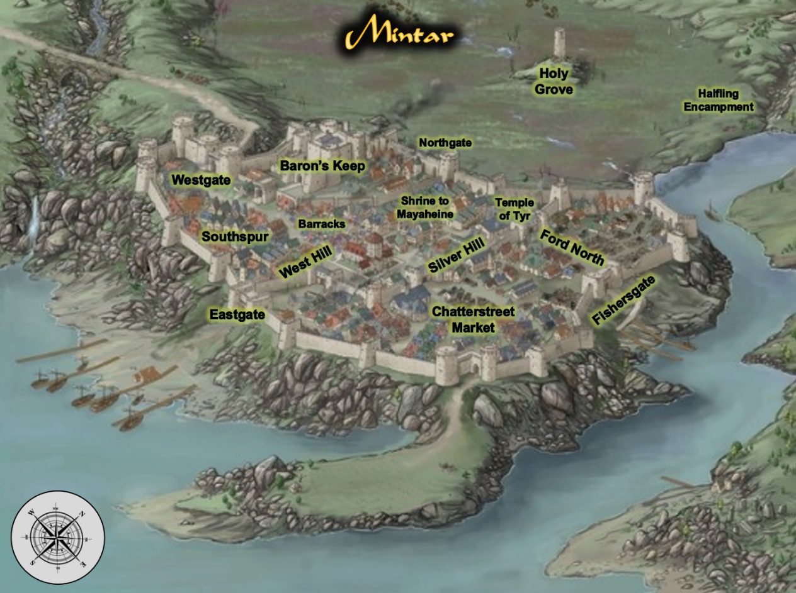

As the inspection of the seven-wagon convoy wrapped up, a few of the city guards made their way over and saluted everyone warmly as Captain Samand presented his seal and the writ detailing the delivery of the prisoner. “The city of Mintar welcomes you, heroes,” said the senior guard, a dwarven woman of at least 100 years. “You know where you’re headed?” the woman asked, being new to this post, and unfamiliar with Samand and Valerie.

“Valerie here is actually a citizen,” Samand explained as he motioned to his counterpart, “and I’ve done this a few times already on behalf of my city-state. We’re to deliver the accused directly to the Magistrate’s Court, where he is scheduled for trial this very afternoon.”

The dwarven woman nodded, “Aye, I see all is in order, Saradush. And this is your contingent?” she looked at the archon and the three women at his side.”

“Yes, the city of Saradush opted for a heavy security detail this time around,” Samand smiled, having been in the conversation when that decision was made. “Some of it may be above my salt grade, but this one did some horrific things to the innocent. He’ll...” Samand bit his tongue, then shook his head, “well, it’s not for me to decide his fate.”

Saradette stood quietly as the city guard did their duty. She was used to the process, as each city did much the same to visitors. All the same, she looked around at the people near her, keeping a discreet but careful watch over their prisoner.

Barkley took in the view as they approached. He was also curious about their laws and rules. He liked the idea of the Peace Bonded weapons as well as the more conservative nature of the people.

He did look forward to a trip to the marketplace, however, he also wanted to visit the Halfling encampment and see what goods they had to offer in the way of food and drink.

When they reached the gate and were greeted by the guard, Barkley remained silent and observant, making sure he kept an eye on Oral in his wagon.

Elsabet nodded at Valerie as she removed her spiked knuckles and slipped them into her pockets. “I’ll be a bit more careful with my words, then. I would not want them to cause more trouble than we would normally encounter.” She knew some words did have power—though usually only when accompanied by the appropriate gestures, and perhaps boosted by a material component or focus, but she also respected the elf’s sensitivities.

“I’ve no problem with my weapons being peace-bonded; I don’t need them to be able to defend myself from many potential enemies. Indeed, it would be a better world if such weapon were never needed.”

Inwardly she chuckled when Samand brought out the writ answering her question, though she kept a straight face so as not to appear self-righteous. She agreed with Valerie that her group was indeed the armed escort that mattered most—but it wouldn’t hurt to have an official Mintari presence as well.

Elsabet rode inside the wagon with Oral the rest of the way.

~*~

The sounds and smells of the carnival were everywhere, and a menagerie of exotic dinosaurs from Chult displayed their crests and thagomizers, mounted by skilled jockeys who led them along the path without so much as scratching a vendor’s cart along the way. The wagons and cart had reached the Baron’s Keep—as it was generically called—not long after entering the city gates, and seeing as Mintar was governed by a landed gentry and singular noble family with no royalty to pay homage to, they were in as central a location as they could get when it came to civic power. The Baron himself—patriarch of the noble House of Rajapur—was not in, or so they were told, but the Keep seemed more like a place of official government business than the home of a nobleman. In effect, the residential area was confined to the topmost floor and the open deck above it. Independent stairways along each watchtower led downward in such a way as to circumvent the baronial family’s chambers, and the warriors in the band were impressed at the tactical considerations that had been made in the construction and embellishment of this fortification.

Mintar, Valerie had just related on the way over, had been conquered by an army of the church of Xvim—now Bane—led by Teldorn Darkhope. For a while everyone in the city had served the army and the church, which was also backed by Fzoul Chembryl of the Zhentarim. Eventually, bands of heroes managed to stave back the Banite forces, and by last year’s winter, the city had rid itself of all Banite influence. Teldorn Darkhope was banished to one of the Lower Planes, and though he vowed to get revenge on the townsfolk for ousting him, he had never been seen nor heard from again.

With power restored to local rulers whose kinship bonds ran deep within the lineages of other prominent families near and far, the city was a beacon of prosperity, if not order, and it seemed to some of the newly arrived that they might find a hospitable home overlooking the shining coastline, which they could now partly see from their elevated vantage point.

“Ah, you’ve arrived,” a human voice roused their attention from the small talk they were making with the two guards who had escorted them here from Westgate. A woman of about 30 years dressed in full plate with the visor of her helmet raised greeted the heroes and wagoners. “I am Rector Fyore. I commend you on your timeliness. Some of us were contemplating asking the judges to postpone the hearing for fear that you might’ve been waylaid.”

“Not at all,” Valerie said as Samand presented his writ to the woman. “Or rather, we *were* waylaid a bit, but it was nothing too serious.”

Rector Fyore nodded, then called, “Notary!”

A young elf approached with plenty of parchment and magic items, casting *amanuensis* upon the writ and copying it magically onto a blank parchment before their very eyes. It was nothing they hadn’t seen before, but this caster did it with such alacrity that it seemed to the heroes that this is what this fellow did day in and day out.

“Did he poop on himself?” asked the Rector politely but directly.

“Oh, yes, that’s him you’re smelling. He really wanted us to earn our coin on this one,” Laryssa diplomatically vented.

As they were wrapping up the summary transaction with the aid of magic, almost a dozen folks started to come out of the stockade to their immediate west. Most were clearly seasoned war veterans with scars and banged up armor and weapons to show for it, but there were a few robed and pointy hatted mages coming out as well. They knew this was the team assigned to take the prisoner into Mintar’s custody, and as the mages greeted the elven notary and plated Rector, introductions ensued. By the end of the round, the outlanders could scarcely remember any of the names that blurred into one another in their shared differences from what the northerners were accustomed to: Rashid, Bashir, Hashim, Karim, Khalid, Hakim, Salim, and variants of those with an a at the end for the women.

One plated male among them—completely unarmed save for a modest dagger—walked among the others carrying six sacks of gold, and upon the Rector’s nod, handed one to each of the travelers from Saradush. “Your payment as promised. And now, as we take the prisoner in and get him... prepared for his hearing, we invite you to rest your feet in our mess hall.”

“Would you like us to hose down the wagon?” a halfling lad with a hose and a pump asked at the wagon washing station just inside the keep’s walls.

“Yes, please, by all means,” Samand gratefully nodded. “Very kind.”

“I could use a meal,” Saradette said hopefully, looking at her companions.

Elsabet also gladly accepted.

As they walked through the town, Barkley was fascinated by the dinosaurs and their riders. He made a mental note to go back and see if he could get a ride on one of the massive beasts.

When they finally turned Oral over to the guards, he gladly accepted the offer of food and drink. He also offered to share a couple of bottles of his own wine with the guards.

~*~

*[Only the off-duty folks are drinking more than a single mug of ale with the food.]*

Barkley was recounting the tale of how they met the elven drunkard, Bornoflove, whose renown reached as far as this city, and whose name invoked tales worthy of telling without embellishing, back in Saradush at the Obstinate Loaf. “Everyone was yelling at the same time, and it was hard to tell who was saying what to whom all the ruckus, but the loudest and most foulmouthed of the instigators—a human named Malcome Neversurrender—cast *scorching ray* upon the dude who’d told him to get impregnated by a goat. He was like, ‘Now it’s time for you to learn your place!’ and stole the guy’s peace from him with the fiery bolt.” [Reference: Chapter 6, p. 16]

“By the gods, I remember that!” Elsabet slapped her knee as her sides started hurting from so many back-to-back tales of funny moments that seemed to successively outdo one another in intensity and implausibility.

Barkley continued, “The badly injured dude was none other than Tyberius Shaunce, the up-and-coming rogue-swashbuckler prodigy whose tongue was slightly sharper than his blade.”

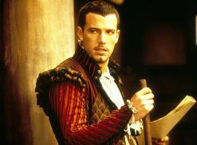

Recent conscripts brought the seasoned veterans at the table another round of pewter mugs filled with human ale, and cleared away some of the empty vessels from the previous rounds.

The hound-faced Celestial continued, “So the swashbuckler shrugged off the scorching pain, drew his hand crossbow, and declared some valiant thing, then shot at Malcome.”

“Did he get him?” one of the now inebriated guards asked as the comrade next to him told him to slow down on the drink.

“You’re back on duty by Highsun,” he warned the other man.

“Uh... I don’t remember. Did he get him?” Barkley asked his lady friends.

“I don’t remember either,” Laryssa smiled, enjoying the way the archon told the story.

“Yeah, so anyweez, the whole thing was over within a minute, and by the time we’d restrained the survivors from the belligerent party, the authorities showed up and took everyone’s statements. Oh, so the whole point—sorry, I got off on the tangent of the story—the whole point of this is that Malcome and this guy Oral that we just brought in had some association between the time that we had Malcome put away and now.”

“Oh?” asked one of the guards most recently promoted to a position of seniority, unaware of this detail.

Rector Fyore knew of this, as it was part of the report that she’d had to review before the prisoner handoff. She interjected, “Yes, they were both incarcerated at the same time, and colluded to escape together. Allegedly, Oral turned on Malcome, and in his attempt to escape, killed another few guards and bystanders. The vetted evidence will all be presented today if a not-guilty plea is entered.”

Saradette listened to the stories while she fixed her meal from the communal table. Using her eating utensils, she cut up a small loaf of bread into slices, added sliced meat, cheese, tomatoes and cucumbers, and stacked another thick slice of bread atop it. A side of celery sticks and carrots, a mug of ale, and she was all set for lunch. The gnome sat at a table and started in on her meal.

Barkley tried the various meats and cheeses offered. He found that the spicier meats were more to his liking. The flavors and aromas were much more inviting and appetizing.

In response to Barkley’s question and Laryssa’s reaction, Elsabet spoke up, saying “I’m pretty sure I got the whole sequence of who did what to whom in what order all sorted out after the fight, and recorded it all in my journal, so I could check, if it matters. I wanted to have it all recorded in writing in case the magistrate needed a review. But please, continue!”

She took another sip of ale, taking her drink slowly as was her wont. She had taken a quick visual survey of what the locals were eating, and gotten herself a plate of the same foods.

Waiting for a break in the stories Barkley was telling—perhaps the archon should consider some Bardic training—Elsabet spoke up again.

“According to Valerie’s map, there’s a temple of Mayaheine here in Mintar. I’d like to head over there after we eat; who else would like to go with me? I’d like to offer thanks to the Goddess and talk to one of the priests, make myself available to them while we’re here. And perhaps they’ll know of a druid who might be willing to take care of our little stray fawn.”

“Do I have time to bathe and change out of this armor, first?” Saradette asked.

“I’m sure the Goddess would have no problem seeing you as you are—She sees us whether at temple or not, after all—and worship while armored up is not a problem, if the worshipper is sincere,” Elsabet reassured Saradette. “If you wish, I will call upon Her to give you Her gentle touch and restore your sobriety so that you do not embarrass yourself in front of her temple priests.”

With Saradette’s acceptance, Elsabet then cast *lesser restoration* on the gnome.

A few more minutes of conversation ensued before a man and woman—both halflings—entered the room, and the chatter died down. “Prefects!” Rector Fyore turned in her seat towards the two legislative executors. “This is unexpected.”

The two halflings nodded and greeted everyone, and the Rector introduced the four heroes who’d delivered Oral. “The City of Mintar is in your debt.”

“Oh, no, you’ve already paid,” the half-drunk artificer leaning against Barkley smiled.

The two halflings—stone cold sober—looked back at the Rector, and the halfling woman said, “Rector, there’s something that requires your attention.”

“Oh?” the Rector stood up, reading in the body language of the two Prefects that this was a discrete matter. “Of course,” she wiped her lips clean of the pheasant she’d just been munching on, and stood up, excusing herself and leaving the heroes to entertain themselves among the rest of the guards.

The halflings and dwarf went up a flight of stairs, and eventually, the dwarf’s armor could be heard clanking no more.

And though the talk was still pleasant after that, the heroes knew they had to stop drinking so early in the morning and began to get a move on. It took a while for goodbyes to be exchanged, given the elaborate forearm-clasping and chest-pounding rituals that these guys got into when it came to parting. Even the armored women partook in the chest bumps, albeit lightly, inviting the four heroes to come back some other time and share in the merriment.

“Sure will,” Elsabet nodded, clear headed for the most part.

“Will dooo!” Saradette had drunk as much as Elsabet, but weighed a fifth as much, so her liver was working overtime right now, and her brain was marinating in a medium of human ale and a shot of something she could no longer pronounce.

Barkley picked up the gnome and carried all 44 pounds of pixie-haired hottie for the moment. “Be seeing you!”

Elsabet then proceeded into the temple with her friends. She planned to donate some gold, and chat with a priest to get some local news, etc. If the group decided to stay in town for a bit, which seemed likely, she planned to come back the next day, perhaps after buying lunch for Samand and Valerie before seeing them off.

~*~

With sacks of gold weighing them down, the heroes were now standing in front of the barracks alongside Samand and Valerie, who had opted to pay their respects to Valerie’s family, who had recently lost one of their members: Valerie’s eldest maternal cousin. The late elf—a man named Vephrendiir Khulamtherian—had been cremated a few tendays ago, and this was Valerie’s first time back since his unforeseen passing, which seemed to be of natural causes, despite the elf being only 237 years old.

Captain Samand and Valerie had just come back, paid the two human spellcaster girls who’d been watching the horses and wagons, and fed a bagful of vegetable scraps to the horses, which they’d brought from Valerie’s mother’s house. Saradette had an arrangement to feed her pony, given the smaller creature’s more sensitive stomach, and the gnome now realized she should’ve asked the cooks if they had any scraps for Gadget. No matter. They had plenty of horse feed in the wagon, and could get plenty more now that they were in town.

Saradette stumbled into her cart, where the fawn and Widget were huddling. The racoon was grooming the nameless fawn of ticks, which he had acquired on the way over. The tropical variety of parasite was tasty, particularly the ones that’d sucked on the deer’s blood for a good few days by now. Mmmm!

“Eewwww!” Saradette slurred. “So nasty!”

Widget shrugged at Barkley as Barkley did his best to place the woman comfortably in her own cart. She wasn’t all that sloshed—or rather, she’d been worse—but needed to give her system the better part of an hour to process what she’d imbibed.

Barkley, Elsabet, and Laryssa stood outside the cart as Samand and Valerie laughed at the antics of Valerie’s favorite horse, who refused the celery that the other three horses consumed with glee. Despite the recent death that she was now processing, Valerie seemed to them a stalwart and resilient person who expected little of the world, and delighted in the freedom of the road, even if it was usually the same road. Sometimes the most oft-blazed trail is the best one. As Laryssa beheld her, the paladin thought that in another life, given different opportunities and circumstances, Valerie might’ve become a druid, and perhaps a warden of Darkhope’s Road, as they’d learned it was called here.

Samand made sure to set the heroes up before anything else. “You all have lodging secured for two nights at the Missing Minotaur at the expense of the Baron. Here’s the place,” he pointed to a spot adjacent to where they were now. “It’s right around the barracks, and it’s owned by a friend of a friend. As for a fellow by the name of Quimby, and present them with this, which they can exchange for coin once you’ve checked out and filled out this part with the number of nights.”

“Looks like the Shrine to Mayaheine is on the way to the Temple of Tyr,” Barkley pointed out on the map. “Maybe we can make a pilgrimage to both.”

“You’re going to prayers?” Samand asked.

“Yes, and to speak to the local clerics perhaps,” Laryssa added, encumbered by all the weight she was carrying. “And to the coin exchange maybe.”

Valerie reminded them, “We will be here until tomorrow, when the verdict is announced.”

Samand added, “We expect to know the outcome by mid-Morning, but to give the judges a cushion of time, we don’t plan on leaving until Highsun. You are—of course—welcome to stay here in Mintar, and enjoy your two nights of free lodging, but we have our duties back in Saradush.”

“No more fly by night?” Elsabet appreciated the shift from nocturnal to diurnal travel now that they had no prisoner to worry about.

Samand smiled and exhaled through his nostrils, “We’ll actually be able to sleep on solid ground at night now.”

“… instead of taking shifts in the wagons,” Barkley finished the thought.

The four heroes realized at this point—if they hadn’t already—that unlike Samand and Valerie, they didn’t really have to return to Saradush, at least not right away, and in light of the festival being underway, they entertained the idea of staying a while and returning to their respective businesses in a few more days, perhaps paying for passage rather than having to work as guards on the way back.

Prior to heading out, Barkley gave Samand 250 gold, asking him, “Take this back to the Obstinate Loaf and give it to the owner so that he could buy supplies to make more of our wines, beers, and spirits as well as fix anything that needs fixing.”

“I will hand it to him myself,” Samand gave his word.

Barkley bowed slightly, “Thank you, and may Tyr smile on you and your family, my friend. Safe travels to you.”

~*~

They walked along the section of the city that housed many of merchant elites and landed families. The mostly straight and normally wide streets of Mintar teemed with activity as the fair engulfed Providence Throughway. This and other main streets were now narrowed by more and more carts, booths, and tents lining both sides. Pedestrians clogged the road completely at some points, barring the passage of horses or anything larger. Artisans, entertainers, and merchants staffed their booths, calling to potential customers and trumpeting their wares. If pickpockets were anywhere in the city, this would be the place where they’d likely gravitate.

Two notable features—the tallest buildings in the city—defined the town’s landscape, these being the Baron’s walled keep, and a bell tower that stood like a sentry, casting a shadow on neighboring buildings. Barkley led the pony by its leather bridle, and Saradette now poked her head out of the cart, asking where they were.

“Going to Mayaheine’s,” Barkley said in a cool and soothing tone as the gnome sobered up a bit.

The neighborhood of Silver Hill—ensconced by crenellated stone walls—led to the North Ford, a walled neighborhood that housed the tallest and most monumental temples in the city, including that of Tyr, which they could not yet see. The paladin and the crusader had been noting the peace-bonded weapons on other people all along, but what they were noticing now is that they were pretty much the only armed people out on this street. Maybe it was early, but even with the bustle of the festival, the elites didn’t seem to have a need to bear weapons or spell components.

As they made their way closer to where the map indicated the Shrine to Mayaheine to be, the party started noticing the marked prices on street vendors’ crates and carts started rising, and by the time they spotted the Shrine, they were in a place where their coin might have gone half as far as in the other parts of town. Nevertheless, the quality of the fabrics, ornate jewelry, and spices here seemed impeccable—really the best goods that the Lake of Steam could offer.

They’d begun to pick up on the idiosyncrasies of the Mintari accent, which emphasized the frontmost consonants, replacing some of the mandibular sounds that the party was used to making—mostly some mandibular Rs and a family of voiceless postalveolar fricatives—with their own rolled Rs and a single fricative to replace them all. This accent was brought to life in speech with the melody of Shaarite cants, the culmination of millennia-old languages of deities and mortals swirled into the contemporary vernacular that was the Common tongue. It would take a few days for the outlanders to get it right, but in the meantime, they wouldn’t stand out too much in this cosmopolitan haven of polyglottal traders and sailors.

Samand and Valerie had told them that they’d wait for the heroes until Highsun tomorrow in front of the Missing Minotaur, and there’d be no hard feelings if they didn’t want to return with them. The job was finished, and the two wagoners could take care of (or escape from) most random roadside attacks. Without the threat of Oral’s friends coming to free him, they could sleep much more soundly without four guards, a raccoon, and a fawn in their midst.



“Behold, the Shrine to Mayaheine,” said Laryssa, being the first to spot and identify her deity’s holy symbols above the front archway, these being Mayaheine’s sword, and the more abstract, gem-encrusted symbol underneath it.



“It’s beautiful,” Saradette said slowly, noting the jet-black shape chiseled and embossed atop the rectangular amber encrusted into the façade of the building, which was open to the sky. “I don’t know if I should go in like this. She may not like it much.” She patted her armored chest as they made their way to the coin exchange lady just across from the Shrine. “I’d want to bathe and get into something more presentable.” She felt a burp coming on and covered her mouth with her hand until it passed. “And be sober.”

Saradette smiled as she thought about selling her wares in this market. She looked for a likely place to sell her locks and utensils.

Elsabet appreciated Saradette’s concerns, but suggested a quick wash of face and hands would be sufficient, and as a goddess of guardians, armored worshippers fresh from the road would not be that unusual as visitors to the temple. But she herself planned to come back the next day in cleaner clothes as well, so if Saradette wished to wait until then to go in, Elsabet would be happy to have Saradette’s company then. But she still offered to restore Saradette to a less inebriated state.

“Okay,” Saradette nodded. “That will help.”

As they walked along, Barkley paid special attention to the food and beverages being sold. With his enhanced sense of smell, he tried to identify the foods and drinks as often as he could. Knowing what they were making, and its aroma would tell him more about the establishment than its appearance from the street.

“Let’s exchange some of our gold for platinum first,” one of Barkley’s Angels suggested, and they went into the coin exchange place.

The heady scent of incense comingled with freshly baked foods, seafood, and garbage, all consistent with what Barkley would have expected. Though he could not place every ingredient that he was sampling with his hypersensitive olfactory nerves, he began getting a general sense of the local cuisine and its mainstays. The locals used a lot of roots as side dishes: yuccas, yams, turnips, potatoes, carrots, and a variety of tubers with whose names the heroes were unfamiliar, but the sea was also usually a contributor to the Mintari dinnerplate, and the archon’s mouth began to drool as the others made pleasantries with the coin exchange lady, Srafeen Zetanzari. Their bags were lightened, for every gold coin that each hero withdrew and a fifth as many platinum coins went back into each bag. They then paid the 1% fee and were off.

“Alright, faithful,” Laryssa prepared herself and her fellow heroines (and Barkley) to meet the cleric(s) of Mayaheine.

The archon was also looking forward to visiting the temple of Tyr here in Mintar. He hoped to be able to get some time to pray at the temple and perhaps receive guidance from his deity. The archon followed the ladies into the Shrine to Mayaheine, but stayed towards the back, stepping off to the side and observing. He’d seen other temples before, and enjoyed taking in the sites and scenery of them. Seeing what symbols were used and what ceremonies meant the most to each temple and each religion.

They entered through the marble threshold under the amber stone that displayed their goddess’ holy symbol, and beheld the combination of simplicity and majesty that they expected. Miniaturized renditions of Mayaheine’s bastard sword and shield were displayed along the east and west walls, but along the north wall—which one faced as one entered—was the unmistakable rendition of the consummate paladin become divinity: Mayaheine herself.

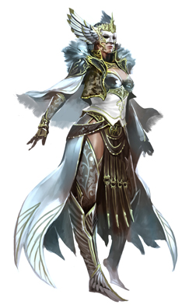

The image was rendered across a magical canvas that was impervious to the elements, as were most of the stone and metal objects in the shrine. Open to the sky, the single room had only a front threshold, and a simple altar as the notable, permanent fixtures of the structure. Three windows lined every wall except the southern wall through which the heroes had just stepped, and a single, square, wooden table up against the north wall under the painting of the goddess had three chairs, two of which were now occupied.

The senior woman—a half-elf wearing the accoutrements of a paladin slightly more decorated than Laryssa—and bearing the same holy symbol as Laryssa—turned to the heroes, recognizing their own emblematic accoutrements and regarding them as friends. “Sisters and brother,” she assumed Barkley was one of the faithful, and in a way, he was. “What fortunes and blessings bring you to the Shrine of the Shieldmaiden?”

The paladin-cleric stood from the table, where a few parchments and quills had been used to draft some correspondence, and introduced herself, “I am Priestess Uma Sarasvati, and this is Deacon Tåriq Sarkrin. We are at your service.”

The other person sitting—a human boy of twenty or so years—displayed the vestments and regalia of an acolyte of the priestess. “Your accents carry the trace of Saradush, and perhaps a bit of the North.” The inquisitive lad bid them, “Please delight us in the tale of how you came to be in Mintar.”

~*~

The corpse lay dead, and was now cooling and rigidifying. Rigor mortis was always such a drag to recover from!

The horned and hoofed male lay lifeless, his weapons and most coveted items confiscated after a pack of murder hobos invaded his master’s domain and killed the tiefling and his blackguard henchman.

Larlum the Redhanded, formerly a whispering scoundrel who eked a life as a pickpocket and later repented his Chaotic ways, turned to the Lawful Evil path, became ordained by a Velshari coven, eventually took over that coven, and expanded the meek organization into a formidable undead-hunting team.

The cleric of Velsharoon had retired from that life years ago, and had commissioned the building of a grotto near the Lake of Steam. His tastes were such that the grotto was reinforced with thousands of bones from monsters large and colossal, and the corridors of his keep had been lined with rib cages, vertebrae, and femoral stilts. His four bedposts were each adorned with the skull of his four most formidable enemies: a desmodu, a human vampire, a yugoloth, and a lich, and that was just the beginning.

His base of operations—coveted and well warded as it was—eventually came under attack by an enemy far more powerful than Larlum, and Larlum was cast out of his home with little more than his armor and clothing, left to fend for himself.

In time, his path crossed Kaszüm, and when one thing led to another, the tiefling found himself in the employ of the ambitious gnome as a mere thug. Thinking this would be a temporary setback as he acquired some new magic items and found some schmucks to do his bidding for a few scraps of the spoils.

The tiefling’s corpse lay defeated, his demise sealed by the heroes who’d just cut him down and slipped away into the Shadow Plane.

And now, the cleric’s corpse began to vaporize, and slowly thereafter, the man simply dematerialized, leaving only his armor, boots, and other clothing behind.

~*~

<< Rise, Larlum, son of Eremdorr son of Khornito son of Orakulus son of Demortim’vek son of Qelem son of Dispater, >> a disembodied voice uttered as the tiefling gained a semblance of consciousness and felt his arms pushing him up. He didn’t know all that about his lineage, but it was noteworthy for later. << Yes... >>

The voice was speaking in an impeccably enounced Infernal, and as the sounds of gigantic hooves approaching made Larlum’s ears twitch and turn towards his left and behind him, his eyes began to adjust to the dim, red light. The scent of brimstone hung high, and he thought for a split second that he might’ve been resurrected to the Hells, and rendered a lemure, but looking down, he noted that his nude form was the same as that which he held in life.

He was dead, and resurrected here on Mungoth, in a cluster of Velshari influence called Death’s Embrace.

<< Master! >> Larlum was now on his own hooves, and bowed, falling forward unto one knee.

Mellifleur, the Velshari avatar that governed this portion of Dis under Dispater’s direct oversight, got within 20’ of Larlum and squinted, taking a measure of the muscular cleric. Towering over the tiefling, the giant manifestation of the god of undeath on this plane decreed, << You—Larlum the Redhanded—have been chosen—among others—for an undertaking so nefarious that you will not yet comprehend it. >>

<< I exist to serve, Master, >> Larlum kept his gaze down at the hooves that were larger than his own horned skull.

Completely undressed, he felt neither hot nor cold, but vulnerable to the judgment of the most powerful force he’d ever beheld. The avatar spoke: << You will exercise a sabbatical from your hunting of ghouls and wraiths. You will cease your relentless pursuits of regaining your bone grotto. Your personal ambitions are your crutches. You exist solely to please Velsharoon, and Velsharoon demands your talents. >>

<< I exist to serve my Master! >>

~*~

Barkley did not speak to the paladin or the acolyte as they approached, as he was not a direct worshiper of Mayaheine. He did bow his head and smiled in acknowledgement of their words and greeting. He was impressed with how simple, yet how powerful the temple seemed. He could almost feel the power of the goddess in the building. He also found himself admiring the paladin as she approached the group. Her from, her grace, her voice, her clothing, all carried a certain amount of charisma, power and beauty.

Saradette was simply overwhelmed with the atmosphere of the place, and she unconsciously edged closer to Barkley. She wasn’t normally intimidated by the big people, but she felt like a child here. This was by far the most beautiful shrine to her deity that she’d visited, and she stared at her goddess’ image in awe.

“Greetings, sister, brother,” Elsabet said respectfully, then stepped aside so that others could step forward to introduce themselves however they wished. “My sisters in Her service, and my brother who serves Tyr and fights at our side, are here to render our respects and perhaps discuss events with the wise here at this great Temple to our Goddess.”

“Ah, a faithful of Tyr, by whose grace Mayaheine ascended to godhood!” proclaimed Priestess Uma.

Barkley grinned and bowed to the paladin from the temple. “It is a pleasure to meet you. This is a beautiful temple.”

Elsabet nodded, “Good Priestess, I wish to donate this small token of my appreciation of Her blessings to help with Temple upkeep and supplies.” She handed over the sack, which contained the 150 gp she had set aside for this purpose. “My name is Elsabet, a favored soul of the Goddess, who with Her blessing has also developed some other abilities to use in Her service, and among other things,”

Saradette’s head spun as she noticed Elsabet’s gift. Her eyes shifted, and then she slipped a hand into her bag.

“My!” Uma proclaimed, with honest surprise. “Your generosity does you honor, Favored of the Shieldmaiden,” the Priestess looked at Elsabet square in the eyes. “Know that this will go towards a worthy cause. You all know as well as we do that austerity is germane to our chosen path, but to heal the wounded and sickly, that is the righteousness that is needed here of late.”

“Wounded?” Barkley asked, wondering if there had been war here recently.

“Children, mostly. Broken limbs from playing. They attend the School of Medium Knocks. Lessons learned,” the young Deacon clarified.

Elsabet turned everyone’s attention back to their purpose, “Priestess, if I may, I would like to ask guidance for my future path from those wiser than myself, as well as share the tales of our travels as a group thus far. I have a journal in which I have recorded such things, which I would be willing to share with a temple scribe, if any of the stories are deemed worthy of keeping in the temple records.”

|  |  |  |  |  |  |  |
| --- | --- | --- | --- | --- | --- | --- |
| **Skill** | **Rank** | **Ability & Mod.** | **Misc. Mods.** | **Total** | **Roll** | **Check** |
| **Elsabet, Diplomacy** | 8 | **Cha (+2)** | 4 | 14 | 5 | 19 |

*See below.*

The Priestess looked down at the folio, and saw Elsabet extending it forth, so she took it and said, “Let me sit with this a few moments, yes?”

“Of course.”

Saradette had just fished from her bag and now pulled out a set of four silver and gold inlaid, polished steel eating forks and knives. “Uh, here. These are, um, I made these. Maybe someone here can use them. They don’t have the box, though.” She handed the set, which was wrapped in clean linen, to the acolyte. She felt her face heat as she looked up at them.

“Oh, a set… of… silverware,” the Priestess tried to nod.

Tåriq finished the thought, “… without... the box,” and raised an eyebrow.

Others smiled and held back a giggle as Uma responded, “I know someone in the community who could use these.” She handed the silver trinkets to Tåriq, and sat the table, reading the journal that Elsabet had kept while the heroes talked with the Deacon a bit.

When the conversation turned back to Barkley, he took the opportunity to say, “I am grateful for the chance to visit. As my companion said, I am a worshiper of Tyr. My name is Bazazath Anath, or Barkley to my friends,” he looked at his traveling companions, “or the friends of my friends.” He looked at the two members of the temple with the last ‘friends’ comment, adding a smile and another bow. He then stepped back to allow the worshipers of the goddess to talk.

Uma thumbed through the pages, nodding, smiling, and within ten minutes or so had read enough to have a sense of their recent journeys. “So... you’ve been a band of heroes for quite some time, and entrepreneurs as well, it would seem.” She handed Elsabet the journal back and shrugged, “We are—as you can see—at a loss to offer you refreshments here, but please let me take you down the street to the blintz and smoothie place, and we can discuss the guidance you seek. Tåriq, would you watch the fort until the next toll or so?”

“Milady,” the Deacon nodded and bid the heroes well. “Make sure you visit the Silver Hill Armory. They’ll set you up with the best gear for the stalwart warrior.”