*Chapter 8: Shrines & Temples*

Morning, 5 Tarsakh

They reached the Westgate.

There was another caravan in front of them waiting to get in, all seven wagons, each drawn by two horses. The scent of saffron and curry was thick as it wafted eastward towards the heroes and their wagons and cart.

Saradette’s pony gave a little neigh in protest. “We’re *all* hungry,” Saradette hopped off her cart to pet her unnamed pony, and fed her a bit of the produce from the bushel they’d bought at the farm stand not long ago. The gnome pressed her forehead affectionately against the pony’s nape, and the two bonded after the arduous trip. “You’ll rest your hooves today,” she assured the pigmy equine, smelling their prisoner’s hours-old crap.

None of them had prepared spells, and they were weary from a full night’s travel, not to mention the scuffle with the dark tree just hours ago. With the sun now maybe 10 or 15 degrees above the horizon, the heroes could now see its resplendent rays adorning the surface of the Lake of Steam, which was no lake at all, but an inland sea that washed into the vast and seemingly all-encompassing Shining Sea.

“We’re here,” Elsabet sighed to herself as she and the others converged by the frontmost wagon.

Even Samand got down and convened at Valerie’s wagon while Oral gave them all dirty looks through the cracks in the wooden wagon that encased him. He’d soiled himself earlier—probably on purpose—and was now wallowing in his own filth as the caravan in front of them was being inspected.

Valerie had taken a map of the city—of which she had half a dozen stowed inside the frontmost wagon—and had marked several of the noteworthy places inside and outside the walls that might have been of particular interest to the four caravan guards. “Behold: Mintar,” she said as she handed the earmarked map to Laryssa.

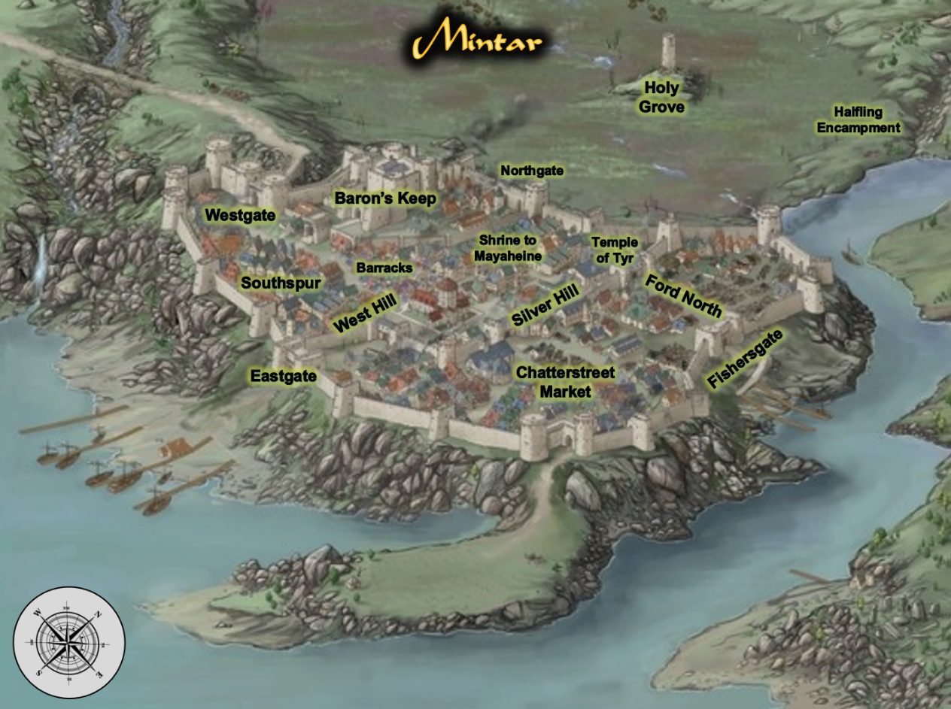

As the inspection of the seven-wagon convoy wrapped up, a few of the city guards made their way over and saluted everyone warmly as Captain Samand presented his seal and the writ detailing the delivery of the prisoner. “The city of Mintar welcomes you, heroes,” said the senior guard, a dwarven woman of at least 100 years. “You know where you’re headed?” the woman asked, being new to this post, and unfamiliar with Samand and Valerie.

“Valerie here is actually a citizen,” Samand explained as he motioned to his counterpart, “and I’ve done this a few times already on behalf of my city-state. We’re to deliver the accused directly to the Magistrate’s Court, where he is scheduled for trial this very afternoon.”

The dwarven woman nodded, “Aye, I see all is in order, Saradush. And this is your contingent?” she looked at the archon and the three women at his side.”

“Yes, the city of Saradush opted for a heavy security detail this time around,” Samand smiled, having been in the conversation when that decision was made. “Some of it may be above my salt grade, but this one did some horrific things to the innocent. He’ll...” Samand bit his tongue, then shook his head, “well, it’s not for me to decide his fate.”

Saradette stood quietly as the city guard did their duty. She was used to the process, as each city did much the same to visitors. All the same, she looked around at the people near her, keeping a discreet but careful watch over their prisoner.

Barkley took in the view as they approached. He was also curious about their laws and rules. He liked the idea of the Peace Bonded weapons as well as the more conservative nature of the people.

He did look forward to a trip to the marketplace, however, he also wanted to visit the halfling encampment and see what goods they had to offer in the way of food and drink.

When they reached the gate and were greeted by the guard, Barkley remained silent and observant, making sure he kept an eye on Oral in his wagon.

Elsabet nodded at Valerie as she removed her spiked knuckles and slipped them into her pockets. “I’ll be a bit more careful with my words, then. I would not want them to cause more trouble than we would normally encounter.” She knew some words did have power—though usually only when accompanied by the appropriate gestures, and perhaps boosted by a material component or focus, but she also respected the elf’s sensitivities.

“I’ve no problem with my weapons being peace-bonded; I don’t need them to be able to defend myself from many potential enemies. Indeed, it would be a better world if such weapon were never needed.”

Inwardly she chuckled when Samand brought out the writ answering her question, though she kept a straight face so as not to appear self-righteous. She agreed with Valerie that her group was indeed the armed escort that mattered most—but it wouldn’t hurt to have an official Mintari presence as well.

Elsabet rode inside the wagon with Oral the rest of the way.

~*~

The sounds and smells of the carnival were everywhere, and a menagerie of exotic dinosaurs from Chult displayed their crests and thagomizers, mounted by skilled jockeys who led them along the path without so much as scratching a vendor’s cart along the way. The wagons and cart had reached the Baron’s Keep—as it was generically called—not long after entering the city gates, and seeing as Mintar was governed by a landed gentry and singular noble family with no royalty to pay homage to, they were in as central a location as they could get when it came to civic power. The Baron himself—patriarch of the noble House of Rajapur—was not in, or so they were told, but the Keep seemed more like a place of official government business than the home of a nobleman. In effect, the residential area was confined to the topmost floor and the open deck above it. Independent stairways along each watchtower led downward in such a way as to circumvent the Baronial family’s chambers, and the warriors in the band were impressed at the tactical considerations that had been made in the construction and embellishment of this fortification.

Mintar, Valerie had just related on the way over, had been conquered by an army of the church of Xvim—now Bane—led by Teldorn Darkhope. For a while everyone in the city had served the army and the church, which was also backed by Fzoul Chembryl of the Zhentarim. Eventually, bands of heroes managed to stave back the Banite forces, and by last year’s winter, the city had rid itself of all Banite influence. Teldorn Darkhope was banished to one of the Lower Planes, and though he vowed to get revenge on the townsfolk for ousting him, he had never been seen nor heard from again.

With power restored to local rulers whose kinship bonds ran deep within the lineages of other prominent families near and far, the city was a beacon of prosperity, if not order, and it seemed to some of the newly arrived that they might find a hospitable home overlooking the shining coastline, which they could now partly see from their elevated vantage point.

“Ah, you’ve arrived,” a human voice roused their attention from the small talk they were making with the two guards who had escorted them here from Westgate. A woman of about 30 years dressed in full plate with the visor of her helmet raised greeted the heroes and wagoners. “I am Rector Fyore. I commend you on your timeliness. Some of us were contemplating asking the judges to postpone the hearing for fear that you might’ve been waylaid.”

“Not at all,” Valerie said as Samand presented his writ to the woman. “Or rather, we *were* waylaid a bit, but it was nothing too serious.”

Rector Fyore nodded, then called, “Notary!”

A young elf approached with plenty of parchment and magic items, casting *amanuensis* upon the writ and copying it magically onto a blank parchment before their very eyes. It was nothing they hadn’t seen before, but this caster did it with such alacrity that it seemed to the heroes that this is what this fellow did day in and day out.

“Did he poop on himself?” asked the Rector politely but directly.

“Oh, yes, that’s him you’re smelling. He really wanted us to earn our coin on this one,” Laryssa diplomatically vented.

As they were wrapping up the summary transaction with the aid of magic, almost a dozen folks started to come out of the stockade to their immediate west. Most were clearly seasoned war veterans with scars and banged up armor and weapons to show for it, but there were a few robed and pointy hatted mages coming out as well. They knew this was the team assigned to take the prisoner into Mintar’s custody, and as the mages greeted the elven notary and plated Rector, introductions ensued. By the end of the round, the outlanders could scarcely remember any of the names that blurred into one another in their shared differences from what the northerners were accustomed to: Rashid, Bashir, Hashim, Karim, Khalid, Hakim, Salim, and variants of those with an a at the end for the women.

One plated male among them—completely unarmed save for a modest dagger—walked among the others carrying six sacks of gold, and upon the Rector’s nod, handed one to each of the travelers from Saradush. “Your payment as promised. And now, as we take the prisoner in and get him... prepared for his hearing, we invite you to rest your feet in our mess hall.”

“Would you like us to hose down the wagon?” a halfling lad with a hose and a pump asked at the wagon washing station just inside the keep’s walls.

“Yes, please, by all means,” Samand gratefully nodded. “Very kind.”

“I could use a meal,” Saradette said hopefully, looking at her companions.

Elsabet also gladly accepted.

As they walked through the town, Barkley was fascinated by the dinosaurs and their riders. He made a mental note to go back and see if he could get a ride on one of the massive beasts.

When they finally turned Oral over to the guards, he gladly accepted the offer of food and drink. He also offered to share a couple of bottles of his own wine with the guards.

~*~

*[Only the off-duty folks are drinking more than a single mug of ale with the food.]*

Barkley was recounting the tale of how they met the elven drunkard, Bornoflove, whose renown reached as far as this city, and whose name invoked tales worthy of telling without embellishing, back in Saradush at the Obstinate Loaf. “Everyone was yelling at the same time, and it was hard to tell who was saying what to whom all the ruckus, but the loudest and most foulmouthed of the instigators—a human named Malcome Neversurrender—cast *scorching ray* upon the dude who’d told him to get impregnated by a goat. He was like, ‘Now it’s time for you to learn your place!’ and stole the guy’s peace from him with the fiery bolt.” [Reference: Chapter 6, p. 16]

“By the gods, I remember that!” Elsabet slapped her knee as her sides started hurting from so many back-to-back tales of funny moments that seemed to successively outdo one another in intensity and implausibility.

Barkley continued, “The badly injured dude was none other than Tyberius Shaunce, the up-and-coming rogue-swashbuckler prodigy whose tongue was slightly sharper than his blade.”



Recent conscripts brought the seasoned veterans at the table another round of pewter mugs filled with human ale, and cleared away some of the empty vessels from the previous rounds.

The hound-faced Celestial continued, “So the swashbuckler shrugged off the scorching pain, drew his hand crossbow, and declared some valiant thing, then shot at Malcome.”

“Did he get him?” one of the now inebriated guards asked as the comrade next to him told him to slow down on the drink.

“You’re back on duty by Highsun,” he warned the other man.

“Uh... I don’t remember. Did he get him?” Barkley asked his lady friends.

“I don’t remember either,” Laryssa smiled, enjoying the way the archon told the story.

“Yeah, so anyweez, the whole thing was over within a minute, and by the time we’d restrained the survivors from the belligerent party, the authorities showed up and took everyone’s statements. Oh, so the whole point—sorry, I got off on the tangent of the story—the whole point of this is that Malcome and this guy Oral that we just brought in had some association between the time that we had Malcome put away and now.”

“Oh?” asked one of the guards most recently promoted to a position of seniority, unaware of this detail.

Rector Fyore knew of this, as it was part of the report that she’d had to review before the prisoner handoff. She interjected, “Yes, they were both incarcerated at the same time, and colluded to escape together. Allegedly, Oral turned on Malcome, and in his attempt to escape, killed another few guards and bystanders. The vetted evidence will all be presented today if a not-guilty plea is entered.”

Saradette listened to the stories while she fixed her meal from the communal table. Using her eating utensils, she cut up a small loaf of bread into slices, added sliced meat, cheese, tomatoes and cucumbers, and stacked another thick slice of bread atop it. A side of celery sticks and carrots, a mug of ale, and she was all set for lunch. The gnome sat at a table and started in on her meal.

Barkley tried the various meats and cheeses offered. He found that the spicier meats were more to his liking. The flavors and aromas were much more inviting and appetizing.

In response to Barkley’s question and Laryssa’s reaction, Elsabet spoke up, saying “I’m pretty sure I got the whole sequence of who did what to whom in what order all sorted out after the fight, and recorded it all in my journal, so I could check, if it matters. I wanted to have it all recorded in writing in case the magistrate needed a review. But please, continue!”

She took another sip of ale, taking her drink slowly as was her wont. She had taken a quick visual survey of what the locals were eating, and gotten herself a plate of the same foods.

Waiting for a break in the stories Barkley was telling—perhaps the archon should consider some Bardic training—Elsabet spoke up again.

“According to Valerie’s map, there’s a temple of Mayaheine here in Mintar. I’d like to head over there after we eat; who else would like to go with me? I’d like to offer thanks to the Goddess and talk to one of the priests, make myself available to them while we’re here. And perhaps they’ll know of a druid who might be willing to take care of our little stray fawn.”

“Do I have time to bathe and change out of this armor, first?” Saradette asked.

“I’m sure the Goddess would have no problem seeing you as you are—She sees us whether at temple or not, after all—and worship while armored up is not a problem, if the worshipper is sincere,” Elsabet reassured Saradette. “If you wish, I will call upon Her to give you Her gentle touch and restore your sobriety so that you do not embarrass yourself in front of her temple priests.”

With Saradette’s acceptance, Elsabet then cast *lesser restoration* on the gnome.

A few more minutes of conversation ensued before a man and woman—both halflings—entered the room, and the chatter died down. “Prefects!” Rector Fyore turned in her seat towards the two legislative executors. “This is unexpected.”

The two halflings nodded and greeted everyone, and the Rector introduced the four heroes who’d delivered Oral. “The City of Mintar is in your debt.”

“Oh, no, you’ve already paid,” the half-drunk artificer leaning against Barkley smiled.

The two halflings—stone cold sober—looked back at the Rector, and the halfling woman said, “Rector, there’s something that requires your attention.”

“Oh?” the Rector stood up, reading in the body language of the two Prefects that this was a discrete matter. “Of course,” she wiped her lips clean of the pheasant she’d just been munching on, and stood up, excusing herself and leaving the heroes to entertain themselves among the rest of the guards.

The halflings and dwarf went up a flight of stairs, and eventually, the dwarf’s armor could be heard clanking no more.

And though the talk was still pleasant after that, the heroes knew they had to stop drinking so early in the morning and began to get a move on. It took a while for goodbyes to be exchanged, given the elaborate forearm-clasping and chest-pounding rituals that these guys got into when it came to parting. Even the armored women partook in the chest bumps, albeit lightly, inviting the four heroes to come back some other time and share in the merriment.

“Sure will,” Elsabet nodded, clear headed for the most part.

“Will dooo!” Saradette had drunk as much as Elsabet, but weighed a fifth as much, so her liver was working overtime right now, and her brain was marinating in a medium of human ale and a shot of something she could no longer pronounce.

Barkley picked up the gnome and carried all 44 pounds of pixie-haired hottie for the moment. “Be seeing you!”

Elsabet then proceeded into the temple with her friends. She planned to donate some gold, and chat with a priest to get some local news, etc. If the group decided to stay in town for a bit, which seemed likely, she planned to come back the next day, perhaps after buying lunch for Samand and Valerie before seeing them off.

~*~

With sacks of gold weighing them down, the heroes were now standing in front of the barracks alongside Samand and Valerie, who had opted to pay their respects to Valerie’s family, who had recently lost one of their members: Valerie’s eldest maternal cousin. The late elf—a man named Vephrendiir Khulamtherian—had been cremated a few tendays ago, and this was Valerie’s first time back since his unforeseen passing, which seemed to be of natural causes, despite the elf being only 237 years old.

Captain Samand and Valerie had just come back, paid the two human spellcaster girls who’d been watching the horses and wagons, and fed a bagful of vegetable scraps to the horses, which they’d brought from Valerie’s mother’s house. Saradette had an arrangement to feed her pony, given the smaller creature’s more sensitive stomach, and the gnome now realized she should’ve asked the cooks if they had any scraps for Gadget. No matter. They had plenty of horse feed in the wagon, and could get plenty more now that they were in town.

Saradette stumbled into her cart, where the fawn and Widget were huddling. The racoon was grooming the nameless fawn of ticks, which he had acquired on the way over. The tropical variety of parasite was tasty, particularly the ones that’d sucked on the deer’s blood for a good few days by now. Mmmm!

“Eewwww!” Saradette slurred. “So nasty!”

Widget shrugged at Barkley as Barkley did his best to place the woman comfortably in her own cart. She wasn’t all that sloshed—or rather, she’d been worse—but needed to give her system the better part of an hour to process what she’d imbibed.

Barkley, Elsabet, and Laryssa stood outside the cart as Samand and Valerie laughed at the antics of Valerie’s favorite horse, who refused the celery that the other three horses consumed with glee. Despite the recent death that she was now processing, Valerie seemed to them a stalwart and resilient person who expected little of the world, and delighted in the freedom of the road, even if it was usually the same road. Sometimes the most oft-blazed trail is the best one. As Laryssa beheld her, the paladin thought that in another life, given different opportunities and circumstances, Valerie might’ve become a druid, and perhaps a warden of Darkhope’s Road, as they’d learned it was called here.

Samand made sure to set the heroes up before anything else. “You all have lodging secured for two nights at the Missing Minotaur at the expense of the Baron. Here’s the place,” he pointed to a spot adjacent to where they were now. “It’s right around the barracks, and it’s owned by a friend of a friend. As for a fellow by the name of Quimby, and present them with this, which they can exchange for coin once you’ve checked out and filled out this part with the number of nights.”

“Looks like the Shrine to Mayaheine is on the way to the Temple of Tyr,” Barkley pointed out on the map. “Maybe we can make a pilgrimage to both.”

“You’re going to prayers?” Samand asked.

“Yes, and to speak to the local clerics perhaps,” Laryssa added, encumbered by all the weight she was carrying. “And to the coin exchange maybe.”

Valerie reminded them, “We will be here until tomorrow, when the verdict is announced.”

Samand added, “We expect to know the outcome by mid-Morning, but to give the judges a cushion of time, we don’t plan on leaving until Highsun. You are—of course—welcome to stay here in Mintar, and enjoy your two nights of free lodging, but we have our duties back in Saradush.”

“No more fly by night?” Elsabet appreciated the shift from nocturnal to diurnal travel now that they had no prisoner to worry about.

Samand smiled and exhaled through his nostrils, “We’ll actually be able to sleep on solid ground at night now.”

“… instead of taking shifts in the wagons,” Barkley finished the thought.

The four heroes realized at this point—if they hadn’t already—that unlike Samand and Valerie, they didn’t really have to return to Saradush, at least not right away, and in light of the festival being underway, they entertained the idea of staying a while and returning to their respective businesses in a few more days, perhaps paying for passage rather than having to work as guards on the way back.

Prior to heading out, Barkley gave Samand 250 gold, asking him, “Take this back to the Obstinate Loaf and give it to the owner so that he could buy supplies to make more of our wines, beers, and spirits as well as fix anything that needs fixing.”

“I will hand it to him myself,” Samand gave his word.

Barkley bowed slightly, “Thank you, and may Tyr smile on you and your family, my friend. Safe travels to you.”

~*~

They walked along the section of the city that housed many of merchant elites and landed families. The mostly straight and normally wide streets of Mintar teemed with activity as the fair engulfed Providence Throughway. This and other main streets were now narrowed by more and more carts, booths, and tents lining both sides. Pedestrians clogged the road completely at some points, barring the passage of horses or anything larger. Artisans, entertainers, and merchants staffed their booths, calling to potential customers and trumpeting their wares. If pickpockets were anywhere in the city, this would be the place where they’d likely gravitate.

Two notable features—the tallest buildings in the city—defined the town’s landscape, these being the Baron’s walled keep, and a bell tower that stood like a sentry, casting a shadow on neighboring buildings. Barkley led the pony by its leather bridle, and Saradette now poked her head out of the cart, asking where they were.

“Going to Mayaheine’s,” Barkley said in a cool and soothing tone as the gnome sobered up a bit.

The neighborhood of Silver Hill—ensconced by crenellated stone walls—led to the North Ford, a walled neighborhood that housed the tallest and most monumental temples in the city, including that of Tyr, which they could not yet see. The paladin and the crusader had been noting the peace-bonded weapons on other people all along, but what they were noticing now is that they were pretty much the only armed people out on this street. Maybe it was early, but even with the bustle of the festival, the elites didn’t seem to have a need to bear weapons or spell components.

As they made their way closer to where the map indicated the Shrine to Mayaheine to be, the party started noticing the marked prices on street vendors’ crates and carts started rising, and by the time they spotted the Shrine, they were in a place where their coin might have gone half as far as in the other parts of town. Nevertheless, the quality of the fabrics, ornate jewelry, and spices here seemed impeccable—really the best goods that the Lake of Steam could offer.

They’d begun to pick up on the idiosyncrasies of the Mintari accent, which emphasized the frontmost consonants, replacing some of the mandibular sounds that the party was used to making—mostly some mandibular Rs and a family of voiceless postalveolar fricatives—with their own rolled Rs and a single fricative to replace them all. This accent was brought to life in speech with the melody of Shaarite cants, the culmination of millennia-old languages of deities and mortals swirled into the contemporary vernacular that was the Common tongue. It would take a few days for the outlanders to get it right, but in the meantime, they wouldn’t stand out too much in this cosmopolitan haven of polyglottal traders and sailors.

Samand and Valerie had told them that they’d wait for the heroes until Highsun tomorrow in front of the Missing Minotaur, and there’d be no hard feelings if they didn’t want to return with them. The job was finished, and the two wagoners could take care of (or escape from) most random roadside attacks. Without the threat of Oral’s friends coming to free him, they could sleep much more soundly without four guards, a raccoon, and a fawn in their midst.



“Behold, the Shrine to Mayaheine,” said Laryssa, being the first to spot and identify her deity’s holy symbols above the front archway, these being Mayaheine’s sword, and the more abstract, gem-encrusted symbol underneath it.



“It’s beautiful,” Saradette said slowly, noting the jet-black shape chiseled and embossed atop the rectangular amber encrusted into the façade of the building, which was open to the sky. “I don’t know if I should go in like this. She may not like it much.” She patted her armored chest as they made their way to the coin exchange lady just across from the Shrine. “I’d want to bathe and get into something more presentable.” She felt a burp coming on and covered her mouth with her hand until it passed. “And be sober.”

Saradette smiled as she thought about selling her wares in this market. She looked for a likely place to sell her locks and utensils.

Elsabet appreciated Saradette’s concerns, but suggested a quick wash of face and hands would be sufficient, and as a goddess of guardians, armored worshippers fresh from the road would not be that unusual as visitors to the temple. But she herself planned to come back the next day in cleaner clothes as well, so if Saradette wished to wait until then to go in, Elsabet would be happy to have Saradette’s company then. But she still offered to restore Saradette to a less inebriated state.

“Okay,” Saradette nodded. “That will help.”

As they walked along, Barkley paid special attention to the food and beverages being sold. With his enhanced sense of smell, he tried to identify the foods and drinks as often as he could. Knowing what they were making, and its aroma would tell him more about the establishment than its appearance from the street.

“Let’s exchange some of our gold for platinum first,” one of Barkley’s Angels suggested, and they went into the coin exchange place.

The heady scent of incense comingled with freshly baked foods, seafood, and garbage, all consistent with what Barkley would have expected. Though he could not place every ingredient that he was sampling with his hypersensitive olfactory nerves, he began getting a general sense of the local cuisine and its mainstays. The locals used a lot of roots as side dishes: yuccas, yams, turnips, potatoes, carrots, and a variety of tubers with whose names the heroes were unfamiliar, but the sea was also usually a contributor to the Mintari dinnerplate, and the archon’s mouth began to drool as the others made pleasantries with the coin exchange lady, Srafeen Zetanzari. Their bags were lightened, for every gold coin that each hero withdrew and a fifth as many platinum coins went back into each bag. They then paid the 1% fee and were off.

*If Laryssa and/or Saradette need to exchange coins, now’s the time to post it.*

“Alright, faithful,” Laryssa prepared herself and her fellow heroines (and Barkley) to meet the cleric(s) of Mayaheine.

The archon was also looking forward to visiting the temple of Tyr here in Mintar. He hoped to be able to get some time to pray at the temple and perhaps receive guidance from his deity. The archon followed the ladies into the Shrine to Mayaheine, but stayed towards the back, stepping off to the side and observing. He’d seen other temples before, and enjoyed taking in the sites and scenery of them. Seeing what symbols were used and what ceremonies meant the most to each temple and each religion.

They entered through the marble threshold under the amber stone that displayed their goddess’ holy symbol, and beheld the combination of simplicity and majesty that they expected. Miniaturized renditions of Mayaheine’s bastard sword and shield were displayed along the east and west walls, but along the north wall—which one faced as one entered—was the unmistakable rendition of the consummate paladin become divinity: Mayaheine herself.

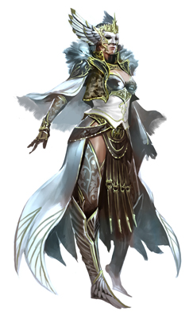

The image was rendered across a magical canvas that was impervious to the elements, as were most of the stone and metal objects in the shrine. Open to the sky, the single room had only a front threshold, and a simple altar as the notable, permanent fixtures of the structure. Three windows lined every wall except the southern wall through which the heroes had just stepped, and a single, square, wooden table up against the north wall under the painting of the goddess had three chairs, two of which were now occupied.

The senior woman—a half-elf wearing the accoutrements of a paladin slightly more decorated than Laryssa—and bearing the same holy symbol as Laryssa—turned to the heroes, recognizing their own emblematic accoutrements and regarding them as friends. “Sisters and brother,” she assumed Barkley was one of the faithful, and in a way, he was. “What fortunes and blessings bring you to the Shrine of the Shieldmaiden?”

The paladin-cleric stood from the table, where a few parchments and quills had been used to draft some correspondence, and introduced herself, “I am Priestess Uma Sarasvati, and this is Deacon Tåriq Sarkrin. We are at your service.”

The other person sitting—a human boy of twenty or so years—displayed the vestments and regalia of an acolyte of the priestess. “Your accents carry the trace of Saradush, and perhaps a bit of the North.” The inquisitive lad bid them, “Please delight us in the tale of how you came to be in Mintar.”

~*~

The corpse lay dead, and was now cooling and rigidifying. Rigor mortis was always such a drag to recover from!

The horned and hoofed male lay lifeless, his weapons and most coveted items confiscated after a pack of murder hobos invaded his master’s domain and killed the tiefling and his blackguard henchman.

Larlum the Redhanded, formerly a whispering scoundrel who eked a life as a pickpocket and later repented his Chaotic ways, turned to the Lawful Evil path, became ordained by a Velshari coven, eventually took over that coven, and expanded the meek organization into a formidable undead-hunting team.

The cleric of Velsharoon had retired from that life years ago, and had commissioned the building of a grotto near the Lake of Steam. His tastes were such that the grotto was reinforced with thousands of bones from monsters large and colossal, and the corridors of his keep had been lined with rib cages, vertebrae, and femoral stilts. His four bedposts were each adorned with the skull of his four most formidable enemies: a desmodu, a human vampire, a yugoloth, and a lich, and that was just the beginning.

His base of operations—coveted and well warded as it was—eventually came under attack by an enemy far more powerful than Larlum, and Larlum was cast out of his home with little more than his armor and clothing, left to fend for himself.

In time, his path crossed Kaszüm, and when one thing led to another, the tiefling found himself in the employ of the ambitious gnome as a mere thug. Thinking this would be a temporary setback as he acquired some new magic items and found some schmucks to do his bidding for a few scraps of the spoils.

The tiefling’s corpse lay defeated, his demise sealed by the heroes who’d just cut him down and slipped away into the Shadow Plane.

And now, the cleric’s corpse began to vaporize, and slowly thereafter, the man simply dematerialized, leaving only his armor, boots, and other clothing behind.

~*~

<< Rise, Larlum, son of Eremdorr son of Khornito son of Orakulus son of Demortim’vek son of Qelem son of Dispater, >> a disembodied voice uttered as the tiefling gained a semblance of consciousness and felt his arms pushing him up. He didn’t know all that about his lineage, but it was noteworthy for later. << Yes... >>

The voice was speaking in an impeccably enounced Infernal, and as the sounds of gigantic hooves approaching made Larlum’s ears twitch and turn towards his left and behind him, his eyes began to adjust to the dim, red light. The scent of brimstone hung high, and he thought for a split second that he might’ve been resurrected to the Hells, and rendered a lemure, but looking down, he noted that his nude form was the same as that which he held in life.

He was dead, and resurrected here on Mungoth, in a cluster of Velshari influence called Death’s Embrace.

<< Master! >> Larlum was now on his own hooves, and bowed, falling forward unto one knee.

Mellifleur, the Velshari avatar that governed this portion of Dis under Dispater’s direct oversight, got within 20’ of Larlum and squinted, taking a measure of the muscular cleric. Towering over the tiefling, the giant manifestation of the god of undeath on this plane decreed, << You—Larlum the Redhanded—have been chosen—among others—for an undertaking so nefarious that you will not yet comprehend it. >>

<< I exist to serve, Master, >> Larlum kept his gaze down at the hooves that were larger than his own horned skull.

Completely undressed, he felt neither hot nor cold, but vulnerable to the judgment of the most powerful force he’d ever beheld. The avatar spoke: << You will exercise a sabbatical from your hunting of ghouls and wraiths. You will cease your relentless pursuits of regaining your bone grotto. Your personal ambitions are your crutches. You exist solely to please Velsharoon, and Velsharoon demands your talents. >>

<< I exist to serve my Master! >>

~*~

Barkley did not speak to the paladin or the acolyte as they approached, as he was not a direct worshiper of Mayaheine. He did bow his head and smiled in acknowledgement of their words and greeting. He was impressed with how simple, yet how powerful the temple seemed. He could almost feel the power of the goddess in the building. He also found himself admiring the paladin as she approached the group. Her from, her grace, her voice, her clothing, all carried a certain amount of charisma, power and beauty.

Saradette was simply overwhelmed with the atmosphere of the place, and she unconsciously edged closer to Barkley. She wasn’t normally intimidated by the big people, but she felt like a child here. This was by far the most beautiful shrine to her deity that she’d visited, and she stared at her goddess’ image in awe.

“Greetings, sister, brother,” Elsabet said respectfully, then stepped aside so that others could step forward to introduce themselves however they wished. “My sisters in Her service, and my brother who serves Tyr and fights at our side, are here to render our respects and perhaps discuss events with the wise here at this great Temple to our Goddess.”

“Ah, a faithful of Tyr, by whose grace Mayaheine ascended to godhood!” proclaimed Priestess Uma.

Barkley grinned and bowed to the paladin from the temple. “It is a pleasure to meet you. This is a beautiful temple.”

Elsabet nodded, “Good Priestess, I wish to donate this small token of my appreciation of Her blessings to help with Temple upkeep and supplies.” She handed over the sack, which contained the 150 gp she had set aside for this purpose. “My name is Elsabet, a favored soul of the Goddess, who with Her blessing has also developed some other abilities to use in Her service, and among other things,”

Saradette’s head spun as she noticed Elsabet’s gift. Her eyes shifted, and then she slipped a hand into her bag.

“My!” Uma proclaimed, with honest surprise. “Your generosity does you honor, Favored of the Shieldmaiden,” the Priestess looked at Elsabet square in the eyes. “Know that this will go towards a worthy cause. You all know as well as we do that austerity is germane to our chosen path, but to heal the wounded and sickly, that is the righteousness that is needed here of late.”

“Wounded?” Barkley asked, wondering if there had been war here recently.

“Children, mostly. Broken limbs from playing. They attend the School of Medium Knocks. Lessons learned,” the young Deacon clarified.

Elsabet turned everyone’s attention back to their purpose, “Priestess, if I may, I would like to ask guidance for my future path from those wiser than myself, as well as share the tales of our travels as a group thus far. I have a journal in which I have recorded such things, which I would be willing to share with a temple scribe, if any of the stories are deemed worthy of keeping in the temple records.”

|  |  |  |  |  |  |  |
| --- | --- | --- | --- | --- | --- | --- |
| **Skill** | **Rank** | **Ability & Mod.** | **Misc. Mods.** | **Total** | **Roll** | **Check** |
| **Elsabet, Diplomacy** | 8 | **Cha (+2)** | 4 | 14 | 5 | 19 |

*See below.*

The Priestess looked down at the folio, and saw Elsabet extending it forth, so she took it and said, “Let me sit with this a few moments, yes?”

“Of course.”

Saradette had just fished from her bag and now pulled out a set of four silver and gold inlaid, polished steel eating forks and knives. “Uh, here. These are, um, I made these. Maybe someone here can use them. They don’t have the box, though.” She handed the set, which was wrapped in clean linen, to the acolyte. She felt her face heat as she looked up at them.

“Oh, a set… of… silverware,” the Priestess tried to nod.

Tåriq finished the thought, “… without... the box,” and raised an eyebrow.

Others smiled and held back a giggle as Uma responded, “I know someone in the community who could use these.” She handed the silver trinkets to Tåriq, and sat the table, reading the journal that Elsabet had kept while the heroes talked with the Deacon a bit.

When the conversation turned back to Barkley, he took the opportunity to say, “I am grateful for the chance to visit. As my companion said, I am a worshiper of Tyr. My name is Bazazath Anath, or Barkley to my friends,” he looked at his traveling companions, “or the friends of my friends.” He looked at the two members of the temple with the last ‘friends’ comment, adding a smile and another bow. He then stepped back to allow the worshipers of the goddess to talk.

Uma thumbed through the pages, nodding, smiling, and within ten minutes or so had read enough to have a sense of their recent journeys. “So... you’ve been a band of heroes for quite some time, and entrepreneurs as well, it would seem.” She handed Elsabet the journal back and shrugged, “We are—as you can see—at a loss to offer you refreshments here, but please let me take you down the street to the blintz and smoothie place, and we can discuss the guidance you seek. Tåriq, would you watch the fort until the next toll or so?”

“Milady,” the Deacon nodded and bid the heroes well. “Make sure you visit the Silver Hill Armory. They’ll set you up with the best gear for the stalwart warrior.”

As they walked along the two-block path, it became evident just how ritzy this quarter was. On their way over here, they’d seen a few musicians, jugglers, jesters, and other street performers, but about 100’ ahead of them now, on a slightly elevated, makeshift stage, there rested a golden harpsichord, played by a male spellscale, and a pair of ballerinas—one elven and the other gnomish—danced daintily like furtive butterflies around the harpsichord. Unlike the spectators they’d seen along the streets before, the audience was an almost unanimously composed group of well-to-do adults. They were standing almost perfectly still, in a way that was so foreign to Elsabet and the other foreigners, though it was the way of the affluent when such a composition was in play.

|  |  |  |  |  |  |  |
| --- | --- | --- | --- | --- | --- | --- |
| **Skill** | **Rank** | **Ability & Mod.** | **Misc. Mods.** | **Total** | **Roll** | **Check** |
| **Saradette, Move Silently** | 5 | **Dex (+3)** | 4 | 12 | 19 | 31 |

*See below.*

It was neither magical music nor the most fantastic mundane music ever, but the resounding harpsichord amidst the nearly silent crowd was interrupted only by the rhythmic chinking of Barkley’s and Elsabet’s chain shirts as they did their best to squeeze by the impeccably clad listeners.

Walking another 200’ or so, they arrived. As they stepped into the establishment known for baking sweets and juicing veggies better than anyone in town, Uma introduced her new friends to the two women at the counter. The two humans—Berlinne and Irma—were the owner-operators of the Burgeoning Kale, and lived upstairs with their cats, who could be seen resting comfortably in well-padded wicker bowls along the corners of the single room. There were six tables, with three to four chairs per table, and two tables were already occupied by other patrons.

Irma asked, “What can we get you today? The bok choi and asparagus swirl may sound funky, but we add a bit of cucumber; it’s really refreshing.”

They ordered drinks, and Uma paid the woman a sum that seemed less than enough, but Irma was happy with the coin and said a few niceties as Berlinne started whipping up drink after drink, each in a magical blending chamber.

“How much did one of those set you back?” Saradette asked Berlinne as the latter made the former’s smoothie.

The veggie expert smiled and answered, “Aw, these? Great investment. We inherited them from Irma’s father. He acquired them—so the story goes—in Neverwinter about 40 years back now. Tales of our juices have spread all over the Lake of Steam, and people make pilgrimages here just for these drinks,” she jested.

The two smiled as the human handed the gnome her order. “Enjoy.”

Saradette, who had practically salivated when she thought of how much her own wares would fetch here, smiled at Berlinne. “Thank you. Mmmm, this is good!” She looked in the cup. “So, this device grinds everything up really finely, right?” She glanced up at them. “Do you know of anyone else who has something like this?”

“Not here,” said the woman. “Maybe in Neverwinter.”

Barkley, Laryssa, and Saradette took a table with three chairs right by the front door, while Elsabet and Uma—who were deep in conversation—took their discussion outside. Elsabet nodded to the others, who were in their own topic by now, and the half-elf and the human stood just outside the main window with a line of sight to the others so they wouldn’t think that the two had wandered off.

“I cannot deny—based on the signs and evidence before me—that you are the chosen of Mayaheine in this world. Your unpresumptuous entrance into our shrine today, the travelers with whom you entered, the words you spoke... you may not realize it, but this is a momentous day for our religion.”

“Oh?” Elsabet had not quite anticipated such a powerful statement, but paladins knew how to contain their enthusiasm, in the face of prophecy rendered flesh, which was what Uma considered Elsabet to be. “I mean, with my recent discovery of Fey-like eldritch power, and powers that I don’t quite comprehend, I’m not sure that I’m prepared to embody the full role of the favored soul until I get a better handle on the Shieldmaiden’s intended uses for these powers.”

“Such as?”

“Ah, well, let’s start with when *charm monster* might be appropriately used. Would it be wise to keep a potentially problematic but useful charmed creature in tow for days or to dismiss such creatures and send them away as soon as the danger has passed? Is charming and using a creature contrary to the teachings of Mayaheine? My reasoning is that while charmed, a creature that is merely a little bad, and not stained with indelible evil, might be persuaded to change their ways at least towards neutral behavior if not all the way to good? Is it wrong to magically persuade a creature in such a way if the greater good might be served?”

Uma began, “Our faith professes that our judgment may not be the best at times.” She sipped on her nanner and rhubarb smoothie, and formulated the next sentence. “But let’s approach this from a reductionist perspective,” the paladin now displayed a bit more intelligence than most in her field. “When we’re talking about *inherently* evil creatures, we mean not some poor fool that lost his way or whose anger overtook him when someone robbed him of his parents or lover.... Good day, Viola!” she waved to a priestess of Lliira who walked by and nodded with a smile. “*Inherently* evil—creatures are quite literally composed of evil particles. Whether they be undead—with negative energy coursing through their walking corpses—Infernal, Abyssal, Hadean, Carcerian—spawned by devils, demons, yugoloths, and shators, among other fiends—Tiamatic, or by some other means the byproduct of evil itself, there is no correct way to collude with them. You know full well that we are in a state of total war with evil, and those forces never rest... nor should we. When it comes to evil, your task is to neutralize it posthaste, with the exception being that if you can defer neutralizing a few evil creatures in order to deal with a significantly larger number later, you bide your time and play the long game. The important thing is that you do not come to embody evil in your struggle to quash it.”

“This is the way?”

“That it is.”

“And, Priestess,” Elsabet then wanted to ask.

“Uma, please,” the sisterly priestess insisted.

“Uma, what of the use of deceptive magic, such as a *disguise self* spell, to gather information unobtrusively, or *deep slumber* to defeat a foe or quell a fight in a nonlethal manner?”

Uma nodded, “To return to my previous point, so long as you do not exercise evil while deceiving your adversary, the Shieldmaiden smiles upon your cunning. Deceive an evil being into committing an evil act unto another, or even unto itself, is evil. You should not cause a villain to slay him or herself, but do convince them to cuff themselves and present themselves to the authorities, by all means. And testify to this, if asked, and the world will know that it was by the grace and wisdom of our Goddess that good prevailed that day.”

“Thank you for all of this, Uma,” Elsabet was grateful as she looked through the window and saw Saradette get up and walk to the counter to get one of the blintzes. “I’m also pretty sure that I’m developing some additional eldritch powers, and though I don’t understand their nature, I will strive to apply these principles to this development.”

“I cannot counsel you much on Fey powers,” admitted the half-elf, “but do trust in your faith and strive always to follow the path of altruism, heroism, and nobility... not the kind of nobility that comes with owning land, but the kind that spreads love throughout the land.”

“Right,” Elsabet smiled. “So you don’t find it problematic that I’m on three different paths? Is there *one* right path for me?”

“Well...” Uma looked at Elsabet with all seriousness. “Paladin, of course.”

A moment of serious tension ensued before Elsabet read the sarcasm in Uma’s face, and had a nice laugh as the paladin elbowed the favored soul and raised her voice to Elsabet could hear her following it up with a cackling, “You’re going about it all wrong, sister!” Elsabet found it refreshing to come across a paladin who could poke fun at her profession’s presumption.

“No, your triptych path is an envious one. You were chosen by the Goddess; the rest of us chose *her*. Your destiny is unique, Elsabet of the Dale. All your paths will lead to Mayaheine,” the paladin smiled more, still taking in the fact that she was participating in such a pivotal conversation in the greater scheme of things. “and might be worthy of study by others as well. Perhaps someday, you’ll take up a post as an instructor of paths.”

Elsabet shook her head, and admitted, “You can likely tell that I’m a little less organized than many who serve Mayaheine.”

“Your kneejerk ways—as you have described them in your journal—are the defining feature of a favored of the Goddess. We paladins are honor-bound to uphold Law, as the Shieldmaiden wills it. You—by contrast—represent the noble end of the axis of Good and Evil, and can dispense with our legislative interpretations when the greater good is at stake. Without the paladin, Mayaheine’s power lacks united resolve; without you—the favored channeler of Her grace, the spontaneously inspired crusader, the free agent of unadulterated kindness—She would be wanting for purpose, and the cosmos would be all the worse for it.”

“Hm, when you put it like that…” Elsabet blinked a few times, doing her best to be receptive to this operatic interpretation of her existence being central to the greater design and ultimate fate of the multiverse. She didn’t finish that thought, but instead streamed her Fey consciousness over to other ideas that on occasion bubbled over like a poorly watched pot of soup. “And are there any things that need doing that our work could accomplish?” Elsabet asked.

The paladin thought over some of the tasks and events on her plate. There was much bureaucratic work to do—testifying in court, filling out paperwork pertinent to cases throughout the city, and the like—but not much that was in her field of vision that required their attention. “In a tenday or so, we expect to receive a guest from Yeshpek. He is my counterpart in the local chapter there, and is to come to help us with outreach efforts, seeing as his congregation numbers in the hundreds there, while ours boasts perhaps a few dozen locals. Good people, mind you, but theology is a market like anything else, and we strive to remain true to our creed despite its lack of popularity among the citizenry.”

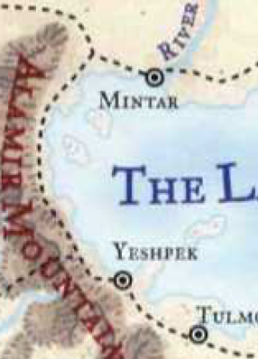

“Perhaps if this shine were situated closer to the common folk...” Elsabet suggested.

“Easier said than done,” sighed Uma. “The teleportation of the stone that comprises the site would be simple enough, but there are ordinances preventing new temples from being sited anywhere but here, in the Silver Hill and Ford North quarters. Only a few ancient holy sites to the Greater Deities have been kept operational in the rest of Mintar, but no, we pretty much *have* to have our ministry here, or outside the wall at the halfling encampment,” she joked, knowing that the halflings wouldn’t be happy with her erecting a monument to her deity in the middle of their very functional and unpretentious riverside campsite.

Barkley, Laryssa, and Saradette walked out of the establishment, thanking Irma and Berlinne for the wonderful munchies and smoothies, and reveled at the sounds of the town. 200’ away, the spellscale harpsichordist was taking a break, talking to some of the spectators, and the ballerinas were probably in the privies.

“Yummy, right?” Uma raised both eyebrows as Barkley was still licking his chops and Saradette still chewed on the last bit of blintz.

The artificer nodded, closing her eyes and emulating someone reveling in the delight of gluttony.

They headed back to the open-air Shrine to Mayaheine, and Elsabet thought to make one last inquiry. “I want to thank you for all that you’ve said...”

“... and I’ll return the voice of gratitude for putting me in the position to say it. Our paths crossed for a reason, as all paths do,” Priestess Uma continued looking forward, swimming politely through the crowd as best as they could.

Elsabet was nodding, and made her inquiry, “I wonder if we might requisition some clerical spells. We’d be happy to make a further donation.”

“Of course. What are you in need of?” she asked as they passed the spellscale musician and smiled their nods at him.

The spellscale nodded back, continuing the pleasantries with the hoity toity circle that most revered his style.

At first, the way the paladin-priestess looked at him, Barkley thought she was impressed with his tongue, something he noticed impressed some females, but he wasn’t completely sure why. However, when she spoke of the drinks, Barkley smiled and nodded, “Yes, they were very tasty and delicious.” Barkley had opted for a very sweet and sugary concoction with several different fruits and no veggies.

Elsabet happily decided to arrange to acquire a selection of scroll spells for herself, and take advantage of the discount on Laryssa’s behalf, should she wish to invest in them; the budding warpriestess might be saving up for improving her weaponry or armor though.

Her thought was to consult her friends on what they might want her to be able to cast from a scroll that might not normally be prepared by Laryssa and that she didn’t know herself, which would need some discussion once they were off the street. They also needed to arrange a place to stay for the immediate future.

“Uma,” she asked, “can you recommend any good places for our group to dine tonight?”

“If you don’t mind eating while standing, all of Eastgate, clear to the ports is lined with food vendors. I’ll warn you, you’ll have to rub shoulders with barbarians and guttersnipes on your way,” she referred to Southspur, which lay between the inn where they were to stay and the Eastgate drawbridge, which was the epicenter of the carnival’s activities.

And then, as it suddenly occurred to her, Elsabet also inquired, “Also, do you know of any good-leaning folks who might want an unusual pet, or a good druid who might care for an orphaned animal? I kind of picked up a stray fawn along the road coming here...” he pointed at the cart that they’d left behind at the Shrine with the young Deacon Tåriq.

With their conversation concluded, the heroes made way for the Temple of Tyr.

~*~

The looming Temple of Tyr stood on a single block, adjacent to no other building. Its double doors—10’ tall—were currently open to the air and the public, and a man and a woman—both humans—stepped up two short steps and entered the building as Barkley and Saradette identified it for what it was.

“We’re here,” the archon sighed, taking in the grandeur of the half-century-old temple. The design was quite contemporary, and had taken hundreds of spellcasters and masons to collaborate on a structurally sound and monumentally astounding building, and it truly did take Barkley’s breath away. The slightly tapered walls and columns exaggerated the perspective of those approaching, giving the impression of an even taller structure as they shaved the remaining distance between themselves and the majestic, towering splendor that served as a conduit of Tyr’s guidance to the city of Mintar.

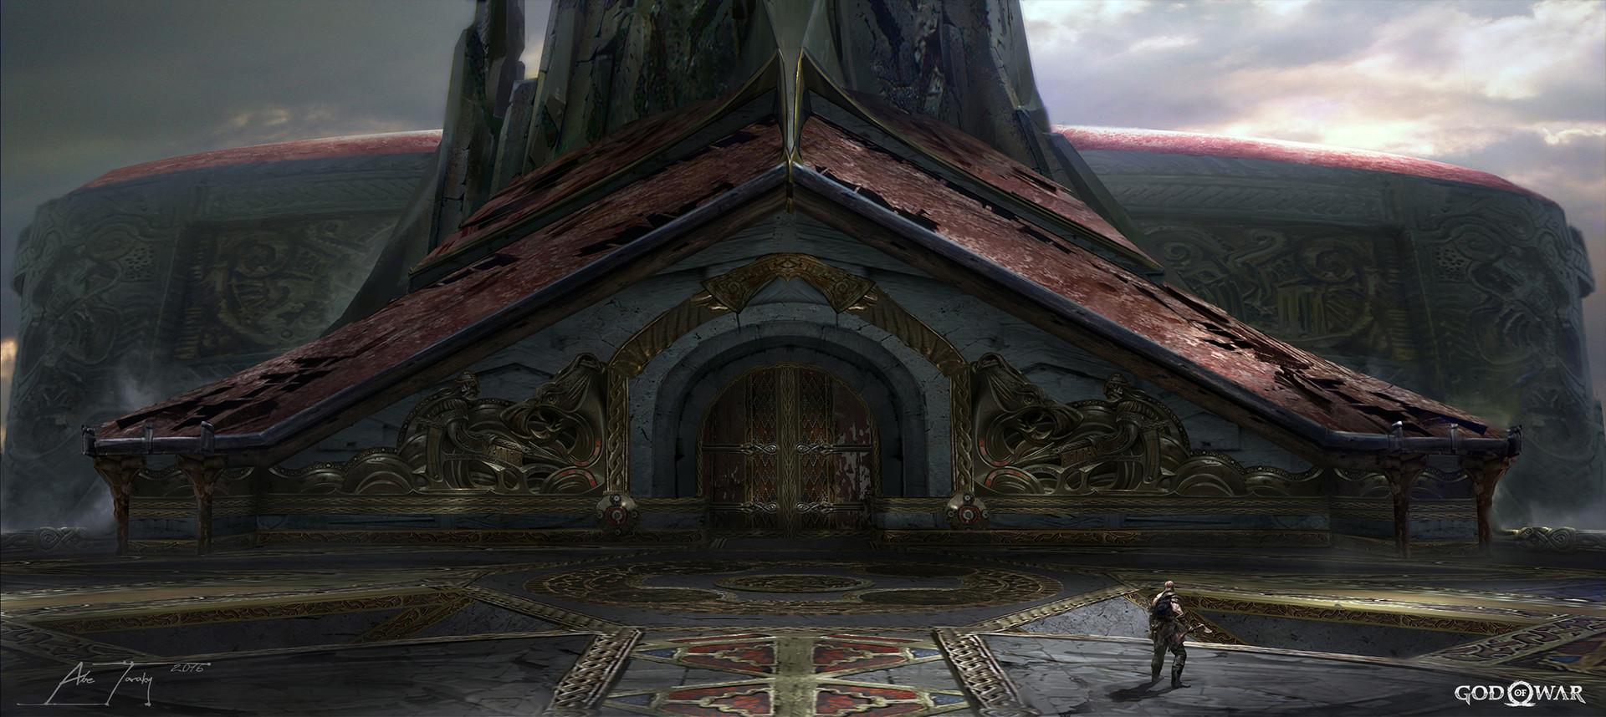

By the time they, too, had entered the stone courtyard leading to it, an elven man of a hundred years or so greeted them, and welcomed them. Barkley bore the insignia that identified him as a worshipper of Tyr, and his guise also betrayed his Celestial nature. Barkley’s three companions smiled and bowed, with Laryssa following the bow with a greeting.

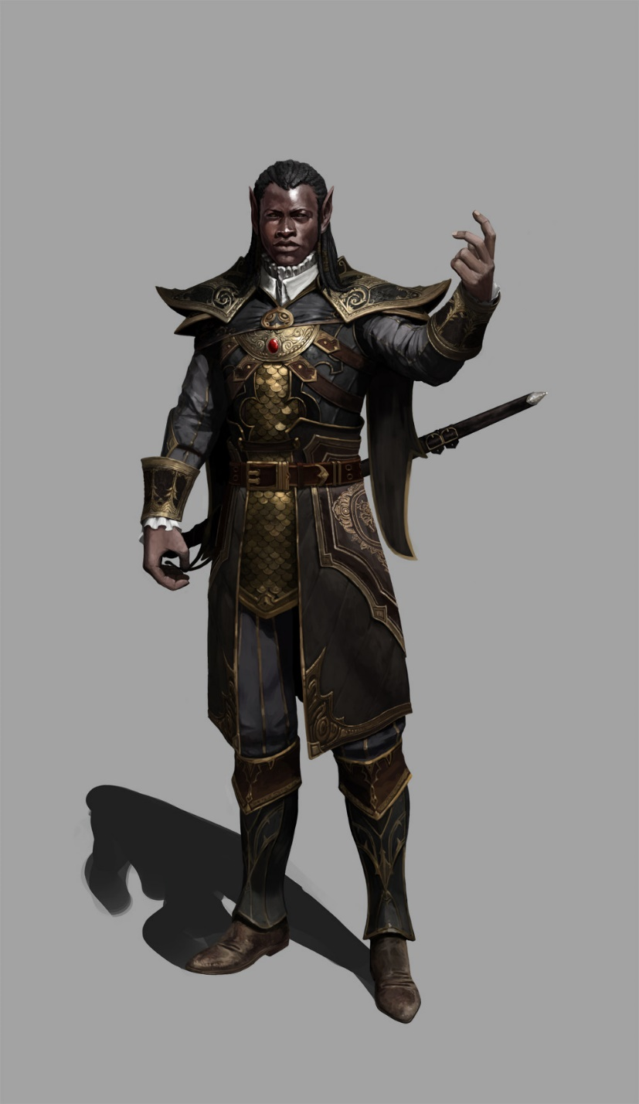

“Peace and blessings, friends, and welcome to the Temple of Tyr,” the Mintari elf spoke with a vowel-rich accent, and his arms were as articulate as his tongue as he waved to his left where a Bishop of Tyr was anointing a recently newborn child, and invited the newcomers to enter. “I am Br. Qaleb; if there is anything in which we can be of service, please let us know. Otherwise, the Bishop would be delighted to speak with a Celestial visitor.”

“Br. Barkley,” the worshipper introduced himself. “My companions are Mayaheinites, and I have spent the better part of a decade with them now.”

“Sisters,” the polite and well armored believer nodded, trying not to sustain eye contact with the ladies.

By now, Barkley had studied the man’s mannerisms, and noted a strict adherence to the code of conduct exemplary of a Knight of Tyr, and now noting the discrete insignia on the gorget covering his heart, he confirmed that this was—in fact—a Knight of Tyr.

noting the discrete insignia on the gorget covering his heart, he confirmed that this was—in fact—a Knight of Tyr.

Upon realizing he was standing in the presence of a Knight of Tyr, something Barkley longed to achieve, Barkley bowed. “It is an honor to be in the presence of a Knight of Tyr. Perhaps, if you have time later, we could discuss tactics, styles, and possibly spells that you have found most beneficial in your experience.”

Qaleb was delighted at the prospect, and agreed, “Let’s come up with a suitable time to do so.”

~*~

Meanwhile, at the Missing Minotaur...

“Is that all of them, love?” asked a man of a woman.

“Not nearly,” she shook her head, sorting through the vouchers from the Baron’s office, “still have those four that are coming in from Saradush.”

“Oh, right: the guards. Wasn’t that Valerie who was to come with them?” asked the man.

“Yes, the poor dear,” sighed his spouse.

“Oy!” an obtuse male voice pierced the conversation, “C’I get another?”

“It’s not even Highsun, Barth,” the male owner of the establishment said, but still got the man a freshly boiled ale. “Nurse it; will you?”

“I thank ye,” the already drunken man expressed. “Once I kill this woe, I’ll be out of your hair.”

“Yah, well, good luck with that,” the owner said as a second patron came in. “Gyorgy!”

“Radnar!” the incoming man cheered the owners’ last name. “*Mrs.* Radnar,” he then removed his hat and bowed his head at the woman.

“Eggs Saradush and a side of chutney?”

“As always. Hey, Barth!”

“Gyor…” Barth lifted the wooden mug at the man across the room, and slouched further into the booth, peering out the window, longing for his runaway lover.

~*~

After the exchange with Brother Qaleb, Barkley found a spot to pray for a moment, asking Tyr for his blessing and sharing his recent deeds with the deity though he knows that Tyr would be aware of those deeds. He knelt before a breastplate bearing his deity’s sacred hammer, and bid his deity for his favors today and forevermore. “Andguidemypathandmakemystrideswift,” he finished the last sentence in a single breath, not out of a sense of urgency, but out of sheer passion for his god and creed.

[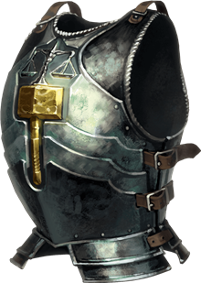](https://www.google.com/url?sa=i&url=https%3A%2F%2Fforgottenrealms.fandom.com%2Fwiki%2FChurch_of_Tyr&psig=AOvVaw0nPuz4jI7WWxAET9BVNaKN&ust=1594240510409000&source=images&cd=vfe&ved=0CAIQjRxqFwoTCKi6gO7-u-oCFQAAAAAdAAAAABBi)

When he finished his prayers, he donated 10 platinum coins to the temple’s coffers, attempting to do it as nonchalantly and unobtrusively as possible.

|  |  |  |  |  |  |  |
| --- | --- | --- | --- | --- | --- | --- |
| **Skill** | **Rank** | **Ability & Mod.** | **Misc. Mods.** | **Total** | **Roll** | **Check** |
| **Barkley, Hide** | 5 | Dex (+1) | 0 | 6 | 10ish | 16ish |
| **Barkley, Sleight of Hand** | 0 | Dex (+1) | 0 | 1 | XX | XX |

*Result unknown.*

On their way out, the Bishop stopped them and tilted his head, “Now don’t tell me you were going to just leave without saying hello!”

The charming human seemed seriously interested in the archon, and though he’d just been debriefed on him and his lady friends, he yearned to know more, “Please, Brother and Sisters, do tell me your names that I might pray for you at Highsun.”

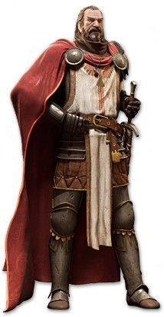

That reminded Laryssa that she was almost due to pray for spells, and needed to be clean before doing so. The inn would be a welcome sight when they finally headed there.

Barkley could not resist the charismatic and enthusiastic Bishop of Tyr, and introduced himself, as well as the ladies.

“And I am Bishop Jericho of Tyr, and you’ve already met Sir Qaleb here,” he extended a hand towards the approaching knight, now that the other congregants had been directed to the appropriate sections of their library, just beyond an open threshold. “Tell me, from where do you hail? I cannot quite place your fashions,” the Bishop noted, not yet having heard their accents. It was likely that the man could’ve gleaned their origins once they’d spoken Common, but he asked in order to glean other information that he was not asking for directly.

The archon could sense no malice in this, but noted the immediate “where’re you from, outlander?” line of questioning, and found it to be at least unexpected from a Bishop of Tyr. Nevertheless, the archon answered, “I am Bazazath Anath in my native land in the Celestial Realm. Here I am simply known as Barkley. I arrived in the Prime Material Plane a few years ago and have traveled with these strong, amazing, dedicated women. As of recently I have resided in Saradush where I am also part owner of a bar called the Obstinate Loaf. If you are ever in town, let the owner know and he will be sure to take care of you.”

Saradette was not as overwhelmed as with her own deity’s temple, but she was still not eager to say anything.

Doing her best to use appropriate terms of address for both the Knight and the Bishop, Elsabet respectfully answered any questions put to her, and when asked about origins, said she was originally from the Dalelands, more recently spent some time in Saradush, but other than that, not volunteering a bunch of extraneous info.

She also tried to get some sense of whether the Bishop is sizing us up for friendly or non-friendly purposes. The Bishop was as hands-off as the Knight, though she knew that Knights of Tyr upheld stricter codes of celibacy or at least reservation in the intimate ways. The Bishop’s hands may have remained off of Elsabet’s person, but his eyes did wander a bit. However, she did not get the impression that he would’ve acted indiscreetly if they had not been in the company of others. This man appeared to be a formerly jovial, but now life-jaded warrior who did his best to keep up bravados with newcomers, though the sadness of a widower or some other experiencer of loss was displayed upon his brow. This might’ve been Elsabet’s misinterpretation of things, but she was pretty confident that he wasn’t trying to size her up to shiv her in a dark alley. She wasn’t quite as talkative as normal, and deferred to Barkley when appropriate, as this is his turf. And Barkley does often “lead” us, as it were, she thinks to herself—usually by hot-dogging it down the trail...

*[Other IC]*

When the conversation concluded, the keepers of the Temple bid the Celestial and his angels a pleasant stay in Mintar, and asked them to come again before leaving. Sir Qaleb added, “It is an honor to host you in our splendorous city.”

Barkley thanked the Bishop and Knight for their time and their hospitality. He also told Qaleb, “Sir Qaleb, if you have time tomorrow around 10 bells, I could come by so we can talk further.” He did not want to disturb any morning preparations or rituals they the knight might have at the temple, so he chose a slightly later hour.

~*~

The party had walked towards the Missing Minotaur, with Saradette leading her pony and cart along the narrow streets. On occasion, they’d had to turn back and take another street, as the route they’d first chosen back to the Baron’s Keep quarter did not necessarily have the 3’ or so of clearance that Saradette needed to get through.

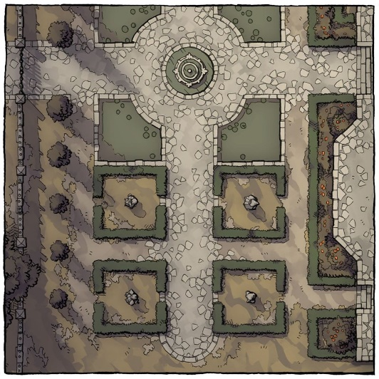

In time, they followed their map and the street signs to and through a courtyard beyond which was the Missing Minotaur, and beyond that, a 15’ wall of the Baron’s Keep. Situated right against the keep’s wall, the rooms along the north wall would be the farthest from the streets’ noises, Barkley surmised, not yet having seen their accommodations.

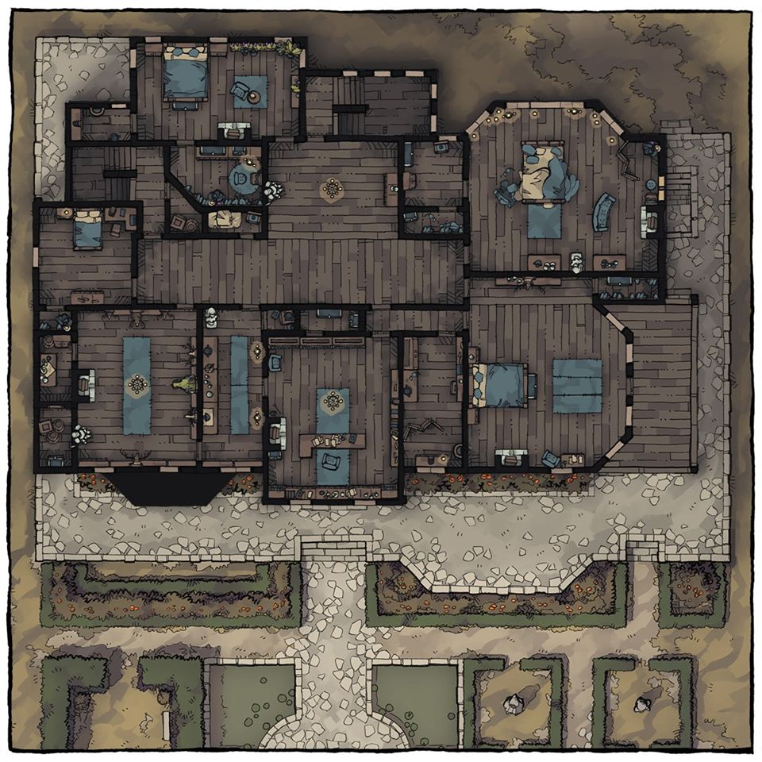

The heroes sighed with satisfaction when they smelled the meats stewing in a cauldron, their scent billowing from the front door, which was held open by a clay pot with a fruitless guava plant in it.

“Saradush, party of four?” confirmed the woman at the door as they approached and entered.

“That’s right. Straight outta Saradush,” Elsabet proclaimed as Saradette tied the pony’s lead to one of the posts right outside the door.

“There, Gadget. You watch the babies and maybe make friends with these two,” she pointed to a horse to her left and a donkey to her right as the fawn and the raccoon, poked their heads out of the cart’s window and sniffed the air.

Widget expressed her desire for some of the lamb and beef that she could smell now, while the fawn was starving for some grass and clovers.

*[The fawn wasn’t critically famished, but hadn’t eaten since you’d stopped at the farm stand and bought those veggies, which was about 5 – 6 hours ago.]*

Saradette gathered feed for the animals, and arranged for their care while they were at the inn. That done, she checked her stock of completed padlocks and hasps, utensils, and hand tools – she made simple-but-well-made things like chisels and flat drill bits for wood – and prepared to make a trip to the market district.

“Hello, hello! Valerie’s friends, right? Come on in, heroes. We’ve been expecting you,” the husband at the counter followed up as the drunkard in the corner shifted, squinted, and studied the folks now coming in.

“We’re the Radnars,” Radnar said as he checked off four entries in the log on the counter, and Barkley saw their names on the list, now checked.

“Mr. and Mrs. Radnar,” Laryssa bowed her head, “Laryssa Firehair, my sword is at your service.”

Mrs. Radnar pleaded, “Please, call me Yerevan.”

“I just go by Radnar,” shrugged the simple man who knew how to run a tavern and inn well enough, but hardly anything else.

From here to the Westgate, where they’d entered the city, the establishments were all dedicated to accentuating the city’s uniqueness, and this was certainly no exception. The decorations in the entry and dining area were markedly Mintari, as they’d come to tell now, having seen a fair amount of the city. There were architectural nuances that they’d picked up on by now: crownings along the eaves, outward-swinging window shutters, armrestless chairs, rounded corners, and a throwback style of engraving narrative illustrations along the vertical edges of furniture, such as chair and table legs, the panels of the counter, the façade of a nearly empty wine rack, and the staircase railing. At first glance, the illustrations depicted dancers holding flowers, and in a multitude of highly symbolic, almost hieroglyphic poses, all juxtaposed with local birds and other wildlife.

The cuisine and cooking wares were also—based on what they’d seen served along the streets—typical of the city’s character, and they began to get the impression that this inn had maybe even overdone it with how stereotypical the décor was. In sum, they were in the one of the touristy centers of the city.

One flight of stairs led up to the private quarters, while another led downward to the cellar, and from the cellar, there now emerged a boy who looked like a slimmer version of Radnar, carrying a crate with glass bottles.

“Ah, and this is my boy, Eros.”

“Ey, Eros!” Barkley, who was nearest the stairs, nodded.

The pimply teenager smiled and gave a half-shy, “Good day,” before setting the crate on the counter and lifting the lid to reveal twelve bottles of corked wine. He grabbed two, and began restocking the wine rack under the largest window as the heroes checked in.

“You’re paid up for two nights, but you have priority reservation if you want to stay longer. Just let us know by tomorrow if you plan to stay longer, and we’ll reserve the rooms for you a bit longer,” Radnar assured them.

As Barkley watched the lad filling the wine rack, he inquired, “I assume the wines are for sale. I would like to purchase a couple of you can tell me how much they are.”

Radnar produced the price list, which the Missus had handwritten ever so elegantly, and the dog-muzzled man browsed through the very reasonable figures.

Barkley pulled out his smaller coin purse to pay the owner of the in for the wines. He also added, “I shall wash up and then I plan to walk the grounds for a while.” Barkley was not tired but didn’t plan to go far. The courtyard in front of the inn would give him plenty of space to walk around and enjoy the night air.

There were three vendors who had set up shop in the courtyard—a potter, a weaver, and a chandler—and the heroes actually all had wanted to peruse their wares before calling it a day.

~*~

After ensuring that her animals were cared for, Saradette found a secure place to park her cart, where she chained it to a wooden post. The boxes with the expensive items were secured to the cart with bolts she had made, and then locked with her own padlocks. Satisfied, she went to put her things in her room, and then she went to bathe. Saradette didn’t linger in the bath, and she dressed in a simple pullover that reached to just above her knees, and slipped on her sandals.

The fawn and raccoon remained in the courtyard, and on occasion, an passerby would enter the courtyard from the street and pet the fawn, steering clear of the raccoon, whose species held a nasty reputation.

The vendors drew her attention, so she went out to visit them. She replenished her rations with suitable items from the chandler, and she looked to see what interesting items the other two vendors had on hand. Since she traveled so much, Saradette had learned to buy unique items from one city to sell in the next. It wasn’t a lot of coin compared to what she earned as a caravan guard, but it was a living for most ordinary folk.

Planning to sample the food from vendors later, Elsabet decided to have only a light lunch, such as a salad or a bowl of soup, asking Yerevan what she’d recommend for the purpose, as well as a mug of cider, or whatever similar Mintari drink might be available.

“This here’s the Mintar stew, sweetie,” Yerevan assured her. “It’s a lamb-lover’s delight, but has so many nutritious vegetables.”

Radnar served Elsabet her cider, and confirmed, “You’ll want to come back for this stew once you’ve had a taste.”

His son, who was at the age when he would eat anything with equal glee, gave neither a supporting nod nor a refuting frown, but just kept on wiping the table and booth that had just been vacated by Barth, the drunken sailor. Barth had paid and wandered off a while back, and was now bothering the potter in the courtyard.

Knowing the others were eager to bathe, Elsabet took her time eating lunch, and waited until her friends were done before performing her own ablutions. Elsabet chatted with Yerevan a bit, inquiring about life in Mintar, social faux pas to avoid, etc. The inn’s handful of housecats, who each had their own respective fluffed up baskets along the corners of the lobby, occasionally rubbed their pelts against Elsabet’s shins as she reached down to say hello and give them the respect due the true rulers of the place, which was also the perspective shared by the local mice.

The woman—though kind—was a bit empty of education and meaningful conversation topics. She was no dummy, but the simplicity of the hospitality industry had never spurred her to enrich herself beyond her and her husband’s dealings, and like Mr. Radnar, she relied for her ontological security on a simpleton’s optimism fostered by a strong economy that could deliver on the favors that the Radnars asked of their patron deity, Eldath.

She also inquired as to whether she could get a few outfits laundered—all her clothes were somewhat dirty from the trip from Saradush, with one a bit worse for wear from being dunking in water.... “Eros, darling,” Yerevan turned to her son. “Would you be a love and get the laundry basket for our guests? Will you all want to have your outfits washed?”

“Yyyesss…” Elsabet thought as she answered, “I believe so. I’ll let my mates know to leave their stuff outside the door. Oh, and I forgot to ask: do want another pet?”

“Cat friendly?”

“Uh... it’s actually a male fawn,” she tried not to smirk.

“So an infant buck?” Radnar confirmed from the counter. “Those don’t do well in confined spaces. Better to let it graze along the river and disappear into the woods to the north before someone makes a meal of it.”

The genderless pronoun suggested to Elsabet that the human would’ve preferred to eat the fawn than harbor it, so she thought to take that prospect elsewhere.

Saradette had come downstairs now, clean and wearing only her undergarments and a complimentary robe. She mentally reviewed what the smoothie shop proprietors had told her, and joined the rest of the conversation before taking Yerevan up on a bowl of stew.

~*~

Approaching Sunset, 6 Tarsakh

After arranging for Eros to collect everyone’s muddy and otherwise dirty clothing, Elsabet summarily bathed and efficiently changed into a clean outfit. She spent some time writing in her journal, and then strolled about the courtyard, chatting briefly with each vendor and complimenting their wares, and making a few purchases—a shallow bowl from the potter, suitable for filling with birdseed say; a shawl from the weaver, of simple yet pretty design; a scented candle from the chandler.

Saradette was already there, minding the restless fawn, who grazed along the less well tended corners of the courtyard where patches of grass had begun to sprout.

“Beautiful choice,” the shawl-weaver said before taking the single gold coin from her and thanking her as Barkley came out and joined the two women.

“May Chauntea smile upon you, my beautiful,” the potter blessed Elsabet as they exchanged a gold coin for a beautifully embossed bowl.

“Me muther made these just yesterday,” the chandler, a disfigured human boy of about 20 summers handed her a dozen candles and nearly lost his breath when she handed him a gold coin for the package that he’d just said was valued at a fifth as much.

“Keep the change.”

“Milady!”

“Bless your mother, young man, and may your future be paved with honorable deeds and commensurate rewards,” the favored soul began to speak more like Priestess Uma now, with a voice that gave strength and hope to others.

Barkley also walked out into the courtyard, talking to each of the venders about their craft, listening to the stories of how they made one item or another. He purchased a sturdy bowl from the potter. From the chandler he purchased 6 candles of different colored wax. And from the weaver he purchased a ‘bed’ or large basket that can be used as a bed for Widget. Barkley had donned all of his clothing and armor—rather than opting to have Eros take his dirty outfit down the street to the cleaning folks—along with his bracers of archery. He bore his longsword and two daggers—peace bonded as law stipulated—and gave the remainder of his dried fruits and nuts to Widget, Gadget and Bambi, having left the haversack in his locked room.

“You want anything?” Elsabet asked Barkley as the three of them now awaited Laryssa’s descent from her room at the inn.

Barkley answered, “I’m looking for a leather belt pouch, and some arrows plus whatever else strikes my fancy.”

“I noted a fletcher down the street when we were headed here earlier,” Saradette announced. “We can head there first once Laryssa comes down.”

Barkley smiled and nodded, “Excellent idea. Then we can stroll along the other shops on our way to the Southspur.”

~*~

Laryssa eventually came down, and the three dames and archon bid the vendors a nice evening.

“We’ll be back in the morning,” the chandler reminded them as the three vendors put their more expensive wares in a backpack, sack, and wheelbarrow, and took their time shutting up their makeshift shacks in front of the Radnars’ inn.

Putting distance between themselves and the Missing Minotaur, the adventurers strolled eastward along the main road they’d taken into the city from Westgate, and followed the well-lit signs as the setting sun’s last rays warmed their backs. By the next bell, twilight will have ensued. The tropical, seasonless afternoon reminded Saradette of even warmer days in Tethyr years earlier, where the smell of passion fruit and guava hung equally high. They turned south where the action and signs appeared to lead.

There were other scents—new things—frankincense and spices so foreign to the heroes that their names were being committed to memory as they passed the carts with lettered signs indicating the names—but not the prices—of nearly everything in sight.

One thing that was scant throughout the city—for a city of this scope—was courtesans. There had appeared to be none until now, when a single, red-and-pink-painted house brought to their attention the dearth of such establishments. They were now in the Southspur, which constituted an exception to most things Mintar. Where Mintar was orderly and sexually reserved, the Southspur was a miniature world of debauchery, barbarism, and moral improvisation, and the authorities did their best to contain such deviance within the quarter’s informal boundaries. It was noteworthy how quickly the scenery and quality of citizenry changed as they entered the area.

Saradette spotted two rats casually meandering along the edge of the Sunset Inn, the pink and red whorehouse to their immediate west, crowned by the halo of the sun’s light behind it. Elsabet’s attention was on the two slovenly slouching but well-dressed human males of grandfatherly age in chairs at a single table in front of what looked like a tavern, but bore no welcoming symbols. Elsabet’s suspicions made her take it for a front for some under-the-table operation. The two men, playing dominoes and wearing their gray hair slicked and tied back, with their beards stylishly trimmed, took a measure of the three women escorted by the archon, and dozens of things passed through their minds as they evaluated what they regarded to be living resources.

Barkley and the women made eye contact and nodded to the two men, who by the second gave off auras of authority, and then Barkley sensed that at least three of the much younger male humans within 40’ of them were standing post as clandestine guards for these two businessmen enjoying their leisurely afternoon as evening was announced.

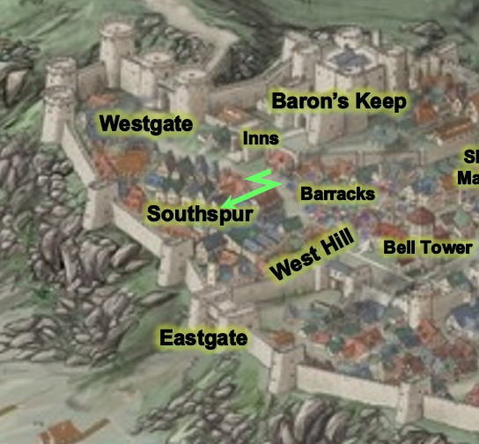

They made way a few blocks further, and it seemed that along every block—among the hundreds of commoners and merchants enjoying the bustling trade and interchange—there were professionals standing about, tending to the security of a single block. The Baronial Guard was absent here, for the most part, and as the four heroes walked by the only pair of Guards they’d seen in the quarter since leaving the Minotaur, they nodded in recognition of the two soldier-constables’ commitment to maintaining order in this peaceful chaos. The Guards reciprocated the nods, and one simply said, “Good evening,” as the two continued westward and the heroes, south.

As the vendor-dominant area receded to a less congested throughway filled with musicians, dancers, and jugglers, the four could still enjoy the tastes of the street food but were now also regaled by a multitude of woodwinds and cymbals that played the soundtrack to a silly skit enacted by two gnomes and a goliath on a stage not 50’ in front of them.

Children were coming out of various houses, comingling near the musicians as the advent of evening invited more and more pedestrians out into the streets, and like a flash flood, where there was plenty of elbow room minutes ago, there would be little minutes from now. The sun’s final beam of cosmic gold receded into the Lake of Steam, and the blue sky in the east now began to grow violet while the orange and pink horizon to the west continued to illuminate the city whose fires were now being lit across every quarter, a premonition of night’s hesitant but eventual unfolding.

Zummas buzzed and dharboukas sung the rhythms of lands across the Lake as humanoid hands caressed and stroked the instruments that invoked the melodies of the moment. Barkley and Saradette were swayed by the complex harmonies and counterrhythms of mostly female voices complementing the musicians.

“Razree-ashhh!” the women sang as other men and women danced. It was grand, and it was happening throughout most of the city, but mainly here in the Southspur and Eastgate.

Suddenly, a shout from the middle of the busy fair spread into an expanding ripple of cries and screams, accompanied by loud crashes that sound like carts and booths being overturned. These ripples of sound immediately rendered a wave of people coming towards the heroes, as bystanders tried to escape whatever was wreaking havoc behind them. In what seemed to be the epicenter of it all Barkley—the tallest of the four—turned towards the shout, and now several screams that followed it—and spotted at about 150’ the epicenter of the wave of fleeing citizens, though it was unclear to him what had caused everyone to flee from that spot.

Barkley pointed southward as the four had to be quick to evade being trampled by the stampede, and the ladies could also now see the area.

Back in the courtyard of the Missing Minotaur, Gadget ate some alfalfa, now safely stabled in a mini-stall, while the fawn was in an adjacent stall, with Widget is watching over them and the cart, which is chained to a nearby post. It was far from a quiet night, but at least no one was coming into the gated courtyard. The Radnar patriarch would come out to check on the animals once or twice during the night, but for the moment, all was harmonious among the racoon and the herbivores.