Frontier Entrepreneur

Plot and Purpose

This Star Frontiers campaign is designed for a party consisting of:

- a promising financier right out of the classroom,
- a pilot fresh out of the academy,
- a security specialist with fresh credentials, and
- a technician/roboticist with a few publications.

The party will be presented with a variety of options ranging in profitability, risk, moral considerations, and scientific problem solving. The story is centered in the Prenglar System, and focuses on technology (particularly vehicles and spaceships) more than the usual Alpha Dawn campaign. Though the mechanics have high fidelity to the AD system, the campaign borrows from the Gadget System in D20 Future Tech, and allows for a wide customization of weapons and other equipment. The general conversion from D20 to SF metrics is such that for every +1 boost (or -1 penalty), the SF rate adds a 5% probability increase (or decrease) to the desired outcome in a resolution.

Game Features

- Posting medium: Groups.io.
- Posting format: Please post IC text consistently in third-person past-tense form (e.g., “Hansel zapped the enemy with his laser pistol” instead of “I’ll attack the other guy”), and use appropriate tags (OOC and IC) where applicable. The more ambiguous your post, the more I must assume or add.
- Participation expected: Only active writers/players please. The posting rate should be about one significant post per week (no one liners, please). Marginal participation in the game will greatly impair your PC’s development. In fairness to the more dedicated players, characters abandoned/neglected by their players will not be kept indefinitely in the game.
- Mechanics: Alpha Dawn with elements from D20 Future Tech supplement, and simplified Knight Hawks spaceship rules. The story will be written in narrative format, and most mechanics will be shown. To avoid meta-gaming, mechanics involving Intuition- and Logic-based checks are usually hidden so you can’t tell if your PC is being lied to or missing a clue. Some Personality- and Leadership-based checks will also be hidden.
- Sexually explicit content: Consider this to be an R-rated story, if absolutely necessary. This is not intended to be an erotica campaign.
- Advancement: This is also not a murder-hobo type of campaign. Experience points in this game are more tied to your writing than to offing opponents. Some ways to earn experience points include:
  - Know the plot: As a player, I am guilty of having posted to storylines on which I wasn’t up to date, and it is usually obvious when others do it in one’s own game. Please ask questions after reading the updates if you’re unsure or unclear on anything you think may be important.
  - Exploit the Star Frontiers setting: Unless the campaign alters the events of the canon timeline, the Zeb’s Guide timeline serves as a good benchmark for the greater events that will influence the economy of the Frontier.
  - Spelling, grammar, and punctuation: In order to minimize my editing efforts to make this fully legible to anyone that might want to read it, please use your computer’s spelling and grammar aides before sending your posts. Please spell your character’s name consistently.
  - Species: Labels pointing to one’s species (e.g., human, vrusk, kurabanda) are not generally capitalized.
  - National/Planetary Origins: Labels suggesting geographic or origins (e.g., Quiveran, K’tsa-kari, Prenglari, Drammunian) are always capitalized.

Campaign Background: The Prenglar System
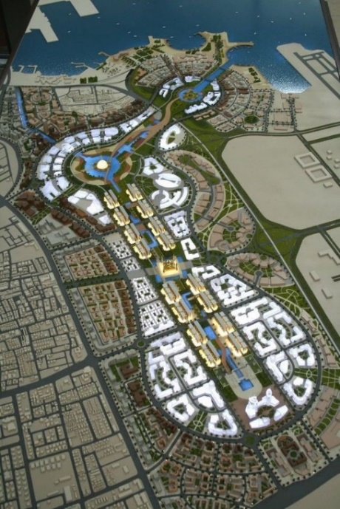
While the comparatively monolithic vrusk civilization that established the initial Prenglar colonies over a century ago was founded on order, predictability, and collective loyalty, recent decades have seen an influx of humans, yazirians, and dralasites, and this has disrupted the traditional structures, replacing them with a planetary bureaucracy that has run Gran Quivera since the founding of the UPF.

Consequently, the city of Port Loren—capital of Gran Quivera and headquarters of the UPF—is rife with corruption during the heyday of the Frontier’s founding. The economy is still simple, surveillance infrastructure has yet to saturate the city, and there’s plenty of opportunity and temptation in Port Loren drawing a steady influx of ne’er-do-wells from every corner of the Frontier and in-between.

Setting, Canon Books Used, and House Rules

This potentially multigenerational story begins early in the Frontier’s development (10 FY), and though it’ll start slow and smalltime, it can potentially span well beyond the Second Sathar War (80 – 90 FY) when interstellar technology allows for the merging of the Frontier and Rim networks.

The larger the scope of the central character’s equity, the more sim-like will become the resolution of events. Trade—the main focus of the game—will be largely predicated on the rate at which interstellar travel and communication can be achieved during any given period of the story.

The D20 Future and Future Tech books are the canon source of mechanics for weapons, vehicles, etc., and the spaceship rules are a highly simplified version of KH mechanics.

Starships with hyperdrives can travel at hundreds of times the speed of light (~1 light year per day), so it takes a few weeks to cross the Frontier at this point. There is no acceleration/deceleration period associated with FtL travel.

Frontier Technology and Progress Levels (PLs)

By 10 Federation Year (FY), Fusion Age (PL6) vehicular technology is commonplace, while Gravity Age (PL7) available to the elites in the Frontier’s capital, and on the horizon in a wider market, but for now scarcely available as prototypes. Laser, needler, and gyrojet weaponry are still considered necessary personal belongings for most working-class people planetside, and even some elites. BodyComp progits contain thousands of apps, rather than just a handful, and are integrated into powerhelmets and other personal empowerment technology.

Speed Limits

The following is a general guideline of speed limits throughout the greater metropolitan area:

Alleys 15 km/h
Downtown Port Loren area (i.e., the canon map) 30 km/h
Streets near schools and the University of Gran Quivera 50 km/h
Most streets outside the Downtown area 60 km/h
Major avenues and boulevards 70 km/h
Freeways 100 km/h

Planetary and Galactic Standard Time (GST)

This setting departs from canon in that the day/night cycle on Gran Quivera lasts 24 hours, not 15 (per Zebulon’s Guide, p. 49). Galactic Standard Time is synchronized to Gran Quivera’s planetary time, so GST and Prenglar local time will be synonymous. Therefore, at tropical latitudes, it’ll always be dawn around 06:00, daytime at 12:00, sunset around 18:00, and midnight at 00:00.
Submitting a Character

The main criterion for approving your character submission is the writing quality (see PC form), specifically (1) a physical description, (2) a personality profile including the character’s preferences, fears, biases, traumatic experiences, promises/vows, conversions, addictions, etc., and (3) an origin story. Please use the PC form to create your PC.

Races: The main character can represent any standard Alpha Dawn race (dralasite, human, vrusk, yazirian) at the beginning of the timeline.

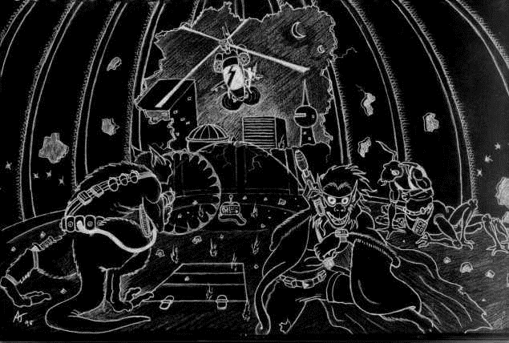

Campaign Resources

The following supporting game resources are available:

Character Stats Generator: A random ability generator to facilitate adding more muscle to each faction as PCs gain prominence and followers.
Tally of Characters by Faction and Specialization: Pre-generated NPCs for every showcased faction.
Vehicles by Faction: Ready-to-use vehicle stats modified to suit each faction’s specific needs.
Weapons: Quick-reference table.
Maps: Includes digitized versions of Star Frontiers canon maps and original material for use with the campaign setting and its constituent plotlines and scenarios.



