Appendix X.1 ~ Maps

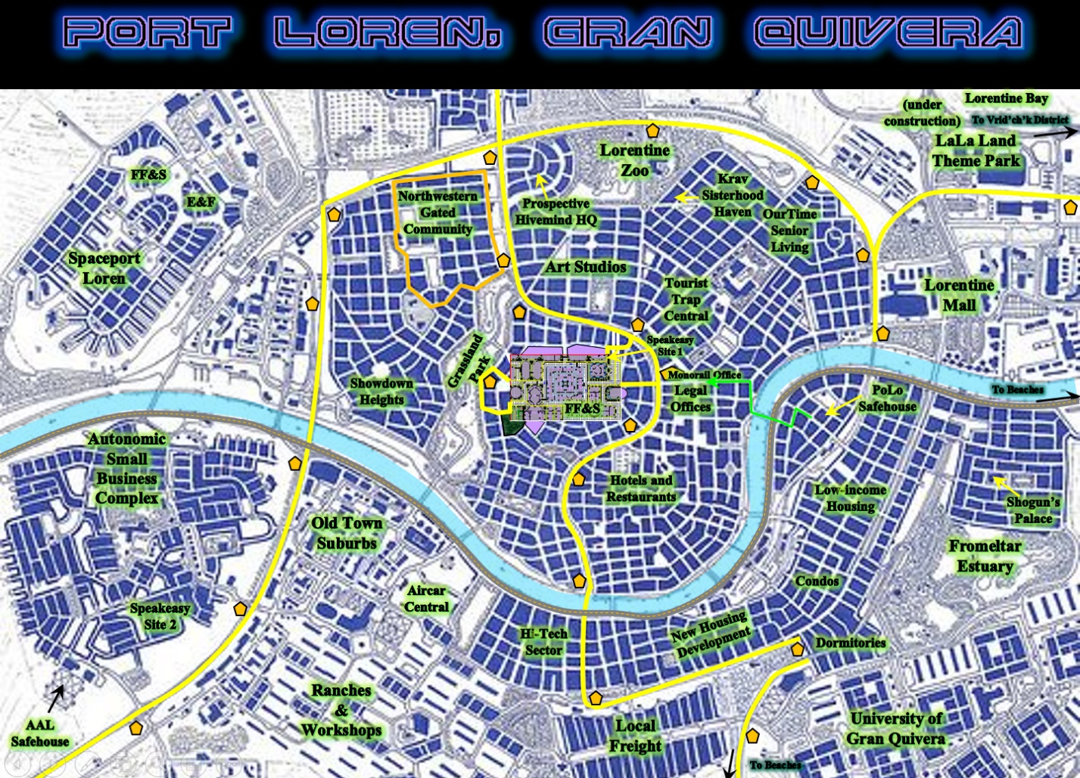

Greater Port Loren Metropolitan Area



Classic Alpha Dawn Maps

Maps by specific plot forthcoming…