Frontier Entrepreneur

Factions: Megacorps, Cadres, Cults, and Gangs

Alongside the existing canon factions in *Zebulon’s Guide to Frontier Space*, the incorporation of the organizations in this campaign setting re-themes the flavor of the Frontier for the urban intrigue showcased in the suggested Plots. If the players choose to represent a showcased faction, they can either flesh out the pregenerated NPCs provided or create their own PCs aligned with the ideology or motive structure of the faction.

MEGACORPS

Driven primarily by profit motives, and maintaining at least a front-facing image of legitimacy and service to the Frontier’s millions of citizens, there are only twelve megacorps in this setting. Of those mentioned in *Zebulon’s Guide*, only the following exist at this point in the timeline: Pan-Galactic Corporation, Streel Corporation, Cassidine Development Corporation, MercCo, Synthetics Corporation, Universal Households, and the Association of Intergalactic Power Suppliers. Five non-canon megacorps are detailed below:

**Ebb & Flow Astronautics**

Fiercely competitive and reluctant to partner with any other megacorp, E&F Astro—as it’s affectionately called by its legal team—makes the bulk of its revenues by acquiring cutting-edge patents and other up-and-coming intellectual properties, and leveraging them to maximize their marketability in the spacefaring industry. The senior partner in this privately held corporation is a dralasite named Anon, who happens to be the half-brother of the Malthar (see *SFKH1: Dramune Run* module). Anon’s office is in the roughly heart-shaped cluster at the northeast end of Spaceport Loren.

Entry into this corporation is generally based on a very exclusive, reputation-based, patron-client vouching system that diffuses responsibility throughout workgroups comprised of technocratic colleagues from the entire constellation. E&F Astronautics is primarily motivated by long-term profits and stable, predictable growth. Market share is less important than market control over certain key patents.

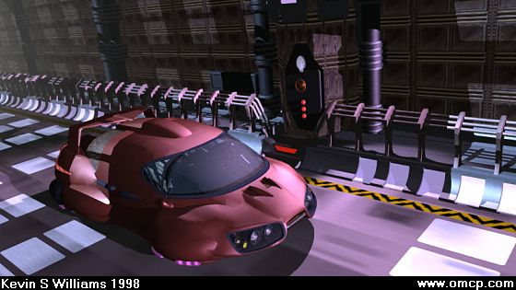

AudoDyn Vehicularistics—a subsidiary of E&F—is currently the leader in the civilian vehicle market, and its stock has remained stable and strong over the last decade. As part of its research and development operations, AutoDyn produces an exclusive line of vehicle prototypes for E&F’s internal use, which are designed with strictly urban considerations with a variety of defensive aftermarket options, and are visibly distinct in their rounded bodies. They are tailored for paved and well-maintained roads, and become subject to severe wear and tear on uneven ground, snow, sand, and the like. The leadership’s trusted driver—Zenith Kidof Sevenitou—performs and oversees much of the modification work on their Port Loren fleet, which includes an ironclad dozen of the safest elitemobiles across the Frontier.

**Frontierwide Freight and Shipping**

Pioneers in containerization and other standardization measures implemented in shipping during the last few decades, FF&S will someday be subsumed into the CDC, but for now, the public megacorp is the definer of the freight industry’s course. FF&S also owns the largest taxi company operating within the city limits: QuiveraCab.

Delivery convoys are currently facing vulnerability to poaching bandits along the road between the city center and Spaceport Loren’s distribution yard, and the call for an investigative team has been published in the local online forum. FF&S is at risk of going under, and is consequently primarily motivated by short-term profits and asset liquidation on peripheral systems.

FF&S produces many of the freight vehicles and vessels that it operates. As a transportation conglomerate, this megacorp boasts the widest variety of commonly used vehicles, and produces some of the highest-end prototypes. However, this megacorp does have more than a few recalls that should never have passed through pre-production inspections, and their cited lack of redundancies in some methods is often to blame. Some speculate these laxities allow for corrupt channels to operate within the otherwise legitimate apparatus of FF&S.

**Hivemind Enterprises**

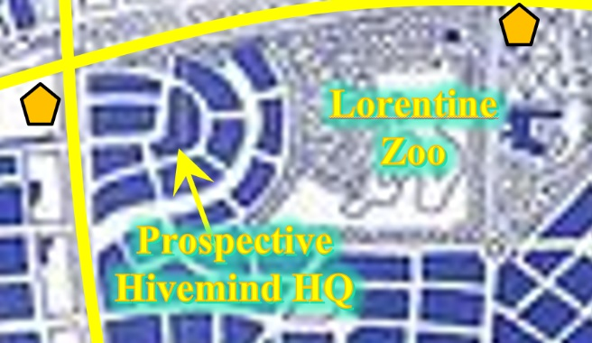Specializing in logistics solutions, AI software, subspace communication, surveillance, data storage/management, this vrusk-led for-profit think tank has surfaced as the new giant surpassing the ₡trillion equity limit that officially qualifies an economic entity for megacorp status.

Hivemind is currently opening up a new location at the north end of Port Loren, just west of the Lorentine Zoo, and needs to subcontract a team of security specialists during the construction period. They also have a hit list with about 10 people on it at any given time, and Port Loren is a likely place for one of these to be frequenting during an opportune moment. Hivemind is primarily motivated by expansion across the Frontier.

Hivemind uses mostly FF&S brand vehicles with their own aftermarket defense and offense enhancements. Their leadership prefers to be driven in limos by chauffeur-bodyguards.

**The Shiv-råm Consortium**

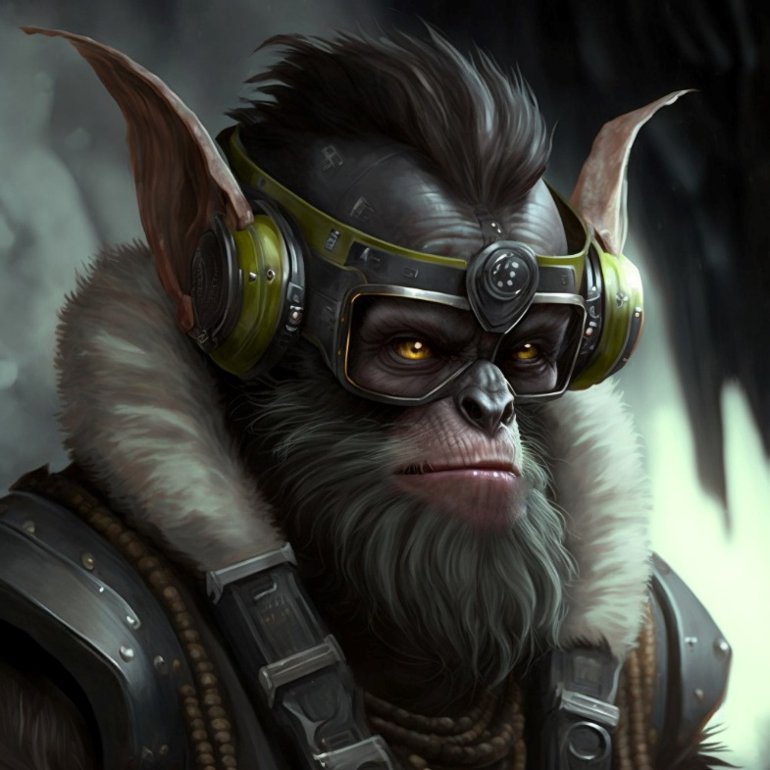Based in the Gruna Garu system, theShiv-råm Consortium is a centuries-old yazirian good old boys’ club comprised of the sons and other male heirs of shoguns and warlords from pre-Contact days. They deal in anything and everything that maintains their stronghold on the remaining bastions of the old yazirian patriarchy. Of all the showcased megacorps, they most resemble a criminal organization in their structure and operations. Only yazirians may become members of the governing board, but other males and dralasites may serve lesser posts as employees, liaisons, consultants, and contractors. Females of all races are regarded as the potential property of a male by any loyal member of this group. Unclaimed and unprotected yazirian females in and around Port Loren have been known to be claimed by members of the Consortium. Their presence in the capital city is significant, and their headquarters here are sited in the ancient Shogun’s Palace[1] at the east end of the city. The Consortium is primarily motivated by the preservation of yazirian-principled patriarchy across the Frontier, which is increasingly coming under attack by legislation enacted in the spirit of equity and mutual prosperity.

The Consortium’s mechanics and techies have gone to great lengths to render vehicle bodies in an intricate variety of styles ranging from steampunk to faux fantasy. Aside from conventional pursuit deterrents—such as oil slick pods, swivel-turret machine guns, protracting hubcap spikes, and smoke screens—these folks have also been known to outfit their rigs with surface-to-air missiles, as well as chemical weapons, though this hasn’t happened in Port Loren yet.

**Speakeasy Pharmacopoeia, Ltd.**

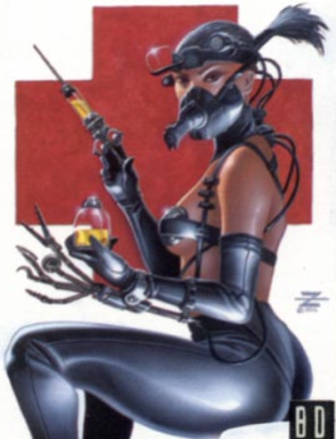In recent decades, a syndicate of drug smugglers successfully lobbied for legislation to legalize about half of the products that it was pushing. After some compromises made to the chemicals in question, the eco-pharma wing of their operations was annexed from a co-op of self-sustainable terraformers on one of Moonworld’s satellites, and the rest is history.

Speakeasy’s Port Loren offices are a bit run down, and they’re looking to relocate to a new site on the opposite hemisphere where land values are lower, and natural resources are plentiful. However, legal/tax troubles are also behind the corporation’s motives to leave town, and local law enforcement has yet to uncover the rest of this iceberg. Speakeasy is primarily motivated to keep up appearances despite internal flops and ethical gray zones.

 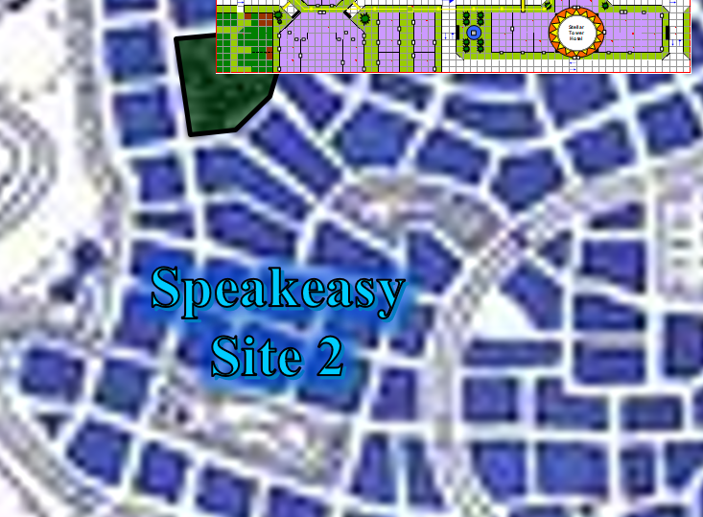

Speakeasy’s vehicles are painted in a mustard-and-teal theme, reminiscent of one of the pre-UPF flags of a now-defunct Cassidinian dralasite polity called the Susur Republic.

CADRES AND CULTS

The motives of cadres and cults are markedly ideological, its goals lying somewhere on a continuum between the consolidation of control over their membership on one end, and on the other, manifesting some monumental and lasting change in the Frontier, or a significant part of it. In contrast to gangs, which profit from regional specialization, the goals of cadres and cults are by default absolutist and spatially limitless in their ambitions, superseded only by dire motives, such as secrecy. This early in the timeline, the Silver Death Cult does not exist, but at the referee’s discretion, all other such entities in Zebulon’s Guide could be included alongside those below.

The headquarters and other meeting places of cadres and cults are generally unknown to the public, so it will take effort on the part of the PCs to uncover such sites, if they exist. The referee should consider such sites to be in a discreet location convenient sited near a freeway.

**Anti-Android League**

A predecessor to the Silver Death Cult, this far less violent cadre seeks to dumb down all technology to single-use devices. They have claimed dozens of acts of vandalism and sabotage, and are unique in their care to avoid harming living things when they destroy computers, robots, and other infrastructure. The AAL has a local team of engineers and technosavants who collaborate on rigging their vehicles with fully analog components, rendering them immune to most digital countermeasures.

**Plot Hook:** The AAL has a timetable to destroy the UPF Headquarters in Port Loren by 10.190 (i.e., the 190th day of the 10th year since the founding of the UPF), which will involve infiltrating the backstage portions of the building, a demolitions team to assess and execute the operation, and a getaway driver to evacuate the operatives.

This group is likely to be holed up in one of the larger computer-related offices in the Downtown area, or in the Autonomic Small Business Complex south of Spaceport Loren. The League is primarily motivated by an ideology professing that all technology must be limited in order to prevent an android takeover. Their robots and computers are meticulously modified with firewalls and safety protocols to ensure that they are as singularly purposed as possible.

The League’s vehicles are almost exclusively salvaged, refurbished, and specifically modified for singular purposes, such as surveillance, drive-by offensives, bombings, getaways, and clandestine freight.

**The Daughters of Amnesty**

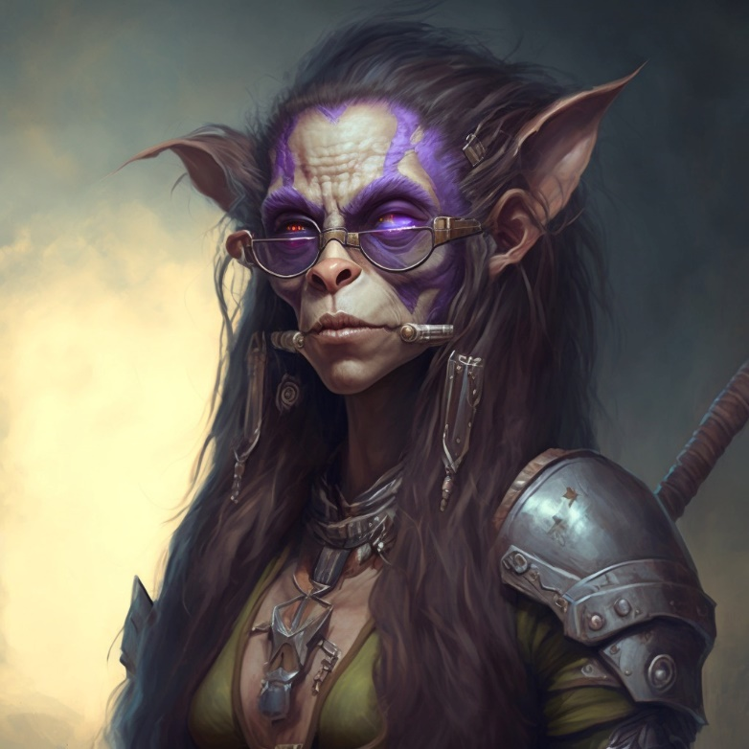Serving as a front and recruiting/promotion pool for the Krav Sisterhood, a feminist and anti-imperialist conglomerate of ideologues set on the reformation of the more traditional colonies of the Frontier, particularly yazirian patriarchies. The Daughters’ public campaign is one of progress and the development of new colonies modeled after bottom-up management philosophies, but reports and arrests linking their members to sex trafficking rings have recently put a dent on their reputation. Consequently, the Krav Matron has clamored for the restructuring of the Daughters’ governing body, which may or may not be met with martial resistance. The Daughters are primarily motivated to perpetuate their good image as the Frontier’s sweethearts, laundering many of their benefactor’s funds via nonprofit pursuits throughout the more disenfranchised sectors of the constellation.

The Daughters’ vehicles are—much like those used by hivemind—purposed primarily for the protection of their high-profile passengers. These generally have no offensive gadgets, and sometimes house holocameras, which collectively project 3D renditions of the faction’s celebrity propaganda.

**The PoLo Militia**

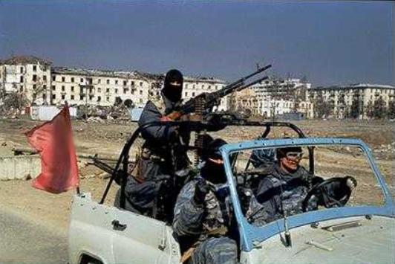Devoted to planetary safety in words and deeds, these glorified and self-appointed city watchpersons are the thorns in the side of the Port Loren Municipal Force (MuFos for short), which is the actual, commissioned police force in the city where these plots unfold. The PoLos see the MuFos and any other military/police force in the city as illegitimate occupiers, and though they are characteristically mindful of the well-being of civilians, they tactically engage law enforcement with little warning. Though the justice-oriented everyman narrative behind this faction’s propaganda wins the hearts and minds of the young people who constitute the frontlines of these “squadrons”, the leadership structure has become increasingly corrupt, and rumor has it that they are now in league with more sinister organizations. These folks are likely to be headquartered outside the Downtown area, as most of their numbers hail from the low-income neighborhoods to the southeast of the city center.

The PoLos would like to see the Anti-Android League succeed in the undoing of the UPF Headquarters, and may see it in their interest to help in order to gain inside information, and or orchestrating a well-timed diversion. However, because the AAL is an unabashedly criminal organization, the PoLos would be just as happy to see the enemies of their enemies destroyed or damaged in their efforts. The Militia is primarily motivated by the premise that they can do a better job than the establishment, and are mandated by all moral imperatives to do so. They range in self-righteousness along a spectrum between the conviction that they will prevail because their cause is just to the belief that they will prevail due to the strength of their resolve relative to their corrupt counterparts. The Municipal Force is their main adversary, but they also have the UPF Military (and its assets) in their sights. They are nearly impossible to bribe, and have all sworn to carry out an execution on any fellow member whom they accuse of treason and who is found guilty of that accusation. Their lead intelligence operative—Siu-Ling D’Avignon—serves as an impartial judge in these matters.

The PoLos’ vehicles often come from the junkyards owned and operated by the Anti-Android League, and resemble the improvised rigs and hogs refurbished by that cadre. The ideology-aligned business relationship between these two factions leads to a lot of similarity in the gadgets and mods used by both, and convoys comprised of both groups have occasionally been spotted making their way across the city.

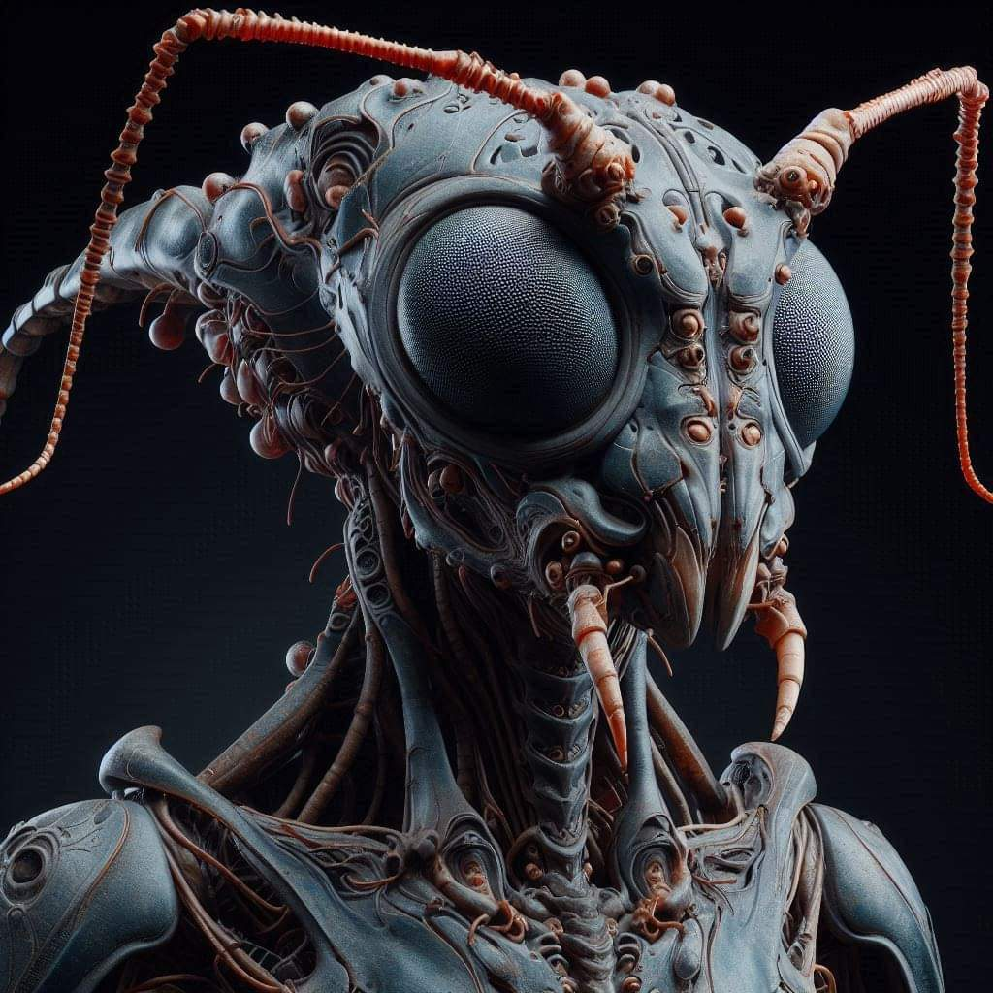**The Queenstemple**

The smallest and most antagonistic of the noted cults, this group constitutes the last prominent fragment of religious fanaticism among vrusk traditions. Their first priority is to restore the pre-UPF order on the planet, and the more militant factionalists in the movement have heralded genocide as the most expedient path to this end. Their high tension with non-vrusk has made it all but impossible for other races to constitute this cult’s membership, though a handful of pious yazirians and amenable dralasites have been tolerated associates. This fringe group is bold enough to still have a few standing temples throughout the city, though they are closing down due to pressure from multiple fronts. Because of their primary motive to preserve the traditions that prevailed here when the vrusk were the only race on this planet, their interests can be lured with significant collections of things that would normally be kept in museums, as this faction addresses such artifacts with inordinate fetishism, and makes much ado about their existing collections of esoteric (mostly vrusk) memorabilia from time immemorial.

The Queenstemple’s vehicles are made to look like the now quaint, vrusk-outfitted vans and buses reminiscent of the days before the UPF and the prominence of the vertical races when public transportation was all there was in vrusk societies. Due to security concerns, their spacious vehicles normally carry passengers using a 1-to-1 bodyguard-to-elite ratio.

**GANGS AND OTHER FACTIONS**

Gangs have opportunism and profit motives in common with megacorps, and share a penchant for violence with cults, cadres, and law enforcement. Thus, they constitute the most ravenous organizations in this campaign setting, and exhibit the widest range of logic and motive structures.

**The Four Horsemen**

Four or so guys, gals, and/or drals on hoverbikes have been robbing banks across the hemisphere for about a week now, and have eluded authorities as they crisscrossed the Quiveran Supercontinent. Intel suggests that they’ve arrived in Port Loren, and are planning their biggest heist yet. The media has dubbed them the Four Horsemen, and largely hyped up their notoriety, leading to copycat factions of hooligan hoverbikers throughout the planet. This group has a safehouse in a poorly surveilled and sparsely populated area near or in a mechanic shop or money laundering operation. The Four Horsemen are primarily motivated by a quick score, and a yabba-dabba-do-type getaway.

The Horsemen’s hoverbikes aren’t built to last, and will probably be dumped as soon as better vehicles become available. Gadgets preferred by this faction focus on pursuit deterrents.

**The Krav Sisterhood**

As the funding stream for the Daughters of Amnesty, this coven of Godmothers under the Krav Matrons is a direct splinter group of the Shiv-råm Consortium, founded by Valkyrie Krav Grunamor, the daughter of Shogun Grunamor, whose death sealed the split between the oldest patriarchal order in the Frontier and its corporate antithesis. The current Krav Matron has fallen ill, and in the anticipation of her death, rivalries have ensued internally, leading to a power struggle among possible successors. The Sisterhood is primarily motivated by the desire to stamp out the Shiv-Råm Consortium, and to continue to use the Daughters as a front for their less-than-always-scrupulous operations.

Unlike the Sisterhood’s vehicles—which are deliberately opulent and flashy, this criminal ring’s vehicles are usually painted gray, black, or brown, and are made to look as plain and inconspicuous as possible.

**The Order of the Prescient**

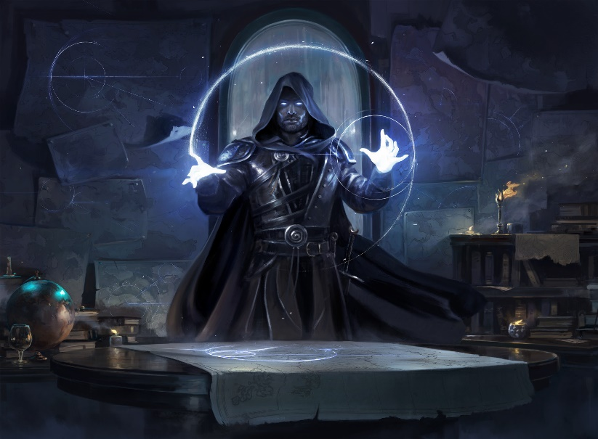

Headed by a cabal comprised of reclusive monks and befabled Mentalists in a far off system of the Frontier, the ultimate motives of this fanatical group remain mysterious, are reputed to kidnap the children of prominent figures, and either ransom them, or implant them with surveillance/mind control tech or psionic implementations.

The Order is thought to be primarily motivated by the domination of a currently powerful group in order to control the entire population of the city, and as much as they can.

The Order’s vehicles are usually made to look nondescript, but boast a suite of subterfuge gadgets.

**The Port Center Upstairs Online Comedy Traffic Night School (P.C.U.O.C.T.N.S.)**

The dralasite-founded free-for-all pyramid scheme and practical joke workshop has only one brick-and-mortar site in the Frontier—called Fortress Campus—and it’s in Port Loren. On account of their many haters, their upstairs mini-mall location is the most densely guarded campus in the Frontier. In addition to teaching the art and science of practical comedy, they also provide a space to play face-to-face roleplaying games and engage in other social activities involving the Bluff skill. The complimentary food is horrible, but the lifetime membership plans are very reasonable. A dralasite kingpin named “Shivers” Im’ram is at the helm of this “firm”, and has been alleged by media to have blackmailed his former partner... allegedly as a practical joke... but better framed as a payback. The Night School is primarily motivated by a quick buzz (i.e., practical joke), superficial soirées, an action-packed war story to embellish, and an adult-rated comedy.

As the least violent of the notable gangs in Port Loren, the Night School has mostly risen on more subtle rackets, such as bribery and corruption, which are far more legally nuanced and therefore harder to prosecute. They’re also about to buy the Lorentine Zoo, and have enough of a stake in legitimate business to have mid-level corporate portfolio.

The Night School’s vehicles—generally a few years old but in good condition—are leased from the local E&F/AutoDyn distributor, and will often have concealed gadgets and weapons made to look like jacks-in-the-box, garden mantis gnomes, or other comical creatures.

**The Shang Initiative**

Formerly a human-only enterprise, this jack-of-all-vices outfit boasts prominent members throughout the Frontier, and has proven to be as versatile as the demands of their funding streams. This gang is indifferent to race, creed, and even motives, dealing with rival factions insofar as it suits them, and betraying anyone that makes it suitable for them to do so. They are the go-to organization for high-end contract killings. The Initiative is primarily motivated by control over key government officials in their pay, and keeping their products moving and services rendered.

The Initiative’s vehicles are top-of-the-line. Although they don’t own any vehicle manufacturing plants, they have at least a dozen chop shops throughout the city that deal in high-end customization, and cutting-edge technology. Their PL 7 vehicle prototypes are probably the most futuristic ground vehicles in the Frontier to date.

**Star Devil**

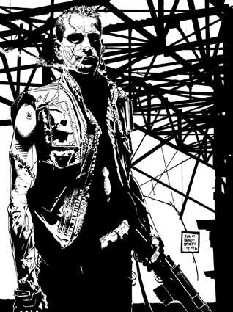The quintessential space pirates of the age, these hardened criminals have established bases in the Zebulon system over the last decade, and have recently set up safehouses in Port Loren from which they funnel their contraband into the city. In exchange for some extortion money, Star Devil provides the muscle and other labor that protects and sustains many of the local businesses in the patches of turf where they operate.

In addition, they are consolidating their control over the vehicle restoration industry, and are consequently using these small businesses in synergy with their auto theft rings, exporting stolen and anonymized vehicles to peripheral colonies under salvage titles.

Star Devil is primarily motivated by eliminating threats to their dominance in the interstellar drug industry and related rackets, but they’ve also recently become interested in the Anti-Android League’s junkyards, and are poised to acquire them one way or another. They indiscriminately target law enforcement and rival gangs, and only rarely take care to miss civilians when an engagement has ensued.

Though unbelievably hodgepodge, Star Devil’s vehicles are a little better in quality than the League’s, Horsemen’s, and Militia’s stolen and refurbished vehicles, and as much is spent on accessories and pomp as in functional gadgets. Star Devil’s established presence in the system motivates them to take better care of their hogs and rides, and souping up a vehicle is a competitive event among some of the members.

**LAW ENFORCEMENT**

Under the unlikely variant in which the players want to play the crimefighters in any of these capers, the parameters that follow pertain to these factions. Both of these factions’ vehicles tend towards cost-efficiency, standardization, logo display, and cleanliness.

**Port Loren Municipal Force**

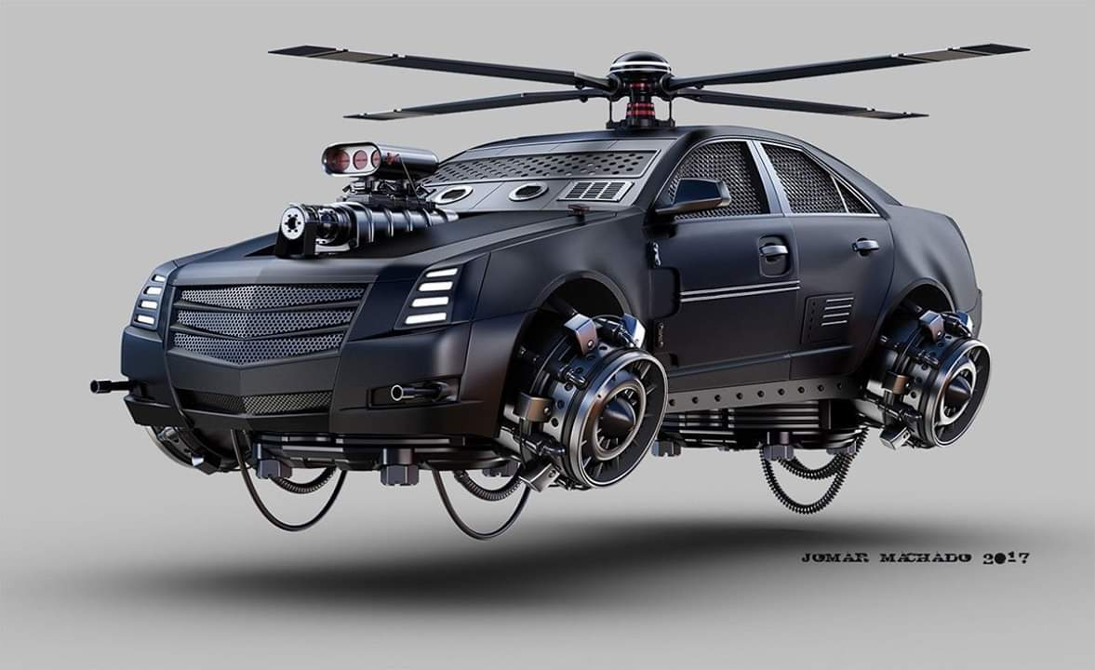The local police force does its best to avoid using lethal force against transgressors, but it’s an imperfect world, and these guys are doing the best they can to keep order in a quickly growing urban area. Chief Kidof Skee has managed to double the number of uniformed officers in the downtown area, and has initiated several programs to foster alternative paths to honest careers for young people in the city. However, the lifelong do-gooder is not without moral weaknesses, such as a gambling addiction, and a past with whoremongering. Needless to say, the Chief is not incorruptible, and has recently been accused of sexual malfeasance with someone in the office, though formal charges have not been pressed.

**UPF Military/Rangers**

Unlike the cops, the military is trained to kill in many more situations, and they are usually only called upon to act when those escalated situations arise. The Military should be introduced if and when the PCs are overwhelming another faction—including the police—but the referee will take care to avoid the urge to manifest a deus ex machina scenario by bringing in all of the military’s big guns and tanks all at once. In the event that the PCs play characters in the UPF Military, the referee will be similarly cautious of granting to PCs any item/vehicle available to this faction.

1. The original Shogun who commissioned the building of this palace was the first non-vrusk diplomat permitted to own land on Gran Quivera. Despite being a yazirian, the legacy of his early contributions to Prenglari culture is found throughout the city and elsewhere across the planet.