Frontier Entrepreneur

Plot and Purpose

This Star Frontiers campaign is set in 50 FY, and focuses on Freelance opportunities including:
- Exploration of remote worlds, some of which are not yet habitable
- Investigation, Recovery, Security, and Mercenary contracts
- Mining and commerce
- The formal and informal politics of Port Loren, Gran Quivera, Prenglar, the civic center of the Frontier, as well as important events taking place on other worlds.

The party will be presented with a variety of livelihood options ranging in profitability, risk, moral considerations, and scientific problem solving. The story’s media-based “lore” for the players is at least initially centered in the Prenglar System, and focuses on technology (particularly vehicles and vessels) more than the usual Alpha Dawn campaign.

Game Features

- Posting medium: Groups.io.
- Posting format: Please post IC text consistently in third-person past-tense form (e.g., “Hansel zapped the enemy human with his laser pistol” instead of “I’ll attack the other guy”). The more ambiguous your post, the more I must assume.
- Participation expected: Only active writers/players please. The posting rate should be about one significant post per week (no one liners, please). Marginal participation in the game will greatly impair your PC’s development. In fairness to the more dedicated players, characters abandoned/neglected by their players will not be kept indefinitely in the game.
- Mechanics: Star Frontiers Alpha Dawn, with some Zebulon’s Guide technology, and simplified spaceship mechanics. The story will be written in narrative format, and most mechanics will be shown.
  - To avoid meta-gaming, mechanics involving Intuition- and Logic-based checks are usually hidden to leave ambiguous whether your PC is being lied to or missing a clue. Some Personality- and Leadership-based checks will also be hidden, depending on context.
  - Technology borrows from the Gadget System in D20 Future Tech, which allows for a wide customization of weapons and other equipment. The general conversion from D20 to SF metrics is such that for every +1 boost (or -1 penalty), the SF rate adds a 5% probability increase (or decrease) to the desired outcome in a resolution.
  - Knight Hawks mechanics have been simplified.
- Sexually explicit content: Consider this to be an R-rated story, if absolutely necessary. This is not an erotica campaign.
- Advancement: This is also not a murder-hobo type of campaign. Experience points in this game are more tied to your writing than to offing opponents. Some ways to earn experience points include:
  - Know the plot, and please ask questions after reading the updates if you’re unsure or unclear on anything you think may be important.
  - Exploit the Star Frontiers setting: Zeb’s Guide serves as a good benchmark for the greater events that will influence the economy of the Frontier at least up to 50 FY.
    - Frontier Explorer and other aftermarket content will also be considered if it doesn’t conflict with the intended setting.
  - Spelling, grammar, and punctuation: In order to minimize my editing efforts to make this fully legible to anyone that might want to read it, please spell and grammar check your posts before sending, and spell characters’ names consistently.
  - Species: Labels pointing to one’s species (e.g., human, vrusk, kurabanda) are not generally capitalized.
  - National/Planetary Origins: Labels suggesting geographic or origins (e.g., Quiveran, K’tsa-kari, Prenglari, Drammunian) are always capitalized.

Campaign Background: The Prenglar System

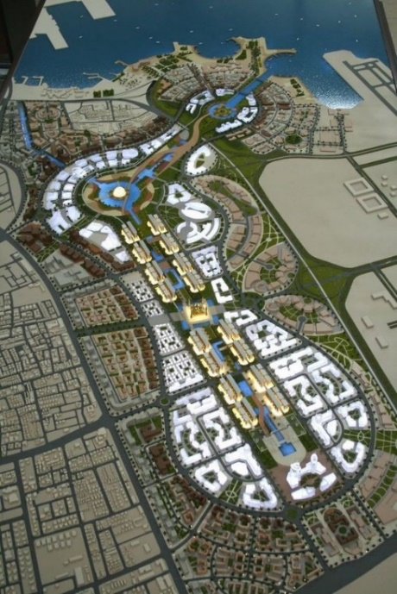
While the comparatively monolithic vrusk civilization that established the initial Prenglar colonies over a century ago was founded on order, predictability, and collective loyalty, recent decades have seen an influx of dralasites, humans, and yazirians, and this has disrupted the traditional structures, replacing them with a cosmopolitan bureaucracy that has run Gran Quivera since the founding of the UPF.

Consequently, the city of Port Loren—capital of Gran Quivera and headquarters of the UPF—is rife with corruption and civil strife during the heyday of the Frontier’s founding. The economy is still simple, surveillance infrastructure has yet to saturate the city, and there’s plenty of opportunity and temptation in Port Loren drawing a steady influx of ne’er-do-wells from every corner of the Frontier and in-between.

Setting, Canon Books Used, and House Rules

This story begins before contact with the sathar, and though it’ll start off slow and smalltime, it can potentially span well beyond the Second Sathar War (80 – 90 FY) when interstellar technology allows for the merging of the Frontier and Rim stellar networks.

Starships with hyperdrives can travel at hundreds of times the speed of light (1 light year per day), so it takes a few weeks to cross the Frontier at this point. In a departure from canon, there is no acceleration/deceleration period associated with FtL travel in this campaign. Subspace communication has a lag of 1 hour per light year (about 24 times faster than moving matter FtL). This may change with advancements in technology.

Frontier Technology and D20 Progress Levels (PLs)

This portion of the rules borrows from D20 Modern/Future. By 50 FY, Fusion Age (PL6) vehicular technology is commonplace. Gravity Age (PL7) tech is available to the elites in the Frontier’s capital, and only scarcely available as prototypes. Laser, needler, and gyrojet weaponry are still considered necessary personal belongings for most working-class people planetside, and even some elites. BodyComp progits contain thousands of apps, rather than just a handful, and are integrated into powerhelmets and other personal empowerment technology.

Planetary and Galactic Standard Time (GST)

This setting departs from canon in that the day/night cycle on Gran Quivera lasts 24 hours, not 15 (as in Zebulon’s Guide, p. 49). Galactic Standard Time is synchronized to Gran Quivera’s planetary time, so GST and Prenglar local time will be synonymous. Therefore, at tropical latitudes on Gran Quivera, it’ll always be dawn around 06:00, and sunset around 18:00. Gran Quivera’s axial tilt is about 23 degrees, and its temperate bands and arctic circles are comparable in range to those of Earth.

As the PCs venture across the Frontier, local planetary times will become relevant.

Submitting a Character

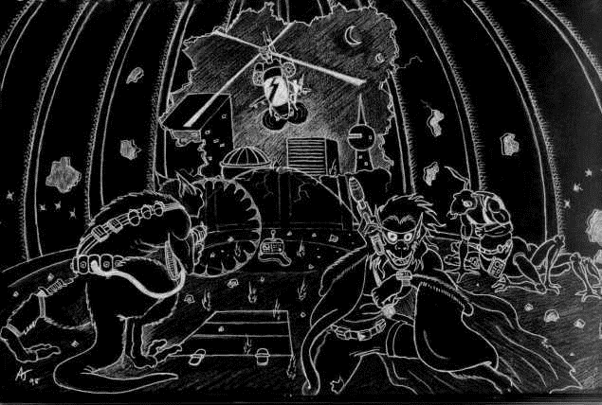
The main criterion for approving your character submission is the writing quality of (1) a physical description, (2) a personality profile including the character’s preferences, fears, biases, traumatic experiences, promises/vows, conversions, addictions, etc., and (3) an origin story.

Races: Only standard Alpha Dawn race (dralasite, human, vrusk, yazirian) at the beginning of the timeline. The sathar and Outer Rim races are unknown in the Frontier in 50 FY.

