Vehicles

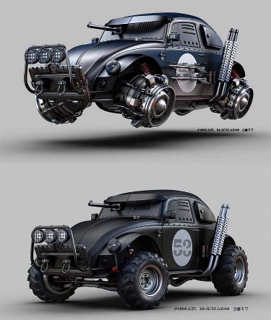All vehicles herein have been customized to align with each faction’s emphases, resources, and motives, and can be further customized based on the referee’s and/or party’s need.

**Prototypes**

While most of the individual vehicles on the list provided can be assumed to be available to a faction in bulk, a few vehicles—especially those comprised of PL 7 tech—are considered prototypes, and are unique in the game. In most cases, these are someone’s “baby”, and their drivers/owners should respond to damage or theft of their mechanical pets with heated sentiments of retribution. Gang wars in Port Loren have been initiated for less. The hovervehicles widely available in this point in the history of hover technology are PL 6 (i.e., rotor-based), and are generally only able to achieve an altitude of 5’.

**Ignition**

Starting a vehicle requires the appropriate key, beeper, retinal scan, fingerprint, or other ignition trigger to be activated. Hijacking the ignition is subject to a *Security Systems: Deactivate* check.

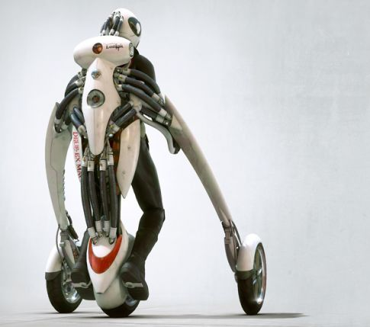

**Gadgets**

Vehicle Gear (*D20 Future*, p. 150) is available, as are the homebrewed Gadgets that follow. Derived from D20’s Gadget system for personal gear, the following add-ons and other modifications are available to some or all factions. The more sophisticated (i.e., PL 7) Gadgets may only be possible to achieve with the expertise of a technosavant, techie, engineer, or other highly qualified character. Gadgets deemed unlawful for civilian use in and near Port Loren are marked with an asterisk.

Personal Gadgets from *D20 Future* Applicable to Vehicles

The following personal item gadgets are listed in order of availability throughout the Frontier, and can be applied to most vehicles.

Environmental Seal (PL 5)

Ultralight Composition (PL 5)

Collapsible (PL 5)

Compact (PL 5)

Booby Trapped (PL 5)

Stun Module (PL 5)

Voice Recognition System (PL 5)

Sensor Baffling* (PL 5)

Genetic Tags (PL 5)

VehicleLink Interface (PL 6)

Self-Repairing (PL 6)

Sound Suppressor (PL 7)

Additional Vehicle Gadgets for This Setting

To calculate the final cost of a vehicle, add/subtract all percentage-based price modifiers (e.g., +5%, -10%), apply them to the vehicle’s base price, then add/subtract credit-based price modifiers (e.g., ₡5,000).

Defensive PL 6 Gadgets

**Reflective Plating**

**Price:** ₡ +25%; must be purchased/applied again after 1,000 points of damage.

**Benefit:** This vehicle’s outer body is coated with a Teflon-like plating that absorbs ¼ of all beam weapon damage, and reflects another ¼ of the damage in a random direction determined by the referee. ½ of the beam weapon damage is sustained by the vehicle.

**Available to:** Daughters of Amnesty, Ebb & Flow Astronautics, Frontierwide Freight and Shipping, Hivemind Enterprises, Krav Sisterhood, Order of the Prescient, Port Loren Municipal Force, Queenstemple, Shang Initiative, Shiv-råm Consortium, UPF Military.

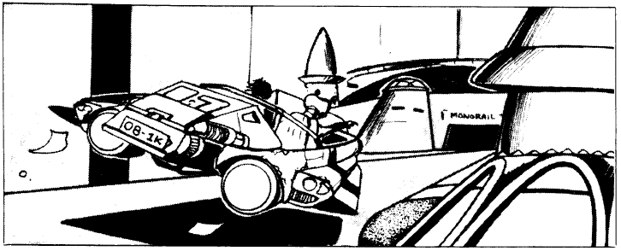

**Vehicle HoloScreen**

**Price:** ₡5,000 for sedan or smaller; ₡10,000 for minivan or bigger

**Benefit:** This gadget replicates the effects of *invisibility*.

**Available to:** Anti-Android League, Daughters of Amnesty, Ebb & Flow Astronautics, Frontierwide Freight and Shipping, Hivemind Enterprises, Krav Sisterhood, Order of the Prescient, P.C.U.O.C.T.N.S., PoLo Militia, Port Loren Municipal Force, Shang Initiative, Shiv-råm Consortium, Speakeasy Pharmacopoeia, Ltd., Star Devil, UPF Military.

Offensive PL 6 Gadgets

**Hubcap Spikes, 4**\*

**Price:** ₡2,000

**Benefit:** Extending 12” from each vehicle’s tire, this razor-sharp daisywheel can puncture tires. For every round that the driver succeeds on a touch attack, one of these spikes does 1d12 points of damage to one wheel of the vehicle on the left or right of your vehicle. If the wheels of your vehicle and the target vehicle are similarly spaced apart (i.e., the distance between front and rear wheels is less than 1’ different between the two cars), a second touch attack can be rolled as a Swift action to try puncturing the second exposed tire.

**Special:** This gadget only does cosmetic body damage to cars without wheels.

**Available to:** Anti-Android League, Four Horsemen, Krav Sisterhood, PoLo Militia, Shang Initiative, Shiv-råm Consortium, Star Devil.

**Oil Slick**\*

**Price:** ₡8,000 + ₡200 per pod

**Benefit:** Releasing a single pod renders a 10’ wide, 40’ strip of viscous oil in the path of any vehicle behind it, which—depending on distance and speed—may have the option to Sideslip, Avoid Hazard, Hard Brake, or engage in some other evasive maneuver. Any vehicle driving over the affected area must make a Drive check (DC 15) to retain control of the vehicle while moving inside the slick area, plus for an additional 50’ thereafter. See *D20 Modern* (p. 160) for additional details on losing control of a moving vehicle.

This device—normally installed in the underside of the rear of the vehicle—can be loaded with up to 20 pods at a rate of 10 pods per round, and can be activated with a Swift action at a rate of one pod per round.

**Special:** This gadget has no effect on hover vehicles.

**Available to:** Anti-Android League, Four Horsemen, PoLo Militia, Shang Initiative, Shiv-råm Consortium, Speakeasy Pharmacopoeia, Ltd., Star Devil.

**Smoke Screen**\*

**Price:** ₡11,000 + ₡20 per capsule

**Benefit:** The vehicle emits a 20’ wide, 150’ long trail of smoke in its wake, causing the following Concealment effects in its wake based on distance from your vehicle:

**Distance Concealment against Front-facing Targets**

0’ – 20’ 50%

21’ – 50’ 25%

51’ – 100’ 10%

100’+ no mechanical impairment

This device—normally installed in the underside of the rear of the vehicle—can be loaded with up to 20 capsules at a rate of 4 capsules per round, and can be activated with a Swift action at a rate of one capsule per round.

**Available to:** Anti-Android League, Daughters of Amnesty, Four Horsemen, PoLo Militia, Shang Initiative, Shiv-råm Consortium, Speakeasy Pharmacopoeia, Ltd., Star Devil.

**Smoke Screen, Poisonous**\*

**Price:** ₡17,000 + ₡200 per capsule

**Benefit:** As Smoke Screen above, but a poisonous gas of the vehicle owner’s choice is commingled in the smoke. The referee can limit the available inhalable poisons from the list in *D20 Modern* (p. 54). Poison capsules are interchangeable, and this device can also use regular capsules that are intended for a regular Smoke Screen.

**Special:** This gadget is not available for cycles or other vehicles without an enclosed cabin.

**Available to:** PoLo Militia, Shang Initiative, Speakeasy Pharmacopoeia, Ltd., Star Devil.

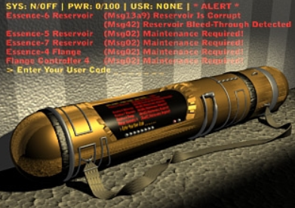

**Surface-to-Air Missile Launcher**\*

**Price:** ₡5,000,000 + ₡100,000 each missile

**Benefit:** The exact nature and scope of the missiles and warheads available is left to the referee’s discretion, but the price above suggests something on the order of a conventional explosive warhead that can take out the entire area represented by the downtown Port Loren map (Alpha Dawn canon), and damage a wider area around that.

**Available to:** Queenstemple, Port Loren Municipal Force, Shiv-råm Consortium, UPF Military.

**Swivel Turret (weapon not included)**\*

**Price:** ₡1,000

**Benefit:** This overhead add-on enables a non-driver sitting behind it to fire a mounted ranged weapon (ideally a rifle or larger weapon) and ignore any penalties due to movement. In addition, the gunner can turn up to 180 degrees as a Swift action, and up to 360 as a Move action. For an additional ₡500, a clear plastic shield can be mounted around the barrel of the weapon, and protects the gunner with the same stats as a large metal shield.

**Available to:** Anti-Android League, P.C.U.O.C.T.N.S., PoLo Militia, Port Loren Municipal Force, Shang Initiative, Star Devil, UPF Military.

**Swivel Turret, Automated (weapon not included)**\*

**Price:** ₡10,000

**Benefit:** As the Swivel Turret, but this is an automated weapon.

**Available to:** P.C.U.O.C.T.N.S., PoLo Militia, Port Loren Municipal Force, Shang Initiative, UPF Military.

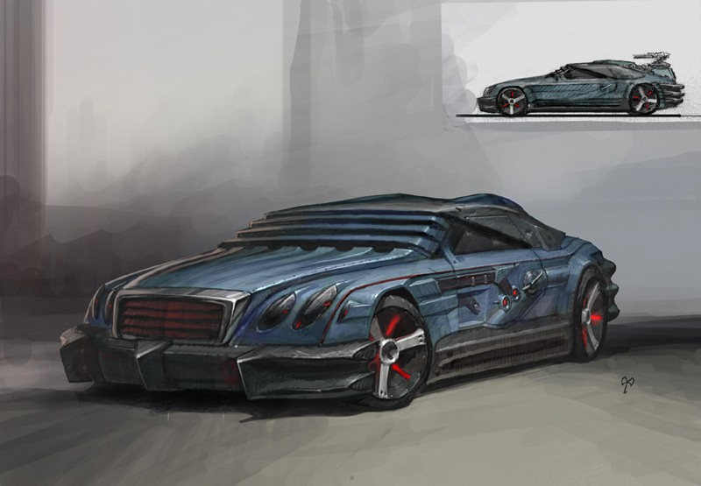

Miscellaneous PL 5/6 Gadgets

**Air Brakes**

**Price:** ₡ +5%

**Benefit:** A vehicle with this gadget can decelerate by up to two speed categories per round.

**Available to:** All factions.

**AudioAct**

**Price:** ₡ +10%

**Prerequisite:** VehicleLink Interface

**Benefit:** A vehicle with this gadget accepts verbal commands, treating any single vehicle-related Standard or Move action per round as a Swift action.

**Available to:** All factions except the Anti-android League.

**CompTalk-DisViz Integrated System (C-DIS)**

**Price:** ₡ +5%

**Prerequisite:** VehicleLink Interface

**Benefit:** CompTalk gives the vehicle an audible voice, and DisViz provides a dashboard display, providing up-to-date, interactive maps of the Frontier, and all large settlements within its jurisdiction. Port Loren maps are rendered with image granularity comparable to that of GoogleEarth. Aside from a fully integrated GPS guidance system, digital services common in urban areas are also accessible via the console.

**Available to:** All factions except the Anti-android League. The PoLos and most gangs also prefer to avoid this feature, as its GPS allows law enforcement agents to track their vehicles’ locations.

**SkidHold**

**Price:** ₡ +10%

**Prerequisite:** VehicleLink Interface

**Benefit:** This gadget coordinates the vehicle’s functions, providing a +4 boost to the driver’s Drive check for the purposes of resolving Bootleg Turns, Hard Turns, and Sideswipes.

**Special:** This gadget only works on wheeled vehicles.

**Available to:** All factions except the Anti-android League.

**Turbines, Anulax**\*

**Price:** ₡ +10%

**Benefit:** Regardless of its current speed, a vehicle with this gadget can accelerate up to (and thereafter maintain) its top speed in a single round. This feature can only be used up to once every 5 rounds.

**Available to:** All factions except law enforcement factions and megacorps.

**Turbines, Harbulary**

**Price:** ₡ +10%

**Benefit:** A vehicle with this gadget can accelerate by up to two speed categories per round.

**Available to:** All factions.

**TurnQuick**

**Price:** ₡ +10%

**Prerequisite:** VehicleLink Interface

**Benefit:** This gadget coordinates the vehicle’s functions, providing a +4 boost to the driver’s Drive check for the purposes of resolving 45-Degree Turns, Avoiding Hazards, Sideslips.

**Available to:** All factions except the Anti-android League.

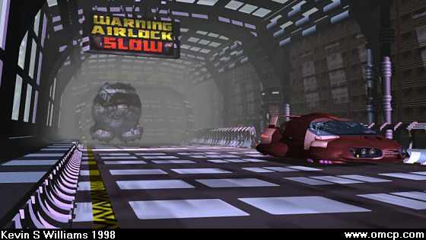

PL 7 Gadgets

**HelpDrive**

**Price:** ₡ +30%

**Prerequisite:** VehicleLink Interface

**Benefit:** This advanced gadget’s stability algorithms assist the vehicle’s onboard computer with re-stabilizing the chassis. A Drive check failed while the driver has lost control of the vehicle can be re-rolled once per round per driver.

**Available to:** Any faction with access to PL 7 vehicles.

**LookMa**

**Price:** ₡ +15%

**Prerequisite:** VehicleLink Interface

**Benefit:** This gadget combines the SkidHold and TurnQuick gadget features.

**Available to:** Any faction with access to PL 7 vehicles.

**Turbines, Pulse**\*

**Price:** ₡ +15%

**Benefit:** This gadget bestows the at-will benefits of Harbulary Turbines as well as the every-five-rounds benefits of Anulax Turbines.

**Available to:** Any cadre, cult, or gang with access to PL 7 vehicles.

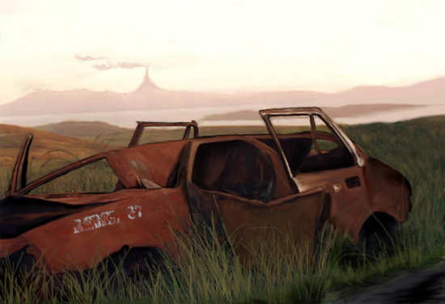

Flaws

This section provides drawbacks indicative of older and/or cheaper vehicles, which can be applied to attenuate vehicles’ costs.

**Gas Guzzler / Battery Hog**

**Price:** ₡ -20%

**Drawback:** This vehicle consumes 1½ times the fuel/energy that a standard version would. If your campaign ignores fuel costs and fueling up schedules, ignore this gadget.

**Lemon Body**

**Price:** ₡ -10%

**Drawback:** This vehicle’s hardness is lowered to ½ of its standard value.

**Lemon Brakes**

**Price:** ₡ -5%

**Drawback:** This vehicle’s deceleration is lagged by one round. For example, a character that decelerates on Rounds 2 and 3 will cause the vehicle to actually decelerate from one speed category to another on Rounds 3 and 4.

**Lemon Chassis**

**Price:** ₡ -10%

**Drawback:** This vehicle’s hit points are lowered to ½ of their standard value.

**Lemon Engine**

**Price:** ₡ -10%

**Drawback:** This vehicle’s acceleration is lagged by one round. For example, a character that accelerates on Rounds 2 and 3 will cause the vehicle to actually accelerate from one speed category to another on Rounds 3 and 4.

**Lemon Ignition System**

**Price:** ₡ -10%

**Drawback:** This vehicle has a cumulative 5% chance (max 100%) of not starting without a jump. This cumulative probability is reset to 5% when the vehicle starts. This vehicle comes standard with jumper cables.

**Lemon Suspension**

**Price:** ₡ -10%

**Drawback:** This vehicle imposes a -4 Penalty to Drive checks pertaining to Sideslips, Avoiding Hazards, Bootleg Turns, Hard Brakes, Hard Turns, and Sideswipes.

**Topheavy**

**Price:** ₡ -10%

**Drawback:** This vehicle imposes a -4 Penalty do Drive checks to determine whether a driver has lost control, and to resolve what happens when a driver loses control.