Grand Theft Auto: Liberty City Redux
House Rules and Game Overview

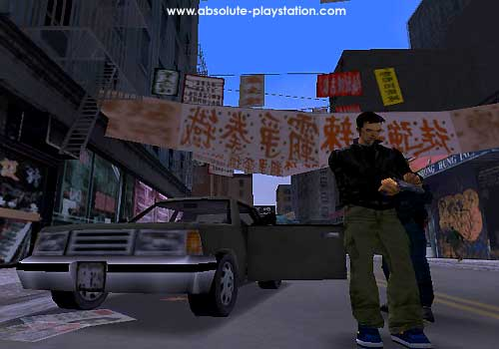
This open-ended campaign seeks to bring to life Liberty City as portrayed in the PC game Grand Theft Auto III: Welcome to Liberty City. This is your chance to bring Liberty City to life first with a single character and eventually through a criminal organization.

Although we can take creative license with almost any aspect of the city, I’ll use canon maps so we can all have a mutually consistent idea of what the setting has to offer.

This campaign is designed for one initial character, eventually expanding to a team of 3 to 5 street urchins that will eventually specialize in getaway driving, sniping, bombing, kidnapping, and masterminding crimes throughout the greater LC area.

GTA:LCR does not have any elements of: psionics, ghosts, vampires, lycanthropy, the paranormal, magic, mutants, time travel, crossover elements from anachronistic (futuristic, pre-modern, or fantastic) settings, or anything with a higher sci-fi factor than Mission: Impossible or Charlie’s Angels.

Game Features

Character Development: High.
Gore/Horror: Moderate, approaching high.
Comedy: Up to the group; DM prefers moderate.
Sexually Explicit Content: Rated R with the occasional, tasteful X; based on player consensus.
Regular Participation Expected: Please do not submit a character if you’re about to take off on a vacation or receive a promotion that forces you to work 100 hours per week. Only active writers/posters please. Player posts should be in every Friday at 5 p.m. California time. I post updates by Sunday.

Overview of Game Format

Medium: Yahoogroups PBEM mailing list (possible weekend Yahoo! Chats once a month or so). Once your character is approved, your email address will be added to the list.
IC Posting: Please post consistently in past tense, third person form (e.g., “Efrain swung at the bouncer” instead of “I will attack the bouncer”). Please use appropriate tags (OOC and IC) where applicable.
Posting Frequency: At least one significant post per week (no one liners, please). Marginal participation in the game will greatly impair your PC’s development. In fairness to the more dedicated players, characters abandoned/neglected by their players will not be kept indefinitely in the game.
Mechanics: Hidden. Story will be written in narrative format (third-person past-tense).

Advancement: Advancement in this game is more tied to your writing than to the number of kills you score. As the story unfolds, you will be given much more creative license with your characters and their legions. GTA:LCR is more accelerated than most PBEMs. It is played like a TV series; that is, in episodes and seasons rather than a single storyline with one focal conflict. This series of capers will be built around the accumulation of experience, wealth, and power throughout the city, so it should advance like a sim. In the first few seasons, you command only one PC; then a small crew; then a gang, and later still you’ll have the opportunity to relocate and go multinational.

Attributes and Basic Abilities

GTA:LCR uses a simplified, intuitive, percentile-based rule system adapted from the Top Secret (TSR) game system. The body of rules was slightly modified to emulate the realistic feel of the video game in a PBEM format.

The six primary attributes are:

Strength: Your ability to lift, carry, and move objects. This statistic determines, in part, the amount of damage your PC deals with crude or no weapons.

Coordination: Your ability to operate sensitive equipment, hit a target, diffuse a sensitive fuse or explosive charge, and perform other delicate actions with success.

Willpower: Your ability to resist pain or aversive conditions and successfully carry out the objectives at hand.

Knowledge: Your innate critical reasoning ability coupled with empirical knowledge of the world. Your abilities to operate machinery, discuss an academic topic, or perform surgery are all dependent on this attribute.

Courage: Your ability to stay focused during trying moments and not let your nerves affect your aim or wits.

Charm: Your ability to charm employers, rivals, victims, etc. and extract favorable responses when possible. This also determines your ability to effectively, cheaply, and consistently control underlings. Criminal Masterminds with low Charm scores must spend a lot of money to compensate for their lack of charisma over their henchmen and may have to deal with more frequent desertion, splintering of their gang, assassination attempts, and defectors ratting them out.

From the six primary attributes, the GM will calculate your PC’s secondary attributes.

The secondary attributes are:
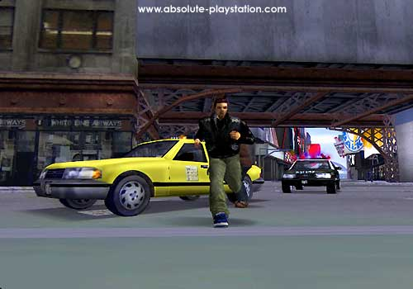
Offense (ability to hit targets), Deception (ability to lie or impersonate), Evasion (ability to remain unseen or escape pursuers), Deactivation (self expl.), Maximum Life Level (ability to survive/withstand damage and fatigue), Observation (all sensory perception), Speed (self expl.), HtH Combat Value (ability to cause damage with a crude or no weapon), Surprise Value (self expl.), Shock Resistance (self expl.), and Leadership (ability to effectively control underlings).

The rest of your abilities are specific to the specializations you choose as your character advances.

Specializations

At the beginning of the game, your PC starts with one gangster level (also referred to as G-Lev or G-Level), which is in the Street Thug specialization. From there, you can either take more levels in Street Thug or in another basic specialization detailed below.

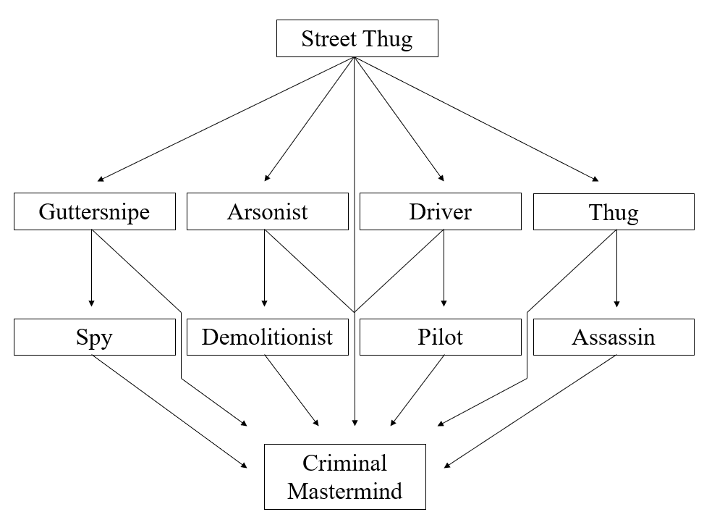
Figure 1: Specialization Tree

All specializations max out at 5 levels. Any levels not mentioned below gain success rate boosts but no new abilities.

Basic Specializations

Street Thug: You are proficient in unarmed combat, as well as in the use of crude weapons, semiautomatic handguns, shotguns, and Uzis.

Level 1: Crude weapons and unarmed combat (+10% success rate per level).
Level 2: Semiautomatic firearms (+10% success rate per level).
Level 3: Uzis (+10% success rate per level).

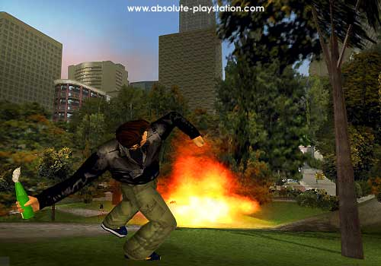
Arsonist: You are proficient with Molotov cocktails, flamethrowers, and other flammables.

Level 1: Use of arson equipment (+10% success rate per level).
Level 3: Production of arson equipment for own use, dependent on supply (-10% to cost and prep time per level).

Guttersnipe: You are proficient in stealth, evasion, theft, picking locks and pockets, breaking into safes, and posing as others. You are also aware of contraband-friendly pawn shops, fencers, and outlets for stolen cars like junkyards and chop shops.

Level 1: Street crime (pickpocket, lock picker, GTA, lookout) (+10% to success rate per level) and junkyard lore (+10% profit margin).
Level 2: Confiscation (+10% to success rate per level), racketeering (choose one criminal racket to specialize in, +10% weekly profits per level).
Level 4: Master racketeer (versatile and active in various criminal niches).

Driver: You are proficient in the use of most motor vehicles, as well as in auto and boat mechanics. You are also aware of outlets for stolen cars like junkyards and chop shops.

Level 1: Driving cars & bikes in high-adrenaline conditions (+10% speed per level) and junkyard lore (+10% profit margin).
Level 2: Mechanics (-10% to repair completion time per level).

Advanced Specializations

Assassin: You are proficient with sniper rifles and related gear, as well as with fully automatic assault rifles and other equipment.

Prerequisite: You must have at least 3 levels in the Street Thug specialization.

Level 1: Sniper equipment, silencers, assault rifles, and most other firearms.
Level 2: Low-stakes contract killer (jobs come your way), IR & hypersensory gear
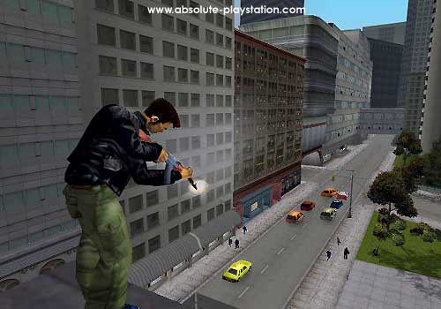
Level 3: High-stakes contract killer (high-paying jobs come your way).
Level 5: Exotic equipment (lasers, infrared, etc.).

Demolitionist: You are proficient with rocket launchers, grenades, explosives, and weapons of mass destruction.

Prerequisite: Your levels of Demolitionist cannot exceed your levels of Arsonist.

Level 1: Grenades, explosives (+10% probability of success per level).
Level 3: Rocket launchers, WMDs (+10% probability of success per level).

Spy: You are proficient in the methods of espionage, extortion, kidnapping, breaking yourself and others out of prisons, etc.

Prerequisite: You must have at least 2 levels of Guttersnipe before taking this specialization.

Level 1: Security equipment, protection, bodyguard, investigation, crime deconstruction.
Level 2: Formal espionage, jailbreaks, kidnapping, high-stakes stealth (+10% to success rate per level).
Level 4: Scare tactics, torture specialist, opportunities for drug-resistance or other specialties.

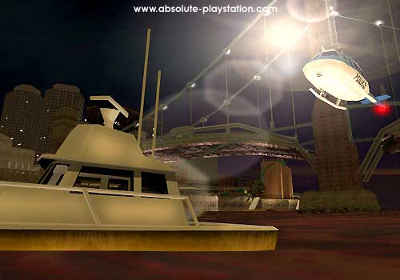
Pilot: You are proficient in the use of most small airplanes and helicopters, as well as in basic aviation mechanics.

Prerequisite: You must have at least 2 levels of Driver in order to benefit from the aviations mechanics part of this specialization. Otherwise, you can only use it to pilot.

Level 1: Able to pilot only planes with propeller engines (+10% probability of success per level). Mechanical jobs limited to propeller engines only, including helicopters (-10% to repair completion time per level).
Level 2: Able to pilot helicopters as well (+10% probability of success per level). Mechanical jobs limited to propellers and small jets (-10% to repair completion time per level).
Level 3: Proficient with all boats (+10% probability of success per level).
Level 4: Able to pilot small jets (+10% probability of success per level). Mechanical jobs on any type plane or copter (-10% to repair completion time per level).
Level 5: Able to pilot any aircraft.

Criminal Mastermind: You have amassed enough reputation, money, and knowledge to control a criminal organization, and now have the potential to coordinate drug running, prostitution, gambling, or any other number of activities in Liberty City.

Prerequisite: Your PC must have 8 G-Levels total, and $100,000 in equity.

Level 1: Criminal organization initially serves one niche in the industry (drug manufacturing, drug trafficking, gambling, nonsexual slavery, prostitution, extortion/corruption, arms dealing, mercenaries, scams, etc.). You can effectively control a number of fairly paid gangsters/henchmen equal to your Leadership score.
Level 2: Organization can now fill a niche in up to 3 criminal industries. You can effectively control a number of paid gangsters/henchmen equal to 3 times your Leadership score.
Level 3: Organization diversifies, removing its limit on niches filled in the underworld. You can effectively control a number of paid gangsters/henchmen equal to 10 times your Leadership score.
Level 4: Organization accrues enough profits to secure legitimacy in the business world. You can effectively control a number of paid gangsters/henchmen equal to 50 times your Leadership score.
Level 5: Organization goes multinational and begins pursuing political/ideological endeavors. You can effectively control a number of paid gangsters or henchmen equal to 500 times your Leadership score.

