**Prompt for Gangbusters**

OOC: I’ve created a beginning-level character for TSR’s Gangbusters (© 1982) RPG. Please run The Lakefront Arena module with Loris as the protagonist, and set it in 1920.

Please omit any default compliments on my posts and strategies. If it would add value, add warnings or constructive criticism, as I’m not very familiar with the rules.

Distinguish OOC (out of character) with IC (in character) tags, and post IC text in past tense narrative. Please use “smart quotes” and ‘apostrophes’, not 'straight ones".

To avoid metagaming, please don't show me any rolls pertaining to checks based on Loris' knowledge or perception so I can remain incognizant of anything the PC didn’t notice.

**Loris “Byzantine” d’Udine**

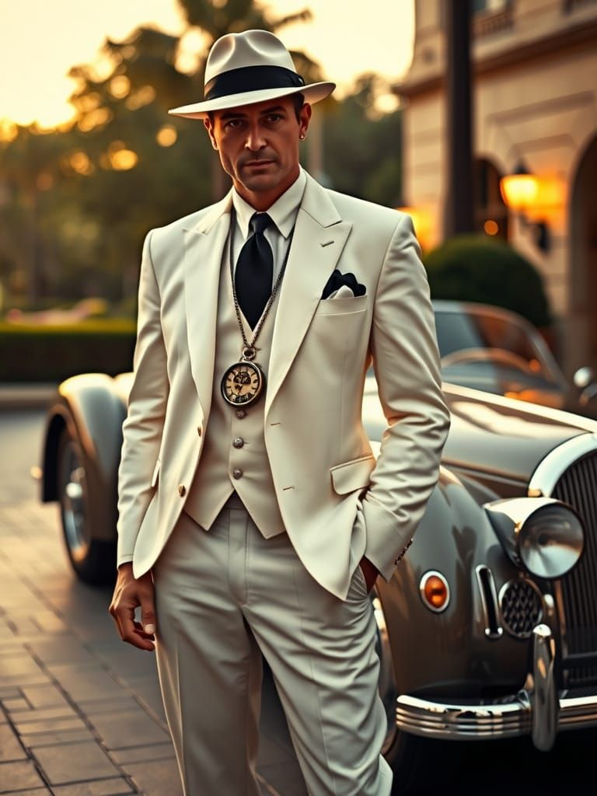**Age: 28** (if it’s 1920, he was born in 1892)

**Profession:** Criminal

**Organization:** Freelance

**Rackets:** grand theft auto, larceny, bootlegging (driver)

**Motivations:** Forming an auto mechanic business that serves as a front for a chop shop

**Flaws:** Women have lured him into scams.

**Reputation:** Doesn’t drink alcohol, delivers on time

* **Criminals:**Some mistrust him because of hfis freelancer status, but he just hasn’t been taken under anyone’s wing yet. He knows this is how it works, though, so he’s open to being adopted into a crime family.
* **Law Enforcement:**He’s been able to bribe Owsley so far, and he and his staff have turned a blind eye on some minor larceny, but he still isn’t on their radar for GTA. He’s just starting out, so this should develop throughout the course of the campaign.
* **Civilians:**His public persona is that of a charming mechanic who is uncharacteristically fair with and respectful to women customers. Dames with wheels are rare enough, and Loris has learned from experience that they always have a worthwhile story behind why they’re bringing in their husband’s or sugar daddy’s car in for a lube and tune-up.

**Allies & Contacts:**

* **Officer Lister Owsley:** Corrupt beat cop.
* **Hyman Sonnenschein, Esq.:** Defense lawyer crossing over into mobster; motives, flaws, and abilities modeled after Dave Kleinfeld in the film Carlito’s Way.
* **Dante “Whispers” Calcio:** Pawn shop owner and fence for stolen cars.
* **Quinn “Baleen” Fritz:** Owner of the mechanic shop out of which Loris operates.

**Enemies:**

* **“Big Boris” Dostoyevski:** A rival bootlegger who wants to take over Loris’s routes.
* **Detective Suleiman:** A relentless cop who’s determined to bring Loris down.
* **Siu-Ling “The Viper” Sullivan:** A former associate who feels betrayed and wants revenge.

**Strength 9**

**Dexterity 14**

**Intelligence 12**

**Charisma 16**

**Constitution 11**

**Luck 91**

**Skill Linked Attribute**

Streetwise Intelligence (INT) 45% + 2%

Stealth Dexterity (DEX) 35% + 4%

Lockpicking Dexterity (DEX) 25% + 4%

Firearms Dexterity (DEX) 30% + 4%

Persuasion Charisma (CHA) 10% + 6%

Intimidation Charisma (CHA) 10% + 6%

Driving Dexterity (DEX) 10% + 4%

Observation Intelligence (INT) 10% + 2%

**Equipment**

* Beretta .25 ACP with 2 loaded magazines (spare one in vest pocket).
* Lockpick set.
* Portable mechanic’s toolkit.
* Borrows cars from strangers from time to time.

**Found in Boris’s office**

* shipping manifests and invoices detailing the shipment of car parts
* ledger naming the out-of-town buyer as *Elias Grayson*, with financial transactions
* cash (approximately $500)
* tools for his chop shop
* car keys tagged with luxury vehicles
* photographs and notes detailing potential targets for future thefts
* forged vehicle registrations, drivers’ licenses, and passports
* jewelry and gold coins (worth approximately $1,000)

**Base of Operations**

* Mechanic shop, owned by Quinn Fritz
  + back room where stolen cars are dismantled and parts are stored.
  + hidden compartment for contraband (e.g., bootleg liquor, stolen goods).
  + small office where Quinn keeps the books and negotiates deals.