Heroes of the Sword Coast

Chapter 1: Beregost

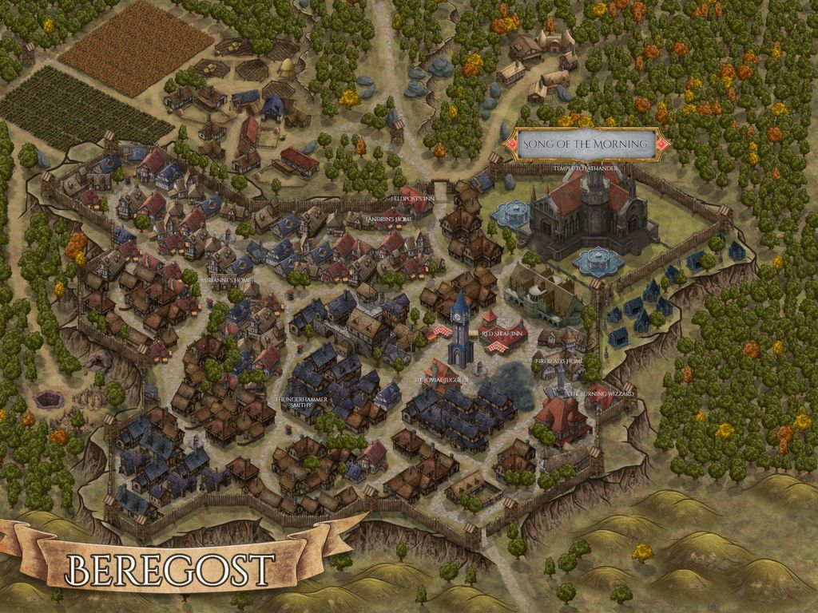

The party happened upon the outskirts of Beregost shortly after dawn, and just before sunrise, having partly lost their way under moonlight due to an obsolete trail on their map that was now part of a farmstead. Before them were erected forty or so stone and wood buildings that catered to various trades. A few merchants wearing fashions emblematic of Amn and Baldur’s Gate alike eyed the newcomers as they made their way into town via the southern gate. The breeze brought with it the scent of dew on otherwise dry grass that bespoke of spring’s gradual yielding to summer one leaf and blade at a time. Nihm and Lee noted the thirst of the land relative to what this vegetation was accustomed to, and expected a dry heat in the day ahead as they beheld the first few townsfolk, mostly young’uns.

They had heard that this town had no official government, instead being run by the high priest of its major temple to Lathander, the Song of the Morning Temple; in function, it was the opposite of a hamlet, which was a village too small to warrant a standing clergy. Yellow-garbed acolytes of the temple bore arms and kept the peace as they, too, kept their gazes on the outlanders, particularly the dog-faced one. With a permanent population of just under 3,000 denizens, the village was isolated from the nearest settlement by countless acres of rolling grassland peppered by wooded forests.

Nihm, Baldoor, and Lee had been discussing the curious footnote of the town’s founder being a spellcaster rather than a politician. This wizard, named Ulcaster, established a magic school here that had attracted a farming village to support it. Alas, Jealous Calishite wizards had burned down Ulcaster’s school three hundred years ago, and the ruins still dominated the eastern side of the road, where the Morninglord’s clerics grazed their sheep to keep an eye on the ruins and prevent unsavory characters from going in or coming out. If there were arcanist scholars here today, they were few, and likely reclusive.

The cleric that had let them pass had charged a toll, citing the need for road upkeep, and they now walked with the writ he’d given them, which specified their day and time of entry—Dawn, 1 Flamerule, 1372 DR—and would help if they were harassed by authorities. The town wasn’t normally under such lockdown conditions, but the cleric at the gate—Elder Severum—had left them with a final word of heed, cautioning them to be vigilant of kobolds skulking around. “Been burglarizing and vandalizing,” the Elder had specified.

This was consistent with their runty kind’s reputation, and the party had already discussed contingencies for addressing any late-night thieves coming for their belongings. They expected to find a handful of inns to choose from, and had enough coin among them to splurge on the finest that this town could offer, but they also knew that this was likely a lucrative target for any kobold collective that knew the layout of the town.

The heroes made their way along the only paved road they’d seen—a promenade of sorts wide enough for two wagons and lined on both sides with shops, pubs, and parlors conveying wares, aliments, and services of the most basic kinds. They would be hard pressed to find a weapon shop with a single enchanted item for sale in this Podunk of the Sword Coast. Nevertheless, with Midsummerfest just a month away, a caravan had already arrived in town, though it would not stay long, as it was headed for Candlekeep, which was roughly 40 miles to the west along one of the craggiest stretches of the Sword Coast. Beregost was a waystation for many merchants and itinerant entertainers making their way along the Sword Coast, and Midsummer saw scores of bards and vendors come and go, adding to the village’s cultural and economic value as they left behind exotic goods and took with them tales of the quaint generosity of a people resiliently steading in the midst of a vast wilderness.

The sound of chestnut castanets, goat-hoof anklets, and brass thumb cymbals suggested the presence of troubadours around the corner, and sure enough, as they reached the central square where a simple but functional clock tower had recently been erected, they happened upon a quintet of dancers casting a rhythmic overture on a makeshift stage in front of an establishment with a sign that read, “Red Sheaf Inn”. Thus far, it was the largest structure they’d passed that advertised public lodging, and with the music and dancing, it certainly made for an inviting place at the moment, but there was much more to the town, and they’d heard of a handful of hidden gems off the main promenade, so they made their way northward to the reputed location of one such place, the Beheaded Beholder.

As with most businesses in a town such as this, the inn and tavern that constituted the Beholder were on the first floor, while upstairs was the owner’s domicile. Landrin was a single, middle-aged human with a sweet tooth and a green thumb, but he had a poor sense of cuisine, and entrusted this to three cooks—a human, a gnome, and a dwarf—who all lived on this northern block and had grown up together. Landrin stuck to the bartending—though it had taken years to acquire proficiency in the associated skillset—and the management of the lodging, which was limited to five rooms in a separate building that had formerly been a barn. The heroes had been told all of this by someone who’d recently stayed here and had recommended the place.

After locating the inn and tavern, cheekily known as the Beheaded Beholder, that had been recommended recently, they walked in, and Baldoor cleared his throat to get the attention of someone inside. When someone approached, Nihm smiled and spoke in a soft tone. “We are seeking lodging for the next several days. How large are your rooms and what is your rate? We also need some refreshment after our time on the road, do you offer quality food and beverages?”

The rooms were described to be ample—save for the halfling suite in the hayloft—and cost exactly what they’d been told to expect: 2 gold per night, even the halfling suite.

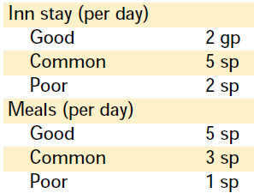

“We’ll take three rooms then, if you have the space,” Nihm said as Kassuq was sniffing the air.

“Very well,” Landrin replied.

“Smells like something good cooking in the kitchen,” the archon stated.

Baldoor shook his head, “Always thinkin’ about food. I just hope they have a decent ale.”

Landrin overheard and replied, “It’ll take you where you need to go.”

Meanwhile Lee just stood next to Nihm, his hands folded in front of chest as he waited for the clerk to hand over the keys.

Nihm and Lee shared a room, while Baldoor and Kassuq took their own separate rooms.

~*~

Having settled into their rooms at the Beheaded Beholder, changed, and left their extra outfits and less valuable belongings in drawers and closets, the party took to exploring the streets of Beregost. They didn’t have to go very far in the direction of the Song of the Morning Temple to find a caravan of wagons bearing enclosures of different sizes, including one tarped enclosure that had to be fitted on two wagons, the rearmost of which had a swivel platform to allow for tight turns around bends and tight alleys.

They couldn’t see what was in the first few tarped cages they passed, but the telltale smell of herbivore and carnivore dung comingled gave the heroes—best of all, Kassuq—the sense that this was a traveling zoo. Upon further glances as they meandered southwardly, some of the smaller cages did bear reptiles, birds, mammals, and even some invertebrates. The humanoids busying themselves around the wagons wore garments indicative of a stature between peasantry and gentry, and all bore prominently burgundy- and mustard-colored bands matching the wagons’ décor, which consisted mostly of carved designs along the platforms, all highlighted in the same shades of reddish-purple and autumn jaune.

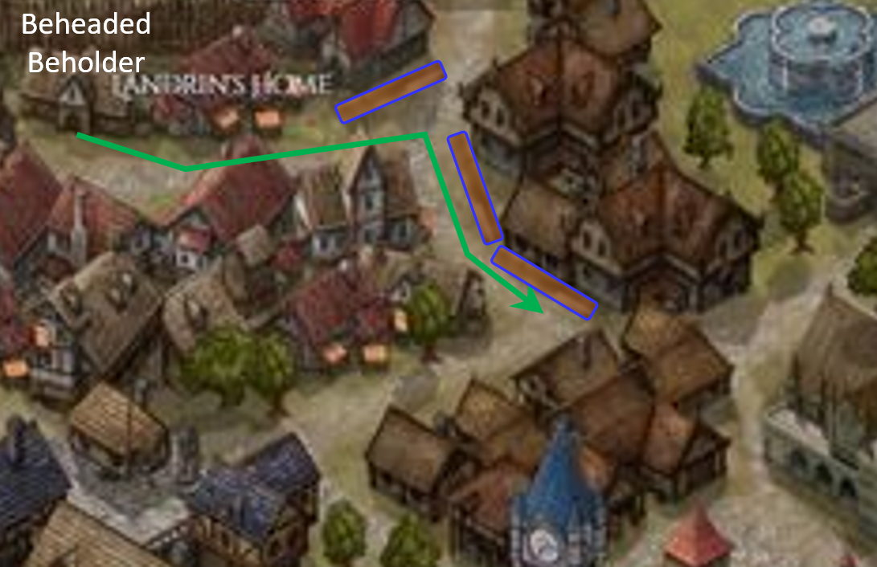

All in all, they took a measure of no less than three clusters of wagons, with probably 20 wagons in total, before they’d passed them all. The animals they *could* see—a few peafowls, an iguana, and a pangolin—were mundane in the arcane sense, though they were exotic to this part of Faerûn; Nihm and Lee noted this, though they also noted that they were species that thrived in similar biomes along this latitude, so they were likely low-maintenance beasts to keep healthy so long as the convoy didn’t venture any farther north.

After passing the zoo, the team headed for the primary market to have look around and see what there was to see. There appeared to be some merchants unloading their wagons, but none preparing to leave, or they would have defaulted to offering their escort services. Instead, they saw what exotic items—clothing, jewelry, spices, painting supplies—and magical items might be for sale, hoping that perhaps later in the morning there might be someone rearing to leave somewhere. The primary exports of the region—gold, pottery, silver, and wool—were abundant in bulk and in finished products, and anything made of these was likely to come at what the heroes would have considered a slightly discounted rate. On the other hand, iron-based goods—including steel—appeared to be priced on the steep side of what was reasonable.

As they passed a few vendors, Nihm purchased a canvas along with some unusual color paints and a couple brushes.

Lee spent his time listening to those passing by, trying to pick up tidbits of information of their surroundings.

Baldoor was not impressed with many of the items about, but did keep an eye out for a good tavern to stop in for a drink when they were done shopping.

Kassuq was taking in the sites and scents of their surroundings. He was still fascinated by every town that they went into having grown up on the frozen tundra north of the Spine of the World mountains.

They ended up at a tavern that Baldoor spotted, and as everyone enjoyed their favorite spirits, Lee related what little he’d made out from the passersby’s conversations. This included mentions of a new apothecary who’d just moved into the western edge of town, and was already making a name for himself by healing some of the townsfolk for a pittance. There were also rumors that the kobolds that were ransacking the countryside and looting the village stores were associated with a sinister spellcaster named Mulcahy, who was last spotted trying to swindle some merchants just outside of Nashkel. There were other tidbits, but they were dead-end fragments of conversations from which he could conjecture nothing definitive.

Baldoor spoke up, “Perhaps we should look into this Mulcahy character. Set him and his kobold vermin straight.” He also asked the server that was getting their drinks, “You heard of a Mulcahy and a band a kobolds causing problems around here?”

He shook his head, preoccupied with the health of the ailing dog in the corner behind the counter, whom he’d just tried to feed, then sighed, “I know the usual barkeep’s a heap of gossip, but I’ve ne’er been one to keep names and faces straight, so I try to stay out of other people’s business. They tell me I’m a good listener, so feel free to tell me your tales. I’ll mix’em up with other folks’ anecdotes, but they’ll make for good retelling to the kids across the street.” They’d noted a schoolhouse situated there, and assumed its students came here for lunch, given how small the schoolhouse was.

After talking to the server, they headed back towards their inn—the Beholder—hoping to find some leads on the person that Lee heard talk about Mulcahy. They tried several times to start conversations with locals, but the quartet of armed strangers—and one of them with a canine face—coming at locals with questions did not get much from the Beregostian pedestrians until they passed once again by the troupe of dancers in front of the Red Sheaf Inn.

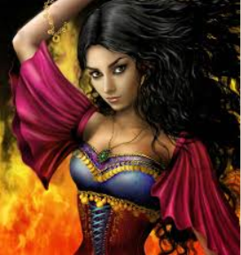

Her name was Kali. She was an elven sword dancer, the practitioner of an ancient technique at the intersection of dance and martial arts, and though her sabers were sheathed, the movements of her statuesque form suggested a martial prowess beyond their own. She was the frontwoman for this band of performers of fortune known as the Mercenaries of the Stage.

She had initially called them out, captivated a bit by the eclectic composition of the outlanders. The archon, the dwarf, the elf, and the human were more than happy to stop and engage in conversation with the equally captivating group of thespians and entertainers.

Lee and Nihm walked up to the sword dancer. “I am Lee and this is Nihm. We just arrived in Beregost and we were wondering where you arrived from? We interested in any information you might have from your travels.”

“Ah,” she said in a manner that was both a greeting and an affirmation. “We hail from many places, but Haer’Dalis and I grew up in nearby Amn. And you? You look to be from the northern lands.”

Baldoor and Kassuq milled about the area as Lee and Nihm talked.

Lee smiled, “I am from the Dalelands; never really stayed in one place when I was young.”

Nihm then chimed in, “And I am from Battledale, where you didn’t have to go far to find a fight.”

Both gave the sword dancer a friendly smile. Lee then asked, “Have you run across any trouble recently? We’ve heard rumors of kobolds causing trouble in the area, possibly to the south of here.”

The bards all laughed, some of them still bearing recent lacerations that they hadn’t had a chance to magically heal yet. “Well, just a bit,” she then recounted a synopsis of their run-ins with a hobgoblin gang and a handful of elven supremacists who wanted to purge all other humanoids from existence on this plane.

“You don’t say!” Lee simulated such an encounter in his imagination. “I trust you laid them by their heels?”

“Not exactly, but we got away alive,” the senior woman spoke for the others, who appeared to be novice adventurers compared to her.

“We think we *did* slay one of them,” added Haer’Dalis with optimism.

“And you all? Don’t tell me you made it through any stretch of this forest unscathed,” she smirked and read their faces as if they were exposing a hand of cards.

Lee laughed, “For the most part, yes. Sometimes it pays to travel in small numbers and travel light. If you would care to indicate where this happened, we would appreciate it. We may investigate on our own, or may get hired as escorts, so knowing what is out there is always helpful.”

“We were fortunate enough to hitch passage on an Amnish barge patrolling the coastline to Candlekeep. We stayed in that grand monastery for two nights, and ventured here with a merchant caravan that left a few days ago for Nashkel. If you’ve a caravan, we’ll be in the market for passage in a tenday or so.”

Nihm nodded her agreement as she pulled out a piece of canvas and drew a simple map of the area as she recalled it, with Lee’s input.

Did they tell Nihm anything to put on her map?

“Don’t want to be stuck anywhere around here by Midsummerfest,” Haer’Dalis admitted. “My constitution can’t take the quaintness.”

“Stop it!” Kali scolded her apparent right-hand associate.

“Well, we currently have no caravan,” stated Nihm.

“If they serve enough ale, then the Midsummerfest wouldn’t be that bad,” added Baldoor as he and Kassuq joined Nihm and Lee.

“You haven’t seen the acts that play here on ‘Fest,” a junior troubadour raised her head from tying her bootlaces and said. “There’s not enough ale in the land to make it worthwhile.”

A few others laughed, having gotten caught here a few years ago without money, and having had to book a gig with just about the worst performers who’d ever seen coin for their work.

“We are looking for work, or maybe some trouble to get into,” added Kassuq with a laugh.

Lee shook his head, “The pup is right, we’re looking for work, so if you do hear of any merchants heading out that need guards, or you have room for 4 more when you head out, let us know.”

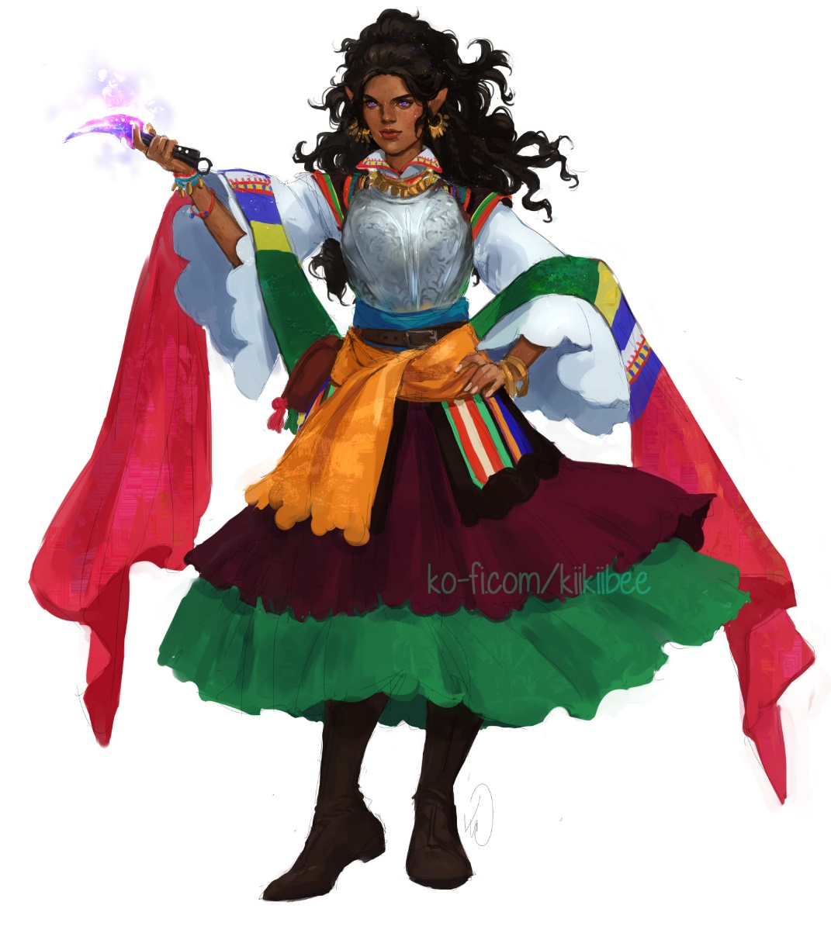

“Will do,” more than one of them said as they bid the heroes well and began tuning instruments and stretching joints.

The four strangers made their way back toward the Beholder, and Kassuq was the first to hear among the voices of the crowds now teeming along this stretch of the road the sudden wailing of an animal up ahead. They were about to turn the corner anyway, but instinctively sped up towards the sound that they could now all make out. Citizens also heard it, but in a town like this, the sound of an unruly donkey being beaten was not inexistent, so it didn’t exactly rouse alarm.

And though it sounded like a pack mule, it was actually a rust monster that was being whipped by a human sporting an eclectic mix of fashions from lands afar and near. The dungeon monster was gagged by a piercing apparatus that made it visibly painful for it to open its mouth while the contraption was in place.

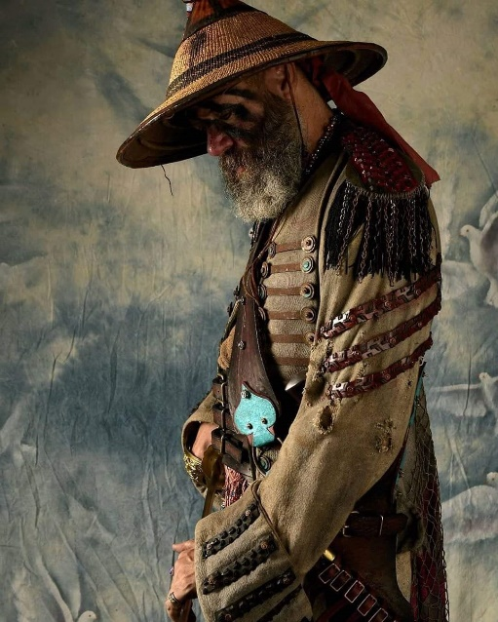

“Wretch!” the human blurted as the heroes—from about 50’ away—witnessed him lashing out angrily with little calculation in his whipping.

The rust monster neighed again, the sound now distinctive from that of a mule.

As the man was about to whip the rust monster again, Nihm spoke up, her tone cold and direct, “I wouldn’t do that again if I were you.” To her right, Lee stood, hands on both his sword and axe. To Lee’s right stood Baldoor, warhammer already in his hand. Over to Nihm’s left, Kassuq glared at the man with the whip, teeth bared and a low, menacing growl coming from his throat.

“And what’s it to you?” clamored the outlander in a Thayyan-like accent. “Animal has to be broken. I’m not the boss; just the one that has to do it.”

Nihm took a step forward, “It’s bad enough you have them caged up and paraded around.” Nihm was not fond of zoos, be they in a city or in a caravan. However, she did see the benefit to helping those that didn’t travel being able to see strange and unusual creatures. “You don’t need to beat or abuse them. There are better, more beneficial ways to get an animal or creatures cooperation.”

This exchange across a nearly 50’ distance had drawn the crowd’s attention, and the eclectically dressed beastmaster now turned as if to face off with Nihm, then parted his lips to speak, only to be preceded by another voice: that of a well fed human with an accent from the northwestern reaches of the continent. “Juneau, take a break.”

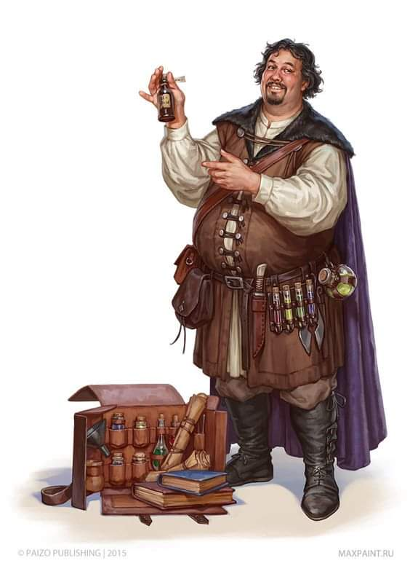

“But...”

“Go cool off. You and I will have words later,” the rotund fellow’s voice grew stern as a handful of younger assistants followed behind and did their best to calm down the tied-up rust monster.

Juneau shook his head and did as told while the neighing of the monster began to subside, three knaves now caressing its tail and sides and loosening the clamp that kept its mouth shut.

The man that seemed to be in charge looked over the quartet of heroes who’d just stood defiantly against Juneau, and addressed Nihm. “Name’s Kondratieff. You seem true of heart, and reckless. No doubt you are adventurers, and not from these parts. Wherefrom hail you, outlanders?” asked the itinerant merchant, who had once specialized in herbal tonics, but had since abandoned that industry and focused his livelihood on his lifelong passion: zookeeping.

Lee and Nihm both noticed certain details in his urban outfit that were indicative of a rural upbringing, such as the manner in which his clothing fit, which was more indicative of the peasantry than of the gentry. It was evident from the bits of straw, minor dirt scuffs, and other peculiarities in the fabric that he had slept on the ground or a straw bale the night prior, rather than on a more comfortable mattress.

Nihm thought this man seemed more reasonable. They were also happier with the better treatment that the rust monster was receiving.

The group moved a bit closer to Kondratieff and Nihm spoke up. “We are from all over, and have traveled near and far.” She gave him a friendly smile, not wanting to commit to any facts at the moment. Nodding her head towards Juneau, “So why was he put in charge of an animal that he is certainly not qualified to supervise? These other seem more than capable of treating the animal with care and keeping it from getting out of hand.”

“He’s,” Kondratieff tilted his head, “my partner’s brother.” And with these few words, the man also revealed that said partner had more say than Kondratieff in matters of personnel, so the absent partner was likely the senior partner in this venture, inferred Kassuq and Nihm.

The others had relaxed their stances though Kassuq kept on eye on Juneau as he walked away. It was a good thing he did, too, because the latter unexpectedly turned and charged Kondratieff. “I *heard* that! You think that’s the only reason I’m here, you fuck!?”

Round 1

Baldoor, Lee and Kassuq moved to bet between Juneau and Kondratieff while Nihm took a couple of steps forward and motioned for Kondratieff to move closer to her. Baldoor had his hammer out, the others simply had their hands on the hilts of their weapons.

Juneau, however, wasn’t really concerned with the four strangers as much as with his hangover, and with his impatience for the impetuous Kondratieff thinking he could belittle his partner’s family in public, so he lashed out at Kondratieff.

|  |  |  |  |  |  |  |  |  |  |
| --- | --- | --- | --- | --- | --- | --- | --- | --- | --- |
| **Character** | **Attack Type** | **Damage** | **BAB** | **Str Mod+** | **W+** | **Other+** | **Total Score** | **Roll** | **Total** |
| Juneau | MW Whip | 1d3+2 | 3 | 2 | 1 | 0 | 6 | 6 | 12 |

*Hit. Dmg: 2 + 2 = 4.*

“Aw, you son of dogs!” Kondratieff blurted as he bled from his face now. He drew and threw a dart at Juneau.

|  |  |  |  |  |  |  |  |  |  |
| --- | --- | --- | --- | --- | --- | --- | --- | --- | --- |
| **Character** | **Attack Type** | **Damage** | **BAB** | **Dex Mod+** | **W+** | **Total Score** | **Roll** | **Total** | **Notes** |
| Kondratieff | Dart of Sleep | 1d4+sleep | 2 | 1 | 1 | 4 | 15 | 19 | DC 15 |

*Hit. Dmg: 2 + Sleep.*

|  |  |  |  |  |
| --- | --- | --- | --- | --- |
| **Character** | **Save vs.** | **Ranks** | **Roll** | **Check** |
| Juneau | Fortitude | 2 | 17 | 19 |

*Success. Saved vs. Sleep.*

The dart hit the whip-cracking human in the shoulder, which started to swell a bit as Juneau shrugged off the narcoleptic effects. Spectators either fled, cheered, and stood and watched, some even taking bets on the outcome. The rust monster backed away, and Kondratieff’s employees did their best to make sure the animal didn’t escape now that it was untied.

Round 2

|  |  |  |  |  |  |
| --- | --- | --- | --- | --- | --- |
| **Character** | **Group** | **Initiative** | **Roll** | **Modified Roll** | **Speed** |
| Baldoor | 1 | 5 | 18 | 23 | 30’ |
| Juneau | 3 | 2 | 18 | 20 | 30’ |
| Nihm | 1 | 6 | 12 | 18 | 30’ |
| Kondratieff | 2 | 1 | 11 | 12 | 30’ |
| Kassuq | 1 | 6 | 4 | 10 | 40’ / 60’ |
| Lee | 1 | 2 | 3 | 5 | 40’ |

Baldoor moved about 50’ eastward, hoping to apply subduing damage to Juneau.

Juneau whipped Kondratieff again, “Bitchboy!”

|  |  |  |  |  |  |  |  |  |
| --- | --- | --- | --- | --- | --- | --- | --- | --- |
| **Character** | **Attack Type** | **Damage** | **BAB** | **Dex Mod+** | **W+** | **Total Score** | **Roll** | **Total** |
| Juneau | MW Whip | 1d3 | 3 | 2 | 1 | 6 | 5 | 11 |

*Miss.*

Nihm also made it eastward about 50’ and was about to step between Kondratieff and Juneau.

Kondratieff wasn’t having it. He drew his knobbed club and shook his head, holding his ground while he sought the opportunity for a nice charge-attack.

Lee and Kassuq followed their friends about 50’ towards Juneau in an attempt to grab and restrain him. Their goal was not to take Juneau out, but to stop the fight and send him off to sober up. They got into a position where they could do this effectively in the next few seconds.

Round 3

They were all now in one another’s vicinity, and the next few seconds were like a communal dance among participants who hadn’t rehearsed. First, Baldoor stepped in unarmed and punched Juneau, aiming for the face as Nihm stepped between Kondratieff and Juneau.

|  |  |  |  |  |  |
| --- | --- | --- | --- | --- | --- |
| **Melee Weapon** | **Dmg.** | **D+** | **Atk** | **Roll** | **Check** |
| Unarmed Attack | 1d3 | +1 | +3 | 10 | 13 |

*Miss.*

The dwarf nicked the human’s leather epaulettes instead of his jaw. Juneau turned to Baldoor and spat out, “*Now* you’ve got my attention!” Taking a step back, he lashed out at the cleric of Moradin.

|  |  |  |  |  |  |  |  |  |  |
| --- | --- | --- | --- | --- | --- | --- | --- | --- | --- |
| **Character** | **Attack Type** | **Damage** | **BAB** | **Str Mod+** | **Dex Mod+** | **W+** | **Total Score** | **Roll** | **Total** |
| Juneau | MW Whip | 1d3 | 3 | 2 | 2 | 1 | 6 | 12 | 18 |

*Hit. Dmg: 2 [19/21].*

“Suck it!” the monster beater had to add.

Kondratieff saw his moment, and charge-attacked Juneau now that he was about 10’ away from the dwarf whose face he’d just lashed up.

|  |  |  |  |  |  |  |  |  |
| --- | --- | --- | --- | --- | --- | --- | --- | --- |
| **Character** | **Attack Type** | **Damage** | **BAB** | **Str Mod+** | **Other+** | **Total Score** | **Roll** | **Total** |
| Kondratieff | Club | 1d6-1 | 2 | -1 | +2 charge | 3 | 12 | 15 |

*Hit. Dmg: 2 – 1 = 1.*

Spectators had now organized themselves in clusters behind soft cover, and most of the others were running or walking away.

Lee and Kassuq tackled Juneau in a tandem effort.

|  |  |  |  |
| --- | --- | --- | --- |
| **Touch Attack** | **Atk** | **Roll** | **Check** |
| Kassuq | +5 | 18 | 23 |
| Lee | +3 | 9 | 12 |

*Hit, miss.*

Kassuq managed to connect; Lee fumbled but regained his footing.

|  |  |  |  |
| --- | --- | --- | --- |
| **Melee Weapon** | **Atk** | **Roll** | **Check** |
| Grapple | +5 | 10 | 15 |
| **Character** | **Attack Type** | **BAB** | **Str Mod+** | **Total Score** | **Roll** | **Total** |
| Juneau | Grapple | 3 | 2 | 5 | 2 | 7 |

*Grapple successful.*

The hound archon applied a forceful chokehold on the human, and for the moment, the confrontation seemed resolved.

Kondratieff wasted no time in delegating to the incoming security guards the task of removing Juneau from public view. “Put him in that one that still has the pseudodragon droppings.”

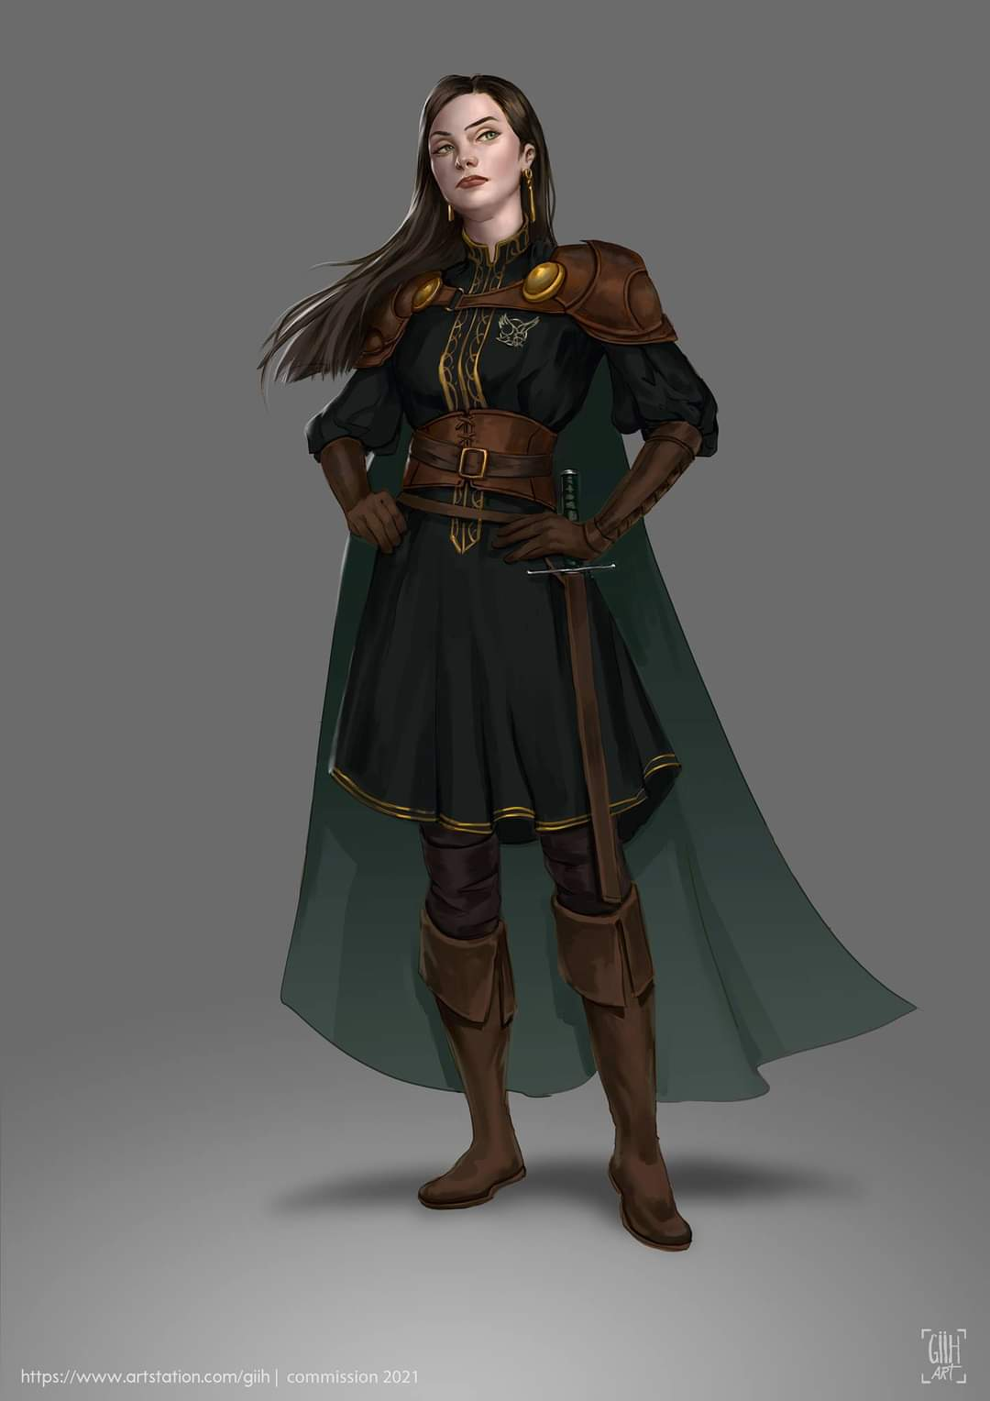

Two armed women—one a human and the other a half-elf—apprehended the ruffian rogue by his arms, nodding to Kassuq that he might loosen his grip.

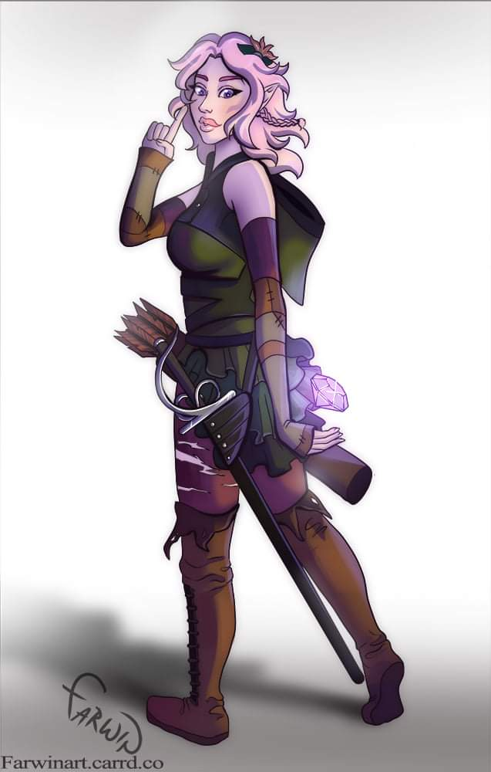

Once he did, the two surprisingly strong women took him away despite his initial struggle.

A few sighs and phews ensued as Kondratieff turned to the four strangers and shook his head. “I don’t know whether to start with gratitude or apologies.”

Nihm turned to Kondratieff, “No need to apologize; he’s responsible for his own behavior.”

“Besides,” Lee added as he walked up, “nobody got hurt, or at least not badly.” He gave Baldoor a sideways glance.

Baldoor grumbled something under his breath about not pulling punches next time as Kassuq walked over to join the group. The young archon shooting a last glance over his shoulder at the woman taking Juneau to the cage to cool off, though the archon did wonder if that would actually help.

“So, where are you headed, or are you preparing for a show?” Nihm inquired, not sure what had been going on when they first walked up.

“We *were* headed for Candlekeep along with the longer caravan that left ‘round lunchtime,” he sighed, then confirmed, “but with the warnings about kobolds going around town, we’re better off staying here until the roads are safe. I’m waiting on a report on this so we can better chart our trip. Eventually, it’s off to Athkatla for us. And you?”

Nihm and Lee both nodded. Lee spoke up, “Right now we have no destination, but we are looking for work. We are willing scouts, guides and guards, and we are willing to negotiate our fees.” Lee gave Kondratieff a friendly smile, adding, “So if you are in need of escorts when you head to Athkatla, then keep us in mind.”

As the rust monster was brought over, Baldoor took a few steps back. Kassuq handed Baldoor his longsword before stepping over to the monster and petting it gently.

Nihm and Lee watched the archon as they waited for Kondratieff to reply.

Kondratieff then invited the heroes for a bit of seasick cake, which—like spotted dick—was nothing like what it sounded. He pointed to one of the larger wagons along an alley the heroes hadn’t passed through yet, and asked the youngsters in his employ to bring the now calmed rust monster over for a looksie.

“Now then, Mugsie, let’s take a look at you,” said the tonic peddler turned animal handler. “Bring that vat,” he pointed to a bucket full of old nails that they’d just purchased from the local junkyard lady and looked at one of his right-hand assistants. “We’re going to give this girl a treat.”

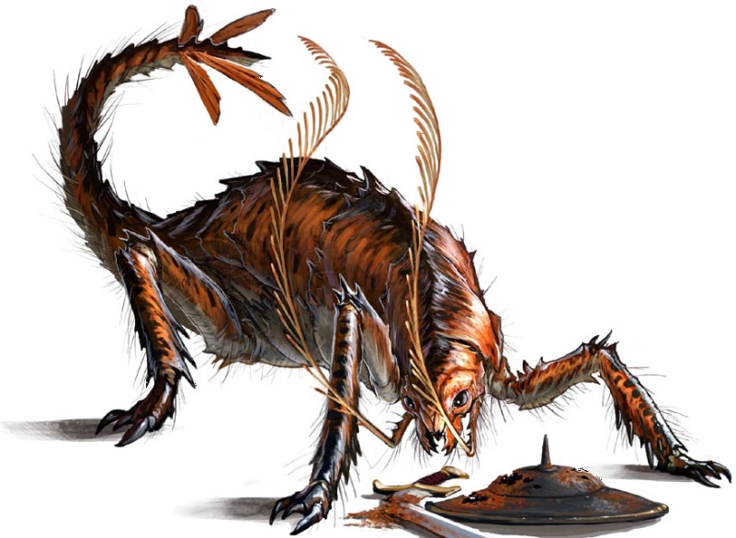

And with this, the younger human gently poured a panorama of nails, screws, tacks, clamps, nuts, bolts, and wires, onto the ground before Mugsie, and Kondratieff patted her on her lower back, causing her tail to rattle with glee as the keeper released the clamp and gently murmured, “Now if you’ll just take to your training, we don’t have to put this nasty clamp back on. Get back, heroes.”

They took a few steps back, coming around the side of a counter that would protect their weapons and armor from the corrosive spray of the monster should it get spooked, and watched with amusement as the rust monster emitted its juices onto the junk and wooden floor beneath it, instantly oxidizing the metal while leaving a coating of rusty moisture on the wood, which could be easily cleaned up.

The magical beast sated itself, wrapping its crudely prehensile tail around Kondratieff’s leg as a moment of relative calm ensued.

Said moment was rudely brought to an abrupt transition when they heard the hurried footsteps of at least two people coming around the covered wagon. Turning, they beheld a well-dressed human bearing a vague similarity to Juneau. “What’s this about you assaulting my brother?” the stranger confirmed his identity by referring his question to Kondratieff as he ignored the others.

Rubbing the rust monster’s carapace with encouraging affection, the junior partner shook his head and said, “You know full well that his account rarely bears semblance to events. These good people interfered in what would otherwise have resulted in a lump on the head from this here club. We’ll need to discuss your brother’s involvement with the animals moving forward; the abuse he inflicted on Mugsie probably set us back two weeks!”

As the four heroes took note of the words spoken, and the human peculiarities and intonations with which they were pronounced, they could briefly hear Juneau’s belligerent yelling a few hundred feet away. “You hear that?” Kondratieff furthered his point. “The other day, Devnaur found him trying to sodomize the pseudodragon.”

“And who might you all be, other than four strangers who accosted my kin?” the senior partner then asked the group of armed adventurers.

Baldoor took the first step towards the new arrival, anger obvious on his expression. However, Lee and Kassuq each put a hand on Baldoor’s shoulders as they both gave angry looks at the human.

Nihm stepped forward, standing a couple of feet from Juneau’s brother. “Perhaps you should attempt to verify facts before you make accusations. Your brother was attacking the rust monster when we arrived. We asked him to stop. When Kondratieff sent him off and made a comment, Juneau came running back. All we did was break up the fight and restrain him. Now you have the truth so you can run back to sticking you head up your ass and your brother can shove his back into a barrel of ale.” She gave the man a smile somewhere between seductive and venomous.

|  |  |  |  |  |  |  |
| --- | --- | --- | --- | --- | --- | --- |
| **Skill** | **Rank** | **Ability & Mod.** | **Misc. Mods.** | **Total** | **Roll** | **Check** |
| **Nihm, Diplomacy** | 0 | **Cha (+1)** | 0 | 1 | **5ish** | ?? |

*See below.*

The human opted to see the more venomous message in her gaze, and thus, shook his head, turning back to his business associate. “We leave at dawn. Word has it that a kobold contingent has recently taken over the iron mines between here and Nashkel, and the ironmongers have all fled for their lives. The few that managed to hitch a ride here are now at the Penitent Pug telling the tale of the raid and of their escape.”

“And so it’s decided then?” Kondratieff seemed to be insinuating something that would later be discussed in discretion. “Do you mean to say that kobolds are headed this way from both the west and the southeast?” he referred to Candlekeep and Nashkel, respectively.

“Aye,” the senior zookeeper nodded, noting Baldoor’s symbol of Moradin displayed. “Over the last few weeks, they have been heading west from the Candlekeep area, but cunningly skirted Beregost last tenday when the first sightings were reported.” The senior partner then turned to Baldoor, who had politely stood and occasionally nodded to suggest a calm control over oneself, and said, << Moradin’s favors, >> in broken Dwarven, displaying an affinity for the stranger’s patron deity. He then switched back to Common, having studied the demeanor of the others by now, and said, “No doubt Kondratieff here has mentioned me.”

“Not by name,” the zookeeper seated inside the wagon said as he petted the rust monster that was now finishing its meal. “This is my partner: Yenshi the Indigestible.”

“Just Yenshi is fine,” chuckled the well-to-do entrepreneur whose love for coin outweighed his affection for animals. “I was once swallowed by a dunewinder queen, and—well—that monarch and her ilk are no more,” the cad bragged as some of his sycophants coalesced outside the wagon to see what was going on.

Juneau’s yelling came back, now louder, and it was evident that he was now out of the pseudodragon’s cage, and approaching. Yenshi peeked around the side of the wagon, making a gesture that expressed, “What are you doing?”

Kondratieff nonchalantly placed his hat over the muzzle clamp that would otherwise have gone into the rust monster’s mouth as he squinted in anticipation of a reprisal.

The next few seconds consisted of Juneau asking his brother if he’d fired Kondratieff yet, Yenshi trying to find the right words to explain to his feebleminded sibling that one could not fire their partner, and a few of the animal tamers and other facility hands holding Juneau back as he punched his way through.

Once again, the belligerent man did not achieve his intended outcome, and his brother—visibly embarrassed by the spectacle—had him put back in the same cage as before, wondering internally how best to handle this situation.

“Say…” Yenshi then stepped onto the wooden steps that led into the wagon, and nodded to his employees to resume their duties. He turned to Kondratieff, then to Baldoor, Kassuq, Lee, and Nihm, and proposed, “You all look like you’re either capable combatants, or you inherited the gear and mannerisms of such individuals. We can offer you room and board on our way to Candlekeep, plus 4 gold each for every full night of travel.” It was clear that Nihm’s presentation of self had left him nonplussed, but he was betraying a genuine interest in his proposal.

“As sellswords?” confirmed Baldoor, the most diplomatic among them.

Kondratieff nodded, “We’d discussed the same prospect, though I think 5 coin per night is a fairer wage. With any luck, your swords will never have to leave their scabbards.”

Lee asked, “And what of additional compensation for our wounds, should we sustain any?”

Yenshi—a shrewd but reasonable businessman—asked, “How many *cure* potions have we in stock?”

“One grade-3, a handful of grade-2, and I’m not sure how many grade-1 vials,” recalled Kondratieff off the top of his head.

“We can cover you insofar as we have the available potions on hand. I can look into getting a few more while we’re here tonight,” Yenshi hoped to seal the deal, “but I can’t commit more coin than this.”

Nihm looked past Yenshi and asked, “Have you considered gagging him and keep him in his own cage.” Shrugging her shoulders, she added, “Just a thought.”

Baldoor, Lee and Kassuq relaxed their stance. Baldoor nodded and allowed a slight smile at the greeting in his native tongue, it wasn’t perfect, but close enough. Baldoor bowed his head slightly and replied in Dwarven, <<Moradin’s favor to you as well.>>

Lee then asked, “So where it this Penitent Pub or was it Pug? Either way, we’d like to gather some intel about those kobolds.”

Kondratieff huffed a single giggle, “Yes, it’s a pub called the Pug. We stop in every time we pass through.”

The four all looked at each other and nodded. Baldoor spoke up, “That sounds reasonable. When do you leave again? We will need to collect the rest of our gear.”

“At morrow,” Yenshi meant shortly after dawn. “We pay at noon, daily. See that lad there? That’s Devnaur. I trust him with my nuts. He’ll be at the head of the caravan; report to him, and he’ll provide you with a tour of the caravans.”

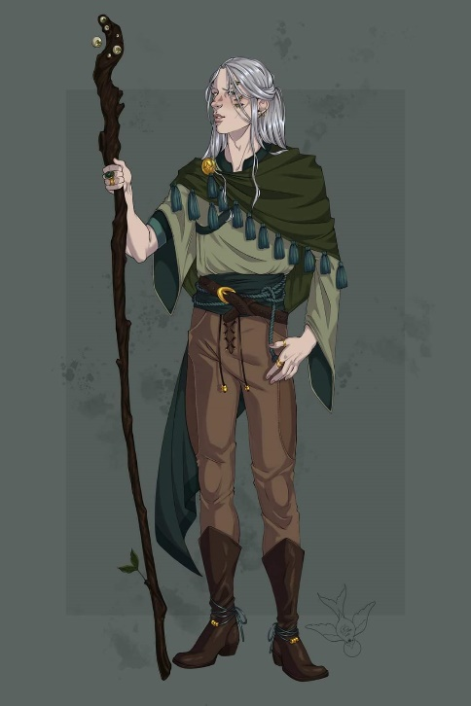

Nihm and Lee had taken the trust-with-nuts comment literally, and were trying to get past the visual, as Kassuq and Baldoor nodded to the half-elf introduced to them as Devnaur.

The staff-wielding male nodded back and added, “We’ll get a wagon ready for you. It’ll be tight sleeping for four, but we’ll have two shifts, so only two of you would be in there at a time.”

“It won’t be as tight as you think,” Kassuq said then changed into a small, arctic fox. He sat and looked up at the others, his tongue out as he was panting. Then he reverted to his humanoid form that was just over six feet tall.

Some of the animal lovers in their midst got cuted out, and wanted to hold Kassuq now.

“We’ll manage,” added Baldoor. “Also, if you have a horse or two to spare, the others,” the dwarf pointed to his three companions, “are capable of riding as well.”

Once they were done talking, the four went to the Penitent Pug and see what information they could get about the kobolds, realizing that some of it might be exaggerations.

After leaving the caravan, the group made their first stop at the Penitent Pug to see what information they could find. They spent several gold on food, drinks and bribes to get stories and information about what was going on outside of town, especially about the kobolds. They try to sort out the truth from the exaggerations.

After the pub, they split up for a little while. Baldoor and Nihm paid a visit to the Thunderhammer Smithy to see if he had any recent additions that might be suitable for the group as well as in their current price range. While there, they spoke to a couple of the shop keepers, and learned that Taerom Fuiruim was gone for the day. They learned that many of the weapons on display had already been paid for and were waiting for their owners to pick them up. With few items to purchase, Nihm and Baldoor spoke with the ship keepers to see what they had heard.

Meanwhile, Lee and Kassuq stopped at the Jovial Juggler to see if they could learn any information there. Lee spent time talking to the different performers and patrons while Kassuq entertained some of them with his different dog shapes and some tricks he learned.

After a few hours, they all met back at the Beheaded Beholder for dinner and to compare notes.

~*~

Scratch, scratch. Sweating and panting that grew as dissonance replaced harmony.

Lee awoke from a suddenly sour dream in the wee hours, reeling with the lingering image of a clawed appendage exploring his body against his will. The sensation of an itch having been scratched was still fresh in his memory, and as he looked out of the window of the room in the Beheaded Beholder, he made sure everything in the room was the way it should be, then rolled onto his right side and returned to sleep.

~*~

They reported at dawn, having had no trouble finding the lead wagon and Devnaur at the reins, performing a quality check. “Ah, security at last!” the half-elf seemed genuinely glad to see the well-armed adventurers. “I appreciate your timeliness, brethren. We’re still on schedule, and will have time for a snack before setting off. This is Montparnasse; he’ll guide you to your wagon, and brief you on the protocols for each section of the convoy.”

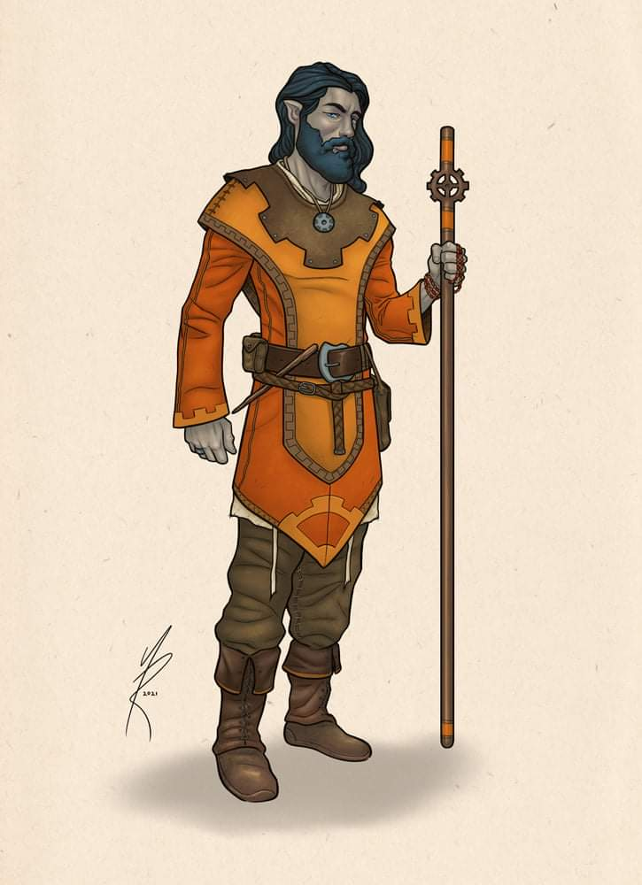

The half-drow approached with the air of a goatherder, followed by a kid goat that would soon sprout horns. “Friendly morning,” he greeted the four strangers and invited them for a tour of the convoy.

“Good morning,” Nihm replied as the others all nodded their greetings.

“We’ve prepared two horses for you; one is a heavy riding horse, and the other is a light warhorse,” the half-drow announced.

“Very good,” Lee said, “lead the way.”

Reaching the horses roped to the wagon that would constitute their lodging and storage space for the next few days, Nihm and Lee decided on being the default horseback riders. They’d discussed it earlier, but now that they were looking at the steeds and deciding who would ride which, it seemed an even better idea than before.

Kassuq resolved to be in the wagon with Baldoor when not trotting along in wolf form. He kept a distance from the horses, his scent having spooked one of them just now.

“Do they have names?” asked Nihm.

“Perhaps, but we just acquired them, so they’ll need new ones,” answered Montparnasse. If you’d like to stow anything valuable inside, there are two built-in chest compartments. Locks and keys should be there.”

As Lee and Nihm approached their mounts and studied them, Nihm gently rubbed each of the horses’ foreheads, stroking them between their eyes. “This one,” she said as she walked along the side of the smaller horse, “I shall call,” she paused to confirm that the smaller horse was female and the larger a male. “This one Rose. She has beauty like the flower but is fierce and can bite the thorns of the rose as well.” The horse’s head bobbed as if it agreed with the name.

Then Lee patted the larger one and scratched its neck. “I think I will call you Brutus, because your big and strong, deserving of a strong name.” The horse scratched at the ground with its front hooves, and huffed, seeming to disagree with the name.

They then continued on the tour, seeing the menagerie of tetrapods and invertebrates that Yenshi and Kondratieff had amassed. The heroes realized that in addition to setting up their wagons for display along every stop, they also made a revenue from trading livestock, including mostly fowls. So in essence, they were guarding an itinerant hatchery and nursery that farmed animals from one region, trading them where they were otherwise unavailable or rare. It seemed a sound business model.

All in all, there were over thirty different species of animals and magical beasts, and some of the deadlier species—Montparnasse said—were intended for sale to researchers delving into homeopathy and other medical applications. There was an infant bronze dragon that would soon gain sentience and be trained as a guard for the traveling zoo, but it was evident that Yenshi and Kondratieff needed muscle to make their way across the nearly trackless trails that separated the humble settlements of this region. The collection of species also boasted a number of dire animals, including the dire hawk, whose plumage captivated Kassuq. The bulk of the creatures, however, were small enough to fit inside smaller exhibits, which were stacked by taxonomic order on two of the wagons. One such wagon consisted of arthropods, mollusks, and other invertebrates while the other one hosted small beasties with a dorsal spine, mostly reptiles.

“On to Candlekeep!” some impatient soul blared out in the distance, and others calmed her down as provisions continued to be loaded onto the storage wagons.

“We’ll have some fresh biscuits from the bakery you probably passed coming here. They take good care of us, and we leave them plenty of eggs,” Montparnasse added.

As they went past the wagons, and they were informed of the different animals, the four took care to listen to any instructions that they were given. They wanted to be able to help with any of the animals should the need arise. They also wanted to know where the more prized animals were in case someone attacked them with the intent to take one of those animals, and by noon or so, they likely would have gotten a fairly good understanding of that inventory.

Heading back towards the lead wagon where the majority of the staff was now coalescing, they also met some of the regular security guards, who were just wandering knaves the convoy had picked up along the road. Most of these regular employees remained at their posts to ensure that no townsfolk would vandalize the wagons or their contents, while the handlers, breeders, tamers, and other hired hands now formed a circle around Kondratieff and Yenshi.

After an initial roll call, the owners each divulged their respective protocols for a successful journey, giving the four newcomers a sense of who was who by name, face, and function. It would be a while before they would have a mental manifest of their colleagues, and they might not be around this band for very long anyway.

Everyone already sported either a badge or other insignia emblematic of their role in the organization, and the four newcomers were beginning to acquaint themselves with their colleagues.

Kassuq spent some time in wolf form running alongside and out in front of the lead wagon by a few yards until he started spooking the horses. He then assumed a smaller fox form, and kept a considerable distance from all of the horses, occasionally going inside their wagon with Baldoor, who simply took in the scenery from his seat in their wagon. Kassuq observed many of the members of the caravan, gleaning the surface of who got along with whom. He also kept a wary eye on Juneau.

Nihm indulged in talking with any of the animal handlers and the vet, while Lee spent his time talking to the others on horseback, getting a feel for their abilities, both as riders as well as fighters.

The first day’s trek had been rather uneventful, with only a pack of famished wolves accosting them, and being driven away by a few cantrips, some rock throwing, and a lot of shouting from the crew. They had taken the northwestward road that bent westward, and were now about a third of the way to Candlekeep.

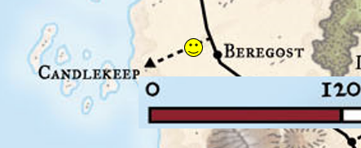

Having chosen a location to rest for the night, the convoy set itself up in a circular formation in a clearing they apparently knew well, and were fortunate to find unused. Sliver’s Crossing, they kept calling it, though no sign confirmed the name. The main road was around the corner of a slight hill, but out of sight and thus the security team was entrusted to scout out the perimeter, particularly the higher ground where a panoramic view was accessible.

When they set up camp, Kassuq joined Nihm and Lee as they checked the hill and the view it afforded. Kassuq did this in his wolf form and used his scent ability to see if he could pick up any odd, unusual or familiar odors.

Baldoor stayed back with the wagons and went over the security procedures with whomever was in charge. He wanted to make sure he understood the watch rotation, the duties expected of the guards, and what they used for an alarm in an emergency, plus any other procedures they had in place for the animals in the cages.

The watch rotation consisted of two six-hour stints: one during the day on horseback and another at night while the horses and most others slept. Fortunately, they had no animals that were dedicatedly nocturnal, so they wouldn’t be haunted by the growling of some nearby beast in a cage.

The guards’ duties were fairly lax, given the eclectic skillsets of each hired sword. There was a general understanding—a prevailing culture—that anyone contracted for their skills in combat was in effect a representative of their own sense of heroism, and while that would not have floated in a military regiment or monastery, it seemed to work well for a wandering band of zookeepers.

Their alarm system was inexistent, save for the expected screams or shouts that one might expect. They were told to be clear in their warnings. Learning codes had been found to be inefficient, and they had no diviners or telepaths among them; thus, a clear line of communication was considered ideal in dire situations. The civilian crew knew to hide inside the wagons and procure the few chests of ammunition and provisions that might aid the combatants in safeguarding the convoy.

The animals—per Yenshi’s decree—were to be protected from theft and harm, and the heroes could tell from the wording chosen by the handywoman who called herself Ratchet that more emphasis was placed on the lives of the man’s property than of the more easily replaceable crew. It also came out that Yenshi was quite the fencing champion, and could actually hold his own in a battle. He came from a family of swashbucklers, and though he lacked the perseverance and dedication to have followed in that tradition, he’d had enough lessons early on to eschew any kind of personal security guard.

Kondratieff had no affinity for the rapier, having been brought up in a working-class family. His gnarled club was a sign of a humble upbringing, likely from a place about as rural as this stretch of beaten path.

Their conversations with those closest to the owners provided insights convergent on the idea that although both men were shrewd merchants at the negotiating table, Kondratieff was the compassionate people person who might sacrifice a bit of short-term profit for the sake of goodwill among his team, while Yenshi did his best to avoid personal interactions with the crew, instead writing tenets that Devnaur and other senior staff would convey to the others. They’d been told the main ones, including one about evacuating at least 100’ from the convoy, and preferably after some of the animals had been allowed a stretch. Most seemed like common operating procedures for a business like this, but there was also a tinge of control issues stemming from a perhaps warranted paranoia.