Chapter 10: The Sea of Swords

They had boarded the ship a while back, and were ready for duty, armored and armed as usual for the moment, wondering if they would need to be suited up the entire time. Sails were unfurling above them, and though they had not been assigned any duties involving seamanship, the four heroes observed in case they had to make do at some point.

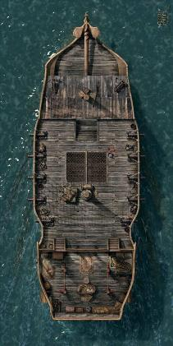

The captain came out from her quarters, which emanated a waft of incense from the lower deck via a hatch with no doors. “Captain on deck!” Azmul called out.

The crew stopped their work—those that could immediately—and faced the hatch, and the woman that emerged and took a measure of those present, best of all the four new strangers who had only hours ago tested their mettle against some of the best among her security force. “I am Captain Providence,” she proclaimed with a stern gaze, communicating that her trust would have to be earned.

“You were promised passage aboard the Swarm for your services, should they be required; that’s 170 coin for each of you, waived. I will also compensate you for any ammunition, spell components, and the like, that you spend in the defense of my ship and her crew, once we reach Lewellyn,” she pledged before everyone. “Have they been assigned quarters yet?”

“The spare quarter is being cleaned now,” Azmul reported, then turned to the heroes. “There are two bunks, so you’ll have to take turns on shifts.”

“We do this quite regularly,” Nihm assured him.

As the Captain spoke, the four all listened closely. Baldoor spoke up after Nihm, “Than ye, Captain. I kin promise you that we will do our best. We plan ta earn our passage.”

Kassuq nodded his agreement as he looked around at the crew while Haal found himself a little surprised by the Captain’s beauty and her aura of confidence. When Baldoor spoke, Haal pulled himself from his momentary trance and smiled, also nodding his agreement.

Nihm caught Haal’s reaction from the corner of her eye and smiled, finding his innocence a bit charming.

~*~

The night shift among our protagonists was handpicked by the Captain: Haal and Kassuq. Meanwhile, Baldoor and Nihm, by proxy chosen as the day shift, got what rest they could as the hull crashed against some moderate waves on its west-southwestward way across the Sea of Swords. The Locust Swarm averaged 6 knots when the winds were fair, which would have gotten them at least 140 nautical miles of distance traveled per day, but on occasion, the winds were fastidious, or insignificant, and the active crew on deck took smoke and lunch breaks.

Night passed rather uneventfully, other than the winds picking up vigorously and making up for lost time earlier. They were surprised to see the sails holding up against some of the gusts that hurled them across the choppy waters.

While they were on watch, Haal tried out his new, Everburning Torch and again thanked Kassuq for casting the spell for him. “Without the ability to see in the dark,” Haal said, “this will be very helpful for me, thanks again.”

Kassuq bowed his head slightly, “It was no big deal, I was glad to help. However,” the archon added with a wink, “should you decide to sell those things, then I would like a cut of the profits.”

Haal gave a smile and small laugh, adding, “Deal.”

The two spent the night between watching the crew and taking notes—Kassuq mentally and Haal mentally and on his parchments—looking at the stars and trying to identify any creatures that they saw in the sky or the sea.

~*~

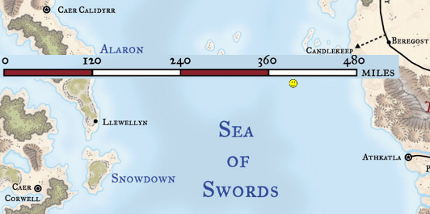

The next day, the sun rose over the eastern waters as the Swarm continued along an invisible, somewhat straight path across the surface of this great ocean. As Baldoor and Nihm rose and came out of their cabins, the Captain’s first mate—Azmul—was outside discussing with Kassuq and Haal a tear along the main sail that needed patching. They noted the dwarf and elf coming out, and nodded a greeting to both. The sunlight was welcome in the midst of the cool ocean breeze, and the dwarf’s senses were aroused when he smelled the smoke of ganja emanating from three sailors’ spliffs as they stood at the aft of the vessel after their evening shifts.

“Do any of you have the skills to mend this, or the magic?” asked Azmul.

Haal looked at the sail then at Azmul, “Since I have not rested yet, I cannot mend this. However, I can pray for the spell to do that and make sure I have a few extras as well. Then, when I awake in a few hours, then I should be able to help.” He looked at the sail again then Azmul, “Will that suffice?”

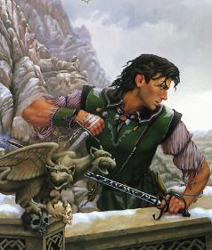

Azmul looked at Davos, whose knowledge of seamanship excelled above that of most.

The sailor’s son, nephew, *and* grandson—this being Davos—had heard Haal’s question, and replied, “For now, we can patch it, but if a gust hits it, it will get worse. We’d certainly appreciate an eventual *mending*.”

Haal nodded, “Very well, then that is what I shall do.”

As Nihm made her way up to the higher vantage point, Kassuq kept himself busy helping out on the main deck. He helped furl and unfurl the sails. He watched and learned different knots and ways to use rope to tie off items above deck.

Meanwhile, below deck, Baldoor and Haal both took a few moments to pray to their respective deities before climbing into the hammocks/bunks. Baldoor made only a slight change to his spells while Haal made a larger adjustment to his spells for the remainder of the day. The two then drifted off to the gentle rocking of the ocean waves.

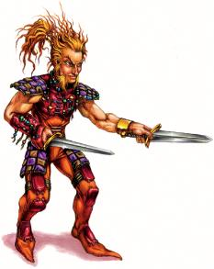

They’d already met a wiry-looking halfling named Joneas, who dressed in fire-tones and gemstones, some of which were just obsidian and quartz. He joked way too much about “jabbin’ a dickhead if he stepped up,” but was otherwise harmless, and knew more about Llewellyn than Azmul and the Captain, it seemed.

“Smoke?” he offered Nihm, eyeing the elf from head to toe with no shame about his rugged masculinity. His garnet-red eyes were nothing innately evil, though it was suggested that he might have had some distant—and now vestigial—red draconic heritage.

Smiling, Nihm replied, “No thank you.” She then looked up stating, “I think I will take a shift in the crow’s nest,” she looked back at Joneas adding, “alone.” Kassuq smiled and looked at Joneas but did not say anything. The Archon knew how close Lee and Nihm had been, and was happy to have avenged his friend’s death. He also knew that Nihm was still mourning Lee’s loss in her own, internal way.

~*~

Most of the shift passed without much incident.

Then, as the sun approached its zenith over the summer sky that warmed this hemisphere, something struck the Locust Swarm.

Everyone awake felt it, and within second, calls to man posts were heard throughout. Reserves on their sleeping shifts awakened one by one, and came to realize that they were in a dire situation.

Moments seemed like hours as everyone got their bearings and grabbed harpoons and other weapons.

Then a single female voice—the Captain’s—identified the culprit beneath the waves. “Ramfish!” she said, wearing a rose-tinted pair of eyeglasses that allowed her to see much better underwater. And as some saw over the starboard railing, the body of the massive monster was evident.

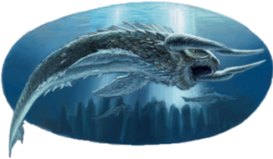

There were a dozen or so men and women already on deck shuffling to and fro, positioning themselves tactically based on the monster’s anticipated next attack on the 85’ hull.

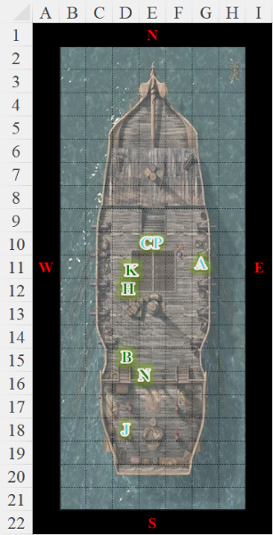

Round 1

Baldoor moved to the east side of the boat and cast *spiritual weapon [expired on Round 6]*, directing the magical hammer towards the ramfish.

The spiritual hammer manifested above the ramfish, and plummeted down to pummel it.

|  |  |  |  |  |  |  |  |  |  |
| --- | --- | --- | --- | --- | --- | --- | --- | --- | --- |
| **Melee Weapon** | **Dmg.** | **D+** | **TH+** | **Critical** | **Type** | **Wt.** | **Atk** | **Roll** | **Check** |
| Spiritual Hammer | 1d8 | 1 | 0 | x3 | Bludgeon | - | +5 | 5 | 10 |

*Miss.*

Haal tried to recall anything about the ramfish that he might have read.

|  |  |  |  |  |  |  |
| --- | --- | --- | --- | --- | --- | --- |
| **Haal, Skill** | **Rank** | **Ability & Mod.** | **Misc. Mods.** | **Total** | **Roll** | **Check** |
| **Knowledge: Arcana** | 3 | **Int (+2)** | 2 | 7 | 9 | 16 |

*Haal gained +2 bonus to attack and damage vs. ramfish.*

He then cast *summon monster II [expired on Round 6]* and called forth 3 Celestial porpoises to attack the ramfish.

Kassuq looked around for something to throw, a spear, harpoon, anything. If he finds one, he will move do the railing and throw it when the creature gets within 30 feet of the ship.

|  |  |  |  |  |  |  |  |  |  |
| --- | --- | --- | --- | --- | --- | --- | --- | --- | --- |
| **Ranged Weapon** | **Dmg** | **D+** | **TH+** | **Critical** | **Rng.** | **Wt.** | **Atk** | **Roll** | **Check** |
| MW Harpoon | 1d10 | 2 | 1 | x2 | 30’ | 10.0 | +7 | 4 | 11 |

*Miss.*

Nihm looked down and watched as the fish approached, her longbow ready. She then fired off as many arrows as she could.

|  |  |  |  |  |  |  |  |  |  |  |
| --- | --- | --- | --- | --- | --- | --- | --- | --- | --- | --- |
| **Ranged Weapon** | **Dmg.** | **D+** | **TH+** | **Critical** | **Rng.** | **Wt.** | **Atk** | **Roll** | **Check** | **Notes** |
| Longbow +1 | 1d8 | 1 | 1 | x3 | 100’ | 3.0 | +8 | 16 | 24 | +1 within 30’ |
| Longbow, Rapid Shot | 1d8 | 1 | 1 | x3 | 100’ | - | +8 | 5 | 13 | +1 within 30’ |
| Longbow, *haste* | 1d8 | 1 | 1 | x3 | 100’ | - | +8 | 3 | 11 | +1 within 30’ |

*Full Round Action + Rapid Shot*

The ramfish rammed the ship with a Powerful Charge.

|  |  |  |  |  |  |  |  |
| --- | --- | --- | --- | --- | --- | --- | --- |
| **Character** | **Attack Type** | **Damage** | **BAB** | **Str Mod+** | **Total Score** | **Roll** | **Total** |
| Ramfish | Gore | 2d6+5+2d6 P. Charge | 10 | 4 | 14 | 1 | 15 |

*Miss.*

The Captain had already readied her hand crossbow, and Haal noted the magic charge coating the loaded bolt. She waited for the wobble of the water displaced by the fish to rock the boat, then fired upon the animal as the keel steadied the hull.

|  |  |  |  |  |  |  |  |  |  |
| --- | --- | --- | --- | --- | --- | --- | --- | --- | --- |
| **Character** | **Attack Type** | **Damage** | **BAB** | **Dex Mod+** | **W+** | **Total Score** | **Roll** | **Total** | **Notes** |
| Captain P | Light Crossbow +1 | 1d8+1+1d6 fire | 6 | 2 | 1 | 9 | 17 | 26 | Fire Bolt |

*Hit. Dmg: 4 + 1 + 4 fire = 9.*

The crew took the opportunity to follow their leader, attacking with standard-issue harpoons like the one Kassuq had been handed.

|  |  |  |  |  |  |  |  |  |  |
| --- | --- | --- | --- | --- | --- | --- | --- | --- | --- |
| **Character** | **Attack Type** | **Damage** | **BAB** | **Str Mod+** | **Dex Mod+** | **W+** | **Total Score** | **Roll** | **Total** |
| Darfur | MW Harpoon | 1d10+2 | 4 | 2 | 0 | 1 | 7 | 12 | 19 |
| Durban | MW Harpoon | 1d10+1 | 4 | 1 | 2 | 1 | 6 | 9 | 15 |
| Davos | MW Harpoon | 1d10 | 4 | 0 | 2 | 1 | 7 | 5 | 12 |
| Dogeater | MW Harpoon | 1d10+3 | 4 | 3 | -1 | 1 | 8 | 7 | 15 |
| Azmul | MW Harpoon | 1d10+1 | 6 | 1 | 1 | 1 | 8 | 5 | 13 |
| Joneas | MW Harpoon | 1d8+1 | 4 | 1 | 3 | 1 | 6 | 19 | **25** |
| Sailor | MW Harpoon | 1d10+2 | 3 | 2 | 1 | 1 | 6 | 8 | 14 |
| Sailor | MW Harpoon | 1d10+2 | 3 | 2 | 1 | 1 | 6 | 7 | 13 |
| Sailor | MW Harpoon | 1d10+2 | 3 | 2 | 1 | 1 | 6 | 2 | 8 |
| Sailor | MW Harpoon | 1d10+2 | 3 | 2 | 1 | 1 | 6 | 18 | **24** |
| Sailor | MW Harpoon | 1d10+2 | 3 | 2 | 1 | 1 | 6 | 18 | **24** |
| Sailor | MW Harpoon | 1d10+2 | 3 | 2 | 1 | 1 | 6 | 13 | 19 |

*3 hits. Dmg: (8 + 1) + (10 + 2) + (3 + 2) = 9 + 12 + 5 = 26.*

|  |  |  |  |  |
| --- | --- | --- | --- | --- |
| **Character** | **Save vs.**  *Harpoon lodging* | **Ranks** | **Roll** | **Check** |
| Ramfish | Reflex | 8 | 16 | 24 |
| Ramfish | Reflex | 8 | 17 | 25 |

*Success, success. Ramfish not harpooned.*

The harpoons were a good call, but the fish remained free as the sailors retracted their harpoons via the ropes tethered to them.

Round 2

The Captain reloaded her light crossbow, and shot again.

|  |  |  |  |  |  |  |  |  |  |  |
| --- | --- | --- | --- | --- | --- | --- | --- | --- | --- | --- |
| **Character** | **Attack Type** | **Damage** | **BAB** | **Dex Mod+** | **W+** | **Other+** | **Total Score** | **Roll** | **Total** | **Notes** |
| Captain P | Light Crossbow +1 | 1d8+1+1d6 fire | 6 | 2 | 1 | -2 water | 7 | 17 | 28 | Fire Bolt |

*Hit. Dmg: 8 + 1 + 1 fire = 10.*

Baldoor directed the *spiritual hammer* to continue attacking the ramfish as he grabbed a harpoon and threw it at the fish, holding the tether like the rest of the crew was doing..

|  |  |  |  |  |  |  |  |  |  |
| --- | --- | --- | --- | --- | --- | --- | --- | --- | --- |
| **Melee Weapon** | **Dmg.** | **D+** | **TH+** | **Critical** | **Type** | **Wt.** | **Atk** | **Roll** | **Check** |
| Spiritual Hammer | 1d8 | 1 | 0 | x3 | Bludgeon | - | +5 | 10 | 15 |

*Miss.*

Haal directed the Celestial porpoises to keep attacking the ramfish as he moved to the edge and reluctantly grabbed a harpoon.

|  |  |  |  |  |  |  |  |  |  |
| --- | --- | --- | --- | --- | --- | --- | --- | --- | --- |
| **Character** | **Attack Type** | **Damage** | **BAB** | **Str Mod+** | **Dex Mod+** | **W+** | **Total Score** | **Roll** | **Total** |
| C. porpoise | Slam | 2d4 | 1 | 0 | 0 | 1 | 2 | 4 | 6 |
| C. porpoise | Slam | 2d4 | 1 | 0 | 0 | 1 | 2 | 11 | 13 |
| C. porpoise | Slam | 2d4 | 1 | 0 | 0 | 1 | 2 | 18 | 20 |

*Miss, miss, hit. Dmg: 7.*

Haal had never been good at any kind of ranged attacks or games involving throwing, but he figured what the heck, and hurled the seaman’s javelin towards the fish’s dorsal area.

|  |  |  |  |  |  |  |  |  |  |  |
| --- | --- | --- | --- | --- | --- | --- | --- | --- | --- | --- |
| **Ranged Weapon** | **Dmg.** | **D+** | **TH+** | **Critical** | **Rng.** | **Wt.** | **Atk** | **Roll** | **Check** | **Notes** |
| MW Harpoon | 1d10 | -2 water | 1 | x2 | 30’ | 10.0 | +2 | 7 | 9 | Lodge DC 10+dmg |

*Miss.*

Kassuq quickly reeled in his harpoon and threw it at the fish once again.

|  |  |  |  |  |  |  |  |  |  |  |
| --- | --- | --- | --- | --- | --- | --- | --- | --- | --- | --- |
| **Ranged Weapon** | **Dmg** | **D+** | **TH+** | **Critical** | **Rng.** | **Wt.** | **Atk** | **Roll** | **Check** | **Properties** |
| MW Harpoon | 1d10 | 2 | 1 – 2 water | x2 | 30’ | 10.0 | +5 | 16 | 21 | Lodge DC 10+dmg |

*Hit. Dmg: 8 + 2 = 10. Lodge DC 20; see below.*

Nihm remained up in the crow’s nest and fired off another round of arrows at the fish.

|  |  |  |  |  |  |  |  |  |  |  |
| --- | --- | --- | --- | --- | --- | --- | --- | --- | --- | --- |
| **Ranged Weapon** | **Dmg.** | **D+** | **TH+** | **Critical** | **Rng.** | **Wt.** | **Atk** | **Roll** | **Check** | **Notes** |
| Longbow +1 | 1d8 | 1 | 1 – 2  water | x3 | 100’ | 3.0 | +6 | 6 | 12 | +1 within 30’ |
| Longbow, Rapid Shot | 1d8 | 1 | 1 – 2  water | x3 | 100’ | - | +6 | 17 | 23 | +1 within 30’ |

*Miss, hit. Dmg: 4 + 1 + 1 = 6.*

Azmul harpooned the fish once again.

|  |  |  |  |  |  |  |  |  |  |  |
| --- | --- | --- | --- | --- | --- | --- | --- | --- | --- | --- |
| **Character** | **Attack Type** | **Damage** | **BAB** | **Str Mod+** | **Dex Mod+** | **W+** | **Total Score** | **Roll** | **Total** | **Notes** |
| Azmul | MW Harpoon | 1d10+1 | 5 | 1 | 1 | 1 – 2 water | 5 | 17 | 22 | Lodge DC 10+dmg |

*Hit. Dmg: 2 + 1 = 3. Lodge DC 13; see below.*

The crew repeated their harpooning attempts.

|  |  |  |  |  |  |  |  |  |  |  |
| --- | --- | --- | --- | --- | --- | --- | --- | --- | --- | --- |
| **Character** | **Attack Type** | **Damage** | **BAB** | **Dex Mod+** | **W+** | **Other+** | **Total Score** | **Roll** | **Total** | **Notes** |
| Darfur | MW Harpoon | 1d10+2 | 4 | 0 | 1 | -2 water | 3 | 8 | 11 | Lodge DC 10+dmg |
| Durban | MW Harpoon | 1d10+1 | 4 | 2 | 1 | -2 water | 5 | 12 | 17 | Lodge DC 10+dmg |
| Davos | MW Harpoon | 1d10 | 4 | 2 | 1 | -2 water | 5 | 8 | 13 | Lodge DC 10+dmg |
| Dogeater | MW Harpoon | 1d10+3 | 4 | -1 | 1 | -2 water | 2 | 8 | 11 | Lodge DC 10+dmg |
| Joneas | MW Harpoon | 1d8+1 | 4 | 3 | 1 | -2 water | 6 | 13 | 19 | Lodge DC 10+dmg |
| Sailor | MW Harpoon | 1d10+2 | 3 | 1 | 1 | -2 water | 3 | 2 | 5 | Lodge DC 10+dmg |
| Sailor | MW Harpoon | **1d10+2** | 3 | 1 | 1 | -2 water | 3 | 20 | 23 | Lodge DC 10+dmg |
| Sailor | MW Harpoon | 1d10+2 | 3 | 1 | 1 | -2 water | 3 | 10 | 13 | Lodge DC 10+dmg |
| Sailor | MW Harpoon | **1d10+2** | 3 | 1 | 1 | -2 water | 3 | 19 | 22 | Lodge DC 10+dmg |
| Sailor | MW Harpoon | **1d10+2** | 3 | 1 | 1 | -2 water | 3 | 18 | 21 | Lodge DC 10+dmg |

*Miss, miss, miss, miss, miss, miss, hit, miss, hit, hit.*

*Dmg, hit 1: 3 + 2 = 5. Lodge DC 15; see below.*

*Dmg, hit 2: 6 + 2 = 8. Lodge DC 18; see below.*

*Dmg, hit 3: 5 + 2 = 7. Lodge DC 17; see below.*

The ramfish was visibly distressed, and tugged at the lodged harpoons along its dorsal spine.

|  |  |  |  |  |
| --- | --- | --- | --- | --- |
| **Character** | **Save vs.**  *Lodged harpoons* | **Ranks** | **Roll** | **Check** |
| Ramfish | Reflex [20] | 8 | 11 | 19 |
| Ramfish | Reflex [13] | 8 | 11 | 19 |
| Ramfish | Reflex [15] | 8 | 20 | 28 |
| Ramfish | Reflex [18] | 8 | 2 | 10 |
| Ramfish | Reflex [17] | 8 | 17 | 25 |

*Fail, success, success, fail, success.*

With Kassuq’s harpoon now lodged about a quarter of the way from the head to the tail of the horned behemoth, as well as the harpoons of one of the crewmen whose name now escaped the archon, the fish turned tail and jerked away.

The crewman cried out, “Awww! She’s giving up.” And with this, he let go of the harpoon, also heeding Kassuq to, “Let’er go, lad!”

|  |  |  |  |  |  |  |
| --- | --- | --- | --- | --- | --- | --- |
| **Save + Skill**  to react | **Rank** | **Ability & Mod.** | **Misc. Mods.** | **Total** | **Roll** | **Check** |
| **Kassuq, Reflex** | 4 | **Dex (+2)** | 1 | 7 | **15** | 22 |
| **Kassuq, Sense Motive** | 4 | Wis (+2) | 0 | 6 | **10** | 16 |

*See below.*

The archon had the quick sense to follow the example of the other man, and let go of the tether that would have otherwise gotten him into a waterski event.

“Woohoo!” emoted a few others before the Captain parted her lips and the booya died down.

“She may be back,” stated the seawoman. “She was thin, and is likely wagering her odds against her hunger.”

Round 3

The fish emerged partly from the choppy waters, attempting to shake herself free of the barbed augers.

“Pussy!” Joneas called out as the mood quickly grew jovial again.

Azmul and the Captain looked at one another as if communicating contingencies triggered by another attempt at the hull. They then took a look at the side that had been struck. “We’ll definitely appreciate you preparing at least one *make whole* spell,” she conveyed again the preemptive gratitude.

“Is it bad?” asked Darfur.

“Not so bad that she’ll sink,” Azmul gauged. “But we’ll have to have a constant bilge rotation until she’s patched.”

Baldoor grumbled as his harpoon missed, “Blasted fish, hold still.”

Kassuq howled as they cheered. Though, he had to admit he was happy when the fish gave up the fight and turned away.

Nihm watched from above as the fish finally swam off, giving up the attacks on the ship.

Haal followed the captain and Azmul as they went below deck to inspect the damage. When the Captain thanked him for the spell, Haal smiled, a little embarrassed. “It’s the least I can do Captain.” He then went about casting ‘Make Hole’ in the area where the damage had occurred, hoping to minimizing any additional flooding.

When the situation seemed to have returned to normal, Nihm climbed down from her vantage point in the crow’s nest. She patted Kassuq on the back, “That was a nice throw,” she added as she turned towards Baldoor.

Before she could say anything, Baldoor spoke up. “Not a word, lass,” he stated, “I’m not designed fir fightin’ at sea. Let me take on sum beast that size on land en see how it ends.” Baldoor then walked off to the bow of the ship, leaving Kassuq and Nihm fighting back laughs as smiles cracked their faces.

Davos and others on deck laughed heartily, having seen the dwarf’s blunders.

Captain Providence patted Baldoor on the back, comforting him. “Pay no attention to these hazing ragamuffins!”

The crew laughed even more as the fish’s horns emerged at a distance of about 200’. It made no attempt to veer back towards the ship, and they did not spot it again.

~*~

Highsun, 14 Flamerule

Meanwhile, along the road from Grady to Llewellyn, there walked southward a tall, willowy, graceful, athletic figure whose ashen white hair was woven into dreadlocks adorned with beads and feathers. With blue eyes scanning the periphery to her sides, and permanent tribal-like markings tattooed on her face, the elven woman wore her resplendent chain shirt despite the weight and heat that it caused her on this Highsun in mid Flamerule.

The trees became more numerous as she meandered southward along the trail, walking with the wind, and it was then that she smelled the goblins who were behind an outcropping of rocks and now attacked Serasande. None of these knaves would have been a match for her—not even the leader, who was the first to emerge and command the others to action—but together, this dozen would present a challenge to the elf.

The first round of surprise allowed some of the goblins to take up positions atop the largest of the rocks, while others hurled javelins at her.

|  |  |  |  |  |  |  |  |
| --- | --- | --- | --- | --- | --- | --- | --- |
| **Character** | **Attack Type** | **Damage** | **BAB** | **Dex Mod+** | **Total Score** | **Roll** | **Total** |
| Goblin | Javelin | 1d4 | 1 | 2 | 3 | 10 | 13 |
| Goblin | Javelin | 1d4 | 1 | 2 | 3 | 8 | 11 |
| Goblin | Javelin | 1d4 | 1 | 2 | 3 | 15 | 18 |
| Goblin | Javelin | 1d4 | 1 | 2 | 3 | 13 | 16 |

*Miss, miss, hit, miss. Dmg: 3 [25/28].*

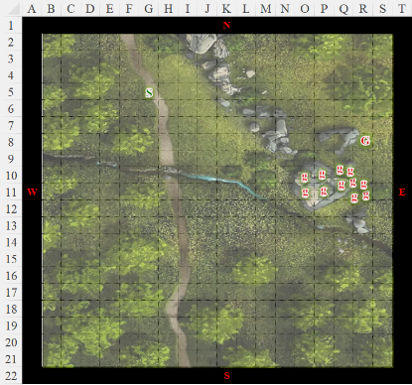

Deveraux walked northward, not far from a trail that smelled of boot soles and horseshoes, and heard a commotion up ahead. He took the woodsiest path towards the sound with cautionary creeping.

Round 1

|  |  |  |  |  |  |
| --- | --- | --- | --- | --- | --- |
| **Character** | **Group** | **Initiative** | **Roll** | **Modified Roll** | **Speed** |
| Seradande | 1 | 6 | 14 | 20 | 30’ |
| Goblins | 2 | 1 | 15 | 16 | 30’ |

Serasande had wanted to cast *mage armor [expired in 4 hours]* on herself and drew her swords. “Come and get it, if you feel like a lucky booger,” she taunted the goblins.

The goblins lunged another volley of javelins at the lone traveler.

|  |  |  |  |  |  |  |  |
| --- | --- | --- | --- | --- | --- | --- | --- |
| **Character** | **Attack Type** | **Damage** | **BAB** | **Dex Mod+** | **Total Score** | **Roll** | **Total** |
| Goblin Chief | Javelin | 1d4 | 1 | 2 | 3 – 2 range | 2 | 3 |
| Goblin | Javelin | 1d4 | 1 | 2 | 3 – 2 range | 2 | 3 |
| Goblin | Javelin | 1d4 | 1 | 2 | 3 – 2 range | 13 | 14 |
| Goblin | Javelin | 1d4 | 1 | 2 | 3 – 2 range | 19 | 20 |
| Goblin | Javelin | 1d4 | 1 | 2 | 3 – 2 range | 7 | 8 |
| Goblin | Javelin | 1d4 | 1 | 2 | 3 – 2 range | 3 | 4 |
| Goblin | Javelin | 1d4 | 1 | 2 | 3 – 2 range | 16 | 17 |
| Goblin | Javelin | 1d4 | 1 | 2 | 3 – 2 range | 4 | 5 |
| Goblin | Javelin | 1d4 | 1 | 2 | 3 – 2 range | 17 | 18 |
| Goblin | Javelin | 1d4 | 1 | 2 | 3 – 2 range | 10 | 11 |
| Goblin | Javelin | 1d4 | 1 | 2 | 3 – 2 range | 8 | 9 |

*Miss, miss, miss, hit, miss, miss, hit, miss, hit, miss, miss.*

*Dmg: 3 + 1 + 3 = 7 [18/28].*

As he approached, Deveraux heard more distinctly the sound of the Goblin tongue spoken by goblin tongues and throats, and though he could scarcely understand it, there was urgency in the tone.

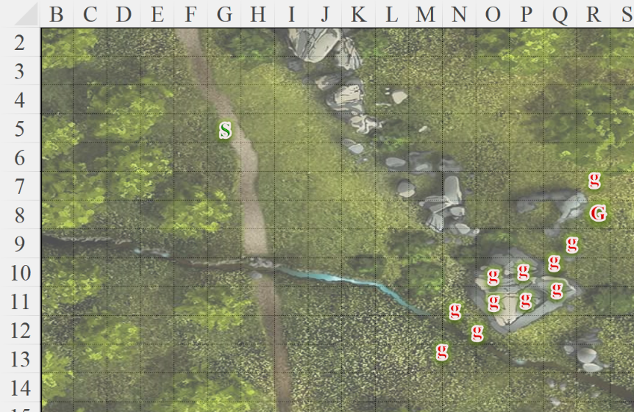

Round 2

With a low growl, Serasande cast *magic missile* at the group of goblins before moving to duck behind a tree for cover. Both missiles hit true to their marks, as expected, then fizzled out of existence as two goblins flinched with pain.

*Dmg: 3 + 1 = 4 magic.*

*Dmg: 1 + 1 = 2 magic.*

The goblins saw that one of their kin was nearly dead, and the other maimed, and turned to their chieftain or expeditionary leader or whatever. He commanded them to do their thing, and they did.

|  |  |  |  |  |  |  |  |  |
| --- | --- | --- | --- | --- | --- | --- | --- | --- |
| **Character** | **Attack Type** | **Damage** | **BAB** | **Dex Mod+** | **Other+** | **Total Score** | **Roll** | **Total** |
| Goblin Chief | Javelin | 1d4 | 1 | 2 | -2 range | 1 | 12 | 13 |
| Goblin | Javelin | 1d4 | 1 | 2 | -2 range | 1 | 15 | 16 |
| Goblin | Javelin | 1d4 | 1 | 2 | -2 range | 1 | 1 | 3 |
| Goblin | Javelin | 1d4 | 1 | 2 | -2 range | 1 | 8 | 10 |
| Goblin | Javelin | 1d4 | 1 | 2 | -2 range | 1 | 10 | 12 |
| Goblin | Javelin | 1d4 | 1 | 2 | -2 range | 1 | 11 | 13 |
| Goblin | Javelin | 1d4 | 1 | 2 | -2 range | 1 | **20** | 22 |
| Goblin | Javelin | 1d4 | 1 | 2 | -2 range | 1 | 2 | 4 |
| Goblin | Javelin | 1d4 | 1 | 2 | -2 range | 1 | 10 | 12 |
| Goblin | Javelin | 1d4 | 1 | 2 | -2 range | 1 | 17 | 19 |
| Goblin | Javelin | 1d4 | 1 | 2 | -2 range | 1 | 2 | 4 |
| Goblin | Javelin | 1d4 | 1 | 2 | -2 range | 1 | 7 | 9 |

*Miss, hit, miss, miss, miss, miss, threat, miss, miss, hit, miss, miss. 1d20 = 13 + 3 = 16, (barely) not a critical hit.*

*Dmg: 3 + 2 = 5 [13/28].*

Deveraux could now see the scuffle between a band of goblins and a lone elf, and studied the latter to get a sense of everyone’s motives.

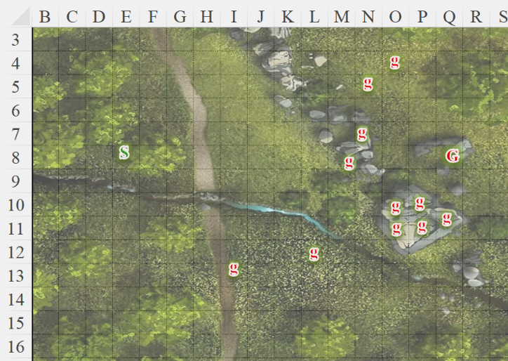

Round 3 *[reversing initiative]*

Acting on impulse, Deveraux planted himself firmly before emitting an inaudible frequency focused on the cluster of goblins atop the rock.

|  |  |  |  |  |
| --- | --- | --- | --- | --- |
| **Character** | **Save vs.**  *sleep* | **Ranks** | **Roll** | **Check** |
| Goblin | Will | -1 | 9 | 8 |
| Goblin | Will | -1 | 11 | 10 |
| Goblin | Will | -1 | 1 | 0 |
| Goblin | Will | -1 | 16 | 15 |

*Fail, fail, fail, success.*

Three of the goblins fell onto the rock, and rolled down to the ground.

The eight goblin grunts that remained standing looked at their leader, who was like, << Gabot, divhraughm! >>

Two of the cowardly goblins turned tail and ran eastwardly, defying the squadron leader’s orders, while the other six threw another volley of sharpened sticks at the elf, and the chief himself hurled a javelin at one of the deserters.

|  |  |  |  |  |  |  |  |  |  |
| --- | --- | --- | --- | --- | --- | --- | --- | --- | --- |
| **Character** | **Attack Type** | **Damage** | **BAB** | **Dex Mod+** | **Other+** | **Total Score** | **Roll** | **Total** | **Targeting** |
| Goblin Chief | Javelin | 1d4 | 1 | 2 | 0 | 3 | 12 | 15 | Goblin 9 |
| Goblin | Javelin | 1d4 | 1 | 2 | 0 | 3 | 8 | 11 | Serasande |
| Goblin | Javelin | 1d4 | 1 | 2 | 0 | 3 | 10 | 13 | Serasande |
| Goblin | Javelin | 1d4 | 1 | 2 | 0 | 3 | 11 | 14 | Serasande |
| Goblin | Javelin | 1d4 | 1 | 2 | 0 | 3 | 15 | 18 | Serasande |
| Goblin | Javelin | 1d4 | 1 | 2 | 0 | 3 | 8 | 11 | Serasande |
| Goblin | Javelin | 1d4 | 1 | 2 | 0 | 3 | 15 | 18 | Serasande |

*Hit (G9), miss, miss, miss, hit*, miss, hit*.*

*\* Concealment checks: 81, 85. Both hits bypass concealment.*

*Dmg: 4 + 3 = 7 [6/28].*

Standing behind the tree, remembering why she really hated goblins, Serasande knocked back one of her healing potions *[standard action]* before she stepped back out from behind the tree *[move action]*, ready to cast a *magic missile* at the goblin leader.

*Serasande gained 6 + 4 = 10 hps [16/28].*

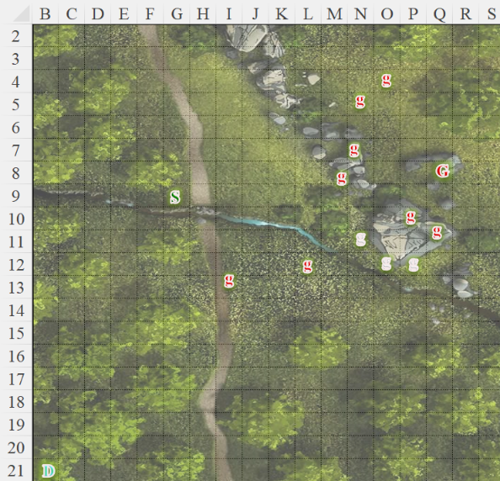

Round 4

Deveraux manifested his *sleep [expired on Round 44]* ability again.

*Sleep* vibes overtook the chief and two of the lesser goblins.

|  |  |  |  |  |
| --- | --- | --- | --- | --- |
| **Character** | **Save vs.**  *sleep* | **Ranks** | **Roll** | **Check** |
| Goblin Leader | Will | 0 | 20 | 20 |
| Goblin | Will | -1 | 3 | 2 |
| Goblin | Will | -1 | 9 | 8 |

*Success, fail, fail.*

Once again, Serasande saw a few more goblins fall. The leader, overwhelmed, also fled, causing the remainder of the goblins to also book it.

Serasande decided on whether or not to trigger that *magic missile* her fingers had half-wiggled into being.

As the remainder of the so-called warriors made way along any available path away from the duskblade.

Serasande spotted an anthropomorphic plant to her south, whose face regarded her with neither contempt nor fondness.

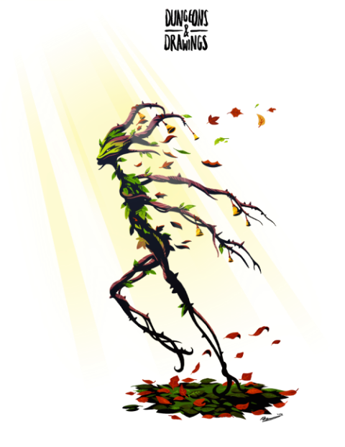

~*~

The rest of that day transpired in relative calm.

Nihm spent some time with the Captain and Azmul, asking questions about where they had been, which seemed to constitute the whole of the Moonshaes, and other gems of land interspersed throughout the Sea of Swords. Providence had made her way up the chain of command on another ship through bravery and wit, while Azmul had pursued material goals, and his understanding of commerce had gotten him his position in Providence’s hierarchy.

Kassuq, before going to bed, stopped in the galley to see about whipping up some stew or something for the crew. Having received a few offers, he was happy to spar with anyone or even do tricks in one of his canid forms to help pass the time.

Haal, after mending the damage from the ramfish, spent some time mending the sails as had been requested. He then spent time talking to the crew and learning as much about sailing as he can, as well as where they have travelled.

The crew had seen their fair share of fish, crustacean, and aberration in their day, but mostly spoke of betentacled mollusks and other monsters from the deep that haunted their souls.

“A kraken basically looks like a draft animal version of a mind flayer,” Joneas explained at one point. “And they smell uniquely horrible.”

Baldoor did what he could to help while on deck, learning the different jobs and tasks germane to a sailor’s day. He thought to try to improve the taste of the ale aboard the ship, and discussed religion and deities.

~*~

The next evening, the four heroes awoke from their sleep, ready for the night shift. Baldoor and Haal were in one quarter, and the other two in the adjacent room. The day before had taught them many things about the crew, the local maritime fauna, and the cultures of nearby settlements. Davos—for example—was descended of the lesser nobility of the House of Bergère, whose lands were repossessed by the High King Tristan Kendrick after his successful campaign to unify the two peoples of the Moonshaes. In previous years, the Northlanders and the Effolk had spent much of their time at each other’s throats, particularly because of the Northlanders’ penchant for bloody raiding, and Davos’ family had sided with the unfortunate side in that schism, forced by the late High King’s daughter, High Queen Alicia, who current held her kingdom together by instigating and managing small wars among petty lords. Compared to the nations of mainland Faerun, the Moonshaes had seen a relative calm for the last few decades, but words from more than one sailor painted a picture of a fragmenting, feudal hierarchy on the verge of transition.

The sailors were not particularly superstitious or religious people; beyond what would have been expected of a man or woman of their walk of life, they cared little for the gods of landlubbers, and relied—if at all—on Valkur’s blessings.

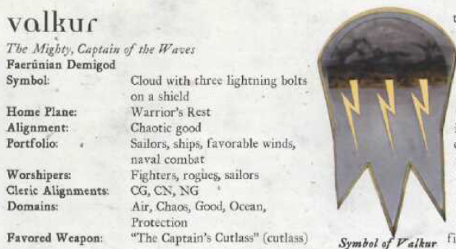

The sun had set recently, and they could now see its last light surrendering to the horizon. Azmul was also posted to night duty at the helm, and Darfur and Dogeater now greeted them as they ventured into the quarters that Haal and Baldoor had just vacated, ready for their downtime.

~*~

The four had all been on duty for a few hours. The moon was providing very little light through the overcast sky. Nihm had taken her position up in the crow’s nest once again. Haal was near the helm, talking about navigating with the helmsmen on duty. Kassuq and Baldoor were walking the deck, talking to the three sailors that were on duty on the nightshift.

It was close to midnight, while the seas were calm, when 10 kuo-toa came of the railings of the ship, five on each side. One of the crew yelled, “BOARDERS!” as the kuo-toa rushed the nearest crew member. Baldoor and Kassuq quickly turned around and drew their weapons. Nihm, aloft in her perch, quickly pulled her bow and nocked an arrow. Haal pulled out a scroll and began reading it. The kuo-toa began to spread out, two of them throwing spears at helm, one striking the helm itself and the other missing both Haal and the helmsman.

Nihm fired off a couple of arrows, striking and killing one of the kuo-toa while Kassuq and Baldoor rushed in, confronting three of the creatures. Sword and hammer flying as they engaged them, landing a couple of blows each. The other three crew members were facing off with four creatures as the ones that had thrown their spears were now rushing the helm.

Baldoor and Kassuq quickly dealt with the three they faced, wounding two badly, forcing them to leap off the ship, back into the water. Nihm helped the sailors by raining down a few more arrows from above. The kuo-toa climbing to the helm were met with three Celestial riding dogs as Haal finished reading the summoning spell from his scroll. Caught off guard, the kuo-toa climbed back down the stairs and called to the others. They all quickly ran off the ship, diving into the water. They had obviously expected a less prepared and defended ship out in the middle of the sea.

With the threat gone, the four made sure that the crew was alright and that nothing had been taken. As they did a quick inventory, they determined nothing of value was missing and they were all ok, except for a couple of minor scratches.

~*~

The crew of the Locust Swarm slept soundly with hours to go before their next shift began. In a day’s time, they should be arriving on the Llewellyn Coast, as the locals cheekily referred to their tiny stretch of portside boardwalks and beaches.

The last few days of their journey at sea were rather uneventful. The four had learned a good deal from the crew about seamanship and were serviceable crew members by the time the city of Llewellyn came into sight.

Baldoor had been spending some time discussing the virtues of Moradin and the other dwarven deities while he listened to the sailors tell him about Valkur and any other gods that they prayed to for good weather or fair seas.

Haal had tried to absorb whatever knowledge he could. Though not the strongest, he found ways to be useful on deck. Whether mending sails with his magic or learning how to steer the ship to use the winds best, it was an adventure he had truly come to enjoy.

Nihm had been a bit distant to many of the crew at first, but she became more friendly as they voyage went on. Part was because she did not want any attention while she was still mourning the loss of her companion of the last few years. She did enjoy taking to the Captain and Azmul as well as learning what she could of their destination. She, like Haal, were interested in the Moon Wells.

Kassuq took to sailing quickly and easily. The physical aspects of it were right up his alley. He also enjoyed the smells and the wind in his face. The experience was much different than his life with Baldoor, the dwarves and other hound archons back in Ten Towns.

As the voyage drew to a close, Joneas had become far more belligerent with Azmul, and later with the Captain, such that it became clear that his former worship of Umberlee was getting in the way of his morale, and at one point, the halfling curtsied and declared his resignation upon arrival to the port.

Things were quieter for the last few hours before sighting land.