Chapter 12: Grady to Pembroke

It was night now, and the owls’ hooting had now replaced the chirping of diurnal birds settling into their nightly torpor. The stars were out on this summer’s eve, and as Lucky licked Nihm’s hand as a sign of gratitude for the scraps he’d just eaten, she looked down and petted his soft, furry head.

They crossed the main promenade and stepped back into the Mahogany Manticore, were shown to their room—a quarter with four cots—and settled into their own nightly routines.

~*~

The next morning, they awakened with the sun’s rising, and heard the bustling of breakfast’s preparations downstairs as they began to prepare themselves for the day.

Once they were all dressed, the five headed down to have breakfast at the inn. As they ate, they looked over the map and the notes that Haal had taken and discussed where they should head to first. Once they were done with breakfast, Nihm asked the server, “Do you have any bones for my friend?” she indicated Lucky, “I will pay for them, of course.”

Lucky got to eat some more body parts before they meandered around the more populated streets in the town to get a better understanding of where they might head.

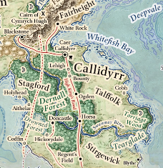

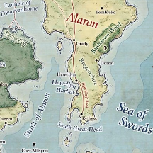

Haal and Baldoor—the more bookish of the quartet—had been researching in their journal—which was chock-full of seamen’s tales from when they were aboard the Locust—and saw that Pembroke was a settlement literally encircled by a quintet of Moonwells, each about 20 to 30 miles away.

With this in mind, they sought to ask around for any lore on Pembroke, and after a bit of mingling with the variety of humans that frequented the village center, they learned:

|  |  |  |  |  |  |  |
| --- | --- | --- | --- | --- | --- | --- |
| **Skill** | **Rank** | **Ability**  **& Mod.** | **Misc.**  **Mods.** | **Total** | **Roll** | **Check** |
| **Haal, Gather Information** | 0 | **Cha (+2)** | 0 | 2 | 16 – 20 | ?? |

* There was a schism in the Kingdom of Calidyrr, and the Dernall Forest was the epicenter of the divide between the southern county of Stirgewick, which remained loyal to King Cymrych II, and the factions of the Fairheight Range to the northeast, bordering so-called Empire of Alaron.
  + The woman leading the rebellion against Cymrych was named Syracuse, and was reputed to be a dragon shaman, a type of spirited warrior with which they were as of yet unfamiliar. She took the title of General, raising an army of barbarians and other woodsy types, and fortifying the Fairheight Foothills against reprisals from their former King.
  + Though questionable, one woman swore that there were sightings of Syracuse’s forces advancing southward, and it was now inadvisable to travel into the Dernall Forest, and even the lands just north of Pembroke, which was still firmly loyal to King Cymrych.
* Goblins were likely to be encountered while traveling along the road from Grady to Pembroke, and only slightly less likely to do so if they took any other northward course for the next day or two. No reliable information could be gleaned on goblins in areas beyond that reach.
  + As they had noticed, the goblins here were described as dwarfed variants of the mainland type, though not so much that they were a size category smaller.
  + Hobgoblins were likely to be among goblins, and these were dwarfed to the point of being comparable in height and build to mainland goblins, but they were as fierce as any hobgoblin.
* The Moonwells were a somewhat taboo topic for most locals, and travelers from afar had no idea of what the heroes were saying. Merchants from Pembroke and other nearby settlements were the most willing to impart information, which came mostly in the form of warnings, omens of great peril, and heeds to avoid these centers of misfortune.
  + Some kid added that going there turns humanoids into goblinoids, quoting his late father with pride.

As intriguing as the Darnall Forest sounded, the group decided to check out the Moonwells around Pembroke. Realizing it may be a little more dangerous, they made sure they were topped off on projectiles. They also made sure they had plenty of trail rations to go along with the bones for Lucky. Nihm carried the rations for now, these being enough to last the four humanoids for four days, the scraps of which would go to Lucky. At the rate that—for them—felt discounted, they only paid 6 gold for the whole lot.

|  |  |  |  |
| --- | --- | --- | --- |
| **Item** | **Qty.** | **Wt.** | **Value** |
| Trail Rations | 16 | 16.0 | 6.0 |

Seeing a three-wagon caravan setting up to head to Pembroke shortly before Highsun, Haal wangled them a spot on the rear wagon for 10 gold per person, plus 15 for the wolf. This was comparably steep, but then again, these folks weren’t exactly a passenger service; they were boxing up seafood and other goods for a quick overland transport to the inland outposts that lay between here and Pembroke, saving the bulk of what they were currently loading onto their wagons for the Pembroke market, where they would subsequently stock up on a wholly different variety of foodstuffs and commodities.

*[DM assumption]* The heroes went ahead and paid the fee, and hopped aboard the rear wagon.

The merchants were retired adventurers—this much was evident in their scars and even by how they were clad. They consisted of a pair of humans—brother and sister—as well as a silver dragonborn and a half orc, and though none of them were from the Moonshaes, they spoke like they knew this island quite well by now. The heroes’ offers to work as security for the merchants were eschewed politely, which further corroborated the narrative that these four were a formidable enough lot to not warrant any additional muscle on their trek through goblin-infested lands.

And so, they took in the sights of Grady growing smaller and more distant as the sea itself receded into the horizon, and was soon lost to the rolling hills that characterized this stretch of the trip.

~*~

They stopped in the mid Afternoon, when their shadows were twice as long as they were tall. Setting up a brief picnic, not quite a full camp, the merchants invited the heroes and their wolf over, and they all shared in a meal, each quartet trading parts of their rations for others without keeping too much track of who was getting more meat or cheese out of it. The merchants were fairly egalitarian in their interactions, and the spirit of reciprocity seemed to be more important than accounting for specific values. It eventually became evident that not all of the goods they were transporting were for sale, and as the human woman spoke, the heroes learned that there was a Joint Mission of Lathander and Shaundakul in Pembroke. In years past, it served as the hub of the island’s trade network, but as the Moonwells became desecrated by mysterious forces and monstrous humanoids began to proliferate and grow more corrupt, the merchant networks that comprised the local economy dwindled, and many locals fled to the mainland or other islands with more stable governments.

This breakdown of economic stability—allegedly—was the main cause of the rebellion against King Cymrych II’s rule in the north, which—according to Jadziya, the woman with the sickle—wasn’t limited to the Fairheight region. “The Dernall Forest, all the way south to Hickorydale, is now under the control of Syracuse,” Jadziya referenced the woman they’d heard of in town, though it was now clarified that Syracuse was not a dragon shaman, but rather a cleric of Red Knight, though her right-hand woman was a dragon shaman who allegedly came out of the wilderness, and was tamed by Syracuse.

Having heard this and a few other outlandish tales, the topic of gnolls came up, and the heroes realized they had a good one to tell the merchants.

“Ah,” said Haal when the mention of gnolls came up. “We had a slight run in with a small band of gnolls are our way to Grady.”

“Bah,” interrupted Baldoor, “it was just a band o’ incompetent oafs.” Kassuq smiled, knowing Baldoor never wanted to give any evil creatures any credit.

Nihm looked at Baldoor, then at Haal before looking at the other 4 adventures/merchants. “I believe the gnolls were surprised to find out that the wagon was well defended, quickly ruining their planned robbery.”

The breeze kicked up a bit as Haal nodded, “As Nihm said, they didn’t seem to be expecting us. As the wagon we were in came around a bend, the driver said, “We have trouble.” Haal looked at Baldoor, “Baldoor looked out and grunted, saying ‘gnolls, three of ‘em. Probably more in tha woods.” Haal then looked back at their hosts. “When the wagon came to a stop, we sprang into action. I cast my spiritual mace and attacked the middle gnoll on the roadway from behind, catching him totally off guard. As he was struck, my fury friends,” he indicated Kassuq, who smiled, and Lucky, who gave Haal an odd look, twisting his head as if wondering what the cleric was saying. “Launched themselves from the back of the wagon then charged the three gnolls on the road. This, as Baldoor expected, drew out the other two gnolls hiding in the woods. One on our left and one to the right. Their arrows missed the swift fury warriors and thudded into the wagon. Baldoor leapt from the wagon and charged the gnoll on the right, taking a grazing shot from an arrow to his shoulder and deflecting the other off his shield. Meanwhile,” he turned to Nihm, “Our fine archer engaged the gnoll on our left. Two swift and accurate shots had the gnoll turning and running fairly quickly. It didn’t take long for the other three to reach the remaining gnolls. Kassuq and Lucky made quick work of two of the gnolls in front of the wagon while Nihm and I combined her arrow and my spiritual mace to finish off the other. Baldoor reached his foe and quickly broke the gnolls bow with his head as the gnoll swung it down on him. This led to Baldoor hacking away and not leaving much of the gnoll behind.”

Haal got up and went to refill his mug with water, the crunching of leaves beneath his feet almost as loud as his voice. “In the end, one wounded gnoll got away, and 4 were left for the forest creatures to deal with.”

Cups were raised, and that victory was celebrated once again. “Grateful!” the merchants cheered, as was local custom to do when expressing thanks and congratulations. It was an islander synecdoche for “I am grateful to see you lived through hardship, and you should be grateful for such success.” As the cheers subsided, Kassuq thought he heard movement behind him, to the south. Turning, he saw nothing, and smelled nothing from the northeast, where the breeze was coming from.

The four raised their glasses and echoed the “Grateful” slogan. It was a quaint, little phrase with a broad meaning.

While the others continued to talk, Kassuq kept his senses sharp. He twisted his ears to try and pick up any more noises while he continued to look about, without drawing too much attention. He sniffed at the air as well, trying to pick up anything different in the wind. The archon’s Tongues ability extended to spoken languages, but Kassuq was also a perceptive fellow, and was developing a fundamental gesture protocol with the wolf as they continued to spend time together.

They drank a bit more, and the tale of the Eldreth Veluuthra was also told again, as it had the night before just south of Grady. At this tale, the merchants listened more somberly, for they, too—Jadziya imparted after their recounting was done—had faced a faction of those genocidal elves when on the mainland. “They are murderous to no end,” the half-orc—named Thrashmosh—shook his head as his eyes tried to unsee the horrors he’d witnessed them unleashing upon the innocent.

Nihm nodded, “They are a disgrace to true elven beliefs and passions.”

“I’ve never...” Thrashmosh corrected himself before testifying before his friends, “I’ve *seldom* seen humanoids that irredeemable.”

They looked at each other, and nodded as Jadziya, sighed, “We... uh... lost two comrades-in-arms a few years ago to a shoal of sahuagin.”

“It’s what brought us here... originally,” added Bríjido, Jadziya’s brother.

Bríjido’s sister nodded again, then shook her head as she accounted for how long they’d been here, “We stopped looking for the sahuagin a while ago. They’re long gone by now, and we’ve found peace and purpose in bringing some of these supplies to the Mission of Lathander and Shaundakul, plus there’s enough surplus for a profitable haul every time.”

Nihm again spoke up, “We share your grief as we lost a member of our band as well.” She raised her mug, “To those that we have lost in the fight against evil, may they rest in peace and glory.”

“Grateful!” they cheered again as birds chirped overhead.

Baldoor nodded, “We had a run-in with sum o’ those beasts too. We foiled their raid on our ship and sent ‘em all swimmin’ off, well, not all. A couple of ‘em were only good fir fish food.” Baldoor took a long drink from his mug. Though he’d enjoyed the trip over, he decided that drowning was likely the worst way to die. Give him a fire death from a dragon over downing any day.

The dragonborn man was the quiet one in the bunch, though he—too—warmed up to the passengers that they were mostly helping out. The sharing of the rations had been least advantageous to his lactose-intolerant diet, and he made do with the fruits and meats. His name was scarcely pronounceable by the others; thus, he went by the nickname, “Procol-Harum”, which was about as close as mammalian lips and unforked tongues got to the actual pronunciation of his given name.

He spoke with an eloquent vernacular, accentuating his common with the occasional Draconic-ism, “When it comes to vanquishing evil, one must steel oneself such that one sacrifices the peace of mind that comes with this life,” he pointed with open palms to the tranquility around him as the afternoon sunlight pierced through the oscillating branches above them, and the others understood his point. He added. “While there is thrill in adventure, and glory in setting the world to rights, it does not come without its price.”

And that’s a silent blowgun delivered a dart towards the dragonborn.

|  |  |  |  |  |  |  |  |  |  |  |
| --- | --- | --- | --- | --- | --- | --- | --- | --- | --- | --- |
| **Character** | **Attack Type** | **Damage** | **BAB** | **Dex Mod+** | **W+** | **Other+** | **Total Score** | **Roll** | **Total** | **Notes** |
| Hob Warcaster | Blowgun | 1d2+Poison | 4 | 2 | 1 | 0 | 7 | 15 | 22 | DC 12, 1d4 Strength |

*Hit. Dmg: 1 + Poison.*

|  |  |  |  |  |
| --- | --- | --- | --- | --- |
| **Character** | **Save vs.** | **Ranks** | **Roll** | **Check** |
| ProcolHarum | Fortitude | 6 | 1 | 7 |

*Fail. Dmg: 2 Strength.*

Three hobgoblins now emerged from their stalking positions, all within a hemisphere of *silence*, and dispersed, two of them charging at the humanoids, and the third moving to his left, putting away his blowgun, and prepping to cast a spell. As soon as the two chargers split up from the spellcaster, the sounds of their trampling on the ground could be heard. They had snuck up on the group from the south, and they were about to do their worst.

|  |  |  |  |  |  |  |  |  |  |  |
| --- | --- | --- | --- | --- | --- | --- | --- | --- | --- | --- |
| **Character** | **Attack Type** | **Damage** | **BAB** | **Str Mod+** | **W+** | **Other+** | **Total Score** | **Roll** | **Total** | **Threat** |
| Hob Duskblade | MW Longsword | 1d8+1+2 | 3 | 2 | 1 | 2 charge | 8 | 6 | 14 | ý |
| Hob Spellscourge | Spiked Chain +1 | 2d4+1+3+1 | 5 | 3 | 1 | 2 charge | 11 | ***20*** | 31 | þ |

*Miss, threat. 1d20 = 18 + 11 = 29, critical hit.*

*Dmg to ProcolHarum: (2 x 7) + 1 + 3 + 1 = 19.*

The horses got spooked, and began to pull the wagons north a bit.

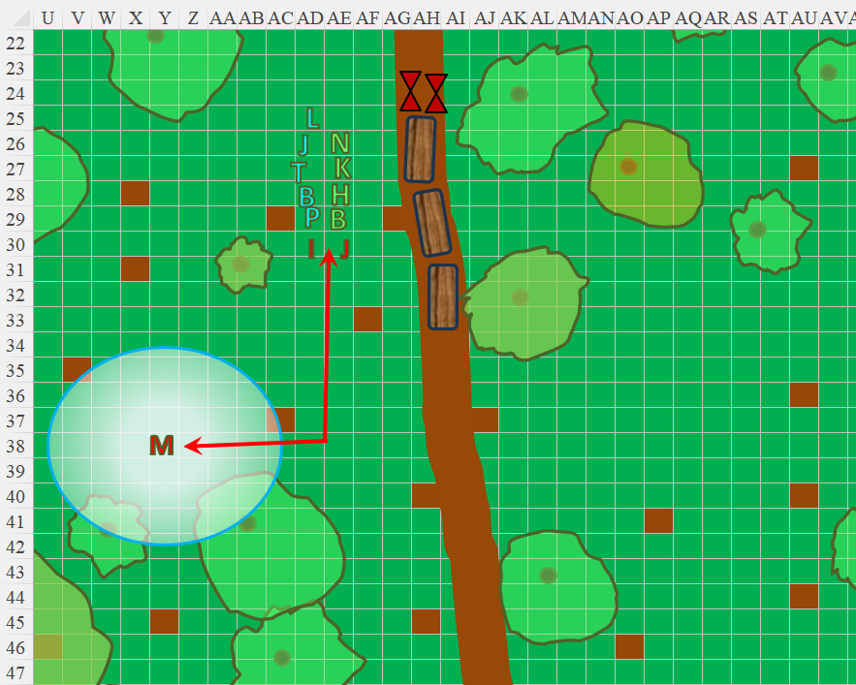

Round 1

|  |  |  |  |  |  |
| --- | --- | --- | --- | --- | --- |
| **Character** | **Group** | **Initiative** | **Roll** | **Modified Roll** | **Speed** |
| Baldoor | 1 | 6 | 19 | 25 | 30’ |
| Nihm | 1 | 6 | 18 | 24 | 30’ |
| Merchants | 1 | 4 | 15 | 19 | 30’ |
| Hobgoblins | 2 | 2 | 13 | 15 | 30’ |
| Kassuq | 1 | 6 | 7 | 13 | 40’ - 60’ |
| Haal | 1 | 6 | 4 | 10 | 30’ |

Baldoor got up, grabbed his hammer and then swung at the closest hobgoblin.

|  |  |  |  |  |  |  |  |  |  |
| --- | --- | --- | --- | --- | --- | --- | --- | --- | --- |
| **Melee Weapon** | **Dmg.** | **D+** | **TH+** | **Critical** | **Type** | **Wt.** | **Atk** | **Roll** | **Check** |
| MW Warhammer | 1d8 | +1 | 1 | x3 | Bludgeon | 3.0 | +4 | *1* | 5 |

*Miss.*

Nihm got up from her seated posture, grabbed her bow, and urged, “Duck!” to get a clear shot at the hobgoblin warcaster dubbed Moses. With a clear path now that they’d come out from behind the bushes and smaller trees, she stepped 5’ to the west and held her shot until the others moved out of her way. Lucky stayed by her side for now, growling, waiting for a command.

Jadziya drew her rapier as she got up from her sitting position, and focused on Immanuel, moving around the trees in order to better flank him.

Bríjido used his staff to prop himself up, then cast *mage armor [expired in 6 hours]*, then got out of the way a bit.

*Bríjido gained +4 to FFAC and AC.*

ProcolHarum did the same as Bríjido, leaving room for Thrashmosh to better deal with the frontline chargers. The dragonborn then cast *curse of arrow attraction [expired on Round 7]* upon Immanuel, who seemed to be the most stalwart of the two frontline enemies. The armored hobgoblin became surrounded in a nimbus of emerald light that was about to draw missiles coming toward it.

*Immanuel incurred –5 to AC vs. ranged attacks, including projectile weapons, thrown weapons, and ranged touch attacks; critical threats on ranged attacks are automatically confirmed.*

Nihm fired as many arrows as she could.

|  |  |  |  |  |  |  |  |  |  |  |
| --- | --- | --- | --- | --- | --- | --- | --- | --- | --- | --- |
| **Ranged Weapon** | **Dmg.** | **D+** | **TH+** | **Critical** | **Rng.** | **Wt.** | **Atk** | **Roll** | **Check** | **Notes** |
| Longbow +1 | 1d8 | 1 | 1 – 4 firing  into melee | x3 | 100’ | 3.0 | +4 | 19 | 23 | +1 within 30’ |
| Longbow, Rapid Shot | 1d8 | 1 | 1 – 4 firing  into melee | x3 | 100’ | - | +4 | 14 | 18 | +1 within 30’ |

*Hit, hit. Dmg: (4 + 1) + (5 + 1) = 5 + 6 = 11.*

Immanuel grimaced and full-attacked Thrashmosh.

|  |  |  |  |  |  |  |  |  |
| --- | --- | --- | --- | --- | --- | --- | --- | --- |
| **Character** | **Attack Type** | **Damage** | **BAB** | **Str**  **Mod+** | **W+** | **Total**  **Score** | **Roll** | **Total** |
| Hob Spellscourge | Spiked Chain +1 | 2d4+1+3+1 | 5 | 3 | 1 | 9 | 19 | 28 |

*Hit. Dmg: 5 + 1 + 3 + 1 = 10.*

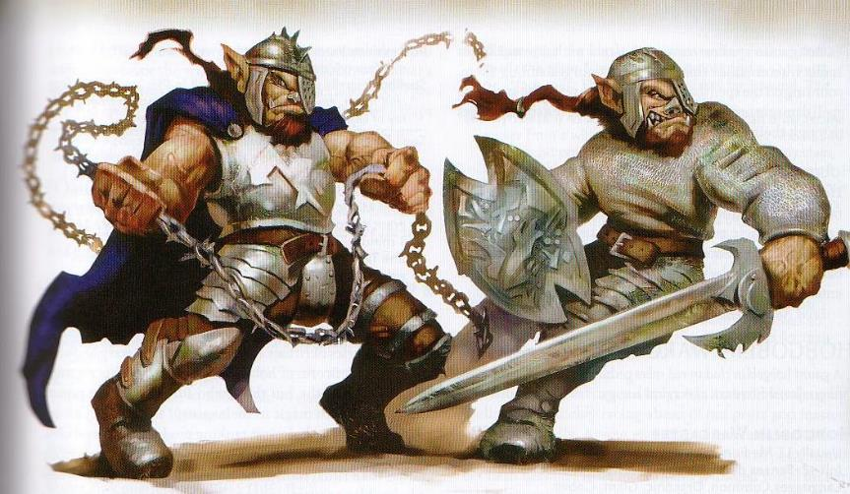

Jacques full-attacked Baldoor.

|  |  |  |  |  |  |  |  |  |
| --- | --- | --- | --- | --- | --- | --- | --- | --- |
| **Character** | **Attack Type** | **Damage** | **BAB** | **Str Mod+** | **W+** | **Total Score** | **Roll** | **Total** |
| Hob Duskblade | MW Longsword | 1d8+1+2 | 3 | 2 | 1 | 6 | 11 | 17 |

*Hit. Dmg: 3 + 1 + 2 = 6.*

Moses cancelled his *silence* spell, and cast *flaming sphere [expired on Round 5]* on the robed Bríjido.

|  |  |  |  |  |
| --- | --- | --- | --- | --- |
| **Character** | **Save vs.**  *flaming sphere* | **Ranks** | **Roll** | **Check** |
| Bríjido | Will | 5 | 6 | 11 |

*Fail. Dmg: 9 fire.*

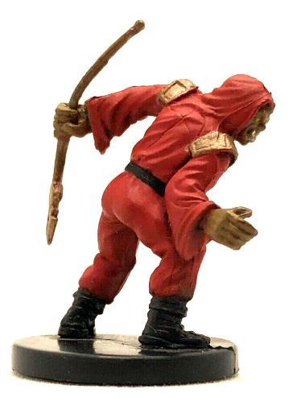

Kassuq moved 5’ to the east, then charged Jacques and attacked him with his sword.

|  |  |  |  |  |  |  |  |  |  |
| --- | --- | --- | --- | --- | --- | --- | --- | --- | --- |
| **Melee Weapon** | **Dmg** | **D+** | **TH+** | **Critical** | **Type** | **Wt.** | **Atk** | **Roll** | **Check** |
| Longsword +1 | 1d8 | 3 | 1 + 2  charge | 19-20/x2 | Slashing | 4.0 | +9 | 12 | 21 |

*Hit. Dmg: 8 + 1 + 2 + 2 = 13.*

Haal took a step 5’ step to the northwest and pulled out his sling, sending a stone flying towards the hobgoblin spellcaster.

|  |  |  |  |  |  |  |  |  |  |
| --- | --- | --- | --- | --- | --- | --- | --- | --- | --- |
| **Ranged Weapon** | **Dmg.** | **D+** | **TH+** | **Critical** | **Rng.** | **Wt.** | **Atk** | **Roll** | **Check** |
| Sling +1 | 1d4 | 1 | 1 | ×2 | 30’ | 1.0 | +4 | 8 | 12 |

*Miss.*

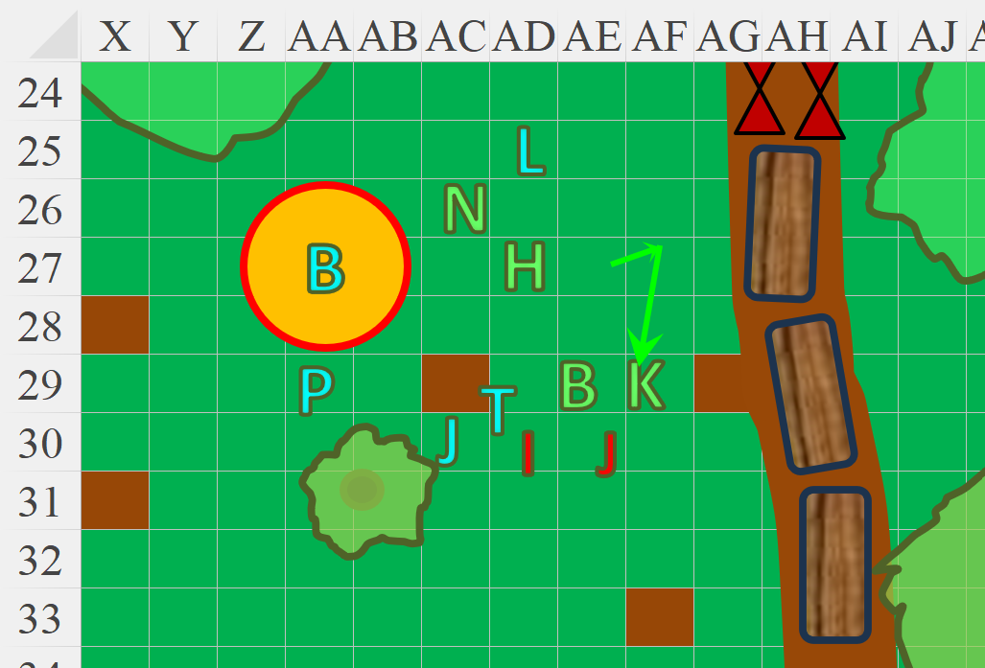

Round 2

The horses stopped once they got a few feet further.

They’d fought hobgoblins before, but the heroes had forgotten just how much more disciplined and stalwart hobgoblins were relative to the wee goblins they’d faced off recently. There were just three of them—and hopefully no reinforcements—and they were each a formidable opponent, not to mention them as a trio.

Hobgoblins were as brutal as they were disciplined, known to form highly organized, conquest-driven kingdoms. They routinely served as mercenaries for other evil creatures, including influential goblins and orcs, though these looked like loyalists... purists in their creeds, having altered their bodies to suit their specializations.

With surprising alacritiy, Jacques, attacked Baldoor. The duskblade was clad in a chain shirt, and held his longsword out threateningly, while keeping his shield—covered in runes— close to his torso. The skilled swordsman was reputed to be the slayer of the wizard named Tartak Firehand, from whom he had previously learned the vocation of the duskblade before vowing to forevermore serve the will of Maglubiyet, the Great Scourge, aiding wizards and sorcerers in their plights against the weak. Jacques cast *ray of enfeeblement [expired on Round 31]* to soften up Baldoor, then studied the playing field and decided to draw more heavily upon his mojo via his arcane channeling ability. Whether it be *shocking grasp, acid splash, ray of frost, or burning hands* would be decided momentarily.

|  |  |  |  |  |  |  |  |  |
| --- | --- | --- | --- | --- | --- | --- | --- | --- |
| **Character** | **Attack Type** | **Damage** | **BAB** | **Dex Mod+** | **W+** | **Total Score** | **Roll** | **Total** |
| Hob Duskblade | Ranged Touch | varies | 3 | 2 | 1 | 6 | 9 | 15 |

*Hit. Dmg: 2 + 3 = 5 Strength.*

|  |  |  |
| --- | --- | --- |
| **Strength** | 13 – 5 = 8 | -1 |

Baldoor continued to attack the hobgoblin in front of him with his hammer as he pulled out and readied his shield.

|  |  |  |  |  |  |  |  |  |  |
| --- | --- | --- | --- | --- | --- | --- | --- | --- | --- |
| **Melee Weapon** | **Dmg.** | **D+** | **TH+** | **Critical** | **Type** | **Wt.** | **Atk** | **Roll** | **Check** |
| MW Warhammer | 1d8 | -1 | 1 + 2  flank | x3 | Bludgeon | 3.0 | +4 | 19 | 23 |

*Hit. Dmg: 7 – 1 = 6.*

The duskblade flinched as its blood spurted all over the Vaasan cleric of Moradin.

Nihm held her ground and fired off another round of arrows at the warcaster. For now, she kept Lucky by her side, waiting to see how the battle went.

|  |  |  |  |  |  |  |  |  |  |  |
| --- | --- | --- | --- | --- | --- | --- | --- | --- | --- | --- |
| **Ranged Weapon** | **Dmg.** | **D+** | **TH+** | **Critical** | **Rng.** | **Wt.** | **Atk** | **Roll** | **Check** | **Notes** |
| Longbow +1 | 1d8 | 1 | 1 | x3 | 100’ | 3.0 | +8 | 14 | 22 | +1 within 30’ |
| Longbow, Rapid Shot | 1d8 | 1 | 1 | x3 | 100’ | - | +8 | 9 | 17 | +1 within 30’ |

*Hit, hit. Dmg: (3 + 1) + 6 + 1) = 4 + 7 = 11.*

“Manny, may I recuse myself?” the warcaster cringed—now nearly dead—and asked the spellscourge in Common.

The spellscourge turned southward towards Moses, shook his head, and to the warcaster’s dismay, uttered, << Ghabrich-kut xuk, Moe! >> (“Stand your ground, Moe!”)

Jadziya flanked Immanuel “Manny”, the spellscourge, and swiped at him with her rapier.

|  |  |  |  |  |  |  |  |  |  |  |  |
| --- | --- | --- | --- | --- | --- | --- | --- | --- | --- | --- | --- |
| **Character** | **Attack Type** | **Damage** | **BAB** | **Dex**  **Mod+** | **W+** | **Other+** | **Total**  **Score** | **Roll** | **Total** | **Crit** | **Threat** |
| Jadziya | Rapier +1 | 1d6+1 | 6 | +3 | 1 | 2 flank | 9 | **19** | 28 | 18 | þ |
| Jadziya | Rapier +1, 2nd Attack | 1d6+1 | 1 | +3 | 1 | 2 flank | 4 | 6 | 10 | 18 | ý |

*Threat, miss. 1d20 = 11 + 9 = 20, critical hit. Dmg: [(2 x 2) + 1] + (1 + 1) = 5 + 2 = 7.*

Still plagued by the *flaming sphere* spell, Bríjido tried to move out of the way and cast *mass whelm* upon the two frontline hobgoblins.

|  |  |  |  |  |  |  |
| --- | --- | --- | --- | --- | --- | --- |
| **Save vs.**  *flaming sphere* | **Bríjido** | **Ability**  **& Mod.** | **Misc.**  **Mods.** | **Total** | **Roll** | **Check** |
| **Bríjido, Reflex** | 3 | **Dex (+1)** | 0 | 4 | 20 | 24 |

*Success. Damage negated.*

|  |  |  |  |  |  |  |
| --- | --- | --- | --- | --- | --- | --- |
| **Skill** | **Bríjido** | **Ability**  **& Mod.** | **Misc.**  **Mods.** | **Total** | **Roll** | **Check** |
| **Bríjido, Concentration** | **8** | **Con (-1)** | 0 | 7 | 1 | 8 |

*Spell failed.*

Thrashmosh was already holding his greatsword above his head, and the blade now came swinging down hard on the spellscourge. “Manny, is it?” asked the half-orc ranger as he delivered the blow.

|  |  |  |  |  |  |  |  |  |  |  |
| --- | --- | --- | --- | --- | --- | --- | --- | --- | --- | --- |
| **Character** | **Attack Type** | **Damage** | **BAB** | **Str Mod+** | **W+** | **Total Score** | **Roll** | **Total** | **Crit** | **Threat** |
| Thrashmosh | Greatsword +1 | 1d12+1+1 | 6 | +1 | 1 | 7 + 2 flank | 9 | 18 | 20 | ý |
| Thrashmosh | Greatsword +1 | 1d12+1+1 | 1 | +1 | 1 | 2 + 2 flank | ***20*** | 24 | 20 | þ |

*Hit, threat. 1d20 = 3 + 4 = 7, not a critical hit. Dmg: (3 + 1 + 1) + (10 + 1 + 1) = 5 + 12 = 19.*

“Scourge you!” the spellscourge said to the ranger.

Keeping an eye on the warcaster to the south, ProcolHarum, the dragonborn favored soul of Lathander, moved closer to the frontline combatants, and cast *holy storm [expired on Round 8]*.

*Dmg to Immanuel “Manny”: 11 good.*

*Dmg to Jacques “Jack”: 10 good.*

Jack began to die as Immanuel turned back to Moses and, said, << Vrik jihaaaarx! >> (“Retreeeeat!”) They then both turned tail and ran southward for their lives.

Baldoor, Jadziya, and Thrashmosh took the opportunity to swipe at the retreating “Manny”.

|  |  |  |  |  |  |  |  |  |  |
| --- | --- | --- | --- | --- | --- | --- | --- | --- | --- |
| **Melee Weapon** | **Dmg.** | **D+** | **TH+** | **Critical** | **Type** | **Wt.** | **Atk** | **Roll** | **Check** |
| MW Warhammer | 1d8 | -1 | 1 + 2 flank | x3 | Bludgeon | 3.0 | +4 | 10 | 12 |

*Miss.*

|  |  |  |  |  |  |  |  |  |  |  |
| --- | --- | --- | --- | --- | --- | --- | --- | --- | --- | --- |
| **Character** | **Attack Type** | **Damage** | **BAB** | **Str Mod+** | **Dex Mod+** | **W+** | **Other+** | **Total Score** | **Roll** | **Total** |
| Jadziya | Rapier +1 | 1d6+1 | 6 | +0 | +3 | 1 | 2 flank | 9 | 3 | 12 |
| Thrashmosh | Greatsword +1 | 1d12+1+1 | 6 | +1 | +3 | 1 | 2 flank | 9 | 15 | 24 |

*Miss, hit. Dmg: 1 + 1 + 1 = 3.*

Immanuel fell to the floor, begged for mercy, and passed out as blood left his body and his warcaster left him to die. Kassuq charged after Immanuel and struck at the prone hobgoblin, finishing him off.

*Automatic hit. Dmg killed Manny off for good.*

Haal moved to Jacques and attempted to stabilize the hobgoblin, figuring it would be helpful to question him and find out why they attacked and how many more may be in the area.

|  |  |  |  |  |  |  |
| --- | --- | --- | --- | --- | --- | --- |
| **Skill** | **Rank** | **Ability**  **& Mod.** | **Misc.**  **Mods.** | **Total** | **Roll** | **Check** |
| **Haal, Heal** | 7 | **Wis (+2)** | 0 | 9 | 15 | 24 |

*Success. Subject stabilized.*

Round 3

The magical rain subsided, having only lasted a few seconds.

Baldoor held his ground and watched over Haal in case the hobgoblin did something foolish.

Nihm let the warcaster hobgoblin run, turning instead to deal with the horses. Calling Lucky to follow her, the pair went to the horses to calm them down.

|  |  |  |  |  |  |  |
| --- | --- | --- | --- | --- | --- | --- |
| **Skill** | **Rank** | **Ability**  **& Mod.** | **Misc.**  **Mods.** | **Total** | **Roll** | **Check** |
| **Nihm, Handle Animal** | 5 | **Cha (+1)** | 0 | 6 | **11 – 15** | ?? |

*See below.*

The animals stayed put, and were calmer than she’d expected. They would later learn that these wagon-drawing horses had seen more action than some heroes on the roads that crisscrossed this island.

Jadziya, Bríjido, Thrashmosh, and ProcolHarum stood guarding the duskblade as the warcaster disappeared behind trees and bushes to the south. Jacques blinked a bit as he realized that he was neither able to get up nor to reach for his longsword, and was at the mercy of these fig eaters. “You... should have left me for dead, for I am to be delivered unto Maglubiyet.”

Kassuq sheathed his sword then returned to the others, standing menacingly over the hobgoblin that Haal had stabilized.

Haal, satisfied that the hobgoblin wouldn’t die any time soon, stood up and stepped back. “If you still wish to meet Maglubiyet, I’m sure one of my friends would be happy to help with that. In the meantime, if you answer some questions, that meeting could be put off far longer.”

|  |  |  |  |  |  |  |
| --- | --- | --- | --- | --- | --- | --- |
| **Skill** | **Rank** | **Ability & Mod.** | **Misc. Mods.** | **Total** | **Roll** | **Check** |
| **Haal, Intimidate** | 0 | **Cha (+2)** | 0 | 2 | 16 – 20 | ?? |

*See below.*

Round 4

The *flaming sphere* remained in place, now with no caster to guide it.

Nihm and Lucky climbed into the front seat of the lead wagon. Nihm stood on the seat to get a better vantage of what was around. She proceeded to check in every direction for any additional threats.

Baldoor stood next to Haal, his hammer bouncing up and down off of his left hand.

The hobgoblin nodded, though he harbored hatred on his visage, and occasionally eyed his dropped sword as he tried to get himself up onto his elbows.

Catching the hobgoblin eyeing his sword, Kassuq picked it up.

Baldoor then glared at the hobgoblin, “Other than tha mage that ran off, how many more o’ you filth in the area?”

After some hesitation, the duskblade reported, “We are dozens, though we were once a horde of thousands.” The hobgoblin then related, “Humanoids from the north reduced our numbers by sword and flame, and only the hardiest of us survived.”

Haal initially stood by and let Baldoor and the others handle the questioning. Nihm, meanwhile, kept watch from the front of the wagons.

Haal spoke in a flat, even tone, as if he were giving a lecture to a class. “If you answer our questions and cooperate, we will let you live and let you go when we reach our destination. What is your leader’s name?”

“His... name...? His name was Manny. He was a hard man.”

Kassuq nodded, “That was the coward that ran,” he confirmed to the others.

“How far away is your camp from here?”

“We have no camp. We’re adventurers now.”

Haal’s right eyebrow went up. “Well, not sure about adventures. Why did you decide to attack us? Those are the actions of thugs and bandits, not adventurers.”

“You’re humanoid scum. You reap the bounty from the land and leave barrenness in your wake.”

“Ah,” Haal replied, raising his right hand and pointing up.

“What Baroness?” Baldoor misunderstood.

Haal corrected his understanding, then continued, “You are a bit misguided, as not all humanoids are scum and leave barren lands in their wake.”

“But this one’s actions make him the very humanoid scum that he mentions,” Kassuq added, receiving a grunt of agreement from Baldoor.

“It’s a preemptive strike, dog-man!” Jacques raised his voice.

“Can we expect more ambushes along the way?”

“Goblins and humanoids vie for control of these hinterlands. Expect both. I like neither... nor dog-men for that matter.”

Baldoor nodded as did the others, the answer not very surprising.

“What do you know of the Moonwells in the area?”

“Yes, I know of them... not much, but there’s one about a half-day’s march from here. Not a good place.”

Haal had a curious expression on his face. He knew that the Moonwells had been corrupted, so he inquired further. “What do you mean by ‘not a good place’? Do you mean not a good place for evil filth like yourself or do you mean not good as in unsafe or deadly for anyone to approach?”

“Not safe for anyone who cannot manage the magical forces near the wells. I would not knowingly venture towards one.”

“You said you were dozens of adventurers, and that this sorry sot was your leader,” Kassuq interjected. “Where are the rest of your dozens?”

“We scattered to the winds,” the hobgoblin blurted out as if he were repeating himself, then added, “We ran into another party days ago, but they were emaciated, and had been chased by goblins into the most inhospitable pockets of these lands. They were weak, and unworthy of our company... but we will reunite someday, and claim stake to some land that we can call our own. I may not be there to rejoice, but it will be so. Now, slay me with dignity. I have spoken enough to you of weak flesh.”

“Ah,” Haal again interjected. “We had a bargain. You answer our questions, and we would let you live. You have held up your end, so we will hold up hours. We will take you with us a distance, then release you. At that point, you can decide where you want to go.” Haal looked to the others, “We will need manacles or rope to tie his hands, as he is our prisoner until we let him go.” Haal then looked back a Jacques, “I do hope one day that you and your people can settle down somewhere and find a home and find peace.”

“I piss on you, and would pay to see the dog-man eye-socket-fuck you,” the hobgoblin displayed his true feelings.

Thrashmosh announced, “You—hobgoblin—are about a hair’s width away from me rescinding the kindness that our guests have offered you. And, sure, if you all want to bring this savage along, it’ll be an extra 20 gold for the dead weight.”

*[The PCs are now aware of most of the hobgoblin information in MM V, pages 84 – 89, including the information on warsouls, which were not part of this encounter.]*

They’d secured Jack’s hands and feet, placing him in the back of one of the wagons with a guard or two. When they neared their destination, they resolved, they would let the hobgoblin go, or maybe after another day’s travel, depending on his disposition, and the trip’s length. All in all, they considered the battle to be to their benefit, as they had never met a duskblade before, let alone a spellscourge and warcaster. This amplified their notions of their own respective specializations.

After they secure the hobgoblin, and before they start moving, Haal and Baldoor ask, “Does anyone require healing before we move on?” They were all good by this time, though.

“Off we go then,” Baldoor voiced their reprise of the trek to Pembroke, getting in the wagon with the prisoner as the four merchants—who had taken most of the damage in the fight—licked their wounds figuratively, and got the horses back on track.

~*~

They thought they might have run into a party of goblins as night descended, but it was a false alarm, though traces of recent goblinoid presence were clear at a makeshift encampment near the road. The merchants and their newfound friends searched the campsite, and found a ring that likely had magical properties, though they could not identify it. The dragonborn pocketed it before they continued a bit more, reaching a point where no trace of goblins was to be found.

“This is our spot,” claimed the half-orc as they started to set up their sleeping area.