Chapter 22: Return to the Blackscale Swamps

They put a few miles between themselves and Daggerford, and followed the vague directions that the Blackscale lizardfolk had given them a few days earlier. They happened upon an encampment that bore telltale signs of lizardfolk—not mammalian humanoids—living here. It was, however, deserted, and seemed to have been abandoned both quickly and recently.

“They abandoned camp only hours ago,” one of them mentioned at the sight of the embers still burning in the midst of an outer ring of logs that hadn’t been burned much. Personal belongings were strewn about as if the residents left in a dire hurry, but nothing had damaged the tent domiciles, so they did not assume that a raid or animal attack had transpired.

Kelvar and his bison-sized ram rode the point, while Kassuq and Nihm followed, riding side-by-side as they surveyed the semipermanent campsite. Lucky darted around, sniffing the air often to come back into Nihm’s orbit.

The wind was blowing southward, bringing with it an additional smoky scent that was fleshier than these woody embers.

They went in that direction, seeing as most of the tracks pointed there. A minute into the tracking, they could hear lizardfolks calling to one another, not with alarm, but with seriousness.

Haal called out, “Ho there, we come in peace! We would like to speak with you!” He then climbed down off the wagon, preparing to walk over and greet whoever responded. The other remained where they were, weapons sheathed or stored, but ready to grab them should things go badly.

There was silence for a few tense moments, then the sound of rustling leaves approaching, and then two Blackscale tribesmen toting spears and studying the mammalian humanoids cautiously. Then one of them recognized Haal, and said in decent Common, “You. We met you a few days ago!” The other lizardman’s posture now got less defensive, and they both lowered their spears.

“Yes,” Haal said in response, “and we have a new friend,” he indicated Kelvar on his mount, “with us. We have come to seek your assistance with a mutual problem. The Poisondusk lizardfolk are attacking a town north of here and I believe they have been harassing you as well. We also know about the gem that allows for the vast laying of eggs and quick growth of the young.” Haal looked the lizard he was speaking to in the eye. “We mean to destroy the gem; I am telling you up front so there is no confusion. That gem will only cause problems for the tribe that owns it. Because if one town falls and they threaten others, you will have all of Faerûn coming down on not only the tribe that possess it, but all of your kind. And I would hate to see that.” Haal was firm, but sincere in his tone.

|  |  |  |  |  |  |  |
| --- | --- | --- | --- | --- | --- | --- |
| **Skill** | **Rank** | **Ability & Mod.** | **Misc. Mods.** | **Total** | **Roll** | **Check** |
| **Haal, Diplomacy** | 4 | **Cha (+2)** | 4 | 10 | 11 – 15 | ?? |

*See below.*

~*~

Haal and his mates had spent the better part of ten minutes speaking to the new chief—Kodak the Forsaken—who had succeeded his father after an onslaught by—not the Poisondusk tribesmen, as they’d expected—but a contingent of bullywugs who had reduced the Blackscales’ numbers to a mere score or so.

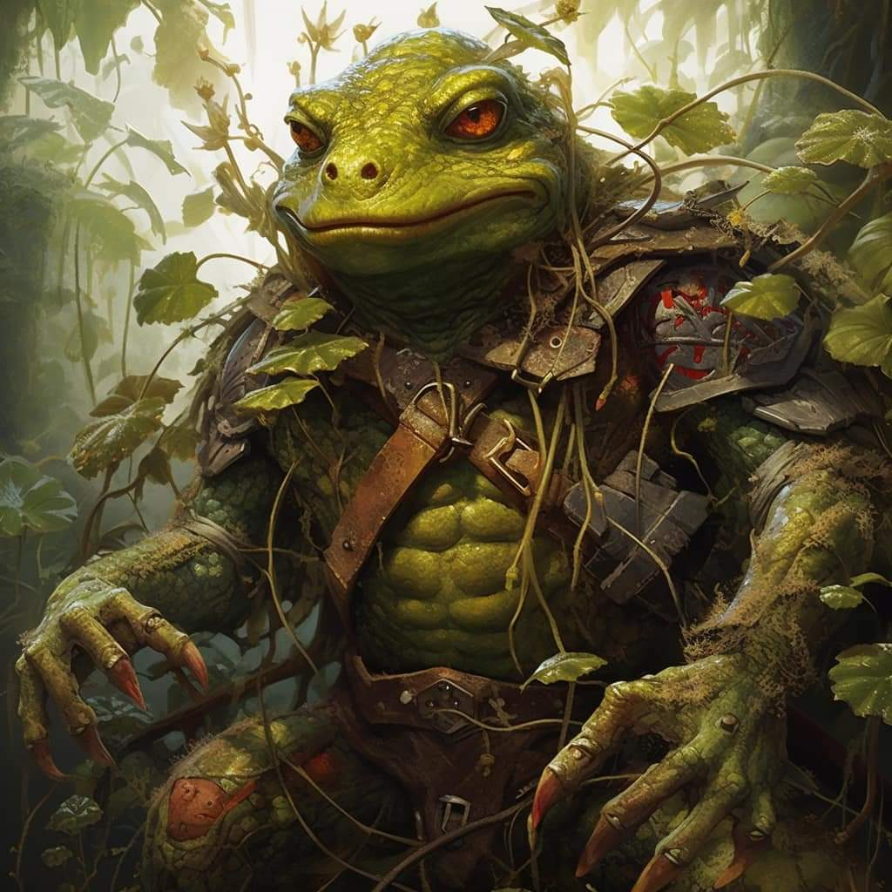

“So the Poisondusk and the bullywugs are allies?” asked Kelvar.

“Not in the least,” Kodak assured them. “Bullywugs are notorious for their torture tactics, and the Poisondusk are known for their self-preserving wits, so it stands to reason that after the Poisondusk lizardfolk stole the bullywugs’ Gravid Gem, the local bullywugs sent envoys along the coast to summon reinforcements for the amphibians’ cause,” Kodak related slowly in Common.

They continued to discuss speculations and what little they knew of the situation, and the mammalians expressed their condolences for their fallen comrades.

Kodak nodded: “Much appreciated. We’ve been hiding here in the bushes for nearly two days now, and have spotted bullywug scouts three times. They mean to wipe us out, and settle in our marshes and swamps.”

It was difficult for Nihm and others to witness this tribe of hundreds being cut down to so few, and having to eke out an existence in the apocalypse of their nation.

After a moment of thought, Tore responded, “I would understand, then, if you were not able to help us. Your numbers have dwindled to a precarious level. However, we still need to find and destroy that gem. If any of your warriors do wish to assist us, the help would be appreciated. Regardless of any assistance, we will pass on your friendly nature to the towns in the area to hopefully boost relations and help your tribe. We would need a decision in a few minutes as we will need to press on and locate the Poisondusk tribe.”

Several male lizardfolk gathered around Kodak the Forsaken, speaking in their own language, and expressing somatic gestures suggesting an offensive.

Kodak turned to the fuzzy folks, and looked them all in the eye one by one. He inhaled, flaring his scaly nostrils, and sighed, “We will fight to the end.... It is what my father would have wanted.”

Nods and grunts from the Chief’s chief men echoed their collective sentiment. Some brandished their favored weapons, showing off a few signature lunges and smirking with rows of perfectly identical teeth lining their gums.

~*~

Kodak’s head scout was a man named Umbrage, whose shortbow and short spear were beautifully hand carved by the spearman himself. He and a few other sentries had spotted a Poisondusk encampment—not quite a settlement—and was now leading the heroes there. Most of the Blackscale lizardfolk also toted spears of various sizes and complexities, each unique in its engravings, now that the heroes had the opportunity to study them.

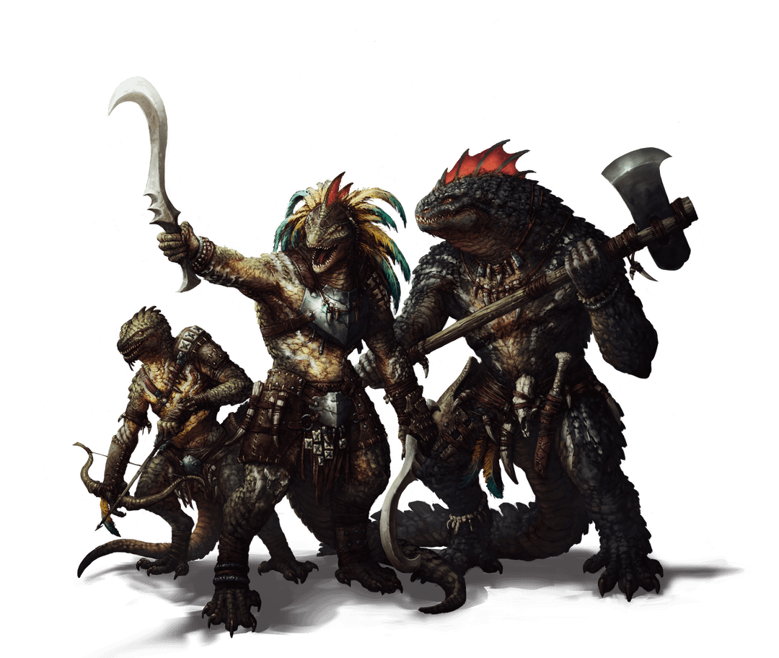

They were a noble people—the Blackscale—nothing like what some of the mammalians had expected. Yes, they were a wholly carnivorous bunch, which often went with grotesque rituals, but their sense of bushido was quite civilized for swamp-dwelling gator wrestlers.

They were 23 in all: a prime number, which to these lizardfolk was a good omen. Most of them led ahead of the mammals in the smelly bog that had formed here once the water levels had dropped and this specific body of water became disconnected from the rest of the estuary.

“There is no more trail to be blazed ahead,” Umbrage broke his silence and translated one of their sayings, meaning that they were now going to travel about knee-deep in the muck.

“Glad we didn’t bring the wagon,” Amara sighed.

“How much further is it?” asked Kelvar, his knowledge of the land having ended about a half-hour ago.

“We should march cautiously,” he warned of Poisondusk sentries likely patrolling the trackless mud. “Maybe 10 gnomish minutes,” the scout apparently had dealt with gnomes.

“So we are already within the confines of the lands they regularly patrol,” Nihm surmised. “Our tracks behind us will surely give us away.”

“That’s only if they’re found in the next 10 minutes,” Kassuq was pretty sure.

“We still have the element of surprise,” Amara though aloud, “but we don’t know what their numbers are.”

“Perhaps the stealthiest among us can go ahead,” suggested Haal, “and gather intel to better profit from the element of surprise.”

After Haal suggested the stealthiest of them go ahead, Nihm and Kassuq nodded.

“We,” Nihm said as she pointed to Kassuq & Lucky, can go ahead with the other scouts and see what the Poisondusk tribe has prepared.”

The archon nodded his agreement and prepared to head out.

Amara nodded as well, “When we are ready to move in, I can turn invisible and we,” Amara pat’s Xena on the head, “can search for the gem, though, I think it should be easy enough to figure out where they have it.” She then walks over to Lucky, Nihm and Kassuq, “Just to keep you safer for now,” she then chanted and cast *mage armor [expired in 6 hours]* on all three of them.

*Nihm, Kassuq and Lucky gained +4 to FFAC and AC.*

As the scouts prepared to head out, Haal turned to Umbrage, “I have a spell that can make one of your warriors larger and another that will make one stronger. Can you ask for a couple of volunteers? They will need to be by me until we begin our attack so I can cast the spells.”

*Enlarge person & bull’s strength to be cast on Gnar Nahsh and Charger 1, respectively.*

Haal would also use a *summon monster II* scroll upon confronting the Poisondusk.

*Readying Glove of the Starry Sky and spiritual weapon.*

Baldoor watched as the scouts prepared and then headed out. He was ready to get out of the swamp, but knew they had a job to do, so kept his complaints about the mud and its depth to himself. He found a drier place to sit or stand while they waited for the others to return. As he waited, he asked, “Do these Poisondusk lizards have any spellcasters and do they prefer spells with lightning or anything like that?”

The Blackscale didn’t really have a good sense of specifics, but replied that there were usually adepts buffing the warriors.

Baldoor resolved to cast *protection from energy* right before entering combat, using the knowledge shared to determine the type of energy. He would then cast *bull’s strength* on himself and Kelvar before they charged in. The timing and order of spells would be determined once they were closer to the encampment.

Kelvar felt a bit like Baldoor, not at home in the swamps and bogs. Like his fellow dwarf, he found a place to rest that was a bit dryer. He knew his skills were not meant for stealth, so he began preparing himself for the coming fight.

They gathered the scouts, with Nihm, Kassuq and Lucky leading five stealthy lizardfolk. The others waited for the expeditionary force to return while Haal inquired about volunteers willing to receive boosts (*Enlarge Person & Bull’s Strength* spells.)

They then converged on the planned contingencies at the onset of the engagement.

Preparation to attack:

1) Move into positions to prepare to attack.

2) Baldoor Casts Protection from Energy (type TBD) on himself and then casts Bull’s Strength on himself and Kelvar.

3) Haal casts *Bull’s Strength* and *Enlarge Person* on two separate lizardfolk.

4) Haal then casts *Summon Monster II* from a scroll.

5) Haal casts *Spiritual Weapon* as far from himself as possible.

6) Amara casts *Invisibility* upon herself and begins moving towards the building we believe houses the gem.

7) Haal uses his Gloves of the Starry Sky and will fire off a few *Magic Missiles*.

~*~

The scouts trekked silently for the better part of 10 minutes until they came upon a mound to the south atop which was the Poisondusk encampment. There were no actual buildings, just tents, and at a distance of 500’, it was difficult to tell anything else. They were still behind the cover of mangroves and swamp shrubs; approaching would likely negate their cover.

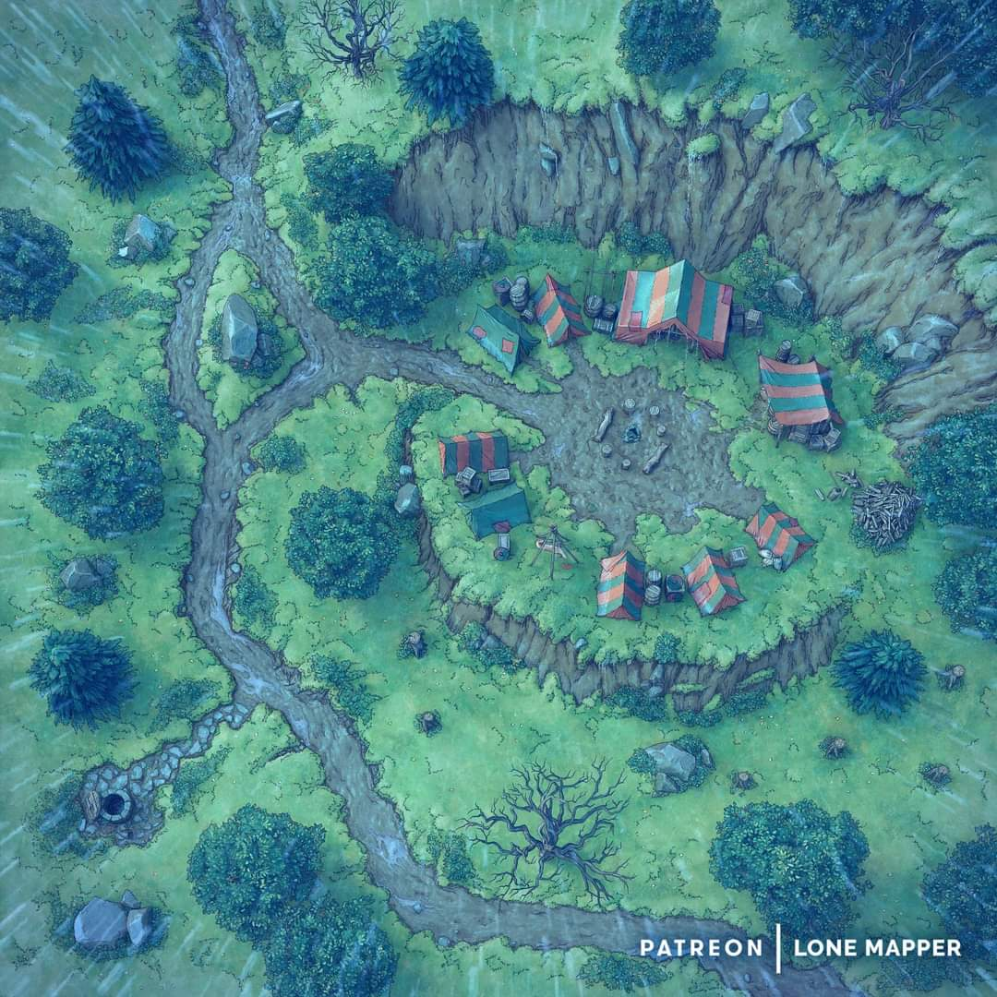

Kassuq turned to one of the scouts and, using his ‘Tongues’ racial ability, asked, “Is there no way to get closer? Is there a way for someone to attack from the top of the ridge while others attack from lower?”

The man replied that this was once a Blackscale mound, and that it was chosen for its strategic location. The vegetation had been cut down to about where they were, and any further approach would be conducted out in the open.

~*~

The expeditionary force returned to brief the rest of the group. Once they finished with the report, the only question Haal had, before laying out the plan, was, “Did they have many scouts out patrolling?”

“We ran into none, which was surprising,” one of the Blackscale members said.

When told about their specialties, Haal nodded. “Perhaps, with their numbers, they are overconfident and have left themselves open. However,” he added before the chief could reply, “it is also possible they have laid magical traps. Several of us can cast *detect magic* when we get within a few minutes of the edge of the tree line. This way we can avoid any magical traps they may have set. The third possibility is that their main group has gone off to attack Daggerford in retaliation for what the Red Knights did to their other tribe members.” Haal shook his head just thinking about the bodies staked out on pikes and spears.

With that settled, Haal, with the help of Kassuq’s translations (Tongues ability), began laying out the plan.

“We will move in one group to an area about 1000’ from their camp. There we split into our four groups. The ranged group will follow Nihm and Lucky,” Haal points to the elf ranger and her wolf. “You will all move through the tree line to the top of the ridge here,” he pointed to the makeshift map drawn in the dirt. “Group one will go with Baldoor and Kelvar,” Haal pointed to the two dwarves, “and will attack here with the intent of reaching the main camp. The second group will follow Kassuq and approach from just south of the well. Your main job will be to support group 1 if they get slowed down, or group 3 should too many Poisondusk members try to flee or outflank us on the right. The third group will follow myself and Amara,” he pointed to the half-elf sorceress, “with the intent of approaching the camp from the back side and cutting off any escape. Amara will go in ahead of us after turning invisible to try and reach the tent before they can remove the gem, if it is there.” Haal knew it was possible that the gem might be hiding somewhere else, but this was their best guess and best chance to try and end this fighting.

“Are there any questions?” Haal asked and looked around at the warriors.

The lizardfolk were prepared, and some salivated at the thought of retribution against the Poisondusk.

After logistical and mindset preparations, they set off.

~*~

Rounds 1 – 50

The group was about 1500’ from camp, and Amara, Haal and Baldoor all cast *detect magic [expired on Rounds 61, n.a., 41, and 61, respectively]*.

*Amara, Haal, and Baldoor concentrating on detecting magic.*

They all then took up positions, poising themselves for the execution of their plan, and moved forward.

Rounds 51 – 60

At about 600’ from the mound, Haal’s *detect magic* spell expired.

Detecting no magic, the group split up, and each went to their respective positions.

Round 61

They continued to buff up before breaking cover. Some of the lizardfolk adepts buffed themselves and others as well. It would soon be within view.

Amara cast *cat’s grace [expired on Round 121]* on herself.

|  |  |  |  |  |  |  |
| --- | --- | --- | --- | --- | --- | --- |
| **Skill** | **Rank** | **Ability & Mod.** | **Misc. Mods.** | **Total** | **Roll** | **Check** |
| **Amara, Concentration** | 8 | Con (+0) | 0 | 8 | 16 | 24 |

*Amara gained +4 to Dex.*

Baldoor cast *bull’s strength* *[expired on Round 121]* on Kelvar.

|  |  |  |  |  |  |  |
| --- | --- | --- | --- | --- | --- | --- |
| **Skill** | **Rank** | **Ability & Mod.** | **Misc. Mods.** | **Total** | **Roll** | **Check** |
| **Baldoor, Concentration** | 5 | Con (+1) | 0 | 6 | 19 | 25 |

*Kelvar gained +4 to Str.*

Haal cast *bull’s strength [expired on Round 101]* on one of the Blackscale lizards.

*Blackscale Charger 1 gained +4 to Str.*

Kassuq cast *aid [expired on Round 101]* upon a random Blackscale lizard.

*Blackscale Charger 1 gained +1 to AB and Saves vs. Fear, plus 17 hps.*

Some of the warriors were anointing their spear tips with buffing oil, while others were painting on their faces before honoring their ancestors.

Round 62

With about 60’ of brush between the clearing and himself, Baldoor cast *bull’s strength [expired on Round 122]* on himself.

*Baldoor gained +4 to Str.*

Kassuq cast *aid [expired on Round 102]* upon one of the fiercest Blackscale lizards.

*Gnar Nahsh gained +1 to AB and Saves vs. Fear, plus 18 hps.*

Round 63

Each group was about 580’ from the mound, and with only 30’ of brush in front of them, they began the final round of buffs as they continued to carefully step forward.

Kassuq cast *aid* *[expired on Round 103]* on himself.

*Kassuq gained +1 to AB and Saves vs. Fear, plus 16 hps [52/36].*

Haal cast *enlarge person* *[expired on Round 103]* on Gnar Nahsh.

*Gnar Nahsh gained +2 to Strength, -2 to Dexterity, and -1 to AB.*

Amara cast *invisibility* *[expired on Round 663]* on herself and Xena.

*Amara and Xena gained invisibility.*

Round 64

They had reached the perimeter of the clearing that the Poisondusk had deliberately blazed with tactical considerations.

Kassuq’s group charged forward, followed by Baldoor’s and Kelvar’s groups.

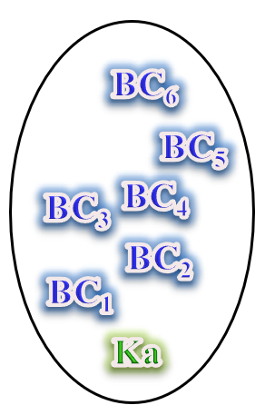

Seeing Kassuq’s contingent charging, Amara’s and Haal’s group also charged ahead while Haal followed a bit behind, casting *summon monster II [expired on Round 68]* and summoning a Celestial giant bee, sending after the closest Poisondusk lizard.

*Invisible* now, Amara headed off to the side to avoid being struck, resolving to make her way towards the largest tent, staying close to the cliff wall.

Nihm cast *entangle [expired on Round 67]*, centering the effect on a spot 440’ south of her *[maximum range]*, which was still 60’ from the mound.

Then, she and her group moved to the edge of the ridge, ready to fire arrows down on the Poisondusk lizards once they were in range.

Lucky stood watch to make sure they weren’t attacked from behind.

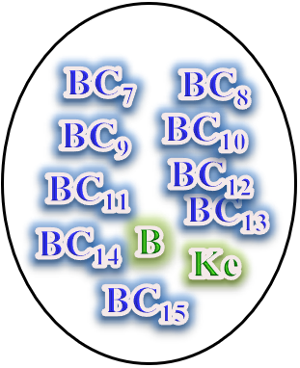

Baldoor and Kelvar led nine chargers forward, with Kojak, Gnar Nahsh and a few elite skirmishers on their left.

Round 65

*Second round of full running.*

They were now about 380’ from the mound, and charging ahead at full speed as independent units.

A Poisondusk sentry atop the mound spotted the charging trespassers, and blew a horn, rousing all of the braves to the north side of the mound.

Round 66

They were now about 260’ from the mound.

Poisondusk tribesmen were taking up position along the northern ridge of the mound, resolving to put down the siege with javelins very similar to those of the Blackscales.

Round 67

They were now about 140’ from the mound, and winded from running.

Amara’s and Baldoor’s *detect magic* spells expired.

Everyone was pretty tired by now, and slowed down their charges as the first few javelins were hurled their way by their strongest champions.

|  |  |  |  |  |  |  |  |  |  |
| --- | --- | --- | --- | --- | --- | --- | --- | --- | --- |
| **Character** | **Attack Type** | **Damage** | **BAB** | **Dex Mod+** | **W+** | **Other+** | **Total Score** | **Roll** | **Total** |
| Poisondusk Commando | Javelin | 1d6-1 | 3 | 0 | -2  distance | 2 height | 3 | 3 | 6 |
| Poisondusk Commando | Javelin | 1d6-1 | 3 | 0 | -2  distance | 2 height | 3 | 1 | 4 |
| Poisondusk Commando | Javelin | 1d6-1 | 3 | 0 | -2  distance | 2 height | 3 | 13 | 16 |
| Poisondusk Commando | Javelin | 1d6-1 | 3 | 0 | -2  distance | 2 height | 3 | 17 | 20 |
| Poisondusk Commando | Javelin | 1d6-1 | 3 | 0 | -2  distance | 2 height | 3 | 7 | 10 |
| Poisondusk Commando | Javelin | 1d6-1 | 3 | 0 | -2  distance | 2 height | 3 | 5 | 8 |
| Poisondusk Commando | Javelin | 1d6-1 | 3 | 0 | -2  distance | 2 height | 3 | 15 | 18 |

*Miss, miss, hit BC4, hit BS3, miss, miss, miss (Amara).*

*Dmg to BC4: 1 – 1 = 1 minimum.*

*Dmg to BS3: 4 – 1 = 3.*

A Poisondusk witch doctor cast a buff on their greatest champion.

*Good stuff happens to the champion.*

Round 68

|  |  |  |  |  |  |
| --- | --- | --- | --- | --- | --- |
| **Character** | **Group** | **Initiative** | **Roll** | **Modified Roll** | **Speed** |
| Kassuq | 1 | 6 | 17 | 23 | 40’ - 60’ |
| Baldoor | 1 | 7 | 14 | 21 | 30’ |
| Haal | 1 | 0 | 16 | 16 | 30’ |
| Kelvar | 1 | 7 | 7 | 14 | 30’ |
| Nihm | 1 | 4 | 6 | 10 | 30’ |
| Amara | 1 | 4 | 4 | 8 | 30’ |
| Blackscale Lizardfolk | 1 | 0 | 8 | 8 | 40’ |
| Poisondusk Lizardfolk | 2 | 0 | 8 | 8 | 40’ |

At a distance of 80’ southwest of the base of the mound, Kassuq and his pack _____.

At a distance of 90’ west of the mound, Baldoor, Kelvar, and their band _____.

At a distance of 80’ south of the mound, Haal, Amara, and their charger friends _____.

Haal’s Celestial giant bee dematerialized.

At a distance of 80’ northeast of the mound, Nihm and her archer allies circled around the *entangle* spell’s effect, and _____.

The Blackscale lizardfolk *[these actions will depend on what each PC leads them to do, plus some Diplomacy checks]* ?

The Poisondusk lizardfolk began to evacuate gravid women and youngsters along the southeastern side of the mound.

~*~

*Post-battle spellcasting inventory:*

Round 85

Amara cast *detect magic [expired on Round 145]*.

Haal cast *detect magic [expired on Round 125]*.

Baldoor cast *detect magic [expired on Round 145]*.

Nihm tried to cast *detect poison*, which she hadn’t prepared, and lost one of her *flare* spells in the process.

*Per prior communication, this expends a level-equivalent spell slot.*



Kelvar and Kassuq remained outside on watch.

~*~

Round 100

The battle had not taken long, as they had happened upon the fortification when it was least heavily guarded. The majority of the braves in the band had gone off on a hunt for a rare stock of grazing animal, and they had left the youngsters, gravid women, and brooding mothers with a few adepts and defenders, but all in all, the Poisondusk had been ill prepared for what the Blackscale and mammalians brought to them.

Amara—no longer *invisible*—searched for the Gravid Gem along with some of the Blackscales. The few Poisondusk captives that had been tentatively spared had taken the lives of their younger siblings, then their own, in lieu of captivity and dishonor.

Baldoor and Nihm had looked for any possible hiding places while the others prepared for the Poisondusks to arrive, but this encampment was rather makeshift, and had no ducts, tunnels, or other unseen causeways leading out.

Now, in the midst of the few dozen carcasses of Poisondusk kiddos and adolescents, the heroes assessed the situation. They’d not had much time to seek out the Gravid Gem, so it could still be here, but as Nihm and other scouts spotted a contingent of Poisondusk warriors approaching from the west at a distance of 500’ from the mound, she called everyone’s attention to the urgency of the moment.

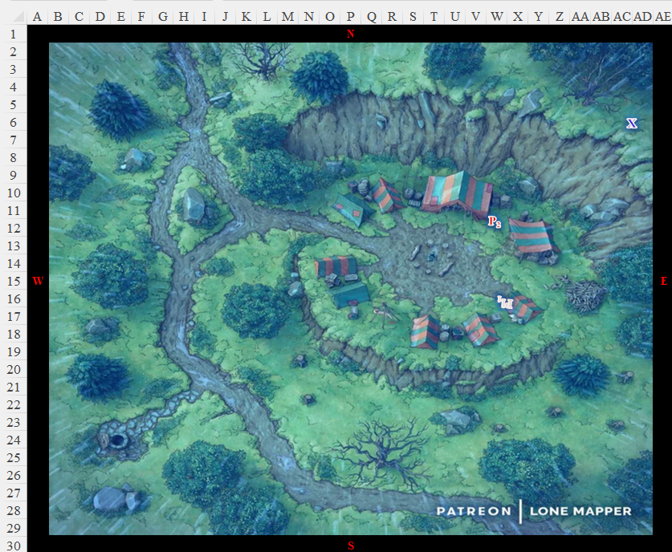

Round 101

Kassuq cast *aid [expired on Round 141]* on the first charger as they mobilized to defend the mound they’d just besieged.

*Blackscale Charger 1 began to regain buffs.*

Nihm, Haal, Amara and Lucky stationed themselves at the top of the 5’ ledge, ensuring that nobody climbed up that ledge.

Baldoor and Kelvar set up a defensive frontline, and Kassuq would join them after his castings.

Kodak the Forsaken ordered the skirmishers to seek high ground, and mobilized the Blackscale chargers, who braced for a downward charge when the moment was right.

The Poisondusk lizardfolk were now about 320’ west of the mound.

Round 102

Kassuq cast *aid [expired on Round 142]* on Gnar Nahsh.

*Gnar Nahsh began to regain buffs.*

One skirmisher (9) climbed atop a rock to get a nicer line of attack.

|  |  |  |  |  |
| --- | --- | --- | --- | --- |
| **Character** | **Check** | **Ranks** | **Roll** | **Check** |
| Blackscale | Climb | 10 | 6 | 16 |

*Success.*

Baldoor yelled, “Now, Lass!” and triggered his *stone shape* spell, causing a line of rock to rise from the ground right in front of the charging Poisondusk lizards, hoping to trip several of them up and slow their advance.

Haal cast *summon monster II* and called forth a Celestial giant bombardier beetle behind the Poisondusk lizards [A12].

Kelvar stayed put, anticipating a wanton battle.

Nihm cast her *entangle* just behind the Poisondusk lizards’ frontlines, trying to catch the largest group she can, or target a spellcaster in the middle of it as her second priority.

*See fireball description below.*

Amara cast *fireball* upon the leading Poisondusks now caught in Nihm’s *entangle* spell.

|  |  |  |  |  |
| --- | --- | --- | --- | --- |
| **Character** | **Save vs.**  *fireball* | **Ranks** | **Roll** | **Check** |
| Poisondusk Commando 1 | Reflex | 6 | 11 | 17 |
| Poisondusk Commando 2 | Reflex | 6 | 14 | 20 |
| Poisondusk Commando 3 | Reflex | 6 | 6 | 12 |
| Poisondusk Commando 4 | Reflex | 6 | 15 | 21 |
| Poisondusk Commando 5 | Reflex | 6 | 15 | 21 |
| Poisondusk Commando 6 | Reflex | 6 | 20 | 26 |
| Poisondusk Marshal | Reflex | 6 | 2 | 8 |

*Success, success, fail, success, success, success, fail.*

*Base dmg: 21 fire (½ = 10 fire).*

One of the frontline Poisondusk commandos died, while the rest who were caught in the *fireball* remained on foot, and continued their charge.

The Blackscale archers prepared to loose arrows as the frontline Poisondusk lizardfolk reached a spot about 140’ west of the mound.

Round 103

It began to rain a bit.

Kassuq cast *aid [expired on Round 143]* on himself.

*Kassuq began to regain buffs.*

Amara cast another *fireball*, this time centered on the largest Poisondusk cluster.

|  |  |  |  |  |
| --- | --- | --- | --- | --- |
| **Character** | **Save vs.**  *fireball* | **Ranks** | **Roll** | **Check** |
| Poisondusk Commando 7 | Reflex | 6 | 14 | 20 |
| Poisondusk Commando 8 | Reflex | 6 | 15 | 21 |
| Poisondusk Commando 9 | Reflex | 6 | 8 | 14 |
| Poisondusk Commando 10 | Reflex | 6 | 6 | 12 |
| Poisondusk Commando 11 | Reflex | 6 | 12 | 18 |
| Poisondusk Commando 12 | Reflex | 6 | 9 | 15 |
| Poisondusk Commando 13 | Reflex | 6 | 8 | 14 |
| Poisondusk Commando 14 | Reflex | 6 | 17 | 23 |
| Poisondusk Commando 15 | Reflex | 6 | 19 | 25 |
| Poisondusk Commando 16 | Reflex | 6 | 15 | 21 |
| Poisondusk Commando 17 | Reflex | 6 | 5 | 11 |

*Success, success, fail, fail, success, fail, fail, success, success, success, fail.*

*Base dmg: 28 fire (½ = 14 fire).*

That blast left none of the seared commandos within it standing, practically dealing the decisive blow to the Poisondusk expeditionary force.

The remaining Poisondusk lizardfolk reached the mound, and the Blackscales charged down the hill to meet them.

|  |  |  |  |  |  |  |  |  |  |  |
| --- | --- | --- | --- | --- | --- | --- | --- | --- | --- | --- |
| **Character** | **Attack Type** | **Damage** | **BAB** | **Str Mod+** | **Other+** | **Total Score** | **Roll** | **Total** | **Crit** | **Threat** |
| Poisondusk Commando | Spear | 1d6-1 | 3 | -1 | 2 charge | 4 | ***20*** | 24 | 20 | þ |
| Poisondusk Commando | Spear | 1d6-1 | 3 | -1 | 2 charge | 4 | ***3*** | 7 | 20 | ý |
| Poisondusk Commando | Spear | 1d6-1 | 3 | -1 | 2 charge | 4 | ***20*** | 24 | 20 | þ |
| Poisondusk Commando | Spear | 1d6-1 | 3 | -1 | 2 charge | 4 | ***3*** | 7 | 20 | ý |
| Poisondusk Commando | Spear | 1d6-1 | 3 | -1 | 2 charge | 4 | ***17*** | 21 | 20 | ý |
| Poisondusk Commando | Spear | 1d6-1 | 3 | -1 | 2 charge | 4 | ***7*** | 11 | 20 | ý |
| Poisondusk Commando | Spear | 1d6-1 | 3 | -1 | 2 charge | 4 | ***17*** | 21 | 20 | ý |
| Poisondusk Commando | Spear | 1d6-1 | 3 | -1 | 2 charge | 4 | ***15*** | 19 | 20 | ý |

*Threat, miss, threat, miss, hit, miss, hit, hit. 1d20 = 18 + 4 =22, 12 + 4 = 16, two critical hits.*

*Dmg to BC1: (2 x 1) – 1 = 1.*

*Dmg to BC2: 3 – 1 = 2.*

*Dmg to BC3: (2 x 2) – 1 = 3.*

*Dmg to BC4: 3 – 1 = 2.*

*Dmg to BC5: 5 – 1 = 4.*

Haal cast *flaming sphere* from a scroll, targeting the Poisondusk marshal.

|  |  |  |  |  |
| --- | --- | --- | --- | --- |
| **Character** | **Save vs.**  *flaming sphere* | **Ranks** | **Roll** | **Check** |
| Poisondusk Marshal | Reflex | 6 | 13 | 19 |

*Success. Damage negated.*

Nihm let loose a pair of arrows upon the marshal.

|  |  |  |  |  |  |  |  |  |  |  |
| --- | --- | --- | --- | --- | --- | --- | --- | --- | --- | --- |
| **Ranged Weapon** | **Dmg.** | **D+** | **TH+** | **Critical** | **Rng.** | **Wt.** | **Atk** | **Roll** | **Check** | **Notes** |
| Longbow +1 | 1d8 | 1 | 1 | x3 | 100’ | 3.0 | +9 | **20** | 29 | +1 within 30’ |
| Longbow, Rapid Shot | 1d8 | 1 | 1 | x3 | 100’ | - | +9 | 3 | 12 | +1 within 30’ |

*Threat, miss. 1d20 = 19 + 9 = 28, critical hit.*

*Dmg: (3 x 3) + 1 = 10.*

Haal’s Celestial beetle attacked a charging commando (P4).

|  |  |  |  |  |  |  |  |
| --- | --- | --- | --- | --- | --- | --- | --- |
| **Character** | **Attack Type** | **Damage** | **BAB** | **Str Mod+** | **Total Score** | **Roll** | **Total** |
| Celestial Giant Beetle | Bite | 1d4 + 1 | 1 | 1 | 2 + 2 flank | 14 | 18 |

*Hit. Dmg: 2 + 1 = 3.*

The seared and now bitten commando was finished, and fell in battle.

Seeing their marshal and a few soldiers fall flat on his face, Amara now began targeting the frontline chargers with *magic missile* spells.

*Dmg: 3 + 2 = 5 magic [force].*

This was almost enough to slay the lead charger.

*This is subject to me fudging numbers to reflect an imperfect damage/vitality assessment.*

|  |  |  |  |  |  |
| --- | --- | --- | --- | --- | --- |
| **Character** | **Total Damage** | **Temp** | **Healing** | **HPs** | **Current HPs** |
| **Amara** | 0 |  |  | 18 | 18 |
| **Baldoor** | 0 |  |  | 42 | 42 |
| **Haal** | 0 |  |  | 39 | 39 |
| **Kassuq** | 0 | 16 |  | 36 | 52 |
| **Nihm** | 0 |  |  | 36 | 36 |
| **Lucky** | 0 |  |  | 18 | 18 |
| **Kodak the Forsaken** | 0 |  |  | 32 | 32 |
| **Gnar Nahsh** | 0 | 18 |  | 38 | 56 |
| **Blackscale Charger 1** | 1 | 17 |  | 28 | 44 |
| **Blackscale Charger 2** | 2 |  |  | 28 | 26 |
| **Blackscale Charger 3** | 3 |  |  | 28 | 25 |
| **Blackscale Charger 4** | 3 |  |  | 28 | 25 |
| **Blackscale Charger 5** | 4 |  |  | 28 | 24 |
| **Blackscale Charger 6** | 0 |  |  | 28 | 28 |
| **BS 1 (Umbrage)** | 0 |  |  | 24 | 24 |
| **Blackscale Skirmisher 2** | 0 |  |  | 24 | 24 |
| **Blackscale Skirmisher 3** | 3 |  |  | 24 | 21 |
| **Blackscale Skirmisher 4** | 0 |  |  | 24 | 24 |
| **Blackscale Skirmisher 5** | 0 |  |  | 24 | 24 |
| **Blackscale Skirmisher 6** | 0 |  |  | 24 | 24 |
| **Celestial Giant Bee** | 0 |  |  | 13 | 13 |
| **Poisondusk Commando 1** | 15 |  |  | 18 | 3 |
| **Poisondusk Commando 2** | 10 |  |  | 13 | 3 |
| **Poisondusk Commando 3** | 21 |  |  | 14 | **-10** |
| **Poisondusk Commando 4** | 10 |  |  | 13 | 0 |
| **Poisondusk Commando 5** | 10 |  |  | 14 | 4 |
| **Poisondusk Commando 6** | 10 |  |  | 14 | 4 |
| **Poisondusk Commando 7** | 14 |  |  | 13 | **-1** |
| **Poisondusk Commando 8** | 14 |  |  | 13 | **-1** |
| **Poisondusk Commando 9** | 28 |  |  | 13 | **-15** |
| **Poisondusk Commando 10** | 28 |  |  | 12 | **-16** |
| **Poisondusk Commando 11** | 14 |  |  | 13 | **-1** |
| **Poisondusk Commando 12** | 28 |  |  | 12 | **-16** |
| **Poisondusk Commando 13** | 28 |  |  | 12 | **-16** |
| **Poisondusk Commando 14** | 14 |  |  | 12 | **-2** |
| **Poisondusk Commando 15** | 14 |  |  | 12 | **-2** |
| **Poisondusk Commando 16** | 14 |  |  | 12 | **-2** |
| **Poisondusk Commando 17** | 28 |  |  | 12 | **-16** |
| **Poisondusk Commando 18** | 0 |  |  | 12 | 12 |
| **Poisondusk Commando 19** | 0 |  |  | 12 | 12 |
| **Poisondusk Commando 20** | 0 |  |  | 12 | 12 |
| **Poisondusk Marshal** | 31 |  |  | 25 | **-6** |

Baldoor and Kelvar joined the Blackscale in battle, not yet reaching their respective foes.

