Chapter 23: The Bullywugs’ Depravity

They had effectively made short work of the Poisondusk, and were now dealing with the sole survivor, whose left arm had been cleft off by Kodak’s men. Kodak interrogated the captive, now learning that the Gravid Gem was reappropriated by the bullywugs, and the Poisondusk had been betrayed.

Frustrated that this wasn’t at an end, Haal asked (through Kassuq and his Tongues ability if needed), “Where is the bullywug encampment and how long they have had the gem?” Haal and the others are concerned they may already have used it and would have dozens if not hundreds of eggs hatching soon.

The captive hesitated, then answered.

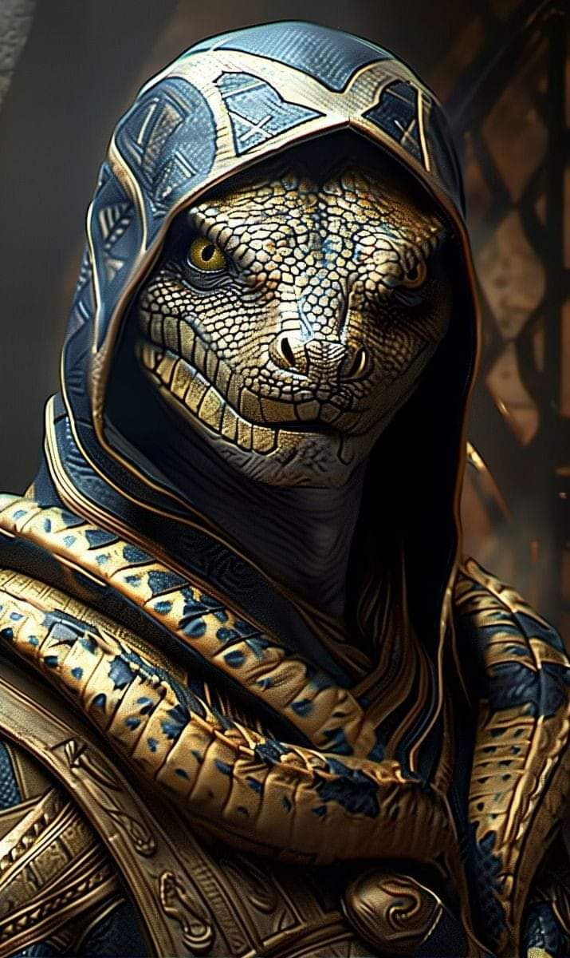

The archon related that it had been only yesterday that they lost the Gravid Gem, and the last known encampment of the bullywugs was a league’s march west of here at the point where the muddy path succumbed to the estuary’s margins. The group knew by way of the Blackscale that a bullywug encampment was nothing lasting. Unlike the lizardfolks’ land-built encampments, bullywugs’ entrenchments were comprised of small dams to control water flow through the swamp that was their prime domain.

The injured Blackscale had drunk some potions to cure their wounds, and now there were about ten separate conversations around their boon of fortune in vanquishing this Poisondusk group. “It’s on now!” one of the archers told her charger lover as their injured scales returned to their intact state.

The mammalian humanoids had not cast spells in a few minutes, and with no anticipation of what would happen next, continued the interrogation. Haal thought for a moment then turned to the leader of the Blackscale lizards. “Do you think there is a way we can draw out the bullywugs to fight them? Your people might be able to fight in the watery conditions, but my friends and I would be at a great disadvantage.”

Round 143

The Poisondusk survivor looked at Haal, contemplating the gambit proposed.

Amara noticed that her cat’s grace spell—which should have expired by now—was still active, and Haal noticed the same for his bull’s strength spell. The three aid spells that Kassuq had cast should also have just expired, and yet the archon and his two Blackscale allies were still endowed with these buffs.

A contingent of bullywugs that had been tracking the Poisondusk the heroes had just slain now came with the intention of finishing off this village, and they likely considered it a bonus that the work had been done by the Blackscales and mammals in their midst. The convenience was exploited, and the frogmen had snuck around to the northeast edge of the clearing. With a silent somatic command, they now leapt towards the summit, and were duly spotted by a few of the archers that Kodak had positioned along the highest ridge to the north.

“Bullywugs innncomiiiing!” called out the sharpest shooter among the Blackscales as he and other archers prepared arrows and waited until the enemies got closer.

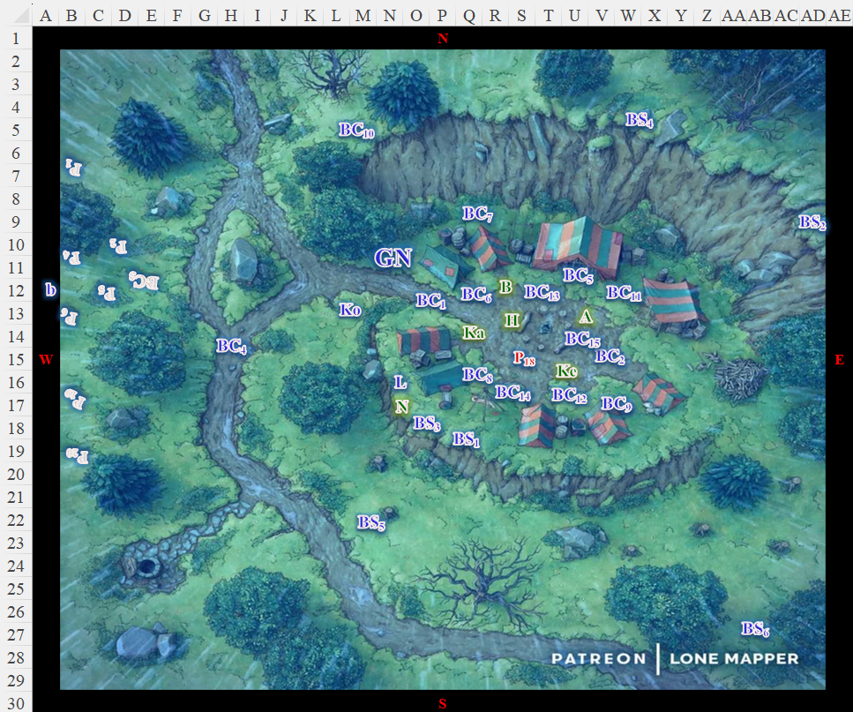

Round 144

Character | Group | Initiative | Roll | Modified Roll | Speed
Kelvar | 1 | 7 | 19 | 26 | 30’
Bullywugs | 2 | 0 | 19 | 19 | 40’
Blackscale Lizardfolk | 1 | 0 | 18 | 18 | 40’
Kassuq | 1 | 6 | 11 | 17 | 40’ - 60’
Nihm | 1 | 4 | 11 | 15 | 30’
Haal | 1 | 0 | 13 | 13 | 30’
Baldoor | 1 | 7 | 4 | 11 | 30’
Amara | 1 | 4 | 4 | 8 | 30’

Kelvar knew the bullywugs to be characteristically sadistic and brutal warriors, and was not looking forward to an up-close confrontation with them. He ran west and circled around to the north and east to get to the top of the ridge. Being a close combat fighter, there wasn’t much he could do from the camp below.

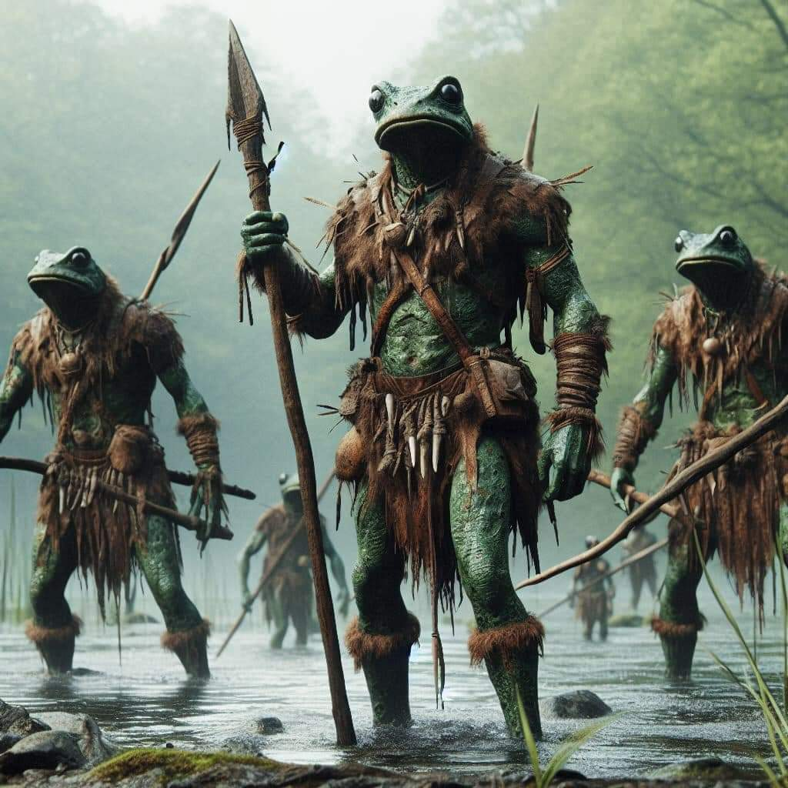

The bullywugs advanced. Now aware that they no longer had the advantage of surprise, some of their spellcasters slowed down to cast spells on themselves and others passing by them with long-legged strides. The frontmost warrior was about 400’ from the mound, with a pack of frog-headed men and women hopping behind the leader for almost 100’.

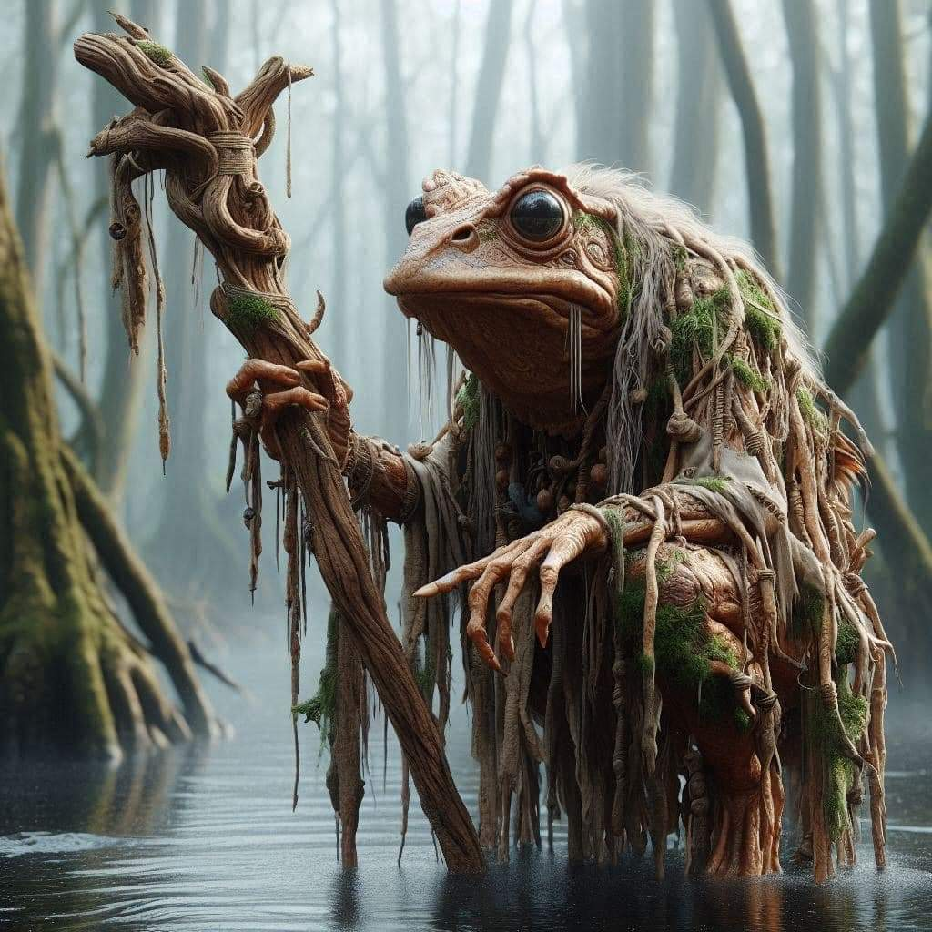

The Blackscale lizardfolk mobilized so as to concentrate chargers atop the northern ridge. “Archers, be on the lookout for incursions from other directionssss!” Kodak warned.

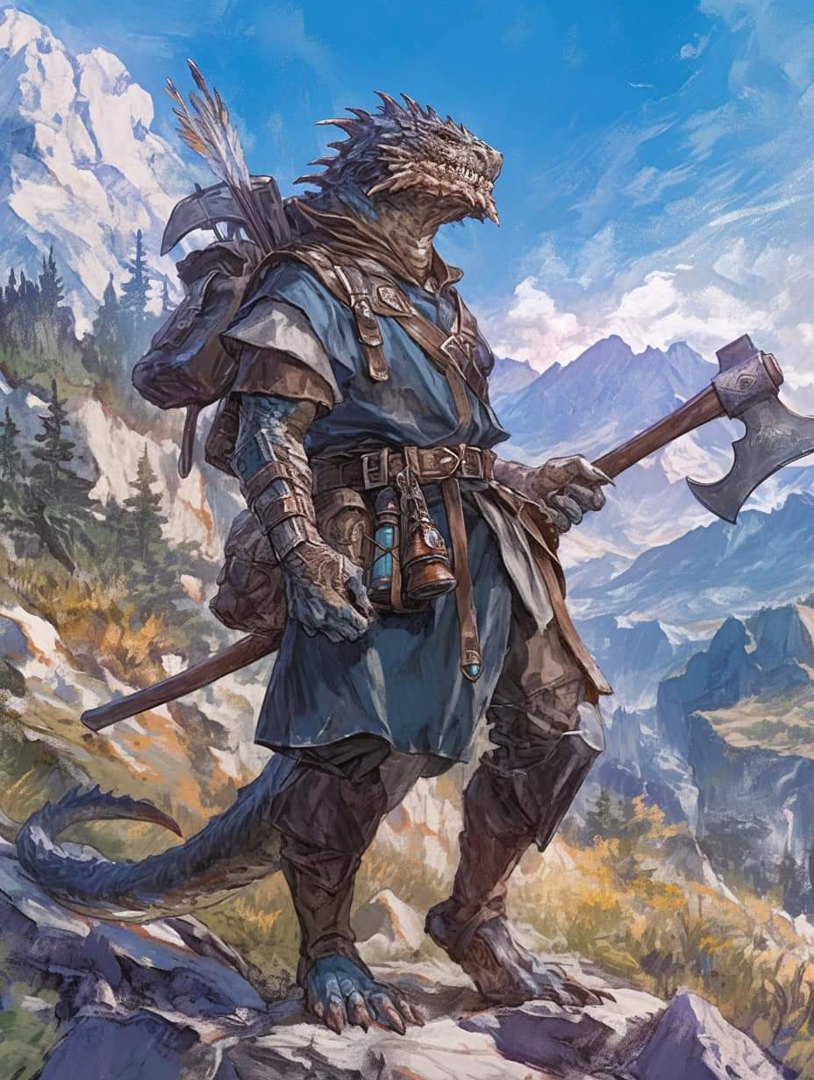

Archers and chargers took up positions, clustered mostly around the northern ridge.

One charger watched over the bound Poisondusk hostage.

Kassuq ran ahead of the dwarfs, using his superior speed to get to the top of the ridge and help those lizards that were already there.

Nihm headed to the edge of the lower ridge by the tents where she watched for bullywugs, expecting them to attack from multiple directions. Lucky trotted along at her side.

Haal was not as personally familiar with bullywugs as Kelvar was, but his bookish understanding of the ruthless killers nevertheless gave him cause for concern. The warrior-priest ran along next to Amara stopping just ahead of her and Nihm and held his Gloves of the Starry Sky in front of himself, prepared to expend a 1st-level spell to cast magic missiles at the first bullywug they saw.

Baldoor ran alongside his fellow dwarf, wanting to get in close and personal with the approaching bullywugs.

Amara followed Nihm, running along behind the ranger and wolf. She stopped and stood next to Nihm and was prepared to cast magic missiles against the first bullywug she saw.

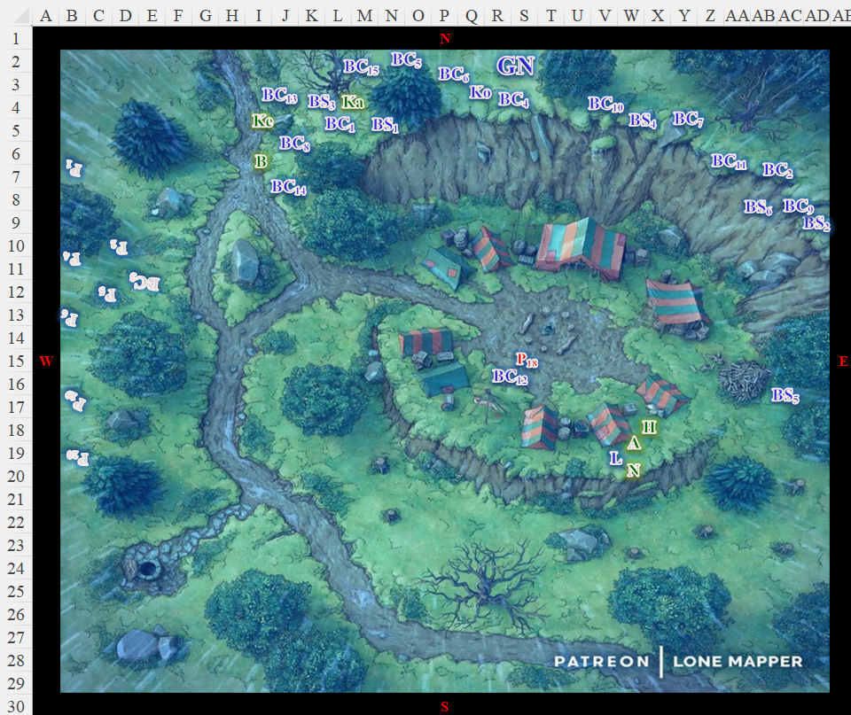

Round 145

The bullywugs continued to advance from the east-northeast, their frontlines reaching 320’. The rear of the formation sprinted such that the 100’ long advance shrunk to about 50’ with bullywug diehards and berserkers coming closer together as they steeled their nerves. One divine spellcaster—warded with a visible, cylindrical sanctuary spell—was foaming at the mouth, a sign of the frenzied state that these ruthless ruffians would imminently attain once combat ensued.

Kodak reached the summit, and commanded, “Ready arrows!” Within six seconds, he would give the call to release the first volley, which was likely to slow down at least a handful of bullywugs. The Blackscale Chieftain was pretty much out of buff spells by now, so he drew an axe and chose an opponent coming his way.

The Blackscale archers had already prepped their first arrows, and held their stances as the frog-faced assailants advanced.

Kassuq continued his charge up the slope as well, hoping to be in a position to engage the bullywugs as they reached the frontlines of the lizardfolk.

Kelvar and Baldoor continued their advance up the hill to the slope, intent on supporting the lizardfolk against the bullywugs.

Seeing no immediate threat, Haal, Amara, Nihm and lucky began to move east, watching the slope for any bullywugs approaching from the east.

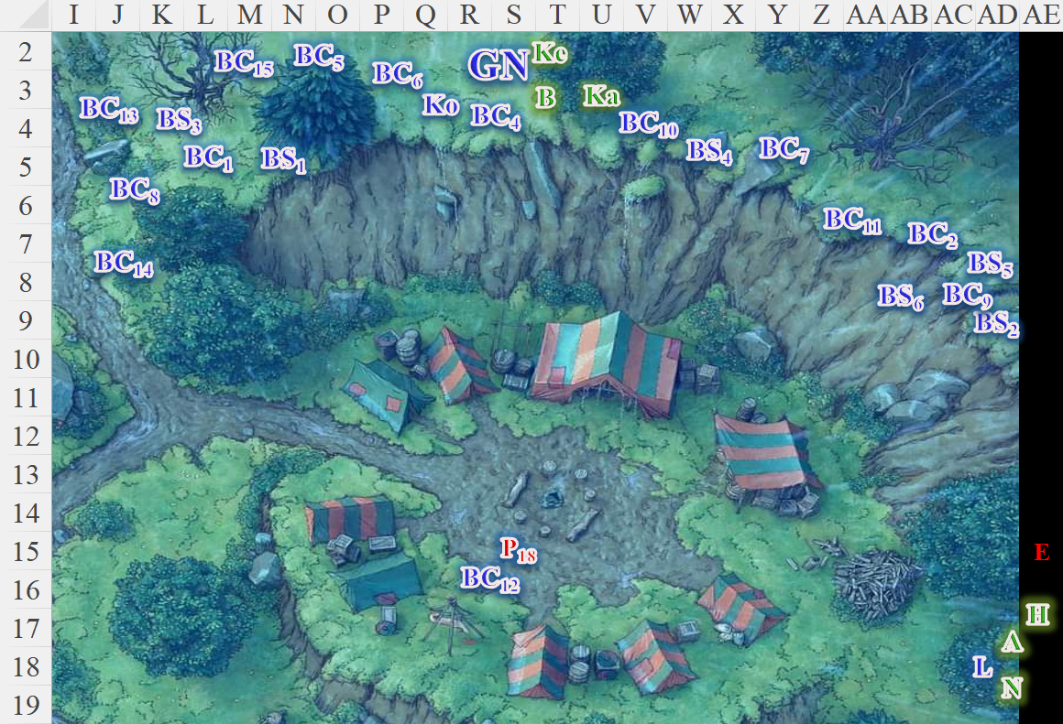

Round 146

Most of the bullywugs were visibly frothing at the mouth, and now leapt forward on their lithe, muscular legs, the frontline reaching 200’ while the formation remained dispersed across 50’ or so.

The Blackscale lizardfolk were now also frenzied with the anticipation of yet another battle.

“Skirmisherssss,” Kodak ordered, “Loose arrows at will until they are upon us; then execute a skirmishing retreat! Warriors, hold positions.”
Character | Attack Type | Damage | BAB | Dex Mod+ | W+ | Other+ | Total Score | Roll | Total
Blackscale Skirmisher 1  (Umbrage) | MW Longbow | 1d8/x3 | 3 | 3 | 1 | +2 height  -4 distance | 5 | 7 | 12
Blackscale Skirmisher 2 | MW Longbow | 1d8/x3 | 3 | 3 | 1 | +2 height | 5 | 9 | 14
Blackscale Skirmisher 3 | MW Longbow | 1d8/x3 | 3 | 3 | 1 | -4 distance | 5 | 19 | 24
Blackscale Skirmisher 4 | MW Longbow | 1d8/x3 | 3 | 3 | 1 | +2 height | 5 | 14 | 19
Blackscale Skirmisher 5 | MW Longbow | 1d8/x3 | 3 | 3 | 1 | -4 distance | 5 | 10 | 15
Blackscale Skirmisher 6 | MW Longbow | 1d8/x3 | 3 | 3 | 1 | +2 height | 5 | 13 | 18
Miss, miss, hit (Diehard 1), hit (Diehard 1), miss, hit (Diehard 2).
Dmg to Diehard 1: 6.
Dmg to Diehard 2: 7.

Kelvar stopped as he reached the Blackscale lizards’ lines and stood to Baldoor’s left, putting his fellow dwarf between himself and Kassuq. He prepared himself for the coming fight, his shield and warhammer ready to meet the bullywug menace.

Kassuq stood ready to fight and took a moment to cast aid [expired on Round 186] upon himself, though he’d noted it was still active, as he howled a warning to the bullywugs as they approached.

As Baldoor got up to the Blackscale lizards’ lines, he cast nimbus of light upon himself as he readied himself to fight, shield in his left hand, warhammer in his right.

On the opposite side of the line, Haal, Amara, Nihm and Lucky stopped and watched up the slope, ready for the bullywugs to emerge. Nihm was prepared to cast one of her two remaining ranger entangle spells, and to send forth a blast of magic missiles at the first bullywug that she saw in range. Haal, meanwhile, pulled out a scroll of summon monster II and prepared to call forth a Celestial giant bee once Nihm trapped any bullywugs inside her entangle spell. Lucky was standing just in front of Nihm, growling at the approaching bullywugs, his hackles up and ears turned back, prepared to defend his friends while Xena stayed perched on Amara’s shoulder, not really looking forward to the coming battle.

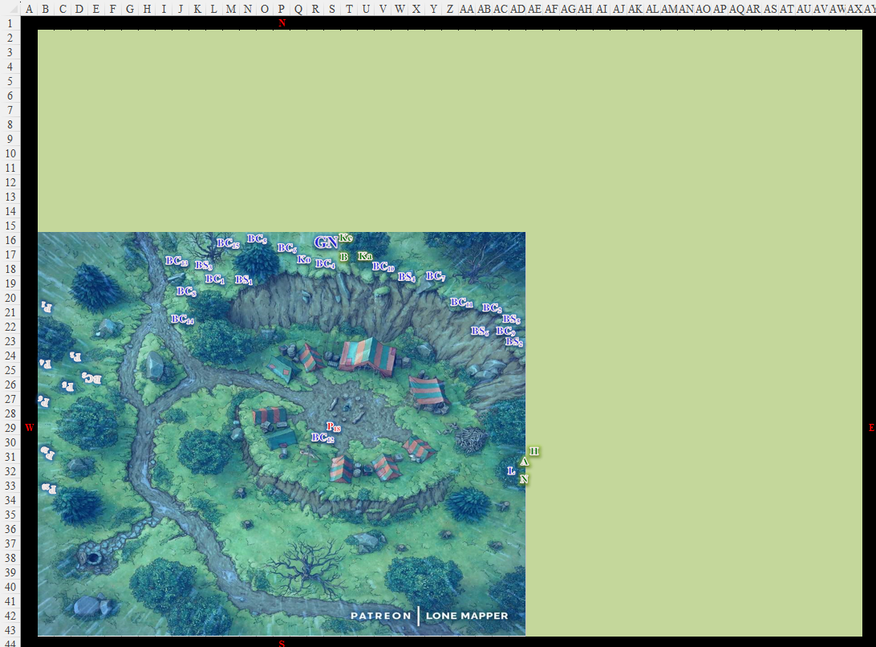

Round 147

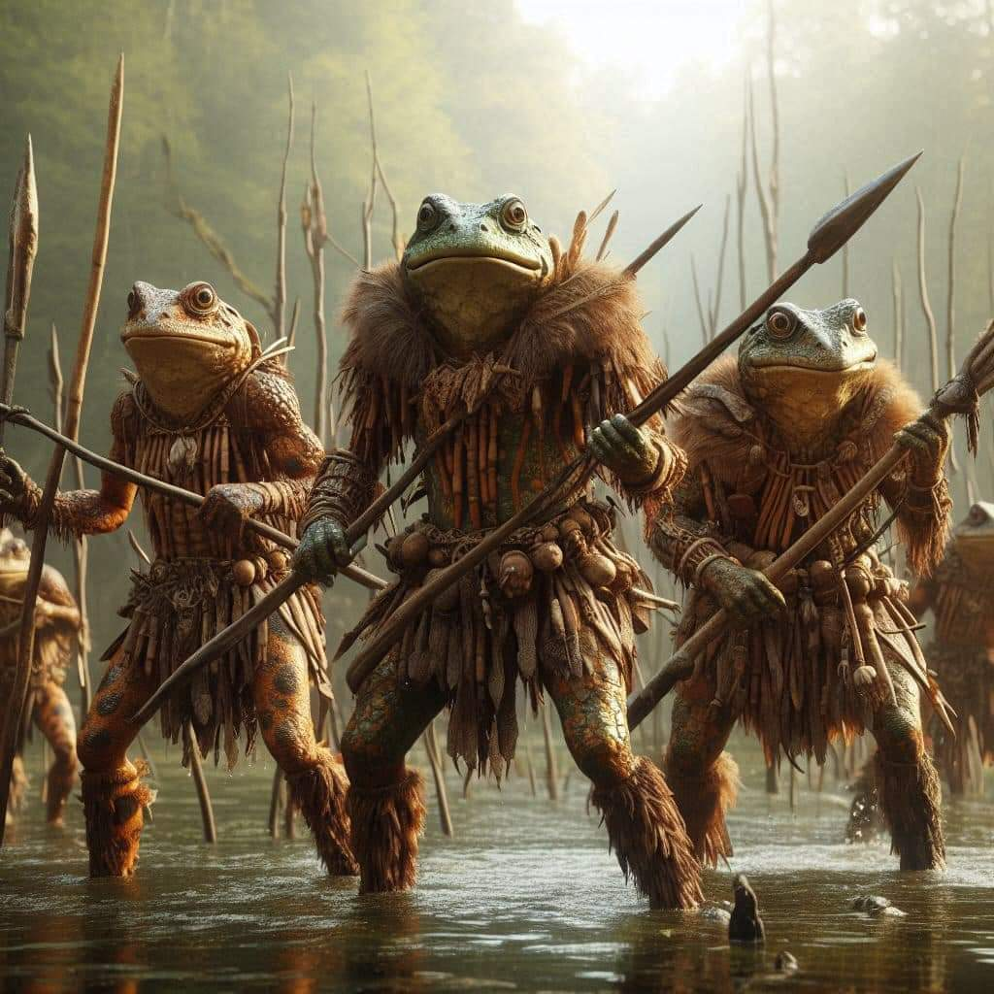

The bullywugs advanced some more, now well within firing range of the frontline Blackscale skirmishers. The Blackscale lizardfolk archers released another volley of arrows, as their warrior friends reveled in the face of the enemy.
Character | Attack Type | Damage | BAB | Dex Mod+ | W+ | Other+ | Total Score | Roll | Total
Blackscale Skirmisher | MW Longbow | 1d8/x3 | 3 | 3 | 1 | 2 height | 9 | 6 | 15
Blackscale Skirmisher | MW Longbow | 1d8/x3 | 3 | 3 | 1 | 2 height | 9 | 7 | 16
Blackscale Skirmisher | MW Longbow | 1d8/x3 | 3 | 3 | 1 | 2 height | 9 | 13 | 22
Blackscale Skirmisher | MW Longbow | 1d8/x3 | 3 | 3 | 1 | 2 height  -2 distance | 7 | 17 | 24
Blackscale Skirmisher | MW Longbow | 1d8/x3 | 3 | 3 | 1 | 2 height  -2 distance | 7 | 12 | 19
Blackscale Skirmisher | MW Longbow | 1d8/x3 | 3 | 3 | 1 | 2 height | 9 | 11 | 20
Miss, hit (Diehard 1), hit (Diehard 1), hit (Diehard 2), hit (Diehard 2), hit (Diehard 3).
Dmg to Diehard 1: 7 + 1 = 8.
Dmg to Diehard 2: 2 + 3 = 5.
Dmg to Diehard 3: 8.

Diehard 2 died hard.

Kelvar held his ground as he awaited the approaching bullywugs. He knew stepping out further could get him surrounded, so he remained in place, ready to fight.

Kassuq also stood his ground and growled at the bullywugs as they got closer.

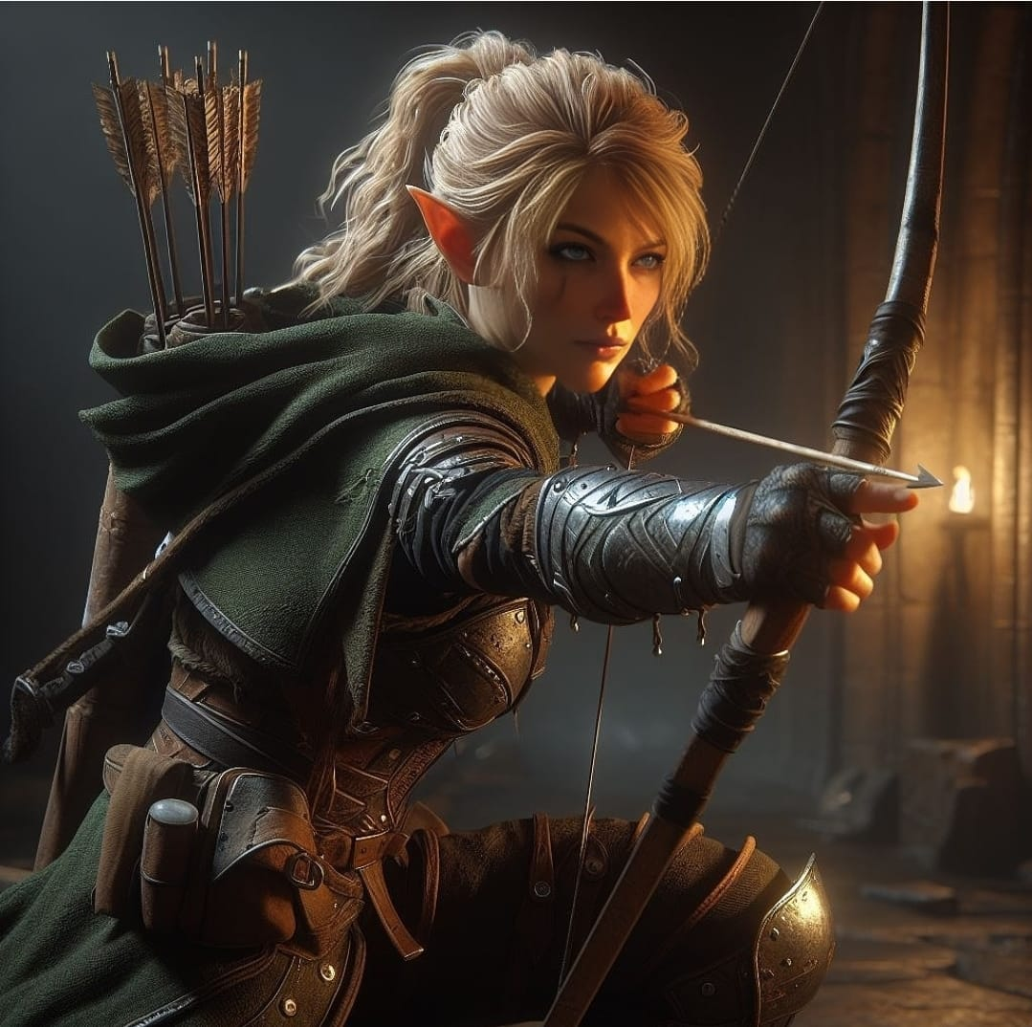

Nihm and Lucky knew the bullywugs were getting close as the Blackscale lizards launched their arrows, so they advanced slowly until they could see the approaching bullywugs.

Haal followed Nihm, not wanting his friend to get caught out in the open alone. He was still prepared to send off a barrage of magic missiles from his gloves when he had the chance.

Baldoor smiled at the approaching bullywugs as the light from his spell surrounded him. He waited as they grew closer, intending to let his light blast forth once a bullywug was within 20’ of him.

Amara followed both Haal and Nihm as Xena tried to be as unnoticeable as possible, half hiding inside of Amara’s hood. Amara watched for any bullywugs, ready to let loose a group of magic missiles as soon as she had a target.

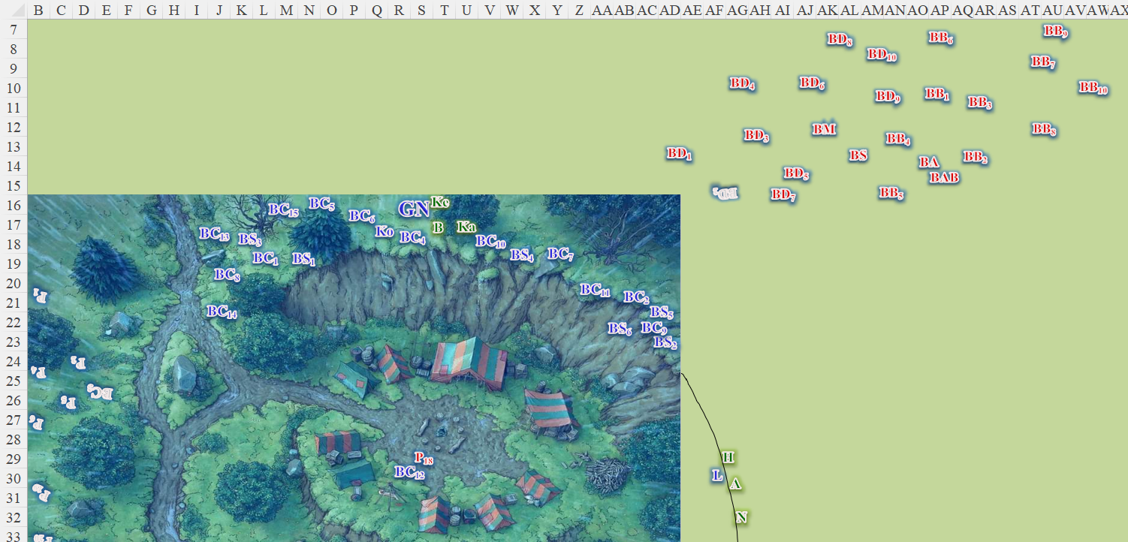

Round 148

The bullywugs continued the charge, some reaching the Blackscale lizardfolk, who engaged them, charging from the top of the ridge. Their marshal emitted some blurby battle cry, and the bullywugs all became overcome with a murderous frenzy.
Force of Will: Bullywugs gained +1 to Will saves.
Character | Attack Type | Damage | BAB | Str Mod+ | Other+ | Total Score | Roll | Total | Targeting
Bullywug Diehard 3 | Halfspear | 1d6 | 3 | 0 | 2 charge | 5 | 3 | 8 | Kassuq
Bullywug Diehard 1 | Halfspear | 1d6 | 3 | 0 | 2 charge | 5 | 18 | 23 | Charger 7
Bullywug Diehard 7 | Halfspear | 1d6 | 3 | 0 | 2 charge | 5 | 17 | 22 | Charger 2
Bullywug Diehard 5 | Halfspear | 1d6 | 3 | 0 | 2 charge | 5 | 4 | 9 | Charger 11
Bullywug Diehard 4 | Halfspear | 1d6 | 3 | 0 | 2 charge | 5 | 3 | 8 | Charger 6
Miss, hit (BC7), hit (BC2), miss, miss.
Dmg to BC7: 6 + 2 charge = 8.
Dmg to BC2: 3 + 2 charge = 5.
Character | Attack Type | Damage | BAB | Str Mod+ | Other+ | Total Score | Roll | Total | Targeting
Bullywug Berserker 4 | Halfspear | 1d6 | 3 | 2 | 2 charge | 7 | 14 | 21 | Charger 9
Hit. Dmg: 1 + 2 charge = 3.
Character | Attack Type | Damage | BAB | Str Mod+ | W+ | Other+ | Total Score | Roll | Total | Targeting
Blackscale Charger 9 | MW Spear (oiled) | 1d8/x3 | 3 | 3 | 1 | 2 charge | 9 | 1 | 10 | Berserker 4
Blackscale Charger 6 | MW Spear (oiled) | 1d8/x3 | 3 | 3 | 1 | 0 | 7 | 10 | 17 | Diehard 4
Blackscale Charger 7 | MW Spear (oiled) | 1d8/x3 | 3 | 3 | 1 | 0 | 7 | 9 | 16 | Diehard 1
Blackscale Charger 2 | MW Spear (oiled) | 1d8/x3 | 3 | 3 | 1 | 0 | 7 | 7 | 14 | Diehard 7
Blackscale Charger 4 | MW Spear (oiled) | 1d8/x3 | 3 | 3 | 1 | 0 | 7 | 5 | 12 | Diehard 3
Blackscale Charger 11 | MW Spear (oiled) | 1d8/x3 | 3 | 3 | 1 | 2 charge | 9 | 6 | 15 | Diehard 5
Gnar Nahsh | MW Spear (oiled) | 1d8/x3 | 4 | 6 | 1 | 0 | 11 | 11 | 22 | Diehard 4
Miss, hit (BD4), hit (BD1), miss, miss, hit (BD4).

Diehard 1 died.

Gnar Nahsh struck at the impetuous diehard.
Character | Attack Type | Damage | BAB | Str Mod+ | W+ | Total Score | Roll | Total | Targeting
Gnar Nahsh | MW Spear (oiled) | 1d8/x3 | 4 | 6 | 1 | 11 | 9 | 20 | BD4
Hit. Dmg: 8 + 4 = 12.

Diehard 4 was nearly dead from the stab.

The bullywug marshal studied the battlefield, directing his diehards and berserkers to their respective foes.

The bullywug shaman cast desecrate to his immediate west, getting some of his own diehards in the blast.
Base dmg: 6 + 6 = 12 negative energy [evil].
Character | Save vs.  negative energy burst | Ranks | Roll | Check
Bullywug Diehard 1 | Will | 3 | 9 | 12
Bullywug Diehard 7 | Will | 3 | 4 | 7
Blackscale Charger 2 | Will | 4 | 1 | 5
Blackscale Charger 5 | Will | 4 | 16 | 20
Blackscale Charger 11 | Will | 4 | 12 | 16
Blackscale Skirmisher 2 | Will | 4 | 14 | 18
Blackscale Skirmisher 5 | Will | 4 | 5 | 9
Blackscale Skirmisher 6 | Will | 4 | 6 | 10
Fail, fail, fail, success (BC5), success (BC11), success (BS2), fail, fail.
Dmg to BC5, BC11, and BS2: 6 negative energy [evil].
All others take base damage above

The bullywug acolyte with the sanctuary spell was close to the blast, and healed one of his mates.
CMW: BD7 gained 10 + 4 = 14 hps.

The bullywug altar boy stood behind the shaman holding some potions and other accoutrements.

Kodak the Forsaken pointed his chargers and skirmishers towards the central formation [Z11:AC13], and began to move forward with his axe in his hand.

Kelvar charged forward 5’ and swung his warhammer at the bullywug closest to them.
Melee Weapon | Dmg. | D+ | TH+ | Critical | Type | Wt. | Atk | Roll | Check
MW Warhammer | 1d8 | +3 | 1 + 2  Flank | x3 | Bludgeon | 3.0 | +8 | 5 | 13
Miss.

Kassuq stepped forward and swung his sword at the bullywug in front of him.
Melee Weapon | Dmg | D+ | TH+ | Critical | Type | Wt. | Atk | Roll | Check
Longsword +1 | 1d8 | 6 | 1 + 2  Flank | 19-20/x2 | Slashing | 4.0 | +13 | 13 | 26
Hit. Dmg: 3 + 6 = 9.

Kassuq stood defiantly as his foe went down on his froggy knees and began to die.

Nihm, finally able to see some bullywugs, cast her entangle (ranger) spell, trying to get at least a couple of them entangled as well as making it more difficult for them to maneuver on the flank closest to her.

Some of the bullywugs were able to wrest free of the tendrils for the moment.
See next round.

Haal, spotting a bullywug headed his direction, pointed his hands (Gloves of the Starry Sky) towards the evil creature and, sacrificing his sanctuary spell, sent forth 2 magical projectiles from his gloves at the charging creature.
Dmg: 5 + 2 = 7 magic [force].

Baldoor moved forward next to Gnar Nash and looked for another target for his spell.
Target first bullywug within 20’ with Nimbus of Light. This target (BD4) appears nearly dead (unless another PC just killed it); select other target?

Amara turned towards the closest bullywug and let loose a barrage of magical projectiles (magic missile).
Dmg: 8 + 2 = 10 magic [force].

Haal’s and Amara’s magic missiles were enough to bring down the bullywugs’ charger.

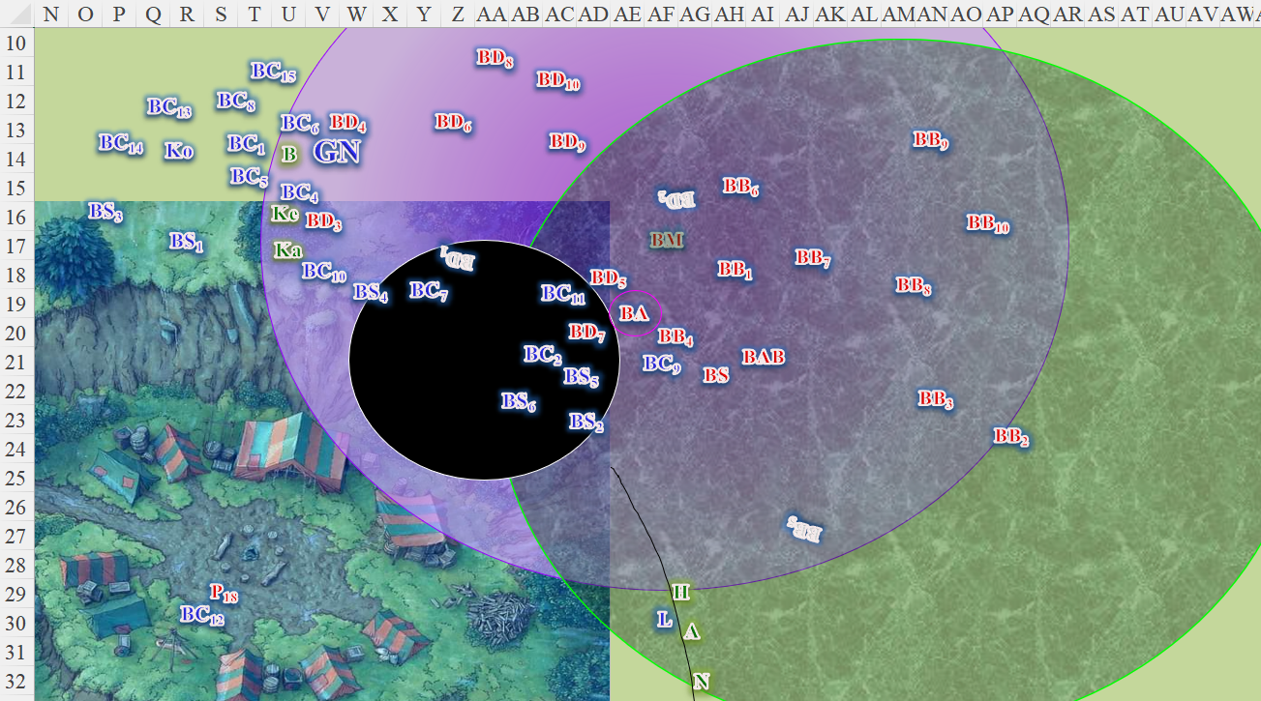

Round 149

The bullywugs continued their assaults, with the martial directing those who could escape the entangle spell to do so.
Character | Save vs.  entangle | Ranks | Roll | Check
Bullywug Diehard 5 | Reflex | 1 | 3 | 4
Bullywug Diehard 7 | Reflex | 1 | 15 | 16
Bullywug Berserker 1 | Reflex | 0 | 1 | 1
Bullywug Berserker 4 | Reflex | 0 | 16 | 16
Bullywug Berserker 5 | Reflex | 0 | 18 | 18
Bullywug Berserker 6 | Reflex | 0 | 19 | 19
Bullywug Berserker 7 | Reflex | 0 | 5 | 5
Bullywug Berserker 3 | Reflex | 0 | 15 | 15
Bullywug Berserker 8 | Reflex | 0 | 9 | 9
Bullywug Berserker 9 | Reflex | 0 | 14 | 14
Bullywug Berserker 10 | Reflex | 0 | 5 | 5
Fail, success, fail, success, success, success, fail, success, fail, success, fail.

Bullywug diehard 5 and berserkers 1, 7, 8, and 10 were stuck by the entangling vines.

The rest of the squadron proceeded, leaping high in the air before pouncing on their reptile and mammal foes. Those inside the entangle spell who had slipped free were still only moving at half speed, and were hopping angrily.

Those at the frontlines attacked.
Character | Attack Type | Damage | BAB | Str Mod+ | Other+ | Total Score | Roll | Total | Targeting
Bullywug Diehard 8 | Halfspear | 1d6 | 3 | 0 | 2 charge | 5 | 14 | 19 | BC15
Bullywug Diehard 4 | Halfspear | 1d6 | 3 | 0 | 2 flank | 5 | 19 | 24 | BC6
Bullywug Diehard 10 | Halfspear | 1d6 | 3 | 0 | 2 charge | 5 | 12 | 17 | Gnar Nhash
Bullywug Diehard 6 | Halfspear | 1d6 | 3 | 0 | 2 charge  2 flank | 7 | 7 | 14 | Gnar Nhash
Bullywug Diehard 3 | Halfspear | 1d6 | 3 | 0 | 2 charge | 5 | 13 | 18 | Kelvar
Bullywug Diehard 9 | Halfspear | 1d6 | 3 | 0 | 2 charge | 5 | 9 | 14 | Kassuk
Bullywug Berserker 6 | Halfspear | 1d6 | 3 | 2 | 2 charge | 7 | 8 | 15 | BC10
Hit, hit, miss, miss, hit, miss, miss.
Dmg to BC15: 6 + 2 = 8.
Dmg to BC6: 1 + 2 = 3.
Dmg to Kelvar: 5 + 2 = 7 [28/35].

Further to the southeast, those within the entangle spell did what they could to fight off the lizardfolk.
Character | Attack Type | Damage | BAB | Str Mod+ | W+ | Other+ | Total Score | Roll | Total | Targeting
Bullywug Diehard 5 | Halfspear | 1d6 | 3 | 0 | 0 | 2 charge | 5 | 5 | 10 | BC11
Bullywug Diehard 7 | Halfspear | 1d6 | 3 | 0 | 0 | 2 charge | 5 | 15 | 20 | BC2
Bullywug Berserker 4 | Halfspear | 1d6 | 3 | 2 | 0 | 2 charge | 7 | 15 | 22 | BS5
Miss, hit, hit.
Dmg to BC2: 2 + 2 = 4.
Dmg to BS5: 5 + 2 + 2 = 9.

The enemy elites did their best against Nihm’s spell.
Character | Save vs.  entangle | Ranks | Roll | Check
Bullywug Marshal | Reflex | 3 | 14 | 17
Bullywug Shaman | Reflex | 1 | 19 | 20
Bullywug Acolyte | Reflex | 2 | 3 | 5
Bullywug Altar Boy | Reflex | 0 | 12 | 12
Success, success, fail, fail.

The marshal and shaman were able to move a bit, and the former exited the entangled area.

The shaman cast inflict moderate wounds on BC9.
Character | Attack Type | Damage | BAB | Str Mod+ | Total Score | Roll | Total
Poisondusk Shaman | Touch Attack | 2d8+4 negative energy | 4 | 1 | 5 | 14 | 19
Hit. Dmg: 12 + 4 = 16 negative energy [evil].

The charger was still alive, but badly drained of life.

The Blackscale lizardfolk parried and retaliated.
Auto-resolve that only 2 lizardfolk within the entangle spell pass their save, and move 5’ east.
Character | Attack Type | Damage | BAB | Str Mod+ | W+ | Other+ | Total Score | Roll | Total | Targeting
Blackscale Charger 13 | MW Spear (oiled) | 1d8/x3 | 3 | 3 | 1 | 2 flank | 96 | 15 | 24 | BD8
Blackscale Charger 15 | MW Spear (oiled) | 1d8/x3 | 3 | 3 | 1 | 2 flank | 9 | 9 | 18 | BD8
Blackscale Charger 8 | MW Spear (oiled) | 1d8/x3 | 3 | 3 | 1 | 2 flank | 9 | 9 | 18 | BD8
Blackscale Charger 6 | MW Spear (oiled) | 1d8/x3 | 3 | 3 | 1 | 0 | 7 | 20 | 27 | BD4
Hit, hit, hit, threat. 1d20 = 19 + 7 = 26, critical hit.
Dmg to BD8: (6 + 3) + (1 + 3) + (4 + 3) = 9 + 4 + 7 = 20.
Dmg to BD4: (3 x 4) + 3 = 12 + 3 = 15.

Diehard 4 and 8 both died.
Character | Attack Type | Damage | BAB | Str Mod+ | W+ | Other+ | Total Score | Roll | Total | Targeting
Gnar Nahsh | MW Spear (oiled) | 1d8/x3 | 4 | 6 | 1 | 2 flank | 11 | 4 | 15 | BD6
Blackscale Charger 1 | MW Spear (oiled) | 1d8/x3 | 4 | 5 | 1 | 0 | 10 | 19 | 29 | BD10
Blackscale Charger 4 | MW Spear (oiled) | 1d8/x3 | 3 | 3 | 1 | 2 flank | 7 | 20 | 27 | BD6
Miss, hit, threat. 1d20 = 2 + 7 = 9, not a critical hit.
Dmg to BD10: 1 + 5 = 6.
Dmg to BD6: 5 + 7 = 12.

Character | Attack Type | Damage | BAB | Str Mod+ | W+ | Other+ | Total Score | Roll | Total | Targeting
Blackscale Charger 10 | MW Spear (oiled) | 1d8/x3 | 3 | 3 | 1 | 0 | 7 | 17 | 24 | BD9
Blackscale Charger 7 | MW Spear (oiled) | 1d8/x3 | 3 | 3 | 1 | 0 | 7 | 8 | 15 | BB6
Blackscale Charger 11 | MW Spear (oiled) | 1d8/x3 | 3 | 3 | 1 | 0 | 7 | 1 | 8 | BD5
Blackscale Charger 2 | MW Spear (oiled) | 1d8/x3 | 3 | 3 | 1 | 0 | 7 | 7 | 14 | BD7
Blackscale Charger 9 | MW Spear (oiled) | 1d8/x3 | 3 | 3 | 1 | 0 | 7 | 1 | 8 | BS
Hit, miss, miss, miss, miss.
Dmg to BD9: 6 + 3 = 9.

Kodak ordered for the archers to target the elites, with the marshal being the closest and most vulnerable target. The Blackscale skirmishers let loose a volley of arrows, carefully placed to avoid hitting their friends.
Character | Attack Type | Damage | BAB | Dex Mod+ | W+ | Total Score | Roll | Total | Targeting
Blackscale Skirmisher | MW Longbow | 1d8/x3 | 3 | 3 | 1 | 7 | 7 | 14 | Bullywug Marshal
Blackscale Skirmisher | MW Longbow | 1d8/x3 | 3 | 3 | 1 | 7 | 2 | 9 | Bullywug Marshal
Blackscale Skirmisher | MW Longbow | 1d8/x3 | 3 | 3 | 1 | 7 | 3 | 10 | Bullywug Marshal
Blackscale Skirmisher | MW Longbow | 1d8/x3 | 3 | 3 | 1 | 7 | 6 | 13 | Bullywug Marshal
Blackscale Skirmisher | MW Longbow | 1d8/x3 | 3 | 3 | 1 | 7 | 11 | 18 | Bullywug Marshal
Blackscale Skirmisher | MW Longbow | 1d8/x3 | 3 | 3 | 1 | 7 | 9 | 16 | Bullywug Marshal
Miss, miss, miss, miss, hit, hit.
Dmg: 12.

Though the marshal was quite the tactician, he did not seem to be a stalwart combatant, and did not fare well against the twin arrows. He remained standing, however, inspiring his men all the while.

Kelvar stepped past the dead body of one bullywug and swung his hammer at the next one he could find.
Melee Weapon | Dmg. | D+ | TH+ | Critical | Type | Wt. | Atk | Roll | Check
MW Warhammer | 1d8 | +3 | 1 + 2  Flank | x3 | Bludgeon | 3.0 | +8 | 16 | 24
Hit. Dmg to BD6: 5 + 3 = 8.

The foe died at Kelvar’s feet.

Kassuq did the same, swinging his sword at the bullywug before him.
Melee Weapon | Dmg | D+ | TH+ | Critical | Type | Wt. | Atk | Roll | Check
Longsword +1 | 1d8 | 6 | 1 + 2  Flank | 19-20/x2 | Slashing | 4.0 | +13 | 20 | 33
Threat. 1d20 = 6 + 13 = 19. Dmg to BD9: 3 + 6 = 9.

The diehard bullywug held on to his spilling guts as he dropped to the ground.

Nihm nocked an arrow and targeted the closest bullywug with a barrage of arrows.
Ranged Weapon | Dmg. | D+ | TH+ | Critical | Rng. | Wt. | Atk | Roll | Check | Notes
Longbow +1 | 1d8 | 1 | 1 | x3 | 100’ | 3.0 | +9 | 1 | 10 | +1 within 30’
Longbow, Rapid Shot | 1d8 | 1 | 1 | x3 | 100’ | - | +9 | 10 | 19 | +1 within 30’
Miss, hit. Dmg to BB2: 1 + 1 = 2.

Lucky continued to growl and howl at the bullywugs, taunting them to get closer if they could.

Haal, happy with their success so far, smiled as he pointed his gloves at the bullywug out in front of him. Sacrificing another spell and sent forth another pair of magic missiles.
Dmg: 6 + 2 = 8 magic [force].

The cleric then reviewed his remaining spells.
Prepared Spells
Spell | Level | Focus? | DC | Cast?
Detect Magic | 0 | 0 | 12 | þ
Detect Magic | 0 | 0 | 12 | þ
Read Magic | 0 | 0 | 12 | q
Read Magic | 0 | 0 | 12 | q
Read Magic | 0 | 0 | 12 | q
Detect Evil | 1 | 0 | 13 | q
Protection from Evil | 1 | 0 | 13 | q
Protection from Evil | 1 | 1 | 14 | þ
Sanctuary | 1 | 0 | 13 | þ
Enlarge Person | 1 | 0 | 13 | þ
Restoration (Lesser) | 2 | 0 | 14 | q
Spiritual Weapon | 2 | 0 | 14 | q
Spiritual Weapon | 2 | 0 | 14 | q
Bull’s Strength | 2 | 1 | 15 | þ
 | 3 | 0 | 15 | q
 | 3 | 0 | 15 | q

Baldoor took aim with his spell. Motioning with his hands, he collected the energy of the nimbus of light into a swirling ribbon around his outstretched arm. He then gave the command word and launched the spells energy and light at a nearby enemy.
Ranged Weapon | Dmg. | D+ | TH+ | Critical | Rng. | Wt. | Atk | Roll | Check
Ranged Touch Attack | varies | varies | +0 | - | varies | - | +5 | 20 | 25
Hit (no crit applies). Dmg: 8 + 3 = 11 light [good].

The ray struck true, but Haal began to notice that the berserkers were of varying ranks, and he might have just pissed off the burliest, highest-ranking one.

Amara looked across the battlefield and decided to launch her last fireball. She sent it soaring to land and engulfed as many bullywugs as she could.
Character | Save vs.  fireball | Ranks | Roll | Check
Bullywug Berserker 1 | Reflex | 0 | 11 | 11
Bullywug Berserker 7 | Reflex | 0 | 8 | 8
Bullywug Berserker 8 | Reflex | 0 | 5 | 5
Bullywug Berserker 10 | Reflex | 0 | 10 | 10
Bullywug Altar Boy | Reflex | 1 | 3 | 4
Bullywug Shaman | Reflex | 1 | 17 | 18
All but the shaman fail.
Dmg to all but the shaman: 21 fire.
Dmg to shaman: 10 fire.

Berserkers 1, 7, and 10 died, as did the altar boy.

The sorceress then realized she still had another fireball in her daily portfolio.

 | Spells per Day by Level
 | 0th | 1st | 2nd | 3rd | 4th | 5th | 6th | 7th | 8th |  | 9th
Base Spells | 6 | 6 | 5 | 3 | 0 | 0 | 0 | 0 | 0 |  | 0
Charisma Bonus | 0 | 1 | 1 | 1 | 0 | 0 | 0 | 0 | 0 |  | 0
Total Spells | 6 | 7 | 6 | 4 | 0 | 0 | 0 | 0 | 0 |  | 0
Spell DC | 13 | 14 | 15 | 16 | 17 | 18 | 19 | 20 | 21 |  | 22
Cast? | 2 | 1 | 1 | 3 | 0 | 0 | 0 | 0 | 0 |  | 0
 | Effective Caster Level: |  |  | 6

The bullywugs were gravely outnumbered now, having sacrificed their frontline diehards for the cause. However, at least some of the berserkers would not go down so easily.

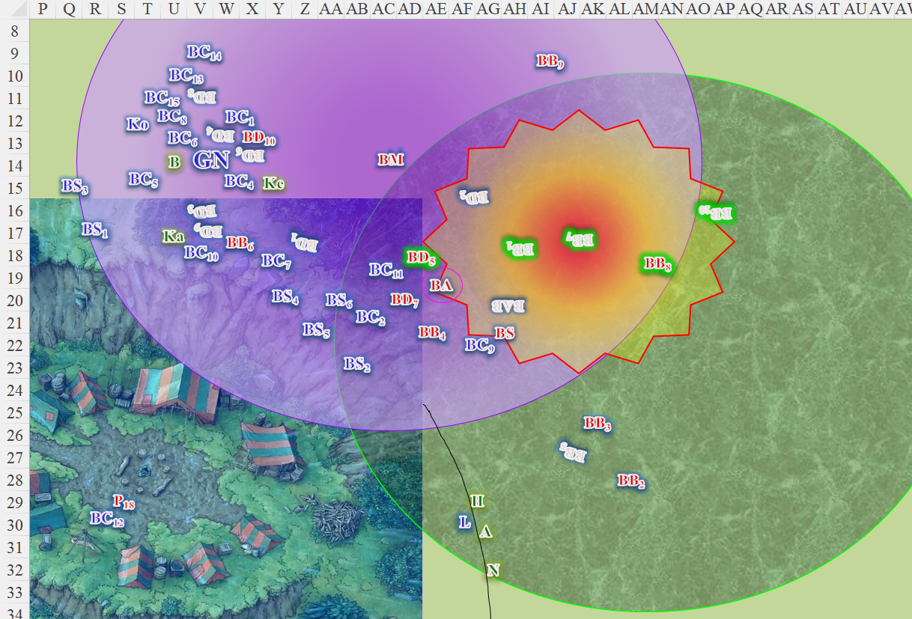

Round 150

The remaining bullywugs jabbed at their foes violently. The acolyte lost his sanctuary buff in the process.
Character | Attack Type | Damage | BAB | Str Mod+ | W+ | Other+ | Total Score | Roll | Total | Targeting
Bullywug Diehard 5 | Halfspear | 1d6 | 3 | 0 | 0 | 2 flank | 3 | 1 | 4 | BC11
Bullywug Diehard 7 | Halfspear | 1d6 | 3 | 0 | 0 | 2 flank | 3 | 12 | 15 | BC11
Bullywug Acolyte | Staff +2 | 1d6+1+2 | 4 | 1 | 2 | 2 flank | 7 | 18 | 25 | BC11
Miss, miss, hit. Dmg: 2 + 1 + 2 = 5.
Character | Attack Type | Damage | BAB | Str Mod+ | Dex Mod+ | W+ | Total Score | Roll | Total | Targeting
Bullywug Diehard 10 | Halfspear | 1d6 | 3 | 0 | 1 | 0 | 3 | 4 | 7 | BC1
Bullywug Berserker 4 | Halfspear | 1d6 | 3 | 2 | 0 | 0 | 5 | 5 | 10 | BC2
Bullywug Berserker 6 | Halfspear | 1d6 | 3 | 2 | 0 | 0 | 5 | 10 | 15 | BC10
Bullywug Marshal | Staff +2 | 1d6+1+2 | 4 | 1 | 2 | 2 | 7 | 14 | 21 | BC9
Bullywug Shaman | Touch Attack | IMW | 4 | 1 | 2 | 0 | 5 | 6 | 11 | Kelvar
Miss, miss, miss, hit, miss.
Dmg to BC9: 3 + 1 + 2 = 6.

The Blackscales were feeling good about their odds, and continued cutting down their froggy foes. The archers went first.
Character | Attack Type | Damage | BAB | Dex Mod+ | W+ | Total Score | Roll | Total | Targeting
Blackscale Skirmisher 1 | MW Longbow | 1d8/x3 | 3 | 3 | 1 | 7 | 9 | 16 | BD10
Blackscale Skirmisher 2 | MW Longbow | 1d8/x3 | 3 | 3 | 1 | 7 | 1 | 8 | BB4
Blackscale Skirmisher 3 | MW Longbow | 1d8/x3 | 3 | 3 | 1 | 7 | 2 | 9 | BB4
Blackscale Skirmisher 4 | MW Longbow | 1d8/x3 | 3 | 3 | 1 | 7 | 9 | 16 | BB9
Blackscale Skirmisher 5 | MW Longbow | 1d8/x3 | 3 | 3 | 1 | 7 | 5 | 12 | BB4
Blackscale Skirmisher 6 | MW Longbow | 1d8/x3 | 3 | 3 | 1 | 7 | 14 | 21 | BD7
Hit, miss, miss, hit, miss, hit.
Dmg to BD10: 1.
Dmg to BB9: 6.
Dmg to BD7: 2.

As the archers moved into better positions for their next shorts, the chargers cleaned up the battlefield a bit more.
Character | Attack Type | Damage | BAB | Str Mod+ | W+ | Other+ | Total Score | Roll | Total | Targeting
Gnar Nahsh | MW Spear (oiled) | 1d8/x3 | 4 | 6 | 1 | 2 flank | 13 | 2 | 15 | BD10
Blackscale Charger 1 | MW Spear (oiled) | 1d8/x3 | 4 | 5 | 1 | 2 flank | 12 | 18 | 30 | BD10
Blackscale Charger | MW Spear (oiled) | 1d8/x3 | 3 | 3 | 1 | 2 flank | 9 | 13 | 22 | BD10
Blackscale Charger | MW Spear (oiled) | 1d8/x3 | 3 | 3 | 1 | 2 flank | 9 | 17 | 26 | BD10
Blackscale Charger | MW Spear (oiled) | 1d8/x3 | 3 | 3 | 1 | 2 flank | 9 | 18 | 27 | BD10
Blackscale Charger | MW Spear (oiled) | 1d8/x3 | 3 | 3 | 1 | 0 | 7 | 5 | 12 | BB6
Blackscale Charger | MW Spear (oiled) | 1d8/x3 | 3 | 3 | 1 | 0 | 7 | 2 | 9 | BB9
Blackscale Charger | MW Spear (oiled) | 1d8/x3 | 3 | 3 | 1 | 0 | 7 | 14 | 21 | BA
Blackscale Charger | MW Spear (oiled) | 1d8/x3 | 3 | 3 | 1 | 0 | 7 | 5 | 12 | BB4
Blackscale Charger | MW Spear (oiled) | 1d8/x3 | 3 | 3 | 1 | 0 | 7 | 15 | 22 | BS
Miss, hit, hit, hit, hit, miss, miss, hit, miss, hit.
Dmg to BD10: 5 + 7 + 3 + 4 = 19.
Dmg to BA: 8.
Dmg to BS: 2.

Diehard 10 died.

“We diee as we liiiiiiiiive!” the bullywug marshal called out in Common. “Our sacrifice is for the Clutch and Brood!”

Kelvar swung his hammer at the bullywug marshal in front of him, hoping to end the existence of another foul creature.
Melee Weapon | Dmg. | D+ | TH+ | Critical | Type | Wt. | Atk | Roll | Check
MW Warhammer | 1d8 | +3 | 1 + 2  Flank | x3 | Bludgeon | 3.0 | +8 | 10 | 18
Hit. Dmg: 6 + 3 = 9.

The marshal was badly hurt, and now focused on ending Kelvar’s life.

Kassuq stepped past a dead bullywug to swing his sword at the bullywug engaged with the Blackscale lizard next to him.
Melee Weapon | Dmg | D+ | TH+ | Critical | Type | Wt. | Atk | Roll | Check
Longsword +1 | 1d8 | 6 | 1 + 2  Flank | 19-20/x2 | Slashing | 4.0 | +13 | 13 | 26
Hit. Dmg: 8 + 6 = 14.

The bullywug flinched and croaked menacingly at the archon.

Nihm nocked an arrow and targeted the same bullywug with her arrows.
Ranged Weapon | Dmg. | D+ | TH+ | Critical | Rng. | Wt. | Atk | Roll | Check | Notes
Longbow +1 | 1d8 | 1 | 1 | x3 | 100’ | 3.0 | +9 | 17 | 26 | +1 within 30’
Longbow, Rapid Shot | 1d8 | 1 | 1 | x3 | 100’ | - | +9 | 1 | 10 | +1 within 30’
Hit, miss. Dmg: 3 + 1 = 4.

The entangled bullywug swore to fuck up the druid’s funny looking dog.

Lucky inched forward, sensing that his companion elf would soon drop the spell and he would charge the bullywug if it remained alive.

Haal cast spiritual weapon [expired on Round 154] and brought forth a magical mace next to the bullywug stuck in the entangle spell in front of him, striking at the foul creature.
Melee Weapon | Dmg | D+ | TH+ | Critical | Type | Wt. | Atk | Roll | Check
Spiritual Heavy Mace | 1d8 | 2 | 0 | ×2 | Bludgeon | - | +8 | 4 | 12
Miss.

Baldoor, with no bullywugs nearby, instead focused on his allies, taking note of the health of the chargers in their number.
Character | Melee | Ranged | Evil/  Neg | Total Damage | Temp | HPs | Current HPs
Gnar Nahsh |  |  |  | 0 | 18 | 38 | 56
Blackscale Charger 1 |  |  |  | 0 | 17 | 28 | 45
Blackscale Charger 2 | 9 |  | 12 | 21 |  | 28 | 7
Blackscale Charger 3 |  |  |  | 0 |  | 28 | 28
Blackscale Charger 4 |  |  |  | 0 |  | 28 | 28
Blackscale Charger 5 |  |  | 6 | 6 |  | 28 | 22
Blackscale Charger 6 |  |  |  | 0 |  | 28 | 28
Blackscale Charger 7 | 8 |  |  | 8 |  | 28 | 20
Blackscale Charger 8 |  |  |  | 0 |  | 28 | 28
Blackscale Charger 9 | 9 |  | 16 | 25 |  | 28 | 3
Blackscale Charger 10 |  |  |  | 0 |  | 28 | 28
Blackscale Charger 11 | 5 |  | 6 | 11 |  | 28 | 17
Blackscale Charger 12 |  |  |  | 0 |  | 28 | 28
Blackscale Charger 13 |  |  |  | 0 |  | 28 | 28

He approached a Blackscale lizard that had been injured.

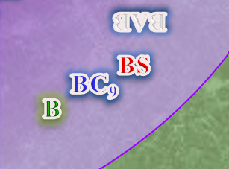
Executing this as posted will get Baldoor deep inside the entangle spell, so I’m going to select another Blackscale with less injuries and cast a lower-level spell, getting him only 5’ into the entangle spell.

Baldoor reached the injured charger, and would cast the spell in a moment.

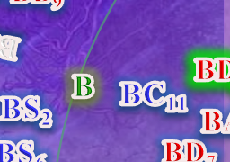

Amara scanned the battlefield again and sent a barrage of magic missiles at the bullywug shaman now engaged with one of the Blackscale lizard chargers, hoping to end the bullywug’s existence before it could do the same to the lizard.
Dmg: 4 + 2 = 6 magic [force].

The stalwart shaman barely flinched, continuing his offensive against the charger before him.

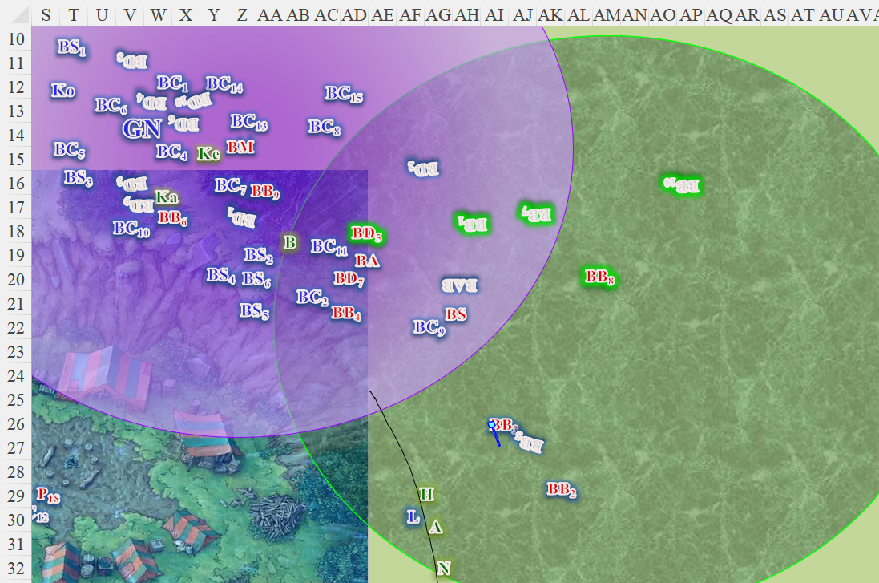

Round 151

The bullywug bosses took a tally of their surviving berserkers and diehards, and continued to insist that the day would belong to them. The marshal croak-roared and cast inflict moderate wounds on Kelvar from a single-use fuse-like item that burnt up in the casting.
Character | Attack Type | Damage | BAB | Str Mod+ | Total Score | Roll | Total
Bullywug Marshal | Touch Attack | 3d8 + 6 | 4 | 1 | 5 | 19 | 24
Hit. Dmg: 10 + 7 = 17 negative energy [evil] [11/35].

The acolyte cast inflict serious wounds upon BC11.
Character | Attack Type | Damage | BAB | Str Mod+ | Total Score | Roll | Total
Bullywug Acolyte | Touch Attack | 3d8 + 6 | 4 | 1 | 5 | 7 | 12
Hit. Dmg: 15 + 6 = 21 negative energy [evil].

The Blackscale charger was nearly dead, and dropped to the floor, losing consciousness. Baldoor hastened his step to reach him.

The shaman cast inflict serious wounds on BC9.
Character | Attack Type | Damage | BAB | Str Mod+ | Total Score | Roll | Total
Bullywug Shaman | Touch Attack | 3d8 + 7 | 4 | 1 | 5 | 2 | 7
Miss.

The berserkers and diehards fought to the bitter end. Some inside the entangle spell wrested themselves free for the moment, and one of them reached Nihm.
Character | Attack Type | Damage | BAB | Str Mod+ | Total Score | Roll | Total
Bullywug Berserker | Halfspear | 1d6 | 3 | 2 | 5 | 16 | 21
Hit. Dmg: 3 [33/36].

Kodak made his way across the dead bodies, emboldening his men as he said something in the language of his ancestors.

The Blackscale skirmishers took a few more potshots at the remaining diehards and berserkers.
Character | Attack Type | Damage | BAB | Dex Mod+ | W+ | Total Score | Roll | Total | Targeting
Blackscale Skirmisher 1 | MW Longbow | 1d8/x3 | 3 | 3 | 1 | 7 | 15 | 22 | Marshal
Blackscale Skirmisher 2 | MW Longbow | 1d8/x3 | 3 | 3 | 1 | 7 | 5 | 12 | Diehard 5
Blackscale Skirmisher 3 | MW Longbow | 1d8/x3 | 3 | 3 | 1 | 7 | 15 | 22 | Berserker 6
Blackscale Skirmisher 4 | MW Longbow | 1d8/x3 | 3 | 3 | 1 | 7 | 10 | 17 | Berserker 9
Blackscale Skirmisher 5 | MW Longbow | 1d8/x3 | 3 | 3 | 1 | 7 | 8 | 15 | Berserker 9
Blackscale Skirmisher 6 | MW Longbow | 1d8/x3 | 3 | 3 | 1 | 7 | 20 | 27 | Berserker 9
Hit, miss, hit, hit, miss, threat. 1d20 = 13 + 7 = 20, critical hit.
Dmg to Marshal: 8.
Dmg to Berserker 6: 5.
Dmg to Berserker 9: (3 x 1) + 7 = 10.

Berserker 6 died.

Gnar Nhash could now tell that the marshal was the main ringleader in all of this, so he stepped onto some fresh bodies and gave the bullywug leader a piece of his mind.
Character | Attack Type | Damage | BAB | Str Mod+ | W+ | Other+ | Total Score | Roll | Total
Gnar Nahsh | MW Spear (oiled) | 1d8/x3 | 4 | 6 | 1 | 2 flank | 13 | 13 | 26
Hit. Dmg: 5 + 4 = 9.

The marshal perished, groaning and sending a shiver of panic across the battlefield’s remaining bullywugs.

The Blackscale chargers converged on the remaining frogmen. Berserker 9 was in trouble.
Character | Attack Type | Damage | BAB | Str Mod+ | W+ | Other+ | Total Score | Roll | Total
Blackscale Charger 1 | MW Spear (oiled) | 1d8/x3 | 4 | 5 | 1 | 0 | 10 | 12 | 22
Blackscale Charger 7 | MW Spear (oiled) | 1d8/x3 | 3 | 3 | 1 | 0 | 7 | 17 | 24
Blackscale Charger 8 | MW Spear (oiled) | 1d8/x3 | 3 | 3 | 1 | 0 | 7 | 7 | 14
Blackscale Charger 13 | MW Spear (oiled) | 1d8/x3 | 3 | 3 | 1 | 0 | 7 | 17 | 24
Blackscale Charger 15 | MW Spear (oiled) | 1d8/x3 | 3 | 3 | 1 | 0 | 7 | 12 | 19
Hit, hit, miss, hit, hit. Dmg: 6 + 1 + 3 + 3 = 13.

Some of the chargers entered the entangled area in order to finish off the bullywugs.

Now that the marshal was dead, the shaman was the senior bullywug, and pleaded, “We yield! Please spare ussss!”

Nihm released her entangle spell and said, “Attack.” Lucky instantly leapt forward and attempted to bite the bullywug (BB2) near him and threatening his companion. Nihm followed up Lucky’s attack with an attack of her own, launching two arrows at the bullywug.
Character | Attack Type | Damage | BAB | Str Mod+ | W+ | Other+ | Total Score | Roll | Total
Lucky | Bite | 1d6+3 | 2 | 1 | 0 | 2 charge | 5 | 2 | 7
Miss.
Ranged Weapon | Dmg. | D+ | TH+ | Critical | Rng. | Wt. | Atk | Roll | Check | Notes
Longbow +1 | 1d8 | 1 | 1 – 4  melee | x3 | 100’ | 3.0 | +5 | 13 | 18 | +1 within 30’
Longbow, Rapid Shot | 1d8 | 1 | 1 – 4  Melee | x3 | 100’ | - | +5 | 9 | 14 | +1 within 30’
Hit, miss. Dmg: 7 + 1 + 1 PBS = 9.

Taking the situation for what it was, Kodak saw that the mammals had opted to take the war path to the end of the conflict, and ordered his men to finish off the bullywugs.

Haal continued to guide his spiritual weapon against the bullywug as he took a couple of steps forward, shield ready and mace in hand.
Melee Weapon | Dmg | D+ | TH+ | Critical | Type | Wt. | Atk | Roll | Check
Spiritual Heavy Mace | 1d8 | 2 | 0 | ×2 | Bludgeon | - | +8 | 15 | 23
Hit. Dmg: 4 + 2 = 6.

Baldoor cast cure light wounds on the Blackscale charger (BC11).
BC11 gained 5 + 6 = 11 hps.

The charger regained consciousness, and looked around to see that the fight was pretty much over.

Kelvar, Kassuq and Baldoor all held their ground as Baldoor cast his healing spell. They waited to see if the lizardfolk took pity on the bullywugs and accepted their surrender, or if they continued the fight to finish off their foes. This was not their land nor place to decide the terms, so they waited and watched.

The charger regained consciousness.

Amara drew her mace as she took a step forward, swung at the bullywug that Lucky and Nihm were dealing with.
Melee Weapon | Dmg | + Mod | TH+ | Critical | Type | Wt. | Atk | Roll | Check
MW Light Mace | 1d6 | 0 | 1 | x2 | Bludgeon | 4.0 | +4 | 20 | 24
Threat. 1d20 = 8 + 4 = 12, not a critical hit.
Dmg: 2.

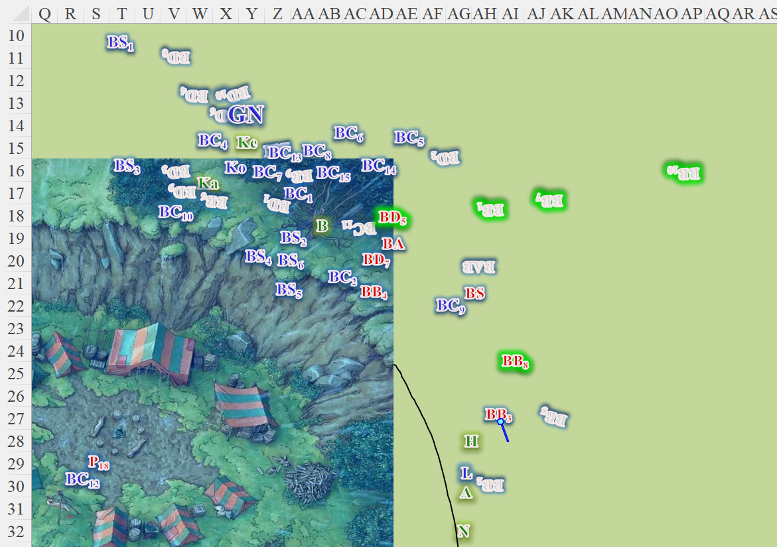

Round 152

The seven remaining bullywugs cowered with their arms covering their faces as the Blackscale skirmishers and chargers finished them off with impunity.

Gnar Nhash sprinted across the field to catch the three deserters, best off all, the acolyte, who was limping away.

Kelvar, seeing no immediate threats, held his ground, satisfied that the bullywug menace had been thwarted.

Kassuq advanced, attempting to get next to Baldoor as his friend seemed to be about to heal one of the Blackscale lizards.

At this point, the battle had become more of a sport for the Blackscale chargers, who chased the bullywugs towards the trees as the skirmishers released another volley eastwards, managing to only hit the acolyte and rob him of any chance of escape.

Nihm began looking over the field in front of her, searching for any hints of magic.

Haal started moving out into the field of battle where the dead bullywugs lay. He focused his search on the shaman and other leaders of the group, assuming they would be the ones carrying the gem.

Baldoor cast detect magic [expired on Round 212] and strode forward to search the bodies of the nearby bullywugs, noting his remaining spells after this casting.
Daily Spells
Spell | Level | Heal? | DC | Cast?
Detect Magic | 0 | 0 | 10 | þ
Detect Magic | 0 | 0 | 10 | þ
Detect Magic | 0 | 0 | 10 | þ
Read Magic | 0 | 0 | 10 | q
Read Magic | 0 | 0 | 10 | q
Detect Evil | 1 | 0 | 11 | þ
Nimbus of Light | 1 | 0 | 11 | þ
Protection from Evil | 1 | 0 | 11 | q
Protection from Evil | 1 | 0 | 11 | q
Sanctuary | 1 | 0 | 11 | q
Bull’s Strength | 2 | 0 | 12 | þ
Bull’s Strength | 2 | 0 | 12 | þ
Luminous Armor | 2 | 0 | 12 | q
Spiritual Weapon | 2 | 0 | 12 | q
Soften Earth & Stone | 2 | 0 | 12 | q
Searing Light | 3 | 0 | 13 | q
Stone Shape | 3 | 0 | 13 | þ
Stone Shape | 3 | 0 | 13 | q

Amara cast detect magic [expired on Round 212] upon herself and Xena, then told her weasel companion, “Go and find any magic gems or shiny jewels amongst the dead bullywugs.” Amara then did the same, scanning the field for any faint glows of magic.

As the four searched, they tossed any magical weapons off to the side for the Blackscale lizards to claim. They also pointed out any magical armor, again, leaving it for the lizardfolk.

A handful of Blackscale warriors chased the remaining bullywugs into the woods.

Rounds 153 – 170

A few minutes had passed, and while most of the items consisted of spears and leather armor, Xena had filched a Replenishing Skin and a handful of potions.

“They did not come to settle here,” Kodak stated. “The Gravid Gem is with their Chieftain, no doubt, and surely they mean to now replenish their lost ranks with a future generation of expendable, croaking grunts.”

Gnar Nhash grunted, making his way over to the surviving Poisondusk, “You sure you don’t have anything else to tell us, half-a-man?” the towering Blackscale yelled at the minute Poisondusk who now knelt with his hands bound behind his back.

Kodak followed, taking the opportunity to add, “What my man-at-arms means,” he licked the air with his forked tongue, and continued, “is that we believe you do have an inkling as to the whereabouts of the bullywugs’ settlement. You may share this, or Gnar Nhash will share your guts with yonder wolf,” he pointed at Lucky.

Round 171

When Kodak mentioned feeding the lizards guts to Lucky, Kassuq transformed into a wolf as well and howled as if anticipating a good meal. Baldoor and Kelvar looked at the wolf and archon and shook their head, giving a little laugh.

Amara and Nihm looked over the skin and the potions, leaving the other items for the lizards to distribute as they desired.
Potions not identified by mundane means.

Haal walked over to Kodak and asked, “May I have a word?”

Kodak agrees and they walked over to the side with Haal. Once away from the Poisondusk lizard, Haal said, “I have a scroll of zone of truth I could use on the Poisondusk lizard if you’d like. He will be unable to intentionally lie to us.”

Kodak agreed, and the Haal used the scroll. Within minutes, they learned that there were surely other bullywugs closer to the coast. The hostage didn’t know what west was, but that was what he meant, and pointed in that direction.

Haal thought for a moment then said to Kodak, “I believe we should rest for the night and regain our spells. We can send out scouts to locate the bullywugs’ stronghold in the morning and prepare a plan of attack. Is this agreeable to you?”
Skill | Rank | Ability & Mod. | Misc. Mods. | Total | Roll | Check
Haal, Diplomacy | 4 | Cha (+2) | 4 | 10 | 1 – 5 | ??
See below.

The Blackscale leader looked like he’d already been thinking about their next steps, and contemplated his response. “You fight bravely, all of you, but we are but a few dozen stacked against considerable numbers.” He sighed, “Our ways profess that we should seek out the counsel of Myastanaklon.”

Haal, Skill | Rank | Ability & Mod. | Misc. Mods. | Total | Roll | Check
Knowledge: Arcana | 4 | Int (+2) | 2 | 8 | 1 – 5 | ??
Knowledge: History | 4 | Int (+2) | 0 | 6 | 11 – 15 | ??
Knowledge: Local | 4 | Int (+2) | 0 | 6 | 16 – 20 | ??
See below.

“You speak of the youngest son of Eliinwyluwyther, the black dragon that once ravaged this part of the coast,” Haal recognized the name fairly well.

“He is wise, though avaricious, and we will have to sacrifice one of our own for his aid,” the lizardman proclaimed, already having settled his mind on the matter.

“Are there others that might aid us against the bullywugs?” asked Haal. “Others with an interest in keeping their populations from encroaching upon their own settlements?”

Kodak thought about it for a moment, then suggested sending an envoy to a nearby grotto where a band of troglodytes resides. “Though hostile by default, they can be reasoned with, and they’ve already had run ins with the bullywugs.” He then added, “You staying here overnight is suicide. They’ll come looking for their comrades, following slime trails all the way here, and they’ll slit your throats in your sleep.”

Haal nodded, “You know the land, so we will follow your counsel on where to stay for the night. As for the dragon, he may want the gem for himself, which could be worse. I have no objections to meeting with the troglodytes to gain their assistance. Are there any other lizardfolk tribes that you are on good terms with who might be able to provide even a small amount of aid?”

The goliath-sized leader considered the Sharptooth clan, a group of human-sized lizardfolk that dwelled about half a day’s march inland along the more arid plains of the Western Heartlands. He referenced them, adding, “But I would not say that we are on good terms. There have been... disagreements over bride prices among our clans. Their women cannot bear eggs formed from a union with our men; they’re too large. We wanted food and spirits in exchange, and they refused. You can imagine what followed.”

Haal nodded, “Sounds like a wise decision. As you know the parties involved better than we do, you let us know which of us you would like to go with either party.”

Kodak looked over to Gnar Nhash, who approached and leaned in to discuss the specifics of the matter. After some time, they both nodded, and Kodak responded in Common, “We shall make the pilgrimage to our patron, Aklon,” he referred to the black dragon by his familiar suffix. “You will fare better than us with the troglodytes, though that isn’t saying much.”

They spoke at greater length about the potential benefits of each alliance, and added, “Aklon may have lesser drakes joining him, and of course, they would approach from the sky, so we will depend on your forces to take out any ballistae or other anti-airborne weapons, which the bullywugs are known to have.”

“And what relative gains do the troglodytes bring to the table?” asked Haal, being less familiar with this scaly race.

“You will do well to not startle them, or you will suffer their stench,” he warned, then gave the human verbal directions. “It’s actually a straight shot.”

