Chapter 24: The Hunt for the Chuul

They followed the Blackscale leader’s southward directions, which were, indeed, straightforward, and reached the area of rolling hills rising above the coastal plain to their west. The grotto was guarded by no less than three troglodyte braves, who wasted no time in calling for reinforcements and threatening the newcomers with spears.

Haal knew this to be a moment that called for diplomacy. He stepped forward, his hands at shoulder level, palms facing the troglodyte guards so they could see he carried no weapons. “We come in peace,” he said, Kassuq translating in case they did not understand common. “We wish to talk to you about an alliance against a potential threat and mutual enemy. If you do not wish to speak, then we shall leave you in peace and wish you well.” He was careful not to get too close, but made sure they could hear him.

|  |  |  |  |  |  |  |
| --- | --- | --- | --- | --- | --- | --- |
| **Skill** | **Rank** | **Ability & Mod.** | **Misc. Mods.** | **Total** | **Roll** | **Check** |
| **Haal, Diplomacy** | 4 | **Cha (+2)** | 4 | 10 | 16 – 20 | ?? |

*See below.*

The others stood back, hands empty of weapons, though Baldoor and Kelvar did have their shields in hand. Nihm made sure she kept Lucky calm, scratching behind his ear.

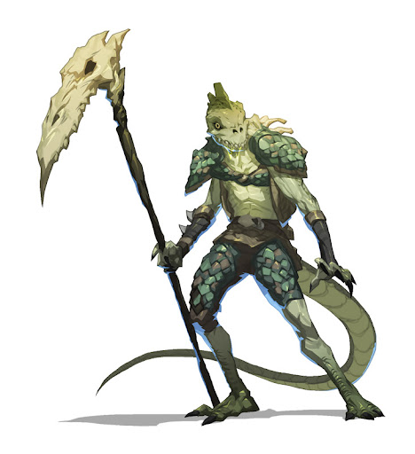

The leader showed himself, being among the tallest of the human-sized troglodytes. His bone scythe was impressive, and his Common was intelligible by the mammals who had shown up on his doorstep. Hearing Haal out, he then conferred with a few of his confidants, then turned back to Haal, taking a few steps forward along with his ablest spearmen, and asked, “Who is this mutual enemy of which you speak?”

Haal decided to be completely up front about the situation. “It is a tribe of bullywugs. They have obtained a magic gem that could make them very dangerous. The local lizard tribes, mainly the Blackscale lizards, are preparing to take on the bullywugs and are trying to recruit others. They felt that you and your warriors would make good allies in the fight even though there have been disagreements in the past.”

Murmurs grew to a half-dozen dialogues amongst the trogs, and coalesced into the Chieftain’s monologue, “Good allies... yes, we have been formidable flankers in a score of battles... but Kodak the Forsaken insults Chieftain Kittha Weah with his absence. This request should have come from him, by the will of both our ancestors!”

A unanimous, gargle-like hail of agreement resounded throughout the spacious cavern, painting the moment ambiguously.

Haal continued, “Kodak is even now seeking the alliance of Aklon, the black dragon.”

The awed troglodytes knew full well of the dragon, and some whispered his entire name, “Myastanaklon....”

Haal returned to the point at hand. “If you do not want to get involved, we will respect that decision. However, I believe we would have a much better chance of success with you and your warriors on our side.” Haal hoped that the troglodyte was a reasonable leader and wouldn’t let past disagreements cloud his better judgment.

|  |  |  |  |  |  |  |
| --- | --- | --- | --- | --- | --- | --- |
| **Skill** | **Rank** | **Ability**  **& Mod.** | **Misc.**  **Mods.** | **Total** | **Roll** | **Check** |
| **Haal, Diplomacy** | 4 | **Cha (+2)** | 4 | 10 | 1 – 5 | ?? |

*See below.*

***DM observation:*** *Haal’s 10 points go a long way to negotiating favorable deals with NPCs. Kudos on this character’s well played role.*

“Why are the Blackscale lizardfolks so eager to fight the bullywugs?” frowned the Chieftain.

Haal could sense that deceit and reticence would not be well received here, so he divulged the truth, revealing the existence of the Gravid Gem.

The Chieftain and his men and women listened, some urging the rest to slay the mammals and get on with the day. After a few minutes of discussing it with two robed, gray-scaled, wizened sage types—one a man and the other a woman—Chieftain Kittha Weah looked once again upon Haal, then upon the other humanoids. In a ceremonial fashion, the alpha troglodyte lifted his scythe, and proclaimed in rhyming Draconic (which only Kassuq and Nihm could understand), << By the will of Laogzed, we do *not* recognize you as our fellow warrior kin! >>

Nihm was somewhat familiar with what was about to unfold, and translated for Haal with a peaceful tone. She was about to elaborate on her understanding of what would ensue next, but the Chieftain stepped forth. Kittha Weah had spoken an ancient, proverbial passage that was more than a mere statement, perhaps even cast a spell with it. In any case, the rest of the troglodytes looked at Haal and his number as their leader licked the air with a forked tongue, then spoke cryptically at first, “Your worth will right Kodak’s wrong today, and you will prove yourselves on the Hunt!” he emphasized the last word as if it should have been capitalized.

Nihm braced herself for the remainder of the prospect: its target.

“Yesss, today, we hunt chuul! And tonight we feast. At dawn, those who survived will support Kodak’s campaign against the bullywugs.”

“Who’s chuul?” Kelvar wondered.

Nihm knew, and explained what a chuul was. The others all nodded. Haal then turned to the leader of the troglodytes and asked, “When do we start the hunt?”

They pretty much began at that moment, setting off via one of the downward tunnels in the grotto.

The Chieftain asked for a better sense of everyone’s specializations, then explained that their role was to aid where their prowess was most formidable, asking that Kassuk and Kelvar serve as frontline combatants while spellcasters do what they could to bring down the chuul.

As they prepared to head off on the ‘Hunt’, Baldoor spoke up, “I’ll follow directly behind the front line warrior to do any healing.”

**SPECIALIZATIONS?**

Kassuq and Kelvar took their places towards the front, Kelvar adding a bit of inspiration, or so he hoped, by banging his hammer against his shield a couple of times and adding, “Let’s get this over with.”

Nihm told Lucky, “Heel,” instructing the wolf to stay at her side. She would send him in to help if the opportunity arose.

Haal and Amara also took their places as instructed, both ready to use whatever spells that they felt would be effective against such a creature. Haal also confirms, “Do these chuul have any specific vulnerability that you are aware of? Like perhaps fire or electrical energy like lightning bolts?”

When the Chieftain asked about the group’s capabilities, Haal looked around at the team and then spoke up. Pointing to Nihm, Haal began. “Nihm is a ranger and good with her bow and tracking. She does have an *entangle* spell remaining today. Her friend, Lucky, is a loyal protector and can fight if needed. Kassuq is a good fighter and prefers up close fighting. Amara has a wide array of spells at her disposal, though she has used many of her stronger spells.”

The Chieftain nodded and took a visual measure of the men and women of the moment as Haal continued.

“Baldoor is a good fighter and cleric. He has a few offensive spells available, but can provide healing magic if needed. Kelvar is a new friend of ours and has proven himself a solid and fearless warrior. As for me,” Haal gave a slight bow, “I’m a cleric like my dwarf friend and can provide some healing. With my magic items and some scrolls, I can provide some offensive magic as well. If you would like to know specifics, I can go into that. Though, as far as you need to know, we will all fight to the end to defend ourselves and our allies and friends. So, what do you say friend, shall we begin the hunt?”

“Hmmm...” the alpha troglodyte exhaled through twin nostrils, then opened his maw, saying, “With such champions, we will surely triumph, and you will eat the best chuul stew of your life.”

~*~

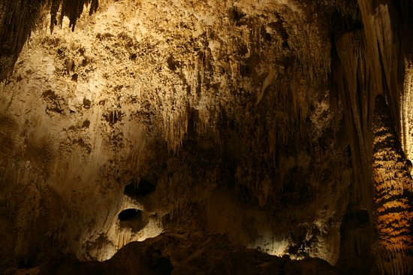

The cavern’s height had significantly increased from about 10’ to nearly 100’, and the newcomers half-expected droppers, ropers, cloakers, chokers, and other stalactite-loving denizens to pounce down on them. The Chieftain’s lead bodyguard noticed this, and leaned over to assure them. “We keep these areas clear of hazards like droppers. The chuul is all we keep from extinguishing, for it makes the finest meal of all.”

That was a simplification of a much more elaborately derived tradition of cultivating the chuul for both sport and meat, as its meat contained a honey-like lipid that greatly delayed its decomposition, rendering stores of meat that would last them for tendays. And so it would be today.

One of the lead scouts smelled something telltale, then gave an affirmative hand signal to those behind him, who inhaled with forked tongues out, looking like hybrids of humans and lizardfolk, though there were not. Minutes earlier, they’d walked by the carcass of the last chuul the trogs had downed, along a narrower chamber they called the slaughterkitchen, and were now told to steel their senses, as they would soon be upon their target. The sounds of something emerging from the water, its water-drenched form dripping as carapaced limbs clicked onto the rocky ground, confirmed the words of the scout, and spears went from upward- to forward-pointing almost unanimously as the trogs took up positions at least 5’ apart from anyone else, urging the mammalians to do the same. This allegedly would make the group look bigger to the chuul, inciting hesitation from the highly instinctive creature.

The passage meandered northwestwardly, opening into yet another wide chamber, and there was the beast at the edge of an underground pond.

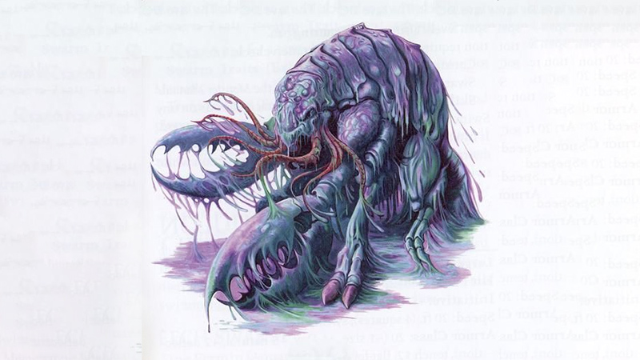

Round 1

<< It’s onnnnn! >> the Chieftain proclaimed in Draconic, and off the warriors went, fanning out across the mouth of the tunnel, waiting for the beast to approach so they could skewer it with javelins, hopefully before it reached any of them.

Kassuq and Kelvar moved off to the left, taking up a position on the end of the line. The pair stood, weapons at the ready. Kelvar also banged his hammer on his shield and yelled, “Come on, beastie. I’m hungry.” Kelvar studied the chuul and tried to gauge the depth of any pools of water near him. He also took in the scent, placing its aroma in his memory for any future encounters.

It was difficult for the dwarf—even with his enhanced vision in dim light—to discern the deepest points of the pools, but at the borders, they were clearly puddles. A man would step into water up to his ankles or lower calves.

“Mealssss that come to Foraging Me,” the chuul said in a frothy Common as it made its way towards the frontlines, intending to kill them all.

Baldoor moved up next to the chief and cast *shield other* on the chieftain. He then watched and waited for the chuul to move a little closer before casting *spiritual weapon*. Because he had prepared neither *shield other* nor *spiritual weapon* this day, he instead burned up one of the slots with a *protection from evil* spell.

|  |  |  |  |  |
| --- | --- | --- | --- | --- |
| *Baldoor’s Spells* | | | | |
| **Spell** | **Level** | **Heal?** | **DC** | **Cast?** |
| Detect Magic | 0 | 0 | 10 | þ |
| Detect Magic | 0 | 0 | 10 | þ |
| Detect Magic | 0 | 0 | 10 | þ |
| Read Magic | 0 | 0 | 10 | q |
| Read Magic | 0 | 0 | 10 | q |
| Detect Evil | 1 | 0 | 11 | þ |
| Nimbus of Light | 1 | 0 | 11 | þ |
| Protection from Evil | 1 | 0 | 11 | þ |
| Protection from Evil | 1 | 0 | 11 | q |
| **Sanctuary** | 1 | 0 | 11 | q |
| Bull’s Strength | 2 | 0 | 12 | þ |
| Bull’s Strength | 2 | 0 | 12 | þ |
| Luminous Armor | 2 | 0 | 12 | q |
| Spiritual Weapon | 2 | 0 | 12 | q |
| **Soften Earth & Stone** | 2 | 0 | 12 | q |
| Searing Light | 3 | 0 | 13 | q |
| Stone Shape | 3 | 0 | 13 | þ |
| **Stone Shape** | 3 | 0 | 13 | q |

Nihm and Lucky moved through the troglodytes to stand just behind the front row of warriors. Lucky sniffed the air and growled as he watched the chuul. Nihm readied an arrow and waited for the troglodytes to launch their javelins. That would be her signal to start her ranged barrage of arrows.

Haal moved up to stand in front of the chief and studied the chuul. He had to admit it was a little bigger and scarier looking than he had imagined, but not the scariest thing he’d ever seen. Like Baldoor, Haal was waiting for the beast to move up before casting his own *spiritual weapon* spell.

Amara held her position and cast *mage armor [expired in 6 hours]* upon herself as she too waited before unleashing any offensive spells. She whispered to Xena, “I know it smells horrible. I just hope it tastes better than it smells.” The weasel chirped back, blew its nose in a huff and crawled down into her pocket.

The chuul picked a fool in the frontlines and went for him, inciting a skirmish of javelins and a charge from the grunts.

|  |  |  |  |  |  |  |  |  |  |  |  |  |
| --- | --- | --- | --- | --- | --- | --- | --- | --- | --- | --- | --- | --- |
| **Character** | **Attack Type** | **Damage** | **BAB** | **Str Mod+** | **Dex Mod+** | **W+** | **Other+** | **Total Score** | **Roll** | **Total** | **Crit** | **Threat** |
| Troglodyte Javeliner 1 | MW Javelin | 1d8/x3 | 3 | 0 | 1 | 1 | 0 | 5 | 12 | 17 | 20 | ý |
| Troglodyte Javeliner 2 | MW Javelin | 1d8/x3 | 3 | 0 | 1 | 1 | 0 | 5 | 7 | 12 | 20 | ý |
| Troglodyte Javeliner 3 | MW Javelin | 1d8/x3 | 3 | 0 | 1 | 1 | 0 | 5 | 3 | 8 | 20 | ý |
| Troglodyte Javeliner 4 | MW Javelin | 1d8/x3 | 3 | 0 | 1 | 1 | 0 | 5 | 20 | 25 | 20 | þ |
| Troglodyte Javeliner 5 | MW Javelin | 1d8/x3 | 3 | 0 | 1 | 1 | 0 | 5 | 11 | 16 | 20 | ý |
| Troglodyte Grunt 1 | MW Spear | 1d8+2/x3 | 3 | 2 | -1 | 1 | +2 charge  +2 flank | 10 | 4 | 14 | 20 | ý |
| Troglodyte Grunt 2 | MW Spear | 1d8+2/x3 | 3 | 2 | -1 | 1 | +2 charge  +2 flank | 10 | 17 | 27 | 20 | ý |
| Troglodyte Grunt 3 | MW Spear | 1d8+2/x3 | 3 | 2 | -1 | 1 | +2 charge  +2 flank | 10 | 17 | 27 | 20 | ý |

*Miss, miss, miss, threat, miss, miss. 1d20 = 4 + 5 = 9, not a critical hit.*

*Javelin dmg: 3.*

*Miss, hit, hit. Dmg: (7 + 2 + 2 charge) + (8 + 2 + 2 charge) = 11 + 12 = 23.*

Round 2

|  |  |  |  |  |  |
| --- | --- | --- | --- | --- | --- |
| **Character** | **Group** | **Initiative** | **Roll** | **Modified Roll** | **Speed** |
| Nihm | 1 | 4 | 16 | 20 | 30’ |
| Kassuq | 1 | 6 | 12 | 18 | 40’ - 60’ |
| Baldoor | 1 | 7 | 5 | 12 | 30’ |
| Chuul | 2 | 7 | 4 | 11 | 30’ / 20’ |
| Haal | 1 | 0 | 11 | 11 | 30’ |
| Troglodytes | 1 | -1 | 12 | 11 | 30’ |
| Kelvar | 1 | 7 | 3 | 10 | 30’ |
| Amara | 1 | 4 | 4 | 8 | 30’ |

When the troglodytes threw their javelins and charged the chuul, Nihm let loose with a couple of arrows, targeting the chuul. Lucky remained at her side for now, the hair on the back of his neck and shoulders standing on end as he growled at the creature.

|  |  |  |  |  |  |  |  |  |  |
| --- | --- | --- | --- | --- | --- | --- | --- | --- | --- |
| **Ranged Weapon** | **Dmg.** | **D+** | **TH+** | **Critical** | **Rng.** | **Wt.** | **Atk** | **Roll** | **Check** |
| Longbow +1 | 1d8 | 1 | 1 – 4  melee | x3 | 100’ | 3.0 | +5 | 13 | 18 |
| Longbow, Rapid Shot | 1d8 | 1 | 1 – 4  melee | x3 | 100’ | - | +5 | 4 | 9 |

*Miss, miss.*

Kassuq ran in an arc to spot just behind the chuul. With barely enough time to swing before the monster attacked again, he swung at it with his sword.

|  |  |  |  |  |  |  |  |  |  |
| --- | --- | --- | --- | --- | --- | --- | --- | --- | --- |
| **Melee Weapon** | **Dmg** | **D+** | **TH+** | **Critical** | **Type** | **Wt.** | **Atk** | **Roll** | **Check** |
| Longsword +1 | 1d8 | 6 | 1 + 2  flank | 19-20/x2 | Slashing | 4.0 | +13 | 18 | 31 |

*Hit. Dmg: 5 + 6 = 11.*

Baldoor cast his last *spiritual weapon [expired on Round ]*, placing the magical weapon behind the creature and attacked it from there.

|  |  |  |  |  |  |  |  |  |  |
| --- | --- | --- | --- | --- | --- | --- | --- | --- | --- |
| **Melee Weapon** | **Dmg.** | **D+** | **TH+** | **Critical** | **Type** | **Wt.** | **Atk** | **Roll** | **Check** |
| Spiritual Hammer | 1d8 | 2 | 2 flank | x3 | Bludgeon | - | +7 | 9 | 16 |

*Miss.*

The chuul swung at the nearest grunt.

|  |  |  |  |  |  |  |  |  |
| --- | --- | --- | --- | --- | --- | --- | --- | --- |
| **Character** | **Attack Type** | **Damage** | **BAB** | **Str Mod+** | **Total Score** | **Roll** | **Total** | **Notes** |
| Chuul | Claw | 2d6+5 | 8 | 4 | 12 | 12 | 24 | Improved Grab |
| Chuul | Grapple/Constrict | 3d6+5 | 8 | 4 | 12 | 18 | 30 |  |

*Hit; Improved Grab initiated. Dmg: 8 + 5 = 13.*

The claw clamped onto the warrior *[TG3]*, and nearly cut him in half, gripping his dying flesh.

The troglodyte healers positioned themselves behind the grunts, ready to assist the wounded, and the head healer proclaimed and urged, “We can do nothing for Norbert. Finish the chuul, braves!”

Haal held his infinite scroll case and pulled out a scroll of *summon monster II [expired on Round 7]* and called for a giant bombardier beetle behind the creature and it charged in and attacked.

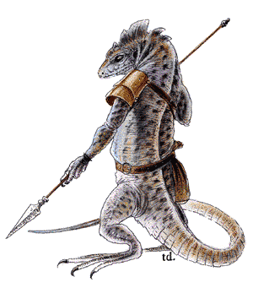

The troglodyte grunts encircled the beast as the javeliners repositioned themselves so as to skewer the chuul’s head region by throwing their next volleys over the heads of their comrades.

|  |  |  |  |  |  |  |  |  |  |
| --- | --- | --- | --- | --- | --- | --- | --- | --- | --- |
| **Character** | **Attack Type** | **Damage** | **BAB** | **Str Mod+** | **W+** | **Other+** | **Total Score** | **Roll** | **Total** |
| Troglodyte Grunt 2 | MW Spear | 1d8+2/x3 | 3 | 2 | 1 | 2 flank | 8 | 17 | 25 |
| Troglodyte Grunt 4 | MW Spear | 1d8+2/x3 | 3 | 2 | 1 | 2 flank | 8 | 15 | 23 |
| Troglodyte Grunt 5 | MW Spear | 1d8+2/x3 | 3 | 2 | 1 | 2 flank | 8 | 4 | 12 |

*Hit, hit, miss. Dmg: (1 + 2) + (8 + 2) = 3 + 10 = 13.*

One of the grunts reached the beast, but did not have time to attack before the next round.

The alpha grunt—a brave named Hlathgrr—swung harder than usual. *[Power Attack +3]*

|  |  |  |  |  |  |  |  |  |  |
| --- | --- | --- | --- | --- | --- | --- | --- | --- | --- |
| **Character** | **Attack Type** | **Damage** | **BAB** | **Str Mod+** | **W+** | **Other+** | **Total Score** | **Roll** | **Total** |
| Troglodyte Grunt 1 | MW Spear | 1d8+2/x3 | 3 | 2 | 1 | 2 flank  -3 PA | 5 | 18 | 23 |

*Hit. Dmg: 4 + 2 + 3 PA = 9.*

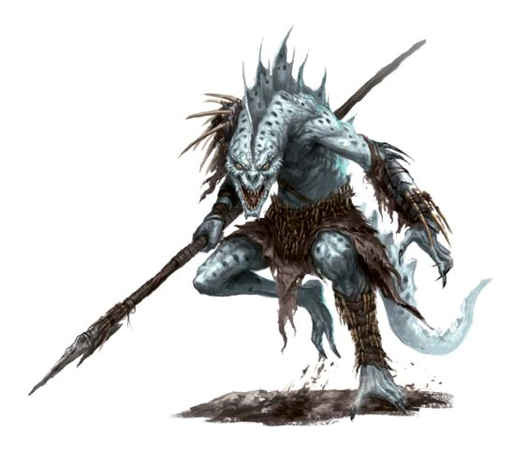

That was enough to make the creature reconsider its position, and as it backed away and reared its head just a few feet, the javeliners released their next volley.

|  |  |  |  |  |  |  |  |  |  |  |  |
| --- | --- | --- | --- | --- | --- | --- | --- | --- | --- | --- | --- |
| **Character** | **Attack Type** | **Damage** | **BAB** | **Dex Mod+** | **W+** | **Other+** | **Total Score** | **Roll** | **Total** | **Crit** | **Threat** |
| Troglodyte Javeliner | MW Javelin | 1d8/x3 | 3 | 1 | 1 | -4 melee | 1 | 6 | 7 | 20 | ý |
| Troglodyte Javeliner | MW Javelin | 1d8/x3 | 3 | 1 | 1 | -4 melee | 1 | 17 | 18 | 20 | ý |
| Troglodyte Javeliner | MW Javelin | 1d8/x3 | 3 | 1 | 1 | -4 melee | 1 | 8 | 9 | 20 | ý |
| Troglodyte Javeliner | MW Javelin | 1d8/x3 | 3 | 1 | 1 | -4 melee | 1 | 11 | 12 | 20 | ý |
| Troglodyte Javeliner | MW Javelin | 1d8/x3 | 3 | 1 | 1 | -4 melee | 1 | 15 | 16 | 20 | ý |

*Miss, miss, miss, miss, miss.*

Kelvar followed behind the archon, though not as quickly. He gave a long and loud battle cry as he ran in and swung at the beast with his hammer. He’d wanted a clear path to charge, but with two allies in the way, the momentum was broken, though he would be able to give a good swing on the next occasion.

Amara cast a series of *magic missiles* at the chuul as the warriors engaged it. She then moved forward slightly, following behind the chieftain of the troglodytes.

*Dmg: .8 + 2 = 10 magic.*

“Unholy fuuuuck!” the chuul remarked as it tried to recede towards the waters, but could not on account of being surrounded.

Round 3

*[DM assumption]* Nihm fired again.

|  |  |  |  |  |  |  |  |  |  |
| --- | --- | --- | --- | --- | --- | --- | --- | --- | --- |
| **Ranged Weapon** | **Dmg.** | **D+** | **TH+** | **Critical** | **Rng.** | **Wt.** | **Atk** | **Roll** | **Check** |
| Longbow +1 | 1d8 | 1 | 1 – 4  melee | x3 | 100’ | 3.0 | +5 | 5 | 10 |
| Longbow, Rapid Shot | 1d8 | 1 | 1 – 4  melee | x3 | 100’ | - | +5 | 18 | 23 |

*Miss, hit. Dmg: 6 + 1 = 7.*

*[DM assumption]* Lucky remained in place, seeing as the chuul was being brought down in a well-coordinated effort.

*[DM assumption]* Kassuq repeated his strike.

|  |  |  |  |  |  |  |  |  |  |
| --- | --- | --- | --- | --- | --- | --- | --- | --- | --- |
| **Melee Weapon** | **Dmg** | **D+** | **TH+** | **Critical** | **Type** | **Wt.** | **Atk** | **Roll** | **Check** |
| Longsword +1 | 1d8 | 6 | 1 – 2  flank | 19-20/x2 | Slashing | 4.0 | +9 | 14 | 23 |

*Hit. Dmg: 6 + 6 = 12.*

*[DM assumption]* The lobsteresque monster was nearly done for, and in a fit of bravado Kelvar emerged from the flanking pack to deliver a mighty blow.

|  |  |  |  |  |  |  |  |  |  |
| --- | --- | --- | --- | --- | --- | --- | --- | --- | --- |
| **Melee Weapon** | **Dmg.** | **D+** | **TH+** | **Critical** | **Type** | **Wt.** | **Atk** | **Roll** | **Check** |
| MW Warhammer | 1d8 | +3 | 1 | x3 | Bludgeon | 3.0 | +9 | 4 | 13 |

*Miss.*

It was mighty, indeed, but poorly executed, and the dwarf’s hammer clanked loudly on the ground.

*[DM assumption]* The *spiritual hammer* swung at the monster.

|  |  |  |  |  |  |  |  |  |  |
| --- | --- | --- | --- | --- | --- | --- | --- | --- | --- |
| **Melee Weapon** | **Dmg.** | **D+** | **TH+** | **Critical** | **Type** | **Wt.** | **Atk** | **Roll** | **Check** |
| Spiritual Hammer | 1d8 | 2 | 0 | x3 | Bludgeon | - | +5 | 15 | 20 |

*Miss.*

Baldoor moved up a bit more quickly, joining the troglodyte healers in case his healing spells were needed. So far, everyone was either tiptop or dying, so he though to stabilize the dying man now that the monster’s pincer had discarded the body. *[Soften earth and stone spent to cast cure moderate wounds.]*

*Troglodyte Grunt 3 gained 13 + 6 = 19 hps.*

Thanking the dwarf, the trog popped back up onto his feet, and prepared to do more damage to the chuul.

With no escape route, the chuul grabbed Grunt 2, trying to crush him to death as well.

|  |  |  |  |  |  |  |  |  |  |
| --- | --- | --- | --- | --- | --- | --- | --- | --- | --- |
| **Character** | **Attack Type** | **Damage** | **BAB** | **Str Mod+** | **Dex Mod+** | **Total Score** | **Roll** | **Total** | **Notes** |
| Chuul | Claw | 2d6+5 | 8 | 4 | 3 | 12 | 12 | 24 | Improved Grab |
| Chuul | Grapple/Constrict | 3d6+5 | 8 | 4 | 3 | 12 | 7 | 19 |  |

*Hit; Improved Grab initiated. Dmg: 10 + 5 = 15.*

The warrior also lost consciousness as his spine and inner organs were crushed by the chuul’s pincer.

A giant bombardier beetle appeared, and moved into position below Baldoor’s *spiritual hammer*, where there was an opening in the close-quarters formation. The Heavenly insect bit at the abominable crustacean.

|  |  |  |  |  |  |  |  |
| --- | --- | --- | --- | --- | --- | --- | --- |
| **Character** | **Attack Type** | **Damage** | **BAB** | **Str Mod+** | **Total Score** | **Roll** | **Total** |
| Celestial Giant Beetle | Bite | 1d4 + 1 | 1 | 1 | 2 | 16 | 18 |

*Miss.*

Haal took note of the beetle’s ineffectiveness against such a formidable foe, and resolved to summon comparably formidable minions in the future. The human then sacrificed his remaining *protection from evil* spell and used his Gloves of the Starry Sky, sending magical projectiles at the chuul (*magic missile*).

*Dmg: 6 + 2 = 8 magic [force].*

The chuul writhed and gurgled as the troglodytes eagerly skewered the dying monster.

Confused but inspired by the true cleric’s healing powers, one of the troglodyte healers positioned himself so as to heal the second trog killed. Apparently, the troglodyte adepts were not as adept as clerics in the way of healing the unconscious, but perhaps this would change today.

Amara, seeing that the beast was finished, decided to hold off on casting any further spells, and instead moved up between a couple of the troglodytes, where she was prepared to send off another set of missiles if they were needed.

They were not.

The Chieftain proclaimed, “Begin the butchering!” and with this phrase, spears and javelins were used to dismember the carapaced monster.

The dead trog was healed by his brother-in-law, and the two rejoiced in their victory.

Within minutes, a fire had been built, and the smell of lobster-like flesh cooking emanated from a pot the women had brought in now that there was no threat. “Taste!” one of the trogs said to Haal, with whom they were most comfortable.

Haal accepted the offered morsel and took a bit. He was surprised at how it tasted. It was not the best food he’d ever eaten, but it was not bad at all. “Mmmm,” he said to the Chieftain, “my compliments to your cooks. This is delicious.”

The others each then took their allotted portions and sat down among the troglodytes to eat. Nihm shared her portion with Lucky who gladly accepted it and ate it. The wolf then looked around and accepted food from any others that offered it.

As the group sat and ate, they inquired about the typical techniques used in combat with any troglodytes that could speak Common. Kassuq also inquired about the cooking and preparation of the meal, interested in whatever tips he could get.

He and his comrades were a bit concerned that they were colluding with Evil-aligned folks, and they would likely have to atone for all of this to keep their alignments in check. Still, they broke bread—or crust and flesh—with the evildoers.

When the meal was finished and discussion of combat tactics in general, and listening to stories of past battles, Haal approached the chieftain.

Giving a bow, Haal began, “I thank you for the delicious meal and for allowing us to participate in your hunt. It was quite a pleasure and a learning experience and I am glad you trusted enough to include us. I hope this means we can count on your support against the bullywugs. I also hope this can lead to better relations between the inhabitants of these swamp lands and the nearby settlements.”

“Probably not,” the hard-bitten troglodyte answered. “We’ve no interest in being among them. I take up arms against their enemy because I know the bullywugs to be worse than the humanoids. Your lot... seems different,” he looked upon the charismatic priest and his friends.