Chapter 3: Candlekeep

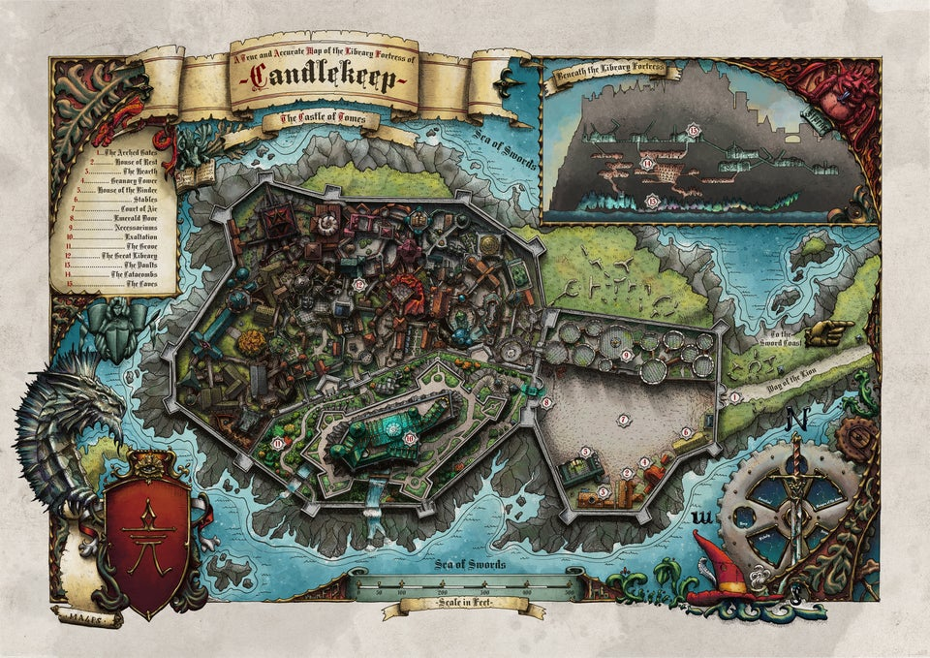

They were now inside the city, and had received a map of the city with some notable locations highlighted, eight of which they’d just passed. Nihm committed to memory these first eight locations, starting with the keep’s enormous, east-facing double gates, which stood three times as tall as a man. Its doors were forged from a strange black metal, and each featured the sigil of Candlekeep: the image of castle with flames set atop each of its towers.

Another fascinating sight was the Court of Air, a vast cobblestone courtyard around which were Candlekeep’s central establishments and amenities that catered to visitors and “Seekers”: those who arrived with the purpose of finding knowledge and wisdom.

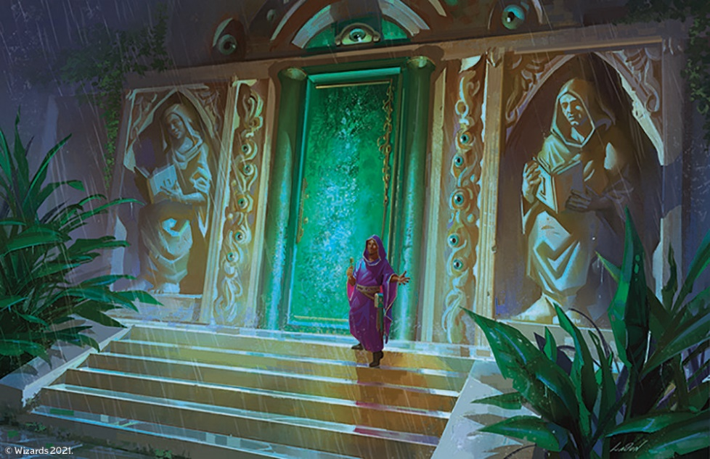

*[Adapted from* [*Tyranny of Dragons*](https://thetyrannyofdragonsdawnofheroes.obsidianportal.com/wikis/candlekeep)*]* At the famous Emerald Door stood that ushered newcomers into the city proper there stood a Keeper of the Emerald Door at all times, assisted by a small group of under-monks who acted as messengers and runners. It was the Keeper who officially welcomed newly arrived seekers, and made arrangements for their stay. Only this door led deeper into the inner ward; the other towers had entrances onto the Court of Air, but no points of egress into the inner ward and thus the rest of the library.

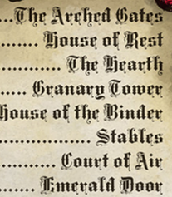

Baldoor took note of the House of the Binder, where he would likely find the tomes and other documentation on history and the Planes that he was seeking. As for the smithing training materials, this might be better sought in one of the more central library wings.

Having cleared the city’s dire security protocols, the convoy was now identified by special tags affixed to each wagon and horse, and treated as a single entity for the purposes of exercising any additional security measures while they made their way to their designated campground and adjacent vending area that would soon be host to their zoo. The monk on duty at the Keeper’s post noted the insignia on each wheeled and hoofed unit traveling in single file, and urged them along, having a few words with Yenshi and Kondratieff as the lead wagons passed through.

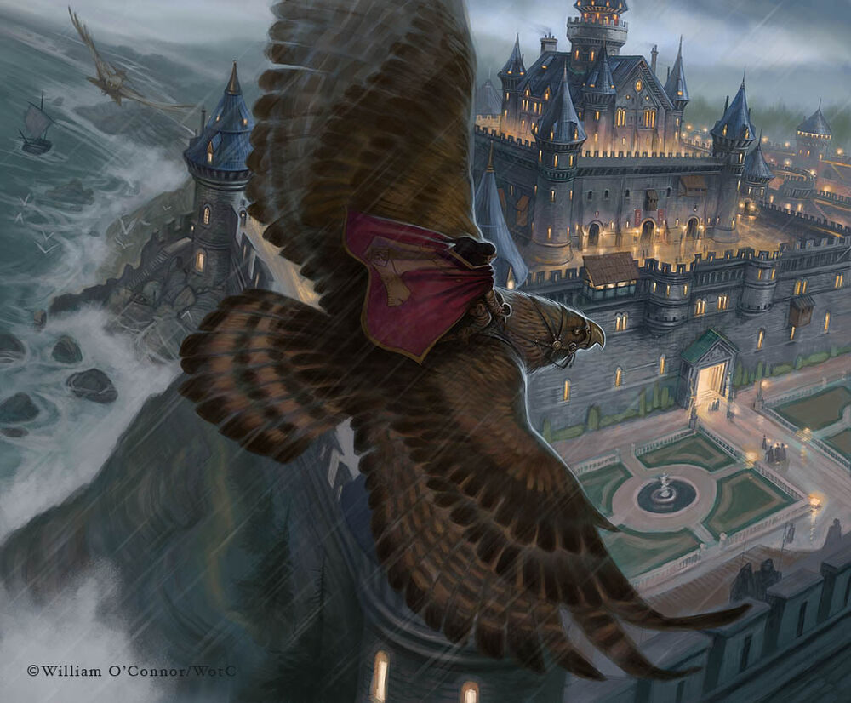

The images of Alaundo and other sage-saints adorned the façades of the architecture as they passed the slumless citadel at the edge of the continent.

“On to the Grove!” Kassuq heard the monk call out to each wagoner as they passed through the verdant threshold.

As the caravan moved into position, the four heroes took in the sights. The well-maintained and manicured lawns areas almost gave a feeling of being outside of the city, were it not for the wall visible all around.

As the caravan began pulling off the road and setting up, the four pitched in to help getting the tents ready and the animals (at least the animals they had become familiar with) settled. They were looking forward to the chance to explore the city, though each with their own agenda.

Lee was hoping to be able to work outside the city walls with the militia, trying to figure out more about what had driving the kobolds into a suicidal assault.

Nihm was also hoping to assist the militia, but was also content setting up a spot to do some painting. Especially when she saw the beauty inside of the Candlekeeps walls.

Baldoor had made note of the areas he would need to go to explore any knowledge of the planes and dwaven history. Though, his first choices would be to look into books on brewing so that he could improve his recipes for ale, perhaps adding more flavor or trying a different technique.

As for Kassuq, he was very excited as they moved deeper into the city. Unlike other towns he’d been in this one had extremely well-maintained park areas. Obviously maintained through the knowledge within these walls as well as some magical assistance. As they went about setting up the tents, Kassuq made sure he knew where the kitchen would be set up so that he could help with meal preparations later.

~*~

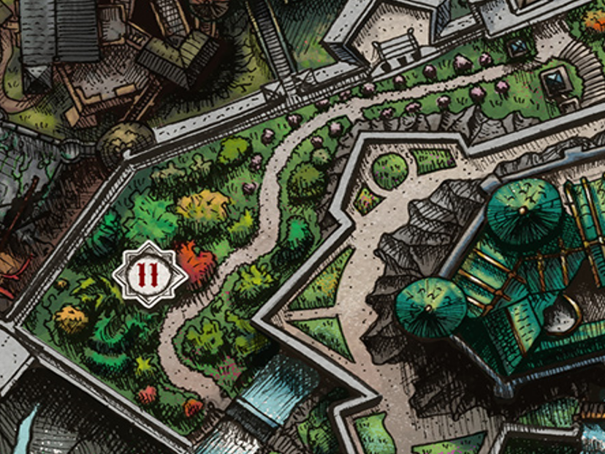

They had arrived at the site that normally served as a refuge for introverted lectors and reclusive meditators, and per the city’s preordained decree, Yenshi and Kondratieff could operate here for up to 20 days during a 45-day period that had begun about a tenday ago, so they were well within the window to operate, and could likely get an extension if they felt the need to procure one.

The convoy was still lined up in single file along the northwestern side of the winding path, but even now, wagons were being pushed onto the side of said path, and tents were already being pitched along the western end of the walled garden where an aqueduct released a waterfall into the sea.

~*~

They had all set-up camp, and the four heroes were now standing outside their two tents in anticipation of a splendid afternoon as the zoo staff worked diligently to prepare each display and exhibit. Security shifts were the same six-hour slices of the day as they had been before, so Kassuq and Baldoor were free until the sixth toll this evening, whereupon Lee and Nihm would be relieved of duty and could go explore the libraries and other amenities in Candlekeep.

While Lee and Nihm were on guard duty, Kassuq and Baldoor headed through the town. They had decided to seek a library that contained books on cooking and brewing, hopefully all in the same structure. Once they found the books they were seeking, they began reading through them, looking for ideas and techniques that they could each use later on.

Kassuq looked for new recipes and information on ingredients he’d never encountered. He was interested in learning how they worked and intermixed with each other. Baldoor, on the other hand, sought out information on brewing techniques as well as recipes to see if there was anything he could do to improve his own techniques and recipes.

By the time they were done reading (for the moment), they’d gleaned enough information to improve their respective brewery and cuisine topics, and found one another as they were returning the books to a recirculatory standing by a permanent *Tenser’s floating disc* supporting a wooden bin that the recirculatory would later tow along the aisles, placing books in their proper locations.

“How’re you feeling?” asked one of them.

“Savvy,” the other replied as they concluded their day’s study and returned to their wagon, stopping at a scribe’s shop to purchase one quill each and two or three pieces of paper/parchment.

Things seemed relaxed at the zoo as folks finished setting up displays, exhibits, and shops in strategic locations along the garden. They’d done this before, and planned subsequent stays well once they had an understanding of the garden’s layout. Kondratieff himself now walked along each setup, ensuring the correctness of its position before proceeding to the next.

“Good wisdom hunting?” Nihm asked.

“Indeed,” Baldoor was satisfied with what he’d learned.

They traded places, and Nihm and Lee took their leave, beholding the rouge splendor of the sun setting behind the tallest towers of the town, beyond which lay the vastness of an ocean on a world still younger than most.

After Baldoor and Kassuq returned and talked about what they had found, Lee and Nihm filled them in on their duties with the caravan inside the city walls.

Baldoor and Kassuq walked a few rounds around the site, and noted that animals were still being fed and cared for even into twilight.

Nihm and Lee found a spot not far away where Lee could relax and lay in the grass while Nihm sat not far away with her paint supplies. She began drawing then painting the sunset as she saw it over the tops of the walls and towers.

The night was uneventful, though somewhere in the distance, at least one determined person hammered away at some wooden structure, working under magical light well into the Midnight hour before finally retiring once their *light* spell fizzled. Shortly thereafter, Nihm and Lee finished their shift, and went to sleep as Baldoor and Kassuq reprised theirs until dawn.

~*~

As Baldoor and Kassuq were walking around the caravan, then noticed someone approaching the wagon containing the sailsnake. They did not recognize the man, so they started walking that way. As they approached, the man pulled a wand from his cloak and held a vial in his other hand. He began chanting something that Baldoor recognized as a sleep spell. “He’s tryin’ ta put the snake ta sleep,” he told Kassuq who nodded and ran ahead.

“Stop!” Kassuq yelled as he ran up to the man, drawing his sword, “Drop the wand!”

Startled, the man dropped the wand, more out of shock than due to instruction. “Wait, wait, I have permission!” the man pleaded.

Baldoor stepped up, “Permission fur what?” Baldoor demanded.

Just then, one of the animal handlers that they knew stepped up. “What’s going on?”

“That’s what we’d like ta know,” Baldoor replied. “We caught this one about ta try and do somethin to that snake there.”

The man looked then smiled and laughed, “I am sorry, I got stopped by someone looking at the needletooths. This is Brother Snardis, he is interested in animals and natural poisons they create for defense and offense. He is purchasing a couple vials of sailsnake venom for study.”

Kassuq, bowed and put his sword back into its sheath, “My apologies, we thought you were intending harm to the animal.”

Baldoor also bowed his head in apology, “A hundred pardons,” he said. “I hope me young friend here didn’t scare ya too much.” Baldoor and Kassuq both offered smiles to Brother Snardis who picked up his wand and returned the smile. “Apologies accepted. It is good to see that these amazing creatures are well protected and cared for.”

The two remained and watched as the monk collected his samples and went on his way.

~*~

Dawn came, and before the sun rose, the zoo staff was already up and about, having rested between 8 and 10 hours. A few fires were lit in designated pits, and breakfast was being served to humanoids and beasts alike. A quartet that would later play near the entrance of the garden had wandered over to the dire hawk’s cage and mused its rugged features before the bird’s caretaker approached and remarked that she remembered them from last year.

“Oh, right, you requested... what was it?” asked a string-and-bow musician with a feather in his wide-brimmed hat.

“Por un Amor?” a horn player responded.

“Yesss! Reminds me of my days in Amn,” Belgrad Hammertime sighed, and the topic then veered towards the hawk before them.

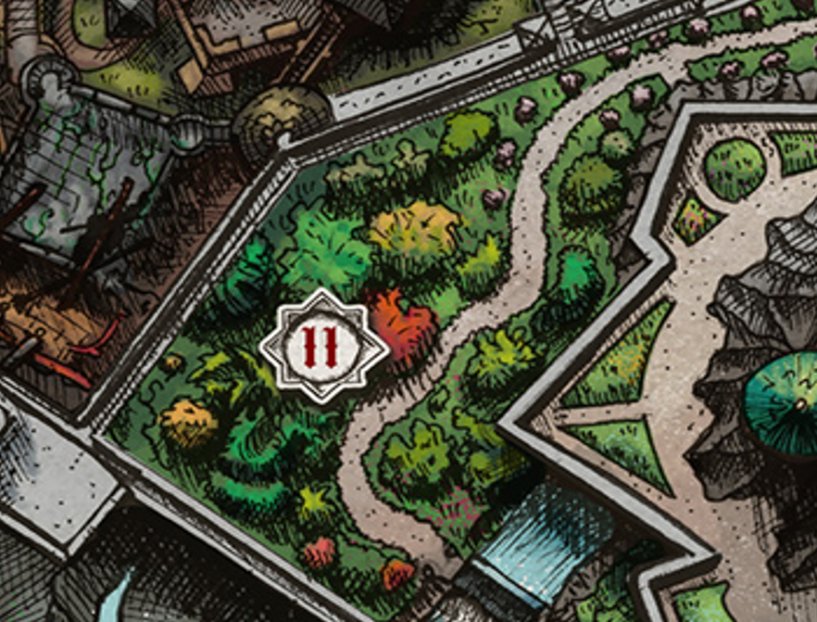

Baldoor, Kassuq, Lee, and Nihm took a moment to regroup as one shift ended and the other began. They were all eating at a wooden table-bench combo near the needletooth exhibit, which had been positioned near the aqueduct that cascaded into the rocks and shore below.

“... and now sweet love, I bring thee gentle doves…” a poet recited a few verses from the previous tenday’s writing, “... and sing thee farewell and good pardonnnn….”

The day had started off splendidly, and the heroes couldn’t imagine themselves in a better place, which seemed to balance a reverence for study and structure with a comparable level of harmony with the nature within and without the city walls.

After finishing their morning meal, the four spent a few minutes discussing what they had been up to over the last day or so. Nihm and Lee intended to see if the city guard could use their assistance as trackers outside of the city, but they’d already committed 12 hours of their day to the zoo, so they could only really devote one or two more to this before encroaching on their sleep and spell preparation.

Meanwhile, Kassuq and Baldoor intended to try out their newly learned recipes and get the opinion of the caravan crew, though it would be several days of brewing before Baldoor’s beverage was ready. Nevertheless, by Afternoon, he had gathered the necessary components to get the brewing underway, and wondered how he might go about it on their schedule.

It happened in different parts of the city throughout the better part of an hour: an infestation of spiders. By the time the news had reached the garden, three different species of monstrous spiders had been spotted emerging from the ground. The four heroes now overheard Kondratieff shouting, “This is unnatural. This species is a tree-dweller; they don’t burrow! Foulness is afoot!”

More and more screams and expressions of disgust and pain could be heard throughout the zoo. Patrons, staff, animals, and bookkeepers were all being accosted by the vermin.

Round 1

The four reacted as quickly as they could, heading in the direction of the closest spiders, which were just a few feet away. Now within melee range of a half-dozen spiders ranging in body size from a gnome’s fist to a goliath’s fist, the heroes drew their weapons.

Nihm fired an arrow from her just-drawn longbow upon a spider threatening her.

|  |  |  |  |  |  |  |  |  |  |  |
| --- | --- | --- | --- | --- | --- | --- | --- | --- | --- | --- |
| **Ranged Weapon** | **Dmg.** | **D+** | **TH+** | **Critical** | **Rng.** | **Wt.** | **Atk** | **Roll** | **Check** | **Notes** |
| MW Longbow | 1d8 | +0 | 1 | x3 | 100’ | 3.0 | +7 | *1* | 8 | +1 within 30’ |

*Miss.*

Lee charged towards the closest spider swinging away with his short sword.

*If able he will take a 5’ step away from the spider he struck - Intent: Use his Skirmish Class Ability to deal added damage.*

Baldoor stopped a few steps in front of Nihm, taking a position to defend her if any spiders came after her. As he stood his ground, he cast *summon monster II*.

Kassuq swiped at the spider closest to him with his longsword. He then prepared to take on the next spider should one attack him.

|  |  |  |  |  |  |  |  |  |  |
| --- | --- | --- | --- | --- | --- | --- | --- | --- | --- |
| **Melee Weapon** | **Dmg** | **D+** | **TH+** | **Critical** | **Type** | **Wt.** | **Atk** | **Roll** | **Check** |
| Longsword | 1d8 | +2 | 0 | 19-20/x2 | Slashing | 4.0 | +5 | 14 | 19 |

*Hit. Dmg: 5 + 2 = 7.*

Spiders attacked all those around them.

|  |  |  |  |  |  |  |  |  |
| --- | --- | --- | --- | --- | --- | --- | --- | --- |
| **Character** | **Attack Type** | **Damage** | **BAB** | **Dex Mod+** | **Total Score** | **Roll** | **Total** | **Attacking** |
| Monstrous Spider | Bite | 1d3-4 + Poison (Fort DC 10; 1d2 Strength) | 0 | 5 | 5 | 8 | 13 | Baldoor |
| Monstrous Spider | Bite | 1d3-4 + Poison (Fort DC 10; 1d2 Strength) | 0 | 5 | 5 | 18 | 23 | Baldoor |
| Monstrous Spider | Bite | 1d3-4 + Poison (Fort DC 10; 1d2 Strength) | 0 | 5 | 5 | 9 | 14 | Kassuq |
| Monstrous Spider | Bite | 1d3-4 + Poison (Fort DC 10; 1d2 Strength) | 0 | 5 | 5 | 1 | 6 | Lee |
| Monstrous Spider | Bite | 1d3-4 + Poison (Fort DC 10; 1d2 Strength) | 0 | 5 | 5 | 2 | 7 | Lee |
| Monstrous Spider | Bite | 1d3-4 + Poison (Fort DC 10; 1d2 Strength) | 0 | 5 | 5 | 9 | 14 | Nihm |

*Miss, hit (Baldoor), miss, miss, miss, hit (Nihm).*

*Dmg to Baldoor: 1 + Poison [20/21].*

*Dmg to Nihm: 1 + Poison [20/21].*

All around them, guards, staff, and patrons fended off the multitude of spiders in their midst.

Round 2

A single Celestial giant fire beetle appeared next to Baldoor and attacked the adjacent spider.

|  |  |  |  |  |  |  |  |
| --- | --- | --- | --- | --- | --- | --- | --- |
| **Character** | **Attack Type** | **Damage** | **BAB** | **Dex Mod+** | **Total Score** | **Roll** | **Total** |
| Celestial giant beetle | Bite | 2d4 | 0 | 1 | 1 | 13 | 14 |

*Miss.*

The spider attacked the beetle.

|  |  |  |  |  |  |  |  |
| --- | --- | --- | --- | --- | --- | --- | --- |
| **Character** | **Attack Type** | **Damage** | **BAB** | **Dex Mod+** | **Total Score** | **Roll** | **Total** |
| Monstrous Spider | Bite | 1d3-4 + Poison | 0 | 5 | 5 | 4 | 9 |

*Miss.*

Nihm took a step away from the spider that attacked her, and fired two arrows at it.

|  |  |  |  |  |  |  |  |  |  |  |
| --- | --- | --- | --- | --- | --- | --- | --- | --- | --- | --- |
| **Ranged Weapon** | **Dmg.** | **D+** | **TH+** | **Critical** | **Rng.** | **Wt.** | **Atk** | **Roll** | **Check** | **Notes** |
| MW Longbow | 1d8 | +0 | 1 | x3 | 100’ | 3.0 | +7 | 9 | 16 | +1 within 30’ |
| Longbow, Rapid Shot | 1d8 | +0 | 1 | x3 | 100’ | - | +7 | 19 | 26 | +1 within 30’ |

*Hit, hit. Dmg: (8 + 1) + (4 + 1) = 9 + 5 = 14.*

Lee continued to dance and skirmish around the spider that he was attacking.

|  |  |  |  |  |  |  |  |  |  |  |
| --- | --- | --- | --- | --- | --- | --- | --- | --- | --- | --- |
| **Ranged Weapon** | **Dmg.** | **D+** | **TH+** | **Critical** | **Rng.** | **Wt.** | **Atk** | **Roll** | **Check** | **Notes** |
| MW Shortbow | 1d6 | 1d6 | 1 + 1 | x3 | 60’ | 2.0 | +6 | 3 | 9 | +1 within 30’ |

*Miss.*

Baldoor instructed the Celestial giant fire beetle to defend Nihm, then swung his warhammer at the spider that attacked and bit him.

|  |  |  |  |  |  |  |  |  |  |
| --- | --- | --- | --- | --- | --- | --- | --- | --- | --- |
| **Melee Weapon** | **Dmg.** | **D+** | **TH+** | **Critical** | **Type** | **Wt.** | **Atk** | **Roll** | **Check** |
| MW Warhammer | 1d6 | +1 | 1 | x3 | Slashing | 3.0 | +4 | 12 | 16 |

*Hit. Dmg: 4 + 1 = 5.*

The beetle attacked the adjacent spider as Baldoor sliced another spider in half.

|  |  |  |  |  |  |  |  |
| --- | --- | --- | --- | --- | --- | --- | --- |
| **Character** | **Attack Type** | **Damage** | **BAB** | **Dex Mod+** | **Total Score** | **Roll** | **Total** |
| Celestial giant beetle | Bite | 2d4 | 0 | 1 | 1 | 2 | 3 |

*Miss.*

Kassuq continued to swing away with his longsword at the spider closest to him.

|  |  |  |  |  |  |  |  |  |  |
| --- | --- | --- | --- | --- | --- | --- | --- | --- | --- |
| **Melee Weapon** | **Dmg** | **D+** | **TH+** | **Critical** | **Type** | **Wt.** | **Atk** | **Roll** | **Check** |
| Longsword | 1d8 | +2 | 0 | 19-20/x2 | Slashing | 4.0 | +5 | 4 | 9 |

*Miss.*

Spiders attacked the heroes, zoo staff, and townsfolk alike.

|  |  |  |  |  |  |  |  |  |
| --- | --- | --- | --- | --- | --- | --- | --- | --- |
| **Character** | **Attack Type** | **Damage** | **BAB** | **Dex Mod+** | **Total Score** | **Roll** | **Total** | **Notes** |
| Monstrous Spider | Bite (Baldoor) | 1d3-4 + Poison | 0 | 5 | 5 | 1 | 6 | Fort DC 10; 1d2 Strength |
| Monstrous Spider | Bite (Baldoor) | 1d3-4 + Poison | 0 | 5 | 5 | 14 | 19 | Fort DC 10; 1d2 Strength |
| Monstrous Spider | Bite (Kassuq) | 1d3-4 + Poison | 0 | 5 | 5 | 15 | 20 | Fort DC 10; 1d2 Strength |
| Monstrous Spider | Bite (Kassuq) | 1d3-4 + Poison | 0 | 5 | 5 | 4 | 9 | Fort DC 10; 1d2 Strength |
| Monstrous Spider | Bite (Lee) | 1d3-4 + Poison | 0 | 5 | 5 | 19 | 24 | Fort DC 10; 1d2 Strength |
| Monstrous Spider | Bite (Nihm) | 1d3-4 + Poison | 0 | 5 | 5 | 13 | 18 | Fort DC 10; 1d2 Strength |
| Monstrous Spider | Bite (Nihm) | 1d3-4 + Poison | 0 | 5 | 5 | 12 | 17 | Fort DC 10; 1d2 Strength |

*Miss, hit (Baldoor), hit (Kassuq), miss, hit (Lee), hit (Nihm), hit (Nihm).*

*Dmg to Baldoor: 1 + Poison [19/21].*

*Dmg to Kassuq: 1 + Poison [26/27].*

*Dmg to Lee: 1 + Poison [19/21].*

*Dmg to Nihm: 1 + Poison [17/18].*

|  |  |  |  |  |  |  |  |
| --- | --- | --- | --- | --- | --- | --- | --- |
| **Save vs.**  Poison | **Rank** | **Ability & Mod.** | **Misc. Mods.** | **Total** | **Roll** | **Check** | **Notes** |
| **Baldoor, Fortitude** | **3** | Con (+1) | 0 | 4 | 10 | 14 | +2 vs. Poison & Spells |
| **Kassuq, Fortitude** | **3** | Con (+3) | 1 | 7 | 17 | 24 | +4 vs. Poison |
| **Lee, Fortitude** | **1** | Con (+1) | 0 | 2 | 6 | 8 |  |
| **Nihm, Fortitude** | **3** | Con (+0) | 0 | 3 | 14 | 17 |  |

*Success, success, fail (Lee), success.*

*Dmg to Lee: 1 Strength.*

Round 3

The beetle and adjacent spider continued claw-to-maw combat.

|  |  |  |  |  |  |  |  |
| --- | --- | --- | --- | --- | --- | --- | --- |
| **Character** | **Attack Type** | **Damage** | **BAB** | **Dex Mod+** | **Total Score** | **Roll** | **Total** |
| Monstrous Spider | Bite | 1d3-4 + Poison | 0 | 5 | 5 | 10 | 15 |
| Celestial giant beetle | Bite | 2d4 | 0 | 1 | 1 | 3 | 4 |

*Miss, miss.*

A few new spiders came out of the earth, got on the heroes, and started nipping.

|  |  |  |  |  |  |  |  |  |
| --- | --- | --- | --- | --- | --- | --- | --- | --- |
| **Character** | **Attack Type** | **Damage** | **BAB** | **Dex Mod+** | **Total Score** | **Roll** | **Total** | **Notes** |
| Monstrous Spider | Bite | 1d3-4 + Poison | 0 | 5 | 5 | 8 | 13 | Fort DC 10; 1d2 Str  vs. Baldoor |
| Monstrous Spider | Bite | 1d3-4 + Poison | 0 | 5 | 5 | 8 | 13 | vs. Kassuq |
| Monstrous Spider | Bite | 1d3-4 + Poison | 0 | 5 | 5 | 15 | 20 | vs. Lee |
| Monstrous Spider | Bite | 1d3-4 + Poison | 0 | 5 | 5 | 16 | 21 | vs. Nihm |

*Miss, miss, hit, hit.*

*Dmg to Lee: 1 + 2 Str [18/21].*

*Dmg to Nihm: 1 + 1 Str [16/18].*

Nihm again backed away from the spider and tried to put the beetle between it and herself as she took another two shots at the spider, taking a 5’ step to maneuver around the Celestial fire beetle.

|  |  |  |  |  |  |  |  |  |  |  |
| --- | --- | --- | --- | --- | --- | --- | --- | --- | --- | --- |
| **Ranged Weapon** | **Dmg.** | **D+** | **TH+** | **Critical** | **Rng.** | **Wt.** | **Atk** | **Roll** | **Check** | **Notes** |
| MW Longbow | 1d8 | +0 | 1 | x3 | 100’ | 3.0 | +7 | 17 | 24 | +1 within 30’ |
| Longbow, Rapid Shot | 1d8 | +0 | 1 | x3 | 100’ | - | +7 | 10 | 17 | +1 within 30’ |

*Hit, hit. Dmg: (7 + 1) + (4 + 1) = 8 + 5 = 13.*

Killing this one, Nihm surveyed the landscape, seeing the spiders losing out to almost all of their foes.

Baldoor, after smashing through the previous spider, went after the next closest one and commanded the beetle to go help Lee next.

|  |  |  |  |  |  |  |  |  |  |
| --- | --- | --- | --- | --- | --- | --- | --- | --- | --- |
| **Melee Weapon** | **Dmg.** | **D+** | **TH+** | **Critical** | **Type** | **Wt.** | **Atk** | **Roll** | **Check** |
| MW Warhammer | 1d6 | +1 | 1 | x3 | Slashing | 3.0 | +4 | 4 | 8 |

*Miss.*

The conjured creature did so as Lee continued to dance away then back in around and skirmish with the spider that he had chosen to eliminate.

|  |  |  |  |  |  |  |  |
| --- | --- | --- | --- | --- | --- | --- | --- |
| **Character** | **Attack Type** | **Damage** | **BAB** | **Dex Mod+** | **Total Score** | **Roll** | **Total** |
| Monstrous Spider | Bite | 1d3-4 + Poison | 0 | 5 | 5 | 10 | 15 |
| Celestial giant beetle | Bite | 2d4 | 0 | 1 | 1 | 19 | 20 |

*Miss, hit. Dmg to spider: 2.*

Lee managed to incapacitate the spider by bolting it into the ground where it began to die.

Kassuq, getting frustrated, continued to swing away at the spider, hoping to kill it before more of them began swarming over them.

|  |  |  |  |  |  |  |  |  |  |
| --- | --- | --- | --- | --- | --- | --- | --- | --- | --- |
| **Melee Weapon** | **Dmg** | **D+** | **TH+** | **Critical** | **Type** | **Wt.** | **Atk** | **Roll** | **Check** |
| Longsword | 1d8 | +2 | 0 | 19-20/x2 | Slashing | 4.0 | +5 | 7 | 12 |

*Miss.*

No more spiders were emerging from the ground, and those that remained after the heroes and others had mobilized and taken action against them were now either retreating to the city walls or making mad, impetuous charges at their mammalian foes only to find that most of the humanoids were quite able with the clubs and pitchforks they’d just grabbed.

Nihm and Baldoor felt the whiz of a few spells that flew not too near to them—*rays of frost*, *magic missiles*, and a few other line-of-attack effects—carefully placed so as to avoid collateral damage. Most hit true, and the targeted spiders went down with little more than a wretch and a writhe.

The one Kassuq had missed now went for his eyes.

|  |  |  |  |  |  |  |  |  |
| --- | --- | --- | --- | --- | --- | --- | --- | --- |
| **Character** | **Attack Type** | **Damage** | **BAB** | **Dex Mod+** | **Total Score** | **Roll** | **Total** | **Notes** |
| Monstrous Spider | Bite | 1d3-4 + Poison | 0 | 5 | 5 | 9 | 14 | Fort DC 10; 1d2 Strength |

*Miss.*

The hound archon pivoted on his hips and proved that he could be more alacritous than a frenzied arthropod.

Baldoor, Kassuq, Lee, and Nihm converged back-to-back now, seeing only one good cluster that was now coalescing into a swarm. Other than that, it looked like the other arachnids were dispersing. A few arrows and spells pierced through a half-dozen that were climbing this part of the city wall.

Round 4

*[DM assumption]*

The heroes made way for the only challenge that actually threatened the lives of the animals—what they’d been charged with protecting—and the other humanoids whose lives they intrinsically valued. After a brief sprint, they were 40’ from the swarm, which began to veer away from the needletooth exhibit and towards the quartet, shortening the distance between them to 20’.

Round 5

Nihm came to a halt and fired off two arrows at the swarm of spiders in the front of the group.

|  |  |  |  |  |  |  |  |  |  |  |
| --- | --- | --- | --- | --- | --- | --- | --- | --- | --- | --- |
| **Ranged Weapon** | **Dmg.** | **D+** | **TH+** | **Critical** | **Rng.** | **Wt.** | **Atk** | **Roll** | **Check** | **Notes** |
| MW Longbow | 1d8 | +0 | 1 | x3 | 100’ | 3.0 | +7 | **20** | 27 | +1 within 30’ |
| Longbow, Rapid Shot | 1d8 | +0 | 1 | x3 | 100’ | - | +7 | 7 | 14 | +1 within 30’ |

*Threat, miss. 1d20 = 17 + 7 = 25, critical hit.*

*Dmg: (3 x 1) + 1 = 4.*

Baldoor stood his ground a few steps in front of Nihm as he commanded the beetle to charge into the spiders. As he did, he cast his last 2nd level spell, *spiritual weapon [expired on Round 8]* and called forth a magic hammer that he sent after the spider that Nihm shot at.

A magic hammer came into view, but not yet into physical being.

Lee and Kassuq both charged at the spiders, Lee going to the left and Kassuq to their right, slashing at the spiders on the flanks as they continued past (if able to move beyond the spiders after the attack.

*Lee is wielding his shortbow, so the above can’t be executed.*

|  |  |  |  |  |  |  |  |  |  |
| --- | --- | --- | --- | --- | --- | --- | --- | --- | --- |
| **Lee** | **Dmg.** | **D+** | **TH+** | **Critical** | **Type** | **Wt.** | **Atk** | **Roll** | **Check** |
| MW Shortsword | 1d6 | 0 | 1 + 1 Sk | 19-20/x2 | Slashing | 2.0 | +4 | 18 | 22 |

*Hit. Dmg: 3 + 5 Skirmish + 1 = 9.*

|  |  |  |  |  |  |  |  |  |  |
| --- | --- | --- | --- | --- | --- | --- | --- | --- | --- |
| **Kassuq** | **Dmg** | **D+** | **TH+** | **Critical** | **Type** | **Wt.** | **Atk** | **Roll** | **Check** |
| Longsword | 1d8 | +2 | 2 charge | 19-20/x2 | Slashing | 4.0 | +7 | 3 | 10 |

*Miss.*

The spider swarm closed in and enveloped all of the heroes.

*Dmg to Baldoor: 2 [17/21].*

*Dmg to Kassuq: 4 [22/27].*

*Dmg to Lee: 5 [13/21].*

*Dmg to Nihm: 4 [12/18].*

|  |  |  |  |  |  |  |  |
| --- | --- | --- | --- | --- | --- | --- | --- |
| **Save vs.**  Poison | **Rank** | **Ability & Mod.** | **Misc. Mods.** | **Total** | **Roll** | **Check** | **Notes** |
| **Baldoor, Fortitude** | **3** | Con (+1) | 0 | 4 | 1 | 5 | +2 vs. Poison & Spells |
| **Kassuq, Fortitude** | **3** | Con (+3) | 1 | 7 | 16 | 23 | +4 vs. Poison |
| **Lee, Fortitude** | **3** | Con (+3) | 1 | 7 | 16 | 23 | +4 vs. Poison |
| **Nihm, Fortitude** | **3** | Con (+0) | 0 | 3 | 9 | 12 |  |

*Fail, success, success, success. Baldoor suffered 2 Strength damage.*

Other spiders outside the swarm continued to be dealt with, and the more perceptive in the quartet could tell that fellow security folks were coming over to carefully deal with the cluster.

Round 6

The heroes were overwhelmed with the spiders jumping on them, finding it difficult to do anything as complicated as spellcasting.

|  |  |  |  |  |  |  |
| --- | --- | --- | --- | --- | --- | --- |
| **Save vs.**  Distraction | **Rank** | **Ability & Mod.** | **Misc. Mods.** | **Total** | **Roll** | **Check** |
| **Baldoor, Fortitude** | **3** | Con (+1) | 0 | 4 | 16 | 20 |
| **Kassuq, Fortitude** | **3** | Con (+3) | 1 | 7 | 15 | 22 |
| **Lee, Fortitude** | **1** | Con (+1) | 0 | 2 | 12 | 14 |
| **Nihm, Fortitude** | **3** | Con (+0) | 0 | 3 | 19 | 22 |

*Success, success, success, success. Effect negated.*

Despite the bewilderment, they kept their cool for the moment and resolved to put down the swarm once and for all.

Baldoor directed the hammer and the beetle to attack one of the spiders while he swung his hammer at another. The hammer materialized, and Baldoor’s will drove it unto the swarm of spiders.

|  |  |  |  |  |  |  |  |  |  |
| --- | --- | --- | --- | --- | --- | --- | --- | --- | --- |
| **Melee Weapon** | **Dmg.** | **D+** | **TH+** | **Critical** | **Type** | **Wt.** | **Atk** | **Roll** | **Check** |
| MW Warhammer | 1d6 | +0 | 1 | x3 | Slashing | 3.0 | +3 | 9 | 12 |
| Spiritual Warhammer | 1d6 | +1 | 1 | x3 | Slashing | 3.0 | +5 | 15 | 20 |

*Miss, hit. Dmg: 6 + 1 = 7.*

Kassuq and Lee kept slashing away at the remaining spiders as the swarm dispersed. Lee maneuvered around the dissipating mass, attempting to put his skirmishing skills to use.

*Swarm destroyed.*

Nihm was about to resort to using her bow as a club to put down the arachnids, but then saw that they were either burying and scurrying back into the ground or fleeing to avoid being killed like the multitude of carapaced corpses all around them.

The other security personnel, townsfolk, and visitors pierced, hacked, and clubbed away at the vermin, ridding this part of Candlekeep from their scourge.

Round 7

Kondratieff could be heard cheering everyone on as he stepped on one of the scrambling spiders who’d lost too many legs to sprint but not enough to be harmless.

“What in the blazes?” they could hear Penelope’s booming voice from behind the Sword Coast monitors’ exhibit. “... never in me life’d’I seen something like this!”

Others were remarking on the suddenness of the frenzied spiders’ emergence, and throughout the city, laypersons and public servants were heading to libraries, campuses, and experts’ private studies to consult with the most learned in the City of Learning.

Baldoor looked around, feeling a bit tired and drained (of his strength). “I’ll have ta rest and pray for *restoration* unless someone else knows it.” As he knelt next to a dead spider, he added, “Is there any record of somethin’ like this in any o’ the historical records? Perhaps worshippers of Lolth have done this before?”

Kassuq licked at a couple of his wounds as he listened to his dwarven friend. This was certainly a very odd occurrence, especially for someone that grew up on the frozen tundra north of the spine of the world mountains.

Nihm took a few moments to make sure that none of the spiders were pretending to be dead as she pierced several of them with her rapier. Noting Baldoor’s comments, she nodded, “That is a possible source behind the spiders. I also wonder if this is also connected to the kobold and dragon attack.”

Lee nodded his agreement. “I believe I’ve heard that drow do use kobolds as fodder for battle. This could be a concerted effort to breach the city and its defenses.”

Baldoor approached the closest official or public servant and inquired, “Where can I find someone or somewhere to see if attacks like this have occurred elsewhere in the realms *and*,” he emphasized so as not to be interrupted, “where can I find a source of information on drow history?”

Kassuq stood next to Baldoor and awaited the reply while Lee and Nihm walked about the area, listening to any of the other discussions going on.

“Go towards that domed building with the alabaster façade,” the dignitary with the emblem on his lapel pointed to a white-and-gray-veined structure that loomed notably higher than the adjacent infrastructure. A number of people were already shuffling yonder, some wearing the distinctive caps of learned specialists while others wore the similarly descript headdresses of students or nothing at all.

Within a few minutes, it had been determined that there would not be enough space inside the buildings to deliver any type of meaningful information, and thus, they began to be pushed back by the tide of humanoids as a few wretched spiders’ corpses could be heard and felt under the feet of those among them.

In good time, a dozen or so experts had gathered near a ziggurat-like mound that was usually a venue for far more esoteric and abstract lectures. Today, the topic was as practical and hands-on as it had ever been. “My colleagues and fellow citizens, travelers, visitors, and strangers,” the eldest humanoid—an elf of at least four centuries—lifted his gaze to study the faces of those he did not recognize, “it appears from preliminary but validated intelligence that we have been assailed by the miscreant ilk of Lolth’s circle.”

Woes and cries of disbelief and instant validation ensued, fomenting an incoherent cacophony of disagreement amidst the elder lifting his hands as if to express something else of value. The elf lacked pretension, but spoke with an air of confidence in the information being conveyed. Some other details and speculations were exchanged, but this was all they knew so far: drow were involved, and powerful ones at that.

Most of the zoo staff had stayed behind, and while Nihm and Lee had finished their shift a few hours ago, Baldoor and Kassuq just realized that in the heat of the adrenalized moment they’d abandoned their posts, and should get back soon, particularly in the case of another attack upon the animals.

Baldoor nodded and gave a satisfied grunt as his suspicions were confirmed. He then turned to Kassuq, “We need to get back to tha caravan.”

Kassuq nodded and the pair headed back to the zoo caravan.

As Baldoor and Kassuq departed, Lee and Nihm continued to walk through the crowd, listening for any talk of drows, and there was plenty of speculative talk about them, but nothing that piqued their attention. They approached a couple of the more learned scholars they overheard, but they admitted that they had no evidence to support their suspicions, which revolved around Lolth lovers from the Underdark trying to undermine Candlekeep, perhaps literally.

Nihm and Lee looked at each other and then back at the scholars. Nihm said, “That could be more likely than you think. They may be expanding below Candlekeep and see it as a threat. Are there any dungeons or caverns in the area that can be explored and checked?”

One scholar nodded, “I’m afraid so. The tunnels begin further inland, but I wouldn’t be surprised if the drow were excavating new ones closer to town.

They both nodded, “Perhaps these recent attacks are all connected,” Lee stated as if it were obvious.

“Perhaps...” shrugged the human.

Nihm nodded adding, “Has anyone begun planning to investigate this possible threat?”

“I know not, but I imagine the town criers will convey the information that can be conveyed within a few bell tolls. As you might imagine, they cannot release all the details for fear of the information reaching whatever enemies are doing this to us,” the local man also took a moment to point out the obvious. “The name’s Chartreuse Vermillion,” said the spellcaster with the Ankhapuri accent as they continued to speculate on what was befalling Candlekeep.

~*~

Returning to the zoo area, Baldoor and Kassuq were met by Kondratieff, who extended his arms with a concerned as if to ask what had happened. “I thought the spiders had taken you away,” he half-joked, then expected an explanation for being AWOL for the better part of the last hour.

Baldoor apologized, “We went ta see what tha leaders and scholars had ta say en lost track o’ tha time. Our apologies. We kin work an extra hour ta pay back whoever covered fir us.”

Kassuq nodded, “Yeah, we didn’t mean to miss the start of our shift. We were hoping to find out some useful information. Though,” he looked at Baldoor then back at Kondratieff, “I don’t think they know what’s going on either.”

Yenshi was behind them now, and startled them, “No one covered for you. We had only the others who were on staff at the time, and had to fend off stray spiders from the animals. You should pay for the needletooth we lost!” he had a good mind to fire them both at the moment as Notoflolth brought the body of the deceased beast to the zoo owner.

The half-drow held his head low, having established a fondness for the little needletooth in life. Townsfolk passing by scoffed at the presence of a half-drow in the midst of what was already being framed as a drow incursion. “Filth”, “scourge”, and “heathen” were uttered by the less educated Candlekeepers, most of whom constituted the service industry that supported this ivory tower’s academics. Wearing or carrying aprons and other wares indicative of their vocations, they shook their heads at the other zoo staff and gossiped about how it was likely the zoo that had brought the spiders with them.

One peasant spat on the floor near Notoflolth as Yenshi awaited the archon’s and dwarf’s response.

Baldoor shrugged his shoulders, “Do as ya will. We apologized, en can do no more than that. We regret tha loss of any o’ your fine creatures, but we kin not bring it back. Also,” Baldoor made an emphasized look at the citizens of Candlekeep that had made the racist remarks, “I believe you will need as many guards as you kin spare under the circumstances. I’d also suggest that our friend Notoflolth not go anywhere alone.” Baldoor didn’t state that if the pair were fired, that it would likely cost the caravan 4 guards, not just two, but Kondratieff at least could tell by now by their solidarity that this quartet was a solid unit. With no obligation to stay with the caravan, the 4 would likely seek to assist the city guard in going after the recent threat if that was the city’s plan.

Kassuq looked at the dead creature, his own sadness at the loss evident on his face. He walked over to Notoflolth, “I am so sorry,” as he patted the half-drow on the back gently.

The man nodded and thanked the archon for his kind words. “I’ve developed a thick skin for that, but I fear I’ll bring the ire of the underclass upon us all.”

Juneau stared on from about 40’ away with his hands in his pockets. Kassuq’s keen eye spotted Juneau’s left testicle dangling from a hole in his leggings. The barely inhibited animal handler diddled the ball back and forth with the subtlety of the proverbial madman across the water, but at the moment, he was not the culprit of negligence, and his brother was now contemplating having to recruit new muscle here in town.

As these circumstances were voiced, and grievances were further aired by all parties concerned, Juneau reveled in the loss of face of those who’d snubbed him, and shrugged off his prior vendetta against them, at least against *these* two.

A few would-be bards who couldn’t have been more than a few birthdays into puberty did their best to rattle and strum a few instruments nearby, but only the kid with the hand cymbals was worth a damn as a musician at the moment, and it would be years before their band’s name would be spoken across this coast.

Yenshi took his leave, passing by Baldoor and Kassuq and decreeing, “Speak to Gaizvar to see what’s needed.”

~*~

Lee extended his hand, “It’s a pleasure to meet you Chartreuse, I am Leelasham Moontracer, or Lee for short. This lovely warrior is my good friend, Nihm Tighthorn.”

“A pleasure, travelers,” he identified the outlanders by scent and garment.

Nihm also extended her hand next, “Yes, it is a pleasure to meet you. What brings you to this fine city? We came as guards for the traveling zoo,” Nihm looked around, “and I’m glad we did.”

The human thought his conspecific was flirting now, and answered, “Oh, I’m a visiting professor of Incantation, the field associated with metamagic that incantators study, here at the University of Candlekeep. My bride of eleven years is at the Academy of Forensic Divination just down the street. We’re from the Lake of Steam area.”

~*~

Kassuq simply shook his head at Juneau’s antics, finding them rather unamusing. When the bards began playing, Kassuq turned his ears away to try and minimize the sound coming in.

When Yenshi mentioned that they should talk to Gaizvar, Baldoor nodded, “That we shall do.” He then motioned to Kassuq, “Come on young one, let’s see what Gaizvar has ta say.”

~*~

Meanwhile, somewhere across Candlekeep, Nihm and Lee both smiled at the ‘professor’s’ quick remark about being married. He’d obviously mistaken their friendliness, or more specifically Nihm’s comments, as something more than a greeting. “We will leave you and your bride of eleven years,” Lee replied with a smile, “to enjoy the city. We shall go and seek out the city guard and see what they may have planned. Good day, sir,” he finished with a bow of his head. Nihm also gave the professor of incantations a smile and a wink, adding, “See you around,” in a playful tone. She couldn’t resist the potential of making the mage a little more uncomfortable before he headed in one direction with Lee and Nihm in another.

~*~

Gaizvar and the other security personnel seemed surprised to see the dwarf and archon back. The senior guard said, “Nice to see you back; thought we’d seen the last of you after those spiders. Glad to see you still have iron in your blood. And your elven and human friends?”

“They should be back in a few hours,” Baldoor expected.

Gaizvar nodded, “Well, there’s still some work to do reinforcing some of the habitats that got rattled in the scuffle. It shouldn’t take more than an hour’s toil for two as strong as you.”

Baldoor and Kassuq both nodded. “We kin help with that,” Baldoor said. “Though, if these attacks keep up, protecting the city will be more important. Is there a safer place that tha wagons and critters kin be kept?”

“Not one available to us,” Gaizvar sighed. “Kondratieff is talking about pulling us out today if anything else happens.”

Baldoor and Kassuq both nodded and headed off to help with whatever they could to shore up and fix the animals wagons and cages. They wondered, though, if they would stay with the caravan of if they would stay and help the city if it came to that.

For Kassuq, it was a question of which threat was greater, and which one could they best address. Baldoor’s disposition, on the other hand, led him to consider the existing pact and corollary commitment made with the traveling zoo.

~*~

Lee and Nihm had identified and approached a sergeant with the City Guard, and after initial greetings, the elf introduced herself and asked, “We were wondering if there were plans to send out a party to find the possible source of these recent attacks.”

Lee also introduced himself and added, “If so, we might be able to lend our services to the city guard. We came along with the zoo caravan, and we have two other friends that are capable in a fight.”

“The garrison,” they were pointed northeastward, “is going to be the place to find *that* out.”

And within a few minutes, they were walking into a promenade filled with scholars, scribes, and laborers alike. A delegation of officials stood on a platform overlooking the downward slope to the south, a stage designed for giving lectures on aesthetics, nature, and the divine arts. They were publicly briefing about a dozen willing combatants and spellcasters, as well as investigators with little combat experience, and were asking if anyone else had any hard evidence to present to this team.

Lee and Nihm listened for a moment, and when the call was given for more evidence, Lee spoke up. “We have no additional evidence. However,” he indicated Nihm next to him, “we, and two of our friends with the zoo caravan, would be able to lend our swords and bows to this venture. We would only ask that the caravan be given a more defensible position if that is possible.” His tone was not forceful, but carried sincerity for both the offer of assistance and the request for the caravan.

Once Lee and Nihm got their reply on help being needed and tentative acceptance from the city, they sought to approach the zoo caravan leaders and propose that the four help the city for the mutual good. However, should the caravan the city, they would honor their obligations as outlined in the contract.

~*~

“Is that so?” Yenshi rubbed his fledging goatee as he entered the wagon wherein the four heroes were broaching the subject with Kondratieff.

The latter said a few words that he knew would soothe the matter in his brother’s mind, and followed up with, “I *do* agree that we’re talking about a common good here, particularly since we don’t know if the wilderness poses a greater risk right now. And in the long-term, we can always use goodwill with the city.”

The two brothers argued for a moment about short- and long-term benefits of compromising their security, and Yenshi finally landed on a plot to ask the city for a wee bit of security support in the garden area in exchange for the four gung-ho fools that stood before him. “I’ll draft up the language, and you—Nihm, is it?—you strike me as the best deliverer of news amongst your comrades. I’ll ask you to be the emissary of my writ to those whom you would serve for the duration of this investigation.”

There was some chatter just outside the wagon, as a dozen or so employees had coalesced outside, and were also volunteering their opinions as a form of service. “Quiet, you motley crew of landlubber rabble!” the elder owner shouted and quieted down the lot with a quote he’d heard from a bard not a tenday ago. He still didn’t have a solid notion of what a landlubber was, and how one went about lubbing land, but he liked the harshness of the idiom, and got most of his employees to scamper. “What?”

“We just want to put in our names in case they need an extra hand or three,” three other zoo staff folks remained and took turns expressing in slightly different words.

“Noted,” Yenshi promised. “Now go and deal with the feeding and cleaning.”

Nihm nodded and replied, “Very well,” when she was told she would be the message bearer.

Baldoor added, “We will see what we kin do about movin’ tha caravan to a more secure location as well. A place that would be easier to defend.” He then looked at the brothers in turn, “And should we survive and return, we’d be happy ta finish out our escort duties.”

“We shan’t be moving the caravan,” Yenshi came back into the dialogue before Kondratieff could explore that complication. “We’re licensed to operate here, and I’ll not have our spot usurped by the rabble.”

~*~

With the writ in hand, Nihm and her friends returned to the garrison as the Morning approached Highsun, and presented the document to a notary, who, in turn, gated the heroes through the appropriate bureaus and led them into a courtyard guarded by four humanoids, each posted at a corner of the cloistered area as many of the same leaders they’d seen before now conferred. The notary announced the four newcomers, stated the qualifications he’d just gleaned from the writ and their testimony on their way through the building complex, and handed the document to one of the strategists standing in a circle.

“Yes, I remember you from earlier today,” an elderly elf who looked ready for bed smiled and welcomed them. “I know Kondratieff, the brother of the writ’s author, and can vouch for his practices. But tell us, friends, in your own words, how can you contribute to this investigation, and how prepared are you for what challenges might lie ahead? The last thing we need to do now is dispatch every willing hero out into the woods and to their doom.”

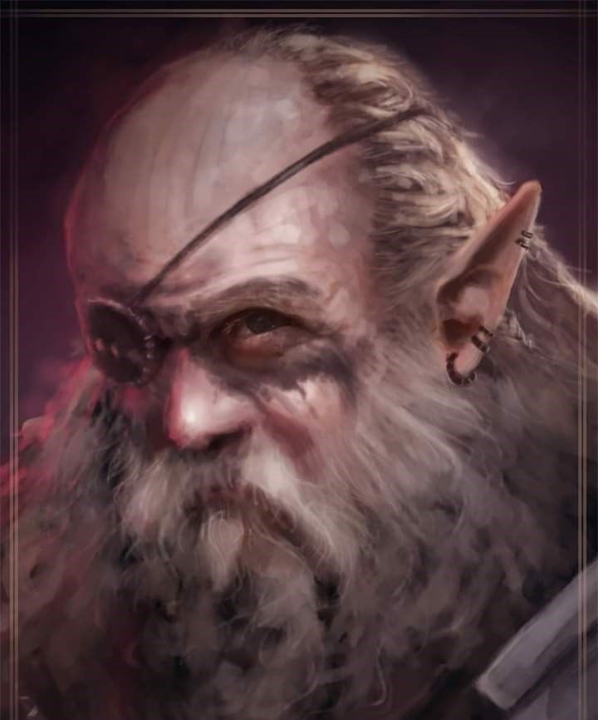

Baldoor stepped forward, looking up at the elf. “We have bin travelin’ together fer a while. I’ve known this one,” he pointed at Kassuq, “since he was a mere pup, and he does not fear anything. He is good with his sword and tenacious in combat.” He then looked over at Nihm, “And this fair lady is deadly with her bow. Her skills were honed in the Three Rivers region of Battledale where she also learned ta track as well.” He then pointed to Lee, “Lastly, our Scout is an effective and willing skirmisher both with his sword and his bow.” Then looking back at the elf, “and besides me weapons, I kin assist with healen’ or other spells if needed. We are an experienced team and are prepared to do what needs to be done for the good of all.”

The scholars and legislators conferred with their tacticians, viziers, and marshals. “You *do* seem like the sort of on-site investigators that we need.” He nodded to a whisper gnome who stepped forward, and went to stand with the party. “This is Commodore Faram Kithre. In our municipality, the term Commodore is not a military rank, but a civil office entailing the school of Divination.”

“Interesting,” the archon absentmindedly said.

“Faram isn’t the best of combatants, nor the most self-sufficient adventurer, but he knows this stretch of the Underdark as well as anyone in Candlekeep,” continued the elven elder.

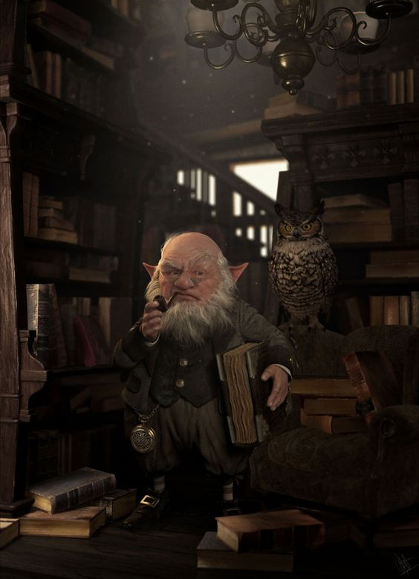

Faram introduced himself as, “Just call me Faram. I’m preemptively grateful for your support as we investigate matters, and while there are a few teams dispatched to overland itineraries, I would now ask that you venture with me underground, heading wherever word of mouth and other clues should lead us.

Though Baldoor could cast the occasional divination, a dedicated diviner was a sore void in the party’s collective skillset, and it would be a learning experience to spelunk into the womb of the continent for once.

Baldoor extended his hand in greeting to Faram, “It’s a pleasure ta meet ya and we’ll our best to protect ya.”

Each of the others extended their hands, introducing each other, “We may not be familiar with the Underdark,” Nihm said, “but we are familiar with each other. Just stay close to us and we should all be fine.”