Chapter 4: The Aranea

They were at the commissary now, waiting for some of Faram’s taller orders to be fulfilled as they also got stocked up on arrows, potions, and whatnot. The group looked around at the items for sale. Having little money to spend, they simply refilled their quivers and looked to see what potions were available.

Faram was approaching when they exited the commissary’s area, and the five now discussed their next figurative steps as they took literal steps towards the gates that would lead them out of the secured area and onto the outdoors. They passed a few donkeys led by a dwarven woman who waved to them and called to Faram.

“And to you, Silkenore!” Faram replied with sincerity. They were now as equipped as could be for the trek ahead, and Faram said that until they discovered anything noteworthy, the idea was to zigzag northeastwardly and southeastwardly along an increasingly wide perimeter, hopefully coming across some evidence of arachnid activity. “This, of course, will be dictated by the terrain, which isn’t always flat along this part of the woods.”

The group acknowledged Faram’s planned route and followed his lead with Nihm and Lee intermittently closest to the gnome guide at all times while Baldoor followed next and Kassuq brought up the rear.

They went northeast for about 10 minutes, then southeast for about 30 minutes before turning northeast once again at a ravine that led to a 6’ wide stream below. Nihm peered downward and noted that they were on the high end of the bank, which was currently dry.

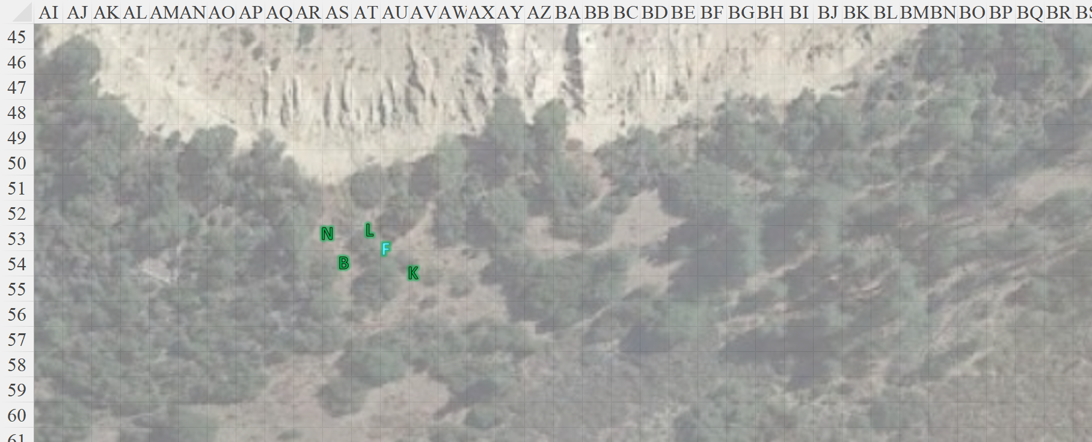

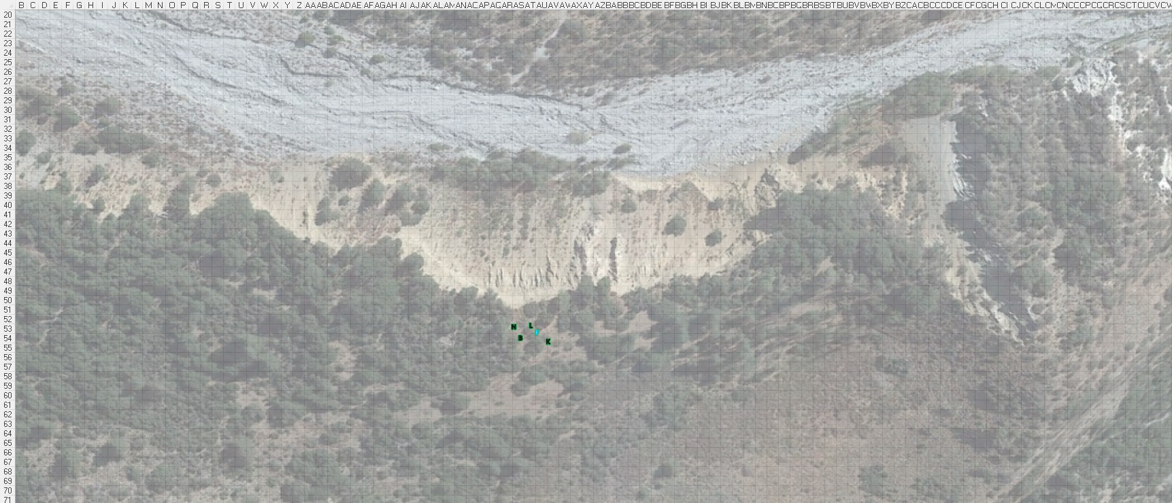

Faram had cast *mage armor* a while back during a false alarm that ended up being a squirrel. Still well armored, the gnome took a moment to survey the panorama before losing such an advantageous vantage once they turned southeastward again.

“Magnificent,” said Lee as the afternoon sun began to dip towards the west.

Their guide proposed, “We shouldn’t stop for a full rest just yet, but if you want to take a quick breather, we can relieve our bladders as well.”

And so they did. All was going well until it got to Lee’s turn. The others had gone behind a bush by the cliff, while he had chosen a more southward spot. As he pulled out his human cock to pee, he first heard—then spotted—a barbaric-looking human coming from around the next clump of bushes ready to plow him to the dirt, though he didn’t charge at first.

With a halberd carried in his left hand, and in his right, he drank the potion *[unidentified]* in his left hand as a few others came out from behind him.

*Barbarian gained +2 to TAC and AC.*

Another human—a spellcaster—stood in the middle of the quartet now, has his wand of *web* in his left hand, he sprayed Lee before his barbarian friend had a chance to take some lumps.

|  |  |  |  |  |
| --- | --- | --- | --- | --- |
| **Character** | **Check** | **Ranks** | **Roll** | **Check** |
| Chadwick | Use Magic Device | 11 | 7 | 18 |

*Success.*

|  |  |  |  |  |  |  |
| --- | --- | --- | --- | --- | --- | --- |
| **Save vs.**  *web* | **Rank** | **Ability & Mod.** | **Misc. Mods.** | **Total** | **Roll** | **Check** |
| **Lee, Reflex** | **3** | Dex (+2) | 0 | 5 | 20 | 25 |
| **Kassuq, Reflex** | **3** | Dex (+2) | 0 | 5 | 20 | 25 |
| **Baldoor, Reflex** | **1** | Dex (+1) | 2 vs. spells | 4 | 12 | 16 |

*Success3. Effect negated for now.*

A roguish halfling had snuck up around the other side, and now threw a dart coated with a black, dripping oil at Lee.

|  |  |  |  |  |  |  |  |  |
| --- | --- | --- | --- | --- | --- | --- | --- | --- |
| **Character** | **Attack Type** | **Damage** | **BAB** | **Dex Mod+** | **Total Score** | **Roll** | **Total** | **Notes** |
| Halandar | Small Dart with Medium Spider Venom | 1d3-2 + Poison | -2 | 3 | -2 | 5 | 3 | 1d2 Dex |

*Miss.*

The costly dart hit the ground uneventfully.

