Chapter 6: Scarlet

And so, they continued their quest, zigzagging for yet a few more hours, making their way along a beaten path that took them through an expansive lavender field.

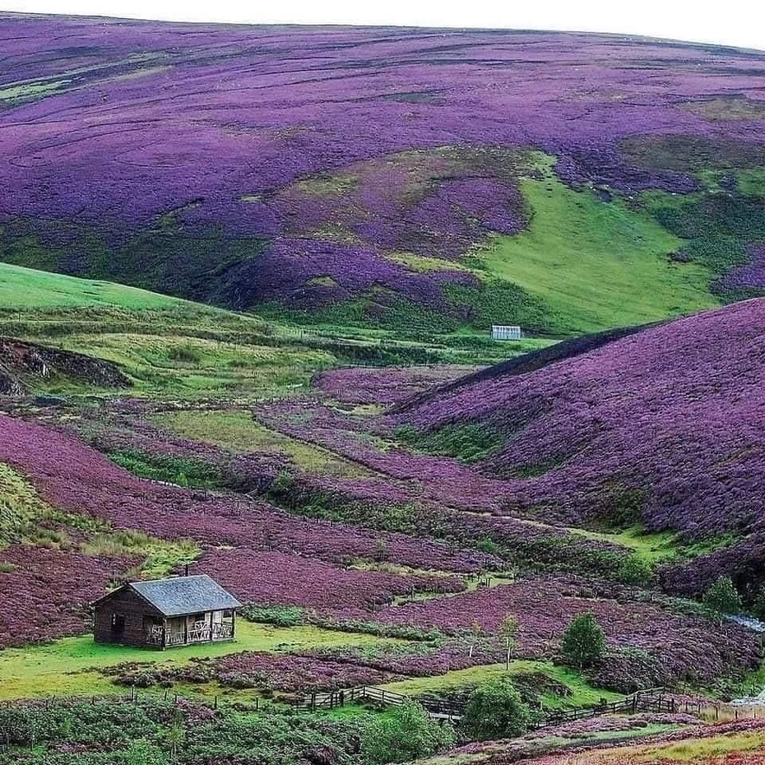

Their initial impression of the plantation highlighted its immensity along the rolling hills that surrounded the few structures in clear disrepair, but as they made their way over the first few hills, they resigned themselves to the fact that they would be seeing a sea of periwinkle under a now darkening sky as the sun set behind an overcast canopy of rainclouds menacing the western horizon.

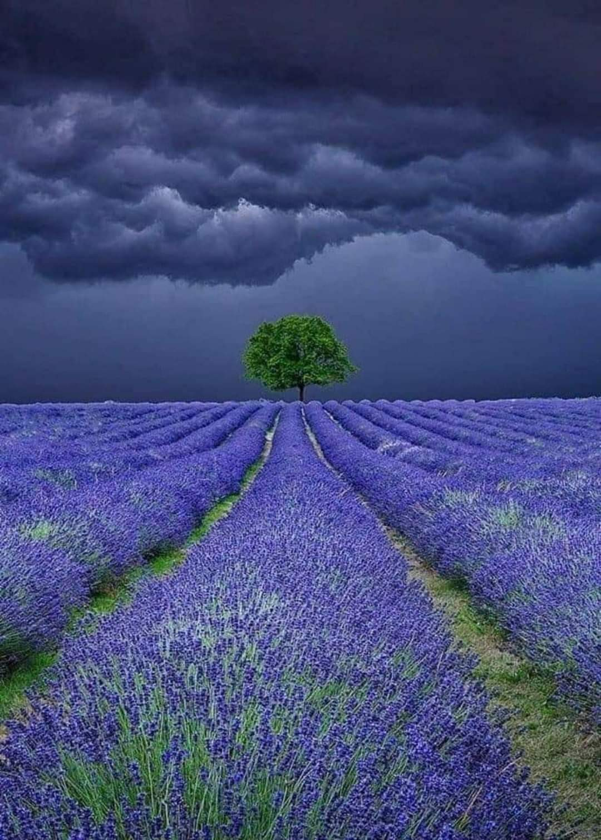

And upon this resignation, they spotted to the east before them a far sightlier structure—perhaps a residence with some processing infrastructure for the flora they no doubt harvested here—surrounded by a lawn, a rose garden, and some other breaks in the gardening monotony.

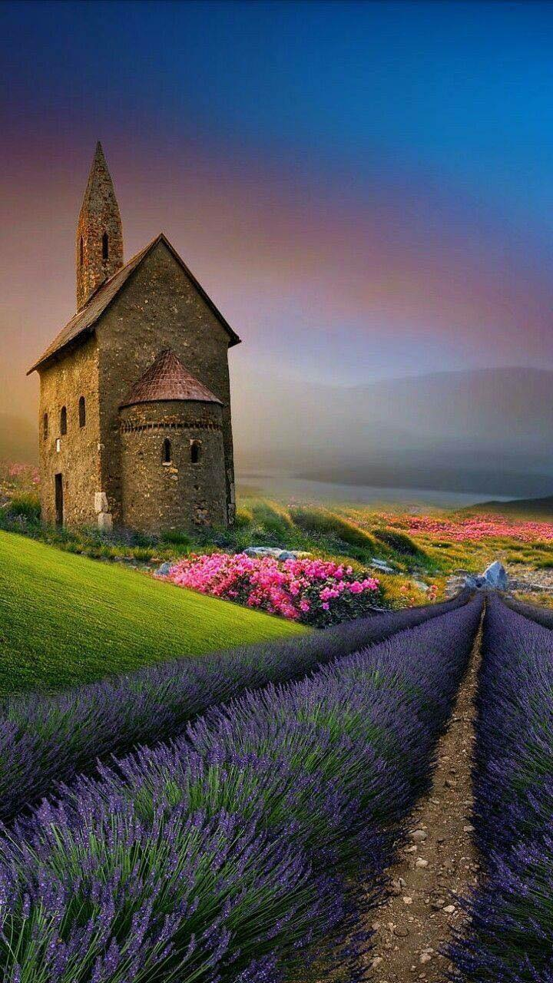

Their feet were tired, and they had grown hungry from the afternoon trek.

Baldoor turned to Nihm and Kassuq only a few feet behind himself and Faram. “Keep yer eyes open. I have a bad feelin’ ‘bout this.”

Nihm and Kassuq nodded and continued scanning the fields around them.

All three gave the building looks, watching for any movement or shadows through the windows or other openings.

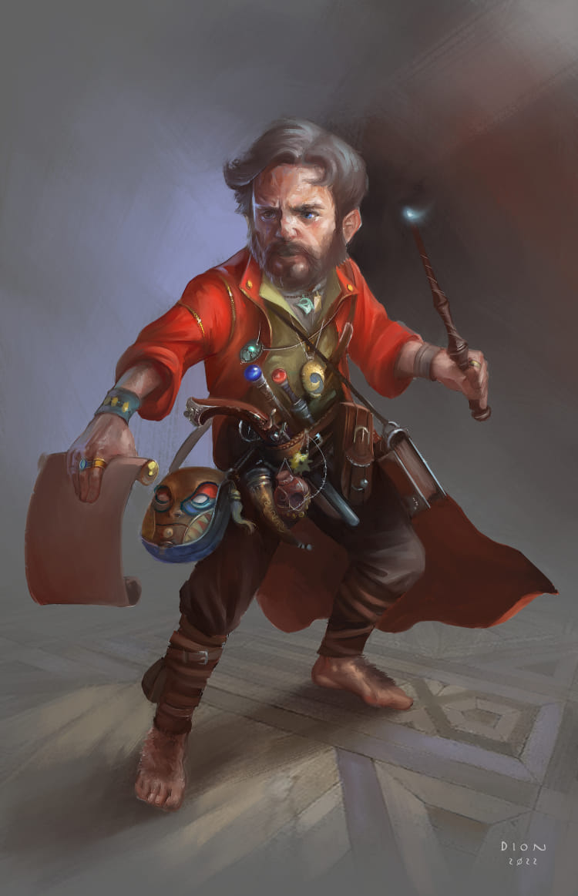

“There!” Faram cautiously motioned towards and faced one side of the farmstead, where a figure now lurked. The gnome made no effort to conceal his distress, going so far as to call out, “A fair afternoon to you, sir. We have seen much strife to reach your farm, and wish you no ill. We’ll be happy to pass through, and even peruse any wares you might be selling.”

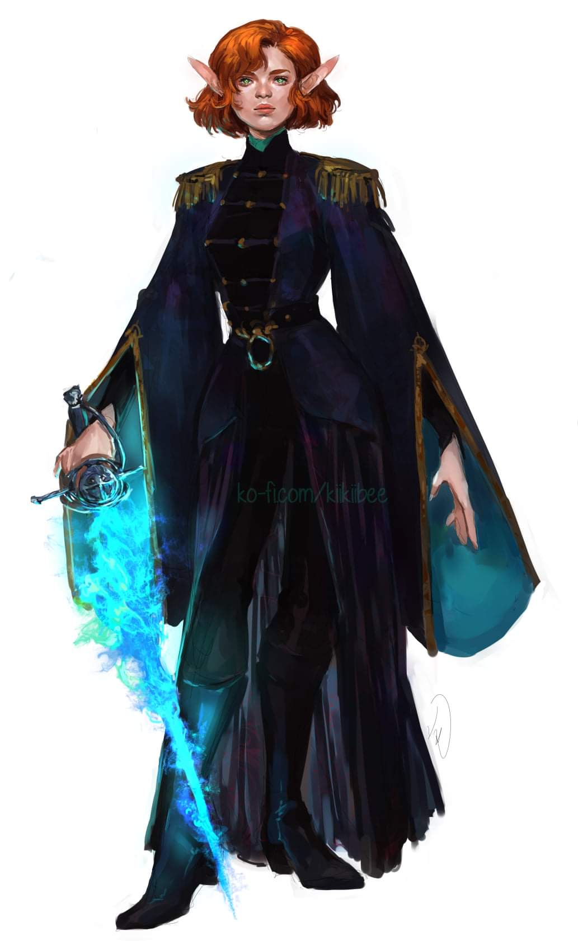

The figure came out into the light cast by a few beams of sunset ochre, and revealed herself to be an elven woman of about 100 years. She’d been holding a frostflame sword inside the doorway, and now revealed it as she sheathed it and replied, “If you are indeed peaceful passersby, please do come in and peruse our goods, though unless you buy in bulk, I cannot reduce my marked prices.”

A moment passed.

“Oh, and if you come with ill will, we will surely quarrel,” she added, smirking, and studying Nihm’s frame up and down.

All three turned to look at what had gotten Faram so upset. When the elf stepped out of the doorway and sheathed her sword, the three visibly relaxed.

As they walked towards the door, Baldoor replied, “I don’t doubt it. En after the day we’ve had I’m in no mood for more quarrels.”

Kassuq and Nihm both nodded their agreement. Kassuq couldn’t help but stare at the woman’s hair. He’d never seen an elf with such a bright and stunning. Nihm had noticed their host giving her the once over and simply smiled in reply, not wanting to offend the other elf and not really sure why the woman had focused on her.

They went inside and looked around, seeing a billboard with Elven script, identifying a dozen types of tea and other beverages available. Faram was cautious of strangers in such nice, desolate digs offering sustenance. “Long as you don’t mean to eat us,” he joked, looking into the eyes of the elf to try to glean an unguarded reaction the moment the words were said.

Nihm translated for those who did not speak or read Elven, and within minutes they had put in some requests for various teas, and a pot of water began to boil.

“So, travelers...” she looked at all four of them, but Nihm could tell the elf’s eyes lingering on Nihm’s own torso wasn’t random. “... from where do you hail? Those coming from the west are either coming from through Candlekeep or from one end of the byway that you just cut across half a mile ago.”

They recalled the north-south crossroad that they’d passed several minutes ago, and Faram answered, “We *did indeed* come through Candlekeep, though I regret that we could not spend enough time there. They had a spider infestation, so we had to be on our way.” He didn’t exactly bluff, but put only part of the narrative out there for the woman to react to. “And you are a native of these lands, uh... sorry, I didn’t get your name.”

“Call me Scarlet,” the woman said almost with the flair of a retired bard who now preferred the non-performing art of farming and teamaking.

Baldoor stepped forward and extended his hand, “Pleasure ta meet ya, lass. As our gnome friend said, we’ve come from Candlekeep en have been on tha road fur a good while.”

“Better part of the day now,” Faram sighed.

Kassuq also stepped forward and also extended his hand, “Good to meet you.”

Nihm simply nodded and gave a slight bow to their hostess, “Pleasure to meet you.”

Though Baldoor and Kassuq were relaxed, Nihm still felt a bit unsettled, wondering why Scarlet had given her an extra look.

~\*~

Long after the tea was served and second pourings had ensued, the conversation had drawn away from the heroes’ itinerant adventures, and to the establishment’s history, which Scarlet could only recount as far back as a century and a half ago. She admitted that there was a longer history, “but the paperwork on any former owners before the 12th century was lost long ago. In any case, I inherited the place, and hopefully I’ll have a child or two to take over the land once I’m gone.”

“Hopefully it’ll be a long, elven life,” Faram sipped his tea and studied Scarlet nonchalantly. The Unseen Seer—as he was called back in town—didn’t like the way she’d been eyeing Nihm.

As they drank their tea, Baldoor relayed the story of the young elf they encountered and how the lad tried to attack them. Baldoor made it clear they tried to subdue him in the end when it was obvious he was working alone. “Then tha lad just ran off inta tha woods. I’d ‘ave liked ta known what was wrong,” Baldoor ended in a sincere tone.

The woman pursed her lips and shook her head, “Shame about our youth these days.”

They also mentioned the loss of Lee as well. During the relaying of the battle, and especially during the mention of Lee’s death (just that he died, not how) it was obviously painful for the group, more so for Nihm.

Scarlet expressed her condolences over Lee, then went to a cauldron where boiling water waited to be mixed with lavender petals, and dropped a good heap of those petals into the boiling brew. She then began a conversation centered on Nihm, asking her about her origins and whereabouts, which Nihm knew to be typical of some elves. “Where in Battledale did you grow up? I’m not familiar with any elven enclaves there.”

Nihm smiled, “That is because it is a small enclave. We wander the Yevenwood and keep an eye on Hap and Haptooth hill for any signs of drow returning to the area. Our small numbers allow us a bit of secrecy.” She then gave Scarlet a smile, “Why have you chosen to settle here?”

“Oh, a number of things: the culture of ease, a lack of scandalous rabble to hold accountable for pissing on the side of the mill, some other things I don’t miss,” she half-reminisced. “The climate is also as fair for my taste as it gets,” she didn’t have to explain why.

The smell of lavender and spice lingered eternally in their midst, and they now enjoyed the sound of a music box that the woman had just wound up and now let loose.

While Nihm talked and Scarlet returned to stir the cauldron, Baldoor kept an eye on their hostess, curious to know just what Scarlet was doing.

Kassuq sniffed at the aroma from the food and drinks while his ears continually twitched and moved about listening for any unusual sounds inside or out.

A few more minutes passed, and somewhat intriguing local lore was imparted upon the guests, and it was then that the sound of someone approaching on horseback announced them long before they dismounted and reached the door.

Two elves—one bearing the likeness of Scarlet’s kin—entered, and the boys bid their guests well.

“These travelers are from Candlekeep. Rijtram, do stable the horses before you get too settled in,” Scarlet introduced the diners, then bade the boy with the darker hair to tend to the light riding horses whose sweat Kassuq could barely smell now.

The three nodded and greeted the two new arrivals. Kassuq and Baldoor kept an especially close eye on the three elves, noting nothing out of place. Nihm got up and stepped outside to look at the horses to see what condition they were in. She offered her assistance in stabling the horses as well.

Faram eyed the two strangers before the bruin-haired one bowed his hellos and took his leave once again, leading the two mounts to the adjacent barn.

“Candlekeep, eh?” asked the boy who might have been Scarlet’s brother and perhaps a decade younger. “What news bring you from the west then?”

Baldoor smiled, “We ‘ere not residents, but yes, we’ve bin sent out by Candlekeep ta look inta tha source of an attack on tha city. Have yee seen anythin’ odd or unusual tha last few days?” Baldoor kept his tone even and friendly.

The two elves present now spoke to each other in Elven words that Nihm would have easily understood had she not just left the room. Heading to the barn with the other elf, she got Rijtram to talk a bit, and by the time they were inside the stables and had secured both steeds inside among three other horses, a cow, and a few goats, she learned that the young man longed to be elsewhere.

Baldoor and Kassuq gave the elves and odd look and looked over at Faram to see if he understood the elves. He shrugged, but earlier they thought they’d heard him say that he spoke a little Elven.

In either case, to Baldoor it seemed rather odd and arrogant to speak in a tongue that had not been established as known by all. In Dwarven, he grumbled, “How rude!” hoping that the elf understood and to get a reaction from her if she did.

“What’s her name?” Nihm intuited the unspoken reason.

He looked up at her as they walked back, “Oh...” he smiled. “It’s actually this dude named Engelbrit.”

“A human?”

“No, pure elf. He just has a funny, human-sounding name, but he’s legit,” mused the lad.

“And where is Engelbrit now?”

“As of the last *sending*,” he sighed, “in Neverwinter, but that was over two moons ago.”

Nihm stopped before reaching the door and looked at Rijtram, her head tilted to the side slightly. “Then why not *go* to him? There are always caravans needing assistance headed in that direction. You are old enough to choose a path to follow, so what keeps you here?” She was cautious as she asked, keeping her tone low and watched Rijtram for his reaction.

They reached the door to the main building as the conversation had once again turned to the Common tongue.

Faram was speaking now, jovial as they’d ever seen him, and full in the belly. “I commend you, Madame Scarlet, on this fine establishment, and will certainly convey my recommendations to travelers to come and pay patronage to you. Might I also purchase one of those sacks of lavender? I’d love to brew my own once we’re back home.”

The keeper of the place obliged the man, handing him one sack and taking his coin. As Nihm entered further, the seated heroes stood from the table and offered the senior gnome to pay for their own food, but he insisted, adding, “Once you’re the eldest in the lot, or the richest, *you* be the purveyor of the moment.”

The two elven boy-men now helped themselves to a plate each, partaking of the stew that had been waiting for them, and placing their plates near the oven to keep them warm as they cleared the table of the guests’ dishes.

With the sun setting behind her and its faint rouge beaming in through a window, Scarlet rearranged the sacks of lavender on the main shelf and went to pull open the cellar door. “Iffin’ you’re interested,” she turned one last time to sell the good stuff, “We have essential oils, elixirs, and tonics that I’ve distilled or refined myself.”

Baldoor shook his head, “Not at tha moment,” he stated politely. “We just need a place ta bed down fir tha night.”

Nihm and Kassuq both also turned down the offer of any oils or elixirs at the moment. Though Nihm was contemplating getting some of the oils for her baths.

“Oh!” she hadn’t anticipated that they would stay the night, “we’ll have to tidy up the cots, methinks. Boys, can you tend to... how many rooms would you want? Each has two cots and costs 15 GP,” she held to her steep price out here in the wilderness.

They were prepared to camp out in the open, but 15 per room was within their scope.

“Methinks one room will do,” Baldoor said and both Nihm and Kassuq nodded their agreement.

Kassuq said he could transform into a small fox for the night and Baldoor would sleep on the floor in his bedroll. “Nihm and Faram can have the cots,” the archon gallantly offered.

“One room,” nodded Scarlet. “Simple enough. Lads, can you ready the Raptoran Loft?”

The boys cleaned up the avian-themed quarter just above the kitchen, which had an open pair of foldout windows that the boys promptly closed before drawing the curtains and offering them the room, now with ample privacy.

The gnome had bagged up his purchase, and now paid the elf 15 GPs for the room, and bade Scarlet a pleasant evening before joining the others up the squeaky but sturdy staircase. “Privies are right outside, around the corner to the left,” G’noxo—the taller male—motioned as they passed one another at the threshold of their rented room.

Nihm had spotted the stalls, and was first to use one, which was the salvaged end of a garderobe originally belonging to a palace now lying in rubble. It was an ingenious reuse for such a relic.

~\*~

Back upstairs, the other three tended to their respective wares, setting down their gear, preparing to prepare spells, and all-around fixing to rest.

Baldoor had pulled out two of his candles and had set them up on either side of his holy symbol which was on the floor in front of him. He then began a prayer to Moradin in dwarven. The chant was in his low, baritone voice, though at a softer volume then his normal speech. Meanwhile, Kassuq had pulled out his bedroll and folded it up into a small, 2’-by-2’ square. He sat on it, listening to his friend and waiting for Nihm to return.

The elves each had a room adjacent or near the heroes’, and they were urged to let Scarlet—in the “Peafowl Room”—know if they needed anything.

Nihm returned, and in time everyone tended to their respective biological needs and got to rest.

Nihm entered and took a few moments to make her bed and make sure her weapons were within easy reach. She smiled at Baldoor and Kassuq. Baldoor had finished his prayers and was putting away his candles and placed his holy symbol back around his neck. Kassuq smiled back before transforming into small fox. He did a couple of circles around his bed before finally settling down.

~\*~

Night came and Baldoor and Faram had prepped their spells. It was probably just past midnight when the unmistakable sound of a dragon flying and roaring overhead startled them all.

They instinctively scrambled for their weapons, but by the time everyone was out of their cot or corner, the creature had flown by and could be seen continuing southward at an altitude of about 300’. The moonlight carved out the dragon’s silhouette as Faram went to the window and identified it as a green dragon.

All three looked out the window watching the dragon shrink into the distance. Now in his full sized form, Kassuq unrolled his bedroll and prepared to climb in as Faram spoke up.

“Doesn’t look like it cares to waste its time on us,” sighed the gnome as the others relaxed.

“I’m glad o’ that,” Baldoor said as he lingered at the window a little longer. “Perhaps we should set a watch fir tha rest o’ tha night.” He looked at the others, “I’ll take the first one, Nihm, you can take the next one.” Nihm nodded as she climbed back into bed, her bow a bit closer than normal.

Scarlet knocked on the door and asked, “Is all well in there?”

Faram answered, “Yes, we’ve just spotted a juvenile dragon flying overhead.” The gnome opened the door.

Scarlet looked in on everyone. “The young dragons know better than to trifle with humanoids, and there hasn’t been a full-sized drake sighted here in years. I’ll remain vigilant in case it returns.”

They thanked her and closed the door, eventually settling back into their cots or post. Baldoor had by now taken watch for a couple of hours, then Nihm. Now Kassuq would take over, and finally Faram, whose bladder and metabolism had already spurred him to the privy several times during the night.

~\*~

When Nihm awoke, Kassuq and Baldoor were still asleep, and Faram was gone, likely peeing again. The sun had just risen, and her dreams of home were still fresh in her head. They would soon subside to daytime matters as she got dressed and ready for the trek back to Candlekeep.

They had not found much in the way of spiders and drow, but they had rested and recuperated, and were now in top condition to face what trifles came their way.

The elf’s shifting rustled up the archon, whose whining stretch awoke the dwarf.

With everyone awake, they prepared their gear for the day’s travel, and Faram eventually returned from a morning stroll with tales of squirrels and other animals known to share an affinity for gnomes.

“Looks like you’re all ready,” Faram observed aloud. “I’ll fetch my bag and we can check out.”

Baldoor asked as they checked out, “Before we leave, have any o’ you seen any unusual activity round tha area? Spiders or kobolds where they should not be?”

“Kobolds?” Scarlet frowned. “I thought you said it was drow you were looking for, and as I mentioned, we’ve seen neither monstrous spiders nor *unfriendly* drow, nor kobolds, recently, for that matter. Had a drow lady stay a week or so last year, but she was total love; nothing like the lolth lovers you’re—no doubt—looking for.”

“Yes, the spiders are a giveaway,” Faram sighed as they bade the elves well and stepped back outside unto the myriad rows of lavender that would skirt their path for now.

Baldoor nodded, “Thanks fir yer hospitality. We will take our leave. We need ta return to Candlekeep and report our lack o’ findings.” Baldoor paused for a moment, “Unless any o’ you know of any caves or other entrances to the world below in the area.” Baldoor looked at all three of their hosts to see if any of them knew something and might be hiding that information.

One of the lads did. “You *sure* you want to go spelunking in them dreary caves... just the four of you?”

They nodded. Kassuq watched their hosts closely, not getting a very definitive read on the elves.

The boy shrugged, and drew them a makeshift map, taking them along a trail they’d not taken during their zigzagging across the inland marchlands between here and Candlekeep.

Faram said, “This is the trail we crossed a few miles back before getting on this one here.”

“Shouldn’t have any problem finding it,” Nihm mused.

Scarlet gave Nihm a warm smile as they left.

Baldoor smiled, “We may not go in, but we need ta at least check it out.” Nihm and Kassuq both nodded.

Nihm added, “Plus, it’s on our way back, so just a small detour.”