Chapter 9: Candlekeep Docks

The next morning, they rose from their rented cots, giving themselves plenty of time to make a final decision on whether to continue with this drow business or strike camp and maybe even set sail for somewhere. The Candlekeep Docks—an independent settlement of booksellers and other traders—was known to have regular arrivals and departures with vacancies to fill.

After the night to consider their options, the four gathered outside of the inn where Baldoor, Nihm and Kassuq had been staying. When Haal arrived, they spoke briefly and had all decided they would set sail and see where the tides and winds would take them. With that decision out of the way, they did some training with Haal, showing him some good maneuvers with his quarterstaff and also better ways to dodge an attack.

When they had decided it was a good time for Haal to take a break and allow his bruises to heal, the four headed back to city hall to inform the council that they would be departing and inquired as to whom the best ship captains to contact for passage would be.

They were received with decorum, and invited to return to Candlekeep whenever they chose. They were given a rudimentary map to Candlekeep Docks, which was just about a mile from Candlekeep proper, and began to ponder that short jaunt. “Provisions are cheaper there,” mentioned Haal, who knew the place, and didn’t need a map. “We should stock up on food and any other mundane items while we’re there.”

~*~

Candlekeep Docks

This delta settlement was built along the highest-altitude portions of an estuary with a view to the open sea. A wide river cut through the estuary, and the piers and docks that lined the exploitable topography were now hosts to about two-dozen boats. About a quarter-mile downstream, they could see three large ships waiting for passengers to be ferried aboard by some of the boats moored here.

The experience in Candlekeep, and the preceding adventure with the traveling zoo, had both added wisdom to the heroes’ portfolios, and although they’d lost Lee in a senseless brawl, Haal was now here to accompany them wherever fate would take them.

They meandered through the gateless village, finding a central row of taverns, shops, and inns, and identified a place to book passage on a variety of passenger cruises, as well as a job board with a variety of posts ranging from bounty hunts to carpentry labor wanted.

It was still morning, and the four heroes stood looking around for a moment at the thirty or so people they could see in what could only be a town center in such a sparsely populated place. Some of these were children, playing with the burnt remains of a xvart that had likely been too bold for his own good.

It was a bit early for lunch, but it was worth making the best of the situation while they had every reasonable amenity available to them.

As they walked along, Haal mentioned that he was trying to come up with a device to use *continual flame* to provide light for himself in situations like yesterday. Kassuq mentioned he could cast *continual flame* as an ability, and would be happy to provide the spell once the object was ready.

Haal replied, “Excellent, I just need to get the design to a blacksmith. It’s a reflective tube to cast the light in specific areas. Also, the rear, holding the spell, can be removed to provide the light over a larger, 360-degree area. Sort of two items in one.”

As the two discussed the idea, Baldoor spoke up, “Let’s step en get sumthin’ ta eat, then we kin take care or your idea then find a ship.”

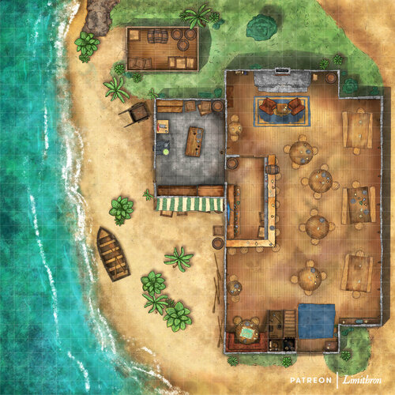

~*~

After brunch, they went to see a blacksmith about Haal’s ‘flashlight’ idea.

The blacksmith—a druid named Kvun—offered to do this for about twice the price of what Haal had estimated it would have run them for materials.

They discussed the details a bit more to ensure an accurate understanding of the contraption in question: “… a tube about 1’ long and a couple of inches in diameter. It has a twist on the back side where the stone or object with the *continual flame* is attached. It can be unscrewed to be more like a lantern/candle. Then there is a hood/cover for the front that can be removed or replaced like turning a flashlight on or off.

Kvun nodded and replied that it “could be ready within a tenday, … but possibly as little as five days.”

Haal contemplated the prospect, conferred with Kassuq and the others, then declined.

~*~

The four adventurers then found a few ships going along the coast. Haal noted each ship’s itinerary, and its corresponding fare.

Shallowave

Athkatla **60 ₲**

Irphong **250 ₲**

Velen **350 ₲**

Murann **455 ₲**

Locust Swarm

Llewellyn **170 ₲**

Iron Keep **300 ₲**

Port Korinn **650 ₲**

Port Mintarn East **1000 ₲**

Misadventure Galley

Port Mintarn East **600 ₲**

Baldur’s Gate **895 ₲**

Baggins’ Barnacle

Baldur’s Gate **80 ₲**

Waterdeep **800 ₲**

They had heard the rumors of piracy being more prevalent along the southern routes, and on the high seas, and considered their prospects. Though other ships would come along, they would likely have similar routes based on the same prevailing winds.

Looking at the map on the wall of the booking office, they further pondered their collective destiny.

At lunch the four discussed some options for travel. The concern about pirates would allow them to travel as protection on any ship, they would just need to make sure they adjusted their spells properly.

During the meal, Nihm suggested, “I suggest we head for Alaron, the southern city of Llewellyn. If we go as guards or deck hands, we might not have to pay.”

Baldoor nodded, “We kin try en’ negotiate with ‘em, see what they say. I have no preference fir our destination.”

Kassuq looked up from his steak and shrugged his shoulders, “Sounds good to me. Is there anything special about Llewellyn?”

“Not really,” replied Nihm, “I’ve never heard much about it, but a small port town could have plenty of work and options. Plus, there is plenty of island to explore if we get bored.”

Haal smiled and nodded, “Sounds like a plan.”

The four finished their meal and after haggling with the blacksmith, decided they would wait around for the ‘Ever burning torch’, as Haal decided to name it, to be completed. In the meantime, they offered their services to any of the warehouses or bars that might need security or bouncers.

First, Baldoor tried doing the talking.



|  |  |  |  |  |  |  |
| --- | --- | --- | --- | --- | --- | --- |
| **Skill** | **Rank** | **Ability & Mod.** | **Misc. Mods.** | **Total** | **Roll** | **Check** |
| **Baldoor, Gather Information** | 0 | Cha (+0) | 0 | 0 | 5 | 5 |

*See below.*

That didn’t seem to get them anywhere, so they looked to Haal, the learned local among them.



|  |  |  |  |  |  |  |
| --- | --- | --- | --- | --- | --- | --- |
| **Skill** | **Rank** | **Ability & Mod.** | **Misc. Mods.** | **Total** | **Roll** | **Check** |
| **Haal, Gather Information** | 0 | **Cha (+2)** | 0 | 2 | 4 | 6 |

*See below.*

They didn’t fare any better with Haal’s leadership in the schmoozing department, and thought about hiring out a rogue who could also negotiate on their behalf, the drawback being that this individual would likely negotiate their way into a lucrative deal at the cost of the party.

“What this needs is a lady’s charm,” suggested Nihm before trying her luck in the endeavor.



|  |  |  |  |  |  |  |
| --- | --- | --- | --- | --- | --- | --- |
| **Skill** | **Rank** | **Ability & Mod.** | **Misc. Mods.** | **Total** | **Roll** | **Check** |
| **Nihm, Gather Information** | 0 | **Cha (+1)** | 0 | 1 | **10** | 11 |

*See below.*

After a few marriage proposals and single-serving versions of said proposals, the elven ranger had gone a little too druid in her dress as of late, and her unkempt and natural appearance did not help her to glean much information of use, though she would have had lovers galore if that’s what she’d been after.

Kassuq cracked his knuckles, ruffled his mane up a little, and winked at the ranger-druid as he muttered, “Luck indeed be a lady, or perhaps an archon.”



|  |  |  |  |  |  |  |
| --- | --- | --- | --- | --- | --- | --- |
| **Skill** | **Rank** | **Ability & Mod.** | **Misc. Mods.** | **Total** | **Roll** | **Check** |
| **Kassuq, Gather Information** | 0 | **Cha (+0)** | 0 | 0 | **18** | 18 |

*See below.*

And though he was as rough around the edges as usual, the Celestial’s true persona shone through the sled-dog-like appearance that often perturbed humanoids’ interpretations of his intentions. Though not particularly adept in the art of gab, the archon used his Tongues ability to orate in the languages of those he heard near him, at one point coming up with a short series of rhymes that bridged a verse in Elven, another in Chondathan, and another in Halfling, impressing the travelers and merchants.

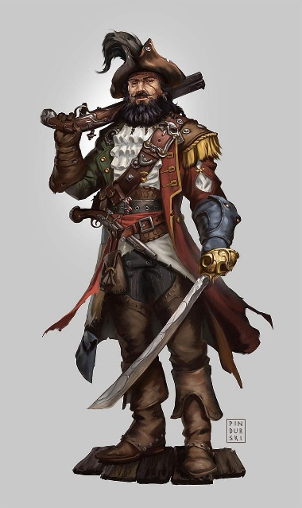

“Say...” an impressed, two-eyed, well-clad seaman named Azmul asked before introducing himself, “You four look like adventuring types.”

They looked at one another, having expected him to speak more like Baldoor, though his accent skewed towards Candlekeep.

He continued, “My employer’s ship—the Locust Swarm—is headed for the Moonshaes, and is recruiting security personnel.”

“We *might* be interested,” Baldoor turned to face the man.

“Good. If you can fend off one of them each,” he pointed to some nightstick-wielding men and women, “without anybody getting killed, you’re in the wedding. Healing will be provided afterwards, even if you fail.”

Baldoor looked at the others, getting nods from Nihm and Kassuq and a shrug of the shoulders from Haal. He then turned to the captain, “Sounds far enuf; we accept.”



And so, with the view of the bay’s coastline on one side, and the seaside settlement all around them, they took to one-on-ones with four folks named Darfur, Durban, Davos, and Dogeater.

Round 1

*OOC: NPCs have initiative. Each PC is now 5’ from their opponent, and at least 15’ away from any other character.*

Darfur, Durban, Davos, and Dogeater went after Baldoor, Haal, Kassuq, and Nihm, respectively.

|  |  |  |  |  |  |  |  |  |  |  |
| --- | --- | --- | --- | --- | --- | --- | --- | --- | --- | --- |
| **Character** | **Attack Type** | **Damage** | **BAB** | **Str Mod+** | **Dex Mod+** | **W+** | **Other+** | **Total Score** | **Roll** | **Total** |
| Darfur | MW Club | 1d6+2 | 4 | **2** | 0 | 1 | 0 | 7 | 14 | 20 |
| Durban | MW Club | 1d6+1 | 4 | **1** | 2 | 1 | 0 | 6 | 17 | 22 |
| Davos | MW Sap | 1d3+2 | 4 | 0 | **2** | 1 | 0 | 7 | 5 | 11 |
| Dogeater | MW Greatclub | 1d10+3 | 4 | **3** | -1 | 1 | 0 | 8 | 17 | 24 |

*Hit, hit, hit, hit.*

*Dmg to Baldoor: 3 + 2 = 5 nonlethal [30/35].*

*Dmg to Haal: 6 + 1 = 7 nonlethal [24/31].*

*Dmg to Nihm: 9 + 3 = 12 nonlethal [18/30].*

Baldoor grunted, accepting the hit and swung back with his hammer, focusing on nonlethal damage. He also shifted his stance to a bit more defensive.

|  |  |  |  |  |  |  |  |  |  |
| --- | --- | --- | --- | --- | --- | --- | --- | --- | --- |
| **Melee Weapon** | **Dmg.** | **D+** | **TH+** | **Critical** | **Type** | **Wt.** | **Atk** | **Roll** | **Check** |
| MW Warhammer | 1d8 | +1 | 1 – 2 CE | x3 | Bludgeon | 3.0 | +2 | 3 | 5 |

*Miss.*

Kassuq growled at his opponent and struck back using the flat of his sword.

|  |  |  |  |  |  |  |  |  |  |
| --- | --- | --- | --- | --- | --- | --- | --- | --- | --- |
| **Melee Weapon** | **Dmg** | **D+** | **TH+** | **Critical** | **Type** | **Wt.** | **Atk** | **Roll** | **Check** |
| Longsword +1 | 1d8 | 3 | 1 | 19-20/x2 | Slashing | 4.0 | +7 | 10 | 17 |

*Hit. Dmg: 3 + 2 + 1 = 6 nonlethal.*

Nihm smiled at her opponent and maneuvered the rapier around and ‘slapped’ at her opponent with it, careful not to puncture them.

|  |  |  |  |  |  |  |  |  |  |
| --- | --- | --- | --- | --- | --- | --- | --- | --- | --- |
| **Melee Weapon** | **Dmg** | **D+** | **TH+** | **Critical** | **Type** | **Wt.** | **Atk** | **Roll** | **Check** |
| Rapier | 1d6 | 0 | 1 | 19-20, x2 | Slashing | 4.0 | +5 | 12 | 17 |

*Hit. Dmg: 6 nonlethal.*

Haal took the strike but didn’t seem to enjoy it. He then struck back with his quarterstaff, deciding not to use any spells for this fight.

|  |  |  |  |  |  |  |  |  |  |
| --- | --- | --- | --- | --- | --- | --- | --- | --- | --- |
| **Melee Weapon** | **Dmg** | **D+** | **TH+** | **Critical** | **Type** | **Wt.** | **Atk** | **Roll** | **Check** |
| MW Quarterstaff | 1d6 | 0 | 1 | x2 | Bludgeon | 4.0 | +6 | 15 | 21 |

*Hit. Dmg: 2 nonlethal.*

Round 2

The pirates gave the prospects another taste of their saps and clubs.

|  |  |  |  |  |  |  |  |  |
| --- | --- | --- | --- | --- | --- | --- | --- | --- |
| **Character** | **Attack Type** | **Damage** | **BAB** | **Str Mod+** | **Dex Mod+** | **Total Score** | **Roll** | **Total** |
| Darfur | MW Club | 1d6+2 | 4 | 2 | 0 | 6 | 2 | 8 |
| Durban | MW Club | 1d6+1 | 4 | 1 | 2 | 5 | 10 | 15 |
| Davos | MW Sap | 1d3+2 | 4 | 0 | 2 | 6 | 16 | 22 |
| Dogeater | MW Greatclub | 1d10+3 | 4 | 3 | -1 | 7 | 1 | 8 |

*Miss Baldoor.*

*Hit Haal. Dmg: 4 + 1 = 5 nonlethal [19/31].*

*Hit Kassuq. Dmg: 1 + 2 = 3 nonlethal [33/36].*

*Miss Nihm.*

*[DM assumption]* The prospects swung back once again.

|  |  |  |  |  |  |  |  |  |  |
| --- | --- | --- | --- | --- | --- | --- | --- | --- | --- |
| **Melee Weapon** | **Dmg.** | **D+** | **TH+** | **Critical** | **Type** | **Wt.** | **Atk** | **Roll** | **Check** |
| MW Warhammer | 1d8 | +1 | 1 | x3 | Bludgeon | 3.0 | +4 | 15 | 19 |
| MW Quarterstaff | 1d6 | 0 | 1 | x2 | Bludgeon | 4.0 | +6 | 14 | 20 |
| Longsword +1 | 1d8 | 3 | 1 | 19-20/x2 | Slashing | 4.0 | +7 | 3 | 10 |
| Rapier | 1d6 | 0 | 1 | 19-20, x2 | Slashing | 4.0 | +5 | 5 | 10 |

*Hit (Darfur), hit (Durban), miss (Davos), miss (Dogeater).*

*Dmg to Darfur: 3 + 1 = 4 nonlethal.*

*Dmg to Durban: 3 + 2 + 1 = 6 nonlethal.*

Round 3

The pirates did their best to discourage the new guys from a rugged life on the high seas.

|  |  |  |  |  |  |  |  |  |
| --- | --- | --- | --- | --- | --- | --- | --- | --- |
| **Character** | **Attack Type** | **Damage** | **BAB** | **Str Mod+** | **Dex Mod+** | **Total Score** | **Roll** | **Total** |
| Darfur | MW Club | 1d6+2 | 4 | 2 | 0 | 6 | 8 | 14 |
| Durban | MW Club | 1d6+1 | 4 | 1 | 2 | 5 | 14 | 19 |
| Davos | MW Sap | 1d3+2 | 4 | 0 | 2 | 6 | 18 | 24 |
| Dogeater | MW Greatclub | 1d10+3 | 4 | 3 | -1 | 7 | 2 | 9 |

*Miss Baldoor.*

*Hit Haal. Dmg: 5 + 1 = 6 nonlethal [14/31].*

*Hit Kassuq. Dmg: 3 + 2 = 5 nonlethal [28/36].*

*Miss Nihm.*

The young and barely armored fighter missed the dwarf, and shook his head with a grunt, as did the barbarian facing the archer woman. The other two got some good hits in.

*^^ Darfur ^^*

Three of the four newcomers continued swinging away, a bit frustrated that they had not already imposed their will upon this meager bunch.

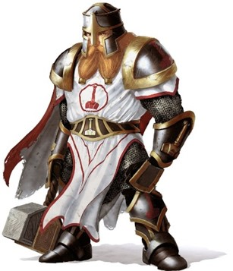

Baldoor maintained a defensive stance (-2 Attack +2 to AC – Combat Expertise) while Haal grabbed his quarterstaff with both hands and swung at Durban as hard as he could, hoping to down his opponent or throw off his aim.

|  |  |  |  |  |  |  |  |  |  |
| --- | --- | --- | --- | --- | --- | --- | --- | --- | --- |
| **Melee Weapon** | **Dmg** | **D+** | **TH+** | **Critical** | **Type** | **Wt.** | **Atk** | **Roll** | **Check** |
| MW Quarterstaff | 1d6 | 0 | 1 | x2 | Bludgeon | 4.0 | +6 | 11 | 17 |

*Miss.*

***Do you have an image for Haal?***

Kassuq smiled and continued to slap at Davos with the side of his sword.

|  |  |  |  |  |  |  |  |  |  |  |
| --- | --- | --- | --- | --- | --- | --- | --- | --- | --- | --- |
| **Melee Weapon** | **Dmg** | **D+** | **TH+** | **Critical** | **Type** | **Wt.** | **Atk** | **Roll** | **Check** | **`** |
| Longsword +1 | 1d8 | 3 | 1 | 19-20/x2 | Slashing | 4.0 | +7 | 16 | 23 |  |

*Hit. Dmg: 3 + 3 = 6 nonlethal.*

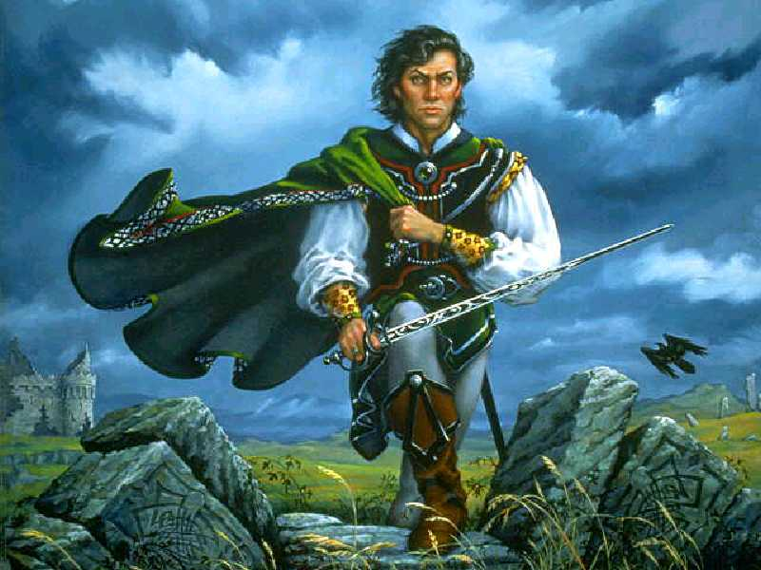

“Aaargh!” Davos put his left hand on the part of his head where the archon’s longsword’s broad side had just blunted him, and raised his right hand, adding, “Yield... I’m done. Give me my vial.” The swashbuckler errant was done for the moment.

A lad named Jackalsong rushed to do just that, asking Kassuq to let Davos be. “You’ve proven your mettle, archon,” the half-elf said.

*Davos gained 11 + 6 = 17 hps.*

“Well played,” the swashbuckler raised an empty vial to his opponent as the fight continued around them.

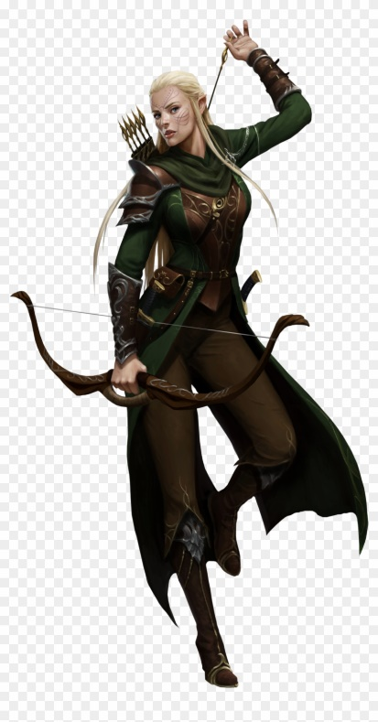

Nihm danced about, swatting at the towering Dogeater. “Is that really your name, *Dogeater*?”

|  |  |  |  |  |  |  |  |  |  |
| --- | --- | --- | --- | --- | --- | --- | --- | --- | --- |
| **Melee Weapon** | **Dmg** | **D+** | **TH+** | **Critical** | **Type** | **Wt.** | **Atk** | **Roll** | **Check** |
| Rapier | 1d6 | 0 | 1 | 19-20, x2 | Slashing | 4.0 | +5 | 15 | 20 |

*Hit. Dmg: 5 nonlethal.*

“Awf! Yes, or namesake,” said the ruggedly handsome barbarian.

Azmul approached Kassuq, personally handing him a potion, and commented, “You have a brave swing, and a solid grip, even when switching the mercy to strike with the broad side. Good technique.”

Kassuq accepted the potion and nodded his strength. When asked about Haal he thought for a moment. “He is a scholar and is just learning to fight. Whether he is a cartographer or a scribe, I’m sure he would take on any roll.” Looking back at Azmul, “I will also add, that he has courage and conviction from what I have seen. So, whatever the task, he will perform it to the best of his ability.”

Baldoor, catching Kassuq winning his fight, smiled and swung with a little extra zest in his swing, boosted by the pride he felt having taught Kassuq a good amount of what the young archon knows about fighting.

Haal focused on his foe and swung down with his quarterstaff, realizing that this may not be the best choice for a fighting weapon.

Nihm continued her fluid movements as she slapped at her opponent again, sensing that she had him nearly beaten.

Round 4

Jackalsong looked at Azmul, ready to deliver vials to the resilient but badly bludgeoned cloistered cleric doing his best to remain chipper on the interview.

Azmul was also growing concerned that Haal may not have been up to the rugged life that would await them on deck, and leaned over to Kassuq as they and other crewmembers watched the remaining three pairs of melees ensuing. “Your friend, who is he to you? A bookkeeper or treasurer?”

At first, Kassuq had interpreted the question to imply that Haal was about to be rejected from the pool, but then read in the human’s face that he was trying to find another function for Haal to fulfill while everyone else did seaman stuff. “Is he perhaps a cartographer? Or at least a scribe?”

This round, Baldoor decided to go on the offensive, and swung his hammer at his opponent one more time.

|  |  |  |  |  |  |  |  |  |  |
| --- | --- | --- | --- | --- | --- | --- | --- | --- | --- |
| **Melee Weapon** | **Dmg.** | **D+** | **TH+** | **Critical** | **Type** | **Wt.** | **Atk** | **Roll** | **Check** |
| MW Warhammer | 1d8 | +1 | 1 | x3 | Bludgeon | 3.0 | +4 | 16 | 20 |

*Hit. Dmg: 8 + 1 = 9 nonlethal.*

Haal continued to swing wildly with his quarterstaff, hoping to connect and take down his opponent, especially since he was already beginning to feel nearly beaten himself.

|  |  |  |  |  |  |  |  |  |  |
| --- | --- | --- | --- | --- | --- | --- | --- | --- | --- |
| **Melee Weapon** | **Dmg** | **D+** | **TH+** | **Critical** | **Type** | **Wt.** | **Atk** | **Roll** | **Check** |
| MW Quarterstaff | 1d6 | 0 | 1 | x2 | Bludgeon | 4.0 | +6 | 12 | 18 |

*Hit. Dmg: 2 nonlethal.*

Nihm continued to slap at her opponent with her sword, hoping to bring down her foe in order to help Haal or Baldoor.

|  |  |  |  |  |  |  |  |  |  |
| --- | --- | --- | --- | --- | --- | --- | --- | --- | --- |
| **Melee Weapon** | **Dmg** | **D+** | **TH+** | **Critical** | **Type** | **Wt.** | **Atk** | **Roll** | **Check** |
| N: Rapier | 1d6 | 0 | 1 | 19-20, x2 | Slashing | 4.0 | +5 | 15 | 20 |

*Hit. Dmg to Dogeater: 2 nonlethal.*

Azmul raised his left hand and blew a whistle held in the right. Darfur, Durban, and Dogeater held their stances, communicating with their body language that the sparring was over. “Healing!” Dogeater called out to Jackalsong.

Round 5

Azmul drew upon his managerial experience to start with something positive, and directed himself at Haal instead, “You, sir, are—no doubt—a man of letters, are you not?”

Haal nodded, first at Azmul, then at his adversary, Durban, who shouldered his club.

Jackalsong gave dogeater the appropriate dosage to get him up to full health, then provided similar vials to Baldoor, Haal, Nihm, Darfur, Durban, and finally Kassuq.

“You *all* fought bravely. But *you*...” he went back to the learned man with the quarterstaff. “You held your ground against one of the best rangers to have coursed through this land.”

“It is true,” Durban said of Davos. “Bards in Berdusk still sing tales of his high deeds.”

Haal blushed slightly at the compliment. He hadn’t realized just how good his opponent had been, he had been too focused on trying not to get hit.

Haal drank the offered healing potion and bowed to his opponent. “I think I need to look at using a different weapon. This quarterstaff may be good for walking around and pointing, but for combat, it seems a bit too much.”

“I assume that means we passed tha test,” said Baldoor in the form of a question he assumed had been answered. “What time do ya need us to report to tha ship?”

“At four tolls of the Candlekeep bell,” they were told.

~*~

The ship was to sail in a few hours, and they had just heard the third bell tolling from Candlekeep, just a mile away.

Baldoor, Kassuq, and Nihm sat on a rock overlooking the ocean, and Haal now joined them. “Hail, Candlekeeper!” Kassuq announced the newcomer as the human sat down to face the dipping sun.

“When the sun sets, we’ll no longer be on firm ground,” warned Nihm.

“Everyone have their sea legs?” asked Baldoor, not knowing Haal very well.

Hall answered. “I spent time on fishing boats along this coast during my youth, but I’m no sailor,” he admitted.

“Maybe time will change that,” Baldoor supposed.

“Any long walks on the beach that we need to take should be taken now,” Kassuq noted, a bit wary of life on the high seas, and its perils. The DM would have to comb through Stormwrack to see what challenges would be appropriate for them.

Baldoor made some etchings in his notebook, and Haal noted the nice penmanship:

|  |  |  |  |  |
| --- | --- | --- | --- | --- |
| ***Heroes of the Sword Coast: 1370*** |  |  |  | x |
|  |  |  |  |  |
| ***Event*** | º | R |  |  |
| The party arrives in Beregost, and learns of the kobolds’ recent burglaries and vandalisms | Dawn | 1 | Flamerule |  |
| The party heads to Candlekeep with an itinerant zoo | Dawn | 2 | Flamerule |  |
| The party encounters and vanquishes a dozen ankhegs that wanted to eat the zoo’s staff and animals | Midnight | 3 | Flamerule |  |
| The party arrives in Candlekeep | Highsun | 3 | Flamerule |  |
| Spiders overrun the City of Candlekeep, drow are suspected | * | 4 | Flamerule |  |
| The party zigzags northeast and southeast from the City, and take lodging in a lavender farm | * | 5 | Flamerule |  |
| The party returns to Candlekeep, and is accosted by those who’d provided them lodging the night before | * | 6 | Flamerule |  |
| The party is commissioned to join 3 other strike teams in a raid against the drow who had assailed the city | * | 7 | Flamerule |  |
| The party heads to Candlekeep Docks, fights their way into security positions aboard the Locust Swarm, and head to Llewellyn | * | 8 | Flamerule |  |

They had been traveling quite a bit in the last tenday, starting with that zoo caravan, and would now be heading further west than Haal had ever been.

<><><><><><><><><><><><><><><><><><><><><><><><><><><><><><><><><><><><><><>

Baldoor had lived a long life, and still had many years to go. So far, that life had been spent with both feet firmly planted on or under the ground. He had never gone out to sea, not do to any kind of fear, he had just never had the reason too. Even when he lived in Ten Towns for several years, helping to raise a young hound archon, he never went out on the lakes. He was content to watch the others go out in their boat or watch as they swam and splashed around. Now, he had a chance to travel over the ocean, to see lands that could only be seen by crossing the vast, trackless seas. He knew that Kassuq would be looking forward to the adventure. The young pup had always enjoyed moving around, shifting from place to place. The young archons uncle once told him what Kassuq means.

“It means drifting ice,” Akiak had told him many years ago. Baldoor always thought that is was a fitting name for the archon that was never tied down to one spot. Baldoor even tried to teach the archon a trade, hoping it would keep the archon focused and in one place. That only gave the archon something to do on the coldest of days. On those days he could get out, the archon did, often dragging Baldoor along. Baldoor smiled, remembering how he would grumble about Kassuq never staying in one place for long, but inwardly enjoying their walks and adventures. Now it was time for them to drift off on a new course, following their drifting futures where ever they may lead.

<><><><><><><><><><><><><><><><><><><><><><><><><><><><><><><><><><><><><><>

Haal had rarely done anything as dangerous as he had in the last few days fighting off the drow. It had made him reflect on his past and how he had always relied on others for his own security and sanctuary. He had read many tales of bravery and chivalry, but had never lived it.

From his youngest days living in a converted closet in a temple to his recent home in Candlekeep, others had always assured his safety.

Now he was heading out onto the sea. Something he also had little experience with. Sure, when he was young he had worked on a handful of fishing boats, though they had all ben small and never left sight of the shore. He’d never been brave, at least not like the stories, but he had shown bravery in the recent fights. He now hoped that he wouldn’t fail his new friends, his first friends outside of the temple or library.

As he thought about his childhood years, growing up in Waterdeep, he smiled. Though he had lost his father to a goblinoid horde and his mother to suicide shortly after, he never wanted for anything. The clerics of Lethander had seen to his upbringing and schooling. Though he had few memories of his parents, the few he had also made him smile. Now, as he looked out over the ocean, it felt as if he was gazing off into a new and uncertain future. The thought scared him but also intrigued him more. He had a chance to go out and be part of those stories, or make his own story, perhaps even one that bards would sing of and scribes would right about.

<><><><><><><><><><><><><><><><><><><><><><><><><><><><><><><><><><><><><><>

As he prepared for a new adventure, Kassuq thought back to his home on the great glacier. Life had been tough, but it had been good. With his family and his tribe around him, he had felt safe and loved. That was until the giants came and destroyed that sense of safety. His parents and several other tribe members had been killed by three giants. His uncle, with the help of Baldoor and other dwarves, tracked down and avenged the tribe, killing all three giants. It was then that Kassuq began to live in the restraints of a ‘civilized’ society. He had learned a trade from the dwarf that had become like a second father to the young archon.

Kassuq looked over at Baldoor and smiled, seeing the dwarf talking to Haal, their newest friend. The pair had traveled many miles on land, now they were turning their sights on the sea and the lands far from these shores. He wondered what those adventures would be like. In his youth, ships could only reach Ten Towns during certain times of the year, so this would be something very new to the archon more accustomed to the ice and winds beyond the Spine of the World Mountains.

<><><><><><><><><><><><><><><><><><><><><><><><><><><><><><><><><><><><><><>

Nihm sat quietly and remembered Lee. They had met many years ago while both tracking a group of hobgoblins. They had each been hired by separate groups to track down the hobgoblins that had been raiding the farms and small settlements several miles east of Beregost. Eventually, both groups ended up finding the hobgoblin camp and attacked. Nihm remembered Lee looking at her and smiling as he fought off a couple of hobgoblins. She found the man charming and a decent fighter and tracker. The two had become fast friends and opened a small business in Beregost as guides, trackers and guards. They did a decent business and became much closer. Nihm had always been told that humans lives were too short, don’t let yourself fall in love with them. It was sound advise, and Nihm had planned to follow it, but her heart had other ideas. Lee had found a way into her heart, and now she mourned quietly and internally as his life had be cut far too short. A tear escaped her eyes as she smiled, remembering both their first kiss a few years ago and their last kiss a few days ago.

<><><><><><><><><><><><><><><><><><><><><><><><><><><><><><><><><><><><><><>

And so, it came to pass, that this band—which had only days ago included the gallant Lee—was once again a quartet, and although they were now comprised of two clerics of differing faiths, they felt a certain cohesion, as if their divine guidance were choreographed by the selfsame self.

*All PCs permanently gained +1 to Wis.*