Loreseekers
Chapter 1: Secomber’s Legacy

Hastarl, 212 DR

The winds howled down from the High Moor, dry and sharp as a butcher’s knife. For decades—off and on—the Bleak Winter had gnawed at Athalantar’s borders—frostbitten springs, meager harvests, and rains that came too late to nourish the land. The herds had thinned. The fields lay fallow. The people of Hastarl spoke of old scars returning, cracks in the earth long healed now breaking open once more.

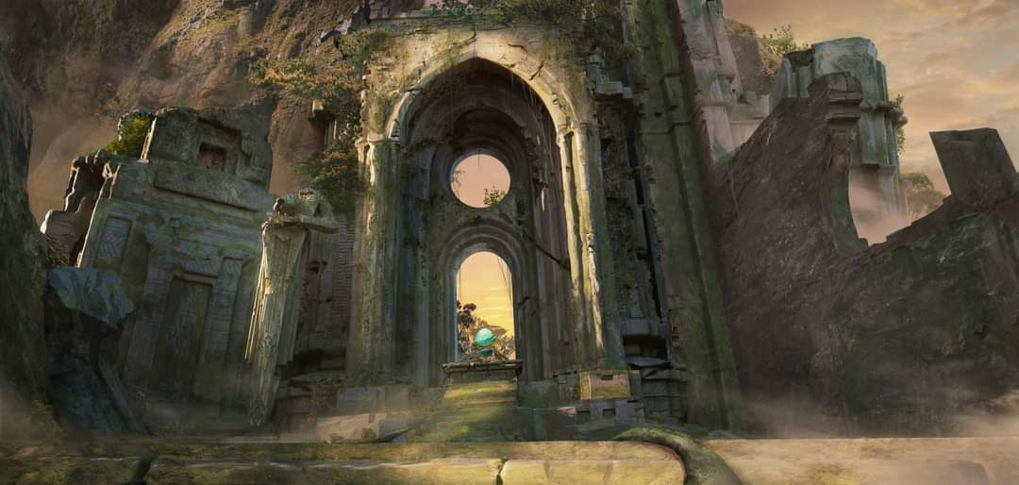

But it was not the earth alone that had grown hungry.

They came from the north and east—gray tusked tribes of the Nether Peaks, lean and gaunt after years of failed hunts. Others, driven by blood-feuds from the Stonelands and the broken barrows of the Fallen Lands, marched with them. Old Mother Blacktusk wove them together in secret. Her sons and daughters called her the Matron of Tumors—her words were curses made flesh, and the whisper of her name could blacken a lamb in its mother’s womb.

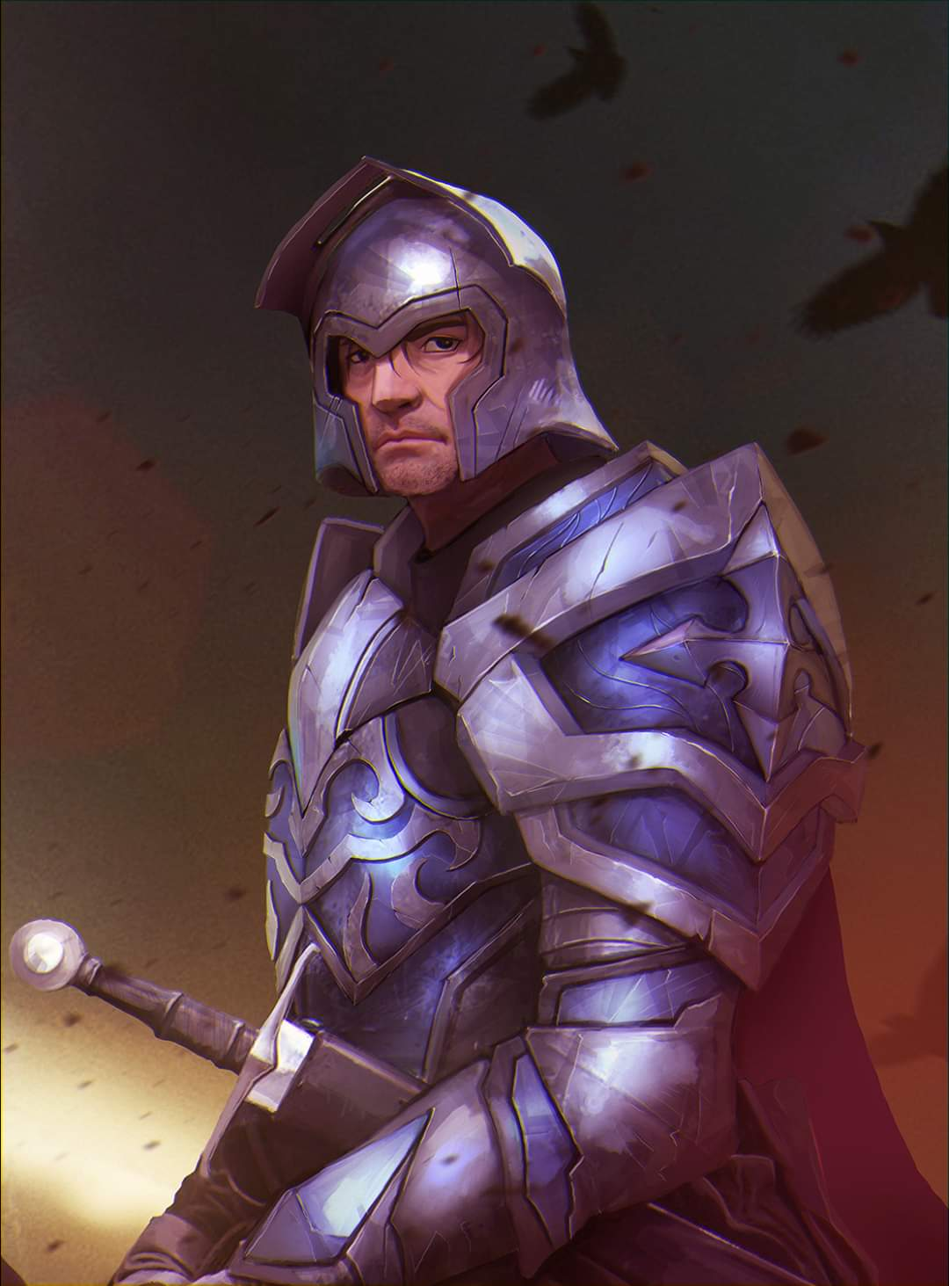

Uthgrael Aumar, the Stag King, had never feared death. His father’s sword hung heavy on his hip, his arms still strong beneath his bronze-wrought mail. Yet as he climbed the chapel steps, the ache in his chest was not from the weight of steel but from the slow crumbling of the world he had sworn to defend.

The last of his bodyguards followed him—a handful of men-at-arms and three knights of the Stag. Their tabards were torn, their spears nicked and dulled. The orcs had come from two directions, encircling Hastarl in the night. Already the smoke of burning crofts gathered on the wind. By dawn, the town would be a ruin.



The chapel stood on the hill’s crest—an ancient place, older than Uthgrael’s line. Its walls of whitewashed stone bore the green sigils of Silvanus, the Oak Father. The bronze bells in the tower had rung at dawn and dusk for centuries. Tonight they hung silent, waiting for hands that would never rise to ring them again.

Inside, the air was heavy with incense. The last families of Hastarl—women, children, the elderly—huddled beneath the wooden beams. A few whispered prayers. Most simply stared, their faces hollow.

Uthgrael knelt at the altar, resting his sword before him.

“Lord of Branch and Root,” he whispered, voice low. “I beg thee—one sign. One word. Shelter them.”

Outside, the horns began to sound.

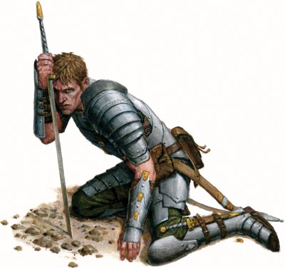

A knight stepped forward—Sir Caldran, the youngest of the Stag. “Majesty—”

“Not yet.” Uthgrael’s hand tightened around the hilt. He bowed his head again.

The wind shifted. The scent of rot wafted through the cracks in the walls. Somewhere beyond the chapel doors, blades clashed—a brief cry cut short. The duskblade was close now. Old Mother Blacktusk’s favorite—her knife in the dark.

Uthgrael’s lips trembled. The gods had not answered him in years. Silvanus had abandoned the land long before the first orc crossed the borders of Athalantar. He had prayed through droughts and blights, watched his people scrape the earth bare, watched his knights desert him one by one to seek greener lands. Only his duty remained.

The last prayer was not for salvation. It was for the strength to die well.

A scream echoed through the chapel. The doors burst open.

The duskblade came first—a wiry orc draped in black charms, his curved blade flickering with pale green fire. Behind him, three more shadows followed—lesser killers, lean and quick. They poured into the knave like wolves into a fold.

Uthgrael rose. His sword hissed from its scabbard. “For the Green Crown,” he called, voice steady.

The Stag Knights moved to bar the aisle. Caldran fell in the first rush, his throat opened by a hooked knife. The others fought hard—grizzled men, bound by oaths they knew would die with them. Yet the orcs slipped past the blades, silent and quick. Blood splashed against the chapel stones.

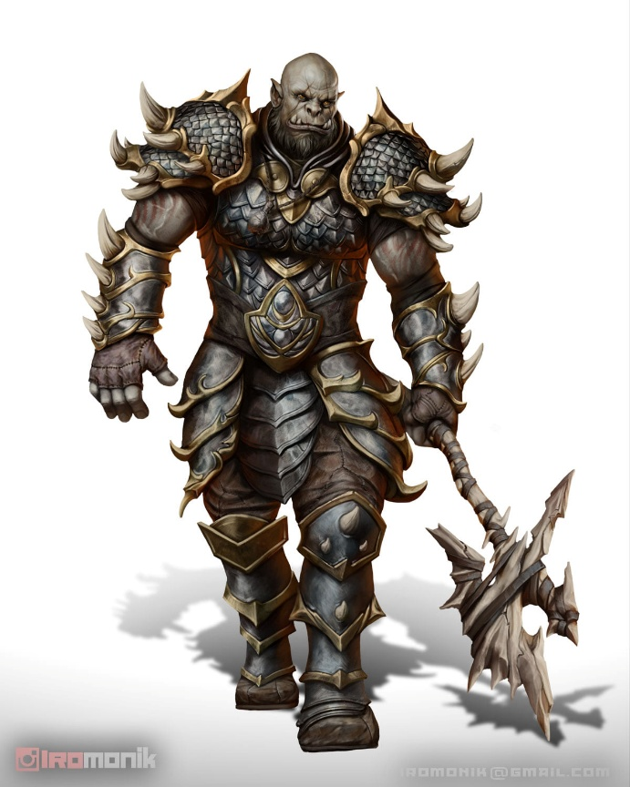

Uthgrael met the duskblade in the center of the nave. Their swords rang together—once, twice. The orc’s magic whispered along the steel, burning where it kissed mail. The Stag King pressed forward, driving the duskblade back, his shield-arm steady.

The duskblade flicked his wrist. A second knife buried itself in Uthgrael’s thigh.

The Stag King staggered. They were on him then—three, four bodies swarming at once. Blades punched into mail. Hands seized at his cloak. He drove one through the throat, kicked another to the flagstones—but they kept coming, knives rising and falling. The old wound in his chest flared, and his vision narrowed to slits of torchlight.

He fell to his knees at the altar, blood pooling at his feet.

“Shelter them,” he whispered.

No voice answered.

When the dawn came, and the smell of orc no longer hung in the air, the tower stood in ruins—its bronze bells melted to slag, its beams charred black. The orcs left the bodies to rot among the broken pews. Only the wind carried the Stag King’s prayer. A lone banner—torn and tattered—rustled in the breeze, a herald of a time that would eventually pass into the dim recesses of history.

For centuries to come, the hill would bear no green.

~*~

Secomber, Highsun, 1 Deepwinter, 1370 DR, a little over two elven lifetimes later…



“… and yes, they descended upon the land like swarms of locusts!” The raggedy man’s voice rose lilting and warm beneath the clear morning sky. With each word, the wooden puppets danced along their strings—painted knights in bright tabards, a green-crowned king, and a leering orc with tusks carved from bone. A dozen children sat cross-legged before the little stage, eyes wide, their breaths held as if the tale itself might carry them away.

“And when the orcs howled at Hastarl’s gates,” the storyteller said, tapping the wooden king lightly with a calloused finger, “the Stag King stood firm, for his heart was mighty, and his sword was sharp and true!” The puppet raised its tiny sword. A few children clapped. Others leaned forward, drawn into the world conjured by voice and wood.

The storyteller smiled—a fleeting glimmer beneath the cowl of their patched wool robe. He was thin, his face lined with age, hair cropped close and streaked with gray. No belt cinched his robe. No pouch weighed the folds of cloth. A simple begging bowl rested near his feet, though only a few copper coins gleamed within.

The New Year’s festivities had taken place last night, and the town was still decorated with banners and signs as confetti peppered the ground around the children. Among the watching parents, a few cast glances at the bowl—some with pity, others with quiet disapproval. Secomber had little patience for the penniless, even those vowed to poverty. Yet the children cared only for the story.

“And in the chapel at the heart of Tallstag Tower, the King knelt to pray. What do you think he asked for, little ones?” The storyteller’s voice softened.

A few hands shot up.

“A sword?”

“More knights!”

“To be saved!”

The storyteller nodded at each in turn. “Perhaps. But some say he asked for nothing—only that his people would remember him well. And that is why the bells of Hastarl still ring in the wind, even though the tower is long abandoned, and lies in ruins.”

The puppets froze as the storyteller’s fingers stilled. A hush settled over the public space—broken only by birdsong and the lazy drone of bees among the blossoms.

A little girl clutched a cloth doll to her chest. “Did the gods answer him?”

The storyteller’s smile flickered again—wry, knowing. “Ah, but that is another story.”

With slow, careful hands, he gathered the strings and began to pack the puppets away, his hempen necklace and holy symbol of Lliira now poking out from his robes. A few children lingered, the magic still holding them in place. The parents began to murmur—some calling little ones away, others pressing copper into the bowl.

Across the field, the maypole’s ribbons fluttered in the breeze—bright red, gold, and green against the endless blue of the sky. Another day in Secomber had begun, and the truth had danced just a little further from its bones.

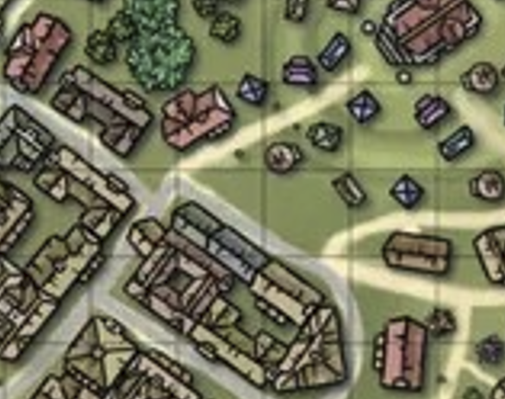

Not a block from the local Temple of Oghma—a modest chapter comprised of perhaps three-dozen regulars and a handful of rotating clergy on sabbatical from their various pursuits and services—there now walked one of its disciples, who’d recently made the rank of Acolyte of What Is Known, and had been asked by the local congregation’s leadership to undertake a minor quest, particularly since he’d let them know that he was already enroute to Candlekeep. Consequently, at the request of the Temple, he was to be outfitted with new regalia befitting his scholastic accomplishments. As he passed by the storyteller, he noted the Lliirite holy symbol and remembered the last conversation—more of a confrontation—that he’d suffered with a rather vocal Lliirite and proponent of the idea that history was always subjectively told, and without an objective way to reconstruct the past, embellishing the truth was a sacred duty.

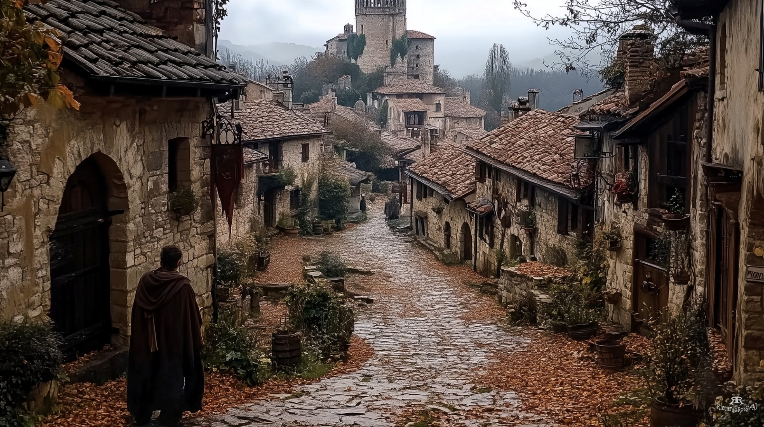

Claudius refrained from making eye contact with the ascetic puppeteer who now gathered his only belongings and thanked the kids that had hung around. Continuing on his merry way to see the blacksmith and armorer, a dwarf calling himself the “Magnificent Snark”, the Acolyte read the voucher he’d just been given to collect the armor and accompanying holy sash and accessories that went with it.

~*~

Amelia, on her way to the armorer’s to collect a new set of leather armor, her earlier set having been damaged beyond repair, had stopped to listen to the tale spun by the Lliirite, though from a bit further away than the children. As the last couple of children lingered, she stepped forward. “Best you head home, younglings,” she suggested with a smile as the taleteller packed away his props.

Impressed by his skill and amused by what she assumed were embellishments or fabrications, once the kids were out of earshot, she nodded to the fellow and squatted down so as not to tower over him. “Excellent story,” she said with a grin. “I wonder how close it was to whatever happened? We may never know...” Pulling a gold coin from her purse, she continued, with a question. May I buy a story? Tell me of your goddess? I search for the truth, but my magic is... beguiling, shall we say.”

She looked at him intently, ready to give him the coin if he were willing to talk to her.

The man looked at the coin, and tilted his head, saying, “My! A whole gold coin; that’s worth more than all the coppers and silvers in this here tray. Sure, I could splurge on dinner tonight, treat myself. It’s been a while.”

~*~

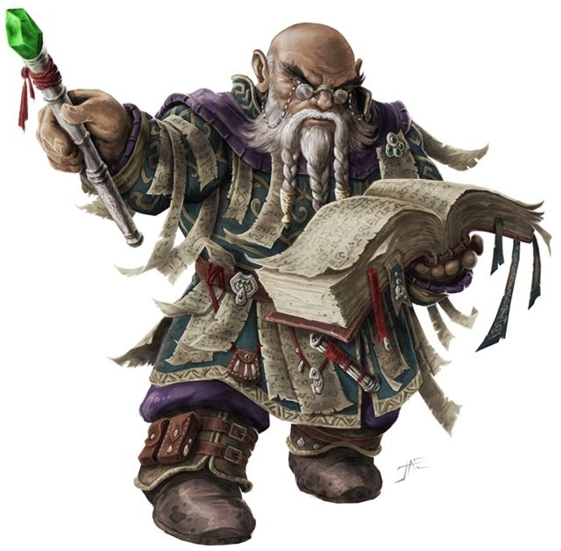

Loremaster Parzin Peregrin, a rock gnome over a century old, had seen his fair share of espionage, subterfuge, and the undermining of the Fellowship of Oghma across Faerûn, and he would be damned to suffer it yet again. Having arrived in Secomber only this morning via teleportation, he now cleared security protocols—both municipal and ecclesiastical—and greeted his counterparts with far less words and fanfare than would normally have been considered a requisite.

No one seemed put off by this, and as he and three other figures present passed the last of the Oghmanyte guards, they made eye contact, smiled briefly with sighs, and prepared to enter the sanctum’s Altar of Revelation, recently reinforced on account of the security breaches that had taken place throughout the last few days.

Walking in tandem with Peregrin was Loremaster Jaz Koreyjus, a human approaching the end of his natural life who had traversed the Planes—Inner, Outer, and Transitive—and found tranquility in semi-retirement here in Secomber, City of a Thousand Thrushes as the locals called it.

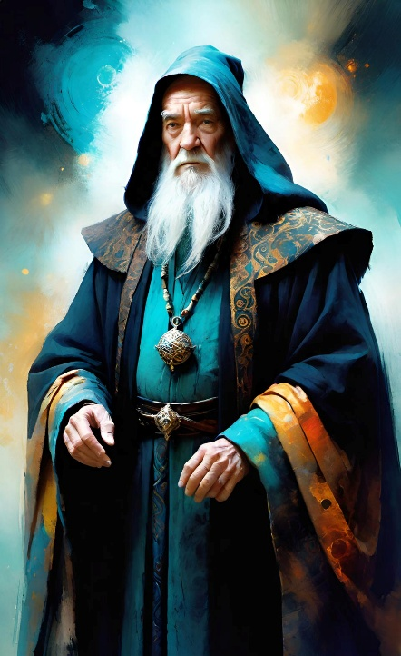

The two were followed by their colleagues who had arranged the in-person meeting to circumvent whatever magics facilitated the eavesdropping on their prior conversations via magical means.

Now 40’ below the Temple of Oghma in Secomber, they inhaled, prepared to have a difficult discussion, and beheld the ziggurat-like structure before them, with staircases that led up to the platform, centered around which was a Permanent and Enlarged zone of truth spell effect, and within this sphere was a slightly smaller zone of silence effect, shaped such that its center excluded the effect, recently made effective by the clergy to mask any outside scrying or clairaudience spells. Thus, the faithful of Oghma could discuss the matters at hand in as secure a manner as possible, given their means.

They entered the sanctum, and felt the zone of truth spell’s familiar, psychic tug at their memory, and away from their imagination and speculation. “Are we ready to begin?” asked Sebenzi, a Chultean cleric of Oghma who had made the pilgrimage here, following a vision.

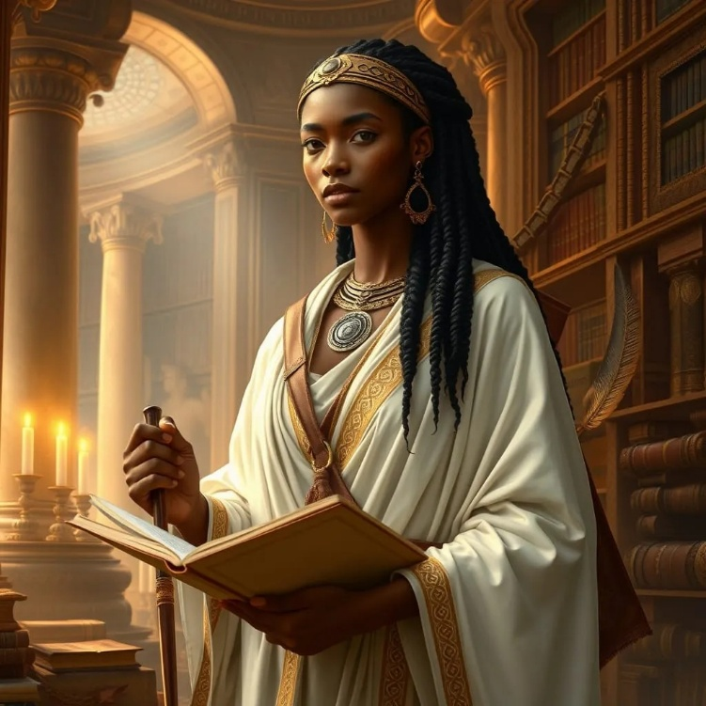

The priestess held her notebook open, and produced a quill as they all set up their respective notes.

“Ready,” Peregrin nodded, having removed most of his magic items before entering the underground sanctum, just like the others had.



Derrida Baudrillard, the fourth member of this discretely convocated council—a priestess from the North—also announced her readiness, and they began to brief one another on what each party had gathered on the case.

~*~

Claudius entered Snark’s shop, and identified the man by one of his assistants calling him by first name before he emerged diligently from the shop to answer a client’s question about bootheels. “Secret compartment, eh?” Snark smirked as Claudius stood in line, looking over a few other patrons going into and out of dressing rooms to try on the wares they’d also had tailor-made by the “Magnificent” smith’s staff. “Yeah, we can make that happen. Speak with Hrufneth over there, and he’ll take the specifications and measurements.”

He’d only been here a few days, having come from Silverymoon, where he received his Acolyte credentials, and already the Secomberite clergy had seen in Claudius a young man they could trust in matters of discretion and self-reliance, and he’d been consequently asked to present himself later today in the uniform that would shortly be brought to him alongside his new armor.

A minute later, Claudius approached the counter and Snark asked, “Can I do ye for?”

“I’m Acolyte Marinus, here to pick up the studded leather armor that should be ready today,” he answered.

Snark nodded, just having finished it yesterday, “Ah, yeah, the Oghmanyte studded leather... got a few Oghmanyte pieces done this tenday. One moment.”

Overhearing, a few folks turned towards Claudius, one of them displaying a holy symbol of Oghma. Among them, Ogden Nash—a halfling urban ranger whose doggie was outside at the trough hamming it up with a few mares—was a faithful of the Oghmanyte community, and was now in conversation with a fellow congregant—Nyrinn—whom he’d just met.

OOC: PC-to-PC dialogue can take place here at your discretion. I’m using Claudius’ reference to Candlekeep to initiate the plot.

~*~

“Sister Derrida,” Sebenzi asked, “would you summarize the minutes to ensure we have a unified understanding?”

The group’s notetaker finished casting amanuensis in order to produce three facsimiles of her notes for Sebenzi, the group’s recordkeeper, as well as Peregrin and Koreyjus, who represented Waterdeep’s and Secomber’s congregations, respectively. “Of course,” she said once the spell began to transfer ink from a vial directly onto a parchment in the likeness of the adjacent parchment.

“By headings: communications compromised; Maskarrans likely culprits; Secomber and Waterdeep chapters suffering the most breaches, three each in the last four days, along with Silverymoon, Daggerford, Candlekeep, and the hamlet of Floshin’s Turnpike along the Delimbyr Route, with one reported for each…”

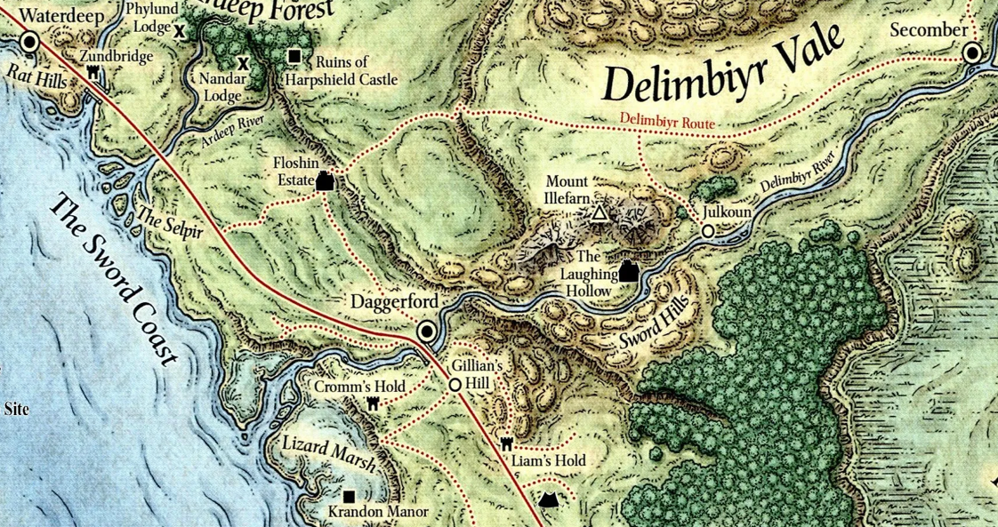

The scribe continued in greater detail, “… the compromise of our standard security protocols has proven to have gaps exploited by an uninvited entity, and the majority of our diviners and others with high-level clearance are suspect simply by virtue of our access to sensitive information…. That’s the general gist.”

Sebenzi and the others nodded as the first parchment was finished. Derrida picked up the page, handing it to their guest from Waterdeep as the spell continued to copy her handwriting to another sheet.

The Chultean priestess took the page handed to her as she spoke, the zone of truth spell invoking only the most sincere motives and knowledge. “If we are all potential suspects in this—which I see follows from the evidence and logic before us—only Oghma knows the true outcome of this predicament.”

“Yes,” Koreyjus rubbed his chin. “The Maskarrans—or whoever is behind this—has placed us in a precarious spot. The more high-ranking a team we entrust to investigate this matter—to investigate us—the more likely it is that they are behind this plot, or worse yet, that their knowledge will be turned against them and they will become puppets of our underminers.”

Peregrin offered the same perspective’s converse: “Of course,” he smiled before continuing, as if checking himself. “That prompts us to consider less orthodox solutions, perhaps something less tried-and-true, and more innovative… more unexpected.”

“What do you propose Loremaster Peregrin?” the scribe addressed the visiting scholar and senior clergyman.

He inhaled, looking at the local functionaries of the Temple. “Our main problem right now is reestablishing a secure medium of long-range communications across our chapters. Once we have that, established, the next priority will be to establish where the source of the problem is centered, and how to best deal with it. As to our initial priority of reestablishing discrete communications across the Sword Coast, perhaps we ought to entrust a team of... I don’t want to put it elitistly, but innocents to the task. We provide a copy of this document to each of the local chapters, along with further contingencies and instructions for the envoys based on the situation at their destination.”

“Fools off the street?” Sebenzi’s indignation began to warm behind her ears. “You can’t be serious.”

“No, no, competent people, but people whose minds have no insider knowledge of the case… and among our faithful.”

“So, congregants…” Koreyjus summarized. “Our own flock?”

“I’m not suggesting we sacrifice them to the Maskarrans,” Peregrin clarified. “We can supply and support a team to deliver the documents, and perhaps also send a decoy of more notable identifiability—someone of our rank, perhaps—to distract anyone that would otherwise get wind of the actual expeditionary party.”

“I don’t know about a decoy,” Sebenzi shook her head. “We’re trying to not involve the clergy. That’s a possible security breach in the making.”

“As we’re discussing this,” the Waterdhavian in the room asked, “does anyone in town come to mind?”

Sebenzi and Derrida had a mutual contact, and both of them thought of him at the same time. “Loremaster Koreyjus,” Sebenzi asked, “do you know Amelia Barton?”

“Yyyyesss, I believe so. Also a Waterdhavian if I recall,” he answered.

“Ah, by Oghma’s will!” Peregrin commented, being a proud citizen of that autonomous city-state.

“She’s known to have a way with discretion,” Derrida vouched for the stealthy spellcaster. “And not entrenched enough in the dealings of the Temple to have the temptation of compromise.”

“Let’s start there,” Sebenzi said. “With Amelia. There’s another man, a halfling with whom she prays sometimes.”

~*~

The storyteller cradled Amelia’s gold coin between his fingers, holding it up to the morning light as if judging its worth beyond metal. Then, with a chuckle, he tucked it into the folds of his robe and settled onto the grass, gesturing for her to join him.

“A gold tale for a gold coin, then. But remember, Oghmanyte—some truths wear masks until laughter loosens them, and in the search for truth, there is often less to see and more to touch.”

With his miniature stage collapsed and ready to carry, he drew out a single puppet—a wooden bard with a lute—and let its strings dangle like unspoken words before his crossed legs, reciting by memory, “Once, in the perfumed courts of Tethyr, there lived a bard named Velshaan al’Hiral, whose ink-stained hands chronicled every war, treaty, and secret whispered in the Palace of the Seven Stars. He worshipped Oghma as a scribe does: truth was parchment, ink, and precision. Yet for all his learning, his songs rang hollow. ‘Why?’ begged the nobles. ‘Why do your ballads of joy feel like tax ledgers?’

“Shamed, Velshaan sought the wisdom of the Lliirans. In the Temple of the Unmasked Heart at dusk, he found not scholars, but dancers—spinning barefoot, their laughter peeling back the layers of the world. ‘Tell me the truth of joy!’ he demanded. The high priestess, a woman whose silver hairbells chimed with every step, tossed him a tambourine. ‘Dance first. Write after.’

“Frustrated, he resolved to document their revels from afar. Night after night, he scribbled descriptions of the dances—the Radiant Awakening, the Gilded Sigh—but his verses wilted on the page. Then, on the eve of Highharvestide, he witnessed the Dance of the Silent Dancer…

“A masked figure moved alone in the torchlight, their body a language beyond words. None knew the dancer’s name, nor heard them speak, yet their movements told of a sorrow even Lliira’s joy could not dissolve. The priests murmured: ‘They dance the Song of the Lost House—a dirge for a noble line erased by treachery.’

“Velshaan, ever the archivist, crept closer to record the steps—until the dancer seized his wrist. Without a word, they pressed his palm to their chest. And there, beneath the drumbeat of their heart, he felt it: the truth. Not names or dates, but the raw wound of a story too terrible for ink. The dancer was the last heir of a fallen family, their history scrubbed from scrolls by a tyrant’s decree. The Lliirans had known, yet let joy be their testimony.

“The next dawn, Velshaan burned his notes. When he finally joined the dance, his voice returned—not as a chronicle, but as a living hymn. And so the Broken Song was born: a ballad that survives only when sung wrong, its verses shifting like footsteps, because some truths are too bright for parchment.”

The storyteller let the bard-puppet droop in his hands. ”Velshaan’s journals are dust now, but in Tethyr, they still sing his song—or at least, the shadow of it. The Silent Dancer? Gone. The tyrant? Forgotten. But the joy that carried their truth? Ah, that lingers.”

He tilted his head, studying Amelia. ”So tell me, seeker: is a truth less true if it’s felt, not written? Or does the dance simply hold what the quill cannot? Should a painter always be bound to tell you what it looked like? Would her time not be better spent painting what it felt like?”

Around them, the wind stirred the New Year’s banners—as if the tale itself had taken flight.

Amelia sat and listened to the storyteller intently, and felt quite moved by it. After he finished, she was still for a moment, enjoying the powerful feelings his words evoked. Then she spoke.

“Your words have given me much to think upon, and I thank you for that. Wisdom is priceless, of course, but you certainly gave me good value for my gold. I hope your dinner is excellent!”

She stood, then bowed to show him respect. “Our ways of seeking answers and truth may vary, but that is a good thing. On your travels, may the best of your past be the worst of your future.”

Smiling at him, she continued, “I will record what I remember of your tale, and the truth it portrays, in my journal later. And, as it happens, I do enjoy dancing!” She performed a pirouette, though perhaps not a very fancy one, having only a little training, nodded to him again with respect, then continued her journey to the armorer.

~*~

As Claudius looked around and noticed the other Oghmanytes in the shop. With the dwarven shopkeeper headed to retrieve his items, Claudius turned to the Oghmanytes and bowed, “Good morning and may Oghma bless your day. My name is Claudius Marinimus, a newly ordained acolyte. To whom do I have the pleasure of meeting?” He gave the two others a friendly smile.

Amelia entered the shop and stepped to the side, out of the doorway, while her eyes adjusted to the lighting inside. Looking around, she noted the shop was pretty busy today, and was glad Snark was doing some decent business. As she was about to move through the other customers, she overheard someone invoke Oghma’s blessing, and introduce himself as an acolyte. This day was continuing to become more interesting by the moment!

As the priest struck up a conversation with a halfling fellow and a human gal, she moved slowly closer, off to the side, but not interrupting, figuring to wait until they’d finished making introductions. She made sure to stay out of other customers’ way while she waited her turn.

The short human woman with curly dark red hair, fair skin with freckles, and amber eyes, in a traveler’s outfit with a wooden holy symbol of Oghma, who’d been standing nearby waiting to be noticed, spoke up with a slight smile.

“Hi, I’m Amelia Barton. You folks new in town? I’ve been here a few years, studying subtle spellcraft with a gnarly gnome. From Waterdeep originally. Good to meet some fellow Oghmanytes! Welcome to Secomber!”

Claudius caught some movement out of the corner of his eye. As he waited for the two before him to respond, he smiled and nodded to the new arrival, motioning for her to join them.

The tall, dark-skinned human woman smiled as she approached Claudius. “May Oghma bless you this day,” she said in a Cormyrean accent.

Claudius bowed his head in thanks to Nyrinn as he looked between the other two. Perhaps Oghma was smiling on him this day. It would be much better to have some additional help and company on the road to Candlekeep, and who better than fellow worshipers of the same deity.

“Good day to you brothers, I am Ogden,” the halfling said as he tipped his black brimmed hat towards the others. “I am also here for my Oghmanyte armor. A gift for services rendered by a young man’s family. I am a seeker, you see, seeking knowledge so that I may better serve.” He reached into his left belt pouch, pulling a small piece of parchment. “Ah, here is my sales slip.” Ogden said as he emphasized his point with a turtle-shell-patterned pipe. “What news do you bring, for I am a native to Secomber and you are clearly not?”

A town crier had been repeating something as he approached, and they could now make out one of the daily jingles that he read off of a rumpled script. “Hear ye, hear ye! Shadows creep upon our trade routes! The Zhentarim rise, their gold gleams, their power schemes! Merchants and nobles, beware the web of the Black Network! Watch your wagons and guard your coin, for Secomber is not safe from their designs!”

“Let’s see,” Nyrinn mused, “There was a dispute over fishing grounds between Suzail and Marsember. One of Oghma’s clerics successfully helped mediate the dispute. Amn reportedly had an outbreak of an unknown fever that is still resistant to healing spells. A group of trolls briefly seized the Boareskyr Bridge, but the guards from several caravans, aided by horsemen from Scornubel, drove them away after a pitched battle. A storm came ashore at Daggerford and flooded a dozen houses and businesses along the riverfront, including the town’s most popular bordello.” She shrugged. “That’s all I’ve heard about.”

Amelia spoke up, once Nyrinn indicated she was done. “Pleased to meet you all!” Winking at Nyrinn and nodding to Ogden, facing the latter, she continued, “that’s brothers in the generic sense right, short for brothers and sisters? I have 3 older brothers, and sometimes they did treat me like one of the boys; not my older sister, though, she was always more proper and formal.”

The young lad was right outside the shop now, crying out loud, “Hear ye, hear ye! Noble plots and royal wrangles stir the halls of Cormyr! A storm brews in the land of the Purple Dragon—rival factions clash, and whispers of intrigue spread like wildfire! Merchants, tread carefully, for unrest shadows the trade roads!”

She smiled, showing she wasn’t truly bothered by the halfling words, then continued. “Anyways, I’m afraid most of my news would be local, what places are cheap to eat and drink at, where the entertainment is occasionally above the norm, who’s best for getting stains out of clothing...”

“But I’ve been thinking about traveling again, having finished my apprenticeship. Started off dabbling in a variety of roguish skills that I mostly learned from my father, and from some of the folks they brought into the watch station in Waterdeep where my oldest brother worked as a guard officer. But I had a natural affinity for magic stuff, and an Oghmanyte priest at the Temple there sent me her so study with an old master beguiler who wanted to pass some of his techniques on. No, I want to test what I’ve learned.”

The town crier’s voice was now fading again as he continued down the street, “Hear ye, hear ye! Prosperity rings through Secomber’s streets as merchants toast their golden gains! But beware the shadow behind the shimmer—meimer, the youths’ new vice, lines pockets yet bleeds them dry! A boom and bane, spreading far and wide! Tread wisely, my friends, for fortunes and follies walk hand in-” they couldn’t make out the rest of the shpiel.

Claudius looked at the three Oghmanytes in front of him and smiled as they replied to his greeting. It was obvious they were a good or forthright group of individuals. Turning to Ogden, Claudius responded, “I am not from here, that is correct. I hail from Icewind Dale, the town of Good Mead to be specific. I’m a rather good artist and cartographer as well. As for what I am doing here,” he looked at the three before him, “I was given a mission by the temple of Oghma and I believe that our deity, in all his wisdom, has brought us all together today. If you are all agreeable, I could use some company on my mission to deliver an important item to Candlekeep.” He scanned back and forth, looking at the others before him, hoping that they would agree to accompany him, making the trip safer and more enjoyable.

“I’m in!” Amelia declared. “Shall we meet somewhere tomorrow morning, or at some later time, depending of what works best for all? I’ll need tonight at least to say my goodbyes to my master, pack up my stuff, and load up my donkey.”

Claudius smiled and held back a laugh, delighted with Amelia’s enthusiasm. “Tomorrow morning is fine. We can meet in front of the temple to Oghma and share breakfast before hitting the road. I do have a horse and donkey for myself. Should anyone need transportation, I can offer a little assistance, though I do not have much in the way of spare gold.” Claudius knew it would be much better and faster if they all had a mount rather than walking to Candlekeep.

“Nah,” Amelia replied, “no horse for me. I mean, horses could be good for speed in a scary situation, but my donkey is no faster than I am, and I don’t mind walking. Also, horses are not very easily hidden, they’re humongous! I’d rather hide than ride...”

“Very well, then,” Nyrinn replied. “I will tend to buying a horse and possibly some other items, and I might have enough left to at least help with another one . Where is everyone staying for the night?”

Amelia smiled at the other woman. “I’m staying one last night at my master’s cottage. Gotta pack up my few things and tidy up around the place one last time.”

Nyrinn nodded. “I will do that, then. Do you know where the local hostler is in town?”

Amelia said , “Once I grab my new leathers, and we’ve made all necessary plans with these two gentlemen, we can head on over there. It’s not too far away.” She grinned. “And once you’ve made arrangements and suchlike, we can head on over to Master Turenack’ cottage.”

The 4’10” human woman, at 110 lbs., under 150 lbs. with her worn and carried gear, could probably keep a light warhorse at a light load and be able to ride at double her walking speed, but with no particular skill at handling animals or riding, she was honestly a bit concerned about having a horse; the donkey was much more easily handled.

After thinking for a moment, she continued. “If you don’t already have a place, you’re welcome to bunk with me for the night, save yourself a coin or two. The bed’s big enough, and Master Turenack is pretty charming for an old gnome. I bet he’d enjoy the chance to tell us some old story after dinner.”

Nyrinn smiled. “I could use another under-tunic, and some provisions for the road. My caravan had a victualer, so there was no worries about food or water.”

They finished up their fittings, then signed for the receipt of the armor and gear before heading to the Temple of Oghma, which served as the town’s sole library. Situated on Bookworm Walk—a cobblestone street lined with bookshops, scribe offices, parchment and ink vendors, and an eyeglass fitting shop—the temple was the heart of Secomber’s academic activity. Though there was no independent college here, the Temple of Oghma was in and of itself an institution of higher education and empirical inquiry, be it mundane, divine, or arcane.

While they now had plans to grab another horse, and maybe even a wagon, the stables and wainwright were on the far end of town by the farms. The Temple of Oghma, on the other hand, bordered and overlooked the River Delimbiyr. They entered the Temple, greeted by one of the acolytes they knew, Brother Steadstance. “Amelia, fair day to you. Loremistress Sebenzi has been asking about you. She may have you in mind for a call to action that seems to be afoot. It’s hush-hush, so I’m guessing sensitive stuff.”

The young dwarf pointed with an open hand towards Sebenzi, who was at the far end of the temple, speaking with two men Amelia didn’t know, though she’d seen the bearded human here before. He was likely a cloistered cleric, one of the few who kept to the Inner Sanctum most of the time. On one occasion, Amelia saw him relieving a weary aide at the end of a long shift, and finished restocking the library shelves himself.

Sebenzi was a Chultean priestess who had left the rugged jungles of her homeland for more temperate latitudes a few years ago, and had since made Secomber her home. The woman caught Amelia’s eye, and motioned to her much as Br. Steadstance had motioned to Sebenzi, “Ah, and here she is now.”

Amelia had a very frontstage relationship with Sebenzi, and only knew her within the confines of the Temple. They had always spoken warmly and frankly—as Oghmans tended to—and her tone today suggested even more confidence. There were introductions, such that Amelia and all her friends had a chance to state their names and passions, and they, in turn, learned that the two men before them were Loremasters Parzin Peregrin and Jaz Koreyjus. Peregrin was a Waterdhavian representative, and Koreyjus was the local cloistered cleric who practically embodied the local congregation.

“Ah, you are Claudius!” one cloistered cleric identified another. “I was told that we had a recent graduate in town. Welcome, and well met, young man... all of you.”

After a few minutes of a makeshift interview that the heroes didn’t realize they were undergoing, the three Loremasters stood in circumstance nodding to one another for a moment.

“Come, Amelia, Claudius...” Sebenzi did not state the others’ names, but made eye contact with them, inviting them to follow them along one of the halls.

They descended along a narrowing staircase, then entered another corridor that led them into a vast chamber lined with bookshelves. In the middle of the ample atrium was a ziggurat-like structure with staircases that led up to the platform. It was explained to them that they were about to enter a zone of truth spell’s radius of effect, which was wrapped within a larger sphere of silence, such that no outside ears or monitoring magic could eavesdrop on what was about to be imparted upon them.

“Please leave your weapons and magic items upon this table,” she assumed they might have had something magical, or perhaps she caught the Conjuration aura from the everfull mug inside Claudius’s backpack.

Nyrinn, who had been following the group and silently observing the proceedings, lifted her baldric with both her quiver and her longsword attached over her head and set it on the table. She removed her cased longbow and set it down, and then took her dagger out and added it to the pile.

Claudius did as instructed. He placed his rapier and two daggers on the table. He then took off his backpack with the rest of his items in it and placed it on the table. He then walked into the area indicated and waited as the others did the same.

Amelia grinned, as she unbuckled her belt with a pouch as well as a sheathed rapier and dagger on it, then pulled a sap out of her pocket. She looked in her satchel, then just unslung it and laid it down carefully, saying “just a couple options and some blessed bandages, easier just to leave the satchel.” Finally she unslung her well-made light crossbow and the small case of boots it fired, placing them carefully next to the satchel.

Ogden got caught picking his nose, and eventually dropped his stuff right where he stood, causing a bit of an unease.

“As you can now tell,” the urban visitor scholar cleared his throat, “we’ve gathered you here in the utmost confidence. Our congregation, and several others throughout the Sword Coast, are unable to sustain communications across magical channels, and our attempts at speaking freely outside this sacred space have also been breached.”

With this explanation for the secrecy amongst the disciples of knowledge, Sebenzi continued, “We have spoken individually with the entirety of our local clergy, and Loremaster Peregrin’s staff has done the same at the Font of Knowledge in Waterdeep, but there are a number of sites whose statuses are currently unknown, and rather than sending messages magically, we are faced with sending messengers instead... though also magically.”

This piqued Claudius’s curiosity, and he shifted in his stance as he continued to listen.

The conversation took a good five minutes, and consisted mostly of an outline that the three Loremasters took turns addressing:

- Magical means of communications across vast distances had recently been breached, and mundane conversations had also been eavesdropped on, such that sensitive information was leaked, leading to unacceptable consequences, which—for their safety—were kept from the young heroes.
- Some of the clergy and others among the congregation were implicated, and as such, Amelia was one of the only people outside the network of compromised congregants that Sebenzi considered capable, and perhaps even dependable based on her prior conduct and accomplishments.
  - OOC: Claudius and Nyrinn are also cool, but I need your creative input as to what impresses the Loremasters the most about your respective PCs, since they’re not known quantities at the Temple. Claudius could very plausibly have a writ of recommendation from his Silverymoon chapter, which would be enough to put him on par with Amelia in their eyes.
- Several Temples along the Sword Coast have lost the ability to communicate securely, able only to detect the presence of scrying, but not its nature, source, or any specific properties. Evil and Chaos are both suspected forces at play.

Sebenzi clarified, “We have reason to believe that in addition to these security breaches, there may be more nefarious malfeasance. We are supplying you with a wand of sending, which we trust you will use to convey significant findings at your destination, should you choose to accept this mission.”

Koreyjus added, “Which makes this the appropriate time to ask. You are within the zone of truth spell’s effect, so I’ll dispense with the high dramatics, and simply ask that each of you search within your heart and speak their mind if it finds any doubt in this cause, or in your involvement in it.”

[Opportunity for clarification: PC questions and NPC answers, but see below re. transportation.]

[Because this is the premise for the beginning of the campaign…] “Very well,” one of them said after all had been clarified, and the rest agreed in their own respective ways.

“And how will we get there?”

Peregrin was happy to report, “The Church of Ilmater has strong relations with the Temple of Oghma, and they have made a donation to this cause, as well as the Traveling Congregation of Shaundakul. The Ilmataris have entrusted us with an Amulet of Toxin Delay,” he handed the necklace and pendant to Ogden, who seemed the most likely person to know how to don and use it. The Waterdhavian then provided a Revelation Crystal from the Oghman repository at the Font of Knowledge.

Sebenzi, meanwhile, took a brass gorget—the Gorget of Armistice—and took the better part of a minute to affix it properly to Nyrinn’s sternum like a brass centerpiece for her steel chain shirt. “Suits you, young sister,” she then added proudly.

“And as to your question of how you’ll get to your destination…” Peregrin turned towards the wizened, bearded human.

Koreyjus nodded, then looked Claudius up and down, his face displaying that of a man who remembered wearing the exact same regalia as the younger lad now before him, and simply said, “Elegant.” His endowment was to be the most instrumental to their cause. Koreyjus produced the Compass of Teleportation, donated by the Traveling Congregation of Shaundakul, and held it up to Claudius that he might marvel at its intricate detail. Aside from being a functional compass on the Material Plane, Koreyjus explained it had a rechargeable store of teleportation spells for them to use in order to reach their destination.

“And what is the destination?” asked Nyrinn.

Koreyjus asked, “Are you familiar with Floshin’s Estate?”

They looked at one another with blank expressions.

Peregrin tried, “Daggerford, perhaps?”

Two of them knew Daggerford fairly well.

“Ah, well, it’s just north of Daggerford on the road to Waterdeep,” Peregrin pointed it out on the map in the middle of the small discussion room.

They looked, particularly Claudius, whose role it would be to learn how to attune himself to such a powerful item, and hone its powers to a righteous cause.

“And what is our cause, or our charge, in this quest?” asked Amelia as she was handed the Wand of Sending.

Koreyjus said, “Your primary objective is to deliver this sealed message to any functional clergy in the settlement around Floshin’s Estate. You will be compromising your safety—as well as the safety of the mission, and of many Oghmanytes along the Sword Coast—if you were to read it. The less you know for now, the better.” Amelia was handed a magically sealed envelope with a wax mark imprinted with Oghma’s scroll emblem.

Sebenzi added to the answer, “And your secondary objective will be to reconnoiter as best as you can, given that we know next to nothing about what’s actually happening. Whether or not a standing clergy still exists there, we’ll need you to relay your findings via sending spell once you’ve made a reasonable assessment of the situation, and we will provide your next set of objectives. You will benefit from this detailed map to aid you in your teleportation attempts.”
The many landmarks and sites labeled on the map of the grant Claudius (a) a +2 Use Magic Device checks to use the compass, and (b) a -10% Circumstance bonus (low rolls succeed on this table) on teleportation rolls.

Peregrin nodded, “Yes, any information you can send back, please do, but our team has vetted the procedures for remote communication via sending spell. You must observe these rules. First, never use the wand in an urban area. Go far from the city, then cast detect magic, wait a bit to ensure that you’re seeing as best as possible, and then, and only then, tap the wand and cast the spell.”

“Do we suspect anyone at all?” Claudius asked as Ogden stared off into space.

“Nothing that evidence informs, so no,” Sebenzi summarized, her eyes shifting to the halfling.

Ogden then responded as if they were still back in the shop. “I live in town, I have plenty of floor space. Rufus and I will be happy to share. We can break fast and go to the temple in the morning.” There was a tense moment of silence as they all looked at one another, then realized they’d made a mistake.

Koreyjus frowned, then sighed, then led Ogden out of the sanctum and asked an acolyte to place him in a recovery center. “He’s been traumatized by something. See that he gets the proper care.”

A minute or so later, the man returned and they recapped what had been said and done. The Amulet of Toxin Delay was instead provided to Claudius. As Sebenzi handed it to him, she said, “I did not have the privilege of reviewing your credentials, but I trust you have some healing training in your background?” she asked a statement.

“I’m no field medic, but I can stitch a wound, yes,” Claudius self-evaluated.

Over the next few minutes, each item’s use and properties was explained to them, such that they were functionally proficient with it, and the wand was outfitted with a Band of the Starry Sky.

- Amelia: Revelation Crystal (MIC 66); Wand of Sending (CL 7, 20 charges, +5 to UMD to use this wand only)
- Claudius: Amulet of Toxin Delay (MIC 70); Compass of Teleportation (CL 9), a donation from the Traveling Congregation of Shaundakul
  - Bears the properties of a Wand of Teleportation (20 of 50 charges remaining), grants +5 Competence bonus to UMD for the compass’s teleportation effect. Wielder still cannot use UMD on any other device if they have no actual ranks in UMD.
  - If the wielder attunes oneself to the item for 24 hours, the bonus becomes +10
- Nyrinn: Gorget of Armistice (+2 to Cha, and 1/day casting of either charm person or charm monster, CL 6)

OOC: Hey, guys. It’s just the three of us once again.

Ogden’s player has just dropped out (he’s done this twice before, so he’s pretty much off my list), and the party is thin as frogs’ hairs. I’m considering recruiting a new player, but I want to get your input. All four of us are going through some real-life changes right now, and I want to be extra mindful of that since we’re not strangers, and I’m hoping that this is the start of another long, rewarding campaign.

So given that fate has brought us together again on the closing of our previous mutual campaign, I want to propose a situation for Loreseekers wherein at least Ed and Ernie play 2 characters. JR has expressed that he doesn’t want to manage multiple characters, but if this changes, the option is there for you too, JR.

The crucial niches needed (in this order of importance) are:

- Archivist (Int-focused academic investigator)
- Urban ranger (Cha- and Wis-focused social investigator)
- Bard (spokesperson [alongside Nyrinn] and buffer/motivator)
  - There are two really interesting variants—divine bard, and savage bard—that would work in the campaign. The savage bard (this class is illiterate, like the barbarian) can be a savant who memorizes holy passages and recites them as a spoken word artist. Alternately, he can have ranks in Perform: Comedian and demoralize the enemies with funny putdowns. Just some ideas.
  - There are also two bardic prestige classes—thaumaturgist and lyric thaumaturge—that might be applicable to the plot.

As you might be aware, archivists tend towards Lawful alignments while bards lean away from them. Because this campaign will be heavily focused on humanoid-heavy settings, compliance with laws will sometimes save the party a lot of time in the long run, and an archivist could be highly instrumental in organizing their paperwork and making sure all is in order so they have the legal system’s cooperation, no matter how much the bard complains.

As important to this goal, however, is a diplomatic character who can broker those relationships with law enforcement, merchants, private security personnel, temple authorities, etc..

So you guys have first dibs on any of the above slots. Let me know if there’s interest in going this route.

~*~

