*Marvel Universe 617 Campaign Features*

**Plot and Purpose**

This [MSH/FASERIP](http://mshgamer.com/wp-content/uploads/2013/03/TSR6871.Advanced.Players.Book_.pdf) campaign is designed around a band of heroes on Earth, though the campaign could become cosmic in scope by the later chapters.

The story will begin with everyone’s individual origin stories, after which the GM will introduce a plot that brings the heroes together.

**Game Features**

* **Medium:** [Groups.io](https://groups.io/g/MU617/).
* **Posting Format:** Please post narrative (not necessarily dialogue) in past tense, third person form (e.g., “The hero known as *Subterfuge* tripped his opponent” instead of “I’ll attack the other guy”).
* **Sexually Explicit Content:** This is not intended to be an erotica campaign.
* **Regular Participation Expected:** Only active writers/players please. The ideal posting rate is at least two significant posts per week (no one liners, please). Marginal participation in the game will greatly impair your character’s development. In fairness to the more dedicated players, characters abandoned/neglected by their players will not be kept indefinitely in the game.
* **Advancement** in this game is tied to the clarity and quality of your writing more than simply defeating opponents. As a player, I am guilty of having posted to storylines on which I wasn’t up to date, and it is usually obvious when others do it in one’s own game. Please ask questions after reading the updates if you’re unsure or unclear on anything you think may be important.

**House Rules**

The MSH ruleset assumes characters’ scopes of power to be fully developed during gameplay. This campaign showcases powers as they develop with practice, study, innovation, mutation, the grace of the gods, etc.

**Submitting a Character**

Because the predominant medium of communication will be the written word (with some maps, graphs, tables, etc.), the main criterion for approving your character submission is your writing quality.

In addition to hard stats, your write-up should consist of a physical description (one paragraph), and a personality profile (at least one paragraph) including the character’s preferences, fears, biases, traumatic experiences, promises/vows, conversions, addictions, etc.. Please use the *PC form* to create your hero/heroine, then email it back to me.

Characters will start with quite a bit of room for growth. You must apply one category between Feeble and Incredible to each of the seven abilities, which means that no ability will have the same scope for any single character at the start. Throughout character development, lower scores will automatically be raised, and you will also have the opportunity to select a permanent boost for an ability from time to time.

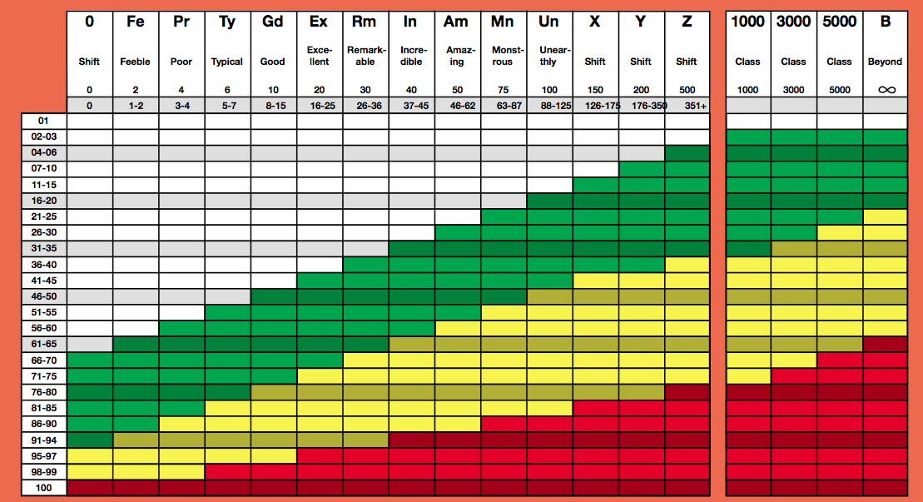

Characters start with 3 Powers and 3 Talents (GM assigns initial ranks of Feeble to Typical to these). These will improve rapidly towards Remarkable, and can be further raised thereafter with Karma Points.

Please consult the character creation guidelines in the [canon rulebook](http://mshgamer.com/wp-content/uploads/2013/03/TSR6871.Advanced.Players.Book_.pdf), and feel free to contact me if there’s any need for clarification or interpretation.

The initial plot is set to begin in Nassau, Bahamas.