No Laughing Matter

Chapter 1: The Stygian Bowels

It was the beginning of 1384; not that it mattered. The party was far from any place where the Dale Reckoning was pertinent. They’d been slicing and dicing lesser dretches on their way along a one-way tunnel that smelled of wretch itself, and was comprised of a flesh-like leather that provided a slight spring-like effect that they’d exploited in order to jump out of the way of the wilier dretches. The floor was fairly level, while the rest of the chamber was tubular, and had been almost uniformly less than 10’ wide until now.

“Ew, this place smells like shit,” Pussyfoot grumbled as she trailed the others down the corridor. The rogue had been leading, but she’d dropped back to watch Atlas’ back as they prepared to fight yet another group of well-named dretches. The Tallfellow halfling, whose real name was Brene Zefni Diafice Tryndrey Noakes of Clan Tunnelly, grew up in Athkatla, the capital of Amn. She was 28 years old, and she’d met Steelshade the year before while the half drow had been visiting there.

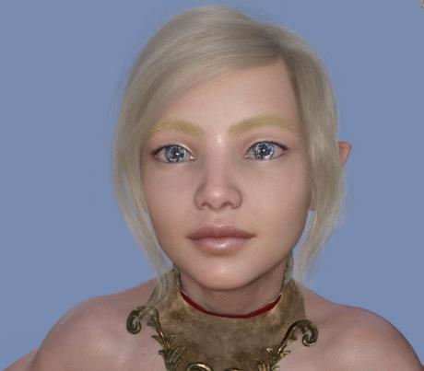

“That’s because it’s a bowel of some sort,” Atlas replied in his cultured tenor. The towering, dark-skinned, 34-year-old human archivist was from far to the south in Thesk, where he grew up in an orphanage. He was so named for his love of books and maps, and he knew no other name. He’d met Steelshade nine months ago, when they crossed paths in Iriaebor. He and Brene – he refused to use her irreverent nickname - had been lovers for three months now.

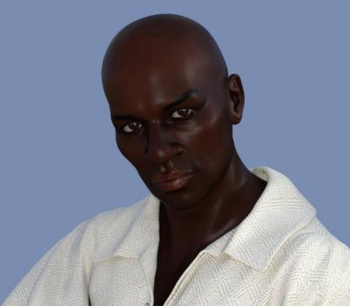

Ohtistar Devrion Bolchanar, or just Devrion to his companions, paid the couple no mind as he prepared for battle. His people were from Chult, and he’d fought for the Border Kingdoms while honing his skills as a warmage. The half-elf was 41 years old, and he’d met Steelshade, or Angren as he called her, in Suzail. “Here we go,” he said quietly.

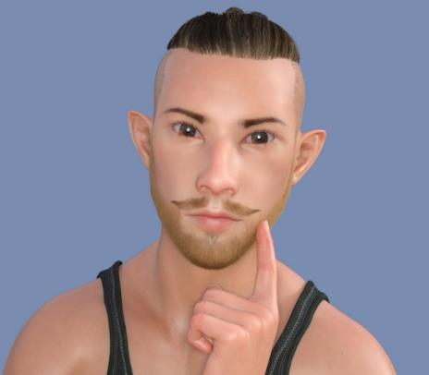

Steelshade, or Angren as she typically introduced herself, drew her sword in preparation for battle. She’d recruited the three people behind her as she’d traveled with the caravans that plied the roads between the far-flung cities that traded with the Westlands. The draconic-descended half-drow had been a caravan guard for several years, where she’d earned her nickname as an able practitioner of the ferocious, magic-using combat style known as a duskblade. Aasterinian, her draconic deity, had called her two years ago, at age 30, to begin a series of quests involving her family, the drowish one she’d never known. She’d visited Lauren Maltholas at her home near Waterdeep, where the senior duskblade had given her Arkenlyl, the family’s blade.

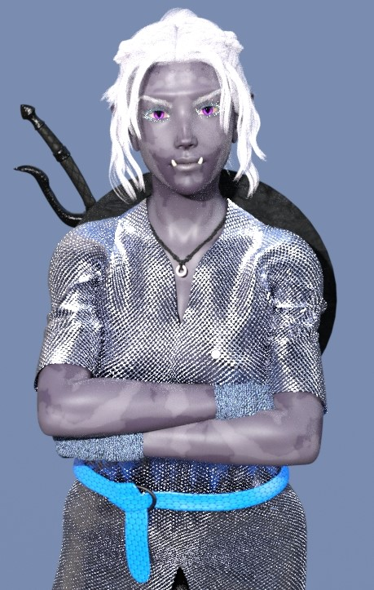

The corridor had amplified a bit, growing evermore irregular, and as the quartet of adventurers cleared out the last of the dretches that had been pursuing from behind, they began to see a whole new slew of adversaries clawing their way out of the walls of the monstrous bowels around them. They were likely dretches as well, but these looked larger, and more feral.

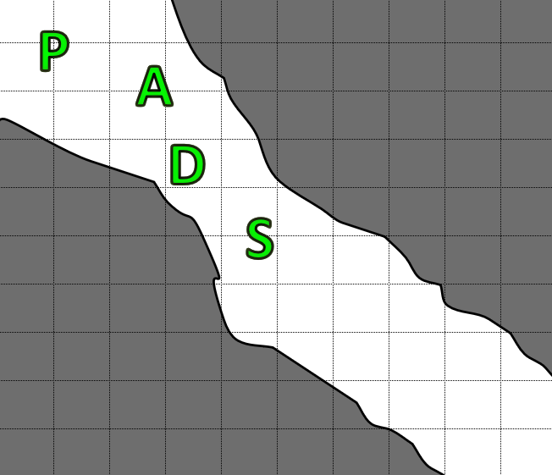

Round 1

Steelshade cast barkskin [expired on Round 1701] on herself, and waited to meet her enemies.
Steelshade gained +5 to AC.

They’d been fighting these lowly, misshapen beings for the better part of an hour now, and Devrion was beginning to grow impatient with the individual slicing and dicing. The warmage gathered himself, and pointed his right forefinger at his enemies. “Tűzlabda!” A tiny mote of fire leapt from his fingertip, streaked past Steelshade, and detonated squarely in the middle of the charging pack. The warmage ensured that he detonated the fireball far enough away to not catch Steelshade in the blast.
Character | Save vs.  fireball | Ranks | Roll | Check
Gastric Dretch | Reflex | 6 | 8 | 14
Sciatic Dretch | Reflex | 10 | 11 | 21
Digestive Dretch | Reflex | 5 | 11 | 16
Gastric Dretch | Reflex | 6 | 16 | 22
Sciatic Dretch | Reflex | 10 | 4 | 14
Digestive Dretch | Reflex | 5 | 18 | 23
Fail, success, success, success, fail, success.
Dmg to GD₁: 29 fire. Partial damage negated.
Dmg to SD₁: 14 fire. Partial damage negated.
Dmg to DD₁: 14 fire. Partial damage negated.
Dmg to GD₂: 14 fire. Partial damage negated.
Dmg to SD₂: 29 fire. Partial damage negated.
Dmg to DD₂: 14 fire. Partial damage negated.

The dretches were significantly diminished in their vitality after that blast, but not in their resolve. They finished emerging from the intestinal walls that encased our heroes, and one bolted towards Steelshade, who assessed the situation, with some certainty now as to these dretches’ tactical properties…
Character | TAC | FFAC | AC | Damage Reduction |  | Fire | Cold | Acid | Electric | Evil/  Neg | Good/  Pos | Chaos | HPs | Current HPs
Atlas | 12 | 25 | 27 | none | 0 |  |  |  |  |  |  | Imm | 94 | 94
Devrion | 12 | 23 | 25 | none | 0 |  |  |  |  |  | Imm | Imm | 94 | 94
Pussyfoot | 17 | 23 | 29 | none | 0 |  |  |  |  |  |  | Imm | 94 | 94
Steelshade | 12 | 35 | 37 | none | 0 | R20 |  |  |  |  |  | Imm | 179 | 179
Gastric Dretch 1 | 11 | 16 | 16 | cold iron/good | 5 | 19 | R10 | R10 | Imm | Imm |  | Imm | 20 | 1
Sciatic Dretch 1 | 18 | 11 | 19 | cold iron/good | 5 | 4 | R10 | R10 | Imm | Imm |  | Imm | 25 | 21
Digestive Dretch 1 | 8 | 20 | 20 | cold iron/good | 5 | 4 | R10 | R10 | Imm | Imm |  | Imm | 30 | 26
Gastric Dretch 2 | 11 | 16 | 16 | cold iron/good | 5 | 4 | R10 | R10 | Imm |  |  |  | 20 | 16
Sciatic Dretch 2 | 18 | 11 | 19 | cold iron/good | 5 | 19 | R10 | R10 | Imm |  |  |  | 25 | 6
Digestive Dretch 2 | 8 | 20 | 20 | cold iron/good | 5 | 4 | R10 | R10 | Imm |  |  |  | 30 | 26

Atlas closed his eyes for an instant, and breathed a couple of words. An instant after the magical fire manifested, he caused a sudden burst of tentacle-like structures to burst from the floor and entangle [expired on Round 171] the dretches. The archivist had his crossbow in hand, and he waited to further aid his fellows.
Character | Save vs.  entangle | Ranks | Roll | Check
Gastric Dretch | Reflex | 6 | 3 | 9
Sciatic Dretch | Reflex | 10 | 14 | 24
Digestive Dretch | Reflex | 5 | 16 | 21
Gastric Dretch | Reflex | 6 | 15 | 21
Sciatic Dretch | Reflex | 10 | 10 | 20
Digestive Dretch | Reflex | 5 | 3 | 8
Fail, success, success, success, success, fail.

Pussyfoot, shortbow in hand, watched to the rear of the group, spotting another half-dozen lesser dretches coming at them. Two were nearly upon her, while to their southeast, the damage and restraint done to the incoming pack had made it easier for Steelshade to distribute single-hack attacks to each of them. However, the entangle spell prevented this, as only one of the sciatic dretches was able to leap out of the way of the tendrils, and charge-attack the half-dragon.
Character | Attack Type | Damage | BAB | Str Mod+ | Other+ | Total Score | Roll | Total
Sciatic Dretch | Claw 1 | 1d8+1 | 2 | 1 | 2 charge | 5 | 17 | 22
Miss.

The demon’s claw ricocheted off of the woman’s armor as her skin finished taking on the guise of bark.

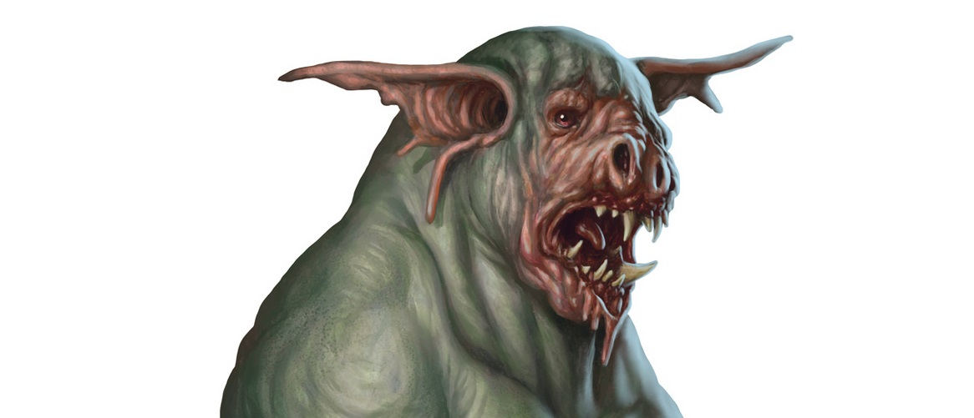

The other dretches struggled against the entanglement, all in vain for now.

In the greenish, phosphorescent glow of the gut walls around them, Pussyfoot could see the gleaming in the eyes of the two closest demons that would pounce upon her within the next few seconds.

“Devrion,” Pussyfoot said in warning as she faced the oncoming dretches. She fired two arrows from her shortbow; the wooden shafts hissed through the cloying air to their target (C2). She straightened, and her dagger seemed to leap into her hand as she readied herself to receive the dretches’ attacks, placing herself between the enemy and the warmage.
Ranged Weapon | Dmg. | D+ | TH+ | Critical | Rng. | Wt. | Atk | Roll | Check
Shortbow +2 | 1d4 | 2 | 2 | x3 | 60’ | 2.0 | +21 | 10 | 31
Shortbow, 2nd Shot | 1d4 | 2 | 2 | x3 | 60’ | - | +16 | 7 | 23
Hit, hit. Dmg: (3 + 2 = 5) + (2 + 2 = 4) = 9.

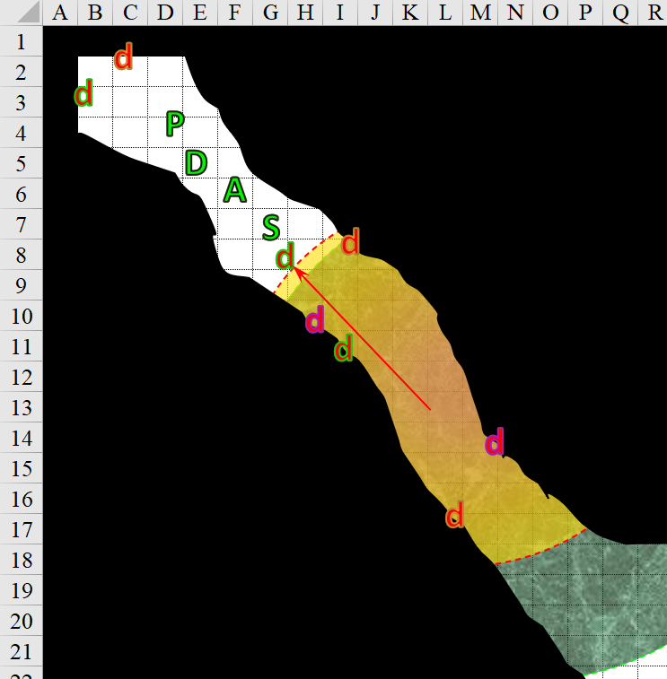

Round 2

Character | Group | Initiative | Roll | Modified  Roll | Move
Pussyfoot | 1 | 5 | 19 | 24 | 20’
Devrion | 1 | 2 | 14 | 16 | 30’
Bowel Dretches | 2 | 2 | 13 | 15 | 20’
Steelshade | 1 | 6 | 7 | 13 | 30’
Atlas | 1 | 2 | 5 | 7 | 30’

Round 2

With alacrity, Pussyfoot held her bow, drew her dagger, and struck the nearest dretch as it came at her.
Melee Weapon | Dmg | D+ | TH+ | Critical | Type | Wt. | Atk | Roll | Check
Keen Dagger of Wounding +2 | 1d3+2 | 1+? | 2 | 19-20, x2 | Prc/Slash | 0.5 | +16 | 6 | 22
Dagger, 2nd Attack | 1d3+2 | 1+? | 2 | 19-20, x2 | Prc/Slash | - | +11 | 15 | 26
Hit, hit. (2 + 2) = 4.

<< Fucker! >> it seemed to say to her in a single syllable as it contorted with the pain of her arrow and dagger having pierced it.

With satisfaction at having seared the demons to the south, Devrion turned and pointed to the nearest dretch, which was now snapping at Pussyfoot. “Rakéta!” Five tiny spears of force appeared at his fingertips and streaked to their target (magic missile).
Dmg: 11 + 5 + 4 Warmage Edge = 20 magic.

The dretch died in midair, unable to get even a single lick into the rogue, who nodded to Devrion as another dretch pounced on Pussyfoot, or rather, failed to.
Character | Attack Type | Damage | BAB | Str Mod+ | W+ | Other+ | Total Score | Roll | Total
Gastric Dretch | Claw | 1d6+1 | 2 | 1 | 0 | 2 charge | 5 | 5 | 10
Miss.

The other bowel dretches—gastric, sciatic, and digestive—continued to dretch.
Character | Save vs.  entangle | Ranks | Roll | Check
Bowel Dretch | Escape Artist | 11 | 17 | 28
Bowel Dretch | Escape Artist | 11 | 7 | 18
Bowel Dretch | Escape Artist | 11 | 16 | 27
Bowel Dretch | Escape Artist | 11 | 11 | 22
Bowel Dretch | Escape Artist | 11 | 3 | 14
Bowel Dretch | Escape Artist | 11 | 7 | 18
Success, success, success, success, fail, success.

All but one dretch got free of the tendrils, and continued their mad, impetuous charge towards Steelshade.
Character | Attack Type | Damage | BAB | Str Mod+ | W+ | Other+ | Total Score | Roll | Total
Gastric Dretch | Claw | 1d6+1 | 2 | 1 | 0 | 2 charge | 5 | 5 | 10
Sciatic Dretch | Claw 1 | 1d8+1 | 2 | 1 | 0 | 2 charge | 5 | 1 | 6
Digestive Dretch | Bite 1 (Pincer) | 1d8+1+1d4 acid | 3 | 1 | 0 | 2 charge | 6 | 8 | 14
Digestive Dretch | Bite 1 (Pincer) | 1d8+1+1d4 acid | 3 | 1 | 0 | 2 charge | 6 | 15 | 14
Miss, miss, miss, miss.

One of the charging dretches didn’t quite reach Steelshade.

Steelshade almost effortlessly deflected the incoming dretches as they came at her, and slashed them with her blade, not bothering to empower the strikes, careful to avoid being entangled.
Melee Weapon | Dmg | D+ | TH+ | Crit | x | Type | Wt. | Atk | Roll | Check
Shattermantle Bloodstone Falchion +3 | 2d4 | +7 +3 | 3 | 18 | 2 | Slashing | 8.0 | +27 | 19 | 46
SB Falchion +3, 2nd Attack | 2d4 | +7 +3 | 3 | 18 | 2 | Slashing | - | +22 | 13 | 35
SB Falchion +3, 3rd Attack | 2d4 | +7 +3 | 3 | 18 | 2 | Slashing | - | +17 | 6 | 23
SB Falchion +3, 4th Attack | 2d4 | +7 +3 | 3 | 18 | 2 | Slashing | - | +12 | 3 | 15
Hit, hit, hit, miss.
Dmg to SD₁: 8 + 7 + 3 = 18.
Dmg to DD₁: 3 + 7 + 3 = 13.
Dmg to DD₂: 4 + 7 + 3 = 14.

The original charger of the pack was now headless, and the rest were trembling with fear, but instinctively fiercer. The gastric dretches backed away, while the others remained at her heel.

Atlas turned to see the dretches coming from behind them, and recalled what he knew of these creatures to see if he could help his friends defend against them (Puissance, use 1 of 8). He spoke quickly (insert useful information here).
Skill | Rank | Ability & Mod. | Misc. Mods. | Total | Roll | Check | Notes
Atlas, Knowledge: The Planes | 20 | Int (+5) | 5 | 30 | 2 | 32 | Trivial Knowledge, best of 2 rolls
Atlas, Knowledge: The Planes | 20 | Int (+5) | 5 | 30 | 14 | 44 | Trivial Knowledge, best of 2 rolls
Party gains +3 to Saves vs. dretches.
This would have been +2 without the Trivial Knowledge reroll. It’s a great feat for an archivist.

Three or four more dretches were coming from the northwest, ready to take on Devrion and Pussyfoot.

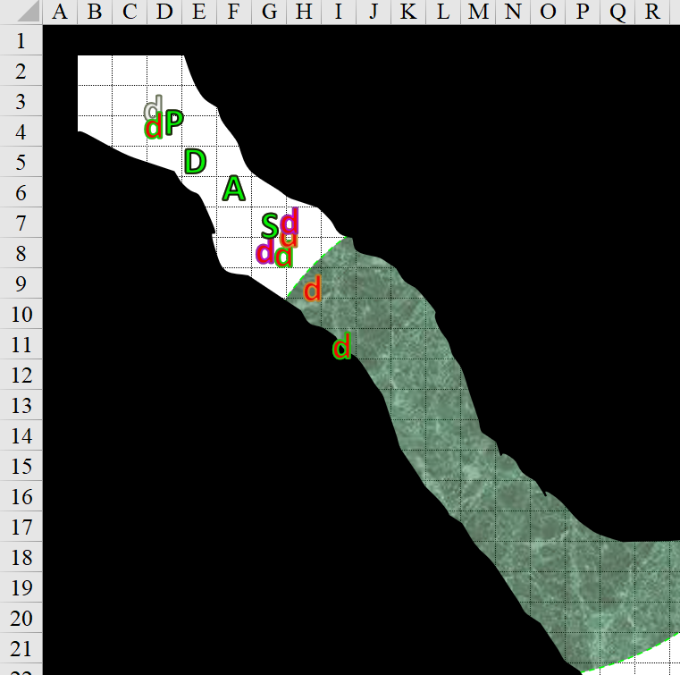

Round 3

Pussyfoot ducked under the dretch’s clumsy swing and stabbed the creature twice more.
Melee Weapon | Dmg | D+ | TH+ | Critical | Type | Wt. | Atk | Roll | Check
Keen Dagger of Wounding +2 | 1d3+2 | 1+? | 2 | 19-20, x2 | Prc/Slash | 0.5 | +16 | 19 | 35
Dagger, 2nd Attack | 1d3+2 | 1+? | 2 | 19-20, x2 | Prc/Slash | - | +11 | 5 | 16
Threat, miss. 1d20 = 11 + 16 = 27, critical hit. Dmg: (2 x 2) + 2 = 6 + 1 Con.

Though weakened, the demon persisted in existing, and insisted on its intrinsic urges to disembowel all of these meat units.

Devrion took the opportunity to cast a protective spell, since the creatures were still approaching. “Mágus páncél!”
Mage armor: Devrion gained +4 to AC.

Bowel dretches attacked. The digestive dretch already at Pussyfoot’s heels tried to eat the halfling.
Character | Attack Type | Damage | BAB | Str Mod+ | Total Score | Roll | Total | Threat | Notes
Digestive Dretch | Bite 1 (Pincer) | 1d8+1+1d4 acid | 3 | 1 | 4 | 4 | 8 | ý | Initiate Maw
Digestive Dretch | Bite 2 (Maw) | 1d12+1+1d8 acid | 3 | 1 | 4 | 19 | 23 | ý | Engulf limb
Miss. Maw attack irrelevant without successful pincer attack.

Pussyfoot realized that the demon was trying to eat her arm off.

Three more dretches—all sciatic ones—lunged and charged at Pussyfoot and Devrion. These were the most limber and muscular of the three varieties that populated just about every cranny in this gut, but they lacked the acidic attack endemic to the other types.
Character | Attack Type | Damage | BAB | Str Mod+ | Other+ | Total Score | Roll | Total
Sciatic Dretch | Claw 1 | 1d8+1 | 2 | 1 | 2 charge | 5 | 12 | 17
Sciatic Dretch | Claw 2 | 1d8+1 | 2 | 1 | 2 charge | 5 | 2 | 7
Sciatic Dretch | Claw 2 | 1d8+1 | 2 | 1 | 2 charge | 5 | 19 | 24
Miss, miss, miss.

The three did little more than push back the heroes a few feet from the momentum of the clash, but their armor and wits were enough to avoid so much as a scrape.

From the other extremity of the tube, the remaining dretches did their best to put Steelshade to shame.
Character | Save vs.  entangle | Ranks | Roll | Check
Bowel Dretch | Escape Artist | 11 | 12 | 23
Bowel Dretch | Escape Artist | 11 | 18 | 29
Success, success.

Most of them surrounded Steelshade, but one took an interest in Atlas.
Character | Attack Type | Damage | BAB | Str Mod+ | Total Score | Roll | Total | Targeting
Gastric Dretch | Squirt | 1d12 acid | 2 | 2 (Dex) | 4 | 4 | 8 | Atlas
Sciatic Dretch | Claw | 1d8+1 | 2 | 1 | 3 | 10 | 13 | Steelshade
Sciatic Dretch | Claw | 1d8+1 | 2 | 1 | 3 | 1 | 4 | Steelshade
Digestive Dretch | Bite 1 (Pincer) | 1d8+1+1d4 acid | 3 | 1 | 4 | 15 | 19 | Steelshade
Digestive Dretch | Bite 2 (Maw) | 1d12+1+1d8 acid | 3 | 1 | 4 | 3 | 7 | Engulf limb
Miss, miss, miss, miss, miss.

Steelshade full-attacked her enemies as they came within her reach.
Melee Weapon | Dmg | D+ | TH+ | Crit | x | Type | Wt. | Atk | Roll | Check
Shattermantle Bloodstone Falchion +3 | 2d4 | +7 +3 | 3 | 18 | 2 | Slashing | 8.0 | +27 | 17 | 44
SB Falchion +3, 2nd Attack | 2d4 | +7 +3 | 3 | 18 | 2 | Slashing | - | +22 | 7 | 29
SB Falchion +3, 3rd Attack | 2d4 | +7 +3 | 3 | 18 | 2 | Slashing | - | +17 | 1 | 18
SB Falchion +3, 4th Attack | 2d4 | +7 +3 | 3 | 18 | 2 | Slashing | - | +12 | 17 | 29
Hit, hit, miss, hit.
Dmg to SD₁: 4 + 7 + 3 = 14.
Dmg to DD₁: 2 + 7 + 3 = 12.
Dmg to SD₂: 3 + 7 + 3 = 13.

Though the swipes were true, Steelshade was impressed at how well each of the swiped-at demons had held up. Only of the slashes had been a lethal one, but she suspected it wouldn’t take much more to cut each of the others down.

The sciatic demon at the duskblade’s feet began to writhe, die, and wither.

Atlas was about to move up to protect Steelshade’s flank and rear as the dretches tried to encircle her, but the gastric dretch before him threatened his path, so he fought it off.
Melee Weapon | Dmg | D+ | TH+ | Critical | Type | Wt. | Atk | Roll | Check
Blackthorn Shillelagh +2 | 1d6 | 3 + 2 | 2 | x2 | Bludgeon | 1.5 | +12 | 15 | 27
2nd Attack | 1d6 | 3 + 2 | 2 | x2 | Bludgeon | - | +7 | 11 | 18
Hit, hit. Dmg: (3 + 3 + 2) + (5 + 3 + 2) = 8 + 10 = 18.

The gastric dretch died and withered like an ettin’s scrotum over a hot skillet. They’d actually seen this being prepared.

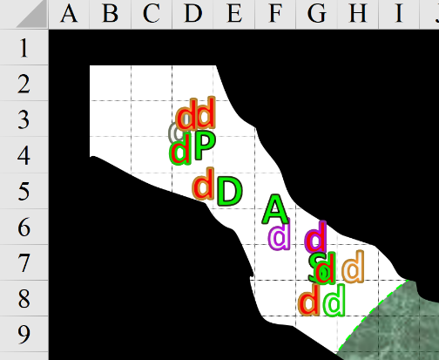

Round 4

Character | TAC | FFAC | AC | Damage Reduction |  | Melee | Ranged | Fire | Magic/  Force | Total Damage | HPs | Current HPs
Atlas | 12 | 25 | 27 | none | 0 |  |  |  |  | 0 | 94 | 94
Devrion | 12 | 27 | 29 | none | 0 |  |  |  |  | 0 | 94 | 94
Pussyfoot | 17 | 23 | 29 | none | 0 |  |  |  |  | 0 | 94 | 94
Steelshade | 12 | 35 | 37 | none | 0 |  |  | R20 |  | 0 | 179 | 179
Gastric Dretch 1 | 11 | 16 | 16 | cold iron/good | 5 | 18 |  | 19 |  | 37 | 20 | -17
Sciatic Dretch 1 | 18 | 11 | 19 | cold iron/good | 5 | 14 |  | 4 |  | 18 | 25 | 7
Digestive Dretch 1 | 8 | 20 | 20 | cold iron/good | 5 | 25 |  | 4 |  | 29 | 30 | 1
Gastric Dretch 2 | 11 | 16 | 16 | cold iron/good | 5 | 18 |  | 4 |  | 22 | 20 | -2
Sciatic Dretch 2 | 18 | 11 | 19 | cold iron/good | 5 | 13 |  | 19 |  | 32 | 25 | -7
Digestive Dretch 2 | 8 | 20 | 20 | cold iron/good | 5 | 14 |  | 4 |  | 18 | 30 | 12
Gastric Dretch 3 | 11 | 16 | 16 | cold iron/good | 5 |  | 13 | R10 | 20 | 33 | 20 | -13
Sciatic Dretch 3 | 18 | 11 | 19 | cold iron/good | 5 |  |  | R10 |  | 0 | 25 | 25
Digestive Dretch 3 | 8 | 20 | 20 | cold iron/good | 5 | 6 |  | R10 |  | 6 | 30 | 24

“Ew, ew, ew!!” Pussyfoot nipped away as the dretch tried to eat her. “Get away!” She stabbed the nearest dretch again; the tiny halfling drifted like smoke among her enemies, effortlessly dodging their attacks while striking them at the same time.
Melee Weapon | Dmg | D+ | TH+ | Critical | Type | Wt. | Atk | Roll | Check
Keen Dagger of Wounding +2 | 1d3+2 | 1+? | 2 | 19-20, x2 | Prc/Slash | 0.5 | +16 | 19 | 35
Dagger, 2nd Attack | 1d3+2 | 1+? | 2 | 19-20, x2 | Prc/Slash | - | +11 | 18 | 29
Hit, hit. Dmg: (3 + 2 + 1) + (2 + 2 + 1) = 6 + 5 = 11 + 2 Con.

“Damned thing won’t die!” complained the rogue.

Devrion grinned. “I thought being eaten was a good thing.” The warmage selected the healthiest-looking dretch, pointed his right palm at it, and spoke sharply. “Éget!”
Character | Save vs.  burning hands | Ranks | Roll | Check
Digestive Dretch | Reflex | 5 | 6 | 11
Fail. Dmg: 12 fire. Partial damage negated.

The nearly dead dretch barely flinched before the fire, and did not appear to be much worse after the casting.

Bowel Dretches probably didn’t play nice, and these were particularly hungry for action and flesh.
Character | Attack Type | Damage | BAB | Str  Mod+ | Total  Score | Roll | Total | Targeting
Gastric Dretch 3 | Claw | 1d6+1 | 2 | 1 | 3 | 17 | 20 | Pussyfoot
Gastric Dretch 3 | Bite | 1d4 | 2 | 1 | 3 | 6 | 9 | Pussyfoot
Sciatic Dretch 3 | Claw 1 | 1d8+1 | 2 | 1 | 3 | 10 | 13 | Pussyfoot
Digestive Dretch 3 | Bite 1 (Pincer) | 1d8+1+1d4 acid | 3 | 1 | 4 | 6 | 10 | Pussyfoot
Digestive Dretch 3 | Bite 2 (Maw) | 1d12+1+1d8 acid | 3 | 1 | 4 | 16 | 20 | Pussyfoot
Digestive Dretch 4 | Bite 1 (Pincer) | 1d8+1+1d4 acid | 3 | 1 | 4 | 14 | 18 | Devrion
Digestive Dretch 4 | Bite 2 (Maw) | 1d12+1+1d8 acid | 3 | 1 | 4 | 7 | 11 | Devrion
Miss, miss, miss, miss, miss, miss, miss.

To the southeast, the other dretches snarled and hacked away.
Character | Attack Type | Damage | BAB | Str Mod+ | Dex Mod+ | Total Score | Roll | Total | Crit | Threat
Gastric Dretch | Claw | 1d6+1 | 2 | 1 | 2 | 3 | 20 | 23 | 20 | þ
Gastric Dretch | Bite | 1d4 | 2 | 1 | 2 | 3 | 18 | 21 | 20 | ý
Sciatic Dretch | Claw 1 | 1d8+1 | 2 | 1 | 6 | 3 | 14 | 17 | 20 | ý
Sciatic Dretch | Claw 2 | 1d8+1 | 2 | 1 | 6 | 3 | 17 | 20 | 20 | ý
Digestive Dretch | Bite 1 (Pincer) | 1d8+1+1d4 acid | 3 | 1 | -3 | 4 | 12 | 16 | 20 | ý
Digestive Dretch | Bite 2 (Maw) | 1d12+1+1d8 acid | 3 | 1 | -3 | 4 | 17 | 21 | 20 | ý
Threat, miss, miss, miss, miss, miss. 1d20 = 3 + 3 = 6, not a critical hit. Dmg: 2 + 1 = 3 [176/179].
Save vs.  Poison | Rank | Ability  & Mod. | Misc.  Mods. | Total | Roll | Check
Steelshade, Fortitude | 10 | Con (+3) | 3 | 16 | 16 | 32
Success. No effect.

“Focus, people, hack and slash.” Steelshade full-attacked her enemies again.
Melee Weapon | Dmg | D+ | TH+ | Crit | x | Type | Wt. | Atk | Roll | Check
Shattermantle Bloodstone Falchion +3 | 2d4 | +7 +3 | 3 | 18 | 2 | Slashing | 8.0 | +27 | 2 | 27
SB Falchion +3, 2nd Attack | 2d4 | +7 +3 | 3 | 18 | 2 | Slashing | - | +22 | 11 | 33
SB Falchion +3, 3rd Attack | 2d4 | +7 +3 | 3 | 18 | 2 | Slashing | - | +17 | 19 | 36
SB Falchion +3, 4th Attack | 2d4 | +7 +3 | 3 | 18 | 2 | Slashing | - | +12 | 11 | 23
Hit, hit, hit, hit.
Dmg to Sciatic Dretch 1: 3 + 7 + 3 = 13 + see below.
Dmg to Digestive Dretch 1: 5 + 7 + 3 = 15.
Dmg to Digestive Dretch 2: 5 + 7 + 3 = 15.
Dmg to Sciatic Dretch 1: 8 + 7 + 3 = 18.

“You piss her off, you’re on your own!” Atlas waded northwest into the fight with his shillelagh, giving pussyfoot a hand.
Melee Weapon | Dmg | D+ | TH+ | Critical | Type | Wt. | Atk | Roll | Check
Blackthorn Shillelagh +2 | 1d6 | +3+2  + 2 charge | 2 + 2  charge | x2 | Bludgeon | 1.5 | +12 | 10 | 22
Hit. Dmg to Sciatic Dretch 3: 2 + 3 + 2 + 2 charge = 7.

Steelshade stepped over the bodies of the dretches around her, and cracked her neck as she prepared to join the others.

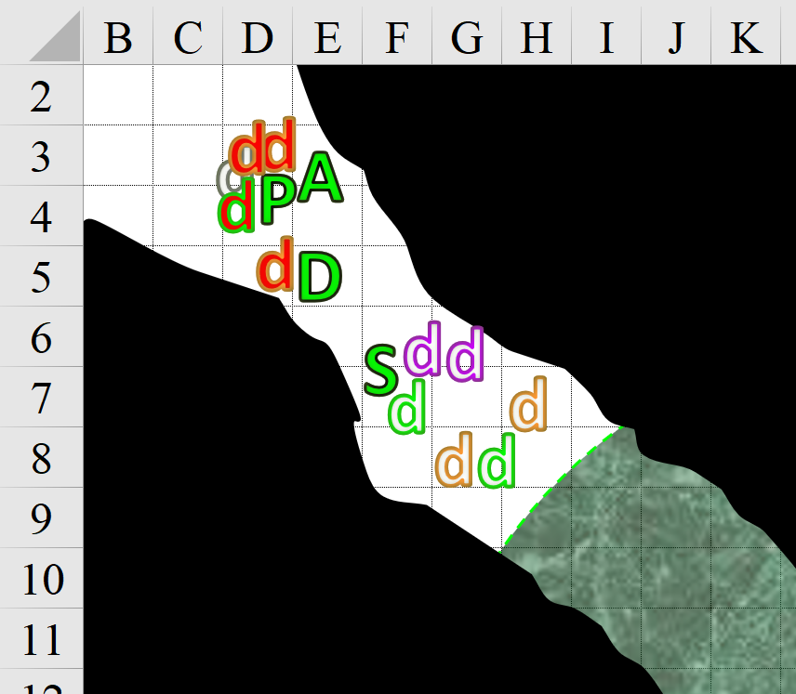

Round 5

“Too bad your weapon isn’t larger,” Atlas observed to his diminutive lover as he thwacked the nearest dretch.
Melee Weapon | Dmg | D+ | TH+ | Critical | Type | Wt. | Atk | Roll | Check
Blackthorn Shillelagh +2 | 1d6 | +3+2 | 2 | x2 | Bludgeon | 1.5 | +12 | 9 | 21
2nd Attack | 1d6 | +3+2 | 2 | x2 | Bludgeon | - | +7 | 18 | 25
Hit, hit. Dmg to Sciatic Dretch 3: (3 + 3 + 2) + (2 + 3 + 2) = 8 + 7 = 15.

Though nearly destroyed, the dretch at the far end of Atlas’ club remained a threat.

“I saw a toothpick you can use as a quarterstaff,” Devrion quipped helpfully. The warmage unlimbered his sickle and went to work on the nearest dretch.
Melee Weapon | Dmg | D+ | TH+ | Critical | Type | Wt. | Atk | Roll | Check
Sickle +2 | 1d6+2 | +1 | 2 | x2 | Slashing | 2.0 | 10 | 14 | 24
Sickle, 2nd Attack | 1d6+2 | +1 | 2 | x2 | Slashing | - | 5 | 17 | 22
Hit, hit. Dmg to Sciatic Dretch 4: (1 + 2 + 1) + (3 + 2 + 1) = 4 + 6 = 10.

One gastric dretch had charged, but never got within melee range, and now spat a squirt upon Pussyfoot the sciatic and digestive dretches that were already in the party’s midst did their best to sacrifice themselves for the benefit of the greater organism.
Character | Attack Type | Damage | BAB | Str Mod+ | Total Score | Roll | Total | Crit | Threat | Targeting
Sciatic Dretch 3 | Claw 1 | 1d8+1 | 2 | 1 | 3 | 17 | 20 | 20 | ý | Atlas
Sciatic Dretch 3 | Claw 2 | 1d8+1 | 2 | 1 | 3 | 5 | 8 | 20 | ý | Atlas
Digestive Dretch 3 | Bite 1 (Pincer) | 1d8+1+1d4 acid | 3 | 1 | 4 | 20 | 24 | 20 | þ | Pussyfoot
Digestive Dretch 3 | Bite 2 (Maw) | 1d12+1+1d8 acid | 3 | 1 | 4 | 17 | 21* | 20 | ý | PF, engulf limb
Gastric Dretch 4 | Squirt | 1d12 acid | 2 | 1 | 4 | 17 | 21 | 20 | ý | Pussyfoot
Sciatic Dretch 4 | Claw 1 | 1d8+1 | 2 | 1 | 3 | 5 | 8 | 20 | ý | Pussyfoot
Sciatic Dretch 4 | Claw 2 | 1d8+1 | 2 | 1 | 3 | 1 | 4 | 20 | ý | Devrion
Digestive Dretch 4 | Bite 1 (Pincer) | 1d8+1+1d4 acid | 3 | 1 | 4 | 7 | 11 | 20 | ý | Devrion
Digestive Dretch 4 | Bite 2 (Maw) | 1d12+1+1d8 acid | 3 | 1 | 4 | 8 | 12 | 20 | ý | D, Engulf limb
Miss, miss, threat, miss, miss, miss, miss, miss, miss. 1d20 = 17 + 4 = 21, not a critical hit.
Dmg to Pussyfoot: 7 + 1 + 2 acid = 10 [84/94] + Engulf Limb.
Character |  | Attack Type |  | BAB | Str Mod+ | Total Score | Roll | Total
Digestive Dretch |  | Grapple |  | 3 | 1 | 4 | 15 | 19
Melee Weapon | Atk |  | Roll | Check
Grapple | +14 |  | 12 | 26
Engulf fails. No additional damage/debilitation.

Steelshade winced as one of the creatures scratched her hand. The duskblade turned, waited for Devrion to swing, and then she stepped in and attacked the dretch, intent on taking it down. “Hack and slash, guys.”
Melee Weapon | Dmg | D+ | TH+ | Crit | x | Type | Wt. | Atk | Roll | Check
Shattermantle Bloodstone Falchion +3 | 2d4 | +7 +3 | 3 | 18 | 2 | Slashing | 8.0 | +27 | 16 | 43
Hit. Dmg to Sciatic Dretch 4: 3 + 7 + 3 = 13.

“The only toothpick you see is your prod, elf,” Pussyfoot quipped as she leaned away to avoid a nasty-looking set of claws, and stuck the dretch to her left.
Melee Weapon | Dmg | D+ | TH+ | Critical | Type | Wt. | Atk | Roll | Check
Keen Dagger of Wounding +2 | 1d3+2 | 1+? | 2 | 19-20, x2 | Prc/Slash | 0.5 | +16 | 2 | 18
Dagger, 2nd Attack | 1d3+2 | 1+? | 2 | 19-20, x2 | Prc/Slash | - | +11 | 8 | 19
Miss, miss.

A single gurgle reverberated throughout the tunnel as it occasionally had before, causing a rumble at the feet of the heroes as they finished off this clutch of digestive aides.

Character | Damage Reduction |  | Melee | Fire | Cold | Acid | Electric | Evil/  Neg | Good/  Pos | Chaos | Total Damage | HPs | Current HPs
Atlas | none | 0 |  |  |  |  |  |  |  | Imm | 0 | 94 | 94
Devrion | none | 0 |  |  |  |  |  |  | Imm | Imm | 0 | 94 | 94
Pussyfoot | none | 0 | 8 |  |  | 2 |  |  |  | Imm | 10 | 94 | 84
Steelshade | none | 0 | 3 | R20 |  |  |  |  |  | Imm | 3 | 179 | 176
Gastric Dretch 1 | cold iron/good | 5 | 18 | 19 | R10 | R10 | Imm | Imm |  | Imm | 37 | 20 | -17
Sciatic Dretch 1 | cold iron/good | 5 | 45 | 4 | R10 | R10 | Imm | Imm |  | Imm | 49 | 25 | -24
Digestive Dretch 1 | cold iron/good | 5 | 40 | 4 | R10 | R10 | Imm | Imm |  | Imm | 44 | 30 | -14
Gastric Dretch 2 | cold iron/good | 5 | 18 | 4 | R10 | R10 | Imm | Imm |  | Imm | 22 | 20 | -2
Sciatic Dretch 2 | cold iron/good | 5 | 13 | 19 | R10 | R10 | Imm | Imm |  | Imm | 32 | 25 | -7
Digestive Dretch 2 | cold iron/good | 5 | 29 | 4 | R10 | R10 | Imm | Imm |  | Imm | 33 | 30 | -3
Gastric Dretch 3 | cold iron/good | 5 |  | R10 | R10 | R10 | Imm | Imm |  | Imm | 33 | 20 | -13
Sciatic Dretch 3 | cold iron/good | 5 | 22 | R10 | R10 | R10 | Imm | Imm |  | Imm | 22 | 25 | 3
Digestive Dretch 3 | cold iron/good | 5 | 17 | 2 | R10 | R10 | Imm | Imm |  | Imm | 19 | 21 | 2
Gastric Dretch 4 | cold iron/good | 5 |  | R10 | R10 | R10 | Imm | Imm |  | Imm | 0 | 20 | 20
Sciatic Dretch 4 | cold iron/good | 5 | 23 | R10 | R10 | R10 | Imm | Imm |  | Imm | 23 | 25 | 2
Digestive Dretch 4 | cold iron/good | 5 |  | R10 | R10 | R10 | Imm | Imm |  | Imm | 0 | 30 | 30

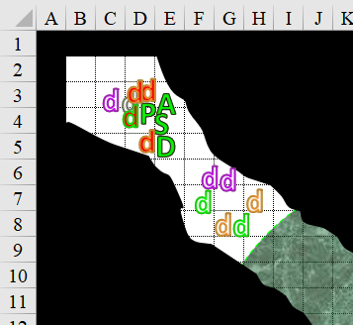

Round 6

Devrion stepped back to give Steelshade room to work, and the duskblade attacked the dretches again.
Melee Weapon | Dmg | D+ | TH+ | Crit | x | Type | Wt. | Atk | Roll | Check
Shattermantle Bloodstone Falchion +3 | 2d4 | +7 +3 | 3 | 18 | 2 | Slashing | 8.0 | +27 | 17 | 44
SB Falchion +3, 2nd Attack | 2d4 | +7 +3 | 3 | 18 | 2 | Slashing | - | +22 | 20 | 42
SB Falchion +3, 3rd Attack | 2d4 | +7 +3 | 3 | 18 | 2 | Slashing | - | +17 | 2 | 19
SB Falchion +3, 4th Attack | 2d4 | +7 +3 | 3 | 18 | 2 | Slashing | - | +12 | 19 | 31
Hit, hit, hit, hit.
Dmg to each target: 5 + 7 + 3 = 15.

That left standing only a digestive dretch and a gastric dretch, and the latter immediately withdrew, not even sticking around for another squirt of acid. The digestive dretch was instinctively driven to fiercely end its life in defense of the intestines that housed it.
Character | Attack Type | Damage | BAB | Str  Mod+ | Total  Score | Roll | Total | Notes
Digestive Dretch | Bite 1 (Pincer) | 1d8+1+1d4 acid | 3 | 1 | 4 | 15 | 19
Digestive Dretch | Bite 2 (Maw) | 1d12+1+1d8 acid | 3 | 1 | 4 | 12 | 16 | Engulf limb
Miss, miss.

Pussyfoot hissed as a bit of acid splashed on her exposed arm. She retaliated with two more stabbing attacks against the digestive dretch.
Melee Weapon | Dmg | D+ | TH+ | Critical | Type | Wt. | Atk | Roll | Check
Keen Dagger of Wounding +2 | 1d3+2 | 1+? | 2 | 19-20, x2 | Prc/Slash | 0.5 | +16 | 8 | 24
Dagger, 2nd Attack | 1d3+2 | 1+? | 2 | 19-20, x2 | Prc/Slash | - | +11 | 11 | 22
Hit, hit. Dmg: (1 + 2 + 1) + (2 + 2 + 1) = 4 + 5 = 9 + 2 Con.

Had it not been for the extra wounding, the dretch would likely still be snapping, but now it snarled and twitched its last as the rogue withdrew her blade.

Atlas went after the gastric dretch, but was mostly only effective in chasing it away.

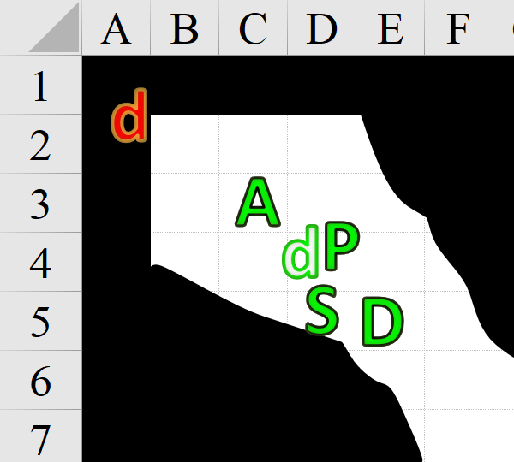

Round 7

The party looked both ways, seeing behind them the fleeing dretch [~45’ away] and to their southeast the tendrils of the entangle spell that would linger on for several more minutes if not snapped out by Atlas. Otherwise, they were alone in the digestive conduit.

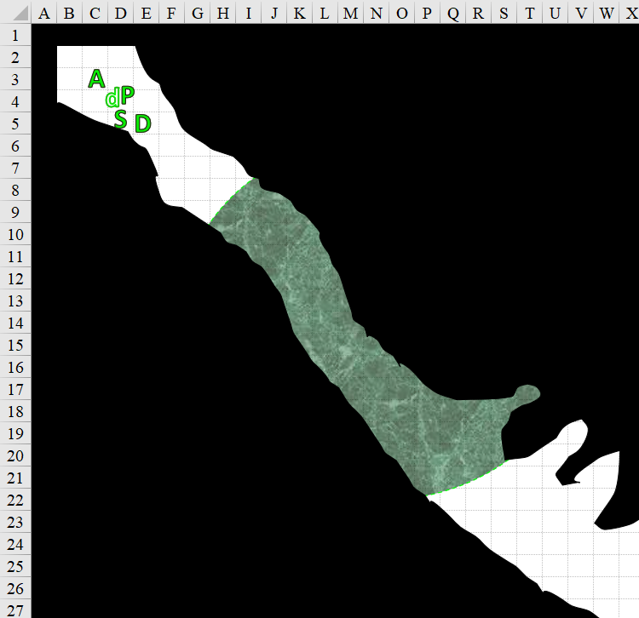

“Ock,” Pussyfoot breathed as she pulled out her waterskin and washed the acid off her hand.

“Here, use this, too,” Steelshade said as she offered a small rag she’d used with water to clean her own hand.

“Let me heal that for you,” Atlas said to Pussyfoot. He touched her while he murmured something melodic, and her wound immediately looked better.
Pussyfoot gained 5 + 5 = 10 hps [94/94].

While he did that, Seelshade and Pussyfoot cleaned their blades.

Round 10

“Okay, let’s keep going,” Steelshade said as she pointed ahead. Atlas dismissed the entanglements with a word and a gesture, and they were once again on their way. Pussyfoot took the lead, at least until they encountered more enemies.

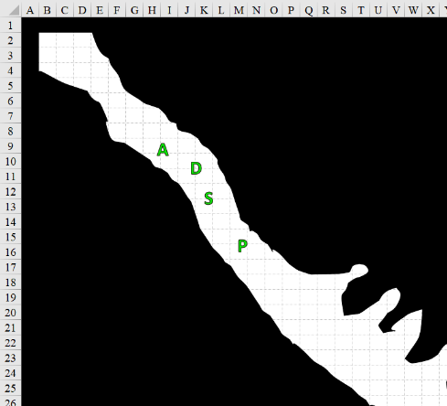

Round 11

They made it a little further until Pussyfoot noted the alcoves to her left, which looked like giant wombs waiting to birth or devour something.

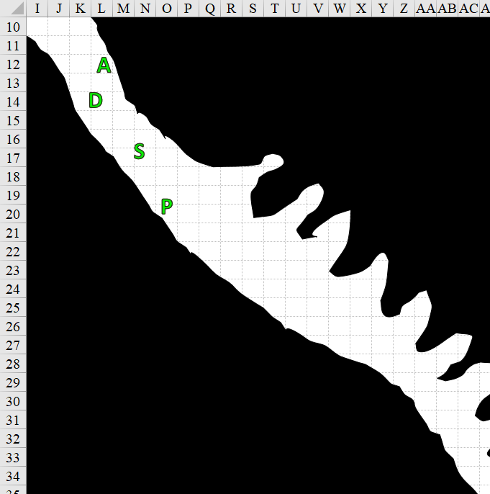

Round 12

Pussyfoot moved slowly, cutting each corner from the opposite side of the passage, and peering into the back of each alcove.

Steelshade wrinkled her nose as she looked around. “Atlas, do you have any ideas about where we are?”

“Apparently, up something’s ass,” the human chuckled. “Let me think on it for a moment.” Atlas considered what he knew about the planes, and of creatures large enough to wander about in their innards.

They were not ambushed, but it was clear that the alcoves were pores—or perhaps follicles—in which dretches resided, crapped, and bred.

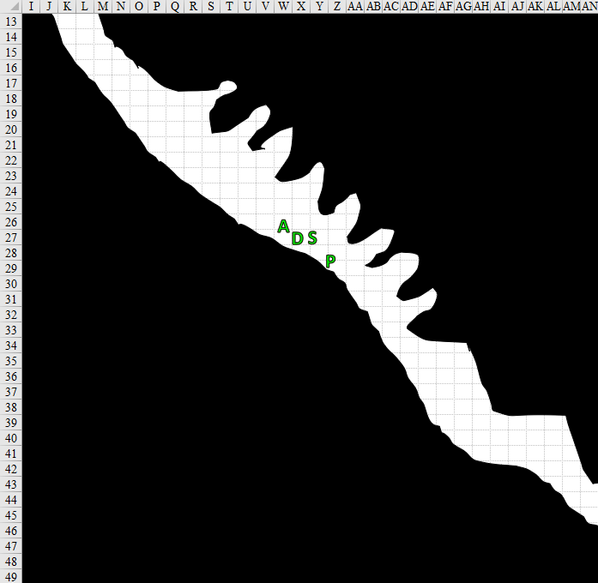

Round 15

“Careful,” one of them said to the others as they cleared the interstitial tissues and follicles that comprised this section.

They walked a bit more until Pussyfoot thought she heard something up ahead and stopped.

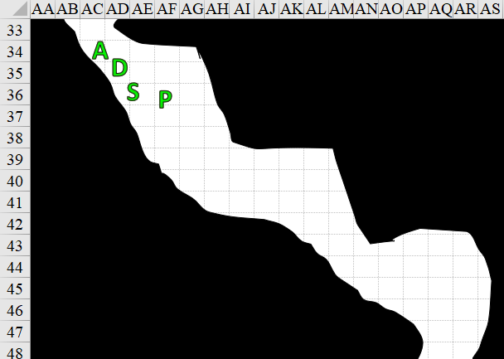

Round 16

Pussyfoot’s ears were the only ones keen enough to sense the thumping to her right.

The rogue stood still and listened intently. The others stood quietly while Pussyfoot plied her trade.

Stepping closer to the porous intestinal wall, the halfling could now hear what was either the bass kick for a swung beat that with an accompanying snare and maybe a high hat might’ve caused her to want to dance, but no, that wasn’t it at all. It was a very regular and definitive heartbeat. “Ba-boom, ba-boom, ba-boom,” she whispered to herself in unison, diagnosing the anatomy of their host body.

“We should be called the Antibodies,” Devrion jested as Steelshade held out her sword towards a newly hatched dretch that had just leapt out of one of the follicles and now became impaled in her sword.

Round 17

Atlas—the more reverent of the four—cringed a bit, and replied, “Bite your tongue; this is no laughing matter.”

“I’m just glad we haven’t seen a cervix yet,” Devrion said with a theatrical shudder.

Steelshade shook the misfortunate wretch of a dretch off of the blade, and asked Pussyfoot, “What is it?”

Round 18

“Ew, Devrion!” Pussyfoot sighed. “I hear a heartbeat—that way.” She pointed to her right, toward the sound’s locus.

Steelshade thought to cut through the veneer of fleshy wall that encased this tube, while Devrion thought the impact of a single fireball might blast the flesh away, revealing a big-ass heart. Atlas looked at Devrion, mundanely reading his mind, and calculating that half of the blast from the fireball would have been wasted on air.

Atlas looked around. “Does anyone remember why we are here, or what this creature might be? We can break through this flesh, I suppose, but should we?”

Rounds 19 – 23

Pussyfoot looked around the area. “We’ve been fortunate so far. But, what happens when we start hacking on whatever-this-is’ internals? It probably has some way to protect itself against a bellyache.”

Devrion nodded. “And, given the size of this thing, causing a major bleed could drown us.”

“That there was about the hundredth dretch we took out,” Steelshade estimated, then protected, “Can’t be more than another hundred left.”

“We can’t just stand here,” Atlas pointed out.

“The last time I looked, a gut has a stomach on one end, and an asshole on the other,” Steelshade mused. “Since we probably don’t want to go to either place, we will need to create an opening somewhere.”

“By the smell, we’ve been moving away from the exit and towards the acidic center,” Atlas guessed right.

“Joy!” Pussyfoot said as her dagger appeared in her hand. “Let’s start with a small cut.”

The other three readied themselves, while Pussyfoot laid her hand on the wall in an attempt to cut without striking a blood vessel. She stuck the dagger in, and started to saw though.

Round 24

The flesh first opened, fizzled, dripped some goo, and receded a few feet. At this rate, it would take her about a minute to cover anywhere between 20’ and 40’ of this flesh if the method was repeated, leaving a tunnel about 5’ wide and tall. Taller and wider versions would take longer, but might not be stable.

The rogue worked her way toward the heartbeat, while the others followed a few feet behind her in single file; Steelshade, Devrion, and Atlas.

Round 31

They’d made considerable headway, and after this last hack, Pussyfoot now could see that she was about to pierce a membrane that appeared to be at least approximately spherical, beyond which was something moving, pulsating with the rhythm of the heartbeat that was now unmistakable.

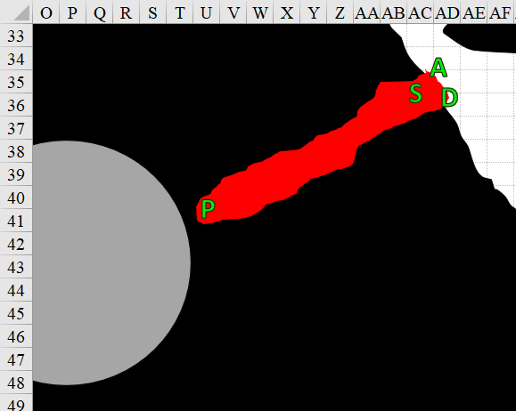

Round 32

Within the chamber was indeed a pulsating heart—green with the filth of the impurities coursing through it, and likely sending blood to a purifying organ nearby.

Atlas pondered the creature’s parts he could see, considering if there was any bit of insight he could glean. His suspicions lay with the heart hypothesis; every indicator pointed there.

“Okay, cut an opening,” Devrion said. “I can put a fireball through it.”

With a trail of fuming blood at her feet seeping out into the corridor where the others stood, Pussyfoot sliced an opening to the heart, if that’s what it really was.

And sure enough, peering through the threshold she’d just sliced in the membrane of the hemispherical chamber with a pulsating heart—blue, red, and violet—and a handful of conduits for the green, red, and yellow blood streams flowing through this environment. The conduits led inward from above, and the liquids flowed downward, underneath her feet.

The heart appeared to be the only moving object within the chamber.

“Okay, move back,” Devrion warned.

Pussyfoot picked her way among the noxious streams of blood back to the others. Everyone but Devrion stepped around the corner, and moved back a few feet.

“Tűzgömb!” Devrion pointed at the opening, and a tiny sphere leapt from his fingertip. The warmage ducked back around the corner as the sphere zipped through the opening and smacked into the beating heart.
Automatic fail. Dmg: 32 fire.

The fireball coursed through the hemispherical room, which constituted almost exactly half the volume of the explosive blast, and by the time the flames subsided, the floor was about a foot lower, and the membrane of the structure was beginning to collapse as the domed ceiling of cooked flesh and molten plasm buckled under the weight of whatever was above it.

Within less than a minute, the whole thing had collapsed, and the gooey substances and chunks of demonic protomatter began to squeeze out through the tunnel that Pussyfoot had carved.

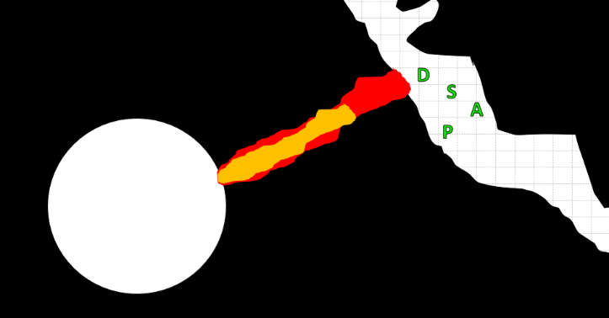

“Incoming,” Devrion made more of the situation than it was.

“So, was that a heart attack, or severe indigestion?” Pussyfoot grinned at her own wit.

“Heartburn,” Steelshade confirmed. “I bet the owner won’t be happy with us.”

“Okay, so now what?” Atlas looked around.

“Let’s go back the way we came,” Steelshade said.

Pussyfoot stepped around her friend and started back along the pathway she’d cut, with the others following her.

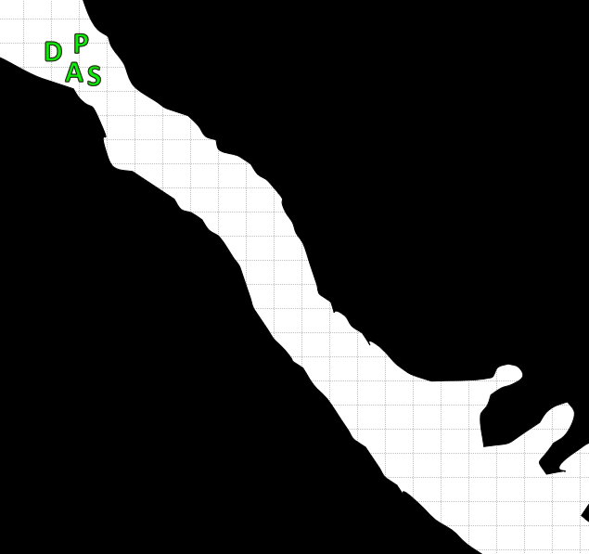

They reached the point where they’d fought the last of the dretches that had come at them, and noted their quickly decomposing and deflating bodies. To the northwest was the slim tube out of which they’d recently crawled in order to get into this wider tunnel, and to the southeast were the alcoves from where dretches would likely emerge once again, given enough gestation time.

The group kept moving northwest.

“We came through here,” Pussyfoot grumbled.

“Then, everything should be dead,” Steelshade answered cheerfully as they descended into the lower intestinal level once again.

They continued into the ever-fouler pits of the giant demon’s digestive tract, and soon were once again knee deep in corrosive digestive fluids... and crap. “Why did we turn back again?” Devrion asked. “We were on solid flesh up there, and with that heart destroyed, were probably making headway.”

Steelshade sighed. “Let’s go back the way we came, and keep moving southwest, then.”

“Devrion, if you have any better ideas, I’m all ears,” Pussy foot glowered up at the tall half-elf.

The warmage shrugged. “If I did, I’d say so. I’m just commenting, is all.”

“All right, everyone,” Atlas said quietly. “Let’s find our way out of here.”

Pussyfoot sighed, and turned to trudge back to where the destroyed heart laid.

By the time they got back, the goo that had seeped out of the cardiac chamber was all over the floor, and its acidic composition began to sizzle away at the soles of their boots.

Everyone’s boots suffered 1 point of damage.

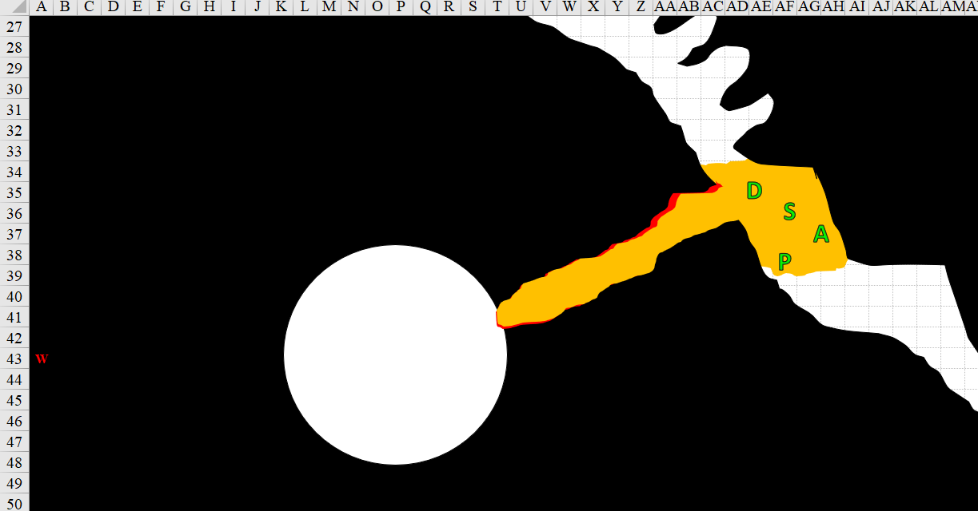

They cleared the puddles and turned back to see the liquid continuing to drip outward; soon this chamber would be a few inches deep in the acidic slime, so they put a bit more distance between it and themselves.

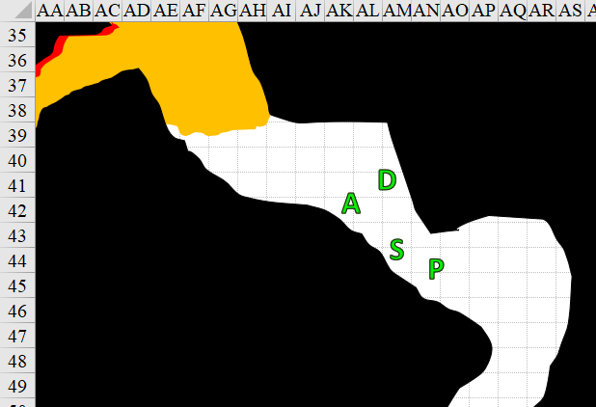

They then reached a bend in the tunnel, and began to hear movement up ahead.

Pussyfoot padded up to the corner and looked around, but saw nothing moving. “It’s just more upper gut,” she whispered.

Atlas noticed a scarred etching of a pentagram with Abyssal writing, which none of them could discern. “Someone’s been here,” he whispered a bit louder than Pussyfoot.

Pussyfoot padded up to the corner and looked around, but saw nothing moving. “It’s just more upper gut,” she whispered.

Atlas noticed a scarred etching of a pentagram with Abyssal writing, which none of them could discern. “Someone’s been here,” he whispered a bit louder than Pussyfoot.

“Is that a rune?” Steelshade pointed to the etching.

“I don’t know,” Atlas said as he peered at it. “Devrion?”

The warmage looked more closely at the etching.

Devrion studied it, and as he did, Pussyfoot noted along the wall behind them a scarred over threshold that likely led elsewhere. Devrion considered this during the 30 seconds or so that he took to decide on a verdict. “It’s definitely not a rune...” he hesitated on the next part, inhaling first, “... I think it’s a road sign.”

“Yeah?” one of them frowned and smirked.

“This figure is a demon’s index finger pointing to the scarred-over flap that was probably a fork in the gut,” Devrion surmised.

They then heard the movement around the corner coming closer. It included irregular steps, something dragging, and perhaps a gurgling along with it.

“Dretches?” Steelshade asked.

“I don’t think so,” the halfling with the acute sense of hearing didn’t recognize the sounds.

“Now, that’s odd,” Steelshade mused as she looked at the etching.

“Everywhere a sign,” Devrion said, half to himself.

“What?” Pussyfoot turned to him with a grin. “Where did you hear that?”

“Oh, a group of five minstrels used to sing a song about that. I don’t even recall where I heard them,” the warmage replied.

“Let’s open this back up,” Steelshade said. “If the owner sealed it, there must be something there it doesn’t want found.”

Atlas shrugged and smiled. “I don’t know about the logic behind that, but there’s only one way to find out.”

“Indeed.” Steelshade lifted Arkenlyl and sliced into the scarred area.

“Guys,” Pussyfoot warned of the incoming movement from the west.

The flap of protoflesh fell like a thin feather fluffily making its way downward, and revealed a treasure chest ensconced in a 10’ deep follicle.

Simultaneously, a demon’s fetid scent reached the heroes before the demon itself, and even before they knew what they were dealing with, they all became sickened.
All PCs suffered –2 penalty attacks, weapon damage, saving throws, skill checks, and ability checks.

The sounds of the approaching denizen of this gut were unfamiliar to the trespassers, but it seemed like a small army of dretches pattering its way over.

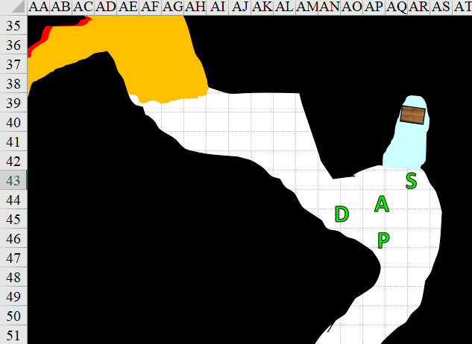

Round 70

Atlas closed his eyes and whispered a few words, and then he burst into loud, hearty laughter that reverberated through the demon’s stench.
Devrion gains +2 to attacks and saves against fear effects, plus 1 + 17 = 18 temporary hit points [112/94].
Evil creatures within 40’ of Atlas suffer -2 to attacks and saves against fear effects.

Devrion stepped up next to Pussyfoot, raised his hand, palm outward. “Fúj!” A powerful burst of wind blasted out, driving the demon’s stench back at it.
Character | Save vs.  gust of wind | Ranks | Roll | Check
Adaru | Fortitude | 12 | 12 | 24
Success.

“Brene, there’s a chest here that’s probably trapped,” Steelshade said. She moved to get a better look around the corner, casting dragonskin [expired on Round 1770] as she went. She was ready to duck back if she spotted something really dangerous.

“Got it,” Pussyfoot replied. She carefully explored the passage, looking for a trap. She did not touch the chest just yet, and now spotted the telltale signs of a mimic as the creature prepared to eat her whole.

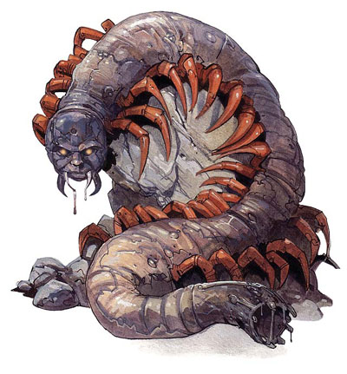

Steelshade spotted a nasty-looking millipede with the face of a demon crawling towards them along the ceiling. It was struggling against the gust of wind but managed to get only a few feet away from Devrion.

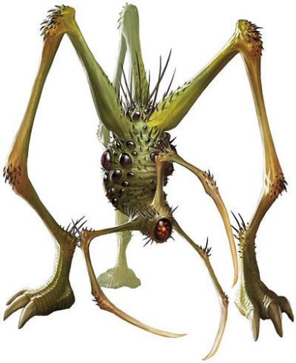

Making eye contact with Steelshade, the demonic myriapod smiled and grimaced simultaneously, and summoned a nasty-looking demon behind Steelshade. The demonic being immediately attacked Steelshade.
Character | Attack Type | Damage | BAB | Str Mod+ | Total Score | Roll | Total
Draudnu | Flesh Hook 1 | 2d6+4+Immobilize | 14 | 4 | 18 | 6 | 24
Draudnu | Flesh Hook 2 | 2d6+4+Immobilize | 14 | 4 | 18 | 15 | 33
Draudnu | Flesh Hook 3 | 2d6+4+Immobilize | 14 | 4 | 18 | 3 | 21
Miss, miss, miss.
Save vs.  Form of Madness | Rank | Ability & Mod. | Misc. Mods. | Total | Roll | Check
Atlas, Will | 10 | Wis (+4) | 13 | 27 | 4 | 31
Devrion, Will | 10 | Wis (+1) | 1 | 12 | 8 | 20
Pussyfoot, Will | 5 | Wis (+1) | 0 | 6 | 15 | 21
Steelshade, Will | 10 | Wis (+2) | 3 | 15 | 10 | 25
Success, success, success, success.

The intruders were able to shrug off a malady that would have permanently (until treated) have weakened them.

Atlas was able to provide a bit of preliminary information on the myriapod-looking demon. “This tanar’ri is an adaru; no terrain presents difficult terrain for them, and are as poisonous as anything we’ve encountered in the belly of this beast.”
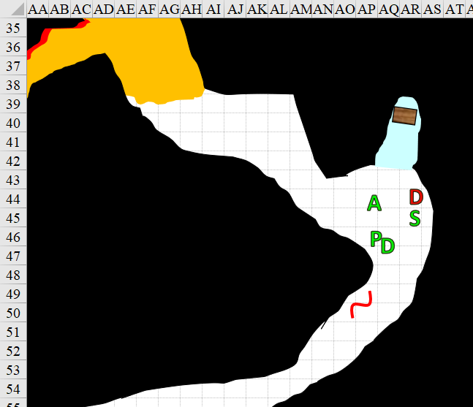

Round 71

Character | Group | Initiative | Roll | Modified Roll
Steelshade | 1 | 6 | 13 | 19
Adaru | 2 | 6 | 13 | 19
Devrion | 1 | 2 | 16 | 18
Draudnu | 2 | 4 | 12 | 16
Pussyfoot | 1 | 5 | 5 | 10
Atlas | 1 | 2 | 2 | 4

Steelshade channeled shocking grasp though her sword and full-attacked the critter who’d attacked her.
Melee Weapon | Dmg | D+ | TH+ | Crit | x | Type | Wt. | Atk | Roll | Check
Shattermantle Bloodstone Falchion +3 | 2d4 | +7 +3 +  5d6 shocking grasp | 3 | 18 | 2 | Slashing | 8.0 | +27 | 8 | 35
SB Falchion +3, 2nd Attack | 2d4 | +7 +3 | 3 | 18 | 2 | Slashing | - | +22 | 19 | 41
SB Falchion +3, 3rd Attack | 2d4 | +7 +3 | 3 | 18 | 2 | Slashing | - | +17 | 3 | 20
SB Falchion +3, 4th Attack | 2d4 | +7 +3 | 3 | 18 | 2 | Slashing | - | +12 | 11 | 23
Hit, hit, miss, hit.
Dmg: (5 + 7 + 3 + 17 electric) + (7 + 7 + 3) + (2 + 7 + 3) + (5 + 7 + 3) = 15 + 17 + 12 + 15 + 17 electric = 78. Partial damage negated.
Acid Spray damage to Steelshade: 4 + 2 + 6 = 12 acid [164/179].

As creatures aligned with evil and chaos, demons reveled in fear and destruction, following their depravity wherever it led. For months, demons had plagued the adventurers, who had finally gone on the offensive against the mothership of them all, in whose bowels they now spelunked. The variety of denizens of this chaos- and evil-imbued corpus-environment acted as antibodies and digestive agents for the benefit of the greater organism that housed them. This symbiotic relationship was rare among the tanar’ri, who were noted for being the fiercest and nastiest of demons.

The adaru cast freedom of movement upon itself, and moved 5’ closer to Devrion, whose gust persisted.

“Wow, you’re ugly!” Devrion pointed his finger at the demon. “Szétesik!”
Ranged Weapon | Dmg. | D+ |  | TH+ | Critical | Rng. | Wt. |  | Atk |  | Roll | Check | Notes
Ranged Touch Attack | - | +4 |  | 1 | - | - | - |  | 10 |  | 13 | 23 | Weapon Focus Included
Bypass Spell Resistance |  |  | varies |  | - | - |  | - |  | - |  | - | 17 | 4 | 21
Hit. Spell Resistance bypassed.
Character | Save vs.  disintegrate | Ranks | Roll | Check
Adaru | Fortitude | 12 | 4 | 16
Fail. Dmg: 126.

The adaru instantly disintegrated.

The draudnu remained behind as the apex enemy of the moment, and tried to immobilize Steelshade by impaling her with its detachable flesh hooks.
Character | Attack Type | Damage | BAB | Str Mod+ | Total Score | Roll | Total
Draudnu | Flesh Hook 1 | 2d6+4+Immobilize | 14 | 4 | 18 | 2 | 20
Draudnu | Flesh Hook 2 | 2d6+4+Immobilize | 14 | 4 | 18 | 1 | 19
Draudnu | Flesh Hook 3 | 2d6+4+Immobilize | 14 | 4 | 18 | 12 | 30
Miss, miss, miss.

Pussyfoot turned to see the demon’s summoned creature attempting to attack Steelshade, and that meant it had its back to the rogue. Her dagger appeared in her hand, and—turning her back to the mimic—she sneak-attacked the draudnu with it.
Melee Weapon | Dmg | D+ | TH+ | Critical | Type | Wt. | Atk | Roll | Check
Keen Dagger of Wounding +2 | 1d3+2 | 1+? | 2 | 19-20, x2 | Prc/Slash | 0.5 | +16 | 16 | 32
Hit. Dmg: 1 + 2 + 1 + 32 sneak = 36. Partial damage negated.

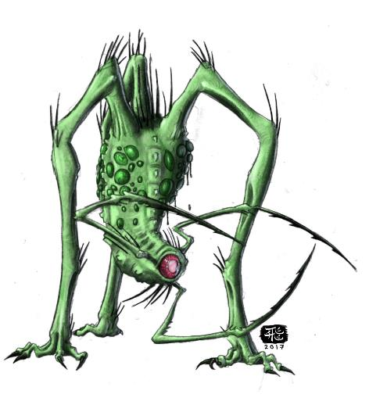

The demon squealed, and turned its attention to Pussyfoot now, hissing with a taste for vengeance.

Atlas recalled, “Both of these types of demons are resistant to spells, but good-aligned weapons can penetrate their dense hides.” He then congratulated

Atlas decided that he would take care of the mimic. He uttered a few words and clapped his hands once. A pinpoint of fiery light projected outward from the archivist, and as the mimic began to emerge from its cozy alcove and head for Pussyfoot, a flaming sphere appeared by the monster and rolled up and around it.
Character | Save vs.  flaming sphere | Ranks | Roll | Check
Mimic | Reflex | 5 | 3 | 8
Fail. Dmg: 7 fire.

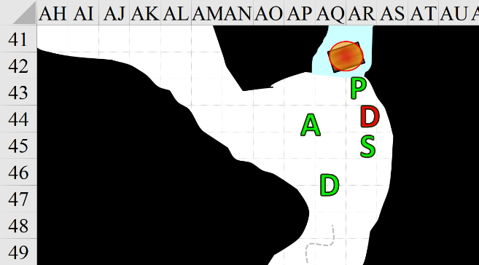

Round 72

Atlas continued to give his adventuring partners advice as it surfaced to his memory: “Beware: Those who look upon a draudnu come to believe that they have something growing inside them,” he turned to Devrion. “… a sickening thought that can’t be shaken.” He continued to direct the flaming sphere to surround the mimic.
Character | Save vs.  flaming sphere | Ranks | Roll | Check
Draudnu | Reflex | 13 | 11 | 24
Success. Dmg: ½ x 6 = 3 fire.

The mimic attacked Pussyfoot.
Character | Attack Type | Damage | BAB | Str Mod+ | Total Score | Roll | Total
Mimic | Slam 1 | 1d8+4 | 5 | 4 | 9 | 15 | 24
Mimic | Slam 2 | 1d8+4 | 5 | 4 | 9 | 7 | 16
Miss, miss.

“Careful behind you,” Steelshade cautioned Pussyfoot as she full-attacked the creature while channeling vampiric touch through her sword. She did her best to avoid looking directly at the creature.
Melee Weapon | Dmg | D+ | TH+ | Crit | x | Type | Wt. | Atk | Roll | Check
Shattermantle Bloodstone Falchion +3 | 2d4 + 8d6 vampiric | +7 +3 | 3 | 18 | 2 | Slashing | 8.0 | +27 | 16 | 43
SB Falchion +3, 2nd Attack | 2d4 | +7 +3 | 3 | 18 | 2 | Slashing | - | +22 | 1 | 23
SB Falchion +3, 3rd Attack | 2d4 | +7 +3 | 3 | 18 | 2 | Slashing | - | +17 | 20 | 37
SB Falchion +3, 4th Attack | 2d4 | +7 +3 | 3 | 18 | 2 | Slashing | - | +12 | 14 | 26
Hit, miss, hit, hit. Dmg: (5 + 7 + 3 + 46 vampiric) + (4 + 7 + 3) + (6 + 7 + 3) = 15 + 14 + 13 + 46 = 88.
Steelshade gained 15 hps [179/179].

Devrion turned and also tried to avoid looking directly at the draudnu, then noted that Steelshade had just dispatched the demon that poofed out of existence. “Rakéta!” he then turned and said as five rods of force jumped from his fingertips and raced to strike the mimic.
Dmg: 14 + 5 = 19 magic.

Pussyfoot turned around as the others engaged the mimic.

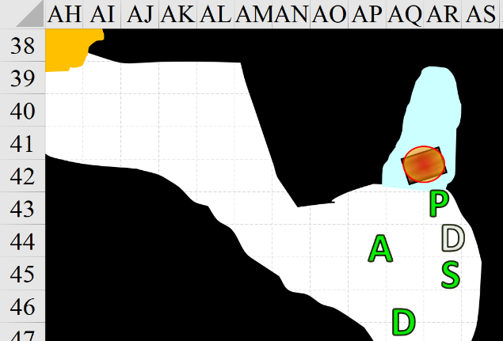

Round 73

Atlas moved the sphere to allow Steelshade to attack the mimic, while Pussyfoot and Devrion looked around for anything else that might threaten them.
Character | Save vs.  flaming sphere | Ranks | Roll | Check
Mimic | Reflex | 5 | 2 | 7
Fail. Dmg: 7 fire.

Steelshade stepped towards and attacked the mimic, holding her spellcasting for the moment.
Melee Weapon | Dmg | D+ | TH+ | Crit | x | Type | Wt. | Atk | Roll | Check
Shattermantle Bloodstone Falchion +3 | 2d4 | +7 +3 | 3 | 18 | 2 | Slashing | 8.0 | +27 | 19 | 46
Threat. 1d20 = 5 + 27 = 32 critical hit. Dmg: ([2 x 4] + 7 + 3) = 18.

The mimic was cleft right down the middle, and the corridor once again was quiet, save for the gust of wind that Devrion was still pushing southwestward.

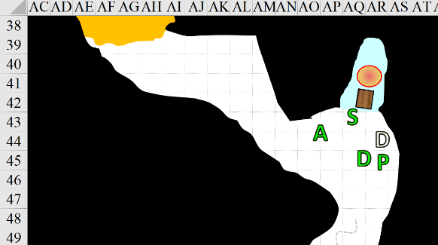

“Well, that was stimulating,” Pussyfoot breathed. “We need to get out of here.” She checked the creatures’ remains to see if there was anything useful.

Atlas dismissed the sphere, and checked the bowel to the northwest for anything that might be sneaking up on them.

Devrion let his spell run itself out, and looked southwest to see what else was there.

“I agree, we need to keep moving,” Steelshade said as she stepped up beside the warmage.

The demons had nothing on them, but the mimic’s gizzard-stomach was filled with jewelry and metal items, which it used in life to grind the flesh of those it consumed. The contents spilled out, the lack of flesh inside revealing that the mimic had not eaten in months; perhaps years.

Among the items were a handful of rings and amulets that looked to bear magical properties.

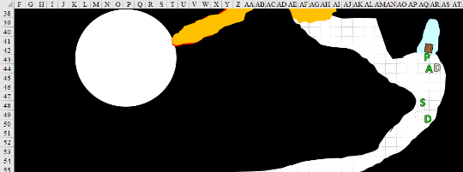

Pussyfoot scooped up everything and dumped them in one of her haversack’s side pockets for later consideration. “Okay, let’s keep going. Oh, wait; I have no haversack.” She then placed the assorted jewelry and other trinkets into Steelshade’s haversack.

The rogue took her place at the front, with Steelshade, Devrion, and Atlas following as they moved southwest.

They continued along the canal, and soon found the phosphorescent, green lining of the walls becoming more jaundiced until they were in a nearly orange chamber. There was a sound of running fluids to their south as they continued, reaching yet another acute bend in the linear path.

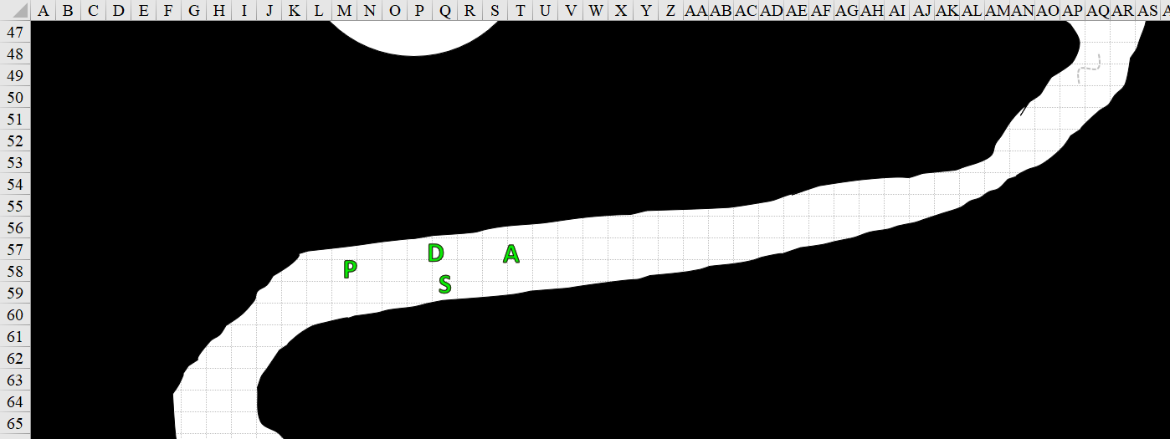

Pussyfoot carefully cut the angles to see around the corner, staying to the outside of the curve. The others followed as she moved.

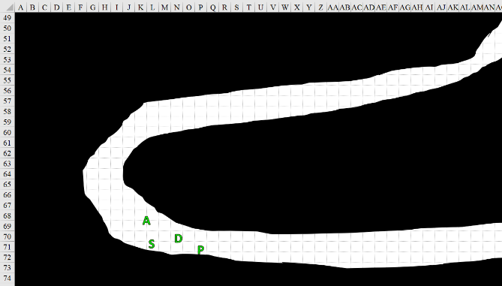

The path meandered leftward again, and the smell of the draft coming towards them was significantly more pleasant than the areas behind them. The phosphorescent orange around them continued to grow redder until they were in a blood-orange-colored call with a fairly level and solid floor underneath them.

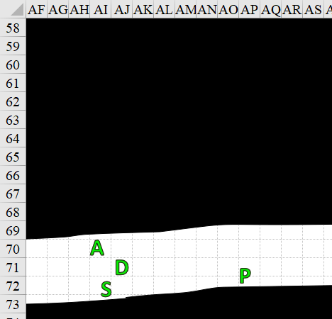

Then Pussyfoot heard sounds up ahead and waved to the others to remain behind for a moment as she inched forward with her blade drawn. She reached the next bend, skirting the outside of the curvature, and saw before her another organ chamber. This was likely not a heart, as it was not beating, but gurgling.

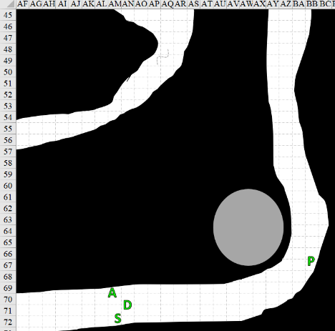

Round 81

She took a few more steps to see better around the corner, and noted no movement to the north.

The rogue waved the others forward, and she stepped back from the corner. “Another organ,” she said as she pointed.

“We had so much fun with the last one,” Devrion said with a grin.

Pussyfoot rolled her eyes. “Right. Let me see if I can cut toward it. Watch yourselves.”

The other three moved back a few feet, and Pussyfoot set to cutting the wall.

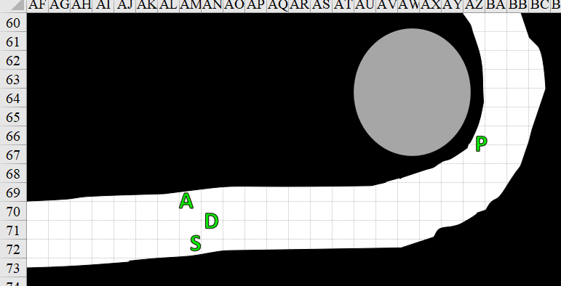

Round 82

The rogue pierced the membrane of the wall that encased them, then cut through the thinner layer of tissue that contained a noxious bubble that now sprayed Pussyfoot and permeated throughout the chamber.
Save vs.  cloudkill (Enlarged) | Rank | Ability & Mod. | Misc. Mods. | Total | Roll | Check
Pussyfoot, Fortitude | 5 | Con (+1) | 0 | 6 | 15 | 21
Success. Saves for ½ damage.
Dmg: ½ x 2 = 1 Con (and consequently -17 hps) [77/77] [expired on Round 232].

The gases continued dispersing outward along both sides of the chamber as the bubble to Pussyfoot’s northwest collapsed.

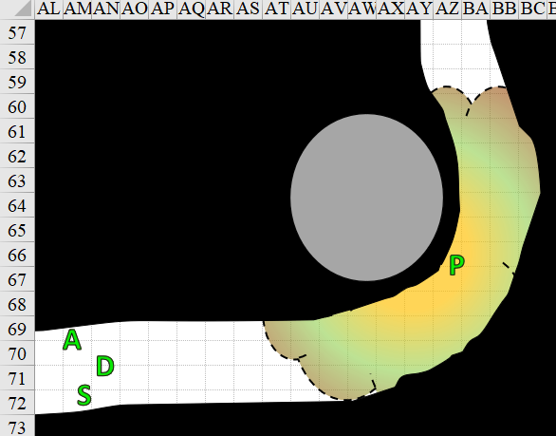

Pussyfoot held her breath and ran back to the west.

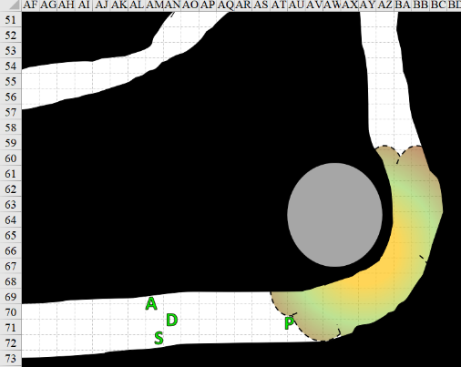

Devrion cast gust of wind to drive the fumes away from them, driving them northward.

Steelshade took her cube in hand in case Devrion’s spell didn’t do enough to drive the cloud away.

Atlas watched behind them while the others helped Pussyfoot. He’d take a moment to help her when she arrived, he thought.

A fiendish efreeti emerged from the chamber and spotted Pussyfoot’s fleeting form.

Devrion’s gust of wind manifested, and the efreeti did all it could to remain in place.

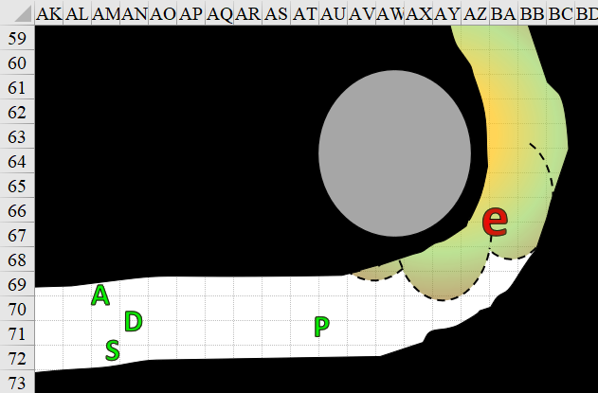

Round 83

Character | Group | Initiative | Roll | Modified Roll | Move
Fiendish Efreeti | 2 | 7 | 17 | 24 | 20’; Fly 40’
Steelshade | 1 | 6 | 14 | 20 | 30’
Atlas | 1 | 2 | 15 | 17 | 30’
Pussyfoot | 1 | 5 | 7 | 12 | 20’
Devrion | 1 | 2 | 5 | 7 | 30’

The fiendish efreeti had meant to surprise-attacked Pussyfoot as the latter made it out of the gaseous blast’s current area, but was left fighting the current, making no headway despite its efforts.

Steelshade held her ground and awaited developments as her comrades acted. She planned to move in on the efreeti – if it survived its introduction to a warmage.

Pussyfoot walked up to her lover. “Well, shit. Help?”

Atlas smiled as he walked 35’ towards her. “Pretty much.” He didn’t have enough time to cast restoration at the moment, so he braced for the enemy’s attack if it got any closer.

Devrion sized up the efreeti and decided to settle matters before the creature could do anything unpleasant. He made his way over so he had a direct line of sight to the enemy as the enemy struggled to lunge.

The efreet saw few options on its plate, and thus fired a scorching ray upon Devrion.
Character | Attack Type | Damage | Ranged? | BAB | Dex Mod+ | Other+ | Total Score | Roll | Total
Fiendish Efreeti | Scorching Ray | 4d6 fire | þ | 10 | 3 | 0 | 13 | 1 | 14
Miss.

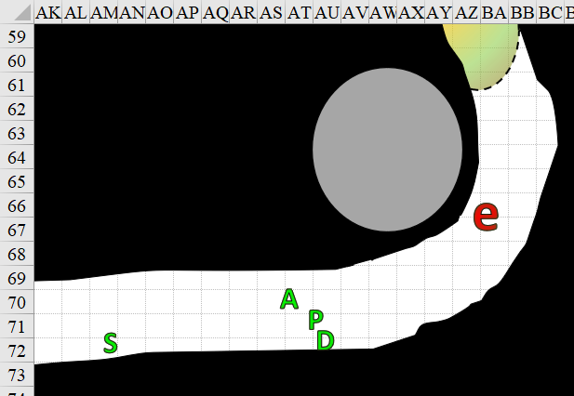

Round 84

Atlas closed his eyes, murmured a few words, and then laid his hands on her shoulders.
Restoration. 1 Con (and consequently -17 hps) restored [94/94].

Devrion pointed his finger at the creature. “Szétesik!”
Character | Save vs.  disintegrate | Ranks | Roll | Check
Fiendish Efreeti | Fortitude | 9 | 20 | 29
Success. Saves for reduced damage. Dmg: 21 magic.

Steelshade and Pussyfoot nodded, and wondered how they could contribute to the fiery being’s demise. The duskblade moved to the front of the formation in case the gust of wind died down.

The efreet turned tail and flew away.

Round 85

“Well, that sucked,” Devrion grumbled as the efreeti simply shook off most of the spell’s effects.

“You’re not the one who got gassed,” Pussyfoot said as she poked him in the arm with a slim finger.

“All right, children,” Atlas sighed. “Let’s see where the bad efreeti went, shall we?” The archivist focused his thoughts on the beings, trying to come up with some ideas to help the group.

Steelshade walked east to see if she could catch sight of the efreeti, while Pussyfoot looked behind them, just in case.

The gust of wind continued to push the lethal gases away from them.

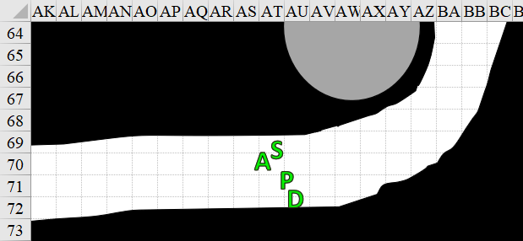

Round 86

Devrion cast gust of wind again to keep the airborne poisons moving away from them. The quartet shifted formation, with Pussyfoot once again taking the lead, Steelshade following, Devrion behind her, and Atlas bringing up the rear.

Rounds 87 – 88

They moved around the corner, passing the collapsed chamber that likely still contained an organ or something, and continued north.

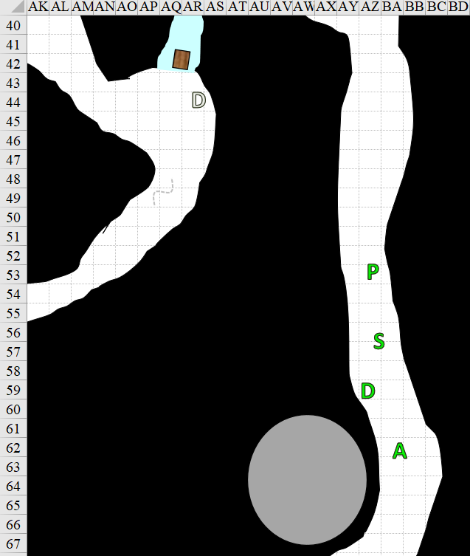

Rounds 89 – 91

Atlas stopped in his tracks as a thought occurred to him. “Did we check the chamber where the efreeti came out?” He called to the others.

Pussyfoot stopped and rolled her eyes. “Why no, why would I do that?” She turned on her heel and walked back to the opening she made, ignoring her lover’s grin as she passed him. She carefully peeked inside to see if there were any other surprises in store.

Devrion and Steelshade followed her, and positioned themselves where they could see in both directions while the rogue examined the opening, taking care to not stand in line with the opening, just in case something else shot out.

The inside of the chamber looked like a tent whose poles had collapsed, and within she could see a white-glowing bulb the size of her body, shaped and studded like a budding pinecone.

“Okay, maybe we should stand clear,” Pussyfoot said as she pointed west. “Go over there, except for you, Devrion.”

“Of course, Milady,” the half-elf said with an unctuous bow.

Everyone except Devrion moved back to the west, clear of any effects from destroying the organ. The warmage pointed his index finger at the organ. “Tűzgömb!” A mote of flame leapt from his fingertip, and he turned to run westward toward his companions.
Dmg: 28 fire.

Round 92

It took some time for the smoke to clear, but amidst the smell of cooking meat, the rogue and warmage were able to make out the organ’s remains on the ground.

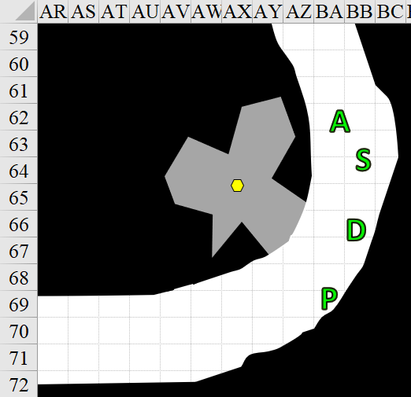

Pussyfoot stepped closer, careful about how weak the floor or walls might be.

A gem about the size of Atlas’ hands cupped together shone in the darkened chamber, which was devoid of the phosphorescent, orange light that emanated from the tunnel. The prismatic gem’s facets barely reflected the dim light into the halfling’s eyes, which were about as accustomed to darkness as her human lover’s.

Protoflesh still clung to the gem, or perhaps it was fairer to say that the gem was still somewhat encrusted in its meat sack, which smelled of roast cockatrice, compliments of Chef Devrion.

Pussyfoot took out one of her arrows and poked at the gem, moving it a bit closer. Nothing unexpected happened.

Devrion stepped into view of the entrance, watching with most of his body shielded by the wall. The others did so as well.

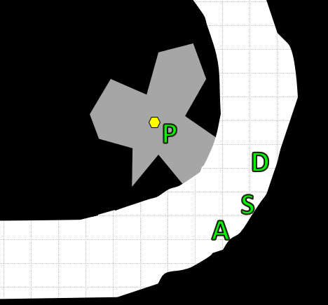

Pussyfoot tugged at the gem with the arrow flutes, dragging it back toward the others.

Round 93

“What are you doing?” Devrion laughed. “Just pick it up.”

“Not on your life, finger wiggler,” Pussyfoot retorted. “It might turn me into a toad, or worse, a finger wiggler.”

Atlas held out his hand and murmured a few words, casting detect magic.

Steelshade stepped back and looked both directions in the corridor to ensure that no one was sneaking up on them.

Round 94

The archivist focused on the gem, waiting for the spell to narrow down as he employed it.

“Well?” The halfling looked at him.

“Keep moving it this way; it will take a moment.”

Pussyfoot kept working the gem toward the entrance with the arrow point.

Atlas detected the presence of at least one magic aura nearby, which was expected since they were all carrying magic items.

Round 95

Aside from the familiar auras around their persons, Atlas noted the strong to overwhelming aura around the giant gemstone. “Its resplendence bears the signature of an Evocation,” he said as he said squinted.

Rounds 96 – 98

Pussyfoot backed away a bit further while Atlas examined the gem.

Atlas examined the gem to see what it was. “Ah!” he gasped with sudden delight, and picked it up, asking Steelshade to crush it with her hands. Offering it to her, he said, “Here, strongwoman. Inside lies the true gem, which will impart the prismatic spray ability to a weapon. It has a limited number of charges before it’s completely used up.”

“Rechargeable?” Devrion asked.

“Not likely,” Atlas shrugged. “It’s a gland, and has a limited reservoir of power, but I wouldn’t be surprised if there were more around here.” The archivist’s sense of spellcraft was poor, but he was moderately confident in his suspicions.

Rounds 99 – 101

Steelshade took the gem and crushed it between the heels of her hands, revealing a much smaller and harder gem inside. It was the perfect size and shape to be fitted onto a weapon—as Atlas had suggested—and was pretty to look at under the orange light.

She handed the gem back to Atlas. “For your stick.”

“It’s a shillelagh,” he sighed.

“It’s a stick,” Steelshade repeated. “Or, a club. Take your pick.”

Atlas took the gem and inserted it in his shillelagh, but it likely required some smithing, and might not have been appropriate for a gnarled stick, no matter how gallant and glorious. “Thank you.”

“Okay, Shorty, let’s go,” Devrion said with a wave of his hand.

Pussyfoot archly ignored him, and started off to the north again, with Steelshade, Devrion, and Atlas following.

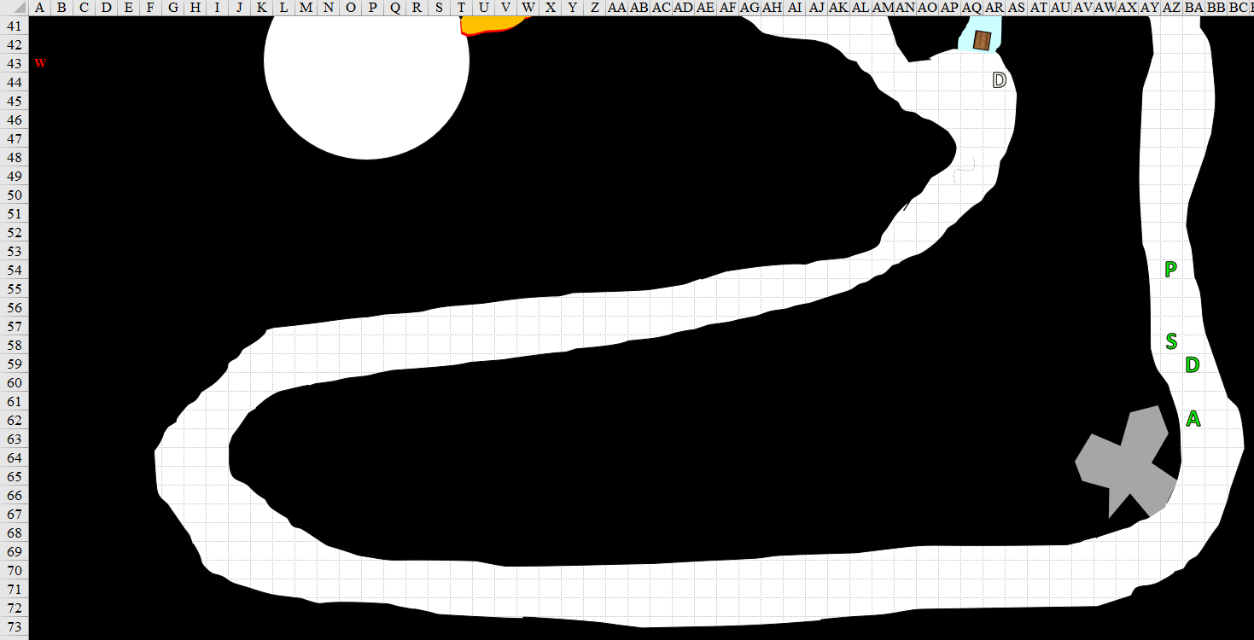

Round 102

The light was beginning to dim as the rogue led her companions along, and she began to see a fork in the path up ahead—the first since they’d entered this abominable alimentary canal. She slowed her steps, turned around, and made the usual Y-formation with her hands to indicate the fork up ahead.

Pussyfoot led the group forward, smelling the noxious effects of the cloudkill spell as the orange light was nearly inexistent. “I won’t be able to lead much further,” the halfling said, having poor night vision.

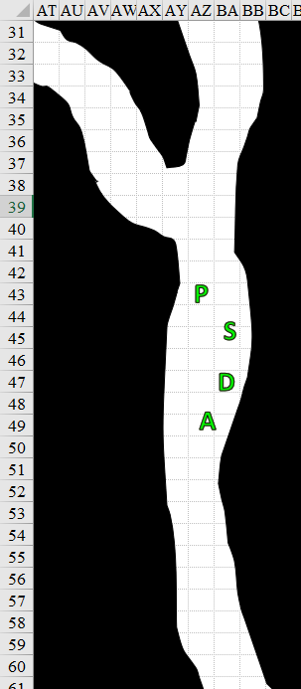

Round 103

“What happened to your goggles?” Atlas asked.

“Goggles? Oh!” Pussyfoot dug in her pack, and pulled out a pair of magical goggles. She slipped them on and grinned at Atlas. “What would I do without you?”
Pussyfoot’s goggles shifted from Equipment Carried to Equipment Worn.

“It’d probably involve your fingers,” Devrion snarked. The other three just looked at him. “What?”

Round 104

“Never mind him,” Steelshade sighed. “Which way do we go? Atlas?”

Now able to see heat differentiation about 60’ out, the halfling blinked a few times as her eyes adjusted to the rouge and gray hues.

Also lacking any form of night vision, the archivist considered the two paths ahead of them. He would have to use his sunrod, or Devrion’s spell, if he was to travel much further.

Atlas then heard something approaching from the south as something from the north heard them speaking.

Round 105

“Guys,” Atlas said as he turned around to see what it was.

It was another half-dozen dretches—maybe more of them farther off—coming at them from the south.

Pussyfoot continued ahead, looking at each branch of the corridor.

“Atlas, stay with her,” Steelshade said as she waited to see which way they would go.

“What about them?” Devrion asked.

“Save your magic for the moment,” Steelshade replied. “I’ll go after them if they get too close. Let’s see if we can keep moving forward.”

Devrion moved off to back up Pussyfoot and Atlas.

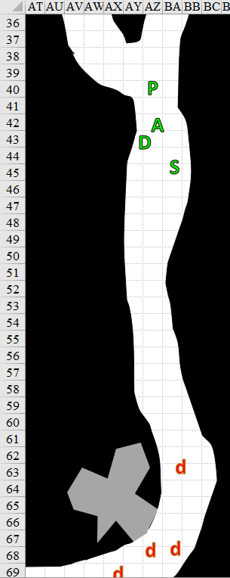

Round 106

Character | Group | Initiative | Roll | Modified  Roll | Move
Assorted Dretches | 2 | 2 | 18 | 20 | 20’
Atlas | 1 | 2 | 11 | 13 | 30’
Steelshade | 1 | 6 | 5 | 11 | 30’
Pussyfoot | 1 | 5 | 5 | 10 | 20’
Devrion | 1 | 2 | 8 | 10 | 30’

“But where to?” Pussyfoot referenced the fork in the darkening road.

The dretches charged towards Steelshade. At the same time, the efreeti, who had heard the heroes approaching, came closer for another try, got Pussyfoot in his sights, and cast another Aganazzar’s scorcher.
Save vs.  Aganazzar’s scorcher | Rank | Ability  & Mod. | Misc.  Mods. | Total | Roll | Check
Pussyfoot, Reflex | 10 | Dex (+6) | 0 | 16 | 11 | 27
Success. Saves for ½ damage. Dmg: ½ x 28 = 14 fire [76/94].

Atlas murmured something and stabbed his finger downward toward his feet. Immediately, a lightning bolt lanced down on the efreeti call lighting [expired on Round 276].
Ranged Weapon | Dmg. | D+ | TH+ | Critical | Rng. | Wt. | Atk | Roll | Check | Notes
Call lightning Spell | 7d6 | x1½ | 1 | - | - | - | +10 | 16 | 26 | 9 bolts remaining
Hit. Dmg: 22 electric.

Steelshade took a 5’ step southward, channeled shocking grasp through her blade, and engaged the frontmost dretch before the rest reached her.
Melee Weapon | Dmg | D+ | TH+ | Crit | x | Type | Wt. | Atk | Roll | Check
Shattermantle Bloodstone Falchion +3 | 2d4 | +7 +3 | 3 | 18 | 2 | Slashing | 8.0 | +27 | 6 | 33
SB Falchion +3, 2nd Attack | 2d4 | +7 +3 | 3 | 18 | 2 | Slashing | - | +22 | 8 | 30
SB Falchion +3, 3rd Attack | 2d4 | +7 +3 | 3 | 18 | 2 | Slashing | - | +17 | 2 | 19
SB Falchion +3, 4th Attack | 2d4 | +7 +3 | 3 | 18 | 2 | Slashing | - | +12 | 16 | 28
Hit, hit, miss, hit. Dmg: (5 + 7 + 3 + 17 electric) + (8 + 7 + 3) + (6 + 7 + 3) = 15 + 18 + 16 + 17 electric = 66. Electric damage negated.

The dretch died with the third slice, releasing a burst of acid up on Steelshade.
Dmg: 11 acid [168/179].

Pussyfoot moved to her left to get out of the line of fire, and to check the other passage. Her displacement cloak would have been great for something like a scorching ray, which required the caster to aim a beam at her. The automated telemetry of the Aganazzar spell, on the other hand, rendered the cloak moot, and even burned it a little.

Devrion pointed at the efreeti. “Szétesik!”
Ranged Weapon | Dmg. | D+ | TH+ | Critical | Rng. | Wt. | Atk | Roll | Check
Ranged Touch Attack | - | +4 | 1 | - | - | - | 10 | 5 | 15
Hit.
Character | Save vs.  disintegrate | Ranks | Roll | Check
Fiendish Efreeti | Fortitude | 9 | 15 | 24
Success. Dmg: 20 magic.

The efreeti resisted the worst of the damage and remained intact, albeit critically injured, and prepared to charge-attack Pussyfoot.

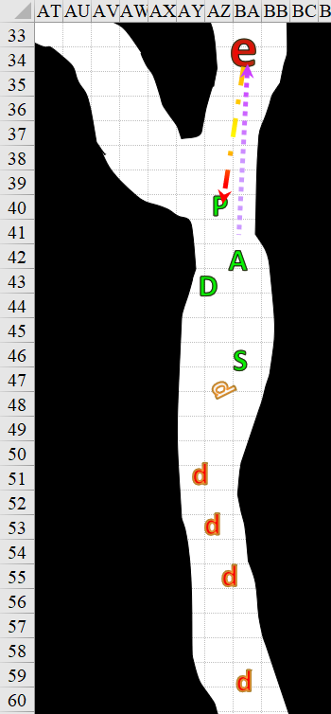

Round 107

The dretches attacked Steelshade.
Character | Attack Type | Damage | BAB | Str Mod+ | Other+ | Total Score | Roll | Total
Antibody Dretch | Claw 1 | 1d12+2 | 8 | 2 | 2 charge | 12 | 17 | 29
Antibody Dretch | Claw 1 | 1d12+2 | 8 | 2 | 2 charge | 12 | 19 | 31
Antibody Dretch | Claw 1 | 1d12+2 | 8 | 2 | 2 charge | 12 | 14 | 26
Antibody Dretch | Claw 1 | 1d12+2 | 8 | 2 | 2 charge | 12 | 2 | 14
Miss, miss, miss, miss.

Atlas pointed downward, and zapped the efreeti again.
Ranged Weapon | Dmg. | D+ | TH+ | Critical | Rng. | Wt. | Atk | Roll | Check | Notes
Call lightning Spell | 7d6 | x1½ | 1 | - | - | - | +10 | 14 | 24 | 8 bolts remaining
Hit. Dmg: 21 electric.

The efreeti was no more.

Steelshade waded into the dretches, shifting her attacks from one to the other to keep them engaged.
Melee Weapon | Dmg | D+ | TH+ | Crit | x | Type | Wt. | Atk | Roll | Check
Shattermantle Bloodstone Falchion +3 | 2d4 | +7 +3 | 3 | 18 | 2 | Slashing | 8.0 | +27 | 4 | 31
SB Falchion +3, 2nd Attack | 2d4 | +7 +3 | 3 | 18 | 2 | Slashing | - | +22 | 3 | 25
SB Falchion +3, 3rd Attack | 2d4 | +7 +3 | 3 | 18 | 2 | Slashing | - | +17 | 6 | 23
SB Falchion +3, 4th Attack | 2d4 | +7 +3 | 3 | 18 | 2 | Slashing | - | +12 | 8 | 20
Hit, hit, hit, hit.
Dmg to Antibody Dretch 2: 4 + 7 + 3 = 14.
Dmg to Antibody Dretch 3: 7 + 7 + 3 = 17.
Dmg to Antibody Dretch 4: 4 + 7 + 3 = 14.
Dmg to Antibody Dretch 5: 6 + 7 + 3 = 16.

It wasn’t quite enough to bring any of them down, but she would likely take them all down on the next quartet of swings.

Pussyfoot moved further left and looked down the other passage.

Devrion sighed as the efreeti’s spell resistance overcame his spell – again. Since Pussyfoot was clear of his line of sight, the warmage leaned forward a bit, as if he were blowing out a candle, and almost pronounced the words, “Kúp hideg!” which would have triggered a cone of cold spell. Instead, he walked up to the efreeti’s remains, and checked to see if the creature had anything of value.

A ring, a bracelet, an earring, and a nipple ring were the only seemingly valuable items.

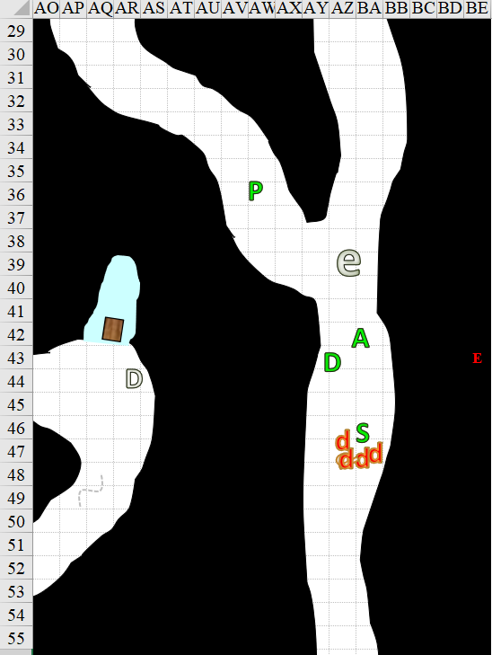

Round 108

The dretches full-attacked Steelshade.
Character | Attack Type | Damage | BAB | Str Mod+ | Other+ | Total Score | Roll | Total
Antibody Dretch 2 | Claw 1 | 1d12+2 | 8 | 2 | 2 | 12 | 14 | 26
Antibody Dretch 2 | Claw 2 | 1d12+2 | 8 | 2 | 0 | 10 | 19 | 29
Antibody Dretch 3 | Claw 1 | 1d12+2 | 8 | 2 | 2 | 12 | 18 | 30
Antibody Dretch 3 | Claw 2 | 1d12+2 | 8 | 2 | 0 | 10 | 3 | 13
Antibody Dretch 4 | Claw 1 | 1d12+2 | 8 | 2 | 2 | 12 | 7 | 19
Antibody Dretch 4 | Claw 2 | 1d12+2 | 8 | 2 | 0 | 10 | 4 | 14
Antibody Dretch 5 | Claw 1 | 1d12+2 | 8 | 2 | 2 | 12 | 4 | 16
Antibody Dretch 5 | Claw 2 | 1d12+2 | 8 | 2 | 0 | 10 | 1 | 11
Miss⁸.

Atlas took a moment to consider their location, and tried to think of anything that would help them.

Steelshade continued to engage the dretches.
Melee Weapon | Dmg | D+ | TH+ | Crit | x | Type | Wt. | Atk | Roll | Check
Shattermantle Bloodstone Falchion +3 | 2d4 | +7 +3 | 3 | 18 | 2 | Slashing | 8.0 | +27 | 6 | 33
SB Falchion +3, 2nd Attack | 2d4 | +7 +3 | 3 | 18 | 2 | Slashing | - | +22 | 8 | 30
SB Falchion +3, 3rd Attack | 2d4 | +7 +3 | 3 | 18 | 2 | Slashing | - | +17 | 2 | 19
SB Falchion +3, 4th Attack | 2d4 | +7 +3 | 3 | 18 | 2 | Slashing | - | +12 | 16 | 28
Hit, hit, miss, hit.
Dmg to Antibody Dretch 2: 7 + 7 + 3 = 17.
Dmg to Antibody Dretch 3: 2 + 7 + 3 = 12.
Dmg to Antibody Dretch 4: 6 + 7 + 3 = 16.

Antibody dretch 2 began to die.

Antibody dretch 3 remained on foot.

Antibody dretch 4 fell to the ground, trying to squirm away.

Pussyfoot walked forward a few steps, taking care to not go too far from her companions. The area around her was now completely dark, and she took a moment to study the infrared signatures. She also smelled the hint of the cloudkill spell, which had likely been pushed into the area by Devrion.

Devrion put up the items he found, and moved up to the right side passage entry to look further north, but it was too dark for him to see much further.

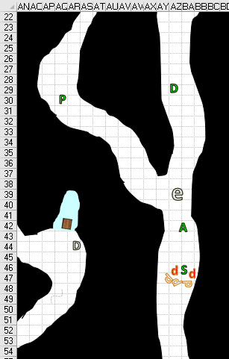

Round 109

The antibody dretches attacked Steelshade.
Character | Attack  Type | Damage | BAB | Str  Mod+ | Total  Score | Roll | Total
Antibody Dretch | Claw 1 | 1d12+2 | 8 | 2 | 12 | 12 | 22
Antibody Dretch | Claw 2 | 1d12+2 | 8 | 2 | 10 | 4 | 14
Antibody Dretch | Claw 1 | 1d12+2 | 8 | 2 | 12 | 6 | 16
Antibody Dretch | Claw 2 | 1d12+2 | 8 | 2 | 10 | 15 | 25
Miss, miss.

Atlas zapped one of the remaining dretches before it could attack Steelshade again.
Ranged Weapon | Dmg. | D+ | TH+ | Atk | Roll | Check | Notes
Call lightning Spell | 7d6 | x1½ | 1 | +10 | 2 | 12 | 7 bolts remaining
Miss.

Steelshade attacked the remaining dretches.
Melee Weapon | Dmg | D+ | TH+ | Crit | x | Type | Wt. | Atk | Roll | Check
Shattermantle Bloodstone Falchion +3 | 2d4 | +7 +3 | 3 | 18 | 2 | Slashing | 8.0 | +27 | 17 | 44
SB Falchion +3, 2nd Attack | 2d4 | +7 +3 | 3 | 18 | 2 | Slashing | - | +22 | 19 | 41
SB Falchion +3, 3rd Attack | 2d4 | +7 +3 | 3 | 18 | 2 | Slashing | - | +17 | 12 | 29
SB Falchion +3, 4th Attack | 2d4 | +7 +3 | 3 | 18 | 2 | Slashing | - | +12 | 13 | 25
Hit, hit, hit, hit.
Dmg to Dretch 3: (3 + 7 + 3) = 13.
Dmg to Dretch 5: (3 + 7 + 3) = 13.

Dretch 5 remained barely alive, and turned to flee. [5’ step only]

Pussyfoot stopped to watch and listen, as did Devrion.

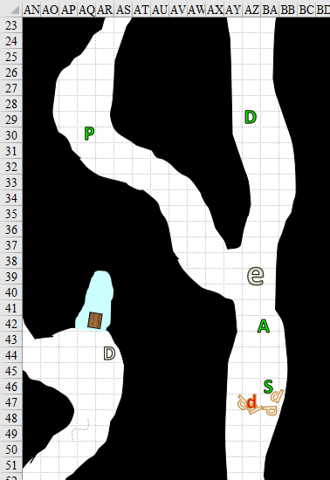

Round 110

The last dretch fled southward.

Atlas triggered another lightning bolt, targeted on the fleeing creature.
Ranged Weapon | Dmg. | D+ | TH+ | Critical | Rng. | Wt. | Atk | Roll | Check | Notes
Call lightning Spell | 7d6 | x1½ | 1 | - | - | - | +10 | 4 | 14 | 6 bolts remaining
Hit. Dmg: 26 electric. Damage negated.

The demon got away as Steelshade turned to see where the others had gotten off to. “Don’t wander off too far,” she called in a low voice.

Devrion and Pussyfoot retraced their steps back to join Steelshade.

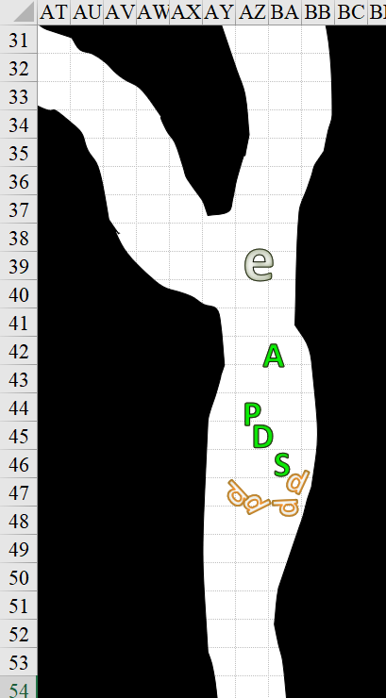
Rounds 111 – 112

“So, now what?” Devrion said as he walked up to Steelshade. “You have a bit of acid on you.” He produced a bit of cloth and wiped the droplets off her armored shoulder.

The drow held still while he worked. “I don’t really know. The right side passage?”

“Sounds as good as the other,” Pussyfoot said. When Devrion was done, the rogue started off down the right side passage, with Steelshade, Devrion, and Atlas following.

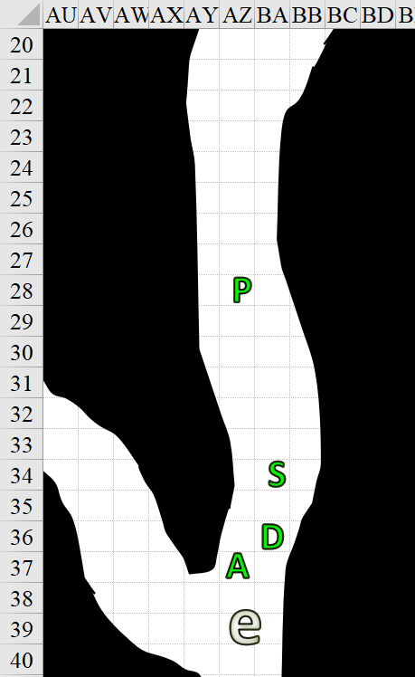

Round 113

The quartet kept moving northward.

Round 114

Pussyfoot took the next angle around the wide side, noting nothing moving to her west.

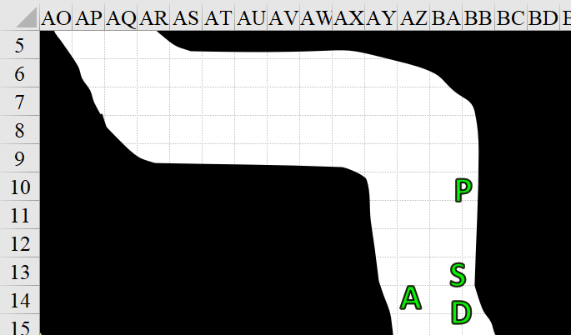

Round 115

They kept moving forward around the turn and looked to the northwest, where a gray, translucent sphincter porta seemed to stare at Pussyfoot.

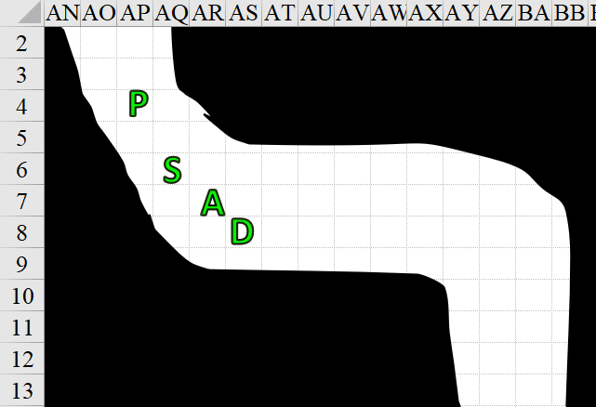

Round 116

Pussyfoot grimaced and turned to Atlas. “Okay, what body part is gray like that?”

“I’m wondering if it’s keeping something out, or something in,” Devrion said. “If we destroy it, and there’s a lot of liquid, or,” he grimaced, “semi-solids behind it, there’s nowhere to run from it.”

“Maybe we should check the other passageway first,” Steelshade said.

Round 117

Devrion peered into the closed opening, trying to discern what was on the other side, but could not from this distance.

Atlas peered at the sphincter, trying to determine its likely purpose. “It looks like an epiglottal stopgap.”

“A what?” asked Devrion.

“A muscle that controls swallowing.”

Round 118

“I think we should check the other passage,” Steelshade said as she looked at the doorway. “If that’s for swallowing, it could crush us.”

Pussyfoot shrugged. “Okay with me.”

She led the group back the other way, and turned up the left fork when she got to it.

Round 123

They reached what looked like the cloudkill effect. Atlas moved to the front to confirm this.

“Yes, this can either be dispelled, or we can wait for it to automatically snuff itself out... not sure how long that would take,” the archivist informed his friends.

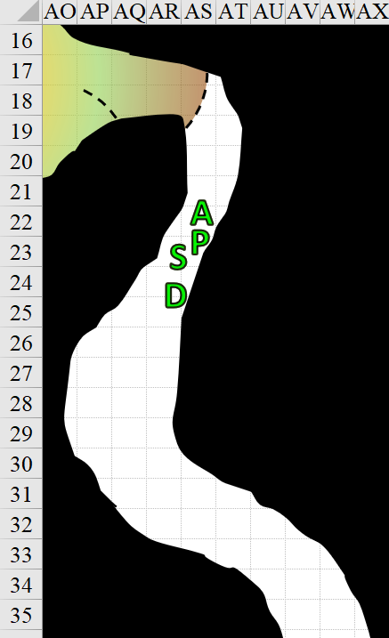

“Dispel it,” Steelshade said. “Hopefully, it killed anything that might be waiting on us.”

Atlas nodded. He murmured a few soft words, and extended his palm toward the cloud, fingers spread.
Ranged Weapon | Dmg. | D+ | TH+ | Critical | Rng. | Wt. | Atk | Roll | Check
Dispel Magic | - | - | 0 | - | - | - | +17 | 19 | 36
Success. Cloudkill negated.

Round 124

Pussyfoot cautiously entered the dead-end chamber, and happened upon four chests that looked almost identical to the mimic they’d seen before, but slightly larger. Aside from that, the chamber was akin to the two other chambers wherein they’d found the heart and other indiscernible organ that had housed a gemstone in it, but there was no organ here to destroy.

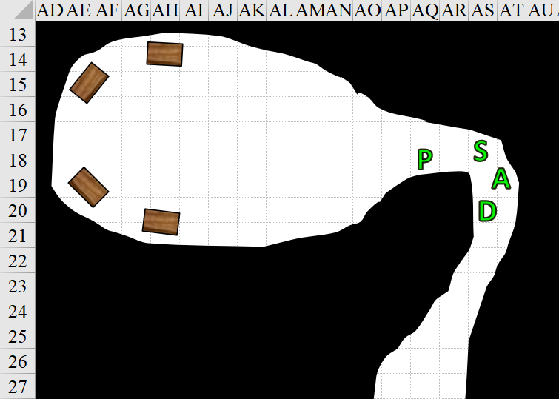

Round 125

The rogue stepped further into the room, looking all around for traps or anything else unusual. “Stay back,” she warned her companions. She moved to her right as she entered, and followed the wall westward.

Steelshade palmed her Cube of Force, just in case, while Devrion stood by to cast a spell, and Atlas stepped back to the corner to watch behind them.

It became fairly evident to Pussyfoot that the mimics weren’t mimics, but actual chests, or at least the one closest to her. However, all was not calm. Without warning, a membrane pierced and slashed through the part of the ceiling like an iron curtain, separating Pussyfoot from her comrades.

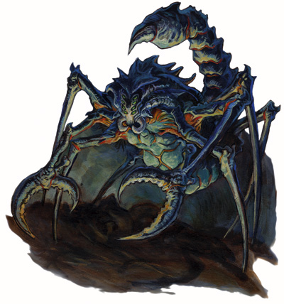

Dropping in from the ceiling just west of the solid membrane, a hideous, chitinous demon landed just south of her.

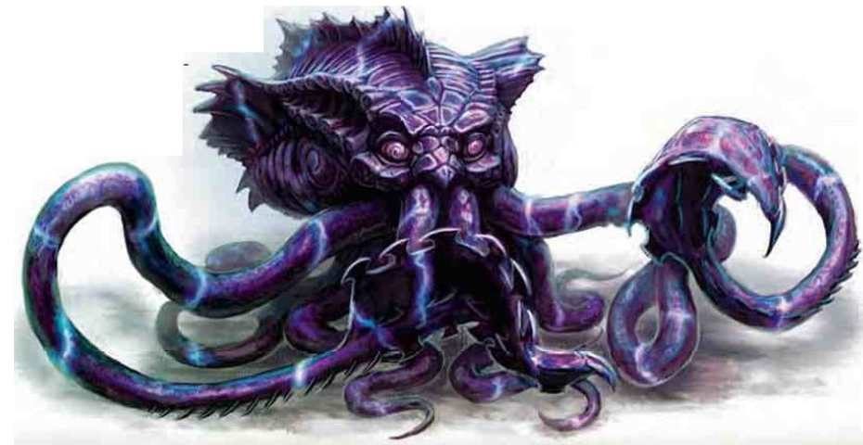

And if that weren’t enough, a kraken-looking thing dropped down from the mushy, fleshy ceiling among the chests which remained inanimate.

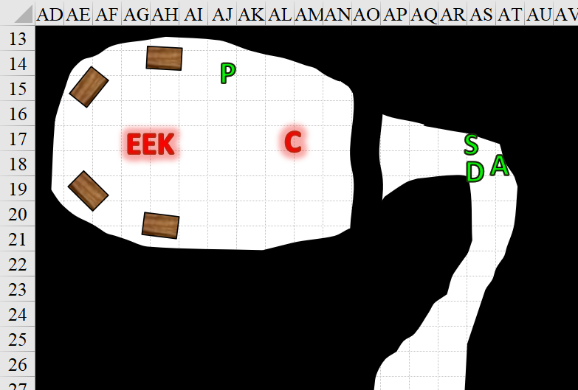

Round 126

Character | Group | Initiative | Roll | Modified Roll | Move
Devrion | 1 | 2 | 17 | 19 | 30’
Pussyfoot | 1 | 5 | 12 | 17 | 20’
Atlas | 1 | 2 | 9 | 11 | 30’
Unidentified Demon | 2 | 3 | 6 | 9 | 50’/20’ climb
Steelshade | 1 | 6 | 2 | 8 | 30’
Unidentified Kraken | 2 | 0 | 6 | 6 | 20’ walk & swim

Unable to see past the membrane, and barely able to hear movement beyond it, Devrion thought to get himself to the other side. “To me!” Devrion reached out and touched Steelshade and Atlas, and then he spoke sharply. “Dimenziós ajtó!”

Pussyfoot extracted a Scroll of Enervation, read from it, and pointed her finger at the kraken demon.
Ranged Weapon | Dmg. | D+ | TH+ | Critical | Rng. | Wt. | Atk | Roll | Check
Ranged Touch Attack | - | - | 1 | - | - | - | +20 | 12 | 32
Hit. Dmg: 4 negative levels: –4 on all skill checks, ability checks, attack rolls, and saving throws; –20 hit points; –4 effective level.

Atlas put his hands together and murmured something. Then, he opened his mouth and let out a gut-shaking ROAR!
Character | Save vs.  lion’s roar | Ranks | Roll | Check
Elder Eidolon Kraken | Fortitude | 6 | 1 | 7
Elder Eidolon Kraken | Will | 6 | 14 | 20
Cildabrin | Fortitude | 4 | 8 | 12
Cildabrin | Will | 3 | 19 | 22
Fail, fail, fail, fail.
Dmg to kraken: 34 sonic + stun for 1 round.
Dmg to cildabrin: 49 sonic + stun for 1 round.
PCs gained +1 to attacks and saves vs. fear, plus 6 + 17 = 23 hps.
Character | Melee | Fire | Acid | Total Damage | Temp | Healing | HPs | Current HPs
Atlas |  |  |  | 0 | 23 |  | 94 | 117
Devrion |  |  |  | 0 | 41 |  | 94 | 135
Pussyfoot | 12 | 14 | 2 | 28 | 23 | 10 | 94 | 99
Steelshade | 3 | R20 | 23 | 26 | 23 | 15 | 179 | 191

The cildabrin and kraken both writhed with pain.

Steelshade channeled shocking grasp through her sword and struck the demon to her left.
Melee Weapon | Dmg | D+ | TH+ | Crit | x | Type | Wt. | Atk | Roll | Check
Shattermantle Bloodstone Falchion +3 | 2d4 | +7 +3 | 3 + 1 | 18 | 2 | Slashing | 8.0 | +28 | 16 | 44
Hit. Dmg: 6 + 7 + 3 + 21 electric = 37.

This nearly killed the stunned demon.

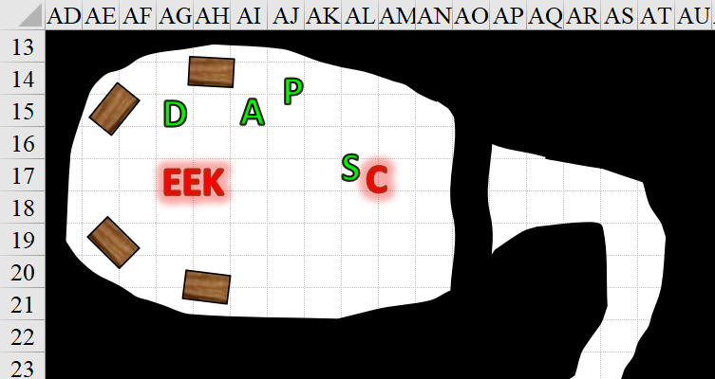

Round 127

Devrion pointed his finger at the kraken. “Hideg kúp!”
Character | Save vs.  cone of cold | Ranks | Roll | Check
Elder Eidolon Kraken | Reflex | 6 | 8 | 14
Fail. Dmg: 46 cold.

The kraken seethed and squealed with pain, but Devrion could also tell that it had a troll-like ability to heal, and its tentacles started to grow back almost as quickly as they turned to icicles and broke off.

Pussyfoot ran to help Steelshade, and, arriving on the creature’s flank, stabbed it with her dagger.
Melee Weapon | Dmg | D+ | TH+ | Critical | Type | Wt. | Atk | Roll | Check | Properties
Keen Dagger of Wounding +2 | 1d3+2 | 1+? | 2 | 19-20, x2 | Prc/Slash | 0.5 | +16 | 10 | 26 | Sneak Attack 9d6
Hit. Dmg: 1 + 2 + 1 + 38 Sneak = 42.

That was more than enough to put down the demonic creature.

Atlas pointed downward, almost activating his lighting strike spell again as he targeted the cildabrin, then saw it fall, turned his gaze and index finger, and targeted the kraken instead.
Ranged Weapon | Dmg. | D+ | TH+ | Critical | Rng. | Wt. | Atk | Roll | Check | Notes
Call lightning Spell | 7d6 | x1½ | 1 | - | - | - | +10 | 10 | 20 | 5 bolts remaining
Hit. Dmg: 29 electric.

Once Devrion’s cone of cold had been sprayed, Steelshade turned on the remaining demon. She channeled shocking grasp through her blade, and struck the creature.
Melee Weapon | Dmg | D+ | TH+ | Crit | x | Type | Wt. | Atk | Roll | Check
Shattermantle Bloodstone Falchion +3 | 2d4 | +7 +3 | 3 | 18 | 2 | Slashing | 8.0 | +27 | 6 | 33
Hit, hit, miss, hit. Dmg: (6 + 7 + 3 + 17 electric) = 33.

The elder eidolon kraken fought back.
Character | Attack Type | Damage | BAB | Str Mod+ | Total Score | Roll | Total
Elder Eidolon Kraken | Tentacle 1 | 2d8+16 | 15 | 12 | 27 | 16 | 43
Elder Eidolon Kraken | Tentacle 2 | 2d8+16 | 15 | 12 | 27 | 16 | 43
Elder Eidolon Kraken | Arm 1 | 1d6+8 | 15 | 7 | 22 | 14 | 36
Elder Eidolon Kraken | Arm 2 | 1d6+8 | 15 | 7 | 22 | 12 | 34
Elder Eidolon Kraken | Arm 3 | 1d6+8 | 15 | 7 | 22 | 18 | 40
Elder Eidolon Kraken | Arm 4 | 1d6+8 | 15 | 7 | 22 | 7 | 29
Elder Eidolon Kraken | Arm 5 | 1d6+8 | 15 | 7 | 22 | 15 | 37
Elder Eidolon Kraken | Arm 6 | 1d6+8 | 15 | 7 | 22 | 10 | 32
Elder Eidolon Kraken | Bite | 4d6+8 | 15 | 7 | 22 | 1 | 23
Hit, hit, miss, miss, hit, miss, hit, miss, miss.
1d20 = 58, 76, 26, 79. 3 hits bypassed concealment. Cloak says 20% miss chance; I have 40% in the battle tally. Which is correct?
Dmg: (12 + 16) + (8 + 16) + (2 + 8) = 28 + 24 + 10 = 62.

The duskblade grunted as the demon’s limbs hammered at her armor and shield. “A little help?”

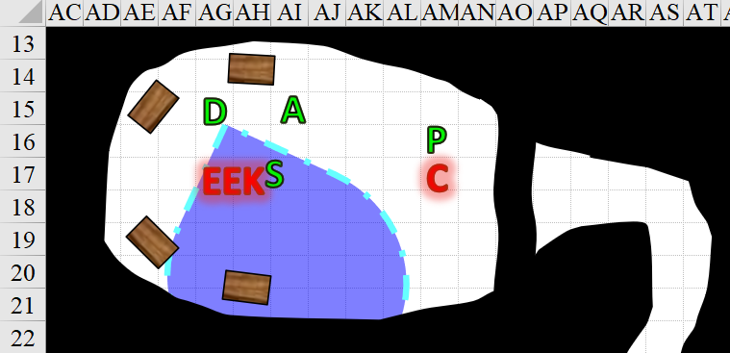

Round 128

Atlas zapped the creature again, while Pussyfoot again circled around and struck the creature from the flank.
Ranged Weapon | Dmg. | D+ | TH+ | Critical | Rng. | Wt. | Atk | Roll | Check | Notes
Call lightning Spell | 7d6 | x1½ | 1 | - | - | - | +10 | 6 | 16 | 4 bolts remaining
Keen Dagger of Wounding +2 | 1d3+2 | 1+? | 2 | 19-20, x2 | Prc/Slash | 0.5 | +16 | 6 | 22 | Sneak Attack 9d6
Hit, miss. Dmg: 25 electric.

The kraken squealed with pain.

Devrion pointed at the creature. “A halál ujja!”
Character | Save vs.  finger of death | Ranks | Roll | Check
Elder Eidolon Kraken | Fortitude | 6 | 3 | 9
Fail.

Steelshade was about to channel disintegrate through her blade, but the kraken died.

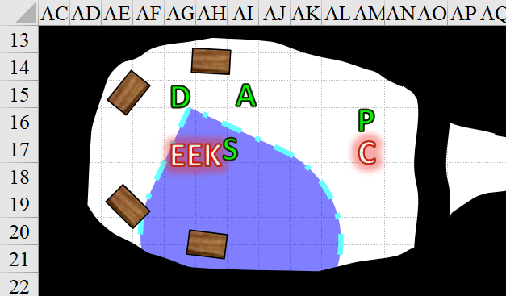

Round 129

A trembling ensued under their feet as the kraken collapsed.

“Well, that got someone’s attention,” Atlas observed dryly.

“Pussyfoot, please check those chests,” Steelshade said as she looked around for more enemies.

The rogue moved to the nearest chest and checked it for traps.

There appeared to be no traps on the locked chests.

Round 130

“Give me a moment,” the rogue said. She extracted her lockpick tools and set to work on the chests.
Skill | Rank | Ability & Mod. | Misc. Mods. | Total | Roll | Check
Pussyfoot, Open Lock | 10 | Dex (+6) | 2 | 18 | 4 | 22
Success.

The northeasternmost chest was now unlocked.

Round 131

She tried the second chest.
Skill | Rank | Ability & Mod. | Misc. Mods. | Total | Roll | Check
Open Lock | 10 | Dex (+6) | 2 | 18 | 3 | 21
Success.

She was able to undo this lock as well.

While she worked, the other three gave her some space, wary of being caught by something as Pussyfoot worked with the chests.

Round 132

She tried the third chest’s lock.
Skill | Rank | Ability & Mod. | Misc. Mods. | Total | Roll | Check
Open Lock | 10 | Dex (+6) | 2 | 18 | 11 | 29
Success.

She undid this one too.

Round 133

She then went to the fourth chest, and repeated the same steps.
Skill | Rank | Ability & Mod. | Misc. Mods. | Total | Roll | Check
Open Lock | 10 | Dex (+6) | 2 | 18 | 18 | 36
Success.

The fourth lock now came undone.

Round 134

“I’m going to open them, one at a time,” Pussyfoot said. “Here we go.”

Carefully, she opened the chests one at a time, in reverse order.

The first chest contained a thousand shards of broken glass, all differently stained.

Round 135

The second chest contained a bottle with a long neck, containing a white, opaque fluid.

Round 136

The third chest contained a device of some kind. It was handheld, and had eight buttons and a finger-long stick protruding from it.

Round 137

The fourth chest contained another bottle, this one with a short neck, and a clear fluid.

Round 138

Pussyfoot looked from one chest to the next. “Well, it’s not gold coins.”

Atlas stepped over to the chests and examined the contents without touching anything.

“Any thoughts?” Devrion asked.

“I’m thinking it’s a construction kit for a stained glass golem,” Atlas replied. “But, I’m not certain of that. Give me a moment.”

Steelshade looked around the chamber for anything else that might be a threat as she waited.

Round 139

Atlas was fairly certain that his guess was right, and by the looks of the fluids, one was a magical adhesive, while the clearer liquid was an animator agent. “Stained glass golems don’t put up much of a fight,” he sighed, “but we may be able to use it in a situation where we don’t want to risk our own neck.”

Round 140

“So that’s what this stuff is?” the warmage asked.

Atlas nodded. “It would take about 10 minutes to do this; less if Pussyfoot helps with some of the finer touches.”

Round 141

“I, and you, Atlas, are not putting this thing together,” Pussyfoot huffed. “It’d probably step on us like a poorly trained horse.”

“Be that as it may,” Steelshade interjected. “Let’s not leave this here for whomever stored it. Can we gather everything up and take it along?”

Round 142

“I think it best if we carry everything separately,” Atlas observed. “Angren, you take the shards, since you have that haverpack. I’ll take the clear potion, and Devrion, you take the other one. That leaves the control box to you, Brene.” The archivist suspected that with the controller, they wouldn’t have to face any attacks from the golem.

Round 143

“That’s fitting,” Devrion smirked as he reached for the potion.

“Don’t!” Pussyfoot stepped over to the chest. “Let me take them out, Goofball. They could be trapped.”

“Oops!” Devrion straightened and stepped back.

Pussyfoot removed each of the smaller items, and handed them out as Atlas had suggested. Then, she used her rod to dig through the shards to ensure nothing was in there but glass.

Rounds 144 – 148

Satisfied, Pussyfoot contemplated how to best store the glass shards.

Steelshade stepped up next to her. “Maybe the whole chest will fit in my haverpack. Or, I have this leather backpack that might hold the shards, and then we put that in the haverpack.”

Atlas shook his head, “The chest is too big to fit. The backpack would work.”

Using their daggers and Pussyfoot’s rod, they worked to gather the shards into the tough leather pack, and then into the haverpack.

Round 149

With that labor achieved, they were all set to continue, but the steel wall was still blocking their path.

“Okay, now what’s this?” Pussyfoot stepped over to the wall and looked for a handle or other control mechanism.

“That’s odd that there would be a metal plate in something’s gut,” Atlas observed the intra-uterine slab with curiosity.

Devrion sighed. “I can break though it with a spell, you know.”

“Maybe, maybe not,” Steelshade mused. “It could be magically shielded.”

Round 150

Pussyfoot turned to look at him. “What now?”

“This is a uterus,” the archivist then surmised.

“Oh, great,” Devrion sighed. “I suppose it beats a colon, but not by much.”

“Oh, gee thanks,” Steelshade glared at him. “I know how likely it will be that you get close to anything connected with a uterus in the future.”

Round 151

Pussyfoot looked at Steelshade. “Oh, come on, Angren. Really?”

“Shut up, Brene. Just shut up,” Steelshade huffed.

Pussyfoot just laughed. “Okay, so let’s get out of here before something else shows up.” She stepped back, ignoring Steelshade, who had a definite blush going. “Hammer it, Devrion.”

Devrion stepped up to within five feet of the wall, and pointed his finger at it. “Szétesik!”

Rounds 152 – 153

The mundane wall disappeared, leaving a membrane around the opening, dripping with some of the same jaundiced goo that they’d bloodlet along other part of this giant dungeon’s anatomy. The cervical threshold was done for, and would likely collapse within a minute or less—Pussyfoot surmised.

“Let’s get out of here,” Pussyfoot said. “This whole... womb... is about to collapse.

The rogue led the way, and everyone followed her back to the intersection.

Round 154

Reaching the intersection, they saw the corpse of the efreeti still smoldering, but nearly out.

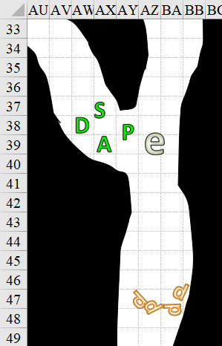

Round 155

Pussyfoot turned left and headed for the other passage’s end, with the others following.

Devrion looked around. “It sure looks different from this perspective.”

“Hush,” Steelshade growled.

The warmage looked at Atlas, who just shook his head.

“Whatever,” Devrion sighed.

Round 161

The party reached the closed opening that they’d seen before.

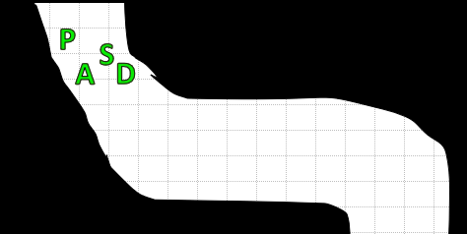

Round 162

Pussyfoot looked at Devrion. “Well, zap it.” She wiggled her fingers, and then glared as the half-elf grinned. “No remarks, just zap it.”

Devrion laughed. “Fine, but be ready to run if there’s stuff behind there.” He stepped up, pointed his finger, and spoke sharply. “Szétesik!”

The sphincter disappeared, leaving a bleeding membrane all around it.

Round 163

Pussyfoot stepped forward, and, avoiding the blood as best she could, looked out through the opening.

A corridor continued northward and slightly upward as far as their eyes could see, this one being far cleaner smelling.

The rogue stepped through the opening, and the others followed her – Steelshade, Devrion, and then Atlas.

They walked for what seemed like a thousand feet, and then the trachea-like pipe—ribbed and drafty—turned up to about a 45-degree angle. “We must climb if we are to proceed,” Pussyfoot stated the obvious.

Round 200

“Let’s fly instead.” Steelshade produced her carpet from her haversack, and beckoned the others to board. She carefully piloted the carpet up the pipe.

They must’ve gone upward for nearly three more minutes—about the same amount of time they’d spent walking along the trachea—and though the draft had been a downward one for the last minute or so, it suddenly turned upward, and with the force of a gigantesque sneeze, shot them all clean off the carpet and into a large chamber.

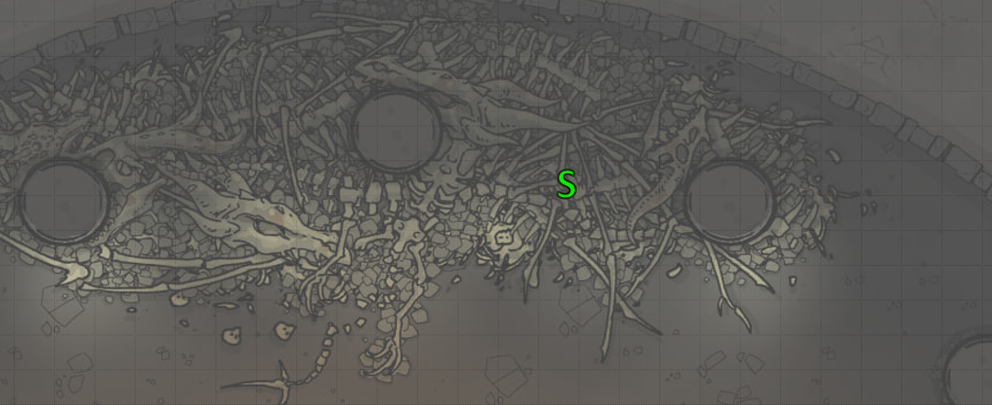

Round 232

Steelshade landed on a pile of dry, digested bones: mostly dragons’ bones.

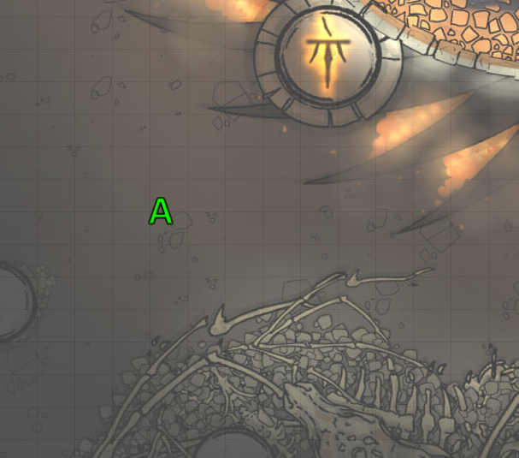

The others landed on a rock-hard surface that seemed completely different from just about every other part of this gods forsaken dungeon.

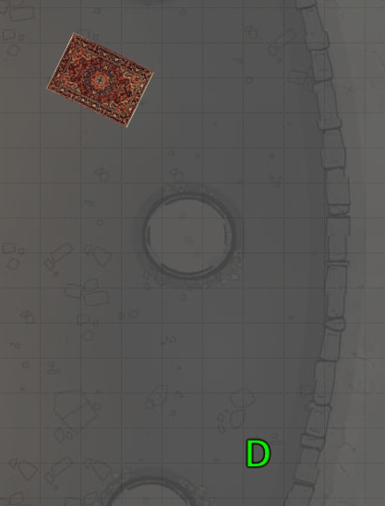

They had barely enough time to hop back onto their feet, and noted that a gargantuan worm made of fresher bones was already waiting for them to be spewed up into the chamber. It wasted no time in going for Pussyfoot, who had landed nearest to the monster.

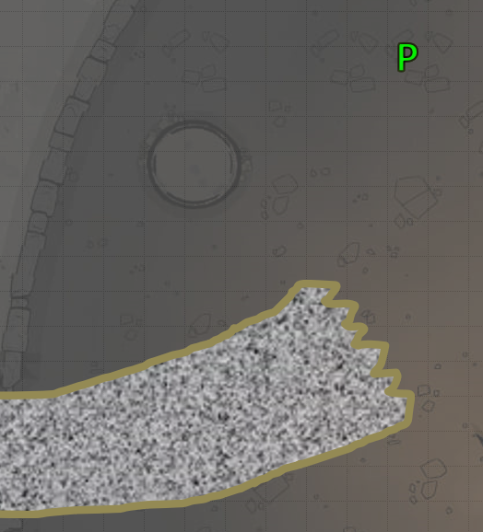

It entered the room and veered northward, but did not yet reach the halfling.

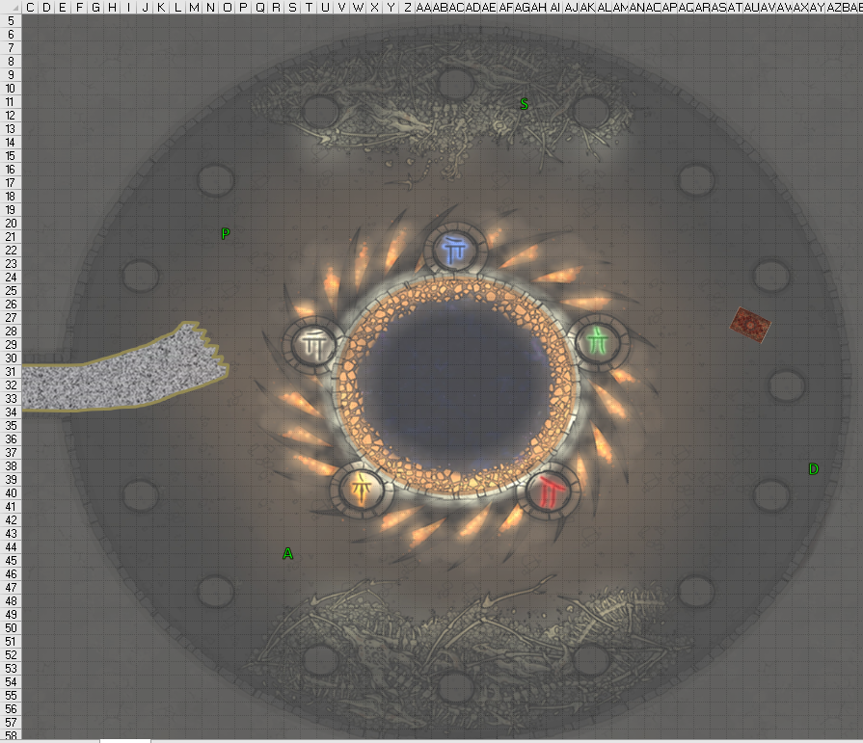

Round 233

Character | Group | Initiative | Roll | Modified Roll | Move
Steelshade | 1 | 6 | 16 | 22 | 30’
Devrion | 1 | 2 | 20 | 22 | 30’
Pussyfoot | 1 | 5 | 13 | 18 | 20’
Charnel Worm | 2 | 2 | 4 | 6 | 40’
Atlas | 1 | 2 | 3 | 5 | 30’

Steelshade spoke sharply, and her skin turned to scales reminiscent of her draconic heritage. She vanished, and reappeared an instant later directly off the worm’s left side. She slashed at the creature while applying magical energy and an electrical spell though her blade.
Melee Weapon | Dmg | D+ | TH+ | Crit | x | Type | Wt. | Atk | Roll | Check | Properties
Shattermantle Bloodstone Falchion +3 | 2d4 | +7 +3 | 3 + 4  Arcane Strike | 18 | 2 | Slashing | 8.0 | +31 | 7 | 38 | +1d6  positive
SB Falchion +3, 2nd Attack | 2d4 | +7 +3 | 3 + 4  Arcane Strike | 18 | 2 | Slashing | - | +26 | 17 | 43 | +1d6  positive
SB Falchion +3, 3rd Attack | 2d4 | +7 +3 | 3 + 4  Arcane Strike | 18 | 2 | Slashing | - | +21 | 3 | 24 | +1d6  positive
SB Falchion +3, 4th Attack | 2d4 | +7 +3 | 3 + 4  Arcane Strike | 18 | 2 | Slashing | - | +16 | 19 | 35 | +1d6  positive
Greater Truedeath Crystal | 1d6 | vs. | undead | - | - | - | - | - | - | -
Hit, hit, miss, hit. Dmg: (3 + 7 + 3 + 11 Arcane + 22 electric + 5 positive) + (4 + 7 + 3 + 12 Arcane + 2 positive) + (8 + 7 + 3 + 8 Arcane + 2 positive) = 24 + 26 + 26 + 22 electric + 9 positive = 107.

Steelshade had faced off against a charnel worm before—and a charnel hound—but this worm was about twice as big and nasty as the previous one, and she suspected that it would take an added effort to vanquish this undead monstrosity comprised of other creatures’ bones.

Devrion closed his eyes and pressed his fingertips to his head, incanting, “Fantomgyilkos!” Then, he ran for the grounded carpet. Unfortunately, however, the undead worm was immune to the spell.

“Shit!” Pussyfoot ran to put a column between herself and the worm.

The charnel worm turned with unexpected alacrity, and full-attacked Steelshade.
Character | Attack Type | Damage | BAB | Str Mod+ | Total Score | Roll | Total
Charnel Worm | Bite | 2d8+19 | 10 | 7 | 17 | 10 | 27
Charnel Worm | Claw 1 | 2d6+12 | 10 | 2 | 12 | 14 | 26
Charnel Worm | Claw 2 | 2d6+12 | 10 | 2 | 12 | 10 | 22
Miss, miss, miss.

Atlas spoke a few words, and gestured downward with both hands. A column of fire flashed down onto the worm.
Character | Save vs.  flame strike | Ranks | Roll | Check
Charnel Worm | Reflex | 9 | 2 | 11
Fail. Dmg: 22 fire + 23 holy (good) = 45.

The charnel worm seethed and squealed with pain as the column of holy fire scalded its head.

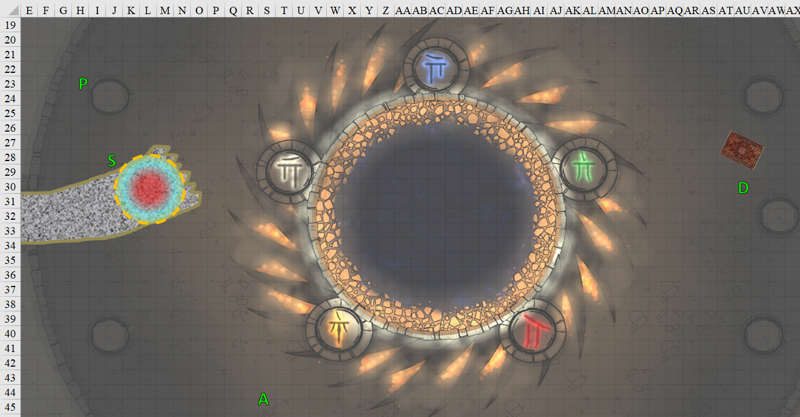

Round 234

Steelshade full-attacked the worm, again channeling shocking grasp and Arcane Strike.
Melee Weapon | Dmg | D+ | TH+ | Crit | x | Type | Wt. | Atk | Roll | Check | Properties
Shattermantle Bloodstone Falchion +3 | 2d4 | +7 +3 | 3 + 4  Arcane Strike | 18 | 2 | Slashing | 8.0 | +31 | 19 | 50 | +1d6  positive
SB Falchion +3, 2nd Attack | 2d4 | +7 +3 | 3 + 4  Arcane Strike | 18 | 2 | Slashing | - | +26 | 7 | 33 | +1d6  positive
SB Falchion +3, 3rd Attack | 2d4 | +7 +3 | 3 + 4  Arcane Strike | 18 | 2 | Slashing | - | +21 | 9 | 30 | +1d6  positive
SB Falchion +3, 4th Attack | 2d4 | +7 +3 | 3 + 4  Arcane Strike | 18 | 2 | Slashing | - | +16 | 6 | 26 | +1d6  positive
Greater Truedeath Crystal | 1d6 | vs. | undead | - | - | - | - | - | - | -
Hit, hit, hit, hit. Dmg: (2 + 7 + 3 + 10 Arcane + 16 electric + 6 positive) + (8 + 7 + 3 + 11 Arcane + 5 positive) + (5 + 7 + 3 + 7 Arcane + 3 positive) + (5 + 7 + 3 + 10 Arcane + 6 positive) = 22 + 29 + 22 + 25 + 16 electric + 20 positive = 134.

They were good strikes, but this monstrosity was a horror she’d never quite confronted.

Devrion lifted the carpet and closed in on the creature. Hopping onto the magic carpet, he pointed his finger at the worm and spoke, “Napsugár!”, casting sunbeam [5 beams, expired on Round 251].
Character | Save vs.  sunbeam | Ranks | Roll | Check
Charnel Worm | Reflex | 9 | 12 | 21
Success. Saves for ½ damage and negates blindness.
Dmg: 52 light [good].

Pussyfoot drew her dagger and looked for an opportunity to sneak attack the worm.
Melee Weapon | Dmg | D+ | TH+ | Critical | Type | Wt. | Atk | Roll | Check | Properties
Keen Dagger of Wounding +2 | 1d3+2 | 1+? | 2 | 19-20, x2 | Prc/Slash | 0.5 | +16 | 16 | 32 | Sneak Attack 9d6
Hit. Dmg: 1 + 2 + 1 + 28 Sneak = 32 + 1 Con [-21 hps].

The charnel worm—nearly destroyed—lacked the intelligence to retreat, and thus continued to try to bring down the heroes, now targeting Pussyfoot.
Character | Attack Type | Damage | BAB | Str Mod+ | Total Score | Roll | Total | Notes
Charnel Worm | Bite | 2d8+19 | 10 | 7 | 17 | 15 | 32 | Rend 4d6+21
Charnel Worm | Claw 1 | 2d6+12 | 10 | 2 | 12 | 3 | 15 | Rend 4d6+21
Charnel Worm | Claw 2 | 2d6+12 | 10 | 2 | 12 | 17 | 29 | Rend 4d6+21
Hit, miss, hit. 1d100 = 18, 67; first hit negated.
Dmg: (8 + 12) = 20 [79/94].

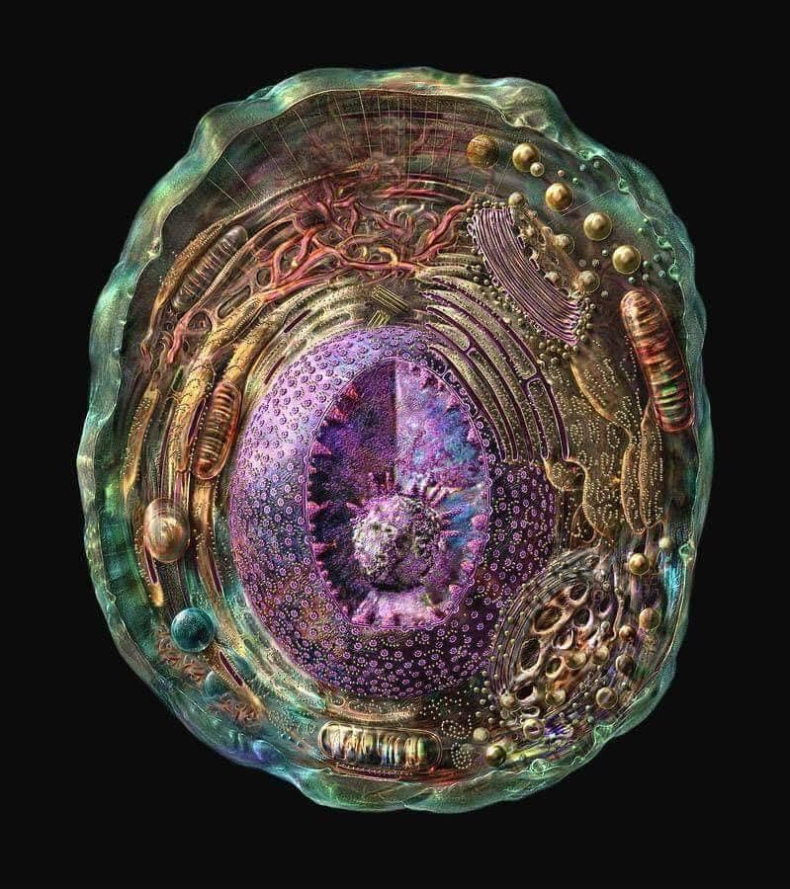

Noticing the intricate, organic dome above them—which contrasted sharply with the stony floor at his feet—Atlas growled as his lover was bowled over by the creature, and jabbed his finger downward, flinging another bolt of lighting at the worm.
Ranged Weapon | Dmg. | D+ | TH+ | Critical | Rng. | Wt. | Atk | Roll | Check | Notes
Call lightning Spell | 7d6 | x1½ | 1 | - | - | - | +10 | 1 | 11 | 3 bolts remaining
Miss.

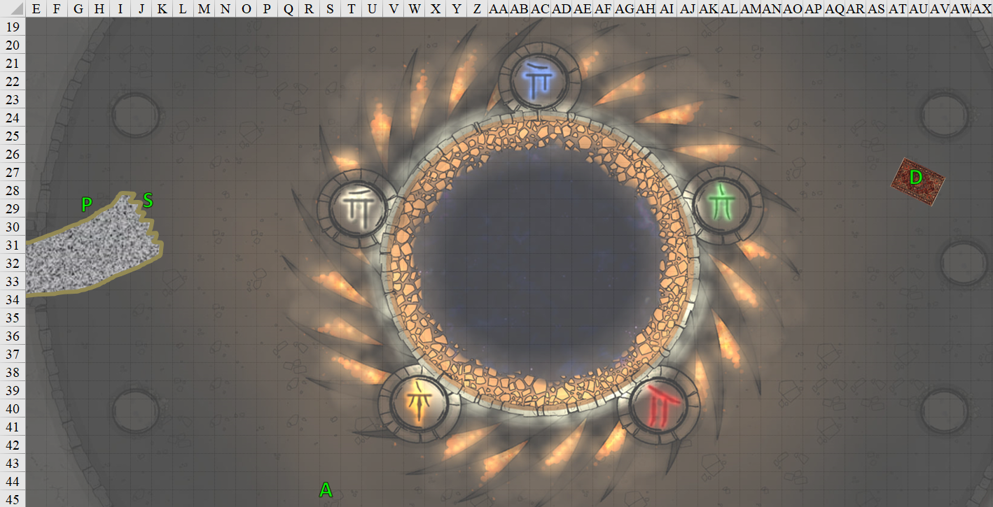

Round 235

Once again, Steelshade full-attacked the worm, channeling shocking grasp and Arcane Strike.
Melee Weapon | Dmg | D+ | TH+ | Crit | x | Type | Wt. | Atk | Roll | Check | Properties
Shattermantle Bloodstone Falchion +3 | 2d4 | +7 +3 | 3 + 4  Arcane Strike | 18 | 2 | Slashing | 8.0 | +31 | 13 | 44 | +1d6  positive
SB Falchion +3, 2nd Attack | 2d4 | +7 +3 | 3 + 4  Arcane Strike | 18 | 2 | Slashing | - | +26 | 11 | 37 | +1d6  positive
SB Falchion +3, 3rd Attack | 2d4 | +7 +3 | 3 + 4  Arcane Strike | 18 | 2 | Slashing | - | +21 | 8 | 29 | +1d6  positive
SB Falchion +3, 4th Attack | 2d4 | +7 +3 | 3 + 4  Arcane Strike | 18 | 2 | Slashing | - | +16 | 18 | 34 | +1d6  positive
Greater Truedeath Crystal | 1d6 | vs. | undead | - | - | - | - | - | - | -
Hit, hit, hit, hit. Dmg: (4 + 7 + 3 + 7 Arcane + 20 electric + 6 positive) + (6 + 7 + 3 + 12 Arcane + 2 positive) + (4 + 7 + 3 + 9 Arcane + 6 positive) + (3 + 7 + 3 + 9 Arcane + 4 positive) = 21 + 28 + 23 + 22 + 20 electric + 18 positive = 132.

Nearly out of 4th-tier power, the duskblade saw the bones that comprised the worm collapse onto a linear pile before them, revealing the westbound tunnel through which it had emerged. The tunnel was still piled a few feet high with bones, but the bones were porous and would likely break easily with the weight of their steps, making the trek through the only out-way much like a walk over a snow-packed causeway.

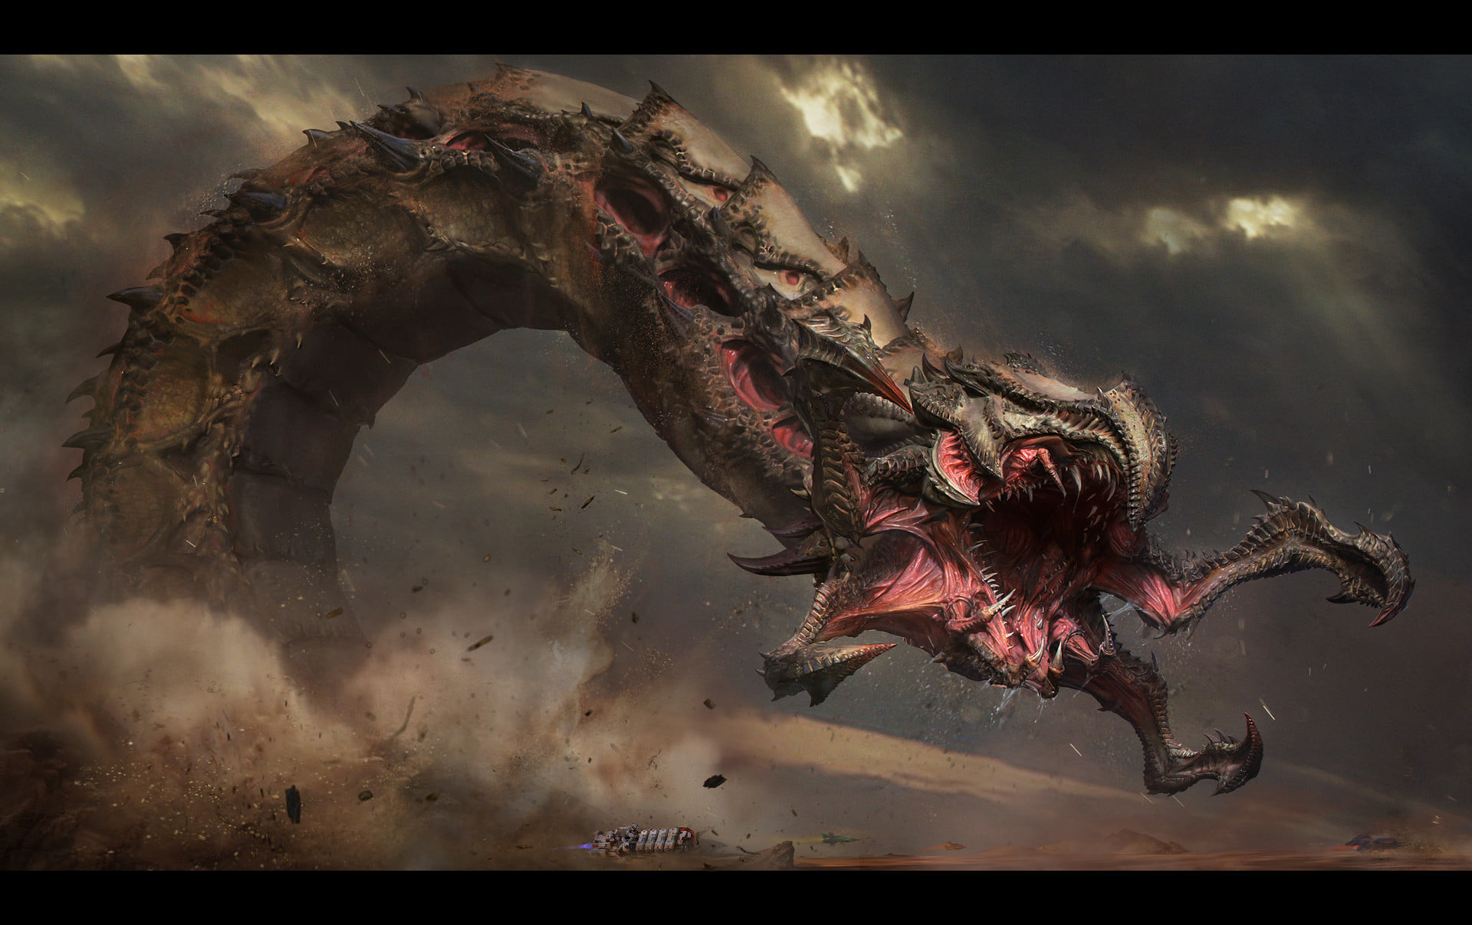

As the monster collapsed, Devrion recalled a living worm that he had once helped to bring down on some gods-forsaken world floating in the Astral Plane. This undead thing was nearly as large, but more formidable than the aberration that he and his former group of friends had brought down. He now sighed with the satisfaction of bringing down such a nasty undead thing.

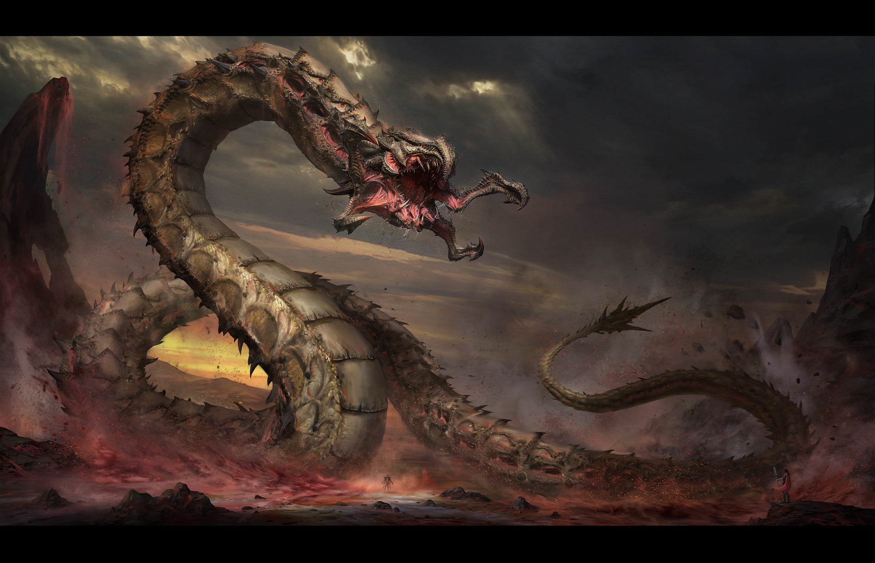

Devrion guided the carpet towards his friends, catching the upward draft from the trachesophagus from which they’d emerged seconds earlier.

Pussyfoot and Atlas looked at one another from across the bone-strewn chamber.

Round 236

Devrion guided the carpet down to where Steelshade and Pussyfoot waited. “Let’s go.”

The pair stepped aboard, and Devrion lifted off again.

Round 241

They’d been flying along the bone-strewn passage for about half a minute when the stony tunnel receded once again to a fleshen tube, porous and filled with Small dretches that lunged out at them from every direction.

Devrion and Atlas exhausted their sunbeam and call lightning spells, and then Devrion cast ring of blades [cast on Round 246; expired on Round 416] and sent it tearing though the dretches.

“Is this the only way out?” Pussyfoot asked.

“It’s the only one I saw,” Atlas replied.

Steelshade grimaced. “I really hope so. I’m sick of this place.”

Round 252

After a sharp, upward turn, they emerged from the tunnel, which ended up being the nasal cavity of a giant skull that had once housed the brain of a giant, demonic creature whose attempt to conquer a part of the surrounding area.

