*Chapter 11: Rhylon’s Swamp*

Devrion cast *accuracy [expired in about an hour and a half]* on Brene’s bow. “Now, we’re ready,” he announced.

And with this, Atlas cast *greater plane shift*, taking himself and his three companions to the exact spot where he’d scouted the day before.

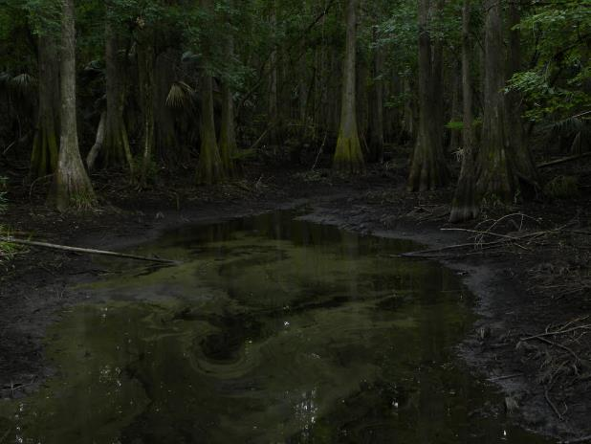

“Where to?” whispered Brene.

“That way,” Atlas whispered even more faintly, and pointed northward.

Brene grimaced at the swampy ground and started forward, her bow at the ready.

Steelshade followed the rogue, her sword and shield in hand.

With no weapon drawn, Devrion levitated a foot above the ground and followed the duskblade.

Atlas brought up the rear with his crossbow loaded and ready.

~*~

It took them no time at all to make their way southward along an unbeaten path to the swamps that had a dozen entrances to Rhylon’s lair. Surely, the dragon had lured hundreds of victims into its lair only to drown them and feast on their welting corpses with the patience emblematic only of a creature with a thousand-year-lifetime.

Then they were ambushed. Atlas had in the last few days studied some testimonials of survivors of an attack on a nearby village, and now recognized the antagonists in those narratives.

*Draconic Aura (3) shifted from Senses to Toughness.*

To their west was the black dragon shaman known as Goehring, who now let out a war cry in Draconic as the cleric of Tiamat to their east emerged from the foliage, clearly aware of the heroes’ advent. The cleric—named Goebbels—cast *hold person [expired on Round 12]* upon Brene.

|  |  |  |  |  |  |  |
| --- | --- | --- | --- | --- | --- | --- |
| **Save** | **Rank** | **Ability & Mod.** | **Misc. Mods.** | **Total** | **Roll** | **Check** |
| **Brene, Will** | **6** | **Wis (+5)** | 3 | **14** | 5 | 19 |

*Success. Effect negated.*

And if that wasn’t enough of a challenge, the legendary black knight—Goliad—now came out from behind the trees in front of the heroes and charged at Brene with his brandished greatsword held high.

*Goliad did not yet reach Brene.*

Round 1

Brene quickly read her scroll of *fly [expired on Round 61]*, and lifted upwards 20’, out of the black dragon knight’s reach.

|  |  |  |  |  |  |  |
| --- | --- | --- | --- | --- | --- | --- |
| **Skill/Save** | **Rank** | **Ability & Mod.** | **Misc. Mods.** | **Total** | **Roll** | **Check** |
| **Use Magic Device** | 12 | **Cha (+2)** | 0 | **14** | 18 | 32 |

*Success.*

Steelshade quick-cast *dimension hop*, hoping to place herself directly behind the cleric, but not having quite the mojo to do so.

*Maximum range is ½ x CL = 9 x 5’ = 45’.*

She would need to repeat this on the next round in order to complete the task, but for now, she had at least gotten the cleric’s interest.

Devrion turned to face the shaman, and levitated toward him in a climbing arc. He pointed at his target *[sunbeam, expired no later than Round 20]*. “Napsugár!”

|  |  |  |  |  |
| --- | --- | --- | --- | --- |
| **Character** | **Save vs.**  *sunbeam* | **Ranks** | **Roll** | **Check** |
| Goehring | Reflex | 9 | 6 | 15 |

*Fail. Dmg: 14 light [fire].*

*5 sunbeams left.*

Atlas sighed as his companions all lifted away from the knight. He pointed at the knight and spoke quietly *[flame strike]*.

|  |  |  |  |  |
| --- | --- | --- | --- | --- |
| **Character** | **Save vs.**  *flame strike* | **Ranks** | **Roll** | **Check** |
| Goliad | Reflex | 6 | 4 | 10 |

*Fail. Dmg: 25 fire + 25 divine = 50.*

Goebbels also cast *flame strike*, targeting the archivist. << Taste this! >> he said in Draconic.

|  |  |  |  |  |  |  |
| --- | --- | --- | --- | --- | --- | --- |
| **Save vs.**  *flame strike* | **Rank** | **Ability & Mod.** | **Misc. Mods.** | **Total** | **Roll** | **Check** |
| **Atlas, Reflex** | **6** | **Dex (+7)** | 13 | 26 | 17 | 43 |

*Success. Saves for ½ damage. Dmg: (½ x 22 fire) + (½ x 22 divine) = 22. Fire damage negated [94/105].*

Goliad charge-power (+3)-attacked Steelshade, [Swiftly] challenging the duskblade to a deathmatch.

*Goliad gained +1 to Will saves, attacks, and damage against Steelshade.*

*1d100 = 16, bypassed Concealment.*

|  |  |  |  |  |  |  |  |  |  |  |  |
| --- | --- | --- | --- | --- | --- | --- | --- | --- | --- | --- | --- |
| **Character** | **Attack Type** | **Damage** | **BAB** | **Str Mod+** | **W+** | **Other+** | **Total Score** | **Roll** | **Total** | **Crit** | **Threat** |
| Goliad | Greatsword +3 | 2d4+7+3+2+3 PA+1 KC | 12 | 7 | 4 | 2 charge  -3 PA  +1 KC | 23 | ***20*** | 43 | 20 | þ |

*Threat. 1d20 = 12 + 22 = 34, critical hit. Dmg: (2 x 6) + 7 + 3 + 2 + 3 + 1 = 28 [170/198].*

Goehring blew his acidic breath weapon upon Devrion.

|  |  |  |
| --- | --- | --- |
| **Character** | **Attack Type** | **Damage** |
| Goehring | Breath Weapon | 6d6 acid; 60’ line; DC 18 ½ |

|  |  |  |  |  |  |  |
| --- | --- | --- | --- | --- | --- | --- |
| **Save vs.**  Breath Weapon (Acid) | **Rank** | **Ability & Mod.** | **Misc. Mods.** | **Total** | **Roll** | **Check** |
| **Devrion, Reflex** | **6** | **Dex (+7)** | 3 | 16 | 2 | 18 |

*Success. Saved for ½ damage. Dmg: ½ x 21 = 10 acid. Damage negated.*

Round 2

|  |  |  |  |  |  |
| --- | --- | --- | --- | --- | --- |
| **Character** | **Group** | **Initiative** | **Roll** | **Modified Roll** | **Speed** |
| Devrion | 1 | 6 | 16 | 22 | 30’ |
| Goebbels | 2 | 4 | 18 | 22 | 45’ |
| Brene | 1 | 6 | 13 | 19 | 30’ |
| Goehring | 2 | 4 | 14 | 18 | 50’ |
| Steelshade | 1 | 5 | 10 | 15 | 20’ |
| Haldulf | 2 | 4 | 7 | 11 | 60’/150’/60’ |
| Goliad | 2 | 4 | 3 | 7 | 40’ |
| Atlas | 1 | 2 | 5 | 7 | 30’ |

Devrion pointed at Goehring. “ Implózió!” *[implosion, expired no later than Round 6]* The warmage still had five sunbeams left, and three more instances of the *implosion* spell to use.

|  |  |  |  |  |
| --- | --- | --- | --- | --- |
| **Character** | **Save vs.**  *implosion* | **Ranks** | **Roll** | **Check** |
| Goehring | Fortitude | 10 | 12 | 22 |

*Fail.*

Goehring turned into a stew of bones and organs.

Disgusted by his friend’s implosion, Goebbels could detect that Devrion was Good, and also noted that the other three did not register as such. He cast his remaining preparation of *hold person [expired on Round 14]* on Devrion.

|  |  |  |  |  |  |  |  |
| --- | --- | --- | --- | --- | --- | --- | --- |
| **Save vs.**  *hold person* | **Rank** | **Ability & Mod.** | **Misc. Mods.** | **Total** | **Roll** | **Check** | **Notes** |
| **Devrion, Will** | **11** | **Wis (+3)** | 3 | 17 | 11 | 28 | +2 vs. Enchantments |

*Success. Effect negated.*

Brene fired her bow at the knight after she lifted up.

|  |  |  |  |  |  |  |  |  |  |  |
| --- | --- | --- | --- | --- | --- | --- | --- | --- | --- | --- |
| **Ranged Weapon** | **Dmg.** | **D+** | **TH+** | **Critical** | **Rng.** | **Wt.** | **Atk** | **Roll** | **Check** | **Properties** |
| Shortbow +2 | 1d4 | 2 | 2 - 4 firing into melee  +2 altitude | x3 | 60’ x 2 | 2.0 | +26 | 8 | 34 | Sneak Attack 10d6 |
| Shortbow, 2nd Shot | 1d4 | 2 | 2 - 4 firing into melee  +2 altitude | x3 | 60’ x 2 | - | +21 | **20** | 41 | Sneak Attack 10d6 |

*Hit, threat. 1d20 = 11 + 21 = 32, critical hit.*

*Dmg: (2 + 2 + 33 Sneak) + ([2 x 1] + 2 + 44 Sneak) = 37 + 48 = 85. Partial damage negated.*

Steelshade heard the flapping of large wings overhead to the northwest, but could not see through the canopy of baobabs above them. She quick-cast *dimension hop* once again, then channeled *vampiric touch* through Arkenlyl, and empowered her strikes (+4) as she full-attacked the cleric.

|  |  |  |  |  |  |  |  |  |  |  |
| --- | --- | --- | --- | --- | --- | --- | --- | --- | --- | --- |
| **Melee Weapon** | **Dmg** | **D+** | **TH+** | **Crit** | **x** | **Type** | **Wt.** | **Atk** | **Roll** | **Check** |
| Falchion +4 | 2d4 | +9 +3  +4d4 AS | 3 + 4 AS | 18 | 2 | Slashing | 8.0 | +35 | 4 | 39 |
| Falchion +4, 2nd Attack | 2d4 | +9 +3  +4d4 AS | 3 + 4 AS | 18 | 2 | Slashing | - | +30 | 20 | 50 |
| Falchion +4, 3rd Attack | 2d4 | +9 +3  +4d4 AS | 3 + 4 AS | 18 | 2 | Slashing | - | +25 | 12 | 37 |
| Falchion +4, 4th Attack | 2d4 | +9 +3  +4d4 AS | 3 + 4 AS | 18 | 2 | Slashing | - | +20 | 5 | 25 |
| Greater Crystal of Arcane Steel | +1 to touch spells | 1 | +1 | - | - | - | - | - | - | - |

*Hit, threat, hit, miss. 1d20 = 8 + 30 = 38, critical hit. Dmg: (8 + 9 + 3 + 10 Arcane Strike) + ([2 x 5] + 9 + 3 + 12 Arcane Strike) + (3 + 9 + 3 + 10 Arcane Strike) = 30 + 34 + 25 + 19 Vampiric Touch = 108.*

*Steelshade gained 19 hps [189/198].*

Goliad full-attacked Steelshade, knowing that it would likely be his final act in this life.

|  |  |  |  |  |  |  |  |  |
| --- | --- | --- | --- | --- | --- | --- | --- | --- |
| **Character** | **Attack Type** | **Damage** | **BAB** | **Str Mod+** | **W+** | **Total Score** | **Roll** | **Total** |
| Goliad | Greatsword +3 | 2d4+7+3 | 12 | 7 | 4 | 23 | 5 | 28 |
| Goliad | Greatsword, 2nd Attack | 2d4+7+3 | 7 | 7 | 4 | 18 | 19 | 37 |

*Miss, miss.*

Atlas neither saw nor heard a dragon.

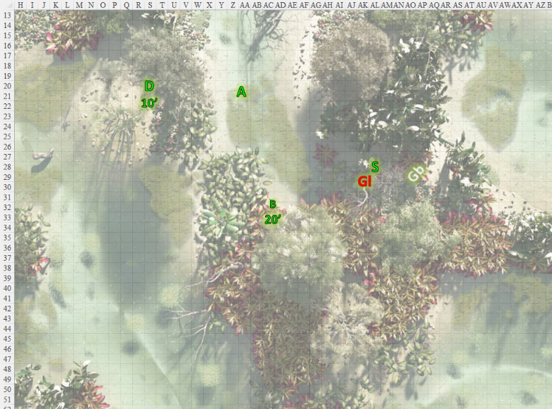

Round 3

Steelshade full attacked Goliad, electing to not use any of her spell power for this attack.

|  |  |  |  |  |  |  |  |  |  |  |
| --- | --- | --- | --- | --- | --- | --- | --- | --- | --- | --- |
| **Melee Weapon** | **Dmg** | **D+** | **TH+** | **Crit** | **x** | **Type** | **Wt.** | **Atk** | **Roll** | **Check** |
| Falchion +4 | 2d4 | +9 +3 | 3 | 18 | 2 | Slashing | 8.0 | +31 | 12 | 43 |
| Falchion +4, 2nd Attack | 2d4 | +9 +3 | 3 | 18 | 2 | Slashing | - | +26 | 5 | 31 |
| Falchion +4, 3rd Attack | 2d4 | +9 +3 | 3 | 18 | 2 | Slashing | - | +21 | 10 | 31 |
| Falchion +4, 4th Attack | 2d4 | +9 +3 | 3 | 18 | 2 | Slashing | - | +16 | 5 | 21 |

*Hit, hit, hit, miss. Dmg: (3 + 9 + 3) + (5 + 9 + 3) + (5 + 9 + 3) = 15 + 17 + 17 = 49.*

If they’d wanted to, they could have roasted some of the filets that Steelshade had just carved out of the knight’s armored torso. She inspected her blade as they all heard now something to the northwest, and turned.

*This deferment allows for all the actions you posted below.*

Alerted by the howling of the dragon shaman, an adult black dragon named Haldulfvinemmonis “Haldulf”, son of Rhylon, flew down from above the tree line, and headed straight for the warmage near the back of the south-facing formation, blasting the jungle half-elf with a line of acid.

|  |  |  |  |  |  |  |
| --- | --- | --- | --- | --- | --- | --- |
| **Save vs.**  Breath Weapon | **Rank** | **Ability**  **& Mod.** | **Misc.**  **Mods.** | **Total** | **Roll** | **Check** |
| **Devrion, Reflex** | **6** | **Dex (+7)** | 3 | 16 | 20 | 36 |

*Success. Saves for ½ damage. Dmg: ½ x 30 = 15 acid. Damage negated.*

The dragon’s hissing roar was also meant to manifest a frightful presence, but these heroes were far too hardy for this lesser drake to influence their mood much.

*PCs are immune to FP due to their HDs.*

Atlas focused his attention on the dragon, and determined how to best attack the creature.

|  |  |  |  |  |  |  |  |
| --- | --- | --- | --- | --- | --- | --- | --- |
| **Dark Knowledge**  Tactics | **Rank** | **Ability & Mod.** | **Misc. Mods.** | **Total** | **Roll** | **Check** | **Notes** |
| **Knowledge: Arcana** | 18 | **Int (+8)** | 2 | 28 | 17 | 45 | Trivial Knowledge, **best of 2 rolls** |
| **Knowledge: Arcana** | 18 | **Int (+8)** | 2 | 28 | 6 | 34 | Trivial Knowledge, best of 2 rolls |

*PCs gained +3 to attacks against black dragons.*

Devrion faced the dragon and retaliated with his prepared spell. “Implózió!”

|  |  |  |  |  |
| --- | --- | --- | --- | --- |
| **Character** | **Save vs.**  *implosion* | **Ranks** | **Roll** | **Check** |
| Haldulf | Fortitude | 15 | 6 | 21 |

*Fail.*

The dragon turned into a ball of jerky, and fell to the floor just below Devrion’s floating feet.

Brene flew northeast, about to fire her bow at the dragon, then saw the pitiful ball of scaly flesh that it had become, and shook her head.

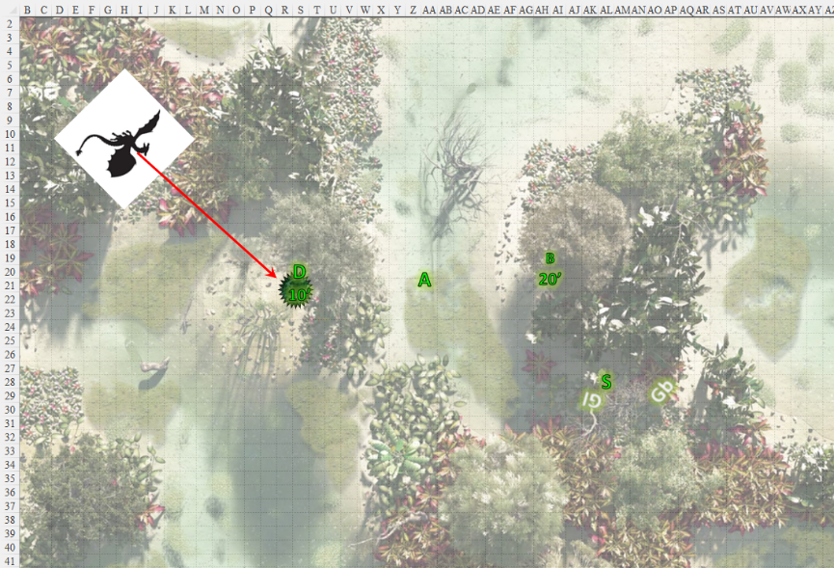

Round 4

Steelshade picked up the fallen knight’s sword and stowed it away in her haverpack, and then walked toward Atlas, picking her way through the swampy ground.

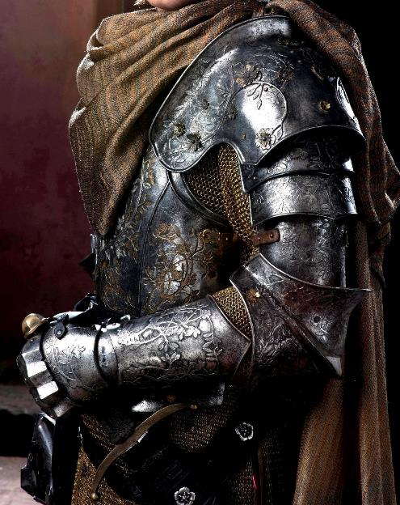

Devrion moved closer to Atlas. “I expect to see the senior dragon soon. Keep your eyes open.”

Brene flew closer to Atlas. “Yeah, and he will be pissed off, too.”

“Alright,” Atlas said. “Let’s keep moving.”

~*~

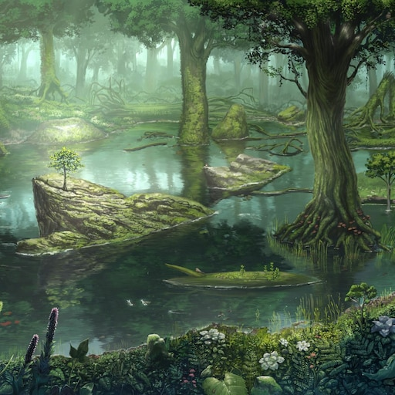

They kept moving along the carboniferous swamp, led by the rogue, who was in turn led by Atlas’ whispers to turn here and there.

Round 46

Their short-term spells had expired by now, but they’d gotten the best use out of them so far. Devrion knew to keep at least one top-tier slice of mojo to ensure a casting of *implosion* upon the arch-dragon on sight.

They were known as heroes throughout the multiverse, but they were not above striking low when it came to innate and incurable evildoers.

“There,” Atlas pointed down towards the swampy muck, and the others noted the dismal entrance to what was likely the watery grave of multitudes of their predecessors. “This is the service entrance... for minions.”



“Looks legit,” Brene shrugged as Devrion opened his mouth to speak.

Then—from the muck below—there emerged Rhylon the Serrated.

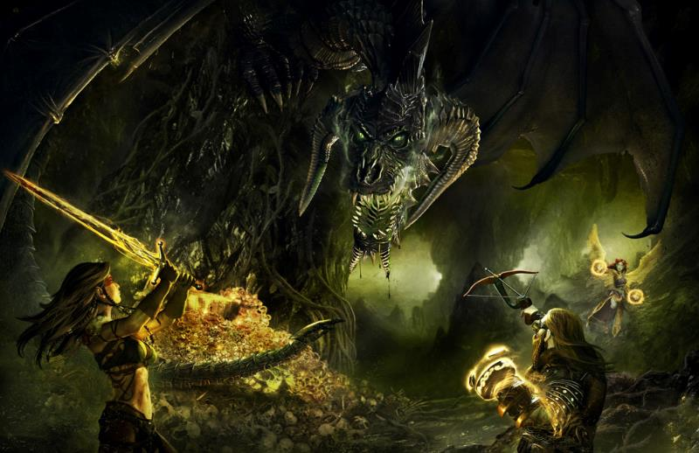

The huge, ancient black dragon hissed, and tore through the mud and water like a knife through butter, menacing the No Laughing Matter crew with its horrendous face and cone of acid.

|  |  |  |  |
| --- | --- | --- | --- |
| **Character** | **Attack Type** | **Damage** | **Ranged?** |
| Rhylon | Frightful Presence | HD ≤ 30; Will DC 28 negates | 300’ |

|  |  |  |  |  |  |  |  |
| --- | --- | --- | --- | --- | --- | --- | --- |
| **Save vs.**  Frightful Presence | **Rank** | **Ability & Mod.** | **Misc. Mods.** | **Total** | **Roll** | **Check** | **Notes** |
| **Atlas, Will** | **11** | **Wis (+6)** | 13 | 30 | 3 | 33 |  |
| **Brene, Will** | **6** | **Wis (+5)** | 3 | 14 | 16 | 30 | +2 vs. Fear |
| **Devrion, Will** | **11** | **Wis (+3)** | 3 | 17 | 11 | 28 |  |
| **Steelshade, Will** | **11** | **Wis (+4)** | 3 | 18 | 15 | 33 |  |

*Success4. No effect.*

|  |  |  |  |
| --- | --- | --- | --- |
| **Character** | **Attack Type** | **Damage** | **Range** |
| Rhylon | Breath Weapon | 20d4 acid; Ref DC 31 ½ | 40’ cone |

|  |  |  |  |  |  |  |
| --- | --- | --- | --- | --- | --- | --- |
| **Save vs.**  Breath Weapon | **Rank** | **Ability & Mod.** | **Misc. Mods.** | **Total** | **Roll** | **Check** |
| **Atlas, Reflex** | **6** | **Dex (+7)** | 13 | 26 | 15 | 41 |
| **Devrion, Reflex** | **6** | **Dex (+7)** | 3 | 16 | 15 | 31 |
| **Steelshade, Reflex** | **6** | **Dex (+5)** | 3 | 14 | 15 | 29 |

*Success, success, fail.*

*Dmg to Atlas: ½ x 49 = 24 acid. Damage negated.*

*Dmg to Devrion: ½ x 43 = 21 acid. Damage negated.*

*Dmg to Steelshade: ½ x = 56 acid [163/198]. Partial damage negated.*

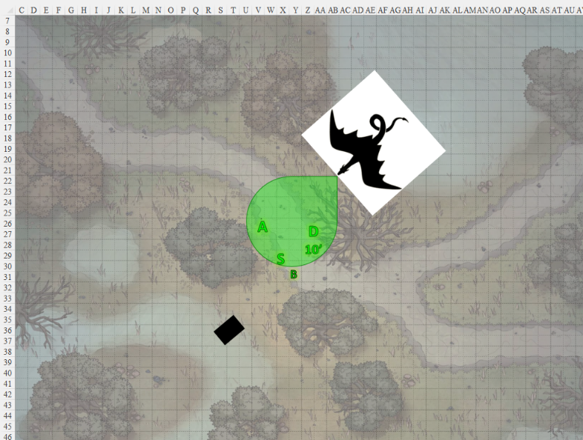

Round 47

|  |  |  |  |  |  |
| --- | --- | --- | --- | --- | --- |
| **Character** | **Group** | **Initiative** | **Roll** | **Modified Roll** | **Speed** |
| Brene | 1 | 6 | 12 | 18 | 30’ |
| Steelshade | 1 | 5 | 11 | 16 | 20’ |
| Rhylon | 2 | 4 | 8 | 12 | 60’/150’/60’ |
| Atlas | 1 | 2 | 9 | 11 | 30’ |
| Devrion | 1 | 6 | 3 | 9 | 30’ |

Brene flew due east and climbed enough to take flanking shots on the great dragon over the trees. She reached an altitude of 70’ and got a good line of attack going, and had time to fire once.

|  |  |  |  |  |  |  |  |  |  |  |
| --- | --- | --- | --- | --- | --- | --- | --- | --- | --- | --- |
| **Ranged Weapon** | **Dmg.** | **D+** | **TH+** | **Critical** | **Rng.** | **Wt.** | **Atk** | **Roll** | **Check** | **Properties** |
| Shortbow +2 | 1d4 | 2 | 2 + 2  Altitude  +3 DK | x3 | 60’ x 2 | 2.0 | +33 | 19 | 52 | Sneak Attack 10d6 |

*Hit. Dmg: 3 + 2 + 31 Sneak = 36.*

Steelshade cast *swift fly*, quick cast *dimension door* to place herself on the dragon’s back at the junction of his neck and torso, channeled vampiric touch through her blade, and empowered her strike as she full-attacked the dragon from atop its back.

|  |  |  |  |  |  |  |  |  |  |  |
| --- | --- | --- | --- | --- | --- | --- | --- | --- | --- | --- |
| **Melee Weapon** | **Dmg** | **D+** | **TH+** | **Crit** | **x** | **Type** | **Wt.** | **Atk** | **Roll** | **Check** |
| Falchion +4 | 2d4 | +9 +3  + 4d4 | 3 + 4  +3 DK | 18 | 2 | Slashing | 8.0 | +34 | 6 | 40 |
| Falchion +4, 2nd Attack | 2d4 | +9 +3  + 4d4 | 3 + 4  +3 DK | 18 | 2 | Slashing | - | +29 | 17 | 46 |
| Falchion +4, 3rd Attack | 2d4 | +9 +3  + 4d4 | 3 + 4  +3 DK | 18 | 2 | Slashing | - | +24 | 2 | 26 |
| Falchion +4, 4th Attack | 2d4 | +9 +3  + 4d4 | 3 + 4  +3 DK | 18 | 2 | Slashing | - | +19 | 13 | 32 |

*Hit, hit, miss, miss. Dmg: (7 + 9 + 3 + 10 AS) + (8 + 9 + 3 + 8 AS) = 29 + 28 = 57.*

In a feat that warranted an artist’s rendition—or at least a bard’s oration—the duskblade cut a single slit in the dragon’s neck, and remained aloft for the moment, noting the remaining power in her reserves.

|  |  |  |  |  |  |  |
| --- | --- | --- | --- | --- | --- | --- |
| **Ring of Wizardry?** | **Daily Duskblade Spells** | | | | | |
| Not worn | **0th** | **1st** | **2nd** | **3rd** | **4th** | **5th** |
| **Duskblade Spells** | 6 | 10 | 9 | 8 | 7 | 3 |
| **Intelligence Bonus** | 0 | 1 | 1 | 1 | 0 | 0 |
| **Total Daily Spells** | **6** | **11** | **10** | **9** | **7** | **3** |
| **DC** | 16 | 17 | 18 | 19 | 20 | 21 |
| **Cast?** | **0** | **0** | **4** | **2** | **1** | **0** |

Rhylon full-attacked Steelshade as he hovered over his muggy, muddy lair.

|  |  |  |  |  |  |  |  |  |
| --- | --- | --- | --- | --- | --- | --- | --- | --- |
| **Character** | **Attack Type** | **Damage** | **BAB** | **Str Mod+** | **Total Score** | **Roll** | **Total** | **Threat** |
| Rhylon | Bite | 2d8+11 | 40 | 0 | 40 | 9 | 49 | ý |
| Rhylon | Claw 1 | 2d6+5 | 40 | -4 | 36 | 4 | 40 | ý |
| Rhylon | Claw 2 | 2d6+5 | 40 | -4 | 36 | ***20*** | 56 | þ |
| Rhylon | Wing 1 | 1d8+5 | 40 | -5 | 35 | ***20*** | 55 | þ |
| Rhylon | Wing 2 | 1d8+5 | 40 | -5 | 35 | 7 | 42 | ý |
| Rhylon | Tail Slap | 2d6+16 | 40 | -5 | 35 | 6 | 41 | ý |

*Hit, miss, threat, threat, miss, miss. 1d20 = 10 + 36 = 46; 18 + 35 = 53; both are critical hits.*

*1d100 = 43, 60, 50. Concealment bypassed all three times.*

*Dmg: (14 + 11) + ([2 x 7] + 5) + ([2 x 8] + 5) = 25 + 19 + 21 = 65 [98/198].*

Atlas spoke a few words, and then he roared in the creature’s face *[lion’s roar, expired on Round 237]*.

|  |  |  |  |
| --- | --- | --- | --- |
| **Ranged Weapon** | **Atk** | **Roll** | **Check** |
| Bypass Spell Resistance | +19 | 12 | 31 |

*Success.*

|  |  |  |  |  |
| --- | --- | --- | --- | --- |
| **Character** | **Save vs.**  *lion’s roar* | **Ranks** | **Roll** | **Check** |
| Rhylon | Fortitude | 23 | 20 | 43 |

*Success. Saved for ½ damage and negated stun. Dmg: 40 sonic.*

Devrion moved to his left to circle the dragon. He pointed at the dragon. “Halál ujja!” *[finger of death]*

|  |  |  |  |
| --- | --- | --- | --- |
| **Ranged Weapon** | **Atk** | **Roll** | **Check** |
| Bypass Spell Resistance | 19 | **20** | 39 |

*Success.*

|  |  |  |  |  |
| --- | --- | --- | --- | --- |
| **Character** | **Save vs.**  *finger of death* | **Ranks** | **Roll** | **Check** |
| Rhylon | Fortitude | 23 | 7 | 30 |

*Success. Saves vs. Death. Dmg: 11 + 19 = 30.*

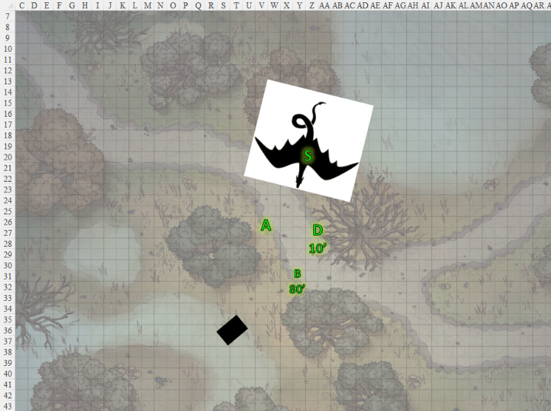

Round 48

Brene twice fired her bow at the dragon as she kept moving to flank it.

|  |  |  |  |  |  |  |  |  |  |  |
| --- | --- | --- | --- | --- | --- | --- | --- | --- | --- | --- |
| **Ranged Weapon** | **Dmg.** | **D+** | **TH+** | **Critical** | **Rng.** | **Wt.** | **Atk** | **Roll** | **Check** | **Properties** |
| Shortbow +2 | 1d4 | 2 | 2 + 2  Altitude  +3 DK | x3 | 60’ x 2 | 2.0 | +33 | 3 | 36 | Sneak Attack 10d6 |
| Shortbow, 2nd Shot | 1d4 | 2 | 2 + 2  Altitude  +3 DK | x3 | 60’ x 2 | - | +28 | 12 | 40 | Sneak Attack 10d6 |

*Miss, hit. Dmg: 2 + 2 + 31 Sneak = 35.*

Steelshade staggered as the dragon raked her shield with a claw and buffeted her with a wing strike. The duskblade used all three charges in her amulet of tears (swift action), and cast *swift fly* once again.

*Steelshade gained 24 hps [122/198].*

She channeled *keen edge* through her sword, empowered her attacks (+4) and struck the great dragon again.

|  |  |  |  |  |  |  |  |  |  |  |
| --- | --- | --- | --- | --- | --- | --- | --- | --- | --- | --- |
| **Melee Weapon** | **Dmg** | **D+** | **TH+** | **Crit** | **x** | **Type** | **Wt.** | **Atk** | **Roll** | **Check** |
| Falchion +4 | 2d4 | +9 +3  +4d4 AS | 3 + 4 AS  +3 DK | 18 | 2 | Slashing | 8.0 | +38 | 14 | 52 |
| Falchion +4, 2nd Attack | 2d4 | +9 +3  +4d4 AS | 3 + 4 AS  +3 DK | 18 | 2 | Slashing | - | +33 | 5 | 38 |
| Falchion +4, 3rd Attack | 2d4 | +9 +3  +4d4 AS | 3 + 4 AS  +3 DK | 18 | 2 | Slashing | - | +28 | 9 | 37 |
| Falchion +4, 4th Attack | 2d4 | +9 +3  +4d4 AS | 3 + 4 AS  +3 DK | 18 | 2 | Slashing | - | +23 | 13 | 36 |

*Hit, hit, miss, miss. Dmg: (5 + 9 + 3 + 10 AS) + (3 + 9 + 3 + 12) = 27 + 27 = 52.*

Rhylon full-attacked Steelshade.

|  |  |  |  |  |  |  |  |
| --- | --- | --- | --- | --- | --- | --- | --- |
| **Character** | **Attack Type** | **Damage** | **BAB** | **Str Mod+** | **Total Score** | **Roll** | **Total** |
| Rhylon | Bite | 2d8+11 | 40 | 0 | 40 | 15 | 55 |
| Rhylon | Claw 1 | 2d6+5 | 40 | -4 | 36 | 17 | 53 |
| Rhylon | Claw 2 | 2d6+5 | 40 | -4 | 36 | 12 | 48 |
| Rhylon | Wing 1 | 1d8+5 | 40 | -5 | 35 | 9 | 44 |
| Rhylon | Wing 2 | 1d8+5 | 40 | -5 | 35 | 5 | 40 |
| Rhylon | Tail Slap | 2d6+16 | 40 | -5 | 35 | 14 | 49 |

*Hit, hit, hit, hit, miss, hit.*

*1d100 = 12, 08, 77, 29, 35.*

*3rd hit bypassed concealment.*

*Dmg: 3 + 5 = 8 [114/198].*

Atlas lifted his hands and spoke quietly *[end to strife, expired on Round 67]*. “Let us talk instead of fight, Keygrodekkerrhylon.”

*Any creature in the spell’s area that makes an attack takes 20d6 points of damage.*

*Atlas decides whether the spell deals lethal or nonlethal damage but cannot change her mind once the spell is cast.*

Devrion boldly levitated right past the dragon, and he tapped Steelshade with his wand of *cure moderate wounds*.

*Steelshade gained 6 + 4 = 10 hps [124/198].*

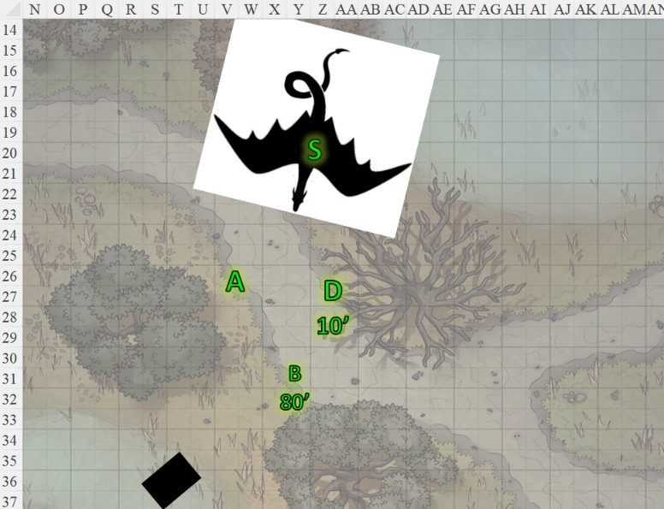

Round 49

Brene circled further around behind the dragon, but she held her fire.

Steelshade cast *swift fly*, and moved away from the dragon in company with the warmage.

And then it was as if the dragon read their minds, hissing, “Viviparousss ssscum! Ssso that’sss what you’re after!” and with this he cast *teleport*.

Atlas and Devrion both identified the spell upon the first word’s utterance, and had only a fraction of a moment to thwart the dragon’s concentration and possibly foil the spellcasting.

Atlas produced a scroll of *teleport* with the intention to use it as a counterspell against the dragon’s casting just as Devrion thought to activate his ring of *telekinesis* to force the dragon’s tongue against the roof of his mouth hard enough to disrupt his speech without causing him an injury, but both saw the dragon disappear before they could expend their powers.

Rounds 50 – 54

The swamp was quiet once again.

“He likely cast *detect thoughts*,” Atlas suspected aloud.

“Which would mean that he teleported back to his lair to protect the item that would augment Brene’s bow,” Steelshade surmised.

“The Recurve Grip of Alacrity,” Atlas named the item that would bestow the Rapid Fire ability unto her bow.

Devrion posited, “We could storm his sanctum; it’s not like we haven’t been in more disgusting confines. Take the Recurve Grip and the rest of the drake’s hoard.”

“He’s reputed to have quite a bit of gem and coin stowed under our feet,” Brene tapped her right foot down. She tapped Steelshade once with her wand of *cure serious wounds*, and also gave her friend *[DM assumption: Steelshade]* the potion of the same name she was carrying.

*Steelshade gained 12 + 6 = 18 hps [142/198].*

“My concern is that Rhylon is choosing to attack the local people here. I thought by stopping the attack and trying to talk that he’d be reasonable. I guess that was a mistake.” Atlas sighed.

Brene stepped over and gripped his hand in hers. “It’s part of what I love about you. You were willing to give him a chance.”

“I vote we come at him a little smarter this time,” Steelshade grumbled. “He hits damned hard. Letting him go,” she raised a hand, “not that I was against the idea, means that he will have healed up by the time we find him again.”

*DM assumption:* Steelshade then gulped down the potion that Brene had just handed her.

*Steelshade gained 15 + 5 = 20 hps [162/198].*

The dragon was probably doing the same right about now, and buffing up if he knew what was good for him.

“We *do* need to go get him, or just go home,” Brene said with a hopeful lilt.

Atlas pointed to the minion’s entrance. “I believe this is our way in.”

Brene sighed. “Why did I know you’d say that?”

With that, the group arranged themselves, and Brene carefully checked the entrance for traps before they started down. The rogue, duskblade, warmage, and archivist began their descent into Rhylon’s lair.

~*~

The rough, tubular tunnels had led them in circles for a few minutes until they got their bearings. “Are we all good with night vision?” asked Steelshade as they ventured deeper into a chamber where even indirect sunlight was absent.

Atlas took out a coin and prayed briefly, casting *light [expired on Round 1961]* on it. He held the coin in his fingers, and regulated the amount and direction of the light shed by manipulating the coin in his hand. “I’m fine,” he said quietly.

*Coin gained light spell properties.*

Brene looked for signs of recent use, as she guessed the minions they’d killed had used these passageways to reach the swamp. She looked for scrapes on the rocks, bits of soil on the floor, or other indications of recent use.

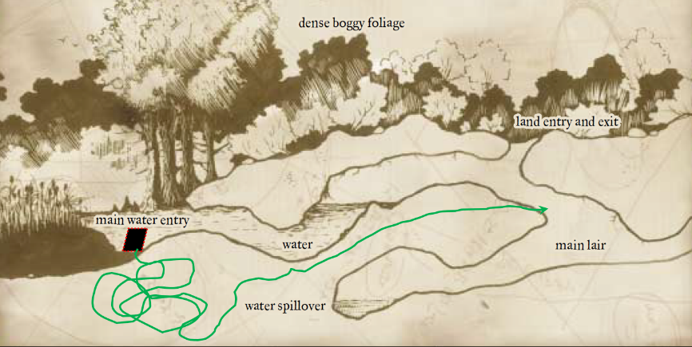

Speaking softly, Atlas had wanted to cast *chasing perfection* on everyone as they moved quietly forward, but he’d already done so and they still had about 10 minutes left with their current boost.

It did not take the halfling sleuth-extraordinaire to find their way to the main chamber. She gave them a warning as they heard the dragon or some other sizeable creature stirring around the corner amongst piles of treasure. The hissing slurs they then heard confirmed that it was Rhylon.

They all stopped to see what he might be saying/casting, and heard him talking to himself while gulping down a potion.

Brene padded up to where she could see, and took a quick peek around the corner, drawing back immediately after.

At a distance of 50’ the dragon was already facing her, smelling the heroes, and grinned, “It is time.” The black saurian then advanced.

With only seconds before Rhylon would be upon them, the heroes mobilized.

Round 71

“Which would mean that he teleported back to his lair to protect the item that would augment Brene’s bow,” Steelshade surmised. The duskblade stayed close to Devrion as they both settled to the ground. The warmage continued to use his wand to help restore her.

*Steelshade gained 11 + 4 = 15 hps [177/198].*

The archivist considered trying to speak with Rhylon again, but he dismissed the idea as too dangerous. He stepped around the corner and roared [*lion’s roar, boost expiration extended from Round 237 to 261*] in the creature’s face.

|  |  |  |  |
| --- | --- | --- | --- |
| **Ranged Weapon** | **Atk** | **Roll** | **Check** |
| Bypass Spell Resistance | +19 | 6 | 25 |

*Success (barely).*

|  |  |  |  |  |
| --- | --- | --- | --- | --- |
| **Character** | **Save vs.**  *lion’s roar* | **Ranks** | **Roll** | **Check** |
| Rhylon | Fortitude | 23 | 2 | 25 |

*Fail. Dmg: 49 sonic + Stun [1 round].*

The dragon had already been approaching, snaking forward until the spell stunned his crawling frame.

Brene nipped around the corner and turned to her right along the wall, where she fired at the [flat-footed] dragon. She planned to keep moving to her right to flank the creature as the others hopefully attracted its attention.

|  |  |  |  |  |  |  |  |  |  |  |
| --- | --- | --- | --- | --- | --- | --- | --- | --- | --- | --- |
| **Ranged Weapon** | **Dmg.** | **D+** | **TH+** | **Critical** | **Rng.** | **Wt.** | **Atk** | **Roll** | **Check** | **Properties** |
| Shortbow +2 | 1d4 | 2 | 2 | x3 | 60’ x 2 | 2.0 | +28 | 9 | 37 | Sneak Attack 10d6 |
| Shortbow, 2nd Shot | 1d4 | 2 | 2 | x3 | 60’ x 2 | - | +23 | *1* | 24 | Sneak Attack 10d6 |

*Miss, miss.*

One arrow bounced off of the black dragon’s scales, while the other went into the muddy ground.

With Devrion having just healed her a bit more, Steelshade cast swift fly, channeled *shocking grasp* through her blade, and empowered her strikes (+5) as she directly attacked Rhylon. She still had her *keen edge* enchantment on her blade, as well, and now flew into a jousting charge attack against the disabled drake. She even felt her knew ankh-embroidered hilt warming with the anticipation of battling Rhylon some more. The blade had already tasted the dragon’s blood, and now seemed to want more.

|  |  |  |  |  |  |  |  |  |  |  |
| --- | --- | --- | --- | --- | --- | --- | --- | --- | --- | --- |
| **Melee Weapon** | **Dmg** | **D+** | **TH+** | **Crit** | **x** | **Type** | **Wt.** | **Atk** | **Roll** | **Check** |
| Falchion +5 | 2d4 + 5d4 | +9 +5  + 5d6 electric | 5 + 2 charge + 5 AC  + 2 unexplainable boon | 18 | 2 | Slashing | 8.0 | +42 | 17 | 59 |

*Threat. 1d20 = 4 + 42 = 46, critical hit. Dmg: (2 x 5) + 9 + 6 + 15 AC + 10 electric + 7 DK = 57.*

The dragon was visibly injured, his right eye, completely skewered and disabled by the falchion, which she had used to pierce instead of slash at the meaty eyeball.

Round 72

Devrion levitated around the corner and moved to his left in a climbing arc along the chamber wall. He pointed at the great but still disabled dragon, and uttered the ominous syllables: “Implózió! *[implosion]*”

|  |  |  |  |  |
| --- | --- | --- | --- | --- |
| **Character** | **Save vs.**  *implosion* | **Ranks** | **Roll** | **Check** |
| Rhylon | Fortitude | 23 | 7 | 30 |

*Success. Effect negated.*

*[DM assumption]* Brene repeated her attack from afar, aiming for a spot far from Steelshade.

|  |  |  |  |  |  |  |  |  |  |  |
| --- | --- | --- | --- | --- | --- | --- | --- | --- | --- | --- |
| **Ranged Weapon** | **Dmg.** | **D+** | **TH+** | **Critical** | **Rng.** | **Wt.** | **Atk** | **Roll** | **Check** | **Properties** |
| Shortbow +2 | 1d4 | 2 | 2 | x3 | 60’ x 2 | 2.0 | +28 | 17 | 45 | Sneak Attack 10d6 |
| Shortbow, 2nd Shot | 1d4 | 2 | 2 | x3 | 60’ x 2 | - | +23 | 5 | 28 | Sneak Attack 10d6 |

*Hit, miss. Dmg: 2 + 2 + 39 Sneak + 9 DK [against FF AC] = 52.*

The first arrow entered the creature’s long neck, piercing the jugular that released its blood as its remaining eye shut forever.

Atlas sighed, noting no other dragons or threats about.

They now stood in the ample treasure chamber beholding the villain’s hoard.

The quartet regrouped beside the fallen dragon’s head.

“Even given his history, this is a sad thing,” Devrion said as he regarded the massive creature’s remains. “He was irascible to the end. Too bad for such an ancient one.”

“We did try to talk with him,” Atlas reminded the warmage.

“I’m going to look for that artifact,” Brene said as she looked for the Recurve Grip of Alacrity and anything else of above-average value, such as large gems, weapons, or other artifacts.

“What are we going to do about all of this?” Steelshade asked. “We can’t just leave it all here, and letting some random person take all of it could cause more problems.”

Atlas thought for a moment. “Rhylon caused a good deal of death and destruction. I say we take as much coin as we can carry, and deliver it as restitution. Of course, we also take anything else we decide to keep. Then,” he glanced at Devrion, “he brings this whole place down and buries it.”

Devrion nodded. “I can do that.”

With that, the four of them began to search the huge chamber, with Devrion using his telekinesis ring to move heavier objects like a large shovel through the larger piles. They kept an eye and ear out for any sign of trouble while they worked.

Steelshade again felt the mercy of her blade warming, and looked down to see a new, violet glow emanating from her falchion. As she walked toward a particularly well ensconced portion of the late dragon’s hoard, the glow grew brighter until she happened upon a trio of oblong dragon eggs, each the size of a watermelon and likely no less heavy. Rhylon was a male, but it wasn’t unheard of for male black dragons to raise their young in a consort’s absence, or to even steal other dragons’ eggs when fertility was beyond their reach.

Atlas came around the mound of coins, gems, amulets, and rings, and hummed as he beheld the eggs. “They’ll likely hatch soon, and if there are any humanoid settlements nearby, the hatchlings will surely head by scent towards those areas.”

“So we can’t just crack them open and have a breakfast of champions?” Devrion protested.

“You won’t find a yolk inside anymore,” Atlas explained. “See the veins in the eggshell?” he pointed to the patterns of gray discoloration. These critters are probably fully developed, and days away from bursting out.”

Brene and Devrion took little time to sort through the well-organized piles of stuff before finding the Recurve Grip of Alacrity, as well as a few other useful items for the party.

“Look at these,” Brene pointed to a neatly arranged row of soft leather boots adorned with inlaid runes. She applied the Grip to her bow as she spoke, though she realized that this would require a professional bowyer with arcane knowhow.

Atlas went to examine them. “They are all Levitating Boots of Greater Agility,” he pronounced.

Each of them took a pair and donned them in place of their existing footwear. Then, each of them gathered 500 gold coins, and as many gems as they could carry in their packs. Lastly, everyone but Brene put a dragon egg in a sack and picked it up to carry in their off hand.

“We go straight up and out using our new boots,” Atlas said. “Brene, you lead the way.”

“When we get out, I will use my *earthquake* spells to completely bury this place,” Devrion stated.

“Good man... among neutrals,” Steelshade muttered.

~*~

The *earthquake* spell had not only crushed a half-dozen other dragons that were in peripheral chambers into which the heroes had never ventured, but also released one lucky one who was able to squeeze out of the fissures before they closed up. The juvenile black dragon flew upwards, visibly frightened, took a look at the heroes, and flapped away over and behind the tree line at full speed.

The group used their carpet to scout the area for the villages Rhylon and his minions may have attacked. Keeping the bagged eggs out of sight on the carpet, Brene stepped down at each village and passed out the gold coins to the families of the dragons’ victims.

There were no towns or villages in sight, though there was a hamlet led by an initially mistrustful woman named Anæsthesia, who within minutes took a liking to the heroes and offered them plesiosaur belly stew, a Chultean delicacy.

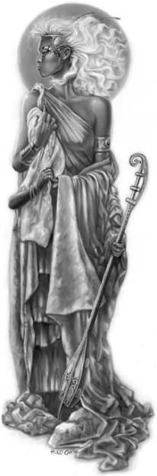

The No Laughing Matter crew was told to return whenever they wanted to visit. “You have friends here for life,” Anæsthesia assured them.

That done, they took the rest of the items back to Waterdeep. There, they gave the eggs to the proper authorities for disposal, sold their excess items, and donated whatever was over their wealth limits to Rook’s church.

Back in Waterdeep, the quartet walked down the paved street toward a broad plaza in the northeast quadrant of the city. There, a building of cut and fitted stone sat, plain and utilitarian, as befitted the temple of a warrior deity. The courtyard was encircled by a chest-high wall with openings for pedestrians equipped with low iron gates that normally stood open. They passed though one of the gates, and saw Elaith standing near the doorway, talking with three of her acolytes. The duskblade looked up at them and smiled as they approached.

“Good day to you,” she said. Her eyes took on a mischievous glint as her gaze fell on Brene. “Picked any good pockets lately?”

“Oh, gods,” Brene sighed. “You elves never forget shit, do you?” She shot a baleful glance at Devrion as he laughed softly.

“Nope,” Elaith laughed. “Not if we can tease you with it for the next decade or so.” She sobered. “Seriously, it is good to see you all. How may I, or we, help you today?”

“We actually came to see Rook, and you, of course,” Angren said. “We came into a fair bit of treasure, and we’d like to share it with your church.”

“Of course. Come this way, please.”

As Elaith led the way into the church complex, Angren reflected on her first meeting with Lauren’s comrades. When she set out to find the legendary duskblade, Angren had come here with her newly recruited companions. At first, Rook and Elaith had been loath to help her, but Angren’s story had convinced them to broker a meeting with their liege. Since then, Elaith had assisted Angren with her duskblade training, and Rook had found others to help Brene, Devrion, and Atlas with their respective vocations, as well.

Elaith opened a door, revealing Rook seated at the desk in his office. “Hello, Angren, Brene, Devrion, and Atlas. What can I do for you today?” The inquisitor rose to his feet as he spoke.

“We come bearing a gift from a late and unlamented black dragon in Chult,” Angren replied as the group extracted bags of coins and gems they’d taken from Rhylon’s lair.

“Well, how nice of him to donate!” Rook said with a smile. “I suppose he doesn’t want a receipt?”

Conversation ensued, and it was confirmed by Rook that after spending years in the Lurkwood with her bride, Allisa, Lauren had ventured into the Outer Planes by way of Arborea. “She called it a pilgrimage,” explained Elaith, “and wouldn’t say exactly what she was seeking, but I could tell it was something specific.

“I recall the tale of Destiny’s Gambit in Arborea,” Angren nodded as Rook smirked with fond nostalgia for that campaign. “You’d all wandered into the Citadel of the Planes, yes? And eventually vanquished Kaszüm the Acquirer if I’m not mistaken.”

“We did take him out in the Astral Suite, and liberated a multitude of souls in the process,” Rook proudly summarized that notch in his team’s résumé.

“Did Allisa go with Lauren,” Devrion asked.

“No, their interests diverged,” sighed Elaith. “Allisa leaned rather hard into her Mistress of Many Forms discipline, and one day, she just decided to never assume her half-elven form again.”

“It happens,” Rook noted. “In this world, we either become epitomes of ourselves or perish trying.”

“I don’t know them well enough to offer an opinion about it,” Angren said quietly. “I would like to think that a mate would be more important to me than self-actualization. It’s one of those things one gives away in exchange for companionship.”

“A mate *is* self-actualization,” Atlas pontificated, and gave Brene little butterflies in her stomach.

“I always thought the druids were an odd folk, anyway,” Brene put in. “They’re even worse than finger wigglers.” Devrion snorted in derision, and Brene cracked a smile. “Given that, some finger wigglers might be better than others.”

Devrion rolled his eyes. “I agree with Angren. Heartbreak can drive people to make poor or unfortunate choices. It’s hardly a rare phenomenon, sadly.”