*Chapter 12: Dynasty’s Gambit*

The heroes had tracked a vile dragon shamaness named Dynasty to the far reaches of the Inner Planes; more specifically, to a pocket plane of Elemental Earth at one of the few discrete borders between the Elemental Planes of Air and Water, where the Para-Elemental Plane of Steam was unexplainably absent.

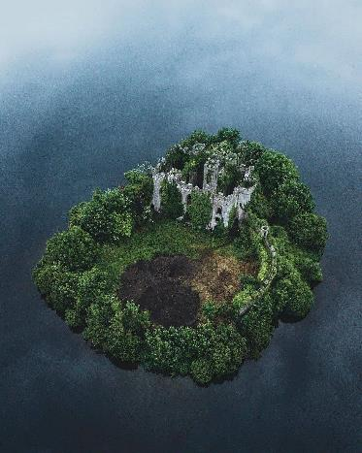

The powerful shamaness had allegedly slain the previous occupants of the purposely dilapidated keep, and was reputed to be hiding from other arch-enemies while fortifying and fostering ties with others via remote communication magics. Atlas was nearly certain that the *greater planar shift* spell would take them to the edge of a wormhole conveniently concealed as a natural sinkhole, and by the time they’d all cast their buffs and tapped one another with wands, Atlas cast the spell and confirmed that they were indeed in the MakDahr-Muth Pocket.

Atlas had cast *chasing perfection [expired in 19 minutes]* on all of them, as well as *protection from evil* *[expired in 19 minutes]* on himself.

*All PCs gained +4 to all primary abilities.*

*Atlas gained +2 to AC and Saves against Evil foes.*

Brene had wanted to cast *stoneskin* from a scroll, but they had instead moved on to their next caper before doing so. She did manage, however, to rummage through the bottom of her haversack and find an old *barkskin [expired in 80 minutes]* scroll, which she had cast on herself.

*Brene gained +2 to FFAC and AC.*

Devrion had cast *mage armor [expired in 19 hours]* on himself, and *accuracy* on Brene’s bow.

*Devrion gained +4 to FFAC and AC.*

*Brene’s bow doubled in range.*

Steelshade had cast *dragonskin [expired in 190 minutes]*, and tapped everyone with Atlas’ wand of eternal *haste*.

*Steelshade gained +5 to FFAC and AC.*

*All PCs gained +1 to BAB, AC, Reflex saves, and either 30’ extra movement or 1 extra attack.*

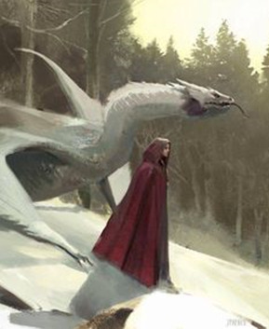

It took only a moment for the dragon shamaness to emerge from the keep. Being vaguely aware of the No Laughing Matter quartet’s interest in her, she had half-expected them by now. They had expected her to be accompanied by at least one white dragon, but instead she approached alone, though not unarmed. They’d confronted her years ago, and noted that she still had the same Returning Shortspear in her possession, though it had been augmented with a warhead of sorts.

“Rest assured that if I’d wanted you dead, I would by now have implemented six contingency traps within your vicinity,” the greeting was as warm as anyone might have anticipated, given their history.

Silence ensued amongst the newcomers, who had come ready for battle.

Dynasty broke the silence once more, “I know you’ve come for the Gorget of Magic Resistance... and while it has been dear to me, and has come in handy, I’ve soul searched a bit on it, and would be willing to part with it...” she trailed off, letting Steelshade get in a few syllables.

“We appreciate the lack of hostility on your part, and as a gesture of good faith, will sheathe the most decisive weapon that you see before you that we might continue to parlay,” the duskblade said.

“Much appreciated, as I’ve grown fond of this place, and would not want to ruin it in an uncivilized attempt to resolve our differences,” Dynasty nodded.

Brene listened curiously. Atlas and Devrion also held their tongues for the moment, seeing that their human/demigoddess hostess was about to get to the point.

“Come,” she invited them into the keep. “I am making soufflé.”

~*~

They hesitated, but one by one, they entered, and noted the utilitarian considerations with which the minimalist furnishings had been arranged. The architecture was older than all of them put together, and though a few *make whole* spells might have restored it, the disrepair added a quaint flavor of ruggedness to the otherwise comfortable abode.

A fireplace housed a three-log fire that stoked as if it had only recently been lit with twigs and pine needles, some of which were still unburned along the periphery of the logs. The scent of dragons’ flesh, scales, eggs, and organs was evident, but not overbearing, and confirmed what they knew of Dynasty: her reverence for dragons—particularly white dragons—was akin to the love that a rapist fostered for the orifices he violated, or the trophies that a hunter beheaded and mounted on her wall as tokens of vain pride to compensate for inner deficiencies.

In Dynasty’s case, there were no heads mounted on the mantles or walls of the keep—at least not in the main chamber—though there were several dragon-derived adornments, cutlery, and even her suit of armor, which hung ready for donning.

The woman removed her cloak and hung it up on the hat tree near the front entrance. “I made enough for ten, and we are only five, so please do me the honor of joining me. If you lack a *detect poison* spell, and have reservations, you may serve my portion first that I might dissuade your fears with the initial bite.” She bit at them as something between a taunt and a flirt, then looked them all over, and said, “You know, back when we met—what was it? 1375? 76?—we could have worked things out. We might’ve even made it worth one another’s while.”

The innuendos went way over Devrion’s head, though Steelshade and the two lovers next to her saw where this was going. Atlas scored some points with Brene by interjecting, “Lady Dynasty, is this why you invited us in? To seduce us?”

Devrion, having recently bathed, still wasn’t connecting the dots. Charismatic and learned as he was, he was still not well studied in the ways of the humanities and elvenities. Steelshade noticed, and held back a smirk, keeping the poker face on for the sake of the dragon shamaness.

Dynasty smirked, “I like a direct man; straight to business. No, that just occurred to me now. You *did* come all dolled up; don’t think I didn’t notice. Don’t blame a girl for trying.”

The warmage finally understood, and blushed, then grinned.

Steelshade then spoke, “As you said, Dynasty: ‘straight to business’. What is it that you want us to do in order to turn your ‘maybe’ into a ‘sure, you can have my Gorget of Magic Resistance!’?”

Dynasty recalled that Steelshade was the executor in the group, and had called the shots even way back when. She inhaled through her nostrils as 11 unsaid words coursed through her mind, then opted for the alternative, “Hmmm, well, as you know, yours truly is *persona non grata* in or anywhere near the Material Plane.”

“No, I didn’t,” Brene said.

“I did,” Atlas noted. “I’ve heard tell that you murdered thousands, depopulating entire villages along the Sword Coast.”

She sighed, “Ahhh... yes, I suppose I did that... but I realize now how fruitless and mismanaged an enterprise that was, and would never manifest that level of collateral damage without certifying via return-on-investment analyses a significant expected value added to my operations.”

“I don’t think ‘collateral damage’ applies when you’re murdering people piecemeal,” Atlas pointed out, and was about to elaborate before his lover cut him off.

“What exactly *is* the rubric of your operations?” Brene asked without much tactical motive; she was randomly curious.

“Uh...” the dragon shamaness thought of how best to frame it. “Amass power, consolidate security, increase scope of influence, amass more power, repeat?” she shrugged. “What’s *your* formula for success?”

“So I notice we’ve yet to get to the point. What do you want from us?” Atlas reined the topic back to center.

“Fine,” the hostess seemed frustrated. She scribbled a few things on a small parchment as she spoke. “I—Dynasty Paledrake of Vaasa—do hereby bestow upon you the request to slay our common enemy—Cheynchaytion—and retrieve several of his organs.” She then finished scribbling, and handed the paper to Steelshade.

The drow-dragon hybrid looked at the dragon shamaness straight in the eyes as she took it, then looked to her friends before looking down at the paper, and noted the legible but rough calligraphy of a person accustomed to writing in Draconic now writing in Common. The list read:

* Both eyes, try to keep them intact.
* 10 lbs. of micro-scales, found behind the ear slits.
* 20 lbs. of standard size scales from any part of the torso; should be 3 to 4 scales at most.
* 2 claws, preferably not the pinky claws; can be from front or rear appendages.
* Heart
* Liver
* Spleen
* Pancreas
* Forked tip of the tongue
* Tonsils

Once the duskblade had read the note aloud, Dynasty added, “I have a few haversacks large enough to fit the intended liver—the largest of the individual items—so transporting the items should not be a problem.”

The No Laughing Matter crew took in the situation before Steelshade summarized, “You’re asking us to seek out the dragon—I’m assuming you know the whereabouts of his lair—slay him, butcher him up for you, bring you back the ingredients for your next soufflé, maybe eat some of it with you, and then you’re going to freely give up the Gorget?”

Devrion’s ears perked up, as this was an item of particular interest to him. At the very least, it would give him the Spell Resistance he’d coveted for quite some time, but in time, he may be able to attune himself to it in such a way as to harness relic or legacy powers that had likely not been tapped in centuries.

Their hostess thought about her answer, going over Steelshade’s words, “I mean, you don’t have to join me for soufflé now, or afterwards, if you really don’t want to. It’s made with white dragon eggs, big surprise there…. So what do you say... to my proposition?”

“Let me pose the naysayer argument,” Brene interjected. “Let’s say they all trust you, but I, being a shrewd hand when it comes to handshake deals, remain reluctant to trust that you won’t cross us once we deliver you these goods?”

The villain seemed to take to heart the rogue’s sentiments. “I hadn’t considered it before, but I could come with you, and once we’ve laid out the renegade reptile, I could impart the item to you, and you can leave me to the butchering. Maybe stay behind a bit to make sure the dragon’s progeny isn’t around to represent.”

“I would have taken you for someone powerful enough to accomplish this yourself,” Atlas shifted in his stance.

“Probably, but not unscathed. A girl has to look out for her own wellbeing too; that’s the ‘consolidate security’ part of my grand scheme that I was revealing earlier.”

“I doubt that any one of us could take an ancient dragon, so I understand,” Steelshade said after a moment. “The question is, what sort of power will the dragon’s parts give to you? Maybe you would be a worse enemy than the dragon once bestowed with what you seek.”

“It’s a sort of power comparable to what you’d get with my Gorget, depending on how I cook up the ingredients,” she answered.

Atlas could tell she was withholding more than she was revealing, “I’d wager you’ll be brewing potions and imbuing items with some of the organic essence.”

She divulged a bit more, “Yes, and myself. So it’s a win-win. You gain the Gorget; I stay busy extracting for the next six months... and in the end, we’re all a bit better off for it.”

The quartet shared a look among them. The unspoken consensus was to go ahead with the attack on the dragon, and deal with the woman later, if it came to that.

“We will do as you ask,” Steelshade said.

“Excellent...” the dragon shamaness murmured as if this was all part of a script so far being followed to the letter. “Should I don my armor and prep my long terms in anticipation of joining you, or should I just sit tight?”

“I think we can handle the fight. We will come back for you when it is over.”

“Suit yourselves,” she smirked, handing Atlas a detailed map depicting Vaasa on the front, and a far more detailed close-up of the location of the dragon’s keep. Keeping her casual outfit on, the hostess sat and lounged in the main chamber as the party prepared to *plane shift* to the Material Plane’s northern reaches. “Do help yourselves to anything else you happen to stumble upon in Cheyn’s hoard.”

And thus, with no further buffs or fanfare, the four antivillains clasped hand to wrist as they did almost daily, and Atlas cast them through the multiverse and back into the all-too-familiar Material Plane, though this place was new to them.

~*~

*[Adapted from FRCS]*

Vaasa: This untamed wasteland of frozen moors and tundra had once been the seat of power for the evil lich Zhengyi the Witch-King until his defeat by a band of adventurers. Vaasa was once again a lonely land dotted with scratch farms and inhabited by evil humanoids and other monsters. What the land lacked in hospitality it made up for in untapped wealth, as the mountains of Vaasa were rich in metals and gems, particularly bloodstone. Miles of mountainside went unclaimed by any civilization, and many well-armed prospectors made the trip to Vaasa hoping to find gems as large as a grown man’s fist—and survive long enough to sell them.

But today, there were neither scrupulous gemologists nor evil humanoids and monsters around. Along the circular horizon around them, the picture was a still life, though there were sled tracks and paw prints that told of a recent hunting party passing through. This was a cold, dreary place with poor soil, inadequate, for large settlements without magical help. During the brief summer the frozen earth turned to thick mud, making travel more difficult than in wintertime, when dogsleds and skis were a common sight. Numerous bands of humanoids hunted the plains and mountains in search of game, mainly caribou and small herbivores. Other humanoids resort to consuming the dead of enemy tribes.

Then Devrion did spot a single rothé ruminating on frozen mosses to the far southeast. The lumbering bovine stared back, but did nothing.

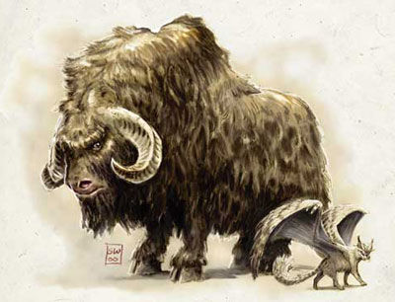

“Where to?” Steelshade asked the resident expert in everything.

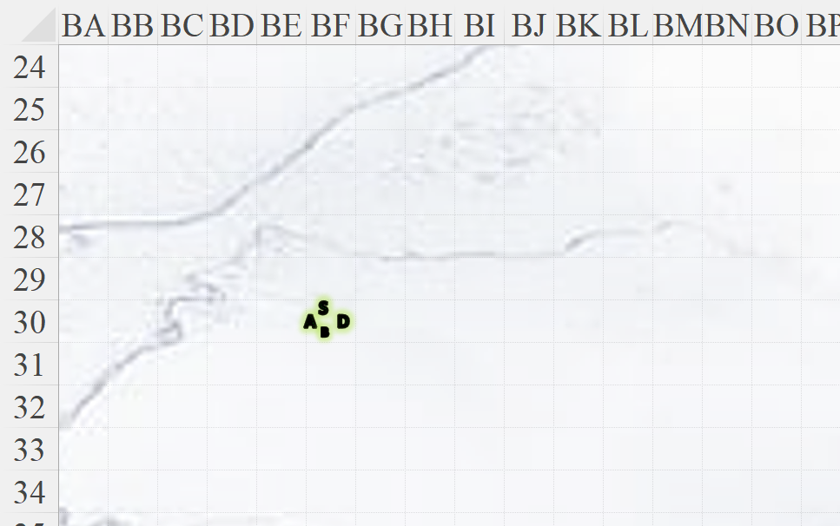

Atlas took the map he’d studied, reckoned it against the landscape, which consisted of a fairly flat area covered in a foot of snow with two roughly parallel rivers—now frozen solid—that nearly converged at this location.

*OOC: This map is not in the standard 5’ x 5’ scale; each square’s sides are 10’.*

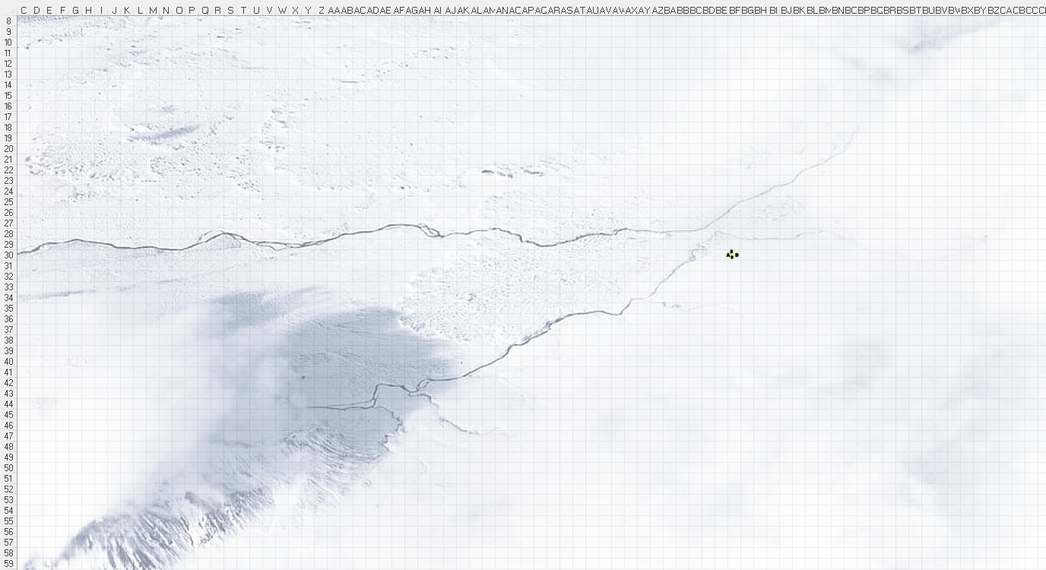

Round 75

Steelshade then spotted a white dragon fitting their description of interest flying east-northeast towards them. It had just emerged from a cloud that loomed over the only notable topography in the otherwise flat tundra. It was between 350’ and 400’ away horizontally, and about 200’ above them, descending in such a way as to best pounce on them.

It was no surprise to them that a dragon this capable—even a white dragon—would be keenly aware of any intruders, but the fact that this one was already out looking for them, suggested that he had spies across the multiverse, particularly in the den of the woman plotting to hunt and butcher him.

Atlas considered what he knew of white dragons to give the group an edge.

|  |  |  |  |  |  |  |  |
| --- | --- | --- | --- | --- | --- | --- | --- |
| **Skill** | **Rank** | **Ability & Mod.** | **Misc. Mods.** | **Total** | **Roll** | **Check** | **Notes** |
| **Knowledge: Arcana** | 18 | **Int (+8)** | 2 | 28 | 16 | 44 | Trivial Knowledge |
| **Knowledge: Arcana** | 18 | **Int (+8)** | 2 | 28 | 20 | 48 | Trivial Knowledge, **best of 2 rolls** |

*PCs gained +3 to attacks against white dragons (not half-dragons).*

Brene levitated herself enough to make moving across the snow easier, and she moved south from Atlas and prepared her bow. She planned to shoot the creature when it came into range. She also checked around to be sure nothing else was sneaking up on them. Then she noticed the rider atop the dragon.

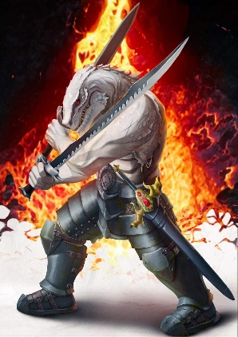

Devrion levitated 5’ and moved north from Atlas. He then pointed at the incoming dragon. “Meteorraj!”

|  |  |  |  |
| --- | --- | --- | --- |
| **Ranged Weapon** | **Atk** | **Roll** | **Check** |
| Bypass Spell Resistance | 19 | 13 | 32 |

*Success. SR bypassed.*

|  |  |  |  |  |  |  |  |  |  |  |
| --- | --- | --- | --- | --- | --- | --- | --- | --- | --- | --- |
| **Ranged Weapon** | **Dmg.** | **D+** | **TH+** | **Critical** | **Rng.** | **Wt.** | **Atk** | **Roll** | **Check** | **Notes** |
| Ranged Touch Attack | - | +6 + 3 | 1 | - | - | - | 21 | 17 | 38 | Weapon Focus Included |
| Ranged Touch Attack | - | +6 + 3 | 1 | - | - | - | 21 | 4 | 25 | Weapon Focus Included |
| Ranged Touch Attack | - | +6 + 3 | 1 | - | - | - | 21 | 20 | 41 | Weapon Focus Included |
| Ranged Touch Attack | - | +6 + 3 | 1 | - | - | - | 21 | 11 | 32 | Weapon Focus Included |

*Hit, hit, hit, hit. Dmg: (6 + 6) + (8 + 6) + (9 + 6) + (4 + 6) = 12 + 14 + 15 + 10 = 51.*

The meteors then exploded.

*Cheyn denied save.*

*Dmg: 22 + 18 + 17 + 31 = 88 fire.*

|  |  |  |  |  |
| --- | --- | --- | --- | --- |
| **Character** | **Save vs.**  *meteor swarm* | **Ranks** | **Roll** | **Check** |
| Quiñón | Reflex | 12 | 16 | 28 |
| Quiñón | Reflex | 12 | 1 | 13 |
| Quiñón | Reflex | 12 | 8 | 20 |
| Quiñón | Reflex | 12 | 13 | 25 |

*Success, fail, fail, fail. Saves once for ½ damage.*

*Dmg: (½ x 19) + 18 + 20 + 26 = 74 fire.*

And before it could even make an entrance, the two-sword-using ranger dropped dead and onto the snowy ground.

Steelshade levitated enough to make walking on the snow easier, and moved twenty feet toward the dragon. She extracted a vial of oil *[greater magic weapon, expired on Round 4801]* from her pack, and poured it over Arkenlyl. Then, she waited for the dragon to come closer.

*Steelshade’s falchion gained +2 to attack and damage.*

The dragon was mad now, and made every attempt to lay out these intruders in one swift, icy breath.

|  |  |  |  |
| --- | --- | --- | --- |
| **Character** | **Attack Type** | **Damage** | **Ranged?** |
| Cheyn | Frightful Presence | HD ≤30; DC 28 negates | 300’ |

|  |  |  |  |  |  |  |  |
| --- | --- | --- | --- | --- | --- | --- | --- |
| **Save vs.**  Frightful Presence | **Rank** | **Ability & Mod.** | **Misc. Mods.** | **Total** | **Roll** | **Check** | **Notes** |
| **Atlas, Will** | **11** | **Wis (+6)** | 13 | 30 | 17 | 47 |  |
| **Brene, Will** | **6** | **Wis (+5)** | 3 | 14 | 11 | 25 | +2 vs. Fear |
| **Devrion, Will** | **11** | **Wis (+3)** | 3 | 17 | 14 | 31 |  |
| **Steelshade, Will** | **11** | **Wis (+4)** | 3 | 18 | 10 | 28 |  |

*Success4. Effect negated.*

Evaluating Steelshade and Devrion as the more offensively capable foes, the dragon lined them up and blew icy frost upon them.

|  |  |  |  |
| --- | --- | --- | --- |
| **Character** | **Attack Type** | **Damage** | **Ranged?** |
| Cheyn | Breath Weapon | 11d6 cold; Ref DC 33 ½ | 60’ |

|  |  |  |  |  |  |  |
| --- | --- | --- | --- | --- | --- | --- |
| **Save vs.**  Breath Weapon | **Rank** | **Ability & Mod.** | **Misc. Mods.** | **Total** | **Roll** | **Check** |
| **Devrion, Reflex** | **6** | **Dex (+7)** | 3 | 16 | 4 | 20 |
| **Steelshade, Reflex** | **6** | **Dex (+5)** | 3 | 14 | 10 | 24 |

*Fail, fail.*

*Dmg to Devrion: 34 cold. Partial damage negated [101/105].*

*Dmg to Steelshade: 38 cold. Partial damage negated [190/198].*

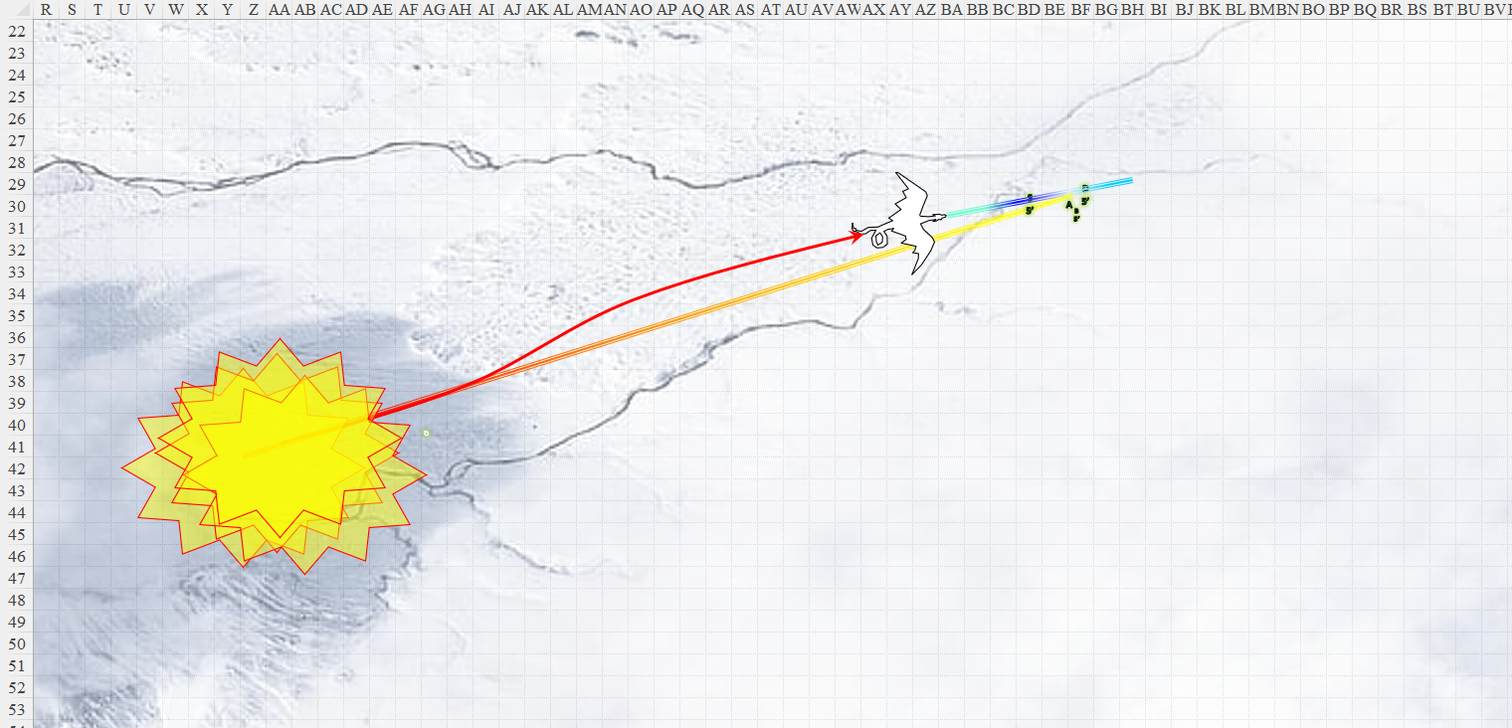

Round 76

|  |  |  |  |  |  |
| --- | --- | --- | --- | --- | --- |
| **Character** | **Group** | **Initiative** | **Roll** | **Modified Roll** | **Speed** |
| Brene | 1 | 6 | 11 | 17 | 30’ |
| Cheyn | 2 | 0 | 16 | 16 | 60’ / 30’ b / 60’ s / 250’ f |
| Atlas | 1 | 2 | 10 | 12 | 30’ |
| Steelshade | 1 | 5 | 5 | 10 | 20’ |
| Devrion | 1 | 6 | 3 | 9 | 30’ |

Brene dropped from her levitated position, settled herself into the snow and fired on the dragon as it bore down on them.

|  |  |  |  |  |  |  |  |  |  |  |
| --- | --- | --- | --- | --- | --- | --- | --- | --- | --- | --- |
| **Ranged Weapon** | **Dmg.** | **D+** | **TH+** | **Critical** | **Rng.** | **Wt.** | **Atk** | **Roll** | **Check** | **Properties** |
| Rapid Shortbow +2 | 1d4 | 2 | 2 + 3 DK | x3 | 60’ x 2 | 2.0 | +31 | 9 | 40 | Sneak Attack 10d6 |
| Shortbow, 2nd Shot | 1d4 | 2 | 2 + 3 DK | x3 | 60’ x 2 | - | +26 | 11 | 37 | Sneak Attack 10d6 |
| Shortbow, Rapid Shot | 1d4 | 2 | 2 + 3 DK | x3 | 60’ x 2 | - | +31 | 19 | 50 | Sneak Attack 10d6 |

*Hit, miss, hit. Dmg: (2 + 2 + 41) + (2 + 2 + 29 Sneak) = 33 + 45 = 78.*

Cheyn flew down and dire-charge-attacked Steelshade.

|  |  |  |  |  |  |  |  |  |  |
| --- | --- | --- | --- | --- | --- | --- | --- | --- | --- |
| **Character** | **Attack Type** | **Damage** | **BAB** | **Str Mod+** | **W+** | **Other+** | **Total Score** | **Roll** | **Total** |
| Cheyn | Bite | 4d6+12 | 33 | 8 | 2 charge | 2 altitude | 45 | 5 | 50 |
| Cheyn | Claw 1 | 2d8+6 | 33 | 6 | 0 | 2 altitude | 41 | 15 | 56 |
| Cheyn | Claw 2 | 2d8+6 | 33 | 6 | 0 | 2 altitude | 41 | 10 | 51 |
| Cheyn | Wing 1 | 2d6+6 | 33 | 6 | 0 | 2 altitude | 41 | 6 | 47 |
| Cheyn | Wing 2 | 2d6+6 | 33 | 6 | 0 | 2 altitude | 41 | 16 | 57 |
| Cheyn | Tail Slap | 2d8+18 | 33 | 6 | 0 | 2 altitude | 41 | 6 | 47 |

*Hit, hit, hit, hit, hit, hit. 1d100 = 01, 42, 28, 20, 56, 84.*

*Concealment bypassed on hits 1, 3, and 4.*

*Dmg: (17 + 12) + (10 + 6) + (7 + 6) = 29 + 16 + 13 = 58 [132/198].*

|  |  |  |  |  |  |  |  |  |
| --- | --- | --- | --- | --- | --- | --- | --- | --- |
| **Character** | **Melee** | **Ranged** | **Fire** | **Cold** | **Acid** | **Total Damage** | **HPs** | **Current HPs** |
| **AtlasPfE** |  |  | *R30* | *R30* | *R30* | 0 | 105 | 105 |
| **Brene** |  |  | *R30* | *R30* | *R30* | 0 | 105 | 105 |
| **Devrion** |  |  | *R30* | *4* | *R30* | 4 | 105 | 101 |
| **Angren** | 120 |  | *R30* | *8* | *R30* | 128 | 198 | 70 |
| **Cheyn** | 50ish | 80ish | *180ish* | *Imm* |  | 300ish | 450ish | 140ish |
| **Quiñón** |  |  | *150ish* | *Imm* |  | 150ish | 100ish | **-50ish** |

Atlas could tell that the dragon was nearly done for, and a full complement of swipes from Steelshade would likely put it out of commission. Still, if it got a chance to attack the duskblade again, she would likely be a goner forever. The archivist took a breath, and roared in the creature’s face. *[lion’s roar, expired on Round 266]*

|  |  |  |  |  |
| --- | --- | --- | --- | --- |
| **Character** | **Save vs.**  *lion’s roar* | **Ranks** | **Roll** | **Check** |
| Cheyn | Fortitude | 25 | 14 | 39 |

*Success. Saved for ½ damage and negated stun.*

*Dmg: ½ x 35 = 17 sonic.*

*PCs gained +1 to attacks and saves against fear.*

*Atlas gained 2 + 19 = 21 temporary hps [****126****/105].*

*Brene gained 7 + 19 = 26 temporary hps [****131****/105].*

*Devrion gained 5 + 19 = 24 temporary hps [****125****/105].*

*Steelshade gained 4 + 19 = 23 temporary hps [****155****/198].*

Steelshade ducked, dodged and parried as the dragon tried to pile drive her into the icy ground. For all the wyrm’s fury, it was badly hurt. She could see charred patches on its body and wings, and Brene’s arrows had struck deep into its belly. The duskblade shook her head to clear it, bared her fangs at her massive enemy, and leapt into action. She cast *swift fly*, quick cast *dimension door*, and empowered her strikes (+4), vanishing from under the massive dragon, and appearing directly atop its back where the wings joined the body. She full-attacked before the creature could react, channeling Arkenlyl’s stored *vampiric touch* spell as she did.

|  |  |  |  |  |  |  |  |  |  |  |
| --- | --- | --- | --- | --- | --- | --- | --- | --- | --- | --- |
| **Melee Weapon** | **Dmg** | **D+** | **TH+** | **Crit** | **x** | **Wt.** | **Atk** | **Roll** | **Check** | **Properties** |
| Shattermantle Bloodstone Falchion +5 | 2d4 + 3d4 AS + 5d6 VT | +9 +5 | 7 + 1 + 4 + 3 DK | 18 | 2 | 8.0 | +43 | 13 | 56 |  |
| SB Falchion +5, 2nd Attack | 2d4 + 3d4 AS | +9 +5 | 7 + 1 + 4 + 3 DK | 18 | 2 | - | +38 | 16 | 54 |  |
| SB Falchion +5, 3rd Attack | 2d4 + 3d4 AS | +9 +5 | 7 + 1 + 4 + 3 DK | 18 | 2 | - | +33 | 8 | 41 |  |
| SB Falchion +5, 4th Attack | 2d4 + 3d4 AS | +9 +5 | 7 + 1 + 4 + 3 DK | 18 | 2 | - | +28 | 19 | 47 |  |
| Greater Crystal of Arcane Steel | +1 to touch spells | 1 | +1 | - | - | - | - | - | - | +1 to spell DC |

*Hit, hit, hit, hit. Dmg: (3 + 9 + 5 + 5 AS + 17 VT) + (5 + 9 + 5 + 4 AS) + (6 + 9 + 5 + 9 AS) + (3 + 9 + 5 + 8 AS) = 22 + 23 + 29 + 25 + 17 Vampiric = 116.*

“Oh, you mother!!!” exclaimed Angren’s falchion in the Common language with a Mulhorandi accent. “You will soon fall at my sorce’s hand!”

Devrion blanched as his would-be lover was nearly smashed by the dragon’s great bulk. He sighed in relief as she placed herself atop the creature and hacked at it. He pointed at the badly wounded creature and spoke sharply. “Halál ujja!” *[finger of death]*

|  |  |  |  |  |
| --- | --- | --- | --- | --- |
| **Character** | **Save vs.**  *finger of death* | **Ranks** | **Roll** | **Check** |
| Cheyn | Fortitude | 25 | 10 | 35 |

*Success. Dmg: 12 + 19 = 31 negative energy.*

The dragon didn’t realize that its heart had stopped beating, but by the time his neurology caught up to its physiological demise, the ancient male lost the luster in his eyes, and dropped onto the snow, causing a massive but painless flurry of frost to coat the heroes.

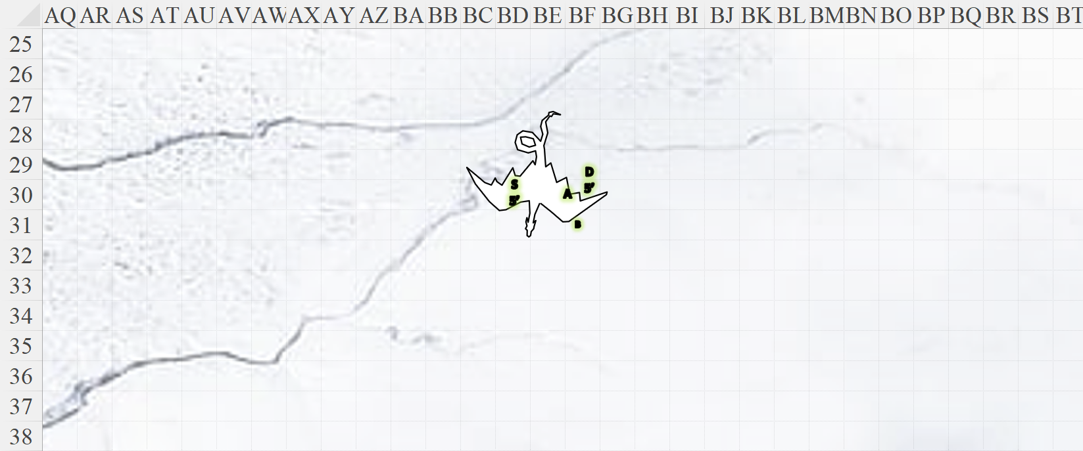

Round 77

Brene took aim at the dragon, cautious for a moment.

“All in a day’s work,” the half-dragon duskblade sighed as she brushed off the snow and beheld the creature that had nearly fallen atop her. She looked down at her warm falchion, which was glowing but no longer speaking.

With the job of butchering the dragon before them, the party gathered in circumstance, each looking up, down, and around occasionally, ensuring that the coast was clear.

“Well, that was exciting,” Devrion said as he stepped up to Steelshade and tapped her with his wand of *cure moderate wounds*. He then counted the number of brightly colored notches left on it.

*Steelshade gained 16 + 4 = 20 hps [****175****/198].*

|  |  |  |  |  |
| --- | --- | --- | --- | --- |
| **Wands, Scrolls and Potions** | **Qty.** | **Level** | **CLev** | **Notes** |
| Wand of Cure Moderate Wounds | 1 | 2 | 4 | 47 charges |

The duskblade’s temporary health would eventually expire, but for now, she was feeling quite well. Completely nonplussed about her sword talking, Steelshade took out their carpet as the warmage healed her.

Round 78

“Atlas, where is the lair?” Brene let herself drift down to the ground, her bow still ready.

Atlas consulted his map. “It’s that way,” he said as he pointed to the gloomy outcropping of ice under the looming cloud that did not move from its place, though the wind was blowing.

Round 79

“So we butcher here, then loot whatever’s in the hoard inside that igloo? Is that the plan?” Brene noted the somewhat hemispherical dome of ice that was just the tip of the proverbial and possibly literal iceberg that was Cheynchaytion’s lair.

“I’ve chopped on that dragon enough,” Steelshade said as the quartet took their places on the carpet. “If that woman wants the parts, she can take them herself.”

“That wasn’t the bargain,” Atlas warned that they might have to face her in combat to get the Recurve Grip if they didn’t deliver the butchered goods to her fair-weather pocket-plane keep.

Brene guided the carpet toward the late dragon’s lair, and then she stopped as she spotted the fallen rider’s remains. “Maybe this one has something interesting.”

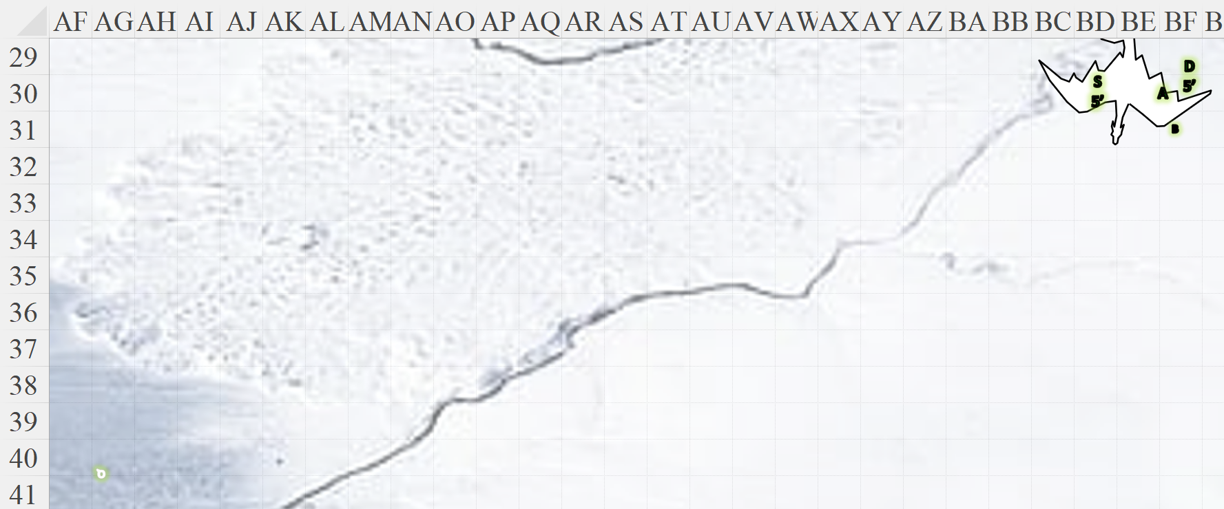

The body lay a few hundred feet away, so she opted to wait until they were all aboard the carpet before approaching.

~*~

Having ridden the carpet west-southwest a bit, Atlas stepped down onto the snow once more to check the rider’s corpse, while the other three kept watch.

“What’s with Arkenlyl?” Devrion asked as he tapped Steelshade again with his wand. He wanted her to be back to full health, just in case.

*Steelshade gained 9 + 4 = 13 hps [188/198].*

“The ankh, of course, but I don’t know what it really does,” the duskblade replied as she examined her blade. “Do you only talk during battle?” she addressed the sword as she held it up.

It took a moment for the handle to vibrate and resonate in the key of G#. “I am...”

“Uh...” Steelshade couldn’t quite grasp whether that was a direct answer to her question or a change of topic.

The item clarified, “I am Mercy... yet I am Defiance. I have Salvaged, yet I have Slaughtered.”

The clarifying platitudes left the quartet with more questions.

“Do you have a name?” Steelshade asked.

In the meantime, Atlas searched the rider’s body for anything useful or valuable, while Brene kept watch.

“I am Elsinor Winterforged,” the blade now vibrated with a voice that sounded by the second more and more like a half-drow woman. “I am Besieger and Redeemer alike.”

Atlas finished his investigation, and stepped back aboard the carpet. “Let’s go see about the lair.”

Brene lifted the carpet and piloted it to the dragon’s lair, looking for an entrance.

While she talked with Elsinor, Steelshade also stepped onto the carpet. “I am known as Angren’halya among the elves, and Steelshade among the humans,” Steelshade told Elsinor. “The blade you now inhabit is called Arkenlyl, and we are in Aasterinian’s service. My companions are Brene Noakes, Atlas, and Devrion Bolchanar.”

“I shall call you Sorce,” the weapon spake.

“‘Sorce’?” Steelshade didn’t quite understand.

“I am now attuned to you. I draw the power of a sorceress, and in turn, imbue her weapon with an extra edge.”

“I’m no sorcerer,” Steelshade assured her weapon.

“Yes, yes, duskblade: really a specialized battle sorcerer. This I know from prior experience with both,” the ankh on the handle of her blade boasted.

“I’ll need to identify the armor later, but it definitely has some magical properties,” Atlas said as he took a few minutes to remove the armor without damaging it. “This bugger was really well protected. That *meteor* really did the trick,” the archivist then commended the warmage on his arcane prowess.

“All in a day’s work,” replied the half-elf who had been looking forward to seeing the lumbering dragon to the northeast butchered.

“How did you come to be in this talisman, this ankh?” Steelshade asked.

“In the simplest sense, I *am* the ankh. How did you come to be in this hot bod, I dare ask?” the sword attempted to be cheeky by posing the same question to the fleshen half-drow.

“So what’s the script for when we see Dynasty again without having performed the dragon autopsy? I’m assuming you’ll be doing the speaking,” the halfling turned to the half-dragon.

Steelshade laughed softly. “Okay, we can talk more of this later.” She turned to Brene. “As I recall, she did say that she could do that work for herself. We need to check the lair for any other surprises before we return to Dynasty.”

~*~

They were now within an icy dome filled with treasure in absolutely no organized manner. They could grab a random scooping of it without ever having a clue as to what lies beneath the sea of coins and gems that constituted the surface of the hoard.

Brene stepped carefully over the vast pile of treasure. “We could buy Waterdeep with this,” she muttered as she picked up a half dozen of the larger gems that caught her eye.

The other three also looked around briefly, and they picked up a total of twenty-four large gems between the four of them. “Most of the people in Faerûn would kill their mothers for a treasure like this,” Atlas said with a sigh.

“Well, we have enough, I think.” Steelshade put up the gems she’d collected. “Let’s get back to Dynasty.”

They gathered around Atlas, and he took them back to the sorceress’ lair.

Finding themselves once again within the stony fortress of the dragon shamaness, they immediately noted that the woman was now fully armored, buffed, and wielding a spear.

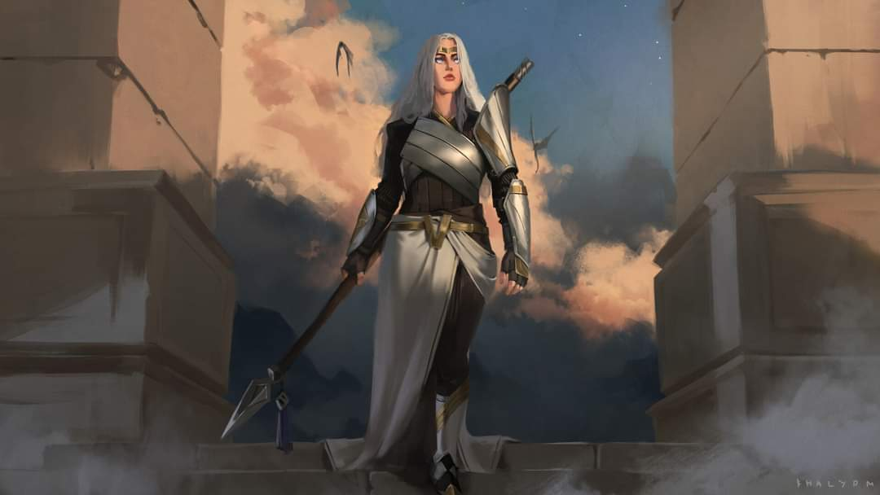

“Well, friends,” she smirked from an entryway that hadn’t been there before. “How did it go?”

That’s when Atlas began to notice other nuances that had been morphed by the dragon-slaying demigoddess before them. Doors and other immobile elements of the dilapidated stronghold had been repositioned, reinforced, and otherwise altered, possibly with tactical considerations, or maybe just to throw them off.

“The dragon and his companion are both dead,” Atlas reported. “We left them where they fell.”

She nodded, “Ah, and the meat?”

“The cold should preserve the carcass until you can attend to it,” Steelshade replies. “You may wish to start right away, in case there are scavengers in the area. The dragon found us almost right away, and we can point out the battle site on the map.”

The shamaness became livid in little time, her tone a mélange of shrills and growls. They didn’t make out every word, but as Atlas had expected, she was finding them in breach of contract and was now talking about letting a gate... or... no... litigating.”

“You really don’t,” Steelshade said as she started to draw her blade, “want to do this.”

Round 1

|  |  |  |  |  |
| --- | --- | --- | --- | --- |
| **Character** | **Group** | **Initiative** | **Roll** | **Modified Roll** |
| Devrion | 1 | 6 | 20 | 26 |
| Atlas | 1 | 2 | 16 | 18 |
| Dynasty | 2 | 1 | 16 | 16 |
| Brene | 1 | 6 | 8 | 14 |
| Steelshade | 1 | 5 | 6 | 11 |

“Sarigra!” Devrion cursed as he levitated ten feet straight up and pointed at the enraged woman. “Furcsa!”

|  |  |  |  |  |  |  |
| --- | --- | --- | --- | --- | --- | --- |
| **Save vs.**  *weird* | **Rank** | **Ability & Mod.** | **Misc. Mods.** | **Total** | **Roll** | **Check** |
| **Dynasty, Will** | **5** | **Wis (+1)** | 0 | 6 | 11 | 17 |
| **Dynasty, Fortitude** | **4** | **Con (+2)** | 0 | 6 | 20 | 26 |

*Fail, success. 9 magic.*

|  |  |  |  |  |  |  |
| --- | --- | --- | --- | --- | --- | --- |
| **Save vs.**  being too slow | **Rank** | **Ability & Mod.** | **Misc. Mods.** | **Total** | **Roll** | **Check** |
| **Devrion, Reflex** | **6** | **Dex (+7)** | 3 | 16 | 13 | 29 |

*Success. See below.*

Devrion heard behind him, then turned and spotted, another Dynasty! Before the *weird* energy left him, he directed the *phantasm* towards the second version of the woman.

Atlas also saw the second version of Dynasty, and recognized the suit of armor she was wearing as the one they’d seen hanging on the rack earlier. He breathed a quick prayer, and then roared at the shamanesses.

|  |  |  |  |  |  |  |
| --- | --- | --- | --- | --- | --- | --- |
| **Save vs.**  *lion’s roar* | **Rank** | **Ability & Mod.** | **Misc. Mods.** | **Total** | **Roll** | **Check** |
| **Dynasty, Fortitude** | **4** | **Con (+2)** | 0 | 6 | 19 | 25 |

*Fail. Dmg: 46 divine.*

The least imposing Dynasty cringed from the pain of both spells cast on her, then lunged towards Devrion as her more formidable counterpart assaulted Steelshade.

|  |  |  |  |  |  |  |  |  |
| --- | --- | --- | --- | --- | --- | --- | --- | --- |
| **Melee Weapon** | **Dmg** | **D+** | **TH+** | **Critical** | **Type** | **Atk** | **Roll** | **Check** |
| Returning Shortspear +3 | 1d6 | +3 +3 +2 | 2 + 2 charge | x3 | Piercing | 15 | 6 | 21 |

*Miss.*

|  |  |  |  |  |  |  |  |  |
| --- | --- | --- | --- | --- | --- | --- | --- | --- |
| **Melee Weapon** | **Dmg** | **D+** | **TH+** | **Critical** | **Type** | **Atk** | **Roll** | **Check** |
| Returning Shortspear +5 | 1d6 | +5 +5 +2 | 2 + 2 charge | x3 | Piercing | 19 | 3 | 22 |

*Miss.*

Brene chose to support Devrion, and fired on that version of the shamaness with her bow.

|  |  |  |  |  |  |  |  |  |  |  |
| --- | --- | --- | --- | --- | --- | --- | --- | --- | --- | --- |
| **Ranged Weapon** | **Dmg.** | **D+** | **TH+** | **Critical** | **Rng.** | **Wt.** | **Atk** | **Roll** | **Check** | **Properties** |
| Rapid Shortbow +2 | 1d4 | 2 | 2 | x3 | 60’ x 2 | 2.0 | +28 | 17 | 45 | Sneak Attack 10d6 |
| Shortbow, 2nd Shot | 1d4 | 2 | 2 | x3 | 60’ x 2 | - | +23 | 10 | 33 | Sneak Attack 10d6 |
| Shortbow, Rapid Shot | 1d4 | 2 | 2 | x3 | 60’ x 2 | - | +28 | 4 | 32 | Sneak Attack 10d6 |

*Hit, hit, hit. Dmg: (4 + 2 + 22 Sneak) + (4 + 2 + 33 Sneak) + (1 + 2 + 38 Sneak) = 28 + 39 + 41 = 108.*

That laid out the *simulacrum*, leaving Steelshade to contend with the original villain. The duskblade full-attacked the original Dyntasty, channeling *shocking grasp* through her blade.

|  |  |  |  |  |  |  |  |  |  |
| --- | --- | --- | --- | --- | --- | --- | --- | --- | --- |
| **Melee Weapon** | **Dmg** | **D+** | **TH+** | **Crit** | **x** | **Atk** | **Roll** | **Check** | **Properties** |
| Shattermantle Bloodstone Falchion +5 | 2d4 | +9 +5 | 7 | 18 | 2 | +35 | 4 | 39 |  |
| SB Falchion +5, 2nd Attack | 2d4 | +9 +5 | 7 | 18 | 2 | +30 | 9 | 39 |  |
| SB Falchion +5, 3rd Attack | 2d4 | +9 +5 | 7 | 18 | 2 | +25 | 4 | 29 |  |
| SB Falchion +5, 4th Attack | 2d4 | +9 +5 | 7 | 18 | 2 | +20 | 17 | 37 |  |
| Greater Crystal of Arcane Steel | +1 to touch spells | 1 | +1 | - | - | - | - | - | +1 to spell DC |

*Hit, hit, hit, hit. Dmg: (5 + 9 + 5 + 13 electric) + (2 + 9 + 5) + (4 + 9 + 5) + (6 + 9 + 5) = 19 + 16 + 18 + 20 + 13 electric = 73 + 13 electric = 86.*

Round 2

Devrion lifted himself out of melee range, and pointed at the shamaness attacking him. “Borzalmas hervadás!”

|  |  |  |  |  |  |  |
| --- | --- | --- | --- | --- | --- | --- |
| **Save vs.**  *horrid wilting* | **Rank** | **Ability & Mod.** | **Misc. Mods.** | **Total** | **Roll** | **Check** |
| **Dynasty, Fortitude** | **8** | **Con (+2)** | 0 | 10 | 19 | 29 |

*Success. Dynasty saved for ½ damage. Dmg: ½ x 79 = 39.*

Atlas brought out his crossbow and loaded it.

Dynasty said something about fiends, then full-attacked Steelshade with an aura that Atlas could identify as a Power boost, making her deadlier in close combat.

|  |  |  |  |  |  |  |  |  |  |
| --- | --- | --- | --- | --- | --- | --- | --- | --- | --- |
| **Melee Weapon** | **Dmg** | **D+** | **TH+** | **Critical** | **Type** | **Wt.** | **Atk** | **Roll** | **Check** |
| Returning Shortspear +5 | 1d6 | +5 +5 +5 +2 | 2 | x3 | Piercing | 9.0 | 17 | 18 | 35 |
| Returning Shortspear, 2nd attack | 1d6 | +5 +5 +5 +2 | 2 | x3 | Piercing | - | 12 | 8 | 20 |

*Miss, miss.*

Nonetheless, Angren was able to dodge such deadly force.

Both women repeated their earlier attacks on Dynasty, with both being equally frustrated at the woman’s utter pigheadedness in continuing the battle. “Stop fighting us,” Brene shouted as she aimed and fired.

|  |  |  |  |  |  |  |  |  |  |  |
| --- | --- | --- | --- | --- | --- | --- | --- | --- | --- | --- |
| **Ranged Weapon** | **Dmg.** | **D+** | **TH+** | **Critical** | **Rng.** | **Wt.** | **Atk** | **Roll** | **Check** | **Properties** |
| Rapid Shortbow +2 | 1d4 | 2 | 2 | x3 | 60’ x 2 | 2.0 | +28 | 6 | 34 | Sneak Attack 10d6 |
| Shortbow, 2nd Shot | 1d4 | 2 | 2 | x3 | 60’ x 2 | - | +23 | 7 | 30 | Sneak Attack 10d6 |
| Shortbow, Rapid Shot | 1d4 | 2 | 2 | x3 | 60’ x 2 | - | +28 | 13 | 41 | Sneak Attack 10d6 |

*Hit, hit, hit. Dmg: (2 + 2 + 33 Sneak) + (4 + 2 + 38 Sneak) + (3 + 2 + 35 Sneak) = 37 + 44 + 40 = 121.*

Steelshade held her blade, seeing the dragon shamaness clutch at the arrow that pierced her throat and knocked her down to her dying spot. The woman’s simulacrum disappeared, leaving only her equipment behind, and with the original shamaness now dead, the pocket plane also began to deteriorate, albeit slowly. A soft tremor alerted Atlas to the imminent collapse of the plane whose morphic properties had been hitherto held in place by Dynasty.

“How long do we have?” Brene asked.

“No more than five minutes,” he quantified the time in gnomish increments.

While Atlas prepared to take the group back to Waterdeep, the other three quickly gathered what items they could take in two or three minutes.

“Maybe we can drop this stuff, and then go back to the dragon’s lair for more,” Brene suggested.

“What would we do with more?” Devrion asked as he worked.

“Good point, but I’m sure Rook could use it,” Brene replied.

“Maybe. Let’s get this back, first,” Atlas said.

When the three minutes had elapsed, everyone gathered around, and Atlas took them back to Waterdeep.

~*~

They were taking an inventory of their loot, and Atlas had identified nearly all of the items, but among the items they’d filched within 3 minutes was not the Gorget of Magic Resistance, and the pocket plane from which they’d just *plane shifted* had likely collapsed by now.

“Let’s get Rook and Elaith to watch our stuff, and go back to that dragon’s lair,” Brene suggested. “We can empty out our packs, and gather as much as we can carry.”

“For what?” Devrion asked. “We can only use so much, and there’s no way we can take everything it had, anyway.”

“We can give it to Rook, and maybe help some others,” Steelshade put in.

“How about we go talk to Rook about it?” Atlas gathered up their items and stored them for the short trip, considering ways to effect a planar pipeline that would allow Rook, Elaith and their people to effectively and completely drain the white dragon’s hoard from the presumably vacant lair. Everyone nodded their assent, and so they trooped over to Rook’s church.

~*~

The Inquisitor of the Waterdeep Parish of the Church of Red Knight received them with gladness and fair tidings from his recent trip to Daggerford, where he was a celebrated hero since his plight against Syracuse of Zelbross back in Deepwinter of 1376. Nearly a decade had passed since that heroic campaign, and though Rook had a few gray hairs on his head, he was still a vigorous, if not youthful, warrior.

Donning civilian attire at the moment, the man known to few as Xavier Forge did his best to make the No Laughing Matter crew feel at home. A chessboard displaying an active game rested at the side of the reception room, and two empty chairs seemed to await the return of the most recent players.

“So, tell me, Champions of Aasterinian: what brings you all back?”

They proceeded to relate the tales of their recent exploits in their pursuit to buff up for a final showdown against Graz’zt.

“Of course, we will appropriate these treasures in the way of mutual prosperity,” the cleric-inquisitor said after expressing his heartfelt gratitude.

Elaith had by now entered, and also gave many thanks on behalf of the congregation. “Our flock will see to the proper distribution of this wealth.

The Red Knightpriests were also intrigued by the prospect of the remaining hoard’s acquisition. While they were not looters or recovery speculators, the sheer amount of treasure described made the enterprise rational to consider.

“As much as I’d like to go in and grab as much as we can carry,” Brene started, “I’m afraid that we’d wreck the local economy with that much money.”

“Yes, but just leaving it for anyone to find engenders that same risk, and it also gives that random lucky finder almost unimaginable wealth,” Devrion retorted.

Atlas speculated: “Right. That amount of wealth in circulation across the multiverse would likely make a dent in the inflation rate of most realms where those funds initially diffused.”

“We did that with the last horde. We buried it and left it,” Steelshade pointed out.

“That is our dilemma, you see,” Atlas addressed the Knightpriests. “Vast wealth inevitably leads to conflict and death. Few mortals, and probably some gods, can’t be trusted with it.” The archivist sighed. “For me, I have no desire for such things in my life. I have all that I need and more.”

The other three nodded in agreement. “As much as I hate to admit it,” Brene said softly, “that is true.”

“Okay, so let’s all go back to the lair, and get what we can carry out,” Brene again suggested.

“I can take eight people, so we can equip ourselves with bags and such, and then gather as much as we can all carry,” Atlas replied. He looked at Rook for his response.

~*~

And within 10 minutes of having left Dynasty’s lair, they returned to Cheyn’s lair with Rook and three of his people—Elaith, Thywine, and Cyka—finding it already in the midst of being looted by a beholder and his humanoid ilk: a handful of fools loading valuables into bags of holding. It seemed that the beholder had been keeping a vigilant eye on the dragon’s wellbeing, and it had wasted no time in implementing its plan before the dragon’s body even froze.

The beholder saw the quartet as soon as they spotted it at a distance of 100’ from their cluster. The humanoid lackeys were also at about that distance, all within 30’ of one another, and of the beholder.

Round 1

With Rook and his people in immediate danger, the quartet went into action.

Steelshade cast *swift fly*, quick cast *dimension door*, placing herself right behind the beholder, that is to say, on the side opposite the creature’s mouth and main eye. The duskblade channeled *shocking grasp* through her blade, and empowered her full-attack strikes (+5).

|  |  |  |  |  |  |  |  |  |  |  |
| --- | --- | --- | --- | --- | --- | --- | --- | --- | --- | --- |
| **Melee Weapon** | **Dmg** | **D+** | **TH+** | **Crit** | **x** | **Type** | **Wt.** | **Atk** | **Roll** | **Check** |
| Shattermantle Bloodstone Falchion +5 | 2d4 | +9 +5 | 7 + 5 AC | 18 | 2 | Slashing | 8.0 | +40 | 17 | 57 |
| SB Falchion +5, 2nd Attack | 2d4 | +9 +5 | 7 + 5 AC | 18 | 2 | Slashing | - | +35 | 19 | 54 |
| SB Falchion +5, 3rd Attack | 2d4 | +9 +5 | 7 + 5 AC | 18 | 2 | Slashing | - | +30 | 12 | 42 |
| SB Falchion +5, 4th Attack | 2d4 | +9 +5 | 7 + 5 AC | 18 | 2 | Slashing | - | +25 | 20 | 45 |
| Greater Crystal of Arcane Steel | +1 | 1 | +1 | - | - | - | - | - | - | - |

*Hit, hit, hit, hit. (5 + 9 + 5 + 20 electric + 14 AC + 1 AS) + (4 + 9 + 5 + 8 AC + 1 AS) + (3 + 9 + 5 + 13 AC + 1 AS) + (5 + 9 + 5 + 11 AC + 1 AS) = 19 + 15 + 18 + 9 + 17 + 14 + 19 + 12 + 20 electric = 143.*

The beholder perished at the woman’s last swipe.

|  |  |  |  |  |  |  |
| --- | --- | --- | --- | --- | --- | --- |
| **Save vs.**  wasting spell | **Rank** | **Ability & Mod.** | **Misc. Mods.** | **Total** | **Roll** | **Check** |
| **Atlas, Reflex** | **6** | **Dex (+7)** | 13 | 26 | 16 | 42 |

*See below.*

Atlas was about to rear back and *roar* at the beholder, but had the quick reflex to stay his hand as Brene kept her bow trained on the dead beholder, and Devrion, Rook, Elaith, Thywine, and Cyka readied their weapons in case the thralls turned to do anything other than continue mindlessly looting stuff.

Steelshade let herself float to the ground as she looked at the late beholder’s minions. She was ready for more fighting, while the others moved toward her at their best speed. “Yield, and you won’t be harmed,” the duskblade called out.

“Gods, I love her,” Devrion said quietly as he advanced with another *swift fly* spell.

Behind him, Atlas and Brene exchanged a grin as they made their way forward using their levitate ability to hop over the snow.

The cavernous space beneath leagues of packed permafrost was ample enough for the largest of dragons to get through, and it could have housed an entire lair for a party of their size.... Nevertheless, the space wasn’t big enough for both factions, and though the beholder had expired, its magic’s duration could only be guessed at as being a matter of minutes to hours, possibly days.

“They look like decent enough people,” Brene said with sarcasm of the tiefling, half-orc, half-dragon, and other tiefling.

Steelshade, a half-drown/half-dragon, gave the gnome a sideways glance, wondering if it was more humane to finish off these four fools before they came to their senses.

“It’s not like we’re heroes... or anything...” Atlas half-joked, having partaken in as many heroic acts with these three as he had in mischief and even malfeasance a few times.

Devrion was their beacon of Goodness in this Chaos-loving band, and he’d steered the others in recent years towards this path. Rook and his lot, on the other hand, bordered on fanaticism when it came to Law, and it was fortunate for everyone’s concentration that the topic had not come up. Under the perfectly wrong conditions, such debates could be as heated as the age-old Good-vs.-Evil topic.

“Alright,” Steelshade said. “Brene and I will keep an eye on them while the rest of you take as much as you can carry. Try to stay away from them as we work.”

For now, Brene stood watch between their own people and the beholder’s group, while Atlas and Devrion loaded up their sacks with whatever they could find. They opted for gems and magic items over gold, but they took what they could find in their immediate area. Devrion loaded Steelshade’s haversack first, and then his own bags.

The quartet found the following items as they looked through the immense hoard. Steelshade found a Ring of Wizardry III, Scabbard of Keen Edges, and Bag of Holding type IV. Brene filched a Conduit Rod, a Bottle of Air, and a Quiver of Energy. Devrion unearthed an Ioun stone, a lavender and green ellipsoid (Spell absorbing), an Immovable Rod, and a Rod of Reversal. Atlas found a Rod of Absorption, a Bag of Holding type III, and Eternal wand of Remove Disease, but as each was finding the last of these respective things—all the while filling the bags of holding with gems and gold coins—they managed to trigger one of the beholder’s minions, which then caused a chain effect. An aberrant word was pronounced by one of the tieflings, and within seconds, the half-orc, half-dragon, and other tiefling were no longer tending to the hoard, but to drawing their weapons.

Round 1

“Seriously?” Brene called out. “You all want to die that badly?”

Atlas raised his hands and pronounced a few words *[end to strife]*. Out to 80’ of the human on all sides there radiated an aura of foresight and caution. Shrouded in goodness, the ominous light showed everyone the image of themselves being crushed by a deific fist that dwarfed Bigby’s by a longshot. The possessed quartet, betrayed queer symptoms of the spell’s effect. The tieflings stood mostly still, shaking a bit as if torn between an arcane compulsion and a divine one. The half-orc and half-dragon also shivered and shuddered as all four did their best to sheathe their blades once again. The half-orc grimaced, did his best to compose himself, and pronounced with effort, “We are... compelled to kill...”

Steelshade and Devrion hefted their loads and stepped over to Atlas, as did Brene. “Let’s finish up and be gone from this place,” the archivist said to his companions. “Rook, I think we need to go.”

And that’s when one of the tieflings succumbed to the late beholder’s sway once again, quick-drew his longsword, and charge-attacked the nearest stranger: Elaith.

*Automatic miss.*

*Dmg to tiefling 2: 75.*

The tiefling died where he stood, crushed by an invisible vertical impact that left Elaith unscathed.

Rook and Atlas realized the other three—remaining three were now visibly agonized by the tension in their muscles—would surely die executing the will of their dead master without a say in the matter.

When everyone was gathered around, Atlas prayed again, taking them all back to Waterdeep but not before the half-orc fell victim to the compulsion to kill Rook and company.

*Automatic death with minimum damage.*

Rook’s armor took a bit of a ding right before they dematerialized and rematerialized on the Material Plane. “Well!” exclaimed the grateful inquisitor. “*That* was unexpectedly brief and yet rewarding.”

“What’d y’all find?” asked one of the knaves waiting for them in the Temple of Red Knight’s inner cloister.

“Rarities among treasures,” Elaith proclaimed.

“I can’t tell you how much this adds to our cause,” Rook thanked the No Laughing Matter crew. “Anytime you need a few extra swords, Elaith and I are with you. The young ones will have to train a bit more before going on perilous expeditions.”

“Now that we have all of this,” Devrion indicated the colossal haul with a wave of his hand, “what do we do with it?”

“The first thing we need to do is to fix our boots,” Steelshade replied. “I want to be able to move around with them, not just lift straight up.”

“Other than the items we picked up,” Atlas said, “the coins and such all go to Rook’s people, too. I’m sure there are worthy causes that could use the funding, preferably in the form of shelter and such things.”

“We can help take some of it elsewhere, I think,” Brene added.